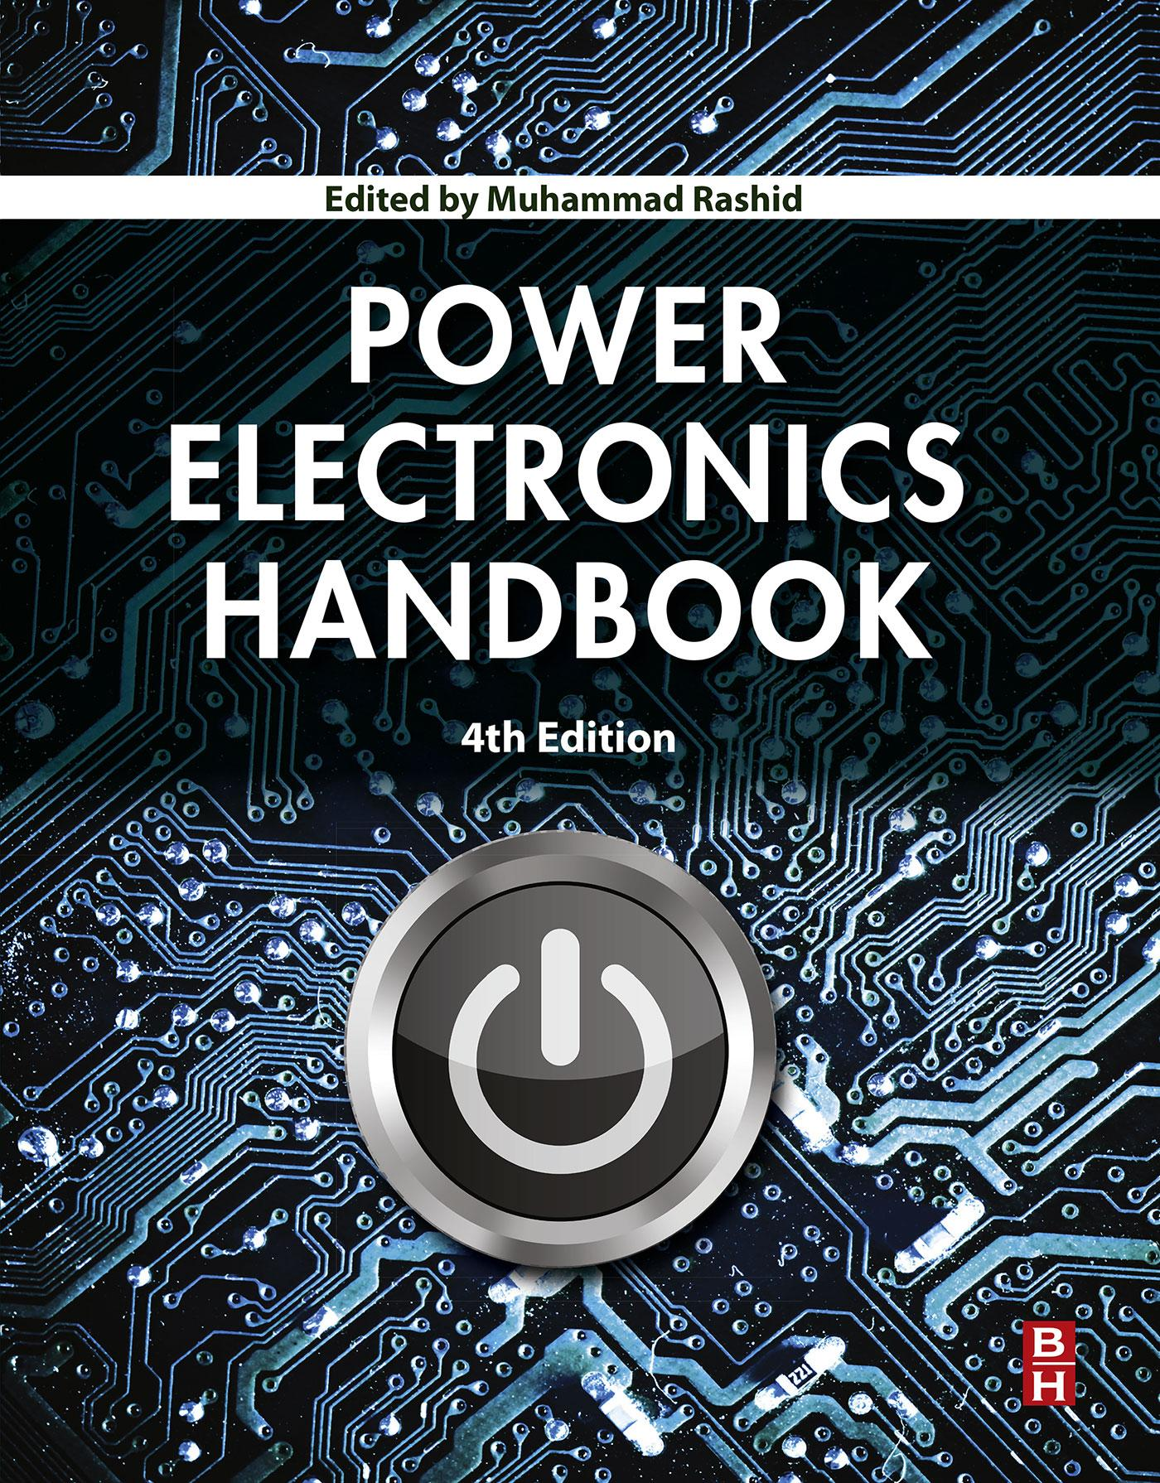

# Power Electronics Handbook

FOURTH EDITION

Muhammad H. Rashid, Ph.D.

*Fellow IET (UK), Life Fellow IEEE, Florida Polytechnic University*

**

# Table of Contents

[Cover image](https://learning.oreilly.com/library/view/power-electronics-handbook/9780128114087/Cover.xhtml)

[Title page](https://learning.oreilly.com/library/view/power-electronics-handbook/9780128114087/B9780128114070099955.xhtml)

[Copyright](https://learning.oreilly.com/library/view/power-electronics-handbook/9780128114087/B9780128114070099979.xhtml)

[Contributors](https://learning.oreilly.com/library/view/power-electronics-handbook/9780128114087/B9780128114070099967.xhtml)

[1: Introduction](https://learning.oreilly.com/library/view/power-electronics-handbook/9780128114087/B9780128114070000015.xhtml)

[Abstract](https://learning.oreilly.com/library/view/power-electronics-handbook/9780128114087/B9780128114070000015.xhtml#ab0010)

[1.1 Power Electronics Defined](https://learning.oreilly.com/library/view/power-electronics-handbook/9780128114087/B9780128114070000015.xhtml#s0010)

[1.2 Key Characteristics](https://learning.oreilly.com/library/view/power-electronics-handbook/9780128114087/B9780128114070000015.xhtml#s0015)

[1.3 Trends in Power Supplies](https://learning.oreilly.com/library/view/power-electronics-handbook/9780128114087/B9780128114070000015.xhtml#s0030)

[1.4 Conversion Examples](https://learning.oreilly.com/library/view/power-electronics-handbook/9780128114087/B9780128114070000015.xhtml#s0035)

[1.5 Tools for Analysis and Design](https://learning.oreilly.com/library/view/power-electronics-handbook/9780128114087/B9780128114070000015.xhtml#s0050)

[1.6 Sample Applications](https://learning.oreilly.com/library/view/power-electronics-handbook/9780128114087/B9780128114070000015.xhtml#s0080)

[1.7 Summary](https://learning.oreilly.com/library/view/power-electronics-handbook/9780128114087/B9780128114070000015.xhtml#s0085)

[**Section I: Power Electronic Devices**](https://learning.oreilly.com/library/view/power-electronics-handbook/9780128114087/sectioni.xhtml)

[2: Semiconductor Diodes and Transistors](https://learning.oreilly.com/library/view/power-electronics-handbook/9780128114087/B9780128114070000027.xhtml)

[Abstract](https://learning.oreilly.com/library/view/power-electronics-handbook/9780128114087/B9780128114070000027.xhtml#ab0010)

[2.1 Semiconductor Diode](https://learning.oreilly.com/library/view/power-electronics-handbook/9780128114087/B9780128114070000027.xhtml#s0010)

[2.2 Power Bipolar Transistor](https://learning.oreilly.com/library/view/power-electronics-handbook/9780128114087/B9780128114070000027.xhtml#s0065)

[2.3 Power MOSFET](https://learning.oreilly.com/library/view/power-electronics-handbook/9780128114087/B9780128114070000027.xhtml#s0105)

[2.4 Insulated Gate Bipolar Transistor](https://learning.oreilly.com/library/view/power-electronics-handbook/9780128114087/B9780128114070000027.xhtml#s0165)

[2.5 Swtiching evaluation of a Real MOSFET](https://learning.oreilly.com/library/view/power-electronics-handbook/9780128114087/B9780128114070000027.xhtml#s0205)

[2.6 Heatsink Thermal Design for Power Semiconductors](https://learning.oreilly.com/library/view/power-electronics-handbook/9780128114087/B9780128114070000027.xhtml#s0230)

[2.7 Transistor Selection Criteria](https://learning.oreilly.com/library/view/power-electronics-handbook/9780128114087/B9780128114070000027.xhtml#s0240)

[3: Thyristors](https://learning.oreilly.com/library/view/power-electronics-handbook/9780128114087/B9780128114070000039.xhtml)

[Abstract](https://learning.oreilly.com/library/view/power-electronics-handbook/9780128114087/B9780128114070000039.xhtml#ab0010)

[3.1 Introduction](https://learning.oreilly.com/library/view/power-electronics-handbook/9780128114087/B9780128114070000039.xhtml#s0010)

[3.2 Basic Structure and Operation](https://learning.oreilly.com/library/view/power-electronics-handbook/9780128114087/B9780128114070000039.xhtml#s0015)

[3.3 Static Characteristics](https://learning.oreilly.com/library/view/power-electronics-handbook/9780128114087/B9780128114070000039.xhtml#s0020)

[3.4 Dynamic Switching Characteristics](https://learning.oreilly.com/library/view/power-electronics-handbook/9780128114087/B9780128114070000039.xhtml#s0040)

[3.5 Thyristor Parameters](https://learning.oreilly.com/library/view/power-electronics-handbook/9780128114087/B9780128114070000039.xhtml#s0065)

[3.6 Types of Thyristors](https://learning.oreilly.com/library/view/power-electronics-handbook/9780128114087/B9780128114070000039.xhtml#s0070)

[3.7 Gate Drive Requirements](https://learning.oreilly.com/library/view/power-electronics-handbook/9780128114087/B9780128114070000039.xhtml#s0210)

[3.8 Applications](https://learning.oreilly.com/library/view/power-electronics-handbook/9780128114087/B9780128114070000039.xhtml#s0225)

[4: Static Induction Devices](https://learning.oreilly.com/library/view/power-electronics-handbook/9780128114087/B9780128114070000040.xhtml)

[Abstract](https://learning.oreilly.com/library/view/power-electronics-handbook/9780128114087/B9780128114070000040.xhtml#ab0010)

[4.1 Introduction](https://learning.oreilly.com/library/view/power-electronics-handbook/9780128114087/B9780128114070000040.xhtml#s0010)

[4.2 Theory of Static Induction Devices](https://learning.oreilly.com/library/view/power-electronics-handbook/9780128114087/B9780128114070000040.xhtml#s0015)

[4.3 Characteristics of SIT](https://learning.oreilly.com/library/view/power-electronics-handbook/9780128114087/B9780128114070000040.xhtml#s0020)

[4.4 Bipolar Mode Operation of SI devices (BSIT)](https://learning.oreilly.com/library/view/power-electronics-handbook/9780128114087/B9780128114070000040.xhtml#s0025)

[4.5 Emitters for Static Induction Devices](https://learning.oreilly.com/library/view/power-electronics-handbook/9780128114087/B9780128114070000040.xhtml#s0030)

[4.6 Static Induction Diode](https://learning.oreilly.com/library/view/power-electronics-handbook/9780128114087/B9780128114070000040.xhtml#s0035)

[4.7 Lateral Punch-Through Transistor](https://learning.oreilly.com/library/view/power-electronics-handbook/9780128114087/B9780128114070000040.xhtml#s0040)

[4.8 Static Induction Transistor Logic](https://learning.oreilly.com/library/view/power-electronics-handbook/9780128114087/B9780128114070000040.xhtml#s0045)

[4.9 BJT Saturation Protected by SIT](https://learning.oreilly.com/library/view/power-electronics-handbook/9780128114087/B9780128114070000040.xhtml#s0050)

[4.10 Static Induction MOS Transistor](https://learning.oreilly.com/library/view/power-electronics-handbook/9780128114087/B9780128114070000040.xhtml#s0055)

[4.11 Space Charge Limiting Load (SCLL)](https://learning.oreilly.com/library/view/power-electronics-handbook/9780128114087/B9780128114070000040.xhtml#s0060)

[4.12 Power MOS Transistors](https://learning.oreilly.com/library/view/power-electronics-handbook/9780128114087/B9780128114070000040.xhtml#s0065)

[4.13 Static Induction Thyristor](https://learning.oreilly.com/library/view/power-electronics-handbook/9780128114087/B9780128114070000040.xhtml#s0070)

[4.14 Gate Turn Off Thyristor](https://learning.oreilly.com/library/view/power-electronics-handbook/9780128114087/B9780128114070000040.xhtml#s0075)

[5: SiC and GaN Power Semiconductor Devices](https://learning.oreilly.com/library/view/power-electronics-handbook/9780128114087/B9780128114070000052_1.xhtml)

[Abstract](https://learning.oreilly.com/library/view/power-electronics-handbook/9780128114087/B9780128114070000052_1.xhtml#ab0010)

[5.1 Background](https://learning.oreilly.com/library/view/power-electronics-handbook/9780128114087/B9780128114070000052_1.xhtml#s0010)

[5.2 Silicon Carbide and Gallium Nitride Materials](https://learning.oreilly.com/library/view/power-electronics-handbook/9780128114087/B9780128114070000052_1.xhtml#s0015)

[5.3 SiC Power Devices](https://learning.oreilly.com/library/view/power-electronics-handbook/9780128114087/B9780128114070000052_1.xhtml#s0075)

[5.4 GaN Power Devices](https://learning.oreilly.com/library/view/power-electronics-handbook/9780128114087/B9780128114070000052_2.xhtml#s0130)

[Appendix Lightly Doped Drift Region Thickness](https://learning.oreilly.com/library/view/power-electronics-handbook/9780128114087/B9780128114070000052_3.xhtml#s0195)

[6: Power Electronic Modules](https://learning.oreilly.com/library/view/power-electronics-handbook/9780128114087/B9780128114070000064.xhtml)

[Abstract](https://learning.oreilly.com/library/view/power-electronics-handbook/9780128114087/B9780128114070000064.xhtml#ab0010)

[6.1 Introduction](https://learning.oreilly.com/library/view/power-electronics-handbook/9780128114087/B9780128114070000064.xhtml#s0010)

[6.2 Discrete Power Devices Versus Power Modules](https://learning.oreilly.com/library/view/power-electronics-handbook/9780128114087/B9780128114070000064.xhtml#s0015)

[6.3 An Example of Power Module](https://learning.oreilly.com/library/view/power-electronics-handbook/9780128114087/B9780128114070000064.xhtml#s0020)

[6.4 Manufacturing Process](https://learning.oreilly.com/library/view/power-electronics-handbook/9780128114087/B9780128114070000064.xhtml#s0025)

[6.5 Types of Power Electronic Modules](https://learning.oreilly.com/library/view/power-electronics-handbook/9780128114087/B9780128114070000064.xhtml#s0055)

[6.6 Thermal Management of Power Modules](https://learning.oreilly.com/library/view/power-electronics-handbook/9780128114087/B9780128114070000064.xhtml#s0075)

[6.7 Reliability of Power Modules](https://learning.oreilly.com/library/view/power-electronics-handbook/9780128114087/B9780128114070000064.xhtml#s0120)

[6.8 Design Guidelines and Considerations](https://learning.oreilly.com/library/view/power-electronics-handbook/9780128114087/B9780128114070000064.xhtml#s0140)

[**Section II: Power Conversion**](https://learning.oreilly.com/library/view/power-electronics-handbook/9780128114087/sectionii.xhtml)

[7: Diode Rectifiers](https://learning.oreilly.com/library/view/power-electronics-handbook/9780128114087/B9780128114070000076.xhtml)

[Abstract](https://learning.oreilly.com/library/view/power-electronics-handbook/9780128114087/B9780128114070000076.xhtml#ab0010)

[7.1 Introduction](https://learning.oreilly.com/library/view/power-electronics-handbook/9780128114087/B9780128114070000076.xhtml#s0010)

[7.2 Single-Phase Diode Rectifiers](https://learning.oreilly.com/library/view/power-electronics-handbook/9780128114087/B9780128114070000076.xhtml#s0015)

[7.3 Three-Phase Diode Rectifiers](https://learning.oreilly.com/library/view/power-electronics-handbook/9780128114087/B9780128114070000076.xhtml#s0075)

[7.4 Poly-Phase Diode Rectifiers](https://learning.oreilly.com/library/view/power-electronics-handbook/9780128114087/B9780128114070000076.xhtml#s0110)

[7.5 Filtering Systems in Rectifier Circuits](https://learning.oreilly.com/library/view/power-electronics-handbook/9780128114087/B9780128114070000076.xhtml#s0130)

[7.6 High-Frequency Diode Rectifier Circuits](https://learning.oreilly.com/library/view/power-electronics-handbook/9780128114087/B9780128114070000076.xhtml#s0170)

[8: Single-Phase Controlled Rectifiers](https://learning.oreilly.com/library/view/power-electronics-handbook/9780128114087/B9780128114070000088.xhtml)

[Abstract](https://learning.oreilly.com/library/view/power-electronics-handbook/9780128114087/B9780128114070000088.xhtml#ab0010)

[8.1 Introduction](https://learning.oreilly.com/library/view/power-electronics-handbook/9780128114087/B9780128114070000088.xhtml#s0010)

[8.2 Line-Commutated Single-Phase Controlled Rectifiers](https://learning.oreilly.com/library/view/power-electronics-handbook/9780128114087/B9780128114070000088.xhtml#s0015)

[8.3 Unity Power Factor Single-Phase Rectifiers](https://learning.oreilly.com/library/view/power-electronics-handbook/9780128114087/B9780128114070000088.xhtml#s0060)

[9: Three-Phase Controlled Rectifiers](https://learning.oreilly.com/library/view/power-electronics-handbook/9780128114087/B978012811407000009X.xhtml)

[Abstract](https://learning.oreilly.com/library/view/power-electronics-handbook/9780128114087/B978012811407000009X.xhtml#ab0010)

[9.1 Introduction](https://learning.oreilly.com/library/view/power-electronics-handbook/9780128114087/B978012811407000009X.xhtml#s0010)

[9.2 Line-Commutated Controlled Rectifiers](https://learning.oreilly.com/library/view/power-electronics-handbook/9780128114087/B978012811407000009X.xhtml#s0015)

[9.3 Force-Commutated Three-Phase Controlled Rectifiers](https://learning.oreilly.com/library/view/power-electronics-handbook/9780128114087/B978012811407000009X.xhtml#s0090)

[10: DC-DC Converters](https://learning.oreilly.com/library/view/power-electronics-handbook/9780128114087/B9780128114070000106.xhtml)

[Abstract](https://learning.oreilly.com/library/view/power-electronics-handbook/9780128114087/B9780128114070000106.xhtml#ab0010)

[10.1 Introduction](https://learning.oreilly.com/library/view/power-electronics-handbook/9780128114087/B9780128114070000106.xhtml#s0010)

[10.2 DC Choppers](https://learning.oreilly.com/library/view/power-electronics-handbook/9780128114087/B9780128114070000106.xhtml#s0015)

[10.3 Step-Down (Buck) Converter](https://learning.oreilly.com/library/view/power-electronics-handbook/9780128114087/B9780128114070000106.xhtml#s0020)

[10.4 Step-Up (Boost) Converter](https://learning.oreilly.com/library/view/power-electronics-handbook/9780128114087/B9780128114070000106.xhtml#s0055)

[10.5 Buck-Boost Converter](https://learning.oreilly.com/library/view/power-electronics-handbook/9780128114087/B9780128114070000106.xhtml#s0060)

[10.6 Ćuk Converter](https://learning.oreilly.com/library/view/power-electronics-handbook/9780128114087/B9780128114070000106.xhtml#s0075)

[10.7 Effects of Parasitic Components](https://learning.oreilly.com/library/view/power-electronics-handbook/9780128114087/B9780128114070000106.xhtml#s0080)

[10.8 Synchronous and Bidirectional Converters](https://learning.oreilly.com/library/view/power-electronics-handbook/9780128114087/B9780128114070000106.xhtml#s0085)

[10.9 Control Principles](https://learning.oreilly.com/library/view/power-electronics-handbook/9780128114087/B9780128114070000106.xhtml#s0090)

[10.10 Applications of DC-DC Converters](https://learning.oreilly.com/library/view/power-electronics-handbook/9780128114087/B9780128114070000106.xhtml#s0095)

[11: Inverters](https://learning.oreilly.com/library/view/power-electronics-handbook/9780128114087/B9780128114070000118_1.xhtml)

[Abstract](https://learning.oreilly.com/library/view/power-electronics-handbook/9780128114087/B9780128114070000118_1.xhtml#ab0010)

[11.1 Introduction](https://learning.oreilly.com/library/view/power-electronics-handbook/9780128114087/B9780128114070000118_1.xhtml#s0010)

[11.2 Single-Phase Inverters](https://learning.oreilly.com/library/view/power-electronics-handbook/9780128114087/B9780128114070000118_1.xhtml#s0015)

[11.3 Three-Phase Voltage Source Inverters](https://learning.oreilly.com/library/view/power-electronics-handbook/9780128114087/B9780128114070000118_1.xhtml#s0080)

[11.4 Three-Phase Current Source Inverters](https://learning.oreilly.com/library/view/power-electronics-handbook/9780128114087/B9780128114070000118_1.xhtml#s0135)

[11.5 Multilevel Inverters](https://learning.oreilly.com/library/view/power-electronics-handbook/9780128114087/B9780128114070000118_2.xhtml#s0180)

[11.6 Closed-Loop Operation of Inverters](https://learning.oreilly.com/library/view/power-electronics-handbook/9780128114087/B9780128114070000118_2.xhtml#s0235)

[11.7 Regeneration in Inverters](https://learning.oreilly.com/library/view/power-electronics-handbook/9780128114087/B9780128114070000118_2.xhtml#s0270)

[12: Resonant and Soft-Switching Converters](https://learning.oreilly.com/library/view/power-electronics-handbook/9780128114087/B978012811407000012X.xhtml)

[Abstract](https://learning.oreilly.com/library/view/power-electronics-handbook/9780128114087/B978012811407000012X.xhtml#ab0010)

[12.1 Introduction](https://learning.oreilly.com/library/view/power-electronics-handbook/9780128114087/B978012811407000012X.xhtml#s0010)

[12.2 Classification](https://learning.oreilly.com/library/view/power-electronics-handbook/9780128114087/B978012811407000012X.xhtml#s0015)

[12.3 Resonant Switch](https://learning.oreilly.com/library/view/power-electronics-handbook/9780128114087/B978012811407000012X.xhtml#s0020)

[12.4 Quasi-Resonant Converters](https://learning.oreilly.com/library/view/power-electronics-handbook/9780128114087/B978012811407000012X.xhtml#s0035)

[12.5 ZVS in High Frequency Applications](https://learning.oreilly.com/library/view/power-electronics-handbook/9780128114087/B978012811407000012X.xhtml#s0055)

[12.6 Multi-resonant Converters](https://learning.oreilly.com/library/view/power-electronics-handbook/9780128114087/B978012811407000012X.xhtml#s0070)

[12.7 Zero-voltage-transition Converters](https://learning.oreilly.com/library/view/power-electronics-handbook/9780128114087/B978012811407000012X.xhtml#s0075)

[12.8 Non-dissipative Active Clamp Network](https://learning.oreilly.com/library/view/power-electronics-handbook/9780128114087/B978012811407000012X.xhtml#s0080)

[12.9 Load Resonant Converters](https://learning.oreilly.com/library/view/power-electronics-handbook/9780128114087/B978012811407000012X.xhtml#s0085)

[12.10 Control Circuits for Resonant Converters](https://learning.oreilly.com/library/view/power-electronics-handbook/9780128114087/B978012811407000012X.xhtml#s0135)

[12.11 Extended-Period Quasi-Resonant Converters](https://learning.oreilly.com/library/view/power-electronics-handbook/9780128114087/B978012811407000012X.xhtml#s0150)

[12.12 Soft-Switching and EMI Suppression](https://learning.oreilly.com/library/view/power-electronics-handbook/9780128114087/B978012811407000012X.xhtml#s0180)

[12.13 Snubbers and Soft-Switching for High Power Devices](https://learning.oreilly.com/library/view/power-electronics-handbook/9780128114087/B978012811407000012X.xhtml#s0185)

[12.14 Soft-Switching DC-AC Power Inverters](https://learning.oreilly.com/library/view/power-electronics-handbook/9780128114087/B978012811407000012X.xhtml#s0190)

[13: Multilevel Power Converters](https://learning.oreilly.com/library/view/power-electronics-handbook/9780128114087/B9780128114070000131.xhtml)

[Abstract](https://learning.oreilly.com/library/view/power-electronics-handbook/9780128114087/B9780128114070000131.xhtml#ab0010)

[13.1 Introduction](https://learning.oreilly.com/library/view/power-electronics-handbook/9780128114087/B9780128114070000131.xhtml#s0010)

[13.2 Multilevel Power Converter Structures](https://learning.oreilly.com/library/view/power-electronics-handbook/9780128114087/B9780128114070000131.xhtml#s0015)

[13.3 Multilevel Converter PWM Modulation Strategies](https://learning.oreilly.com/library/view/power-electronics-handbook/9780128114087/B9780128114070000131.xhtml#s0105)

[13.4 Conclusion](https://learning.oreilly.com/library/view/power-electronics-handbook/9780128114087/B9780128114070000131.xhtml#s0165)

[14: AC-AC Converters](https://learning.oreilly.com/library/view/power-electronics-handbook/9780128114087/B9780128114070000143_1.xhtml)

[Abstract](https://learning.oreilly.com/library/view/power-electronics-handbook/9780128114087/B9780128114070000143_1.xhtml#ab0010)

[14.1 Introduction](https://learning.oreilly.com/library/view/power-electronics-handbook/9780128114087/B9780128114070000143_1.xhtml#s0010)

[14.2 Single-Phase AC-AC Voltage Controller](https://learning.oreilly.com/library/view/power-electronics-handbook/9780128114087/B9780128114070000143_1.xhtml#s0015)

[14.3 Three-Phase AC-AC Voltage Controllers](https://learning.oreilly.com/library/view/power-electronics-handbook/9780128114087/B9780128114070000143_1.xhtml#s0030)

[14.4 Cycloconverters](https://learning.oreilly.com/library/view/power-electronics-handbook/9780128114087/B9780128114070000143_1.xhtml#s0045)

[14.5 Matrix Converter](https://learning.oreilly.com/library/view/power-electronics-handbook/9780128114087/B9780128114070000143_1.xhtml#s0105)

[14.6 High Frequency Linked Single-Phase to Three-Phase Matrix Converters](https://learning.oreilly.com/library/view/power-electronics-handbook/9780128114087/B9780128114070000143_1.xhtml#s0135)

[14.7 Applications of AC-AC Converters](https://learning.oreilly.com/library/view/power-electronics-handbook/9780128114087/B9780128114070000143_2.xhtml#s0150)

[15: Multiphase Converters](https://learning.oreilly.com/library/view/power-electronics-handbook/9780128114087/B9780128114070000167_1.xhtml)

[Abstract](https://learning.oreilly.com/library/view/power-electronics-handbook/9780128114087/B9780128114070000167_1.xhtml#ab0010)

[15.1 Introduction](https://learning.oreilly.com/library/view/power-electronics-handbook/9780128114087/B9780128114070000167_1.xhtml#s0010)

[15.2 Types and Topologies of Multiphase Converters](https://learning.oreilly.com/library/view/power-electronics-handbook/9780128114087/B9780128114070000167_1.xhtml#s0015)

[15.3 Multiphase Multipulse AC-DC Converters](https://learning.oreilly.com/library/view/power-electronics-handbook/9780128114087/B9780128114070000167_1.xhtml#s0040)

[15.4 Multiphase DC-AC Converters](https://learning.oreilly.com/library/view/power-electronics-handbook/9780128114087/B9780128114070000167_1.xhtml#s0095)

[15.5 Multiphase AC-AC Converter](https://learning.oreilly.com/library/view/power-electronics-handbook/9780128114087/B9780128114070000167_3.xhtml#s0240)

[15.6 Multiphase DC-DC Converter](https://learning.oreilly.com/library/view/power-electronics-handbook/9780128114087/B9780128114070000167_3.xhtml#s0325)

[16: Power Factor Correction Circuits](https://learning.oreilly.com/library/view/power-electronics-handbook/9780128114087/B9780128114070000179.xhtml)

[Abstract](https://learning.oreilly.com/library/view/power-electronics-handbook/9780128114087/B9780128114070000179.xhtml#ab0010)

[16.1 Introduction](https://learning.oreilly.com/library/view/power-electronics-handbook/9780128114087/B9780128114070000179.xhtml#s0010)

[16.2 Definition of PF and THD](https://learning.oreilly.com/library/view/power-electronics-handbook/9780128114087/B9780128114070000179.xhtml#s0015)

[16.3 Power Factor Correction](https://learning.oreilly.com/library/view/power-electronics-handbook/9780128114087/B9780128114070000179.xhtml#s0020)

[16.4 CCM Shaping Technique](https://learning.oreilly.com/library/view/power-electronics-handbook/9780128114087/B9780128114070000179.xhtml#s0080)

[16.5 DCM Input Technique](https://learning.oreilly.com/library/view/power-electronics-handbook/9780128114087/B9780128114070000179.xhtml#s0140)

[16.6 Summary](https://learning.oreilly.com/library/view/power-electronics-handbook/9780128114087/B9780128114070000179.xhtml#s0205)

[17: Magnetic Circuit Design for Power Electronics](https://learning.oreilly.com/library/view/power-electronics-handbook/9780128114087/B9780128114070000192.xhtml)

[Abstract](https://learning.oreilly.com/library/view/power-electronics-handbook/9780128114087/B9780128114070000192.xhtml#ab0010)

[Acknowledgment](https://learning.oreilly.com/library/view/power-electronics-handbook/9780128114087/B9780128114070000192.xhtml#ac0010)

[17.1 Introduction](https://learning.oreilly.com/library/view/power-electronics-handbook/9780128114087/B9780128114070000192.xhtml#s0010)

[17.2 Magnetic Materials and Characteristics](https://learning.oreilly.com/library/view/power-electronics-handbook/9780128114087/B9780128114070000192.xhtml#s0015)

[17.3 Magnetic Circuits](https://learning.oreilly.com/library/view/power-electronics-handbook/9780128114087/B9780128114070000192.xhtml#s0035)

[17.4 Transformer Design](https://learning.oreilly.com/library/view/power-electronics-handbook/9780128114087/B9780128114070000192.xhtml#s0055)

[17.5 High-Frequency Effects](https://learning.oreilly.com/library/view/power-electronics-handbook/9780128114087/B9780128114070000192.xhtml#s0080)

[**Section III: General Applications**](https://learning.oreilly.com/library/view/power-electronics-handbook/9780128114087/sectioniii.xhtml)

[18: Solid-State Pulsed Power Modulators and Capacitor Charging Applications](https://learning.oreilly.com/library/view/power-electronics-handbook/9780128114087/B9780128114070000209_1.xhtml)

[Abstract](https://learning.oreilly.com/library/view/power-electronics-handbook/9780128114087/B9780128114070000209_1.xhtml#ab0010)

[Acknowledgments](https://learning.oreilly.com/library/view/power-electronics-handbook/9780128114087/B9780128114070000209_1.xhtml#ac0010)

[18.1 Introduction](https://learning.oreilly.com/library/view/power-electronics-handbook/9780128114087/B9780128114070000209_1.xhtml#s0010)

[18.2 Power Semiconductors for PP](https://learning.oreilly.com/library/view/power-electronics-handbook/9780128114087/B9780128114070000209_1.xhtml#s0015)

[18.3 Load Types and Requirements](https://learning.oreilly.com/library/view/power-electronics-handbook/9780128114087/B9780128114070000209_1.xhtml#s0085)

[18.4 Solid-State PP Topologies](https://learning.oreilly.com/library/view/power-electronics-handbook/9780128114087/B9780128114070000209_1.xhtml#s0105)

[18.5 Power Electronics in Capacitor Charging Applications](https://learning.oreilly.com/library/view/power-electronics-handbook/9780128114087/B9780128114070000209_2.xhtml#s0195)

[18.6 Conclusions and Future Trends](https://learning.oreilly.com/library/view/power-electronics-handbook/9780128114087/B9780128114070000209_2.xhtml#s0220)

[19: Uninterruptible Power Supplies](https://learning.oreilly.com/library/view/power-electronics-handbook/9780128114087/B9780128114070000210.xhtml)

[Abstract](https://learning.oreilly.com/library/view/power-electronics-handbook/9780128114087/B9780128114070000210.xhtml#ab0010)

[19.1 Introduction](https://learning.oreilly.com/library/view/power-electronics-handbook/9780128114087/B9780128114070000210.xhtml#s0010)

[19.2 Classifications](https://learning.oreilly.com/library/view/power-electronics-handbook/9780128114087/B9780128114070000210.xhtml#s0015)

[19.3 Performance Evaluation](https://learning.oreilly.com/library/view/power-electronics-handbook/9780128114087/B9780128114070000210.xhtml#s0060)

[19.4 Applications](https://learning.oreilly.com/library/view/power-electronics-handbook/9780128114087/B9780128114070000210.xhtml#s0065)

[19.5 Control Techniques](https://learning.oreilly.com/library/view/power-electronics-handbook/9780128114087/B9780128114070000210.xhtml#s0070)

[19.6 Energy Storage Devices](https://learning.oreilly.com/library/view/power-electronics-handbook/9780128114087/B9780128114070000210.xhtml#s0075)

[20: Power Supplies](https://learning.oreilly.com/library/view/power-electronics-handbook/9780128114087/B9780128114070000222.xhtml)

[Abstract](https://learning.oreilly.com/library/view/power-electronics-handbook/9780128114087/B9780128114070000222.xhtml#ab0010)

[20.1 Introduction](https://learning.oreilly.com/library/view/power-electronics-handbook/9780128114087/B9780128114070000222.xhtml#s0010)

[20.2 Linear Series Voltage Regulator](https://learning.oreilly.com/library/view/power-electronics-handbook/9780128114087/B9780128114070000222.xhtml#s0015)

[20.3 Linear Shunt Voltage Regulator](https://learning.oreilly.com/library/view/power-electronics-handbook/9780128114087/B9780128114070000222.xhtml#s0030)

[20.4 Integrated Circuit Voltage Regulators](https://learning.oreilly.com/library/view/power-electronics-handbook/9780128114087/B9780128114070000222.xhtml#s0035)

[20.5 Switching Regulators](https://learning.oreilly.com/library/view/power-electronics-handbook/9780128114087/B9780128114070000222.xhtml#s0055)

[21: Electronic Ballasts](https://learning.oreilly.com/library/view/power-electronics-handbook/9780128114087/B9780128114070000234.xhtml)

[Abstract](https://learning.oreilly.com/library/view/power-electronics-handbook/9780128114087/B9780128114070000234.xhtml#ab0010)

[21.1 Introduction](https://learning.oreilly.com/library/view/power-electronics-handbook/9780128114087/B9780128114070000234.xhtml#s0010)

[21.2 High Frequency Supply of Discharge Lamps](https://learning.oreilly.com/library/view/power-electronics-handbook/9780128114087/B9780128114070000234.xhtml#s0030)

[21.3 Discharge Lamp Modeling](https://learning.oreilly.com/library/view/power-electronics-handbook/9780128114087/B9780128114070000234.xhtml#s0065)

[21.4 Resonant Inverters for Electronic Ballasts](https://learning.oreilly.com/library/view/power-electronics-handbook/9780128114087/B9780128114070000234.xhtml#s0070)

[21.5 High-Power Factor Electronic Ballasts](https://learning.oreilly.com/library/view/power-electronics-handbook/9780128114087/B9780128114070000234.xhtml#s0105)

[21.6 Applications](https://learning.oreilly.com/library/view/power-electronics-handbook/9780128114087/B9780128114070000234.xhtml#s0125)

[22: Wireless Power Transfer](https://learning.oreilly.com/library/view/power-electronics-handbook/9780128114087/B9780128114070000246.xhtml)

[Abstract](https://learning.oreilly.com/library/view/power-electronics-handbook/9780128114087/B9780128114070000246.xhtml#ab0010)

[22.1 Introduction](https://learning.oreilly.com/library/view/power-electronics-handbook/9780128114087/B9780128114070000246.xhtml#s0010)

[22.2 Methods of Wireless Power Transfer](https://learning.oreilly.com/library/view/power-electronics-handbook/9780128114087/B9780128114070000246.xhtml#s0015)

[22.3 Inductive WPT System Applications](https://learning.oreilly.com/library/view/power-electronics-handbook/9780128114087/B9780128114070000246.xhtml#s0020)

[22.4 Resonant Inductive WPT System Design](https://learning.oreilly.com/library/view/power-electronics-handbook/9780128114087/B9780128114070000246.xhtml#s0025)

[22.5 WPT Systems With Multiple Coils](https://learning.oreilly.com/library/view/power-electronics-handbook/9780128114087/B9780128114070000246.xhtml#s0045)

[22.6 A Glance Into WPT Power Source Converter](https://learning.oreilly.com/library/view/power-electronics-handbook/9780128114087/B9780128114070000246.xhtml#s0065)

[22.7 Efficient Magnetic Link Design](https://learning.oreilly.com/library/view/power-electronics-handbook/9780128114087/B9780128114070000246.xhtml#s0080)

[22.8 Summary](https://learning.oreilly.com/library/view/power-electronics-handbook/9780128114087/B9780128114070000246.xhtml#s0105)

[**Section IV: Power Generation and Distribution**](https://learning.oreilly.com/library/view/power-electronics-handbook/9780128114087/sectioniv.xhtml)

[23: Energy Sources](https://learning.oreilly.com/library/view/power-electronics-handbook/9780128114087/B9780128114070000258.xhtml)

[Abstract](https://learning.oreilly.com/library/view/power-electronics-handbook/9780128114087/B9780128114070000258.xhtml#ab0010)

[23.1 Introduction](https://learning.oreilly.com/library/view/power-electronics-handbook/9780128114087/B9780128114070000258.xhtml#s0010)

[23.2 Available Energy Sources](https://learning.oreilly.com/library/view/power-electronics-handbook/9780128114087/B9780128114070000258.xhtml#s0015)

[23.3 Electric Energy Generation Technologies](https://learning.oreilly.com/library/view/power-electronics-handbook/9780128114087/B9780128114070000258.xhtml#s0075)

[23.4 Conclusions](https://learning.oreilly.com/library/view/power-electronics-handbook/9780128114087/B9780128114070000258.xhtml#s0295)

[24: Photovoltaic System Conversion](https://learning.oreilly.com/library/view/power-electronics-handbook/9780128114087/B978012811407000026X.xhtml)

[Abstract](https://learning.oreilly.com/library/view/power-electronics-handbook/9780128114087/B978012811407000026X.xhtml#ab0010)

[24.1 Introduction](https://learning.oreilly.com/library/view/power-electronics-handbook/9780128114087/B978012811407000026X.xhtml#s0010)

[24.2 Solar Cell Characteristics](https://learning.oreilly.com/library/view/power-electronics-handbook/9780128114087/B978012811407000026X.xhtml#s0015)

[24.3 Photovoltaic Technology Operation](https://learning.oreilly.com/library/view/power-electronics-handbook/9780128114087/B978012811407000026X.xhtml#s0020)

[24.4 Maximum Power Point Tracking Components](https://learning.oreilly.com/library/view/power-electronics-handbook/9780128114087/B978012811407000026X.xhtml#s0025)

[24.5 MPPT Controlling Algorithms](https://learning.oreilly.com/library/view/power-electronics-handbook/9780128114087/B978012811407000026X.xhtml#s0040)

[24.6 Grid-Connected Photovoltaic System](https://learning.oreilly.com/library/view/power-electronics-handbook/9780128114087/B978012811407000026X.xhtml#s0075)

[24.7 Stand-Alone Photovoltaic System](https://learning.oreilly.com/library/view/power-electronics-handbook/9780128114087/B978012811407000026X.xhtml#s0100)

[24.8 Factors Affecting PV Output](https://learning.oreilly.com/library/view/power-electronics-handbook/9780128114087/B978012811407000026X.xhtml#s0110)

[24.9 PV System Design](https://learning.oreilly.com/library/view/power-electronics-handbook/9780128114087/B978012811407000026X.xhtml#s0130)

[25: Power Electronics for Renewable Energy Sources](https://learning.oreilly.com/library/view/power-electronics-handbook/9780128114087/B9780128114070000271.xhtml)

[Abstract](https://learning.oreilly.com/library/view/power-electronics-handbook/9780128114087/B9780128114070000271.xhtml#ab0010)

[25.1 Introduction](https://learning.oreilly.com/library/view/power-electronics-handbook/9780128114087/B9780128114070000271.xhtml#s0010)

[25.2 Power Electronics for Photovoltaic Power Systems](https://learning.oreilly.com/library/view/power-electronics-handbook/9780128114087/B9780128114070000271.xhtml#s0015)

[25.3 Power Electronics for Wind Power Systems](https://learning.oreilly.com/library/view/power-electronics-handbook/9780128114087/B9780128114070000271.xhtml#s0215)

[25.4 Power Electronics for Hybrid Energy Systems](https://learning.oreilly.com/library/view/power-electronics-handbook/9780128114087/B9780128114070000271.xhtml#s0405)

[26: Electric Power Transmission](https://learning.oreilly.com/library/view/power-electronics-handbook/9780128114087/B9780128114070000295.xhtml)

[Abstract](https://learning.oreilly.com/library/view/power-electronics-handbook/9780128114087/B9780128114070000295.xhtml#ab0010)

[26.1 Elements of Power System](https://learning.oreilly.com/library/view/power-electronics-handbook/9780128114087/B9780128114070000295.xhtml#s0010)

[26.2 Generators and Transformers](https://learning.oreilly.com/library/view/power-electronics-handbook/9780128114087/B9780128114070000295.xhtml#s0015)

[26.3 Transmission Line](https://learning.oreilly.com/library/view/power-electronics-handbook/9780128114087/B9780128114070000295.xhtml#s0020)

[26.4 Factors That Limit Power Transfer in Transmission Line](https://learning.oreilly.com/library/view/power-electronics-handbook/9780128114087/B9780128114070000295.xhtml#s0030)

[26.5 Effect of Temperature on Conductor Sag or Tension](https://learning.oreilly.com/library/view/power-electronics-handbook/9780128114087/B9780128114070000295.xhtml#s0065)

[26.6 Standard and Guidelines on Thermal Rating Calculation](https://learning.oreilly.com/library/view/power-electronics-handbook/9780128114087/B9780128114070000295.xhtml#s0075)

[26.7 Optimizing Power Transmission Capacity](https://learning.oreilly.com/library/view/power-electronics-handbook/9780128114087/B9780128114070000295.xhtml#s0080)

[26.8 Overvoltages and Insulation Requirements of Transmission Lines](https://learning.oreilly.com/library/view/power-electronics-handbook/9780128114087/B9780128114070000295.xhtml#s0095)

[26.9 Methods of Controlling Overvoltages](https://learning.oreilly.com/library/view/power-electronics-handbook/9780128114087/B9780128114070000295.xhtml#s0115)

[26.10 Insulation Coordination](https://learning.oreilly.com/library/view/power-electronics-handbook/9780128114087/B9780128114070000295.xhtml#s0120)

[27: HVDC Transmission](https://learning.oreilly.com/library/view/power-electronics-handbook/9780128114087/B9780128114070000301.xhtml)

[Abstract](https://learning.oreilly.com/library/view/power-electronics-handbook/9780128114087/B9780128114070000301.xhtml#ab0010)

[Acknowledgments](https://learning.oreilly.com/library/view/power-electronics-handbook/9780128114087/B9780128114070000301.xhtml#ac0010)

[27.1 Introduction](https://learning.oreilly.com/library/view/power-electronics-handbook/9780128114087/B9780128114070000301.xhtml#s0010)

[27.2 Main Components of HVDC Converter Station](https://learning.oreilly.com/library/view/power-electronics-handbook/9780128114087/B9780128114070000301.xhtml#s0060)

[27.3 Analysis of Converter Bridge](https://learning.oreilly.com/library/view/power-electronics-handbook/9780128114087/B9780128114070000301.xhtml#s0120)

[27.4 Controls and Protection](https://learning.oreilly.com/library/view/power-electronics-handbook/9780128114087/B9780128114070000301.xhtml#s0125)

[27.5 MTDC Operation](https://learning.oreilly.com/library/view/power-electronics-handbook/9780128114087/B9780128114070000301.xhtml#s0190)

[27.6 Application](https://learning.oreilly.com/library/view/power-electronics-handbook/9780128114087/B9780128114070000301.xhtml#s0210)

[27.7 Modern Trends](https://learning.oreilly.com/library/view/power-electronics-handbook/9780128114087/B9780128114070000301.xhtml#s0240)

[27.8 VSC-HVDC System](https://learning.oreilly.com/library/view/power-electronics-handbook/9780128114087/B9780128114070000301.xhtml#s0295)

[27.9 Control of VSC-HVDC System](https://learning.oreilly.com/library/view/power-electronics-handbook/9780128114087/B9780128114070000301.xhtml#s0410)

[27.10 HVDC System Simulation Techniques](https://learning.oreilly.com/library/view/power-electronics-handbook/9780128114087/B9780128114070000301.xhtml#s0460)

[27.11 Concluding Remarks](https://learning.oreilly.com/library/view/power-electronics-handbook/9780128114087/B9780128114070000301.xhtml#s0475)

[28: Flexible AC Transmission Systems](https://learning.oreilly.com/library/view/power-electronics-handbook/9780128114087/B9780128114070000313.xhtml)

[Abstract](https://learning.oreilly.com/library/view/power-electronics-handbook/9780128114087/B9780128114070000313.xhtml#ab0010)

[28.1 Introduction](https://learning.oreilly.com/library/view/power-electronics-handbook/9780128114087/B9780128114070000313.xhtml#s0010)

[28.2 Ideal Shunt Compensator](https://learning.oreilly.com/library/view/power-electronics-handbook/9780128114087/B9780128114070000313.xhtml#s0015)

[28.3 Ideal Series Compensator](https://learning.oreilly.com/library/view/power-electronics-handbook/9780128114087/B9780128114070000313.xhtml#s0020)

[28.4 Synthesis of FACTS Controllers](https://learning.oreilly.com/library/view/power-electronics-handbook/9780128114087/B9780128114070000313.xhtml#s0025)

[28.5 Ancillary Services](https://learning.oreilly.com/library/view/power-electronics-handbook/9780128114087/B9780128114070000313.xhtml#s0155)

[**Section V: Motor Drive**](https://learning.oreilly.com/library/view/power-electronics-handbook/9780128114087/sectionv.xhtml)

[29: Drive Types and Specifications](https://learning.oreilly.com/library/view/power-electronics-handbook/9780128114087/B9780128114070000337.xhtml)

[Abstract](https://learning.oreilly.com/library/view/power-electronics-handbook/9780128114087/B9780128114070000337.xhtml#ab0010)

[29.1 An Overview](https://learning.oreilly.com/library/view/power-electronics-handbook/9780128114087/B9780128114070000337.xhtml#s0010)

[29.2 Drives Requirements and Specifications](https://learning.oreilly.com/library/view/power-electronics-handbook/9780128114087/B9780128114070000337.xhtml#s0070)

[29.3 Drive Classifications and Characteristics](https://learning.oreilly.com/library/view/power-electronics-handbook/9780128114087/B9780128114070000337.xhtml#s0105)

[29.4 Load Profiles and Characteristics](https://learning.oreilly.com/library/view/power-electronics-handbook/9780128114087/B9780128114070000337.xhtml#s0175)

[29.5 VSD Topologies](https://learning.oreilly.com/library/view/power-electronics-handbook/9780128114087/B9780128114070000337.xhtml#s0215)

[29.6 PWM-VSI DRIVE](https://learning.oreilly.com/library/view/power-electronics-handbook/9780128114087/B9780128114070000337.xhtml#s0280)

[29.7 Applications](https://learning.oreilly.com/library/view/power-electronics-handbook/9780128114087/B9780128114070000337.xhtml#s0405)

[29.8 Summary](https://learning.oreilly.com/library/view/power-electronics-handbook/9780128114087/B9780128114070000337.xhtml#s0465)

[30: Motor Drives](https://learning.oreilly.com/library/view/power-electronics-handbook/9780128114087/B9780128114070000349_1.xhtml)

[Abstract](https://learning.oreilly.com/library/view/power-electronics-handbook/9780128114087/B9780128114070000349_1.xhtml#ab0010)

[30.1 Introduction](https://learning.oreilly.com/library/view/power-electronics-handbook/9780128114087/B9780128114070000349_1.xhtml#s0010)

[30.2 DC Motor Drives](https://learning.oreilly.com/library/view/power-electronics-handbook/9780128114087/B9780128114070000349_1.xhtml#s0015)

[30.3 Induction Motor Drives](https://learning.oreilly.com/library/view/power-electronics-handbook/9780128114087/B9780128114070000349_1.xhtml#s0055)

[30.4 Synchronous Motor Drives](https://learning.oreilly.com/library/view/power-electronics-handbook/9780128114087/B9780128114070000349_1.xhtml#s0125)

[30.5 Permanent-Magnet Synchronous Motor Drives](https://learning.oreilly.com/library/view/power-electronics-handbook/9780128114087/B9780128114070000349_1.xhtml#s0185)

[30.6 Permanent-Magnet Brushless DC Motor Drives](https://learning.oreilly.com/library/view/power-electronics-handbook/9780128114087/B9780128114070000349_2.xhtml#s0240)

[30.7 Servo Drives](https://learning.oreilly.com/library/view/power-electronics-handbook/9780128114087/B9780128114070000349_2.xhtml#s0355)

[30.8 Stepper Motor Drives](https://learning.oreilly.com/library/view/power-electronics-handbook/9780128114087/B9780128114070000349_2.xhtml#s0415)

[30.9 Switched-Reluctance Motor Drives](https://learning.oreilly.com/library/view/power-electronics-handbook/9780128114087/B9780128114070000349_2.xhtml#s0500)

[30.10 Synchronous Reluctance Motor Drives](https://learning.oreilly.com/library/view/power-electronics-handbook/9780128114087/B9780128114070000349_2.xhtml#s0600)

[31: Fundamentals of Power Electronics Controlled Electric Propulsion](https://learning.oreilly.com/library/view/power-electronics-handbook/9780128114087/B9780128114070000350.xhtml)

[Abstract](https://learning.oreilly.com/library/view/power-electronics-handbook/9780128114087/B9780128114070000350.xhtml#ab0010)

[31.1 Introduction](https://learning.oreilly.com/library/view/power-electronics-handbook/9780128114087/B9780128114070000350.xhtml#s0010)

[31.2 Electric Vehicular Technology](https://learning.oreilly.com/library/view/power-electronics-handbook/9780128114087/B9780128114070000350.xhtml#s0035)

[31.3 Classification of Electric Vehicular Technology [6]](https://learning.oreilly.com/library/view/power-electronics-handbook/9780128114087/B9780128114070000350.xhtml#s0040)

[31.4 Electrical Propulsion System](https://learning.oreilly.com/library/view/power-electronics-handbook/9780128114087/B9780128114070000350.xhtml#s0090)

[31.5 Electronic Control Unit](https://learning.oreilly.com/library/view/power-electronics-handbook/9780128114087/B9780128114070000350.xhtml#s0220)

[31.6 Power Management and Control Algorithm](https://learning.oreilly.com/library/view/power-electronics-handbook/9780128114087/B9780128114070000350.xhtml#s0225)

[31.7 Summary](https://learning.oreilly.com/library/view/power-electronics-handbook/9780128114087/B9780128114070000350.xhtml#s0230)

[32: Automotive Applications of Power Electronics](https://learning.oreilly.com/library/view/power-electronics-handbook/9780128114087/B9780128114070000362.xhtml)

[Abstract](https://learning.oreilly.com/library/view/power-electronics-handbook/9780128114087/B9780128114070000362.xhtml#ab0010)

[32.1 Introduction](https://learning.oreilly.com/library/view/power-electronics-handbook/9780128114087/B9780128114070000362.xhtml#s0010)

[32.2 The Present Automotive Electrical Power System](https://learning.oreilly.com/library/view/power-electronics-handbook/9780128114087/B9780128114070000362.xhtml#s0015)

[32.3 System Environment](https://learning.oreilly.com/library/view/power-electronics-handbook/9780128114087/B9780128114070000362.xhtml#s0020)

[32.4 Functions Enabled by Power Electronics](https://learning.oreilly.com/library/view/power-electronics-handbook/9780128114087/B9780128114070000362.xhtml#s0045)

[32.5 Multiplexed Load Control](https://learning.oreilly.com/library/view/power-electronics-handbook/9780128114087/B9780128114070000362.xhtml#s0085)

[32.6 Electromechanical Power Conversion](https://learning.oreilly.com/library/view/power-electronics-handbook/9780128114087/B9780128114070000362.xhtml#s0090)

[32.7 Dual/High Voltage Automotive Electrical Systems](https://learning.oreilly.com/library/view/power-electronics-handbook/9780128114087/B9780128114070000362.xhtml#s0155)

[32.8 Electric and Hybrid Electric Vehicles](https://learning.oreilly.com/library/view/power-electronics-handbook/9780128114087/B9780128114070000362.xhtml#s0185)

[32.9 Summary](https://learning.oreilly.com/library/view/power-electronics-handbook/9780128114087/B9780128114070000362.xhtml#s0190)

[33: Fuel-Cell Systems for Transportations](https://learning.oreilly.com/library/view/power-electronics-handbook/9780128114087/B9780128114070000374.xhtml)

[Abstract](https://learning.oreilly.com/library/view/power-electronics-handbook/9780128114087/B9780128114070000374.xhtml#ab0010)

[33.1 Introduction](https://learning.oreilly.com/library/view/power-electronics-handbook/9780128114087/B9780128114070000374.xhtml#s0010)

[33.2 Hydrogen Infrastructure and Vehicle Hydrogen Storage System](https://learning.oreilly.com/library/view/power-electronics-handbook/9780128114087/B9780128114070000374.xhtml#s0015)

[33.3 Fuel Cells and Types](https://learning.oreilly.com/library/view/power-electronics-handbook/9780128114087/B9780128114070000374.xhtml#s0035)

[33.4 Fuel Cell System Components](https://learning.oreilly.com/library/view/power-electronics-handbook/9780128114087/B9780128114070000374.xhtml#s0070)

[33.5 Fuel Cells in Automotive Applications](https://learning.oreilly.com/library/view/power-electronics-handbook/9780128114087/B9780128114070000374.xhtml#s0075)

[33.6 Conclusion](https://learning.oreilly.com/library/view/power-electronics-handbook/9780128114087/B9780128114070000374.xhtml#s0120)

[34: Wireless Charging of Electric Vehicles](https://learning.oreilly.com/library/view/power-electronics-handbook/9780128114087/B9780128114070000386.xhtml)

[Abstract](https://learning.oreilly.com/library/view/power-electronics-handbook/9780128114087/B9780128114070000386.xhtml#ab0010)

[34.1 Introduction to Wireless Electric Vehicles](https://learning.oreilly.com/library/view/power-electronics-handbook/9780128114087/B9780128114070000386.xhtml#s0010)

[34.2 Static Inductive Charging of Battery Electric Vehicles](https://learning.oreilly.com/library/view/power-electronics-handbook/9780128114087/B9780128114070000386.xhtml#s0040)

[34.3 Dynamic Inductive Charging of Road Powered Electric Vehicles](https://learning.oreilly.com/library/view/power-electronics-handbook/9780128114087/B9780128114070000386.xhtml#s0060)

[34.4 Design Considerations of Wireless Electric Vehicles](https://learning.oreilly.com/library/view/power-electronics-handbook/9780128114087/B9780128114070000386.xhtml#s0105)

[34.5 Summary](https://learning.oreilly.com/library/view/power-electronics-handbook/9780128114087/B9780128114070000386.xhtml#s0135)

[**Section VI: Control**](https://learning.oreilly.com/library/view/power-electronics-handbook/9780128114087/sectionvi.xhtml)

[35: Linear and Nonlinear Control of Switching Power Converters](https://learning.oreilly.com/library/view/power-electronics-handbook/9780128114087/B9780128114070000398_1.xhtml)

[Abstract](https://learning.oreilly.com/library/view/power-electronics-handbook/9780128114087/B9780128114070000398_1.xhtml#ab0010)

[Acknowledgments](https://learning.oreilly.com/library/view/power-electronics-handbook/9780128114087/B9780128114070000398_1.xhtml#ac0010)

[35.1 Introduction](https://learning.oreilly.com/library/view/power-electronics-handbook/9780128114087/B9780128114070000398_1.xhtml#s0010)

[35.2 Switching Power Converter Control Using State-Space Averaged Models](https://learning.oreilly.com/library/view/power-electronics-handbook/9780128114087/B9780128114070000398_1.xhtml#s0015)

[35.3 Sliding-Mode Control of Switching Power Converters](https://learning.oreilly.com/library/view/power-electronics-handbook/9780128114087/B9780128114070000398_2.xhtml#s0095)

[35.4 Predictive Optimum Control of Switching Power Converters](https://learning.oreilly.com/library/view/power-electronics-handbook/9780128114087/B9780128114070000398_4.xhtml#s0275)

[35.5 Fuzzy Logic Control of Switching power converters](https://learning.oreilly.com/library/view/power-electronics-handbook/9780128114087/B9780128114070000398_5.xhtml#s0330)

[35.6 Backstepping Control of Switching Power Converters](https://learning.oreilly.com/library/view/power-electronics-handbook/9780128114087/B9780128114070000398_5.xhtml#s0370)

[35.7 Conclusions](https://learning.oreilly.com/library/view/power-electronics-handbook/9780128114087/B9780128114070000398_5.xhtml#s0375)

[36: Fuzzy-Logic Applications in Electric Drives and Power Electronics](https://learning.oreilly.com/library/view/power-electronics-handbook/9780128114087/B9780128114070000404.xhtml)

[Abstract](https://learning.oreilly.com/library/view/power-electronics-handbook/9780128114087/B9780128114070000404.xhtml#ab0010)

[Acknowledgments](https://learning.oreilly.com/library/view/power-electronics-handbook/9780128114087/B9780128114070000404.xhtml#ac0010)

[36.1 Introduction](https://learning.oreilly.com/library/view/power-electronics-handbook/9780128114087/B9780128114070000404.xhtml#s0010)

[36.2 PI/PD-Like Fuzzy Control Structure](https://learning.oreilly.com/library/view/power-electronics-handbook/9780128114087/B9780128114070000404.xhtml#s0015)

[36.3 FNN PI/PD-Like Fuzzy Control Architecture](https://learning.oreilly.com/library/view/power-electronics-handbook/9780128114087/B9780128114070000404.xhtml#s0030)

[36.4 Learning Algorithm-Based EKF](https://learning.oreilly.com/library/view/power-electronics-handbook/9780128114087/B9780128114070000404.xhtml#s0055)

[36.5 Fuzzy PID Control Design-Based Genetic Optimization](https://learning.oreilly.com/library/view/power-electronics-handbook/9780128114087/B9780128114070000404.xhtml#s0060)

[36.6 Classical PID Versus Fuzzy-PID Controller](https://learning.oreilly.com/library/view/power-electronics-handbook/9780128114087/B9780128114070000404.xhtml#s0080)

[36.7 Genetic-Based Autotuning of Fuzzy-PID Controller](https://learning.oreilly.com/library/view/power-electronics-handbook/9780128114087/B9780128114070000404.xhtml#s0085)

[36.8 Fuzzy and *H*∞ Control Design](https://learning.oreilly.com/library/view/power-electronics-handbook/9780128114087/B9780128114070000404.xhtml#s0090)

[36.9 Fuzzy Control for DC-DC Converters](https://learning.oreilly.com/library/view/power-electronics-handbook/9780128114087/B9780128114070000404.xhtml#s0130)

[36.10 Fuzzy Control Design for Switch-Mode Power Converters](https://learning.oreilly.com/library/view/power-electronics-handbook/9780128114087/B9780128114070000404.xhtml#s0140)

[36.11 Optimum Topology of the Fuzzy Controller](https://learning.oreilly.com/library/view/power-electronics-handbook/9780128114087/B9780128114070000404.xhtml#s0150)

[36.12 Adaptive Network-Based Fuzzy Control System for DC-DC Converters](https://learning.oreilly.com/library/view/power-electronics-handbook/9780128114087/B9780128114070000404.xhtml#s0160)

[36.13 Summary](https://learning.oreilly.com/library/view/power-electronics-handbook/9780128114087/B9780128114070000404.xhtml#s0200)

[37: Artificial Neural Network Applications in Power Electronics and Electric Drives](https://learning.oreilly.com/library/view/power-electronics-handbook/9780128114087/B9780128114070000416.xhtml)

[Abstract](https://learning.oreilly.com/library/view/power-electronics-handbook/9780128114087/B9780128114070000416.xhtml#ab0010)

[37.1 Introduction](https://learning.oreilly.com/library/view/power-electronics-handbook/9780128114087/B9780128114070000416.xhtml#s0010)

[37.2 Conventional and Neural Function Approximators](https://learning.oreilly.com/library/view/power-electronics-handbook/9780128114087/B9780128114070000416.xhtml#s0015)

[37.3 ANN-Based Estimation in Induction Motor Drives](https://learning.oreilly.com/library/view/power-electronics-handbook/9780128114087/B9780128114070000416.xhtml#s0030)

[37.4 ANN-Based Controls in Motor Drives](https://learning.oreilly.com/library/view/power-electronics-handbook/9780128114087/B9780128114070000416.xhtml#s0095)

[37.5 ANN-Based Controls in Power Converters](https://learning.oreilly.com/library/view/power-electronics-handbook/9780128114087/B9780128114070000416.xhtml#s0115)

[38: Novel AI-Based Soft Computing Applications in Motor Drives](https://learning.oreilly.com/library/view/power-electronics-handbook/9780128114087/B9780128114070000428.xhtml)

[Abstract](https://learning.oreilly.com/library/view/power-electronics-handbook/9780128114087/B9780128114070000428.xhtml#ab0010)

[38.1 Introduction](https://learning.oreilly.com/library/view/power-electronics-handbook/9780128114087/B9780128114070000428.xhtml#s0010)

[38.2 Differences Between GA and PSO and Other Evolutionary Computation Techniques](https://learning.oreilly.com/library/view/power-electronics-handbook/9780128114087/B9780128114070000428.xhtml#s0015)

[38.3 Single Objective Genetic Optimization Search Algorithm (SOGA)](https://learning.oreilly.com/library/view/power-electronics-handbook/9780128114087/B9780128114070000428.xhtml#s0020)

[38.4 Single Objective Particle Swarm Optimization Search Algorithm (SOPSO)](https://learning.oreilly.com/library/view/power-electronics-handbook/9780128114087/B9780128114070000428.xhtml#s0025)

[38.5 Multiobjective Optimization (MOO)](https://learning.oreilly.com/library/view/power-electronics-handbook/9780128114087/B9780128114070000428.xhtml#s0045)

[38.6 Multiobjective Genetic Optimization Search Algorithm (MOGA)](https://learning.oreilly.com/library/view/power-electronics-handbook/9780128114087/B9780128114070000428.xhtml#s0050)

[38.7 Multiobjective Particle Swarm Optimization Search Algorithm (MOPSO)](https://learning.oreilly.com/library/view/power-electronics-handbook/9780128114087/B9780128114070000428.xhtml#s0055)

[38.8 GA and PSO Applications in Speed Control of Motor Drives](https://learning.oreilly.com/library/view/power-electronics-handbook/9780128114087/B9780128114070000428.xhtml#s0060)

[38.9 Conclusion](https://learning.oreilly.com/library/view/power-electronics-handbook/9780128114087/B9780128114070000428.xhtml#s0150)

[39: DSP-Based Control of Variable Speed Drives](https://learning.oreilly.com/library/view/power-electronics-handbook/9780128114087/B978012811407000043X.xhtml)

[Abstract](https://learning.oreilly.com/library/view/power-electronics-handbook/9780128114087/B978012811407000043X.xhtml#ab0010)

[39.1 Introduction](https://learning.oreilly.com/library/view/power-electronics-handbook/9780128114087/B978012811407000043X.xhtml#s0010)

[39.2 Variable Speed Control of AC Machines](https://learning.oreilly.com/library/view/power-electronics-handbook/9780128114087/B978012811407000043X.xhtml#s0015)

[39.3 General Structure of a Three-Phase AC Motor Controller](https://learning.oreilly.com/library/view/power-electronics-handbook/9780128114087/B978012811407000043X.xhtml#s0020)

[39.4 DSP-Based Control of Permanent Magnet Brushless DC Machines](https://learning.oreilly.com/library/view/power-electronics-handbook/9780128114087/B978012811407000043X.xhtml#s0045)

[39.5 DSP-Based Control of Permanent Magnet Synchronous Machines](https://learning.oreilly.com/library/view/power-electronics-handbook/9780128114087/B978012811407000043X.xhtml#s0075)

[39.6 DSP-Based Vector Control of Induction Motors](https://learning.oreilly.com/library/view/power-electronics-handbook/9780128114087/B978012811407000043X.xhtml#s0110)

[40: Predictive Control of Power Electronic Converters](https://learning.oreilly.com/library/view/power-electronics-handbook/9780128114087/B9780128114070000441.xhtml)

[Abstract](https://learning.oreilly.com/library/view/power-electronics-handbook/9780128114087/B9780128114070000441.xhtml#ab0010)

[Acknowledgment](https://learning.oreilly.com/library/view/power-electronics-handbook/9780128114087/B9780128114070000441.xhtml#ac0010)

[40.1 Introduction](https://learning.oreilly.com/library/view/power-electronics-handbook/9780128114087/B9780128114070000441.xhtml#s0010)

[40.2 Theory of Predictive Control](https://learning.oreilly.com/library/view/power-electronics-handbook/9780128114087/B9780128114070000441.xhtml#s0015)

[40.3 Types of Predictive Control](https://learning.oreilly.com/library/view/power-electronics-handbook/9780128114087/B9780128114070000441.xhtml#s0020)

[40.4 Model Predictive Control for Power Electronics](https://learning.oreilly.com/library/view/power-electronics-handbook/9780128114087/B9780128114070000441.xhtml#s0025)

[40.5 MPC Applications in Power Electronic](https://learning.oreilly.com/library/view/power-electronics-handbook/9780128114087/B9780128114070000441.xhtml#s0050)

[**Section VII: Power Quality and EMI Issues**](https://learning.oreilly.com/library/view/power-electronics-handbook/9780128114087/sectionvii.xhtml)

[41: Active Power Filters](https://learning.oreilly.com/library/view/power-electronics-handbook/9780128114087/B9780128114070000465_1.xhtml)

[Abstract](https://learning.oreilly.com/library/view/power-electronics-handbook/9780128114087/B9780128114070000465_1.xhtml#ab0010)

[Acknowledgments](https://learning.oreilly.com/library/view/power-electronics-handbook/9780128114087/B9780128114070000465_1.xhtml#ac0010)

[41.1 Introduction](https://learning.oreilly.com/library/view/power-electronics-handbook/9780128114087/B9780128114070000465_1.xhtml#s0010)

[41.2 Types of Active Power Filters](https://learning.oreilly.com/library/view/power-electronics-handbook/9780128114087/B9780128114070000465_1.xhtml#s0015)

[41.3 Series Active Power Filters](https://learning.oreilly.com/library/view/power-electronics-handbook/9780128114087/B9780128114070000465_1.xhtml#s0150)

[41.4 Hybrid Active Power Filters](https://learning.oreilly.com/library/view/power-electronics-handbook/9780128114087/B9780128114070000465_1.xhtml#s0220)

[41.5 Predictive Control in Active Power Filters](https://learning.oreilly.com/library/view/power-electronics-handbook/9780128114087/B9780128114070000465_1.xhtml#s0255)

[42: EMI Effects of Power Converters](https://learning.oreilly.com/library/view/power-electronics-handbook/9780128114087/B9780128114070000477.xhtml)

[Abstract](https://learning.oreilly.com/library/view/power-electronics-handbook/9780128114087/B9780128114070000477.xhtml#ab0010)

[42.1 Introduction](https://learning.oreilly.com/library/view/power-electronics-handbook/9780128114087/B9780128114070000477.xhtml#s0010)

[42.2 Power Converters as Sources of EMI](https://learning.oreilly.com/library/view/power-electronics-handbook/9780128114087/B9780128114070000477.xhtml#s0015)

[42.3 Measurements of Conducted EMI](https://learning.oreilly.com/library/view/power-electronics-handbook/9780128114087/B9780128114070000477.xhtml#s0020)

[42.4 EMI Filters](https://learning.oreilly.com/library/view/power-electronics-handbook/9780128114087/B9780128114070000477.xhtml#s0025)

[42.5 Random Pulse Width Modulation](https://learning.oreilly.com/library/view/power-electronics-handbook/9780128114087/B9780128114070000477.xhtml#s0030)

[42.6 Other Means of Noise Suppression](https://learning.oreilly.com/library/view/power-electronics-handbook/9780128114087/B9780128114070000477.xhtml#s0035)

[42.7 EMC Standards](https://learning.oreilly.com/library/view/power-electronics-handbook/9780128114087/B9780128114070000477.xhtml#s0040)

[43: Power Electronics Standards](https://learning.oreilly.com/library/view/power-electronics-handbook/9780128114087/B9780128114070000489.xhtml)

[Abstract](https://learning.oreilly.com/library/view/power-electronics-handbook/9780128114087/B9780128114070000489.xhtml#ab0010)

[43.1 Introduction](https://learning.oreilly.com/library/view/power-electronics-handbook/9780128114087/B9780128114070000489.xhtml#s0010)

[43.2 General Review of Power Electronics Standards](https://learning.oreilly.com/library/view/power-electronics-handbook/9780128114087/B9780128114070000489.xhtml#s0015)

[43.3 Examples of IEEE Power Electronics Standards](https://learning.oreilly.com/library/view/power-electronics-handbook/9780128114087/B9780128114070000489.xhtml#s0020)

[43.4 Conclusions](https://learning.oreilly.com/library/view/power-electronics-handbook/9780128114087/B9780128114070000489.xhtml#s0040)

[**Section VIII: Simulation and Packaging**](https://learning.oreilly.com/library/view/power-electronics-handbook/9780128114087/sectionviii.xhtml)

[44: Computer Simulation of Power Electronics and Motor Drives](https://learning.oreilly.com/library/view/power-electronics-handbook/9780128114087/B9780128114070000490.xhtml)

[Abstract](https://learning.oreilly.com/library/view/power-electronics-handbook/9780128114087/B9780128114070000490.xhtml#ab0010)

[44.1 Introduction](https://learning.oreilly.com/library/view/power-electronics-handbook/9780128114087/B9780128114070000490.xhtml#s0010)

[44.2 Use of Simulation Tools for Design and Analysis](https://learning.oreilly.com/library/view/power-electronics-handbook/9780128114087/B9780128114070000490.xhtml#s0015)

[44.3 Simulation of Power Electronics Circuits With LTspice](https://learning.oreilly.com/library/view/power-electronics-handbook/9780128114087/B9780128114070000490.xhtml#s0020)

[44.4 Simulations of Power Electronic Circuits and Electric Machines](https://learning.oreilly.com/library/view/power-electronics-handbook/9780128114087/B9780128114070000490.xhtml#s0025)

[44.5 Simulations of AC Induction Machines Using Field Oriented (Vector) Control](https://learning.oreilly.com/library/view/power-electronics-handbook/9780128114087/B9780128114070000490.xhtml#s0030)

[44.6 Simulation of Sensorless Vector Control Using LTspice](https://learning.oreilly.com/library/view/power-electronics-handbook/9780128114087/B9780128114070000490.xhtml#s0035)

[44.7 Conclusions](https://learning.oreilly.com/library/view/power-electronics-handbook/9780128114087/B9780128114070000490.xhtml#s0040)

[45: Design for Reliability of Power Electronic Systems](https://learning.oreilly.com/library/view/power-electronics-handbook/9780128114087/B9780128114070000519.xhtml)

[Abstract](https://learning.oreilly.com/library/view/power-electronics-handbook/9780128114087/B9780128114070000519.xhtml#ab0010)

[45.1 Introduction](https://learning.oreilly.com/library/view/power-electronics-handbook/9780128114087/B9780128114070000519.xhtml#s0010)

[45.2 Power Electronic Converters and Mission Profiles](https://learning.oreilly.com/library/view/power-electronics-handbook/9780128114087/B9780128114070000519.xhtml#s0015)

[45.3 Design for Reliability (DfR) of Power Electronic Systems](https://learning.oreilly.com/library/view/power-electronics-handbook/9780128114087/B9780128114070000519.xhtml#s0050)

[45.4 Case Study](https://learning.oreilly.com/library/view/power-electronics-handbook/9780128114087/B9780128114070000519.xhtml#s0080)

[45.5 Summary](https://learning.oreilly.com/library/view/power-electronics-handbook/9780128114087/B9780128114070000519.xhtml#s0115)

[46: Thermal Modeling and Analysis of Power Electronic Components and Systems](https://learning.oreilly.com/library/view/power-electronics-handbook/9780128114087/B9780128114070000520.xhtml)

[Abstract](https://learning.oreilly.com/library/view/power-electronics-handbook/9780128114087/B9780128114070000520.xhtml#ab0010)

[46.1 Introduction](https://learning.oreilly.com/library/view/power-electronics-handbook/9780128114087/B9780128114070000520.xhtml#s0010)

[46.2 Background](https://learning.oreilly.com/library/view/power-electronics-handbook/9780128114087/B9780128114070000520.xhtml#s0015)

[46.3 Semiconductor Device Modelling](https://learning.oreilly.com/library/view/power-electronics-handbook/9780128114087/B9780128114070000520.xhtml#s0020)

[46.4 Magnetic Components](https://learning.oreilly.com/library/view/power-electronics-handbook/9780128114087/B9780128114070000520.xhtml#s0025)

[46.5 Thermal Conduction](https://learning.oreilly.com/library/view/power-electronics-handbook/9780128114087/B9780128114070000520.xhtml#s0030)

[46.6 Convection](https://learning.oreilly.com/library/view/power-electronics-handbook/9780128114087/B9780128114070000520.xhtml#s0035)

[46.7 Radiation](https://learning.oreilly.com/library/view/power-electronics-handbook/9780128114087/B9780128114070000520.xhtml#s0040)

[46.8 Steady State Thermal Circuit Modeling](https://learning.oreilly.com/library/view/power-electronics-handbook/9780128114087/B9780128114070000520.xhtml#s0045)

[46.9 Dynamic Thermal Circuit Modeling](https://learning.oreilly.com/library/view/power-electronics-handbook/9780128114087/B9780128114070000520.xhtml#s0050)

[46.10 Approximating Distributed Thermal Behaviour Using Ladder Networks](https://learning.oreilly.com/library/view/power-electronics-handbook/9780128114087/B9780128114070000520.xhtml#s0055)

[46.11 Transient Thermal Impedance](https://learning.oreilly.com/library/view/power-electronics-handbook/9780128114087/B9780128114070000520.xhtml#s0060)

[46.12 Procedure to Calculate the Transient Thermal Impedance](https://learning.oreilly.com/library/view/power-electronics-handbook/9780128114087/B9780128114070000520.xhtml#s0065)

[46.13 Finite Element Numerical Methods](https://learning.oreilly.com/library/view/power-electronics-handbook/9780128114087/B9780128114070000520.xhtml#s0070)

[46.14 Dynamic Thermal Equivalent Circuit Models](https://learning.oreilly.com/library/view/power-electronics-handbook/9780128114087/B9780128114070000520.xhtml#s0075)

[46.15 Summary](https://learning.oreilly.com/library/view/power-electronics-handbook/9780128114087/B9780128114070000520.xhtml#s0080)

[Index](https://learning.oreilly.com/library/view/power-electronics-handbook/9780128114087/B9780128114070099931_1.xhtml)

# Copyright

Butterworth-Heinemann is an imprint of Elsevier

The Boulevard, Langford Lane, Kidlington, Oxford OX5 1GB, United Kingdom

50 Hampshire Street, 5th Floor, Cambridge, MA 02139, United States

Copyright © 2018 Elsevier Inc. All rights reserved.

No part of this publication may be reproduced or transmitted in any form or by any means, electronic or mechanical, including photocopying, recording, or any information storage and retrieval system, without permission in writing from the publisher. Details on how to seek permission, further information about the Publisher’s permissions policies and our arrangements with organizations such as the Copyright Clearance Center and the Copyright Licensing Agency, can be found at our website: [www.elsevier.com/permissions](http://www.elsevier.com/permissions).

This book and the individual contributions contained in it are protected under copyright by the Publisher (other than as may be noted herein).

**Notices**

Knowledge and best practice in this field are constantly changing. As new research and experience broaden our understanding, changes in research methods, professional practices, or medical treatment may become necessary.

Practitioners and researchers must always rely on their own experience and knowledge in evaluating and using any information, methods, compounds, or experiments described herein. In using such information or methods they should be mindful of their own safety and the safety of others, including parties for whom they have a professional responsibility.

To the fullest extent of the law, neither the Publisher nor the authors, contributors, or editors, assume any liability for any injury and/or damage to persons or property as a matter of products liability, negligence or otherwise, or from any use or operation of any methods, products, instructions, or ideas contained in the material herein.

**Library of Congress Cataloging-in-Publication Data**

A catalog record for this book is available from the Library of Congress

**British Library Cataloguing-in-Publication Data**

A catalogue record for this book is available from the British Library

ISBN: 978-0-12-811407-0

For information on all Butterworth-Heinemann publications visit our website at <https://www.elsevier.com/books-and-journals>



*Publisher:* Joe Hayton

*Acquisition Editor:* Lisa Reading

*Editorial Project Manager:* Anna Valutkevich

*Production Project Manager:* Mohana Natarajan

*Cover Designer:* Vicky Pearson

Typeset by SPi Global, India

# Contributors

**Norazlina Abdullah** Transmission and Distribution TNB Research, Kajang, Malaysia

**Mehdi Abolhassani** Black & Decker (US) Inc., Towson, MD, United States

**Haitham Abu-Rub** Texas A&M University at Qatar, Doha, Qatar

**Ahmed Abu-Siada** Curtin University, Perth, WA, Australia

**Jesus Acero** University of Zaragoza, Zaragoza, Spain

**Khurram K. Afridi** University of Colorado, Boulder, CO, United States

**Salman Ahmad** Aligarh Muslim University, Aligarh, India

**Mohammad S. Alam** Texas A&M University-Kingsville, Kingsville, TX, United States

**Mohammad Ali** Aligarh Muslim University, Aligarh, India

**Jose Marcos Alonso** University of Oviedo, Oviedo, Spain

**Maurício Aredes** Electrical Engineering Department, Polytechnic School and COPPE/Federal University of Rio de Janeiro, Rio de Janeiro, Brazil

**Pedro G. Barbosa** Electrical Engineering Department, Federal University of Juiz de Fora, Juiz de Fora, Brazil

**Sertac Bayhan**

Texas A&M University at Qatar, Doha, Qatar

Gazi University, Ankara, Turkey

**Robert Betz** University of Newcastle, Callaghan, NSW, Australia

**Frede Blaabjerg** Aalborg University, Aalborg, Denmark

**Angus Bryant** System Architect, Amantys Power electronics Ltd, Cambridge, UK

**Tiago Davi C. Busarello** Federal University of Santa Catarina, Santa Catarina, Brazil

**Adrian Cheok** Imagineering Institute, Nusajaya, Malaysia

**Martin H.L. Chow** The Hong Kong Polytechnic University, Hung Hom, Hong Kong

**Dariusz Czarkowski** New York University, New York, NY, United States

**Robson F. daSilva Dias** Electrical Engineering Department, Polytechnic School and COPPE/Federal University of Rio de Janeiro, Rio de Janeiro, Brazil

**Francisco K. deAraújo Lima** Electrical Engineering Department, Federal University of Ceara, Fortaleza, Brazil

**William C. Dillard** Archangel Systems, Incorporated, Auburn, AL, United States

**Juan Dixon** Catholic University of Chile, Santiago, Chile

**Maeve C. Duffy** National University of Ireland, Galway, Ireland

**Adel A.A. Elgammal** University of Trinidad and Tobago UTT, Wallerfield, Trinidad and Tobago

**Soheila Eskandari** University of South Carolina, Columbia, SC, United States

**Mohammad Etemadrezaei** North Carolina State University, Raleigh, NC, United States

**José Fernando Silva** Universidade de Lisboa, Lisboa, Portugal

**Tanya K. Gachovska** Senior Verification Engineer, Solantro Semiconductor Corp., Ottawa, ON, Canada

**Michael Giesselmann** Texas Tech University, Lubbock, TX, United States

**Seyed Ahmad Hamidi** University of Wisconsin-Milwaukee, Milwaukee, WI, United States

**Lei Hao** Wavecrest Laboratories, Rochester Hills, MI, United States

**Jerry L. Hudgins** University of Nebraska-Lincoln, Lincoln, NE, United States

**Shu Yuen (Ron) Hui** The University of Hong Kong, Pokfulam, Hong Kong

**William G. Hurley** National University of Ireland, Galway, Ireland

**Zahrul F. Hussien** Transmission and Distribution TNB Research, Kajang, Malaysia

**Atif Iqbal** Qatar University, Doha, Qatar

**Syed M. Islam** Curtin University, Perth, WA, Australia

**Shailendra Jain** Maulana Azad NIT, Bhopal, India

**Baburaj Karanayil** The University of New South Wales, Sydney, NSW, Australia

**Alireza Khaligh** University of Maryland at College Park, College Park, MD, United States

**Iftikhar A. Khan** Sarhad University of Science and Information Technology, Peshawar, Pakistan

**Yuri Khersonsky** IEEE, Sunnyvale, CA, United States

**Abdallah Kouzou** Ziane Achour University of Djelfa, Djelfa, Algeria

**Philip T. Krein** University of Illinois, Urbana, IL, United States

**Lalit Kumar** NIT, Raipur, India

**Yuk M. Lai** The Hong Kong Polytechnic University, Kowloon, Hong Kong

**Yim-Shu Lee** The Hong Kong Polytechnic University, Hung Hom, Hong Kong

**Silvangela L.S. Lima Barcelos** Electrical Engineering Department, Federal University of Maranhão, São Luís, Brazil

**Joaquín Vaquero López** King Juan Carlos University, Madrid, Spain

**Shaikh Moinoddin** Aligarh Muslim University, Aligarh, India

**Luis Morán** University of Concepción, Concepción, Chile

**Md Mubashwar Hasan** Curtin University, Perth, WA, Australia

**Kishore N. Mude**

University of Porto, Porto, Portugal

Amrita Vishwa Vidyapeetham University, Bengaluru, India

**Adel Nasiri** University of Wisconsin-Milwaukee, Milwaukee, WI, United States

**Chem V. Nayar** Curtin University, Perth, WA, Australia

**Peyman Niazi** Maxtor Co., Shrewsbury, MA, United States

**Abdul R. Ofoli** The University of Tennessee at Chattanooga, Chattanooga, TN, United States

**Omer C. Onar** Oak Ridge National Laboratory, Oak Ridge, TN, United States

**Ziwei Ouyang** Danish Technical University, Lyngby, Denmark

**Patrick Palmer** University of Cambridge, Cambridge, UK

**Dean Patterson** University of Nebraska, Lincoln, LE, United States

**Kang Peng** Infineon Technologies AG Design Center, Tewksbury, MA, United States

**David J. Perreault** Massachusetts Institute of Technology, Cambridge, MA, United States

**Sónia F. Pinto** Universidade de Lisboa, Lisboa, Portugal

**José A. Pomilio** University of Campinas, Campinas, Brazil

**Azlan A. Rahim** Transmission and Distribution TNB Research, Kajang, Malaysia

**Muhammed F. Rahman** The University of New South Wales, Sydney, NSW, Australia

**Muhammad H. Rashid** Florida Polytechnic University, Lakeland, FL, United States

**Luis Redondo** Instituto Superior de Engenharia de Lisboa, IPL, Pulsed Power Advanced Applications Research Group, Lisboa, Portugal

**Chun T. Rim** GIST, Gwangju, South Korea

**Mohammad Rizwan Khan** Aligarh Muslim University, Aligarh, India

**Ariya Sangwongwanich** Aalborg University, Aalborg, Denmark

**Enrico Santi** University of South Carolina, Columbia, SC, United States

**Gilson Santos** Forbes Bros Ltd, Edmonton, Alberta, Canada

**Adil Sarwar** Aligarh Muslim University, Aligarh, India

**Yahya Shakweh** AEC, London, United Kingdom

**Adel M. Sharaf** University of Trinidad and Tobago UTT, Wallerfield, Trinidad and Tobago

**Xiaojie Shi** The University of Tennessee, Knoxville, TN, United States

**Henry Shu-Hung Chung** City University of Hong Kong, Kowloon, Hong Kong

**Marcelo G. Simões** Colorado School of Mines, Golden, CO, United States

**Vijay K. Sood** University of Ontario Institute of Technology, Oshawa, ON, Canada

**Bo Tian** University of South Carolina, Columbia, SC, United States

**Leon M. Tolbert** The University of Tennessee, Knoxville, TN, United States

**Hamid A. Toliyat** Texas A&M University, College Station, TX, United States

**Miguel Torres** University of O'Higgins, Rancagua, Chile

**Andrzej M. Trzynadlowski** University of Nevada, Reno, NV, United States

**Mehmet Uzunoglu** Yildiz Tehnical University, Istanbul, Turkey

**Nimrod Vázquez** Technological Institute of Celaya, Celaya, Mexico

**Jeziel Vázquez** Superior Technological Institute of South Guanajuato, Uriangato, Mexico

**Huai Wang** Aalborg University, Aalborg, Denmark

**Edson H. Watanabe** Electrical Engineering Department, COPPE/Federal University of Rio de Janeiro, Rio de Janeiro, Brazil

**Bogdan M. Wilamowski** Auburn University, Auburn, AL, United States

**Peter R. Wilson** University of Bath, Bath, United Kingdom

**Yongheng Yang** Aalborg University, Aalborg, Denmark

**Subbaraya Yuvarajan** North Dakota State University, Fargo, ND, United States

**Jun Zhang** Huawei Corporation, Shenzhen, China

**1**

# Introduction

Philip T. Krein University of Illinois, Urbana, IL, United States

## Abstract

The definition of power electronics and key characteristics including high efficiency and reliability are presented. Methods of analysis including energy balance and switch matrix analysis are introduced. Energy balance examples are given for dc-dc power converters. The challenges of building and operating switching circuits are described, including implications of Kirchhoff's laws for switching power converter operation. Representations of idealized switching devices and classes of power semiconductor devices are presented. Switching functions and control alternatives that include duty ratio control, pulse-width modulation, and phase control are defined. Sample applications and trends in power supplies, transportation, computer power, and renewable energy are discussed.

### KEYWORDS

Power electronics definition; Power electronic systems; Power handling rating; Efficiency objective; Reliability objective; Averaging; Method of energy balance; Switch matrix; Switching function; Restricted switch

1.1 [Power Electronics Defined](https://learning.oreilly.com/library/view/power-electronics-handbook/9780128114087/B9780128114070000015.xhtml#s0010)

1.2 [Key Characteristics](https://learning.oreilly.com/library/view/power-electronics-handbook/9780128114087/B9780128114070000015.xhtml#s0015)

1.2.1 The Efficiency Objective—The Switch

1.2.2 The Reliability Objective—Simplicity and Integration

1.3 [Trends in Power Supplies](https://learning.oreilly.com/library/view/power-electronics-handbook/9780128114087/B9780128114070000015.xhtml#s0030)

1.4 [Conversion Examples](https://learning.oreilly.com/library/view/power-electronics-handbook/9780128114087/B9780128114070000015.xhtml#s0035)

1.4.1 Single-Switch Circuits

1.4.2 The Method of Energy Balance

1.5 [Tools for Analysis and Design](https://learning.oreilly.com/library/view/power-electronics-handbook/9780128114087/B9780128114070000015.xhtml#s0050)

1.5.1 The Switch Matrix

1.5.2 Implications of Kirchhoff's Voltage and Current Laws

1.5.3 Resolving the Hardware Problem—Semiconductor Devices

1.5.4 Resolving the Software Problem—Switching Functions

1.5.5 Resolving the Interface Problem—Lossless Filter Design

1.6 [Sample Applications](https://learning.oreilly.com/library/view/power-electronics-handbook/9780128114087/B9780128114070000015.xhtml#s0080)

1.7 [Summary](https://learning.oreilly.com/library/view/power-electronics-handbook/9780128114087/B9780128114070000015.xhtml#s0085)

[References](https://learning.oreilly.com/library/view/power-electronics-handbook/9780128114087/B9780128114070000015.xhtml#bi0010)

## 1.1 Power Electronics Defined[1](https://learning.oreilly.com/library/view/power-electronics-handbook/9780128114087/B9780128114070000015.xhtml#fn0010)

It has been said that people do not use electricity, but rather they use communication, light, mechanical work, entertainment, and all the tangible benefits of energy and electronics. In this sense, electrical engineering as a discipline is much involved in energy conversion and information. In the general world of electronics engineering, the circuits engineers design and use are intended to convert information. This is true of both analog and digital circuit design. In radio-frequency applications, energy and information are on more equal footing, but the main function of any circuit is information transfer.

What about the conversion and control of energy itself? Energy is a critical need in every human endeavor. The capabilities and flexibility of modern electronics must be brought to bear to meet the challenges of reliable, efficient energy. Electronic circuits and systems can be applied to the challenges of energy conversion and management. This is the framework of *power electronics*, a discipline defined in terms of *electrical energy conversion, applications*, and *electronic devices*. More specifically,

**Definition**

Power electronics involves the study of electronic circuits intended to control the flow of electrical energy. These circuits handle power flow at levels much higher than the individual device ratings.

Rectifiers are typical examples of circuits that meet this definition. Inverters (a general term for dc-ac converters) and dc-dc converters for power supplies are also common applications. As shown in [Fig. 1.1](https://learning.oreilly.com/library/view/power-electronics-handbook/9780128114087/B9780128114070000015.xhtml#f0010), power electronics represents a median point at which the topics of energy systems, electronics, and control converge and combine [[1](https://learning.oreilly.com/library/view/power-electronics-handbook/9780128114087/B9780128114070000015.xhtml#bb0010)]. Any useful circuit design for an energy application must address issues of devices, control, and systems, as well as of the energy itself. Among the unique aspects of power electronics are its emphasis on large semiconductor devices, the application of magnetic devices for energy storage, special control methods that must be applied to nonlinear systems, and its fundamental place as a central component of today's energy systems and alternative resources. In any study of electrical engineering, power electronics must be placed on a par with digital, analog, and radio-frequency electronics to reflect the distinctive design methods and unique challenges.

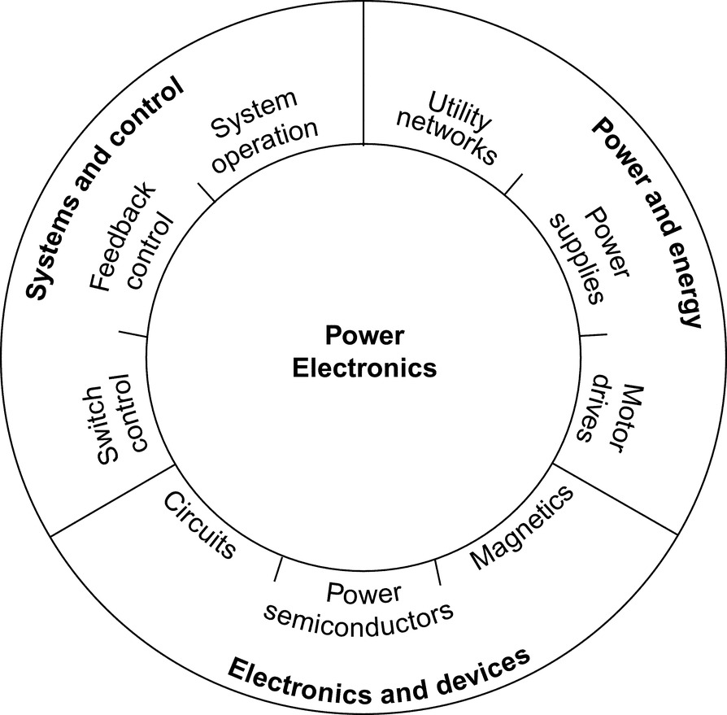

**FIG. 1.1** Control, energy, and power electronics are interrelated.

Applications of power electronics continue to expand. It is not possible to build practical computers, mobile phones, handheld devices, cars, airplanes, industrial processes, and a host of other everyday products without power electronics. Alternative energy systems such as wind generators, solar power, fuel cells, and others require power electronics to function. Technology advances such as electric and hybrid transportation, laptop computers, microwave ovens, flat-panel displays, LED lighting, and hundreds of other innovations were not possible until advances in power electronics enabled their implementation. Although no one can predict the future, it is certain that power electronics will be at the heart of fundamental energy innovations.

The history of power electronics [[2](https://learning.oreilly.com/library/view/power-electronics-handbook/9780128114087/B9780128114070000015.xhtml#bb0015)–[5](https://learning.oreilly.com/library/view/power-electronics-handbook/9780128114087/B9780128114070000015.xhtml#bb0030)] has been closely allied with advances in electronic devices that provide the capability to handle high power levels. Since about 1990, devices have become so capable that a transition from a “device-driven” field to an “application-driven” field continues. This transition has been based on two factors: (1) Advanced semiconductors with suitable power ratings exist for almost every application of wide interest, and (2) the general push toward miniaturization is bringing advanced power electronics into a growing variety of products. Although the devices continue to improve, especially related to the use of wide bandgap semiconductor materials, their development generally tends to follow innovative applications.

## 1.2 Key Characteristics

All power electronic circuits manage the flow of electrical energy between an electrical source and a load. The parts in a circuit must direct electrical flows, not impede them. A general power conversion system is shown in [Fig. 1.2](https://learning.oreilly.com/library/view/power-electronics-handbook/9780128114087/B9780128114070000015.xhtml#f0015). The power converter in the middle controls the energy flow between a source and a load. For our purposes, the power converter will be implemented with a power electronic circuit. Because a power converter appears between a source and a load, any energy used within the converter is lost to the overall system. A crucial point emerges: to build a power converter, we should consider only lossless components. A realistic converter design must approach 100% efficiency.

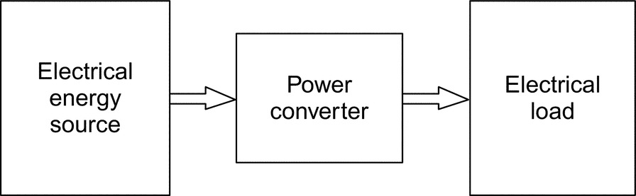

**FIG. 1.2** General system for electric power conversion. (From P. T. Krein, Elements of Power Electronics, Oxford University Press, New York, 1998, Copyright 1998, Oxford University Press, used with permission.)

A power converter connected between a source and a load also affects system reliability. If the energy source is perfectly reliable (it is available all the time), then a failure in the converter affects the user (the load) just as if the energy source had failed. An unreliable power converter creates an unreliable system. To put this in perspective, consider that a typical American household loses electric power only a few minutes a year. Energy is available 99.999% of the time. A converter must be better than this to prevent system degradation. An ideal converter implementation will not suffer any failures over its application lifetime. Extreme high reliability can be a more difficult objective than high efficiency.

### 1.2.1 THE EFFICIENCY OBJECTIVE—THE SWITCH

A circuit element as simple as a light switch reminds us that the extreme requirements in power electronics are not especially novel. Ideally, when a switch is on, it has zero voltage drop and will carry any current imposed on it. When a switch is off, it blocks the flow of current regardless of the voltage across it. The *device power*, the product of the switch voltage and current, is identically zero at all times. A switch therefore controls energy flow with no loss. In addition, reliability is also high. Household light switches perform over decades of use and perhaps 100,000 operations. Unfortunately, a mechanical switch does not meet all practical needs. A switch in a power supply may function 100,000 times each second. Even the best mechanical switch will not last beyond a few million cycles. Semiconductor switches (without this limitation) are the devices of choice in power converters.

A circuit built from ideal switches will be lossless. As a result, switches are the main components of power converters, and many people equate power electronics with the study of switching power converters. Magnetic transformers and lossless storage elements such as capacitors and inductors are also valid components for use in power converters. The complete concept, shown in [Fig. 1.3](https://learning.oreilly.com/library/view/power-electronics-handbook/9780128114087/B9780128114070000015.xhtml#f0020), represents a *power electronic system*. Such a system consists of an electrical energy source, an electrical load, a *power electronic circuit*, and a control function.

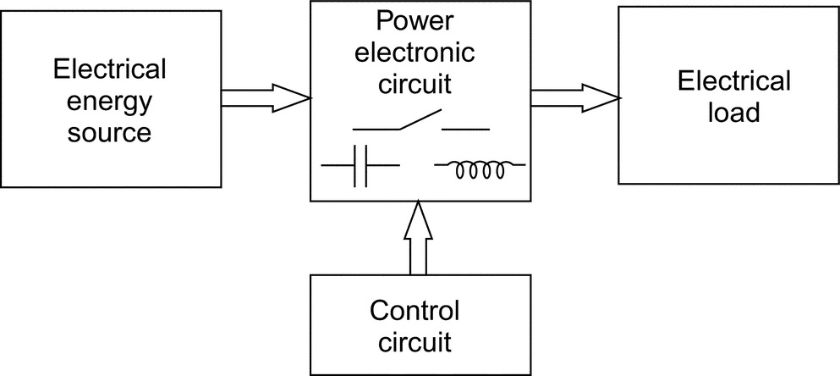

**FIG. 1.3** A basic power electronic system. (From P. T. Krein, Elements of Power Electronics, Oxford University Press, New York, 1998, Copyright 1998, Oxford University Press, used with permission.)

The power electronic circuit contains switches, lossless energy storage elements, and magnetic transformers. The controls take information from the source, the load, and the designer and then determine how the switches operate to achieve the desired conversion. The controls are built up with low-power analog and digital electronics.

Switching devices are selected based on their *power handling* rating—the product of their voltage and current ratings—rather than on power dissipation ratings. This contrasts with other applications of electronics, in which power dissipation ratings dominate. For instance, a typical stereo receiver performs a conversion from ac line input to audio output. Many audio amplifiers do not use the techniques of power electronics, and the semiconductor devices do not act as switches. A commercial 100 W amplifier, using a class A, B, or AB design, usually employs transistors big enough to dissipate the full 100 W, and the circuit is likely to be <10% energy efficient in normal use. In contrast, *switching amplifiers,* class D, E, or F, use the techniques of power electronics. They provide dramatic efficiency improvements. A home theater system implemented with switching amplifiers can exceed 90% energy efficiency in a small package. The amplifiers can even be packed inside the loudspeakers.

Switches can reach extreme power levels, far beyond what might be expected for a given size. Consider the following examples:

**Example 1.1**

The NTP30N20 is a metal-oxide-semiconductor field-effect transistor (MOSFET) with a drain current rating of 30 A, a maximum drain-source breakdown voltage of 200 V, and a rated power dissipation of up to 200 W under ideal conditions. Without a heat sink, however, the device can tolerate no more than 2.5 W of dissipation. For power electronics purposes, the power handling rating is 30 A×200 V=6 kW. Several manufacturers have developed controllers for domestic refrigerators, air conditioners, and high-end machine tools based on this and similar devices. The second part of the definition of power electronics in [Section 1.1](https://learning.oreilly.com/library/view/power-electronics-handbook/9780128114087/B9780128114070000015.xhtml#s0010) points out that the circuits handle power at levels much higher than that of the ratings of individual devices. Here, a device is used to handle 6000 W—compared with its individual rating of no more than 200 W. The ratio 30:1 is high, but not unusual in power electronics contexts. In contrast, the same ratio in a “linear” audio amplifier is close to unity.

**Example 1.2**

The IGW60T120 is an insulated-gate bipolar transistor (IGBT)—a relative of the bipolar transistor that has been developed specifically for power electronics—rated for 1200 V and 60 A. Its power handling rating is 72 kW that is sufficient for a set of them to control an electric or hybrid car.

### 1.2.2 THE RELIABILITY OBJECTIVE—SIMPLICITY AND INTEGRATION

High-power applications lead to interesting issues. In an inverter, the semiconductors often manipulate 30 times their power dissipation capability or more, which implies that only about 3% of the power being controlled is lost. A small design error, unexpected thermal problem, or minor change in layout could alter this somewhat. For instance, if the loss turns out to be 4% rather than 3%, the device stresses are 33% higher, and quick failure is likely to occur. The first issue for reliability in power electronic circuits is to keep device voltage, current, and power dissipation levels well within rating limits. This is challenging when power handling levels are high.

The second issue for reliability is simplicity. It is well established in electronics design that the more parts there are in a system, the more likely it is to fail. Power electronic circuits tend to have few parts, especially in the main energy flow paths. Necessary operations must be carried out through shrewd use of these parts. Often, this means that sophisticated control strategies are applied to seemingly simple conversion circuits.

The third issue for reliability is integration. One way to avoid the reliability-complexity trade-off is to integrate multiple components and functions together. A microprocessor, for example, might contain millions of gates. All interconnections and signals flow within a single chip, and the reliability is nearly that of a single part. Integrated power electronic modules [[6](https://learning.oreilly.com/library/view/power-electronics-handbook/9780128114087/B9780128114070000015.xhtml#bb0035)] achieve this. Manufacturers package multiple switching devices, with their interconnections and protection components, together as a unit. Control circuits for converters are also integrated as much as possible to keep the reliability high. The package itself is a factor in reliability, and one that is a subject of active research. Many semiconductor packages include small bonding wires that can be susceptible to thermal or vibration damage. The small geometries also tend to enhance electromagnetic interference among the internal circuit components.

## 1.3 Trends in Power Supplies

Two distinct trends drive electronic power supplies, one of the major classes of power electronic circuits. At the high end, microprocessors, memory chips, and other advanced digital circuits require increasing power levels and increasing performance at very low voltage. It is a challenge to deliver 100 A or more efficiently at voltages that can be less than 1 V. These types of power supplies are expected to deliver precise voltages, even though the load can change by an order of magnitude in nanoseconds.

At the other end are portable devices with rechargeable batteries. The power supplies for these devices and for other consumer products must be cheap and efficient. It is increasingly important to use the best possible power electronics design techniques for these supplies to save energy while minimizing costs and matching many different global standards. Efficiency standards such as the Energy Star program place stringent requirements on a wide range of low-end power supplies.

In the past, bulky “linear” power supplies were designed with transformers and rectifiers from the ac line frequency to provide dc voltages for electronic circuits. In a well-designed power electronic system today, called a *switch-mode power supply*, an ac source from a wall outlet (which could be nearly anywhere in the world) is rectified without direct transformation. The resulting high dc voltage is converted through a dc-dc converter to the 1, 3, 5, and 12 V or other levels required. A personal computer commonly requires multiple 3.3 and 5 V supplies, 12 V supplies, additional levels, and a separate converter for 1 V delivery to the microprocessor. This is in addition to supplies for the video display or peripheral devices. Only a switch-mode supply can support such complex requirements with acceptable costs.

Switch-mode supplies often take advantage of MOSFET semiconductor technology. Trends toward high reliability, low cost, and miniaturization have reached the point where a 5 V power supply sold today might last more than 1,000,000 h (more than a century), provide 100 W of output in a package with volume no more than 15 cm3, and sell for a price less than US$ 0.10/W. This type of supply brings an interesting dilemma: the ac line cord to plug it in takes up more space than the power supply itself. Innovative concepts such as integrating a power supply within a connection cable or using a block the size of a typical plug are becoming common.

Device technology for power supplies is being driven by expanding needs in the automotive and telecommunication industries and in markets for portable equipment. Power conversion for transportation must be cost effective yet rugged enough to survive the high vibration and wide temperature range to which a truck or passenger car is exposed. Global communication is possible only when sophisticated equipment can be used almost anywhere. Electricity supplies are neither reliable nor consistent throughout much of the world. Although voltage swings in the domestic ac supply in North America are often ±5% around a nominal value, in many developing nations, the swing can be ±25%—when power is available. Power converters for communications equipment must tolerate these swings and must also be able to make use of a wide range of possible backup sources. Designers are challenged to obtain maximum performance from small batteries and to create equipment with minimal energy requirements with power supplies that can operate anywhere in the world.

## 1.4 Conversion Examples

### **1.4.1 SINGLE-SWITCH CIRCUITS**

Electrical energy sources take the form of dc voltage sources at various values, sinusoidal ac sources and polyphase sources, among others. A power electronic circuit might be asked to transfer energy between two different dc voltage levels, between an ac source and a dc load or between sources at different frequencies. It might be used to adjust an output voltage or power level, drive a nonlinear load, or control a load current. In this section, a few basic converter arrangements are introduced, and energy conservation provides a tool for analysis.

**Example 1.3**

Consider the circuit shown in [Fig. 1.4](https://learning.oreilly.com/library/view/power-electronics-handbook/9780128114087/B9780128114070000015.xhtml#f0025). It contains an ac source, a switch, and a resistive load. It is a simple power electronic system.

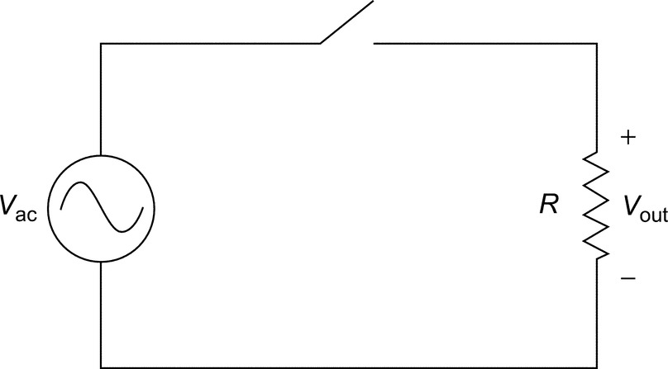

**FIG. 1.4** A simple power electronic system. (From P. T. Krein, Elements of Power Electronics, Oxford University Press, New York, 1998, Copyright 1998, Oxford University Press, used with permission.)

Let us assign a (somewhat arbitrary) control scheme to the switch. What if the switch is turned on whenever  and turned off otherwise? The input and output voltage waveforms are shown in [Fig. 1.5](https://learning.oreilly.com/library/view/power-electronics-handbook/9780128114087/B9780128114070000015.xhtml#f0030). The input has a time average of 0 and root-mean-square (RMS) value equal to , where *V*peak is the maximum value of *V*ac. The output has a nonzero average value given by

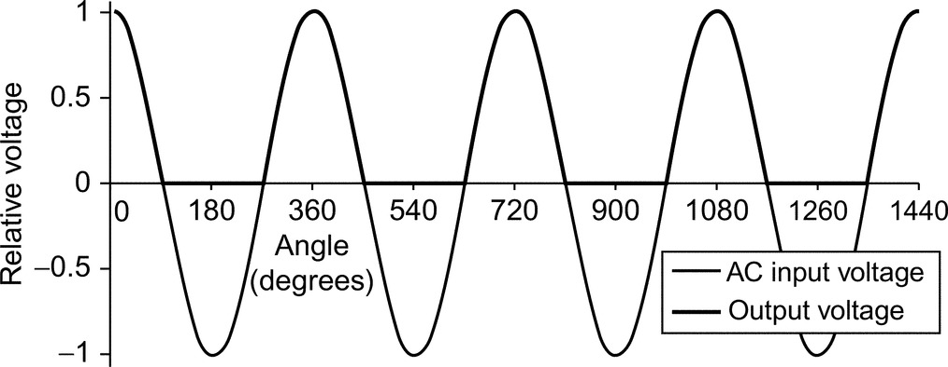

**FIG. 1.5** Input and output waveforms for [Example 1.5](https://learning.oreilly.com/library/view/power-electronics-handbook/9780128114087/B9780128114070000015.xhtml#en0035).

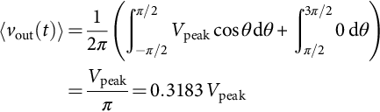 **(1.1)**

and an RMS value equal to *V*peak/2. Since the output has nonzero dc voltage content, the circuit can be used as an ac-dc converter. To make it more useful, a low-pass filter would be added between the output and the load to smooth out the ac portion. This filter needs to be lossless and will be constructed from only inductors and capacitors.

The circuit in [Example 1.3](https://learning.oreilly.com/library/view/power-electronics-handbook/9780128114087/B9780128114070000015.xhtml#en0025) acts as a half-wave rectifier with a resistive load. With the hypothesized switch action, a diode can substitute for the ideal switch. The example confirms that a simple switching circuit can perform power conversion functions. But note that a diode is not, in general, the same as an ideal switch. A diode places restrictions on the current direction, but a true switch would not. An ideal switch allows control over whether it is on or off. In contrast, a diode's operation is constrained by circuit variables.

Consider a second half-wave circuit, now with a series  load, shown in [Fig. 1.6](https://learning.oreilly.com/library/view/power-electronics-handbook/9780128114087/B9780128114070000015.xhtml#f0035):

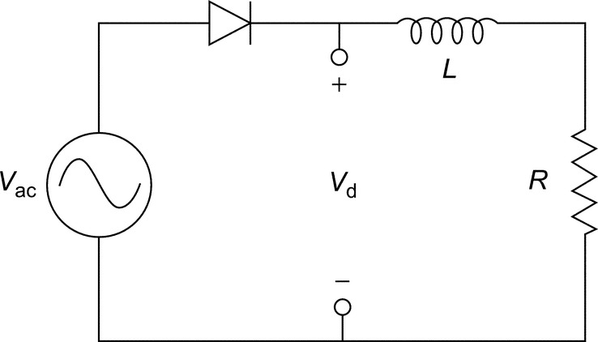

**FIG. 1.6** Half-wave rectifier with  load for [Example 1.5](https://learning.oreilly.com/library/view/power-electronics-handbook/9780128114087/B9780128114070000015.xhtml#en0035).

**Example 1.4**

A series diode  circuit has ac voltage source input. This circuit operates much differently than the half-wave rectifier with resistive load. A diode will be on if forward-biased and off if reverse-biased. In this circuit, when the diode is off, the current will be zero. Whenever the diode is on, the circuit is the ac source with  load. Let the ac voltage be *V*0 cos(*ωt*). From Kirchhoff's voltage law (KVL),

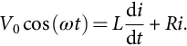

Let us assume that the diode is initially off (this assumption is arbitrary, and we will check it as the example is solved). If the diode is off, the diode current is , and the voltage across the diode will be *v*ac. The diode will become forward-biased when *v*ac becomes positive, so it will turn on when the input voltage makes a zero crossing in the positive direction. This allows us to establish initial conditions for the circuit, . The differential equation can be solved in a conventional way to give

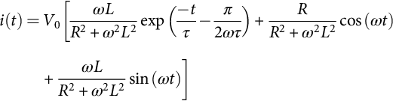 **(1.2)**

where *τ* is the time constant *L*/*R*. What about when the diode is turned off? The first guess might be that the diode turns off when the voltage becomes negative, which is not correct. From the solution, we can determine that the current is not zero when the voltage first becomes negative. If the switch attempts to turn off, it must instantly drop the inductor current to zero. The derivative of current in the inductor, d*i*/d*t*, would become negative infinite. The inductor voltage *L*(d*i*/d*t*) similarly becomes negative infinite, and the devices are destroyed. What really happens is that the falling current allows the inductor to maintain forward bias on the diode. The diode will turn off only when the *current* reaches zero. A diode has definite properties that determine the circuit action, and both the voltage and current are relevant. [Fig. 1.7](https://learning.oreilly.com/library/view/power-electronics-handbook/9780128114087/B9780128114070000015.xhtml#f0040) shows the input and output waveforms for a time constant *τ* equal to about one-third of the ac waveform period.

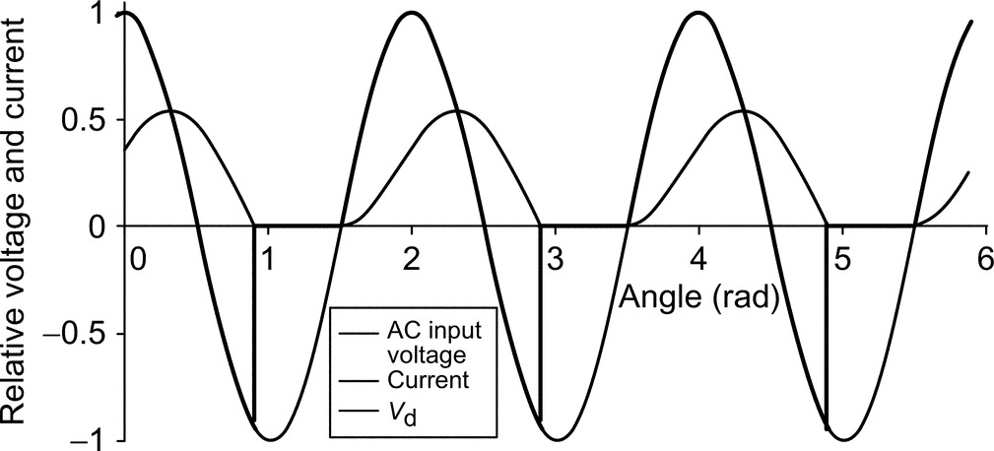

**FIG. 1.7** Input and output waveforms for [Example 1.5](https://learning.oreilly.com/library/view/power-electronics-handbook/9780128114087/B9780128114070000015.xhtml#en0035).

### 1.4.2 THE METHOD OF ENERGY BALANCE

Any circuit must satisfy conservation of energy. In a lossless power electronic circuit, energy is delivered from source to load, possibly through an intermediate storage step. The energy flow must balance over time such that the energy drawn from the source matches that delivered to the load. The converter in [Fig. 1.8](https://learning.oreilly.com/library/view/power-electronics-handbook/9780128114087/B9780128114070000015.xhtml#f0045) serves as an example of how the method of energy balance can be used to analyze circuit operation.

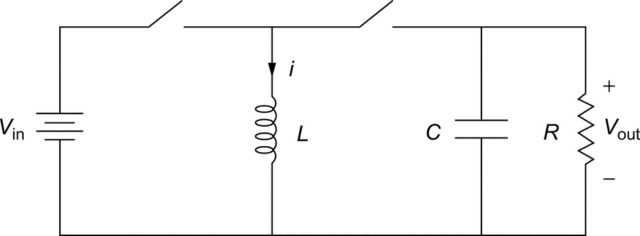

**FIG. 1.8** Energy transfer switching circuit for [Example 1.5](https://learning.oreilly.com/library/view/power-electronics-handbook/9780128114087/B9780128114070000015.xhtml#en0035). (From P. T. Krein, Elements of Power Electronics, Oxford University Press, New York, 1998, Copyright 1998, Oxford University Press, Inc., used with permission.)

**Example 1.5**

The switches in the circuit of [Fig. 1.8](https://learning.oreilly.com/library/view/power-electronics-handbook/9780128114087/B9780128114070000015.xhtml#f0045) are controlled cyclically to operate in alternation: when the left switch is on, the right switch is off and so on. What does the circuit do if each switch operates half the time? The inductor and capacitor have large values.

When the left switch is on, the source voltage *V*in appears across the inductor. When the right switch is on, the output voltage *V*out appears across the inductor. If this circuit is to be viewed as a useful converter, the inductor should receive energy from the source and then deliver it to the load without loss. Over time, this means that energy does not build up in the inductor, but instead flows through on average. The power into the inductor, therefore, must equal the power out, at least over a cycle. Therefore, the *average* power in must equal the *average* power out of the inductor. Let us denote the inductor current as *i*. The input is a constant voltage source. Because *L* is large, this constant voltage source will not be able to change the inductor current quickly, and we can assume that the inductor current is also constant. The average power into *L* over the cycle period *T* is

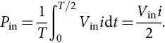 **(1.3)**

For the average power out of *L*, we must be careful about current directions. The current *out* of the inductor will have a value . The average output power is

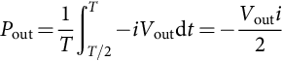 **(1.4)**

For this circuit to be viewed useful as a converter, the net energy should flow from the source to the load over time. The power conservation relationship  requires that .

The method of energy balance shows that, when operated as described in the example, the circuit shown in [Fig. 1.8](https://learning.oreilly.com/library/view/power-electronics-handbook/9780128114087/B9780128114070000015.xhtml#f0045) serves as a polarity reverser. The output voltage magnitude is the same as that of the input, but the output polarity is negative with respect to the reference node. The circuit is often used to generate a negative supply for analog circuits and other applications from a single positive input source. Other output voltage magnitudes can be achieved at the output if the switches alternate at unequal times.

If the inductor in the polarity reversal circuit is moved instead to the input, a step-up function is obtained. Consider the circuit shown in [Fig. 1.9](https://learning.oreilly.com/library/view/power-electronics-handbook/9780128114087/B9780128114070000015.xhtml#f0050) in the following example.

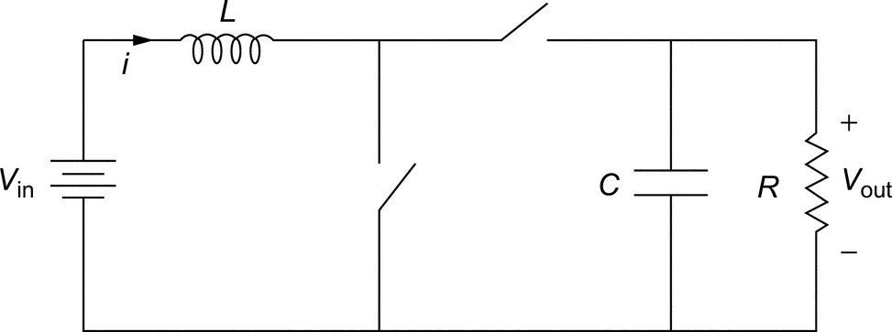

**FIG. 1.9** Switching converter [Example 1.6](https://learning.oreilly.com/library/view/power-electronics-handbook/9780128114087/B9780128114070000015.xhtml#en0040). (From P. T. Krein, Elements of Power Electronics, Oxford University Press, New York, 1998, Copyright 1998, Oxford University Press, used with permission.)

**Example 1.6**

The switches shown in [Fig. 1.9](https://learning.oreilly.com/library/view/power-electronics-handbook/9780128114087/B9780128114070000015.xhtml#f0050) are controlled cyclically in alternation. The left switch is on for two-thirds of each cycle and the right switch for the remaining one-third of each cycle. Determine the relationship between *V*in and *V*out. The inductor's energy should not build up when the circuit is operating normally as a converter.

A power balance calculation can be used to relate the input and output voltages. Let *i* be the inductor current. When the left switch is on, power is injected into the inductor. Its average value is

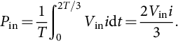 **(1.5)**

Power leaves the inductor when the right switch is on. Care must be taken with respect to polarities, and the current should be set negative to represent output power. The result is

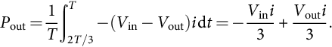 **(1.6)**

When the input and output power are equated,

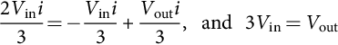 **(1.7)**

and the output voltage is found to be triple the input. Many seasoned engineers find the dc-dc step-up function shown in [Fig. 1.9](https://learning.oreilly.com/library/view/power-electronics-handbook/9780128114087/B9780128114070000015.xhtml#f0050) to be surprising. It is just one example of such action, though. Others (including flyback circuits related to [Fig. 1.8](https://learning.oreilly.com/library/view/power-electronics-handbook/9780128114087/B9780128114070000015.xhtml#f0045)) are used in systems ranging from controlled power supplies to spark ignitions for automobiles.

The circuits in the preceding examples have few components, provide useful conversion functions, and are efficient. If the switching devices are ideal, each circuit is lossless. Over the history of power electronics, development has tended to flow around the discovery of such circuits: a circuit with a particular conversion function is discovered, analyzed, and applied. As the circuit moves from laboratory testing to a complete commercial product, control and protection functions are added. The power portion of the circuit remains close to the original idea. The natural question arises as to whether a systematic approach to conversion is possible: can we start with a desired function and design an appropriate converter, rather than starting from the converter and working backward toward the application? What underlying principles can be applied to design and analysis? In this chapter, a few of the key concepts are introduced. Note that, although many of the circuits look deceptively simple, all these circuits are nonlinear systems with unusual behavior.

## 1.5 Tools for Analysis and Design

### **1.5.1 THE SWITCH MATRIX**

The most readily apparent difference between a power electronic circuit and other types of electronic circuits is the switch action. In contrast to a digital circuit, the switches do not indicate a logic level. Control is effected by determining the times at which switches should operate. Whether there is just one switch or a large group, there is a complexity limit: if a converter has *m* inputs and *n* outputs, even the densest possible collection of switches would have a single switch between each input and output line. The  switches in the circuit can be arranged according to their connections. The pattern suggests a matrix, as shown in [Fig. 1.10](https://learning.oreilly.com/library/view/power-electronics-handbook/9780128114087/B9780128114070000015.xhtml#f0055).

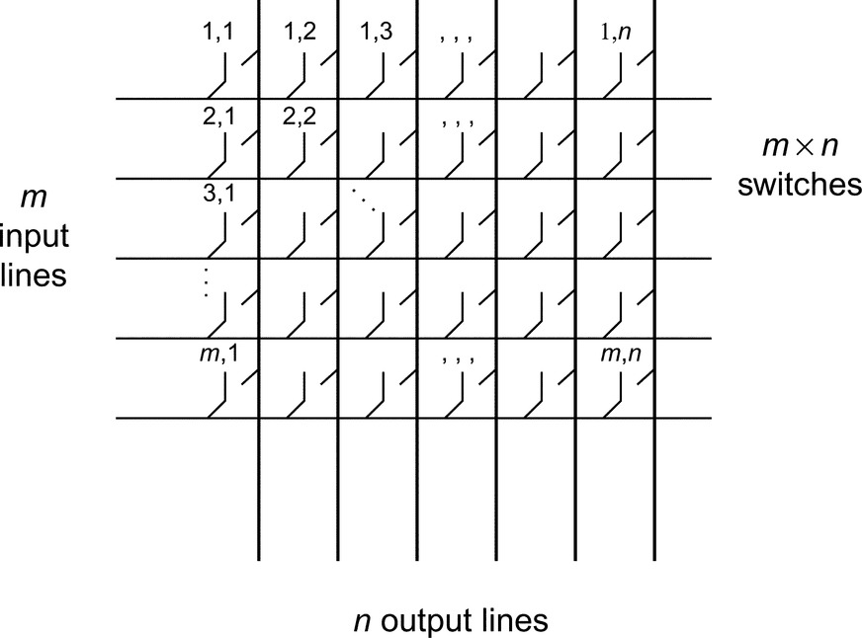

**FIG. 1.10** The general switch matrix.

Power electronic circuits fall into two broad classes [[2](https://learning.oreilly.com/library/view/power-electronics-handbook/9780128114087/B9780128114070000015.xhtml#bb0015)]:

1. Direct switch matrix circuits. In these circuits, energy storage elements are connected to the matrix only at the input and output terminals. The storage elements effectively become part of the source or the load. In the literature, ac-ac versions of these circuits are sometimes called *matrix converters.*

2. Indirect switch matrix circuits, also termed *embedded* converters. These circuits, like the polarity-reverser example, have energy storage elements connected *within* the matrix structure. Indirect switch matrix circuits are most commonly analyzed as a cascade connection of direct switch matrix circuits with storage in between.

The switch matrices in realistic applications are small. A 2×2 switch matrix, for example, covers all possible cases with a single-port input source and a two-terminal load. The matrix is commonly drawn as the *H-bridge* shown in [Fig. 1.11](https://learning.oreilly.com/library/view/power-electronics-handbook/9780128114087/B9780128114070000015.xhtml#f0060). A three-phase bridge rectifier is shown in [Fig. 1.12](https://learning.oreilly.com/library/view/power-electronics-handbook/9780128114087/B9780128114070000015.xhtml#f0065). There are three possible inputs, and the two terminals of the dc circuit provide outputs, which gives a 3×2 switch matrix. In a computer power supply with five separate dc loads, the switch matrix could be 2×10. Very few practical converters have more than 24 switches, and most designs use fewer than 12.

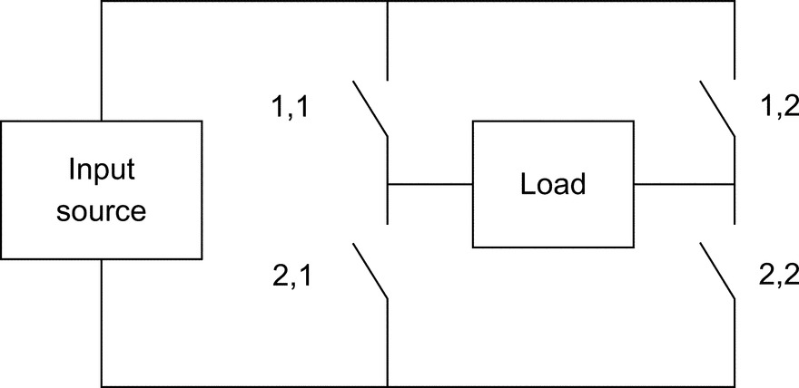

**FIG. 1.11** H-bridge configuration of a 2×2 switch matrix.

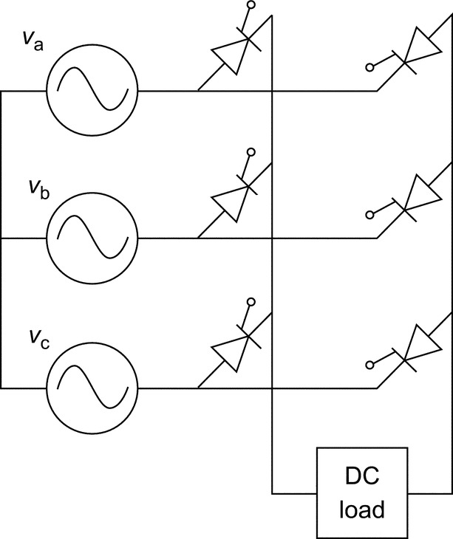

**FIG. 1.12** Three-phase bridge rectifier circuit, a 3×2 switch matrix.

A switch matrix provides a way to organize devices for a given application. It also helps us focus on three major task areas, which must be addressed individually and effectively in order to produce a useful power electronic system:

• The “hardware” task—Build a switch matrix. This involves the selection of appropriate semiconductor switches and the auxiliary elements that drive and protect them.

• The “software” task—Operate the matrix to achieve the desired conversion. All operational decisions are implemented by adjusting switch timing.

• The “interface” task—Add energy storage elements to provide the filters or intermediate storage necessary to meet the application requirements. Lossless filters with simple structures are required.

In a rectifier or other converter, we must choose the electronic parts, how to operate them, and how best to filter the output to satisfy the needs of the load.

### 1.5.2 IMPLICATIONS OF KIRCHHOFF'S VOLTAGE AND CURRENT LAWS

A major challenge of switch circuits is their capacity to “violate” circuit laws. First, consider the simple circuits shown in [Fig. 1.13](https://learning.oreilly.com/library/view/power-electronics-handbook/9780128114087/B9780128114070000015.xhtml#f0070). We might try the circuit shown in [Fig. 1.13A](https://learning.oreilly.com/library/view/power-electronics-handbook/9780128114087/B9780128114070000015.xhtml#f0070) for ac-dc conversion, but there is a problem. According to Kirchhoff's voltage law (KVL), the “sum of voltage drops around a closed loop is zero.” However, with the switch closed, the sum of voltages around the loop is not zero. In reality, this is not a valid result. Instead, a very large current will flow and cause a large  drop in the wires. KVL *will* be satisfied by the wire voltage drop, but a fire or, better yet, fuse action, might result. There is, however, nothing that would prevent an operator from trying to close the switch. KVL, then, implies a crucial restriction: a switch matrix must not attempt to interconnect unequal voltage sources directly. Notice that a wire or dead short can be thought of as a voltage source with , so KVL is a generalization of avoiding shorts across an individual voltage source.

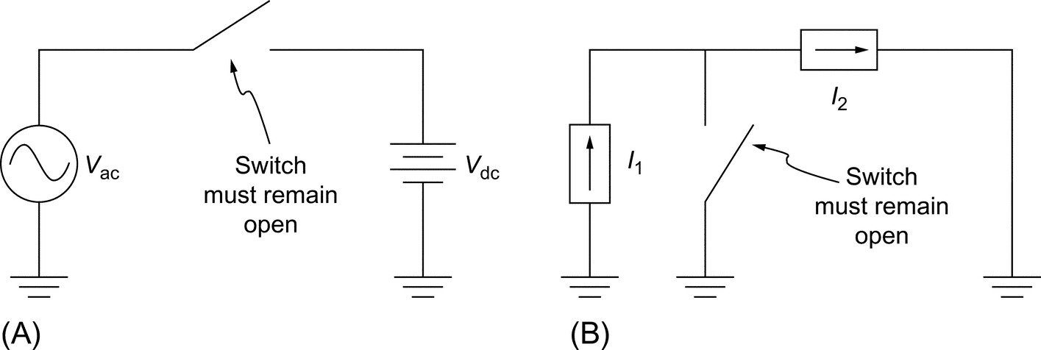

**FIG. 1.13** Hypothetical power converters, (A) possible ac-dc converter and (B) possible dc-dc converter. (From P. T. Krein, Elements of Power Electronics, Oxford University Press, New York, 1998, Copyright 1998, Oxford University Press, used with permission.)

A similar constraint holds for Kirchhoff's current law (KCL) that states that “currents into a node must sum to zero.” When current sources are present in a converter, we must avoid any attempts to violate KCL. In [Fig. 1.13B](https://learning.oreilly.com/library/view/power-electronics-handbook/9780128114087/B9780128114070000015.xhtml#f0070), if the current sources are different and if the switch is opened, the sum of the currents into the node will not be zero. In a real circuit, high voltages will build up and cause an arc to create another current path. This situation has real potential for damage, and a fuse will not help. As a result, KCL implies the restriction that a switch matrix must not attempt to interconnect unequal current sources directly. An open circuit can be thought of as a current source with , so KCL applies to the problem of opening an individual current source.

In contrast to conventional circuits, in which KVL and KCL are automatically satisfied, switches do not “know” KVL or KCL. If a designer forgets to check and accidentally shorts two voltages or breaks a current source connection, some problem or damage will result. KVL and KCL place necessary constraints on the operation of a switch matrix. In the case of voltage sources, switches must not act to create short-circuit paths among unlike sources. In the case of KCL, switches must act to provide a path for currents. These constraints drastically reduce the number of valid switch-operating conditions in a switch matrix, thereby leading to manageable operating design problems.

When energy storage is included, there are interesting implications of the circuit law restrictions. [Fig. 1.14](https://learning.oreilly.com/library/view/power-electronics-handbook/9780128114087/B9780128114070000015.xhtml#f0075) shows two “circuit law problems.” In [Fig. 1.14A](https://learning.oreilly.com/library/view/power-electronics-handbook/9780128114087/B9780128114070000015.xhtml#f0075), the voltage source will cause the inductor current to ramp up indefinitely, since . We might consider this to be a “KVL problem” because the long-term effect is similar to shorting the source. In [Fig. 1.14B](https://learning.oreilly.com/library/view/power-electronics-handbook/9780128114087/B9780128114070000015.xhtml#f0075), the current source will cause the capacitor voltage to ramp toward infinity. This causes a “KCL problem”; eventually, an arc will be formed to create an additional current path, just as if the current source had been opened. However, these connections are not problematic if they are only temporary. It should be evident that an inductor will not support dc voltage, and a capacitor will not support dc current. On average, over an extended time interval, the voltage across an inductor must be zero, and the current into a capacitor must be zero.

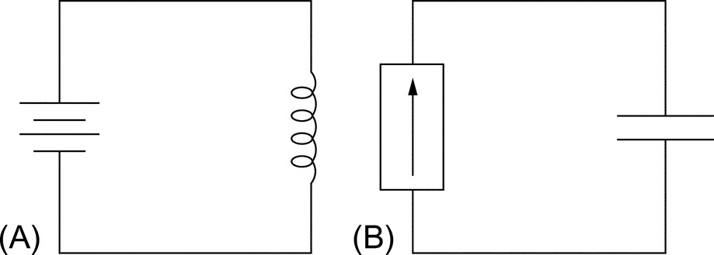

**FIG. 1.14** Short-term KVL and KCL problems in energy storage circuits: (A) An inductor cannot sustain dc voltage indefinitely, and (B) a capacitor cannot sustain dc current indefinitely.

### 1.5.3 RESOLVING THE HARDWARE PROBLEM—SEMICONDUCTOR DEVICES

A switch is either on or off. When on, an ideal switch will carry any current in any direction. When off, it will never carry current, no matter what voltage is applied. It is entirely lossless and changes from its on-state to its off-state instantaneously. A *real switch* can only approximate an ideal switch. The following are the aspects of real switches that differ from the ideal:

• Limits on the amount and direction of on-state current.

• A nonzero on-state voltage drop (such as a diode forward voltage).

• Some levels of leakage current when the device is supposed to be off.

• Limitations on the voltage that can be applied when off.

• Operating speed. The duration of transition between the on-states and off-states is important.

The degree to which the properties of an ideal switch must be met by a real switch depends on the application. For example, a diode can easily be used to conduct dc current; the fact that it conducts only in one direction is often an advantage, not a weakness.

Many different types of semiconductors have been applied in power electronics. In general, these fall into three groups:

1. Diodes, which are used in rectifiers, dc-dc converters, and in a wide range of supporting roles.

2. Transistors, which in general are suitable for control of single-polarity circuits. Several types of transistors are applied to power converters. The insulated-gate bipolar transistor (IGBT) type is unique to power electronics and has good characteristics for applications such as inverters.

3. Thyristors, which are multijunction semiconductor devices with latching behavior. In general, thyristors can be switched with short pulses and then maintain their state until current is removed. The characteristics are especially well suited to high-power controllable rectifiers, but they have been applied to all power conversion applications.

Some of the features of the most common power semiconductors are listed in [Table 1.1](https://learning.oreilly.com/library/view/power-electronics-handbook/9780128114087/B9780128114070000015.xhtml#t0010). The table shows a wide variety of speeds and rating levels. As a rule, faster speeds apply to lower ratings. For each device type, cost tends to increase both for faster devices and for devices with higher power handling capacity.

**Table 1.1**

**Examples of semiconductor devices used in power electronics**

|  |  |
| --- | --- |
| **Device type** | **Characteristics of power devices** |
| Diode | Current ratings from under 1 A to more than 5000 A. Voltage ratings from 10 V to 10 kV or more. The fastest power devices switch in <10 ns, whereas the slowest require 100 μs or more. The function of a diode applies in rectifiers and dc-dc circuits |
| BJT | (Bipolar junction transistor) Conducts collector current (in one direction) when sufficient base current is applied. The function applies to dc-dc circuits. Power BJTs for switching have been supplanted by FETs and IGBTs |
| FET | (Field-effect transistor) Conducts drain current when sufficient gate voltage is applied. Power FETs (nearly always enhancement-mode MOSFETs) have a parallel connected reverse diode by virtue of their construction. Ratings from about 0.5 A to about 150 A and 20 V up to 1200 V. Switching times are fast, from 20 ns or less up to 200 ns. The function applies to dc-dc conversion, where the FET is in wide use, and to inverters |
| IGBT | (Insulated-gate bipolar transistor) A transistor that has the function of a BJT with its base driven by an FET. Faster than a BJT of similar ratings and easy to use. Ratings from 10 A to more than 600 A, with voltages of 600–4500 V. The IGBT is common in inverters from about 1–200 kW or more. It is found almost exclusively in power electronic applications |
| SCR | (Silicon-controlled rectifier) A thyristor that conducts like a diode after a gate pulse is applied. Turns off only when current becomes zero. Prevents current flow until a pulse appears. Ratings from 10 A up to more than 5000 A and from 200 V up to 6 kV. Switching requires 1–200 μs. Widely used for controlled rectifiers. The SCR is found almost exclusively in power electronic applications and is the most common member of the thyristor family |
| GTO | (Gate turn-off thyristor) An SCR that can be turned off by sending a negative pulse to its gate terminal. The ratings approach those of SCRs, and the speeds are similar as well |
| TRIAC | A semiconductor constructed to resemble two SCRs connected in reverse parallel. Ratings from 2 to 50 A and 200–800 V. Used in lamp dimmers, home appliances, and hand tools. Not as rugged as many other device types, but convenient for many ac applications |
| IGCT | (Integrated gate-commutated thyristor) A combination device that includes a high-power GTO and external electronics to control it. This device is a member of a larger family of combination devices, in which multiple semiconductor chips packaged together perform a single power function. The IGCT provides a high-performance switch for power levels above 1 MW |

Conducting direction and blocking behavior are fundamentally tied to the device type, and these basic characteristics constrain the choice of device for a given conversion function. Consider again a diode. It carries current in only one direction and always blocks current in the other direction. Ideally, the diode exhibits no forward voltage drop or off-state leakage current. Although an ideal diode lacks the many features of an ideal switch, it is an important switching device. Other real devices operate with polarity limits on current and voltage and have corresponding ideal counterparts. It is convenient to define a special type of switch to represent this behavior, the *restricted switch*:

**Definition**

A restricted switch is an ideal switch with the addition of restrictions on the direction of current flow and voltage polarity. The ideal diode is one example of a restricted switch.

The diode always permits current flow in one direction, while blocking flow in the other direction. It therefore represents a *forward-conducting reverse-blocking* restricted switch and operates in one quadrant on a graph of device current versus voltage. This *unipolar* function is automatic; the two diode terminals provide all the necessary information for switch action. Other restricted switches require a third *gate* terminal to determine their state. Consider the polarity possibilities given in [Table 1.2](https://learning.oreilly.com/library/view/power-electronics-handbook/9780128114087/B9780128114070000015.xhtml#t0015). Additional functions such as bidirectional-conducting reverse-blocking can be obtained by reverse connection of one of the five types in the table.

**Table 1.2**

**The types of restricted switches**

|  |  |  |  |  |
| --- | --- | --- | --- | --- |
| **Action** | **Device** | **Quadrants** | **Restricted switch symbol** | **Device symbol** |
| Carries current in one direction, blocks in the other (forward-conducting reverse-blocking) | Diode | t01-01-9780128114070 | t01-02-9780128114070 | t01-03-9780128114070 |
| Carries or blocks current in one direction (forward-conducting forward-blocking) | BJT, IGBT | t01-04-9780128114070 | t01-05-9780128114070 | t01-06-9780128114070 |
| Carries in one direction or blocks in both directions (forward-conducting bidirectional-blocking) | GTO | t01-07-9780128114070 | t01-08-9780128114070 | t01-09-9780128114070 |
| Carries in both directions but blocks only in one direction (bidirectional-conducting forward-blocking) | FET | t01-10-9780128114070 | t01-11-9780128114070 | t01-12-9780128114070 |
| Fully bidirectional | Ideal switch | t01-13-9780128114070 | t01-14-9780128114070 | t01-15-9780128114070 |

The quadrant operation shown in the table indicates polarities. For example, the current in a diode will be positive when on, and the voltage will be negative when off. This means diode operation is restricted to the single quadrant comprising the upper vertical (current) axis and the left horizontal (voltage) axis. Other combinations appear in the table. Symbols for restricted switches can be built up by interpreting the diode's triangle as the current-carrying direction and the bar as the blocking direction. Five types of symbols can be drawn as shown in [Table 1.2](https://learning.oreilly.com/library/view/power-electronics-handbook/9780128114087/B9780128114070000015.xhtml#t0015). These symbols are used infrequently but are useful for showing the polarity behavior of switching devices. A circuit drawn with restricted switches represents an idealized power converter.

Restricted switch concepts guide the selection of devices. For example, consider an inverter intended to deliver ac load current from a dc voltage source. A switch matrix built to perform this function must be able to manipulate ac current and dc voltage. Regardless of the physical arrangement of the matrix, we would expect bidirectional-conducting forward-blocking switches to be useful for this conversion. This is a correct result: modern inverters operating from dc voltage sources are built with field effect transistors (FETs) or with IGBTs packaged with reverse-parallel diodes. As new power devices are introduced to the market, it is straightforward to determine what types of converters will use them.

### 1.5.4 RESOLVING THE SOFTWARE PROBLEM—SWITCHING FUNCTIONS

The physical  switch matrix can be associated with a mathematical  *switch state matrix*. Each element of this matrix, called a *switching function*, shows whether the corresponding physical device is on or off:

**Definition**

A *switching function*, *q*(*t*), has a value of 1 when the corresponding physical switch is on and 0 when it is off. Switching functions are discrete-valued functions of time, and control of switching devices can be represented with them.

[Fig. 1.15](https://learning.oreilly.com/library/view/power-electronics-handbook/9780128114087/B9780128114070000015.xhtml#f0080) shows a typical switching function. It is periodic, with period *T*, representing the likely repetitive switch action in a power converter. For convenience, it is drawn on a relative time scale that begins at 0 and draws out the square wave period by period. The actual timing is arbitrary, so the center of the first pulse is defined as a specified time *t*0 in the figure. In many converters, the switching function is generated as an actual control voltage signal that might drive the gate of an FET or IGBT.

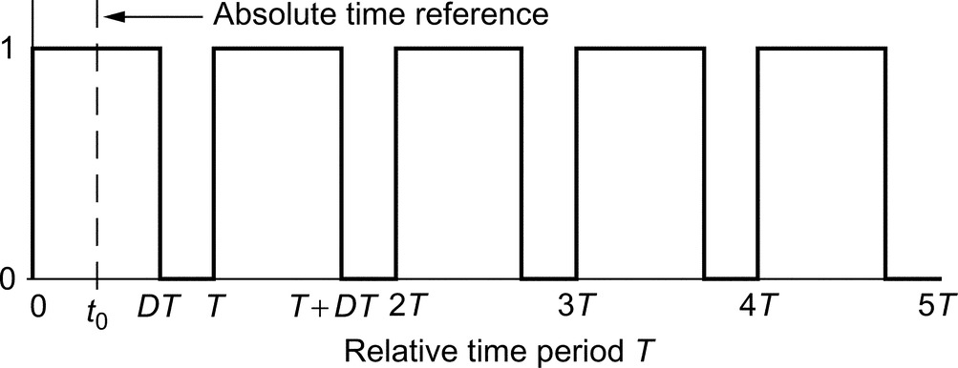

**FIG. 1.15** A generic switching function with period *T*, duty ratio *D*, and time reference *t*0.

The timing of switch action is the only alternative for control of a power converter. Because switch action can be represented with a discrete-valued switching function, timing can be represented within the switching function framework. On the basis of [Fig. 1.15](https://learning.oreilly.com/library/view/power-electronics-handbook/9780128114087/B9780128114070000015.xhtml#f0080), a generic switching function can be characterized completely with three parameters:

1. The *duty ratio*, *D*, is the fraction of time during which the switch is on. For control purposes, the on-time interval or pulse width can be adjusted to achieve a desired result. We can term this adjustment process *pulse-width modulation* (PWM), perhaps the most important process for implementing control in power converters.

2. The frequency  (with radian frequency ) is most often constant, although not in all applications. For control purposes, frequency can be adjusted. This strategy is sometimes used in low-powerdc-dc converters to manage wide load ranges. In other converters, frequency control is unusual because the operating frequency is often dictated by the application.

3. The time delay *t*0 or phase . Rectifiers often use *phase control* to provide a range of adjustment. Phase-shifted bridge circuits are common for high-power dc-dc conversion. A few specialized ac-ac converter applications use phase modulation.

With just three parameters to vary, there are relatively few possible ways to control any power electronic circuit. Inverters and dc-dc converters usually rely on duty ratio adjustment (PWM) to alter their behavior. Phase control is common in controlled rectifier applications.

Switching functions are powerful tools for the general representation of converter action [[7](https://learning.oreilly.com/library/view/power-electronics-handbook/9780128114087/B9780128114070000015.xhtml#bb0040)]. The most widely used control approaches derive from averages of switching functions [[2](https://learning.oreilly.com/library/view/power-electronics-handbook/9780128114087/B9780128114070000015.xhtml#bb0015),[8](https://learning.oreilly.com/library/view/power-electronics-handbook/9780128114087/B9780128114070000015.xhtml#bb0045)]. Their utility comes from their application in writing circuit equations. For example, in the boost converter shown in [Fig. 1.9](https://learning.oreilly.com/library/view/power-electronics-handbook/9780128114087/B9780128114070000015.xhtml#f0050), the loop and node equations change depending on which switch is acting at a given moment. The two possible circuit configurations each have distinct equations. Switching functions allow them to be combined. By assigning switching functions *q*1(*t*) and *q*2(*t*) to the left- and right-switching devices, respectively, we obtain

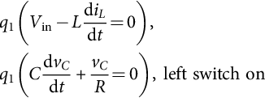 **(1.8)**

**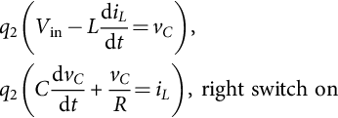** **(1.9)**

Because the switches alternate and the switching functions must be 0 or 1, these sets of equations can be combined to give

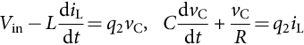 **(1.10)**

The combined expressions are simpler and easier to analyze than the original equations.

For control purposes, the average of equations such as Eq. [(1.10)](https://learning.oreilly.com/library/view/power-electronics-handbook/9780128114087/B9780128114070000015.xhtml#fo0060) often proceeds with the replacement of switching functions *q* with duty ratios *d*. The discrete-time action of a switching function thus will be represented by an average duty ratio parameter. Switching functions, advantages gained by averaging, and control approaches such as PWM are discussed at length in several chapters in this handbook.

### 1.5.5 RESOLVING THE INTERFACE PROBLEM—LOSSLESS FILTER DESIGN

Lossless filters for power electronic applications are sometimes called smoothing filters [[9](https://learning.oreilly.com/library/view/power-electronics-handbook/9780128114087/B9780128114070000015.xhtml#bb0050)]. In applications in which dc outputs are of interest, such filters are commonly implemented as simple low-pass LC structures. The analysis is facilitated because in most cases the residual output waveform, termed ripple, has a predictable shape. Filter design for rectifiers or dc-dc converters is a question of choosing storage elements large enough to keep ripple low, but not so large that the whole circuit becomes unwieldy or expensive.

Filter design is more challenging when ac outputs are desired. In some cases, this is again an issue of low-pass filter design. However, in many applications, low-pass filters are not adequate to meet low noise requirements. In these situations, active filters can be used. In power electronics, the term active filter refers to lossless switching converters that actively inject or remove energy moment by moment to compensate for distortion. The circuits (discussed in [Chapter 41](https://learning.oreilly.com/library/view/power-electronics-handbook/9780128114087/B9780128114070000465_1.xhtml)—active filters in this handbook) are not related to the linear active filter op-amp circuits used in analog signal processing. In ac applications, there is a continuing opportunity for innovation in filter design.

## 1.6 Sample Applications

Although power electronics is becoming universal for electronic systems, a few emerging applications have generated wide interest. Some are discussed briefly here to introduce the breadth of activity in the field.

A hybrid or fully electric vehicle typically has two major power electronic systems and dozens or even hundreds of smaller ones [[10](https://learning.oreilly.com/library/view/power-electronics-handbook/9780128114087/B9780128114070000015.xhtml#bb0055)]. The two large units are the inverter, which controls the electric drive motor, and a rectifier, which manages battery charging. Smaller systems include motor controllers in electric power-steering units, lighting electronics for solid-state lamps, controllers for small motors that actuate everything from windshield wipers to DVD players, and power supplies for the host of microcontrollers embedded in a modern car. As plug-in hybrid and electric cars continue to develop, the efficiency and sophistication of battery chargers and drive motor controllers will increase.

In a hybrid car, a typical inverter rating is about 50 kW. Fully electric automobiles have inverter ratings to about 200 kW. Hybrid and electric drive power levels increase from there to include multimegawatt inverters that power high-speed trains.

At the other power extreme, designers have been working on small power electronic systems that extract energy from various ambient sources for local purposes [[11](https://learning.oreilly.com/library/view/power-electronics-handbook/9780128114087/B9780128114070000015.xhtml#bb0060)]. These energy harvesting applications are an emerging growth area. An example application is a corrosion sensor, built into a highway bridge that gathers energy from vibration. The vibration energy is converted and stored and then used for intermittent communication with a central monitoring computer. Typical power levels can be less than 0.001 W.

Solar, wind, and other alternative energy resources are tightly linked to power electronics. A typical solar panel produces about 30 V dc, with tolerances from 20 to 40 V or more. This randomly changing dc source must be converted to clean, tightly regulated ac voltage that synchronizes to the electricity grid and delivers energy. Solar inverter efficiency, reliability, and cost are major factors in successful energy innovation. A dual application, meaning that energy flows in the opposite direction but that many other characteristics are shared, is that of solid-state lighting [[12](https://learning.oreilly.com/library/view/power-electronics-handbook/9780128114087/B9780128114070000015.xhtml#bb0065)]. In that case, flexible control of a dc current must be provided from an ac grid source.

For wind energy [[13](https://learning.oreilly.com/library/view/power-electronics-handbook/9780128114087/B9780128114070000015.xhtml#bb0070)], a typical large-scale wind turbine can produce 2 MW of variable-frequency ac power. The frequency and voltage vary rapidly according to wind speed. This power must be converted to fixed frequency and voltage for grid interconnection.

## 1.7 Summary

Power electronics is the study of electronic circuits for the control and conversion of electrical energy. The technology is a critical part of our energy infrastructure and is central for a wide range of uses of electricity. For power electronics design, we consider only those circuits and devices that, in principle, introduce no loss and achieve near-perfect reliability. The two key characteristics of high efficiency and high reliability are implemented with switching circuits, supplemented with energy storage. Switching circuits can be organized as switch matrices. This facilitates their analysis and design.

In a power electronic system, the three primary challenges are the hardware problem of implementing a switch matrix, the software problem of deciding how to operate that matrix, and the interface problem of removing unwanted distortion and providing the user with the desired clean power source. The hardware is implemented with a few special types of power semiconductors. These include several types of transistors, especially FETs and IGBTs, and several types of thyristors, especially SCRs and GTOs. The software problem can be represented in terms of switching functions. The frequency, duty ratio, and phase of switching functions are available for operational purposes. The interface problem is addressed by means of lossless filter circuits. Most often, these are lossless LC passive filters to smooth out ripple or reduce harmonics. Active filter circuits also have been applied to make dynamic corrections in power conversion waveforms.

Improvements in devices and advances in control concepts have led to steady improvements in power electronic circuits and systems. This is driving tremendous expansion of applications. Personal computers, for example, would be unwieldy and inefficient without power electronic dc supplies. Mobile devices and laptop computers would be impractical. High-efficiency lighting, motor controls, and a wide range of industrial controls depend on power electronics. Strong growth is occurring in transportation applications, in lighting, in dc power supplies for portable devices, in high-end converters for advanced microprocessors, and in alternative and renewable energy. During the next generation, we will reach a time when almost all electrical energy is processed through power electronics somewhere in the path from generation to end use [[14](https://learning.oreilly.com/library/view/power-electronics-handbook/9780128114087/B9780128114070000015.xhtml#bb0075)].

## References

[1] Motto J., ed. *Introduction to Solid State Power Electronics.* Youngwood, PA: Westinghouse; 1977.

[2] Krein P.T. *Elements of Power Electronics.* New York: Oxford University Press; 1998.

[3] Jahns T.M., Owen E.L. *Ac adjustable-speed drives at the millennium: how did we get here?* In: Proceedings of IEEE Applied Power Electronics Conference; 2000:18–26.

[4] Herskind C.C., McMurray W. History of the static power converter committee. *IEEE Trans. Ind. Appl.* 1984;IA-20(4):1069–1072.

[5] Owen E.L. Origins of the inverter. *IEEE Ind. Appl. Mag.* 1996;2:64.

[6] Van Wyk J.D., Lee F.C. *Power electronics technology at the dawn of the new millennium—status and future.* In: Rec. IEEE Power Electronics Specialists Conference; 1999:3–12.

[7] Wood P. *Switching Power Converters.* New York: Van Nostrand Reinhold; 1981.

[8] Erickson R., Maksimovic D. *Fundamentals of Power Electronics.* second ed. New York: Springer; 2001.

[9] Krein P.T., Hamill D.C. Smoothing circuits. In: Webster J., ed. *Wiley Encyclopedia of Electrical and Electronics Engineering.* New York: John Wiley; 1999.

[10] Emadi A., Rajashekara K., Williamson S.S., Lukic S.M. Topological overview of hybrid electric and fuel cell vehicular power system architectures and configurations. *IEEE Trans. Veh. Technol.* 2005;54(3):763–770.

[11] Sazonov E., Haodong L., Curry D., Pillay P. Self-powered sensors for monitoring of highway bridges. *IEEE Sensors J.* 2009;9(11):1422–1429.

[12] Loo K.H., Lun W.-K., Tan S.-C., Lai Y.M., Tse C.K. On driving techniques for LEDs: toward a gener-alized methodology. *IEEE Trans. Power Electron.* 2009;24(12):2967–2976.

[13] Dang T., Rashid M.H. *Introduction, history, and theory of wind power.* In: Proceedings of IEEE North American Power Symposium; 2009.

[14] Krein P.T. *Elements of Power Electronics.* second ed. New York: Oxford University Press; 2015.

[1](https://learning.oreilly.com/library/view/power-electronics-handbook/9780128114087/B9780128114070000015.xhtml#xfn0010) Portions of this chapter are taken from P. T. Krein, *Elements of Power Electronics*. New York: Oxford University Press, 1998. *©* 1998, Oxford University Press, used with permission.

**SECTION I**

Power Electronic Devices

**2**

# Semiconductor Diodes and Transistors

Tiago Davi C. Busarello Federal University of Santa Catarina, Santa Catarina, Brazil

Marcelo G. Simões Colorado School of Mines, Golden, CO, United States

José A. Pomilio University of Campinas, Campinas, Brazil

## Abstract

This chapter covers the fundamental concepts of diodes and transistor devices. The PN junction will be briefly described. Power bipolar transistors, power metal-oxide-semiconductor field-effect transistors (MOSFETs), and insulated gate bipolar transistors (IGBTs) will be covered in details. The understanding of their physical structure, their static and dynamic characteristics, their switching features, and some applications of them are presented. PSPICE models for these devices are also presented.

### KEYWORDS

Power semiconductors; Transistors; Diodes; Switches; IGBT; MOSFET; BJT; Thermal design; PSPICE model

2.1 [Semiconductor Diode](https://learning.oreilly.com/library/view/power-electronics-handbook/9780128114087/B9780128114070000027.xhtml#s0010)

2.1.1 Static Characteristics

2.1.2 Dynamic Characteristics

2.1.3 Common Types of Diodes

2.1.4 Evaluating the Dynamic Characteristics of Real Diodes

2.1.5 Series and Parallel Connection of Power Diodes

2.1.6 Typical Application of Diodes

2.1.7 PSPICE Model

2.2 [Power Bipolar Transistor](https://learning.oreilly.com/library/view/power-electronics-handbook/9780128114087/B9780128114070000027.xhtml#s0065)

2.2.1 Basic Structure and Operation

2.2.2 Static Characteristics

2.2.3 Safe Operation Area

2.2.4 Switching Characteristics

2.2.5 Transistor Base Driver Circuits

2.2.6 BJT Applications

2.2.7 PSPICE Model

2.3 [Power MOSFET](https://learning.oreilly.com/library/view/power-electronics-handbook/9780128114087/B9780128114070000027.xhtml#s0105)

2.3.1 Basic Structure

2.3.2 Static Characteristics

2.3.3 Switching Characteristics

2.3.4 Safe Operation Area

2.3.5 MOSFET Applications

2.3.6 PSPICE Model

2.4 [Insulated Gate Bipolar Transistor](https://learning.oreilly.com/library/view/power-electronics-handbook/9780128114087/B9780128114070000027.xhtml#s0165)

2.4.1 Basic Structure

2.4.2 Static Characteristics

2.4.3 Switching Characteristics

2.4.4 IGBT Applications

2.4.5 PSPICE Model

2.5 [Swtiching Evaluation of a Real MOSFET](https://learning.oreilly.com/library/view/power-electronics-handbook/9780128114087/B9780128114070000027.xhtml#s0205)

2.5.1 Results for Sw1 ON and Sw2 OFF and *Rpot* at the Maximum Resistance

2.5.2 Results for Sw1 ON and Sw2 OFF and *Rpot* at the Minimum Resistance

2.5.3 Results for Sw1 and Sw2 ON and *Rpot* at the Maximum Resistance

2.5.4 Results for Sw1 and Sw2 OFF and *Rpot* at the Maximum Resistance

2.6 [Heatsink Thermal Design for Power Semiconductors](https://learning.oreilly.com/library/view/power-electronics-handbook/9780128114087/B9780128114070000027.xhtml#s0230)

2.6.1 Heatsink Design

2.7 [Transistor Selection Criteria](https://learning.oreilly.com/library/view/power-electronics-handbook/9780128114087/B9780128114070000027.xhtml#s0240)

[References](https://learning.oreilly.com/library/view/power-electronics-handbook/9780128114087/B9780128114070000027.xhtml#bi0010)

## 2.1 Semiconductor Diode

Understanding a semiconductor diode makes possible to understand other complex devices. A semiconductor diode is a structure containing a PN junction that, within its voltage and current rates, allows the conduction of current only in one direction. If the P region experiences a higher potential compared with the region N, the diode is said to be forward-biased, and a current can flow through the diode. On the other hand, if the region N experiences a higher voltage compared with the region P, the diode is said to be reversed-biased. In this case, no current flows through the diode. [Fig. 2.1](https://learning.oreilly.com/library/view/power-electronics-handbook/9780128114087/B9780128114070000027.xhtml#f0010) shows a simplified illustration of such a diode structure.

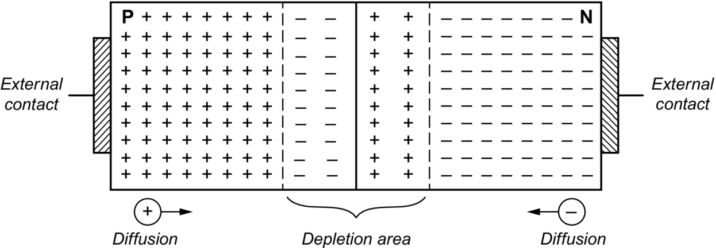

**FIG. 2.1** Simplified illustration of a junction diode structure.

The regions P and N are united by a metallurgical connection. When a negative voltage is applied between the PN junctions, this voltage appears at the depletion area due to the fact that this area presents higher resistance compared with the rest of the structure. Such voltage makes the electrons in the N region to travel to the P region and vice versa, creating a so-called potential barrier, which, in turn, defines the size of the depletion area. The potential barrier opposes the electron and hole movements across the junction. The potential is approximately 0.7 and 0.3 V for silicon and germanium diodes, respectively, and it is defined as threshold voltage [[1](https://learning.oreilly.com/library/view/power-electronics-handbook/9780128114087/B9780128114070000027.xhtml#bb0010)].

When a positive voltage higher than the threshold is applied between the PN junctions, the potential barrier is reduced, minimizing the depletion area, and the carriers are free to conduct through the regions, leading the diode to be forward-biased.

Diodes in electric circuits are represented by the symbol depicted in [Fig. 2.2](https://learning.oreilly.com/library/view/power-electronics-handbook/9780128114087/B9780128114070000027.xhtml#f0015). The terminals of the diode are known as anode (A) that corresponds to the P region and cathode (K) that corresponds to the N region. The conventional current and voltage references through a diode are also shown. The electron flow is in the opposite direction related to the current reference.

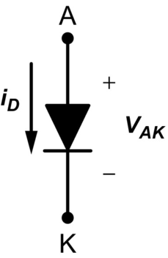

**FIG. 2.2** The symbol used for a diode and its current and voltage references.

### 2.1.1 STATIC CHARACTERISTICS

The static characteristic of an ideal diode is portrayed in [Fig. 2.3](https://learning.oreilly.com/library/view/power-electronics-handbook/9780128114087/B9780128114070000027.xhtml#f0020). For voltages , the diode conducts with current *iF* under null voltage. Consequently, the diode can be represented as a short circuit. For voltages , the diode holds a negative voltage, and it does not conduct any current. Therefore, the diode can be represented by an open circuit.

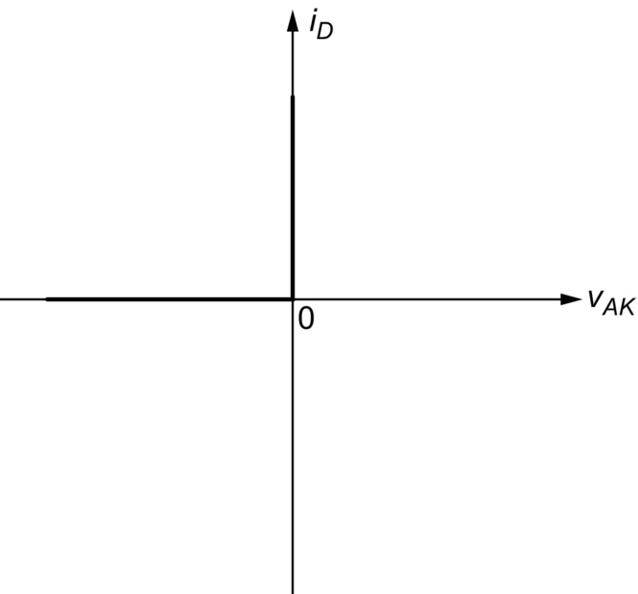

**FIG. 2.3** Static characteristic of an ideal diode.

The use of an ideal diode in analyzing circuits is accepted in power electronic applications, since it is necessary only to know if the diode is forward- or reversed-biased. However, in applications where a deeper analysis is required, it is necessary to consider the diode real features. [Fig. 2.4A](https://learning.oreilly.com/library/view/power-electronics-handbook/9780128114087/B9780128114070000027.xhtml#f0025) presents the static characteristic of a real diode. The characteristic curve is not on scale for better visualization. The first quadrant is the region where the diode is forward-biased. In this case, the diode is in ON state. The third quadrant is the region of reverse bias. Thus, the diode is in OFF state. [Fig. 2.4B](https://learning.oreilly.com/library/view/power-electronics-handbook/9780128114087/B9780128114070000027.xhtml#f0025) presents a more realistic diode structure with its layers length.

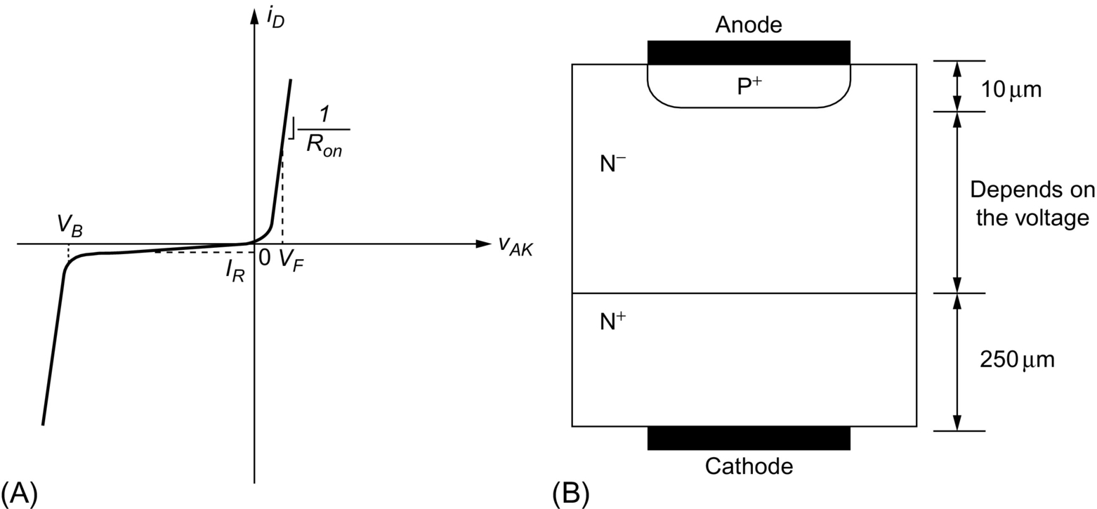

**FIG. 2.4** (A) Static characteristic of a real diode and (B) more realistic diode structure.

The following details can be highlighted from the previous chart [[2](https://learning.oreilly.com/library/view/power-electronics-handbook/9780128114087/B9780128114070000027.xhtml#bb0015)]:

• *Forward voltage, VF*: The voltage drop across the diode, from terminal *A* to *K*, at a specific current when the diode is forward-biased.

• *Breakdown voltage, VB*: The maximum reverse voltage across the diode before the diode starts reverse conduction and gets severe damaged. The point at *Vb* is also known as avalanche point.

• *Reverse current IR*: The current at a particular reverse voltage. This current is usually in the range of μA and hardly taken into account in analysis of power electronic circuits.

• *Conduction resistance RON*: The equivalent resistance presented by the diode when forward-biased and conducting current. The inverse of this resistance is the slope of the curve in forward region. This characteristic is more relevant in high-voltage devices in which the semiconductor length is larger.

A more complete diode model, during conduction, is shown in [Fig. 2.5](https://learning.oreilly.com/library/view/power-electronics-handbook/9780128114087/B9780128114070000027.xhtml#f0030).

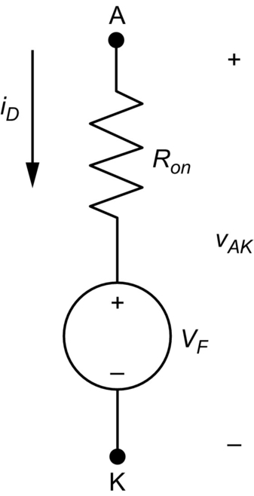

**FIG. 2.5** Equivalent circuit of a real diode when forward-biased.

### 2.1.2 DYNAMIC CHARACTERISTICS

The static characteristics of a diode are valid for analysis in steady-state condition, with the diode completely in the state ON or OFF. For the period when the diode is changing between these states, the diode presents a dynamic behavior. [Fig. 2.6](https://learning.oreilly.com/library/view/power-electronics-handbook/9780128114087/B9780128114070000027.xhtml#f0035) presents the circuit used to analyze the turn-on and turn-off characteristic of a power diode. The turn-on process is defined by the change from the OFF to ON state, while the turn-off process is the change from ON to OFF state. The voltage source is supposed to produce a square waveform. The inductor represents the inductive effect of the circuit (ration of the magnetic flux and current) that is present in any electric circuit. The inductance value can be very low, depending on the circuit topology, but can have an important rule to limit the di/dt.

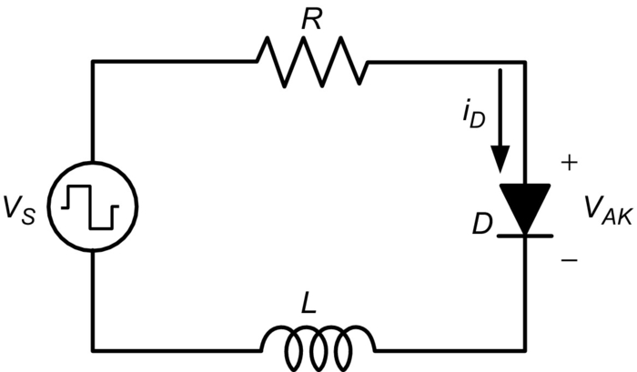

**FIG. 2.6** Circuit used to analyze the switching characteristic of a power diode.

[Fig. 2.7](https://learning.oreilly.com/library/view/power-electronics-handbook/9780128114087/B9780128114070000027.xhtml#f0040) presents a typical dynamic behavior for the voltage and current of a diode during the turn-on and turn-off intervals. The waveform can change slightly from diode to diode and based on intrinsic properties and also if the circuit contains inductive load.

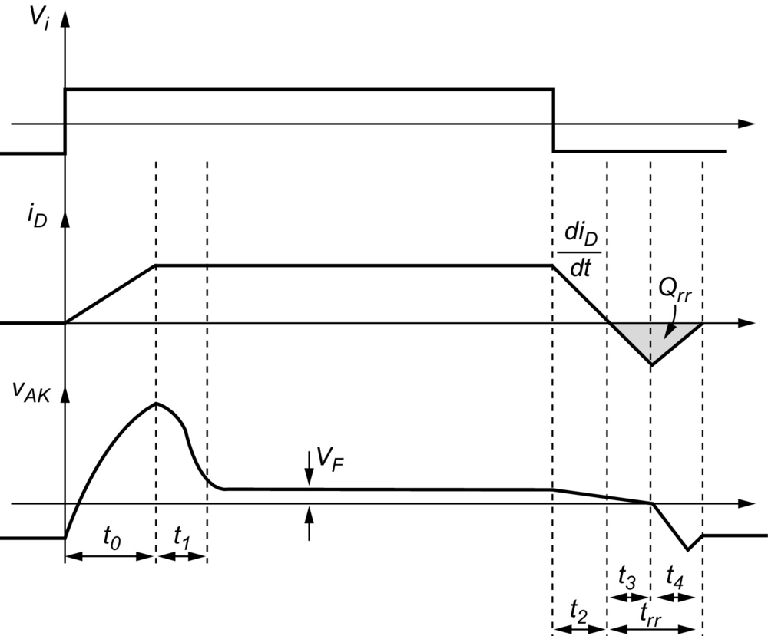

**FIG. 2.7** Typical dynamic behavior for the voltage and current of a diode during the turn-on and turn-off periods.

The time intervals highlighted in the figure are defined as follows:

• *Time interval t*0: The time interval *t*0 begins when the voltage source changes its value from negative to positive, initializing the turn-on process. During *t*0, the storage charges in the depletion area are removed. The diode current begins to rise, while the diode voltage suffers a peak due to the fact that there is no enough injection of carriers into the depletion area and also due to the resistance of the N region.

• *Time interval t*1: At this interval, the injection of carriers is completed, and the diode voltage falls to the forward voltage. In power diodes, the intervals *t*0 and *t*1 are in the range of ten to hundreds of nanoseconds. At the end of *t*1, the turn-on process is completed.

• *Time interval t*2: The interval *t*2 begins when the voltage source changes in value from positive to negative, initializing the turn-off process. The minority carriers (electrons in P region and holes in N region) must be removed before the formation of the potential barrier, during such time the diode keeps conducting. The diode voltage falls slightly due to the fall in the resistance *RON*.

• *Time interval t*3: The interval *t*3 keeps the behavior of the previous interval, but the diode current is achieving negative current. When the current achieves its negative peak, the minority carriers were reversed, and the diode begins to be reversed-biased.

• *Time interval t*4: The interval *t*4 is the time required for the current to achieve null value, recharging the depletion area. The voltage across de diode suffers an overvoltage mainly due to the parasitic inductances found in the circuit.

• *Time interval trr*: The time interval *trr* is the sum of the intervals *t*3 and *t*4 and it is known as reverse recovery time. The area under the t-axis in the current waveform is equivalent to the so-called reverse recovery charge.

The reverse recovery time is an important parameter to decide the switching frequency of applications involving diodes. The reverse recovery time must finish before the diode can be forward-biased again. The lower the *trr* is, the faster the diode can be switched. Diodes with low reverse recovery time are known as fast diodes or sometimes ultrafast diodes.

Another important feature concerning reverse recovery process is how severe the diode current behaves during the reverse recovery time. For this purpose, the terms soft- and hard-recovery diodes are used. Soft-recovery diodes present slow current fall, while hard-recovery diodes present fast current fall. A slow current fall is more attractive because the voltage produced at the parasitic inductances is lower compared with other case.

### 2.1.3 COMMON TYPES OF DIODES

Diodes can be classified into the following major types [[2](https://learning.oreilly.com/library/view/power-electronics-handbook/9780128114087/B9780128114070000027.xhtml#bb0015),[3](https://learning.oreilly.com/library/view/power-electronics-handbook/9780128114087/B9780128114070000027.xhtml#bb0020)]:

*Small signal diode*: This type of diode has a niche of application in low-power rectifiers, limiters, amplifiers, and in waveshaping. These applications are low-voltage, low-current devices. Forward voltage, reverse breakdown voltage, and reverse recovery current and time are parameters that must be known by a designer when applying small signal diode in power electronic applications.

*Power rectifier diode*: This type of diode has high forward current and high reverse breakdown voltage capabilities. They are suited for power applications like rectifiers, inverters, and power supplies. The thermal resistance is an important factor for a designer, since these diodes usually require heat sink for heat dissipation.

*Zener diode*: This type of diode is mainly used in voltage regulation. It operates on the reverse-biased mode. A current called zener current conducts through it in order to clamp the voltage. The behavior on the breakdown voltage is designed to support the dissipation without damaging the device.

*Schottky diodes*: The aforementioned diodes have an ohmic behavior in the contact between the metal terminal and the semiconductor. Schottky diodes are formed by allocating a thin film of metal directly to the semiconductor material. As result, the behavior in the referred region has a rectifier effect. The forward voltage drop in Schottky diodes is usually 0.3 V, and they are used in low-voltage applications.

### 2.1.4 EVALUATING THE DYNAMIC CHARACTERISTICS OF REAL DIODES

In order to visualize how is the real reverse recovery behavior of some types of diodes, the circuit shown in [Fig. 2.8](https://learning.oreilly.com/library/view/power-electronics-handbook/9780128114087/B9780128114070000027.xhtml#f0045) was built. The circuit is composed by a square-wave source. A fast diode (SK3GL04), a slow rectifier diode (1N5404), and a Schottky diode (1N5818) are connected in the circuit through the switches Sw1, Sw2, and Sw3, respectively. A resistor *R* is used as load. Switch Sw4 is used to insert or remove an inductor in the circuit. Initially, this switch Sw4 is ON, bypassing the inductor. Each diode is analyzed individually in the circuit.

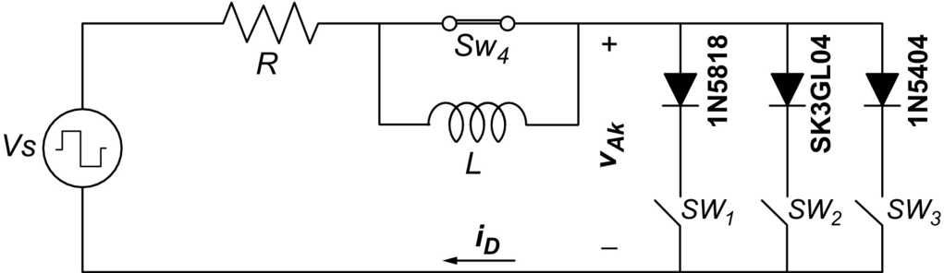

**FIG. 2.8** Circuit used to evaluate the real reverse recovery behavior of diodes.

[Fig. 2.9](https://learning.oreilly.com/library/view/power-electronics-handbook/9780128114087/B9780128114070000027.xhtml#f0050) shows the current of each diode during the turn-off process. For the fast and Schottky diodes, the reverse recovery time is in the range of 2–3 μs. For the slow rectifier diode, the time is approximately 10 μs, and the reserve recovery charge is considerably higher than those for the other diodes. The negative current is limited by the external resistance. It is clear that the rectifier diode can be used only in low-frequency applications with low *dv/dt*, as in 50 and 60 Hz AC systems.

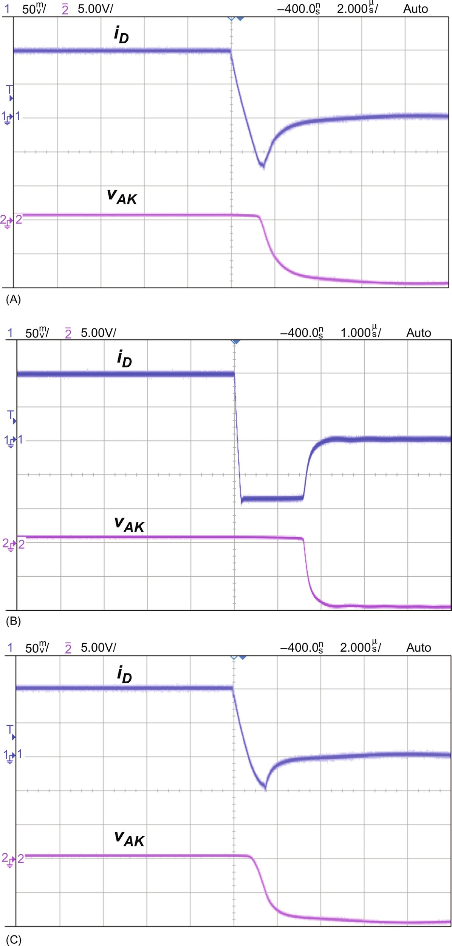

**FIG. 2.9** Current of each diode during the turn-off process. (A) SK3GL04 (fast diode) SW1 is ON, (B) 1N5404 (rectifier) SW2 is ON, and (C) 1N5818 (Schottky) SW3 is ON.

[Fig. 2.10](https://learning.oreilly.com/library/view/power-electronics-handbook/9780128114087/B9780128114070000027.xhtml#f0055) shows the current and voltage in the small signal diode when the switch *Sw*4 is OFF, inserting the inductor in the circuit. Both waveforms oscillate during the reverse recovery time. The oscillation in the voltage may lead the diode to be forward-biased improperly if its value reaches higher value than the threshold.

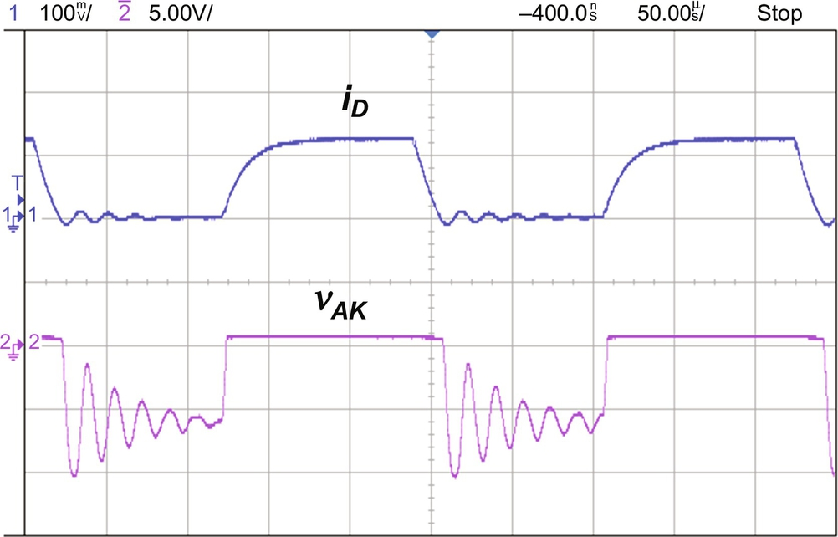

**FIG. 2.10** Current and voltage in the small signal diode when the switch *S*w4 is OFF.

### 2.1.5 SERIES AND PARALLEL CONNECTION OF POWER DIODES

Two important parameters of power diodes concerning voltage ratings are repetitive peak inverse voltage (*VRRM*) and nonrepetitive peak inverse voltage. The first states about the capability of the diode in holding reverse voltage in a sustained manner. The second is the capability of the diode in holding reverse voltage that occurs occasionally.

Concerning current rating, power diodes have the following parameters: average current, RMS current, and peak current. These parameters vary in accordance to the diode temperature. Therefore, by properly dissipating the heat of a diode, the current capability is better utilized.

When an application requires current or voltage ratings that is beyond its capability, parallel or series shall be considered. Connecting diodes in series gives a structure with high-voltage rating, once the voltage will be divided among them. On the other hand, connecting diodes in parallel allows a high-current rating, once the current is divided among the diodes. The major concern in making series or parallel connection is to match their parameters, especially in reverse recovery properties. Otherwise, voltage and current unbalance may occur among the diodes.

In order to overcome such unbalance in series connection, a bank of resistor and capacitor is placed in parallel with the diode string. [Fig. 2.11](https://learning.oreilly.com/library/view/power-electronics-handbook/9780128114087/B9780128114070000027.xhtml#f0060) presents the series connection of diodes with banks of resistor and capacitors. During the transitions, the capacitors equalize the voltage. During the OFF state, the resistive path equally divides the total voltage. The current through the resistor must be higher than the diode reverse leakage current [[2](https://learning.oreilly.com/library/view/power-electronics-handbook/9780128114087/B9780128114070000027.xhtml#bb0015)].

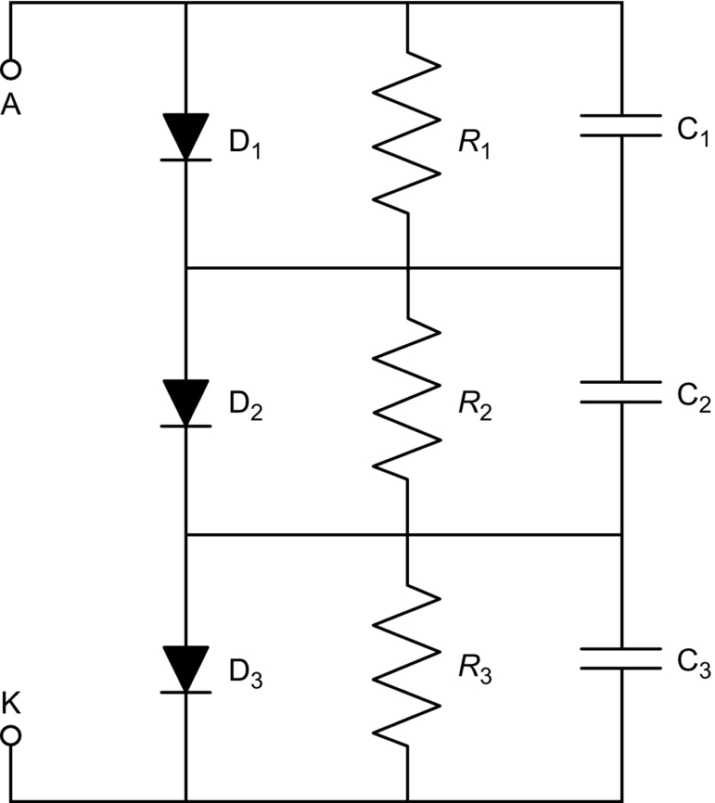

**FIG. 2.11** Series connection of diodes with resistor and capacitors for equalization.

The A–K points are the terminals of a fictitious high-voltage capacity diode. Ideally, when reverse-biased, the reverse voltage is dived equally among the three diodes.

The parallel connection of diodes is intended to divide a current equally through the diodes. However, if one diode turns on before the others, the entire current passes through it. Such occurrence may destroy the diode. In order to overcome that, a resistor can be connected in series with each diode. The resistor limits the current in case one diode turns on before the others. Including a resistor is series with each diode decreases considerably the efficiency of the circuit.

For both parallel and series connection of diodes, a special attention must be paid concerning the construction of the printed circuit board (PCB) layout. Parasitic inductances can cause a diode to be forward-biased before the other. Therefore, the layout must be designed aiming an equal parasitic inductance in the path where diodes are being associated in parallel and series.

### 2.1.6 TYPICAL APPLICATION OF DIODES

#### **2.1.6.1 Rectifiers**

Diodes are widely used as rectifiers. [Fig. 2.12](https://learning.oreilly.com/library/view/power-electronics-handbook/9780128114087/B9780128114070000027.xhtml#f0065) presents the half- and full-wave single-phase rectifiers. An input transformer (not shown) can be placed at the input of rectifiers for isolation and voltage leveling purpose. The use of a half-wave rectifier is exclusively for low-power applications, once the average input current is not zero. A capacitor can be used at the output of full-wave rectifier in order to minimize the voltage ripple.

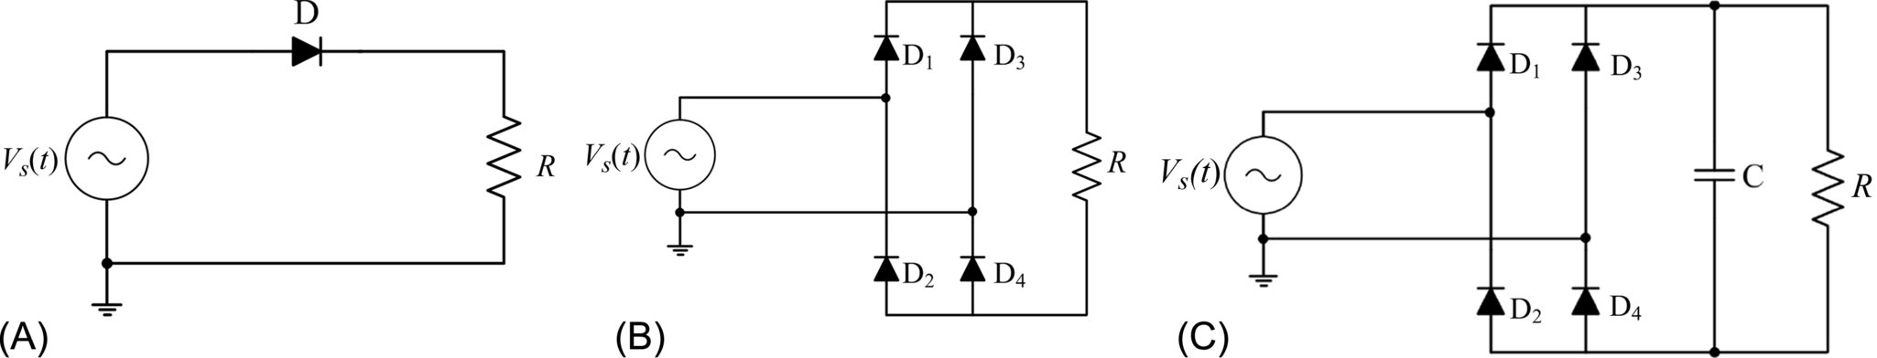

**FIG. 2.12** (A) Half-wave rectifier, (B) full-wave rectifier, and (C) full-wave rectifier with capacitor.

The diodes make only the positive voltage to appear across the load. [Fig. 2.13](https://learning.oreilly.com/library/view/power-electronics-handbook/9780128114087/B9780128114070000027.xhtml#f0070) presents the output voltage for the half-wave,full-wave, and full-wave rectifier with capacitor. In this case, the diodes are considered ideal with no forward voltage drop.

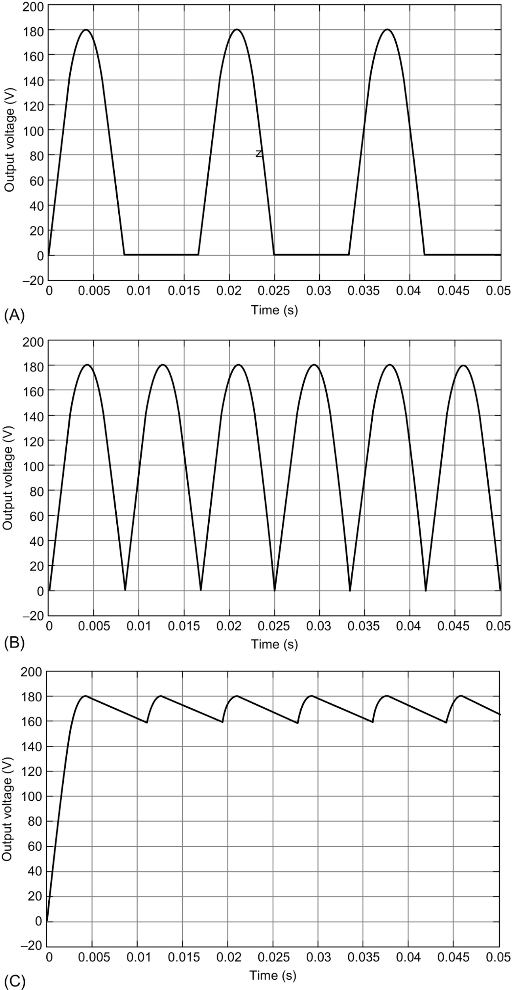

**FIG. 2.13** (A) Half-wave rectifier, (B) full-wave rectifier, and (C) full-wave rectifier with capacitor.

#### **2.1.6.2 Freewheeling**

A diode can be used as a freewheeling path for keeping an inductor current conducting continuously. [Fig. 2.14](https://learning.oreilly.com/library/view/power-electronics-handbook/9780128114087/B9780128114070000027.xhtml#f0075) presents a DC–DC converter where the diode operates as freewheeling path. The switch represents a transistor. Without the diode, the inductor would cause an extremely high *dv/dt* across it when the transistor changes from ON to OFF state. Such high *dv/dt* would appear across the transistor, probably destructing it. However, the diode allows a path to the inductor current avoiding high *dv/dt*. The voltage produced by the inductor current will be high enough to directly polarize the diode. In this converter, this voltage is just higher than the output voltage. The transistor and the diode are considered ideal.

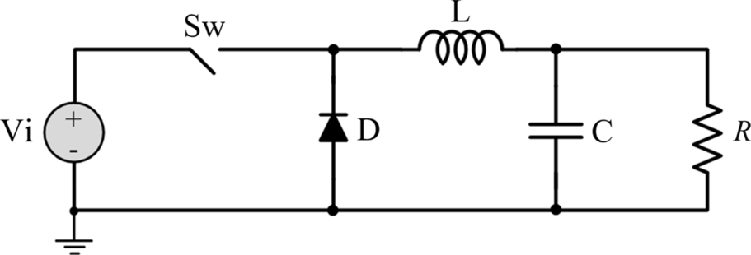

**FIG. 2.14** A DC–DC converter showing a diode operating in a freewheeling path.

[Fig. 2.15](https://learning.oreilly.com/library/view/power-electronics-handbook/9780128114087/B9780128114070000027.xhtml#f0080) presents the inductor current, the transistor current, and the diode current. Notice that the inductor current passes through the transistor when this is ON and through the diode when the transistor is OFF.

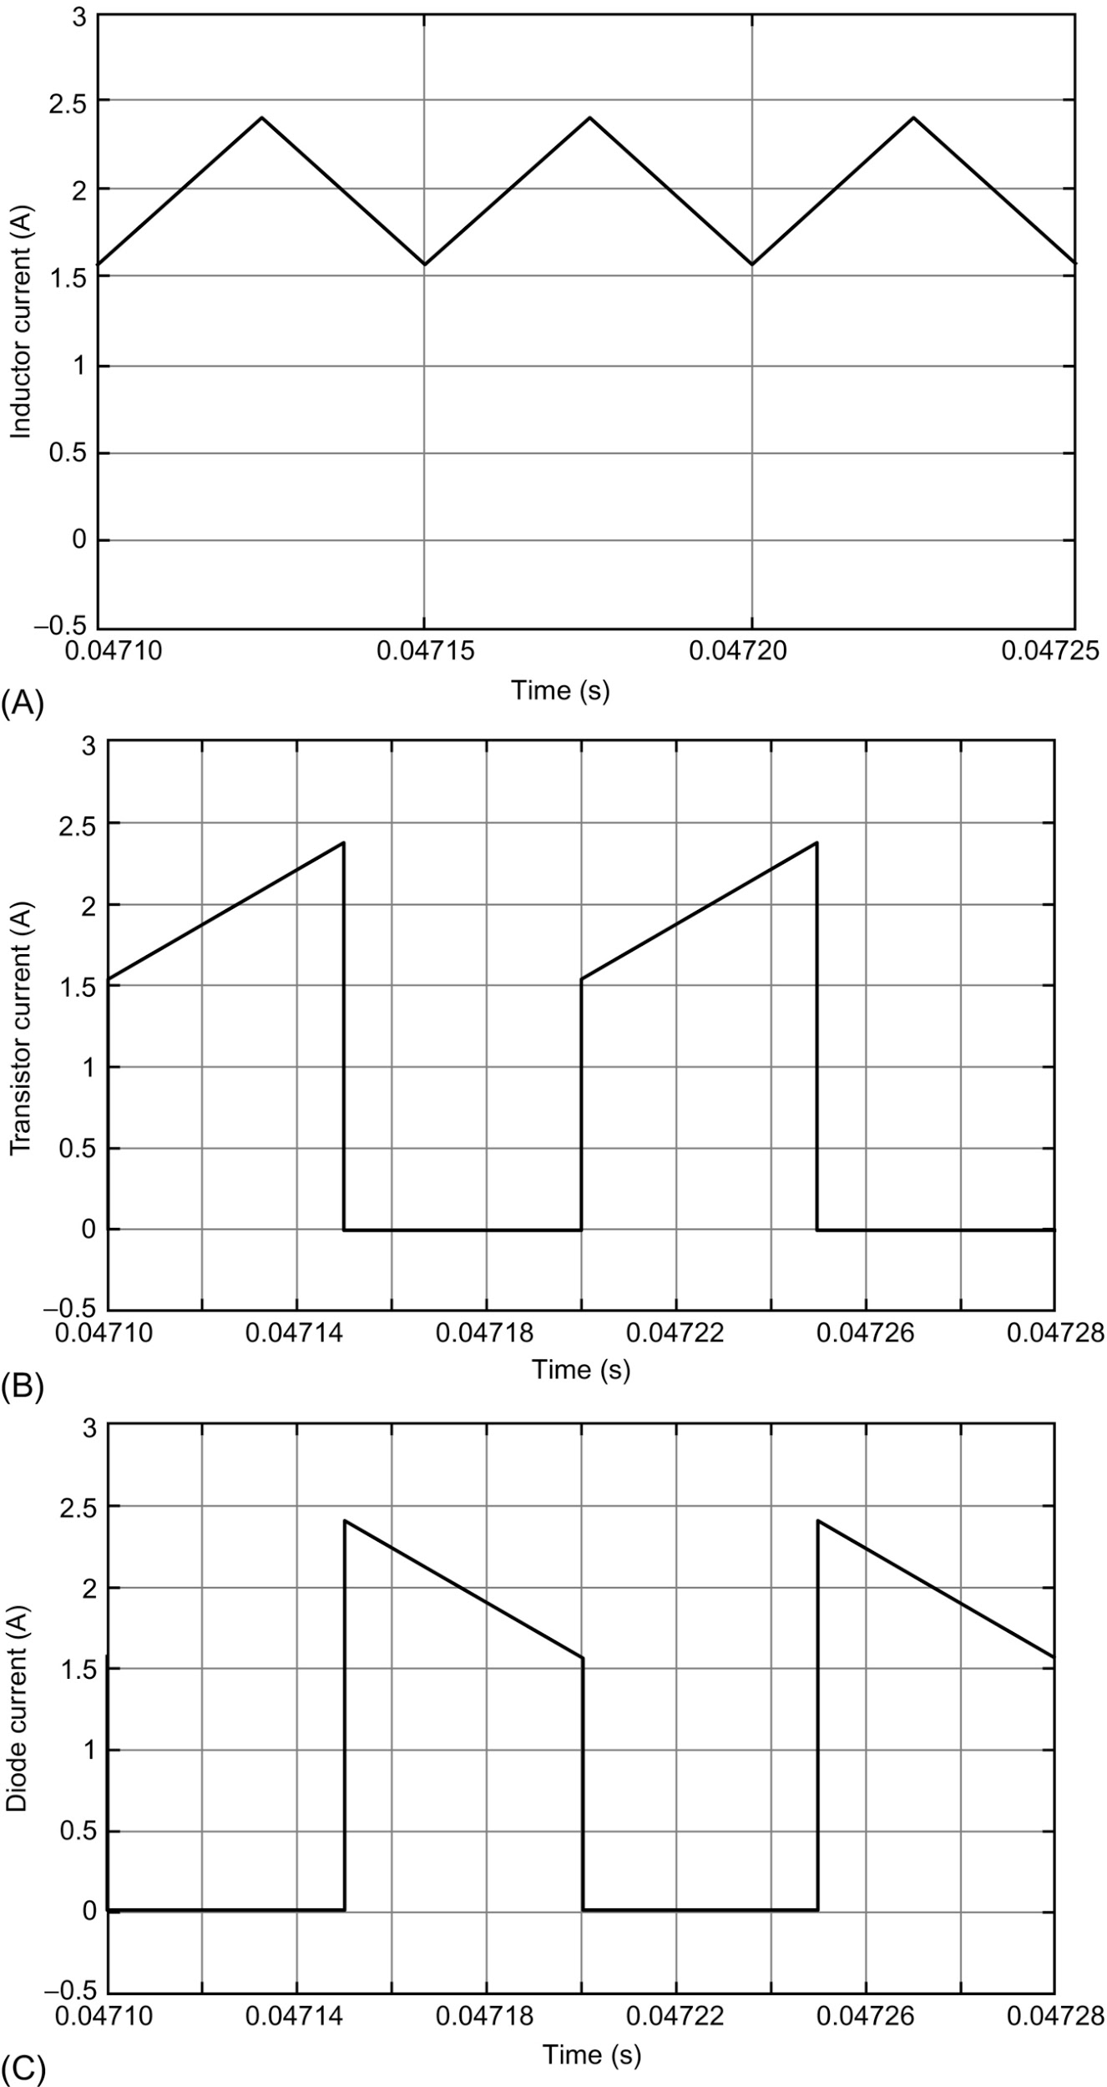

**FIG. 2.15** (A) Inductor current, (B) transistor current, and (C) diode current.

#### **2.1.6.3 Voltage Multiplier**

[Fig. 2.16](https://learning.oreilly.com/library/view/power-electronics-handbook/9780128114087/B9780128114070000027.xhtml#f0085) presents a voltage multiplier circuit with the output voltage four times higher than the amplitude of the input voltage, neglecting the diode voltage drops. This circuit is used when a higher voltage compared with the input is required. The transformer in this case is used only for isolation.

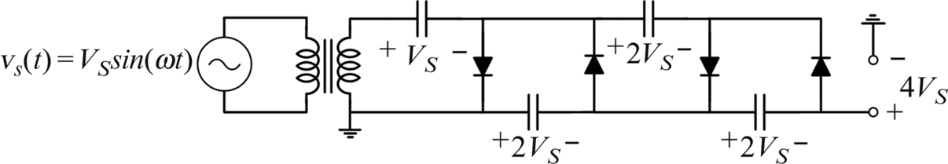

**FIG. 2.16** Voltage multiplier circuit.

### 2.1.7 PSPICE MODEL

SPICE is a general-purpose circuit platform that can be used to simulate electronic and electric circuits [[4](https://learning.oreilly.com/library/view/power-electronics-handbook/9780128114087/B9780128114070000027.xhtml#bb0025)]. SPICE was originally developed at the Electronics Research Laboratory of the University of California, Berkeley (1975). The name stands for simulation program for integrated circuits emphasis. A circuit must be specified in terms of element names, element values, nodes, variable parameters, and sources. SPICE can do several types of circuit analyses:

• Nonlinear DC analysis, calculating the DC transference

• Nonlinear transient analysis—calculates signals as a function of time

• Linear AC analysis—computes the Bode plots as a function of frequency

• Noise analysis

• Sensitivity analysis

• Distortion analysis

• Fourier analysis

• Monte Carlo analysis

In addition, PSPICE has analog and digital libraries of standard components such as operational amplifiers, digital gates, and flip-flops. This makes it a useful tool for a wide range of analog and digital applications. An input file, called source file, consists of three parts: (1) data statements, with description of the components and the interconnections; (2) control statements, which tells SPICE what type of analysis to perform; and (3) output statements, with specifications that outputs are to be printed or plotted. Two other statements are required: the title statement and the end statement. The title statement is the first line and can contain any information, while the end statement is always .END. In addition, there are also comment statements that must begin with an asterisk (⁎) and are ignored by SPICE.

A set of device model parameters is defined on a separate .MODEL card and assigned to a unique model name. Parameter values are defined by appending the parameter name, followed by an equal sign and its value. Model parameters without specific value are assigned the default values.

As an example, the model parameter for the Schottky diode 1N5818 is given by the following text:

.MODEL 1N5818 D (IS=263u RS=73.1m BV=30.0 IBV=1.00m+CJO=203p M=0.333 N=1.90 TT=4.32u )

The definition of each parameter is given in [Table 2.1](https://learning.oreilly.com/library/view/power-electronics-handbook/9780128114087/B9780128114070000027.xhtml#t0010). The description of the parameter is beyond the scope of this chapter.

**Table 2.1**

**Parameter definition of a diode model**

|  |  |
| --- | --- |
| **Parameter** | **Definition** |
| IS | Saturation current |
| RS | Parasitic resistance |
| BV | Reverse breakdown voltage |
| IBV | Reverse breakdown current |
| CJO | Zero-bias P–N capacitance |
| N | Emission coefficient |
| TT | Transit time |
| M | Junction grading coefficient |

The designer will have to decide, depending on the application or the study, if he or she should use of a more or a less sophisticated model of diodes in their circuit simulation.

## 2.2 Power Bipolar Transistor

The first transistor was created in 1948 by a team of physicists at the Bell Telephone Laboratories and soon became a semiconductor device of major importance. In addition of becoming an important switch for power electronic applications, all microprocessors, microcontrollers, and FPGAs have in their microelectronic design a transistor to implement the required logic circuits. Before the transistor was developed, amplification was achieved with vacuum tubes or magnetic devices. Even though there are now integrated circuits with millions of transistors, the flow and control of all the electric energy still require single transistors. Therefore, power semiconductor switches constitute the heart of modern power electronics. Depending on the application, such devices should have larger voltage or current ratings, instant turn-on and turn-off characteristics, very low-voltage drop when fully on, zero leakage current in blocking condition, and ruggedness to switch highly inductive loads, which are measured in terms of the safe operation area (SOA) and reverse-biased second breakdown, high-temperature and radiation capabilities, and high reliability. The right combination of such features restricts the devices suitability to certain applications. High-voltage and high-current ratings permit applications in large motor drives, induction heating, renewable energy inverters, high-voltage DC (HVDC) converters, static reactive energy compensators, and active filters. On the other hand, low-voltage and high-frequency applications concern switching mode power supplies, resonant converters, and motion control systems. Low frequency with high-current and high-voltage devices are restricted to cycloconverter-fed and multimegawatt drives [[5](https://learning.oreilly.com/library/view/power-electronics-handbook/9780128114087/B9780128114070000027.xhtml#bb0030),[6](https://learning.oreilly.com/library/view/power-electronics-handbook/9780128114087/B9780128114070000027.xhtml#bb0035)].

Bipolar junction transistors (BJT) are used to be the traditional component for driving several of those industrial applications. However, insulated gate bipolar transistor (IGBT) and metal-oxide-semiconductor field-effect transistor (MOSFET) technology have progressed so that they are viable replacements for the BJT. However, BJTs still have performance areas in which they may be preferably used, especially when the cost is the main concern.

### 2.2.1 BASIC STRUCTURE AND OPERATION

The BJT consists of a three-region structure of N-type and P-type semiconductor materials. It can be constructed as NPN and PNP. [Fig. 2.17](https://learning.oreilly.com/library/view/power-electronics-handbook/9780128114087/B9780128114070000027.xhtml#f0090) shows the physical structure of a planar NPN BJT. The operation is closely related to that of a junction diode where in normal conditions the PN junction between the base and emitter is forward-biased  causing electrons to be injected from the emitter into the base. Since the base region is thin, the electrons travel across it arriving at the reverse-biased base-collector junction  where there is an electric field (depletion region). Upon arrival at this junction, the electrons are pulled across the depletion region and draw into the collector. These electrons flow through the collector region and out the collector contact. Because electrons are negative carriers, their motion constitutes positive current flowing into the external collector terminal. Even though the forward-biased base-emitter junction injects holes from base to emitter, they do not contribute to the collector current, but result in a net current flow component into the base from the external base terminal. Therefore, the emitter current is composed of those two components: electrons destined to be injected across the base-emitter junction and holes injected from the base into the emitter.

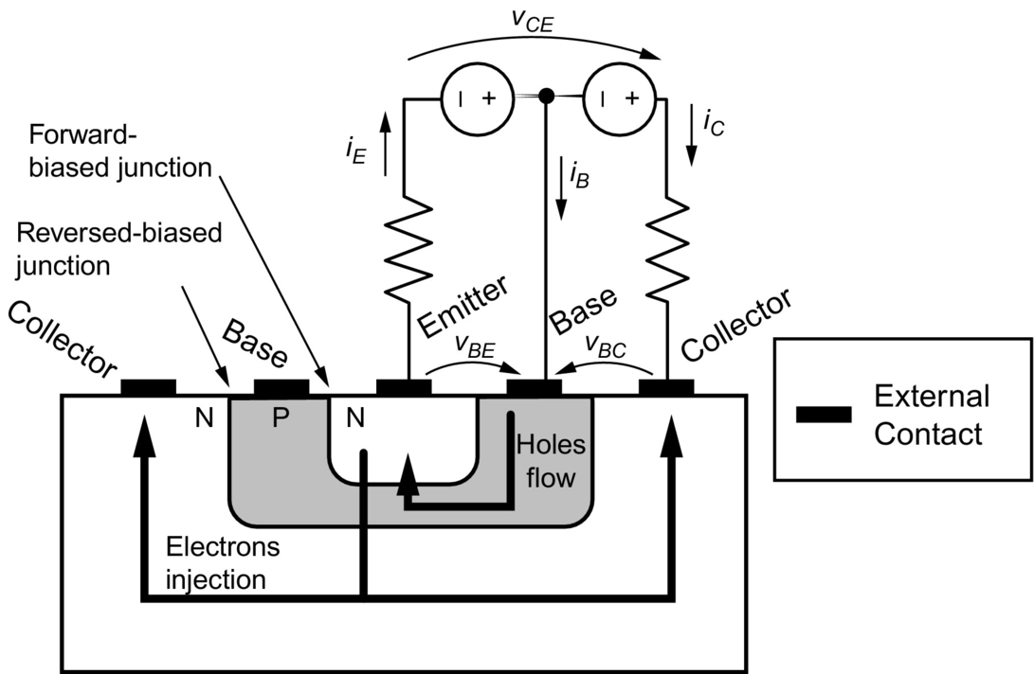

**FIG. 2.17** Structure of a planar bipolar junction transistor.

The emitter current is exponentially related to the base-emitter voltage according to [(2.1)](https://learning.oreilly.com/library/view/power-electronics-handbook/9780128114087/B9780128114070000027.xhtml#fo0010):

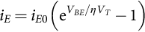 **(2.1)**

where *iE* is the saturation current of the base-emitter junction that is a function of the doping levels, temperature, and the area of the base-emitter junction; *VT* is the thermal voltage *Kt/q*; and *η* is the emission coefficient. The electron current arriving at the collector junction can be expressed as a fraction *α* of the total current crossing the base-emitter junction as shown in [(2.2)](https://learning.oreilly.com/library/view/power-electronics-handbook/9780128114087/B9780128114070000027.xhtml#fo0015):

 **(2.2)**

Since the transistor is a three-terminal device, *iE* is equal to ; hence, the base current can be expressed as the remaining fraction, given by [(2.3)](https://learning.oreilly.com/library/view/power-electronics-handbook/9780128114087/B9780128114070000027.xhtml#fo0020):

 **(2.3)**

The collector and base currents are thus related by the ratio given in [(2.4)](https://learning.oreilly.com/library/view/power-electronics-handbook/9780128114087/B9780128114070000027.xhtml#fo0025):

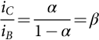 **(2.4)**

The values of *α* and *β* for a given transistor depend primarily on the doping densities in the base, collector, and emitter regions and on the device geometry. Carrier recombination and temperature also affect the values for both parameters. A power transistor requires a large blocking voltage in the OFF state and a high-current capability in the ON state. A vertically oriented four-layer structure as shown in [Fig. 2.18](https://learning.oreilly.com/library/view/power-electronics-handbook/9780128114087/B9780128114070000027.xhtml#f0095) is preferable because it maximizes the cross-sectional area through which the current flows, reducing the on-state resistance and power dissipation in the device. There is an intermediate collector region with moderate doping. The emitter region is controlled so as to have a homogenous electric field.

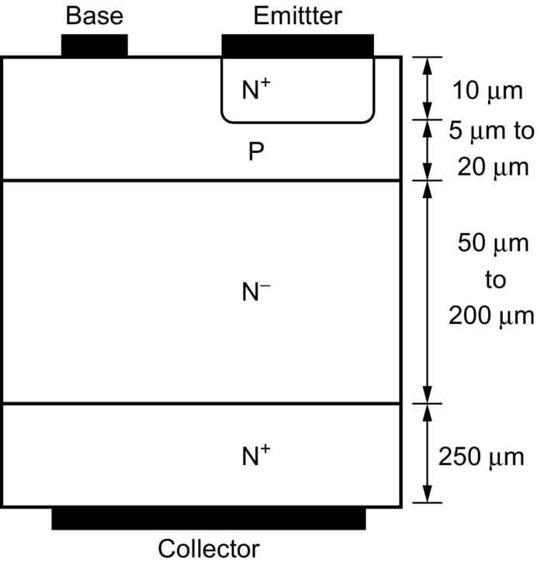

**FIG. 2.18** Power transistor vertical structure.

Optimization of doping and base thickness is required to achieve high breakdown voltage and amplification capabilities. Power transistors have their emitter and base interleaved to reduce parasitic ohmic resistance in the base current path and also to improve the device for second breakdown failure. The transistor is usually designed to maximize the emitter periphery per unit area of silicon, for the purpose of achieving the highest current gain at a specific current level. In order to ensure those features, transistors have the greatest possible safety margin; they are designed to dissipate substantial power and, thus, have low thermal resistance. It is for this reason, among others, that the chip area must be large and that the emitter periphery per unit area is sometimes not optimized. Most transistor manufacturers use aluminum metallization, since it has many attractive advantages, among these are ease of application by vapor deposition and ease of definition by photolithography. A major problem with aluminum is that only a thin layer can be applied by normal vapor deposition techniques. Thus, when high currents are applied along the emitter fingers, a voltage drop occurs along them, and the injection efficiency on the portions of the periphery that are furthest from the emitter contact is reduced. This limits the amount of current each finger can conduct. If copper metallization is used, then it is possible to reduce the resistance from the emitter contact to the operating regions of the transistors (the emitter periphery).

From a circuit point of view, Eqs. [(2.1)](https://learning.oreilly.com/library/view/power-electronics-handbook/9780128114087/B9780128114070000027.xhtml#fo0010)–[(2.4)](https://learning.oreilly.com/library/view/power-electronics-handbook/9780128114087/B9780128114070000027.xhtml#fo0025) are used to relate the variables of the BJT input port (formed by base and emitter) to the output port (collector and emitter). The circuit symbols are shown in [Fig. 2.19](https://learning.oreilly.com/library/view/power-electronics-handbook/9780128114087/B9780128114070000027.xhtml#f0100). Most of the power electronic applications use NPN transistor because electrons move faster than holes, and therefore, NPN transistors have considerable faster commutation times compared with the equivalent PNP transistors.

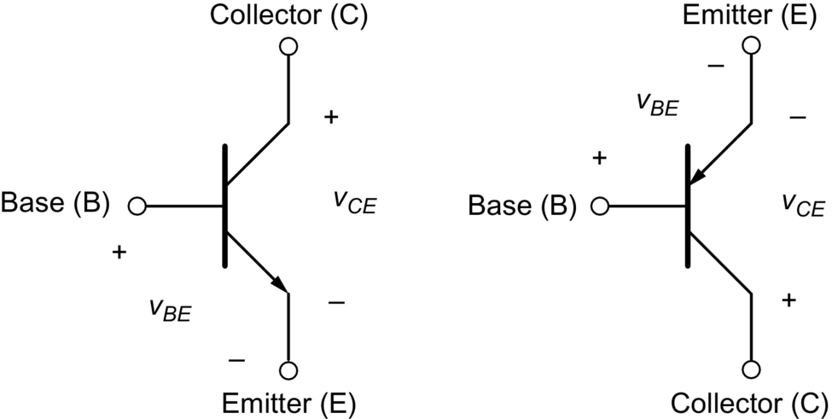

**FIG. 2.19** Circuit symbols, (A) NPN transistor and (B) PNP transistor.

### 2.2.2 STATIC CHARACTERISTICS

The static ratings determine the maximum allowable limits of current and voltage. The absolute voltage limit mechanism is concerned to the avalanche such that thermal runaway does not occur. Forward current ratings are specified at which the junction temperature does not exceed a rated value. [Fig. 2.20](https://learning.oreilly.com/library/view/power-electronics-handbook/9780128114087/B9780128114070000027.xhtml#f0105) shows the base current *iB* plotted as a function of the base-emitter voltage *VBE*. The *Vf* voltage is around 0.7 V for silicon BJTs.

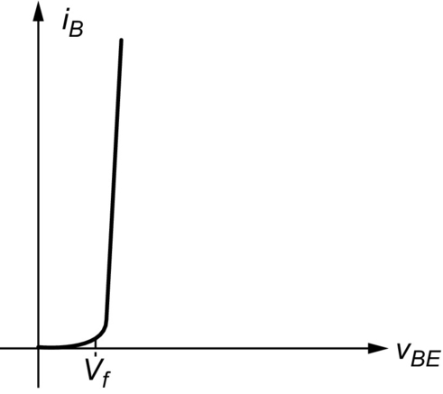

**FIG. 2.20** Base current plotted as a function of the base-emitter voltage.

[Fig. 2.21](https://learning.oreilly.com/library/view/power-electronics-handbook/9780128114087/B9780128114070000027.xhtml#f0110) depicts the collector current *iC* as a function of the collector-emitter voltage *VCE* with *iB* as the controlling variable. The curves are distinguished each other by the value of the base current. A small base current drives the flow of a much larger current between collector and emitter; such gain called beta (Eq. [2.4](https://learning.oreilly.com/library/view/power-electronics-handbook/9780128114087/B9780128114070000027.xhtml#fo0025)) depends upon temperature, *VCE*, and *iC*.

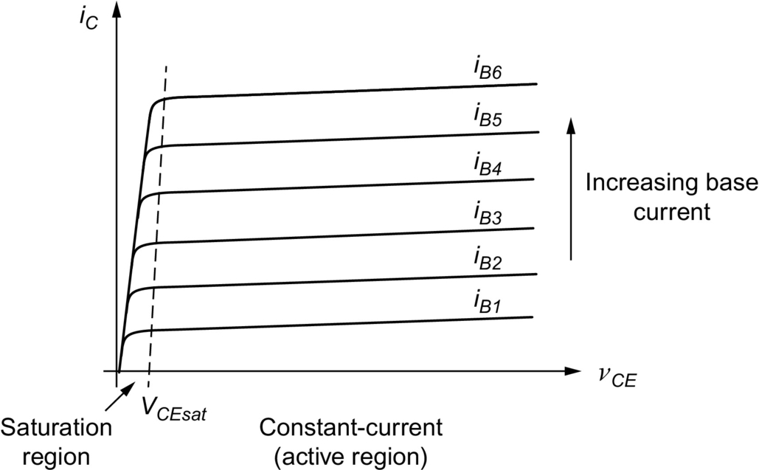

**FIG. 2.21** Collector current as a function of the collector-emitter voltage with the base current as the controlling variable.

The active region is defined where flat, horizontal portions of voltage-current curves show “constant” *iC* current, because the collector current does not change significantly with *VCE* for a given *iB*. Those portions are used for transistors operating as linear amplifiers. In this region, as the voltage and current can present high values, the dissipated power is high. Switching power electronic systems on the other hand requires transistors to operate either in the saturation region where *VCE* is small or in the cutoff region where the current is zero and the voltage is uphold by the device. In both situations, the dissipated power is low. The crossing of the active region must be as fast as possible to minimize the losses and the consequent temperature increase. The saturation region is characterized by the forward-biased of base-collector junction, and it occurs when .

High-voltage BJTs typically have low-current gain, and hence, Darlington-connected devices, as indicated in [Fig. 2.22](https://learning.oreilly.com/library/view/power-electronics-handbook/9780128114087/B9780128114070000027.xhtml#f0115), are commonly used.

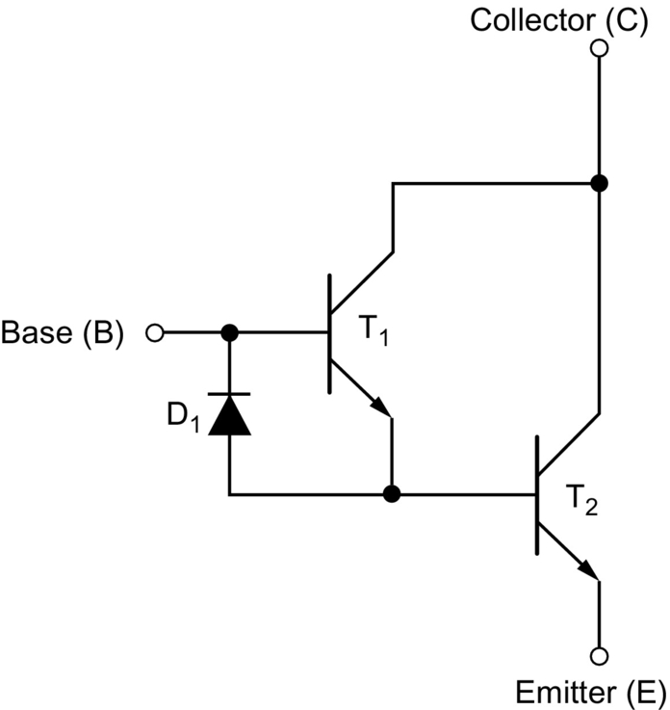

**FIG. 2.22** Darlington-connected BJTs.

Considering gains *β*1 and *β*2 for each one of those transistors, the Darlington connection will have total gain of . Diode D1 speeds up the turn-off process, by allowing the base driver to remove the stored charge on the T2 base.

Vertical-structure power transistors have an additional region of operation called quasi saturation, indicated in the characteristic curve of [Fig. 2.23](https://learning.oreilly.com/library/view/power-electronics-handbook/9780128114087/B9780128114070000027.xhtml#f0120). Such feature is a consequence of the lightly doped collector drift region  where the collector-base junction supports a low reverse bias. If the transistor enters in the hard-saturation region, the on-state power dissipation is minimized but has to be traded off with the fact that in quasi saturation, the stored charges are smaller. At high collector currents, beta gain decreases with increased temperature, and with quasi-saturation operation, such negative feedback allows careful device paralleling. Two mechanisms on microelectronic level determine the fall off in beta, namely, conductivity modulation and emitter crowding.

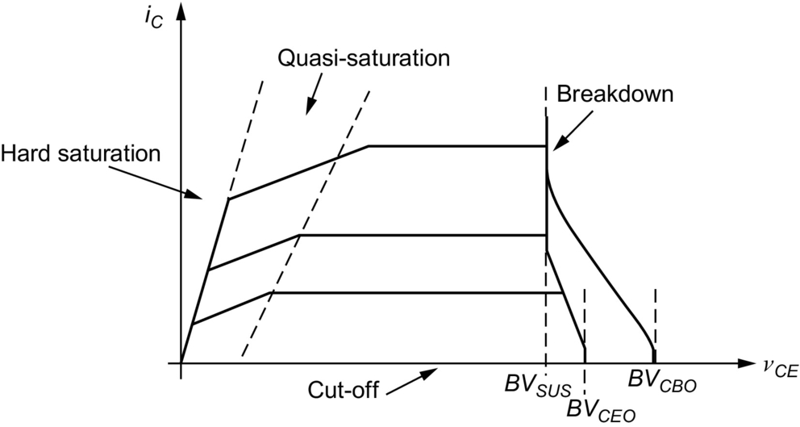

**FIG. 2.23** Voltage-current characteristics for a vertical power transistor.

Concerning the voltage, there is a region called primary breakdown due to conventional avalanche of the collector-base junction and the attendant large flow of current. The *BVSUS* is the limit for primary breakdown; it is the maximum collector-emitter voltage that can be sustained across the transistor when it is carrying collector current. The *BVSUS* is lower than *BVCEO* or *BVCBO* that measure the transistor's voltage standoff capability when the base current is zero or negative. The bipolar transistor has another potential failure mode called second breakdown, which shows as a precipitous drop in the collector-emitter voltage at large currents. Because the power dissipation is not uniformly spread over the device, but it is rather concentrated on regions, a local gradient of temperature can rise very quickly. Such thermal runaway brings hot spots that can eventually melt and recrystallize the silicon resulting in the device destruction. The key to avoid second breakdown is to (1) keep power dissipation under control, (2) use a controlled rate of change of base current during turnoff, (3) use of protective snubbers circuitry, and (4) position the switching trajectory within the SOA boundaries [[2](https://learning.oreilly.com/library/view/power-electronics-handbook/9780128114087/B9780128114070000027.xhtml#bb0015),[5](https://learning.oreilly.com/library/view/power-electronics-handbook/9780128114087/B9780128114070000027.xhtml#bb0030),[7](https://learning.oreilly.com/library/view/power-electronics-handbook/9780128114087/B9780128114070000027.xhtml#bb0040)].

### 2.2.3 SAFE OPERATION AREA

In order to describe the maximum values of current and voltage the transistor should hold, two diagrams are used: the forward-bias safe operating area (FBSOA), known also simply as SOA, given in [Fig. 2.24](https://learning.oreilly.com/library/view/power-electronics-handbook/9780128114087/B9780128114070000027.xhtml#f0125), and the reverse-bias safe operating area (RBSOA) shown in [Fig. 2.25](https://learning.oreilly.com/library/view/power-electronics-handbook/9780128114087/B9780128114070000027.xhtml#f0130).

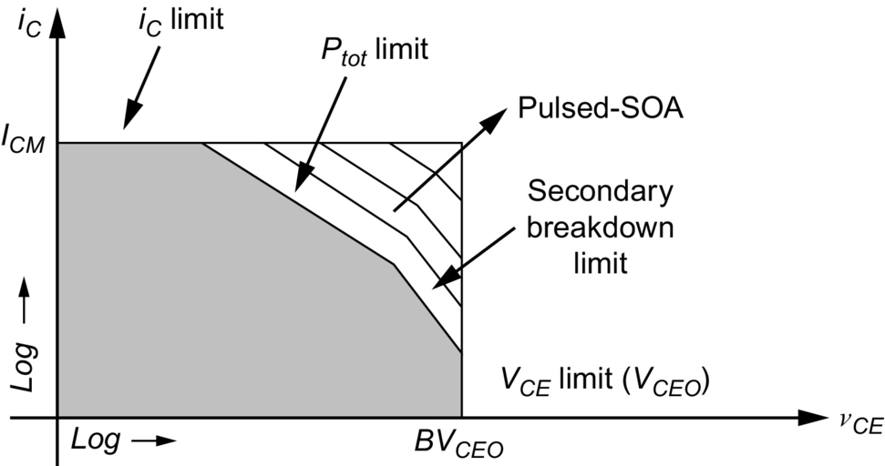

**FIG. 2.24** Forward-bias safe operating area (FBSOA).

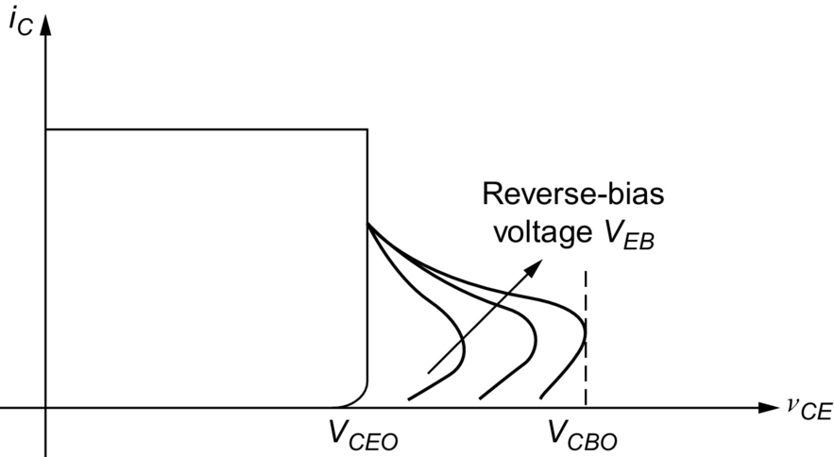

**FIG. 2.25** Reverse-bias safe operating area (RBSOA).

In the FBSOA, the current *ICM* is the maximum current of the device; there is a boundary defining the maximum thermal dissipation and a margin defining the second breakdown limitation. Those regions are expanded for switching mode operation. Inductive load generates higher peak energy at turnoff than its resistive counterpart. It is then possible to have a secondary breakdown failure if RBSOA is exceeded.

A reverse base current helps the cutoff characteristics expanding RBSOA. The RBSOA curve shows that for voltages below *VCEO*, the safe area is independent of reverse-bias voltage *VEB* and is only limited by the device collector current, whereas above *VCEO*, the collector current must be under control depending upon the applied reverse-bias voltage; in addition, temperature effects derate the SOA.

Ability for the transistor to switch high currents reliably is thus determined by its peak power handling capabilities. This ability is dependent upon the transistor's current and thermal density throughout the active region. In order to optimize the SOA capability, the current density and thermal density must be low. In general, it is a hot spot occurring at the weakest area of the transistor that will cause a device to fail due to second breakdown phenomenon. Although a wide base width will limit the current density across the base region, good heat sinking directly under the collector will enable the transistor to withstand high peak power. When the power and heat are spread over a large silicon area, these destructive tendencies are held to a minimum, and the transistor will have the highest SOA capability.

When the transistor is ON, one can ignore the base current losses and calculate the power dissipation on the ON state (conduction losses) by [(2.5)](https://learning.oreilly.com/library/view/power-electronics-handbook/9780128114087/B9780128114070000027.xhtml#fo0030). Hard saturation minimizes collector-emitter voltage, decreasing on-state losses:

 **(2.5)**

### 2.2.4 SWITCHING CHARACTERISTICS

Switching characteristics are important to define the device commutation from conduction (ON) to blocking (OFF) states. Such transition is of paramount importance also because most of the losses are due to high-frequency switching. [Fig. 2.26A](https://learning.oreilly.com/library/view/power-electronics-handbook/9780128114087/B9780128114070000027.xhtml#f0135) presents the switching characteristics of a BJT under resistive load. Index “r” refers to the rising time (from 10 to 90% of maximum value); for example, *tri* is the current rise time. The falling time is indexed by “f”; the parameter *tf* is the current falling time, that is, when the transistor is blocking such time corresponds to crossing from the saturation to the cutoff state. [Fig. 2.26B](https://learning.oreilly.com/library/view/power-electronics-handbook/9780128114087/B9780128114070000027.xhtml#f0135) presents operation points over the static characteristic curves. The thicker line indicates the trajectory of how the BJT passes through the cutoff region to the saturation region. Initially, the collector-emitter voltage is equal to VCC. At the end, the BJT is at the saturation region. The BJT passes through the active region in a linear manner.

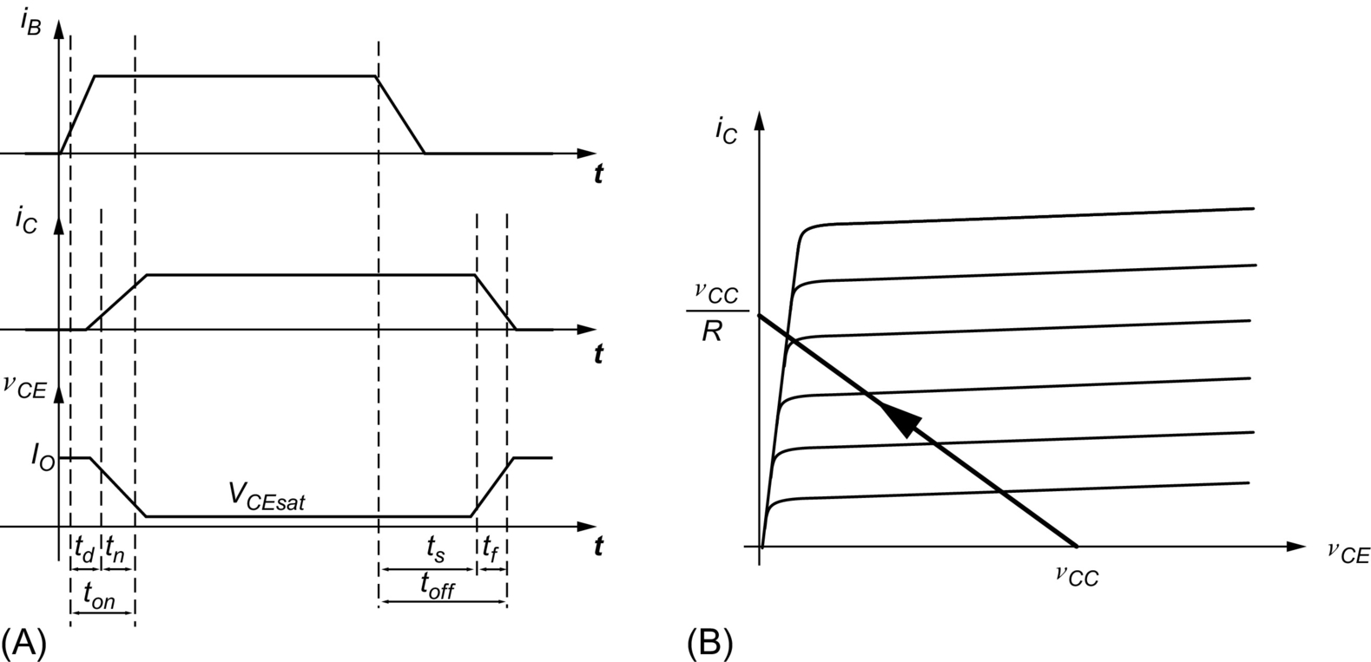

**FIG. 2.26** (A) Switching characteristics of a BJT under resistive load and (B) the trajectory over the static characteristic curves under resistive load.

In order to reduce *tf*, the base current for blocking must be negative, and the device must be kept in quasi saturation to minimize the stored charges. The delay time is denoted by *td*, corresponding to the time to discharge the capacitance of base-emitter junction, which can be reduced with a larger current base with high slope. Storage time (*ts*) is a very important parameter for BJT transistor. It is the required time to neutralize the minority carriers stored in the collector and base. Storage time and switching losses are key points to deal extensively with bipolar power transistors.

[Fig. 2.27](https://learning.oreilly.com/library/view/power-electronics-handbook/9780128114087/B9780128114070000027.xhtml#f0135) presents switching characteristics of a BJT with inductive load. The waveforms slightly change compared with the previous case. The collector current presents overshoot due to the required reversed recover current of a diode connected across the inductive load. The power waveform is also shown in order to present how the power losses in a transistor. The losses are defined as switching losses and conduction losses. With inductive load, at turn-on, the collector-emitter voltage falls only after the collector current reaches the load current level. At the turnoff, the collector-emitter voltage varies quickly, allowing the collector current to start to decrease. [Fig. 2.27B](https://learning.oreilly.com/library/view/power-electronics-handbook/9780128114087/B9780128114070000027.xhtml#f0140) presents the trajectory over the static characteristic curves.

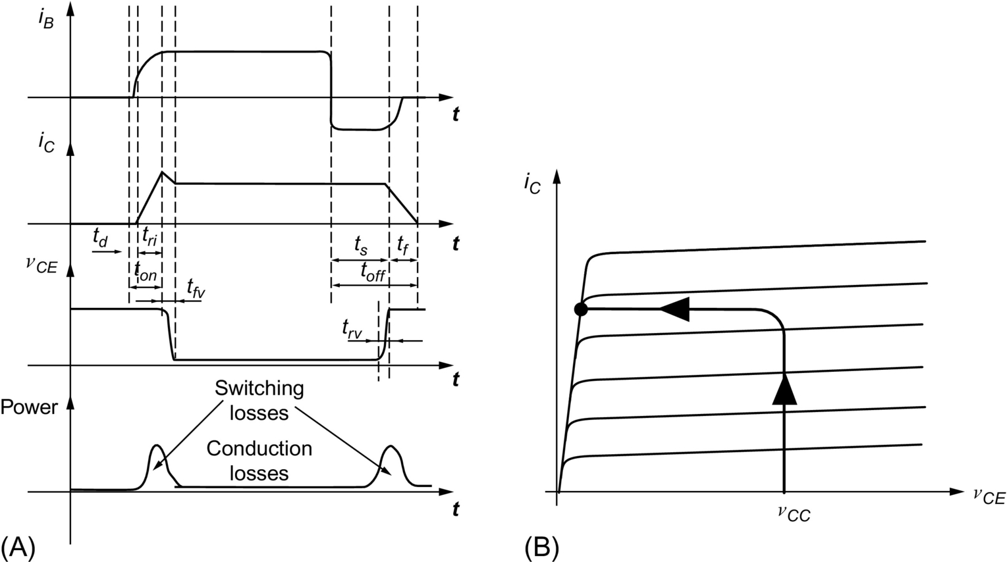

**FIG. 2.27** (A) Switching characteristics of a BJT with inductive load and (B) the trajectory over the static characteristic curves under inductive load.

Most advantageous operation in BJT is achieved when fast transitions are optimized. Such requirement minimizes switching losses. Therefore, a good bipolar drive circuit highly influences the transistor performance. A base drive circuit should provide a high forward base drive current (*IB*1) as indicated in [Fig. 2.28](https://learning.oreilly.com/library/view/power-electronics-handbook/9780128114087/B9780128114070000027.xhtml#f0145) to ensure the power semiconductor turn-on quickly. Base drive current should keep the BJT close to the saturation to minimize forward conduction losses, but a level *IB*2 would maintain the transistor in a quasi-saturation condition, avoiding excess of charges in the base. Controllable slope and reverse current *IBR* sweeps out stored charges in the transistor base, speeding up the device turnoff.

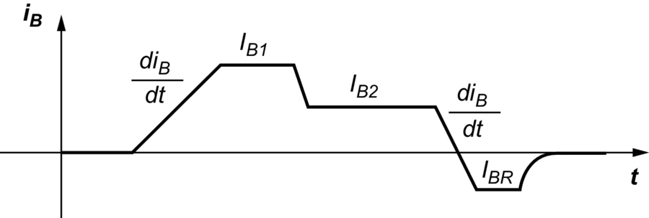

**FIG. 2.28** Recommended base current for BJT driving.

### 2.2.5 TRANSISTOR BASE DRIVER CIRCUITS

Several circuits have been suggested to successfully command transistors for operating in power electronic switching systems. Such circuits try to satisfy the following requirements: supply the right collector current, adapt the base current to the collector current, and extract a reverse current from base to speed up the device blocking. A good base driver reduces the commutation times and total losses, increasing efficiency and operating frequency. Depending upon the grounding requirements between the control and the power circuits, the base drive might be isolated or nonisolated types. [Fig. 2.29](https://learning.oreilly.com/library/view/power-electronics-handbook/9780128114087/B9780128114070000027.xhtml#f0150) shows a nonisolated circuit. When T1 is switched on, T2 is driven, and diode D1 is forward-biased providing a reverse bias keeping T3 off. The base current *IB* is positive and saturates the power transistor TP. When T1 is switched off, T3 switches on due to the negative path provided by *R*3 and − *VCC*, providing a negative current for switching off the power transistor TP.

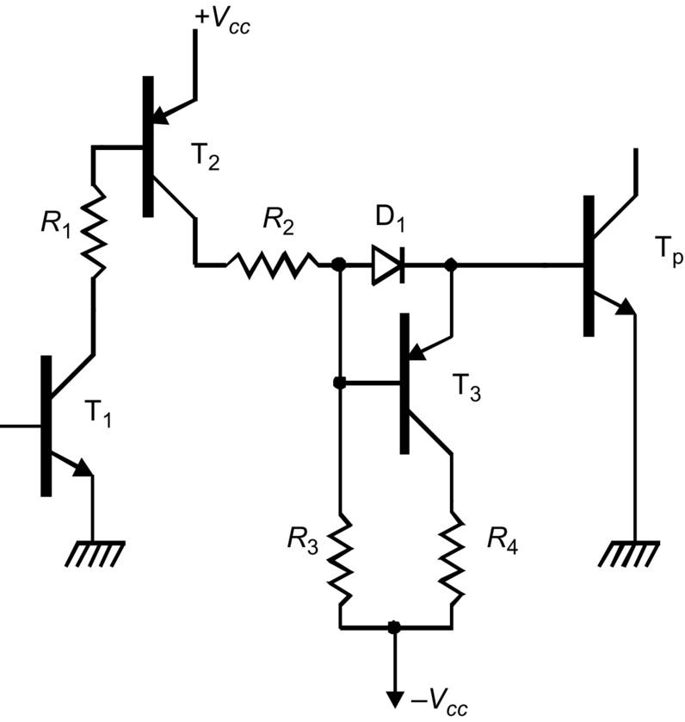

**FIG. 2.29** Nonisolated base driver.

When a negative power supply is not provided for the base drive, a simple circuit like [Fig. 2.30](https://learning.oreilly.com/library/view/power-electronics-handbook/9780128114087/B9780128114070000027.xhtml#f0155) can be used in low-power applications (low-power motors, small DC-DC converters, relays, and pulsed circuits). When the input signal is high, T1 switches on, and a positive current goes to TP keeping the capacitor charged with the zener voltage; when the input signal goes low, T2 provides a path for the discharge of the capacitor, imposing a pulsed negative current from the base-emitter junction of TP.

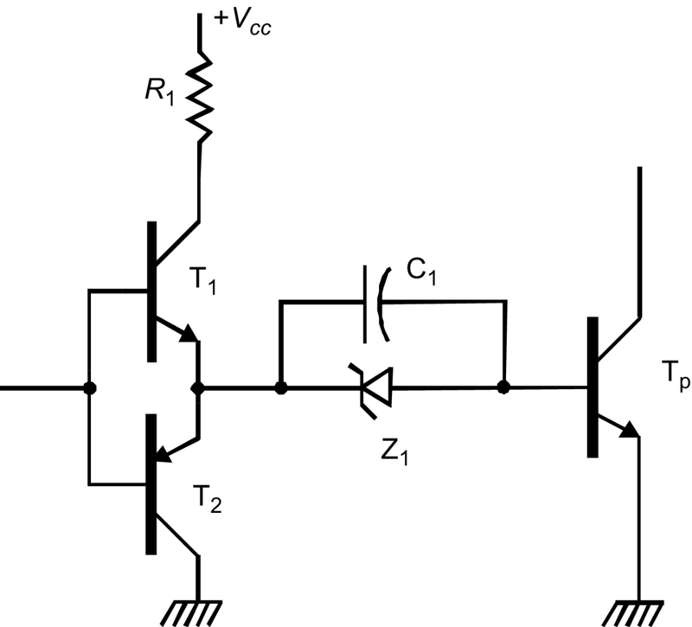

**FIG. 2.30** Base command without negative power supply.

A combination of large reverse base drive and antisaturation techniques may be used to reduce storage time to almost zero. A circuit called Baker's clamp may be employed as illustrated in [Fig. 2.31](https://learning.oreilly.com/library/view/power-electronics-handbook/9780128114087/B9780128114070000027.xhtml#f0160). When the transistor is on, its base is two diode drops below the input. Assuming that diodes D2 and D3 have a forward-bias voltage of about 0.7 V, then, the base will be 1.4 V below the input terminal. Due to diode D1, the collector is one diode drop or 0.7 V below the input. Therefore, the collector will always be more positive than the base by 0.7 V, staying out of saturation, and because collector voltage increases, the gain *β* also increases a little bit. Diode D4 provides a negative path for the reverse base current.

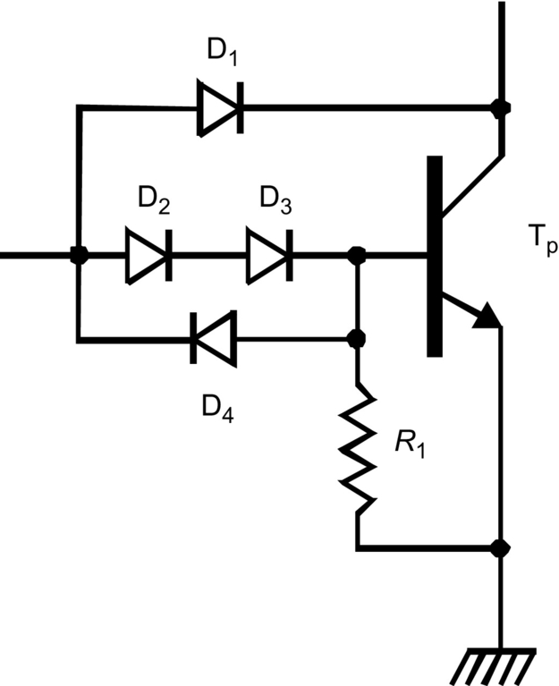

**FIG. 2.31** Antisaturation diodes (Baker's clamp) improve power transistor storage time.

Several situations require ground isolation, off-line operation, and floating transistor topology. In addition, safety needs may call for an isolated base drive circuit. Numerous circuits have been demonstrated in switching power supplies isolated topologies, usually integrating base drive requirements with their power transformers. Isolated base drive circuits may provide either constant current or proportional current excitation. A very popular base drive circuit for floating switching transistor is shown in [Fig. 2.32](https://learning.oreilly.com/library/view/power-electronics-handbook/9780128114087/B9780128114070000027.xhtml#f0165). When a positive voltage is impressed on the secondary winding (*VS*) of T*R*1, a positive current flows into the base of the power transistor TP, which switches on (resistor *R*1 limits the base current). The capacitor *C*1 is charged by (), and T1 is kept blocked because the diode D1 reverse biases T1 base-emitter. When *VS* is zipped off, the capacitor voltage *VC* brings the emitter of T1 to a negative potential with respect to its base. Therefore, T1 is excited so as to switch on and start pulling a reverse current from TP base.

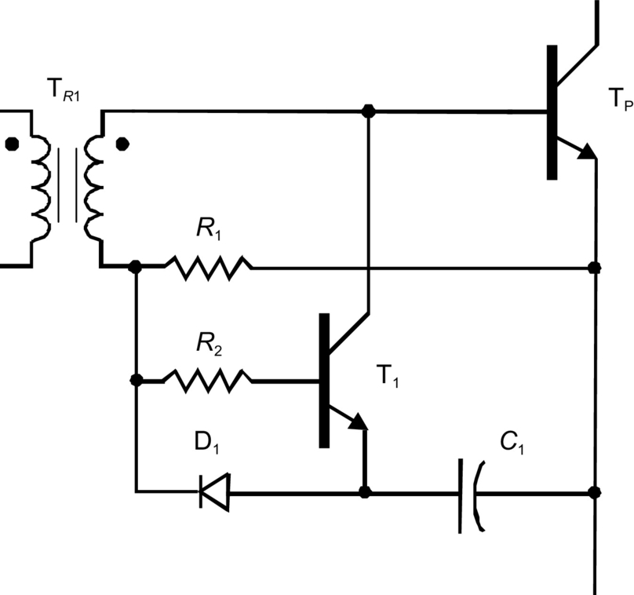

**FIG. 2.32** Isolated base drive circuit.

Another very effective circuit is shown in [Fig. 2.33](https://learning.oreilly.com/library/view/power-electronics-handbook/9780128114087/B9780128114070000027.xhtml#f0170) with a minimum number of components. The base transformer has a tertiary winding that uses the energy stored in the transformer to generate the reverse base current during the turn-off command. Other configurations are also possible by adding to the isolated circuits the Baker clamp diodes or zener diodes with paralleled capacitors.

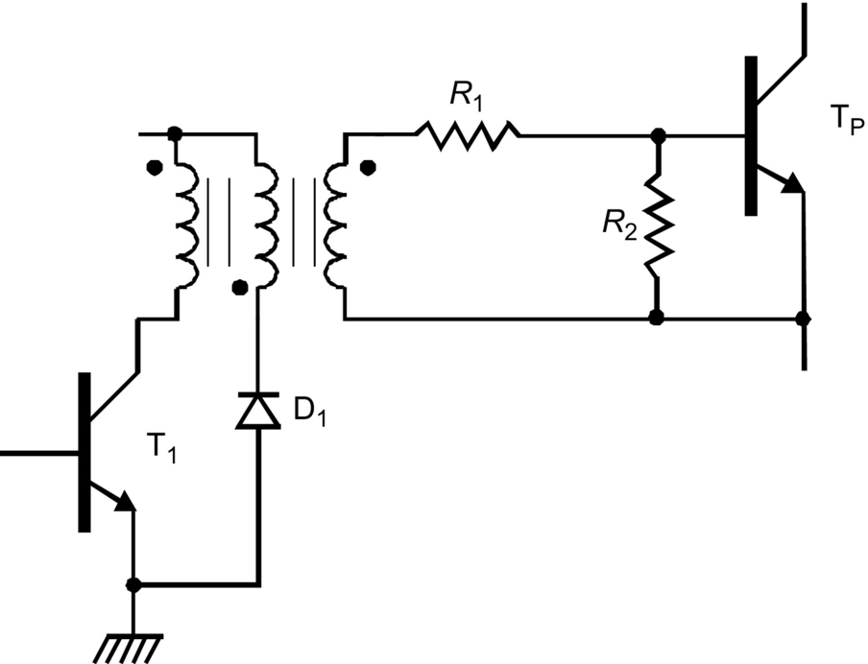

**FIG. 2.33** Transformer-coupled base drive with tertiary winding transformer.

Sophisticated isolated base drive circuits can be used to provide proportional base drive currents where it is possible to control the value of *β*, keeping it constant for all collector currents leading to shorter storage time. [Fig. 2.34](https://learning.oreilly.com/library/view/power-electronics-handbook/9780128114087/B9780128114070000027.xhtml#f0175) shows one of the possible ways to realize a proportional base drive circuit. When transistor T1 turns on, the transformer T*R*1 is in negative saturation, and the power transistor T P is off. During the time that T1 is on, a current flows through winding *N*1, limited by resistor *R*1, storing energy in the transformer and holding it into saturation. When the transistor T1 turns off, the energy stored in *N*1 is transferred to winding *N*4, pulling the core from negative to positive saturation. The windings *N*2 and *N*4 will withstand as a current source, the transistor TP will stay on, and the gain *β* will be imposed by the turn ratio given by [(2.6)](https://learning.oreilly.com/library/view/power-electronics-handbook/9780128114087/B9780128114070000027.xhtml#fo0035):

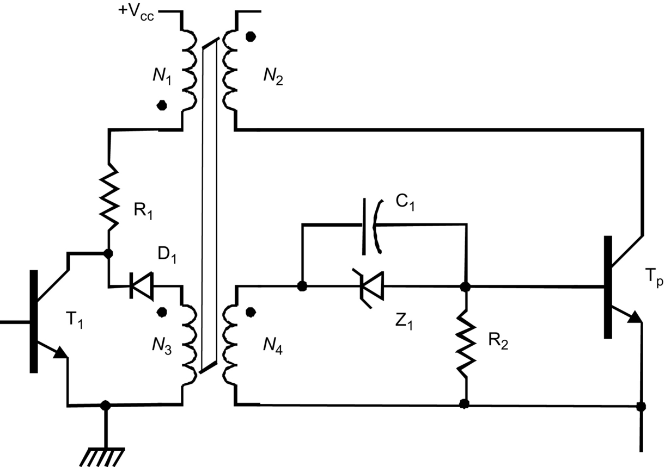

**FIG. 2.34** Proportional base drive circuit.

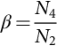 **(2.6)**

In order to use the proportional drive given in [Fig. 2.35](https://learning.oreilly.com/library/view/power-electronics-handbook/9780128114087/B9780128114070000027.xhtml#f0180), careful design of the transformer must be done, so as to have flux balanced, which will keep core under saturation. The transistor gain must be somewhat higher than the value imposed by the transformer turns ratio, which requires cautious device matching.

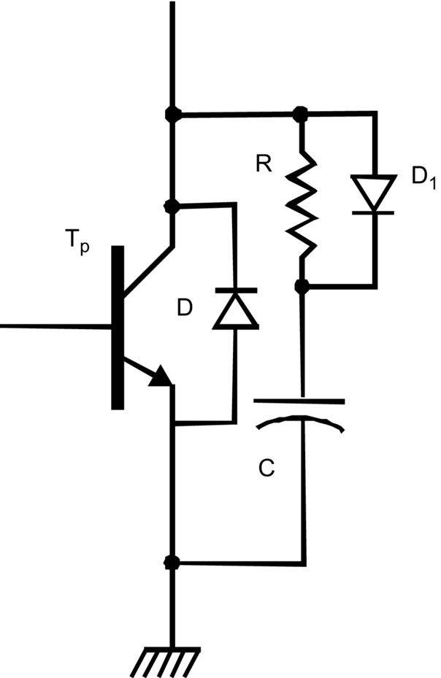

**FIG. 2.35** Turn-off snubber network.

The most critical portion of the switching cycle occurs during transistor turnoff, since normally reverse base current is made very large in order to minimize storage time. Such conditions may avalanche the base-emitter junction leading to failure. There are two options to prevent this behavior: turning off the transistor at low values of collector-emitter voltage (which is not practical in most of the applications) or reducing collector current with rising collector voltage, implemented by *RC* protective networks called snubbers. Therefore, an *RC* snubber network can be used to divert the collector current during the turnoff, improving the RBSOA. In addition, the snubber circuit dissipates a fair amount of switching power relieving the transistor. [Fig. 2.35](https://learning.oreilly.com/library/view/power-electronics-handbook/9780128114087/B9780128114070000027.xhtml#f0180) shows a turn-off snubber network. When the power transistor is off, the capacitor *C* is charged through diode D1. Such collector current flows temporarily into the capacitor as the collector-voltage rises; as the power transistor turns on, the capacitor discharges through the resistor *R* back into the transistor.

### 2.2.6 BJT APPLICATIONS

Bipolar junction power transistors are applied to a variety of power electronic functions, switching mode power supplies, and motor drivers [[8](https://learning.oreilly.com/library/view/power-electronics-handbook/9780128114087/B9780128114070000027.xhtml#bb0045),[9](https://learning.oreilly.com/library/view/power-electronics-handbook/9780128114087/B9780128114070000027.xhtml#bb0050)]. A buck-boost converter is exemplified in [Fig. 2.36](https://learning.oreilly.com/library/view/power-electronics-handbook/9780128114087/B9780128114070000027.xhtml#f0185). The BJT operates in the cutoff and saturation regions. This converter can present a higher or lower voltage on its output terminal related to its input voltage source. This depends on the duty cycle of the BJT. The duty cycle is defined as the time a transistor keeps ON over a switching period. For duty cycles lower than 0.5, the buck-boost output voltage is lower than the input voltage. On the other hand, for duty cycles higher than 0.5, the output voltage is higher than the input voltage. The buck-boost converter has also a feature of presenting a contrary polarity on its output terminal related to the input voltage.

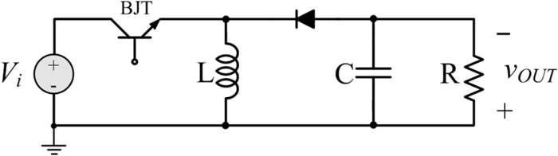

**FIG. 2.36** Buck-boost converter with BJT.

BJT are also commonly applied in chopper drivers. These circuits are connected between a fixed-voltage dc source and a dc motor to vary the armature voltage. In addition to armature voltage control, a dc chopper can provide regenerative braking of the motors and can return energy back to the supply. This energy-saving feature is attractive to transportation systems as mass rapid transit (MRT); chopper drives are also used in battery electric vehicles. A dc motor can be operated in one of the four quadrants by controlling the armature or field voltages (or currents). It is often required to reverse the armature or field terminals in order to operate the motor in the desired quadrant. [Fig. 2.37](https://learning.oreilly.com/library/view/power-electronics-handbook/9780128114087/B9780128114070000027.xhtml#f0190) shows a circuit arrangement of a chopper-fed dc separately excited motor. By varying the duty cycle, the power flow to the motor (and speed) can be controlled.

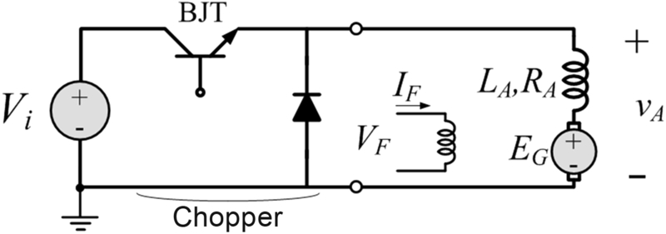

**FIG. 2.37** Chopper driver with DC motor.

### 2.2.7 PSPICE MODEL

The PSPICE model for the BJT is based on the integral-charge model of Gummel and Poon. However, if the Gummel-Poon parameters are not specified, the model reduces to piecewise-linear Ebers-Moll model as depicted in the following text for the 2N2222A NPN transistor [[2](https://learning.oreilly.com/library/view/power-electronics-handbook/9780128114087/B9780128114070000027.xhtml#bb0015)]:

.MODEL Q2N2222A NPN (IS=14.34F XTI=3 EG=1.11

VAF74.03 BF=255.9 NE=1.307 ISE=14.34 F IKF=.2847

XTB=1.5 BR=6.092 NC=2 ISC=0 IKR=0 RC=1 CJC=7.306P

MJC=.3416 VJC=.75 FC=.5 CJE=22.01P MJE=.377 VJE=.75

TR=46.91 N TF=411.1P ITF=.6 VTF=1.7 XTF=3 RB=10)

In either case, charge-storage effects, ohmic resistances, and current-dependent output conductance may be included.

The definition of each parameter is given in [Table 2.2](https://learning.oreilly.com/library/view/power-electronics-handbook/9780128114087/B9780128114070000027.xhtml#t0015) [[4](https://learning.oreilly.com/library/view/power-electronics-handbook/9780128114087/B9780128114070000027.xhtml#bb0025)].

**Table 2.2**

**Parameter definition of a BJT model**

|  |  |
| --- | --- |
| **Parameter** | **Definition** |
| IS | Saturation current |
| XTI | IS temperature effect exponent |
| EG | Bandgap voltage (barrier height) |
| VAF | Forward early voltage |
| BF | Ideal maximum forward beta |
| NE | Base-emitter leakage emission coefficient |
| ISE | Base-emitter leakage saturation current |
| IKF | Corner for forward beta high-current roll-off |
| XTB | Forward and reverse beta temperature coefficient |
| BR | Ideal maximum reverse beta |
| NC | Base-collector leakage emission coefficient |
| ISC | Base-collector leakage saturation current |
| IKR | Corner for reverse beta high-current roll-off |
| RC | Collector ohmic resistance |
| CJC | Base-collector zero-bias P–N capacitance |
| MJC | Base-collector P–N grading factor |
| VJC | Base-collector built-in potential |
| FC | Forward-bias depletion capacitor coefficient |
| CJE | Base-emitter zero-bias P–N capacitance |
| MJE | Base-emitter P–N grading factor |
| VJE | Base-emitter built-in potential |
| TR | Ideal reverse transit time |
| TF | Ideal forward transit time |
| ITF | Transit-time dependency on Ic |
| VTF | Transit-time dependency on Vbc |
| XTF | Transit-time bias dependence coefficient |
| RB | Zero-bias (maximum) base resistance |

## 2.3 Power MOSFET

The MOSFET technology became available by the early 1980s. The novelty of MOSFET over the BJT was the fact that MOSFET uses only majority carriers in conduction and it is commanded by voltage signal instead of current, as in BJT. Additionally, the manner how the electric terminals are constructed presented a great advancement in producing high-speed transistors. Actually, power MOSFET can switch at around 1 MHz. All these features resulted in a different physical behavior of MOSFET compared with BJT [[6](https://learning.oreilly.com/library/view/power-electronics-handbook/9780128114087/B9780128114070000027.xhtml#bb0035),[10](https://learning.oreilly.com/library/view/power-electronics-handbook/9780128114087/B9780128114070000027.xhtml#bb0055)].

### 2.3.1 BASIC STRUCTURE

[Fig. 2.38](https://learning.oreilly.com/library/view/power-electronics-handbook/9780128114087/B9780128114070000027.xhtml#f0195) presents a basic structure of a vertical N-channel MOSFET. The MOSFET has three terminals called drain (D), source (S), and gate (G). The gate terminal is isolated from the rest of the semiconductor by means of a SiO2 layer. The PN junction represents a diode from source to drain terminals. This diode conducts when the drain-source voltage is negative. Additionally, this diode holds the reverse voltage applied to the MOSFET. The MOSFET operates as a transistor when the drain-source voltage is positive.

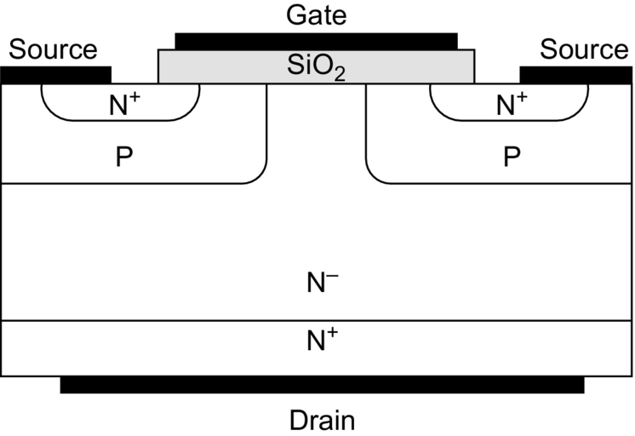

**FIG. 2.38** Basic structure of a vertical N-channel MOSFET.

In case of a positive gate-source voltage, the gate potential repels the positive charges in the P regions and attracts free electrons. When such voltage reaches a threshold voltage, a complete path between source and drain is formed, called channel. This allows a current to be conducted through the drain and source. As the gate-source voltage increases, more carriers are attracted, and more current can be conducted. The carriers are only electrons in the N+ source region along the channel and in the drain (N+ and N−) regions. [Fig. 2.39](https://learning.oreilly.com/library/view/power-electronics-handbook/9780128114087/B9780128114070000027.xhtml#f0200) presents a vertical MOSFET with the N-channel created.

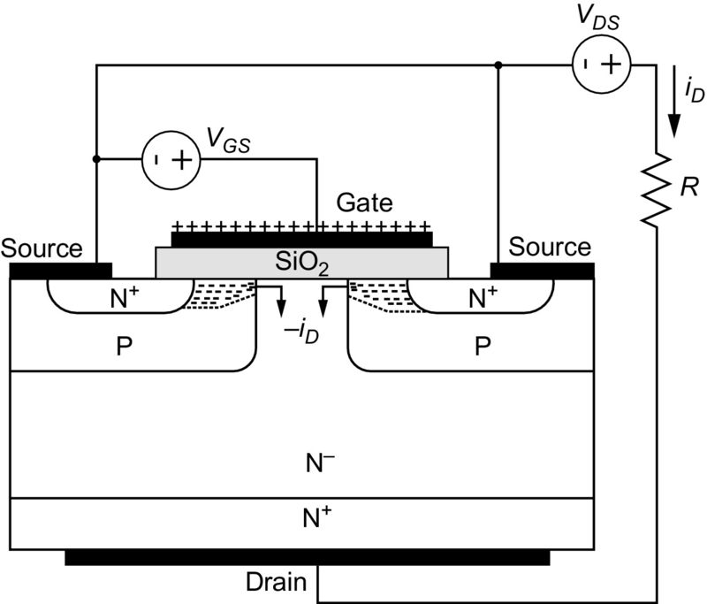

**FIG. 2.39** Vertical MOSFET with the N-channel created.

[Fig. 2.40](https://learning.oreilly.com/library/view/power-electronics-handbook/9780128114087/B9780128114070000027.xhtml#f0205) presents the MOSFET symbols for P- and N-channel types. The voltages across the terminals are highlighted.

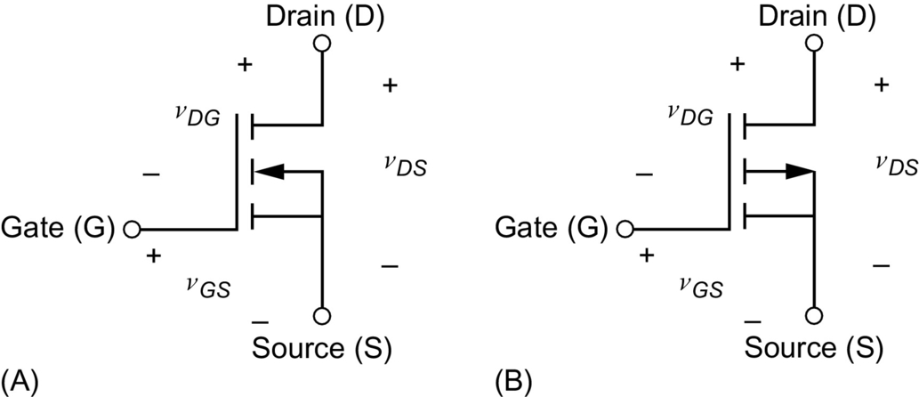

**FIG. 2.40** MOSFET symbols for (A) N-channel and (B) P-channel types.

### 2.3.2 STATIC CHARACTERISTICS

[Fig. 2.41](https://learning.oreilly.com/library/view/power-electronics-handbook/9780128114087/B9780128114070000027.xhtml#f0210) presents the static characteristics of an N-channel MOSFET. The chart shows three regions of operation. In power electronic applications, the MOSFET is preferentially operated in the ohmic and cutoff regions, once either the drain-source voltage or the drain current is small, compared with the active region, thus reducing the power losses. In the active region, the MOSFET operates as an amplifier. *BV* is the breakdown voltage, which is the maximum allowable drain-source voltage across the MOSFET before failure.

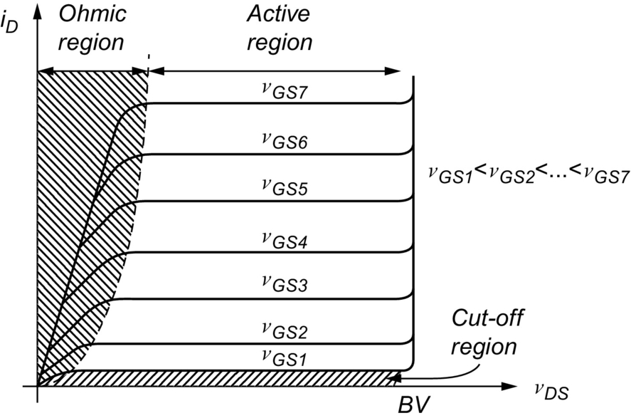

**FIG. 2.41** Static characteristics for an N-channel enhancement-type MOSFET.

#### **2.3.2.1 Ohmic Region**

In the ohmic region, also known as triode region or constant resistance region, the channel of the MOSFET behaves like a constant resistance. Such resistance is called *RDSon*, and it is linearly proportional to drain-source voltage and the drain current. The value of *RDSon* can vary from some milliohms (low-voltage device) to few ohms (high-voltage device). The manufactures usually inform the value of *RDSon* on their datasheets. The value of *RDSon*, together with the drain current, determines the conduction power losses of the MOSFET.

The MOSFET operates at the ohmic region when the constraint shown in [(2.7)](https://learning.oreilly.com/library/view/power-electronics-handbook/9780128114087/B9780128114070000027.xhtml#fo0040) is satisfied:

 **(2.7)**

#### **2.3.2.2 Cut-off Region**

The cutoff region is characterized by the absence of the channel formation. This happens when the gate-source voltage is lower than the threshold voltage, as stated in [(2.8)](https://learning.oreilly.com/library/view/power-electronics-handbook/9780128114087/B9780128114070000027.xhtml#fo0045):

 **(2.8)**

In this case, no current flows through the drain and source terminals of the MOSFET.

#### **2.3.2.3 Active Region**

The active region is also known as saturation region in MOSFETs. However, naming it as saturation region may be misunderstood as the saturation region of BJT. Therefore, throughout this chapter, the name active region is used.

The active region is characterized by a constant drain current, controlled by the gate-source voltage. The MOSFET operates at the active region when the constraint stated in [(2.9)](https://learning.oreilly.com/library/view/power-electronics-handbook/9780128114087/B9780128114070000027.xhtml#fo0050) is satisfied. In this case, the channel width limits the current flow:

 **(2.9)**

### 2.3.3 SWITCHING CHARACTERISTICS

In order to understand the switching characteristics, the MOSFET is represented by an equivalent circuit model shown in [Fig. 2.42](https://learning.oreilly.com/library/view/power-electronics-handbook/9780128114087/B9780128114070000027.xhtml#f0215). The model consists of a voltage-controlled current source and internal capacitances located among the MOSFET terminals.

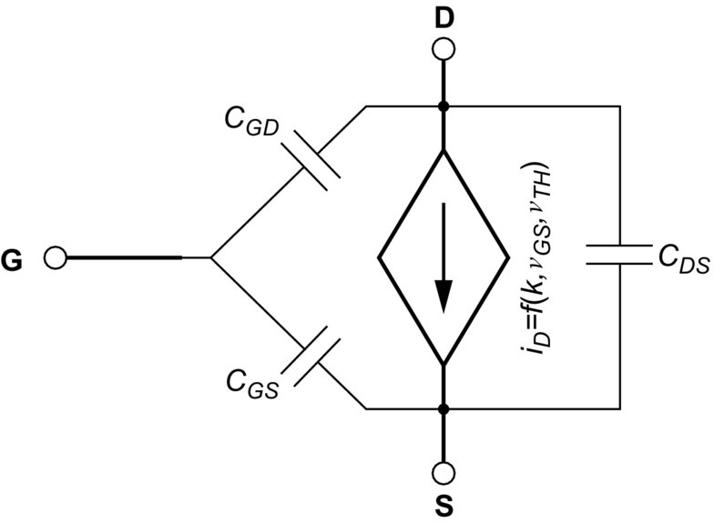

**FIG. 2.42** Equivalent circuit model for a MOSFET.

The internal capacitances are the gate-drain capacitance *CGD*, the gate-source capacitance *CGS*, and the drain-sourcecapacitance *CDS*. These are nonlinear capacitances that vary according to the MOSFET structure and bias voltage.

The voltage-controlled current source is mathematically approximated by [(2.10)](https://learning.oreilly.com/library/view/power-electronics-handbook/9780128114087/B9780128114070000027.xhtml#fo0055):

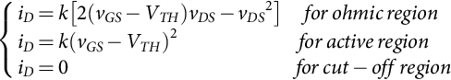 **(2.10)**

where *k* is a constant that depends on the MOSFET construction.

From [(2.7)](https://learning.oreilly.com/library/view/power-electronics-handbook/9780128114087/B9780128114070000027.xhtml#fo0040) to [(2.9)](https://learning.oreilly.com/library/view/power-electronics-handbook/9780128114087/B9780128114070000027.xhtml#fo0050), the drain-to-source voltage at the boundary between the active and ohmic region is given by [(2.11)](https://learning.oreilly.com/library/view/power-electronics-handbook/9780128114087/B9780128114070000027.xhtml#fo0060):

 **(2.11)**

Therefore, [(2.10)](https://learning.oreilly.com/library/view/power-electronics-handbook/9780128114087/B9780128114070000027.xhtml#fo0055) results in [(2.12)](https://learning.oreilly.com/library/view/power-electronics-handbook/9780128114087/B9780128114070000027.xhtml#fo0065):

 **(2.12)**

From [(2.12)](https://learning.oreilly.com/library/view/power-electronics-handbook/9780128114087/B9780128114070000027.xhtml#fo0065), the MOSFET input transfer characteristic can be obtained. [Fig. 2.43](https://learning.oreilly.com/library/view/power-electronics-handbook/9780128114087/B9780128114070000027.xhtml#f0220) presents the input transfer function characteristics, valid for the active region. *Gm* is the slope for an operation point with a *vGS* voltage and *iD* current.

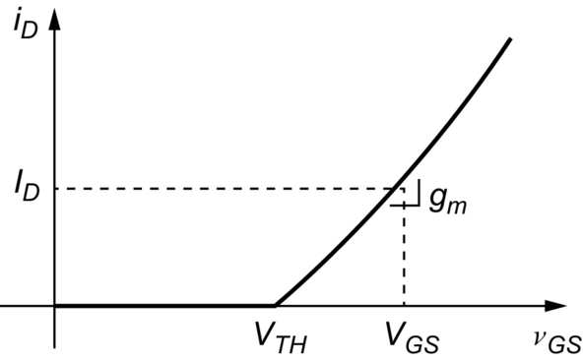

**FIG. 2.43** Input transfer function characteristics for a MOSFET.

In the ohmic region, the MOSFET can be represented by the circuit shown in [Fig. 2.44](https://learning.oreilly.com/library/view/power-electronics-handbook/9780128114087/B9780128114070000027.xhtml#f0225).

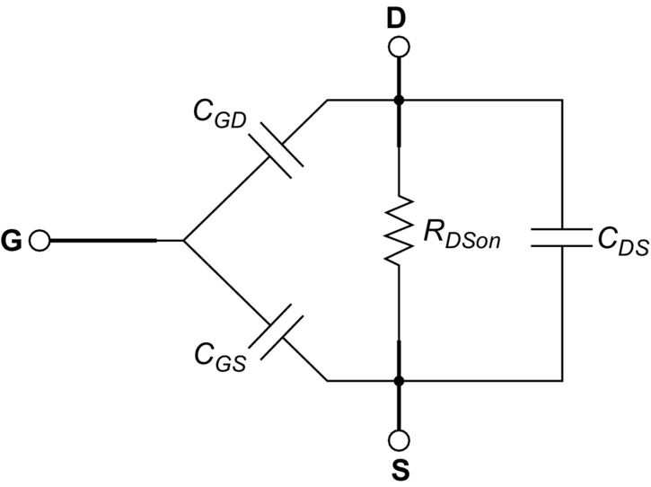

**FIG. 2.44** Equivalent circuit valid for the ohmic region.

#### **2.3.3.1 Turn-on Analysis**

The circuit used to analyze the turn-on and turn-off characteristics of a MOSFET is shown in [Fig. 2.45](https://learning.oreilly.com/library/view/power-electronics-handbook/9780128114087/B9780128114070000027.xhtml#f0230). The circuit contains a DC source (+Vcc), a MOSFET, an inductor (L), a resistor (R), a diode (D), and the gate driver, which is composed of the voltage source *Vg* and the resistor *RG*. The diode is considered ideal (without reverse recovery behavior). The inductor is the load of the circuit. Its inductance value is large enough so that the current thought it is considered constant. The diode is used to supply a path for the load current when the MOSFET is off.

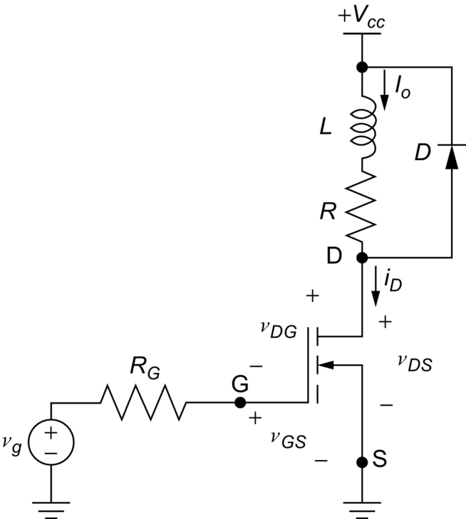

**FIG. 2.45** Circuit used to analyze the turn-on and turn-off characteristics of a MOSFET.

[Fig. 2.46](https://learning.oreilly.com/library/view/power-electronics-handbook/9780128114087/B9780128114070000027.xhtml#f0235) presents waveforms during the turn-on. The x-axis is divided into four intervals, as follows:

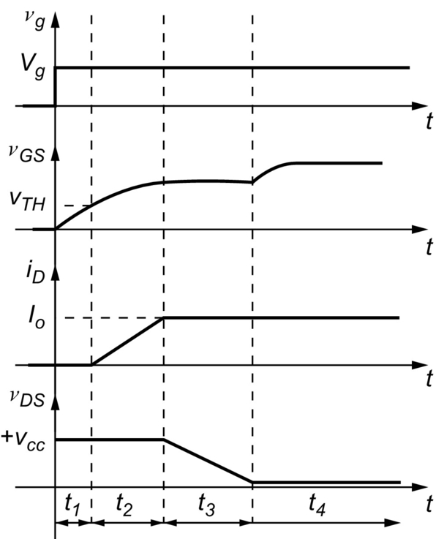

**FIG. 2.46** Waveforms during the turn-on process.

Initially, the MOSFET is in the cutoff region. Thus, the drain current is null, and the drain-to-source voltage is equal to the+Vcc. This makes the gate-drain capacitance to be charged. The interval *t1* begins with the voltage source *VG* going from zero to its nominal value. The gate-source capacitance begins to be charged through the resistor *RG*, while the gate-drain capacitance begins to be discharged. The drain current keeps null until the gate-to-source voltage reaches the threshold voltage. The time interval *t1* ends when the gate-source voltage reaches the threshold voltage. Once the MOSFET leaves the cutoff region at this moment, the interval *t1* represents the turn-on delay time. [Fig. 2.47](https://learning.oreilly.com/library/view/power-electronics-handbook/9780128114087/B9780128114070000027.xhtml#f0240) presents the equivalent circuit for the time interval *t1*. Since the diode is ON, the drain-source voltage does not change.

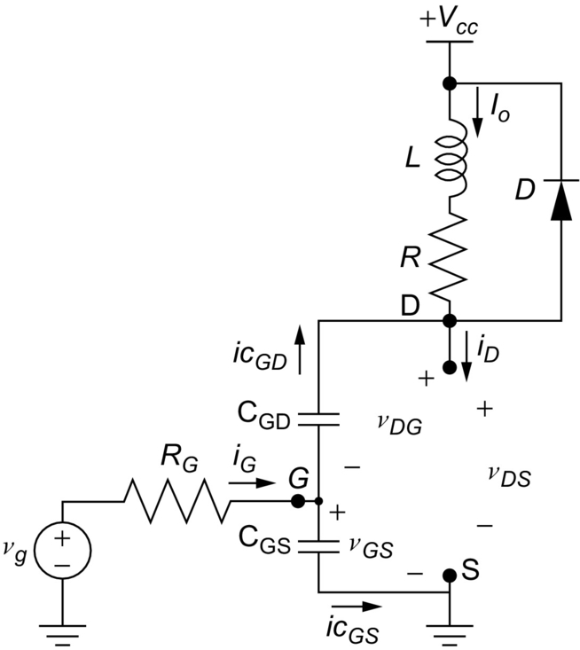

**FIG. 2.47** Equivalent circuit for the interval *t*1.

At the beginning of the interval *t2*, the gate-source voltage is higher than the threshold voltage, and the MOSFET starts conducting. The diode keeps conducting, while the drain current is lower than *Io*. The gate-source voltage remains growing, while the drain-source voltage keeps unchanged. [Fig. 2.48](https://learning.oreilly.com/library/view/power-electronics-handbook/9780128114087/B9780128114070000027.xhtml#f0245) presents the equivalent circuit for the time interval *t2*. The diode was replaced by a short circuit in order to emphasize its conduction state.

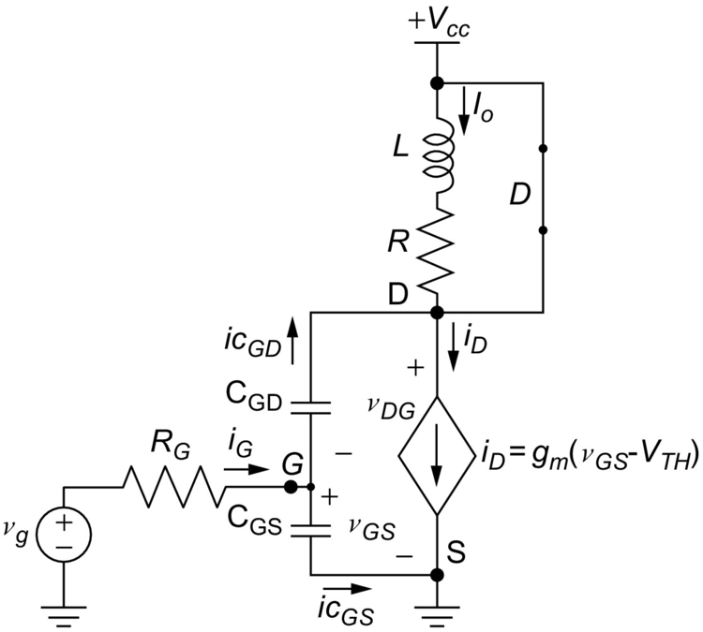

**FIG. 2.48** Equivalent circuit for the interval *t*2.

The interval *t3* begins when the load current is conducted entirely through the MOSFET (), turning off the diode. The drain-source voltage falls throughout this interval, reaching its minimum value at the end. The gate-drain capacitance is discharged by the gate current. Its voltage varies together with the drain-source voltage. [Fig. 2.49](https://learning.oreilly.com/library/view/power-electronics-handbook/9780128114087/B9780128114070000027.xhtml#f0250) shows the equivalent circuit for the time interval *t3*. The diode was replaced by an open circuit.

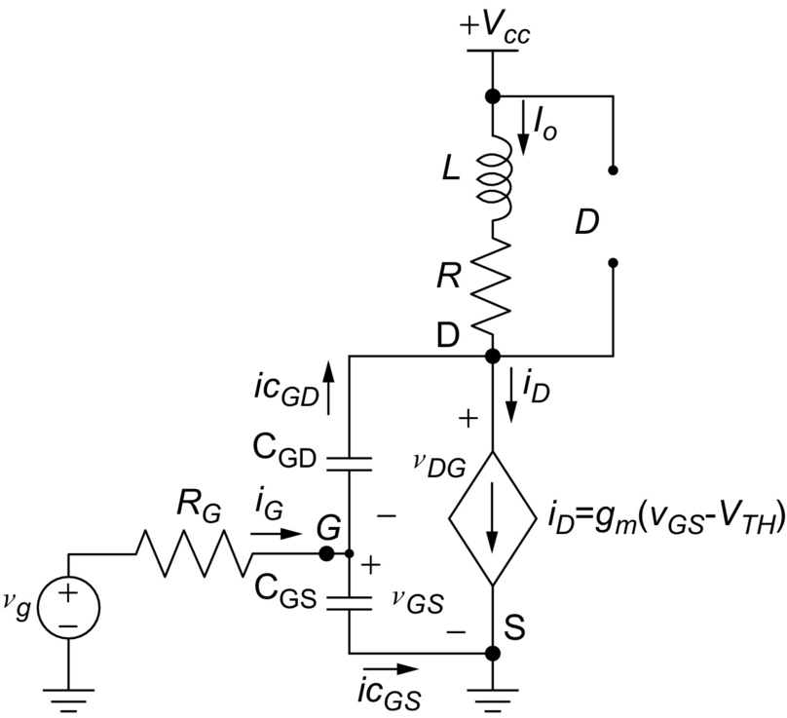

**FIG. 2.49** Equivalent circuit for the interval *t*3.

The interval *t4* begins when the drain-source voltage reaches its minimum value, which is given by [(2.13)](https://learning.oreilly.com/library/view/power-electronics-handbook/9780128114087/B9780128114070000027.xhtml#fo0070):

 **(2.13)**

The gate current finishes charging the gate-source capacitance, the gate-source voltages reaches its nominal value, and the MOSFET entered into the ohmic region. [Fig. 2.50](https://learning.oreilly.com/library/view/power-electronics-handbook/9780128114087/B9780128114070000027.xhtml#f0255) presents the equivalent circuit for the time interval *t4*.

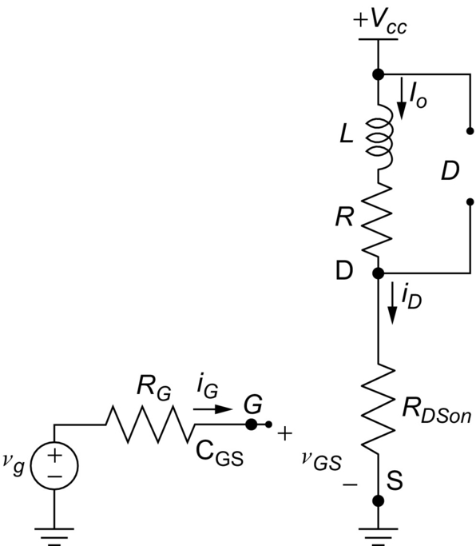

**FIG. 2.50** Equivalent circuit for the interval *t*4.

During intervals *t2* and *t3*, the MOSFET is passing through the active region with considerable drain-source voltage and drain current. As a result, power dissipation occurs during these intervals, contributing to the switching losses.

#### **2.3.3.2 Turn-off Analysis**

In order to analyze the turn-off characteristic, the same circuit shown in [Fig. 2.45](https://learning.oreilly.com/library/view/power-electronics-handbook/9780128114087/B9780128114070000027.xhtml#f0230) was adopted. The MOSFET is initially considered in the ohmic region with the values shown in the waveform of [Fig. 2.46](https://learning.oreilly.com/library/view/power-electronics-handbook/9780128114087/B9780128114070000027.xhtml#f0235). [Fig. 2.51](https://learning.oreilly.com/library/view/power-electronics-handbook/9780128114087/B9780128114070000027.xhtml#f0260) presents the waveforms during the turn-off switching.

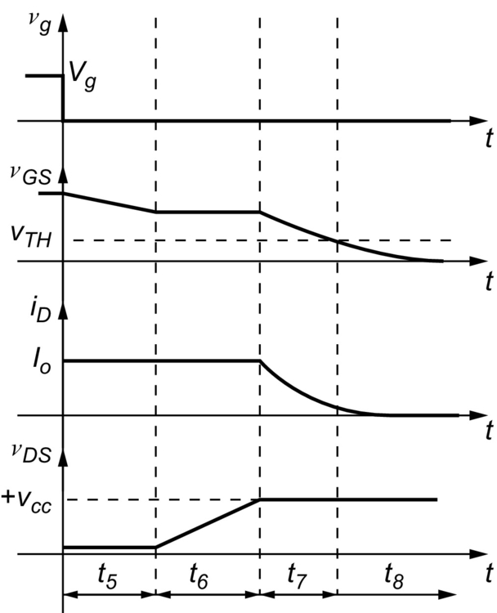

**FIG. 2.51** Waveforms during the turn-off process.

The turnoff of the MOSFET begins when the source Vg is set to zero (a negative voltage is also possible). During interval *t5*, the gate-source voltage begins to fall, discharging the gate-source capacitance and charging the gate-drain capacitance. The drain current and the drain-source voltage keep unchanged.

During interval *t6*, the drain-source voltage rises, while the gate-source voltage keeps constant. At the end of interval *t6*, the drain-source voltage reaches the value of the DC source (+Vcc), turning on the diode, and the drain current begins to fall.

The interval *t7* corresponds to the time required to the gate-source voltage to reach the threshold voltage. After that, the drain current is null, and the MOSFET is in the cutoff region.

Similarly to the turn-on behavior, the intervals *t6* and *t7* present considerable drain current and drain-source voltage, contributing to the switching losses.

### 2.3.4 SAFE OPERATION AREA

The SOA of the MOSFET is shown in [Fig. 2.52](https://learning.oreilly.com/library/view/power-electronics-handbook/9780128114087/B9780128114070000027.xhtml#f0265). The area SOA shows the values of drain current, and drain-source voltage can hold without destructive failure. MOSFETs do not present the second breakdown.

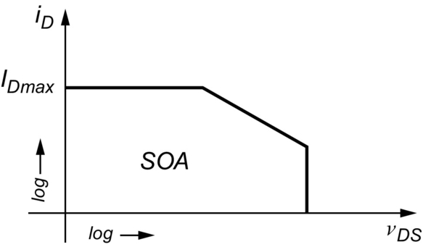

**FIG. 2.52** Safe operation area of the MOSFET.

### 2.3.5 MOSFET APPLICATIONS

The majority of applications of BJT can also be employed with MOSFET, especially those in DC–DC converters. Nevertheless, MOSFETs have been widely used in the field of electric vehicles [[11](https://learning.oreilly.com/library/view/power-electronics-handbook/9780128114087/B9780128114070000027.xhtml#bb0060)]. [Fig. 2.53](https://learning.oreilly.com/library/view/power-electronics-handbook/9780128114087/B9780128114070000027.xhtml#f0270) presents a typical bidirectional DC charger for electric vehicles using MOSFETs. The left side of the high-frequency transformer is the charger. The right side is the battery and the converter of the electric vehicle.

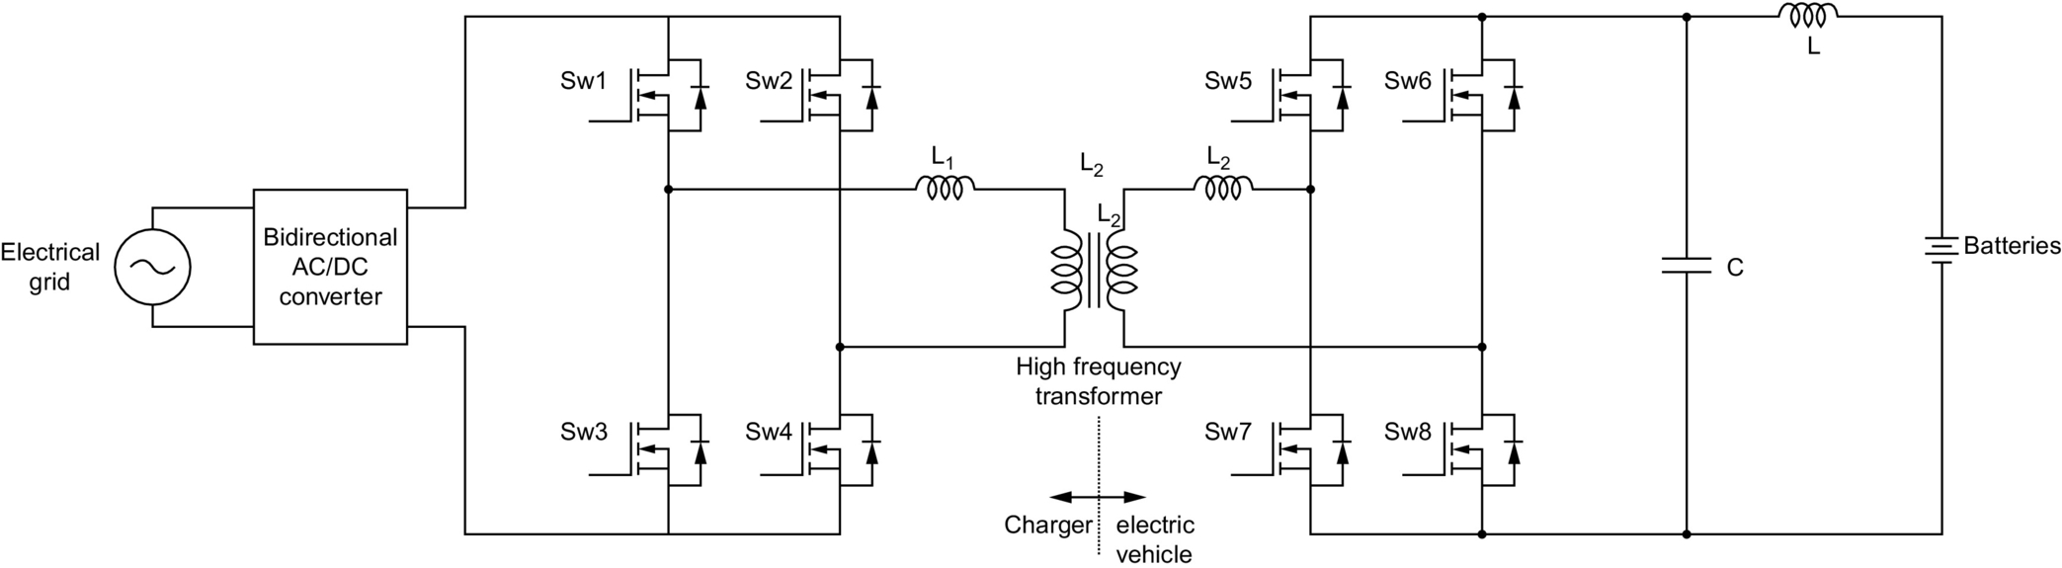

**FIG. 2.53** Typical bidirectional DC charger for electric vehicles using MOSFET.

### 2.3.6 PSPICE MODEL

The following text presents the PSPICE model for the MOSFET IRFBC30:

.Model IRFBC30 NMOS(Level=3 Gamma=0 Delta=0 Eta=0 Theta=0 Kappa=0.2 Vmax=0 Xj=0 + Tox=100n Uo=600 Phi=.6 Rs=5.002m Kp=20.43u

W=.35 L=2u Vto=3.625 + Rd=1.851 Rds=2.667MEG Cbd=790.1p Pb=.8 Mj=.5

Fc=.5 Cgso=1.64n + Cgdo=123.9p Rg=1.052 Is=720.2p N=1 Tt=685)

The definition of each parameter is given in [Table 2.3](https://learning.oreilly.com/library/view/power-electronics-handbook/9780128114087/B9780128114070000027.xhtml#t0020) [[4](https://learning.oreilly.com/library/view/power-electronics-handbook/9780128114087/B9780128114070000027.xhtml#bb0025)].

**Table 2.3**

**Parameter definition of a MOSFET model**

|  |  |
| --- | --- |
| **Parameter** | **Definition** |
| Level | Model type (1, 2, or 3) |
| Gamma | Bulk threshold parameter |
| Delta | Width effect on threshold |
| Eta | Static feedback (LEVEL=3) |
| Kappa | Saturation field factor (LEVEL=3) |
| Vmax | Maximum drift velocity |
| Xj | Metallurgical junction depth |
| Tox | Oxide thickness |
| Uo | Surface mobility |
| Phi | Surface potential |
| Rs | Source ohmic resistance |
| *Kp* | Transconductance |
| *W* | Channel width |
| *L* | Channel length |
| *Vto* | Zero-bias threshold voltage |
| *Rd* | Drain ohmic resistance |
| *Rds* | Drain-source shunt resistance |
| *Cbd* | Bulk-drain zero-bias P–N capacitance |
| *Pb* | Bulk P–N potential |
| *Mj* | Bulk P–N bottom grading coefficient |
| *Fc* | Bulk P–N forward-bias capacitance coefficient |
| Cgso | Gate-source overlap capacitance/channel width |
| Cgdo | Gate-drain overlap capacitance/channel width |
| Rg | Gate ohmic resistance |
| IS | Bulk P–N saturation current |
| *N* | Bulk emission coefficient *n* |
| *Tt* | Transit time |

## 2.4 Insulated Gate Bipolar Transistor

The IGBT is a device that integrates the advantage of having low on-voltage from BJT with the advantage of having an insulated-gate input from MOSFET. Such integration makes the IGBT a device with some superior characteristics compared with the BJT or MOSFET, with relative high switching speed. The IGBT can be gated like a MOSFET, and the output current is handled in a manner similar to the BJT. IGBTs do not have the body diode found in MOSFET. Thus, an external fast recovery diode is usually mounted in the same package for holding high reverse voltage.

### 2.4.1 BASIC STRUCTURE

[Fig. 2.54](https://learning.oreilly.com/library/view/power-electronics-handbook/9780128114087/B9780128114070000027.xhtml#f0275) presents a basic structure of a vertical IGBT. The IGBT has three terminal called collector (C), emitter (E), and gate (G). The gate terminal is isolated from the rest of the semiconductor by means of a SiO2 layer. The P+, N+N−, and P junctions constitute a parasitic BJT. By the application of a positive voltage higher than the threshold between the gate and emitter, the N-channel is created, similar to MOSFET, providing a path for a current from the collector to the emitter terminal. As the junctions P+N+ are forward-biased, it injects carriers into the N region, enhancing the conductivity and reducing the voltage drop along this region. This is the main difference between IGBT and MOSFET. The PN junction blocks reverse voltage when the IGBT is off. In spite of P-channel be possible, as its commutation intrinsically slower than N-channel, it is not convenient for power applications.

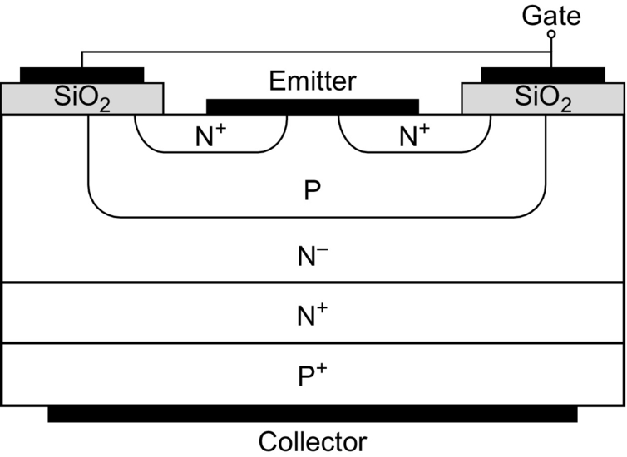

**FIG. 2.54** Basic structure of a vertical IGBT.

[Fig. 2.55](https://learning.oreilly.com/library/view/power-electronics-handbook/9780128114087/B9780128114070000027.xhtml#f0280) presents the symbol for an N-channel type IGBT. The symbol is similar to a BJT, except that the gate terminal is insulated from the rest of the device. Other symbols for IGBT can be found in the literature.

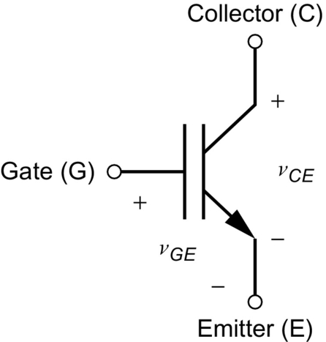

**FIG. 2.55** Symbol for an N-channel type IGBT.

### 2.4.2 STATIC CHARACTERISTICS

[Fig. 2.56](https://learning.oreilly.com/library/view/power-electronics-handbook/9780128114087/B9780128114070000027.xhtml#f0285) presents the static characteristic of an N-channel IGBT. The curves are similar to that for BJT, except that the controlling variable is the gate-emitter voltage. *BV* is the breakdown voltage.

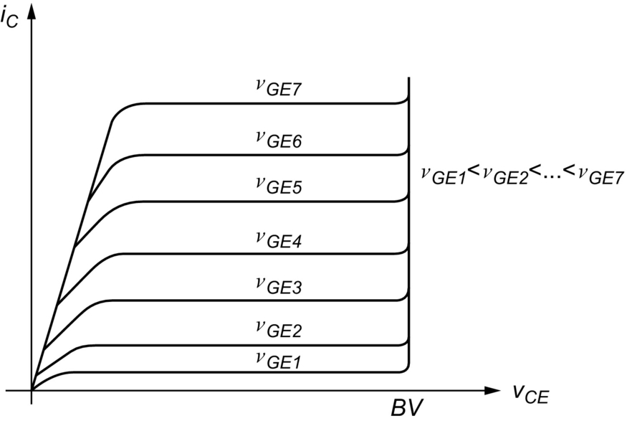

**FIG. 2.56** Static characteristics of an N-channel IGBT.

### 2.4.3 SWITCHING CHARACTERISTICS

#### **2.4.3.1 Turn-on Analysis**

The turn-on process of IGBT is similar to that for MOSFET, once the IGBT has the insulated-gate terminal. However, the *vCE* typically falls slower compared with a MOSFET with the same ratings. [Fig. 2.57](https://learning.oreilly.com/library/view/power-electronics-handbook/9780128114087/B9780128114070000027.xhtml#f0290) presents the waveforms during the turn-on process of an IGBT. The circuit used to analyze these waveforms is that shown in [Fig. 2.43](https://learning.oreilly.com/library/view/power-electronics-handbook/9780128114087/B9780128114070000027.xhtml#f0220), except that the MOSFET is replaced by an IGBT.

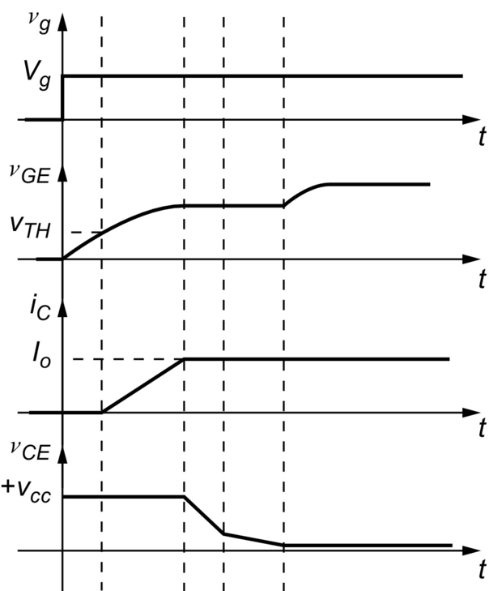

**FIG. 2.57** Waveforms during the turn-on process of an IGBT.

#### **2.4.3.2 Turn-off Analysis**

The turn-off process of IGBT depends on the removal of carriers that came from the P+ region. Since IGBT has insulated gate, such removal cannot be made through the gate terminal. The solution is the inclusion of the N+ layer, which the recombination tax is faster than the N-layer. By diffusion, the storage charges in the N-layer are extinguished, reestablishing the potential barrier. [Fig. 2.58](https://learning.oreilly.com/library/view/power-electronics-handbook/9780128114087/B9780128114070000027.xhtml#f0295) presents the waveforms during the turn-off process of an IGBT.

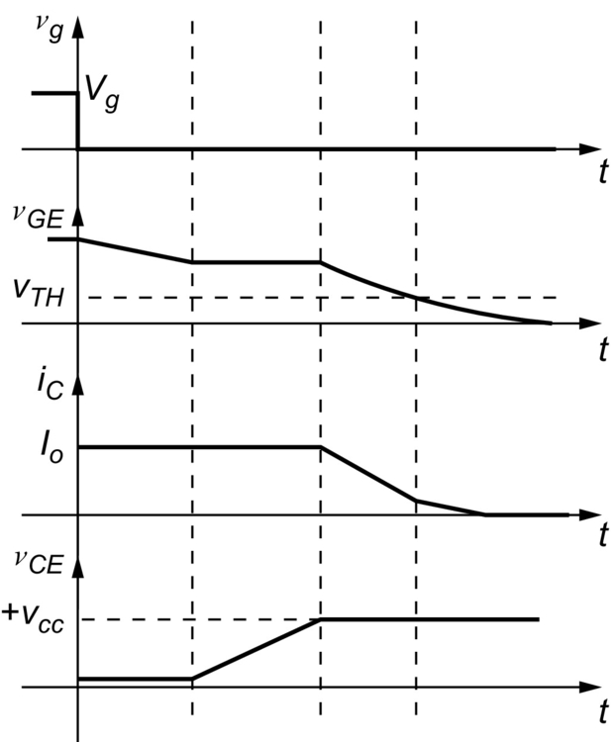

**FIG. 2.58** Waveforms during the turn-off process of an IGBT.

### 2.4.4 IGBT APPLICATIONS

IGBTs have a vast field of application. One of the most relevant is in DC-AC converters, known also as inverters. Such inverters are usually applied in uninterrupted power supplies, motor drivers, and grid interfaces for connecting renewable sources into the distribution/transmission systems [[1](https://learning.oreilly.com/library/view/power-electronics-handbook/9780128114087/B9780128114070000027.xhtml#bb0010),[3](https://learning.oreilly.com/library/view/power-electronics-handbook/9780128114087/B9780128114070000027.xhtml#bb0020),[8](https://learning.oreilly.com/library/view/power-electronics-handbook/9780128114087/B9780128114070000027.xhtml#bb0045),[11](https://learning.oreilly.com/library/view/power-electronics-handbook/9780128114087/B9780128114070000027.xhtml#bb0060)]. [Fig. 2.59](https://learning.oreilly.com/library/view/power-electronics-handbook/9780128114087/B9780128114070000027.xhtml#f0300) presents a single-phase inverter using IGBTs with LC filter. The inverter has a DC source as input. The terminals A and B are the output of the inverter. The inductor and capacitor are used to filter the high-frequency components of the inverter output voltage. When an induction motor is used as load, the LC filter can be removed, since the motor windings work as filter for the current.

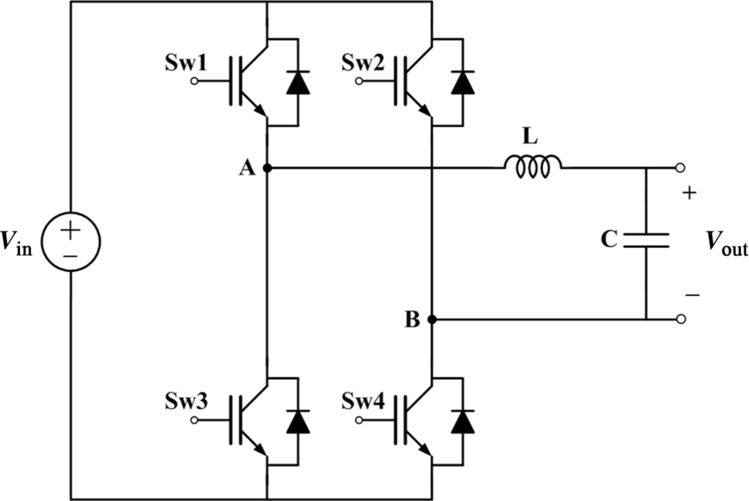

**FIG. 2.59** Single-phase inverter using IGBTs with LC filter.

Another field of application of IGBT-based inverters is in power quality improvements. [Fig. 2.60](https://learning.oreilly.com/library/view/power-electronics-handbook/9780128114087/B9780128114070000027.xhtml#f0305) presents a unified power quality conditioner (UPQC) [[12](https://learning.oreilly.com/library/view/power-electronics-handbook/9780128114087/B9780128114070000027.xhtml#bb0065)] with electronic converters using IGBTs. The UPQC is composed of series and shunt active filters. The first is used to filter the voltage applied to the load, while the second is used to filter the harmonic current produced by the load.

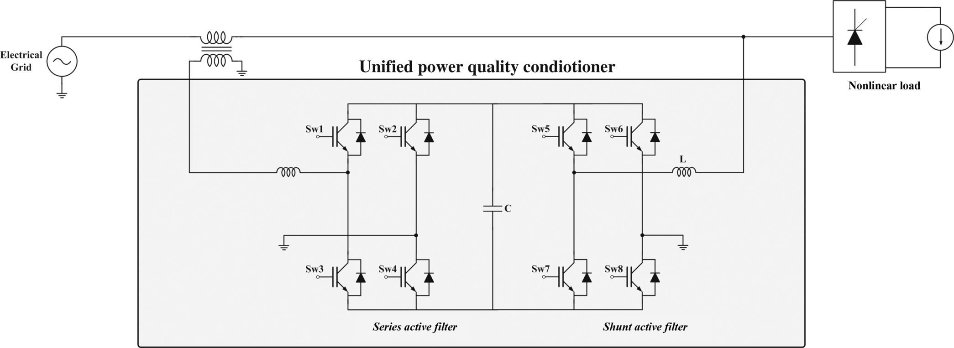

**FIG. 2.60** Unified power quality conditioner (UPQC) with electronics converters using IGBTs.

### 2.4.5 PSPICE MODEL

The following text presents the PSPICE model for the IGBT IXGT32N170A:

.MODEL IXGT32N170A NIGBT (+ TAU=63.552E-9 + KP=14.397 +AREA=16.000E-6 + AGD=6.4000E-6 + WB=117.00E-6 + VT=5.3804 + MUN=1.0000E6 + MUP=150 + BVF=9.9990 +KF=.5005 + CGS=38.737E-9 + COXD=88.530E-9 + VTD=-5)

The definition of each parameter is given in [Table 2.4](https://learning.oreilly.com/library/view/power-electronics-handbook/9780128114087/B9780128114070000027.xhtml#t0025) [[4](https://learning.oreilly.com/library/view/power-electronics-handbook/9780128114087/B9780128114070000027.xhtml#bb0025)].

**Table 2.4**

**2.4 Parameter definition of a IGBT model**

|  |  |
| --- | --- |
| **Parameter** | **Definition** |
| TAU | Ambipolar recombination lifetime |
| KP | MOS transconductance |
| AREA | Area of the device |
| AGD | Gate-drain overlap area |
| WB | Metallurgical base width |
| VT | Threshold voltage |
| MUN | Electron mobility |
| MUP | Hole mobility |
| BVF | Avalanche uniformity factor |
| KF | Triode region factor |
| CGS | Gate-source capacitance |
| COXD | Gate-drain overlap oxide capacitance |
| VTD | Gate-drain overlap depletion threshold |

## 2.5 Swtiching evaluation of a Real MOSFET

In order to verify real switching characteristics of a MOSFET, the circuit shown in [Fig. 2.61](https://learning.oreilly.com/library/view/power-electronics-handbook/9780128114087/B9780128114070000027.xhtml#f0310) was built. The MOSFET is connected to a circuit composed of the main source (Vcc) and an *RL* load. The switch Sw1 is used to insert or remove the inductance of the load. The diode *D* is used as freewheeling path for the load. The gate driver is composed of a square-wave source (*Vg*), a resistor, a potentiometer, a capacitor, and a switch Sw2, used to insert or remove the capacitor. The potentiometer can vary from 0 to 1 kΩ. The MOSFET is the IRF530.

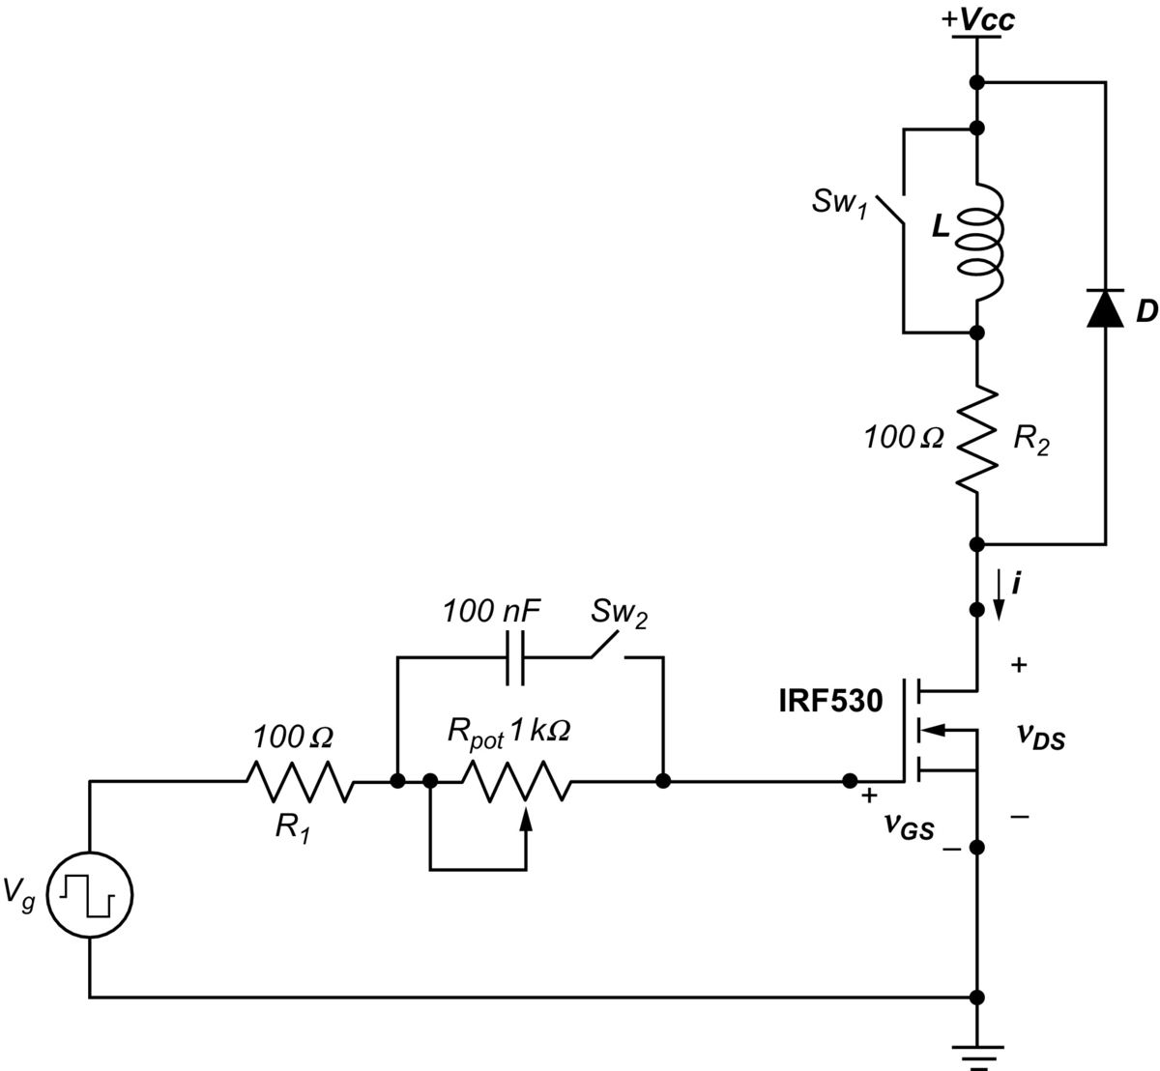

**FIG. 2.61** Circuit used to verify real switching characteristics of transistors.

### 2.5.1 RESULTS FOR SW1 ON AND SW2 OFF AND *RPOT* AT THE MAXIMUM RESISTANCE

The switch Sw1 is ON, bypassing the inductor *L*. The switch Sw2 is OFF, disconnecting the capacitor of the gate driver. The *Rpot* is at its maximum resistance. [Fig. 2.62](https://learning.oreilly.com/library/view/power-electronics-handbook/9780128114087/B9780128114070000027.xhtml#f0315) presents waveforms for *Vg* source and the drain-source voltage. The *Vg* source goes from −3 to +10 V with frequency equal to 5 kHz.

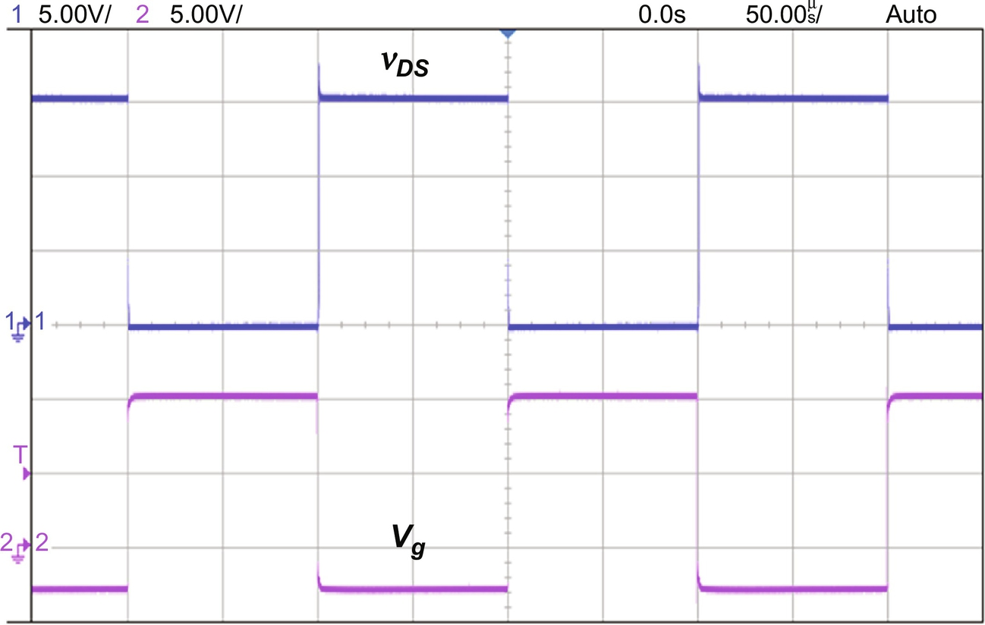

**FIG. 2.62** Waveforms for Vg source and the drain-source voltage.

[Fig. 2.63](https://learning.oreilly.com/library/view/power-electronics-handbook/9780128114087/B9780128114070000027.xhtml#f0320) presents details of the turn-on process. The *Vg* source changes from −3 to 10 V almost instantaneously. The turn-on delay of the MOSFET is measured from the moment where the *Vg* source begins to rise until the drain-source voltage begins to fall. Therefore, the turn-on delay for the MOSFET is 0.7 μs.

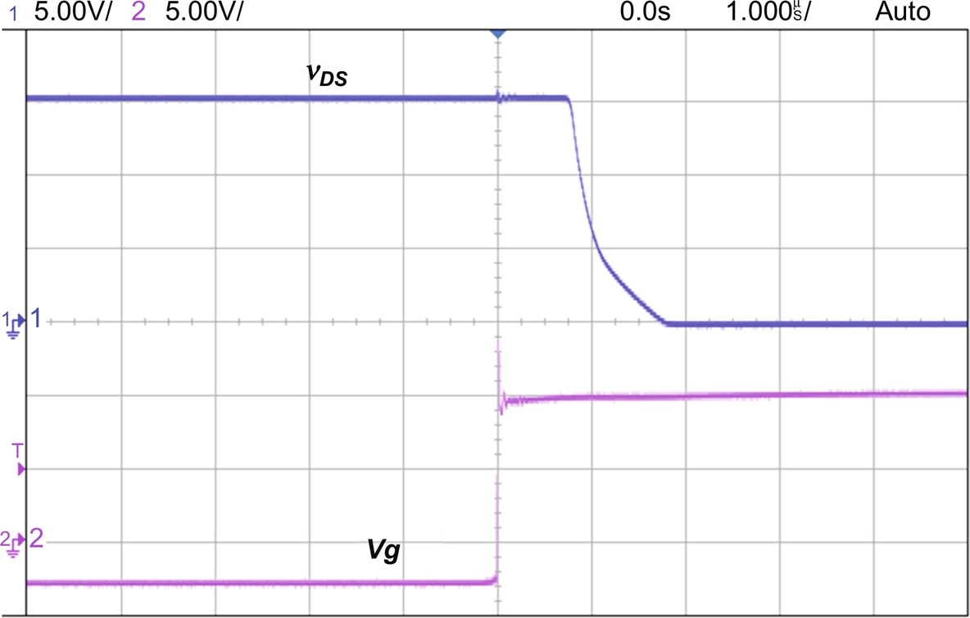

**FIG. 2.63** Details of the turn-on process for Sw1 ON and Sw2 OFF and *Rpot* at the maximum resistance.

[Fig. 2.64](https://learning.oreilly.com/library/view/power-electronics-handbook/9780128114087/B9780128114070000027.xhtml#f0325) presents details of the turn-off process. Similarly, the *Vg* source changes almost instantaneously from +10 to −3 V, and the turn-off delay is measured from the moment the *Vg* source begins to fall until the moment the drain-source voltage begins to rise. The turn-off delay for the MOSFET is 1.5 μs.

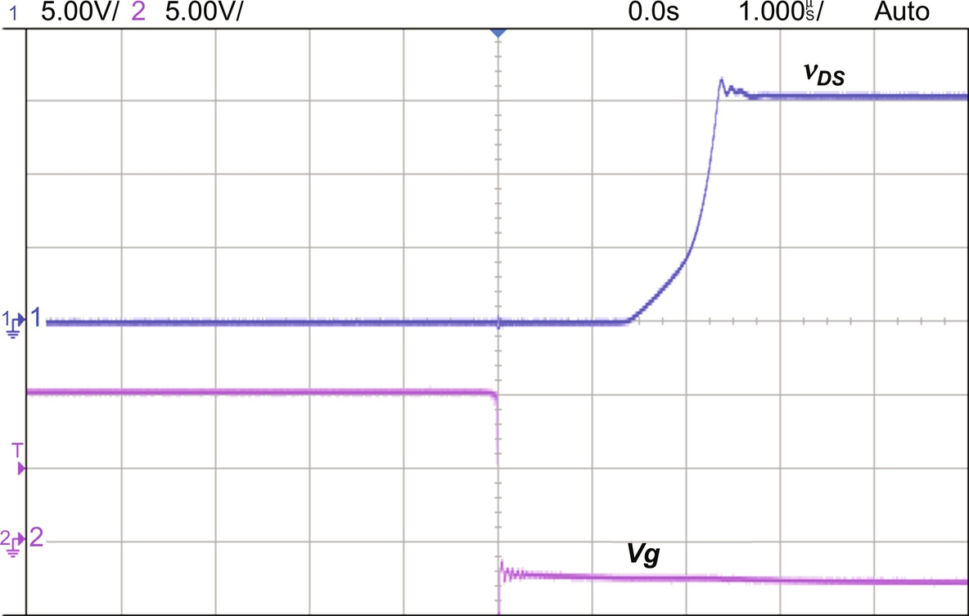

**FIG. 2.64** Details of turn-off process for Sw1 ON and Sw2 OFF and *Rpot* at the maximum resistance.

[Fig. 2.65](https://learning.oreilly.com/library/view/power-electronics-handbook/9780128114087/B9780128114070000027.xhtml#f0330) presents the drain-source voltage and the gate-source voltage during the turn-on process. The threshold voltage of the MOSFET is evident. As soon as the threshold is achieved, the drain-source voltage begins to fall.

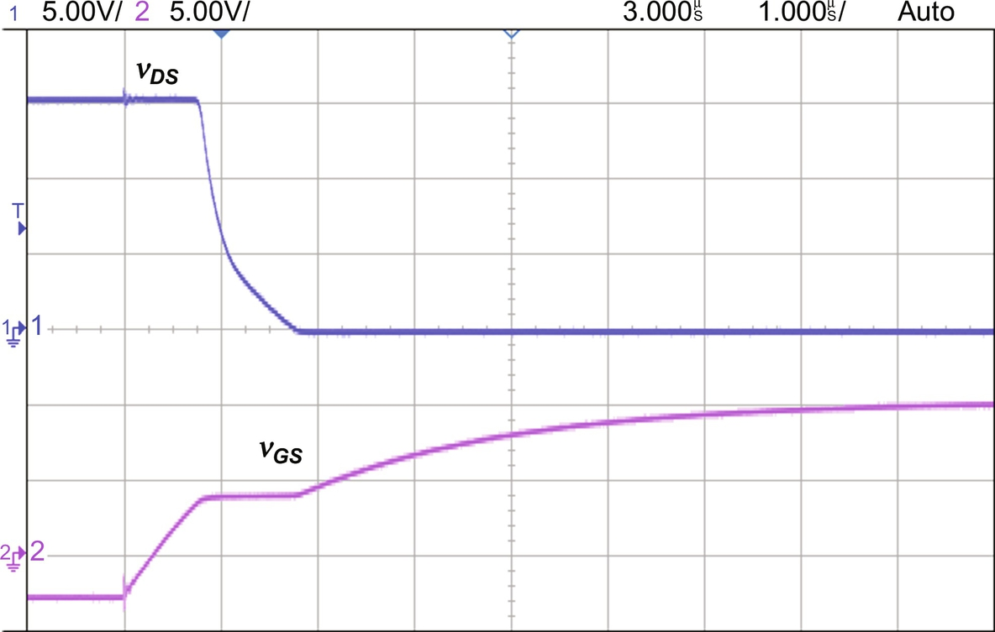

**FIG. 2.65** Drain-source voltage and the gate-source voltage during the turn-on process for Sw1 ON and Sw2 OFF and *Rpot* at the maximum resistance.

[Fig. 2.66](https://learning.oreilly.com/library/view/power-electronics-handbook/9780128114087/B9780128114070000027.xhtml#f0335) presents the drain-source voltage and the gate-source voltage during the turn-off process.

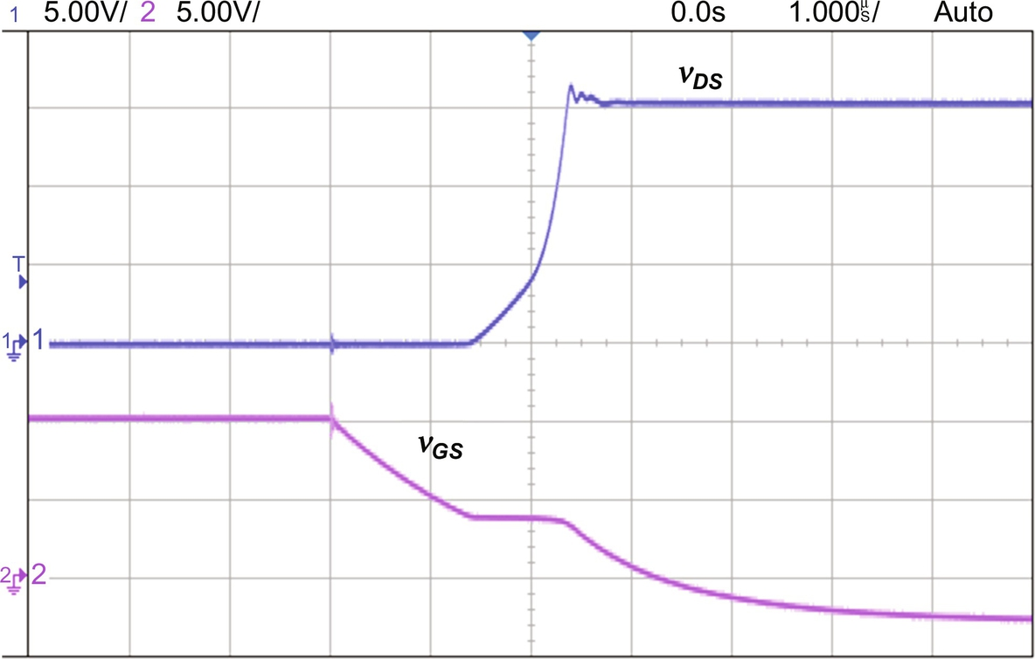

**FIG. 2.66** Drain-source voltage and the gate-source during the turn-off process for Sw1 ON and Sw2 OFF and *Rpot* at the maximum resistance.

### 2.5.2 RESULTS FOR SW1 ON AND SW2 OFF AND *RPOT* AT THE MINIMUM RESISTANCE

The *Rpot* is set to its minimum resistance (0 Ω). [Fig. 2.67](https://learning.oreilly.com/library/view/power-electronics-handbook/9780128114087/B9780128114070000027.xhtml#f0340) presents the details of the turn-on process. The turn-on delay of the MOSFET is approximately 0.15 μs. The delay is lower compared with the previous case. Since the *Rpot* is at its minimum resistance, the gate-driver resistance is made only by *R*1, resulting in a lower time constant for charging the MOSFET capacitance. Consequently, the turn-on process is faster.

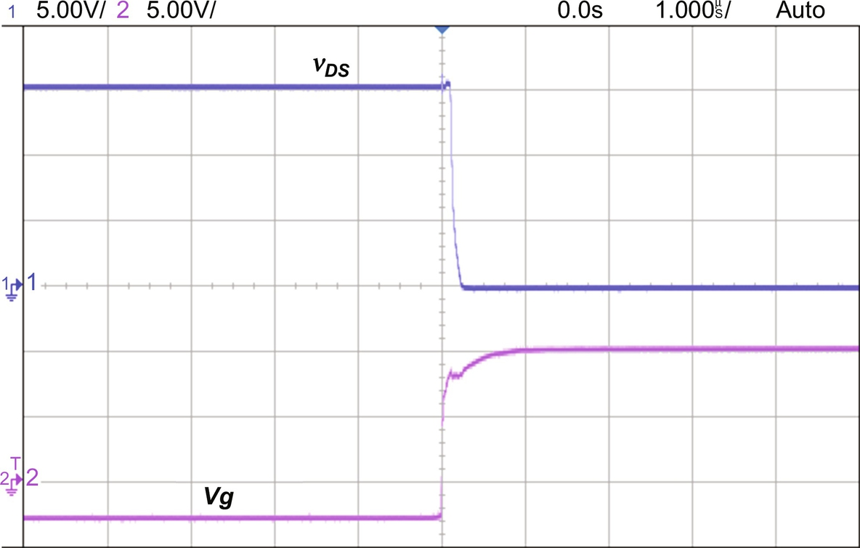

**FIG. 2.67** Details of turn-on process for Sw1 ON and Sw5 OFF and *Rpot* at the minimum resistance.

[Fig. 2.68](https://learning.oreilly.com/library/view/power-electronics-handbook/9780128114087/B9780128114070000027.xhtml#f0345) presents the details of the turn-off process. The turn-off delay of the MOSFET is 0.3 μs.

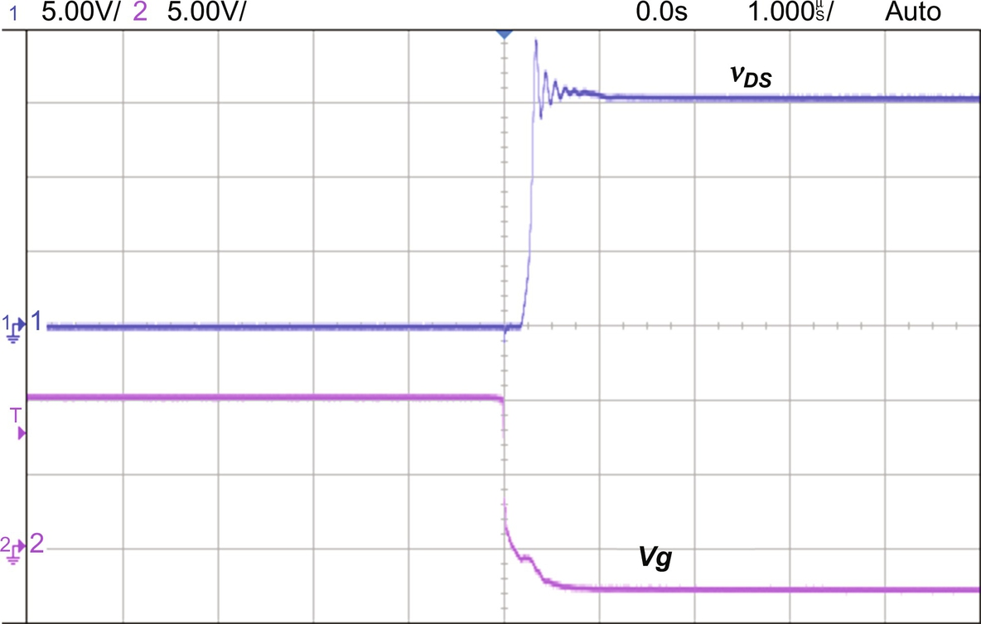

**FIG. 2.68** Details of turn-off process for Sw1 ON and Sw5 OFF and *Rpot* at the minimum resistance.

[Fig. 2.69](https://learning.oreilly.com/library/view/power-electronics-handbook/9780128114087/B9780128114070000027.xhtml#f0350) presents the drain-source voltage and the gate-source voltage during the turn-on process.

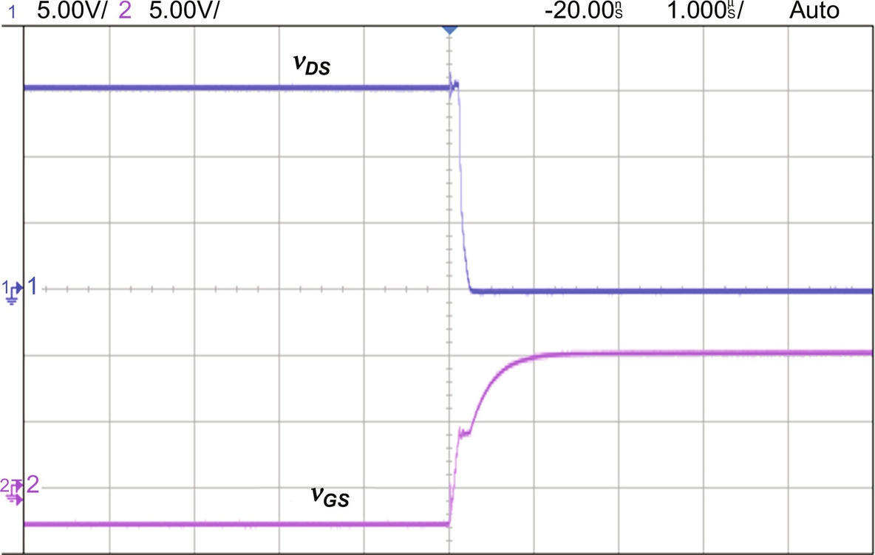

**FIG. 2.69** Drain-source voltage and the gate-source voltage during the turn-on process for Sw1 ON and Sw2 OFF and *Rpot* at the maximum resistance.

[Fig. 2.70](https://learning.oreilly.com/library/view/power-electronics-handbook/9780128114087/B9780128114070000027.xhtml#f0355) presents the drain-source voltage and the gate-source voltage during the turn-off process.

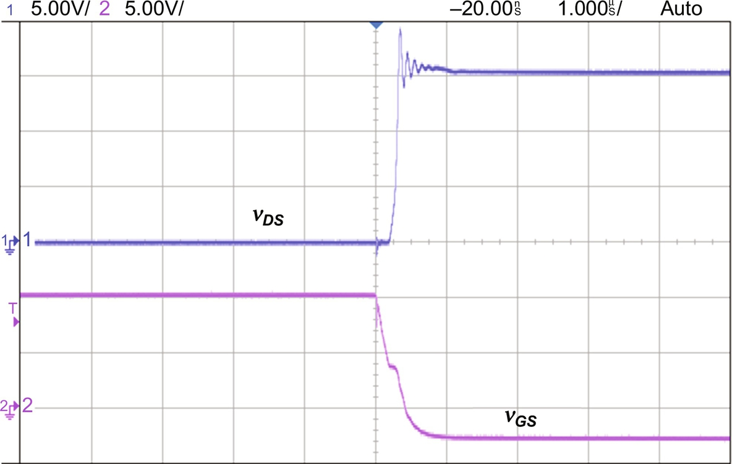

**FIG. 2.70** Drain-source voltage and the gate-source during the turn-off process for Sw1 ON and Sw2 OFF and *Rpot* at the maximum resistance.

### 2.5.3 RESULTS FOR SW1 AND SW2 ON AND *RPOT* AT THE MAXIMUM RESISTANCE

The switch Sw2 is now ON, connecting the capacitor to the gate driver. [Fig. 2.71](https://learning.oreilly.com/library/view/power-electronics-handbook/9780128114087/B9780128114070000027.xhtml#f0360) presents the details of the turn-on process. The turn-on delay of the MOSFET is approximately 100 ns. The inclusion of the capacitor makes the transistor faster due to the fact that at initial turn-on process, the capacitor is seen as a short circuit by the voltage source. Thus, the gate current goes through it and charges faster the MOSFET capacitance. As soon as the capacitor is charged, the gate current passes through the potentiometer.

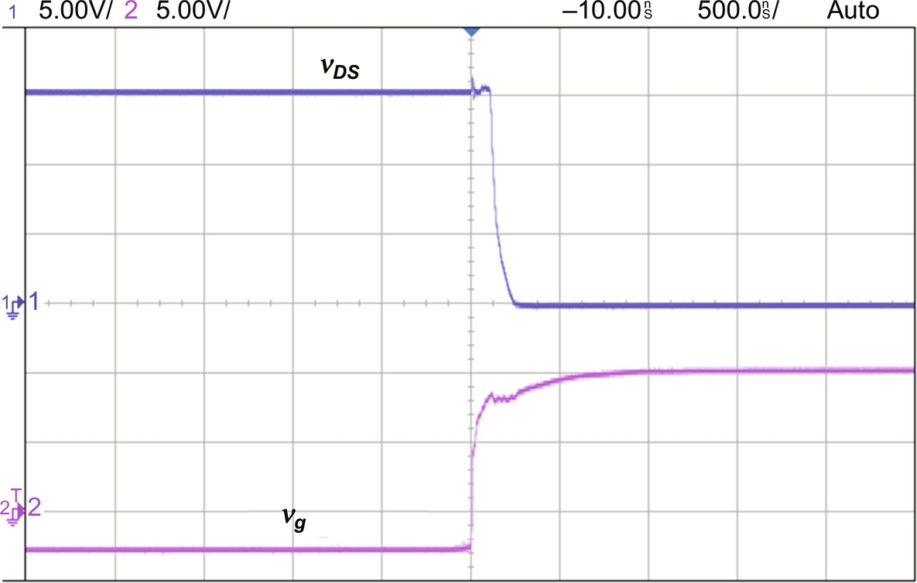

**FIG. 2.71** Details of turn-on process for Sw1 and Sw2 ON and *Rpot* at the maximum resistance.

[Fig. 2.72](https://learning.oreilly.com/library/view/power-electronics-handbook/9780128114087/B9780128114070000027.xhtml#f0365) presents the details of the turn-off process. The turn-off of the MOSFET is 200 ns.

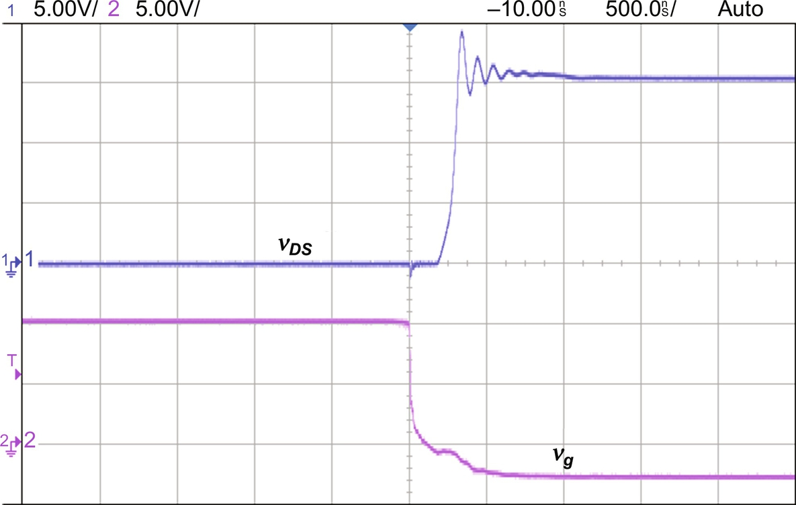

**FIG. 2.72** Details of turn-off process for Sw1 and Sw2 ON and *Rpot* at the maximum resistance.

### 2.5.4 RESULTS FOR SW1 AND SW2 OFF AND *RPOT* AT THE MAXIMUM RESISTANCE

The switches Sw1 and Sw2 are OFF. The inductor now has effect on the circuit. [Fig. 2.73](https://learning.oreilly.com/library/view/power-electronics-handbook/9780128114087/B9780128114070000027.xhtml#f0370) presents the load current (drain current) and the drain-source voltage. The current keeps growing during the conduction of the MOSFET.

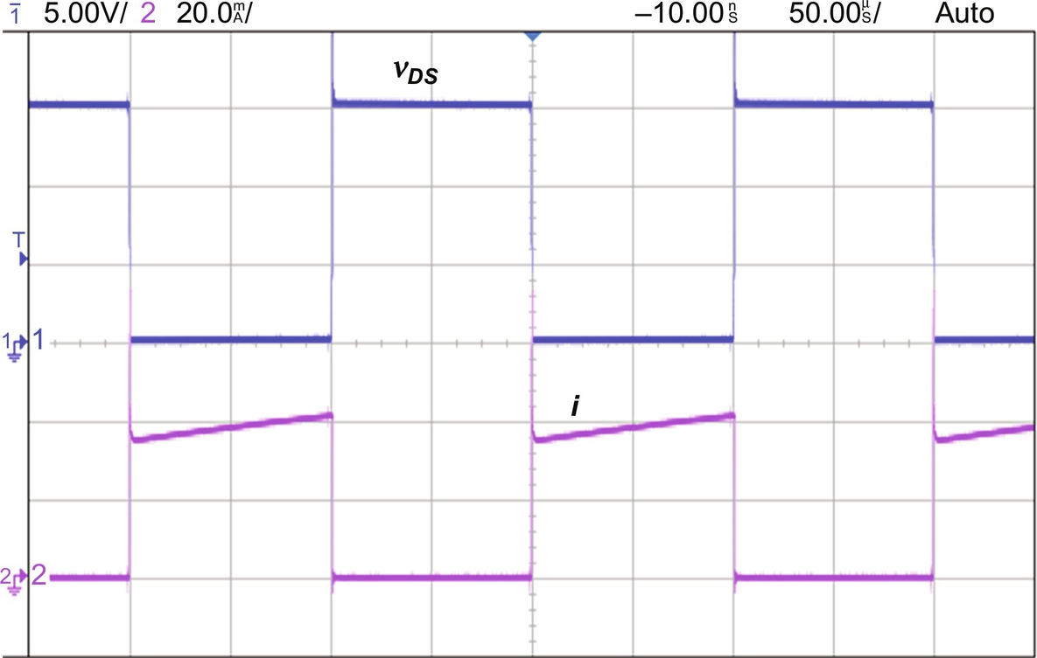

**FIG. 2.73** Load current (drain current) and the drain-source voltage.

[Fig. 2.74](https://learning.oreilly.com/library/view/power-electronics-handbook/9780128114087/B9780128114070000027.xhtml#f0370) presents the details of the turn-on process when Sw1 and Sw2 are OFF and *Rpot* at the maximum resistance.

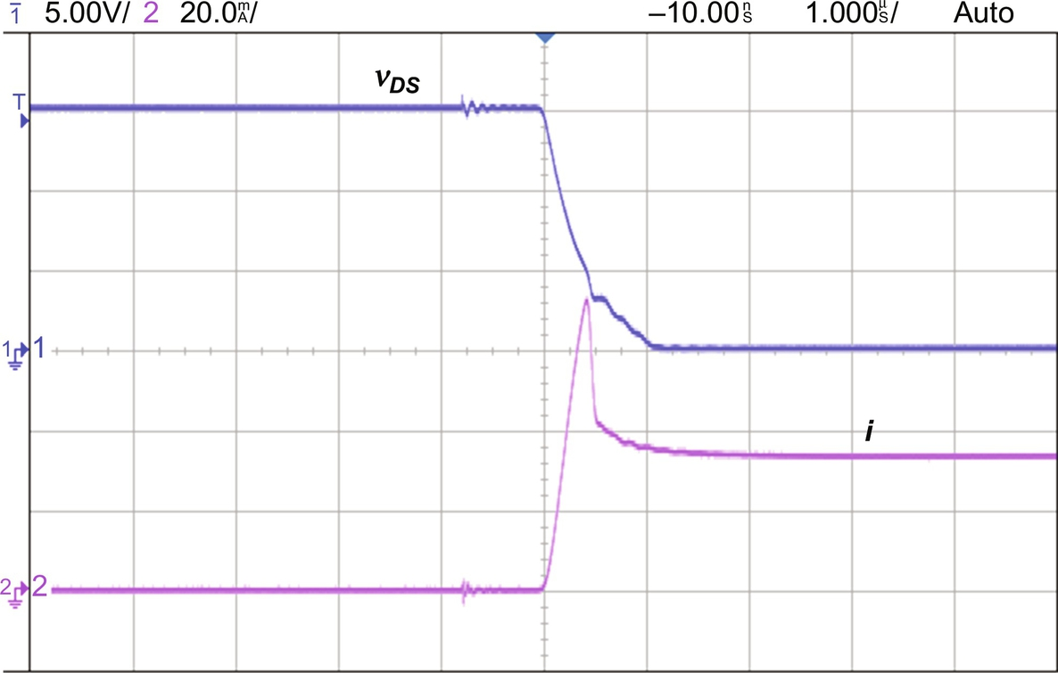

**FIG. 2.74** Detail of the turn-on process when Sw1 and Sw2 are OFF and *Rpot* at the maximum resistance.

[Fig. 2.75](https://learning.oreilly.com/library/view/power-electronics-handbook/9780128114087/B9780128114070000027.xhtml#f0380) presents the details of the turn-off process when Sw1 and Sw2 are OFF and *Rpot* at the maximum resistance.

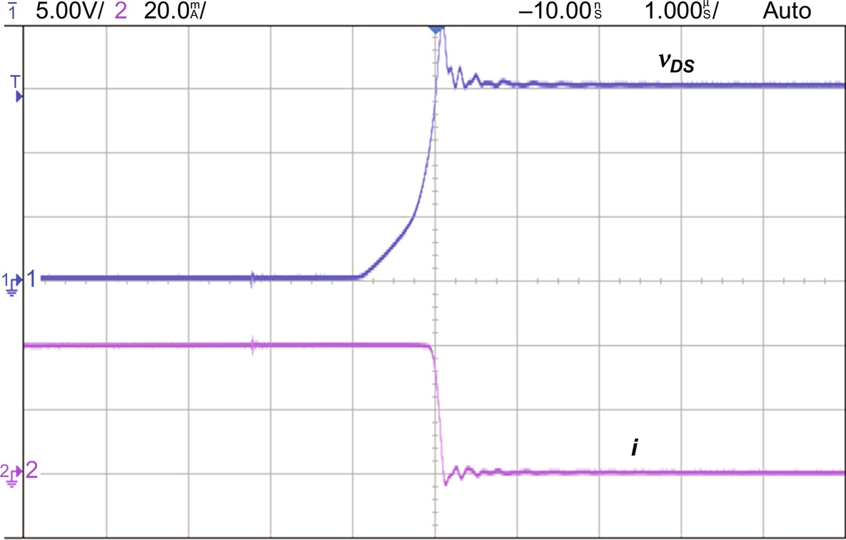

**FIG. 2.75** Detail of the turn-off process when Sw1 and Sw2 are OFF and *Rpot* at the maximum resistance.

## 2.6 Heatsink Thermal Design for Power Semiconductors

In power semiconductor devices, the heat from Joule's effect is produced in the semiconductor wafer. Then, the heat flows to colder environments like the device case and the ambient. This heat flux depends on the temperature gradient and the thermal characteristics of the materials involved.

Usually, an analogy with electric circuit is made to evaluate the heat flow. The average power dissipated in a semiconductor is represented by a current source. The temperatures in junction, case, sink, and ambient are represented by voltage nodes, while the thermal resistances are the circuit resistances. [Fig. 2.76](https://learning.oreilly.com/library/view/power-electronics-handbook/9780128114087/B9780128114070000027.xhtml#f0385) presents the equivalent electric circuit for thermal design, valid for steady-state situation. The heat sink thermal resistances are represented by *RTsa*. *RTcs* represents the material placed between the semiconductor case and the heat sink. Usually, mica is used. Its thermal resistance is low. The dashed lines indicate that the heat sink will be connected after the electric circuit thermal analysis is performed.

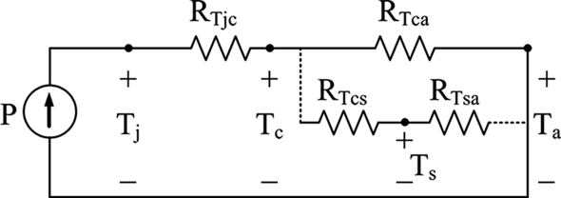

**FIG. 2.76** Equivalent electric circuit for thermal design, valid for steady-state situation.

[Table 2.5](https://learning.oreilly.com/library/view/power-electronics-handbook/9780128114087/B9780128114070000027.xhtml#t0030) presents the nomenclature of the equivalent voltage nodes.

**Table 2.5**

**Nomenclature of the equivalent voltage nodes**

|  |  |
| --- | --- |
| **Parameter** | **Definition** |
| *Tj* | Junction temperature |
| *Tc* | Case temperature |
| *Ta* | Ambient temperature |
| *Ts* | Heat-sink temperature |

[Table 2.6](https://learning.oreilly.com/library/view/power-electronics-handbook/9780128114087/B9780128114070000027.xhtml#t0035) presents the nomenclature of the equivalent resistances.

**Table 2.6**

**Nomenclature of the equivalent resistances**

|  |  |
| --- | --- |
| **Parameter** | **Definition** |
| *RTjc* | Junction-to-case resistance |
| *RTca* | Case-to-ambient resistance |
| *RTcs* | Case-to-heat-sink resistance |
| *RTsa* | Heat-sink-to-ambient resistance |

The objective of heat-sink thermal design is to guarantee that the semiconductor junction does not exceed its maximum allowed temperature. The ambient temperature is considered constant. The junction-to-case and case-to-ambient resistances are informed by manufactures.

According to [Fig. 2.76](https://learning.oreilly.com/library/view/power-electronics-handbook/9780128114087/B9780128114070000027.xhtml#f0385), the junction temperature is given by [(2.14)](https://learning.oreilly.com/library/view/power-electronics-handbook/9780128114087/B9780128114070000027.xhtml#fo0075):

 **(2.14)**

**Example 2.1**

Find the junction and case temperatures for a semiconductor with the parameters given in [Table 2.7](https://learning.oreilly.com/library/view/power-electronics-handbook/9780128114087/B9780128114070000027.xhtml#t0040).

**Table 2.7**

**Semiconductor parameters**

|  |  |  |
| --- | --- | --- |
| **Parameter** | **Value** | **Description** |
| *P* | 20 W | Dissipated power |
| *RTjc* | 2°C/W | Obtained from a manufacture catalog |
| *RTca* | 10°C/W | Obtained from a manufacture catalog |
| *T*a | 40° | Chose by the designer depending on the location |
| *Tjmax* | 120° | Maximum junction temperature before failure. Obtained from a manufacture catalog |

From [Fig. 2.74](https://learning.oreilly.com/library/view/power-electronics-handbook/9780128114087/B9780128114070000027.xhtml#f0375) and [Table 2.7](https://learning.oreilly.com/library/view/power-electronics-handbook/9780128114087/B9780128114070000027.xhtml#t0040), the case and junction temperatures are given by [(2.15)](https://learning.oreilly.com/library/view/power-electronics-handbook/9780128114087/B9780128114070000027.xhtml#fo0080) and [(2.16)](https://learning.oreilly.com/library/view/power-electronics-handbook/9780128114087/B9780128114070000027.xhtml#fo0085), respectively:

 **(2.15)**

**** **(2.16)**

### 2.6.1 HEATSINK DESIGN

From the previous example, the value resulted in [(2.16)](https://learning.oreilly.com/library/view/power-electronics-handbook/9780128114087/B9780128114070000027.xhtml#fo0085) is much higher than the value given in [Table 2.7](https://learning.oreilly.com/library/view/power-electronics-handbook/9780128114087/B9780128114070000027.xhtml#t0040) for the maximum junction temperature. This leads the semiconductor to destruction. Considering the impossibility to reduce the dissipated power and that there is no way to change the thermal resistance, the solution to ovoid the semiconductor destruction is to add a heat sink between the case and ambient with low thermal resistance. The heat sink introduces a low thermal resistance in parallel to the case-to-ambient resistance. This causes a reduction in the case temperature and consequently in the junction temperature. The following example explains hot to design the heat sink.

**Example 2.2**

Design a heat sink for the semiconductor given in [Example 2.1](https://learning.oreilly.com/library/view/power-electronics-handbook/9780128114087/B9780128114070000027.xhtml#en0010).

The design of the heat sink consists on finding the value for the heat-sink-to-ambient resistance *RTsa*. From [Fig. 2.74](https://learning.oreilly.com/library/view/power-electronics-handbook/9780128114087/B9780128114070000027.xhtml#f0375) and [Table 2.7](https://learning.oreilly.com/library/view/power-electronics-handbook/9780128114087/B9780128114070000027.xhtml#t0040), the equivalent resistance between the case and the ambient is given by [(2.17)](https://learning.oreilly.com/library/view/power-electronics-handbook/9780128114087/B9780128114070000027.xhtml#fo0090). The maximum junction temperature is used because the final result in this example will give the maximum heat-sink-to-ambient resistance:

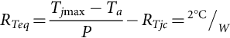 **(2.17)**

The case-to-heat-sink resistance is given by [(2.18)](https://learning.oreilly.com/library/view/power-electronics-handbook/9780128114087/B9780128114070000027.xhtml#fo0095), obtained from a manufacture catalog:

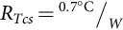 **(2.18)**

The equivalent resistance is also given by [(2.19)](https://learning.oreilly.com/library/view/power-electronics-handbook/9780128114087/B9780128114070000027.xhtml#fo0100):

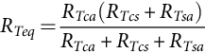 **(2.19)**

Replacing [(2.17)](https://learning.oreilly.com/library/view/power-electronics-handbook/9780128114087/B9780128114070000027.xhtml#fo0090) and [(2.18)](https://learning.oreilly.com/library/view/power-electronics-handbook/9780128114087/B9780128114070000027.xhtml#fo0095) in [(2.19)](https://learning.oreilly.com/library/view/power-electronics-handbook/9780128114087/B9780128114070000027.xhtml#fo0100) and with the values from [Table 2.7](https://learning.oreilly.com/library/view/power-electronics-handbook/9780128114087/B9780128114070000027.xhtml#t0040), the heat-sink-to-ambient resistance is given by [(2.20)](https://learning.oreilly.com/library/view/power-electronics-handbook/9780128114087/B9780128114070000027.xhtml#fo0105):

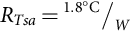 **(2.20)**

At this point, a manufacture catalog must be examined in order to find a heat sink with the same or lower thermal resistance.

The previous results are valid for steady-state condition and assuming that the power dissipated in the semiconductor is represented by its average value. However, the power may present peaks with value higher than the average. These peaks can be taken into account for the heat-sink design.

The junction temperature calculation considering the power peak is made using an electric quantity called thermal impedance (*ZTjc*). Its value is obtained through normalized current found in manufactures catalog. [Fig. 2.77](https://learning.oreilly.com/library/view/power-electronics-handbook/9780128114087/B9780128114070000027.xhtml#f0390) presents typical curves for normalized thermal impedance. The x-axis values are the duration of the pulse over the switching period when the power peak occurs. The impedance is normalized over the junction-to-case thermal resistance.

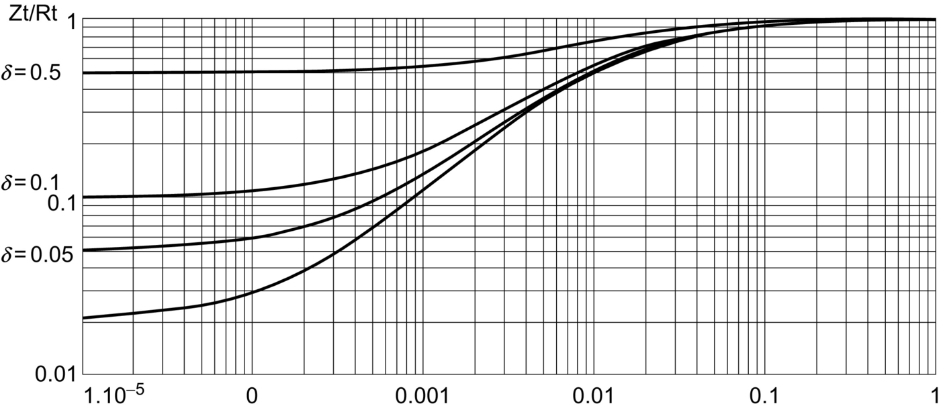

**FIG. 2.77** Typical curves for normalized thermal impedance.

The peak junction temperature is given by [(2.21)](https://learning.oreilly.com/library/view/power-electronics-handbook/9780128114087/B9780128114070000027.xhtml#fo0110):

 **(2.21)**

where the index *pk* means peak.

In case the value obtained in [(2.21)](https://learning.oreilly.com/library/view/power-electronics-handbook/9780128114087/B9780128114070000027.xhtml#fo0110) is higher than the maximum junction temperature, the heat-sink-to-ambient resistance should be recalculated.

## 2.7 Transistor Selection Criteria

The transistor selection for a power electronic application depends on some criteria. The most common is to identify the required reverse voltage and forward current. Switching frequency appears as criteria directly related to the volume of passive elements, such as inductors and capacitors. For applications with desired low volume, a high-frequency transistor is the best choice. With these criteria defined, the next step is to verify if there are transistors available on the market that satisfies such criteria. [Fig. 2.78](https://learning.oreilly.com/library/view/power-electronics-handbook/9780128114087/B9780128114070000027.xhtml#f0395) presents approximated power rate for currently available BJT, MOSFET, and IGBT, valid for silicon-based transistors [[3](https://learning.oreilly.com/library/view/power-electronics-handbook/9780128114087/B9780128114070000027.xhtml#bb0020),[13](https://learning.oreilly.com/library/view/power-electronics-handbook/9780128114087/B9780128114070000027.xhtml#bb0070)].

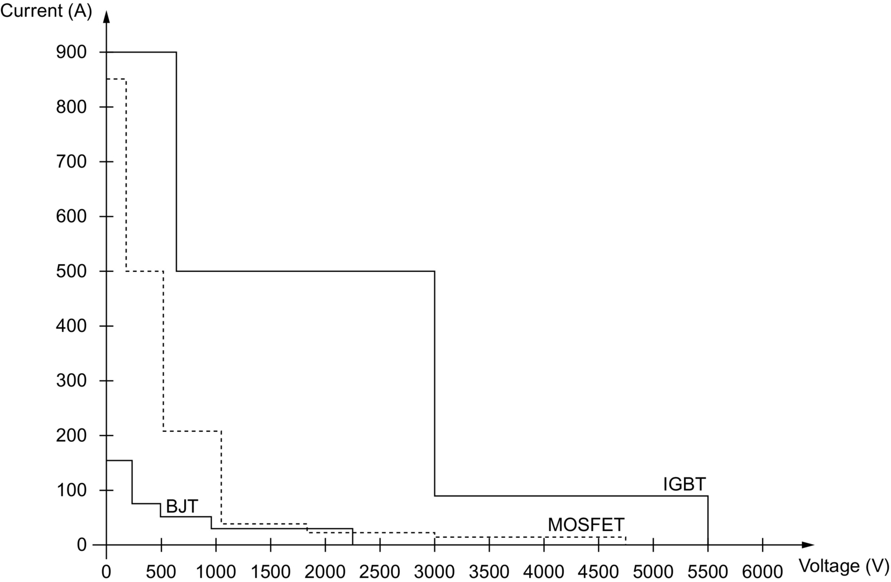

**FIG. 2.78** Approximated power rate for currently available BJT, MOSFET, and IGBT.

Cost and efficiency can also be considered in choosing a transistor. For example, an application where the transistor must hold 500 V and 10 A, according to the previous chart, BJT, MOSFET, or IGBT can be employed. Considering the cost as the main concern, the BJT would likely appear as the best option. On the other hand, if the efficiency is the priority, IGBT is a potential candidate.

Efficiency can be exploited taking into account the transistor material. Emerging transistors based on silicon carbide or gallium nitride [[6](https://learning.oreilly.com/library/view/power-electronics-handbook/9780128114087/B9780128114070000027.xhtml#bb0035),[10](https://learning.oreilly.com/library/view/power-electronics-handbook/9780128114087/B9780128114070000027.xhtml#bb0055),[14](https://learning.oreilly.com/library/view/power-electronics-handbook/9780128114087/B9780128114070000027.xhtml#bb0075),[15](https://learning.oreilly.com/library/view/power-electronics-handbook/9780128114087/B9780128114070000027.xhtml#bb0080)] are a promising technology to enhance the switching behavior and consequently reduce the power losses. Such transistors are considered as wide bandgap power devices. Details of these devices are found in the chapter entitled “Wide Bandgap Materials and Power Semiconductor Devices.”

## References

[1] Lurch E.N. *Fundamentals of Electronics.* Wiley; 1980 634 p.

[2] Rashid M. *Power Electronics Handbook.* Elsevier; 2011 1409 p.

[3] Mohan N., Undeland T.M., Robbins W.P. *Power Electronics: Converters, Applications, and Design.* Wiley; 2002 824 p.

[4] Rashid M.H. *SPICE for Power Electronics and Electric Power.* second ed. CRC Press; 2005 582 p.

[5] Baliga B.J. *Fundamentals of Power Semiconductor Devices.* Springer Science & Business Media; 2010 1085 p.

[6] Baliga B.J. Power semiconductor device figure of merit for high-frequency applications. *IEEE Electron Device Lett.* 1989;10(10):455–457.

[7] Tarter R.E. *Solid-State Power Conversion Handbook.* John Wiley & Sons; 1993 734 p.

[8] Bose B.K. *Power Electronics and AC Drives.* Prentice-Hall; 1986 422 p.

[9] Chryssis G. *High-Frequency Switching Power Supplies: Theory and Design.* McGraw-Hill; 1989 312 p.

[10] Baliga B.J. Trends in power semiconductor devices. *IEEE Trans. Electron Devices.* 1996;43(10):1717–1731.

[11] Trzynadlowski A.M. *Power Electronic Converters and Systems: Frontiers and Applications.* Institution of Engineering and Technology; 2015 657 p.

[12] Akagi H., Watanabe E.H., Aredes M. *Instantaneous Power Theory and Applications to Power Conditioning.* John Wiley & Sons; 2007 396 p.

[13] Internet information on [http://www.digikey.com](http://www.digikey.com/) and <http://www.mouser.com/> (Accessed 23.02.17).

[14] Baliga B.J. *SiC power devices: from conception to social impact.* In: 2016 46th European Solid-State Device Research Conference (ESSDERC); 2016:192–197.

[15] Friedrichs P., Kimoto T., Ley L., Pensl G. *Silicon Carbide, Volume 2: Power Devices and Sensors.* John Wiley & Sons; 2011 523 p.

**3**

# Thyristors

Tanya K. Gachovska Senior Verification Engineer, Solantro Semiconductor Corp, Ottawa, ON, Canada

Jerry L. Hudgins University of Nebraska-Lincoln, Lincoln, NE, United States

Angus Bryant System Architect Amantys Power Electronics Ltd, Cambridge, UK

Patrick Palmer University of Cambridge, Cambridge, UK

Subbaraya Yuvarajan North Dakota State University, Fargo, ND, United States

## Abstract

Thyristors are usually three-terminal devices that have four layers of alternating *p*-type and *n*-type material (i.e., three *p*-*n* junctions) comprising its main power handling section. In contrast to the linear relation that exists between load and control currents in a transistor, the thyristor is bistable. The control terminal of the thyristor, called the gate (*G*) electrode, may be connected to an integrated and complex structure as a part of the device. The other two terminals, called the anode (*A*) and cathode (*K*), handle the large applied potentials (often of both polarities) and conduct the major current through the thyristor. The anode and cathode terminals are connected in series with the load to which power is to be controlled.

### KEYWORDS

Thyristor; SCR; GTO; MOS-controlled thyristors; Static induction thyristors; Optical triggered thyristors; BY-directional controlled thyristors: Diac; Triac

3.1 [Introduction](https://learning.oreilly.com/library/view/power-electronics-handbook/9780128114087/B9780128114070000039.xhtml#s0010)

3.2 [Basic Structure and Operation](https://learning.oreilly.com/library/view/power-electronics-handbook/9780128114087/B9780128114070000039.xhtml#s0015)

3.3 [Static Characteristics](https://learning.oreilly.com/library/view/power-electronics-handbook/9780128114087/B9780128114070000039.xhtml#s0020)

3.3.1 Current–Voltage Curves for Thyristors

3.3.2 Edge and Surface Terminations

3.3.3 Packaging

3.4 [Dynamic Switching Characteristics](https://learning.oreilly.com/library/view/power-electronics-handbook/9780128114087/B9780128114070000039.xhtml#s0040)

3.4.1 Cathode Shorts

3.4.2 Anode Shorts

3.4.3 Amplifying Gate

3.4.4 Temperature Dependencies

3.5 [Thyristor Parameters](https://learning.oreilly.com/library/view/power-electronics-handbook/9780128114087/B9780128114070000039.xhtml#s0065)

3.6 [Types of Thyristors](https://learning.oreilly.com/library/view/power-electronics-handbook/9780128114087/B9780128114070000039.xhtml#s0070)

3.6.1 SCRs and GTOs

3.6.2 MOS-Controlled Thyristors

3.6.3 Generation-1 and Generation-2 MCTs

3.6.4 *N*-Channel MCT

3.6.5 Base Resistance-Controlled Thyristor [28]

3.6.6 MOS Turn-off Thyristor [29]

3.6.7 Static Induction Thyristors

3.6.8 Optically Triggered Thyristors

3.6.9 Bi-Directional Controlled Thyristors

3.7 [Gate Drive Requirements](https://learning.oreilly.com/library/view/power-electronics-handbook/9780128114087/B9780128114070000039.xhtml#s0210)

3.7.1 Snubber Circuits

3.7.2 Gate Circuits

3.8 [Applications](https://learning.oreilly.com/library/view/power-electronics-handbook/9780128114087/B9780128114070000039.xhtml#s0225)

3.8.1 DC–AC Utility Inverters

3.8.2 Motor Control

3.8.3 VAR Compensators and Static Switching Systems

3.8.4 Lighting Control Circuits

[References](https://learning.oreilly.com/library/view/power-electronics-handbook/9780128114087/B9780128114070000039.xhtml#bi0010)

## 3.1 Introduction

Thyristors are usually three-terminal devices that have four layers of alternating *p*-type and *n*-type material (i.e., three *p*-*n* junctions) comprising its main power handling section. In contrast to the linear relation that exists between load and control currents in a transistor, the thyristor is bistable. The control terminal of the thyristor, called the gate (*G*) electrode, may be connected to an integrated and complex structure as a part of the device. The other two terminals, called the anode (*A*) and cathode (*K*), handle the large applied potentials (often of both polarities) and conduct the major current through the thyristor. The anode and cathode terminals are connected in series with the load to which power is to be controlled.

Thyristors are used to approximate ideal closed (no voltage drop between anode and cathode) or open (no anode current flow) switches for control of power flow in a circuit. This differs from low-level digital switching circuits that are designed to deliver two distinct small voltage levels while conducting small currents (ideally zero). Thyristor circuits must have the capability of delivering large currents and be able to withstand large externally applied voltages. All thyristor types are controllable in switching from a forward-blocking state (positive potential applied to the anode with respect to the cathode, with correspondingly little anode current flow) into a forward-conduction state (large forward anode current flowing, with a small anode-cathode potential drop). Most thyristors have the characteristic that after switching from a forward-blocking state into the forward-conduction state, the gate signal can be removed and the thyristor will remain in its forward-conduction mode. This property is termed “latching” and is an important distinction between thyristors and other types of power electronic devices. Some thyristors are also controllable in switching from forward-conduction back to a forward-blocking state. The particular design of a thyristor will determine its controllability and often its application.

Thyristors are typically used at the highest energy levels in power-conditioning circuits because they are designed to handle the largest currents and voltages of any device technology (systems approximately with voltages above 1 kV or currents above 100 A). Many medium-power circuits (systems operating at less than 1 kV or 100 A) and particularly low-power circuits (systems operating below 100 V or several amperes) generally make use of power bipolar transistors, power metal-oxide-semiconductor field-effect transistors (MOSFETs), or insulated gate bipolar transistors (IGBTs) as the main switching elements because of the relative ease in controlling them. IGBT technology, however, continues to improve and multiple silicon die are commonly packaged together in a module. These modules are replacing thyristors in applications operating up to 3 kV that require controllable turn-off because of easier gate-drive requirements. Power diodes are used throughout all levels of power-conditioning circuits and systems for component protection and wave shaping.

A thyristor used in some ac power circuits (50 or 60 Hz in commercial utilities or 400 Hz in aircraft) to control ac power flow can be made to optimize internal power loss at the expense of switching speed. These thyristors are called phase-control devices, because they are generally turned from a forward-blocking into a forward-conducting state at some specified phase angle of the applied sinusoidal anode-cathode voltage waveform. A second class of thyristors is used in association with dc sources or in converting ac power at one amplitude and frequency into ac power at another amplitude and frequency and must generally switch on and off relatively quickly. A typical application for the second class of thyristors is in converting a dc voltage or current into an ac voltage or current. A circuit that performs this operation is often called an inverter, and the associated thyristors used are referred to as inverter thyristors.

There are four major types of thyristors: (i) the silicon-controlled rectifier (SCR), (ii) the gate turn-off thyristor (GTO) and its close relative the integrated gate-commutated thyristor (IGCT), (iii) the MOS-controlled thyristor (MCT) and its various forms, and (iv) the static induction thyristor (SITh). MCTs are so-named because many parallel enhancement-mode, MOSFET structures of one charge type are integrated into the thyristor for turn-on, and many more MOSFETs of the other charge types are integrated into the thyristor for turn-off. An SITh or field-controlled thyristor (FCTh) has essentially the same construction as a power diode with a gate structure that can pinch-off anode current flow. Although MCTs, derivative forms of the MCT and SIThs, have the advantage of being essentially voltage-controlled devices (i.e., little control current is required for turn-on or turnoff and therefore require simplified control circuits attached to the gate electrode), they are currently only found in niche applications such as pulse power. Detailed discussion of variations of MCTs and SIThs and additional references on these devices are discussed by Hudgins in [[1](https://learning.oreilly.com/library/view/power-electronics-handbook/9780128114087/B9780128114070000039.xhtml#bb0010)]. Other types of thyristors include the triac (a pair of antiparallel SCRs integrated together to form a bidirectional current switch) and the programmable unijunction transistor (PUT).

The SCRs and GTOs are designed to operate at all power levels. These devices are primarily controlled using electric signals (current), though some types are made to be controlled using optical energy (photons) for turn-on. Subclasses of SCRs and GTOs are reverse conducting types and symmetrical structures that block applied potentials in the reverse and forward polarities. Other variations of GTOs are the gate-commutated turnoff thyristor (GCT), commonly available as the IGCT and the bidirectional-controlled thyristor (BCT).

All power electronic devices must be derated (e.g., power dissipation levels, current conduction, voltage blocking, and switching frequency must be reduced), when operating above room temperature (defined as approximately 25°C). Bipolar-type devices have thermal runaway problems, in that if allowed to conduct unlimited current, these devices will heat up internally causing more current to flow, thus generating more heat and so forth until destruction. Devices that exhibit this behavior are *pin* diodes, bipolar transistors, and thyristors.

Almost all power semiconductor devices are made from silicon (Si). Research and development continues in developing other types of devices in silicon carbide (SiC), gallium nitride (GaN), and related material systems. However, the physical description and general behavior of thyristors is unimportant to the semiconductor material system used, though the discussion and any numbers cited in the chapter will be associated with Si devices.

## 3.2 Basic Structure and Operation

[Fig. 3.1](https://learning.oreilly.com/library/view/power-electronics-handbook/9780128114087/B9780128114070000039.xhtml#f0010) shows a conceptual view of a typical thyristor with the three *p*-*n* junctions and the external electrodes labeled. Also shown in the figure is the thyristor circuit symbol used in electric schematics.

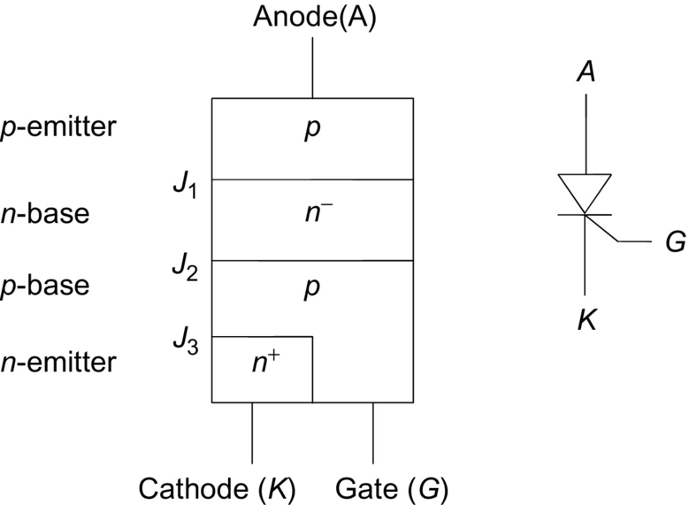

**FIG. 3.1** Simple cross section of a typical thyristor and the associated electric schematic symbols.

A high-resistivity region, *n*−-base, is present in all thyristors. It is this region, the *n*−-base and associated junction, *J*2 of [Fig. 3.1](https://learning.oreilly.com/library/view/power-electronics-handbook/9780128114087/B9780128114070000039.xhtml#f0010), which must support the large applied forward voltages that occur when the switch is in its off- or forward-blocking state (nonconducting). The *n*−-base is typically doped with impurity phosphorous atoms at a concentration of 1013–1014 cm−3. The *n*−-base can be tens to hundreds of micrometer thick to support large voltages. High-voltage thyristors are generally made by diffusing aluminum or gallium into both surfaces to create *p*-doped regions forming deep junctions with the *n*−-base. The doping profile of the *p*-regions ranges from about 1015 to 1017 cm−3. These *p*-regions can be up to tens of micrometer thick. The cathode region (typically only a few micrometers thick) is formed by using phosphorous atoms at a doping density of 1017–1018 cm−3.

The higher the forward-blocking voltage rating of the thyristor, the thicker the *n*−-base region must be. However, increasing the thickness of this high-resistivity region results in slower turn-on and turn-off (i.e., longer switching times and/or lower frequency of switching cycles because of more stored charge during conduction). For example, a device rated for a forward-blocking voltage of 1 kV will, by its physical construction, switch much more slowly than one rated for 100 V. In addition, the thicker high-resistivity region of the 1 kV device will cause a larger forward voltage drop during conduction than the 100 V device carrying the same current. Impurity atoms, such as platinum or gold, and electron irradiation are used to create charge-carrier recombination sites in the thyristor. The large number of recombination sites reduces the mean carrier lifetime (average time that an electron or hole moves through the Si before recombining with its opposite charge-carrier type). A reduced carrier lifetime shortens the switching times (in particular the turnoff or recovery time) at the expense of increasing the forward conduction drop. There are other effects associated with the relative thickness and layout of the various regions that make up modern thyristors, but the major trade-off between forward-blocking voltage rating and switching times and between forward-blocking voltage rating and forward voltage drop during conduction should be kept in mind. (In signal-level electronics, an analogous trade-off appears as a lowering of amplification (gain) to achieve higher operating frequencies and is often referred to as the gain-bandwidth product.)

Operation of thyristors is as follows. When a positive voltage is applied to the anode (with respect to cathode), the thyristor is in its forward-blocking state. The center junction *J*2 (see [Fig. 3.1](https://learning.oreilly.com/library/view/power-electronics-handbook/9780128114087/B9780128114070000039.xhtml#f0010)) is reverse biased. In this operating mode, the gate current is held to zero (open circuit). In practice, the gate electrode is biased to a small negative voltage (with respect to the cathode) to reverse bias the GK junction *J*3 and prevent charge carriers from being injected into the *p*-base. In this condition, only thermally generated leakage current flows through the device and can often be approximated as zero in value (the actual value of the leakage current is typically many orders of magnitude lower than the conducted current in the on-state). As long as the forward applied voltage does not exceed the value necessary to cause excessive carrier multiplication in the depletion region around *J*2 (avalanche breakdown), the thyristor remains in an off-state (forward-blocking). If the applied voltage exceeds the maximum forward-blocking voltage of the thyristor, it will switch to its on-state. However, this mode of turn-on causes nonuniformity in the current flow, is generally destructive, and should be avoided.

When a positive gate current is injected into the device, *J*3 becomes forward biased and electrons are injected from the *n*-emitter into the *p*-base. Some of these electrons diffuse across the *p*-base and get collected in the *n*−-base. This collected charge causes a change in the bias condition of *J*1. The change in bias of *J*1 causes holes to be injected from the *p*-emitter into the *n*−-base. These holes diffuse across the *n*−-base and are collected in the *p*-base. The addition of these collected holes in the *p*-base acts the same as gate current. The entire process is regenerative and will cause the increase in charge carriers until *J*2 also becomes forward biased and the thyristor is latched in its on-state (forward conduction). The regenerative action will take place as long as the gate current is applied in sufficient amount and for a sufficient length of time. This mode of turn-on is considered to be the desired one as it is controlled by the gate signal.

This switching behavior can also be explained in terms of the two-transistor analog shown in [Fig. 3.2](https://learning.oreilly.com/library/view/power-electronics-handbook/9780128114087/B9780128114070000039.xhtml#f0015). The two transistors are regeneratively coupled so that if the sum of their forward current gains (*α*'s) exceeds unity, each drives the other into saturation. Eq. [(3.1)](https://learning.oreilly.com/library/view/power-electronics-handbook/9780128114087/B9780128114070000039.xhtml#fo0010) describes the condition necessary for the thyristor to move from a forward-blocking state to the forward-conduction state. The forward current gain (expressed as the ratio of collector current to emitter current) of the *pnp* transistor is denoted by *αp* and that of the *npn* as *αn*. The *α*'s are current dependent and increase slightly as the current increases. The center junction *J*2 is reverse biased under forward applied voltage (positive, *vAK*). The associated electric field in the depletion region around the junction can result in significant carrier multiplication, denoted as a multiplying factor *M* on the current components, *Ico* and *iG*.

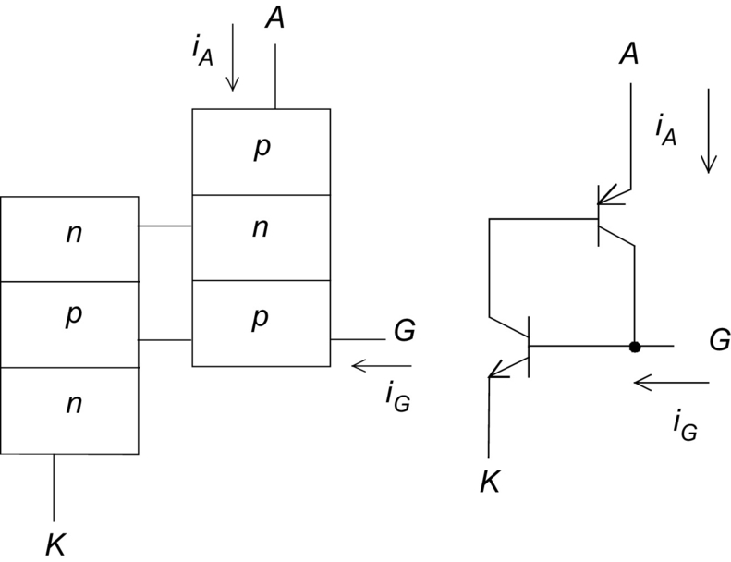

**FIG. 3.2** Two-transistor behavioral model of a thyristor.

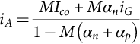 **(3.1)**

In the forward-blocking state, the leakage current *Ico* is small, both *α*'s are small, and their sum is less than unity. Gate current increases the current in both transistors, increasing their *α*'s. Collector current in the *npn* transistor acts as base current for the *pnp*, and analogously, the collector current of the *pnp* acts as base current driving the *npn* transistor. When the sum of the two *α*'s equals unity, the thyristor switches to its on-state (latches). This condition can also be reached, without any gate current, by increasing the forward applied voltage so that carrier multiplication (M≫1) at *J*2 increases the internal leakage current, thus increasing the two *α*'s. A third way to increase the *α*'s exists by increasing the device (junction) temperature. Increasing the temperature causes a corresponding increase in the leakage current *Ico* to the point where latching can occur. The typical manifestation of this temperature dependence is to cause an effective lowering of the maximum blocking voltage that can be sustained by the thyristor.

Another way to cause a thyristor to switch from forward-blocking to forward-conduction exists. Under a forward applied voltage, *J*2 is reverse biased, while the other two junctions are forward biased in the blocking mode. The reverse-biased junction of *J*2 is the dominant capacitance of the three and determines the displacement current that flows. If the rate of increase in the applied *vAK*(*dvAK*/*dt*) is sufficient, it will cause a significant displacement current through the *J*2 capacitance. This displacement current can initiate switching similar to an externally applied gate current. This dynamic phenomenon is inherent in all thyristors and causes there to be a limit (*dv/dt*) to the time rate of applied *vAK* that can be placed on the device to avoid uncontrolled switching. Alterations to the basic thyristor structure can be produced that increase the *dv/dt* limit.

Once the thyristor has moved into forward conduction, any applied gate current is superfluous. The thyristor is latched and, for SCRs, cannot be returned to a blocking mode by using the gate terminal. Anode current must be commutated away from the SCR for a sufficient time to allow stored charge in the device to recombine. Only after this recovery time has occurred, can a forward voltage be reapplied (below the *dv/dt* limit of course), and the SCR again be operated in a forward-blocking mode. If the forward voltage is reapplied before sufficient recovery time has elapsed, the SCR will move back into forward conduction. For GTOs and IGCTs, a large applied reverse gate current (typically in the range of 10%–50% of the anode current for GTOs and 100% of the anode current for IGCTs) applied for a sufficient time can remove enough charge near the GK junction to cause it to turn off. This interrupts the base current to the *pnp* transistor, leaving the *pnp* open base, causing thyristor turn-off. This is similar in principle to use negative base current to quickly turn off a traditional bipolar transistor.

## 3.3 Static Characteristics

### **3.3.1 CURRENT–VOLTAGE CURVES FOR THYRISTORS**

A plot of the anode current (*iA*) as a function of anode-cathode voltage (*vAK*) is shown in [Fig. 3.3](https://learning.oreilly.com/library/view/power-electronics-handbook/9780128114087/B9780128114070000039.xhtml#f0020). The forward-blocking mode is shown as the low-current portion of the graph (solid curve around operating point “1”). With zero gate current and positive *vAK*, the forward characteristic in the off- or blocking state is determined by the center junction *J*2, which is reverse biased. At operating point “1,” very little current flows (*Ico* only) through the device. However, if the applied voltage exceeds the forward-blocking voltage, the thyristor switches to its on- or conducting state (shown as operating point “2”) because of carrier multiplication (*M* in Eq. [(3.1)](https://learning.oreilly.com/library/view/power-electronics-handbook/9780128114087/B9780128114070000039.xhtml#fo0010)). The effect of gate current is to lower the blocking voltage at which switching takes place. The thyristor moves rapidly along the negatively sloped portion of the curve until it reaches a stable operating point determined by the external circuit (point “2”). The portion of the graph indicating forward conduction shows the large values of *iA* that may be conducted at relatively low values of *vAK*, similar to a power diode.

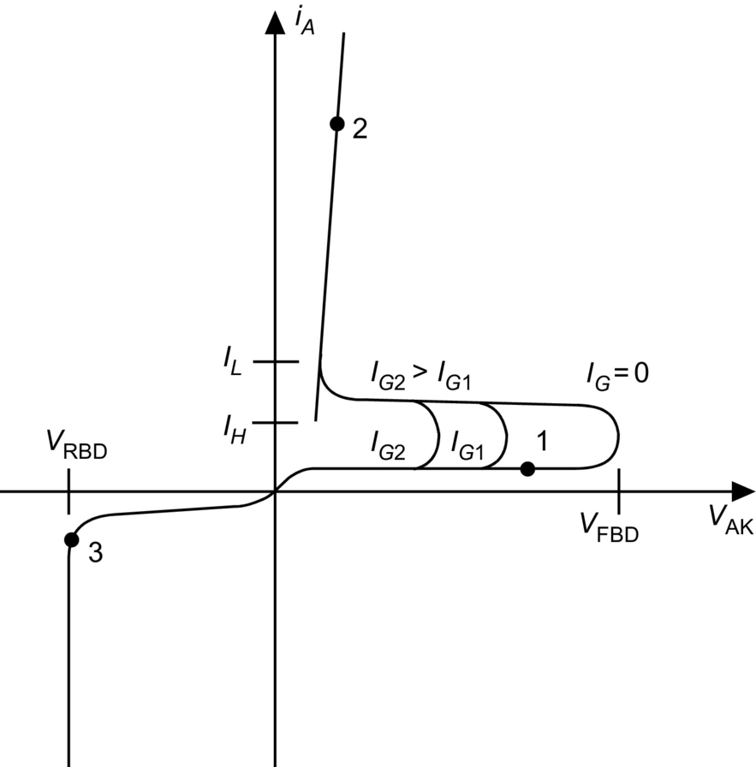

**FIG. 3.3** Static characteristic *i-v* curve typical of thyristors.

As the thyristor moves from forward-blocking to forward-conducting, the external circuit must allow sufficient anode current to flow to keep the device latched. The minimum anode current that will cause the device to remain in forward conduction as it switches from forward-blocking is called the latching current *IL*. If the thyristor is already in forward conduction and the anode current is reduced, the device can move its operating mode from forward conduction back to forward-blocking. The minimum value of anode current necessary to keep the device in forward conduction after it has been operating at a high anode current value is called the holding current *IH*. The holding current value is lower than the latching current value as indicated in [Fig. 3.3](https://learning.oreilly.com/library/view/power-electronics-handbook/9780128114087/B9780128114070000039.xhtml#f0020).

The reverse thyristor characteristic, quadrant III of [Fig. 3.3](https://learning.oreilly.com/library/view/power-electronics-handbook/9780128114087/B9780128114070000039.xhtml#f0020), is determined by the outer two junctions (*J*1 and *J*3), which are reverse biased in this operating mode (applied *vAK* is negative). Symmetrical thyristors are designed so that *J*1 will reach reverse breakdown due to carrier multiplication at an applied reverse potential near the forward breakdown value (operating point “3” in [Fig. 3.3](https://learning.oreilly.com/library/view/power-electronics-handbook/9780128114087/B9780128114070000039.xhtml#f0020)). The forward- and reverse-blocking junctions are usually fabricated at the same time with a very long diffusion process (10–50 h) at high temperatures (>1200°C). This process produces symmetrical blocking properties. Wafer-edge termination processing causes the forward-blocking capability to be reduced to about 90% of the reverse-blocking capability. Edge termination is discussed below. Asymmetrical devices are made to optimize forward conduction and turnoff properties and as such reach reverse breakdown at a lower voltage than that applied in the forward direction. This is accomplished by designing the asymmetrical thyristor with a much thinner *n*−-base than is used in symmetrical structures. The thin *n*−-base leads to improved properties such as lower forward drop and shorter switching times. Asymmetrical devices are generally used in applications when only forward voltages (positive, *vAK*) are to be applied (including many inverter designs).

The form of the gate-to-cathode *i-v* characteristic of SCRs, GTOs, and IGCTs is similar to that of a diode. With positive gate bias, the gate-cathode junction is forward biased and permits the flow of a large current in the presence of a low voltage drop. When negative gate voltage is applied to an SCR, the gate-cathode junction is reverse biased and prevents the flow of current until the avalanche breakdown voltage is reached. In a GTO or IGCT, a negative gate voltage is applied to provide a low-impedance path for anode current to flow out of the device instead of out the cathode. In this way, the cathode region (base-emitter junction of the equivalent *npn* transistor) turns off, thus pulling the equivalent *npn* transistor out of conduction. This causes the entire thyristor to return to its blocking state. The problem with the GTO and IGCT is that the gate-drive circuitry is typically required to sink 10%–50% (for the GTO) or 100% (for the IGCT) of the anode current to achieve turn-off.

### 3.3.2 EDGE AND SURFACE TERMINATIONS

Thyristors are often made with planar diffusion technology to create the cathode region. Formation of these regions creates cylindrical curvature of the metallurgical gate-cathode junction. Under reverse bias, the curvature of the associated depletion region results in electric field crowding along the curved section of the *p*+ diffused region. The field crowding seriously reduces the breakdown potential below that expected for the bulk semiconductor. A floating field ring, an extra *p* diffused region with no electric connection at the surface, is often added to modify the electric field profile and thus reduce it to a value below or at the field strength in the bulk. An illustration of a single floating field ring is shown in [Fig. 3.4](https://learning.oreilly.com/library/view/power-electronics-handbook/9780128114087/B9780128114070000039.xhtml#f0025). The spacing, *W*, between the main anode region and the field ring is critical. Multiple rings can also be employed to further modify the electric field in high-voltage rated thyristors.

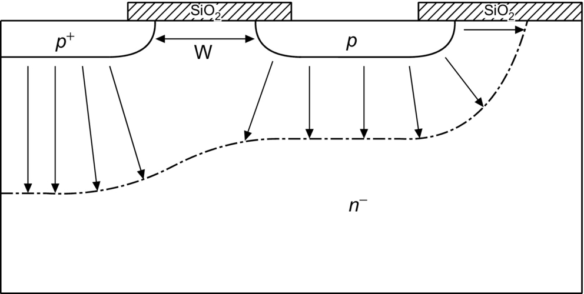

**FIG. 3.4** Cross section showing a floating field ring to decrease the electric field intensity near the curved portion of the main anode region (leftmost *p*+ region).

Another common method for altering the electric field at the surface is by using a field plate as shown in cross section in [Fig. 3.5](https://learning.oreilly.com/library/view/power-electronics-handbook/9780128114087/B9780128114070000039.xhtml#f0030). By forcing the potential over the oxide to be the same as at the surface of the *p*+ region, the depletion region can be extended so that the electric field intensity is reduced near the curved portion of the diffused *p+* region. A common practice is to use field plates with floating field rings to obtain optimum breakdown performance.

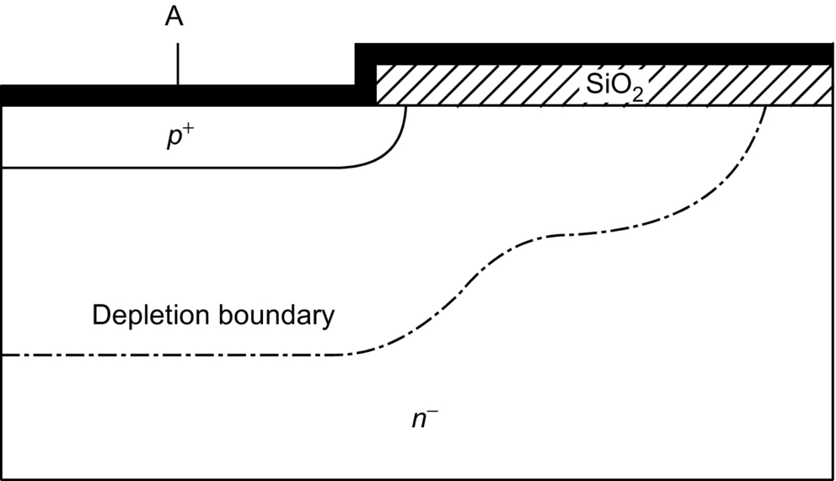

**FIG. 3.5** Cross section showing a field plate used to reduce the electric field intensity near the curved portion of the *p*+-region (anode).

High-voltage thyristors are made from single wafers of Si and must have edge terminations other than floating field rings or field plates to promote bulk breakdown and limit leakage current at the surface. Controlled bevel angles can be created using lapping and polishing techniques during production of large-area thyristors. Two types of bevel junctions can be created: (i) a positive bevel defined as one in which the junction area decreases when moving from the highly doped to the lightly doped side of the depletion region and (ii) a negative bevel defined as one in which the junction area increases when moving from the highly doped to the lightly doped side of the depletion region. In practice, the negative bevel must be lapped at an extremely shallow angle to reduce the surface field below the field intensity in the bulk. All positive bevel angles between 0 and 90 degrees result in a lower surface field than in the bulk. [Fig. 3.6](https://learning.oreilly.com/library/view/power-electronics-handbook/9780128114087/B9780128114070000039.xhtml#f0035) shows the use of a positive bevel for the *J*1 junction and a shallow negative bevel for the *J*2 and *J*3 junctions on a thyristor cross section to make maximum use of the Si area for conduction and still reduce the surface electric field. Further details of the use of beveling, field plates, and field rings can be found in Ghandi [[1](https://learning.oreilly.com/library/view/power-electronics-handbook/9780128114087/B9780128114070000039.xhtml#bb0010)] and Baliga [[2](https://learning.oreilly.com/library/view/power-electronics-handbook/9780128114087/B9780128114070000039.xhtml#bb0015)].

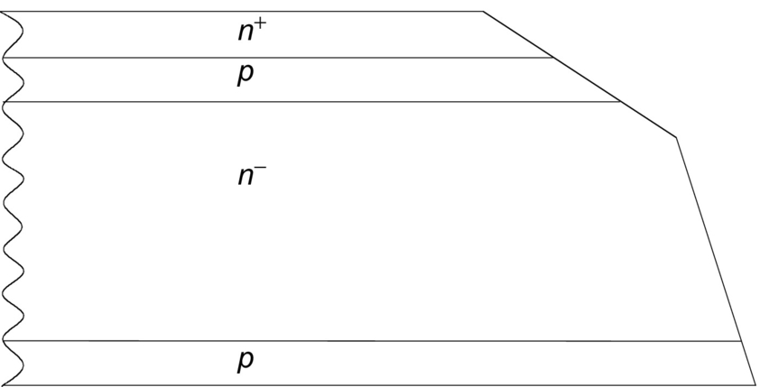

**FIG. 3.6** Cross section of a thyristor showing the negative bevel (upper *p*-*n*− and *p*-*n*+ junctions) and positive bevel (lower *p*-*n*− junction) used for edge termination of large-area devices.

### 3.3.3 PACKAGING

Thyristors are available in a wide variety of packages, from small plastic ones for low-power (i.e., TO-247), to stud-mount packages for medium-power, to press pack (also called flat pack) for the highest power devices. The press packs must be mounted under pressure to obtain proper electric and thermal contact between the device and the external metal electrodes. Special force-calibrated clamps are made for this purpose. Large-area thyristors cannot be directly attached to the large copper pole piece of the press pack because of the difference in the coefficient of thermal expansion (CTE), hence the use of a pressure contact for both anode and cathode. [Fig. 3.7](https://learning.oreilly.com/library/view/power-electronics-handbook/9780128114087/B9780128114070000039.xhtml#f0040) shows typical thyristor stud-mount and press-pack packages.

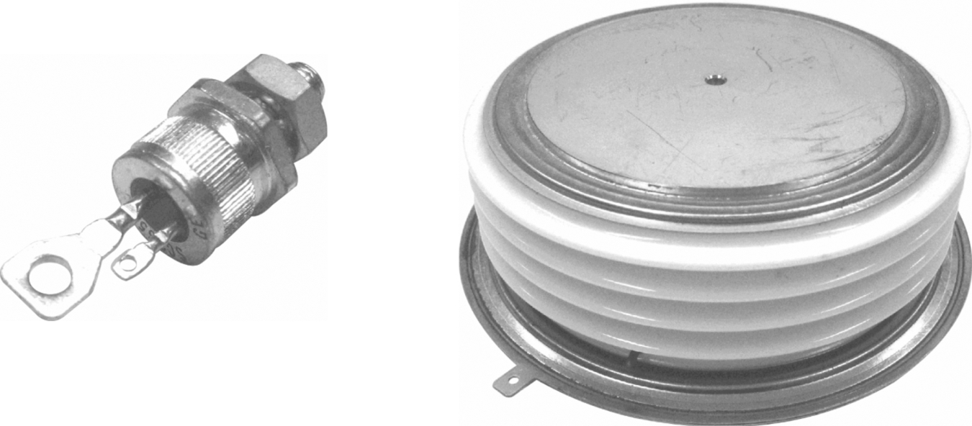

**FIG. 3.7** Examples of thyristor packaging: stud-mount (left) and press-pack/capsule (right).

Many medium-power thyristors are appearing in modules where a half- or full bridge (and associated antiparallel diodes) is put together in one package. A power module package should have five characteristics:

(i) Electric isolation of the baseplate from the semiconductor

(ii) Good thermal performance

(iii) Good electric performance

(iv) Long life/high reliability

(v) Low cost

Electric isolation of the baseplate from the semiconductor is necessary in order to contain both halves of a phase leg in one package and for convenience (modules switching different phases can be mounted on one heat sink) and safety (heat sinks can be held at ground potential).

Thermal performance is measured by the maximum temperature rise in the Si die at a given power dissipation level with a fixed heat sink temperature. The lower the die temperature, the better the package. A package with a low thermal resistance from junction-to-sink can operate at higher power densities for the same temperature rise or lower temperatures for the same power dissipation than a more thermally resistive package. While maintaining low device temperature is generally preferable, temperature variation affects majority carrier and bipolar devices differently. Roughly speaking, in a bipolar device such as a thyristor, switching losses increase and conduction losses decrease with increasing temperature. In a majority carrier device, such as a MOSFET, conduction losses increase with increasing temperature. The thermal conductivity of typical materials used in thyristor packages is shown in [Table 3.1](https://learning.oreilly.com/library/view/power-electronics-handbook/9780128114087/B9780128114070000039.xhtml#t0010).

**Table 3.1**

**Thermal conductivity of thyristor package materials**

|  |  |
| --- | --- |
| **Material** | **Thermal conductivity (W/m·K) at 300 K** |
| Silicon | 150 |
| Copper (baseplate and pole pieces) | 390–400 |
| AlN substrate | 170 |
| Al2O3 (alumina) | 28 |
| Aluminum (Al) | 220 |
| Tungsten (W) | 167 |
| Molybdenum (Mo) | 138 |
| Metal matrix composites (MMC) | 170 |
| Thermal grease (heat sink compound) | 0.75 |
| 60/40 solder (Pb/Sn eutectic) | 50 |
| 95/5 solder (Pb/Sn high temperature) | 35 |

Electric performance refers primarily to the stray inductance in series with the die and the capability of mounting a low-inductance bus to the terminals. Another problem is the minimization of capacitive cross talk from one switch to another, which can cause an abnormal on-state condition by charging the gate of an off-state switch or from a switch to any circuitry in the package (as would be found in a hybrid power module). Capacitive coupling is a major cause of electromagnetic interference (EMI). As the stray inductance of the module and the bus sets a minimum switching loss for the device—because the switch must absorb the stored inductive energy—it is very important to minimize inductance within the module. Reducing the parasitic inductance reduces the high-frequency ringing during transients that is another cause of radiated EMI. Since stray inductance can cause large peak voltages during switching transients, minimizing it helps to maintain the device within its safe area of operation.

Long life and high reliability are primarily attained through minimization of thermal cycling, minimization of ambient temperature, and proper design of the transistor stack. Thermal cycling fatigues material interfaces because of CTE mismatch between dissimilar materials. As the materials undergo temperature variation, they expand and contract at different rates that stresses the interface between the layers and can cause interface deterioration (e.g., cracking of solder layers or wire debonding). Chemical degradation processes such as dendrite growth and impurity migration are accelerated with increasing temperature, so keeping the absolute temperature of the device low and minimizing the temperature changes to which it is subjected is important. Typical CTE values for common package materials are given in [Table 3.2](https://learning.oreilly.com/library/view/power-electronics-handbook/9780128114087/B9780128114070000039.xhtml#t0015).

**Table 3.2**

**CTE for thyristor package materials**

|  |  |
| --- | --- |
| **Material** | **CTE (μm/m·K) at 300 K** |
| Silicon | 4.1 |
| Copper (baseplate and pole pieces) | 17 |
| AlN substrate | 4.5 |
| Al2O3 (Alumina) | 6.5 |
| Tungsten (W) | 4.6 |
| Molybdenum (Mo) | 4.9 |
| Aluminum (Al) | 23 |
| Metal matrix composites (MMC) | 5–20 |
| 60/40 solder (Pb/Sn eutectic) | 25 |

Low cost is achieved in a variety of ways. Both manufacturing and material costs must be taken into account when designing a power module. Materials that are difficult to machine or process, even if they are relatively cheap in raw form (e.g., molybdenum), should be avoided. Manufacturing processes that lower yield also drive up costs. In addition, a part that is very reliable can reduce future costs by reducing the need for repair and replacement.

The basic half-bridge module has three power terminals: plus, minus, and phase. Advanced modules differ from traditional high-power commercial modules in several ways. The baseplate is metallized aluminum nitride (AlN) ceramic rather than the typical 0.125 in. thick nickel-plated copper baseplate with a soldered metallized ceramic substrate for electric isolation. This AlN baseplate stack provides a low thermal resistance from die to heat sink. The copper terminal power buses are attached by solder to the devices in a wirebond-free, low-inductance, low-resistance, device interconnect configuration. The balance of the assembly is typical for module manufacturing with attachment of shells, use of dielectric gels, and hard epoxies and adhesive to seal the finished module. Details of the thermal performance of modules and advanced modules can be found in Beker et al. [[3](https://learning.oreilly.com/library/view/power-electronics-handbook/9780128114087/B9780128114070000039.xhtml#bb0020)] and Godbold et al. [[4](https://learning.oreilly.com/library/view/power-electronics-handbook/9780128114087/B9780128114070000039.xhtml#bb0025)].

## 3.4 Dynamic Switching Characteristics

The time rate of rise of anode current (*di*/*dt*) during turn-on and the time rate of rise of anode-cathode voltage (*dv*/*dt*) during turnoff are important parameters to control for ensuring proper and reliable operation. All thyristors have maximum limits for *di*/*dt* and *dv*/*dt* that must not be exceeded. Devices capable of conducting large currents in the on-state are necessarily made with large surface areas through which the current flows. During turn-on, localized areas of a device (near the gate region) begin to conduct current. The initial turn-on of an SCR is shown in [Fig. 3.8](https://learning.oreilly.com/library/view/power-electronics-handbook/9780128114087/B9780128114070000039.xhtml#f0045). The cross section illustrates how injected gate current flows to the nearest cathode region, causing this portion of the *npn* transistor to begin conducting. The *pnp* transistor then follows the *npn* into conduction such that anode current begins flowing only in a small portion of the cathode region. If the local current density becomes too large (in excess of several thousand amperes per square centimeter), then self-heating will damage the device. Sufficient time (referred to as plasma spreading time) must be allowed for the entire cathode area to begin conducting before the localized currents become too high. This phenomenon results in a maximum allowable rate of rise of anode current in a thyristor and is referred to as a *di*/*dt* limit. In many high-frequency applications, the entire cathode region is never fully in conduction. Prevention of *di/dt* failure can be accomplished if the rate of increase of conduction area exceeds the *di/dt* rate such that the internal junction temperature does not exceed a specified critical temperature (typically approximately 350°C). This critical temperature decreases as the blocking voltage increases. Adding series inductance to the thyristor to limit *di/dt* below its maximum usually causes circuit design problems.

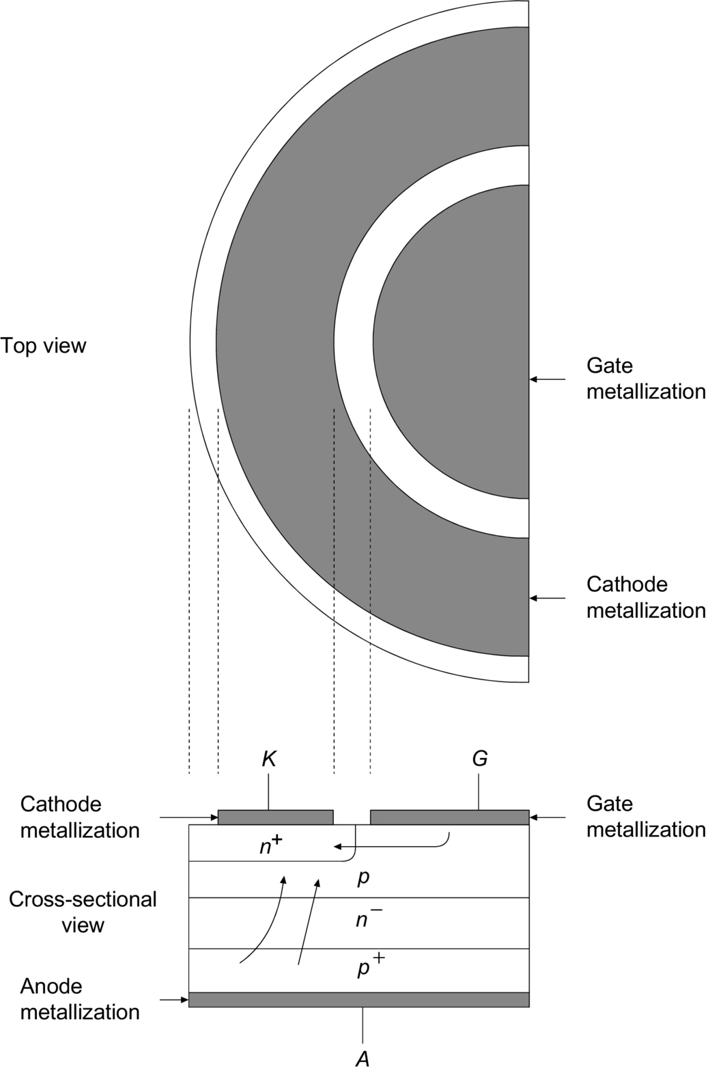

**FIG. 3.8** Top view and associated cross section of gate-cathode periphery showing initial turn-on region in a center-fired thyristor.

Another way to increase the *di/dt* rating of a device is to increase the amount of gate-cathode periphery. Inverter SCRs (so-named because of their use in high-frequency power-converter circuits that convert dc to ac, i.e., invert) are designed so that there is a large amount of gate edge adjacent to a significant amount of cathode edge. A top surface view of two typical gate-cathode patterns, found in large thyristors, is shown in [Fig. 3.9](https://learning.oreilly.com/library/view/power-electronics-handbook/9780128114087/B9780128114070000039.xhtml#f0050). An inverter SCR often has a stated maximum *di/dt* limit of approximately 2000 A/μs. This value has been shown to be conservative in Hadgins [[5](https://learning.oreilly.com/library/view/power-electronics-handbook/9780128114087/B9780128114070000039.xhtml#bb0030)], and by using excessive gate current under certain operating conditions, an inverter SCR can be operated reliably at 10,000–20,000 A/μs.

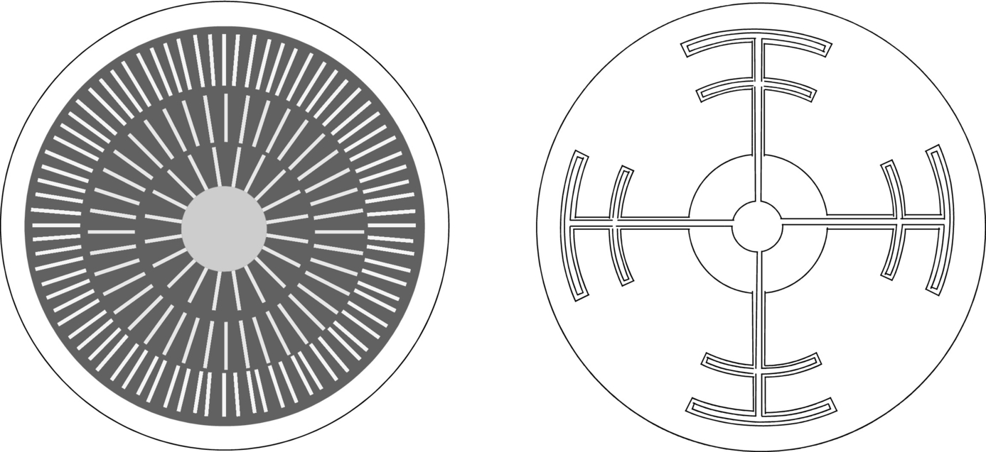

**FIG. 3.9** Top view of typical interdigitated gate-cathode patterns used for thyristors.

A GTO takes the interdigitation of the gate and cathode to the extreme ([Fig. 3.9](https://learning.oreilly.com/library/view/power-electronics-handbook/9780128114087/B9780128114070000039.xhtml#f0050), left). In [Fig. 3.10](https://learning.oreilly.com/library/view/power-electronics-handbook/9780128114087/B9780128114070000039.xhtml#f0055), a cross section of a GTO shows the amount of interdigitation. A GTO often has cathode islands that are formed by etching the Si. A metal plate can be placed on the top to connect the individual cathodes into a large arrangement of electrically parallel cathodes. The gate metallization is placed so that the gate surrounding each cathode is electrically in parallel as well. This construction not only allows high *di/dt* values to be reached, as in an inverter SCR but also provides the capability to turn off the anode current by shunting it away from the individual cathodes and out of the gate electrode upon reverse biasing of the gate. During turnoff, current is decreasing while voltage across the device is increasing. If the forward voltage becomes too high while sufficient current is still flowing, then the device will drop back into its conduction mode instead of completing its turn-off cycle. Also, during turnoff, the power dissipation can become excessive if the current and voltage are simultaneously too large. Both of these turn-off problems can damage the device and other portions of the circuit.

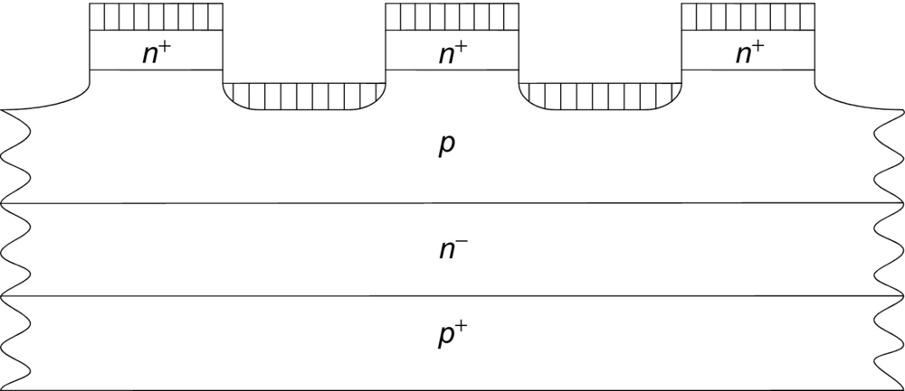

**FIG. 3.10** Cross section of a GTO showing the cathode islands and interdigitation with the gate (*p*-base).

Another switching problem that occurs is associated primarily with thyristors, though other power electronic devices suffer some degradation of performance from the same problem. This problem is that thyristors can self-trigger into a forward-conduction mode from a forward-blocking mode if the rate of rise of forward anode-cathode voltage is too large. This triggering method is due to displacement current through the associated junction capacitances (the capacitance at *J*2 dominates because it is reverse biased under forward applied voltage). The displacement current contributes to the leakage current *I*co, shown in Eq. [(3.1)](https://learning.oreilly.com/library/view/power-electronics-handbook/9780128114087/B9780128114070000039.xhtml#fo0010). The SCRs, GTOs, and IGCTs, therefore, have a maximum *dv*/*dt* rating that should not be exceeded (typical values are 100–1000 V/μs). Switching into a reverse-conducting from a reverse-blocking state, due to an applied reverse *dv/dt*, is not possible because the values of the reverse *α*'s of the equivalent transistors can never be made large enough to cause the necessary feedback (latching) effect. An external capacitor is often placed between the anode and cathode of the thyristor to help control the *dv/dt* experienced. Capacitors and other components that are used to form such protection circuits, known as snubbers, may be found in all power semiconductor devices.

### 3.4.1 CATHODE SHORTS

As the temperature in the thyristor increases above 25°C, the minority carrier lifetime and the corresponding diffusion lengths in the *n*- and *p*-bases increase. This leads to an increase in the *α*'s of the equivalent transistors. Discussion of the details of the minority carrier diffusion length and its role in determining the current gain factor *α* can be found in Sze [[6](https://learning.oreilly.com/library/view/power-electronics-handbook/9780128114087/B9780128114070000039.xhtml#bb0035)]. Referring to Eq. [(3.1)](https://learning.oreilly.com/library/view/power-electronics-handbook/9780128114087/B9780128114070000039.xhtml#fo0010), it is seen that a lower applied bias will give a carrier multiplication factor *M* sufficient to switch the device from forward-blocking into conduction, because of this increase of the *α*'s with increasing temperature. Placing a shunt resistor in parallel with the base-emitter junction of the equivalent *npn* transistor (shown in [Fig. 3.11](https://learning.oreilly.com/library/view/power-electronics-handbook/9780128114087/B9780128114070000039.xhtml#f0060)) will result in an effective current gain, *α*neff, that is lower than *αn*, as given by Eq. [(3.2)](https://learning.oreilly.com/library/view/power-electronics-handbook/9780128114087/B9780128114070000039.xhtml#fo0015), where *vGK* is the applied gate-cathode voltage, *Rs* is the equivalent lumped value for the distributed current shunting structure, and the remaining factors form the appropriate current factor based on the applied bias and characteristics of the gate-cathode junction. The shunt current path is implemented by providing intermittent shorts, called cathode shorts, between the *p*-base (gate) region and the *n*+-emitter (cathode) region in the thyristor as illustrated in [Fig. 3.12](https://learning.oreilly.com/library/view/power-electronics-handbook/9780128114087/B9780128114070000039.xhtml#f0065). The lumped shunt resistance value is in the range of 1–15 Ω as measured from gate to cathode.

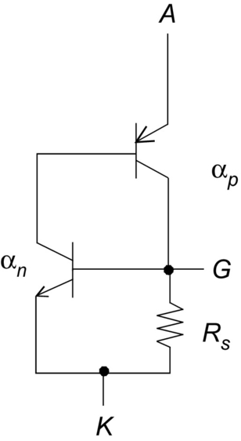

**FIG. 3.11** Two-transistor equivalent circuit showing the addition of a resistive shunt path for anode current.

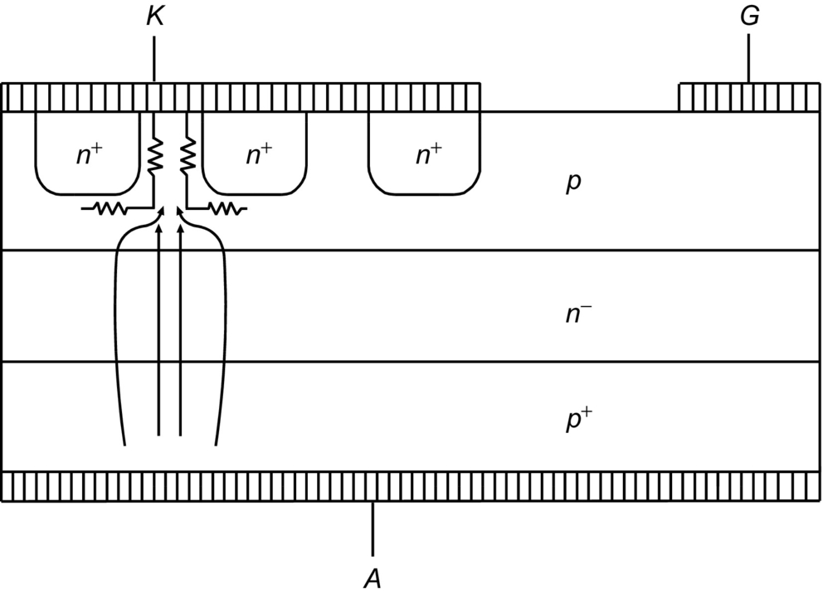

**FIG. 3.12** Cross section showing cathode shorts and the resulting resistive shunt path for anode current.

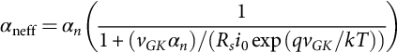 **(3.2)**

Low values of anode current (e.g., those associated with an increase in temperature under forward-blocking conditions) will flow through the shunt path to the cathode contact, bypassing the *n*+-emitter and keeping the device out of its forward-conduction mode. As the anode current becomes large, the potential drop across the shunt resistance will be sufficient to forward bias the gate-cathode junction, *J*3, and bring the thyristor into forward conduction. The cathode shorts also provide a path for displacement current to flow without forward-biasing *J*3. The *dv/dt* rating of the thyristor is thus improved and the forward-blocking characteristics by using cathode shorts. However, the shorts do cause a lowering of cathode current handling capability because of the loss of some of the cathode area (*n*+-region) to the shorting pattern, an increase in the necessary gate current to obtain switching from forward-blocking to forward conduction and an increase in complexity of manufacturing of the thyristor. The loss of cathode area due to the shorting structure is from 5% to 20%, depending on the type of thyristor. By careful design of the cathode short windows to the *p*-base, the holding current can be made lower than the latching current. This is important so that the thyristor will remain in forward conduction when used with varying load impedances.

### 3.4.2 ANODE SHORTS

A further increase in forward-blocking capability can be obtained by introducing anode shorts in addition to the cathode shorts. This reduces *αp* in a similar manner that cathode shorts reduce *αn*. An illustration of this is provided in [Fig. 3.13](https://learning.oreilly.com/library/view/power-electronics-handbook/9780128114087/B9780128114070000039.xhtml#f0070). In this structure, both *J*1 and *J*3 are shorted (anode and cathode shorts), so that the forward-blocking capability of the thyristor is completely determined by the avalanche breakdown characteristics of *J*2. Anode shorts will result in the complete loss of reverse-blocking capability and are only suitable for thyristors used in asymmetrical circuit applications.

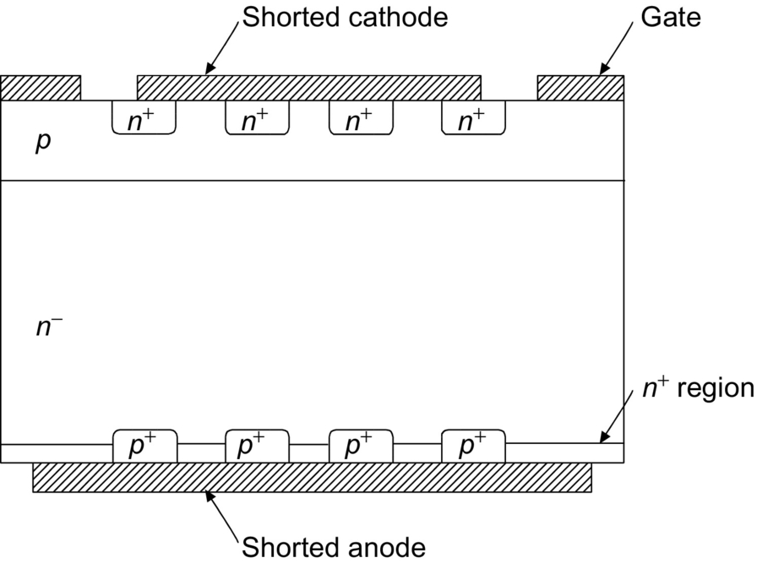

**FIG. 3.13** Cross section showing integrated cathode and anode shorts.

### 3.4.3 AMPLIFYING GATE

The cathode-shorting structure will reduce the gate sensitivity dramatically. To increase this sensitivity and yet retain the benefits of the cathode shorts, a structure called an amplifying gate (or regenerative gate) is used, as shown in [Fig. 3.14](https://learning.oreilly.com/library/view/power-electronics-handbook/9780128114087/B9780128114070000039.xhtml#f0075) (and [Fig. 3.9](https://learning.oreilly.com/library/view/power-electronics-handbook/9780128114087/B9780128114070000039.xhtml#f0050), right). When the gate current (1) is injected into the *p*-base through the pilot-gate contact, electrons are injected into the *p*-base by the *n*+-emitter with a given emitter injection efficiency. These electrons traverse through the *p*-base (the time taken for this process is called the transit time) and accumulate near the depletion region. This negative charge accumulation leads to injection of holes from the anode. The device then turns on after a certain delay, dictated by the *p*-base transit time, and the pilot anode current (2) begins to flow through a small region near the pilot-gate contact as shown in [Fig. 3.14](https://learning.oreilly.com/library/view/power-electronics-handbook/9780128114087/B9780128114070000039.xhtml#f0075).

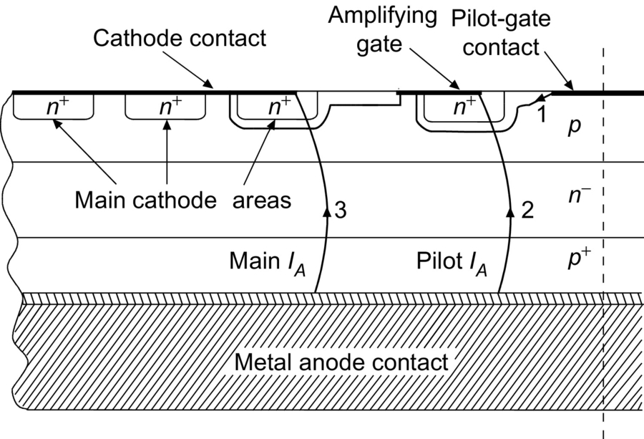

**FIG. 3.14** Cross section showing the amplifying gate structure in a thyristor.

This flow of pilot anode current corresponds to the initial sharp rise in the anode current waveform (phase I), as shown in [Fig. 3.15](https://learning.oreilly.com/library/view/power-electronics-handbook/9780128114087/B9780128114070000039.xhtml#f0080). The device switching then goes into phase II, during which the anode current remains fairly constant, suggesting that the resistance of the region has reached its lower limit. This is due to the fact that the pilot anode current (2) takes a finite time to traverse through the *p*-base laterally and become the gate current for the main cathode area. The *n*+-emitters start to inject electrons which traverse the *p*-base vertically and after a certain finite time (transit time of the *p*-base) reach the depletion region. The total time taken by the lateral traversal of pilot anode current and the electron transit time across the *p*-base is the reason for observing this characteristic phase II interval. The width of the phase II interval is comparable to the switching delay, suggesting that the *p*-base transit time is of primary importance. Once the main cathode region turns on, the resistance of the device decreases and the anode current begins to rise again (transition from phase II to III). From this time onward in the switching cycle, the plasma spreading velocity will dictate the rate at which the conduction area will increase. The current density during phases I and II can be quite large, leading to a considerable increase in the local temperature and device failure. The detailed effect of the amplifying gate on the anode current rise will only be noticed at high levels of *di/dt* (in the range of 1000 A/μs), shown in [Fig. 3.15](https://learning.oreilly.com/library/view/power-electronics-handbook/9780128114087/B9780128114070000039.xhtml#f0080). It can be concluded that the amplifying gate will increase gate sensitivity at the expense of some *di/dt* capability, as demonstrated by Sankaran [[7](https://learning.oreilly.com/library/view/power-electronics-handbook/9780128114087/B9780128114070000039.xhtml#bb0040)]. This lowering of *di/dt* capability can be somewhat offset by an increase in gate-cathode interdigitation as previously discussed.

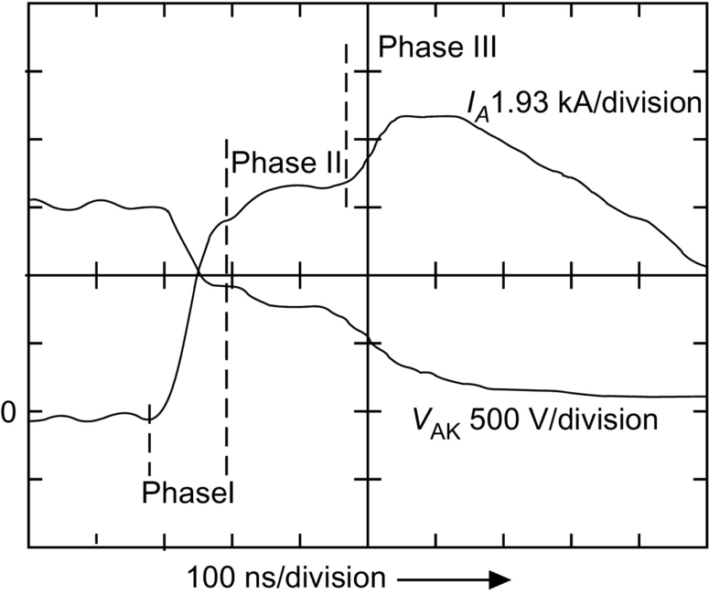

**FIG. 3.15** Turn-on waveforms showing the effect of the amplifying gate in the anode current rise.

### 3.4.4 TEMPERATURE DEPENDENCIES

The forward-blocking voltage of an SCR has been shown to be reduced from 1350 V at 25°C to 950 V at −175°C in a near linear fashion [[8](https://learning.oreilly.com/library/view/power-electronics-handbook/9780128114087/B9780128114070000039.xhtml#bb0045)]. Above 25°C, the forward-blocking capability is again reduced, due to changes in the minority carrier lifetime, which cause the leakage current to increase and the associated breakover voltage to decrease. Several dominant physical parameters associated with semiconductor devices are sensitive to temperature variations, causing their dependent device characteristics to change dramatically. The most important of these parameters are (i) the minority carrier lifetimes (which control the high-level injection lifetimes), (ii) the hole and electron mobilities, (iii) the impact ionization collision cross sections, and (iv) the free-carrier concentrations (primarily the ionized impurity atom concentration). Almost all of the impurity atoms are ionized at temperatures above 0°C, and so further discussion of the temperature effects on ionization is not relevant for normal operation. As the temperature increases above 25°C, the following trends are observed: the carrier lifetimes increase, giving longer recovery times and greater switching losses; the carrier mobilities are reduced, increasing the on-state voltage drop; and at very high temperatures, the intrinsic carrier concentration becomes sufficiently high that the depletion layer will not form and the device cannot switch off. A more detailed discussion of these physical parameters is beyond the scope of this book, but references are listed for those persons interested in pursuing relevant information about temperature effects.

It is well known that charge-carrier recombination events are more efficient at lower temperatures. This shows up as a larger potential drop during forward conduction and a shorter recovery time during turnoff. A plot of the anode current during turnoff, at various temperatures, for a typical GTO is shown in [Fig. 3.16](https://learning.oreilly.com/library/view/power-electronics-handbook/9780128114087/B9780128114070000039.xhtml#f0085).

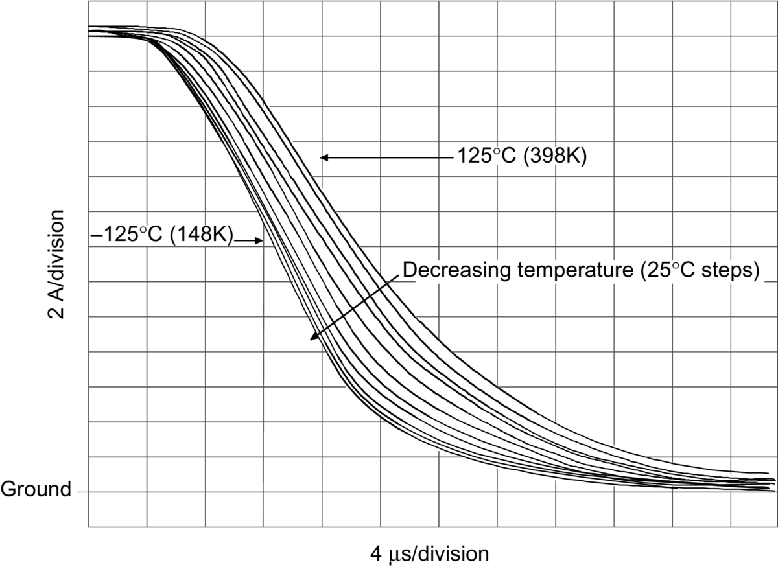

**FIG. 3.16** Temperature effect on the anode current tail during turnoff.

An approximate relation between the temperature and the forward drop across the *n*−-base of a thyristor is discussed in detail by Herlet [[9](https://learning.oreilly.com/library/view/power-electronics-handbook/9780128114087/B9780128114070000039.xhtml#bb0050)] and Hudgins et al. [[10](https://learning.oreilly.com/library/view/power-electronics-handbook/9780128114087/B9780128114070000039.xhtml#bb0055)]. Temperature-dependent equations relating the anode current density, *JA*, and the applied anode-cathode voltage *V*AK are also given in Ref. [[10](https://learning.oreilly.com/library/view/power-electronics-handbook/9780128114087/B9780128114070000039.xhtml#bb0055)]; these include the junction potential drops in the device, the temperature dependence of the band-gap energy, and the *n*−-base potential drop. Data from measurements at forward current densities of approximately 100 A/cm2 on a GTO rated for 1 kV symmetrical blocking give forward voltage drops of 1.7 V at −50°C and 1.8 V at 150°C.

## 3.5 Thyristor Parameters

Understanding of a thyristor's maximum ratings and electric characteristics is required for proper application. Use of a manufacturer's data sheet is essential for good design practice. *Ratings* are maximum or minimum values that set limits on device capability. A measure of device performance under specified operating conditions is a *characteristic* of the device. A summary of some of the maximum ratings that must be considered when choosing a thyristor for a given application is provided in [Table 3.3](https://learning.oreilly.com/library/view/power-electronics-handbook/9780128114087/B9780128114070000039.xhtml#t0020). Thyristor types shown in parentheses indicate a maximum rating unique to that device. Both forward and reverse repetitive and nonrepetitive voltage ratings must be considered, and a properly rated device must be chosen so that the maximum voltage ratings are never exceeded. In most cases, either forward- or reverse-voltage transients in excess of the nonrepetitive maximum ratings result in destruction of the device. The maximum root mean square (RMS) or average current ratings given are usually those which cause the junction to reach its maximum rated temperature. Because the maximum current will depend upon the current waveform and upon thermal conditions external to the device, the rating is usually shown as a function of case temperature and conduction angle. The peak single half-cycle surge-current rating must be considered, and in applications where the thyristor must be protected from damage by overloads, a fuse with an *I*2*t* rating smaller than the maximum rated value for the device must be used. Maximum ratings for both forward and reverse gate voltage, current, and power also must not be exceeded.

**Table 3.3**

**Thyristor maximum ratings specified by manufacturers**

|  |  |
| --- | --- |
| **Symbol** | **Description** |
| *V*RRM | Peak repetitive reverse voltage |
| *V*RSM | Peak nonrepetitive reverse voltage (transient) |
| *VR*(DC) | DC reverse-blocking voltage |
| *V*DRM | Peak repetitive forward off-state voltage |
| *V*DSM | Peak nonrepetitive forward off-state voltage (transient) |
| *VD*(DC) | DC forward-blocking voltage |
| *IT*(RMS),*IF*(RMS) | RMS forward on-state current |
| *IT*(AV),*IF*(AV) | Average forward on-state current at specified case or junction temperature |
| *I*TSM,*IF*(TSM) | Peak one-cycle surge on-state current (values specified at 60 and 50 Hz) |
| *I*TGQ (GTO) | Peak controllable current |
| *I*2*t* | Nonrepetitive pulse overcurrent capability (*t*=8.3 ms for a 60 Hz half cycle) |
| *PT* | Maximum power dissipation |
| *di*/*dt* | Critical rate of rise of on-state current at specified junction temperature, gate current, and forward-blocking voltage |
| *P*GM (*P*FGM for GTO) | Peak gate power dissipation (forward) |
| *P*RGM (GTO) | Peak gate power dissipation (reverse) |
| *PG*(AV) | Average gate power dissipation |
| *V*FGM | Peak forward gate voltage |
| *V*RGM | Peak reverse gate voltage |
| *I*FGM | Peak forward gate current |
| *I*RGM (GTO) | Peak reverse gate current |
| *T*STG | Storage temperature |
| *Tj* | Junction operating temperature |
| *V*RMS | Voltage isolation (modules) |

The maximum rated operating junction temperature *TJ* must not be exceeded, since device performance, in particular voltage-blocking capability, will be degraded. Junction temperature cannot be measured directly but must be calculated from a knowledge of steady-state thermal resistance  and the average power dissipation. For transients or surges, the transient thermal impedance () curve must be used (provided in manufacturer's data sheets). The maximum average power dissipation *PT* is related to the maximum rated operating junction temperature and the case temperature by the steady-state thermal resistance. In general, both the maximum dissipation and its derating with increasing case temperature are provided.

The number and type of thyristor characteristics specified varies widely from one manufacturer to another. Some characteristics are given only as typical values of minima or maxima, while many characteristics are displayed graphically. [Table 3.4](https://learning.oreilly.com/library/view/power-electronics-handbook/9780128114087/B9780128114070000039.xhtml#t0025) summarizes some of the typical characteristics provided as maximum values. The maximum value means that the manufacturer guarantees that the device will not exceed the value given under the specified operating or switching conditions. A minimum value means that the manufacturer guarantees that the device will perform at least, as well as the characteristic given under the specified operating or switching conditions. Thyristor types shown in parenthesis indicate a characteristic unique to that device. Gate conditions of both voltage and current to ensure either nontriggered or triggered device operation are included. The turn-on and turn-off transients of the thyristor are characterized by switching times like the turn-off time listed in [Table 3.4](https://learning.oreilly.com/library/view/power-electronics-handbook/9780128114087/B9780128114070000039.xhtml#t0025). The turn-on transient can be divided into three intervals: (i) gate-delay interval, (ii) turn-on of initial area, and (iii) spreading interval. The gate-delay interval is simply the time between application of a turn-on pulse at the gate and the time the initial cathode area turns on. This delay decreases with increasing gate-drive current and is of the order of a few microseconds. The second interval, the time required for turn-on of the initial area, is quite short, typically less than 1 μs. In general, the initial area turned on is a small percentage of the total useful device area. After the initial area turns on, conduction spreads (spreading interval or plasma spreading time) throughout the device in tens of microseconds for high speed or thyristors. The plasma spreading time may take up to hundreds of microseconds in large-area phase-control devices.

**Table 3.4**

**Typical thyristor characteristic maximum and minimum values specified by manufacturers**

|  |  |
| --- | --- |
| **Symbol** | **Description** |
| *V*TM,*V*FM | Maximum on-state voltage drop (at specified junction temperature and forward current) |
| *I*DRM | Maximum forward off-state current (at specified junction temperature and forward voltage) |
| *I*RRM | Maximum reverse off-state current (at specified junction temperature and reverse voltage) |
| *dv*/*dt* | Minimum critical rate of rise of off-state voltage at specified junction temperature and forward-blocking voltage level |
| *V*GT | Maximum gate trigger voltage (at specified temperature and forward applied voltage) |
| *V*GD,*V*GDM | Maximum gate nontrigger voltage (at specified temperature and forward applied voltage) |
| *IGT* | Maximum gate trigger current (at specified temperature and forward applied voltage) |
| *Tgt* (GTO) | Maximum turn-on time (under specified switching conditions) |
| *Tq* | Maximum turn-off time (under specified switching conditions) |
| *tD* | Maximum turn-on delay time (for specified test) |
| si1_e | Maximum junction-to-case thermal resistance |
| si2_e | Maximum case-to-sink thermal resistance (interface lubricated) |

[Table 3.5](https://learning.oreilly.com/library/view/power-electronics-handbook/9780128114087/B9780128114070000039.xhtml#t0030) lists many of the thyristor parameters that appear as listed values or as information on graphs. The definition of each parameter and the test conditions under which they are measured are given in the table as well.

**Table 3.5**

**Symbols and definitions of major thyristor parameters**

|  |  |  |
| --- | --- | --- |
| *Rθ* | Thermal Resistance | Specifies the degree of temperature rise per unit of power, measuring junction temperature from a specified external point. Defined when junction power dissipation results in steady-state thermal flow |
| si3_e | Junction-to-ambient thermal resistance | The steady-state thermal resistance between the junction and ambient |
| si4_e | Junction-to-case thermal resistance | The steady-state thermal resistance between the junction and case surface |
| si5_e | Junction-to-sink thermal resistance | The steady-state thermal resistance between the junction and the heat sink mounting surface |
| si6_e | Contact thermal resistance | The steady-state thermal resistance between the surface of the case and the heat sink mounting surface |
| *Zθ* | Transient thermal impedance | The change of temperature difference between two specified points or regions at the end of a time interval divided by the step function change in power dissipation at the beginning of the same interval causing the change of temperature difference |
| si7_e | Junction-to-ambient transient thermal impedance | The transient thermal impedance between the junction and ambient |
| si8_e | Junction-to-case transient thermal impedance | The transient thermal impedance between the junction and the case surface |
| si9_e | Junction-to-sink transient thermal impedance | The transient thermal impedance between the junction and the heat sink mounting surface |
| *TA* | Ambient temperature | It is the temperature of the surrounding atmosphere of a device when natural or forced-air cooling is used and is not influenced by heat dissipation of the device |
| *TS* | Sink temperature | The temperature at a specified point on the device heat sink |
| *TC* | Case temperature | The temperature at a specified point on the device case |
| *TJ* | Junction temperature | The device junction temperature rating. Specifies the maximum and minimum allowable operation temperatures |
| *T*STG | Storage temperature | Specifies the maximum and minimum allowable storage temperatures (with no electric connections) |
| *V*RRM | Peak reverse-blocking voltage | Within the rated junction temperature range and with the gate terminal open circuited, specifies the repetitive peak reverse anode-to-cathode voltage applicable on each cycle |
| *V*RSM | Transient peak reverse-blocking voltage | Within the rated junction temperature range and with the gate terminal open circuited, specifies the nonrepetitive peak reverse anode-to-cathode voltage applicable for a time width equivalent to less than 5 ms |
| *VR*(DC) SCR only | Dc reverse-blocking voltage | Within the rated junction temperature range and with the gate terminal open-circuited, specifies the maximum value for dc anode-to-cathode voltage applicable in the reverse direction |
| *V*DRM | Peak forward-blocking voltage | Within the rated junction temperature range and with the gate terminal open circuited (SCR) or with a specified reverse voltage between the gate and cathode (GTO), specifies the repetitive peak off-state anode-to-cathode voltage applicable on each cycle. This does not apply for transient off-state voltage application |
| *V*DSM | Transient peak forward-blocking voltage | Within the rated junction temperature range, and with the gate terminal open circuited (SCR), or with a specified reverse voltage between the gate and cathode (GTO), specifies the nonrepetitive off-state anode-to-cathode voltage applicable for a time width equivalent to less than 5 ms. This gives the maximum instantaneous value for nonrepetitive transient off-state voltage |
| *VD*(DC) | Dc forward-blocking voltage | Within the rated junction temperature range and with the gate terminal open circuited (SCR) or with a specified reverse voltage between the gate and cathode (GTO), specifies the maximum value for dc anode-to-cathode voltage applicable in the forward direction |
| *dv*/*dt* | Critical rate of rise of off-state voltage si10_e is specified off-state voltage *τ* is time constant for exponential | At the maximum rated junction temperature range, and with the gate terminal open circuited (SCR), or with a specified reverse voltage between the gate and cathode (GTO), this specifies the maximum rate of rise of off-state voltage that will not drive the device from an off-state to an on-state when an exponential off-state voltage of specified amplitude is applied to the device |
| *V*TM | Peak on-state voltage | At specified junction temperature, and when on-state current (50 or 60 Hz, half sine wave of specified peak amplitude) is applied to the device, indicates peak value for the resulting voltage drop |
| *IT*(RMS) | RMS on-state current | At specified case temperature, indicates the RMS value for on-state current that can be continuously applied to the device |
| *IT*(AV) | Average on-state current | At specified case temperature, and with the device connected to a resistive or inductive load, indicates the average value for forward current (sine half wave, commercial frequency) that can be continuously applied to the device |
| *I*TSM | Peak on-state current | Within the rated junction temperature range, indicates the peak value for nonrepetitive on-state current (sine half wave, 50 or 60 Hz). This value indicated for one cycle or as a function of a number of cycles |
| *I*2*t* | Current-squared time | The maximum, on-state, nonrepetitive short-time thermal capacity of the device and is helpful in selecting a fuse or providing a coordinated protection scheme of the device in the equipment. This rating is intended specifically for operation less than one half cycle of a 180 (degree) conduction angle sinusoidal wave form. The off-state blocking capability cannot be guaranteed at values near the maximum *I*2*t* |
| *di*/*dt* | Critical rate of rise of on-state current | At specified case temperature, specified off-state voltage, specified gate conditions, and at a frequency of less than 60 Hz, indicates the maximum rate of rise of on-state current which the thyristor will withstand when switching from an off-state to an on-state, when using recommended gate drive |
| *I*RRM | Peak reverse leakage current | At maximum rated junction temperature, indicates the peak value for reverse current flow when a voltage (sine half wave, 50 or 60 Hz, and having a peak value as specified for repetitive peak reverse-voltage rating) is applied in a reverse direction to the device |
| *I*DRM | Peak forward-leakage current | At maximum rated junction temperature, indicates the peak value for off-state current flow when a voltage (sine half wave, 50 or 60 Hz, and having a peak value for repetitive off-state voltage rating) is applied in a forward direction to the device. For a GTO, a reverse voltage between the gate and cathode is specified |
| *P*GM (SCR) *P*GFM (GTO) | Peak gate power dissipation peak gate forward power dissipation | Within the rated junction temperature range, indicates the peak value for maximum allowable power dissipation over a specified time period, when the device is in forward conduction between the gate and cathode |
| *PG*(AV) | Average gate power dissipation | Within the rated junction temperature range, indicates the average value for maximum allowable power dissipation when the device is forward-conducting between the gate and cathode |
| *P*GRM GTO only | Peak gate reverse power dissipation | Within the rated junction temperature range, indicates the peak value for maximum allowable power dissipation in the reverse direction between the gate and cathode, over a specified time period |
| *P*GR(AV) GTO only | Average gate reverse power dissipation | Within the rated junction temperature range, indicates the average value for maximum allowable power dissipation in the reverse direction between the gate and cathode |
| *I*GFM | Peak forward gate current | Within the rated junction temperature range, indicates the peak value for forward current flow between the gate and cathode |
| *I*GRM GTO only | Peak reverse gate current | Within the rated junction temperature range, indicates peak value for reverse current that can be conducted between the gate and cathode |
| *V*GRM | Peak reverse gate voltage | Within the rated junction temperature range, indicates the peak value for reverse voltage applied between the gate and cathode |
| *V*GFM | Peak forward gate voltage | Within the rated junction temperature range, indicates the peak value for forward voltage applied between the gate and cathode |
| *I*GT | Gate current to trigger | At a junction temperature of 25°C, and with a specified off-voltage, and a specified load resistance, indicates the minimum gate dc current required to switch the thyristor from an off-state to an on-state |
| *V*GT | Gate voltage to trigger | At a junction temperature of 25°C, and with a specified off-state voltage, and a specified load resistance, indicates the minimum dc gate voltage required to switch the thyristor from an off-state to an on-state |
| *V*GDM SCR only | Nontriggering gate voltage | At maximum rated junction temperature, and with a specified off-state voltage applied to the device, indicates the maximum dc gate voltage which will not switch the device from an off-state to an on-state |
| *I*TGQ GTO only | Gate-controlled turn-off current | Under specified conditions, indicates the instantaneous value for on-current usable in gate control, specified immediately prior to device turn-off |
| *Rθ* | Thermal resistance | Specifies the degree of temperature rise per unit of power, measuring junction temperature from a specified external point. Defined when junction power dissipation results in steady-state thermal flow |
| *t*on SCR only | Turn-on time | At specified junction temperature, and with a peak repetitive off-state voltage of half rated value, followed by device turn-on using specified gate current, and when specified on-state current of specified *di*/*dt* flows, indicated as the time required for the applied off-state voltage to drop to 10% of its initial value after gate current application. Delay time is the term used to define the time required for applied voltage to drop to 90% of its initial value following gate-current application. The time required for the voltage level to drop from 90% to 10% of its initial value is referred to as rise time. The sum of both these defines turn-on time |
| *Tq* SCR only | Turn-off time | Specified at maximum rated junction temperature. Device set up to conduct on-state current, followed by application of specified reverse anode-cathode voltage to quench on-state current and then increasing the anode-cathode voltage at a specified rate of rise as determined by circuit conditions controlling the point where the specified off-state voltage is reached. Turn-off time defines the minimum time which the device will hold its off-state, starting from the time on-state current reached zero until the time forward voltage is again applied (i.e., applied anode-cathode voltage becomes positive again) |
| *tgt* GTO only | Turn-on time | When applying forward current to the gate, indicates the time required to switch the device from an off-state to an on-state |
| *tqt* GTO only | Turn-off time | When applying reverse current to the gate, indicates the time required to switch the device from an on-state to an off-state |

## 3.6 Types of Thyristors

In recent years, most development effort has gone into continued integration of the gating and control electronics into thyristor modules and the use of MOS technology to create gate structures integrated into the thyristor itself. Many variations of this theme are being developed and some technologies should rise above the others in the years to come. Further details concerning most of the following discussion of thyristor types can be found in [[11](https://learning.oreilly.com/library/view/power-electronics-handbook/9780128114087/B9780128114070000039.xhtml#bb0060)].

### 3.6.1 SCRS AND GTOS

The highest power handling devices continue to be bipolar thyristors. High-powered thyristors are large diameter devices, some well in excess of 100 mm, and as such have a limitation on the rate of rise of anode current, a *di*/*dt* rating. The depletion capacitances around the *p-n* junctions, in particular the center junction *J*2, limit the rate of rise in forward voltage that can be applied even after all the stored charge, introduced during conduction, is removed. The associated displacement current under application of forward voltage during the thyristor blocking state sets a *dv*/*dt* limit. Some effort in improving the voltage hold-off capability and overvoltage protection of conventional SCRs is underway by incorporating a lateral high-resistivity region to help dissipate the energy during breakover. Most effort, though, is being placed in the further development of high-performance GTOs and IGCTs because of their controllability and to a lesser extent in optically triggered structures that feature gate circuit isolation.

High-voltage GTOs with symmetrical blocking capability require thick *n*−-base regions to support the high electric field. The addition of an *n*+ buffer layer next to the *p*+-anode allows high-voltage forward-blocking and a low forward voltage drop during conduction because of the thinner *n*−-base required. Cylindrical anode shorts have been incorporated to facilitate excess carrier removal from the *n*−-base during turnoff and still retain the high blocking capability. This device structure can control 200 A, operating at 900 Hz, with a 6 kV hold-off. Some of the design trade-off between the *n−*-base width and turn-off energy losses in these structures has been determined. A similar GTO incorporating an *n*+-buffer layer and a *pin* structure has been fabricated that can control up to 1 kA (at a forward drop of 4 V) with a forward-blocking capability of 8 kV. A reverse conducting GTO has been fabricated that can block 6 kV in the forward direction, interrupt a peak current of 3 kA, and has a turn-off gain of about 5.

The IGCT is a modified GTO structure. It is designed and manufactured so that it commutates all of the cathode current away from the cathode region and diverts it out of the gate contact. The IGCT is similar to a GTO in structure except that it always has a low-loss *n*-buffer region between the *n*−-base and *p*-emitter. The IGCT device package is designed to result in a very low parasitic inductance and is integrated with a specially designed gate-drive circuit. The gate drive contains all the necessary *di/dt* and *dv/dt* protection; the only connections required are a low-voltage power supply for the gate drive and an optical signal for controlling the gate. The specially designed gate drive and ring-gate package circuit allows the IGCT to be operated without a snubber circuit and to switch with a higher anode *di/dt* than a similar GTO. At blocking voltages of 4.5 kV and higher, the IGCT provides better performance than a conventional GTO. The speed at which the cathode current is diverted to the gate (*diGQ*/*dt*) is directly related to the peak snubberless turn-off capability of the IGCT. The gate-drive circuit can sink current for turn-off at *diGQ*/*dt* values in excess of 7000 A/μs. This hard gate drive results in a low charge storage time of about 1 μs. The low storage time and the fail-short mode make the IGCT attractive for high-power, high-voltage series applications; examples include high-power converters in excess of 100 MVA, static volt-ampere reactive (VAR) compensators, and converters for distributed generation such as wind power.

#### **3.6.1.1 On-State Characteristics**

In the on-state, the GTO operates in a similar manner to the thyristor. If the anode current remains above the holding current level, then positive gate drive may be reduced to zero, and the GTO will remain in conduction. However, as a result of the turn-off ability of the GTO, it does possess a higher holding current level than the standard thyristor, and in addition, the cathode of the GTO thyristor is subdivided into small finger elements to assist turn-off. Thus, if the GTO thyristor anode current transiently dips below the holding current level, localized regions of the device may turn off, thus forcing a high anode current back into the GTO at a high rate of rise of anode current after this partial turnoff. This situation could be potentially destructive. It is recommended, therefore, that the positive gate drive is not removed during conduction but is held at a value *IG*(ON), where *IG*(ON) is greater than the maximum critical trigger current (*IGT*) over the expected operating temperature range of the GTO thyristor.

[Fig. 3.17](https://learning.oreilly.com/library/view/power-electronics-handbook/9780128114087/B9780128114070000039.xhtml#f0090) shows the typical on-state *V*-*I* characteristics for a 40001A, 4500 V GTO from Dynex range of GTOs [[1](https://learning.oreilly.com/library/view/power-electronics-handbook/9780128114087/B9780128114070000039.xhtml#bb0010)] at junction temperatures of 25 and 125°C. The curves can be approximated to a straight line of the form

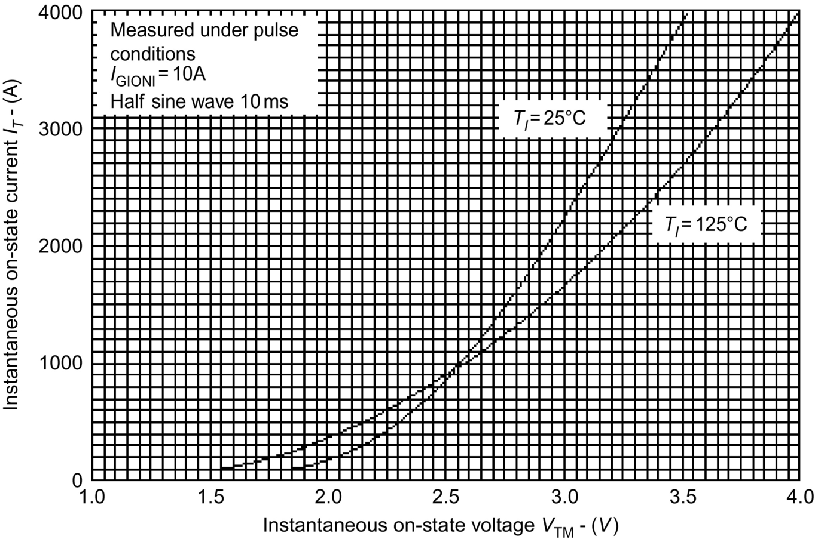

**FIG. 3.17** *V*-*I* characteristics of GTO [[12](https://learning.oreilly.com/library/view/power-electronics-handbook/9780128114087/B9780128114070000039.xhtml#bb0065)].

 **(3.3)**

where *V*0=voltage intercept models the voltage across the cathode and anode forward-biased junctions and *R*0=on-state resistance. When average and RMS values of on-state current (*I*TAV, *I*TRMS) are known, then the on-state power dissipation *P*ON can be determined using *V*0 and *R*0. That is,

 **(3.4)**

#### **3.6.1.2 Off-State Characteristics**

Unlike the standard thyristor, the GTO does not include cathode emitter shorts to prevent nongated turn-on effects due to *dv*/*dt* induced forward-biased leakage current. In the off-state of the GTO, steps should, therefore, be taken to prevent such potentially dangerous triggering. This can be accomplished by either connecting the recommended value of resistance between the gate and the cathode (*RGK*) or by maintaining a small reverse bias on the gate contact (*VRG*=−2 V). This will prevent the cathode emitter becoming forward biased and therefore sustain the GTO thyristor in the off-state.

The peak off-state voltage is a function of resistance *RGK*. This is shown in [Fig. 3.18](https://learning.oreilly.com/library/view/power-electronics-handbook/9780128114087/B9780128114070000039.xhtml#f0095). Under ordinary operating conditions, GTOs are biased with a negative gate voltage of around −15 V supplied from the gate-drive unit during the off-state interval. Nevertheless, provision of *RGK* may be desirable design practice in the event of the gate-drive failure for any reason ( is recommended for a large GTO). *RGK* dissipates energy and hence adds to the system losses.

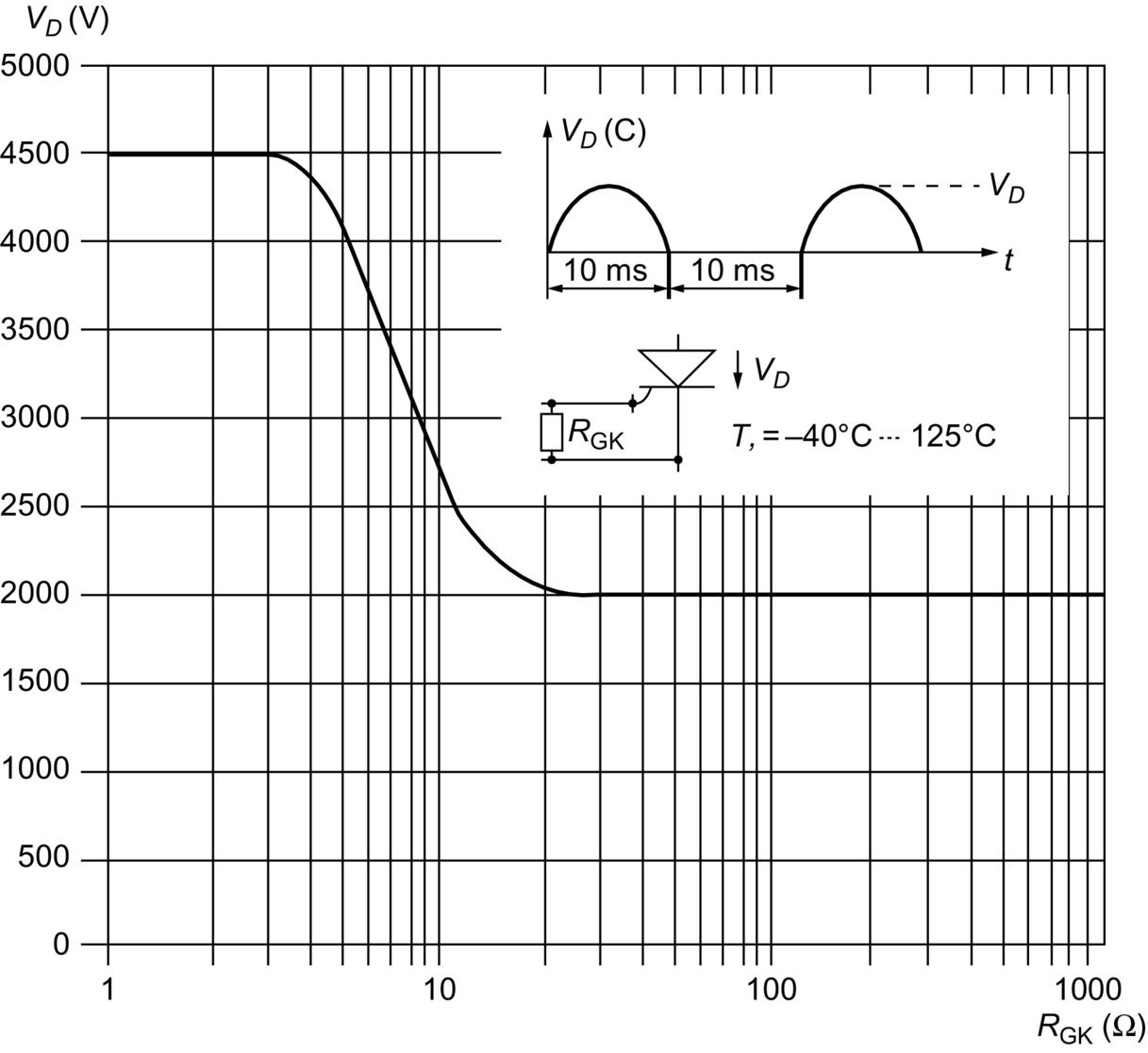

**FIG. 3.18** GTO blocking voltage versus *RGK* [[12](https://learning.oreilly.com/library/view/power-electronics-handbook/9780128114087/B9780128114070000039.xhtml#bb0065)].

#### **3.6.1.3 Rate of Rise of Off-State Voltage (*dvD/dt*)**

The rate of rise of off-state voltage (*dvD*/*dt*) depends on the resistance *RGK* connected between the gate and the cathode and the reverse bias applied between the gate and the cathode. This relationship is shown in [Fig. 3.19](https://learning.oreilly.com/library/view/power-electronics-handbook/9780128114087/B9780128114070000039.xhtml#f0100).

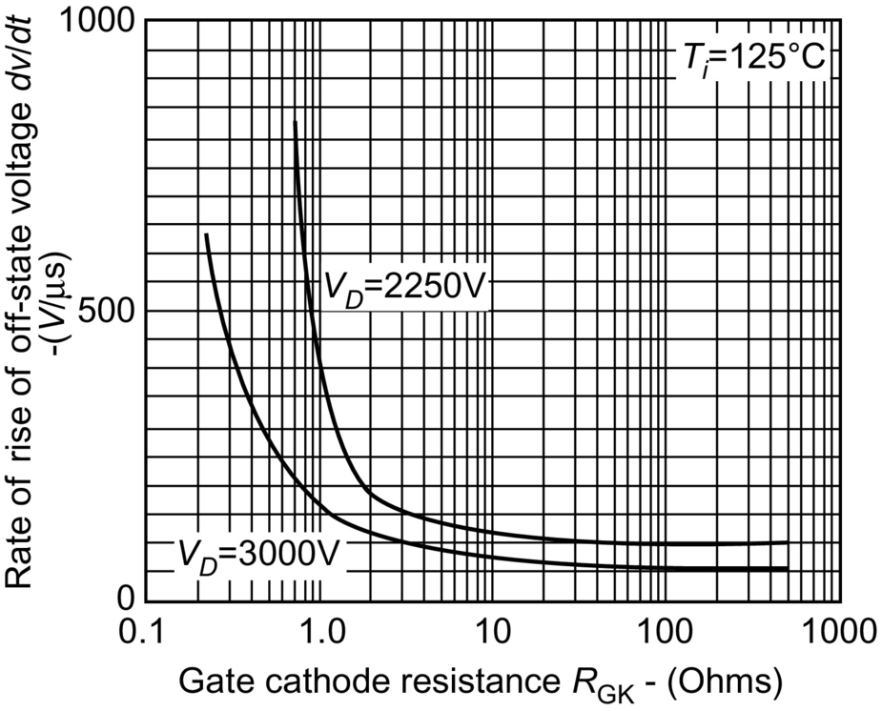

**FIG. 3.19** *dvD/dt* versus *RGK* [[12](https://learning.oreilly.com/library/view/power-electronics-handbook/9780128114087/B9780128114070000039.xhtml#bb0065)].

#### **3.6.1.4 Gate Triggering Characteristics**

The gate trigger current (*IGT*) and the gate trigger voltage (*VGT*) are both dependent on junction temperature *Tj* as shown in [Fig. 3.20](https://learning.oreilly.com/library/view/power-electronics-handbook/9780128114087/B9780128114070000039.xhtml#f0105). During the conduction state of the GTO, a certain value of gate current must be supplied, and this value should be larger than the *IGT* at the lowest junction temperature at which the GTO operates. In dynamic conditions, the specified *IGT* is not sufficient to trigger the GTO switching from higher voltage and high *di*/*dt*. In practice, a much high peak gate current *IGM* (in order of 10 times *IGT*) at *Tj* min is recommended to obtain good turn-on performance.

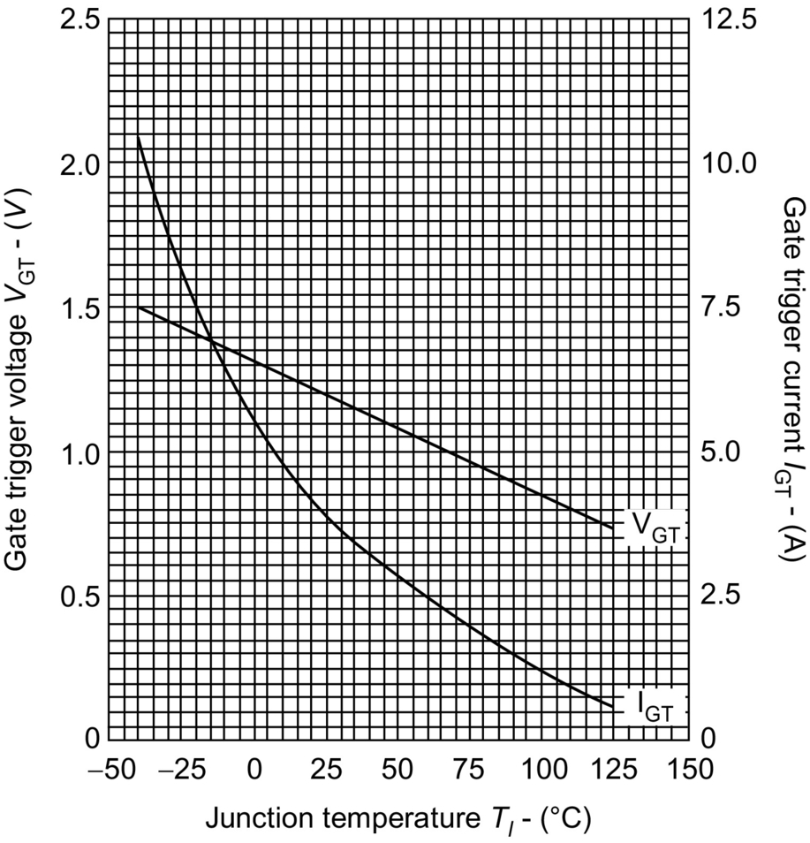

**FIG. 3.20** GTO trigger characteristics (see data sheet in Ref. [[1](https://learning.oreilly.com/library/view/power-electronics-handbook/9780128114087/B9780128114070000039.xhtml#bb0010)]).

#### **3.6.1.5 GTO Switching Phases**

The switching process of a GTO thyristor goes through four operating phases.

##### **Turn-on**

A GTO has a highly interdigitated gate structure with no regenerative gate. Thus, it requires a large initial gate trigger pulse. A typical turn-on wave diagrams and their important parameters are shown in [Fig. 3.21](https://learning.oreilly.com/library/view/power-electronics-handbook/9780128114087/B9780128114070000039.xhtml#f0110). Minimum and maximum values of *IGM* can be derived from the device data sheet. A value of *dig*/*dt* is given in device characteristics of the data sheet, against turn-on time. The rate of rise of gate current, *dig*/*dt* will affect the device turn-on losses. The duration of the *IGM* pulse should not be less than half the minimum on time given in data sheet ratings. A longer period will be required if the anode current *di*/*dt* is low such that *IGM* is maintained until a sufficient level of anode current is established.

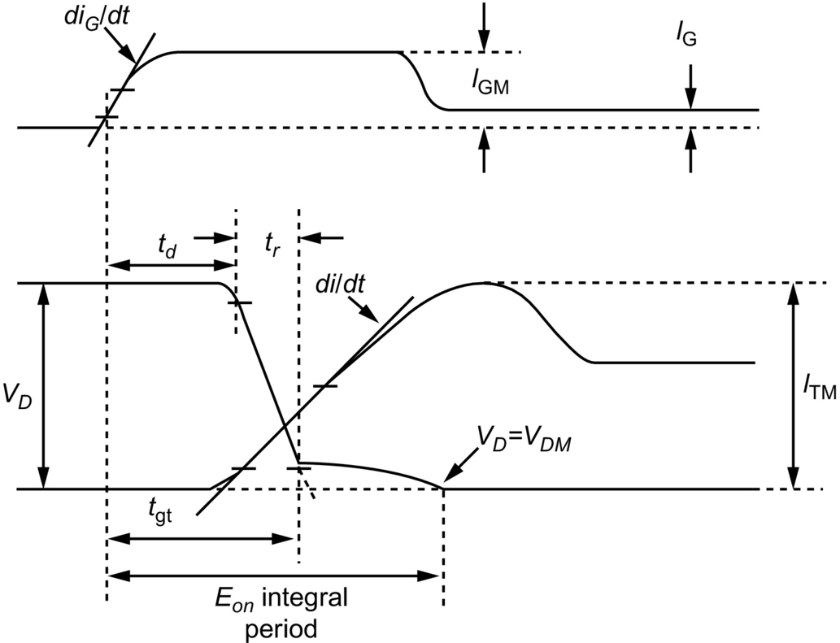

**FIG. 3.21** A typical GTO turn-on wave diagrams [[13](https://learning.oreilly.com/library/view/power-electronics-handbook/9780128114087/B9780128114070000039.xhtml#bb0070)].

##### **On-state**

Once the GTO is turned on, forward gate current must be continued for the whole of the conduction period. Otherwise, the device will not remain in conduction during the on-state period. If large negative *di*/*dt* or anode current to reversal occurs in the circuit during the on-state, then higher values of *IG* may be required. Much lower values of *IG* are, however, required when the device has heated up.

##### **Turn-off**

The turn-off performance of a GTO is greatly influenced by the characteristics of the gate turn-off circuit. Thus, the characteristics of the turn-off circuit must match with the device requirements. [Fig. 3.22](https://learning.oreilly.com/library/view/power-electronics-handbook/9780128114087/B9780128114070000039.xhtml#f0115) shows the typical anode and gate currents during the turn-off. The gate turn-off process involves the extraction of the gate charge, the gate avalanche period, and the anode current decay. The amount of the charge extraction is a device parameter and its value is not significantly affected by the external circuit conditions. The initial peak turn-off current and turn-off time, which are important parameters of the turning-off process, depend on the external circuit components. The device data sheet gives typical values for *IGQ*.

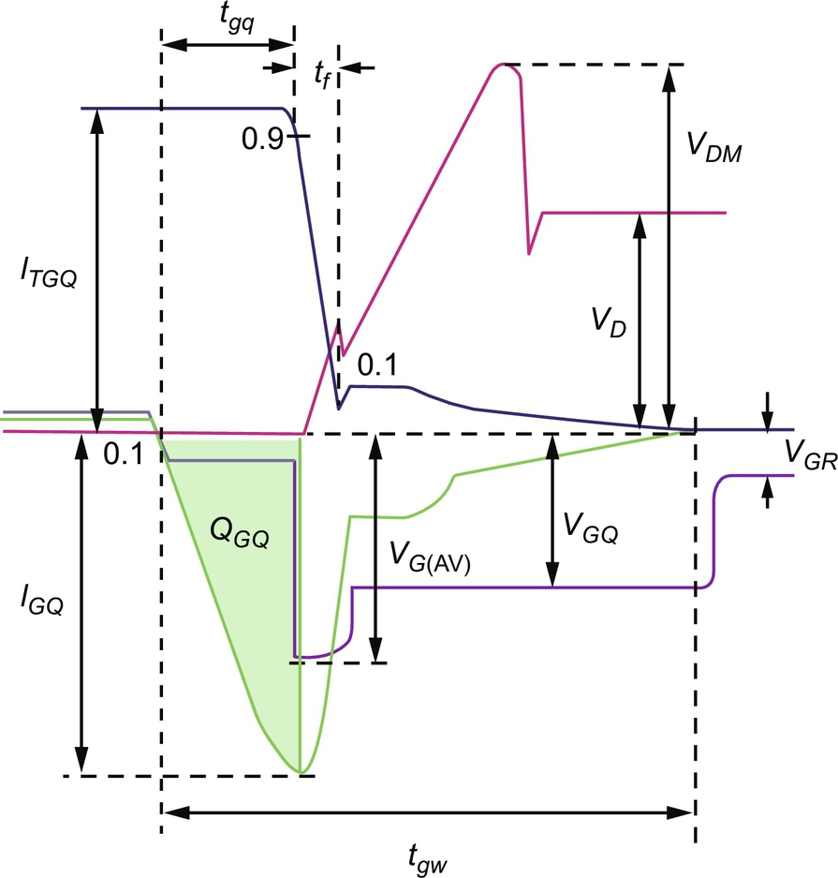

**FIG. 3.22** A typical GTO turn-off currents [[13](https://learning.oreilly.com/library/view/power-electronics-handbook/9780128114087/B9780128114070000039.xhtml#bb0070)].

The turn-off circuit arrangement of a GTO is shown in [Fig. 3.22](https://learning.oreilly.com/library/view/power-electronics-handbook/9780128114087/B9780128114070000039.xhtml#f0115). The turn-off current gain of a GTO is low, typically 6–15. Thus, for a GTO with a turn-off gain of 10, it will require a turn-off gate current of 10 A to turn off an on-state of 100 A. A charged capacitor *C* is normally used to provide the required turn-off gate current. Inductor *L* limits the turnoff *di*/*dt* of the gate current through the circuit formed by *R*1, *R*2, *SW*1, and *L*. The gate circuit supply voltage *VGS* should be selected to give the required value of *VGQ*. The values of *R*1 and *R*2 should also be minimized.

##### **Off-state period**

During the off-state period, which begins after the fall of the tail current to zero, the gate should ideally remain reverse biased. This reverse bias ensures maximum blocking capability and *dv*/*dt* rejection. The reverse bias can be obtained either by keeping *SW*1 closed during the whole off-state period or via a higher impedance circuit *SW*2 and *R*3 provided a minimum negative voltage exits. This higher impedance circuit *SW*2 and *R*3 must sink the gate leakage current.

In case of a failure of the auxiliary supplies for the gate turn-off circuit, the gate may be in reverses biased condition, and the GTO may not be able to block the voltage. To ensure blocking voltage of the device is maintained, then a minimum gate-cathode resistance (*RGK*) should be used. The value of *RGK* for a given line voltage can be derived from the data sheet.

#### **3.6.1.6 GTO SPICModel**

A GTO may be modeled with two transistors shown in [Fig. 3.2](https://learning.oreilly.com/library/view/power-electronics-handbook/9780128114087/B9780128114070000039.xhtml#f0015). However, a GTO model [[14](https://learning.oreilly.com/library/view/power-electronics-handbook/9780128114087/B9780128114070000039.xhtml#bb0075)] consisting of two thyristors, which are connected in parallel, yields improved on-state, turn-on, and turn-off characteristics. The model is shown in [Fig. 3.23](https://learning.oreilly.com/library/view/power-electronics-handbook/9780128114087/B9780128114070000039.xhtml#f0120) with four transistors.

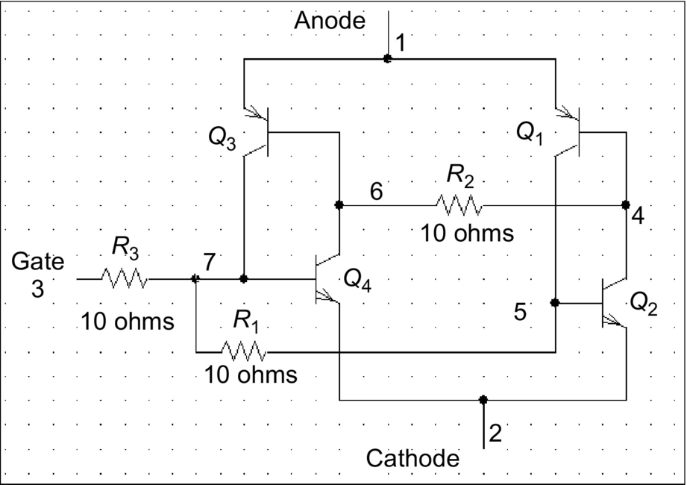

**FIG. 3.23** Four-transistor GTO model.

When the anode-to-cathode voltage *VAK* is positive and there is no gate voltage, the GTO model will be in the off-state like a standard thyristor. If a positive voltage (*VAK*) is applied to the anode with respect to the cathode and no gate pulse applied,  and therefore . Thus, no anode current will flow, .

When a small voltage is applied to the gate, then *IB*2 is nonzero, and therefore, both  are nonzero. Thus, the internal circuit will conduct, and there will a current flow from the anode to the cathode.

When a negative gate pulse is applied to the GTO model, the PNP junction near to the cathode will behave as a diode. The diode will be reverse biased since the gate voltage is negative with to the cathode. Therefore, the GTO will stop conduction.

When the anode-to-cathode voltage is negative, that is, the anode voltage is negative with respect to the cathode, the GTO model will act like a reverse biased diode. This is because the PNP transistor will see a negative voltage at the emitter and the NPN transistor will see a positive voltage at the emitter. Therefore, both transistors will be in the off-state and hence the GTO will not conduct. The SPICE subcircuit description of the GTO model will be as follows:

|  |  |  |  |  |  |  |  |
| --- | --- | --- | --- | --- | --- | --- | --- |
| **Subcircuit** | | | **1** |  | **2** | **3** | **GTO subcircuit definition** |
| \*Terminal | | |  | Anode | Cathode | Gate |  |
| Q1 | 5 | 4 | 1 | DMOD1 |  | PNP | PNP transistor with model DMOD1 |
| Q3 | 7 | 6 | 1 | DMOD1 |  | PNP |  |
| Q2 | 4 | 5 | 2 | DMOD2 |  | NPN | PNP transistor with model DMOD2 |
| Q4 | 6 | 7 | 2 | DMOD2 |  | NPN |  |
| R1 | 7 | 5 | 10 Ω |  |  |  |  |
| R2 | 6 | 4 | 10 Ω |  |  |  |  |
| R3 | 3 | 7 | 10 Ω |  |  |  |  |
| MODEL | | DMOD1 | |  |  | PNP | Model statement for a PNP transistor |
| MODEL | | DMOD2 | |  |  | NPN | Model statement for an NPN transistor |
| ENDS | |  |  |  |  | End of subcircuit definition | |

### 3.6.2 MOS-CONTROLLED THYRISTORS

An effort to combine the advantages of bipolar junction and field-effect structures has resulted in hybrid devices such as the IGBT and the MOS-controlled thyristor (MCT). While an IGBT is an improvement over a bipolar junction transistor (BJT) using a MOSFET to turn-on and turn-off current, an MCT is an improvement over a thyristor with a pair of MOSFETs to turn-on and turn-off current. The MCT overcomes several of the limitations of the existing power devices and promises to be a better switch for the future.

The cross section of the *p*-type MCT unit cell is given in [Fig. 3.24](https://learning.oreilly.com/library/view/power-electronics-handbook/9780128114087/B9780128114070000039.xhtml#f0125). When the MCT is in its forward-blocking state and a negative gate-anode voltage is applied, an inversion layer is formed in the *n*-doped material that allows holes to flow laterally from the *p*-emitter (*p*-channel FET source) through the channel to the *p*-base (*p*-channel FET drain). This hole flow is the base current for the *npn* transistor. The *n*-emitter then injects electrons which are collected in the *n−*-base, causing the *p*-emitter to inject holes into the *n*−-base so that the *pnp* transistor is turned on and latches the MCT. The MCT is brought out of conduction by applying a positive gate-anode voltage. This signal creates an inversion layer that diverts electrons in the *n*−-base away from the *p*-emitter and into the heavily doped *n*-region at the anode. This *n*-channel FET current amounts to a diversion of the *pnp* transistor base current so that its base-emitter junction turns off. Holes are then no longer available for collection by the *p*-base. The elimination of this hole current (*npn* transistor base current) causes the *npn* transistor to turn off. The remaining stored charge recombines and returns the MCT to its blocking state.

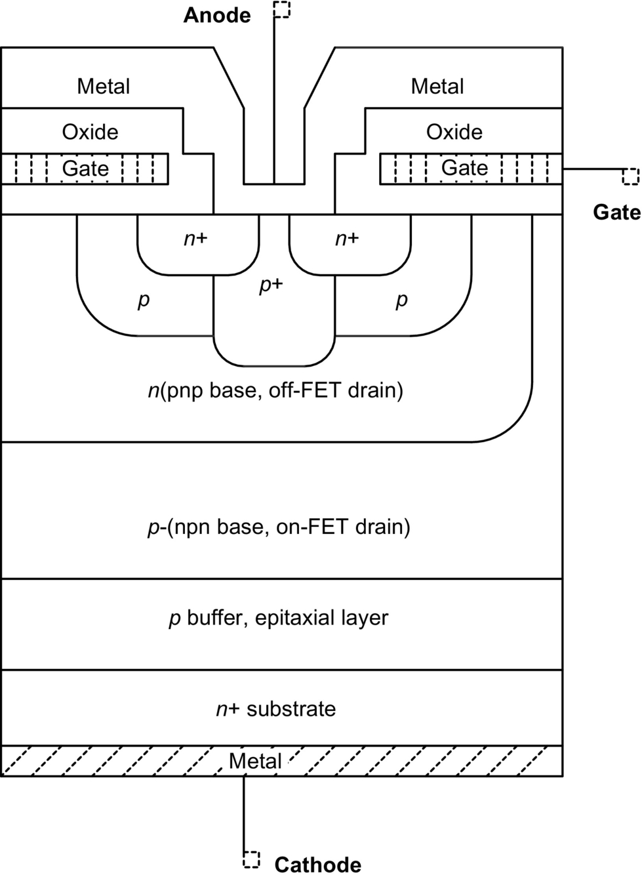

**FIG. 3.24** Cross section of unit cell of a *p*-type MCT.

The seeming variability in fabrication of the turn-off FET structure continues to limit the performance of MCTs, particularly current interruption capability, though these devices can handle two to five times the conduction current density of IGBTs. Numerical modeling and its experimental verification show that ensembles of cells are sensitive to current filamentation during turnoff. All MCT device designs suffer from the problem of current interruption capability. Turn-on is relatively simple, by comparison; both the turn-on and conduction properties of the MCT approach the one-dimensional thyristor limit.

Other variations on the MCT structure have been demonstrated, namely, the emitter switched thyristor (EST) and the dual-gate emitter switched thyristor (DG-EST) [[15](https://learning.oreilly.com/library/view/power-electronics-handbook/9780128114087/B9780128114070000039.xhtml#bb0080)]. These comprise integrated lateral MOSFET structures that connect a floating thyristor *n*-emitter region to an *n*+ thyristor cathode region. The MOS channels are in series with the floating *n*-emitter region, allowing triggering of the thyristor with electrons from the *n*−-base and interruption of the current to initiate turn-off. The DG-EST behaves as a dual-mode device, with the two gates allowing an IGBT mode to operate during switching and a thyristor mode to operate in the on-state.

#### **3.6.2.1 Equivalent Circuit and Switching Characteristics**

The SCR is a four-layer *pnpn* device with a control gate, and applying a positive gate pulse turns it on when it is forward biased. The regenerative action in the device helps to speed up the turn-on process and to keep it in the “ON” state even after the gate pulse is removed. The MCT uses an auxiliary MOS device (PMOSFET) to turn-on, and this simplifies the gate control. The turn-on has all the characteristics of a power MOSFET. The turnoff is accomplished using another MOSFET (NMOSFET), which essentially diverts the base current of one of the BJTs and breaks the regeneration.

The transistor-level equivalent circuit of a P-channel MCT and the circuit symbol are shown in [Fig. 3.25](https://learning.oreilly.com/library/view/power-electronics-handbook/9780128114087/B9780128114070000039.xhtml#f0130). The MCT is modeled as an SCR merged with a pair of MOSFETs. The SCR consists of the bipolar junction transistors (BJTs) *Q*1 and *Q*2, which are interconnected to provide regenerative feedback such that the transistors drive each other into saturation. Of the two MOSFETs, the PMOS located between the collector and emitter of *Q*2 helps to turn the SCR on, and the NMOS located across the base-emitter junction of *Q*2 turns it off. In the actual fabrication, each MCT is made up of a large number (~100,000) cells, each of which contains a wide-base *npn* transistor and a narrow-base *pnp* transistor. While each *pnp* transistor in a cell is provided with an *N*-channel MOSFET across its emitter and base, only a small percentage (~4%) of *pnp* transistors are provided with P-channel MOSFETs across their emitters and collectors. The small percentage of PMOS cells in an MCT provides just enough current for turn-on and the large number of NMOS cells provide plenty of current for turnoff.

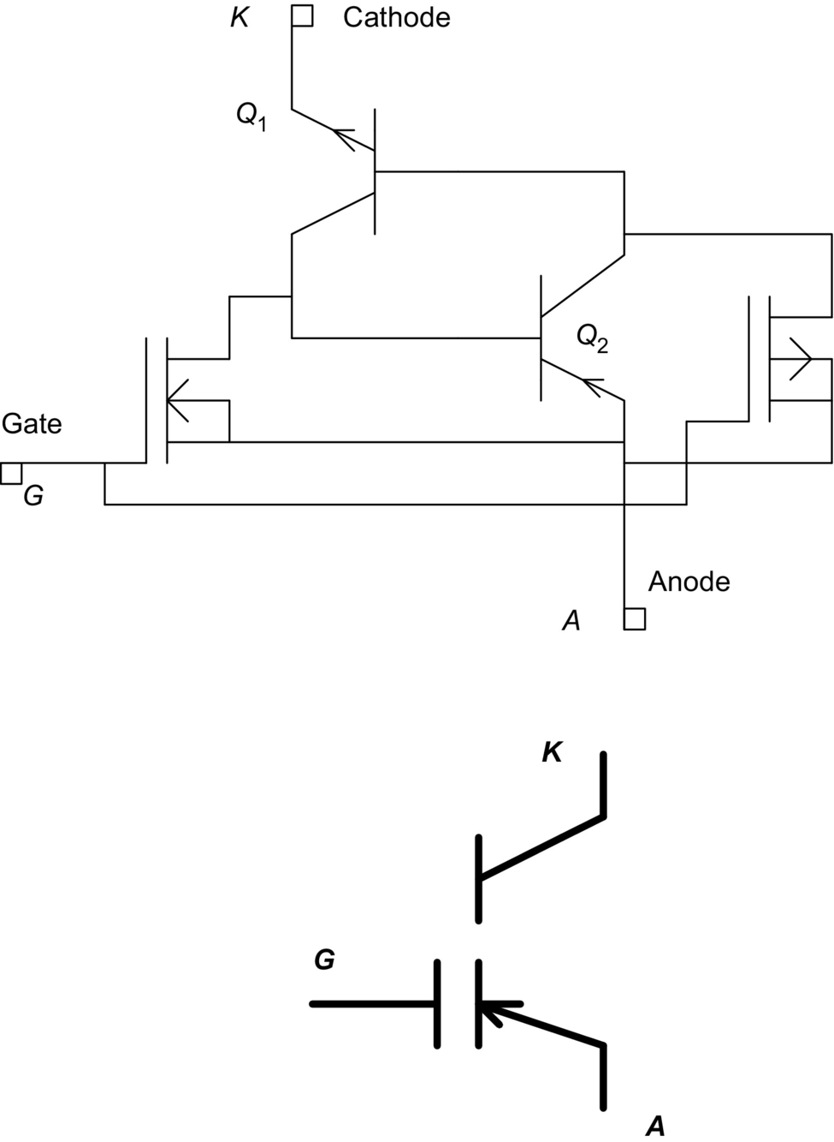

**FIG. 3.25** Equivalent circuit and symbol of an MCT.

#### **3.6.2.2 Turn-On and Turn-Off**

When the MCT is in the forward-blocking state, it can be turned on by applying a negative pulse to its gate with respect to the anode. The negative pulse turns on the PMOSFET (On-FET) whose drain current flows through the base-emitter junction of *Q*1 (*npn*), thereby turning it on. The regenerative action within  turns the MCT on into full conduction within a very short time and maintains it even after the gate pulse is removed. The MCT turns on without a plasma spreading phase, giving a high *di/dt* capability and ease of overcurrent protection. The on-state resistance of an MCT is slightly higher than that of an equivalent thyristor because of the degradation of the injection efficiency of the *n*+-emitter/*p*-base junction. Also, the peak current rating of an MCT is much higher than its average or *rms* current rating.

An MCT will remain in the “ON” state until the device current is reversed or a turn-off pulse is applied to its gate. Applying a positive pulse to its gate turns off a conducting MCT. The positive pulse turns on the NMOSFET (Off-FET), thereby diverting the base current of *Q*2 (*pnp*) away to the anode of the MCT and breaking the latching action of the SCR. This stops the regenerative feedback within the SCR and turns the MCT off. All the cells within the device are to be turned off at the same time to avoid a sudden increase in current density. When the Off-FETs are turned on, the SCR section is heavily shorted and this results in a high *dv/dt* rating for the MCT. The highest current that can be turned off with the application of a gate bias is called the “maximum controllable current.” The MCT can be gate controlled if the device current is less than the maximum controllable current. For smaller device currents, the width of the turn-off pulse is not critical. However, for larger currents, the gate pulse has to be wider and more often has to occupy the entire off-period of the switch.

#### **3.6.2.3 Comparison of MCT and Other Power Devices**

An MCT can be compared with a power MOSFET, a power BJT, and an IGBT of similar voltage and current ratings. The operation of the devices is compared under on-state, off-state, and transient conditions. The comparison is simple and very comprehensive.

The current density of an MCT is 70% higher than that of an IGBT having the same total current [[16](https://learning.oreilly.com/library/view/power-electronics-handbook/9780128114087/B9780128114070000039.xhtml#bb0085)]. During its on-state, an MCT has a lower conduction drop compared with other devices. This is attributed to the reduced cell size and the absence of emitter shorts present in the SCR within the MCT. The MCT also has a modest negative temperature coefficient at lower currents with the temperature coefficient turning positive at larger current [[16](https://learning.oreilly.com/library/view/power-electronics-handbook/9780128114087/B9780128114070000039.xhtml#bb0085)]. [Fig. 3.26](https://learning.oreilly.com/library/view/power-electronics-handbook/9780128114087/B9780128114070000039.xhtml#f0135) shows the conduction drop as a function of current density. The forward drop of a 50 A MCT at 25°C is around 1.1 V, while that for a comparable IGBT is over 2.5 V. The equivalent voltage drop calculated from the value of r*DS*(ON) for a power MOSFET will be much higher. However, the power MOSFET has a much lower delay time (30 ns) compared with that of an MCT (300 ns). The turn-on of a power MOSFET can be so much faster than an MCT or an IGBT; therefore, the switching losses would be negligible compared with the conduction losses. The turn-on of an IGBT is intentionally slowed down to control the reverse recovery of the freewheeling diode used in inductive switching circuits [[17](https://learning.oreilly.com/library/view/power-electronics-handbook/9780128114087/B9780128114070000039.xhtml#bb0090)].

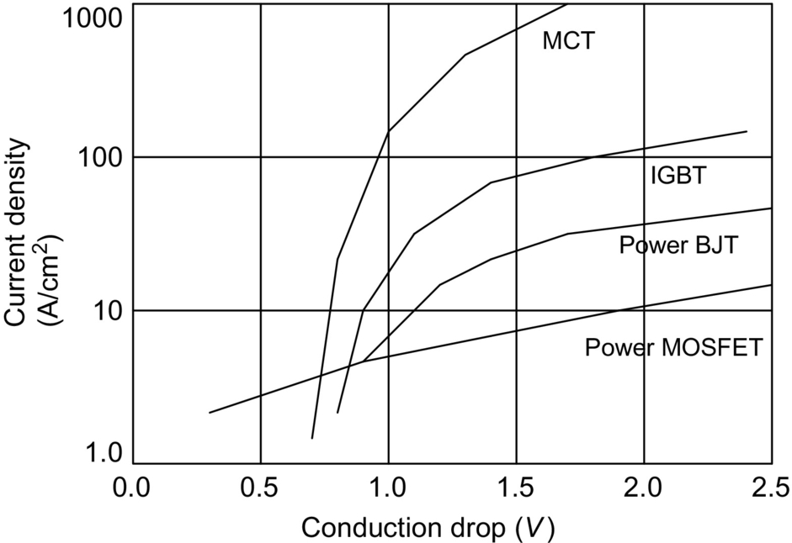

**FIG. 3.26** Comparison of forward drop for different devices.

The MCT can be manufactured for a wide range of blocking voltages. Turn-off speeds of MCTs are supposed to be higher as initially predicted. The turn-on performance of Generation-2 MCTs is reported to be better compared with Generation-1 devices. Even though the Generation-1 MCTs have higher turn-off times compared with IGBTs, the newer ones with higher radiation (hardening) dosage have comparable turn-off times. At present, extensive development activity in IGBTs has resulted in high-speed switched mode power supply (SMPS) IGBTs that can operate at switching speeds 150 kHz [[18](https://learning.oreilly.com/library/view/power-electronics-handbook/9780128114087/B9780128114070000039.xhtml#bb0095)]. The turn-off delay time and the fall time for an MCT are much higher compared with a power MOSFET, and they are found to increase with temperature [[16](https://learning.oreilly.com/library/view/power-electronics-handbook/9780128114087/B9780128114070000039.xhtml#bb0085)]. Power MOSFETs become attractive at switching frequencies above 200 kHz, and they have the lowest turn-off losses among the three devices.

The turn-off safe operating area (SOA) is better in the case of an IGBT than an MCT. For an MCT, the full switching current is sustainable at 50%–60% of the breakdown voltage rating, while for an IGBT, it is about 80%. The use of capacitive snubbers becomes necessary to shape the turn-off locus of an MCT. The addition of even a small capacitor improves the SOA considerably.

The MCT has a MOS gate similar to a power MOSFET or an IGBT, and hence, it is easy to control. In a PMCT, the gate voltage must be applied with respect to its anode. A negative voltage below the threshold of the On-FET must be applied to turn on the MCT. The gate voltage should fall within the specified steady-state limits in order to give a reasonably low delay time and to avoid any gate damage due to overvoltage [[17](https://learning.oreilly.com/library/view/power-electronics-handbook/9780128114087/B9780128114070000039.xhtml#bb0090)]. Similar to a GTO, the gate voltage rise time has to be limited to avoid hot spots (current crowding) in the MCT cells. A gate voltage less than −5 V for turnoff and greater than 10 V for turn-on ensures proper operation of the MCT. The latching of the MCT requires that the gate voltage be held at a positive level in order to keep the MCT turned off.

Because the peak-to-peak voltage levels required for driving the MCT exceed those of other gate-controlled devices, the use of commercial drivers is limited. The MCT can be turned on and off using a push-pull pair with discrete NMOS-PMOS devices, which, in turn, are driven by commercial integrated circuits (ICs). However, some drivers developed by MCT manufacturers are not commercially available [[17](https://learning.oreilly.com/library/view/power-electronics-handbook/9780128114087/B9780128114070000039.xhtml#bb0090)].

A Baker's clamp push-pull can also be used to generate gate pulses of negative and positive polarity of adjustable width for driving the MCT [[19](https://learning.oreilly.com/library/view/power-electronics-handbook/9780128114087/B9780128114070000039.xhtml#bb0100)–[21](https://learning.oreilly.com/library/view/power-electronics-handbook/9780128114087/B9780128114070000039.xhtml#bb0110)]. The Baker's clamp ensures that the push-pull transistors will be in the quasisaturated state prior to turnoff, and this results in a fast switching action. Also, the negative feedback built into the circuit ensures satisfactory operation against variations in load and temperature. A similar circuit with a push-pull transistor pair in parallel with a pair of power BJTs is available [[22](https://learning.oreilly.com/library/view/power-electronics-handbook/9780128114087/B9780128114070000039.xhtml#bb0115)]. An intermediate section, with a BJT that is either cut off or saturated, provides −10 V and +15 V through potential division.

#### **3.6.2.4 Protection of MCTs**

##### **Paralleling of MCTs**

Similar to power MOSFETs, MCTs can be operated in parallel. Several MCTs can be paralleled to form larger modules with only slight derating of the individual devices provided the devices are matched for proper current sharing. In particular, the forward voltage drops of individual devices have to be matched closely.

##### **Overcurrent protection**

The anode-to-cathode voltage in an MCT increases with its anode current, and this property can be used to develop a protection scheme against overcurrent [[19](https://learning.oreilly.com/library/view/power-electronics-handbook/9780128114087/B9780128114070000039.xhtml#bb0100),[20](https://learning.oreilly.com/library/view/power-electronics-handbook/9780128114087/B9780128114070000039.xhtml#bb0105)]. The gate pulses to the MCT are blocked when the anode current and hence the anode-to-cathode voltage exceed a preset value. A Schmitt trigger comparator is used to allow gate pulses to the MCT when it is in the process of turning on, during which time the anode voltage is relatively large and decreasing.

##### **Snubbers**

As with any other power device, the MCT is to be protected against switching-induced transient voltage and current spikes by using suitable snubbers. The snubbers modify the voltage and current transients during switching such that the switching trajectory is confined within the SOA. When the MCT is operated at high frequencies, the snubber increases the switching loss due to the delayed voltage and current responses. The power circuit of an MCT chopper including an improved snubber circuit is shown in [Fig. 3.27](https://learning.oreilly.com/library/view/power-electronics-handbook/9780128114087/B9780128114070000039.xhtml#f0140) [[19](https://learning.oreilly.com/library/view/power-electronics-handbook/9780128114087/B9780128114070000039.xhtml#bb0100),[21](https://learning.oreilly.com/library/view/power-electronics-handbook/9780128114087/B9780128114070000039.xhtml#bb0110)]. The turn-on snubber consists of *Ls* and *DLS*, and the turn-off snubber consists of *Rs*,*Cs*,and*DLS*. The series-connected turn-on snubber reduces the rate of change of the anode current *dlA*/*dt.* The MCT does not support *Vs* until the current through the freewheeling diode reaches zero at turn-on. The turn-off snubber helps to reduce the peak power and the total power dissipated by the MCT by reducing the voltage across the MCT when the anode current decays to zero. The analysis and design of the snubber and the effect of the snubber on switching loss and EMI are given in Refs. [[19](https://learning.oreilly.com/library/view/power-electronics-handbook/9780128114087/B9780128114070000039.xhtml#bb0100)] and [[21](https://learning.oreilly.com/library/view/power-electronics-handbook/9780128114087/B9780128114070000039.xhtml#bb0110)]. An alternative snubber configuration for the two MCTs in an ac-ac converter has also been reported [[22](https://learning.oreilly.com/library/view/power-electronics-handbook/9780128114087/B9780128114070000039.xhtml#bb0115)]. This snubber uses only one capacitor and one inductor for both the MCT switches (PMCT and NMCT) in a power-converter leg.

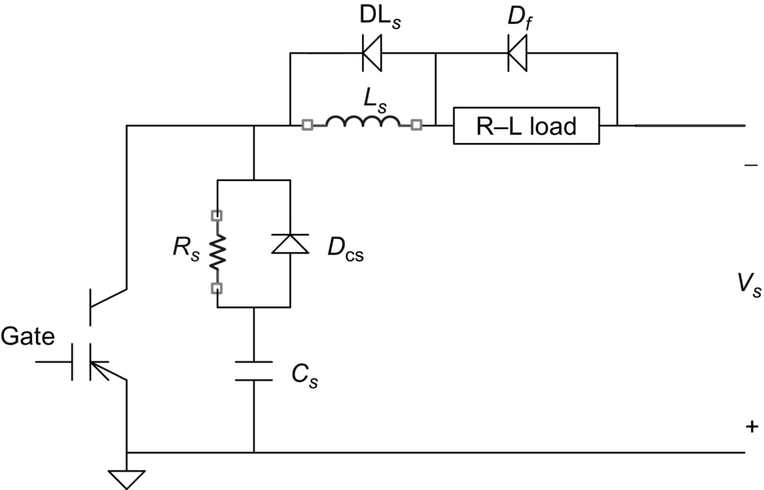

**FIG. 3.27** An MCT chopper with turn-on and turn-off snubbers.

##### **Simulation model of an MCT**

The operation of power converters can be analyzed using PSPICE and other simulation software. As it is a new device, models of MCTs are not provided as part of the simulation libraries. However, an appropriate model for the MCT would be helpful in predicting the performance of novel converter topologies and in designing the control and protection circuits. Such a model must be simple enough to keep the simulation time and effort at a minimum and must represent most of the device properties that affect the circuit operation. The PSPICE models for Harris PMCTs are provided by the manufacturer and can be downloaded from the internet. However, a simple model presenting most of the characteristics of an MCT is available [[23](https://learning.oreilly.com/library/view/power-electronics-handbook/9780128114087/B9780128114070000039.xhtml#bb0120),[24](https://learning.oreilly.com/library/view/power-electronics-handbook/9780128114087/B9780128114070000039.xhtml#bb0125)]. It is derived from the transistor-level equivalent circuit of the MCT by expanding the SCR model already reported the literature. The improved model [[24](https://learning.oreilly.com/library/view/power-electronics-handbook/9780128114087/B9780128114070000039.xhtml#bb0125)] is capable of simulating the breakover and breakdown characteristics of an MCT and can be used for the simulation of high-frequency converters.

### 3.6.3 GENERATION-1 AND GENERATION-2 MCTS

The Generation-1 MCTs were commercially introduced by Harris Semiconductors in 1992. However, the development of Generation-2 MCTs is continuing. In Gen-2 MCTs, each cell has its own turn-on field-effect transistor (FET). Preliminary test results in Generation-2 devices and a comparison of their performance with those of Generation-1 devices and high-speed IGBTs are available [[25](https://learning.oreilly.com/library/view/power-electronics-handbook/9780128114087/B9780128114070000039.xhtml#bb0130),[26](https://learning.oreilly.com/library/view/power-electronics-handbook/9780128114087/B9780128114070000039.xhtml#bb0135)]. The Generation-2 MCTs have a lower forward drop compared with the Generation-1 MCTs. They also have a higher *di/dt* rating for a given value of capacitor used for discharge. During hard switching, the fall time and the switching losses are lower for the Gen-2 MCTs. The Gen-2 MCTs have the same conduction loss characteristics as Gen-1 with drastic reductions in turn-off switching times and losses [[27](https://learning.oreilly.com/library/view/power-electronics-handbook/9780128114087/B9780128114070000039.xhtml#bb0140)].

Under zero-current switching conditions, Gen-2 MCTs have negligible switching losses [[27](https://learning.oreilly.com/library/view/power-electronics-handbook/9780128114087/B9780128114070000039.xhtml#bb0140)]. Under zero-voltage switching, the turn-off losses in a Gen-2 device are one-half to one-fourth (depending on temperature and current level) the turn-off losses in Gen-1 devices. In all soft-switching applications, the predominant loss, namely, the conduction loss, reduces drastically allowing the use of fewer switches in a module.

### 3.6.4 *N*-CHANNEL MCT

The PMCT discussed in this chapter uses an NMOSFET for turnoff, and this results in a higher turn-off current capability. The PMCT can only replace a P-channel IGBT and inherits all the limitations of a P-channel IGBT. The results of a 2-D simulation show that the NMCT can have a higher controllable current [[27](https://learning.oreilly.com/library/view/power-electronics-handbook/9780128114087/B9780128114070000039.xhtml#bb0140)]. It is reported that NMCT versions of almost all Harris PMCTs have been fabricated for analyzing the potential for a commercial product [[17](https://learning.oreilly.com/library/view/power-electronics-handbook/9780128114087/B9780128114070000039.xhtml#bb0090)]. The NMCTs are also being evaluated for use in zero-current soft-switching applications. However, the initial results are not quite encouraging in that the peak turn-off current of an NMCT is one-half to one-third of the value achievable in a PMCT. It is hoped that the NMCTs will eventually have a lower switching loss and a larger SOA as compared with PMCTs and IGBTs.

### 3.6.5 BASE RESISTANCE-CONTROLLED THYRISTOR [[28](https://learning.oreilly.com/library/view/power-electronics-handbook/9780128114087/B9780128114070000039.xhtml#bb0145)]

The base resistance-controlled thyristor (BRT) is another gate-controlled device that is similar to the MCT but with a different structure. The Off-FET is not integrated within the *p*-base region but is formed within the *n*−-base region. The diverter region is a shallow *p*-type junction formed adjacent to the *p*-base region of the thyristor. The fabrication process is simpler for this type of structure. The transistor-level equivalent circuit of a BRT is shown in [Fig. 3.28](https://learning.oreilly.com/library/view/power-electronics-handbook/9780128114087/B9780128114070000039.xhtml#f0145).

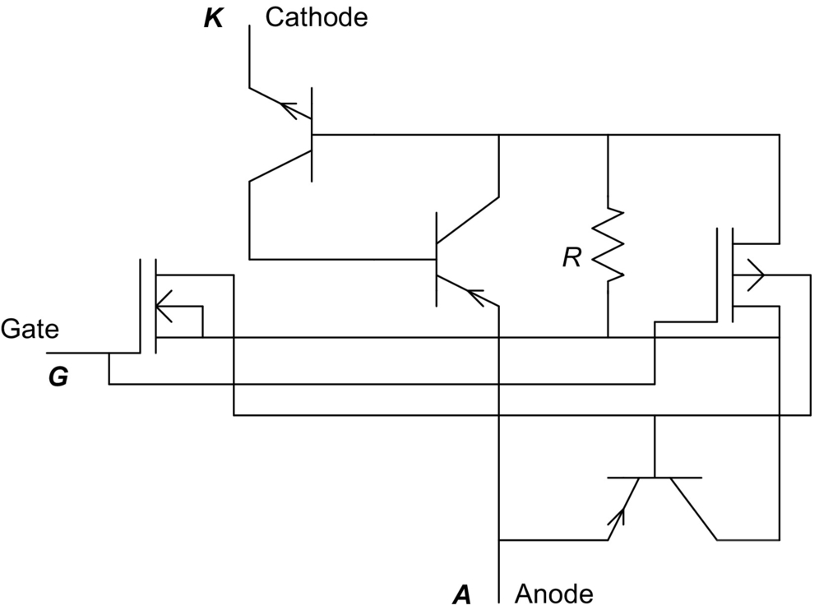

**FIG. 3.28** Equivalent circuit of base resistance-controlled thyristor (BRT).

The BRT will be in the forward-blocking state with a positive voltage applied to the anode and with a zero gate bias. The forward-blocking voltage will be equal to the breakdown voltage of the open-base *pnp* transistor. A positive gate bias turns on the BRT. At low current levels, the device behaves similarly to an IGBT. When the anode current increases, the operation changes to thyristor mode resulting in a low forward drop. Applying a negative voltage to its gate turns off the BRT. During the turn-off process, the anode current is diverted from the n+ emitter to the diverter. The BRT has a current tail during turnoff that is similar to an MCT or an IGBT.

### 3.6.6 MOS TURN-OFF THYRISTOR [[29](https://learning.oreilly.com/library/view/power-electronics-handbook/9780128114087/B9780128114070000039.xhtml#bb0150)]

The MOS turn-off (MTO) thyristor or the MTOT is a replacement for the GTO and it requires a much smaller gate drive. It is more efficient than a GTO; it can have a maximum blocking voltage of about 9 kV, and it will be used to build power converters in the 1–20 MVA range. Silicon Power Corporation (SPCO) manufactures the device.

The transistor-level equivalent circuit of the MTOT (hybrid design) and the circuit symbol are shown in [Fig. 3.29](https://learning.oreilly.com/library/view/power-electronics-handbook/9780128114087/B9780128114070000039.xhtml#f0150). Applying a current pulse at the turn-on gate (*G*l), as with a conventional GTO, turns on the MTOT. The turn-on action, including regeneration, is similar to a conventional SCR. Applying a positive voltage pulse to the turn-off gate (*G*2), as with an MCT, turns off the MTOT. The voltage pulse turns on the FET, thereby shorting the emitter and base of the *npn* transistor and breaking the regenerative action. The MTOT is a faster switch than a GTO in that it is turned off with a reduced storage time compared with a GTO. The disk-type construction allows double-sided cooling.

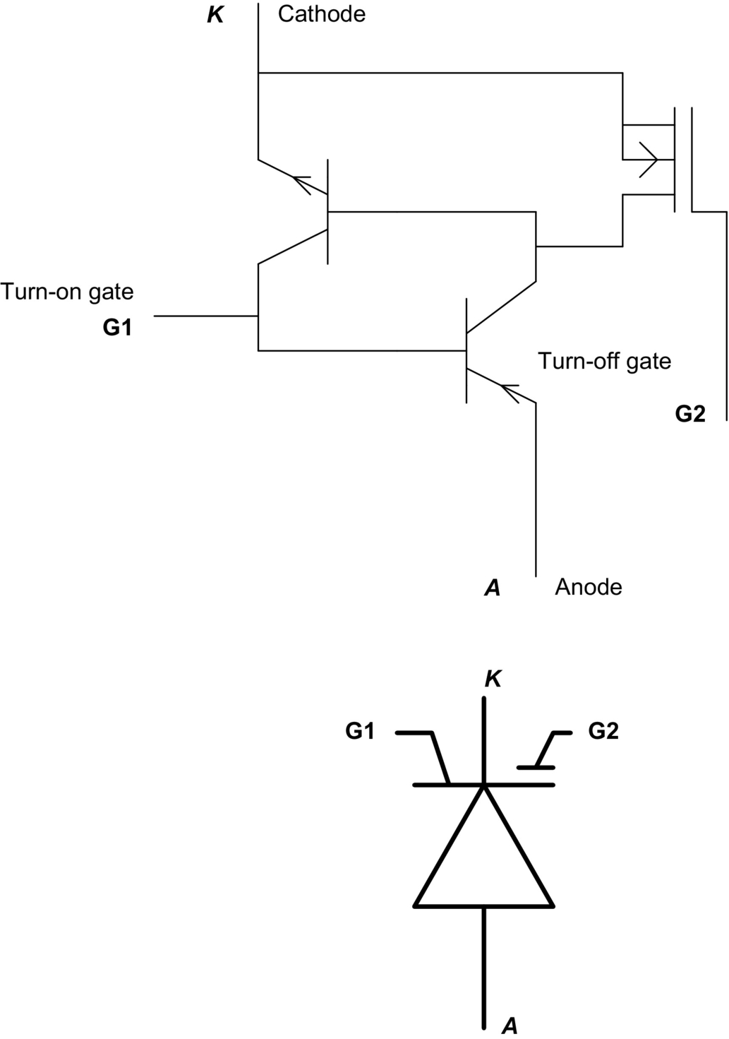

**FIG. 3.29** Equivalent circuit and symbol of a MOS turn-off (MTO) thyristor.

### 3.6.7 STATIC INDUCTION THYRISTORS

An SITh or FCTh has a cross section similar to that shown in [Fig. 3.30](https://learning.oreilly.com/library/view/power-electronics-handbook/9780128114087/B9780128114070000039.xhtml#f0155). Other SITh configurations have surface-gate structures. The device is essentially a *pin* diode with a gate structure that can pinch-off anode current flow. High-power SIThs have a subsurface gate (buried-gate) structure to allow larger cathode areas to be utilized, and hence, larger current densities are possible.

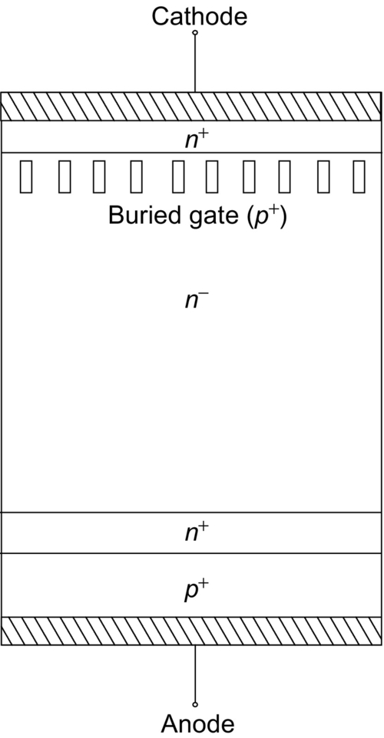

**FIG. 3.30** Cross section of an SITh or FCT.

Planar gate devices have been fabricated with blocking capabilities of up to 1.2 kV and conduction currents of 200 A, while step-gate (trench-gate) structures have been produced that are able to block up to 4 kV and conduct 400 A. Similar devices with a “Verigrid” structure have been demonstrated that can block 2 kV and conduct 200 A, with claims of up to 3.5 kV blocking and 200 A conduction. Buried-gate devices that block 2.5 kV and conduct 300 A have also been fabricated. Recently, there has been a resurgence of interest in these devices for fabrication in SiC.

### 3.6.8 OPTICALLY TRIGGERED THYRISTORS

Optically gated thyristors have traditionally been used in power utility applications where series stacks of devices are necessary to achieve the high voltages required. Isolation between gate-drive circuits for circuits such as static VAR compensators and high-voltage dc-ac inverters (for use in high-voltage dc (HVDC) transmission) has driven the development of this class of devices, which are typically available in ratings from 5 to 8 kV. The cross section is similar to that shown in [Fig. 3.31](https://learning.oreilly.com/library/view/power-electronics-handbook/9780128114087/B9780128114070000039.xhtml#f0160), showing the photosensitive region and the amplifying gate structures. Light-triggered thyristors (LTTs) may also integrate overvoltage protection.

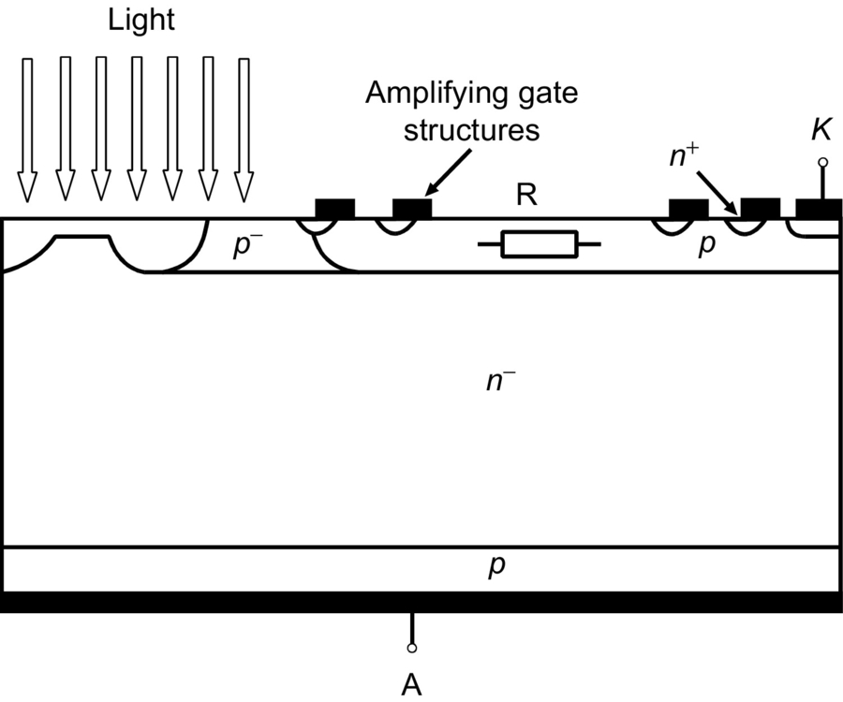

**FIG. 3.31** Cross section of a light-triggered thyristors (LTT).

One of the most recent devices can block 6 kV forward and reverse, conduct 2.5 kA average current, and maintain a *di*/*dt* capability of 300 A/μs and a *dv*/*dt* capability of 3000 V/μs, with a required trigger power of 10 mW. An integrated light-triggered and light-quenched SITh has been produced that can block 1.2 kV and conduct up to 20 A (at a forward drop of 2.5 V). This device is an integration of a normally off buried-gate static induction photo-thyristor and a normally off *p*-channel darlington surface-gate static induction phototransistor. The optical trigger and quenching power required is less than 5 and 0.2 mW, respectively.

### 3.6.9 BI-DIRECTIONAL CONTROLLED THYRISTORS

The BCT is an integrated assembly of two antiparallel thyristors on one Si wafer. The intended applications for this switch are VAR compensators, static switches, soft starters, and motor drives. These devices are rated up to 6.5 kV blocking. Cross talk between the two halves has been minimized. A cross section of the BCT is shown in [Fig. 3.32](https://learning.oreilly.com/library/view/power-electronics-handbook/9780128114087/B9780128114070000039.xhtml#f0165). Note that each surface has a cathode and an anode (opposite devices). The small gate-cathode periphery necessarily restricts the BCT to low-frequency applications because of its *di/dt* limit.

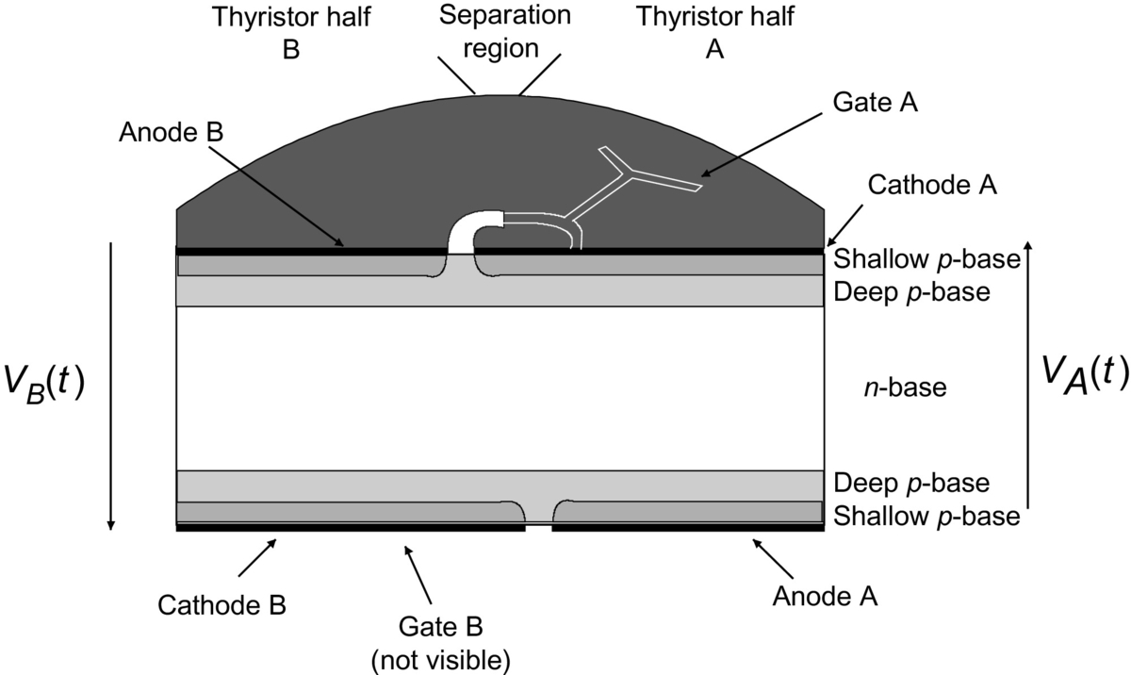

**FIG. 3.32** Cross section of a bidirectional control thyristor (BCT).

Low-power devices similar to the BCT, but in existence for many years, are the diac and triac. A simplified cross section of a diac is shown in [Fig. 3.33](https://learning.oreilly.com/library/view/power-electronics-handbook/9780128114087/B9780128114070000039.xhtml#f0170). A positive voltage applied to the anode with respect to the cathode forward biases *J*1, while reverse biasing *J*2. *J*4 and *J*3 are shorted by the metal contacts. When *J*2 is biased to breakdown, a lateral current flows in the *p*2 region. This lateral flow forward biases the edge of *J*3, causing carrier injection. The result is that the device switches into its thyristor mode and latches. Applying a reverse voltage causes the opposite behavior at each junction, but with the same result. [Fig. 3.33](https://learning.oreilly.com/library/view/power-electronics-handbook/9780128114087/B9780128114070000039.xhtml#f0170) also shows the *i-v* plot for a diac.

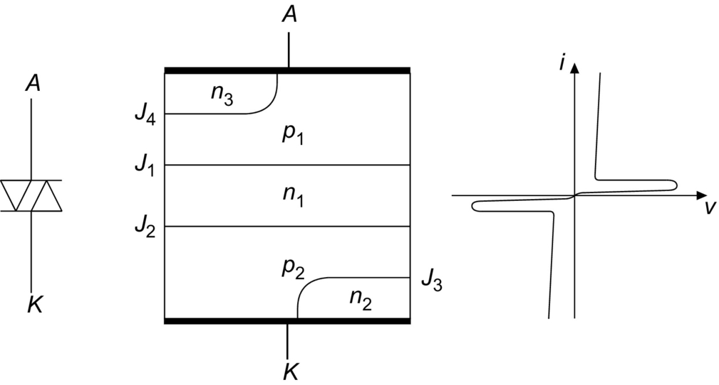

**FIG. 3.33** Cross section and *i-v* plot of a diac.

The addition of a gate connection, to form a triac, allows the breakover to be controlled at a lower forward voltage. [Fig. 3.34](https://learning.oreilly.com/library/view/power-electronics-handbook/9780128114087/B9780128114070000039.xhtml#f0175) shows the structure for the triac. Unlike the diac, this is not symmetrical, resulting in differing forward and reverse breakover voltages for a given gate voltage. The device is fired by applying a gate pulse of the same polarity relative to MT1 as that of MT2.

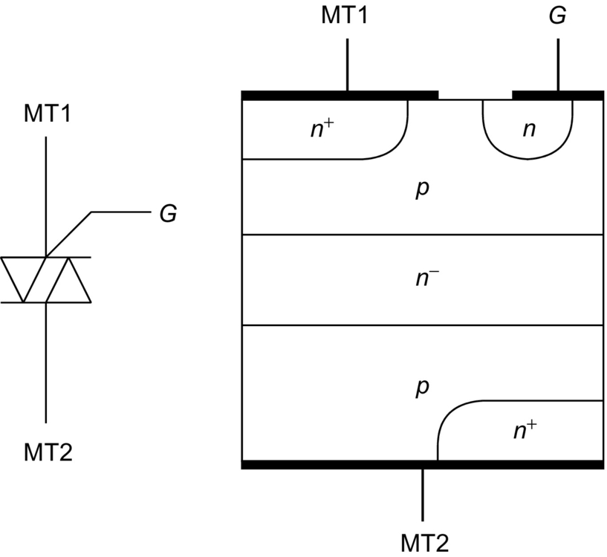

**FIG. 3.34** Cross section of a triac.

## 3.7 Gate Drive Requirements

### **3.7.1 SNUBBER CIRCUITS**

To protect a thyristor, from a large *di/dt* during turn-on and a large *dv/dt* during turnoff, a snubber circuit is needed. A general snubber topology is shown in [Fig. 3.35](https://learning.oreilly.com/library/view/power-electronics-handbook/9780128114087/B9780128114070000039.xhtml#f0180). The turn-on snubber is made by inductance *L*1 (often, *L*1 is stray inductance only). This protects the thyristor from a large *di/dt* during the turn-on process. The auxiliary circuit made by *R*1 and *D*1 allows the discharging of *L*1 when the thyristor is turned off. The turn-off snubber is made by resistor *R*2 and capacitance *C*2. This circuit protects a GTO from large *dv/dt* during the turn-off process. The auxiliary circuit made by *D*2 and *R*2 allows the discharging of *C*2 when the thyristor is turned on. The circuit of capacitance *C*2 and inductance *L*1 also limits the value of *dv/dt* across the thyristor during forward-blocking. In addition, *L*1 protects the thyristor from reverse overcurrents. *R*1 and diodes *D*1,*D*2, are usually omitted in ac circuits with converter-grade thyristors. A similar second set of *L*, *C*, and *R* may be used around this circuit in HVDC applications.

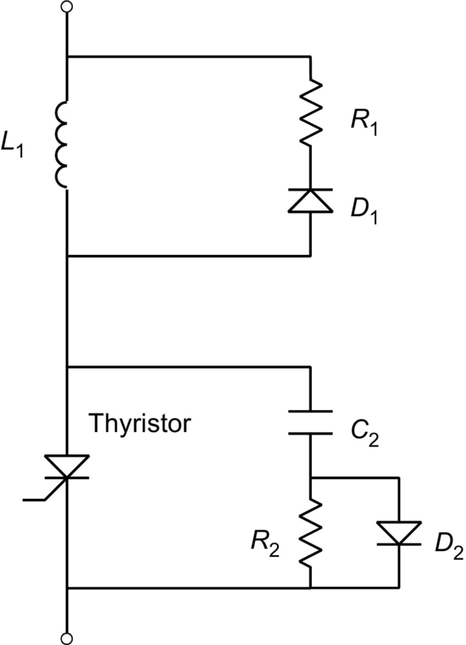

**FIG. 3.35** Turn-on (top elements) and turn-off (bottom elements) snubber circuits for thyristors.

### 3.7.2 GATE CIRCUITS

It is possible to turn on a thyristor by injecting a current pulse into its gate. This process is known as gating, triggering, or firing the thyristor. The most important restrictions are on the maximum peak and duration of the gate pulse current. In order to allow a fast turn-on and a correspondingly large anode *di/dt* during the turn-on process, a large gate current pulse is supplied during the initial turn-on phase with a large *diG*/*dt*. The gate current is kept on, at lower value, for some times after the thyristor turned on in order to avoid unwanted turn-off of the device; this is known as the “back-porch” current. A shaped gate current waveform of this type is shown in [Fig. 3.36](https://learning.oreilly.com/library/view/power-electronics-handbook/9780128114087/B9780128114070000039.xhtml#f0185).

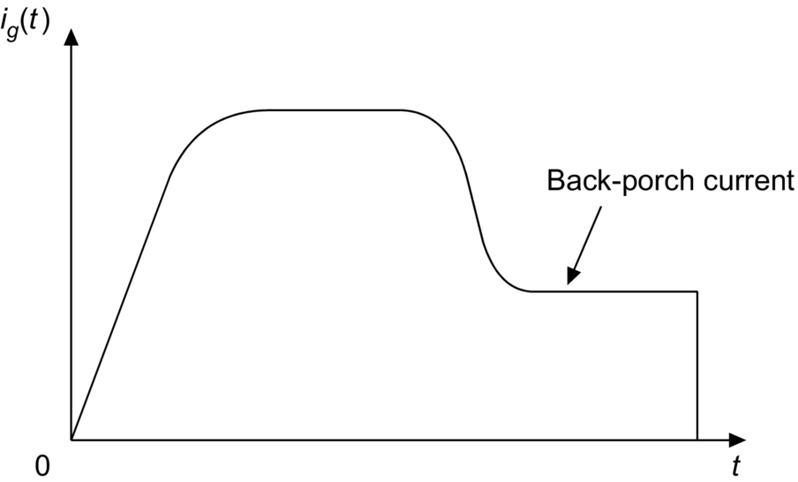

**FIG. 3.36** Gate current waveform showing large initial current followed by a suitable back-porch value.

[Fig. 3.37](https://learning.oreilly.com/library/view/power-electronics-handbook/9780128114087/B9780128114070000039.xhtml#f0190) shows typical gate *i*-*v* characteristics for the maximum and minimum operating temperatures. The dashed line represents the minimum gate current and corresponding gate voltage needed to ensure that the thyristor will be triggered at various operating temperatures. It is also known as the locus of minimum firing points. On the data sheet, it is possible find a line representing the maximum operating power of the thyristor gating internal circuit. The straight line, between *VGG* and *VGG*/*RG*, represents the current voltage characteristic of the equivalent trigger circuit. If the equivalent trigger circuit line intercepts the two gate *i*-*v* characteristics for the maximum and minimum operating temperatures between where they intercept the dashed lines (minimum gate current to trigger and maximum gate power dissipation), then the trigger circuit is able to turn-on the thyristor at any operating temperature without destroying or damaging the device.

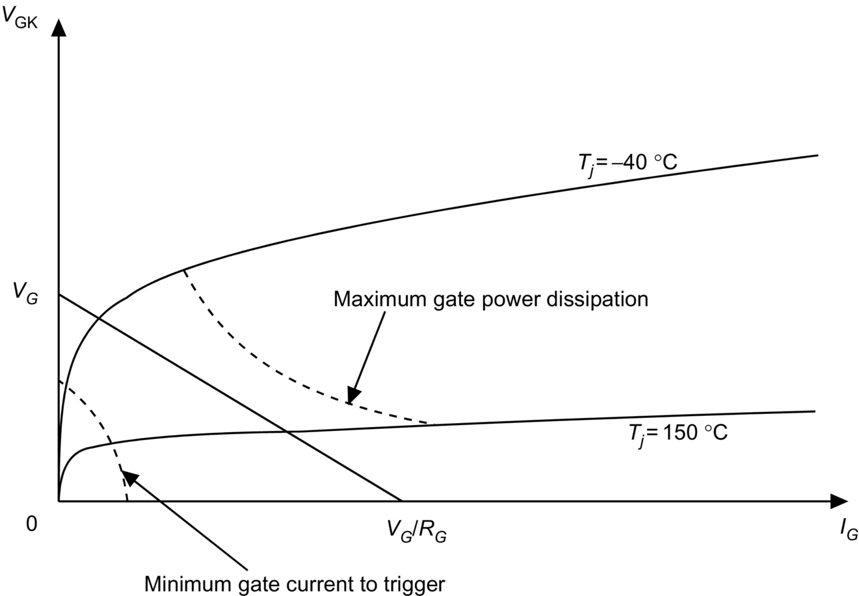

**FIG. 3.37** Gate *i-v* curve for a typical thyristor.

In order to keep the power circuit and the control circuit electrically unconnected, the gate signal generator and the gate of the thyristor are often connected through a transformer. There is a transformer winding for each thyristor, and in this way, unwanted short circuits between devices are avoided. A general block diagram of a thyristor gate trigger circuit is shown in [Fig. 3.38](https://learning.oreilly.com/library/view/power-electronics-handbook/9780128114087/B9780128114070000039.xhtml#f0195). This application is for a standard bridge configuration often used in power converters.

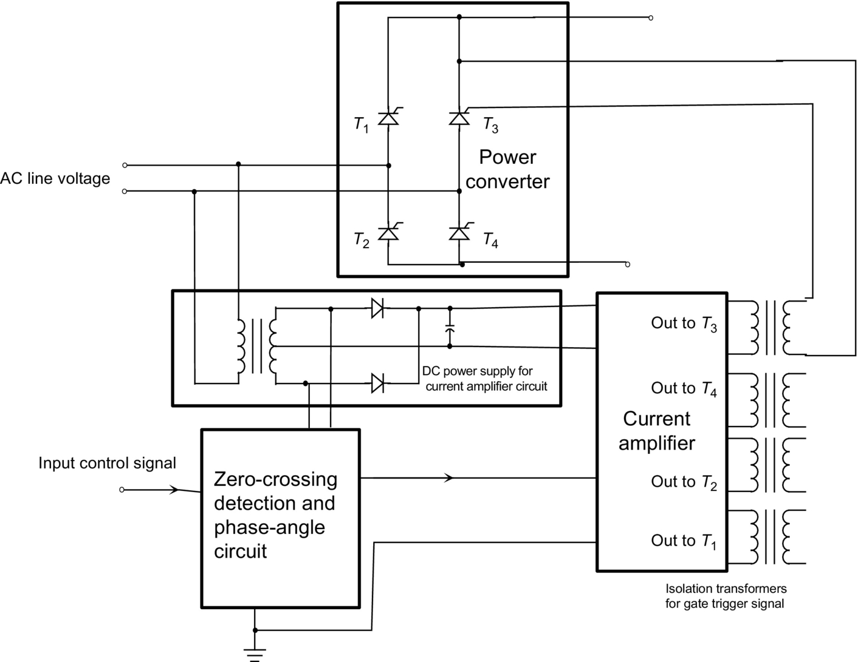

**FIG. 3.38** Block diagram of a transformer-isolated gate-drive circuit.

Another problem can arise if the load impedance is high, particularly if the load is inductive and the supply voltage is low. In this situation, the latching current may not be reached during the trigger pulse. A possible solution to this problem could be the use of a longer current pulse. However, such a solution is not attractive because of the presence of the isolation transformer. An alternative solution is the generation of a series of short pulses that last for the same duration as a single long pulse. A single short pulse, a single long pulse, and a series of short pulses are shown in [Fig. 3.39](https://learning.oreilly.com/library/view/power-electronics-handbook/9780128114087/B9780128114070000039.xhtml#f0200). Reliable gating of the thyristor is essential in many applications.

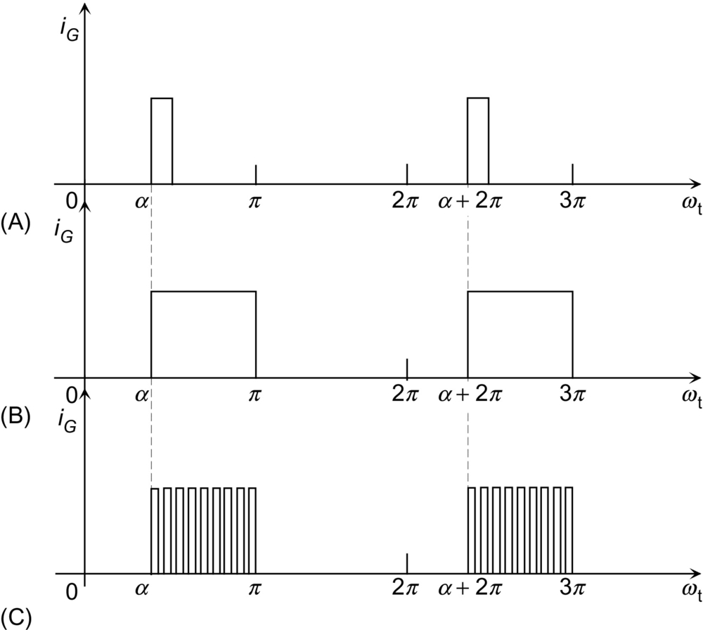

**FIG. 3.39** Multiple gate pulses used as an alternative to one long current pulse.

There are many gate trigger circuits that use optical isolation between the logic-level electronics and a drive stage (typically MOSFETs) configured in a push-pull output. The dc power supply voltage for the drive stage is provided through transformer isolation. Many device manufacturers supply drive circuits available on printed circuit (PC) boards or diagrams of suggested circuits.

IGCT gate drives consist of an integrated module to which the thyristor is connected via a low-inductance mounting; an example is given in [Fig. 3.40](https://learning.oreilly.com/library/view/power-electronics-handbook/9780128114087/B9780128114070000039.xhtml#f0205). Multiple MOSFETs and capacitors connected in parallel may be used to source or sink the necessary currents to turn the device on or off. Logic in the module controls the gate drive from a fiber-optic trigger input and provides diagnostic feedback from a fiber-optic output. A simple power supply connection is also required.

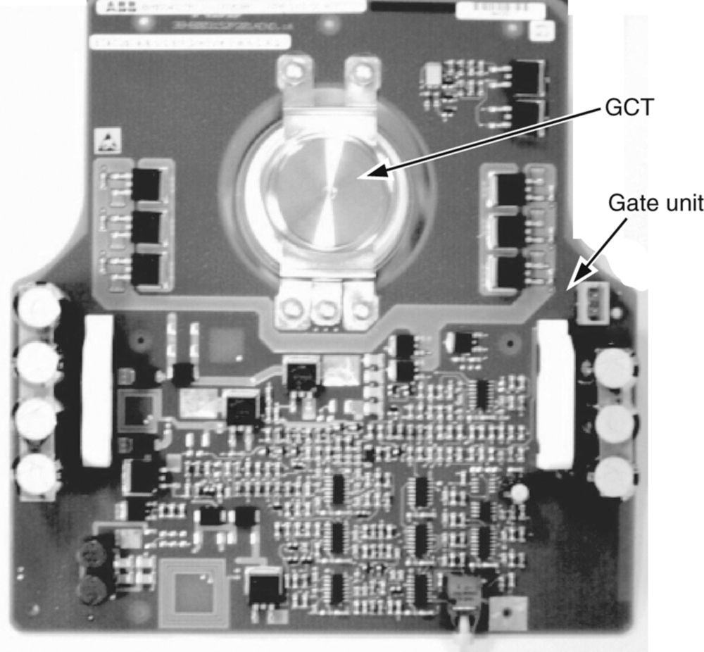

**FIG. 3.40** Typical layout of an IGCT gate drive.

**Values for each cell of a multicell GTO model**

|  |  |  |
| --- | --- | --- |
| **Model component** | **Symbol** | **Value** |
| Delay resistor | *R* | 1 μΩ |
| Delay capacitor | *C* | 1 nF |
| Mutual coupling inductance | *M* | 10 nH |
| Gate contact resistance | *RGC* | 1 mΩ |
| Cathode contact resistance | *RKC* | 1 mΩ |

Other GTO thyristor models have been developed that offer improved accuracy at the expense of increased complexity. The model by Tseng et al. [[30](https://learning.oreilly.com/library/view/power-electronics-handbook/9780128114087/B9780128114070000039.xhtml#bb0155)] includes charge storage effects in the *n−*-base, and its application to a multicell model, as in [Fig. 3.14](https://learning.oreilly.com/library/view/power-electronics-handbook/9780128114087/B9780128114070000039.xhtml#f0075), has been demonstrated successfully. Models for the IGCT, based on the lumped-charge approach [[31](https://learning.oreilly.com/library/view/power-electronics-handbook/9780128114087/B9780128114070000039.xhtml#bb0160)] and the Fourier-based solution of the ambipolar diffusion equation (ADE) [[32](https://learning.oreilly.com/library/view/power-electronics-handbook/9780128114087/B9780128114070000039.xhtml#bb0165)], have also been developed.

## 3.8 Applications

The most important application of thyristors is for line-frequency phase-controlled rectifiers. This family includes several topologies, of which one of the most important is used to construct HVDC transmission systems. A single-phase controlled rectifier is shown in [Fig. 3.41](https://learning.oreilly.com/library/view/power-electronics-handbook/9780128114087/B9780128114070000039.xhtml#f0210).

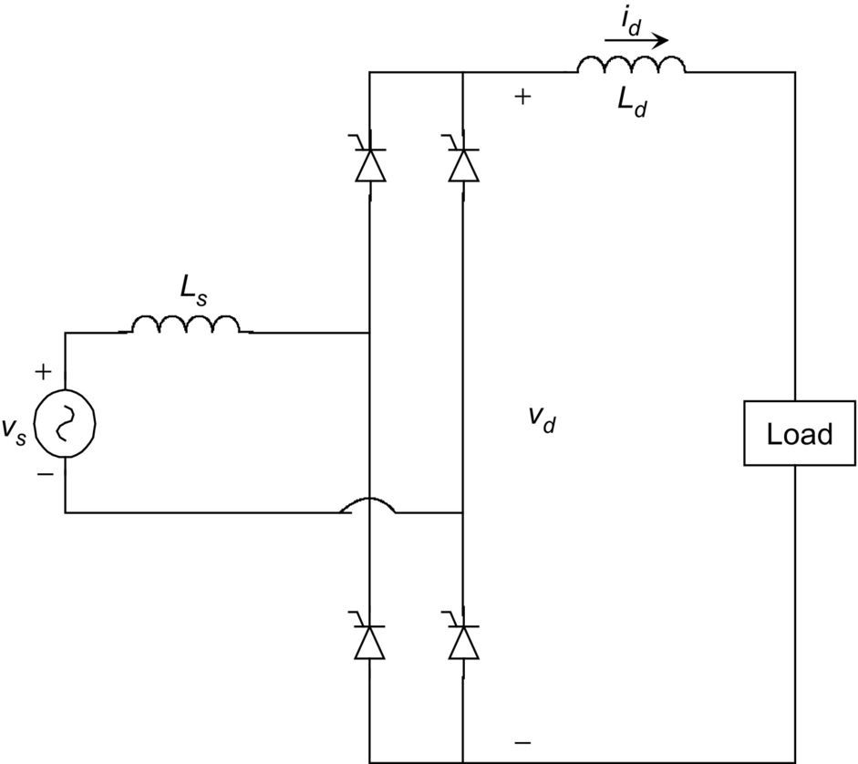

**FIG. 3.41** Single-phase controlled rectifier circuit.

The use of thyristors instead of diodes allows the average output voltage to be controlled by appropriate gating of the thyristors. If the gate signals to the thyristors were continuously applied, the thyristors in [Fig. 3.41](https://learning.oreilly.com/library/view/power-electronics-handbook/9780128114087/B9780128114070000039.xhtml#f0210) would behave as diodes. If no gate currents are supplied, they behave as open circuits. Gate current can be applied any time (phase delay) after the forward voltage becomes positive. Using this phase-control feature, it is possible to produce an average dc output voltage less than the average output voltage obtained from an uncontrolled diode rectifier.

### 3.8.1 DC–AC UTILITY INVERTERS

Three-phase converters can be made in different ways, according to the system in which they are employed. The basic circuit used to construct these topologies—the three-phase controlled rectifier—is shown in [Fig. 3.42](https://learning.oreilly.com/library/view/power-electronics-handbook/9780128114087/B9780128114070000039.xhtml#f0215).

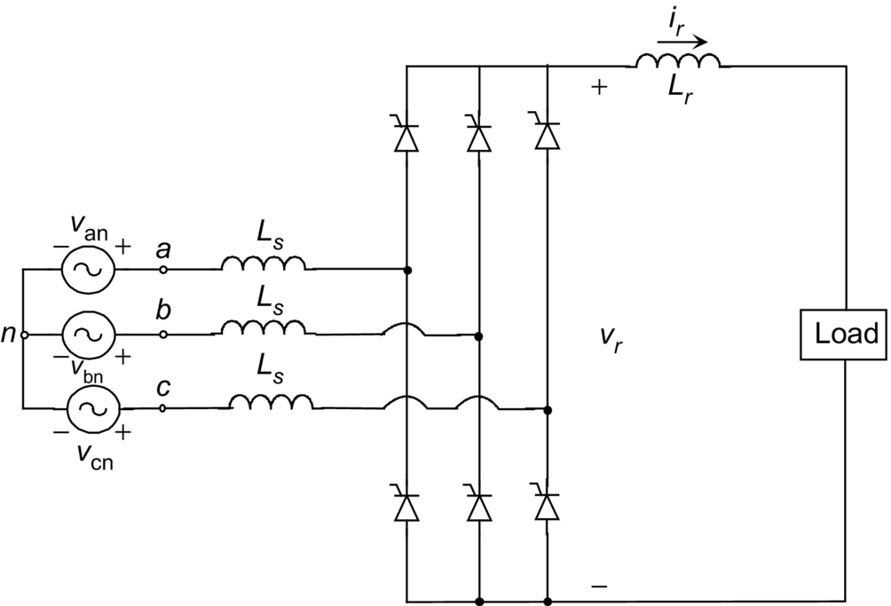

**FIG. 3.42** A three-phase controlled bridge circuit used as a basic topology for many converter systems.

Starting from this basic configuration, it is possible to construct more complex circuits in order to obtain high-voltage or high-current outputs or just to reduce the output ripple by constructing a multiphase converter. One of the most important systems using the topology shown in [Fig. 3.42](https://learning.oreilly.com/library/view/power-electronics-handbook/9780128114087/B9780128114070000039.xhtml#f0215) as a basic circuit is the HVDC system represented in [Fig. 3.43](https://learning.oreilly.com/library/view/power-electronics-handbook/9780128114087/B9780128114070000039.xhtml#f0220). This system is made by two converters, a transmission line, and two ac systems. Each converter terminal is made of two poles. Each pole is made by two six-pulse line-frequency converters connected through Δ–Y and Y–Y transformers in order to obtain a 12-pulse converter and a reduced output ripple. The filters are required to reduce the current harmonics generated by the converter.

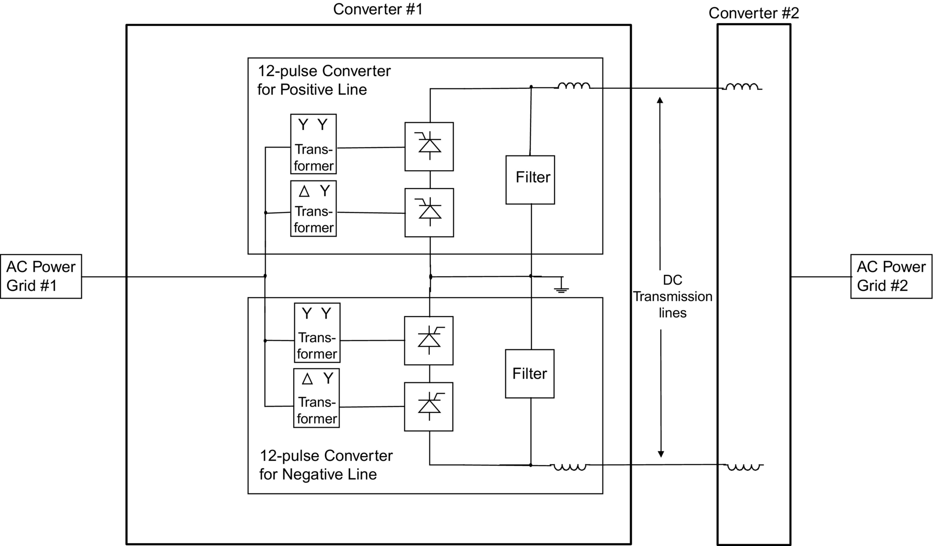

**FIG. 3.43** A HVDC transmission system.

When a large amount of current and relatively low voltage is required, it is possible to connect in parallel, using a specially designed inductor, two six-pulse line-frequency converters connected through Δ–Y and Y–Y transformers. The special inductor is designed to absorb the voltage between the two converters and to provide a pole to the load. This topology is shown in [Fig. 3.44](https://learning.oreilly.com/library/view/power-electronics-handbook/9780128114087/B9780128114070000039.xhtml#f0225). This configuration is often known as a 12-pulse converter. Higher pulse numbers may also be found.

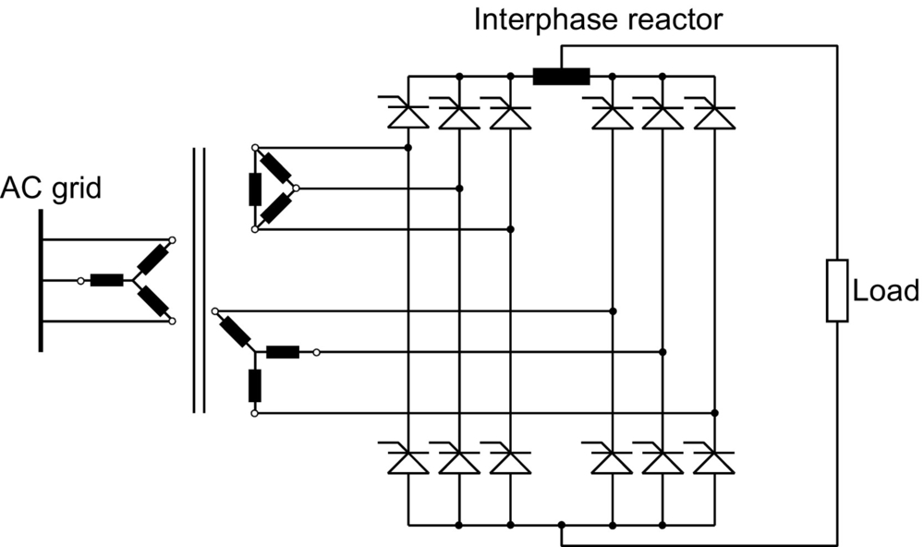

**FIG. 3.44** Parallel connection of two six-pulse converters for high current applications.

### 3.8.2 MOTOR CONTROL

Another important application of thyristors is in motor control circuits. Historically, thyristors have been used heavily in traction, although most new designs are now based on IGBTs. Such motor control circuits broadly fall into four types: (i) chopper control of a dc motor from a dc supply, (ii) single- or three-phase converter control of a dc motor from an ac supply, (iii) inverter control of an ac synchronous or induction machine from a dc supply, and (iv) cycloconverter control of an ac machine from an ac supply. An example of a GTO chopper is given in [Fig. 3.45](https://learning.oreilly.com/library/view/power-electronics-handbook/9780128114087/B9780128114070000039.xhtml#f0230). *L*1,*R*1,*D*1,and*C*1 are the turn-on snubber; *R*2,*D*2,and*C*2 are the turn-off snubber; finally, *R*3and*D*3 form the snubber for the freewheel diode *D*3. A thyristor cycloconverter is shown in [Fig. 3.46](https://learning.oreilly.com/library/view/power-electronics-handbook/9780128114087/B9780128114070000039.xhtml#f0235); the waveforms show the fundamental component of the output voltage for one phase. Three double converters are used to produce a three-phase variable-frequency, variable voltage sinusoidal output for driving ac motors. However, the limited frequency range (less than a third of the line frequency) restricts the application to large, low-speed machines at high powers.

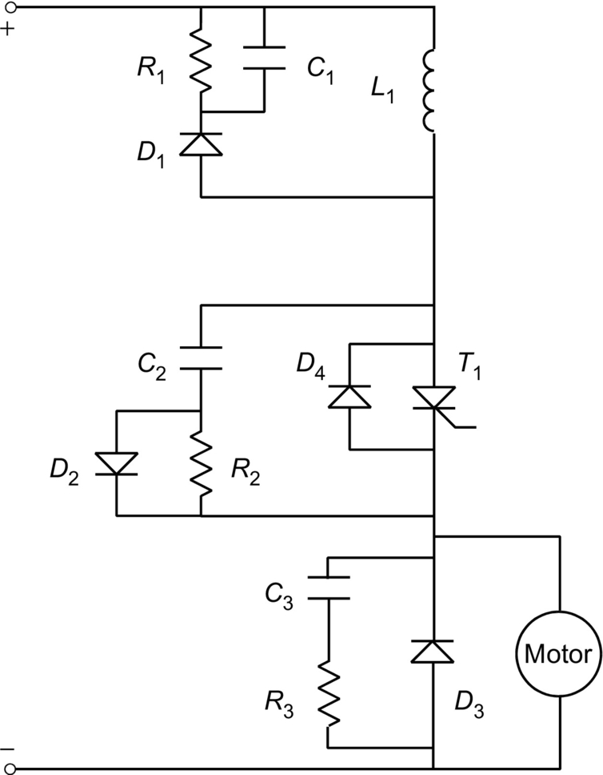

**FIG. 3.45** GTO chopper for dc motor control.

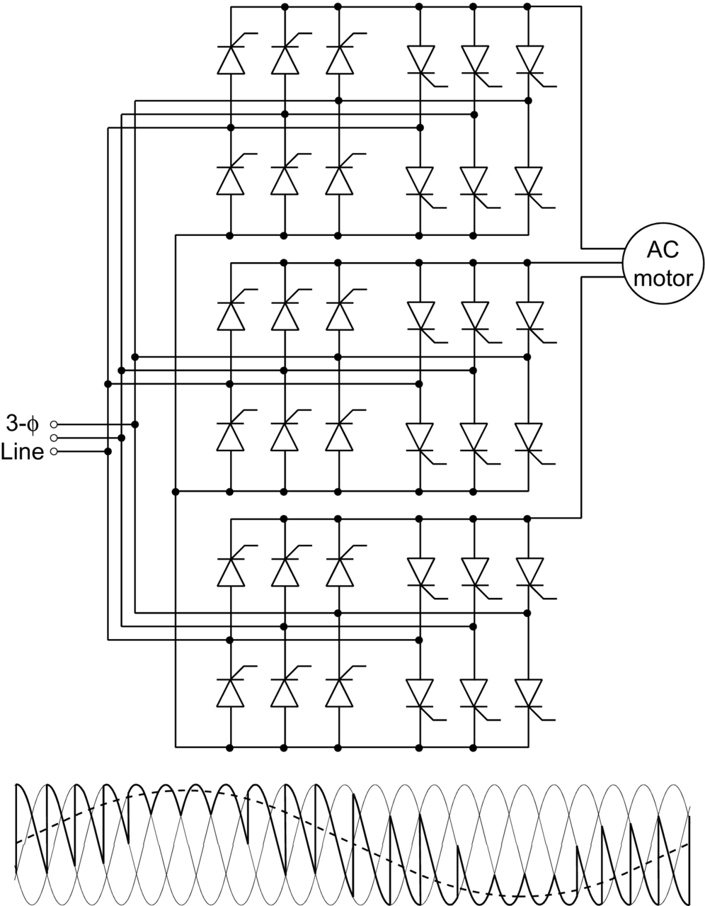

**FIG. 3.46** Cycloconverter for control of large ac machines.

A single- or three-phase thyristor converter (controlled rectifier) may be used to provide a variable dc supply for controlling a dc motor. Such a converter may also be used as the front end of a three-phase induction motor drive. The variable voltage, variable-frequency motor drive requires a dc supply, which is supplied by the thyristor converter. The drive may use a square wave or PWM voltage source inverter (VSI) or a current source inverter (CSI). [Fig. 3.47](https://learning.oreilly.com/library/view/power-electronics-handbook/9780128114087/B9780128114070000039.xhtml#f0240) shows a square wave or PWM VSI with a controlled rectifier on the input side. The switch block inverter may be made of thyristors (usually GTOs or IGCTs) for high power, although most new designs now use IGBTs. Low-power motor controllers generally use IGBT inverters.

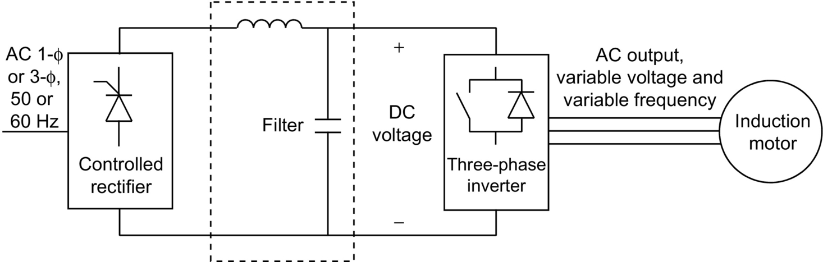

**FIG. 3.47** PWM or square wave inverter with a controlled rectifier input.

In motor control, thyristors are also used in CSI topologies. When the motor is controlled by a CSI, a controlled rectifier is also needed on the input side. [Fig. 3.48](https://learning.oreilly.com/library/view/power-electronics-handbook/9780128114087/B9780128114070000039.xhtml#f0245) shows a typical CSI inverter. The capacitors are needed to force the current in the thyristors to zero at each switching event. This is not needed when using GTOs. This inverter topology does not need any additional circuitry to provide the regenerative braking (energy recovery when slowing the motor). Historically, two back-to-back connected line-frequency thyristor converters have been employed to allow bidirectional power flow and thus regenerative braking. Use of antiparallel GTOs with symmetrical blocking capability, or the use of diodes in series with each asymmetrical GTO, reduces the number of power devices needed, but greatly increases the control complexity.

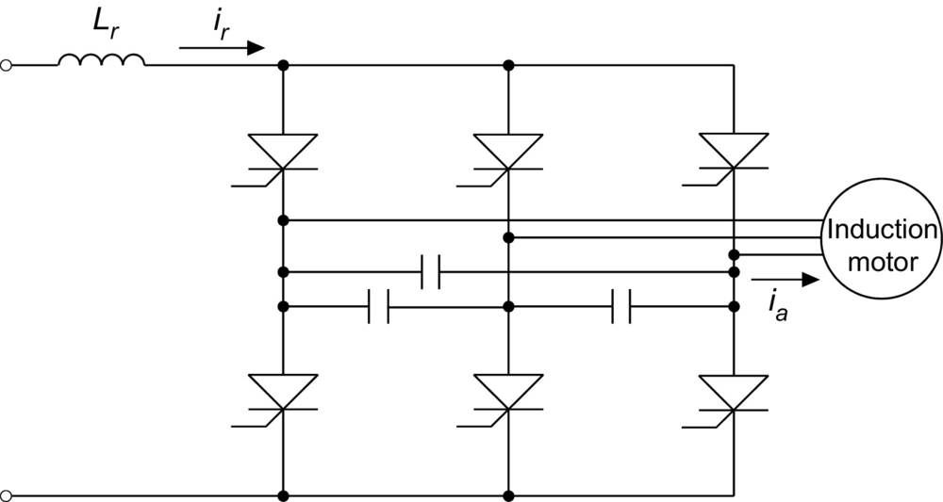

**FIG. 3.48** CSI on the output section of a motor drive system using capacitors for power factor correction.

### 3.8.3 VAR COMPENSATORS AND STATIC SWITCHING SYSTEMS

Thyristors are also used to switch capacitors or inductors in order to control the reactive power in the system. Such arrangements may also be used in phase-balancing circuits for balancing the load fed from a three-phase supply. Examples of these circuits are shown in [Fig. 3.49](https://learning.oreilly.com/library/view/power-electronics-handbook/9780128114087/B9780128114070000039.xhtml#f0250). These circuits act as static VAR controllers. The topology represented on the left of [Fig. 3.49](https://learning.oreilly.com/library/view/power-electronics-handbook/9780128114087/B9780128114070000039.xhtml#f0250) is called a thyristor-controlled inductor (TCI), and it acts as a variable inductor where the inductive VAR supplied can be varied quickly. Because the system may require either inductive or capacitive VAR compensation, it is possible to connect a bank of capacitors in parallel with a TCI. The topology shown on the right of [Fig. 3.49](https://learning.oreilly.com/library/view/power-electronics-handbook/9780128114087/B9780128114070000039.xhtml#f0250) is called a thyristor-switched capacitor (TSC). Capacitors can be switched out by blocking the gate pulse of all thyristors in the circuit. The problem of this topology is the voltage across the capacitors at the thyristor turnoff. At turn-on the thyristor must be gated at the instant of the maximum ac voltage to avoid large overcurrents. Many recent SVCs have used GTOs.

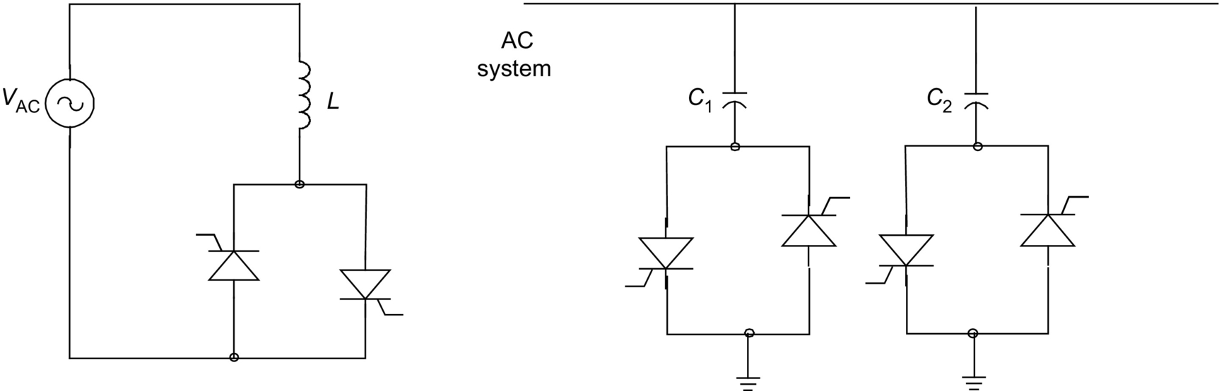

**FIG. 3.49** Per phase TCI and TSC system.

A similar application of thyristors is in solid-state fault current limiters and circuit breakers. In normal operation, the thyristors are continuously gated. However, under fault conditions, they are switched rapidly to increase the series impedance in the load and to limit the fault current. Key advantages are the flexibility of the current limiting, which is independent of the location of the fault and the change in load impedance, the reduction in fault level of the supply, and a smaller voltage sag during a short-circuit fault.

A less important application of thyristors is as a static transfer switch, used to improve the reliability of uninterruptible power supplies (UPS) as shown in [Fig. 3.50](https://learning.oreilly.com/library/view/power-electronics-handbook/9780128114087/B9780128114070000039.xhtml#f0255). There are two modes of using the thyristors. The first leaves the load permanently connected to the UPS system and in case of emergency disconnects the load from the UPS and connects it directly to the power line. The second mode is opposite to the first one. Under normal conditions, the load is permanently connected to the power line, and in event of a line outage, the load is disconnected from the power line and connected to the UPS system.

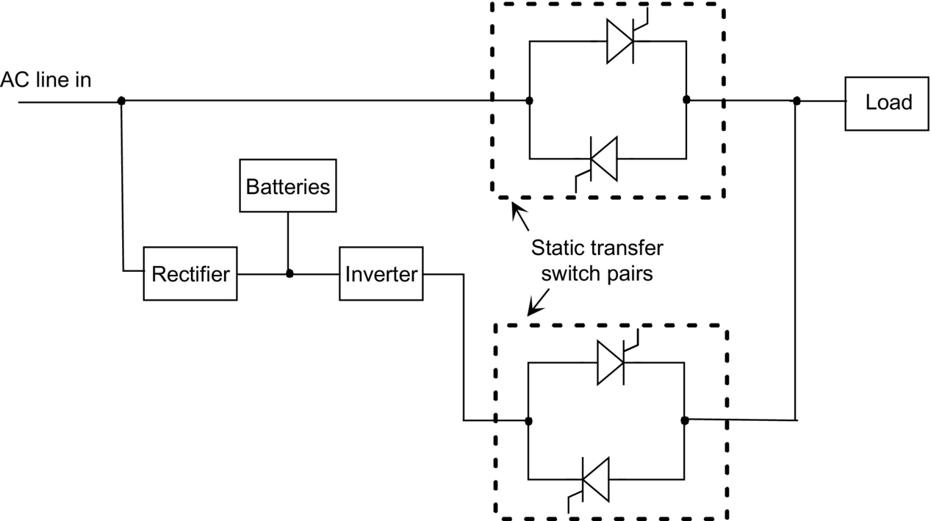

**FIG. 3.50** Static transfer switch used in an UPS system.

### 3.8.4 LIGHTING CONTROL CIRCUITS

An important circuit used in lighting control is the dimmer, based on a triac and shown in [Fig. 3.51](https://learning.oreilly.com/library/view/power-electronics-handbook/9780128114087/B9780128114070000039.xhtml#f0260). The *R*-*C* network applies a phase shift to the gate voltage, delaying the triggering of the triac. Varying the resistance controls the firing angle of the triac and therefore the voltage across the load. The diac is used to provide symmetrical triggering for the positive and negative half cycles, due to the nonsymmetrical nature of the triac. This ensures symmetrical waveforms and elimination of even harmonics. An *L*-*C* filter is often used to reduce any remaining harmonics.

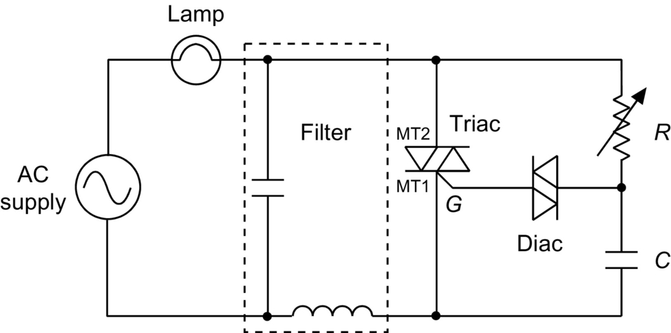

**FIG. 3.51** Basic dimmer circuit used in lighting control.

## References

[1] Ghandi S.K. *Semiconductor Power Devices—Physics of Operation and Fabrication Technology.* New York: John Wiley and Sons; 1977 pp. 63–84.

[2] Baliga B.J. *Power Semiconductor Devices.* Boston, MA: PWS Publishing; 1996 pp. 91–110.

[3] B. Beker, J.L. Hudgins, J. Coronati, B. Gillett, S. Shekhawat, Parasitic parameter extraction of PEBB module using VTB technology, IEEE IAS Ann. Mtg. Rec. (1997) 467–471.

[4] Godbold C.V., Sankaran V.A., Hudgins J.L. Thermal analysis of high power modules. *IEEE Trans. PEL.* 1997;12(1):3–11.

[5] Hudgins J.L., Portnoy W.M. High *di/dt* pulse switching of thyristors. *IEEE Tran. PEL.* 1987;2:143–148.

[6] Sze S.M. *Physics of Semiconductor Devices.* second ed. New York: John Wiley and Sons; 1984 pp. 140–147.

[7] Sankaran V.A., Hudgins J.L., Portnoy W.M. Role of the amplifying gate in the turn-on process of involute structure thyristors. *IEEE Tran. PEL.* 1990;5(2):125–132.

[8] Menhart S., Hudgins J.L., Portnoy W.M. The low temperature behavior of thyristors. *IEEE Tran. ED.* 1992;39:1011–1013.

[9] Herlet A. The forward characteristic of silicon power rectifiers at high current densities. *Solid-State Electron.* 1968;11(8):717–742.

[10] J.L. Hudgins, C.V. Godbold, W.M. Portnoy, O.M. Mueller, Temperature effects on GTO characteristics, IEEE IAS Annual Mtg. Rec. (1994) 1182–1186.

[11] Hudgins J.L. A review of modern power semiconductor electronic devices. *Microelectronics Journal.* 1993;24:41–54.

[12] Dynex semiconductor: Data GTO data-sheets web-site. Available form: <http://www.dynexsemi.com/product-area/gto-thyristors>.

[13] Data sheet: Anode Shorthed Gate Turn-Off Thyristor Type G1000NC450. Available form: <http://www.westcode.com/g1000nc.pdf>, Accessed 23 February 2017.

[14] El-Amin I.M.A. *GTO PSPICE model and its applications.* In: The Fourth Saudi Engineering Conference, vol. III, November 1995; 1995:271–277.

[15] Palmer P.R., Stark B.H. A PSPICE model of the DG-EST based on the ambipolar diffusion equation. *IEEE PESC Rec.* 1999;358–363.

[16] Jahns T.M., De Doncker R.W.A.A., Wilson J.W.A., Temple V.A.K., Waltrus D.L. Circuit utilization characteristics of MOS-controlled thyristors. *IEEE Trans. Ind. Appl.* 1991;27(3):589–597.

[17] Harris Semiconductor, MCT/IGBTs/Diodes Databook, 1995.

[18] P. Holdman, F. Lotuka, SMPS IGBTs—high switching frequencies allow efficient.

[19] Quek D. *Design of Protection and Control Strategies for Low-loss MCT Power Converters.* North Dakota State University; 1994 PhD Thesis.

[20] Quek D., Yuvarajan S. *A novel gate drive for the MCT incorporating overcurrent protection.* In: Proceedings of IEEE IAS Annual Meeting; 1994:1297–1302.

[21] Yuvarajan S., Nelson R., Quek D. *A study of the effects of snubber on switching loss and EMI in an MCT converter.* In: Proceedings of IEEE IAS Annual Meeting; 1994:1344–1349.

[22] Lee T.C., Elbuluk M.E., Zinger D.S. Characterization and snubbing of a bidirectional MCT switch in a resonant ac link converter. *IEEE Trans. Ind. Electron.* 1995;31(5):978–985.

[23] Yuvarajan S., Quek D. A PSPICE model for the MOS controlled thyristor. *IEEE Trans. Ind. Electron.* 1995;42(5):554–558.

[24] Arsov G.L., Panovski L.P. An improved PSPICE model for the MOS-Controlled Thyristor. *IEEE Trans. Ind. Electron.* 1999;46(2):473–477.

[25] Kendle P.D., Temple V.A.K., Arthur S.D. *Switching comparison of Generation-1 and Generation-2 P-MCTs and ultrafast N-IGBTs.* In: Proceedings of IEEE IAS Annual Meeting; 1993:1286–1292.

[26] Yang E., Temple V., Arthur S. *Switching loss of Gen-1 and Gen-2 P-MCTs in soft-switching circuits.* In: Proceedings of IEEE APEC; 1995:746–754.

[27] Huang Q., Amaratunga G.A.J., Sankara Narayanan E.M., Milne W.I. Analysis of -channel MOS-controlled thyristors. *IEEE Trans. Electron Devices.* 1991;38(7):1612–1618.

[28] Jayant Baliga B. *Power Semiconductor Devices.* Boston, MA: PWS Publishing; 1996.

[29] Rodrigues R., Huang A., De Doncker R. *MTO thyristor power switches.* In: Proceedings of PCIM’97 Power Electronics Conference; 1997:4-1–4-12.

[30] Tseng K.J., Palmer P.R. Mathematical model of gate-turn-off thyristor for use in circuit simulations. *IEE Proc. Electr. Power Appl.* 1994;141(6):284–292.

[31] X. Wang, A. Caiafa, J. Hudgins, E. Santi, Temperature effects on IGCT performance. IEEE IAS Annual Mtg. Rec. (2003).

[32] X. Wang, A. Caiafa, J.L. Hudgins, E. Santi, P.R. Palmer. Implementation and validation of a physics-based circuit model for IGCT with full temperature dependencies. IEEE PESC Rec. (2004) 597–603.

**4**

# Static Induction Devices

Bogdan M. Wilamowski Auburn University, Auburn, AL, United States

## Abstract

Several devices from the static induction family such as static induction transistor, static induction diode, static induction thyristor, lateral punch-through transistor, static induction transistor logic, static induction MOS transistor, and space charge limiting load are described. The theory of operation of static induction devices is given for both a current controlled by a potential barrier and a current controlled by space charge. The new concept of a punch-through emitter, which operates with majority carrier transport, is presented.

### KEYWORDS:

Junction field effect transistor; Lateral punch-through transistor; Transconductance; Static induction; Classical thyristor; Silicon control rectifier; Power MOS; Space charge; Gate turn off

4.1  [Introduction](https://learning.oreilly.com/library/view/power-electronics-handbook/9780128114087/B9780128114070000040.xhtml#s0010)

4.2  [Theory of Static Induction Devices](https://learning.oreilly.com/library/view/power-electronics-handbook/9780128114087/B9780128114070000040.xhtml#s0015)

4.3  [Characteristics of SIT](https://learning.oreilly.com/library/view/power-electronics-handbook/9780128114087/B9780128114070000040.xhtml#s0020)

4.4  [Bipolar Mode Operation of SI Devices (BSIT)](https://learning.oreilly.com/library/view/power-electronics-handbook/9780128114087/B9780128114070000040.xhtml#s0025)

4.5  [Emitters for Static Induction Devices](https://learning.oreilly.com/library/view/power-electronics-handbook/9780128114087/B9780128114070000040.xhtml#s0030)

4.6  [Static Induction Diode](https://learning.oreilly.com/library/view/power-electronics-handbook/9780128114087/B9780128114070000040.xhtml#s0035)

4.7  [Lateral Punch-Through Transistor](https://learning.oreilly.com/library/view/power-electronics-handbook/9780128114087/B9780128114070000040.xhtml#s0040)

4.8  [Static Induction Transistor Logic](https://learning.oreilly.com/library/view/power-electronics-handbook/9780128114087/B9780128114070000040.xhtml#s0045)

4.9  [BJT Saturation Protected by SIT](https://learning.oreilly.com/library/view/power-electronics-handbook/9780128114087/B9780128114070000040.xhtml#s0050)

4.10 [Static Induction MOS Transistor](https://learning.oreilly.com/library/view/power-electronics-handbook/9780128114087/B9780128114070000040.xhtml#s0055)

4.11 [Space Charge Limiting Load (SCLL)](https://learning.oreilly.com/library/view/power-electronics-handbook/9780128114087/B9780128114070000040.xhtml#s0060)

4.12 [Power MOS Transistors](https://learning.oreilly.com/library/view/power-electronics-handbook/9780128114087/B9780128114070000040.xhtml#s0065)

4.13 [Static Induction Thyristor](https://learning.oreilly.com/library/view/power-electronics-handbook/9780128114087/B9780128114070000040.xhtml#s0070)

4.14 [Gate Turn Off Thyristor](https://learning.oreilly.com/library/view/power-electronics-handbook/9780128114087/B9780128114070000040.xhtml#s0075)

[References](https://learning.oreilly.com/library/view/power-electronics-handbook/9780128114087/B9780128114070000040.xhtml#bi0010)

## 4.1 Introduction

Static induction devices were invented in 1975 by Nishizawa [[1](https://learning.oreilly.com/library/view/power-electronics-handbook/9780128114087/B9780128114070000040.xhtml#bb0010)], and for many years, Japan was the only country where static induction family devices were successfully fabricated. Static induction transistor (SIT) can be considered as a short channel junction field effect transistor (JFET) device operating in prepunch-through region. The number of devices in this family is growing with time. The SIT can operate with the power over 100 kW at 100 kHz and above 150 W at 3 GHz [[2](https://learning.oreilly.com/library/view/power-electronics-handbook/9780128114087/B9780128114070000040.xhtml#bb0015)]. These devices may operate up to THz frequencies [[3](https://learning.oreilly.com/library/view/power-electronics-handbook/9780128114087/B9780128114070000040.xhtml#bb0020),[4](https://learning.oreilly.com/library/view/power-electronics-handbook/9780128114087/B9780128114070000040.xhtml#bb0025)]. Static induction transistor logic (SITL) had 100 times smaller switching energy than its *I*2*L* competitor [[5](https://learning.oreilly.com/library/view/power-electronics-handbook/9780128114087/B9780128114070000040.xhtml#bb0030),[6](https://learning.oreilly.com/library/view/power-electronics-handbook/9780128114087/B9780128114070000040.xhtml#bb0035)]. Static induction thyristor has many advantages over the traditional silicon-controlled rectifier (SCR), and static induction diod (SID) exhibits high switching speed, large reverse voltage, and low forward voltage drops [[7](https://learning.oreilly.com/library/view/power-electronics-handbook/9780128114087/B9780128114070000040.xhtml#bb0040)].

## 4.2 Theory of Static Induction Devices

The cross section of the SIT is shown in [Fig. 4.1](https://learning.oreilly.com/library/view/power-electronics-handbook/9780128114087/B9780128114070000040.xhtml#f0010), while its characteristics are shown in [Fig. 4.2](https://learning.oreilly.com/library/view/power-electronics-handbook/9780128114087/B9780128114070000040.xhtml#f0015). An induced electrostatically potential barrier controls the current in static induction devices. The derivations of formulas will be done for an *n*-channel device, but the obtained results, with a little modification, can also be applied to *p*-channel devices. For a small electric field existing in the vicinity of the potential barrier, the drift and diffusion current can be approximated by

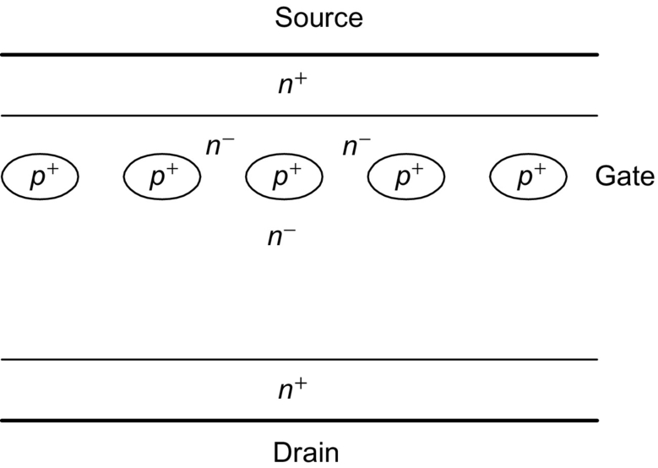

**FIG. 4.1** Cross section of the static induction transistor.

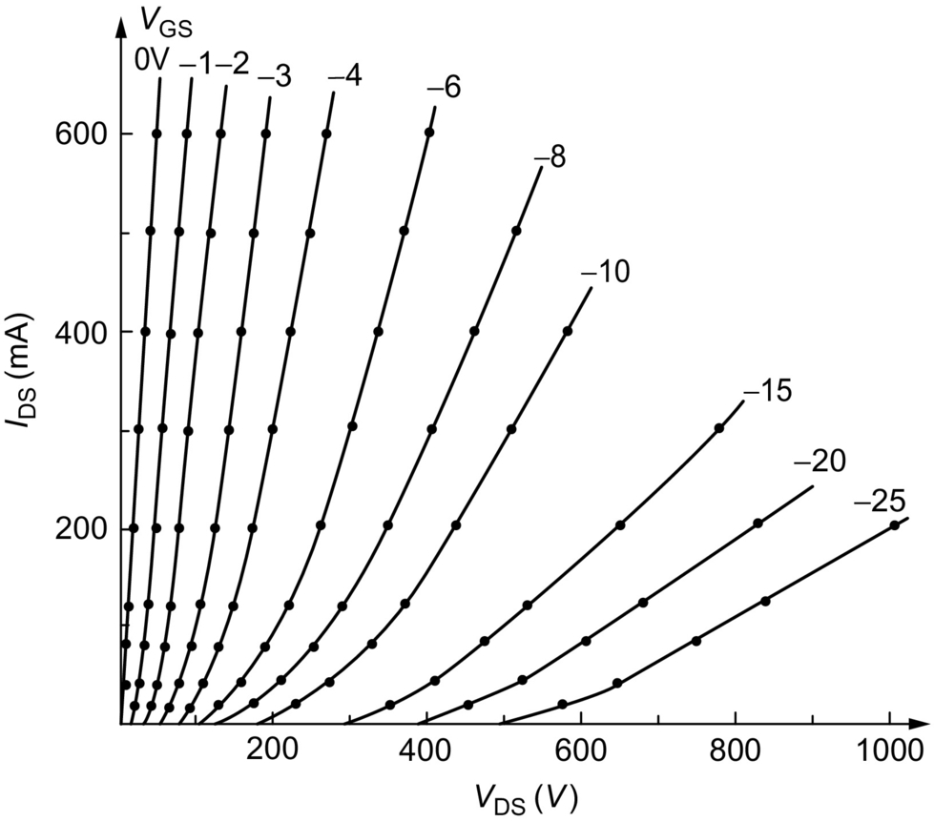

**FIG. 4.2** Characteristics of the early SIT design [[1](https://learning.oreilly.com/library/view/power-electronics-handbook/9780128114087/B9780128114070000040.xhtml#bb0010)].

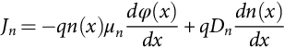 **(4.1)**

where *Dn*=*μnVT* and *VT*=*kT*/*q*. By multiplying both sides of the equation by exp (−*φ* (*x*)/*VT*) and rearranging

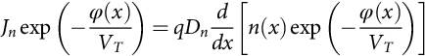 **(4.2)**

Integrating from *x*1 to *x*2, one can obtain

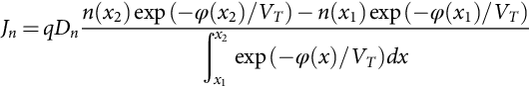 **(4.3)**

With the following boundary conditions

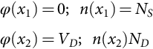 **(4.4)**

Eq. [(4.3)](https://learning.oreilly.com/library/view/power-electronics-handbook/9780128114087/B9780128114070000040.xhtml#fo0020) reduces to

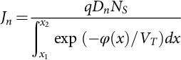 **(4.5)**

Note that the above equations derived for SIT can also be used to find current in any devices controlled by a potential barrier, such as a bipolar transistor, an MOS transistor operation in subthreshold mode, or a Schottky diode.

## 4.3 Characteristics of SIT

Samples of the potential distribution in the SI devices are shown in [Fig. 4.3](https://learning.oreilly.com/library/view/power-electronics-handbook/9780128114087/B9780128114070000040.xhtml#f0020) [[7](https://learning.oreilly.com/library/view/power-electronics-handbook/9780128114087/B9780128114070000040.xhtml#bb0040)]. The vicinity of the potential barrier can be approximated using parabolic formulas ([Fig. 4.4](https://learning.oreilly.com/library/view/power-electronics-handbook/9780128114087/B9780128114070000040.xhtml#f0025)) along and across the channel [[8](https://learning.oreilly.com/library/view/power-electronics-handbook/9780128114087/B9780128114070000040.xhtml#bb0045),[9](https://learning.oreilly.com/library/view/power-electronics-handbook/9780128114087/B9780128114070000040.xhtml#bb0050)].

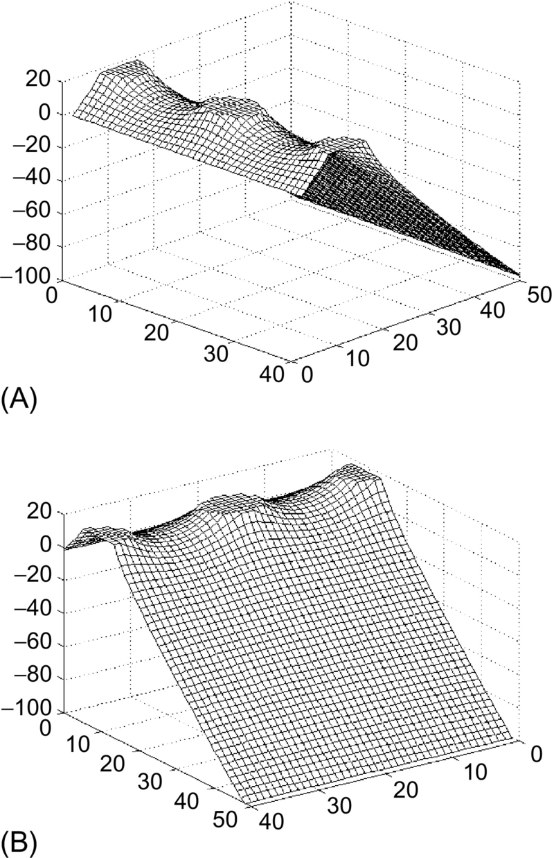

**FIG. 4.3** Potential distribution in SIT: (A) view from the source side and (B) view from the drain side.

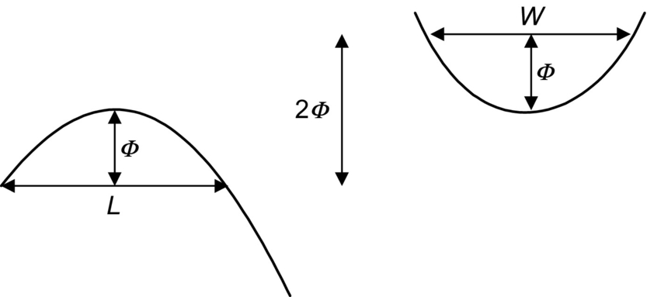

**FIG. 4.4** Potential distribution in the vicinity of the barrier approximated by parabolic shapes.

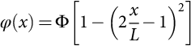 **(4.6)**

**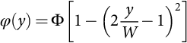** **(4.7)**

Integrating Eq. [(4.5)](https://learning.oreilly.com/library/view/power-electronics-handbook/9780128114087/B9780128114070000040.xhtml#fo0030) first along the channel and then across the channel yields a very simple formula for drain currents in *n*-channel SITs:

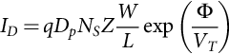 **(4.8)**

where Φ is the potential barrier height in reference to the source potential, *NS* is the electron concentration at the source, *W*/*L* ratio describes the shape of the potential saddle in vicinity of the barrier, and *Z* is the length of the source strip.

Since barrier height Φ can be a linear function of gate and drain voltages, therefore,

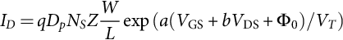 **(4.9)**

The above equation describes characteristics of SIT for small current range. For large current levels, the device current is controlled by the space charge of moving carriers. In the one-dimensional case, the potential distribution is described by the Poisson equation:

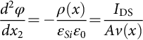 **(4.10)**

where *A* is the effective device cross section and *v*(*x*) is carrier velocity. For a small electric field, *v*(*x*)=*μE*(*x*), and the solution of Eq. [(4.10)](https://learning.oreilly.com/library/view/power-electronics-handbook/9780128114087/B9780128114070000040.xhtml#fo0055) is

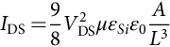 **(4.11)**

and for a large electric field, *v*(*x*)=const, and Eq. [(4.10)](https://learning.oreilly.com/library/view/power-electronics-handbook/9780128114087/B9780128114070000040.xhtml#fo0055) results in

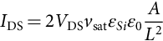 **(4.12)**

where *L* is the channel length and *v*sat≈1011 μm/s is the carrier saturation velocity. In practical devices, the current-voltage relationship is described by an exponential relationship, Eq. [(4.9)](https://learning.oreilly.com/library/view/power-electronics-handbook/9780128114087/B9780128114070000040.xhtml#fo0050); for small currents, a quadratic relationship, Eq. [(4.11)](https://learning.oreilly.com/library/view/power-electronics-handbook/9780128114087/B9780128114070000040.xhtml#fo0060); and finally for large voltages by an almost linear relationship, Eq. [(4.12)](https://learning.oreilly.com/library/view/power-electronics-handbook/9780128114087/B9780128114070000040.xhtml#fo0065). SIT characteristics drawn in linear and logarithmic scales are shown in [Figs. 4.5](https://learning.oreilly.com/library/view/power-electronics-handbook/9780128114087/B9780128114070000040.xhtml#f0030) and [4.6](https://learning.oreilly.com/library/view/power-electronics-handbook/9780128114087/B9780128114070000040.xhtml#f0035), respectively.

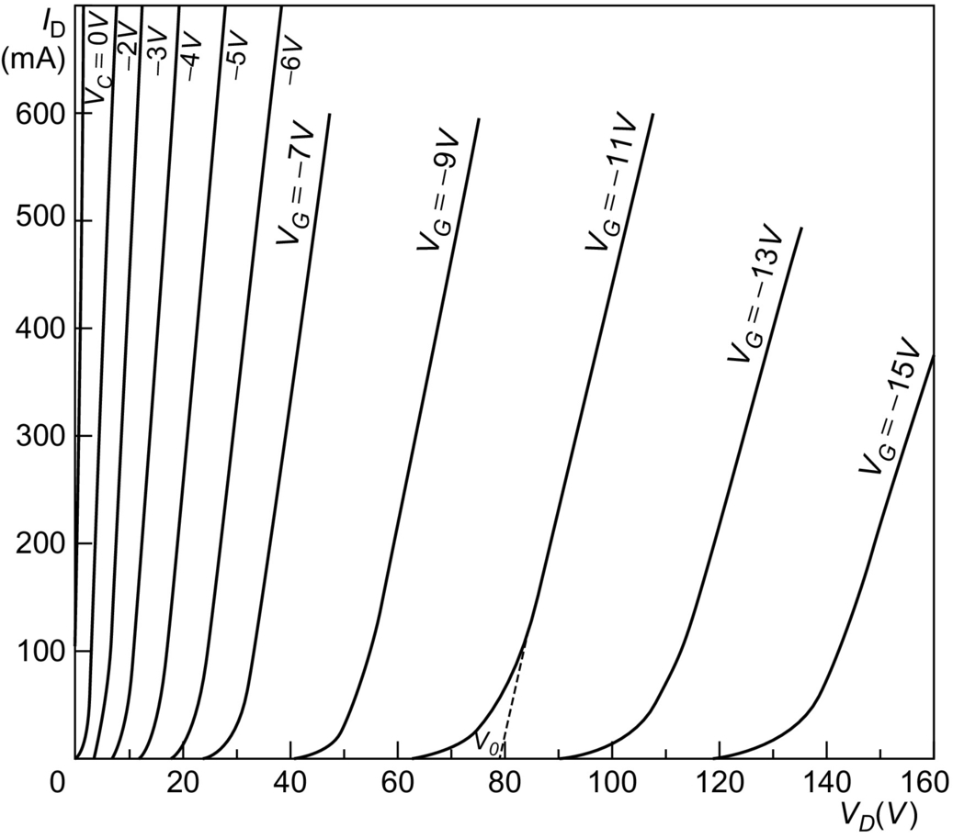

**FIG. 4.5** Characteristics of the SIT drawn in a linear scale.

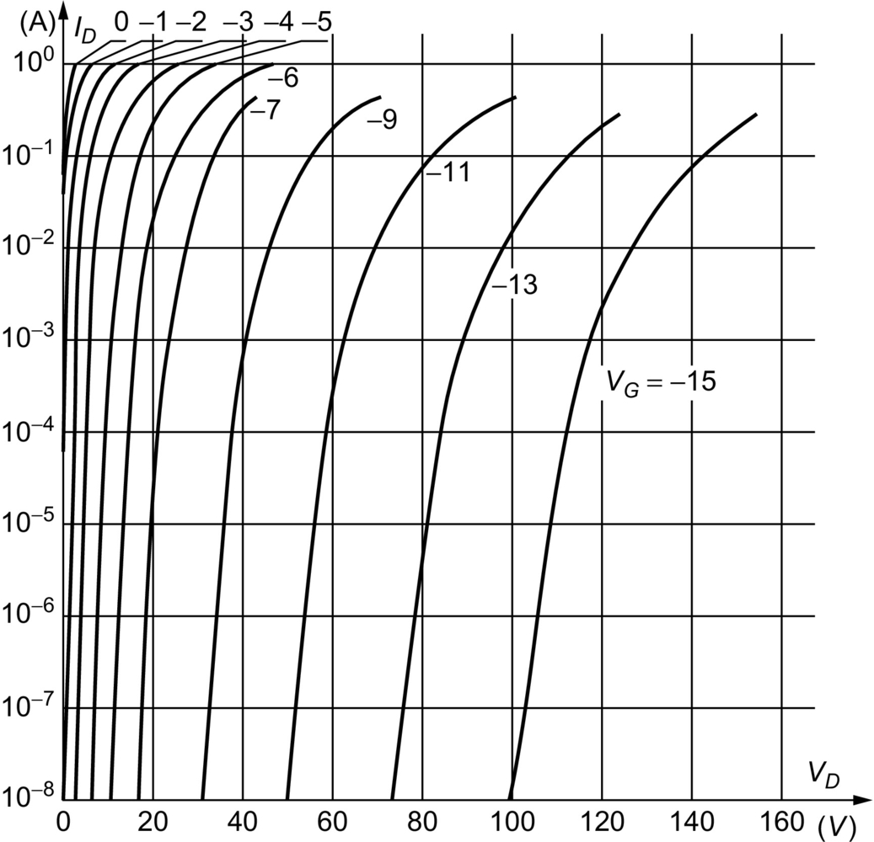

**FIG. 4.6** Characteristics of the SIT drawn in a logarithmic scale.

## 4.4 Bipolar Mode Operation of SI devices (BSIT)

The bipolar mode of operation of SIT was first reported in 1976 by Nishizawa and Wilamowski [[5](https://learning.oreilly.com/library/view/power-electronics-handbook/9780128114087/B9780128114070000040.xhtml#bb0030),[6](https://learning.oreilly.com/library/view/power-electronics-handbook/9780128114087/B9780128114070000040.xhtml#bb0035)]. Several complex theories for the bipolar mode of operation were developed [[10](https://learning.oreilly.com/library/view/power-electronics-handbook/9780128114087/B9780128114070000040.xhtml#bb0055)–[14](https://learning.oreilly.com/library/view/power-electronics-handbook/9780128114087/B9780128114070000040.xhtml#bb0075)], but actually, the simple formula given by Eq. [(4.5)](https://learning.oreilly.com/library/view/power-electronics-handbook/9780128114087/B9780128114070000040.xhtml#fo0030) works well not only for the typical mode of the SIT operation but also for the bipolar mode of the SIT operation. Furthermore, the same formula works very well for the classical bipolar transistors. Typical characteristics of the SI transistor operating in normal and in bipolar modes are shown in [Figs. 4.7](https://learning.oreilly.com/library/view/power-electronics-handbook/9780128114087/B9780128114070000040.xhtml#f0040) and [4.8](https://learning.oreilly.com/library/view/power-electronics-handbook/9780128114087/B9780128114070000040.xhtml#f0045).

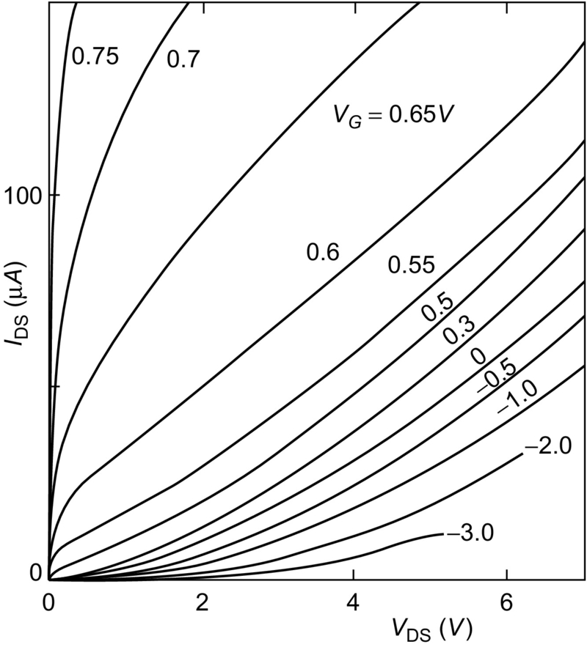

**FIG. 4.7** Small-size SIT transistor characteristics, operating in both the normal and bipolar modes, *ID*=*f* (*V*DS) with *V*GS as a parameter.

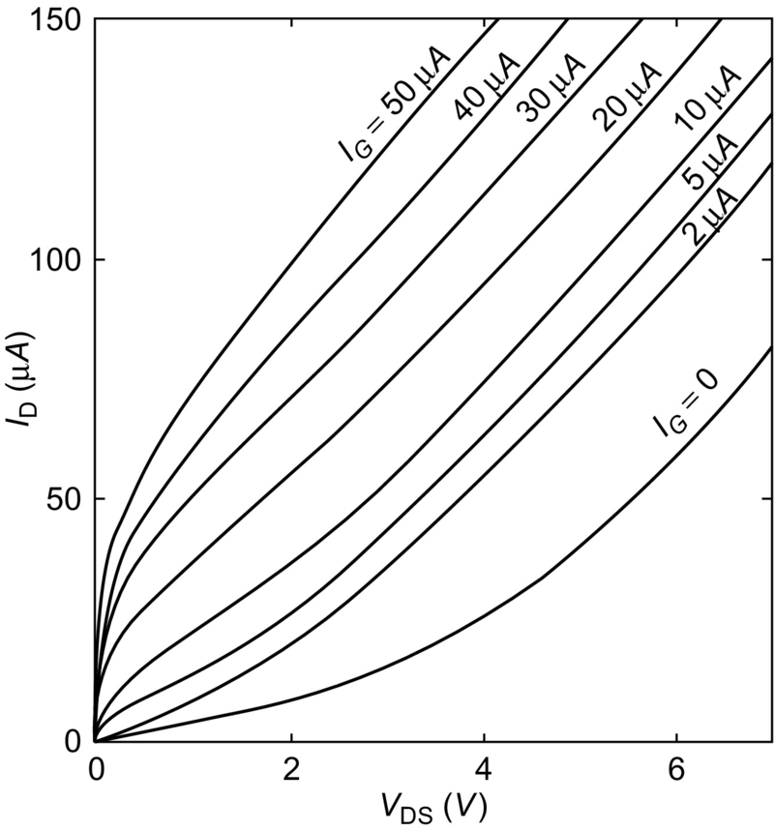

**FIG. 4.8** Small-size SIT transistor characteristics, operating in both the normal and bipolar modes, *ID*=*f* (*V*DS) with *IG* as a parameter.

A potential barrier controls the current in the SIT, and it is given by

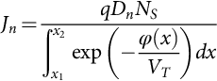 **(4.13)**

where *ϕ*(*x*) is the profile of the potential barrier along the channel.

For example, in the case of *npn* bipolar transistors, the potential distribution across the base in reference to emitter potential at the reference impurity level *NE*=*NS* is described by

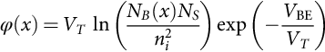 **(4.14)**

After inserting Eq. [(4.14)](https://learning.oreilly.com/library/view/power-electronics-handbook/9780128114087/B9780128114070000040.xhtml#fo0075) into Eq. [(4.13)](https://learning.oreilly.com/library/view/power-electronics-handbook/9780128114087/B9780128114070000040.xhtml#fo0070), one can obtain the well-known equation for electron current injected into the base:

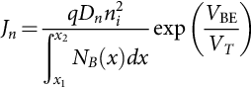 **(4.15)**

If Eq. [(4.13)](https://learning.oreilly.com/library/view/power-electronics-handbook/9780128114087/B9780128114070000040.xhtml#fo0070) is valid for SIT and BJT, then one may assume that it is also valid for the bipolar mode of operation of the SIT transistor. This is a well-known equation for the collector current in the bipolar transistor, but this time, it was derived using the concept of the current flow through the potential barrier.

## 4.5 Emitters for Static Induction Devices

One of the disadvantages of the SIT is the relatively flat shape of the potential barrier ([Fig. 4.9A](https://learning.oreilly.com/library/view/power-electronics-handbook/9780128114087/B9780128114070000040.xhtml#f0050)). This leads to slow, diffusion-based transport of carriers in the vicinity of the potential barrier. The carrier transit time can be estimated using the formula

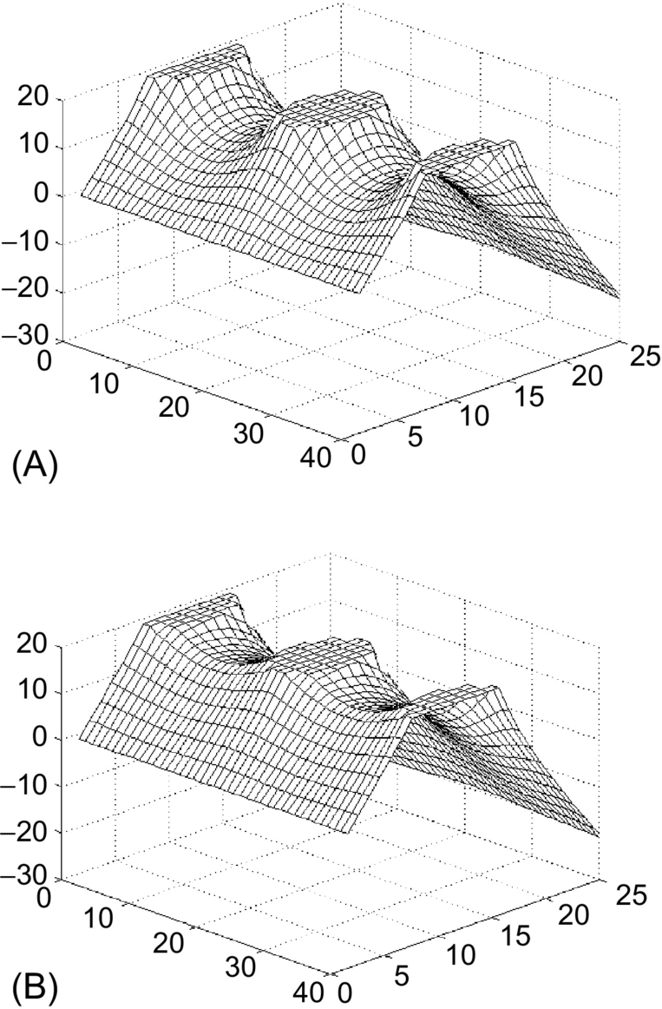

**FIG. 4.9** Potential distributions in SIT: (A) traditional and (B) with sharp potential barrier.

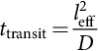 **(4.16)**

where *l*eff is the effective length of the channel and *D*=*μVT* is the diffusion constant. In the case of a traditional SIT transistor, this channel length is about 2 μm, while in the case of SIT transistors with sharper barriers ([Fig. 4.9B](https://learning.oreilly.com/library/view/power-electronics-handbook/9780128114087/B9780128114070000040.xhtml#f0050)), the channel length is reduced to about 0.2 μm. The corresponding transient times are 2 ns and 20 ps, respectively.

Potential distributions shown in [Fig. 4.3](https://learning.oreilly.com/library/view/power-electronics-handbook/9780128114087/B9780128114070000040.xhtml#f0020) are valid for SIT with an emitter made of a traditional *p-n* junction. A much narrower potential barrier can be obtained when the other type of emitter is being used. There are two well-known emitters, (1) *p-n* junction ([Fig. 4.10A](https://learning.oreilly.com/library/view/power-electronics-handbook/9780128114087/B9780128114070000040.xhtml#f0055)) and (2) Schottky junction ([Fig. 4.10B](https://learning.oreilly.com/library/view/power-electronics-handbook/9780128114087/B9780128114070000040.xhtml#f0055)). For silicon devices, *p-n* junctions have a forward voltage drop of 0.7–0.8 V, while Schottky emitters have 0.2–0.3 V only. Since the Schottky diode is a majority carrier device, the carrier storage effect is negligible.

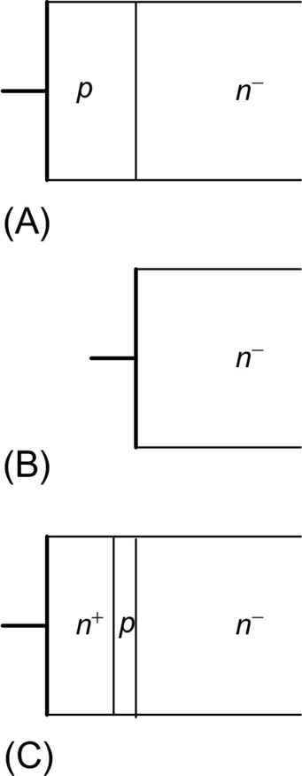

**FIG. 4.10** Various structures of emitters: (A) *p-n* junction including heterostructure with SiGe materials, (B) Schottky junction, and (C) punch-through emitter (in normal operation condition, the *p* region is depleted from carriers).

Another interesting emitter structure is shown in [Fig. 4.10C](https://learning.oreilly.com/library/view/power-electronics-handbook/9780128114087/B9780128114070000040.xhtml#f0055). This emitter has all the advantages of the Schottky diode, with majority carrier injection, even though it is fabricated out of *p-n* junctions.

The concept of static induction devices can be used independently of the type of emitter shown in [Fig. 4.10](https://learning.oreilly.com/library/view/power-electronics-handbook/9780128114087/B9780128114070000040.xhtml#f0055). With Schottky-type and punch-through-type emitters, the potential barrier is much narrower, and this results in faster response time and larger current gain in the bipolar mode of operation.

## 4.6 Static Induction Diode

The bipolar mode of operation of SIT can also be used to obtain diodes with low forward voltage drop and negligible carrier storage effect [[10](https://learning.oreilly.com/library/view/power-electronics-handbook/9780128114087/B9780128114070000040.xhtml#bb0055),[11](https://learning.oreilly.com/library/view/power-electronics-handbook/9780128114087/B9780128114070000040.xhtml#bb0060),[13](https://learning.oreilly.com/library/view/power-electronics-handbook/9780128114087/B9780128114070000040.xhtml#bb0070),[15](https://learning.oreilly.com/library/view/power-electronics-handbook/9780128114087/B9780128114070000040.xhtml#bb0080)]. A SID can be obtained by shorting a gate to the emitter of the SIT [[16](https://learning.oreilly.com/library/view/power-electronics-handbook/9780128114087/B9780128114070000040.xhtml#bb0085),[17](https://learning.oreilly.com/library/view/power-electronics-handbook/9780128114087/B9780128114070000040.xhtml#bb0090)]. Such diode has all the advantages of the SIT such as thermal stability and short switching time. The cross section of such diode is shown in [Fig. 4.11](https://learning.oreilly.com/library/view/power-electronics-handbook/9780128114087/B9780128114070000040.xhtml#f0060).

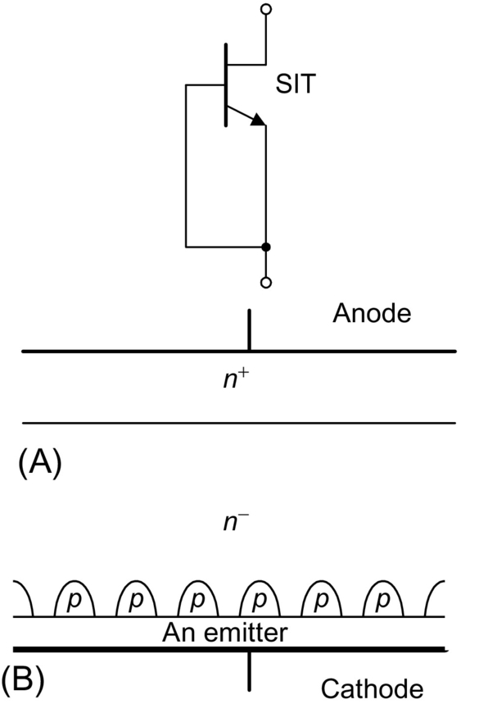

**FIG. 4.11** Static induction diode: (A) circuit diagram and (B) cross section.

The quality of the SID can be further improved with more sophisticated emitters ([Fig. 4.10B and C](https://learning.oreilly.com/library/view/power-electronics-handbook/9780128114087/B9780128114070000040.xhtml#f0055)). The SI diode with Schottky emitter was described by Wilamowski in 1983 [[18](https://learning.oreilly.com/library/view/power-electronics-handbook/9780128114087/B9780128114070000040.xhtml#bb0095)] ([Fig. 4.12](https://learning.oreilly.com/library/view/power-electronics-handbook/9780128114087/B9780128114070000040.xhtml#f0065)). A similar structure was later published by Baliga [[19](https://learning.oreilly.com/library/view/power-electronics-handbook/9780128114087/B9780128114070000040.xhtml#bb0100)].

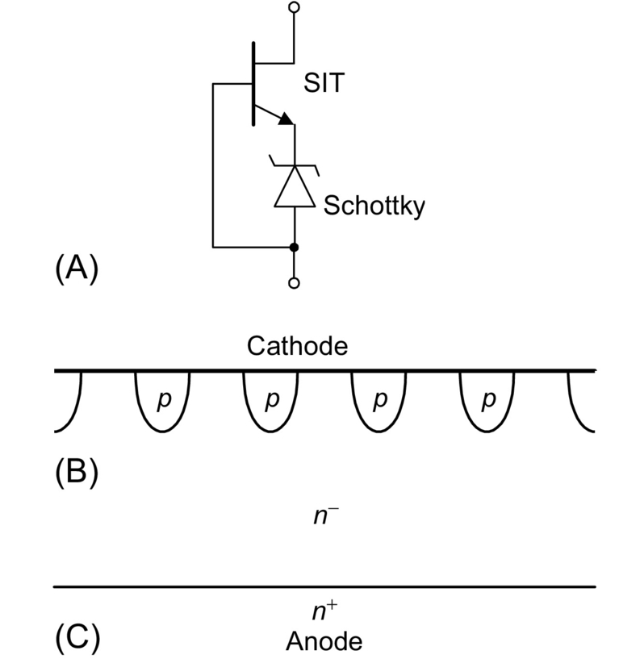

**FIG. 4.12** Schottky diode with enlarged breakdown voltages: (A) circuit diagram and (B and C) two cross section of possible implementation.

## 4.7 Lateral Punch-Through Transistor

Fabrications of SI transistors usually require very sophisticated technology. It is much simpler to fabricate a lateral punch-through transistor (LPTT), which operates on the same principle and has similar characteristics [[20](https://learning.oreilly.com/library/view/power-electronics-handbook/9780128114087/B9780128114070000040.xhtml#bb0105)] ([Fig. 4.13](https://learning.oreilly.com/library/view/power-electronics-handbook/9780128114087/B9780128114070000040.xhtml#f0070)). The cross section of the LPTT is shown in [Fig. 4.14](https://learning.oreilly.com/library/view/power-electronics-handbook/9780128114087/B9780128114070000040.xhtml#f0075).

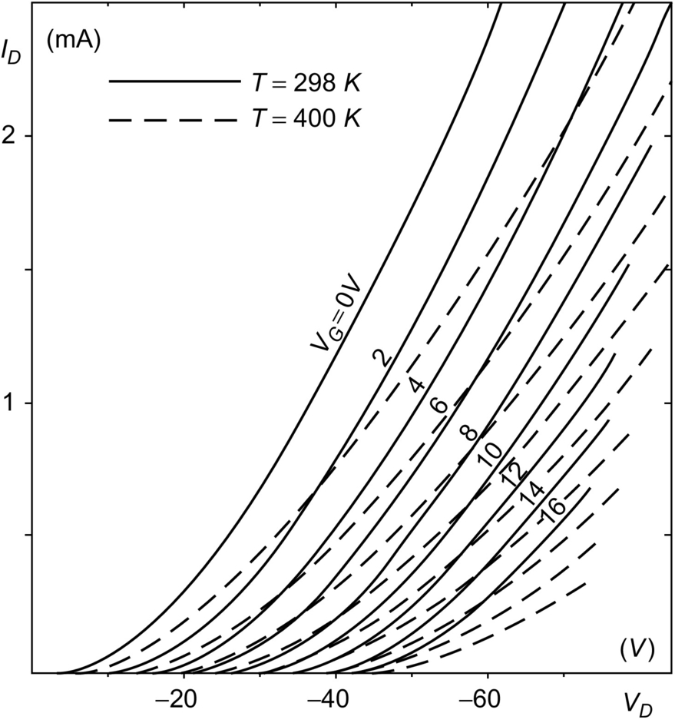

**FIG. 4.13** Characteristics of lateral punch-through transistor.

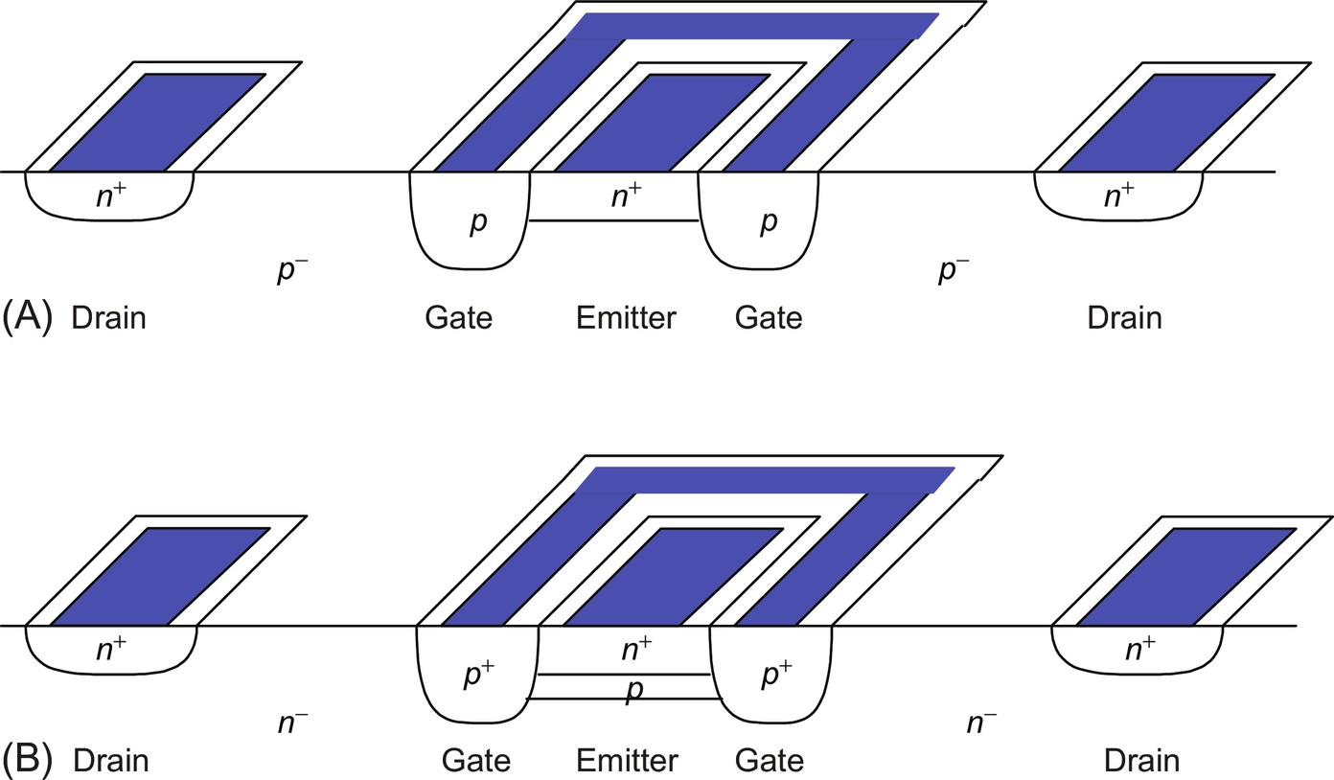

**FIG. 4.14** Structures of the lateral punch-through transistors: (A) simple and (B) with sharper potential barrier.

## 4.8 Static Induction Transistor Logic

The SITL was proposed by Nishizawa and Wilamowski [[5](https://learning.oreilly.com/library/view/power-electronics-handbook/9780128114087/B9780128114070000040.xhtml#bb0030),[6](https://learning.oreilly.com/library/view/power-electronics-handbook/9780128114087/B9780128114070000040.xhtml#bb0035)]. This logic circuit has almost 100 times better power-delay product than its *I*2*L* competitor. Such drastic improvement of the power-delay product is possible because the SITL structure has a significantly smaller junction parasitic capacitance and also the voltage swing is reduced. [Figs. 4.15](https://learning.oreilly.com/library/view/power-electronics-handbook/9780128114087/B9780128114070000040.xhtml#f0080) and [4.16](https://learning.oreilly.com/library/view/power-electronics-handbook/9780128114087/B9780128114070000040.xhtml#f0085) illustrate the concept of SITL. Measured characteristics of *n*-channel transistor of the static induction logic are shown in [Fig. 4.17](https://learning.oreilly.com/library/view/power-electronics-handbook/9780128114087/B9780128114070000040.xhtml#f0090).

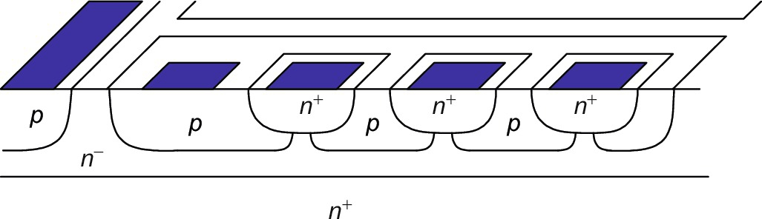

**FIG. 4.15** Cross section of SIT logic.

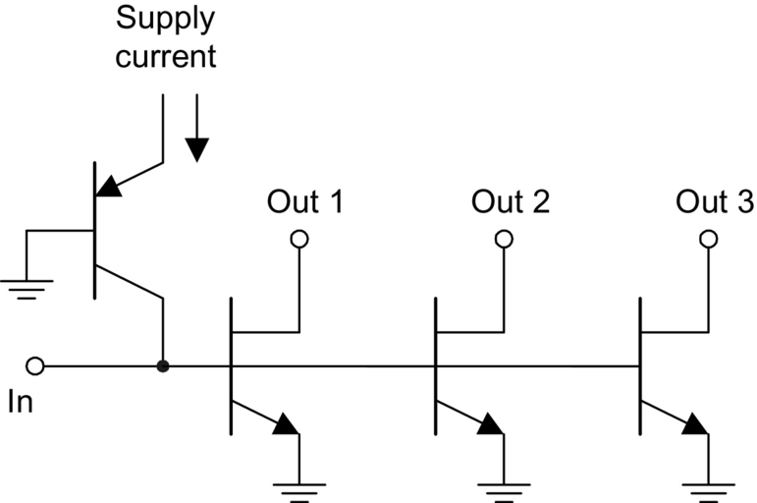

**FIG. 4.16** Diagrams of SIT logic.

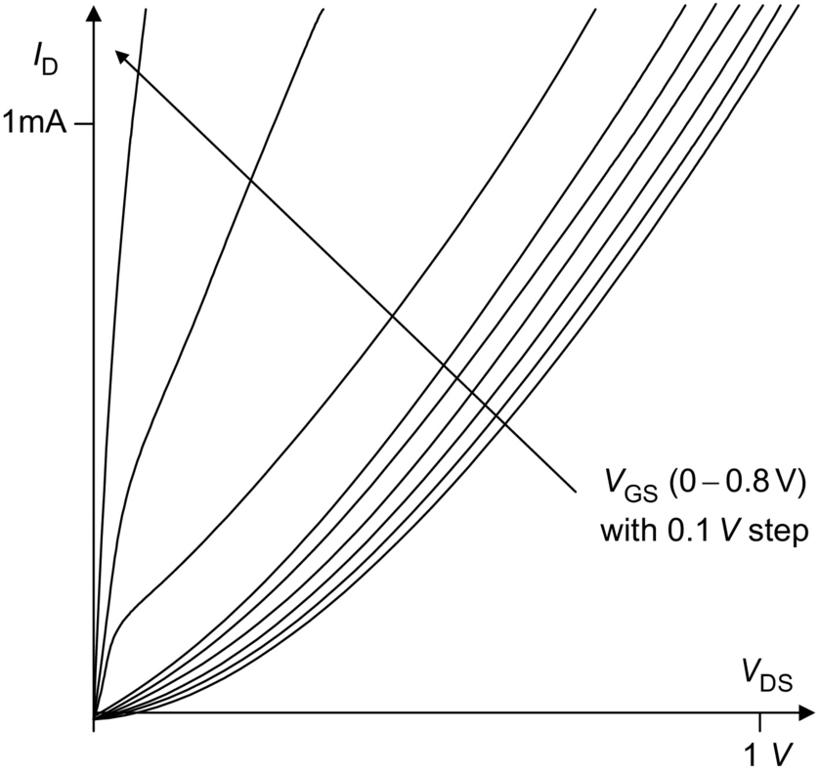

**FIG. 4.17** Measured characteristics of *n*-channel transistor of the logic circuit of [Fig. 4.16](https://learning.oreilly.com/library/view/power-electronics-handbook/9780128114087/B9780128114070000040.xhtml#f0085).

## 4.9 BJT Saturation Protected by SIT

The SI transistor can also be used instead of a Schottky diode to protect a bipolar junction transistor against saturation [[21](https://learning.oreilly.com/library/view/power-electronics-handbook/9780128114087/B9780128114070000040.xhtml#bb0110)]. This leads to faster switching time. The concept is shown in [Figs. 4.13](https://learning.oreilly.com/library/view/power-electronics-handbook/9780128114087/B9780128114070000040.xhtml#f0070) and [4.18](https://learning.oreilly.com/library/view/power-electronics-handbook/9780128114087/B9780128114070000040.xhtml#f0095). Note that this approach is advantageous to the solution with Schottky diode, since it does not require additional area on a chip and it does not introduce additional capacitance between the base and the collector. The base-collector capacitance is always enlarged by the Miller effect, and this leads to slower switching in the case of the solution with the Schottky diode.

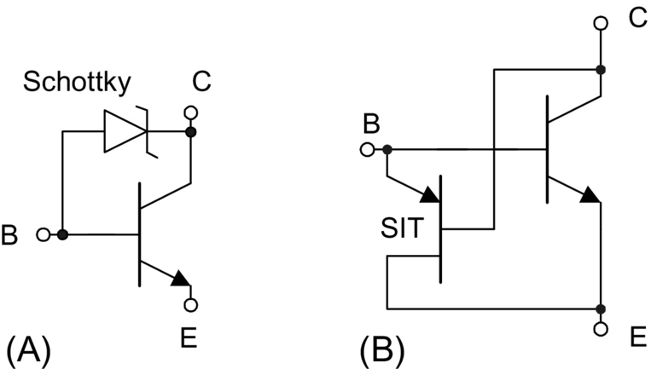

**FIG. 4.18** Protection of bipolar transistor against deep saturation: (A) using Schottky diode and (B) using SIT.

## 4.10 Static Induction MOS Transistor

The punch-through transistor with MOS-controlled gate was described in 1983 [[22](https://learning.oreilly.com/library/view/power-electronics-handbook/9780128114087/B9780128114070000040.xhtml#bb0115),[23](https://learning.oreilly.com/library/view/power-electronics-handbook/9780128114087/B9780128114070000040.xhtml#bb0120)]. In the structure in [Fig. 4.19A](https://learning.oreilly.com/library/view/power-electronics-handbook/9780128114087/B9780128114070000040.xhtml#f0100), current can flow in a similar fashion as in the LPTT [[20](https://learning.oreilly.com/library/view/power-electronics-handbook/9780128114087/B9780128114070000040.xhtml#bb0105)]. In this mode of operation, carriers are moving far from the surface with a velocity close to the saturation velocity. The real advantage of such structure is the very low gate capacitance.

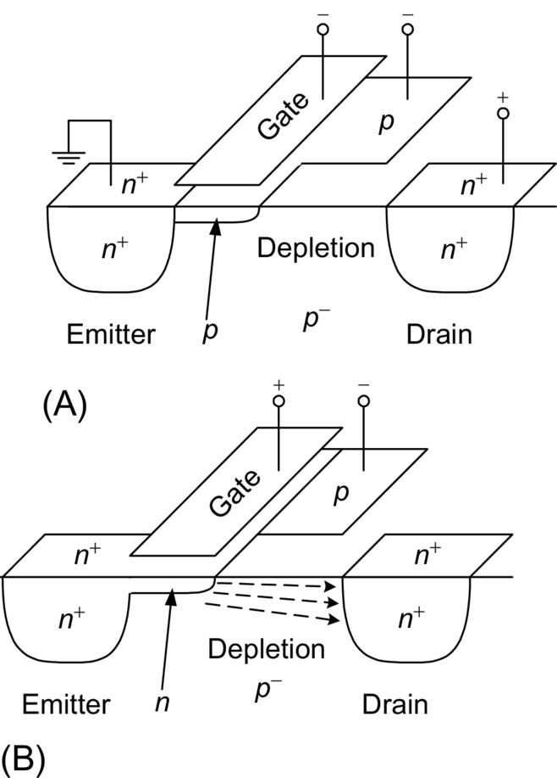

**FIG. 4.19** MOS-controlled punch-through transistor: (A) transistor in the punch-through mode for the negative gate potential and (B) transistor in the on-state for the positive gate potential.

Another implementation of static induction MOS transistor (SIMOS) is shown in [Fig. 4.20](https://learning.oreilly.com/library/view/power-electronics-handbook/9780128114087/B9780128114070000040.xhtml#f0105). The buried *p*+ layer is connected to the substrate, which has a large negative potential. As a result, the potential barrier is high, and the emitter-drain current cannot flow. The punch-through current may start to flow when the positive voltage is applied to the gate, and in this way, the potential barrier is lowered. The *p*-implant layer is depleted, and due to the high horizontal electric field under the gate, there is no charge accumulation under this gate. Such a transistor has several advantages over the traditional MOS transistor ([Fig. 4.21](https://learning.oreilly.com/library/view/power-electronics-handbook/9780128114087/B9780128114070000040.xhtml#f0110)).

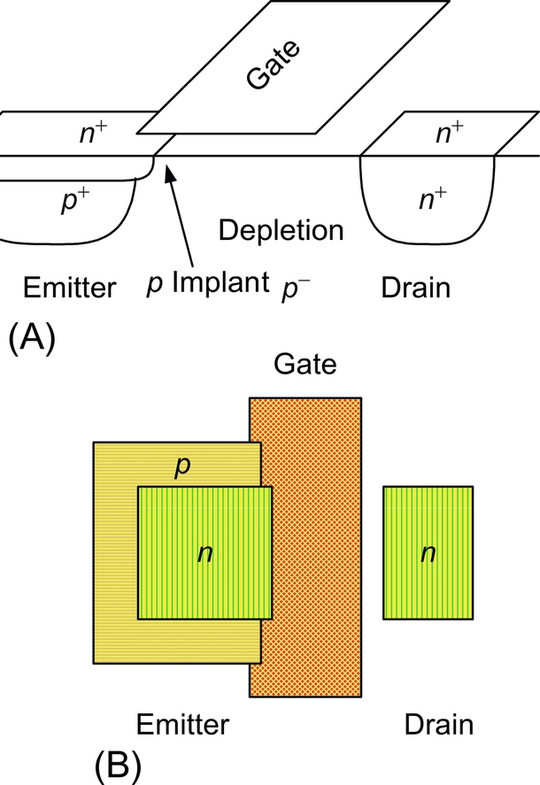

**FIG. 4.20** Static induction MOS structure: (A) cross section and (B) top view.

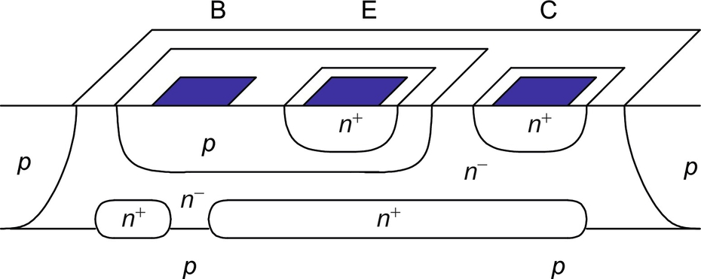

**FIG. 4.21** Cross sections of bipolar transistors protected against deep saturation using SIT.

1. The gate capacitance is very small, since there is no accumulation layer under the gate.

2. Carriers are moving with a velocity close to saturation velocity.

3. Much lower substrate doping and the existing depletion layer lead to much smaller drain capacitance.

The device operates in a similar fashion as MOS transistor in subthreshold conditions, but this process occurs at much higher current levels. Such “bipolar mode” of operation may have many advantages in VLSI applications.

## 4.11 Space Charge Limiting Load (SCLL)

Using the concept of the space charge-limited current flow, it is possible to fabricate very large resistors on a very small area. Moreover, these resistors have a very small parasitic capacitance. For example, a 50 kΩ resistor requires only several square μm when a 2 μm feature size technology is used [[7](https://learning.oreilly.com/library/view/power-electronics-handbook/9780128114087/B9780128114070000040.xhtml#bb0040)].

Depending on the value of the electric field, the device current is described by the following two equations. For a small electric field, *v*(*x*)=*μE*(x):

 **(4.17)**

For a large electric field, *v*(*x*)=const:

 **(4.18)**

Moreover, these resistors, which are based on the space charge limit flow, have a very small parasitic capacitance ([Fig. 4.22](https://learning.oreilly.com/library/view/power-electronics-handbook/9780128114087/B9780128114070000040.xhtml#f0115)).

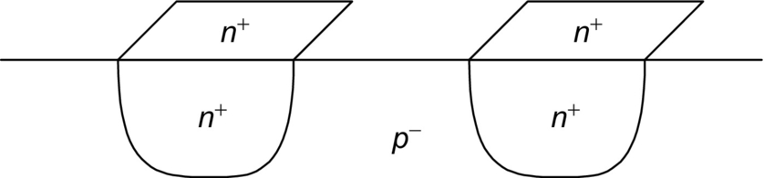

**FIG. 4.22** Space charge limiting load (SCLL).

## 4.12 Power MOS Transistors

Power MOS transistors are being used for fast switching power supplies and for switching power converters. They can be driven with relatively small power, and switching frequencies could be very high. High switching frequencies lead to compact circuit implementations with small inductors and small capacitances. Basically, only two technologies, DMOS and VMOS, are used for power MOS devices as shown in [Figs. 4.23](https://learning.oreilly.com/library/view/power-electronics-handbook/9780128114087/B9780128114070000040.xhtml#f0120) and [4.24](https://learning.oreilly.com/library/view/power-electronics-handbook/9780128114087/B9780128114070000040.xhtml#f0125).

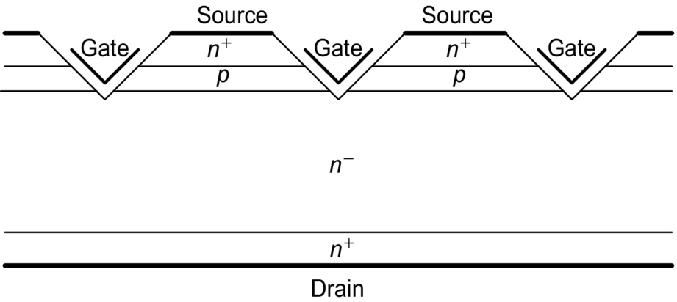

**FIG. 4.23** Cross section of the VMOS transistor.

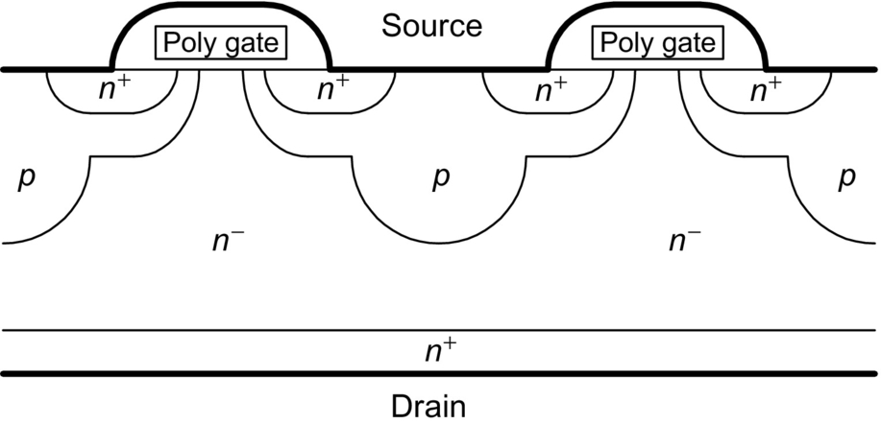

**FIG. 4.24** Cross section of the DMOS transistor.

A more popular structure is the DMOS shown in [Fig. 4.24](https://learning.oreilly.com/library/view/power-electronics-handbook/9780128114087/B9780128114070000040.xhtml#f0125). This structure also uses the SIT concept. Note that for large drain voltages, the *n*-region is depleted from carriers, and statically induced electric field in the vicinity of the virtual drain is significantly reduced. As a result, this transistor may withstand much larger drain voltages, and also the effect of channel length modulation is significantly reduced. The later effect leads to larger output resistances of the transistor. Therefore, the drain current is less sensitive to drain voltage variations. The structure in [Fig. 4.24](https://learning.oreilly.com/library/view/power-electronics-handbook/9780128114087/B9780128114070000040.xhtml#f0125) can be considered as a composition of the MOS transistor and the SIT transistor as is shown in [Fig. 4.25](https://learning.oreilly.com/library/view/power-electronics-handbook/9780128114087/B9780128114070000040.xhtml#f0130).

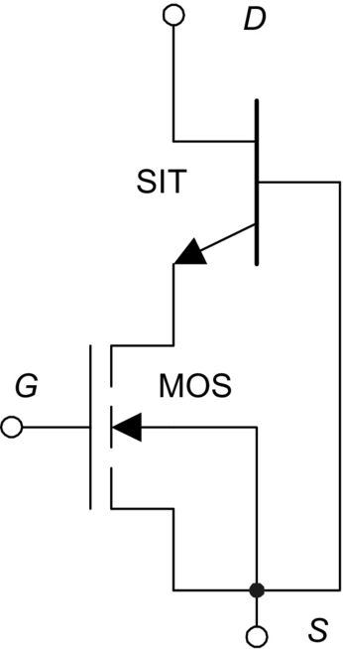

**FIG. 4.25** Equivalent diagram with MOS and SIT of the structure of [Fig. 4.24](https://learning.oreilly.com/library/view/power-electronics-handbook/9780128114087/B9780128114070000040.xhtml#f0125).

The major disadvantage of power MOS transistors is relatively large drain series resistance and much smaller transconductance in comparison with bipolar transistors. Both of these parameters can be improved dramatically by a simple change of the type of drain, in the case of *n*-channel device from *n*-type to *p*-type drain. This way, the integrated structure is being built where its equivalent diagram consists of MOS transistor integrated with bipolar transistor. Such structure has *β* times larger transconductance (*β* is the current gain of bipolar transistor) and much smaller series resistance due to the conductivity modulation effect caused by holes injected into lightly doped drain region. Such device is known as insulated-gate bipolar transistors (IGBT) as shown in [Fig. 4.26](https://learning.oreilly.com/library/view/power-electronics-handbook/9780128114087/B9780128114070000040.xhtml#f0135). Their main disadvantage is large switching time limited primarily by poor switching performance of bipolar transistor. Another difficulty is related to a possible latch-up action of a four-layer *n*+*pn*−*p*+ structure. This undesired effect could be suppressed by using heavily doped *p*+ region in the base of NPN structure, which leads to significant reduction of the current gain of this parasitic transistor. The gain of other PNP transistor must be kept large, so the transconductance of the entire device is large too. The IGBT transistor has breakdown voltages up to 1500 V; turn off times are in range 0.1–0.5 μs. They may operate with currents above 100 A with a forward voltage drop about 3 V.

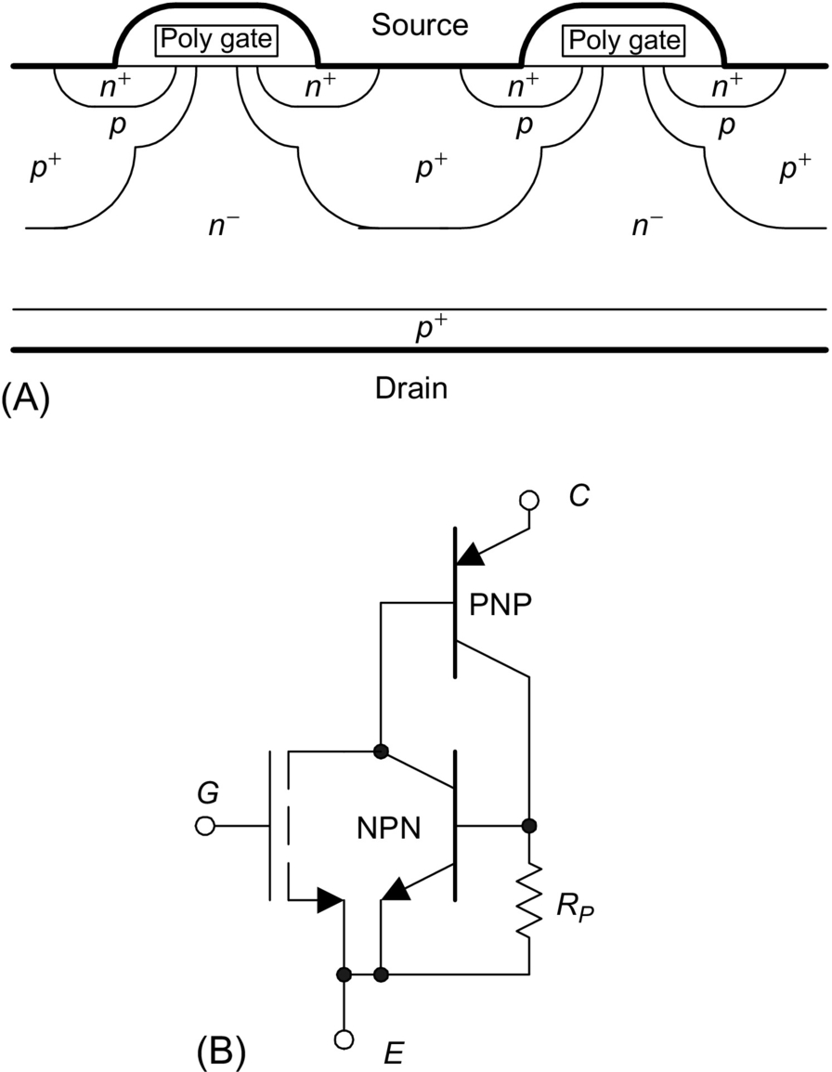

**FIG. 4.26** Insulated-gate bipolar transistor (IGBT), (A) cross section and (B) equivalent diagram.

## 4.13 Static Induction Thyristor

There are several special semiconductor devices dedicated to high power applications. The most popular is thyristor known also as silicon control rectifier (SCR). This device has a four-layer structure as shown in [Fig. 4.27A](https://learning.oreilly.com/library/view/power-electronics-handbook/9780128114087/B9780128114070000040.xhtml#f0140), and it can be considered as two transistors *npn* and *pnp* connected as shown in [Fig. 4.27B](https://learning.oreilly.com/library/view/power-electronics-handbook/9780128114087/B9780128114070000040.xhtml#f0140).

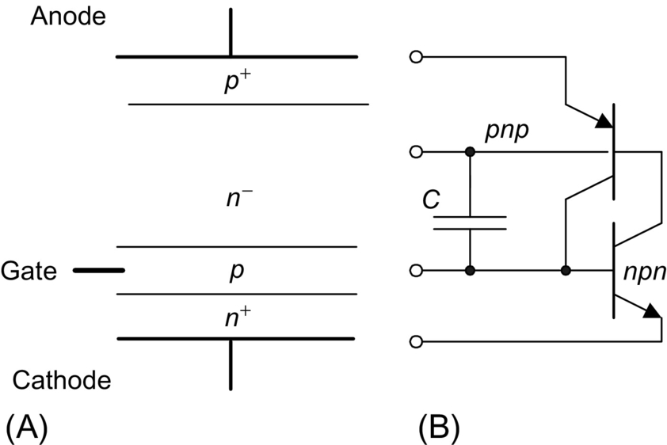

**FIG. 4.27** Silicon control rectifier: (A) cross section and (B) equivalent diagram.

In normal mode of operation (anode has positive potential), only one junction is reverse-biased, and it can be represented by capacitance *C*. A spike of anode voltage can therefore get through capacitor *C*, and it can trigger SCR. This behavior is not acceptable in practical application, and therefore, a different device structure is being used as is shown in [Fig. 4.28](https://learning.oreilly.com/library/view/power-electronics-handbook/9780128114087/B9780128114070000040.xhtml#f0145). Note that by shorting gate to cathode by resistor *R*, it is much more difficult to trigger the *npn* transistor by spike of anode voltage. This way, rapid change of anode voltages is not able to trigger thyristor. Therefore, this structure has a very large *dv/dt* parameter.

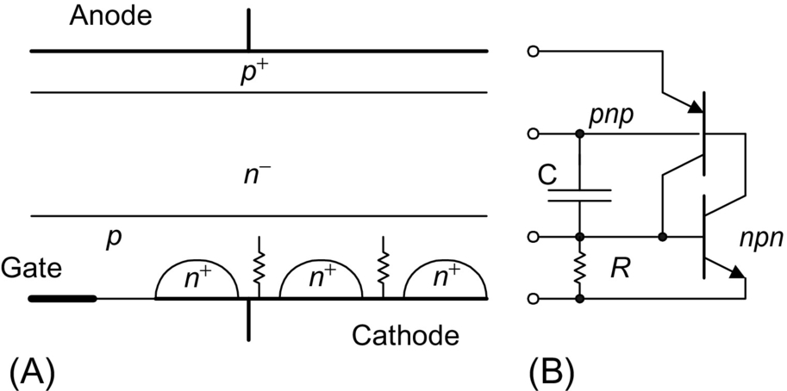

**FIG. 4.28** Silicon control rectifier with larger *dv/dt* parameter: (A) cross section and (B) equivalent diagram.

When NPN transistor is replaced with SI transistor, parameters of a thyristor can be significantly improved. For example, with breaking voltage in the range of 5 kV and current of 600 A, the switching on time can be as short as 100 ns, and *dv/dt* parameter can be as large as 50 kV/s [[15](https://learning.oreilly.com/library/view/power-electronics-handbook/9780128114087/B9780128114070000040.xhtml#bb0080),[24](https://learning.oreilly.com/library/view/power-electronics-handbook/9780128114087/B9780128114070000040.xhtml#bb0125)].

Most of the SCRs sold in the market comprise an integrated structure composed of two or more thyristors. This structure has both large *dv/dt* and *di/dt* parameters. This structure consists of internal thyristor that significantly amplifies the gate signal.

One can notice that the classical thyristor as shown in [Fig. 4.27](https://learning.oreilly.com/library/view/power-electronics-handbook/9780128114087/B9780128114070000040.xhtml#f0140) can be turned off by the gate voltage, while integrated SCR shown in [Fig. 4.29](https://learning.oreilly.com/library/view/power-electronics-handbook/9780128114087/B9780128114070000040.xhtml#f0150) can be only turned off by reducing anode current to zero. Most of the SCRs sold in the market have an integrated structure composed of two or more thyristors. This structure has both large *dv/dt* and *di/dt* parameters.

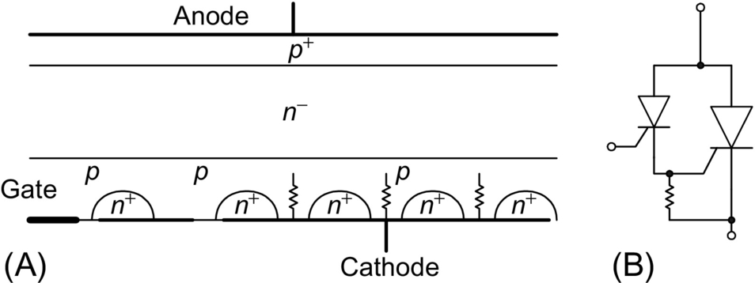

**FIG. 4.29** Integrated structure of silicon control rectifier: (A) cross section and (B) equivalent diagram.

## 4.14 Gate Turn Off Thyristor

For the dc operation, it is important to have a thyristor that can be turned off by the gate voltage. Such thyristor has a structure similar to the one shown in [Fig. 4.27](https://learning.oreilly.com/library/view/power-electronics-handbook/9780128114087/B9780128114070000040.xhtml#f0140). It is important, however, to have significantly different current gains *β* for *pnp* and *npn* transistors. The current gain of *npn* transistor should be as large as possible, and the current gain of *pnp* transistor should be small. The product of *βnpn* and *βpnp* should be larger than one. This can be easily implemented using SI structure as shown in [Fig. 4.30](https://learning.oreilly.com/library/view/power-electronics-handbook/9780128114087/B9780128114070000040.xhtml#f0155).

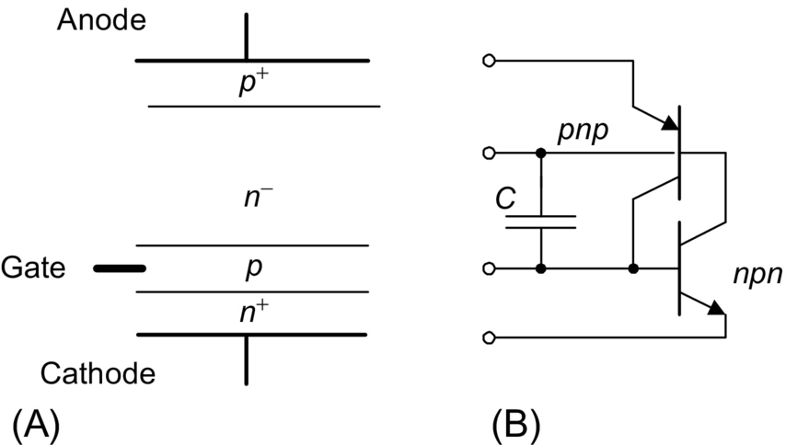

**FIG. 4.30** GTO-SIT: (A) cross section and (B) equivalent diagram.

## References

[1] Nishizawa J., Terasaki T., Shibata J. Field-effect transistor versus analog transistor (static induction transistor). *IEEE Trans. Electron Dev.* 1975;22(4):185–197.

[2] Tatsude M., Yamanaka E., Nishizawa J. High-frequency high-power static induction transistor. *IEEE Ind. Appl. Mag.* 1995;1(2):40–45 March/April.

[3] Nishizawa J., Plotka P., Kurabayashi T. Ballistic and tunneling gaas static induction transistors: nano-devices for THz electronics. *IEEE Trans. Electron Dev.* 2002;49(7):1102–1111.

[4] Nishizawa J., Suto K., Kurabayashi T. Recent advance in tetrahertz wave and material basis. *Russ. Phys. J.* 2003;46(6):615–622.

[5] Nishizawa J., Wilamowski B.M. *Integrated logic—state induction transistor logic.* In: International Solid State Circuit Conference, Philadelphia USA; 1977:222–223.

[6] Nishizawa J., Wilamowski B.M. *Static induction logic—a simple structure with very low switching energy and very high packing density.* In: International Conference on Solid State Devices, Tokyo, Japan; 1976:53–54 Jpn. J. Appl. Phys. 16(1) (1977) 158–162.

[7] Wilamowski B.M. *High speed, high voltage, and energy efficient static induction devices.* In: 12 Symposium of Static Induction Devices – SSID'99, (invited speech) Tokyo, Japan; 1994:23–28.

[8] Plotka P., Wilamowski B.M. Interpretation of exponential type drain characteristics of the SIT. *Solid State Electron.* 1980;23:693–694.

[9] Plotka P., Wilamowski B.M. Temperature properties of the static induction transistor. *Solid State Electron.* 1981;24:105–107.

[10] Kim C.W., Kimura M., Yano K., Tanaka A., Sukegawa T. Bipolar-mode static induction transistor: experiment and two-dimensional analysis. *IEEE Trans. Electron Dev.* 1990;37(9):2070–2075.

[11] Nakamura Y., Tadano H., Takigawa M., Igarashi I., Nishizawa J. Experimental study on current gain of BSIT. *IEEE Trans. Electron Dev.* 1986;33(6):810–815.

[12] Nishizawa J., Ohmi T., Chen H.L. Analysis of static characteristics of a Bipolar-Mode SIT (BSIT). *IEEE Trans. Electron Dev.* 1982;29(8):1233–1244.

[13] Yano K., Henmi I., Kasuga M., Shimizu A. High-power rectifier using the BSIT operation. *IEEE Trans. Electron Dev.* 1998;45(2):563–565.

[14] Yano K., Masahito M., Moroshima H., Morita J., Kasuga M., Shimizu A. Rectifier characteristics based on Bipolar-Mode SIT Operation. *IEEE Electron Dev. Lett.* 1994;15(9):321–323.

[15] Hironaka R., Watanabe M., Hotta E., Okino A. Performance of pulsed power generator using high voltage static induction thyristor. *IEEE Trans. Plasma Sci.* 2000;28(5):1524–1527.

[16] Yano K., Honarkhah S., Salama A. *Lateral SOI static induction rectifiers.* In: Proceedings of 2001 International Symposium on Power Semiconductor Devices, Osaka; 2001:247–250.

[17] Yano K., Hattori N., Yamamoto Y., Kasuga M. *Impacts of channel implantation on performance of static shielding diodes and static induction rectifiers.* In: Proceedings of 2001 International Symposium on Power Semiconductor Devices, Osaka; 2001:219–222.

[18] Wilamowski B.M. Schottky diodes with high breakdown voltage. *Solid State Electron.* 1983;26(5):491–493.

[19] Baliga B.J. The pinch rectifier: a low forward-drop, high-speed power diode. *IEEE Electron Dev. Lett.* 1984;5:194–196.

[20] Wilamowski B.M., Jaeger R.C. The lateral punch-through transistor. *IEEE Electron Dev. Lett.* 1982;3(10):277–280.

[21] Wilamowski B.M., Mattson R.H., Staszak Z.J. The SIT saturation protected bipolar transistor. *IEEE Electron Dev. Lett.* 1984;5:263–265.

[22] Wilamowski B.M. The punch-through transistor with MOS controlled gate. *Phys. Status Solidi (a).* 1983;79:631–637.

[23] Wilamowski B.M., Jaeger R.C., Fordemwalt J.N. Buried MOS transistor with punch-through. *Solid State Electron.* 1984;27(8/9):811–815.

[24] Shimizu N., Sekiya T., Iida K., Imanishi Y., Kimura M., Nishizawa J. *Over 55 kV/us, dv/dt turnoff characteristics of 4 kV-Static Induction Thyristor for Pulsed Power Applications.* In: Proceedings of 2004 International Symposium on Power Semiconductor Devices, Kitakyushu, Japan; 2004:281–284.

**5**

# SiC and GaN Power Semiconductor Devices

Tanya K. Gachovska Senior Verification Engineer, Solantro Semiconductor Corp., Ottawa, ON, Canada

Jerry L. Hudgins University of Nebraska-Lincoln, Lincoln, NE, United States

## Abstract

Wide bandgap semiconductors such as SiC and GaN have drawn a lot of attention in power applications due to their superior material properties such as high critical electric field resulting in a minimum of 10 times higher breakdown voltage or a 100 times smaller on-resistance than Si. Additionally, SiC has a thermal conductivity which is approximately three times higher than Si. These unique properties of SiC and GaN materials have made them promising candidates for future high power, high frequency semiconductor devices.

### KEYWORDS

Wide bandgap; SiC; GaN; ON-resistance; High power; High frequency semiconductor devices

5.1 [Background](https://learning.oreilly.com/library/view/power-electronics-handbook/9780128114087/B9780128114070000052_1.xhtml#s0010)

5.2 [Silicon Carbide and Gallium Nitride Materials](https://learning.oreilly.com/library/view/power-electronics-handbook/9780128114087/B9780128114070000052_1.xhtml#s0015)

5.2.1 Silicon Carbide Polytypes

5.2.2 Gallium Nitride Crystal Structures

5.3 [SiC Power Devices](https://learning.oreilly.com/library/view/power-electronics-handbook/9780128114087/B9780128114070000052_1.xhtml#s0075)

5.3.1 Introduction

5.3.2 SiC Power Diodes

5.3.3 SiC MOSFET

5.3.4 SiC JFET

5.3.5 SiC BJT

5.3.6 SiC IGBT

5.3.7 SiC Thyristor

5.4 [GaN Power Devices](https://learning.oreilly.com/library/view/power-electronics-handbook/9780128114087/B9780128114070000052_2.xhtml#s0130)

5.4.1 Lateral GaN Schottky Barrier Diodes

5.4.2 Vertical GaN PiN Diodes

5.4.3 GaN JFET

5.4.4 GaN MOSFET

5.4.5 GaN HEMT

[References](https://learning.oreilly.com/library/view/power-electronics-handbook/9780128114087/B9780128114070000052_3.xhtml#bi0010)

[Further Reading](https://learning.oreilly.com/library/view/power-electronics-handbook/9780128114087/B9780128114070000052_3.xhtml#fr0010)

NOMENCLATURE

***a*** Width of channel flow, cm

***ai*** Ratio of intercell area to total die area

***A*** Cross-sectional active device area, cm2

**A⁎** Richardson's constant

***AGS*** Coupling area between gate and source, cm2

***Ai*, *bi*, and *mi*** Amplitude parameter (cm−1), ionization energy parameter (V cm−1), and fit parameter

***BV*** Breakdown voltage, kV

***BVCEO*** Maximum open-base breakdown voltage of BJT, kV

***C*, *Cn*, and *Cp*** Auger coefficients, cm6 s−1

***CDep*** Depletion region capacitance, F

**C*j*** Junction capacitance, F

***CGD*** Gate-to-drain capacitance, F

***COX*** Oxide capacitance per unit area, F cm−2

**C*SH*** Shunt capacitance, F

***CT*** Tunneling coefficient

***d*** Length from junction to case, cm

***d*** Recess depth, cm

***ddep*** Depletion width, cm

***d1*, *W*, and *d2*** Depletion region thicknesses of each section of *N*+*N*−*P*+ regions, respectively, cm

***D*** Ambipolar diffusivity, cm2s−1

***Dn* and *Dp*** Electron and hole diffusivities, cm2s−1

***DN*\_** Ambipolar diffusion coefficient in *N*− region, cm2s−1

***DpN*** Hole diffusivity in field-stop *N* layer, cm2s−1

***DpN*+** Minority carrier diffusivities in *N*− region, cm2s−1

***EC*** Critical electric field, V cm−1

***EG*** Bandgap energy, eV

***EM*** Electric field at Schottky barrier, V cm−1

***EM*** Maximum electric field, V cm−1

***fT*** Cutoff frequency, Hz

***hn* and *hp*** Electron and hole recombination parameters, cm−4s−1

***I*** Current passing through drift region, A

***ICG*** Displacement layer, A

***ID*** Drain current, A

***ID*** Diode current, A

***Idisp1* and *Idisp2*** Displacement currents, A

***IE*, *IB*, *IC*** Emitter, base, and collector currents, A

***Imos*** MOS current, A

***In* and *Ip*** Electron and hole currents, A

***In0*, *In1*, and *In2*** Electron current at junctions J0, J1, and J2, A

***Ip0*, *Ip1*, and *Ip2*** Electron current at junctions J*0*, J*1*, and J*2*, A

***IQN*** Capacitive current, A

***Isne*** Emitter electron saturation current, A

***Ip*** Pinch-off current, A

**J0, J1, J2, J3** Junctions

***JF*** Current density, A cm−2

***JFS*** Current density across the Schottky barrier, A cm−2

**, ** Electron carrier densities at the *N*+*N*− and *PN*− junctions, A cm−2

***k* and *n*** Harmonic indexes for CSR carrier density of Fourier series representation

***k*** Boltzmann's constant (1.381×10−23 J K−1)

***K*** Coefficient

***KFV*** Feedback constant

***KGS*** Coupling area coefficient between gate and source

***LA*** Accumulation layer length, cm

***LCH*** DMOSFET channel length, cm

***LDRIFT*** Drift region thickness, cm

***LPN*** Hole diffusion length, cm

***lm*** Intercell half width, cm

***l1*** Width due to voltage VGE, cm

***M*** Number of the terms of the Fourier series

***M*** Number of segments

***N*−** Drift region

***N*+** Field-stop layer

***N*+** Emitter

***NA*** Acceptor doping concentration, cm−3

***NB0*** Electron concentration at junction J0, cm−3

***NC*** Effective density of state in conduction band, cm−3

***NCH*** Channel doping concentration, cm−3

***ND*** Donor doping concentration, cm−3

***NDRIFT*** Doping concentration of lightly doped drift region, cm−3

***ND1*** Doping concentration in the lightly doped *N*-base, cm−3

***ND2*, *ND1* , *NA*** Doping concentration in the *N*+*N*−*P*+ regions, respectively, cm−3

***NE*** Emitter doping concentration, cm−3

***NJEFT*** Doping concentration in the *JFET* region, cm−3

***NN*** Doping concentration of buffer layer, cm−3

***NN*−** Doping concentration in the *N*− region, cm−3

***Np*** Emitter doping concentration, cm−3

***Np*** Doping concentration of gate, cm−3

***NS*** Number of effectively available states per unit volume, cm−3

***NV*** Effective density of state in valence band, cm−3

***n*** Electron carrier concentration, cm−3

***NB1*** Electron concentration base-region boundary, cm−3

***n*** Ideality factor

***ni*** Intrinsic carrier concentration, cm−3

***nPO*** Electron concentration *P*-base region boundary, cm−3

***n0* … *n7*** Nodes in lumped-charge model, cm−3

***npw*** Electron concentration at junction *J3*, cm−3

***npw*** Electron concentration at base region boundary from *N*− emitter side, cm−3

***ns*** 2DEG sheet charge density, cm−3

***P*** *P* emitter

***P*** *P* well

***PB*** Base doping concentration, cm−3

***p*** Hole carrier concentration, cm−3

***PDRIFT*** Hole concentration of drift region, cm−3

***p*(*x*)** Ambipolar carrier density as a function of position, cm−3

***p*(*x*,*t*)** Excess carrier concentration, cm−3

***p*(*x*,*t*)** Ambipolar carrier density as a function of position and time, cm−3

***p0*(*t*)** DC Fourier series component of the carrier storage region (CSR), cm−3

***PJFET*** Doping concentration of JFET region, cm−3

***pk*(*t*), *pn*(*t*)—*k*- or *n*−th** Fourier series component of CSR carrier density profile, cm−3

***PN*−** Hole concentration in *N*− region, cm−3

***pNO*** Hole concentration at the boundary between buffer layer and drift region, cm−3

***pNO*, *pNW*** Hole concentrations at two edges of field-stop layer, cm−3

***pT*(*k*)** Carrier distribution, cm−3

***pT1*, *pT2*, and *pT1*** Carrier densities of the two points of a segment and the carrier density of the segment, cm−3

***px1* and *px2*** Excess carrier concentrations at the two boundaries of the drift region, junctions *J1* and *J2*, cm−3

***q*** Unit electric charge ()

***R*** Half height of Schottky metallization, cm

***RA*** Accumulation layer resistance, Ω

***RAUG*** Auger recombination rate, cm−3s−1

***RCH*** Channel resistance, Ω

***RCONT*** Ohmic contact resistance, Ω

***RDRIFT*** Drift region resistance, Ω

***RJFET*** Junction field-effect transistor resistance, Ω

***ROC*** Ohmic contact resistance, Ω

***RON*** ON-resistance, Ω

***Rs*** Series resistance, Ω

***rsp*** Specific contact resistivity, mΩ cm2

***RSP*\_*ON*** Specific ON-resistance, mΩ cm2

***RSRH*** Shockley-Read-Hall carrier recombination rate, cm−3s−1

 Junction-to-case thermal resistance, K kW−1

***T*** Absolute temperature, K

***Tj*** Junction temperature, K

***VAC*** Anode cathode voltage, V

***VAK*** Voltage drop during conduction state, V

***VB*** Blocking voltage, V

***VBE*** Base-emitter voltage, V

***Vbi*** Built-in voltage, V

***VCE*** Collector-emitter voltage, V

***VCH*** Channel voltage, V

***Vd1* and *Vd2*** Depletion layer voltages, V

***VD*** Drain bias, V

***VDC*** DC supply voltage, V

***VDS*** Drain-source voltage, V

***VF*** Forward voltage drop, V

***VG*** Gate drive voltage, V

***VGE*** Gate emitter voltage, V

***VGS*** Gate-source voltage, V

***VN*−** Carrier storage region voltage, V

***VN*\_** Drift region voltage drop, V

***Vj0*, *Vj1*, and *Vj2*** Voltage drop at junctions J0, J1, and J2, V

***Vj12*** Total junction voltage, V

***VR*** Reverse voltage, V

***vsat*** Saturation velocity, cm s−1

***Vseg*** Resistive voltage drop of a segment, V

***VT*** Thermal voltage, V

***Vth*** Threshold voltage, V

***W*** Depletion layer width, cm

***W*** Miller capacitance width, cm

***W*** Schottky contact width, cm

***WB*** Base width, cm

***WCH*** DMOSFET channel width, cm

***WD*** Drift layer thickness, cm

***Wd1* and *Wd2*** Depletion widths, cm

***WDEP*** Depletion region width, cm

***WDRIFT*** Drift region width, cm

***Wg*** Gate width, cm

***WI*** Intrinsic layer width, cm

***Wmin*** Minimum width of the depletion layer of *N*-base, cm

***WN*** Width of buffer layer, cm

***WP*** Base region width, cm

***WS*** Depletion width between gate and source, cm

***W0*** Zero bias depletion region width, cm

***W1*, *W2*, *W*** Widths of the depletion region on the *N*− and *P* sides of the junction and total depletion layer, cm

***χ*** SiC electron affinity, eV

***xD*** Cross-sectional width, cm

***xj*** P+ region thickness, cm

***xJP*** P-base junction thickness, cm

***x1*** Thickness, cm

***x1* and *x2*** Boundary positions of the carrier storage region, cm

***z*** Length of cell in the orthogonal direction to the cross section

***z*** Width in vertical to paper direction, cm

***αi*, and *αeff*** General ionization coefficient, effective ionization coefficient, cm−1

***β*** Common-emitter gain

***ɛ*** Electric field strength, V cm−1

***ɛC*** Critical electric field strength, V cm−1

***ɛr*** *Si* Dielectric constant

***ɛr*** Relative permittivity

***ɛ*** Material permittivity, Fcm−1

***λ*** Thermal conductivity, W cm−1 K−1

***μCH*** Inversion layer mobility, cm2V−1s−1

***μn* and *μp*** Electron and hole mobilities, cm2V−1s−1

***τ*** High-level carrier lifetime, s

***τ*n, *τp*, and *τHL*** Electron, hole, and high-level injection lifetimes, s

***τPHL*** High-level lifetime in P-base region, s

***τp*N** Minority lifetime in *N* region, s

***τN*\_** Electron lifetime in *N*− region, s

***ψ*** Potential, V

**ρ** Resistivity of the epilayer, Ω cm−2

***QG*** Total gate charge, C

***QGD*** Gate-to-drain charge, C

***QGS*** Gate-to-source charge, C

***QGS*** Charge in buffer region, C

***QN*** Charge in buffer region, C

***QSW*** Switching charge, C

***ϕm*** Work function of the metal, eV

**Acronyms/Initialisms**

**ac** Alternating current

**ADE** Ambipolar diffusion equation

**AlN** Aluminum nitride

**AlGaN** Aluminum gallium nitride

**Al2O3** Alumina

**Au** Gold

**BeO** Beryllia

**BHFFOM** Baliga high-frequency figure of merit

**BJT** Bipolar junction transistor

**C** Carbon

**C** Cubic

**CLFOM** Conduction loss figure of merit

**CS** Carrier storage

**CSL** Current spreading layer

**CSR** Carrier storage region

**CTE** Coefficient of thermal expansion

**DC** Direct current

**DMOSFET** Double diffusion metal-oxide-semiconductor field-effect transistor

**ET** Edge termination

**FACTS** Flexible AC transmission systems

**FET** Field-effect transistor

**FOM** Figure of merit

**FS** Field stop

**GaN** Gallium nitride

**GaAs** Gallium arsenide

**Ge** Germanium

**GTO** Gate turn-off thyristor

**H** Hexagonal

**HEMT** High-electron-mobility transistor

**HFET** Heterostructure field-effect transistor

**HVDCT** High-voltage DC transmission

**ICM** Integral charge control model

**IGBT** Insulated-gate bipolar transistor

**IGCT** Integrated gate-commutated thyristor

**IrPt** Indium-platinum

**JBS** Junction barrier Schottky diode

**JFET** Junction field-effect transistor

**JFOM** Johnson's figure of merit

**LC-JFET** Lateral channel junction field-effect transistor

**LED** Light-emitting diode

**MCT** MOS-controlled thyristors

**MESFET** Metal-semiconductor field-effect transistor

**Mg** Magnesium

**Mo** Molybdenum

**MOS** Metal-oxide-semiconductor

**MOSFET** Metal-oxide-semiconductor field-effect transistor

**MPS** Merged PN-Schottky diode

**MTO** MOS turn-off thyristor

**Ni** Nickel

**Ni/Au** Nickel/gold

**NO** Nitric oxide

**NPT** Nonpunch-through

**PCB** Printed circuit board

**PiN** *P*, intrinsic and *N*-doped regions

**Pd** Palladium

**PdAg** Palladium-silver

**Pt** Platinum

**PNP** *P*-, *N*-, and *P*-doped regions

**PT** Punch-through

**R** Rhombohedral

**RC** Resistor-capacitor

**RESURF** Reduced surface field

**SBD** Schottky barrier diode

**SCR** Silicon-controlled rectifier

**Si** Silicon

**SiC** Silicon carbide

**Si3N4** Silicon nitride

**SiO2** Silicon dioxide

**SLFOM** Switching losses figure of merit

**SRH** Shockley-Read-Hall

**T** Titanium

**2DEG** Two-dimensional electron gas

**VCJFET** Vertical channel junction field-effect transistor

**VJFET** Vertical junction gate field-effect transistors

## 5.1 Background

Power semiconductor devices are key components of power electronics technology, used primarily as switches or rectifiers in circuits and systems. Currently, more than 70% of all electric energy consumed is processed by power electronics. The main function of power electronics is to control and transfer the flow of electric energy from one form to another and in a form that is suitable to the user. Semiconductor devices are widespread and can be found in almost every electric and electronic piece of equipment or product. Their power range depends on the application and can be from milliwatts to megawatts. Power devices have a significant impact on the economy as they determine system cost and efficiency.

The invention of the transistor in 1947 by Shockley, Bardeen, and Brattain [[1](https://learning.oreilly.com/library/view/power-electronics-handbook/9780128114087/B9780128114070000052_3.xhtml#bb0010)] allowed direct solid-state control of electricity for the first time. However, the application of transistors for controlling electric power was limited until the invention of the thyristor in the late 1950s [[2](https://learning.oreilly.com/library/view/power-electronics-handbook/9780128114087/B9780128114070000052_3.xhtml#bb0015)]. Although the thyristor has limited switching capability, it cannot be turned off by external control. Thyristors have been used for the design of different applications, such as control of direct current (DC) motors. The first power bipolar junction transistor (BJT) with substantial power handling capabilities was introduced in the 1960s. The device overcame some of the limitations of the thyristor because it could be switched on or off by applying an external signal.

Further developments of the thyristor led to the realization of a fully controllable switching device, a thyristor that can be turned off using a specialized gate design within the thyristor (GTO) [[3](https://learning.oreilly.com/library/view/power-electronics-handbook/9780128114087/B9780128114070000052_3.xhtml#bb0020)]. This enables the GTO to be used in more complex power conversion technology that is capable of controlling power more directly and efficiently. This significant development greatly enhanced power electronics technology.

The metal-oxide-silicon field-effect transistor (MOSFET) was the next major device introduced in the 1970s [[4](https://learning.oreilly.com/library/view/power-electronics-handbook/9780128114087/B9780128114070000052_3.xhtml#bb0025)]. It has minimal drive requirements due to its insulated gate. Also, the MOSFET is a voltage-controllable device having high input impedance and fast switching response. MOSFETs are unipolar majority carrier devices that give them a faster switching speed than the BJT or thyristor. On the other hand, the power handling capabilities of the MOSFET are low compared with the thyristor because of high ON-state resistance associated with high blocking voltage.

In the early 1980s, a new process technology was developed allowing MOSFET and BJT technology to be integrated on the same chip [[5](https://learning.oreilly.com/library/view/power-electronics-handbook/9780128114087/B9780128114070000052_3.xhtml#bb0030)]. A new device, the insulated-gate bipolar transistor (IGBT), was introduced. IGBTs possess the advantages of both devices: faster switching (inherited from MOSFET) and lower specific ON-state resistance (from the PNP BJT). Improvements in design and technology have made IGBTs popular replacements for BJTs and low- to medium-power thyristor technology. The IGBT is presently the dominate semiconductor device for most medium-power applications.

[Fig. 5.1](https://learning.oreilly.com/library/view/power-electronics-handbook/9780128114087/B9780128114070000052_1.xhtml#f0010) summarizes the most important power silicon (Si) semiconductor devices on the market along with silicon carbide (SiC) and gallium nitride (GaN) power devices that are on the market and others that have been developed and studied in recent years in various semiconductor laboratories. Due to many decades of development, fabrication, and optimization of a large variety of Si devices and a large material abundance, high manufacturing capability, and extremely low cost, Si is still the most used element for production of power semiconductor devices.

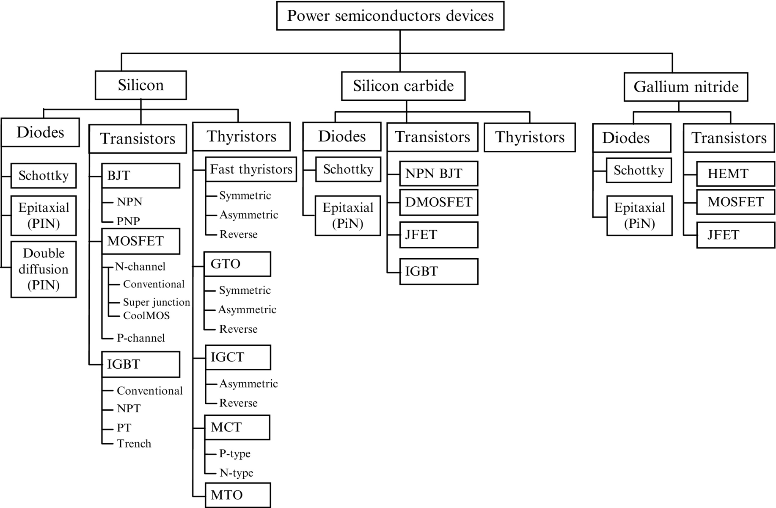

**FIG. 5.1** Most important power semiconductor devices on the market along with silicon carbide and gallium nitride power devices that have been developed and studied in recent years.

Based on their structure, power devices can be classified as diodes, transistors, and thyristors. Si Schottky diodes are typically used for high switching frequencies at low breakdown voltage (*BV*), *BV*≤100 V; the fast switching epitaxial PiN diodes are used for *BV*≤600÷1200 V, and double-diffused PiN diodes are applied at higher voltages, *BV*≥1000 V.

Silicon BJTs have been completely replaced by MOSFETs and IGBTs. By introducing an extra *P*-doping region in the MOSFET drift region, a high breakdown voltage is achieved with much higher drift doping, which results in a drastic reduction (5–10 times) in specific ON-resistance for the same chip area in a voltage range of *BV*=600–1000 V.

Large-area Si devices capable of handling thousands of amperes and kilovolts are now available on the market. Metal-oxide-semiconductor (MOS) gate devices, such as IGBTs, are designed using two different structures: punch-through (PT) and nonpunch-through (NPT). Both types of IGBTs can handle voltage up to 3.3 kV and current up to 1.2 kA [[6](https://learning.oreilly.com/library/view/power-electronics-handbook/9780128114087/B9780128114070000052_3.xhtml#bb0035)]. IGBT modules for 6.5 kV and 0.6 kA are also available.

Silicon GTOs and thyristors are still widely used for very high-power applications. FMCC group is currently selling asymmetrical GTO thyristors for 4.5 kV and 26 kA [[7](https://learning.oreilly.com/library/view/power-electronics-handbook/9780128114087/B9780128114070000052_3.xhtml#bb0040)]. The devices are optimized for low conduction losses, and the switching frequency is in the range of 200–500 Hz for most applications. All GTOs require snubbers for protection during turn-on and turn-off switching. Significant improvement to the GTO structure, including a gate driver, an integrated inverse diode, and better packaging, resulted in a new semiconductor device, the integrated gate-commutated thyristor (IGCT). The IGCTs have much faster turn-off times than GTOs. This allows them to operate at higher frequencies—up to several kilohertz—for very short periods of time. However, the typical IGCT operating frequency is up to 500 Hz due to high switching losses at higher frequencies. Asymmetrical IGCTs, optimized for snubberless turnoff, can operate at 6.5 kV and 4.2 kA. Metal-oxide-semiconductor-controlled thyristors (MCTs) and MOS turn-off thyristors (MTOs) have been proposed, but the market demand for these devices is very low at this time [[8](https://learning.oreilly.com/library/view/power-electronics-handbook/9780128114087/B9780128114070000052_3.xhtml#bb0045)].

The need for high-voltage, high-power-density devices operating at high frequencies and junction temperatures higher than 150°C is growing, especially for advanced power electronics. Silicon-based devices are not able to meet these requirements without connecting, in series and in parallel, to a large number of devices using costly active or passive snubbers and expensive cooling systems [[9](https://learning.oreilly.com/library/view/power-electronics-handbook/9780128114087/B9780128114070000052_3.xhtml#bb0050)]. For this reason, the limitations of Si material properties for power devices have been debated during the last decade; and wide bandgap semiconductors, such as those made of SiC and GaN, have attracted considerable attention.

Significant research into SiC and GaN as materials for semiconductor devices has been carried out during the last 20 years. Their wide bandgap energy enables the devices to operate at elevated temperatures (600°C) while retaining low leakage current. The higher breakdown strength for a given blocking voltage of SiC and GaN results in smaller drift layers or channel lengths as compared with Si devices. As a result, the storage of the minority carriers or the input and output capacitance and, therefore, the associated switching losses at a given switching frequency are reduced. This leads to an increase of the switching frequency to 0.5–1 MHz with acceptable switching losses, which significantly reduces the size and cost of the passive components in power electronic systems.

Regardless of the advantages that SiC and GaN materials possess, they have not been adopted for manufacturing of the entire family of high-power devices. Difficulty with crystal growth, the presence of crystal defects, such as micropipes and dislocations, and the absence of abundant wafer suppliers have all contributed to a lack of progress in the fabrication of SiC and GaN power devices by the commercial sector [[10](https://learning.oreilly.com/library/view/power-electronics-handbook/9780128114087/B9780128114070000052_3.xhtml#bb0055)]. Several industrial research groups and university labs have been working on improving the material properties and development of SiC and GaN power devices. In September 2001, two companies advertised the commercial availability of SiC Schottky diodes: Infineon (from 600 V up to 6 A or from 300 V up to 10 A) and Microsemi (100-200-480 V, 1A) [[11](https://learning.oreilly.com/library/view/power-electronics-handbook/9780128114087/B9780128114070000052_3.xhtml#bb0060)]. Five years later, in February 2006, the first commercially available GaN high-electron-mobility transistor (HEMT) products were launched by Eudyna Devices (now Sumitomo Electric Device Innovations USA, Inc.) [[12](https://learning.oreilly.com/library/view/power-electronics-handbook/9780128114087/B9780128114070000052_3.xhtml#bb0065)]. Since then, new SiC and GaN devices and new companies have been introduced to the market. In the next sections, the physical properties of SiC and GaN materials are compared with Si material, and the new devices are discussed.

## 5.2 Silicon Carbide and Gallium Nitride Materials

This chapter includes details on the physical and electric characteristics of SiC and GaN materials and highlights on the advantageous properties of power semiconductor devices fabricated from them.

### 5.2.1 SILICON CARBIDE POLYTYPES

SiC is known as a classical polytypic substance existing in more than 250 polytypes; the common polytypes are 6H, 15R, 4H, and 3C [[13](https://learning.oreilly.com/library/view/power-electronics-handbook/9780128114087/B9780128114070000052_3.xhtml#bb0070)]. The letters H, C, and R denote the overall lattice type as being hexagonal, cubic, or rhombohedral, respectively. All polytypes have a hexagonal frame with a carbon (C) atom positioned at the center of the mass of the tetragonal structure outlined by the four neighboring Si atoms, and the distance between a C atom to each of the Si atoms is the same [[14](https://learning.oreilly.com/library/view/power-electronics-handbook/9780128114087/B9780128114070000052_3.xhtml#bb0075)].

Polytypes are formed by stacking SiC molecules on top of each other in a certain order. The stacking order between succeeding double layers of C and Si atoms determines the difference between polytypes. During substrate manufacturing for semiconductor devices, it is important that the entire wafer is a single polytype. Growth conditions during substrate production should be stable because any instability in the growing process leads to spontaneous switching from one polytype to another. This will alter the electric properties of the material and act as a nucleation site for defects such as micropipes [[15](https://learning.oreilly.com/library/view/power-electronics-handbook/9780128114087/B9780128114070000052_3.xhtml#bb0080)].

Currently, two SiC polytypes are accepted in SiC device research: 6H-SiC and 4H-SiC. Before the introduction of 4H-SiC wafers in 1994, 6H-SiC was the dominant polytype. Since then, both polytypes have been used in research; but recently, 4H-SiC has become the more dominant polytype. This is because the charge-carrier mobilities in 4H-SiC are identical along the two planes of the semiconductor, whereas the 6H-SiC polytype exhibits anisotropy, which means that the mobilities of the material in the two planes are not the same.

### 5.2.2 GALLIUM NITRIDE CRYSTAL STRUCTURES

Gallium nitride is found in three crystal structures: wurtzite, zinc blende, and rock salt. At ambient conditions, GaN crystalizes in a wurtzite-type structure [[16](https://learning.oreilly.com/library/view/power-electronics-handbook/9780128114087/B9780128114070000052_3.xhtml#bb0085)], while the zinc-blende and rock-salt cubic GaN structures are metastable structures [[17](https://learning.oreilly.com/library/view/power-electronics-handbook/9780128114087/B9780128114070000052_3.xhtml#bb0090)] at normal conditions. The zinc-blende GaN structure is formed during a film preparation process [[18](https://learning.oreilly.com/library/view/power-electronics-handbook/9780128114087/B9780128114070000052_3.xhtml#bb0095)], while the rock-salt cubic GaN structure is formed under ultrahigh pressure of at least 37 GPa, and when the pressure is completely released, the rock-salt structure transfers back to the wurtzite structure [[19](https://learning.oreilly.com/library/view/power-electronics-handbook/9780128114087/B9780128114070000052_3.xhtml#bb0100)]. The zinc-blende GaN structure is not an equilibrium phase, and the growth of it would cost extra energy [[20](https://learning.oreilly.com/library/view/power-electronics-handbook/9780128114087/B9780128114070000052_3.xhtml#bb0105)]. The wurtzite crystal structure of GaN material exhibits a variety of material properties, such as spontaneous polarization and piezoelectric polarization effects, which are very important in the design of GaN heterostructure devices [[21](https://learning.oreilly.com/library/view/power-electronics-handbook/9780128114087/B9780128114070000052_3.xhtml#bb0110)]. Also, the GaN wurtzite crystal structure has a wider bandgap than the zinc-blende structure [[22](https://learning.oreilly.com/library/view/power-electronics-handbook/9780128114087/B9780128114070000052_3.xhtml#bb0115)], which is also an advantage for using the wurtzite structure in the fabrication of power devices.

#### **5.2.2.1 Silicon Carbide and Gallium Nitride Physical and Electrical Properties**

Silicon carbide and GaN materials display a wide range of properties, such as high breakdown electric field strength, high saturated drift velocity, and high thermal stability, which make it attractive for use as a material for semiconductor devices. [Table 5.1](https://learning.oreilly.com/library/view/power-electronics-handbook/9780128114087/B9780128114070000052_1.xhtml#t0010) summarizes some of these properties for the most popular wide bandgap semiconductors and Si. Some of the properties that benefit power semiconductor devices are strongly dependent on the bandgap. These properties are critical electric field, intrinsic carrier concentration, and to a lesser extent mobility and conductivity.

**Table 5.1**

**Physical properties for various semiconductors**

|  |  |  |  |  |  |  |  |  |
| --- | --- | --- | --- | --- | --- | --- | --- | --- |
| **Material** | ***EG* (eV)** | ***EC* (MV cm−1)** | ***ni* (cm−3)** | ***ɛr*** | ***μr* (cm2 V−1 s−1)** | ***vSAT* (107 cm s−1)** | **σT (W m−1 K−1)** | **CTE (ppm K−1)** |
| Si | 1.1 [[23](https://learning.oreilly.com/library/view/power-electronics-handbook/9780128114087/B9780128114070000052_3.xhtml#bb0120)] | 0.3 [[23](https://learning.oreilly.com/library/view/power-electronics-handbook/9780128114087/B9780128114070000052_3.xhtml#bb0120)] | 1010 [[23](https://learning.oreilly.com/library/view/power-electronics-handbook/9780128114087/B9780128114070000052_3.xhtml#bb0120)] | 11.9 | 1400 [[23](https://learning.oreilly.com/library/view/power-electronics-handbook/9780128114087/B9780128114070000052_3.xhtml#bb0120)] | 1.02 [[23](https://learning.oreilly.com/library/view/power-electronics-handbook/9780128114087/B9780128114070000052_3.xhtml#bb0120)] | 130 [[23](https://learning.oreilly.com/library/view/power-electronics-handbook/9780128114087/B9780128114070000052_3.xhtml#bb0120)] | 2.6 [[23](https://learning.oreilly.com/library/view/power-electronics-handbook/9780128114087/B9780128114070000052_3.xhtml#bb0120)] |
| GaAs | 1.424 [[23](https://learning.oreilly.com/library/view/power-electronics-handbook/9780128114087/B9780128114070000052_3.xhtml#bb0120)] | 0.4 [[23](https://learning.oreilly.com/library/view/power-electronics-handbook/9780128114087/B9780128114070000052_3.xhtml#bb0120)] | 2.1×106 | 13.1 | 8500 [[23](https://learning.oreilly.com/library/view/power-electronics-handbook/9780128114087/B9780128114070000052_3.xhtml#bb0120)] | 2.0 [[24](https://learning.oreilly.com/library/view/power-electronics-handbook/9780128114087/B9780128114070000052_3.xhtml#bb0125)] | 55 [[23](https://learning.oreilly.com/library/view/power-electronics-handbook/9780128114087/B9780128114070000052_3.xhtml#bb0120)] | 5.73 [[23](https://learning.oreilly.com/library/view/power-electronics-handbook/9780128114087/B9780128114070000052_3.xhtml#bb0120)] |
| 3C-SiC | 2.36 [[25](https://learning.oreilly.com/library/view/power-electronics-handbook/9780128114087/B9780128114070000052_3.xhtml#bb0130)] [[26](https://learning.oreilly.com/library/view/power-electronics-handbook/9780128114087/B9780128114070000052_3.xhtml#bb0135)] | 1 [[25](https://learning.oreilly.com/library/view/power-electronics-handbook/9780128114087/B9780128114070000052_3.xhtml#bb0130)] | 10 [[27](https://learning.oreilly.com/library/view/power-electronics-handbook/9780128114087/B9780128114070000052_3.xhtml#bb0140)] |  | ≤800 [[25](https://learning.oreilly.com/library/view/power-electronics-handbook/9780128114087/B9780128114070000052_3.xhtml#bb0130)] | 2.0 | 360 [[25](https://learning.oreilly.com/library/view/power-electronics-handbook/9780128114087/B9780128114070000052_3.xhtml#bb0130)] | 3.8 [[25](https://learning.oreilly.com/library/view/power-electronics-handbook/9780128114087/B9780128114070000052_3.xhtml#bb0130)] |
| 4H-SiC | 3.23 [[25](https://learning.oreilly.com/library/view/power-electronics-handbook/9780128114087/B9780128114070000052_3.xhtml#bb0130)] | 3–5 [[25](https://learning.oreilly.com/library/view/power-electronics-handbook/9780128114087/B9780128114070000052_3.xhtml#bb0130)] | 8.2×10−9 | 10.1 | ≤900 [[25](https://learning.oreilly.com/library/view/power-electronics-handbook/9780128114087/B9780128114070000052_3.xhtml#bb0130)] | 2.0 | 370 [[25](https://learning.oreilly.com/library/view/power-electronics-handbook/9780128114087/B9780128114070000052_3.xhtml#bb0130)] | 5.12 [[25](https://learning.oreilly.com/library/view/power-electronics-handbook/9780128114087/B9780128114070000052_3.xhtml#bb0130)] |
| 6H-SiC | 3.0 [[25](https://learning.oreilly.com/library/view/power-electronics-handbook/9780128114087/B9780128114070000052_3.xhtml#bb0130)] | 3-5 | 2.3×10−6 | 9.66 | ≤400 [[25](https://learning.oreilly.com/library/view/power-electronics-handbook/9780128114087/B9780128114070000052_3.xhtml#bb0130)] | 2.0 | 490 [[25](https://learning.oreilly.com/library/view/power-electronics-handbook/9780128114087/B9780128114070000052_3.xhtml#bb0130)] | 4.3–4.7 [[25](https://learning.oreilly.com/library/view/power-electronics-handbook/9780128114087/B9780128114070000052_3.xhtml#bb0130)] |
| GaN wurtzite | 3.39 [[25](https://learning.oreilly.com/library/view/power-electronics-handbook/9780128114087/B9780128114070000052_3.xhtml#bb0130)] | 3-5 [[25](https://learning.oreilly.com/library/view/power-electronics-handbook/9780128114087/B9780128114070000052_3.xhtml#bb0130)] | 1.9×10−10 | 9 | ≤1000 [[25](https://learning.oreilly.com/library/view/power-electronics-handbook/9780128114087/B9780128114070000052_3.xhtml#bb0130)] | 2.2 | 130 [[25](https://learning.oreilly.com/library/view/power-electronics-handbook/9780128114087/B9780128114070000052_3.xhtml#bb0130)] | 3.2–5.6 [[25](https://learning.oreilly.com/library/view/power-electronics-handbook/9780128114087/B9780128114070000052_3.xhtml#bb0130)] |
| GaN zinc blende | 3.2 [[28](https://learning.oreilly.com/library/view/power-electronics-handbook/9780128114087/B9780128114070000052_3.xhtml#bb0145)] |  |  |  |  |  |  |  |
| Diamond | 5.45 [[29](https://learning.oreilly.com/library/view/power-electronics-handbook/9780128114087/B9780128114070000052_3.xhtml#bb0150)] | 5.6 [[29](https://learning.oreilly.com/library/view/power-electronics-handbook/9780128114087/B9780128114070000052_3.xhtml#bb0150)] | 1.6×10−27 [[29](https://learning.oreilly.com/library/view/power-electronics-handbook/9780128114087/B9780128114070000052_3.xhtml#bb0150)] | 5.5 | 1900 [[29](https://learning.oreilly.com/library/view/power-electronics-handbook/9780128114087/B9780128114070000052_3.xhtml#bb0150)] | 2.7 [[29](https://learning.oreilly.com/library/view/power-electronics-handbook/9780128114087/B9780128114070000052_3.xhtml#bb0150)] | 600–2000 [[29](https://learning.oreilly.com/library/view/power-electronics-handbook/9780128114087/B9780128114070000052_3.xhtml#bb0150)] | 0.8 [[29](https://learning.oreilly.com/library/view/power-electronics-handbook/9780128114087/B9780128114070000052_3.xhtml#bb0150)] |

Silicon carbide is from the IV–IV group semiconductor family and has an indirect bandgap. Every SiC polytype has a different bandgap. Gallium nitride is from the III–V semiconductor family and has a direct bandgap. The bandgaps of 4H-SiC and GaN wurtzite-type structures at room temperature are 3.23 and 3.39 eV [[25](https://learning.oreilly.com/library/view/power-electronics-handbook/9780128114087/B9780128114070000052_3.xhtml#bb0130)], which are more than three times higher than the bandgap of Si.

#### **5.2.2.2 Critical Electric Field**

The specific ON-state resistance, , is an important device parameter for determining the device conduction losses. It is based on the critical electric field of the material, *ɛc*. Knowing the energy bandgap of the material, the critical electric field can be calculated. An expression for the critical electric field as a function of the bandgap energy for the indirect bandgap materials, such as SiC, is [[30](https://learning.oreilly.com/library/view/power-electronics-handbook/9780128114087/B9780128114070000052_3.xhtml#bb0155)]

 **(5.1)**

and an expression for the critical electric field for the direct bandgap materials, such as GaN, is [[30](https://learning.oreilly.com/library/view/power-electronics-handbook/9780128114087/B9780128114070000052_3.xhtml#bb0155)]

 **(5.2)**

There is no dependence on the background doping included in these expressions because the voltage blocking capability, during the OFF-state of power electronic devices, depends on the property of the lightly doped drift region [[30](https://learning.oreilly.com/library/view/power-electronics-handbook/9780128114087/B9780128114070000052_3.xhtml#bb0155)]. For Si, an expression for a relationship between the critical electric field, *ɛc*, and the bandgap, *EG*, [[31](https://learning.oreilly.com/library/view/power-electronics-handbook/9780128114087/B9780128114070000052_3.xhtml#bb0160)] is

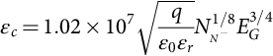 **(5.3)**

where *NN*− is the doping concentration in the lightly doped drift region, *N*− region; *q* is the unity electric charge , ; and *ɛr* is the Si dielectric constant. Assuming that the doping concentration in the lightly doped drift region, *N*− region, is approximately , the electric field can be represented by the formula:

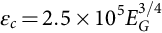 **(5.4)**

The critical electric fields of SiC and GaN materials are high as compared with Si because they have wider bandgaps. A wider bandgap of SiC or GaN material indicates that the energy required to break a bond is significantly higher than the energy required for the Si material. This allows a larger electric field to be applied before the avalanche of a multitude of ionized carriers occurs in the semiconductor. A more than 10 times higher critical electric field for SiC and GaN materials compared with Si allows power devices to be designed with thinner, more highly doped drift regions to achieve similar blocking voltages.

The specific ON-resistance can be related to the breakdown voltage, *BV*; electron mobility, *μn*; relative permittivity, *ɛr*; and bandgap energy, *EG*.

For Si, the specific ON-resistance can be calculated by the following equation [[32](https://learning.oreilly.com/library/view/power-electronics-handbook/9780128114087/B9780128114070000052_3.xhtml#bb0165)]:

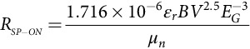 **(5.5)**

For SiC, the specific ON-resistance is [[33](https://learning.oreilly.com/library/view/power-electronics-handbook/9780128114087/B9780128114070000052_3.xhtml#bb0170)]

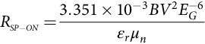 **(5.6)**

For GaN, the specific ON-resistance is [[33](https://learning.oreilly.com/library/view/power-electronics-handbook/9780128114087/B9780128114070000052_3.xhtml#bb0170)]

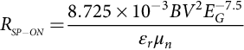 **(5.7)**

[Fig. 5.2](https://learning.oreilly.com/library/view/power-electronics-handbook/9780128114087/B9780128114070000052_1.xhtml#f0015) presents a theoretical, specific ON-state resistance of blocking regions designed for certain breakdown voltages in Si, 4H-SiC, and GaN under optimum punch-through conditions using Eqs. [(5.5)](https://learning.oreilly.com/library/view/power-electronics-handbook/9780128114087/B9780128114070000052_1.xhtml#fo0030)–[(5.7)](https://learning.oreilly.com/library/view/power-electronics-handbook/9780128114087/B9780128114070000052_1.xhtml#fo0040).

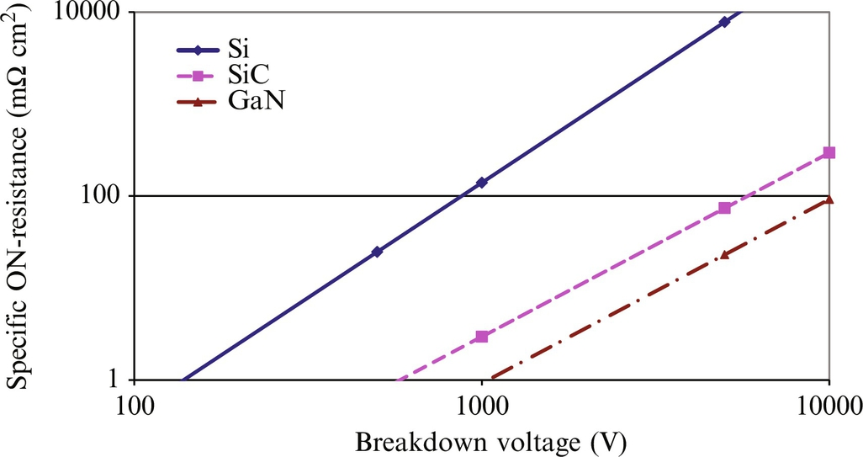

**FIG. 5.2** Specific ON-state resistance of the blocking regions in function of the breakdown voltages for Si, 4H-SiC, and GaN.

From [Fig. 5.2](https://learning.oreilly.com/library/view/power-electronics-handbook/9780128114087/B9780128114070000052_1.xhtml#f0015) and Eqs. [(5.5)](https://learning.oreilly.com/library/view/power-electronics-handbook/9780128114087/B9780128114070000052_1.xhtml#fo0030)–[(5.7)](https://learning.oreilly.com/library/view/power-electronics-handbook/9780128114087/B9780128114070000052_1.xhtml#fo0040), it can be deduced that, for the same blocking voltage, SiC and GaN devices offer specific ON-resistance that is more than 350 times lower than their Si counterparts. The doping concentration also affects the blocking voltage. For the same blocking voltage, the background doping in a SiC and a GaN device can be 10–100 times higher than that of a Si device. An increase in doping concentration will also lead to a decrease in specific ON-resistance. This is one of the most important advantages of high-voltage SiC and GaN devices because for the same blocking voltage, the ON-resistance is much lower. The fact that the devices can be made thinner and more highly doped means that SiC and GaN devices have the capability of operating at a higher frequency. Thinner devices are faster because the carriers do not have to travel as far through the device and have less volume of stored charge (bipolar devices).

#### **5.2.2.3 Intrinsic Carrier Concentration**

The intrinsic carrier concentration of a semiconductor completely free of impurities and defects is the number of excited electrons from the valence band occupying energy-momentum states in the conduction band (and also the number of excited holes in the valence band) per unit volume. It is given by the equation:

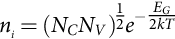 **(5.8)**

where *NC* and *NV* are the effective density of states in the conduction and in the valence band, respectively; *EG* is the energy bandgap; *k* is Boltzmann's constant (1.381×10−23 J K−1); and *T* is the absolute temperature in Kelvin, and it is assumed that *kT*≤*EG*/5.

Due to the wide bandgaps of SiC and GaN materials, their room-temperature intrinsic carrier concentrations are very small, ~8.2×10−9 cm−3 for SiC and 1.6×10−10 for GaN, while the intrinsic carrier concentration of Si is 1.45×1010 cm−3. Wide bandgap semiconductors have the advantage of operating at high temperature and radiation fluxes because degradation effects due to thermally generated carriers are small. As the temperature increases, the electron's thermal energy in the valence band increases leading to a condition where any effects due to impurity doping are negated. This condition at elevated temperatures effectively causes the semiconductor to act as if it were intrinsic (no impurity doping). The temperature at which this condition occurs for Si is about 150°C, while SiC has a wide bandgap, and the valence electrons require more thermal energy to move from valence to conducting band. This intrinsic temperature for SiC is ~900°C.

Radiation energy/particle flux can also excite an electron and make it move to the conducting band. Similar to temperature, a wide bandgap material will require more radiation energy to free an electron from the conducting band.

As a result of a wide bandgap, devices built with SiC and GaN can endure more heat and radiation without losing their designed electric properties. Devices using the wide bandgap materials can theoretically operate in extreme conditions where Si-based devices cannot.

#### **5.2.2.4 Saturated Drift Velocity**

The saturated drift velocity is also one of the most important device-related characteristics of a semiconductor because it determines the frequency limits of power devices and, consequently, the range of their most efficient use. The high-frequency capability of a semiconductor material is directly proportional to the material drift velocity. The drift velocity of 4H-SiC (2×107 cm s−1) and a GaN wurtzite crystal structure (2.2×107 cm s−1) is approximately twice as large as the drift velocity of Si (107 cm s−1); hence, it is expected that 4H-SiC- and GaN-based power devices could be switched at significantly higher frequencies as compared with their Si counterparts. In addition, a higher drift velocity allows charge in the depletion region to be removed faster; therefore, the switching losses are smaller since the reverse recovery current is smaller, and the reverse recovery time is shorter.

#### **5.2.2.5 Thermal Stability**

As was mentioned previously, one of the advantages of 4H-SiC- and GaN-based semiconductor devices is that they can operate at high temperatures due to the wide bandgap. Besides this, 4H-SiC has another thermal advantage—significantly high thermal conductivity, *λSiC*=4.9 W cm−1 K−1, compared with the conductivity of Si, *λSi*=1.5 W cm−1 K−1. This means that SiC-based devices can operate at higher power densities. The thermal conductivity of GaN, *λGaN*=1.3 W cm−1 K−1, is approximately equal to the thermal conductivity of Si. For low-power-density applications, the losses are not much larger, and the device temperature does not exceed the maximum operating junction temperature. Therefore, GaN devices can be built on Si substrates. Silicon is an important material in these applications because there are high quantities of inexpensive Si substrates available compared, for example, with SiC substrates. Thus, the use of Si as a substrate material is desirable, primarily for cost reasons. However, using Si substrates for GaN devices also introduces a number of critical issues due to the lattice mismatch and the difference in the thermal expansion coefficients, which affect the quality and device reliability [[34](https://learning.oreilly.com/library/view/power-electronics-handbook/9780128114087/B9780128114070000052_3.xhtml#bb0175)]. For high-power-density applications, the GaN devices should be grown on a SiC substrate.

The junction-to-case thermal resistance  of a device is calculated by the following equation:

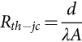 **(5.9)**

where *d* is the length (cm), in the direction of the heat flow, and *A* is the cross-sectional area (cm2) perpendicular to the direction of heat flow. Since the 4H-SiC thermal conductivity is three times higher as compared with Si, the junction-to-case thermal resistances of 4H-SiC devices are three times lower than their Si counterparts. Lower  indicates that the heat generated in a 4H-SiC substrate during the operation could more easily flow (diffuse) to the case, to the heat sink, and then to the environment. Therefore, the advantage of 4H-SiC devices or GaN devices on SiC substrate is faster heat dissipation, reducing the requirement for a heavy heat sink and complex thermal packaging. There is also a real benefit in terms of long-term reliability due to potentially lower thermal stresses.

#### **5.2.2.6 Coefficient of Thermal Expansion**

All materials change their size when subjected to a temperature change as long as the pressure is held constant. The coefficient of thermal expansion (CTE) describes a change in the size of an object with a change in the temperature. It is the fractional change in the volume of the object per degree change in temperature at a constant pressure. During the design of high-power semiconductor devices, it is necessary for the semiconductor CTE to closely match the package substrate CTE to minimize shear stresses at material interfaces.

The CTE of 4H-SiC is 5.2 ppm K−1, and the CTE of GaN is from 3.2 to 5.6 ppm K−1 [[25](https://learning.oreilly.com/library/view/power-electronics-handbook/9780128114087/B9780128114070000052_3.xhtml#bb0130)]. The two coefficients are significantly larger than the CTE of Si (2.6 ppm K−1). The CTE of most package materials is higher than 4.5 ppm K−1. The best matches of the package materials and 4H-SiC and GaN are AlN substrate (4.5 ppm K−1), beryllia (BeO) substrate (6.1 ppm K−1), and alumina (Al2O3) substrate (6.5 ppm K−1).

#### **5.2.2.7 Figure of Merit**

To compare the performance of power semiconductor technologies and devices, two groups of figures of merit (FOMs) are used. The first group includes FOMs that are functions of the intrinsic material parameters, and they are used to compare technologies or materials. A larger FOM number, for the first group, represents better performance. The second group includes FOMs that are functions of the device parameters. They are used to compare device performance in a power system. A smaller FOM number, for the second group, means better device performance.

##### **FOM for materials and technology**

The Baliga high-frequency figure of merit (BHFFOM) is derived to compare the performance of power semiconductor devices operating at high frequencies. Baliga relates the power losses of the devices to the intrinsic material parameters and shows that the switching loss of a power semiconductor device depends on the electron mobility, *μn*, and the critical electric field, . The BHFFOM is given by the following equation [[35](https://learning.oreilly.com/library/view/power-electronics-handbook/9780128114087/B9780128114070000052_3.xhtml#bb0180)]:

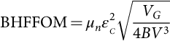 **(5.10)**

where *VG* is gate drive voltage. For high-frequency operation, the power losses can be reduced by using semiconductors with a larger mobility and critical electric field for breakdown [[35](https://learning.oreilly.com/library/view/power-electronics-handbook/9780128114087/B9780128114070000052_3.xhtml#bb0180)]. The FOMs for 4H-SiC and a GaN wurtzite crystal structure normalized to Si are given in [Table 5.2](https://learning.oreilly.com/library/view/power-electronics-handbook/9780128114087/B9780128114070000052_1.xhtml#t0015). For calculation of BHFFOMs, it is assumed that the gate drive voltage, *VG*, and the breakdown voltage, *BV*, are the same for Si, 4H-SiC, and GaN devices. The results show an 81.6 times bigger BHFFOM for 4H-SiC compared with Si and a 197.1 bigger BHFFOM for GaN compared with Si. Therefore, significant performance improvement for high-frequency operation can be achieved by replacing Si with SiC and GaN.

**Table 5.2**

**Figures of merit for 4H-SiC and a GaN wurtzite crystal structure normalized to Si**

|  |  |  |  |
| --- | --- | --- | --- |
| **FOM** | **Si** | **4H-SiC** | **GaN** |
| BHFFOM | 1 | 81.6 | 197 |
| JFOM | 1 | 488 | 1284 |
| BFOM | 1 | 6.15 | 8.97 |

Johnson's figure of merit (JFOM) shows that the performance limits and power-frequency limits of a power device are set by the intrinsic material parameters, such as the critical electric field, *ɛc*, and its electron saturation velocity [[36](https://learning.oreilly.com/library/view/power-electronics-handbook/9780128114087/B9780128114070000052_3.xhtml#bb0185)]:

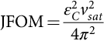 **(5.11)**

For high-power and high-frequency operation, the devices should be based on semiconductor materials with both large breakdown voltage and high electron velocity. Therefore, wide bandgap materials, like GaN and SiC, are having higher critical electric fields and electron saturation velocities and, therefore, higher JFOM. [Table 5.2](https://learning.oreilly.com/library/view/power-electronics-handbook/9780128114087/B9780128114070000052_1.xhtml#t0015) provides calculated JFOM results for 4H-SiC and GaN wurtzite crystal structure normalized to Si, which confirms that 4H-SiC and GaN have 488 and 1284 times higher JFOM, respectively, compared with Si.

In Ref. [[37](https://learning.oreilly.com/library/view/power-electronics-handbook/9780128114087/B9780128114070000052_3.xhtml#bb0190)], JFOM is also presented as a function of the cutoff frequency, *fT*, which is related to the effective saturation velocity and the breakdown voltage, *BV*, that can be related to the critical electric field.

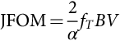 **(5.12)**

The FOMs discussed above are connected to the switching losses of power devices. Power losses of semiconductor devices also include static or ON-state losses, which depend on the specific ON-resistance of the devices. Baliga related the specific ON-resistance to the breakdown voltage, *BV*; electron mobility, *μn*; relative permittivity *ɛr*; and critical electric field, *ɛc*, by the following equation [[38](https://learning.oreilly.com/library/view/power-electronics-handbook/9780128114087/B9780128114070000052_3.xhtml#bb0195)]:

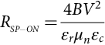 **(5.13)**

The denominator of Eq. [(5.13)](https://learning.oreilly.com/library/view/power-electronics-handbook/9780128114087/B9780128114070000052_1.xhtml#fo0070) is known as the Baliga figure of merit (BFOM) for resistivity or ON-losses:

 **(5.14)**

[Table 5.2](https://learning.oreilly.com/library/view/power-electronics-handbook/9780128114087/B9780128114070000052_1.xhtml#t0015) also gives the calculated results for the BFOM for 4H-SiC and a GaN wurtzite crystal structure normalized to Si. The results confirm that 4H-SiC and GaN have better FOM indexes, that is, 6.15 and 8.97 times higher, respectively, compared with Si.

The ability of GaN to form heterojunctions makes it superior compared with SiC for transistors, although the two materials have similar breakdown fields and saturation electron velocities. GaN can be used to fabricate HEMTs, whereas SiC is currently only used to fabricate metal-semiconductor field-effect transistors (MESFETs) and power MOSFETs. Significantly high mobility (2500 cm2 Vs−1 [[39](https://learning.oreilly.com/library/view/power-electronics-handbook/9780128114087/B9780128114070000052_3.xhtml#bb0200)]) in the two-dimensional electron gas (2DEG) and high carrier concentration for HEMTs leads to low channel resistance, which is especially important for high-frequency operation in power switching applications .

##### **FOM for devices**

Designers of power electronic systems are using FOMs that are related to the device's parameters. The lower the index value of these FOMs, the better the device performance. Two devices with the same value perform the same in a given application.

The switching losses figure of merit (SLFOM) is used to evaluate the switching performance of field-effect transistors (FETs). SLFOM is a product of the specific ON-resistance of a device, , and its gate to drain charge, *QGD*, [[40](https://learning.oreilly.com/library/view/power-electronics-handbook/9780128114087/B9780128114070000052_3.xhtml#bb0205)]:

 **(5.15)**

The gate-to-drain charge, *QGD*, of an FET is a main parameter of the turn-on loss of a FET. Some companies, for example, provide the gate-to-drain charge, *QGD*, and gate-to-source charge, *QGS* [[41](https://learning.oreilly.com/library/view/power-electronics-handbook/9780128114087/B9780128114070000052_3.xhtml#bb0210)]. In this case, a more accurate value of SLFOM can be obtained [[42](https://learning.oreilly.com/library/view/power-electronics-handbook/9780128114087/B9780128114070000052_3.xhtml#bb0215)]:

 **(5.16)**

where *QSW* is known as the switching charge, and it is equal to the sum of *QGD* and *QGS*. The charge *QGS* is the portion of the gate-to-source charge from the device threshold voltage to the gate plateau voltage, which controls the current rise and fall of the device. Since SiC and GaN have a bigger bandgap than Si, their channel width is smaller, and, therefore, their gate-to-drain and gate-to-source capacitance are smaller. Consequently, their gate-to-drain charge and gate-to-source, *QGD* and *QGS*, are smaller. Also, as mentioned above,  of SiC and GaN devices is smaller than  of Si devices. Therefore, the SLFOMs of SiC and GaN devices are smaller than the SLFOM of a Si device.

The conduction loss figure of merit (CLFOM) is used to evaluate a FETs' performance. CLFOM is a product of ON-state resistance, , and total gate charge, *QG* [[43](https://learning.oreilly.com/library/view/power-electronics-handbook/9780128114087/B9780128114070000052_3.xhtml#bb0220)]:

 **(5.17)**

For a given MOSFET technology, both parameters,  and *QG*, are opposite of each other. A device with a lower ON-state resistance has a higher gate charge and vice versa [[44](https://learning.oreilly.com/library/view/power-electronics-handbook/9780128114087/B9780128114070000052_3.xhtml#bb0225)]. The ON-state resistance, total gate charge, and switching charge are not constants. The ON-state resistance and total gate charge values depend on the gate-source voltage, *VGS*, and are also influenced by the junction temperature, *TJ*. Furthermore, the ON-state resistance of a MOSFET depends on the drain current, *ID*, while the total gate charge depends on the drain-source voltage, *VDS*. The switching charge, *QSW*, also depends on the drain-source voltage, *VDS*.

A proper comparison of devices using SLFOM and CLFOMs is possible when it is made under the same conditions [[44](https://learning.oreilly.com/library/view/power-electronics-handbook/9780128114087/B9780128114070000052_3.xhtml#bb0225)]. The more proper CLFOM is given in [[43](https://learning.oreilly.com/library/view/power-electronics-handbook/9780128114087/B9780128114070000052_3.xhtml#bb0220)] and [[44](https://learning.oreilly.com/library/view/power-electronics-handbook/9780128114087/B9780128114070000052_3.xhtml#bb0225)]:

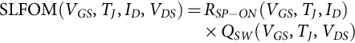 **(5.18)**

**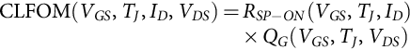** **(5.19)**

The SLFOM and CLFOM for Si, SiC, and GaN devices on the market are given in [Table 5.3](https://learning.oreilly.com/library/view/power-electronics-handbook/9780128114087/B9780128114070000052_1.xhtml#t0020). Although a fair comparison between the devices cannot be done because for the same blocking voltage, they are designed for different drain currents; the SiC and GaN devices have better FOMs than the Si device. A device with a higher drain current will have a bigger area and, therefore, a higher gate-to-source and gate-to-drain capacitance and a high switching charge. It will also have smaller ON-resistance. For breaking voltage equal to 650 V, the smallest figure of merit has the GaN Systems GaN device. The two Cree devices, C3M0065090J and CPM2-1700-0045B, are designed for 900 and 1700 V, correspondingly, but the 900 V device has higher ON-resistance, 65 Ω, compared with the 1700 V device with an ON-resistance of 45 Ω. The low ON-resistance of the 1700 V device can be due to the higher design's drain current than the 900 V device. Also, the 1700 V device is more mature. The maturation of the SiC and GaN technology will result in new devices with smaller FOMs, which will be more attractive for power electronic applications.

**Table 5.3**

**Parameters and FOMs for Si, SiC, and GaN devices**

|  |  |  |  |  |  |  |  |  |  |
| --- | --- | --- | --- | --- | --- | --- | --- | --- | --- |
| **Material** | **Part number** | **Company (reference)** | ***VB* (V)** | ***ID* (A)** | si3_e **(mΩ)** | ***QSW* (nC)** | ***QG* (nC)** | **SLFOM** | **CLFOM** |
| Si | IPB65R045C7 | Infineon [[45](https://learning.oreilly.com/library/view/power-electronics-handbook/9780128114087/B9780128114070000052_3.xhtml#bb0230)] | 650 | 46 | 45 | 53 | 93 | 2385 | 4185 |
| SIC | SCT3017AL | ROHM [[46](https://learning.oreilly.com/library/view/power-electronics-handbook/9780128114087/B9780128114070000052_3.xhtml#bb0235)] | 650 | 118 | 17 | 110 | 172 | 1870 | 2924 |
| SiC | C3M0065090J | Cree [[47](https://learning.oreilly.com/library/view/power-electronics-handbook/9780128114087/B9780128114070000052_3.xhtml#bb0240)] | 900 | 35 | 65 | 18.7 | 30 | 1215.5 | 1950 |
| SiC | CPM2-1700-0045B | Cree [[48](https://learning.oreilly.com/library/view/power-electronics-handbook/9780128114087/B9780128114070000052_3.xhtml#bb0245)] | 1700 | 72 | 45 | 101 | 188 | 4545 | 8460 |
| GaN | GS66508B | GaN Systems [[49](https://learning.oreilly.com/library/view/power-electronics-handbook/9780128114087/B9780128114070000052_3.xhtml#bb0250)] | 650 | 30 | 50 | 4 | 5.8 | 200 | 290 |
| GaN | PGA26E19BA | Panasonic [[50](https://learning.oreilly.com/library/view/power-electronics-handbook/9780128114087/B9780128114070000052_3.xhtml#bb0255)] | 600 | 10 | 140 | 3.3 | NA | 462 | NA |

## 5.3 SiC Power Devices

### **5.3.1 INTRODUCTION**

Due to the significant improvements in SiC material growth technology, SiC-based power devices are available for high-power, high-temperature, and high-frequency applications. Three types of SiC power devices, diodes, transistors, and thyristors, have been designed, modeled, and characterized during the last two decades. Some of them are on the market, and others are in a development stage. Designers are trying to improve the performance of these devices and optimize their FOM parameters to obtain the best ratio between conduction and switching losses, resulting in higher system efficiency [[51](https://learning.oreilly.com/library/view/power-electronics-handbook/9780128114087/B9780128114070000052_3.xhtml#bb0260)]. The physics and important parameters of SiC power devices are discussed in this chapter.

### 5.3.2 SIC POWER DIODES

The power diodes are the key components used in power electronic applications. A power diode is often used as a parallel diode to the switch body diode for decreasing the switching losses. Basically, SiC power diodes can be classified into three types: (1) SiC Schottky diode; (2) SiC PiN diode; and (3) SiC merged PN-Schottky diode (MPS), also called a junction barrier Schottky (JBS) diode.

#### **5.3.2.1 SiC Schottky Diode**

The SiC Schottky diode was the first SiC device on the market by Infineon Technologies (from 600 V up to 6 A or from 300 V up to 10 A) and Microsemi (100-200-480 V, 1 A) [[11](https://learning.oreilly.com/library/view/power-electronics-handbook/9780128114087/B9780128114070000052_3.xhtml#bb0060)]. Now, 15 years later, from 1700 V up to 50 A with zero reverse recovery, zero forward recovery, high-frequency operation, temperature-independent switching behavior, extremely fast switching, and positive temperature coefficient on the forward voltage, *VF*, diodes are available [[52](https://learning.oreilly.com/library/view/power-electronics-handbook/9780128114087/B9780128114070000052_3.xhtml#bb0265)]. The commercially available Si Schottky diodes are usually rated at maximum breakdown voltages of <100 V [[53](https://learning.oreilly.com/library/view/power-electronics-handbook/9780128114087/B9780128114070000052_3.xhtml#bb0270)]. Beyond this limit, Si Schottky diodes cannot compete with Si PiN diodes due to the unacceptably large ON-state resistance of Schottky diodes and the voltage blocking limit due to barrier lowering.

An advantage of high-power SiC Schottky diodes is that they have zero reverse recovery charge since they are majority carrier devices. The reverse recovery current peak is very small compared with a fast Si PiN diode leading to significantly lower turn-OFF losses. The reverse recovery current is due to the displacement current from the junction capacitance. Since the dynamic characteristic of a Schottky diode is capacitive in nature, the reverse recovery characteristic of a SiC Schottky diode is independent from forward current, d*i*/d*t*, and device junction temperature [[54](https://learning.oreilly.com/library/view/power-electronics-handbook/9780128114087/B9780128114070000052_3.xhtml#bb0275)].

A power SiC Schottky diode is formed by the junction of a semiconductor (SiC) with a metal (titanium (Ti), nickel (Ni), gold (Au), or platinum (Pt)) that forms a Schottky barrier. The semiconductor is grown on a substrate that forms an ohmic contact with another metal, as shown in [Fig. 5.3](https://learning.oreilly.com/library/view/power-electronics-handbook/9780128114087/B9780128114070000052_1.xhtml#f0020).

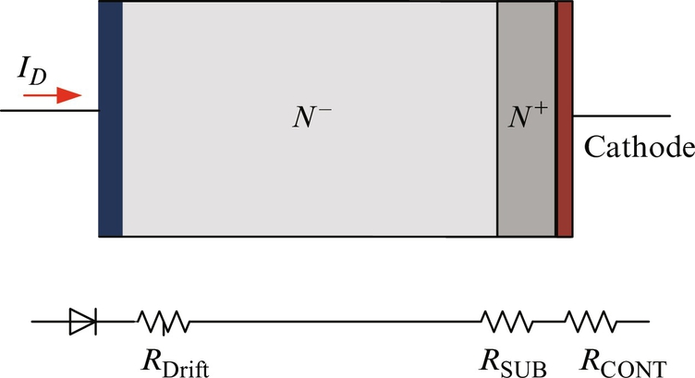

**FIG. 5.3** Schottky diode structure and simple model.

A Schottky diode is a unipolar device, which means that the current conduction is governed only by majority carriers (electrons). Similar to a Si Schottky diode, the forward voltage of SiC, *VF*, is one of the important parameters when selecting a Schottky diode. It is a function of temperature, Schottky barrier height, and drift region resistance. A dependence of the voltage drop and the current density, *JF*, is given by the following equation:

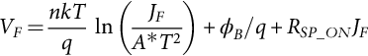 **(5.20)**

where *n* is the ideality factor. For an ideal device, *n* is equal to one, while for a real device, *n* is larger than 1 and can be assumed to be between 1 and 1.3. Boltzmann's constant is *k*, *q* is the electron charge, *T* is the absolute temperature, and *A*⁎ is Richardson's constant with theoretical values of 146 A cm−2K−2 for 4H-SiC [[55](https://learning.oreilly.com/library/view/power-electronics-handbook/9780128114087/B9780128114070000052_3.xhtml#bb0280)] and 110 A cm−2K−2 for Si. For the same current density and at room temperature (300 K), the voltage of the first member of the right side of Eq. [(5.20)](https://learning.oreilly.com/library/view/power-electronics-handbook/9780128114087/B9780128114070000052_1.xhtml#fo0105) for SiC will be 7 mV smaller.

The potential barrier at the metal-semiconductor interface, *ϕB*, given in Eq. [(5.20)](https://learning.oreilly.com/library/view/power-electronics-handbook/9780128114087/B9780128114070000052_1.xhtml#fo0105), is known as the Schottky barrier height. It can be calculated by the equation:

 **(5.21)**

where *ϕm* is the work function of the metal and *χ* is the material's electron affinity. The measured and calculated barrier heights for selected metal/4H-SiC junctions are listed in [Table 5.4](https://learning.oreilly.com/library/view/power-electronics-handbook/9780128114087/B9780128114070000052_1.xhtml#t0025) [[56](https://learning.oreilly.com/library/view/power-electronics-handbook/9780128114087/B9780128114070000052_3.xhtml#bb0285),[57](https://learning.oreilly.com/library/view/power-electronics-handbook/9780128114087/B9780128114070000052_3.xhtml#bb0290)]. Titanium/silicon carbide has the smallest barrier height. The measured barrier heights depend on the surface polarity of SiC (Si- and C-face) and often differ from the calculated values.

**Table 5.4**

**Measured and calculated values of barrier heights for selected metal/4H-SiC junctions**

|  |  |  |  |  |
| --- | --- | --- | --- | --- |
| **Metals** | | **Ti** | **Ni** | **Au** |
| Measured | *ϕB*/*q* (Si-face), V | 1.12 | 1.69 | 1.81 |
| *ϕB*/*q* (C-face), V | 1.25 | 1.87 | 2.07 |
| Calculated | *ϕB*/*q*, V | 1.06 | 1.63 | 1.69 |

The Schottky barrier heights for selected metal/Si junction [[58](https://learning.oreilly.com/library/view/power-electronics-handbook/9780128114087/B9780128114070000052_3.xhtml#bb0295)] are provided in [Table 5.5](https://learning.oreilly.com/library/view/power-electronics-handbook/9780128114087/B9780128114070000052_1.xhtml#t0030). The maximum barrier heights of a Si device are significantly small compared with the minimum barrier heights of a SiC device. The difference between the barrier height of Ti/SiC and Ti/Si is larger than 0.56 V. Due to the high barrier height of a SiC device, the contribution of the barrier height to the forward voltage drop is higher, though the contribution from the specific on-resistance is lower. However, barrier height lowering will occur at high applied electric fields and result in a device design change for SiC diodes, just as in Si diodes, to PiN structures.

**Table 5.5**

**Schottky barrier heights for selected metal/Si junctions**

|  |  |  |  |  |  |  |  |  |
| --- | --- | --- | --- | --- | --- | --- | --- | --- |
| **Metal** | **Mg** | **Ti** | **Cr** | **W** | **Mo** | **Pd** | **Au** | **Pt** |
| *ϕB*/*q*, V | 0.4 | 0.5 | 0.61 | 0.67 | 0.68 | 0.77 | 0.88 | 0.9 |

In Eq. [(5.20)](https://learning.oreilly.com/library/view/power-electronics-handbook/9780128114087/B9780128114070000052_1.xhtml#fo0105), *RSP*\_*ON* is the total specific resistance. It is a sum of the ohmic contact resistance, *RCONT*; the substrate resistance, *RSUB*; and the drift region resistance, *RDrift* [[59](https://learning.oreilly.com/library/view/power-electronics-handbook/9780128114087/B9780128114070000052_3.xhtml#bb0300)]:

 **(5.22)**

For silicon carbide devices, the substrate has higher resistance, and *RSUB* must be included in the analysis. The new SiC devices are fabricated with a thin substrate for a lower forward voltage and improved thermal performance [[54](https://learning.oreilly.com/library/view/power-electronics-handbook/9780128114087/B9780128114070000052_3.xhtml#bb0275)]; therefore, the resistance will be smaller. The ohmic contact resistance, *RCONT*, is the resistance between the contact of the drift region and the cathode. It may also make a substantial contribution to the ON-state voltage drop. The drift region resistance, *RDrift*, can be determined by the drift layer thickness and doping concentration, *WD* and *ND*, and the electron mobility, *μn*, according to the following equation:

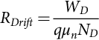 **(5.23)**

The drift region resistance, *RDrift*, can also be given as an expression in terms of the designed blocking voltage, *VB*, and critical electric field, *EC*:

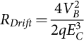 **(5.24)**

The drift region resistance increases quadratically with blocking voltage; therefore, the ON-state losses will increase significantly with an increase of the blocking voltage. Since conductivity modulation effects are not inherent to Schottky diodes, the drift region resistance will be significantly high for high-voltage diodes. In [[60](https://learning.oreilly.com/library/view/power-electronics-handbook/9780128114087/B9780128114070000052_3.xhtml#bb0305)], a 3 kV 4H-SiC Schottky diode with a diameter of 1 mm and ON-resistance of 34 mΩ cm−2 (1.08 Ω) is reported, which is significantly high. For high blocking voltage, a PiN diode is preferred.

Another important parameter of a Schottky diode is the reverse leakage current. If the reverse leakage current is high when the reverse voltage is high, the power dissipated by it leads to an increase in the diode temperature. Since the reverse leakage current is sensitive to the junction temperature, increasing the limits of the power dissipation initiates a positive feedback for the temperature leading to permanent damage of the device [[61](https://learning.oreilly.com/library/view/power-electronics-handbook/9780128114087/B9780128114070000052_3.xhtml#bb0310)]. Therefore, optimizing the diode parameters to obtain low leakage current is an important concern for a device designer.

Two mechanisms significantly contribute to the reverse leakage current operating at a high reverse voltage: the thermionic emission over the potential barrier and quantum mechanical tunneling of the carriers through a potential barrier. When reverse voltage, *VR*, is applied, the leakage current due to the thermionic effect is

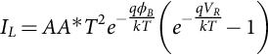 **(5.25)**

where *A* is the Schottky diode cross-sectional area and other parameters are as previously described. Increasing the reverse voltage higher than 3*kT*/*q* for moderately doped semiconductors decreases the Schottky barrier and causes the reverse leakage current to increase. Therefore, for a reverse voltage higher than 3*kT*/*q*, the leakage current equation should include the barrier lowering Δ*ϕB*:

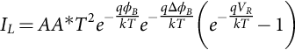 **(5.26)**

The barrier lowering depends on the maximum electric field, *EM*, at the metal-semiconductor interface and the semiconductor relative permittivity [[61](https://learning.oreilly.com/library/view/power-electronics-handbook/9780128114087/B9780128114070000052_3.xhtml#bb0310)]:

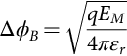 **(5.27)**

For a one-dimensional Schottky junction, the maximum electric field, *EM*, is related to the applied reverse bias voltage, *VR*, by the following equation:

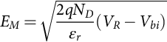 **(5.28)**

Since the barrier lowering increases as the reverse bias voltage increases, the leakage current also increases. The second mechanism that contributes to the increase of the leaking current is the tunneling current. Since SiC has a wide bandgap and, therefore, a high critical electric field, the SiC Schottky diodes are designed to stand significantly higher electric fields on the metal-semiconductor interface compared with Si diodes. The SiC Schottky diodes can experience very high electric fields, higher than 2 MV cm−1, which will contribute to a significant increase of the leakage current. A more rapid increase in leakage current observed in SiC Schottky diodes can be expressed with the thermionic emission model [[59](https://learning.oreilly.com/library/view/power-electronics-handbook/9780128114087/B9780128114070000052_3.xhtml#bb0300)]:

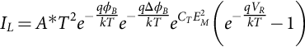 **(5.29)**

where *CT* is a tunneling coefficient. Since the forward voltage drop of a SiC Schottky diode and the leakage current increase as the design breakdown voltage increases, PiN and merged PN-Schottky diodes should be used for applications using higher-voltage SiC.

#### **5.3.2.2 SiC PiN Diode**

The advantage of a SiC PiN diode is low specific resistance *RSP*\_*ON*, during high current conduction, due to high-level injection of minority carriers in the lightly doped drift region resulting in conductivity modulation. However, conductivity modulation causes significant reverse recovery current during switching, which is undesirable because it causes additional turn-ON loss in the active switch. At voltage ratings from 10 to 20 kV, 4H-SiC PiN diodes offer the best trade-off between ON-state voltage drop, switching losses, and high-temperature performance as compared with Si PiN and SiC Schottky/JBS diodes [[62](https://learning.oreilly.com/library/view/power-electronics-handbook/9780128114087/B9780128114070000052_3.xhtml#bb0315)].

Different research groups have worked on designing, fabricating, and characterizing SiC PiN diodes, but the maturity of PiN diodes is not sufficient enough to be marketable. In 2001, a high-voltage PiN diode in SiC with a blocking voltage of over 19 kV was reported [[63](https://learning.oreilly.com/library/view/power-electronics-handbook/9780128114087/B9780128114070000052_3.xhtml#bb0320)]. It has a forward voltage drop of 6.5 V at 100 A cm−2. Also in 2002, the design, fabrication, and high-temperature characteristics of 4H-SiC PiN rectifiers with 5, 6, and 10 kV blocking voltage were reported [[64](https://learning.oreilly.com/library/view/power-electronics-handbook/9780128114087/B9780128114070000052_3.xhtml#bb0325)]. For the 10 kV rectifier, a forward voltage drop of <4.8 V was observed at 100 A cm−2 in the entire 25–200°C temperature range. Also in [[62](https://learning.oreilly.com/library/view/power-electronics-handbook/9780128114087/B9780128114070000052_3.xhtml#bb0315)], 12.9 kV SiC PiN diodes with ultralow ON-state voltage drop and differential ON-resistance of 3.75 V and 3.3 mΩ cm−2 at 100 A cm−2, respectively, were reported. It has also been reported in the literature that Schottky and PiN SiC diodes have significantly less reverse current than the conventional fast or ultrafast Si diode [[65](https://learning.oreilly.com/library/view/power-electronics-handbook/9780128114087/B9780128114070000052_3.xhtml#bb0330)].

SiC PiN diodes consist of a highly doped N-type substrate, a lightly doped N-type epitaxial layer, known as the drift region, and a highly doped P-type region for the anode, which is shown in [Fig. 5.4](https://learning.oreilly.com/library/view/power-electronics-handbook/9780128114087/B9780128114070000052_1.xhtml#f0025). The most important parameter for a power SiC PiN diode is the voltage drop, *VAK*, across it during the conduction state. It is composed of five components, including the voltages across the junctions, J1 and J2, the voltage across the two depletion regions, *Vd1* and *Vd2*, and the voltage across the drift region, .

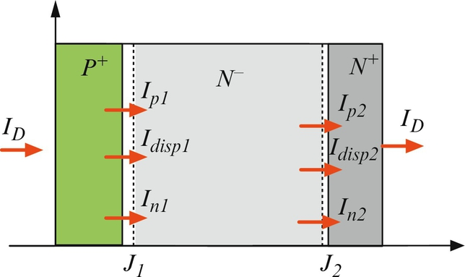

**FIG. 5.4** Schematic structure of a P+N−N + power diode.

 **(5.30)**

Different models have been used to calculate the voltage drop across the diode and the current passing through it. A level-3 model for modeling a power diode using a Fourier-based solution for the ambipolar diffusion equation (ADE) of the lightly doped *N*− drift region is given in [[66](https://learning.oreilly.com/library/view/power-electronics-handbook/9780128114087/B9780128114070000052_3.xhtml#bb0335)]. In their model, the PiN diode is divided into three regions, and the basic equations governing the behavior of semiconductor devices are used to analyze the operation of the diode. The diode current, *ID*, and the electron, hole, and displacement currents at junctions J1 and J2 (*In1*, *Ip1*, *Idisp1* and *In2*, *Ip2*, *Idisp2*) and their direction are shown in [Fig. 5.4](https://learning.oreilly.com/library/view/power-electronics-handbook/9780128114087/B9780128114070000052_1.xhtml#f0025). The *P*+ and *N*+ emitters are assumed to be minority sinks.

Since the *P*+ emitter region is highly doped, high-level injection exists during the ON-state, and therefore, there is a significant electron concentration adjacent to the *P*+*N*− junction. As a result of this high concentration, electrons flow into the *P*+ emitter and recombine with the holes. The resulting electron current due to the emitter recombination is

 **(5.31)**

where *px*1 is the hole concentration at the junction, *J1*. The recombination parameter, *hp*, is calculated by the following equation:

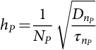 **(5.32)**

where *NP* is the emitter doping concentration and *DnP* and *τnP* are the electron diffusivities and lifetime. The current continuity at junction J1 ([Fig. 5.4](https://learning.oreilly.com/library/view/power-electronics-handbook/9780128114087/B9780128114070000052_1.xhtml#f0025)) requires that

 **(5.33)**

The junction voltage of junction J1 is [[32](https://learning.oreilly.com/library/view/power-electronics-handbook/9780128114087/B9780128114070000052_3.xhtml#bb0165)]

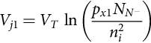 **(5.34)**

where *VT* is the thermal voltage (*kT*/*q*).

A high-power diode has a thick, lightly doped drift region for supporting high blocking voltage. A simple charge control modeling approach cannot be applied for the drift region, since the transient duration is comparable with or shorter than the transient time of the charge carriers. In this case, the charge dynamics in the drift region can be described by the continuity and the transport equations. To simplify the analysis, the charge profile in the thick, lightly doped drift region is assumed to be one-dimensional for more than 90% of its volume. Also, high-level injection in the drift region during most of the time of the transient and ON-state can be assumed. Under these assumptions and quasineutrality, the one-dimensional ADE describing the carrier dynamics in the majority of this region is given by the equation:

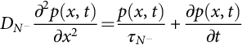 **(5.35)**

where  is the ambipolar diffusion coefficient,  is the high-level carrier lifetime within the drift region, and *p*(*x*,*t*) is the excess carrier concentration. Different methods can be used to solve the ADE. In [[66](https://learning.oreilly.com/library/view/power-electronics-handbook/9780128114087/B9780128114070000052_3.xhtml#bb0335)], Fourier analysis is used to solve the ADE. The basic idea of the Fourier-based solution is to separate excess carrier concentration *p*(*x*,*t*)into its space and time functions. According to Leturcq [[67](https://learning.oreilly.com/library/view/power-electronics-handbook/9780128114087/B9780128114070000052_3.xhtml#bb0340)], the excess carrier concentration, *p*(*x*,*t*), can be represented as a discrete cosine Fourier series:

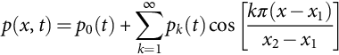 **(5.36)**

where the Fourier series coefficients *pk*(*t*) are

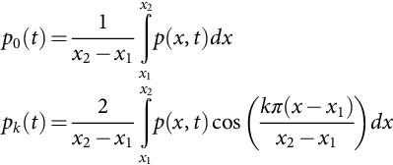 **(5.37)**

By substituting the carrier concentration in the Fourier series from Eq. [(5.37)](https://learning.oreilly.com/library/view/power-electronics-handbook/9780128114087/B9780128114070000052_1.xhtml#fo0190) into the ADE, Eq. [(5.35)](https://learning.oreilly.com/library/view/power-electronics-handbook/9780128114087/B9780128114070000052_1.xhtml#fo0180), the amplitude of the Fourier series *pk*(*t*) can be determined in a group of first-order differential equations. This requires employing the boundary conditions at the edges of the drift region. The required boundary conditions are the boundaries of the regions (*x1* and *x2*), their differentials (*dx1*/*dt* and *dx2*/*dt*), and the carrier density gradients at *x1* and *x2* given by the equations:

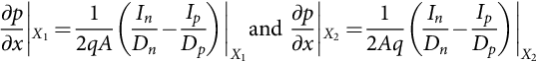 **(5.38)**

where *Dn* and *Dp* are electron and hole diffusivities, *In* and *Ip* are electron and hole currents, and *A* is the active device area. The solution to the ADE is given by the following differential equations as each of them refers to a harmonic, *pk*, of the carrier charge density, *p*(*x*):

For 

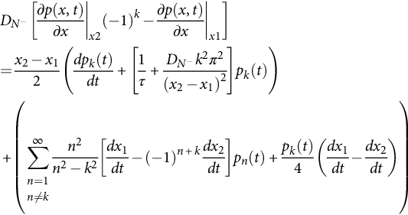

For ,

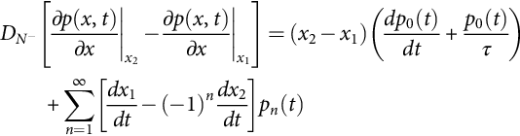 **(5.39)**

At the boundary, *x1* and *x2*, the carrier densities, *px1* and *px2*, are calculated using Eqs. [(*5.40*)](https://learning.oreilly.com/library/view/power-electronics-handbook/9780128114087/B9780128114070000052_1.xhtml#fo0210), [(*5.41*)](https://learning.oreilly.com/library/view/power-electronics-handbook/9780128114087/B9780128114070000052_1.xhtml#fo0215), respectively:

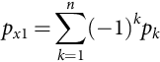 **(5.40)**

**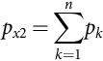** **(5.41)**

The current continuity equation at junction J2 is

 **(5.42)**

Assuming that

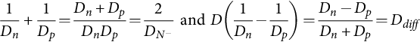 **(5.43)**

and using the current continuity equations at junctions J1, Eq. [(5.33)](https://learning.oreilly.com/library/view/power-electronics-handbook/9780128114087/B9780128114070000052_1.xhtml#fo0170), and J2, Eq. [(5.42)](https://learning.oreilly.com/library/view/power-electronics-handbook/9780128114087/B9780128114070000052_1.xhtml#fo0220), the left side of Eq. [(5.39)](https://learning.oreilly.com/library/view/power-electronics-handbook/9780128114087/B9780128114070000052_1.xhtml#fo0205), for even and odd numbers of *k*, can be calculated by the following equations:

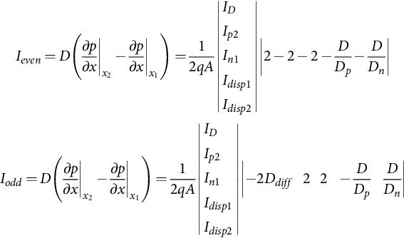 **(5.44)**

The depletion layer voltages, *Vd1* and *Vd2*, across the *P*+*N*− and *N*− *N* depletion layers are derived using a feedback from the boundary carrier densities, *px1* and *px2*:

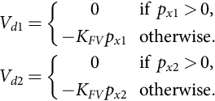 **(5.45)**

The feedback constant, *KFV*, is set to 10−12, which gives good convergence and minimal error. The same value of *KFV* is used to calculate the depletion layer voltages of a diode and an IGBT in [[68](https://learning.oreilly.com/library/view/power-electronics-handbook/9780128114087/B9780128114070000052_3.xhtml#bb0345)].

The depletion widths, *Wd1* and *Wd2*, are

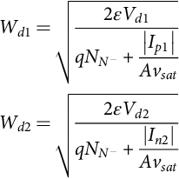 **(5.46)**

The boundary positions, *x1* and *x2*, are

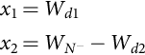 **(5.47)**

The displacement currents, *Idisp1* and *Idisp2*, at junctions J1 and J2 are

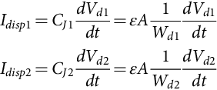 **(5.48)**

The voltage drop in the lightly doped drift region, , can be calculated based on electron and hole currents passing through it. The current transport equations are

 **(5.49)**

**** **(5.50)**

Due to conductivity modulation, it can be assumed that the concentration of the electrons in the drift region is

 **(5.51)**

Including the doping concentration,  is necessary, especially during the switching when the drift region has low conductivity due to the low-level injection.

Summing the current transport equations and including the Einstein relation (*Dp*/*μp*=*kT*/*q*) and Eq. [(5.51)](https://learning.oreilly.com/library/view/power-electronics-handbook/9780128114087/B9780128114070000052_1.xhtml#fo0265), the total current density is

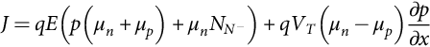 **(5.52)**

The electric field, , is

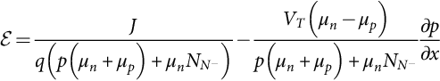 **(5.53)**

The drift region voltage drop is calculated by integrating the electric field between the two boundaries, *x1* and *x2*:

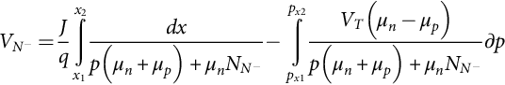 **(5.54)**

The voltage drop in the lightly doped drift region, , is composed of two components: a resistive voltage drop due to the resistivity of the lightly doped drift region and voltage due to the diffusion across the drift region. The first integral of Eq. [(5.54)](https://learning.oreilly.com/library/view/power-electronics-handbook/9780128114087/B9780128114070000052_1.xhtml#fo0280) cannot be solved analytically from the Fourier series relation because the carrier densities must be calculated for each point along the drift region and then substituted in Eq. [(5.54)](https://learning.oreilly.com/library/view/power-electronics-handbook/9780128114087/B9780128114070000052_1.xhtml#fo0280). Instead, the drift region is divided into segments of equal width. It is desirable that the number of segments, M, be equal to the number of the terms in the Fourier series used to calculate the carrier densities. The width of a segment is calculated by the equation:

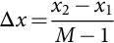 **(5.55)**

The carrier distribution in every point is calculated by the inverse Fourier transformation. The carrier distribution between two points is assumed to be a linear approximation ([Fig. 5.5](https://learning.oreilly.com/library/view/power-electronics-handbook/9780128114087/B9780128114070000052_1.xhtml#f0030)):

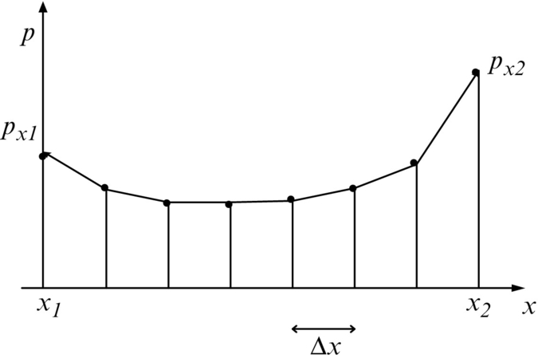

**FIG. 5.5** The carrier distribution in the drift region during the ON-state.

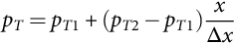 **(5.56)**

The resistive voltage drop for every segment, *Vseg*, is calculated by

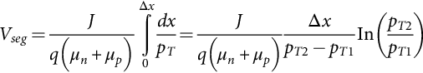 **(5.57)**

For , Eq. [(5.57)](https://learning.oreilly.com/library/view/power-electronics-handbook/9780128114087/B9780128114070000052_1.xhtml#fo0295) is not defined. Using L'Hôpital's rule for this case, the voltage drop of the segment is

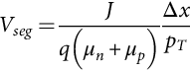 **(5.58)**

These two cases for calculating *Vseg* are generalized in [[68](https://learning.oreilly.com/library/view/power-electronics-handbook/9780128114087/B9780128114070000052_3.xhtml#bb0345)] as follows:

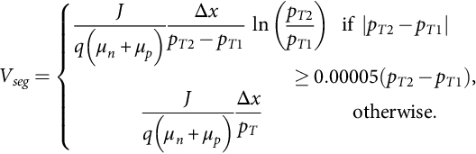 **(5.59)**

and the voltage drop, , of the silicon rectifier is

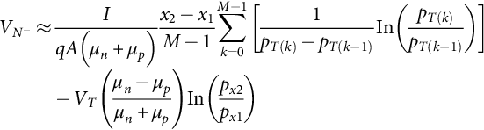 **(5.60)**

where *I* is the current passing through the drift region, *A* is its cross-sectional area, and *M* is the number of terms of the Fourier series, and the carrier distribution, *pT*(*k*), is calculated by

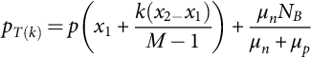 **(5.61)**

The *N*+ emitter region, shown in [Fig. *5.4*](https://learning.oreilly.com/library/view/power-electronics-handbook/9780128114087/B9780128114070000052_1.xhtml#f0025), has a high doping concentration, and therefore, there is a significant hole concentration adjacent to the *N*– *N*+ junction. Due to the high-level injection during the ON-state, electrons from the *N*+ region are injected into the lightly doped drift region, and high concentration holes flow into the highly doped *N*+ emitter region. The holes recombine with the electrons, and the resulting hole current due to the emitter recombination is

 **(5.62)**

The recombination parameter, *hn*, depends on the emitter doping levels, ; the minority carrier diffusivities, ; and the holes' lifetime,  [[69](https://learning.oreilly.com/library/view/power-electronics-handbook/9780128114087/B9780128114070000052_3.xhtml#bb0350)]; and it is calculated by the equation:

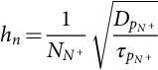 **(5.63)**

The junction voltage, *VJ2*, is [[32](https://learning.oreilly.com/library/view/power-electronics-handbook/9780128114087/B9780128114070000052_3.xhtml#bb0165)]

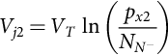 **(5.64)**

Summing the two junction voltages from Eqs. [(5.34)](https://learning.oreilly.com/library/view/power-electronics-handbook/9780128114087/B9780128114070000052_1.xhtml#fo0175), [(5.64)](https://learning.oreilly.com/library/view/power-electronics-handbook/9780128114087/B9780128114070000052_1.xhtml#fo0330), the total junction voltage, *Vj*12, is

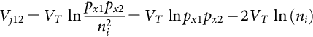 **(5.65)**

The total junction voltage, *Vj12*, does not directly depend on the doping concentration of the lightly doped drift region, . However, there is a dependency between the boundary values of the excess charge concentrations, *px*1 and *px*2, and the impurity doping level that then determines junction voltage values. To obtain the minimum forward voltage drop during conduction, *VF*, the minimum width of the drift region, corresponding to the minimum doping concentration, should be used. However, the results from the simulation given in [[70](https://learning.oreilly.com/library/view/power-electronics-handbook/9780128114087/B9780128114070000052_3.xhtml#bb0355)] do not agree with this simple assertion from Eq. [(5.65)](https://learning.oreilly.com/library/view/power-electronics-handbook/9780128114087/B9780128114070000052_1.xhtml#fo0335). The simulation results show that increasing the doping concentration, , for the same breakdown voltage leads to a decrease of *VAK* to a minimum value, after which further increases in the doping concentration cause an increase in the forward voltage drop. Higher doping concentrations, , lead to reduced injection efficiencies of the higher doped *P*+ and *N*+ emitters into the drift region and, therefore, decrease the values of the carrier densities, *px1* and *px2*, at the region boundaries. It can be seen, from Eq. [(5.65)](https://learning.oreilly.com/library/view/power-electronics-handbook/9780128114087/B9780128114070000052_1.xhtml#fo0335), that as the boundary charge concentrations are reduced, the contribution of the junction voltages to the total forward drop tend to cause a reduction in *VAK*. Also, the total junction voltage, *Vj12*, depends on the intrinsic carrier concentration. Since the intrinsic carrier concentration of Si is ~1010 cm−3, the second member of Eq. [(5.65)](https://learning.oreilly.com/library/view/power-electronics-handbook/9780128114087/B9780128114070000052_1.xhtml#fo0335) is  and will be subtracted to calculate the total junction voltage of a Si diode. The intrinsic carrier concentration of SiC is ~10−10 cm−3, and the second member of Eq. [(5.65)](https://learning.oreilly.com/library/view/power-electronics-handbook/9780128114087/B9780128114070000052_1.xhtml#fo0335) is  and will be added to calculate the total junction voltage of a SiC diode. For the same carrier densities, *px1* and *px2*, the total junction voltage of SiC will be approximately 2.38 V due to a lower intrinsic carrier concentration as compared with Si, which explains the experimental results of the IV characteristics of Si and SiC diodes. The forward voltage drop for a high-voltage Si diode is no more than 1.5 V, while for a SiC diode, the voltage drop is higher than 3 V. In [[71](https://learning.oreilly.com/library/view/power-electronics-handbook/9780128114087/B9780128114070000052_3.xhtml#bb0360)], it is shown that for low-voltage devices (<6.5 kV), the forward voltage drop will be smaller for Si, as compared with SiC devices, while for high-voltage devices, the opposite is true.

Since for the same blocking voltage, the lightly doped drift region of a SiC diode is thinner than the lightly doped drift region of a Si diode, the stored charge will be smaller, the reverse recovery current will be smaller, and consequently, the switching losses will be smaller. Therefore, the power application designer should carefully calculate the losses and choose the best diode for the application.

#### **5.3.2.3 SiC Junction Barrier Schottky Diode**

As mentioned above, a SiC PiN diode has a large forward voltage drop (about 3 V) due to the wide bandgap energy. For low- and medium-voltage applications, 600–6000 V, the forward drop becomes a significant part of ON-state losses in SiC PiN diodes. On the other hand, when using a Si Schottky diode as a rectifier, the forward voltage drop is in the range of 1–1.5 V. Reverse leakage current depends on the blocking voltage, and for the same blocking voltage, the leakage current is significantly higher than that of a SiC PiN diode.

The JBS diode combines the benefits of the Schottky and PiN diode. It was first demonstrated in silicon [[72](https://learning.oreilly.com/library/view/power-electronics-handbook/9780128114087/B9780128114070000052_3.xhtml#bb0365)] as a Schottky structure with a P+N junction grid integrated into its drift region. As of 2016, JBCs can be found on the market for 600, 1200, and 1700 V reverse-blocking ratings.

Schematic cross sections of a JBS structure are shown in [Fig. 5.6](https://learning.oreilly.com/library/view/power-electronics-handbook/9780128114087/B9780128114070000052_1.xhtml#f0035). It combines Schottky and PiN diodes, as illustrated, with P+-well embedded in the N- epilayer. During the forward conduction mode, JBS behaves as a Schottky diode. The current flows from the anode to cathode due to the majority carriers (electrons) flowing through the multiple conductive channels under the Schottky contact. In normal operation, the Schottky current dominates, and the analysis for the forward current can be based on thermionic emission theory for Schottky junctions.

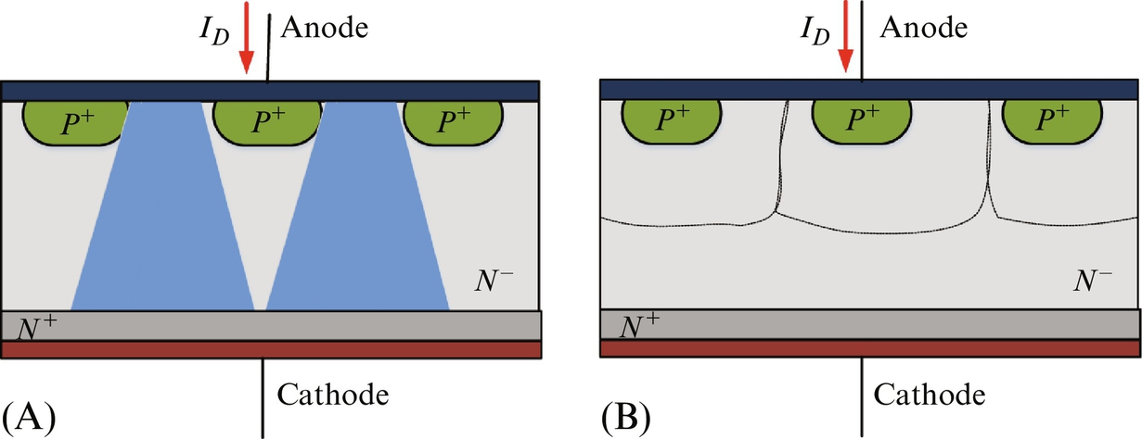

**FIG. 5.6** Structure of a power JBS diode under (A) forward and (B) reverse bias.

The forward voltage drop in the function of current density is determined by the metal-semiconductor Schottky barrier height. The expression for the current density has to be modified to allow for the area taken up by the P+ regions in the structure [[32](https://learning.oreilly.com/library/view/power-electronics-handbook/9780128114087/B9780128114070000052_3.xhtml#bb0165)]:

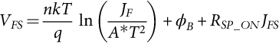 **(5.66)**

where *JFS* is the current density across the Schottky barrier calculated by the following equation:

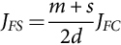 **(5.67)**

where *s* is the diffusion width of the *P*+ regions, *m* is the masked regions (spacing between *P*+ regions), and 2*d* is the actual area of the Schottky diode. The simulation results given in [[73](https://learning.oreilly.com/library/view/power-electronics-handbook/9780128114087/B9780128114070000052_3.xhtml#bb0370)] show that the smallest spacing between P+ regions results in the lowest electric field and the lowest forward voltage drop. For calculating the ON-state resistance, *RSP*\_*ON*, of a JBS diode, it should be taken into account that the current will pass through a different area. The equation for the ON-state resistance, *RSP*\_*ON*, is based on current spreading from the top 2*d* to the bottom (*m*+*s*) [[32](https://learning.oreilly.com/library/view/power-electronics-handbook/9780128114087/B9780128114070000052_3.xhtml#bb0165)]:

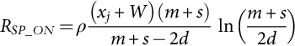 **(5.68)**

In Eq. [(5.68)](https://learning.oreilly.com/library/view/power-electronics-handbook/9780128114087/B9780128114070000052_1.xhtml#fo0350), *ρ* is the resistivity of the epilayer, *xj* is the *P*+ region thickness, and *W* is the depletion layer width:

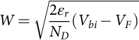 **(5.69)**

The reverse leakage current has two components: one that is due to the injection of carriers across the Schottky barrier and another that is due to space-charge generation and diffusion currents [[32](https://learning.oreilly.com/library/view/power-electronics-handbook/9780128114087/B9780128114070000052_3.xhtml#bb0165)]. The first expression is derived by modifying Eq. [(5.26)](https://learning.oreilly.com/library/view/power-electronics-handbook/9780128114087/B9780128114070000052_1.xhtml#fo0135) to allow for the area taken up by the P+ regions in the structure:

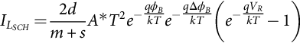 **(5.70)**

The barrier lowering, Δ*ϕB*, is calculated by Eq. [(5.27)](https://learning.oreilly.com/library/view/power-electronics-handbook/9780128114087/B9780128114070000052_1.xhtml#fo0140) where *EM* is the electric field at the Schottky barrier. Applying negative voltage to a JBS causes its P+N junctions to become reverse-biased, and the depletion layers spread into the channel. Increasing the negative voltage leads to pinch-off of the Schottky barrier and forms a potential barrier that limits the electric field at the Schottky contact, while the drift region supports further increase in voltage. The electric field is approximately constant once the channel potential barrier forms and pinch-off occurs. Further increases in reverse voltage are not reflected in the electric field; therefore, the electric field can be expressed by the pinch-off voltage, *Vp*:

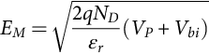 **(5.71)**

The size of the spacing between the P+ regions should be optimized so that pinch-off is reached before the electric field at the Schottky contact increases to the point where excessive leakage currents occur due to tunneling currents and ON-resistance is not so big [[73](https://learning.oreilly.com/library/view/power-electronics-handbook/9780128114087/B9780128114070000052_3.xhtml#bb0370)].

The second component of the leakage current is due to the P+N junction:

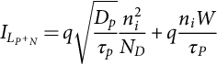 **(5.72)**

where *Dp* and *τp* are hole diffusivity and lifetime in the N region with a width and doping concentration of *W* and *ND*. Since the intrinsic carrier concentration of SiC (10−10) is small compared with Si (1010 cm−3), the leakage current of a SiC JBS due to the P+N junction is significantly smaller and can be neglected. The presence of P+ implanted regions improves the current surge capability and d*v*/d*t* and d*i*/d*t* ratings for JBS diodes [[73](https://learning.oreilly.com/library/view/power-electronics-handbook/9780128114087/B9780128114070000052_3.xhtml#bb0370)].

When a SiC JBS is designed to block high voltage, the N region is significantly thick and lightly doped; therefore, the forward voltage drop will be significantly large, especially for high current. The high-voltage JBS operates at two operation modes: JBS and MPS, depending on the forward-bias voltage level. When the bias voltage is not high enough to turn on the inherent PiN diode (*VF*<3 V), only the Schottky part is conducting. As the forward bias increases (*VF*>3 V), the minority carriers start to be injected into the N- layer from the P+-well and modulate the conductivity of the epilayer resulting in a low resistance in series with the Schottky region. As a result, the ON-state current density in the high-voltage JBS during the MPS mode becomes ever larger than that for a PiN diode. The storage charge during the MPS mode is significantly smaller than that in the PiN diode, and therefore, the reverse recovery behavior of the high-voltage JBSs will be significantly superior to those for PiN diodes. The peak reverse current will be smaller, and therefore, the switching losses, and the stresses in the switch controlling the reverse recovery will be smaller.

If the high-voltage JBS is designed so that the space between the PN junctions within the cell is significantly small, a potential barrier under the Schottky region can be formed. The leakage current will be small since the lowering effect of the Schottky barrier will not be observed.

### 5.3.3 SIC MOSFET

For Si power MOSFETs (breakdown voltage higher than 200 V), the ON-resistance becomes dominated by the drift region resistance leading to an increase in the ON-state voltage drop and conducting losses. Novel Si structures have allowed the breakdown voltage to extend to 600 V, but the specific on-resistance is still reasonably large, which limits high-frequency operation. Theoretically, the much lower drift region resistance in SiC would allow development of power MOSFETs with higher breakdown voltages and smaller switching and conducting losses.

Since the introduction of the first SiC power double diffusion MOSFET (DMOSFET) in 1996 [[74](https://learning.oreilly.com/library/view/power-electronics-handbook/9780128114087/B9780128114070000052_3.xhtml#bb0375)], different devices have been designed, characterized, and studied to improve their performance. Some SiC MOSFETs developed since that time are provided in [Table 5.6](https://learning.oreilly.com/library/view/power-electronics-handbook/9780128114087/B9780128114070000052_1.xhtml#t0035). Since 1996, blocking voltages have increased from 0.76 to 14 kV. For a long period of time, the power MOSFET structures developed in Si could not be directly employed for SiC devices due to the following reasons.

**Table 5.6**

**Parameters of SiC MOSFETs developed in the past few years**

|  |  |  |
| --- | --- | --- |
| **BV (kV)** | ***RSP*\_*ON* (mΩ cm2)** | **Reference** |
| 0.76 | 66 | [[74](https://learning.oreilly.com/library/view/power-electronics-handbook/9780128114087/B9780128114070000052_3.xhtml#bb0375)] |
| 0.95 | 220 | [[75](https://learning.oreilly.com/library/view/power-electronics-handbook/9780128114087/B9780128114070000052_3.xhtml#bb0380)] |
| 0.95 | 8.7 | [[76](https://learning.oreilly.com/library/view/power-electronics-handbook/9780128114087/B9780128114070000052_3.xhtml#bb0385)] |
| 1 | 6.95 | [[77](https://learning.oreilly.com/library/view/power-electronics-handbook/9780128114087/B9780128114070000052_3.xhtml#bb0390)] |
| 1.1 | 74@100°C | [[78](https://learning.oreilly.com/library/view/power-electronics-handbook/9780128114087/B9780128114070000052_3.xhtml#bb0395)] |
| 1.3 | 7 | [[79](https://learning.oreilly.com/library/view/power-electronics-handbook/9780128114087/B9780128114070000052_3.xhtml#bb0400)] |
| 1.4 | 313 | [[80](https://learning.oreilly.com/library/view/power-electronics-handbook/9780128114087/B9780128114070000052_3.xhtml#bb0405)] |
| 1.6 | 27 | [[81](https://learning.oreilly.com/library/view/power-electronics-handbook/9780128114087/B9780128114070000052_3.xhtml#bb0410)] |
| 1.8 | 8 | [[82](https://learning.oreilly.com/library/view/power-electronics-handbook/9780128114087/B9780128114070000052_3.xhtml#bb0415)] |
| 2 | 10.3 | [[83](https://learning.oreilly.com/library/view/power-electronics-handbook/9780128114087/B9780128114070000052_3.xhtml#bb0420)] |
| 2.6 | 200 | [[84](https://learning.oreilly.com/library/view/power-electronics-handbook/9780128114087/B9780128114070000052_3.xhtml#bb0425)] |
| 3.06 | 121 | [[85](https://learning.oreilly.com/library/view/power-electronics-handbook/9780128114087/B9780128114070000052_3.xhtml#bb0430)] |
| 3.36 | 199 | [[85](https://learning.oreilly.com/library/view/power-electronics-handbook/9780128114087/B9780128114070000052_3.xhtml#bb0430)] |
| 10 | 236 | [[86](https://learning.oreilly.com/library/view/power-electronics-handbook/9780128114087/B9780128114070000052_3.xhtml#bb0435)] |
| 10 | 133 | [[87](https://learning.oreilly.com/library/view/power-electronics-handbook/9780128114087/B9780128114070000052_3.xhtml#bb0440)] |
| 10 | 123 | [[88](https://learning.oreilly.com/library/view/power-electronics-handbook/9780128114087/B9780128114070000052_3.xhtml#bb0445)] |
| 10 | 111 | [[89](https://learning.oreilly.com/library/view/power-electronics-handbook/9780128114087/B9780128114070000052_3.xhtml#bb0450)] |
| 14 | 228 | [[90](https://learning.oreilly.com/library/view/power-electronics-handbook/9780128114087/B9780128114070000052_3.xhtml#bb0455)] |

The first is that in low-voltage devices, the ON-resistance is caused by the low mobility of inversion electrons at the SiO2/4H-SiC interface. It was found, however, that the electric quality of the interface can be improved dramatically by postoxidation annealing in nitric oxide (NO) that leads to an increase in the inversion layer electron mobility and a corresponding reduction in channel resistivity [[91](https://learning.oreilly.com/library/view/power-electronics-handbook/9780128114087/B9780128114070000052_3.xhtml#bb0460)]. Also, the introduction of a self-aligned process reduces the channel resistance, and therefore, the specific ON-resistance of a well-fabricated power device is no longer limited by the channel resistance [[92](https://learning.oreilly.com/library/view/power-electronics-handbook/9780128114087/B9780128114070000052_3.xhtml#bb0465)].

The second reason is that a high electric field in the insulator, silicon dioxide (SiO2) of a silicon carbide MOSFET, can cause the device to fail during the blocking mode. The problem is aggravated at the trench corners leading to rupture of the gate oxide at higher drain voltages [[93](https://learning.oreilly.com/library/view/power-electronics-handbook/9780128114087/B9780128114070000052_3.xhtml#bb0470)], thus restricting the maximum operating voltage. It can be prevented by using a buried *P*+ layer to shield the channel region [[94](https://learning.oreilly.com/library/view/power-electronics-handbook/9780128114087/B9780128114070000052_3.xhtml#bb0475)]. As a result, the electric field in the gate oxide is reduced, increasing the reliability of the SiC MOSFETs.

The third reason is that the injection of electrons into the oxide can take place when the electrons in the semiconductor gain sufficient energy to surmount the potential barrier between the SiC and SiO2. This can cause shifting of the threshold voltage of the MOSFET leading to reliability problems.

Many companies have invested extensively in research and development of SiC MOSFETS, and most of the problems have been solved. Now, 1700 V devices can be found on the market [[46](https://learning.oreilly.com/library/view/power-electronics-handbook/9780128114087/B9780128114070000052_3.xhtml#bb0235)]. At the ECCE 2011 Phoenix conference, Cree Inc. presented a new 12 kV SiC MOSFET ready for production.

A common structure for a SiC MOSFET is the double diffused or DMOSFET ([Fig. 5.7](https://learning.oreilly.com/library/view/power-electronics-handbook/9780128114087/B9780128114070000052_1.xhtml#f0040)), which has high switching speed and durability. It is a vertical device with a planar gate. The name is taken from the fabrication technique that involves double diffusion through the same opening: one for creating the P region and the other for the N source. DMOSFET has a very short channel length, *L*CH, for achieving high transconductance and gain and also for high frequency response [[95](https://learning.oreilly.com/library/view/power-electronics-handbook/9780128114087/B9780128114070000052_3.xhtml#bb0480)]. The current capability of a device can be improved by increasing the device aspect ratio *LCH*/*WCH*, where *WCH* is the channel width. The voltage capability can be improved by decreasing the doping concentration or the thickness of the lightly doped drift region.

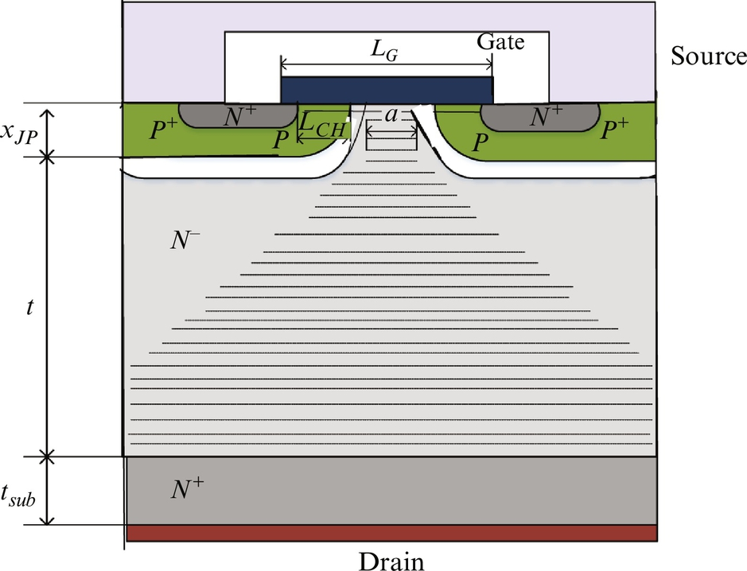

**FIG. 5.7** Structure of a power DMOSFET.

Applying a positive voltage to the gate higher than the threshold voltage, *Vth*, creates an inversion layer (channel) on the top of the P-base region connecting the source to the junction field-effect transistor (JFET) region. An accumulation layer under the gate oxide at the top of the JFET region is also formed, providing current that spreads from the channel into the JFET region. The electron current flows through the channel and then continues to the path with the smallest resistance, that is, through the accumulation layer. After leaving the accumulation layer, the current flows downward and sideways toward the drain electrode [[95](https://learning.oreilly.com/library/view/power-electronics-handbook/9780128114087/B9780128114070000052_3.xhtml#bb0480)].

For small values of the channel voltage, *VCH*<*VCHsat*, the DMOSFET has an approximately constant ON-state resistance with a value that is the sum of the channel and drift region resistance. The drain current, *ID*, is

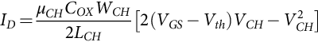 **(5.73)**

where *μCH* is the inversion layer mobility (channel mobility), *COX* is the oxide capacitance per unit area, and *VGS* is the gate-source voltage. The channel voltage, *VCH*, is calculated by the equation:

 **(5.74)**

where *RJFET* and *RDrift* are JFET resistance and drift region resistances, respectively. The JFET resistance, *RJFET*, is the resistance of the lightly doped *N* region that is under the accumulation layer formed under the gate electrode. The cross-sectional area of the JFET region through which the current flow increases slightly with distance, but for simplicity of analysis, a uniform cross section for the current flow can be assumed. If the JFET region is assumed to extend from the gate to the bottom of the P-base junction, *xJP*, (P-region thickness), the resistance of the JFET region can be calculated by Eq. [(5.75)](https://learning.oreilly.com/library/view/power-electronics-handbook/9780128114087/B9780128114070000052_1.xhtml#fo0385) [[38](https://learning.oreilly.com/library/view/power-electronics-handbook/9780128114087/B9780128114070000052_3.xhtml#bb0195)]:

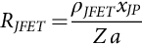 **(5.75)**

where Z is the length of the cell in the orthogonal direction to the cross section shown in [Fig. 5.7](https://learning.oreilly.com/library/view/power-electronics-handbook/9780128114087/B9780128114070000052_1.xhtml#f0040), *ρJFET* is the resistivity of the JFET region depending on the doping concentration of the JFET region and calculated by

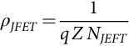 **(5.76)**

and *a* in Eq. [(5.75)](https://learning.oreilly.com/library/view/power-electronics-handbook/9780128114087/B9780128114070000052_1.xhtml#fo0385) is the width of the channel flow. The width can be related to the device structural parameters gate width, *WG*, and the width of the P-base *LCH* by the equation:

 **(5.77)**

where *W0* is the zero-bias depletion region width:

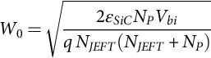 **(5.78)**

Since , the equation for the zero-bias depletion region width can be simplified to

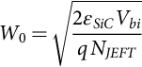 **(5.79)**

The built-in voltage depends on the doping concentration of both sides of the PN junction:

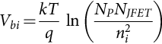 **(5.80)**

The intrinsic carrier concentration for SiC is significantly small compared with Si; therefore, the built-in voltage and drift region resistance will be larger. The parameter P-region thickness can be used to optimize the JFET region.

The drift region is under the JFET region. Since there is no depletion region to restrict the current in the drift region from spreading, it will spread, and therefore, the cross-sectional area will increase. If it is assumed that the cross-sectional width, *XD*, for current flow increases by an angle of 45 degrees, and this width is smaller than the width of the cell, *WCell*; the drift region resistance can be calculated by the following equation:

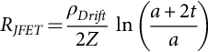 **(5.81)**

where *ρdrift* is the resistivity of the drift region and *t* is the thickness of the drift region. For the same breakdown voltage, the drift region thickness of a Si device is big as compared with a SiC device. The SiC device can also be highly doped; therefore, the drift region resistance for a SiC device will be small as compared with the drift region of a Si device.

At high drain-source voltage, *VDS*>*VDSsat*=*VGS*–*Vth*, the saturation of the current is observed. At least three mechanisms of current saturation in a DMOSFET occur: channel pinch-off, carrier saturation velocity in the high-electric-field regions, and the so-called parasitic JFET effect [[96](https://learning.oreilly.com/library/view/power-electronics-handbook/9780128114087/B9780128114070000052_3.xhtml#bb0485)] that prevents the current from flowing uniformly in the JFET region. During saturation, the current is constrained to flow in a narrow JFET channel. The drain current can be calculated by the following equation:

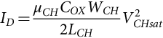 **(5.82)**

where the channel resistance, *RCH*, and the accumulation layer resistance, *RA*, should be included in the calculation of the saturation voltage. The channel resistance depends on the inversion layer mobility, *μCH* and can be calculated by

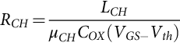 **(5.83)**

The accumulation layer resistance, *RA*, depends on the accumulation layer length, *LA*, and the electron mobility in the accumulation layer, *μA*:

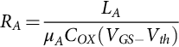 **(5.84)**

The accumulation layer length, *LA*, is

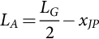 **(5.85)**

where *LG* is the gate length. For modeling the dynamic characteristics of a power SiC DMOSFET, the nonlinear gate-to-drain capacitance, *CGD*, should be calculated as follows:

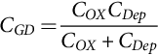 **(5.86)**

where *CDep* is the depletion region capacitance that is formed under the gate oxide.

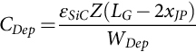 **(5.87)**

where the depletion width, *WDep*, depends on the drain bias, *VD*, and can be calculated by the following equation:

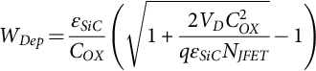 **(5.88)**

From Eqs. [(5.87)](https://learning.oreilly.com/library/view/power-electronics-handbook/9780128114087/B9780128114070000052_1.xhtml#fo0445), [(5.88)](https://learning.oreilly.com/library/view/power-electronics-handbook/9780128114087/B9780128114070000052_1.xhtml#fo0450), the depletion capacitance, *CDep*, decreases as the drain bias voltage *VD*, increases.

### 5.3.4 SIC JFET

The SiC JFET has some benefits, such as a resistive forward characteristic in the first and third quadrants and a monolithic integrated body diode. It is comparable with available SiC Schottky diodes in terms of stored charge, low output capacitance, low gate charge, and low switching losses that makes it attractive for use.

The first commercialized SiC transistor was normally the ON JFET from SemiSouth Laboratories and SiCED Electronics Development. They were easy to implement as there were no reliability issues with gate oxide as with SiC MOSFETs. The JFETs are only depletion-mode, normally ON-type devices that conduct current at zero gate voltage and are fully blocked when the gate voltage is below the pinch-off voltage. The most successful JFET type, in terms of voltage and current ratings, has been the lateral channel JFET (LCJFET), shown in [Fig. 5.8](https://learning.oreilly.com/library/view/power-electronics-handbook/9780128114087/B9780128114070000052_2.xhtml#f0045) The LCJFET allows optimization of the channel parameters and is easy to fabricate. Due to the combined lateral-vertical channel design, the LCJFET has significantly reduced Miller capacitance. A parasitic diode formed with the buried P region and the N drift region can be used as a freewheeling diode without an external antiparallel diode. Also, the current through the channels can flow in the reverse direction when enough gate-source voltage is applied; therefore, the LCJFET can work in synchronous rectification circuits.

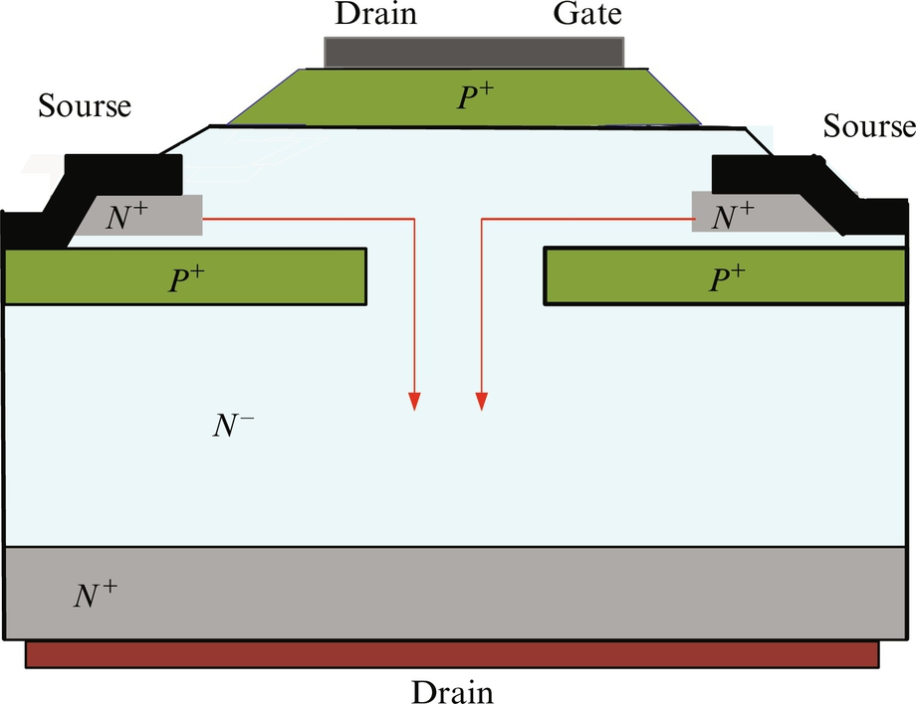

**FIG. 5.8** Lateral channel SiC JFET.

When JFETs are ON, they exhibit constant resistance that can be minimized by increasing the gate voltage slightly higher than zero. A normally-ON device is not easy to use in a power application because losing the control can cause undesired conduction of the switch and, consequently, can lead to shoot-through current damaging the circuit [[97](https://learning.oreilly.com/library/view/power-electronics-handbook/9780128114087/B9780128114070000052_3.xhtml#bb0490)].

A cascode configuration, shown in [Fig. 5.9](https://learning.oreilly.com/library/view/power-electronics-handbook/9780128114087/B9780128114070000052_2.xhtml#f0050), composed of a SiC JFET and a series-connected low-voltage Si MOSFET, can overcome the problem and make a normally-ON JFET behave similarly to a conventional MOSFET. Typically, a 30 V MOSFET with very low ON-resistance controls the JFET conduction. When the two devices are conducting, the conduction losses of the MOSFET will be insignificant. When the Si MOSFET is turned on, the gate-source voltage of the JFET becomes zero, allowing current to pass from the drain to the source. The forward characteristics of a cascode configuration are determined by the gate-source voltage applied to the MOSFET.

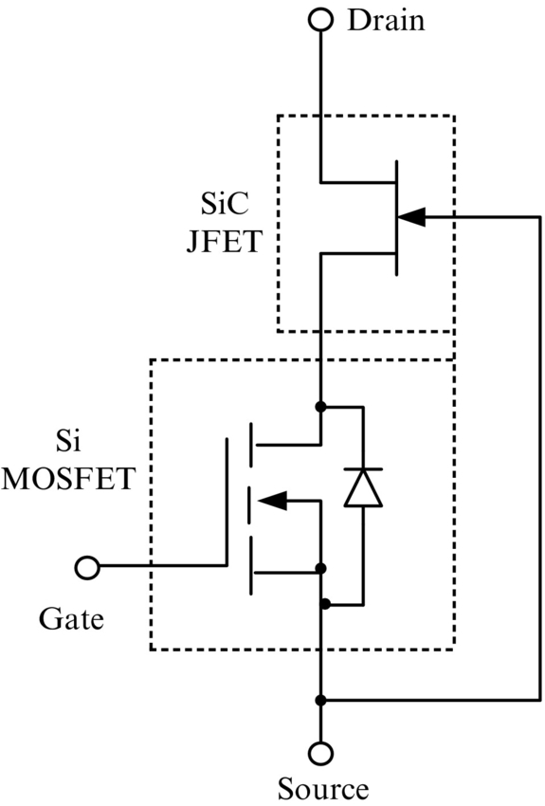

**FIG. 5.9** SiC JFET/Si low-voltage MOSFET cascode configuration.

During the OFF-state, the cascode exhibits a rugged avalanche behavior. Since in a cascode configuration the control device is a low-voltage Si MOSFET, it is easy to replace a power device with a cascode configuration packed as one device, because the control is made with the same voltage levels. The temperature coefficient of the ON-resistance of a SiC JFET is positive, which naturally protects the device from overshooting during high-temperature operation. However, there are some limitations with a cascode configuration. The maximum operating temperature in a cascode configuration is limited by the Si MOSFET, the Si MOSFET internal body diode shows a low d*v*/d*t* rating, limiting the switching frequency of the JFET, and the conduction losses are higher since the two devices are connected in series [[98](https://learning.oreilly.com/library/view/power-electronics-handbook/9780128114087/B9780128114070000052_3.xhtml#bb0495)].

To overcome these limitations, gate drivers that can block a JFET have been designed. The driver output voltage swings from zero to negative voltage. The negative voltage level is less than the maximum pinch-off voltage of the device and, therefore, could cause a gate avalanche condition. In order to limit uncontrolled avalanche current, a parallel circuit, that includes a resistor, capacitor, and diode connected in series to the JFET gate, can be used. This parallel circuit is capable of limiting the avalanche current but supplying the high gate current peaks required for fast switching [[99](https://learning.oreilly.com/library/view/power-electronics-handbook/9780128114087/B9780128114070000052_3.xhtml#bb0500)]. A disadvantage of using a special JFET driver is that a negative supply voltage should be provided to the drive circuit that complicates the control circuit of the device. Also, replacing a power device with a JFET in a power application is more complicated because the driver and the control are also affected.

In 2011, normally OFF vertical channel JFETs (VCJFETs) compatible with standard gate drive circuitry and featuring a positive temperature coefficient for ease in paralleling were commercially available. VCJFETs were based on a patented vertical channel trench structure from SemiSouth Laboratories, Inc. A typical high-voltage VCJFET is shown in [Fig. 5.10](https://learning.oreilly.com/library/view/power-electronics-handbook/9780128114087/B9780128114070000052_2.xhtml#f0055).

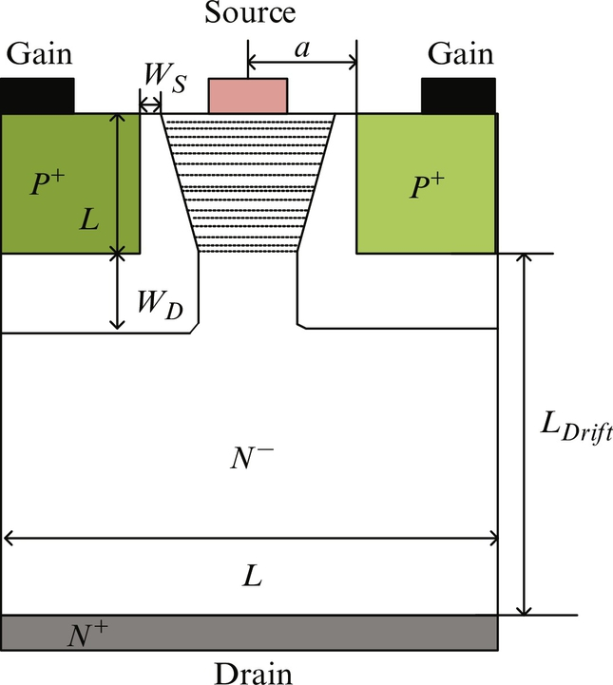

**FIG. 5.10** SiC VCJFET cross section.

When the channel voltage is smaller (*VCH*<*VCHsat*), a VCJFET works in the linear region and has an approximately constant ON-state resistance; the value of which is the sum of the channel and drift region resistance. The drain current, *ID*, can be calculated by the following equation [[100](https://learning.oreilly.com/library/view/power-electronics-handbook/9780128114087/B9780128114070000052_3.xhtml#bb0505)]:

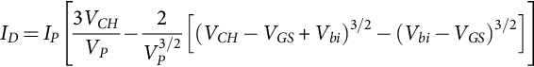 **(5.89)**

where *IP* is the pinch-off current depending on the channel parameters, such as electron mobility, *μn*; doping concentration, *NCH*; VCJFET thickness, Z; half of the width of the channel region, *a*; and the effective length of the channel. The pinch-off current is calculated by the following equation:

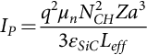 **(5.90)**

Since the drift region of a high-voltage SiC VCJFET is designed to support high voltage, the drift region is thick and lightly doped. Hence, the drift resistance will be significantly higher than other resistance through which the drain current is flowing. Therefore, the drift resistance should be included for calculating the channel voltage, *VCH*:

 **(5.91)**

where *RDrift* is the drift resistance. To simplify the expression for calculating the drift resistance, the current spreading effect of the current coming from the channel can be neglected; then, the drift resistance can be calculated as the resistance of the rectangular area in the drift region under the channel:

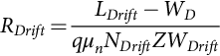 **(5.92)**

where *LDrift* and *WDrift* are the drift region thickness and the width and *NDrift* is the doping concentration of the lightly doped drift region.

The pinch-off voltage depends on the channel parameters and can be calculated by the equation:

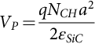 **(5.93)**

The built-in voltage is

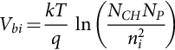 **(5.94)**

where *NP* is the doping concentration of the gate.

When the channel voltage is increased so that *VCH*>*VCHsat*, the drain current saturates. The saturation current is defined by the following equation:

 **(5.95)**

There are two reasons for the drain current to saturate. One reason is that the depletion region becomes progressively wider toward the drain side causing a reduction of channel width and an increase of channel resistance. The other reason is that due to the presence of a high electric field in the channel, the carrier velocity saturates. The saturated drain current, *IDSAT*, can be calculated by the equation [[100](https://learning.oreilly.com/library/view/power-electronics-handbook/9780128114087/B9780128114070000052_3.xhtml#bb0505)]:

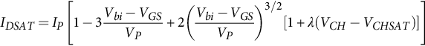 **(5.96)**

The multiplication term  in Eq. [(5.96)](https://learning.oreilly.com/library/view/power-electronics-handbook/9780128114087/B9780128114070000052_2.xhtml#fo0490) is used to account for the channel modulation effect.

A benefit of a VCJFET is that it can be used in directions, forward and reverse, in a converter circuit. The reverse *I*–*V* characteristics do not saturate as do the forward *I*–*V* characteristics. The reason for this is that when the drain current is in the reverse direction, *VGD*>*VGS*, the channel closes so the drain side will be wide open. As a result, as *VSD* increases, the channel is never pinched off when *VGS*>*Vth*, while when *VGS*<*Vth*, the channel is always pinched off on the side of the source and wide open on the drain side. Therefore, it is possible for a VCJFET to be used for freewheeling, although no parasitic diode is formed between the source and the drain [[101](https://learning.oreilly.com/library/view/power-electronics-handbook/9780128114087/B9780128114070000052_3.xhtml#bb0510)].

In order to model the switching losses of a VCJFET, the capacitance between gate and source, *CGS*, and the capacitance between gate and drain, *CGD*, should be known. The gate-source capacitance is

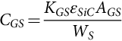 **(5.97)**

where *KGS* is the coupling area, the coefficient of the gate and source; *AGS* is the coupling area between gate and source; and *WS* is the depletion width between the gate and source. The depletion width can be calculated by

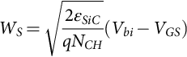 **(5.98)**

The gate-to-drain capacitance is

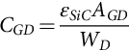 **(5.99)**

where the width of the depletion region between the gate and the drain is

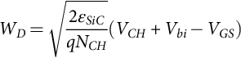 **(5.100)**

Some of the parameters of SiC JFETs and MOSFETs are presented in [Table 5.7](https://learning.oreilly.com/library/view/power-electronics-handbook/9780128114087/B9780128114070000052_2.xhtml#t0040) as their switching losses FOM (SLFOM) and conduction losses FOM (CLFOM). The MOSFET FOMs are smaller although the MOSFET current is higher. In 2009, it was stated that a SiC MOSFET would be the device of choice as soon as the SiO2/SiC interface and reliability issues were resolved [[104](https://learning.oreilly.com/library/view/power-electronics-handbook/9780128114087/B9780128114070000052_3.xhtml#bb0525)]. The two companies that were producing JFETs no longer exist. Infineon Technologies discontinued their JFET products. Other SiC companies are more interested in production and development of SiC MOSFETs; therefore, the future of the SiC JFET is still unknown.

**Table 5.7**

**Parameters and FOMs for 1200 V SiC devices**

|  |  |  |  |  |  |  |  |  |
| --- | --- | --- | --- | --- | --- | --- | --- | --- |
| **Type** | **Part number** | **Company** | ***ID* (A)** | si3_e **(mΩ)** | ***QSW* (nC)** | ***QG* (nC)** | **SLFOM** | **CLFOM** |
| JFET | IJW120R100T1 [[102](https://learning.oreilly.com/library/view/power-electronics-handbook/9780128114087/B9780128114070000052_3.xhtml#bb0515)] | Infineon | 26 | 100 | 48 | 72 | 4800 | 7200 |
| MOSFET | SCT3017AL [[103](https://learning.oreilly.com/library/view/power-electronics-handbook/9780128114087/B9780128114070000052_3.xhtml#bb0520)] | Cree | 40 | 52 | 65 | 115 | 3380 | 5980 |

### 5.3.5 SIC BJT

Power BJTs in SiC are very attractive for power switching applications due to their very low specific ON-resistance and high-temperature operation with high power densities [[105](https://learning.oreilly.com/library/view/power-electronics-handbook/9780128114087/B9780128114070000052_3.xhtml#bb0530)]. The common-emitter gain, *β*; the specific on-resistance, *RSP*\_*ON*; and the open-base breakdown voltage, *BVCEO*, are important parameters that should be accounted for in choosing a device for a power application. The current gain should be high enough to reduce the base current that controls the BJT. Considerable work has been done to improve device performance. One of the main challenges is to increase the current gain of 4H-SiC BJTs [[106](https://learning.oreilly.com/library/view/power-electronics-handbook/9780128114087/B9780128114070000052_3.xhtml#bb0535)] that is limited by the surface recombination [[105](https://learning.oreilly.com/library/view/power-electronics-handbook/9780128114087/B9780128114070000052_3.xhtml#bb0530)]. Reducing the surface recombination current by optimizing the surface passivation improves the current gain [[107](https://learning.oreilly.com/library/view/power-electronics-handbook/9780128114087/B9780128114070000052_3.xhtml#bb0540)]. Also, the common-emitter current gain can be improved by increasing the minority carrier lifetime in the base and emitter regions [[108](https://learning.oreilly.com/library/view/power-electronics-handbook/9780128114087/B9780128114070000052_3.xhtml#bb0545)]. The maximum current gain for high-voltage SiC BJTs that has been reported in the literature is 335 for a 600 V device [[109](https://learning.oreilly.com/library/view/power-electronics-handbook/9780128114087/B9780128114070000052_3.xhtml#bb0550)].

To increase the blocking voltage, the growth of high-purity SiC homoepitaxial thin films on SiC single-crystal wafers is required to form *N*−*N*+ wafer structures [[110](https://learning.oreilly.com/library/view/power-electronics-handbook/9780128114087/B9780128114070000052_3.xhtml#bb0555)]. The maximum open-base breakdown voltage, *BVCEO*, for a SiC BJT was reported to be 6 kV, but the gain was only 3 [[111](https://learning.oreilly.com/library/view/power-electronics-handbook/9780128114087/B9780128114070000052_3.xhtml#bb0560)]. Further work is necessary to improve the design and to develop a new processing technology so that an increase in *BVCEO* can be achieved without sacrificing the current gain of the transistor. Also, the conduction and switching power losses should be minimized. The conduction losses depend on the collector-emitter voltage and the collector current.

The voltage drop, *VCE*, across the high-power SiC BJT is composed of six components, including the voltages across the junctions, J0, J1, and pseudojunction, J2; the voltage across the two depletion regions, *Vd1* and *Vd2*; and the voltage across the carrier storage region (CSR), :

 **(5.101)**

A basic one-dimensional structure of a power BJT is illustrated in [Fig. 5.11](https://learning.oreilly.com/library/view/power-electronics-handbook/9780128114087/B9780128114070000052_2.xhtml#f0060). The BJT is divided into four regions: *N*+ emitter, *P* base, *N*− drift, and *N*+ collector. The external (emitter base and collector currents, *IE*, *IB*, and *IC*) and internal electron and hole and displacement currents (at junctions J0—*In0*, *Ip0*; J1—*In1*, *Ip*, and *Idisp1*; and J2—*In2*, *Ip2*, and *Idisp2*) are indicated for each region.

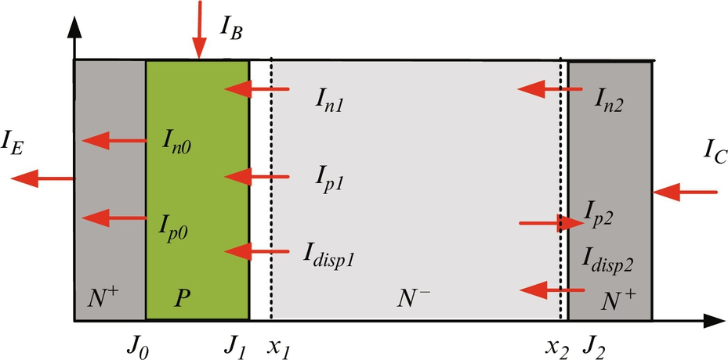

**FIG. 5.11** One-dimensional cross section of a power BJT showing the hole and electron currents in each region.

The *N*+ emitter layer of a power BJT can be simply characterized as a hole sink. The hole current at the junction, *J0*, is obtained by the following equation:

 **(5.102)**

where *nB0* is the electron concentration at junction J0 and *PB* is the base doping concentration. The *N*+ emitter recombination parameter, *hn*, depends on emitter properties, such as doping level (*NE*), hole diffusivity (*Dp*), and hole minority lifetime (*τp*). The electron current component at junction J0 is determined by

 **(5.103)**

and the voltage drop across junction J0 is

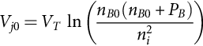 **(5.104)**

The equation for the *P*-base region can be used to derive the boundary current at junction J1. The lumped-charge method is used to model the behavior in the base region due to its moderate doping level and comparatively narrow base width. The injected carrier distribution in the base region during conduction is shown in [Fig. 5.12](https://learning.oreilly.com/library/view/power-electronics-handbook/9780128114087/B9780128114070000052_2.xhtml#f0065).

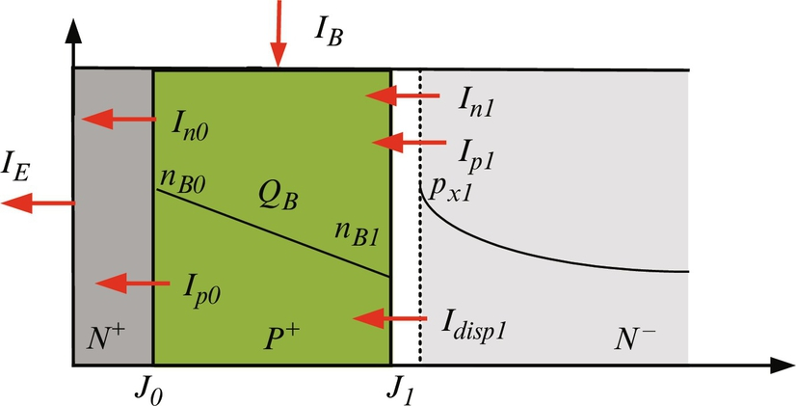

**FIG. 5.12** Charge distribution and boundary current components in *P* base.

Using the continuity equation for the base region, the injected minority carrier charge is described by the relation:

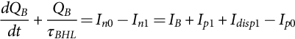 **(5.105)**

where *τBHL* is the high-level lifetime in the *P*-base region.

The total electron charge in the base is expressed as

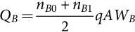 **(5.106)**

where *WB* is the base width. The electron concentration at the base region boundary on the collector side, *nB1*, is related to the excess carrier concentration, *px1*, by the doping concentration of the base, *PB*, by the equation:

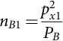 **(5.107)**

Since the diffusion length in the base region is much greater than the base width, the gradient of the electron concentration is approximately linear, giving the electron current at the base-collector junction, J1, as

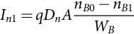 **(5.108)**

The base-emitter voltage *VBE* is calculated by the equation:

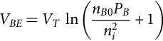 **(5.109)**

The voltage drop in *N*− drift region is calculated during the ON-state in a manner similar to that of a PiN diode. The injected excess carrier concentration is determined by the ADE. As for all power switches, high-level injection and quasineutral conditions exist. Under high-level injection conditions, the ADE for the lightly doped drift describes the carrier dynamics of the majority carriers:

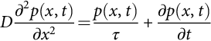 **(5.110)**

where *D* is the ambipolar diffusion coefficient, *τ* is the high-level carrier lifetime within the drift region, and *p*(*x*, *t*) is the excess carrier concentration. The Fourier series solution of the ADE is given by the following first-order differential equations as each of them refers to a harmonic, *pk*(*t*), of the total minority carrier density, *p*(*x*,*t*):

For *k*>0

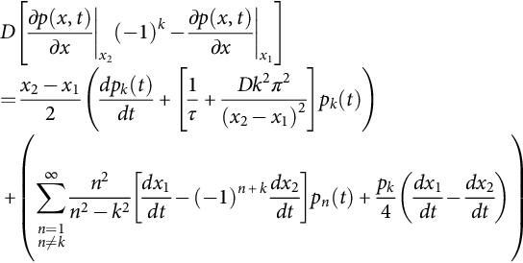 **(5.111)**

for 

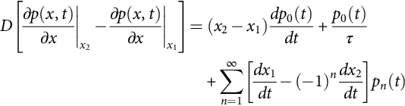

The solution to the ADE is determined by using the boundary conditions at the edges of the charge storage region. The representation requires the width of the undepleted region and the hole and electron currents at the boundaries of the drift region, which give the gradients of the carrier concentrations at *x*1 and *x*2, respectively. For the given direction of the currents ([Fig. 5.13](https://learning.oreilly.com/library/view/power-electronics-handbook/9780128114087/B9780128114070000052_2.xhtml#f0070)), the required boundary conditions are given by the equations:

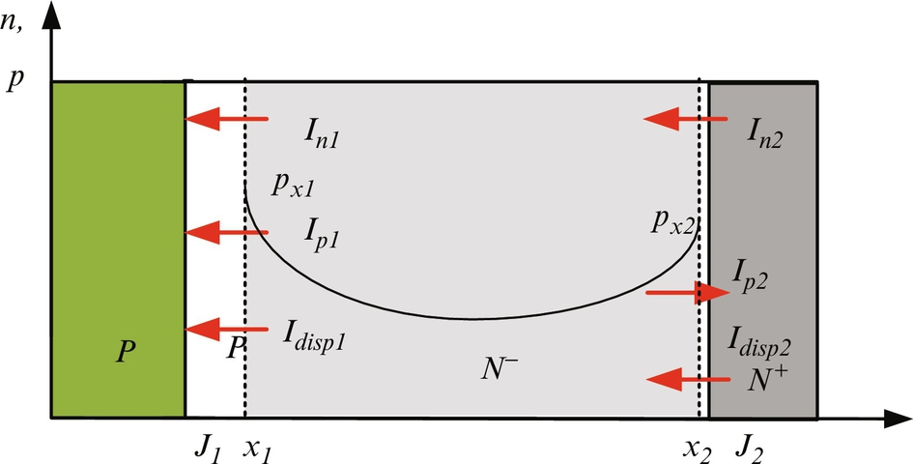

**FIG. 5.13** Charge distribution and boundary current components in *N*− collector.

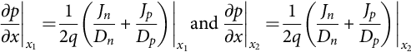 **(5.112)**

Using the boundary condition Equation [(5.112)](https://learning.oreilly.com/library/view/power-electronics-handbook/9780128114087/B9780128114070000052_2.xhtml#fo0575), the left side of Eq. [(5.111)](https://learning.oreilly.com/library/view/power-electronics-handbook/9780128114087/B9780128114070000052_2.xhtml#fo0565), for even and odd numbers of *k*, can be calculated by the following equations:

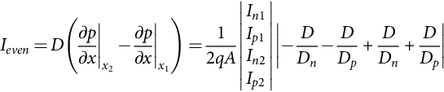 **(5.113)**

**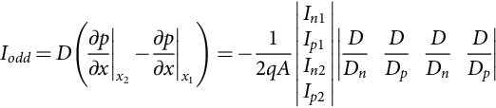** **(5.114)**

The boundary carrier densities, *px1* and *px2*, at the boundaries, *x1* and *x2*, are calculated using the equations:

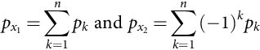 **(5.115)**

The voltages across the *N*−*N*+ and *N*−*P*+ depletion layers, *Vd1* and *Vd2*, are calculated by the following equations:

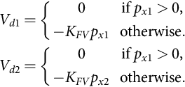 **(5.116)**

The feedback constant, *KFV*, is set to 10−12, which gives good convergence and minimal error [[68](https://learning.oreilly.com/library/view/power-electronics-handbook/9780128114087/B9780128114070000052_3.xhtml#bb0345)]. The associated depletion widths, *Wd1* and *Wd2*, are calculated using a step doping concentration change on each side of the junction:

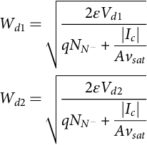 **(5.117)**

The boundary positions, *x1* and *x2*, are calculated by

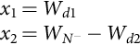 **(5.118)**

The displacement currents, *Idisp1* and *Idisp2*, are due to the changing depletion widths at junctions J1 and J2:

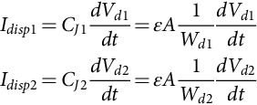 **(5.119)**

The voltages across junctions J1 and J2 are

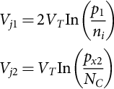 **(5.120)**

The voltage drop across the carrier storage region, , is calculated based on the injected carrier concentration discussed in [Section 5.3.2.2](https://learning.oreilly.com/library/view/power-electronics-handbook/9780128114087/B9780128114070000052_1.xhtml#s0095).

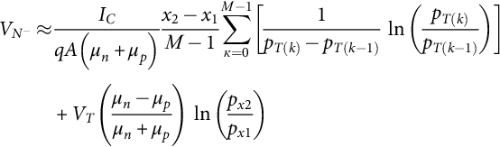 **(5.121)**

where the carrier distribution, *pT*(*k*), is calculated as

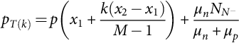 **(5.122)**

The *N*+ collector region has similar properties to the *N*+ emitter region as it also can be presented as a hole sink. The hole current at junction J2 is obtained by the equation:

 **(5.123)**

The electron current at junction J2 is

 **(5.124)**

During the ON-state, the voltages across the *N*−*N*+ and *N*−*P*+ depletion layers, *Vd1* and *Vd2*, are equal to zero, and the collector-emitter voltage is

 **(5.125)**

Substituting the junctions' voltages from Eqs. [(5.104)](https://learning.oreilly.com/library/view/power-electronics-handbook/9780128114087/B9780128114070000052_2.xhtml#fo0530), [(5.120)](https://learning.oreilly.com/library/view/power-electronics-handbook/9780128114087/B9780128114070000052_2.xhtml#fo0615) in Eq. [(5.125)](https://learning.oreilly.com/library/view/power-electronics-handbook/9780128114087/B9780128114070000052_2.xhtml#fo0640) and simplifying, the following equation will be obtained:

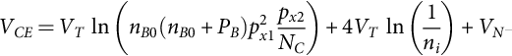 **(5.126)**

Since the thickness of the lightly doped drift region of a SiC BJT is smaller than the lightly doped drift region of a Si device, their boundary carrier densities, *px1* and *px2*, at the boundaries, *x1* and *x2*, are bigger [[71](https://learning.oreilly.com/library/view/power-electronics-handbook/9780128114087/B9780128114070000052_3.xhtml#bb0360)]. Therefore, for the same doping concentration of the four regions of a power SiC BJT and a power Si BJT, the first term of Eq. [(5.126)](https://learning.oreilly.com/library/view/power-electronics-handbook/9780128114087/B9780128114070000052_2.xhtml#fo0645) for a SiC device is big compared with a Si one. Also, if it is assumed that the intrinsic carrier concentrations of Si and SiC are 1010 and 10−10 cm−3 and the thermal voltage, *VT*=0.256, the second term of a Si device is a negative number (approximately −2.36 V) that will subtract from the first term and make collector-emitter voltage smaller, while for a SiC BJT, the second term is a positive number (~2.36 V) that will add to the first term and make the collector-emitter voltage bigger. Only the voltage drop in the lightly doped drift region for SiC will be small compared with a Si one, since the thickness in Si is significantly larger and the doping concentration in Si is lower. To have benefits of conductivity modulation and therefore small ON-resistance, SiC BJTs similar to SiC PiN diode should be designed for higher than 4 kV [[112](https://learning.oreilly.com/library/view/power-electronics-handbook/9780128114087/B9780128114070000052_3.xhtml#bb0565)]. Also, the BJT is a bipolar device having minority and majority carrier flowing during operation; therefore, the drift region stores charge that decreases the device switching speed and thus can only operate at switching frequencies less than can be obtained with a MOSFET structure.

### 5.3.6 SIC IGBT

As previously mentioned, the rapid improvement in 4H-SiC material quality and the maturing of SiC device processing in recent years have enabled the development of high-voltage SiC power devices (MOSFETs and JFETs). However, the ON-resistance of SiC MOSFETs and JFETs rapidly increases as the blocking voltage and operating junction temperature increase because they are unipolar devices and conductivity modulation is not happening in the lightly doped drift region. This makes the conduction loss of the unipolar devices unacceptable for applications with a blocking voltage higher than 10 kV. For these applications, bipolar devices are preferred because they have been shown to have a small voltage drop due to strong conductivity modulation in their drift regions [[113](https://learning.oreilly.com/library/view/power-electronics-handbook/9780128114087/B9780128114070000052_3.xhtml#bb0570)].

Simple gate drive interfaces make 4H-SiC IGBTs attractive devices. Chronologically, the first fabricated and characterized IGBTs were *P*-channel because there was a practical limitation in producing the low resistivity *P*+-type SiC substrate required for fabricating *N*-channel IGBTs [[114](https://learning.oreilly.com/library/view/power-electronics-handbook/9780128114087/B9780128114070000052_3.xhtml#bb0575)]. But with the advantages of the SiC technology, *N*-channel IGBTs have been built. Both *N*- and *P*-channel SiC IGBTs have demonstrated high blocking voltage capability, as the first IGBT fabricated in 2006 had a blocking voltage of 5.8 kV. Since then, different IGBTs have been built; for example, 12 kV *P*-channel IGBTs with 14 mΩ cm2 ON-resistance [[115](https://learning.oreilly.com/library/view/power-electronics-handbook/9780128114087/B9780128114070000052_3.xhtml#bb0580)], 13 kV *N*-channel IGBTs with 22 mΩ cm2 ON-resistance [[116](https://learning.oreilly.com/library/view/power-electronics-handbook/9780128114087/B9780128114070000052_3.xhtml#bb0585)], and 20 kV self-aligned *P*-channel DMOS-IGBTs have been reported [[117](https://learning.oreilly.com/library/view/power-electronics-handbook/9780128114087/B9780128114070000052_3.xhtml#bb0590)]. The 20 kV *P*-channel IGBT has a less than 15 times a smaller voltage drop at 31 A cm−2 current density compared with a theoretical MOSFET with the same blocking voltage [[117](https://learning.oreilly.com/library/view/power-electronics-handbook/9780128114087/B9780128114070000052_3.xhtml#bb0590)]. The last reported IGBT with ultrahigh blocking voltage of 27 kV was reported in 2015 [[118](https://learning.oreilly.com/library/view/power-electronics-handbook/9780128114087/B9780128114070000052_3.xhtml#bb0595)].

Different SiC device research groups have been working on optimizing the IGBT parameters and fabricating and characterizing devices so that soon IGBTs will be on the market. For a given blocking voltage, a trade-off between conduction and switching loses should be made to optimize the IGBT parameters. A reason for this is that there is a huge amount of charge stored in the IGBT lightly doped drift region during the ON-state and that has to be removed during turn-OFF [[119](https://learning.oreilly.com/library/view/power-electronics-handbook/9780128114087/B9780128114070000052_3.xhtml#bb0600)].

In [[120](https://learning.oreilly.com/library/view/power-electronics-handbook/9780128114087/B9780128114070000052_3.xhtml#bb0605)], the device group from Cree Inc. has fabricated a 10 kV MOSFET and an *N*-type IGBT capable of flowing 10 and 4 A, respectively. Both devices were processed identically through the device fabrication process each as a MOS part where the lightly doped drift region had the same length and doping concentration. The only difference between the two devices is that the *N*-channel IGBTs have a moderately doped *N* field-stop (FS) buffer layer and a heavily doped *P*+ injector, while the MOSFET has an *N*+ substrate. The DC characteristics of the devices were measured, and it was observed that the forward voltage drops of the two structures were the same, ~5 V.

The switching results indicated that both devices were much faster than the highest voltage, commercially available Si IGBT. The MOSFET turn-OFF transient time was faster than the IGBT turn-OFF time of 140 and 400 ns, respectively. A reason for slow turn-OFF time is that the IGBT is a bipolar device and stores minority and majority charges in the lightly doped drift region that are removed slowly, while the MOSFET is a unipolar device and is not dependent on carrier recombination during turn-OFF. The IGBT turn-OFF transient can be improved by reducing gate resistance and optimizing the internal capacitance and increasing the high-level lifetime.

Seven years later, the Cree Inc. group demonstrated a 20.7 kV *N*-channel IGBT with a forward voltage drop of 6.4 V at a collector current of 20 A and a 17 kV *N*-channel IGBT with a forward voltage drop of 5.7 V at a collector current of 20 A [[121](https://learning.oreilly.com/library/view/power-electronics-handbook/9780128114087/B9780128114070000052_3.xhtml#bb0610)]. The two IGBTs were fabricated with the same mask sets and identical fabrication process. Although the lightly doped drift region for the 20.7 kV IGBT was significantly increased in width to support higher voltage, the voltage drop did not increase significantly, which can be attributed to conductivity modulation that takes place during the conduction state of the IGBT. Similar to a SiC PiN diode and a BJT, as an IGBT is a bipolar device, the junction voltage drops are dominant in determining the forward voltage drop with a blocking voltage smaller than 20 kV. The ON-resistance for an IGBT will be dominated by the parasitic resistance, such as channel resistance and the contact resistance, while the resistance of the lightly doped drift region will not be much larger due to high-level injection in the lightly doped drift region leading to conductivity modulation.

Results of a comparison of *N*-channel and *P*-channel SiC IGBTs have shown comparable static characteristics that can be explained by the fact that during the ON-state, an IGBT is operating at high-level injection. Regardless of the structure of an IGBT, the behavior of the carriers in the lightly doped drift region is governed by the ADE:

 **(5.127)**

Operating at high-level injection means that the injected carriers in the lightly doped drift region have significantly higher values than the background impurity doping concentration. The electron and hole concentrations in the drift region during the ON-state are equal:

 **(5.128)**

Their concentrations depend on the boundary conditions at each end of the drift region, the minority charge-carrier lifetime, and the drift region width. Assuming that *N*-channel and *P*-channel IGBTs are processed identically through the device fabrication process and the gate-source voltage and collector current are the same, then the carrier concentration in the drift region of the two devices will be equal, and therefore, the voltage drop across the drift regions will be the same. The IGBT junction voltages are functions of the doping concentrations, and they will be the same for the identically processed *N*- and *P*-channel IGBTs. Therefore, the total voltage drop for identically processed *N*-channel and *P*-channel SiC IGBTs will be significantly the same when the devices are subjected to the same conditions: gate-source voltage, collector current, and temperature.

On the other hand, *N*-channel IGBTs offer far superior switching characteristics over *P*-channel IGBTs. In Ref. [[122](https://learning.oreilly.com/library/view/power-electronics-handbook/9780128114087/B9780128114070000052_3.xhtml#bb0615)], the simulation results of the switching characteristics of *N*-channel and *P*-channel 15 kV SiC IGBTs are given that support this fact. The rate of increase in the collector-emitter voltage of an *N*-channel IGBT is 40 V ns−1 and for a *P*-channel IGBT is 5 V ns−1. The current decay for the *N*-channel IGBT is also faster than the current decay for the *P*-channel IGBT. A physical explanation for this is that in the beginning of the turn-OFF process, the collector-emitter voltage, *VCE*, rises from the forward voltage, *VF*, to the DC supply voltage, *VDC*, and the rate of change of the *VCE* depends on the rate of removal of the stored charge through the emitter side. During this time, the recombination and displacement currents are significantly smaller than the minority carrier current and can be neglected. The minority current is responsible for the charge removal. As the *VCE* rises, the depletion region expands toward the collector junction. The minority carriers are swept out through the depletion region, and the majority of carriers are pushed toward the collector where most of them will recombine in the *P*+ injector layer for an *N*-channel IGBT or *N*+ injector layer for a *P*-channel IGBT [[119](https://learning.oreilly.com/library/view/power-electronics-handbook/9780128114087/B9780128114070000052_3.xhtml#bb0600)]. Due to the large rate of change in the minority carrier current, the depletion region expends faster in an *N*-channel IGBT than in a *P*-channel IGBT, and therefore, the collector voltage for *N*-channel an IGBT rises at a faster rate. During the second phase of the turn-OFF process, after the collector-emitter voltage, *VCE*, reaches the DC supply voltage, *VDC*, the freewheeling diode is turned ON that allows the collector current to fall down to a value depending on the remaining storage charge. During this time, the *VCE* overshoots due to the energy stored in the stray inductance in the collector-emitter loop. After that, the collector current depends only on the remaining storage charge, and the recombination rate depends on the high-level carrier lifetime [[123](https://learning.oreilly.com/library/view/power-electronics-handbook/9780128114087/B9780128114070000052_3.xhtml#bb0620)]. Since the holes' lifetime is smaller than the electrons' lifetime, the tailing current phase is shorter for an *N*-channel IGBT compared with a *P*-channel IGBT. Also, an *N*-channel IGBT has faster charge extraction due to the large ionization energy of acceptors in 4H-SiC [[122](https://learning.oreilly.com/library/view/power-electronics-handbook/9780128114087/B9780128114070000052_3.xhtml#bb0615)]. Since the total losses for an *N*-channel IGBT are smaller compared with a *P*-channel IGBT, further developments in IGBT should be focused on an *N*-channel IGBT [[118](https://learning.oreilly.com/library/view/power-electronics-handbook/9780128114087/B9780128114070000052_3.xhtml#bb0595)].

Similar to other power devices, IGBTs consist a thick lightly doped drift region that is required to support high voltage and prevent an avalanche breakdown. The drift region thickness, the doping concentration, and the minority carrier lifetime are important IGBT design parameters. Their values are optimized so that the sum of the conduction and switching losses is minimized for a desired blocking voltage. The drift region thickness and doping concentration are optimized to obtain minimum conduction loses (forward voltage drop) for the same blocking voltage. Increasing the doping concentration requires a thicker drift region to sustain the high voltage and prevent an avalanche breakdown. The minority lifetime effects the conducting and switching losses. An increase in the lifetime enhances the conductivity modulation, and therefore, the forward voltage drop is reduced, while the recombination process becomes slower and results in high switching losses. A compromise between conduction and switching losses should be made to optimize the carrier lifetime in the drift region.

To decrease the drift region thickness for the same IGBT blocking voltage, an FS layer adjacent to the lightly doped drift region is used, making the IGBT an asymmetrical device. In [[124](https://learning.oreilly.com/library/view/power-electronics-handbook/9780128114087/B9780128114070000052_3.xhtml#bb0625)], it is shown that a 15 kV *N*-channel symmetrical IGBT does not have an FS layer and the thickness of the drift region is 247 μm, while for an asymmetrical *N*-channel IGBT, the thickness is 150 μm. Therefore, the voltage drop in the lightly doped drift region is significantly smaller for an asymmetrical device. Also, due to the FS layer, the depletion width starts to expand across the whole drift region when an IGBT is switched OFF and a punch-through effect is observed. Therefore, the depletion width that is equal to the drift region thickness should be designed first. The punch-through effect benefits the switching characteristics of an IGBT. After the punch-through, the sweep-out of the excess carriers practically stops, and the charge removal is performed mostly due to the recombination process in the FS layer. Therefore, the current tail disappears under the punch-through condition. The punch-through effect has some disadvantages also. During punch-through, the parasitic capacitance associated with increasing of the *VCE* turns into a much smaller capacitance instead of a large diffusion capacitance [[121](https://learning.oreilly.com/library/view/power-electronics-handbook/9780128114087/B9780128114070000052_3.xhtml#bb0610)]. This capacitance resonates with the parasitic stray inductance in the collector-emitter loop resulting in voltage overshooting and a ringing phenomenon, which should be carefully considered. The thickness of the FS layer is an important device parameter. Increasing the FS layer thickness results in superior turn-OFF speed but slightly increases the forward voltage drop, while decreasing the FS layer thickness slows down the turn-OFF speed but offers superior conduction capability [[125](https://learning.oreilly.com/library/view/power-electronics-handbook/9780128114087/B9780128114070000052_3.xhtml#bb0630)].

To reduce the ON-state resistance of the lightly doped drift region of an N-channel IGBT, some power device designers have inserted a thin, heavily doped *N*+ current spreading layer (CSL) beneath the P-type base region, forming a JFET layer between the two P bases. An CSL helps to distribute the electron flow more uniformly, minimizing the current crowding at the top of the drift region and reducing the drift layer resistance. Both regions, CSL and JFET, are formed as N-type epitaxial layers having higher doping concentration than the drift layer. Increasing the doping concentration in the JFET region helps to reduce the ON-state resistance; however, it causes an increase in the electric field at the SiC-SiO2 interface during the blocking state. Simulation results have shown that for a drift region width higher than 1.6 μm, the oxide field reaches 4 MV cm−1 prior to the avalanche breakdown in SiC. Decreasing the JFET width increases the resistance since it pinches off the current path but reduces the cell area; consequently, the effect of the specific ON-resistance is negligible [[77](https://learning.oreilly.com/library/view/power-electronics-handbook/9780128114087/B9780128114070000052_3.xhtml#bb0390)]. An optimum width of the JFET region can be determined. When an IGBT has an optimum width, its blocking voltage is limited by the avalanche breakdown for the entire range of the lightly doped drift region. In [[126](https://learning.oreilly.com/library/view/power-electronics-handbook/9780128114087/B9780128114070000052_3.xhtml#bb0635)], it is shown that for their design, the optimum width is 1 μm.

To optimize the parameters of a PT IGBT, a physics-based model, given in [[127](https://learning.oreilly.com/library/view/power-electronics-handbook/9780128114087/B9780128114070000052_3.xhtml#bb0640)], can be used. For this purpose, the device is divided into five regions, as shown in [Fig. 5.14](https://learning.oreilly.com/library/view/power-electronics-handbook/9780128114087/B9780128114070000052_2.xhtml#f0075): *P* emitter (collector terminal), *N*+ field-stop layer, *N*− drift region, *P* well, and *N*+ emitter. [Fig. 5.14](https://learning.oreilly.com/library/view/power-electronics-handbook/9780128114087/B9780128114070000052_2.xhtml#f0075) also shows the external currents (emitter and collector currents *IE* and *IC*), the internal electron and hole currents (at junctions J0 *In*0 and *Ip*0, J1  and , and J2  and ), and the capacitive currents from the displacement layers ( and *ICG*). The IGBT is a gate-controlled device and is used as a controllable switch in power electronic applications. Given its P-N-P-N structure, the IGBT is a voltage bidirectional switch, that is, it can conduct current in one direction only, but it can block the voltage of both polarities. The reverse-blocking capability is rarely used in conventional power converter configurations. Frequently, an antiparallel diode is added as a separate chip to accommodate converter configurations, such as the voltage source inverter, which require a current bidirectional switch. In the normal forward blocking operation of the IGBT, a depletion layer is formed at the MOS end of the drift region (at the *N*− drift region/*P*-well junction), while in a reverse-blocking operation, it is formed at the *P* emitter/drift region junction. In forward blocking, a depletion layer is never formed at the *P* emitter. For this reason, no displacement current for junction J0 is included. The model can be easily extended to reverse-blocking IGBTs by allowing a depletion layer at the junction J0.

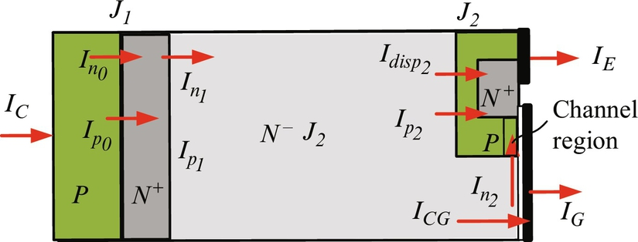

**FIG. 5.14** One-dimensional cross section used for modeling of PT IGBT showing the currents in each region.

The hole and electron currents in the *P*-emitter layer end of a power IGBT at junctions, J0, *Ip0*, and *In0*, depend on the process happening in the FS layer. The sum of them is equal to the IGBT collector current:

 **(5.129)**

where *NN* is the doping concentration of the FS layer.

Adding an FS layer allows a reduction in the drift region thickness for the same blocking voltage and also speeds up the IGBT turn-off process but creates two junctions, J0 and J1. Due to electron reverse injection into the *P*+ emitter, there is a small electron current *In0* at junction *J0*. These electrons travel through the buffer layer from the drift region. The hole current, *Ip0*, injected from the P+ emitter, travels mostly by diffusion through the FS layer. Since the layer is typically quite thin in comparison with the hole diffusion length, , there is little recombination, and most of the holes reach the drift region. This hole current is *Ip1* and represents the hole injection from the buffer layer into the drift region.

The difference between the two hole currents at junctions J1 and J0 is due to the recombination, and it is compensated for by an increase in the electron current, so that the electron current *In1* at junction J1 can be presented by a sum of the recombination component plus the reverse injection electron current *In0*. Static conditions are assumed up to now, while under dynamic conditions, an additional hole current component due to variations in the stored charge in the buffer layer should be considered.

Assuming a quasistatic state, the continuity equation of the holes in the buffer layer is then expressed by

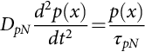 **(5.130)**

where *τpN* is the minority lifetime and *DpN* is the hole diffusivity in the field-stop layer. The solution for the excess hole concentration in the buffer layer is given by

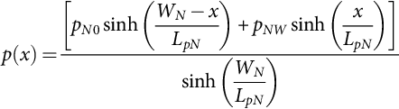 **(5.131)**

where *WN* is the width of the buffer layer, *pN0* and *pNW* are the hole concentrations at the two edges of the field-stop layer (junctions J0 and J1), and *LpN* is the hole diffusion length.

Under the low-level injection, the minority hole current is mostly diffusion current, so it is expressed as

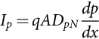 **(5.132)**

Thus, the hole current at the junction J0 is obtained substituting the derivative of Eq. [(5.131)](https://learning.oreilly.com/library/view/power-electronics-handbook/9780128114087/B9780128114070000052_2.xhtml#fo0670) for  into Eq. [(5.132)](https://learning.oreilly.com/library/view/power-electronics-handbook/9780128114087/B9780128114070000052_2.xhtml#fo0675):

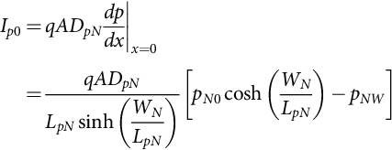 **(5.133)**

Assuming quasiequilibrium, the reverse injection current *In0* at junction J0 is given by

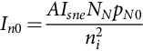 **(5.134)**

where *Isne* is the emitter electron saturation current.

The current continuity at the boundaries of the buffer layer requires that

 **(5.135)**

Then, the hole concentration at the junction J1 is obtained by substituting Eqs. [(5.133)](https://learning.oreilly.com/library/view/power-electronics-handbook/9780128114087/B9780128114070000052_2.xhtml#fo0680), [(5.134)](https://learning.oreilly.com/library/view/power-electronics-handbook/9780128114087/B9780128114070000052_2.xhtml#fo0685) into Eq. [(5.135)](https://learning.oreilly.com/library/view/power-electronics-handbook/9780128114087/B9780128114070000052_2.xhtml#fo0690) and then reorganizing the equation to the form:

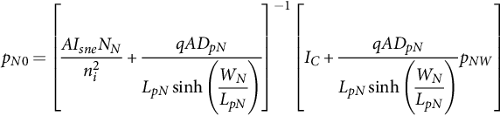 **(5.136)**

The hole current *Ip1* at junction J1 is obtained similar to *Ip0*, only :

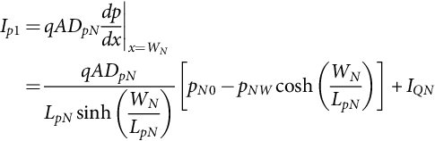 **(5.137)**

The current, *IQN*, represents the capacitive current due to the variation in the charge *QN* stored in the buffer region:

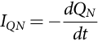 **(5.138)**

The charge *QN* can be approximated as

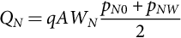 **(5.139)**

The hole concentration, *pNW*, at the boundary between the buffer layer and the drift region is obtained by applying the Boltzmann relationship for the junction J2 under the assumption of high-level injection in the drift region ():

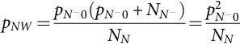 **(5.140)**

where  is the hole concentration in the beginning and  is the doping concentration of the *N*− drift region.

The voltages across the junctions J0 and J1 are

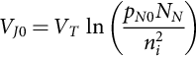 **(5.141)**

**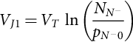** **(5.142)**

The voltage drop in the *N*− drift region is calculated during the ON-state. The charge distribution and the boundary current components in the *N*− region are shown in [Fig. 5.15](https://learning.oreilly.com/library/view/power-electronics-handbook/9780128114087/B9780128114070000052_2.xhtml#f0080). The injected excess carrier concentration is determined by the ADE. As for all bipolar power switches, high-level injection and quasineutral conditions exist. Under high-level injection conditions, the ADE (Eq. [5.35](https://learning.oreilly.com/library/view/power-electronics-handbook/9780128114087/B9780128114070000052_1.xhtml#fo0180)) describes the carrier dynamics.

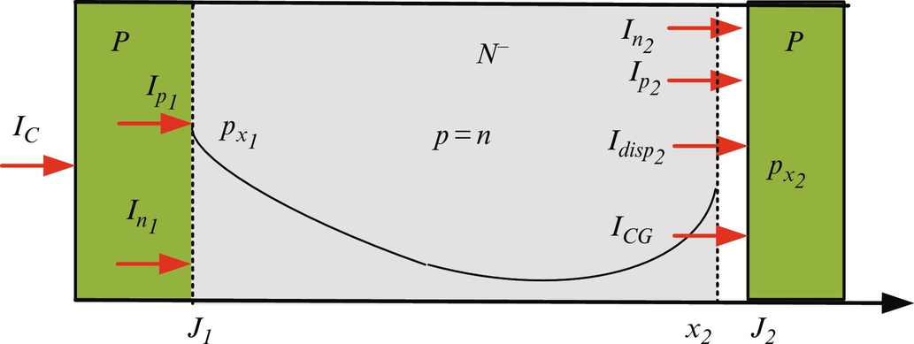

**FIG. 5.15** Charge distribution and boundary current components in the *N*− region of PT IGBT.

It was mentioned that, during forward blocking of an IGBT, no depletion layer forms at junction J1; therefore, its thickness, *x*1, can be approximated as zero. Therefore, the charge storage region, which operates under high-level injection and is described by the ADE, Eq. [(5.35)](https://learning.oreilly.com/library/view/power-electronics-handbook/9780128114087/B9780128114070000052_1.xhtml#fo0180), has  and . The Fourier series solution of the ADE, given by Eq. [(5.39)](https://learning.oreilly.com/library/view/power-electronics-handbook/9780128114087/B9780128114070000052_1.xhtml#fo0205), can be simplified to

For 

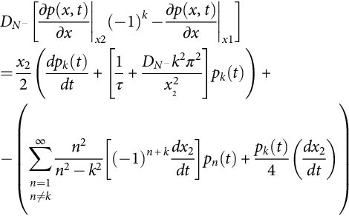 **(5.143)**

For 

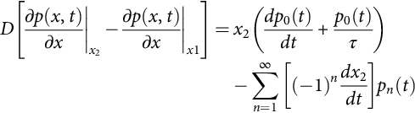

The solution to the ADE is determined by using the boundary conditions at the edges of the charge storage region:

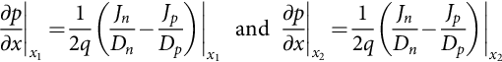 **(5.144)**

The current continuity equation at junction J2 is determined by

 **(5.145)**

The electron current at junction J2 is the MOS channel current:

 **(5.146)**

Substituting Eqs. [(5.146)](https://learning.oreilly.com/library/view/power-electronics-handbook/9780128114087/B9780128114070000052_2.xhtml#fo0750) in [(5.145)](https://learning.oreilly.com/library/view/power-electronics-handbook/9780128114087/B9780128114070000052_2.xhtml#fo0745) and then in Eq. [(5.143)](https://learning.oreilly.com/library/view/power-electronics-handbook/9780128114087/B9780128114070000052_2.xhtml#fo0730), the left side of the solution of the ADE (Eq. [5.143](https://learning.oreilly.com/library/view/power-electronics-handbook/9780128114087/B9780128114070000052_2.xhtml#fo0730)), for even and odd numbers of *k*, can be calculated by the following equations:

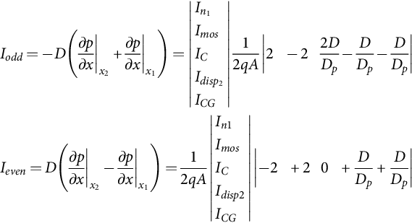 **(5.147)**

The boundary carrier densities *px*1 and *px*2 at the boundaries *x*1 and *x*2 are calculated using the equations:

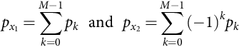 **(5.148)**

The voltage across the *N*−*P* depletion layer, , is calculated by the following equation:

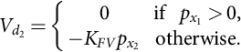 **(5.149)**

The associated depletion width, , is calculated using a step doping concentration change on each side of the junction:

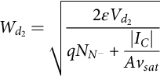 **(5.150)**

The boundary position *x2* is calculated by

 **(5.151)**

The displacement current at *x*2 is composed of two components:  flowing into the *P* well and *ICG* associated with Miller capacitance and accumulation layer charge. The *P*-well displacement current is given by

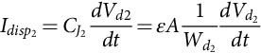 **(5.152)**

To calculate the Miller capacitance, it is assumed that the depletion layer extends under the gate from *P* well and only extends downward through the drift region once the accumulation layer has been removed from the gate in the center of the intercell region. Therefore, the width of the Miller capacitance, *W*, is

 **(5.153)**

where *lm* is an intercell half width and *l1* is a width due to voltage VGE:

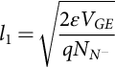 **(5.154)**

The Miller capacitance is given by the series combination of the oxide capacitance *CoxAai* and the depletion capacitance :

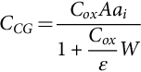 **(5.155)**

where *a*i is the ratio of intercell area to the total die area.

Due to Miller capacitance, the current *ICG* is

 **(5.156)**

where

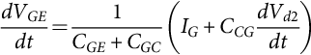 **(5.157)**

The voltage drop in the carrier storage region  is calculated based on the injected carrier concentration:

 **(5.158)**

where the carrier distribution *pT*(*k*) is calculated as

 **(5.159)**

IGBTs are used as switches, operating mainly in two stages: ON and OFF. The MOS region can be modeled as a simple MOSFET. During the ON-state, the MOSFET operates either in the triode region or in the saturation region, while during the OFF-state, it operates in cut-OFF. Therefore, during the OFF-state, the gate-source voltage is smaller than the threshold voltage , and current *Imos* is zero. During the ON-state, the gate-source voltage is larger than the threshold voltage , and current *Imos* is calculated by

 **(5.160)**

The voltage drop *VCE* across PT IGBT is composed of three components: voltages across the junction J1, voltage across the two depletion regions *Vd2*, and voltage across the carrier storage region .

 **(5.161)**

### 5.3.7 SIC THYRISTOR

As the trend of power electronics industry is moving toward high voltage, high current, and high frequency, the conduction and switching losses of the power semiconductor devices should be at an acceptable level. Up to now, SCRs are still the most powerful devices currently available in pulse power applications. A single SCR can block 8 kV and conduct 4 kA, and a GTO can block 6 kV and conduct 6 kA [[128](https://learning.oreilly.com/library/view/power-electronics-handbook/9780128114087/B9780128114070000052_3.xhtml#bb0645)]. However, due to the high switching losses of SCRs and GTOs, their maximum operation frequency is limited to 1 kHz. Because of their switching and driving characteristics, the device paralleling for high-power applications is impossible. SCRs and Si GTOs have a positive temperature coefficient and their operating temperature is limited to 100°C junction temperature, since the leakage current increases significantly above that temperature. Typically, this requires expensive active liquid cooling to maintain safe operation conditions. The leakage current of a SiC GTO is extremely small at 300°C and only requires forced air cooling.

SiC GTOs and IGBTs are two devices that can soon be utilized in utility-based power handling equipment, such as flexible AC transmission systems (FACTS) and high-voltage DC transmissions (HVDCT). A 4H-SiC thyristor is a better candidate because it is capable of higher current densities than a SiC IGBT, since the physical mechanism for conductivity modulation is more effective in the thyristor than the IGBT. Also, SiC IGBTs are limited to 150°C junction temperature due to a limitation of the gate oxide reliability.

In the near future, large-area SiC GTOs will be utilized in FACTS and HVDCT due to three main advantages: a smaller number of devices connected in series since they have higher blocking capability (20–30 kV with the present technology), low current leakage, and reduced cooling requirements due to the ability of SiC GTOs to operate at higher junction temperatures (300°C if the packaging issues are solved). However, the thyristor requires more complex external circuitry as it is a current-controlled device.

The first SiC symmetrical thyristors (700 V with a rated current of 6 A and a forward drop of 3.9 V) were demonstrated by Cree, Inc. [[129](https://learning.oreilly.com/library/view/power-electronics-handbook/9780128114087/B9780128114070000052_3.xhtml#bb0650)]. Since then, scientists from Cree and other institutions have designed and fabricated different asymmetrical *NPNP* devices. The limitations of the epilayer thickness and device footprint have been the main obstacles for increasing the blocking voltage and the current capability of the devices, but different scientific groups have worked in the last two decades to improve design, fabrication, and characterization of different power semiconductor devices that were used for an evaluation of SiC GTOs from 1.77 kV blocking voltage with 4 V voltage drop at 100 A and 200°C [[130](https://learning.oreilly.com/library/view/power-electronics-handbook/9780128114087/B9780128114070000052_3.xhtml#bb0655)] demonstrated in 2005 to a 22 kV blocking voltage with approximately 6.5 V voltage drop at 100 A and 150°C reported 10 years later. The most important developments of this evaluation were increasing the wafer diameter to 5.9′′ (150 mm) [[131](https://learning.oreilly.com/library/view/power-electronics-handbook/9780128114087/B9780128114070000052_3.xhtml#bb0660)]; the electrically active defects, such as dislocations, point defects, and silicon inclusion, have been drastically reduced; the problem of the foreword voltage drop, *VF*, drift due to high density of the basal plane dislocation has been solved by improving the epitaxial growth; and improving the life time of the minority carrier concentration in the lightly doped drift region.

Due to very high blocking voltage (>20 kV) for SiC GTOs, they have a low-doped thick drift region that has high resistivity. In order to obtain significantly low ON-state losses, the ambipolar diffusion length of the minority carriers in the drift region should be significantly large, that is, the minority carrier lifetime must be made as long as possible. For an *N*-type SiC epilayer, a significant improvement of carrier lifetime has been achieved from 0.69 to 9.5 μs by reducing the Z1/2 center via two-step thermal treatment (thermal oxidation and Ar annealing) for a 148 μm N-type epilayer [[132](https://learning.oreilly.com/library/view/power-electronics-handbook/9780128114087/B9780128114070000052_3.xhtml#bb0665)]. However, there is some difficulty for enhancement of the carrier lifetimes in *p*-type epilayers [[133](https://learning.oreilly.com/library/view/power-electronics-handbook/9780128114087/B9780128114070000052_3.xhtml#bb0670)]. In [[134](https://learning.oreilly.com/library/view/power-electronics-handbook/9780128114087/B9780128114070000052_3.xhtml#bb0675)], the lifetime in *P*-type SiC epilayer was improved from 1 to 4 μs by oxidation at 1300°C for 5 h prior to the metal contact processing; however, the carrier lifetime was not uniform across the chip area. The lifetime uniformity can be enhanced by controlling the point defects in SiC by low-energy electron irradiation [[132](https://learning.oreilly.com/library/view/power-electronics-handbook/9780128114087/B9780128114070000052_3.xhtml#bb0665)].

Currently, the thyristors are made on *N*+ 4H-SiC substrates, because *P*+ substrates have higher resistance than the *N*+ substrates. Recently, a significant improvement in *N*+ 4H-SiC substrate quality has been reported. An IGBT with an ultrahigh blocking voltage of 27 kV was built on *N*+ 4H-SiC substrate [[118](https://learning.oreilly.com/library/view/power-electronics-handbook/9780128114087/B9780128114070000052_3.xhtml#bb0595)]. For a Si power thyristor to minimize power losses, the epilayer is *N*− type. Therefore, in the future, power thyristors will build on *P*+ substrate with an *N*− epilayer.

To optimize the parameters of the transistor, a physics-based model for GTOs employing a Fourier-based solution for the ambipolar diffusion equation of the *N*− lightly doped drift region and a lumped-charge method for the P-base region can be used. A new level-3 physics-based model for GTOs employs a Fourier-based solution for the ambipolar diffusion equation of the lightly doped *N*− drift region, and a lumped-charge method for the *P*-base region is provided below. In addition to the external electric characteristics, the model can also provide internal physical and electric information, such as junction voltages, and the charge distribution in the buffer layer and the base regions. [Fig. 5.16](https://learning.oreilly.com/library/view/power-electronics-handbook/9780128114087/B9780128114070000052_2.xhtml#f0085) shows the schematic structure of a SiC high-power thyristor with the direction of the flowing currents.

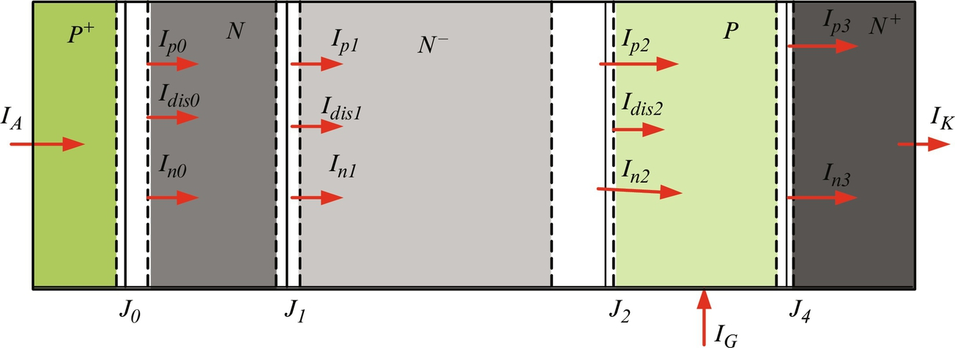

**FIG. 5.16** Schematic structure of SiC high-power thyristor.

A major difficulty in analyzing and modeling the performance of bipolar power devices is due to the different carrier density distribution in the different regions. The behavior of the GTO is modeled by dividing the device into different regions.

The *P*+ and *N*+ emitter regions have high doping concentration, and therefore, there is a significant electron concentration adjacent to the *P*+*N* junction and a significant hole concentration adjacent to the *PN*+ junction due to the equal concentrations of holes and electrons. As a result of these high concentrations, minority carriers flow into the highly doped *P*+ and *N*+ emitter regions, where they recombine with holes and electrons, respectively. The process is known as emitter recombination. The resulting electron and hole currents due to the recombination are

 **(5.162)**

**** **(5.163)**

where *pN*0 and *nPW* are the hole and the electron concentrations at junctions J0 and J3, respectively. The recombination parameters, *hp* and *hn*, calculated by Eqs. [(5.32)](https://learning.oreilly.com/library/view/power-electronics-handbook/9780128114087/B9780128114070000052_1.xhtml#fo0165), [(5.63)](https://learning.oreilly.com/library/view/power-electronics-handbook/9780128114087/B9780128114070000052_1.xhtml#fo0325), depend on the emitter properties, such as doping level ( and ), electron and hole diffusivities (*Dn* and *Dp*), and electron and hole lifetime (*τn* and *τp*). The hole and emitter currents in the P+ and N+ emitter regions are

 **(5.164)**

**** **(5.165)**

Adding a buffer layer allows a reduction of the drift region thickness for the same blocking voltage and speeds up the thyristor turn-off process, but it creates two junctions, J1 and J2. Due to electron reverse injection into the *P*+ emitter, there is a small electron current, *In0*, at junction J0. These electrons travel through the buffer layer coming from the drift region. The hole current, *Ip0*, injected from the *P*+ emitter travels mostly by diffusion through the buffer layer. Since the buffer layer is typically quite thin in comparison with the diffusion length in the buffer layer, , there is little recombination in the buffer layer, and most of the hole current reaches the drift region. This current, *Ip1*, presents the hole injection from the buffer layer into the drift region.

The difference between the two hole currents at the junction J1 and J0 is due to the recombination, and it is compensated by an increase in the electron current, so that the electron current *In1* at junction J1 can be presented by a sum of the recombination component plus the reverse injection electron current *In0*. Static conditions are assumed up to now, while under the dynamic condition an additional hole current component due to variations in the stored charge in the buffer layer should be consider.

Assuming a quasistatic state, the continuity equation of the holes in the buffer layer is then expressed by

 **(5.166)**

where *τpN* is the minority lifetime and *DpN* is the hole diffusivity in the buffer layer. The solution for the excess hole concentration in the buffer layer is given by

 **(5.167)**

where *WN* is the width of the buffer layer, *pN0* and *pNW* are the hole concentrations at the two edges of the buffer layer (junctions J0 and J1), and *LpN* is the diffusion length of the holes.

Under the low-level injection, the minority hole current is mostly diffusion current, so it is expressed as

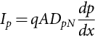 **(5.168)**

Thus, the hole current at the junction J0 is obtained by substituting the derivative of Eq. [(5.167)](https://learning.oreilly.com/library/view/power-electronics-handbook/9780128114087/B9780128114070000052_2.xhtml#fo0855) for  into Eq. [(5.168)](https://learning.oreilly.com/library/view/power-electronics-handbook/9780128114087/B9780128114070000052_2.xhtml#fo0860):

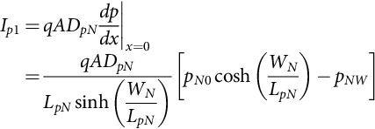 **(5.169)**

Assuming quasiequilibrium, the reverse injection current *In0*, at junction J0 is given by

 **(5.170)**

where *Isne* is the emitter electron saturation current, which is usually small, and *NN* is the doping concentration of the buffer layer.

The current continuity at the boundaries of the buffer layer requires that

 **(5.171)**

Then, the hole concentration at the junction J1 is obtained by substituting Eqs. [(5.169)](https://learning.oreilly.com/library/view/power-electronics-handbook/9780128114087/B9780128114070000052_2.xhtml#fo0865), [(5.170)](https://learning.oreilly.com/library/view/power-electronics-handbook/9780128114087/B9780128114070000052_2.xhtml#fo0870) into Eq. [(5.171)](https://learning.oreilly.com/library/view/power-electronics-handbook/9780128114087/B9780128114070000052_2.xhtml#fo0875) and then reorganizing to the form:

 **(5.172)**

The hole current, *Ip1*, at junction J1 is obtained similar to *Ip0*, only :

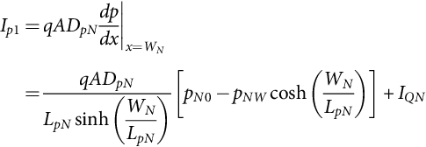 **(5.173)**

The current, *IQN*, represents the capacitive current due to the variation in the charge, *QN*, stored in the buffer region.

 **(5.174)**

The charge, *QN*, can be approximated as

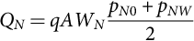 **(5.175)**

The hole concentration, *pNW*, at the boundary between the buffer layer and the drift region, is obtained by applying the Boltzmann relationship for the junction J1 under the assumption of high-level injection in the drift region :

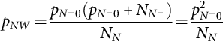 **(5.176)**

where  is the hole concentration in the beginning and  is the doping concentration of the *N*− drift region that is denoted below as *px1*.

The voltages across the junctions, J0 and J1, are

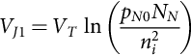 **(5.177)**

**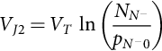** **(5.178)**

The GTO thyristor requires a thick drift region to support a high blocking voltage. A simple charge control modeling approach cannot be applied for the drift region because the transient duration compares with or is shorter than the transient time of the charge carriers. In this case, the charge dynamics in the drift region can be described by the continuity and the transport equations. The charge profile in the thick drift region can be assumed as one-dimensional over more than 90% of the volume, which makes the analysis simple. Also, high-level injection conditions can be assumed during the time of the transient and static state. Under this assumption and quasineutrality, the one-dimensional ambipolar diffusion equation that describes the carrier dynamics in the majority of this region is given by Eq. [(5.35)](https://learning.oreilly.com/library/view/power-electronics-handbook/9780128114087/B9780128114070000052_1.xhtml#fo0180). The equations from [Section 5.3.2.2](https://learning.oreilly.com/library/view/power-electronics-handbook/9780128114087/B9780128114070000052_1.xhtml#s0095) for SiC PiN diodes in Eqs. [(5.35)](https://learning.oreilly.com/library/view/power-electronics-handbook/9780128114087/B9780128114070000052_1.xhtml#fo0180)–[(5.61)](https://learning.oreilly.com/library/view/power-electronics-handbook/9780128114087/B9780128114070000052_1.xhtml#fo0315) are the same for a power GTO, so it will not be repeated.

The junction voltage *VJ*2 between the lightly doped drift region *N*− and the *P* base is

 **(5.179)**

The lumped-charge method can be used to model the charge behavior in the base region due to high doping level and comparatively narrow base width. Using the continuity equation for the base region, the injected minority carrier charge can be described by the relation below:

 **(5.180)**

where *τPHL* is the high-level lifetime in the *P*-base region. The electron concentration at the *P*-base region boundary, *nP*0, is related to *px2* by the doping concentration of the base, *NP*, by the equation:

 **(5.181)**

The total electron charge in the base can be expressed as

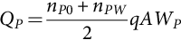 **(5.182)**

where *nPW* is the electron concentration at the base region boundary from the *N*+ emitter side and *WP* is the base width. Since the diffusion length in the *P*-base region is much greater than the base width, the gradient of the electron concentration may be approximated linearly. Then, the electron current at junction, J3, is

 **(5.183)**

The junction voltage *VJ3* between the *P*-base and the *N*+ emitter can be calculated by the equation:

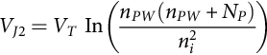 **(5.184)**

The voltage drop *VAK* across the SiC thyristor is composed of seven components including voltages across junctions J0, J1, J2, and J3, the voltage across the two depletion regions, *Vd1* and *Vd2*, and the voltage across the drift region, :

 **(5.185)**

## 5.4 GaN Power Devices

Due to the significant improvements in GaN material growth technology, engineers have utilized different GaN-based power devices in high-frequency and power applications. The device designers are trying to improve performance and reliability and optimize their FOM parameters to obtain high system efficiency. GaN HEMT devices ranging up to 650 V are available on the market. The physics and important parameters of GaN power devices are discussed below.

### 5.4.1 LATERAL GAN SCHOTTKY BARRIER DIODES

To achieve a high-efficiency, high-density power conversion system, the high-voltage diodes used in a system should have low turn-ON voltage, *VT*, low ON-resistance, *RON*, low leakage current, and short reverse recovery time. Due to the wide bandgap of GaN and high electron mobility in the 2DEG, AlGaN-/GaN-based lateral Schottky barrier diodes (SBDs) on a Si, sapphire, or SiC substrate have demonstrated superior performance over rectifiers made in other material systems, such as gallium arsenide (GaAs)-based devices. The advantages of lateral GaN-based devices are that they have a very low ON-resistance because of the extremely high electron concentrations in the 2DEG, up to 10–20 times higher that GaAs-based devices. Lateral SBDs have a small junction capacitance compared with conventional Schottky diodes and, therefore, low reverse recovery times. Also, a lateral design approach enables the standard GaN HEMT process flow to be used for integrating a Schottky diode with a high-voltage transistor [[135](https://learning.oreilly.com/library/view/power-electronics-handbook/9780128114087/B9780128114070000052_3.xhtml#bb0680)].

A cross section of a typical lateral AlGaN/GaN heterostructure Schottky diode is shown in [Fig. 5.17](https://learning.oreilly.com/library/view/power-electronics-handbook/9780128114087/B9780128114070000052_2.xhtml#f0090). The epitaxial layers are grown by metal-organic chemical vapor deposition on a substrate, and then, two types of contacts, ohmic and Schottky, are formed.



**FIG. 5.17** Cross section of a lateral AlGaN/GaN heterostructure Schottky diode (substrate, AlN buffer layer, GaN, and AlGaN).

The quality of the epitaxial GaN depends on the quality of the substrate. Si, sapphire, SiC, and GaN can be used for the substrate. Si substrates have good quality, are significantly large in size, and are inexpensive. They can be used for GaN devices for low-power-density applications, where the losses are not high and the device temperature does not exceed the maximum operating junction temperature. Using a Si substrate for GaN devices introduces a number of critical issues due to the lattice mismatch and the difference in the thermal expansion coefficients, which affects the quality and device reliability [[34](https://learning.oreilly.com/library/view/power-electronics-handbook/9780128114087/B9780128114070000052_3.xhtml#bb0175)]. Sapphire substrates are cost-effective and widely used for electronic devices with high power density and high-pulsed-output power densities, but it has a high lattice mismatch to GaN and poor thermal conductivity. Therefore, it is difficult to remove heat produced during operation. For high-power-density applications, the GaN devices should be grown on a SiC substrate since the SiC thermal conductivity is three times higher than Si, which leads to improved heat dissipation. The qualities of SiC substrates have improved significantly in the last few years, but they are still not widely available at low cost. GaN substrates have only recently been developed and used for power devices, although they are most important for optical applications. By using GaN substrates, the lattice mismatch is fully eliminated, but the cost of these substrates is high, and large diameters are not available. GaN layers grown on GaN substrates have low defect densities compared with layers grown on other types of substrate. Therefore, for devices of the same physical dimensions, devices utilizing GaN substrates will exhibit better OFF-state and ON-state characteristics.

Growth of GaN onto a Si or a sapphire substrate offers the very attractive potential for incorporating GaN devices. However, because of the large difference in lattice constant, crystal structure, and thermal expansion coefficient, it is difficult to epitaxially grow GaN. To solve this problem, a buffer layer that minimizes the mismatch between the substrate and GaN allows growth with a quality equal to GaN. Several buffer layer types have been used to grow GaN on Si, for example, SiC [[136](https://learning.oreilly.com/library/view/power-electronics-handbook/9780128114087/B9780128114070000052_3.xhtml#bb0685)], AlN [[137](https://learning.oreilly.com/library/view/power-electronics-handbook/9780128114087/B9780128114070000052_3.xhtml#bb0690)], GaAs [[138](https://learning.oreilly.com/library/view/power-electronics-handbook/9780128114087/B9780128114070000052_3.xhtml#bb0695)] and silicon nitride (Si3N4) [[139](https://learning.oreilly.com/library/view/power-electronics-handbook/9780128114087/B9780128114070000052_3.xhtml#bb0700)]. An AlN buffer layer is one of the best candidates for obtaining high-quality GaN on a Si substrate. It was found in [[140](https://learning.oreilly.com/library/view/power-electronics-handbook/9780128114087/B9780128114070000052_3.xhtml#bb0705)] that a thicker AlN buffer layer resulted in higher crystalline quality of consequently grown GaN film.

The heterostructure consisting of undoped GaN and undoped zinc blende (cubic) (Al0.3Ga0.7N) is grown on the AlN buffer layer. Due to spontaneous and piezoelectric polarization, a 2DEG is created in the channel at the AlGaN/GaN interface [[141](https://learning.oreilly.com/library/view/power-electronics-handbook/9780128114087/B9780128114070000052_3.xhtml#bb0710)]. The sheet electron density and the mobility in the channel are significantly high, ~1013 cm−2 and 1500 cm2(V s)−1, respectively, which result in low ON-state resistance.

Two types of contacts are formed in a lateral SBD. Metals or alloys such as palladium (Pd), platinum (Pt), indium-platinum (IrPt), palladium-silver (PdAg), and nickel/gold (Ni/Au) that have higher work functions than GaN can be used to form a Schottky barrier to the channel. The Schottky barrier is formed to the AlGaN interfacial layer of an AlGaN/GaN heterostructure. Since the channel has a high electron concentration, the depletion length is significantly shorter than in conventional diodes, although the lateral SBDs have a greater barrier height.

The ohmic contacts of a GaN power device (diodes and transistors), in most cases, represent a metal stack that is formed by thermal evaporation of different metals in multilayers following by rapid thermal annealing. The devices should be optimized to have low specific conduction resistance, and they should also be thermally stable. For *N*-type GaN, metal stacks such as titanium/aluminum/molybdenum/gold (Ti/Al/Mo/Au) and titanium/aluminum/platinum/gold (Ti/Al/Pt/Au) can be used to form ohmic contacts because of their excellent characteristics. A specific contact resistivity as low as 4.7×10−7 Ω cm−2 was obtained by rapid thermal annealing of evaporated Ti/Al/Mo/Au [[142](https://learning.oreilly.com/library/view/power-electronics-handbook/9780128114087/B9780128114070000052_3.xhtml#bb0715)]. Also, Ti/Al/Pt/Au contacts on GaN have shown a minimum contact resistivity of 8.4×10−5 Ω?cm−2 after annealing [[143](https://learning.oreilly.com/library/view/power-electronics-handbook/9780128114087/B9780128114070000052_3.xhtml#bb0720)].

Applying a positive bias, higher than the turn-ON voltage, *VT*, to the anode, causes electrons to flow from cathode to the anode. For an applied anode to cathode voltage, *VAC*, higher than 3*kT*/*q*, the current through the diode is

 **(5.186)**

where A is the Schottky contact area and *A*⁎ is the Richardson constant (26.4 A cm−2K−2), and the potential barrier at the metal-semiconductor interface, *ϕB*, depends on the work function of the metal or alloy used for the Schottky contact.

As a negative bias is applied to the Schottky contact, a depletion layer between the Schottky contact and the 2DEG is formed. Increasing the negative voltage, the depletion layer expands and the junction capacitance decreases, resulting in a nonlinear capacitance-voltage characteristic [[144](https://learning.oreilly.com/library/view/power-electronics-handbook/9780128114087/B9780128114070000052_3.xhtml#bb0725)]. A simple equivalent circuit model of a Schottky/2DEG diode is shown in [Fig. 5.18](https://learning.oreilly.com/library/view/power-electronics-handbook/9780128114087/B9780128114070000052_2.xhtml#f0095). It consist of a voltage-dependent junction capacitance, *Cj*, series resistance, *Rs*, and a shunt capacitance, *Csh*, [[144](https://learning.oreilly.com/library/view/power-electronics-handbook/9780128114087/B9780128114070000052_3.xhtml#bb0725)].



**FIG. 5.18** A simple equivalent circuit model of a Schottky diode.

The junction capacitance, *Cj*, is

 **(5.187)**

where *W* is the Schottky contact width and *R* is the half height of the Schottky metallization. The depletion width *ddep* is

 **(5.188)**

where *Vbi* is the built-in voltage, *VAC* is the reverse bias applied voltage, and *ns* is the 2DEG sheet charge density. The series resistance, *Rs*, is a sum of the undepleted channel resistance, *RCH*, and the ohmic contact resistance, *ROC*:

 **(5.189)**

The undepleted channel resistance, *RCH*, is

 **(5.190)**

where *LAC* is the distance between anode and cathode (channel length) and *μn* is the electron mobility in 2DEG. The ohmic contact resistance, *ROC*, is

 **(5.191)**

where *rsp* is the specific contact resistivity. The shunt capacitance, *Csh*, includes the ohmic contact (pad-to-pad) capacitance and Schottky contact-to-ohmic pad capacitance.

For high-voltage SBDs, the device channels are significantly long. Therefore, it can be assumed that the junction breakdown is caused either by impact ionization or by tunneling. The channel length, *LAC*, is a very important device parameter for a lateral SBD. By increasing the distance, *LAC*, larger breakdown voltages can be obtained, but the ON-resistance and, therefore, the conduction losses will be higher.

Different technologies have been studied to improve SBD performance. One of them uses an anode composed of two metals with different work functions. In this case, two types of contacts are formed: a Schottky and an ohmic, as shown in [Fig. 5.19](https://learning.oreilly.com/library/view/power-electronics-handbook/9780128114087/B9780128114070000052_2.xhtml#f0100).



**FIG. 5.19** A Schottky diode with recessed dual anode metal.

The low work function metal reduces the turn-ON voltage, *VT*, and the high work function metal at the edge of the anode reduces the reverse leakage current and maintains the breakdown voltage. In [[145](https://learning.oreilly.com/library/view/power-electronics-handbook/9780128114087/B9780128114070000052_3.xhtml#bb0730)], it is shown that the turn-ON voltage of the SBD is reduced from 1.47 to 0.57 V by employing the dual metal anode, and the breakdown voltages are virtually unaffected.

Another technology that can be used to reduce the turn-on voltage, *VT*, without an increase in the leakage current is recess etching in the anode region of an SBD. The etching process must be well controlled because uneven etched surface morphologies can result in an increase in the surface leakage current [[146](https://learning.oreilly.com/library/view/power-electronics-handbook/9780128114087/B9780128114070000052_3.xhtml#bb0735)]. A combination of an ohmic anode and a recessed Schottky gate, as shown in [Fig. 5.19](https://learning.oreilly.com/library/view/power-electronics-handbook/9780128114087/B9780128114070000052_2.xhtml#f0100), is responsible for the low turn-ON voltage and an increase in the forward current. No breakdown-voltage degradation has been observed. In comparison with a conventional SBD, the forward current at 1.5 V is increased by two to three times in the SBD with a recessed dual anode metal, resulting in a breakdown voltage of 1440 V. The reason for this is that when a small positive voltage is applied to the anode, electrons flow from the cathode to the anode ohmic metal. Increasing the anode voltage so that the Schottky contact under the recessed anode region is turned on causes electrons to also flow through the Schottky metal. Additional electrons passing through the anode ohmic contact lead to very low turn-ON voltage, *VT*, and high forward current.

The recess depth, *d*, is an important design parameter for a Schottky GaN device. For devices with a higher value than the optimum recessed depth, the electrons tend to flow through the Schottky metal instead of through the anode ohmic metal so that the electrons flowing to the anode ohmic metal are suppressed. The blocking voltage is not affected by the recess depth. In [[146](https://learning.oreilly.com/library/view/power-electronics-handbook/9780128114087/B9780128114070000052_3.xhtml#bb0735)], it is reported that an AlGaN/GaN on Si SBD with dual metal and 16 nm recess depth with 0.34 V turn-ON voltage, *VT*, has an anode current, *IA*, (at 1.5 V) equal to 1.63 A. A SBD with a maximum breakdown voltage of 1.9 kV was reported by [[147](https://learning.oreilly.com/library/view/power-electronics-handbook/9780128114087/B9780128114070000052_3.xhtml#bb0740)].

Researchers have reaped the benefits of GaN lateral Schottky diodes, such as low turn-ON voltage, *VT*; low ON-resistance, *RON*; low leakage current; and low reverse recovery times. Improvements in the reliability of the GaN lateral Schottky diodes will make them the best candidates for high-power applications.

### 5.4.2 VERTICAL GAN PIN DIODES

GaN vertical devices have been studied extensively because of their potential to sustain high breakdown voltage without enlarging the chip area [[148](https://learning.oreilly.com/library/view/power-electronics-handbook/9780128114087/B9780128114070000052_3.xhtml#bb0745)] and hence increasing the number of dies on a wafer. Also, vertical GaN devices have the potential to achieve a higher power at high temperature (150°C) than the lateral devices, especially for higher breakdown voltages and higher scaling level designs [[149](https://learning.oreilly.com/library/view/power-electronics-handbook/9780128114087/B9780128114070000052_3.xhtml#bb0750)]. Vertical devices have high current capability and do not suffer from the thermal management issues associated with thin-film surfaces [[150](https://learning.oreilly.com/library/view/power-electronics-handbook/9780128114087/B9780128114070000052_3.xhtml#bb0755)].

The reliability and performance of GaN-based devices depends on the defect density. GaN layers grown on foreign substrates (e.g., Si or SiC) create difficulties for realizing vertical devices because of higher defect densities (>108–109 cm−2) created. For fabricating devices with high breakdown-voltage capability, low leakage current, and high reliability, it is very important that the epitaxial layers have a low defect density. GaN layers grown on a GaN bulk substrate have significantly low defect densities (<106 cm−2), but the bulk GaN substrates are too expensive and currently have small diameters, which are the main challenges for the commercialization of the GaN vertical devices, although they have shown high performance. Scientists from different universities and companies are conducting ongoing research into improving the quality and increasing the size of the GaN substrates. The research is mostly driven by the optoelectronics industry in two directions: scalability and price reduction. Since there are already multiple suppliers of bulk GaN substrates, the development of GaN vertical power devices will increase soon.

In [Fig. 5.20](https://learning.oreilly.com/library/view/power-electronics-handbook/9780128114087/B9780128114070000052_2.xhtml#f0105), a cross section of a vertical GaN PiN diode is shown. Similar to Si and SiC PiN diodes, a GaN PiN diode consists of a heavily doped *N*+ region, a lightly doped drift region, and a heavily doped *P*+ region. When a GaN vertical diode is built on GaN substrate, the substrate has a high electron concentration (1.5–2×1018 cm−3) and plays a role as a heavily doped *N*+ region. Some researchers have built a GaN vertical diode on a Si substrate. In this case, due to the lattice mismatch and differences in the thermal expansion coefficients between Si and GaN, a buffer layer of AlN/GaN or AlGaN is grown between the substrate and the epitaxial layer. The buffer layer improves the quality of the epitaxial layer grown on top of it. Then, a heavily Si-doped *N*-GaN layer (2×1018 cm−3) is grown.



**FIG. 5.20** A cross section of a vertical GaN PiN diode.

As mentioned earlier for *N*-type GaN, metal stacks, such as Ti/Al/Mo/Au, Ti/Al/Pt/Au, and others, can be used to form low-resistivity stable ohmic contacts because of their excellent characteristics. Obtaining stable contacts with low resistivity for *P*-type GaN is more difficult due to the wide bandgap of GaN. Since the work function of *P*-type semiconductors is larger and for a wide bandgap it will be pronounced, a metal with a larger work function [[151](https://learning.oreilly.com/library/view/power-electronics-handbook/9780128114087/B9780128114070000052_3.xhtml#bb0760)] is required to align the metal and semiconductor Fermi levels. Metal stacks, such as Ni/Au, Pd/Au, Ni/Pd/Au, and others, can be used for these ohmic contacts. An alloy of Ni/Pd/Au is reported to have good ohmic contact with a low specific resistance of 4.5×10−6 Ω cm2 [[152](https://learning.oreilly.com/library/view/power-electronics-handbook/9780128114087/B9780128114070000052_3.xhtml#bb0765)].

For the same breakdown voltage, the thickness of the lightly doped drift region *N*− of a GaN vertical PiN diode is smaller than the thickness of Si and SiC PiN diodes, while GaN PiN diodes can have a higher doping concentration in the lightly doped drift region than SiC and Si. Shown in [Fig. 5.21](https://learning.oreilly.com/library/view/power-electronics-handbook/9780128114087/B9780128114070000052_2.xhtml#f0110) are the calculated results for the minimum width of the lightly doped drift region as a function of the doping concentration for a PiN structure for different applied voltages and different semiconductor materials: Si, 4H-SiC, and GaN [[153](https://learning.oreilly.com/library/view/power-electronics-handbook/9780128114087/B9780128114070000052_3.xhtml#bb0770)]. For a 3 kV GaN diode, the thickness of the lightly doped drift region is ~12 μm, and the doping concentration for this thickness is ~1016 cm−3. For a SiC device, the thickness and the doping concentration for a 3 kV device are 15 μm and ~7×1015 cm−3, while for a Si device the thickness and the doping concentration for a 3 kV device are 200 μm and ~8×1013 cm−3. In [[154](https://learning.oreilly.com/library/view/power-electronics-handbook/9780128114087/B9780128114070000052_3.xhtml#bb0775)], a vertical GaN 2.6 kV power diode is described with a lightly doped drift region width and doping concentration of 15 μm and ~8×1013 cm−3, which support the calculated results given in [[153](https://learning.oreilly.com/library/view/power-electronics-handbook/9780128114087/B9780128114070000052_3.xhtml#bb0770)]. On the drift region, a heavily magnesium (Mg)-doped P+-type GaN layer is grown. The layer's impurity concentration is higher than 2×1017 cm−3, depending on the diode design.



**FIG. 5.21** The minimum width of the lightly doped drift region (Wmin) as a function of doping concentration (*ND1*) for a *P*+*N* diode and a *P*+*N*−*N*+ structure for different applied voltages and different semiconductor materials: (A) Si, (B) 4H-SiC, and (C) GaN.

A level-3 model introduced in [Section 5.3.2.2](https://learning.oreilly.com/library/view/power-electronics-handbook/9780128114087/B9780128114070000052_1.xhtml#s0095) can be used for modeling a GaN PiN power diode. The most important parameter for a power GaN PiN diode is the voltage drop, *VAK*, across it during the conduction state. It is composed of five components, including the voltages across the junctions, J*1* and J*2*; the voltage across the two depletion regions, *Vd1* and *Vd2*; and the voltage across the drift region, :

 **(5.192)**

Although the lightly doped drift region of a GaN PiN diode is significantly thinner than the lightly doped drift region of a Si PiN diode and the carrier concentration in the drift region is considerably higher in a GaN device, the voltage drop across a 5 kV GaN device, at a current smaller than 50 A, is larger than the voltage drop of a Si diode. The published data for the turn-ON voltage at room temperature of a GaN diode are larger than 3 V [[150](https://learning.oreilly.com/library/view/power-electronics-handbook/9780128114087/B9780128114070000052_3.xhtml#bb0755),[155](https://learning.oreilly.com/library/view/power-electronics-handbook/9780128114087/B9780128114070000052_3.xhtml#bb0780)–[157](https://learning.oreilly.com/library/view/power-electronics-handbook/9780128114087/B9780128114070000052_3.xhtml#bb0790)]. The reason for the higher turn-ON voltage of a GaN PiN diode is similar to the reason for that in a SiC PiN diode. SiC and GaN are wide bandgap materials, and their intrinsic carrier concentration, *ni*, at room temperature is significantly smaller than the carrier concentration of Si. The junction voltage of junction J*1* is a dominant term in Eq. [(5.192)](https://learning.oreilly.com/library/view/power-electronics-handbook/9780128114087/B9780128114070000052_2.xhtml#fo0980), especially for the diodes with a breakdown voltage smaller than 5 kV. The junction voltage of junction J*1* is

 **(5.193)**

where *VT* is the thermal voltage (*kT*/*q*), *px1* is the excess carrier concentration of the lightly doped drift region at the junction J*1*, and  is the doping concentration of the lightly doped drift region. The total junction voltage *Vj*12, which is a sum of the voltages of the junctions J*1* and J*2*, *Vj*1 and *Vj*2:

 **(5.194)**

The total junction voltage, *Vj*12, does not directly depend on the doping concentration of the lightly doped drift region, . However, there is a dependency between the boundary values of the excess charge concentrations, *px*1 and *px*2, and the impurity doping level that determines the junction voltage values. Also, the excess carrier concentrations, *px*1 and *px*2, depend on the emitter recombination parameters that can be assumed as constants for calculating the total forward voltage drop.

To obtain the minimum forward voltage drop, *VAK*, during conduction time, the minimum width of the drift region, corresponding to the minimum doping concentration, should be used. However, the results from the simulation given in [[153](https://learning.oreilly.com/library/view/power-electronics-handbook/9780128114087/B9780128114070000052_3.xhtml#bb0770)] do not agree with this simple assertion. Increasing the doping concentration, ,for the same breakdown voltage leads to a decrease of *VAK* to a minimum value, after which further increases in the doping concentration cause an increase in the forward voltage drop. A higher doping concentration, , reduces the injection efficiencies of the higher doped *P*+ and *N*+ emitters into the drift region and, therefore, decreases the values of the excess carrier densities, *px*1 and *px*2, at the region boundaries. From Eq. [(5.194)](https://learning.oreilly.com/library/view/power-electronics-handbook/9780128114087/B9780128114070000052_2.xhtml#fo0990), it can be seen that as the boundary charge concentrations are reduced, the total junction voltage, *Vj*12, also reduces, as shown in [Fig. 5.22](https://learning.oreilly.com/library/view/power-electronics-handbook/9780128114087/B9780128114070000052_2.xhtml#f0115).



**FIG. 5.22** The simulation results of a Si PiN structure for a designed breakdown voltage of 5 kV, given in [[148](https://learning.oreilly.com/library/view/power-electronics-handbook/9780128114087/B9780128114070000052_3.xhtml#bb0745)]: the total junction voltage, *Vj*12, and the voltage drop across the drift region, , as a function of the doping concentration of the lightly doped drift region, .

Although higher doping concentrations, , lead to a decrease in the values of the excess carrier densities, *px*1 and *px*2, the voltage drop across the drift region, , has a minimum value. The forward voltage drop, *VAK*, also has a minimum.

The simulation results for optimizing the doping concentration to minimize the forward voltage drop, *VAK*, of a 5 kV Si PiN diode would lead to a reduction in the forward drop of more than 12%, while for SiC and GaN PiN diodes the reduction in the forward voltage drop for a concentration below 1015 cm−3 is <1% [[153](https://learning.oreilly.com/library/view/power-electronics-handbook/9780128114087/B9780128114070000052_3.xhtml#bb0770)]. Hence, the optimization of the concentration of the lightly doped drift region for SiC and GaN is not necessary.

Fabricating GaN devices with high breakdown voltages requires a low-doped drift region and edge-termination (ET) structures that do not limit device performance. ET plays a key role in determining the device breakdown voltage. The purpose of the ET structures is to spread out the electric field at the edge of the junction such that there is no region with a very high electric field that can damage the device. The lack of good ET reduces the breakdown voltage significantly below the ideal limits due to field crowding at the edges that leads to an avalanche breakdown. To improve device performance, the electric field crowding at the edges should be minimized. Different ET techniques have been used for different types of GaN devices. One of them is smoothing of the equipotential contours at the edge of the device resulting in a manageable electric field [[158](https://learning.oreilly.com/library/view/power-electronics-handbook/9780128114087/B9780128114070000052_3.xhtml#bb0795)]. A field-plate structure consisting of a SiNx passivation layer and a Ti/Au bilayer can be used for the ET [[159](https://learning.oreilly.com/library/view/power-electronics-handbook/9780128114087/B9780128114070000052_3.xhtml#bb0800)]. When the metal contact is extended over a surface dielectric layer, for example, SiO2, the depletion region boundary is extended, and therefore, the electric field crowding is reduced [[160](https://learning.oreilly.com/library/view/power-electronics-handbook/9780128114087/B9780128114070000052_3.xhtml#bb0805)]. Another ET technique for reducing electric field crowding is the formation of a *P*+ floating ring or guard ring [[160](https://learning.oreilly.com/library/view/power-electronics-handbook/9780128114087/B9780128114070000052_3.xhtml#bb0805)]. In [[161](https://learning.oreilly.com/library/view/power-electronics-handbook/9780128114087/B9780128114070000052_3.xhtml#bb0810)], a simple ET technique is used to achieve nearly ideal parallel plane breakdown voltage for GaN devices. The technique involves implanting a neutral species on the edges of devices to form a highly resistive, amorphous layer. ET is obtained by using argon implantation, increasing the breakdown voltage of GaN Schottky barrier diodes from 300 V for unterminated diodes to 1650 V after ET.

Improving the quality and the size of the GaN substrate, improving the quality of the epitaxial layers, and choosing the right ET technique will help the device designer to fabricate a high-voltage GaN PiN diode (>10 kV) that will switch quickly and have a smaller forward voltage drop than the Si PiN diode.

### 5.4.3 GAN JFET

The breakdown voltage of a lateral transistor depends mainly on the channel parameters. In order to maintain low ON-resistance, *RON*, the device width and the space between the gate and the drain should be increased, which limits the breakdown voltage to 1 kV and increases the need for more sophisticated device structures for managing the electric field and also increases the device capacitance. In a vertical device, the breakdown voltage depends on the deposition region parameters, and it is easier to scale up for high current and voltage. Vertical devices allow greater power density, lower capacitance, and generally better performance.

Two types of JFETs are considered in this book: a vertical JFET (VJEFT) and a lateral channel JFET with a vertical drift region (LC-VJFET).

#### **5.4.3.1 Vertical JFET**

Two cross sections of vertical GaN JFETs are depicted in [Fig. 5.23](https://learning.oreilly.com/library/view/power-electronics-handbook/9780128114087/B9780128114070000052_2.xhtml#f0120). The first one has a rectangular channel, and the second has trapezoidal channels. Depending on the doping levels and physical dimensions of a VJFET, the transistor can be designed to operate as a normally-ON or normally-OFF device. A normally-OFF device is preferable because it will prevent current from flowing when no voltage is applied to the gate, and therefore, it can be easily utilized in power applications.



**FIG. 5.23** A cross section of a vertical JFET with rectangular and trapezoidal channels.

A cascode circuit, shown in [Fig. 5.24](https://learning.oreilly.com/library/view/power-electronics-handbook/9780128114087/B9780128114070000052_2.xhtml#f0125), includes a high-voltage, normally-ON GaN JFET with a low-voltage MOSFET that can operate as a normally-OFF high-voltage device. The high-voltage GaN VJFET is a normally-ON device and has a negative threshold voltage, and the low-voltage MOSFET is capable of blocking ~30 V with a standard power MOSFET threshold voltage. The cascode circuit has the gate-driving characteristics of the standard power MOSFET and the current/voltage capability of the high-voltage GaN VJFET. Since the MOSFET is a low-voltage device, its ON-resistance, *RDS*\_*ON*, is significantly smaller than in the GaN JFET, and the associated losses will be insignificant.



**FIG. 5.24** A cascode circuit including a high-voltage JFET and low-voltage MOSFET.

A VJFET consists of a heavily doped *N*+ region, a lightly doped *N*− drift region, and a channel region that is formed between two heavily doped *P*+ regions. On the top of the channel region is the heavily doped *N*+ region. For a normally-OFF device and with no voltage applied to the gates (*VGS*=0), the channel is fully depleted of carriers due to a significantly high doping concentration of the heavily doped *P*+ regions and the significantly low doping concentration in the channel. The depletion region width depends on the doping concentrations of the channel and heavily doped *P*+ region, *NCH* and *NP*; GaN permittivity, *ɛ*; built-in voltage, *Vbi*; and gate-source voltage, *VGS*:

 **(5.195)**

The built-in voltage is calculated by the equation:

 **(5.196)**

where *k is* Boltzmann's constant, T is the temperature in Kelvin, *q* is unit electric charge, and *ni* is the GaN intrinsic carrier concentration. If a positive voltage is applied to the gates, the depletion region width decreases, creating no resistive path for the current, and the current passes through the channel from the drain to the source.

For a normally-ON device and no voltage applied to the gates (*VGS*=0), the channel is not depleted, and the current passes through the channel from the drain to the source. When a negative voltage, with a magnitude higher than the threshold voltage, is applied to the gate, the depletion region is extended and prevents current from passing through the channel.

When a GaN VJFET is built on GaN substrate, the substrate has high electron concentration and plays the role as a heavily doped *N*+ region. Other substrates, such as Si or SiC, can be used for building of a GaN VJFET.

Epitaxial layers are grown on the top of the GaN substrate or the buffer layer for devices made with other substrates. The VJFET GaN epitaxial layers can have nonuniform doping concentration as a function of the thickness of the different layers, which can be used for optimizing a device's performance [[162](https://learning.oreilly.com/library/view/power-electronics-handbook/9780128114087/B9780128114070000052_3.xhtml#bb0815)]. The drift region thickness and the doping concentration are designed to carry the majority of the drain-source voltage, *VDS*. The drift region concentration can be in the range of 1014–1016 cm−3. The gates are formed on the top of the heavily doped *P*+ regions, whose thickness, *tCH*, determines the channel thickness. The doping concentration in the channel can be equal to or less than the doping concentration of the drift region. The doping concentration in the channel depends on the desired threshold voltage of the VJFET.

In [Fig. 5.23](https://learning.oreilly.com/library/view/power-electronics-handbook/9780128114087/B9780128114070000052_2.xhtml#f0120), the channel has a rectangular shape. There are JFETs where the channels can be designed to have a trapezoidal shape. The trapezoidal-shaped channel can improve the performance by enabling better control of the electric field near the location where the channel sidewall and the upper surface meet [[162](https://learning.oreilly.com/library/view/power-electronics-handbook/9780128114087/B9780128114070000052_3.xhtml#bb0815)]. The width of the channel, *WCH*, for a rectangular channel or the bottom base for a trapezoidal-shaped channel can vary depending on numerous factors, such as desired functionality (normally-ON or normally-OFF device) and the channel doping concentration. The width and the thickness of the channel, *WCH* and *tCH*, should be optimized so that a very small leakage current flows from the source to the drain while maintaining a low ON-state resistance, *RON*.

Simulation results given in [[163](https://learning.oreilly.com/library/view/power-electronics-handbook/9780128114087/B9780128114070000052_3.xhtml#bb0820)] showed that the ON-state resistance, *RON*, can be reduced by increasing the channel doping concentration and width, but in this case, the breakdown voltage is reduced, a positive threshold voltage is compromised, and a normally-OFF operation is hard to achieve. The threshold voltage, *VT*, is very sensitive to the channel width, *WCH*. In order to achieve a positive threshold voltage, *VT*, the channel width should be smaller than 1 μm, which leads to a high ON-state resistance, *RON*. To obtain a better trade-off between the threshold voltage, *VT*, and ON-state resistance, *RON*, a lateral channel JFET with a vertical drift region is proposed.

#### **5.4.3.2 Lateral Channel JFET With Vertical Drift Region**

A cross section of a lateral channel GaN JFET with a vertical drift region (LC VJFET) is shown in [Fig. 5.25](https://learning.oreilly.com/library/view/power-electronics-handbook/9780128114087/B9780128114070000052_2.xhtml#f0130). Similar to VJFET, the doping levels and physical dimensions of an LC VJFET determine the transistor functionality to operate as a normally-ON or normally-OFF device. A normally-OFF device is preferable, but the cascode configuration shown in [Fig. 5.24](https://learning.oreilly.com/library/view/power-electronics-handbook/9780128114087/B9780128114070000052_2.xhtml#f0125) has the gate-driving characteristic of the low-voltage MOSFET and the current/voltage capability of the high-voltage LC VJFET, which can be used for a normally-ON device.



**FIG. 5.25** A cross section of a lateral channel JFET with a vertical drift region.

The LC VJFET has three regions of interest. First is the core of the device, which includes the device channel and the gate region. The second region includes the lightly doped drift region and the substrate, and the third region is the edge termination and the isolation region.

A GaN LC VJFET can be built on a heavily doped GaN substrate, but other substrates, such as Si or SiC, can also be used. However, in this case, a buffer layer from AlN/GaN, AlGaN, or other suitable materials should be grown between the substrate and the epitaxial layer to improve the quality of the epitaxial layer grown on top of it. The breakdown voltage of an LC VJFET is determined by the doping concentration and thickness of the lightly doped drift region and also the proper edge-termination techniques. For a kV-rated device, the doping concentration of the lightly doped drift region is in the range of 1015–1016 cm−3. The lightly doped drift region provides a region through which current flows from the drain to source during the ON-state, but during the OFF-state, the drift region provides a region for supporting the electric field by the voltage gradient between the source or gate and the drain [[164](https://learning.oreilly.com/library/view/power-electronics-handbook/9780128114087/B9780128114070000052_3.xhtml#bb0825)].

The channel of the LC-VJFET is composed of two parts: a vertical and a lateral conductive region. A blocking *P*-type GaN layer, with a significantly high impurity concentration in the range of 1017–1019 cm−3, is used to form the two regions. The blocking layer supports the vertical electric field and causes the current to flow in the lateral area of the channel. The length of the overlap, *LGOL*, between the gate and the blocking layer is an important parameter. This is exactly the effective gate that modulates the lateral channel width and changes the conductivity of the channel. When the length of the overlap, *LGOL*, is smaller than the optimum value, leakage current in the device increases as the channel is not fully pinched OFF, and some electrons flow from the source to the drain. But increasing the length of the overlap, *LGOL*, more than the optimum value causes the ON-state resistance of the device to increase [[163](https://learning.oreilly.com/library/view/power-electronics-handbook/9780128114087/B9780128114070000052_3.xhtml#bb0820)].

The vertical channel region is a continuation of the lightly doped drift region. The vertical channel thickness and doping concentration should be optimized with two constraints: minimizing the LC-VJFET ON-resistance when the device is turned ON and providing proper pinch-OFF so that no current passes through the channel when the device is turned OFF. The channel width, *WCH*, is also an important design parameter that determines the functionality of the device as a normally-ON or normally-OFF design. If the channel width, *WCH*, is significantly large, the path of the current from the drain to the source will be low resistance, but in this circumstance, pinch-OFF of the channel is more difficult to achieve.

On the top of the channel, a heavily doped *P*+-type GaN layer is deposited and patterned to form the gate. The blocking *P*-type GaN layer, together with the gate, can control the device by the PN junctions formed with the *N*-type channel. In some designs, the gate and the blocking layer are electrically tied to form a buried *P*-type gate.

The edge-termination scheme used in the transistors is similar to those schemes used in PiN junction diodes. The potential applied to the top metal is spread over a distance that is typically greater than the thickness of the lightly doped drift region. For this purpose, two separate implant steps are used. Smoothing the equipotential contours at the device edges results in better management of the electric field on the device surface and prevents the device from breaking down prematurely [[165](https://learning.oreilly.com/library/view/power-electronics-handbook/9780128114087/B9780128114070000052_3.xhtml#bb0830)]. In this case, if a breakdown occurs, it will be due to an avalanche breakdown.

The operation of an LC-VJFET depends on the design. For a normally-OFF device, where no voltage is applied to the gates (*VGS*=0), the channel is fully depleted of carriers due to a significantly high doping concentration of the heavily doped *P*+ gate and the blocking *P*-type GaN layer from one side and a significantly low doping concentration in the channel from the other side. Two depletion regions are formed: one from the *PN* junction of the *P*+ gate and the *N*-channel and the second one from the blocking *P*-type GaN layer and the *N*-channel. The two depletion widths can be calculated using Eq. [(5.195)](https://learning.oreilly.com/library/view/power-electronics-handbook/9780128114087/B9780128114070000052_2.xhtml#fo0995) by substituting the corresponding doped concentrations. The total depletion width, *W*, is a sum of the depletion width of the two junctions. When a positive voltage is applied to the gates, the depletion width, *W*, decreases, and current passes through the channel from the drain to the source. For a normally-ON device with no voltage applied to the gates (*VGS*=0), the channel is not depleted, and the current flows through the channel from the drain to the source. When a negative voltage, with a magnitude higher than the threshold voltage, is applied to the gate, the two depletion regions are expanded and prevent current from passing through the channel.

The simulation results given in [[163](https://learning.oreilly.com/library/view/power-electronics-handbook/9780128114087/B9780128114070000052_3.xhtml#bb0820)] show that there is a higher degree of coupling between the ON-resistance, *RON*, and the threshold voltage, *VT*, in the LC VJFET than in the VJFET. Therefore, a low ON-state resistance can be obtained with a thinner and more highly doped *N*-GaN channel.

### 5.4.4 GAN MOSFET

In the last 10 years, research on the design, fabrication, and characterization of high-voltage GaN MOSFETs has been based on both lateral and vertical structures: the fabrication process for a lateral high-voltage MOSFET is simpler than the vertical MOSFET since a thick, lightly doped drift region is necessary for a vertical structure. For the same breakdown voltage, a lateral device has a larger area than a vertical device. Therefore, the chip size of a lateral MOSFET is bigger. However, a Si substrate can be used for growth of lateral devices, which are larger and cheaper, while GaN substrates are normally used for vertical MOSFETs, which are smaller and more expensive. Other substrates, such as Si or SiC can also be used for vertical devices, but a buffer layer should be grown between the substrate and the epitaxial layer to improve the quality of the epitaxial layer, which increases the device cost.

#### **5.4.4.1 Vertical Trench MOSFET**

[Fig. 5.26](https://learning.oreilly.com/library/view/power-electronics-handbook/9780128114087/B9780128114070000052_2.xhtml#f0135) shows a cross section of a high-voltage GaN vertical trench MOSFET. Most of the vertical GaN high-voltage MOSFETs are built on a low-defect-density GaN substrate, which is the MOSFET drain. The substrate doping concentration is higher than 1018 cm−3. A lightly doped *N*− drift region is grown on the top of the substrate by metal-organic vapor deposition. The doping concentration of the drift region is in the range of 1014–1016 cm−3, and its thickness depends on the desired breakdown voltage. The area of the drift region depends on its thickness. It should be chosen to allow spreading of the current in the drift region, thereby decreasing the drift region ON-resistance. The value of the thickness and the doping concentration of the lightly doped drift region can be optimized so that the sum of the conduction and the switching losses of the device can be minimized.



**FIG. 5.26** A cross section of a vertical trench MOSFET.

A *P*-type base layer with a thickness smaller than 1 μm is grown on the top of the drift region. The thickness of the *P*-layer is the channel length of the device or the effective gate of the device. The doping concentration of the base is higher than the drift region, and it is in the range of 1017–1019 cm−3. On the top of the base layer, a selective area regrowth of a heavily doped *N*+-type layer is grown to form the MOSFET source. SiO2 can be used as the regrowth mask. The doping concentration of the *N*+-type layer is higher than 3×1018 cm−3, and the thickness is smaller than 0.5 μm. Usually for GaN devices, Si is used as the dopant for the formation of *N*-type layers, and Mg is used for *P*-type.

The gate trench is then formed by etching part of the two MOSFET layers, *P* base and *N*+ source. A SiO2 layer, as a dielectric interlayer, is deposited on the sidewall and the bottom of the trench by plasma-enhanced chemical vapor deposition, and then, the metal is deposited to form the gate electrode. The vertical sidewall of the trench should be well smoothed and cleaned to achieve high inversion layer mobility and, therefore, low resistivity of the channel [[38](https://learning.oreilly.com/library/view/power-electronics-handbook/9780128114087/B9780128114070000052_3.xhtml#bb0195)]. Also, the trench bottom plays a crucial role in achieving superior electric performance and highly reliable operation. Therefore, the trench bottom should be a little bit rounded, which will reduce the P-well pinching effect, and as a result, the pinching resistance under the gate-drain area is decreased [[166](https://learning.oreilly.com/library/view/power-electronics-handbook/9780128114087/B9780128114070000052_3.xhtml#bb0835)].

To improve the OFF-state characteristic, such as the breakdown voltage of a trench MOSFET, a field-plate edge-termination technique can be used to reduce the electric field at the edge of the *PN* junction around the isolation mesa periphery [[167](https://learning.oreilly.com/library/view/power-electronics-handbook/9780128114087/B9780128114070000052_3.xhtml#bb0840)]. The field plate consists of the extended wiring electrode for the source electrode. The field-plate electrode completely overlaps the *PN* junction from the side, and therefore, the potential crowding at the edge of the *PN* junction is effectively reduced. While an improvement of the ON-state characteristic, such as the ON-resistance can be achieved by reducing the cell pitch size, improving the dielectric/semiconductor interface quality, and optimizing the drift layer growth condition which will enhance the electron mobility.

The operation of a high-voltage GaN trench MOSFET is similar to the operation of Si and SiC trench MOSFETs. When a positive voltage higher than the threshold voltage is applied between the gate and the source of the device, an *N*-channel region is formed on the surface of the *P* base that provides a conducting path between the source and drain terminals. If the gate to source voltage is below the threshold voltage, the transistor is turned off, and only a very small leakage current is passing from the drain to the source of the transistor. In theory, the threshold voltage of a MOSFET is defined as the voltage applied between the gate and source that creates an inversion layer of minority carriers with a concentration higher than the base. According to [[168](https://learning.oreilly.com/library/view/power-electronics-handbook/9780128114087/B9780128114070000052_3.xhtml#bb0845)], the threshold voltage is

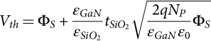 **(5.197)**

where *ɛGaN* and are the permittivity of GaN and SiO2, respectively;,  is the thickness of the SiO2; and *NP* is the doping concentration of the base. The surface potential at the *P* base is Φ*S*. At the deposition-inversion transition point, the surface potential is

 **(5.198)**

For the same doping concentration of the *P* base and SiO2 layer thickness, the calculated threshold voltage for a GaN device should be larger than the threshold voltages of SiC and Si devices because of the significantly low intrinsic carrier concentration of GaN. The simulation result for the threshold voltage of a trench GaN MOSFET (*P*-base doping concentration 3×1019 cm−3) obtained from a one-dimensional, self-consistent Schrödinger-Poisson solver is 26 V, while the experimental result for the same device is significantly lower at 8 V [[169](https://learning.oreilly.com/library/view/power-electronics-handbook/9780128114087/B9780128114070000052_3.xhtml#bb0850)]. Other researchers, [[170](https://learning.oreilly.com/library/view/power-electronics-handbook/9780128114087/B9780128114070000052_3.xhtml#bb0855)–[172](https://learning.oreilly.com/library/view/power-electronics-handbook/9780128114087/B9780128114070000052_3.xhtml#bb0865)], have also reported low experimental threshold voltage values compared with theoretical values. Differences between the simulation and experimental results can be due to the sidewall etch damage of the *P* base, which can cause nitrogen vacancies to form and behave as donors [[169](https://learning.oreilly.com/library/view/power-electronics-handbook/9780128114087/B9780128114070000052_3.xhtml#bb0850)]. Research about decreasing the sidewall etch damage, better smoothing, and cleaning after sidewall etching is being conducted, which will increase the threshold voltage and provide better noise immunity to prevent false turn-on.

In 2016, at the 28th International Symposium on Power Semiconductor Devices and ICs, a state-of-the-art GaN trench MOSFET, with a breakdown voltage of 1.6 kV and a high current operation exceeding 10 A for a single-cell device, was reported [[167](https://learning.oreilly.com/library/view/power-electronics-handbook/9780128114087/B9780128114070000052_3.xhtml#bb0840)]. The breakdown voltage of the device was improved from 1.2 to 1.6 kV by applying a field-plate edge-termination technique around the isolation mesa of the transistor. The specific ON-resistance, *RON*, of the single cell, measured when a gate-source voltage, *VGS*, of 40 V was applied, was 2.7 mΩ cm2. The threshold voltage of the trench MOSFET was reported to be 3.5 V. The authors also showed the switching characteristics for a double-pulse switching experiment (see [Fig. 5.27](https://learning.oreilly.com/library/view/power-electronics-handbook/9780128114087/B9780128114070000052_2.xhtml#f0140)). From the switching characteristics, the rise and fall time, *tr* and *tf*, were determined to be 19 and 10 ns, respectively, when the supply voltage, VDD, was 400 V and the drain current, *ID*, was around 10–14 A. Also, the turn-on and turn-off switching losses were calculated to be 90 and 12 μJ, respectively, which suggests that the fabricated vertical GaN trench MOSFETs are suitable for use in high-power applications with high-frequency switching.



**FIG. 5.27** Schematic circuit diagram for double-pulse switching measurement using the fabricated vertical GaN MOSFET and the internally developed vertical GaN SBD [[162](https://learning.oreilly.com/library/view/power-electronics-handbook/9780128114087/B9780128114070000052_3.xhtml#bb0815)].

#### **5.4.4.2 Lateral MOSFET**

Lateral MOSFETs have a significantly simpler structure than the vertical ones because during fabrication, no heavy etching is used for the gate and no thick, lightly doped drift region is grown. Also, the three terminals, the source, gate, and drain, are placed on the top surface, which is suitable for power-integrated circuits where the power transistor is monolithically integrated with control circuits on the same chip. However, for the same blocking voltage, the length of the channel of a lateral MOSFET is longer, and therefore, the area of the device is larger than the area of a vertical trench MOSFET. Similar to the vertical MOSFET, the lateral MOSFET is normally an OFF device.

A cross section of a GaN lateral MOSFET is shown in [Fig. 5.28](https://learning.oreilly.com/library/view/power-electronics-handbook/9780128114087/B9780128114070000052_2.xhtml#f0145). Different substrates, such as sapphire, SiC, and GaN, have been used for fabricating lateral MOSFETs. A *P*-type Mg-doped GaN layer is grown by metal-organic chemical vapor deposition on top of the substrate. For better growth of the *P*-doped layer, a buffer layer between the substrate and the *P* layer is grown. A SiO2 thin layer is grown on top of the *P* layer to form the MOS structure of the transistor and to suppress any damage or pollution due to ion implantation. The ion implantation is used to place Si ions in the *P* layer and to form heavily doped *N*+ source and drain regions. In the end, low-resistance contact layers are formed on the drain, source, and the gate.



**FIG. 5.28** A cross section of a GaN lateral MOSFET.

The breakdown of a lateral MOSFET is mainly determined by the thickness of the SiO2 layer. Since the drain has a high doping concentration, the voltage drop of the drain region is significantly smaller. Therefore, the potential of the region of the drain under the gate is approximately equal to the applied voltage on the drain. When the gate-source voltage is smaller than the threshold voltage and the drain-source voltage is significantly high, a breakdown can occur in the gate oxide. A schematic of a lateral GaN MOSFET during the OFF-state and its potential and electric field in function of the position is shown in [Fig. 5.29](https://learning.oreilly.com/library/view/power-electronics-handbook/9780128114087/B9780128114070000052_2.xhtml#f0150). During the OFF-state, the gate and source are connected to the ground, and high voltage is applied to the drain with respect to the source. The electric field between the drain and the gate is significantly high because of the small thickness of the SiO2 layer, while the channel length is significantly larger. Therefore, the electric field between the drain and source is smaller. Also, the resistance of the SiO2 layer is larger than the channel resistance. For these reasons, almost all of the electric field is concentrated on the gate oxide, a result of the breakdown near point 1 in [Fig. 5.29](https://learning.oreilly.com/library/view/power-electronics-handbook/9780128114087/B9780128114070000052_2.xhtml#f0150) [[173](https://learning.oreilly.com/library/view/power-electronics-handbook/9780128114087/B9780128114070000052_3.xhtml#bb0870)].

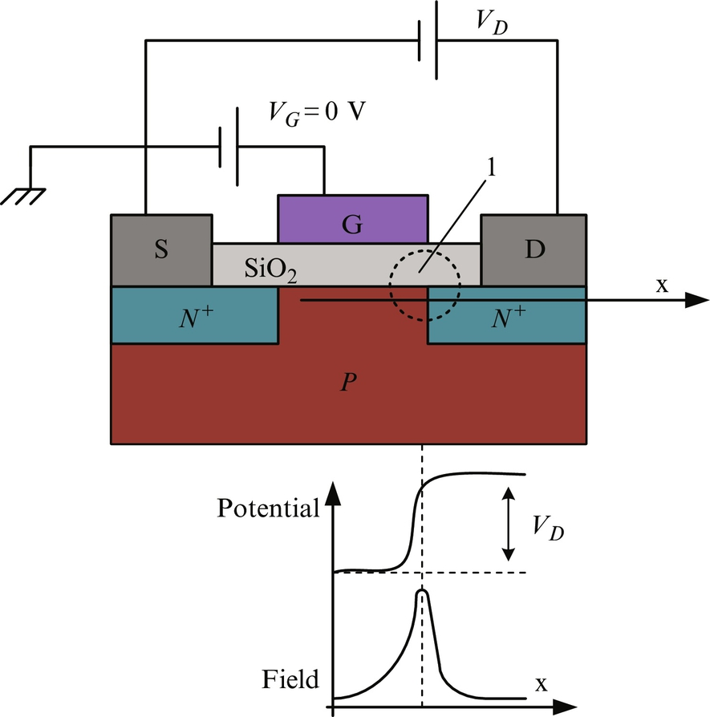

**FIG. 5.29** A schematic of a lateral GaN MOSFET, the potential and electric field during the OFF-state.

The electric field in the region between the gate and the drain is significantly higher and, therefore, limits the voltage applied between the drain and the source. To spread the electric field and decrease its value in the region between the gate and the drain, a lightly doped *N*− layer, known as the reduced surface field (RESURF) layer, is used by different scientific groups to increase the breakdown voltage of a lateral device. The RESURF concept was introduced by Appels and Vaes for the first time [[174](https://learning.oreilly.com/library/view/power-electronics-handbook/9780128114087/B9780128114070000052_3.xhtml#bb0875)]. A RESURF layer increases the breakdown voltage of lateral MOSFETs and increases the ON-state resistance since the layer should be long and lightly doped. Another aspect of a long, lateral drift layer is the additional required chip area, which increases the cost of the devices. For a given breakdown voltage, the optimal parameters of a RESURF layer, the length and doping concentration, should be determined. A trade-off between blocking voltage and ON-state resistance should be found.

A lateral GaN MOSFET with a RESURF layer during the OFF-state and its potential and electric field as a function of the position is shown in [Fig. 5.30](https://learning.oreilly.com/library/view/power-electronics-handbook/9780128114087/B9780128114070000052_2.xhtml#f0155). During the OFF-state, a big part of the electric field of the MOSFET with a RESURF layer is concentrated on the two sides of the RESURF layer, and some part is in the RESURF layer. Therefore, for the same breakdown voltage, the electric field in the gate oxide layer for a MOSFET with a RESURF layer will be significantly smaller than the electric field in the gate oxide layer for a conventional MOSFET. To ensure long-term reliability of a MOSFET, the electric field in the gate oxide layer should be kept below 3 MV cm−1. A lateral GaN MOSFET with RESURF, with a high blocking capability of 1550 V and an operation current of 2.5 A, is reported in [[172](https://learning.oreilly.com/library/view/power-electronics-handbook/9780128114087/B9780128114070000052_3.xhtml#bb0865)]. To further reduce the surface electric field and maintain a high breakdown voltage, two RESURF regions are required. A lateral GaN with two RESURF regions is shown in [Fig. 5.31](https://learning.oreilly.com/library/view/power-electronics-handbook/9780128114087/B9780128114070000052_2.xhtml#f0160). The RESURF1 region is near the gate and has a low implant dose. Lowering the implant dose in RESURF1 will reduce the electric field of the oxide near to the gate. The RESURF2 region is near the drain and has a high implant dose. The higher implant dose in the RESURF2 region will support high breakdown voltage. In [[175](https://learning.oreilly.com/library/view/power-electronics-handbook/9780128114087/B9780128114070000052_3.xhtml#bb0880)], an enhancement mode *N*-channel lateral GaN high-voltage MOSFET with two RESURF regions is presented, with a breakdown voltage of 2.5 kV and a specific on-resistance of 30 mΩ cm−2. Further improvement of lateral GaN MOSFETs can be accomplished by improving the quality of the SiO2/GaN interface and reducing the resistance of the contacts. If the SiO2/GaN interface has poor quality, the electrons passing through the channel are captured at interface states leading to a decrease in electron mobility and, therefore, an increase in channel resistance. Annealing at temperatures higher than 900°C after depositing SiO2 has been used to decrease interface state density [[173](https://learning.oreilly.com/library/view/power-electronics-handbook/9780128114087/B9780128114070000052_3.xhtml#bb0870),[176](https://learning.oreilly.com/library/view/power-electronics-handbook/9780128114087/B9780128114070000052_3.xhtml#bb0885),[177](https://learning.oreilly.com/library/view/power-electronics-handbook/9780128114087/B9780128114070000052_3.xhtml#bb0890)].



**FIG. 5.30** A schematic of a GaN lateral MOSFET with a RESURF layer, the potential and electric field during the OFF-state.



**FIG. 5.31** A cross section of a GaN lateral MOSFET with two RESURF regions.

Simulation results for GaN MOSFET devices of similar dimension with a RESURF region (field-plate structure) and a GaN HEMT are given in [[177](https://learning.oreilly.com/library/view/power-electronics-handbook/9780128114087/B9780128114070000052_3.xhtml#bb0890)]. From the simulation results, it is concluded that both devices are capable of producing similar ON-state modes of operation and achieve similar effective mobility at equivalently larger electric fields. However, during subthreshold operation, the GaN MOSFET is shown to contain a much lower carrier concentration than the GaN heterostructure field-effect transistor (HFET). As a result, the breakdown avalanche effect in the GaN MOSFET is roughly five times larger than the GaN HFET for devices of similar dimensions, 3500 and 600 V, respectively. Therefore, implementing the MOS structure with the high quality of the SiO2/GaN interface can potentially resolve fundamental constraints for high-voltage power applications caused by current device architects.

### 5.4.5 GAN HEMT

#### **5.4.5.1 GaN HEMT Structure**

A GaN HEMT is a field-effect transistor in which two layers of different bandgaps and polarizations (GaN and AlGaN) are grown upon one another forming a heterojunction. As a consequence, in the vicinity of the heterojunction, positive charge is induced at the interface due to both spontaneous and piezoelectric type of polarization. Free electrons are transferred from the AlGaN layer, having higher conduction band energy, to the GaN layer, where the conduction band energy is lower, thus occupying a lower energy state and compensating for the induced positive charge [[178](https://learning.oreilly.com/library/view/power-electronics-handbook/9780128114087/B9780128114070000052_3.xhtml#bb0895)]. The number of electrons is larger, especially if AlGaN is doped with impurities. Accumulated electrons along the heterojunction in a quantum well are usually referred to as two-dimensional electron gas (2DEG). The 2DEG is located in the channel of the HEMT, where current flows between the drain and the source controlled by the gate.

A cross section of a conventional GaN HEMT is shown in [Fig. 5.32](https://learning.oreilly.com/library/view/power-electronics-handbook/9780128114087/B9780128114070000052_3.xhtml#f0165). HEMTs have been successfully grown on Si [[179](https://learning.oreilly.com/library/view/power-electronics-handbook/9780128114087/B9780128114070000052_3.xhtml#bb0900)], sapphire [[180](https://learning.oreilly.com/library/view/power-electronics-handbook/9780128114087/B9780128114070000052_3.xhtml#bb0905)], SiC [[181](https://learning.oreilly.com/library/view/power-electronics-handbook/9780128114087/B9780128114070000052_3.xhtml#bb0910)], and GaN [[182](https://learning.oreilly.com/library/view/power-electronics-handbook/9780128114087/B9780128114070000052_3.xhtml#bb0915)] substrates. SiC and sapphire substrates were the first used for HEMTs because of the existing experience in the light-emitting diode (LED) industry. However, successful growth of GaN HEMTs on Si substrates with parameters similar to HEMTs on SiC substrate has been reported lately. This is attractive to industry since Si substrates are available in large sizes and at low cost. Since SiC has three times the thermal conductivity of Si, HEMT transistors for low-power applications can be built on Si substrates, while for high-power applications, SiC substrates are preferred. The epitaxial layer grown on GaN substrates will not have a mismatch problem, but these substrates are extremely costly and small in size.

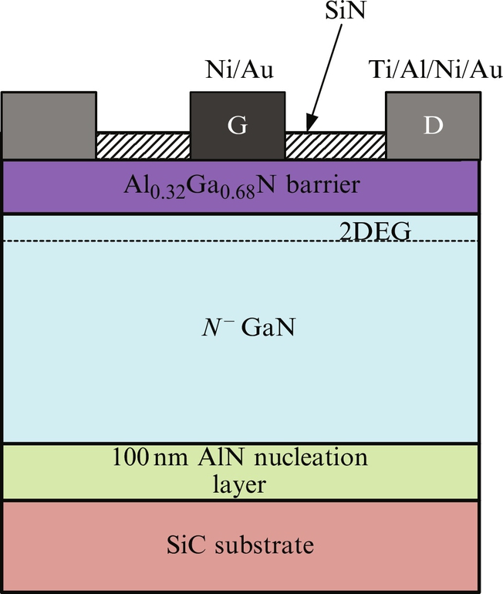

**FIG. 5.32** A cross section of a conventional GaN HEMT.

For HEMTs grown on foreign substrates, an intermediate, nucleation, or buffer layer is essential to the growth of quality GaN on the substrate. The morphology and crystal quality of a buffer layer play a critical role in determining the quality of epitaxial growth [[183](https://learning.oreilly.com/library/view/power-electronics-handbook/9780128114087/B9780128114070000052_3.xhtml#bb0920)]. Aluminum nitride can be used as a nucleation layer. Metal-organic chemical vapor deposition and metal-organic molecular beam epitaxy methods can be used to form the AlN buffer layer. In [[184](https://learning.oreilly.com/library/view/power-electronics-handbook/9780128114087/B9780128114070000052_3.xhtml#bb0925)], it is shown that there is no distinct difference between the GaN grown on a buffer layer obtained by the two methods.

The GaN epilayer grown on the top of the buffer layer is known as a channel layer because a channel is formed within. The channel layer is grown mostly by metal-organic chemical vapor deposition along the [0001] direction to benefit from the spontaneous polarization within the GaN wurtzite crystal. The temperature for growing the GaN epilayer is also important to the quality of the layer. As the temperature increases, the defect density and surface roughness decreases, which may be attributed to the improvement in the surface mobility and activities of source spaces on the substrate [[184](https://learning.oreilly.com/library/view/power-electronics-handbook/9780128114087/B9780128114070000052_3.xhtml#bb0925)].

On the top of the channel layer, a barrier layer with a higher bandgap and lower electron affinity, compared with the GaN channel layer, is grown. The buffer layer can be fabricated with a group-III nitride material, such as Al*x*Ga*y*In1−*x*−*y*N, where 0≦*x*≦1, 0≦*y*≦1 and *x*+*y*≦1 [[185](https://learning.oreilly.com/library/view/power-electronics-handbook/9780128114087/B9780128114070000052_3.xhtml#bb0930)]. The thickness of the AlGaN barrier layer and the aluminum composition can be optimized so that a significant carrier concentration is induced and a 2DEG can be formed.

A passivation layer is deposited on the top of the barrier layer between the gate and the source and the second passivation layer between the drain and the gate. The layers may be initially formed as a single layer that is subsequently etched through to form the gate [[185](https://learning.oreilly.com/library/view/power-electronics-handbook/9780128114087/B9780128114070000052_3.xhtml#bb0930)]. Different dielectric materials can be used, such as SiN, SiO2, Si, Ge, MgO*x*, MgN*x*, ZnO, SiN*X*, and SiO*x*, but usually, SiN is used. The deposition temperature and postannealing temperature of the passivation layer are important for controlling dynamic ON-state resistance degradation. The results given in [[186](https://learning.oreilly.com/library/view/power-electronics-handbook/9780128114087/B9780128114070000052_3.xhtml#bb0935)] indicate that the SiN/AlGaN interface trap density is reduced by increasing the deposition temperature and also by increasing the postannealing temperature. Therefore, the current collapse in terms of dynamic ON-state resistance is also reduced.

As illustrated in [Fig. 5.32](https://learning.oreilly.com/library/view/power-electronics-handbook/9780128114087/B9780128114070000052_3.xhtml#f0165), a conventional AlGaN/GaN HEMT has typically been fabricated with coplanar metal contacts. The source and drain electrodes are ohmic contacts providing low resistance and nonrectifying behavior, while the gate contact is intended to be a nonohmic Schottky barrier contact that controls the carrier concentration in the channel and blocks the current at large reverse voltages. Since the Schottky gate electrode and the 2DEG are separated by the AlGaN layer, the gate leakage current should be suppressed, but a relatively large gate leakage current is usually observed in the devices due to the defects near or at the surface of the AlGaN layer. The defects are formed during the epitaxial layer growth and by interface reaction between the metal and AlGaN layers interacting due to thermal treatments during the fabrication processes. Different materials have been used to create Schottky gate electrodes: Ni, Cu, Pt, and W. Pure metals have poor thermal stability on the AlGaN layer, while using electrodes with compound nitrides, such as TiN, the gate leakage current and the current collapse are suppressed to some extent. A characterization and comparison of poly-Si and TiN gate electrodes have shown advantages in reducing the leakage current and robustness against reverse-bias stressing of the poly-Si gate electrode [[187](https://learning.oreilly.com/library/view/power-electronics-handbook/9780128114087/B9780128114070000052_3.xhtml#bb0940)].

Forming all three contacts on the same epitaxial layer may result in compromises between these characteristics. Therefore, there is a trade-off in device design, when selecting the doping and composition of the AlGaN barrier layer, between optimizing the source and drain ohmic contacts while optimizing the nonohmic gate contact [[185](https://learning.oreilly.com/library/view/power-electronics-handbook/9780128114087/B9780128114070000052_3.xhtml#bb0930)]. Furthermore, high-power HEMTs should be optimized to provide as much current-carrying capability as possible to the region under the gate electrode while allowing the gate to block as high voltage as possible. Hence, it may be useful to have differences in the regions between the source and gate, under the gate, and between the gate and drain in order to modify the amount of energy band bending. Modifying the band bending will change the amount of the sheet region charge and the electric field profile within the device.

To improve electric performance together with reliability, new advanced structures have been designed and characterized. Introducing a field plate between the gate and drain electrodes enables electric field modulation. As a result, the electric field profile is reshaped, and the electric field is spread along the device's channel. Under the field plate, a depletion zone is formed so that the maximum peak value of the electric field at the drain side of the gate edge is reduced. Therefore, using a field-plate structure increases the device breakdown voltage, since the maximum electric field is distributed across the region among the gate and drain [[188](https://learning.oreilly.com/library/view/power-electronics-handbook/9780128114087/B9780128114070000052_3.xhtml#bb0945)].

The phenomenon known as current collapse is associated with surface states in GaN-based HEMTs. It is caused by electrons trapped by defects in the GaN layer and the interface between the passivation film and the AlGaN barrier layer. Since, the electric field at the gate edge has a maximum value, it strongly affects the current collapse due to the acceleration of the electrons in the channel. The ON-resistance increase caused by the current collapse phenomena strongly depends on the gate-edge electric field. The results given in [[189](https://learning.oreilly.com/library/view/power-electronics-handbook/9780128114087/B9780128114070000052_3.xhtml#bb0950)] show that the ON-state resistance increase caused by the current collapse phenomena is dramatically reduced by a field plate since the gate-edge electric field is reduced by the field-plate electrode.

The electron mobility in the 2DEG of an AlGaN/GaN heterostructure is an important transport parameter that characterizes the quality of the structure and determines the HEMT performance [[190](https://learning.oreilly.com/library/view/power-electronics-handbook/9780128114087/B9780128114070000052_3.xhtml#bb0955)]. The 2DEG mobility is limited by a combination of various scattering mechanisms such as background impurities, polarization effects, degeneracy, interface roughness scattering, dislocations, scattering by acoustic and optical phonons, remote modulation doping scattering, and alloy disorder [[191](https://learning.oreilly.com/library/view/power-electronics-handbook/9780128114087/B9780128114070000052_3.xhtml#bb0960)] and [[192](https://learning.oreilly.com/library/view/power-electronics-handbook/9780128114087/B9780128114070000052_3.xhtml#bb0965)].

The electron mobility in the 2DEG is a function of the sheet electron density, *NS*, at the heterointerface over a wide temperature range. It increases with an increase in the sheet electron density, *Ns*, up to a maximum value and decreases with further increases in the density, *NS*. At a high sheet electron density in AlGaN/GaN heterostructures, the electrons spill from the quantum well near the heterointerface and occupy the delocalized states in the channel, leading to a reduction of the electron mobility. In this case, less effective screening and more pronounced ionized impurity scattering were observed when electrons occupied a much wider doped region near the heterointerface [[193](https://learning.oreilly.com/library/view/power-electronics-handbook/9780128114087/B9780128114070000052_3.xhtml#bb0970)].

The sheet electron density near the AlGaN/GaN heterointerface is mainly contributed by the electrons induced by the doped AlGaN barrier and from the electrons generated by the piezoelectric effect. The sheet density of 2DEG is expressed as [[194](https://learning.oreilly.com/library/view/power-electronics-handbook/9780128114087/B9780128114070000052_3.xhtml#bb0975)]:

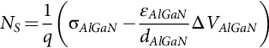 **(5.199)**

where σ*AlGaN* is the sheet charge density that is induced by AlGaN polarization, *q* is the electron charge, and *ɛAlGaN* and *dAlGaN* are the dielectric constant and the thickness of the AlGaN barrier. The potential drop, *ΔVAlGaN*, can be calculated as

 **(5.200)**

where Φ*b* is the surface barrier height, *EF* is the Fermi level position with respect to the GaN conduction band edge at the AlGaN/GaN interface, and Δ*EC* is the conduction band discontinuity between GaN and AlGaN, as shown in [Fig. 5.33](https://learning.oreilly.com/library/view/power-electronics-handbook/9780128114087/B9780128114070000052_3.xhtml#f0170).

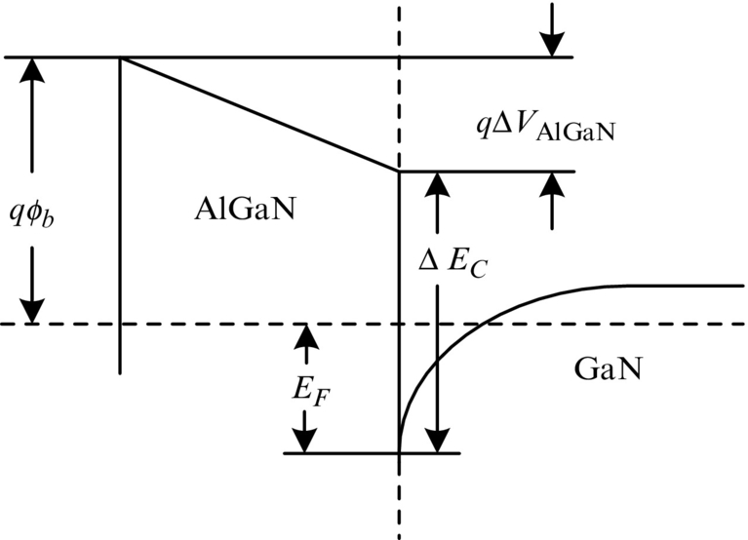

**FIG. 5.33** Conduction band diagram of an AlGaN/GaN heterostructure [[195](https://learning.oreilly.com/library/view/power-electronics-handbook/9780128114087/B9780128114070000052_3.xhtml#bb0980)].

To decrease the sheet electron density, *Ns*, and improve the performance of the HEMT, a GaN capping layer placed between the barrier layer of AlGaN and the passivation layer of SiN is deposited as shown in [Fig. 5.34](https://learning.oreilly.com/library/view/power-electronics-handbook/9780128114087/B9780128114070000052_3.xhtml#f0175). Strong polarization-induced electric fields are present in the AlGaN buffer layer and in the GaN capping layer that affect the 2DEC sheet density, depending on the thickness of the GaN capping layer. Experimental results given in [[195](https://learning.oreilly.com/library/view/power-electronics-handbook/9780128114087/B9780128114070000052_3.xhtml#bb0980)] and the simulation results given in [[196](https://learning.oreilly.com/library/view/power-electronics-handbook/9780128114087/B9780128114070000052_3.xhtml#bb0985)] show that the presence of a GaN capping layer results in a monotonic decrease of the sheet electron density with increases in the capping layer thickness. Decreasing the 2DEG sheet density results in modification of the electron scattering mechanisms and, therefore, modification in the mobility too. The experimental and simulation results show that as the thickness of the GaN capping layer increases, the electron mobility increases monotonically to a maximum point, where further increases in the capping layer thickness will cause the mobility to decrease slightly and eventually saturate [[195](https://learning.oreilly.com/library/view/power-electronics-handbook/9780128114087/B9780128114070000052_3.xhtml#bb0980)] and [[196](https://learning.oreilly.com/library/view/power-electronics-handbook/9780128114087/B9780128114070000052_3.xhtml#bb0985)].

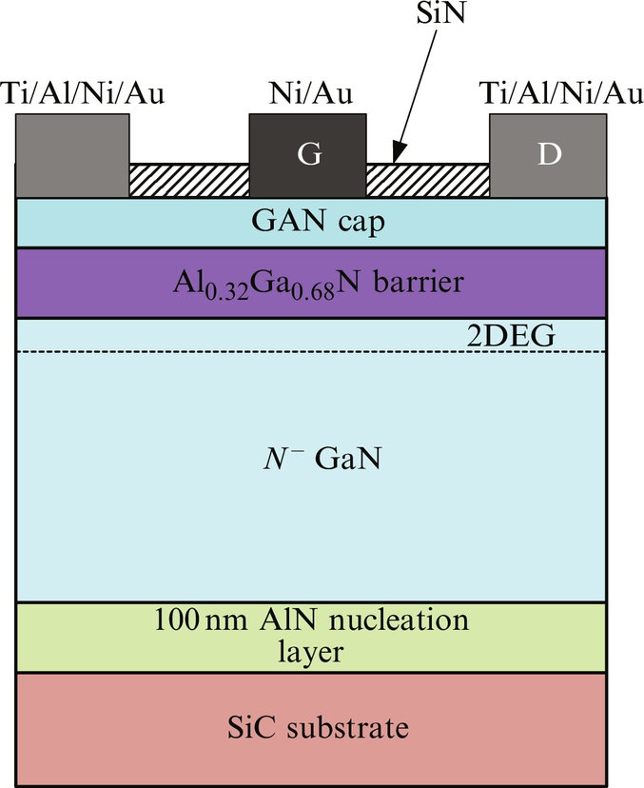

**FIG. 5.34** A cross section of an advanced GaN HEMT structure.

The 2DEG sheet resistance of the GaN/AlGaN/GaN structure can be calculated by the following equation [[194](https://learning.oreilly.com/library/view/power-electronics-handbook/9780128114087/B9780128114070000052_3.xhtml#bb0975)]:

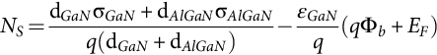 **(5.201)**

where σ*GaN* is the sheet charge density that is induced by the GaN polarization and *ɛGaN* and *dGaN* are dielectric constant and the thickness of the GaN capping layer, respectively. The surface barrier height, Φ*b*, and the Fermi level position, *EF*, are shown in [Fig. 5.35](https://learning.oreilly.com/library/view/power-electronics-handbook/9780128114087/B9780128114070000052_3.xhtml#f0180).

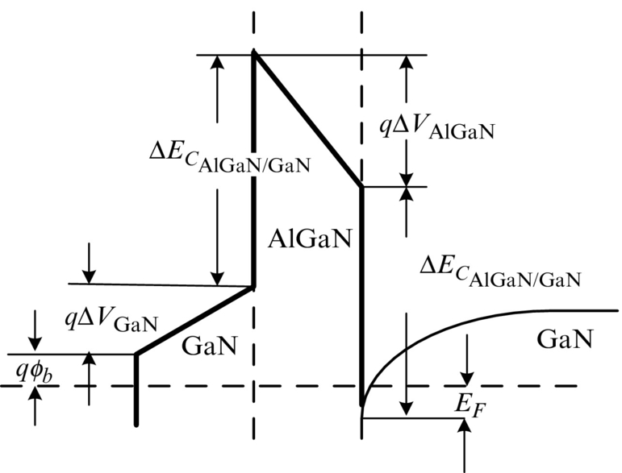

**FIG. 5.35** Conduction band diagram of a GaN/AlGaN/GaN heterostructure [[195](https://learning.oreilly.com/library/view/power-electronics-handbook/9780128114087/B9780128114070000052_3.xhtml#bb0980)].

To achieve better HEMT performance, a thin AlN (∼1 nm) interlayer at the AlGaN/GaN interface is added in some advanced structures. The insertion of the thin AlN interlayer suppresses the penetration of the wave function into the barrier and effectively removes alloy scattering and pushes out most of the 2DEG from the barrier. The small finite part that still penetrates the barrier is not affected by the allow scattering [[197](https://learning.oreilly.com/library/view/power-electronics-handbook/9780128114087/B9780128114070000052_3.xhtml#bb0990)]. Also, additional polarization due to the AlN interlayer is observed. As a result, the sheet charge density and mobility are improved as compared with the conventional AlGaN/GaN heterostructure having equivalent AlGaN parameters.

At small drain bias, *VDS*, the conductivity between the source and drain, known as 2DEG conductivity, is proportional to the product of channel mobility, *μ*, and the sheet electron density, *NS*:

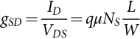 **(5.202)**

where *ID* is the drain current and *L* and *W* are the length and width of the gate. Therefore, insertion of an AlN layer increases the conductivity. In [[198](https://learning.oreilly.com/library/view/power-electronics-handbook/9780128114087/B9780128114070000052_3.xhtml#bb0995)], it is reported that introduction of an AlN interlayer improved the ON-state resistance and current, *RON* and *ION*, by 10%.

The 2DEG sheet resistance of GaN/AlN/AlGaN structure can be calculated by the following equation according to [[194](https://learning.oreilly.com/library/view/power-electronics-handbook/9780128114087/B9780128114070000052_3.xhtml#bb0975)]:

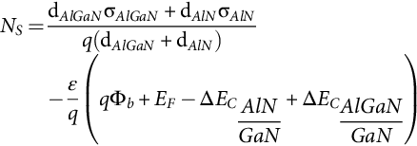 **(5.203)**

where σ*AlN* is the sheet charge density that is induced by AlN polarization and *ɛAlN* and *dAlN* are the dielectric constant and thickness of the AlN capping layer, respectively. The surface barrier height, Φ*b*, and the Fermi level position, *EF*, of the GaN/AlN/AlGaN structure are shown in [Fig. 5.36](https://learning.oreilly.com/library/view/power-electronics-handbook/9780128114087/B9780128114070000052_3.xhtml#f0185).

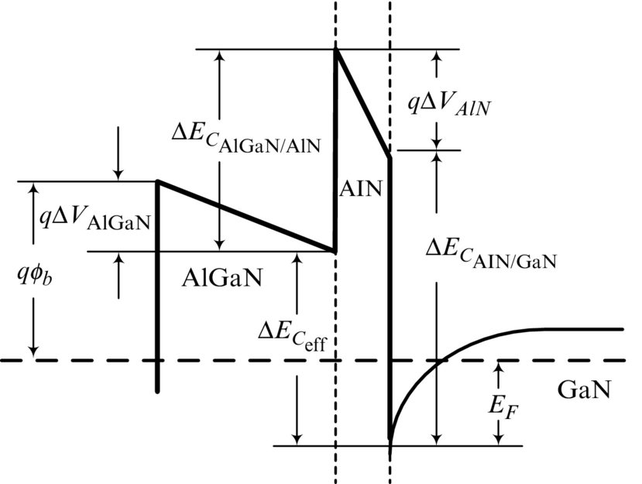

**FIG. 5.36** Conduction band diagram of a GaN/AlN/AlGaN heterostructure [[195](https://learning.oreilly.com/library/view/power-electronics-handbook/9780128114087/B9780128114070000052_3.xhtml#bb0980)].

A critical requirement of the power switch is that it has low ON-resistance, *RON*, immediately after switching from OFF-state to ON-state. The ON-resistance, *RON*, of a HEMT is expressed by the following equation:

 **(5.204)**

where *RC* is the source and drain contact resistance, *RS*, is the parasitic source resistance, *RD*, is the parasitic drain resistance, and *RCH* is the channel resistance. The carrier trapping at the surface and the buffer traps degrade the device performance. In a GaN HEMT, the parasitic charge moving in and out of the traps affects the density of the 2DEG and causes ON-resistance degradation. To characterize the dynamic ON-resistance of a HEMT, a switching test should be performed using [Fig. 5.37](https://learning.oreilly.com/library/view/power-electronics-handbook/9780128114087/B9780128114070000052_3.xhtml#f0190). The gate source of the device is connected to a pulsed generator that can switch the device from OFF- to ON-state. During the OFF-state, high-voltage *VDD* is applied to the device. The load resistance, *RL*, is connected in series with the device under test, and it is adjusted so that the ON-state resistance is measured in the linear region. The turn-ON and turn-OFF time are fixed during the experiment. Turn-OFF time should be long enough, typically larger than 10 ms, so the device under test cools down and its temperature does not affect the results. The ON-time is larger than the time at which the dynamic resistance is measured or the time at which the drain current, *ID*, saturates.

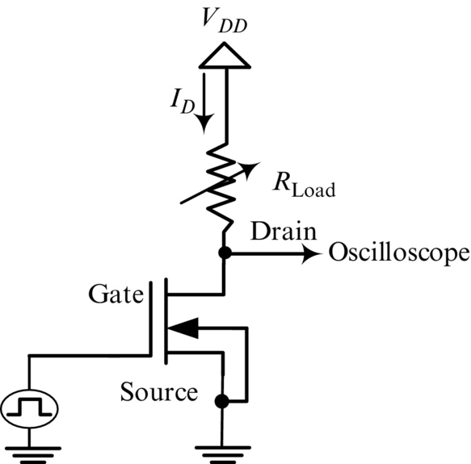

**FIG. 5.37** Pulsed test circuit for dynamic ON-resistance measurement.

The transient drain current through the device, *iD*(*t*), and the drain-source voltage, *vDS*(*t*), are recorded, and the resistance is calculated for different times by the equation:

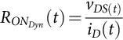 **(5.205)**

The static ON-resistance, *RONstatic*, is calculated by the same equation; only the saturated values for the current and the voltage are used. The experiment and calculation can be repeated for different values of the load resistance (i.e., different drain current). In [Fig. 5.38A](https://learning.oreilly.com/library/view/power-electronics-handbook/9780128114087/B9780128114070000052_3.xhtml#f0195) is a sketch of the gate-source voltage applied to the device under test, the drain-source voltage and the drain current. While in [Fig. 5.38B](https://learning.oreilly.com/library/view/power-electronics-handbook/9780128114087/B9780128114070000052_3.xhtml#f0195) showed a sketch of the dependency of drain current *ID*, as a function of drain-source voltage, *VDS*, for times *t1* and t2 and different values of the load resistance.

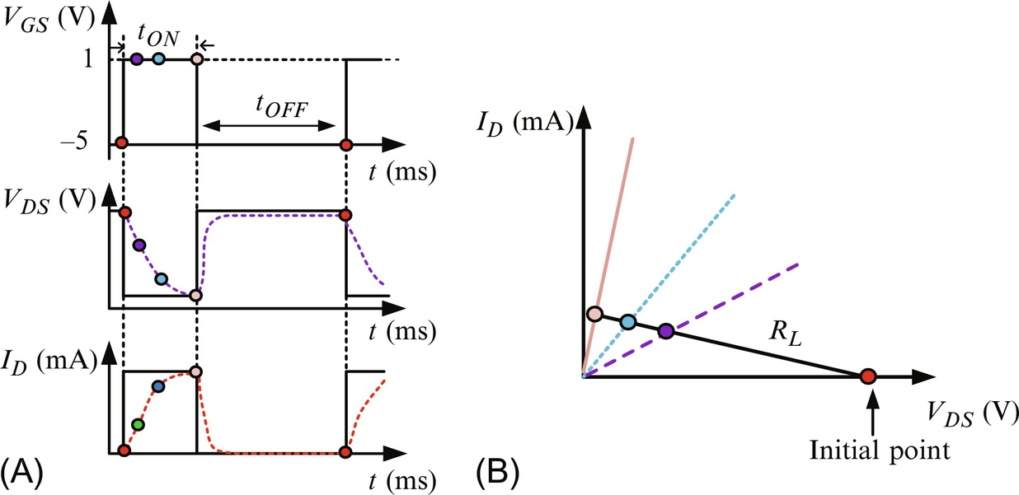

**FIG. 5.38** Pulsed test for calculating dynamic ON-resistance. (A) Gate source voltage applied to the device under test, the drain-source voltage and the drain current in function of time. (B) Dependency of drain current *ID*, as a function of drain-source voltage, *VDS*, for times *t*1 and *t*2 and different values of the load resistance.

The current collapse can be defined as a normalized dynamic ON-resistance (i.e., a ratio of the dynamic resistance value to its static value). The ratio can be used to compare the performances of HEMTs.

#### **5.4.5.2 GaN HEMT DC Characteristics**

The current-voltage characteristics of a HEMT are related to the density variation of the 2DEG where 2DEG depends on the gate-source voltage, *VGS*, applied to the HEMT. Moreover, any changes of *VGS* have an effect on the electron mobility in the channel. A HEMT has three modes of operation: linear, saturation, and cut-OFF. For power applications and the linear mode of operation, the low-field mobility of the electrons in 2DEG, *μn*, is used to calculate the drain current, while when the drain-source voltage increases, the mobility of the electrons in the 2DEG decreases. In this case, a simple model for high field mobility, *μnHV*, based on the geometry of the HEMT structure is used:

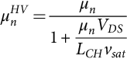 **(5.206)**

where *LCH* is the channel length and *vsat* is the saturation velocity. The drain current, *iD*, is proportional to the density of electrons in the channel [[199](https://learning.oreilly.com/library/view/power-electronics-handbook/9780128114087/B9780128114070000052_3.xhtml#bb1000)]:

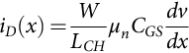 **(5.207)**

where *W* is the channel width. The drain current can be obtained by integrating the current along the channel. If the source and drain contact resistances are neglected and the boundary conditions are used,

 **(5.208)**

then the drain current in the linear regime of operation is

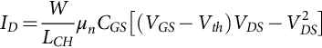 **(5.209)**

where *CGS* is the gate-to-source capacitance and *Vth* is the threshold voltage. In the saturation regime of operation, the drain current is

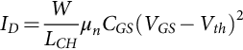 **(5.210)**

#### **5.4.5.3 GaN HEMT Design Considerations**

To improve the performance and also protect GaN HEMTs from damage, the designer should take into account some very important concerns and benefits.

The threshold voltages of GaN HEMTs are low compared with the Si and SiC MOSFETs. Some of the HEMT devices start to conduct current at significantly low gate-source voltage (1.4 V) that makes it difficult to ensure that the device turns OFF, especially at low temperatures (the threshold voltage decreases as the temperature drops). Negative voltage should be used in this case to ensure turn-OFF of the device. This behavior indicates that the threshold voltage has a positive temperature coefficient. HEMTs are unipolar devices (i.e., no minority carriers are involved during conduction). Therefore, there is no reverse recovery charge and thus very small reverse recovery losses.

As it can be seen in [Figs. 5.32](https://learning.oreilly.com/library/view/power-electronics-handbook/9780128114087/B9780128114070000052_3.xhtml#f0165) and [5.34](https://learning.oreilly.com/library/view/power-electronics-handbook/9780128114087/B9780128114070000052_3.xhtml#f0175), GaN HEMTs do not have an intrinsic body diode as in Si and SiC MOSFETs. However, they have a so-called “body-diode” effect that makes the device conduct under applied reverse voltages. The mechanism for an enhancement GaN HEMT to behave as a diode during turn-OFF is as follows [[200](https://learning.oreilly.com/library/view/power-electronics-handbook/9780128114087/B9780128114070000052_3.xhtml#bb1005)]. When the gate-source voltage is zero and the drain-source voltage is positive, no channel is created, and therefore, current is not flowing. As the drain-source voltage starts to become negative, a positive bias on the gate relative to the drift region is formed, injecting electrons under the gate. The gate-to-drain voltage starts to increase, and when it reaches the threshold voltage, there will be a significant amount of electrons under the gate to form a conduction channel.

The temperature coefficient of the ON-state resistance, *RON*, of a GaN HEMT is positive, similar to Si and SiC MOSFETs, but the magnitude is small compared with a Si MOSFET and approximately in the same range as a SiC MOSFET.

Since GaN HEMTs have high switching speed, the voltage slew rate may be more than ten to hundreds of volts per nanosecond, and the current slew rate may be more than 10 A s−1. Such a high slew rate may lead to the so-called Miller effect (i.e., undesirable or parasitic turn-ON of the power transistor and that creates a short circuit that will cause significant damage resulting in destruction of the HEMT).

Shown in [Fig. 5.39A](https://learning.oreilly.com/library/view/power-electronics-handbook/9780128114087/B9780128114070000052_3.xhtml#f0200) is a synchronous buck converter. If the upper HEMT is switched ON, the lower one has to be OFF in order to avoid a shoot-through condition and, therefore, possible failure of the HEMT due to overcurrent.

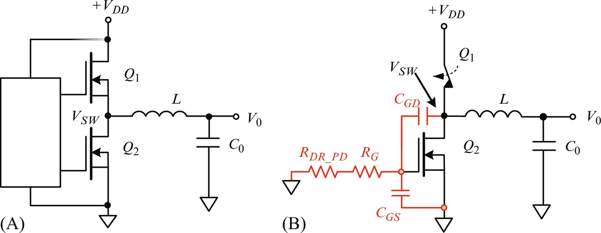

**FIG. 5.39** Synchronous buck converter (A) idea and (B) parasitic resistance and capacitance included.

The mechanism of the parasitic switching for the synchronous buck can be explained with the capacitive voltage divider formed between the gate to drain and gate to source of the low-side transistor ([Fig. 5.39B](https://learning.oreilly.com/library/view/power-electronics-handbook/9780128114087/B9780128114070000052_3.xhtml#f0200)). The gate-source voltage of the low-side transistor is

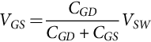 **(5.211)**

where *CGD* and *CGS* are the gate-drain and gate-source capacitances, respectively, and *VSW* is the switching node voltage. Although the gate of the low HEMT is set to zero by the driver circuit, there is a possibility that the low-side HEMT turns ON because of the fast change in the switching voltage. The rate of change of the voltage at the switching node, *VSW*, is approximately *Vin*/*tr*, where *Vin* is the converter input voltage and *tr* is the rise time. The voltage slew causes a current to flow through gate-to-drain capacitance of the low-side HEMT:

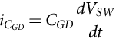 **(5.212)**

This current flows into the equivalent impedance of driver pull-down resistance in series with the gate resistance and both of them in parallel to the gate-source capacitance of the low HEMT. If the gate-source voltage during the rise time of the high side transistor is higher than the threshold voltage, the low HEMT will turn ON parasitically. One way to prevent this from happening is to split the gate pull-up and pull-down connection in the driver and allowing for the insertion of discrete resistors, if needed. The low (OFF-state) pull-down resistance should be a lower resistance value than the pull-up resistance value. If the driver does not support a separate turn-OFF resistor, a diode in parallel can be used, as shown in [Fig. 5.40](https://learning.oreilly.com/library/view/power-electronics-handbook/9780128114087/B9780128114070000052_3.xhtml#f0205).

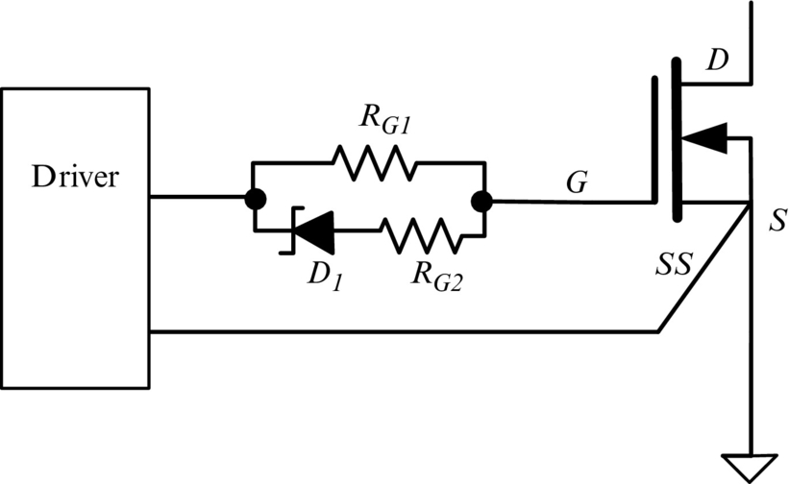

**FIG. 5.40** Separate turn-ON and turn-OFF resistors to control parasitic turn-on of low-side HEMT.

The high slew rate may also cause ringing and, in some cases, damage if the common source inductance, *LS*, is not minimized. The source current, *iS*, is the sum of the drain and the gate currents. Any voltage induced on the common source inductance  will show up as ringing in the gate-source voltage. To address this issue, one company developed packages with exceptionally low internal inductance by implementing source-sense or Kelvin connection, but the external inductance that contributes to the ringing should also be minimized. Shown in [Fig. 5.41](https://learning.oreilly.com/library/view/power-electronics-handbook/9780128114087/B9780128114070000052_3.xhtml#f0210) is a Kelvin connection at the source of a HEMT where the ground return of the gate driver is connected directly to the source on the die internal to the package by a star-point connection. In this case, the external parasitic inductances and resistances in the gate loop will be minimized, and the high slew rate of the drain current during turn-ON switching cannot influence the gate current loop.

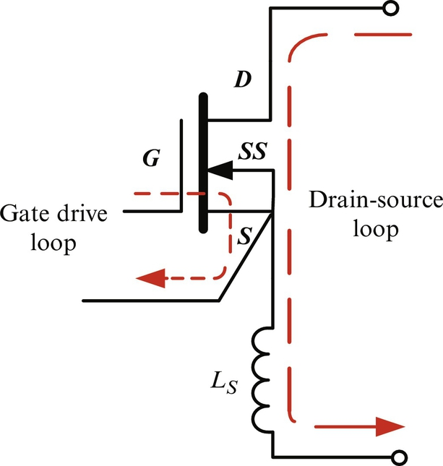

**FIG. 5.41** Source-sense or Kelvin connection at the HEMT source.

However, the (PCB) layout should be carefully considered to minimize the effect of the parasitic inductance. For this purpose, the designers should keep the connection from the output of the driver to the HEMT gate and from the Kelvin connection to the gate return path of the driver as short as possible. To reduce the wire parasitic inductance, the two paths should be on separate board layers physically over each other. In this case, the magnetic flux generated by two current flows will cancel each other and will lower the parasitic inductance. Also, the connection for the decoupling capacitor of the driver power supply should be short.

During the fast switching transition, the Miller capacitance combined with parasitic inductance in the gate-source loop may induce over- or undershoot voltage spikes that could possibly exceed the maximum gate-source voltage rating of the device. This can be avoided by optimizing the PCB layout, but if the spikes still remain after overvoltage clamping a Zener diode and a capacitor in parallel is included as it shown in [Fig. 5.42A](https://learning.oreilly.com/library/view/power-electronics-handbook/9780128114087/B9780128114070000052_3.xhtml#f0215) can be used [[201](https://learning.oreilly.com/library/view/power-electronics-handbook/9780128114087/B9780128114070000052_3.xhtml#bb1010)]. If a negative gate-source voltage is used to turn OFF the HEMT, the overvoltage clamp will have two Zener diodes connected back to back as shown in [Fig. 5.42B](https://learning.oreilly.com/library/view/power-electronics-handbook/9780128114087/B9780128114070000052_3.xhtml#f0215). For effective clamping, the diode and the capacitor should be placed as close to the device gate as possible.

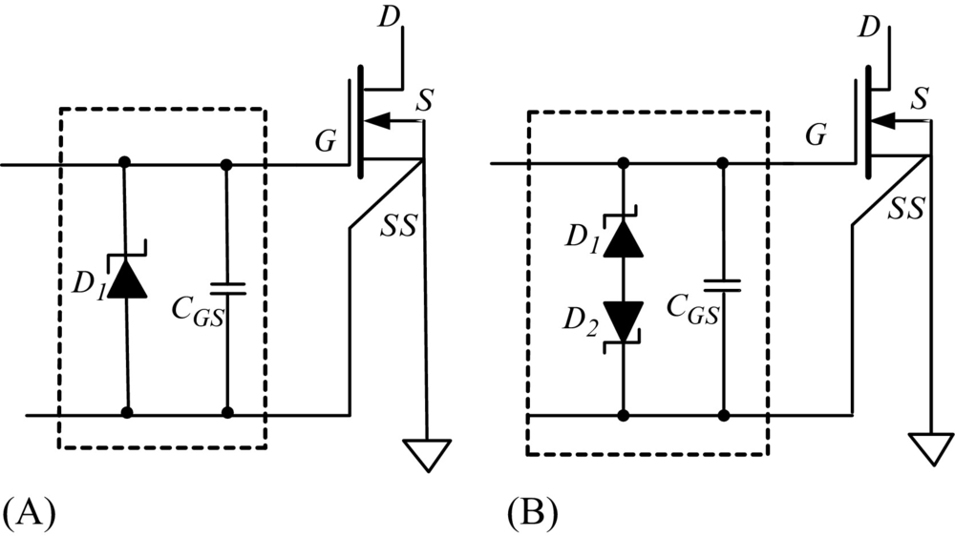

**FIG. 5.42** Gate overvoltage clamping using Zener diodes and capacitor: (A) zero voltage is applied to turn OFF the HEMT, (B) negative voltage is applied to turn OFF the HEMT.

To enable high switching, high power density, and low system cost, some companies are fabricating a gate drive and logic circuit with GaN power FETs on a single chip, as shown in [Fig. 5.43](https://learning.oreilly.com/library/view/power-electronics-handbook/9780128114087/B9780128114070000052_3.xhtml#f0220). The advantages of this type of arrangement are that there is no gate-loop parasitic inductance and, therefore, the output signal will be absent of ringing; has a fast rise-time gate signal; and the ability to have rail-to-rail gate signal values. Plus, it offers high-frequency operation with minimal propagation delay [[202](https://learning.oreilly.com/library/view/power-electronics-handbook/9780128114087/B9780128114070000052_3.xhtml#bb1015)].

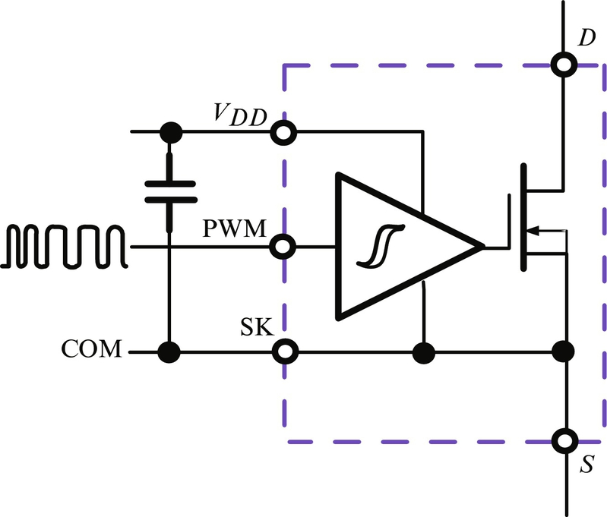

**FIG. 5.43** Gate drive and logic circuits with GaN power FETs on a single chip.

Unlike many conventional Si MOSFETs, the GaN HEMTs are not avalanche rated at the breakdown at the drain-source junction. Therefore, in order to maintain reliability, the maximum drain-source voltage, *VDS*, should be guaranteed by design. For some topologies, Si MOSFETs can be directly substituted for GaN HEMTs with the same breakdown voltage. An example of this type of topology is a full bridge converter controlled as a dual synchronous buck, as shown in [Fig. 5.44](https://learning.oreilly.com/library/view/power-electronics-handbook/9780128114087/B9780128114070000052_3.xhtml#f0225) [[203](https://learning.oreilly.com/library/view/power-electronics-handbook/9780128114087/B9780128114070000052_3.xhtml#bb1020)].

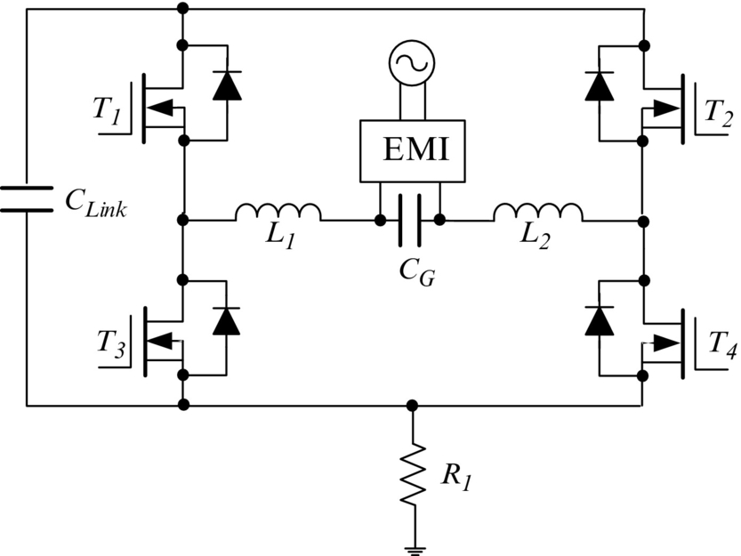

**FIG. 5.44** A dual synchronous buck converter.

While for some resonance topologies, Si MOSFETs cannot be replaced with GaN HEMTs that have the same breakdown voltage. Shown in [Fig. 5.45](https://learning.oreilly.com/library/view/power-electronics-handbook/9780128114087/B9780128114070000052_3.xhtml#f0230) is a resonant-reset forward converter.

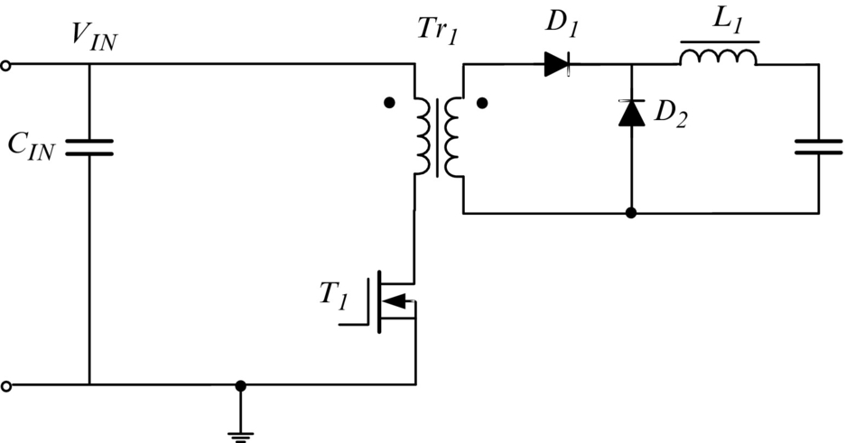

**FIG. 5.45** A resonant-reset forward converter.

After the switch turns OFF, the magnetizing current reverses in a sinusoidal fashion set by the magnetizing inductance, *Lm*, and the resonance capacitance, *CR*. The resonance capacitance, *CR*, is a sum of all capacitances across the primary winding of the transformer including the reflected diode capacitance, *CD*:

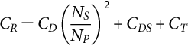 **(5.213)**

where *CDS* is the switch drain-source capacitance, *CT* is transformer primary windings capacitance, and *NS*/*NP* is the transformer winding ratio. The drain-source capacitance, *CDS*, is dominant in this expression. The drain-source peak voltage, *VDSpeak*, of the switch depends on the characteristic impedance  and can be calculated by the equation:

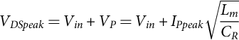 **(5.214)**

where the peak primary current is

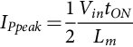 **(5.215)**

From the last three equations, it can be concluded that if only switches are different in the circuit shown in [Fig. 5.45](https://learning.oreilly.com/library/view/power-electronics-handbook/9780128114087/B9780128114070000052_3.xhtml#f0230), the maximum drain-to-source voltage that will be applied to the switch depends on the drain-source capacitance, *CDS*. Since GaN HEMTs have significantly smaller capacitance, the peak voltage, *VP*, will be significantly larger, and therefore, the peak drain-source voltage will correspondingly be larger. In order to maintain maximum reliability, GaN HEMTs should be rated for higher voltages than the Si MOSFETs in any particular application.

Although GaN high-power HEMTs have significantly low switching and conduction power losses, compared with MOSFETs in Si or SiC, during high-power and high-frequency operation, their temperature is increased. Thermal management is another very important consideration for designers. The current fabrication methodology of HEMT structures implies that the gate, drain, and source connections must be made on the same side of the die. For this reason, necessary isolation gaps must be included between these contacts as this mounting technique results in a higher thermal resistance. To improve the thermal resistance, the package of HEMTs has a thermal pad on the bottom side that is connected to the substrate through high-density microvias with copper providing the low thermal resistance path. To optimize the device performance, the thermal pad must always be connected to the source. For most effective cooling, a heat sink can be attached to the PCB bottom copper pad with the recommended thermally conductive interface pad or film between the heat sink and the bottom copper pad. Also, the top copper layer should be a 2 oz or thicker layer. A PCB with four or more internal layers is desirable. To improve the heat transfer is to add plated, through-hole thermal vias between conductive layers, but no vias should be placed under the solder bars unless they are microvias and completely filled with copper [[200](https://learning.oreilly.com/library/view/power-electronics-handbook/9780128114087/B9780128114070000052_3.xhtml#bb1005)]. Vias with holes located directly under the gate, source, or drain solder bars will reduce the transistor's temperature cycling performance. In [Fig. 5.46](https://learning.oreilly.com/library/view/power-electronics-handbook/9780128114087/B9780128114070000052_3.xhtml#f0235), a cross-sectional view of the GaN HEMT package and thermal dissipation path through the PCB, vias, and the heat sink is shown [[204](https://learning.oreilly.com/library/view/power-electronics-handbook/9780128114087/B9780128114070000052_3.xhtml#bb1025)].

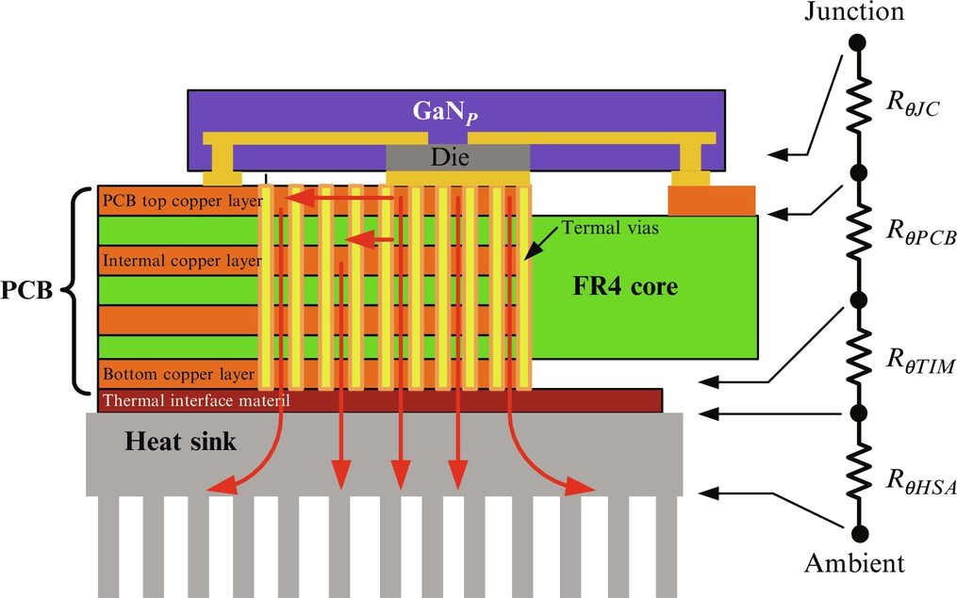

**FIG. 5.46** A cross-sectional view of a GaN HEMT package and thermal dissipation path [[203](https://learning.oreilly.com/library/view/power-electronics-handbook/9780128114087/B9780128114070000052_3.xhtml#bb1020)].

## Appendix Lightly Doped Drift Region Thickness

One of the requirements for choosing a proper power electronic device for a converter is that it must possess a low specific ON-resistance. The specific ON-resistance of a bipolar device is related to the width and doping concentration of the lightly doped drift region (*N*− base). This means that the doping concentration and the width of the low-doped base region in a bipolar device must be carefully considered to achieve a desired avalanche breakdown voltage and ON-resistance (conduction characteristics).

The avalanche breakdown voltage, *VBD*, for an abrupt parallel plate junction, is a function of the background doping and the semiconductor properties, such as dielectric constant, energy bandgap, and impact ionization coefficient. Breakdown occurs when the carrier multiplication becomes greater than unity. Impact ionization coefficients empirically describe the exponential relationship of the applied electric field and associated charge-carrier creation. The impact ionization coefficients for electrons and holes have different values, and values for semiconductor materials of interest are obtained empirically. The general ionization coefficient has been determined to have a theoretical form that is exponential and represented by [[205](https://learning.oreilly.com/library/view/power-electronics-handbook/9780128114087/B9780128114070000052_3.xhtml#bb1030)]:

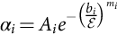 **(A.1)**

where  is the electric field (V cm−1), *Ai* is the amplitude parameter (cm−1), *bi* is the ionization energy parameter related to the mean free path between collisions (V cm−1), and *mi* is an additional fit parameter for use with a multitude of semiconductor materials [[205](https://learning.oreilly.com/library/view/power-electronics-handbook/9780128114087/B9780128114070000052_3.xhtml#bb1030),[206](https://learning.oreilly.com/library/view/power-electronics-handbook/9780128114087/B9780128114070000052_3.xhtml#bb1035)]. These parameter values depend on the semiconductor material, and they are different for electrons or holes. For Si, 6H-SiC, and GaN, *mi* has been determined to be 1 for both electrons and holes [[205](https://learning.oreilly.com/library/view/power-electronics-handbook/9780128114087/B9780128114070000052_3.xhtml#bb1030),[206](https://learning.oreilly.com/library/view/power-electronics-handbook/9780128114087/B9780128114070000052_3.xhtml#bb1035)].

Near the breakdown condition, a small error is introduced by equating the impact ionization coefficients of electrons and holes to an effective ionization coefficient, *αeff*. In this case, the breakdown voltage is defined as the applied voltage at which the summed effects described by the ionization coefficient acting over the depletion width, *W*, create more free charge carriers. The boundary at breakdown is when the integral Eq. [(A.2)](https://learning.oreilly.com/library/view/power-electronics-handbook/9780128114087/B9780128114070000052_3.xhtml#fo1105) achieves a value of unity [[207](https://learning.oreilly.com/library/view/power-electronics-handbook/9780128114087/B9780128114070000052_3.xhtml#bb1040)]. The associated breakdown condition in terms of the effective ionization coefficient is:

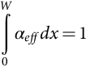 **(A.2)**

Evaluation of this integral using Eq. [(A.1)](https://learning.oreilly.com/library/view/power-electronics-handbook/9780128114087/B9780128114070000052_3.xhtml#fo1100) is very difficult; and no analytical expressions result, thus limiting its usefulness for device design. However, a simplified (and purely empirical) polynomial expression for the ionization coefficient in terms of the electric field is widely used [[207](https://learning.oreilly.com/library/view/power-electronics-handbook/9780128114087/B9780128114070000052_3.xhtml#bb1040)]:

 **(A.3)**

The two previous fit parameters, *Ai* and *bi*, are absorbed into the prefactor, *K*. The coefficient, *K*, is expressed in terms of new parameters, *A*, *b*, and *m*, that are averages of the previous *Ai*, *bi*, and *mi* values, expressed in Eq. [(A.1)](https://learning.oreilly.com/library/view/power-electronics-handbook/9780128114087/B9780128114070000052_3.xhtml#fo1100) for holes and electrons [[206](https://learning.oreilly.com/library/view/power-electronics-handbook/9780128114087/B9780128114070000052_3.xhtml#bb1035)]:

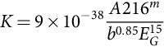 **(A.4)**

where *EG* is the bandgap energy (eV) for the semiconductor material of interest.

For a one-sided abrupt *P*+-*N* junction, the electric field and the voltage across the lightly doped region are functions of the depletion distance and depend on the impurity doping concentration, *ND1*, in the lightly doped *N*-base and the depleted *N*-base width, *W*. The electric field and voltage relations are presented in Eqs. [(A.5)](https://learning.oreilly.com/library/view/power-electronics-handbook/9780128114087/B9780128114070000052_3.xhtml#fo1120), [(A.6)](https://learning.oreilly.com/library/view/power-electronics-handbook/9780128114087/B9780128114070000052_3.xhtml#fo1125), respectively.

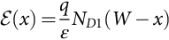 **(A.5)**

**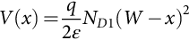** **(A.6)**

The maximum electric field is observed at junction (*x*=0). Using this and substituting Eq. [(A.5)](https://learning.oreilly.com/library/view/power-electronics-handbook/9780128114087/B9780128114070000052_3.xhtml#fo1120) in Eq. [(A.3)](https://learning.oreilly.com/library/view/power-electronics-handbook/9780128114087/B9780128114070000052_3.xhtml#fo1110) and then substituting into the integral Eq. [(A.2)](https://learning.oreilly.com/library/view/power-electronics-handbook/9780128114087/B9780128114070000052_3.xhtml#fo1105), one can obtain the minimum width of the depletion layer, *W*min, at breakdown [[206](https://learning.oreilly.com/library/view/power-electronics-handbook/9780128114087/B9780128114070000052_3.xhtml#bb1035)].

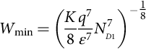 **(A.7)**

The corresponding breakdown voltage can then be determined from Eq. [(A.6)](https://learning.oreilly.com/library/view/power-electronics-handbook/9780128114087/B9780128114070000052_3.xhtml#fo1125) as

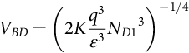 **(A.8)**

It should be noted that the permittivity is correctly placed in the denominator in Eq. [(A.8)](https://learning.oreilly.com/library/view/power-electronics-handbook/9780128114087/B9780128114070000052_3.xhtml#fo1135), not in the numerator as was presented in the expressions from [[206](https://learning.oreilly.com/library/view/power-electronics-handbook/9780128114087/B9780128114070000052_3.xhtml#bb1035)].

To reduce the lightly doped region width and maintain the same breakdown voltage requires the addition of a highly doped *N*+ buffer layer at the end of the drift (*N*-base) region to create a *P*+*N*–*N*+ structure. This will modify the expressions for the minimum width of the depletion layer, *W*min, and the corresponding breakdown voltage, *V*BD. Reducing the width of the base region will decrease the effective on-resistance during conduction and reduce the volume of stored charge, thus decreasing the turn-OFF (and turn-ON) time.

To reduce the thickness of the drift region for the same blocking voltage, a heavily doped *N*+-type buffer layer should be added to the end of the drift region to create a *P*+*N*–*N*+ structure [Fig. A.1B](https://learning.oreilly.com/library/view/power-electronics-handbook/9780128114087/B9780128114070000052_3.xhtml#f0240). Due to the high doping level in the buffer layer, the gradient of the electric field will be steep and positive, in the same way as in the *P*-type region. The electric field has maximum value at the *P*+*N*− junction. The electric field in the drift region will decrease gradually with no requirement for an excessive depletion layer width. The phenomenon that occurs when the depletion layer extends across the entire drift region is known as punch-through.

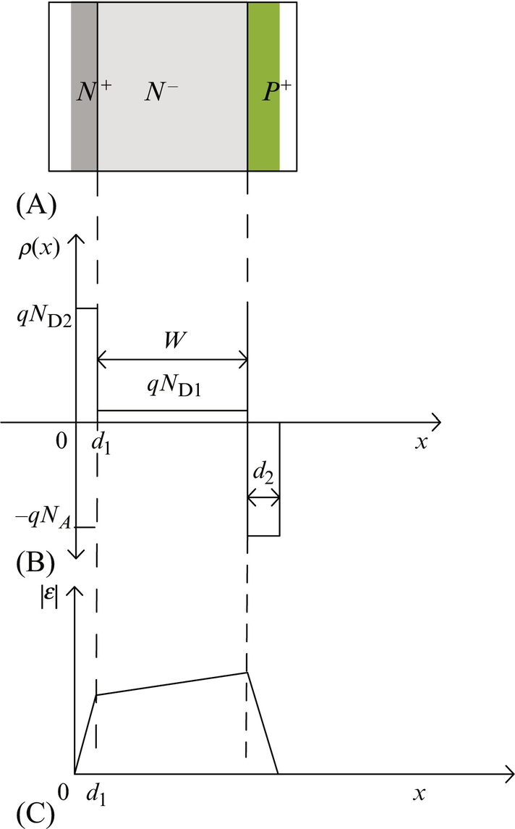

**FIG. A.1** (A) A *P*+*N*−*N*+ structure highlighting the depleting region under a large reverse applied voltage, (B) doping profile of the *P*+*N*−*N*+ structure with charge density as a function of position, and (C) electric field as a function of position.

Consider a two-dimensional *P*+*N*−*N*+ structure under equilibrium conditions with the doping profile sketched in [Fig. A.1](https://learning.oreilly.com/library/view/power-electronics-handbook/9780128114087/B9780128114070000052_3.xhtml#f0240). The electric field in the different regions can be obtained by substituting the charge densities into Poisson's equations and then integrating:

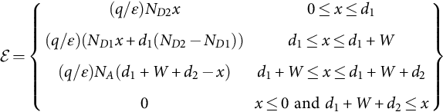 **(A.9)**

where the respective impurity doping concentrations for the *N*+*N*−*P*+ regions are *ND*2, *ND*1, and *N*A. The corresponding depletion region thicknesses of each section are *d*1, *W*, and *d*2.

The maximum electric field of the *P*+*N*−*N*+ structure will be at the *N*−*P*+ junction . Charge neutrality from Eq. [(A.9)](https://learning.oreilly.com/library/view/power-electronics-handbook/9780128114087/B9780128114070000052_3.xhtml#fo1140) gives the depletion thickness, *d*2 of the *P*+ region as

 **(A.10)**

Since , the electric potential applied to the structure is obtained by integrating the electric field from 0 to  resulting in

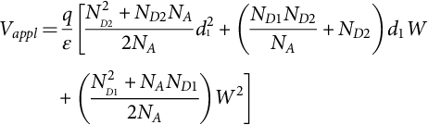 **(A.11)**

Substituting Eqs. [(A.11)](https://learning.oreilly.com/library/view/power-electronics-handbook/9780128114087/B9780128114070000052_3.xhtml#fo1150) into [(A.10)](https://learning.oreilly.com/library/view/power-electronics-handbook/9780128114087/B9780128114070000052_3.xhtml#fo1145) and using the result to calculate the ionization coefficient Eq. [(A.3)](https://learning.oreilly.com/library/view/power-electronics-handbook/9780128114087/B9780128114070000052_3.xhtml#fo1110), we can reevaluate the ionization integral Eq. [(A.2)](https://learning.oreilly.com/library/view/power-electronics-handbook/9780128114087/B9780128114070000052_3.xhtml#fo1105) as

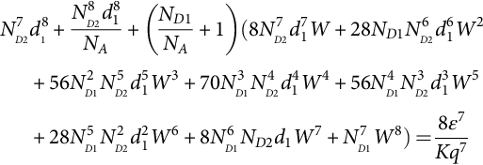 **(A.12)**

For a given breakdown voltage, *BV*, the thicknesses of the drift region, *W*, can be calculated numerically using Eqs. [(A.11)](https://learning.oreilly.com/library/view/power-electronics-handbook/9780128114087/B9780128114070000052_3.xhtml#fo1150), [(A.12)](https://learning.oreilly.com/library/view/power-electronics-handbook/9780128114087/B9780128114070000052_3.xhtml#fo1155).

## References

[1] Bardeen J., Brittain W.H. The transistor, a semiconductor triode. *Phys. Rev.* 1948;230.

[2] Goldey J.M., Mackintosh I.M., Ross I.M. Turn-off gain in p-n-p-n switches. *Solid State Electron.* 1961;3:119.

[3] Goldey J.M., Makintosh I.M., Ross I.M. Turn-off gain in p-n-p-n transistor triodes. *Solid State Electron.* 1961;3:119.

[4] Temple V.A.K., Love R.P. A 600V MOSFET with near ideal onresistance. *IEDM Tech. Dig.* 1978;664.

[5] Baliga B.J. Fast-switching insulated gate transistors. *IEEE Electron Device Lett.* 1983;4(12):452–454.

[6] <http://www.pwrx.com/summary/IGBT/IGBT.aspx>.

[7] <http://fmccgroup.com/products/semiconductors/gto>.

[8] Bernet S. Recent developments of high power converters for industry and traction applications. *IEEE Trans. Power Electron.* 2000;15(6):1102–1117.

[9] Elasser A. Silicon carbide benefits and advantages for power electronics circuits and systems. *Proc. IEEE.* 2002;90(6):969–986.

[10] Johnson C.M., Wright N.G., Ortolland S., Morrison D., Adachi K., O'Neill A.O. *Silicon carbide power devices: hopeful or hopeless?* In: Proc. IEE Colloq. Recent Advances in Power Devices; 1999:10/1–10/5.

[11] Ozpineci B., Tolbert L.M., Islam S.K., Hasanuzzaman M. *Effects of silicon carbide (SiC) power devices on HEV PWM inverter losses.* In: 27 Annual Conference of the IEEE Industrial Electronics Society (IECON'01), Denver, Colorado: s.n., Nov 29 to Dec 2; 2001.

[12] Pearton S. *GaN and ZnO-based Materials and Devices.* Springer Science & Business Media; 2012 s.l.

[13] Dudleyt M., Huangt W., Wangt S., Neudeckt J.A.P., Fazis C. White-beam synchrotron topographic analysis of multi-polytype SiC device configurations. *J. Phys. D. Appl. Phys.* 1995;28:A56–A62.

[14] <http://staff.csc.fi/~raback/sic/thesis/node6.html>.

[15] World Scientific Publishing Co. Pte. Ltd; 8. In: Shur M., Rumyantsev S., Levinshtein M., eds. *SiC Materials and Devices, Selected Topics in Electronics and Systems.* 2007;43 s.l.

[16] Ueno M., Yoshida M., Onodera A., Shimomura O., Takemura K. Stability of the wurtzite-type structure under high pressure: GaN and InN. *Phys. Rev. B.* 1994;49(14) s.l.

[17] Dirote E. *Nanotechnology at the Leading Edge.* New York: Nova Science Publisher, Inc., 2006.

[18] Kuwano N., Kobayashi K., Oki K., Miyoshi S., Yaguchi H., Onabe K., Shiraki Y. Formation of cubic GaN on (111)B GaAs by metal-organic vapor-phase epitaxy with dimethylhydrazine. *Jpn. Soc. Appl. Phys.* 1994;33(1):3415–3417.

[19] Karas G. *New Developments in Crystal Growth Research.* New York: Nova Science Publishers, Inc., 2005.

[20] Shi B., Xie M., Wu H. Transition between wurtzite and zinc-blende GaN: an effect of deposition. *Appl. Phys. Lett.* 2006;89: <http://aip.scitation.org/doi/10.1063/1.2360916>. s.l.

[21] Lei M. *Gallium Nitride Heterogeneous Source Drain MOSFET.* Ann Arbor: ProQuest; 2007.

[22] Levinshtein M., Rumyantsev S., Shur M. *Properties of Advanced SemiconductorMaterials GaN, AlN, InN, BN, SiC, SiGe.* New York: John Wiley & Sons, Inc., 2001.

[23] River Edge, NJ: World Scientific; . In: Levinshtein M., Rumyantsev S., Shurr M., eds. *Semiconductor Parameters.* 1996;1.

[24] Adachi S. *Properties of Group-IV, III-V and II-VI Semiconductors.* John Wiley and Sons; 2005 <http://onlinelibrary.wiley.com/book/10.1002/0470090340>. s.l.

[25] Levinshtein M.E., Rumyantsev S.L., Shur M.S., eds. *Properties of Advanced Semiconductor Materials: GaN, AlN, InN, BN, SiC, SiGe.* New York: John Wiley & Sons, Ins; 2001.

[26] Levinshtein M.E., Rtmlyantsev S.L., Shur M.S. *Properties of Advanced Semiconductor Materials: GaN, AlN, InN, BN, SiC, SiGe.* New York: John Wiley & Sons, Inc; 2001.

[27] Neudeck P.G. Silicon carbide technology. In: *The VLSI Handbook.* second ed. CRC Press; 2006 (Chapter 5).

[28] Suzuki M., Uenoyama T., Yanase A. First-principles calculations of effective-mass parameters of AlN and GaN. *Phys. Rev. B.* 1995;52(11):8132–8139 s.l.

[29] Levinshtein M., Rumyantsev S., Shur M. *Semiconductor Parameters.* River Edge: world Scientific; 1996.1–211.

[30] Hudgins J.L. Wide and narrow bandgap semiconductors for power electronics: a new valuation. *J. Electron. Mater.* 2003;32(6):471–477.

[31] Baliga B. Semiconductors for high-voltage, vertical channel field-effect transistors. *J. Appl. Phys.* 1982;53:1759–1764.

[32] Baliga B.J. *Power Semiconductor Devices.* Boston, MA: PWS Pub. Co., 1996 s.l.

[33] Hudgins J.L., Simin G.S., Santi E., Khan M.A. An assessment of wide bandgap semiconductors for power devices. *IEEE Trans. Power Electron.* 2003;18(3):907–914 s.l.

[34] Johnson J., Piner E., Vescan A., Therrien R., Rajagopal J., Roberts J., Brown J., Brown J., Linthicum K. 12 W/mm AlGaN–GaN HFETs on silicon substrates. *IEEE Electron Device Lett.* 2004;25(7) s.l.

[35] Baliga B.J. Power semiconductor device figure of merit for high-frequency applications. *IEEE Electron Device Lett.* 1989;10(10) s.l.

[36] Johnson E. *Physical Limitations on Frequency and Power Parameters of Transistors.* New York, NY: IRE International Convention Record; 1966.

[37] Marino F.A., Faralli N., Ferry D.K., Goodnick S.M., Saraniti M. Figures of merit in high-frequency and high-power GaN. *J. Phys. Conf. Ser.* 2009;193.

[38] Baliga B.J. *Fundamentals of Power Semiconductor Devices.* New York: Springer Science+Business Media, LLC; 2008.

[39] Skierbiszewski C., Dybko K., Knap W., Siekacz M., Krupczyński W., Nowak G., Boćkowski M., Łusakowski J., Wasilewski Z.R., Maude D., Suski T., Porowski S. High mobility two-dimensional electron gas in AlGaN/GaNAlGaN/GaN heterostructures grown on bulk GaN by plasma assisted molecular beam epitaxy. *Appl. Phys. Lett.* 2005;86(10) s.l.

[40] Huang A.Q. New unipolar switching power device figures of merit. *IEEE Electron Device Lett.* 2004;25(5) s.l.

[41] C2M0025120D Silicon Carbide Power MOSFET Z-FET. s.l. Cree Datasheet, 2014.

[42] Frivaldsky M., Spanik P., Kozacek B., Piri M. *Evaluation of power transistors figure of merit for hard switching commutation mode through experimental analysis.* In: Progress In Electromagnetics Research Symposium Proceedings, Prague, Czech Republic; 2015.

[43] Niculescu E., Purcaru O., Maria M., Cristian M. *A laboratory exercise to estimate the figure of merit index of power MOSFET.* In: Proceedings of the 5th WSEAS/IASME International Conference on Educational Technologies, La Laguna, Spain; 2009.

[44] Ejury J. *How to Compare the Figure of Merit (FOM) of MOSFETs Application Note.* Infineon Technologies Inc; 2003 s.l.

[45] DataSheet 650VCoolMOS™C7PowerTransistor IPB65R045C7, InfineonTechnologiesAG, München, Germany, 2013.

[46] Data Sheet CPM2-1700-0045B N-Channel SiC MOSFET. s.l. ROHM Co. Ltd, 2016.

[47] Data Sheet C3M0065090J Silicon Carbide Power MOSFET C3M MOSFET Technology N-Channel Enhancement Mode, Cree INC, Durham, NC, 2016.

[48] Data Sheet CPM2-1700-0045B Silicon Carbide Power MOSFET C3M MOSFET Technology, Cree Inc., Durham, NC, 2016.

[49] Preliminary Datasheet GS66508B Bottom-side cooled 650 V E-mode GaN transistor. s.l. GaN System, 2016.

[50] PGA26E19BA Preliminary Datasheet, Panasonic Semiconductor Solutions Co., Ltd., Newark, NJ, 2015.

[51] Scarpa V., Harmon O. *120 0 V Co o lSi C™ S ch o ttk y D i od e, Gen er a ti o n 5.* Munich, Germany: Infineon Technologies AG; 2016.

[52] CPW5-1700-Z050B Silicon Carbide Schottky Diode Chip Z-RecTM Rectifier, Cree, Inc., Durham, NC, 2013.

[53] Mantooth H.A., Peng K., Santi E., Hudgins J.L. Modeling of wide bandgap power semiconductor devices—Part I. *IEEE Trans. Electron Dev.* 2015;62(2).

[54] Harmon O., Basler T., Björk F. *Design, Advantages of the 1200 V SiC Schottky Diode with MPS.* Bodo's Power Systems; 2015 <https://www.infineon.com/dgdl/Infineon-Article_Advantages_of_the_1200V_SiC_Schottky_Diode_with_MPS_Design-ART-v01_00-EN.pdf?fileId=5546d46250cc1fdf0151674981861d76>, s.l.

[55] Feng Z.C. *SiC Power Materials: Devices and Applications.* Heidelberg, Germany: Springer Science & Business Media; 2013 s.l.

[56] Defives D., Durand O., Wyczisk F., Noblanc O., Brylinski C., Meyer F. Barrier height analysis of metal/4H-SiC schottky contacts. *Microelectron. Eng.* 2001;55(1–4).

[57] Schroede D. *Modeling of Interface Carrier Transport for Device Simulation.* Wien: Springer-Verlag; 1994.

[58] Hu C. *Semiconductor Devices for Integrated Circuits.* Delhi, India: Pearson; 2010 s.l.

[59] Baliga B.J. *Advanced Power Rectifier Concepts.* New York: Springer Science+Business Media; 2009 s.l.

[60] Wahab Q., Kimoto T., Ellison A., Hallin C., Tuominen M., Yakimova R., Henry A., Bergman J.P., Janzén E. A 3 kV Schottky barrier diode in 4H-SiC. *Appl. Phys. Lett.* 1998;72:445–448.

[61] Zhao J., Sheng K., Lebron-Velilla R.C. Silicone Carbide Schottky barrier diode. *Int. J. High Speed Electron. Syst.* 2005;15(4):821–866.

[62] Sundaresan S.G., Sturdevant C., Marripelly M., Lieser E., Singh R. 12.9 kV SiC PiN diodes with low on-state drops and high carrier lifetimes. *Mater. Sci. Forum.* 2012;717–720:949–952.

[63] Sugawara Y., Takayama D., Asano K., Singh R., Palmour J., Hayashi T. *12-19kV 4H-SiC p–i–n diodes with low power loss.* In: 13th Int. Symp. Power Semiconductor Devices and ICs. s.n. Osaka, Japan; 2001:27–30.

[64] Singh R., Irvine K.G., Capell D.C., Richmond J.T., Berning D., Hefner A.R. Large area, ultra-high voltage 4H-SiC p-i-n rectifiers. *IEEE Trans. Electron Dev.* 2002;49(12):2308–2316.

[65] Elasser A., Kheraluwala M., Ghezzo M., Steigerwald R., Evers N., Kretchmer J., Chow T.P. A comparative evaluation of new silicon carbide diodes and state-of-the-art silicon diodes for power electronic applications. *IEEE Trans. Ind. Appl.* 2003;915–921.

[66] Gachovska T.K., Hudgins J.L., Santi E., Bryan A., Palmer P.R. *Modeling Bipolar Power Semiconductor Devices.* Morgan & Claypool Publishers; 2013 <http://www.morganclaypool.com/doi/suppl/10.2200/S00483ED1V01Y201302PEL005/suppl_file/Gachovska_Ch1.pdf>, s.l.

[67] Leturcq P., Berraies O., Debrie J.L., Gillet P., Kallala M., Massol J.L. *Bipolar Semiconductor Device Models for Computed-Aided Design in Power Electronics.* EPE; 1995.1222–1227.

[68] Braynt A. *Simulation and Optimization of Diode and IGBT Interaction in a Chopper Cell.* (Ph.D. dissertation) University of Cambridge; 2005 s.l.

[69] levels H.S., Gerlach W. On the effective carrier lifetime in p-s-n rectifiers at high injection. *Solid State Electron.* 1969;12:267–275.

[70] Hudgins J.L., Gachovska T.K. Optimization of Forward Voltage Drop for Si, SiC, and GaN High Voltage Diode. *Consum. Electron. Times.* 2013;2(4).

[71] Hudgins J.L., Gachovska T. Comparison of the forward voltage drop of Si and SiC high voltage diodes. *ECS Trans.* 2014;64(7).

[72] Wilamowski B.M. Schottky diodes with high breakdown voltages. *Solid State Electron.* 1983;26(5):491–493.

[73] Severt C., Agarwal A., Singh R., Ryu S.H. *Design of dual use, high efficiency, 4H-SiC Schottky and MPS diodes.* In: Energy Conversion Engineering Conference and Exhibit, 2000. (IECEC) 35th Intersociety, Las Vegas, NV; 2000.

[74] Shenoy J.N., Cooper J.A., Melloch M.R. High-voltage double implanted power MOSFETs in 6H-SiC. *IEEE Electron Device Lett.* 1997;18(3):93–95.

[75] Alok A., Arnold E., Egloff R., Barone J., Murphy J., Conrad R., Burke J. 4H-SiC RF power MOSFET. *IEEE Electron Device Lett.* 2001;22(12):557–558.

[76] Ryu S., Jonas C., Heath B., Richmond J., Agarwal A., Palmour J. *950V, 8.7mohm-cm2 high speed 4H-SiC power DMOSFETs.* In: Material Research Society Spring Meeting, San Francisco: s.n; 2006:391–400.

[77] Saha A., Cooper J.A. A 1-kV 4H-SiC power DMOSFET optimized for low on-resistance. *IEEE Trans. Electron Dev.* 2007;54(10):2786–2791.

[78] Agarwal A.K., Casady J.B., Rowland L.B., Valek W.F., White M.H., Brandt C.D. 1.1kV 4H-SiC power UMOSFET's. *IEEE Electron Device Lett.* 1997;18(12):586–588.

[79] Fujihira K., Miura N., Watanabe T., Nakao Y., Yutani N., Ohtsuka K., Imaizumi M., Takami T., Oomori T. Realization of low on-resistance 4H-SiC power MOSFETs by using retrograde profile in P-body. *Mater. Sci. Forum.* 2007;556–557:827–830.

[80] Sugawara Y., Asano L. *1.4 kV 4H-SiC UMOSFET with low specific on-resistance.* In: 10th International Symposium on Power Semiconductor Devices and ICs, Kyoto; 1998:119–122 s.n.

[81] Ryu S.H., Agarwal A., Richmond J., Palmour J., Saks N., Williams J. *27 mΩ-cm2, 1.6 kV power DiMOSFETs in 4H-SiC.* In: 14th International Symposium on Power Semiconductor Devices and ICs, Santa Fe; 2002:65–68 s.n.

[82] Ryu S.H., Krishnaswami S., Hull B., Heath B., Das M., Richmond J., Agarwal A., Palmour J., Scofield J. Development of 8 mΩ−cm2, 1.8 kV 4H-SiC DMOSFETs. *Mater. Sci. Forum.* 2006;527–529(2):1261–1264.

[83] Ryu S.H., Krishnaswami S., Das M., Hull B., Richmond J., Heath B., Agarwal A., Palmour J., Richmond J. *10.3 mohm-cm2, 2 kV power DMOSFETs in 4H-SiC.* In: 17th Int. Symp. Power Semicond. Devices &IC's; 2005:275–278.

[84] Spitz J., Melloch M.R., Cooper Jr. J.A., Capano M.A. 2.6 kV 4H-Sic lateral DMOSFET's. *IEEE Electron Device Lett.* 1988;19(4):100–102.

[85] Li Y., Cooper J.A., Capano M.A. High-voltage (3 kV) UMOSFETs in 4H-SiC. *IEEE Trans. Electron Dev.* 2002;49(6):972–975.

[86] Ryu S.H., Krishnaswami S., Agarwal A., Richmond J., Palmour J. Development of 10 kV 4H-SiC power DMOSFETs. *Mater. Sci. Forum.* 2004;457–460:1385–1388.

[87] Robert H., Buchoff S., Van Campen S., McNutt T., Ezis A., Bettina B., Kirby C., Sherwin M., Clarke R., Singh R. A 10-kV large-area 4H-SiC power DMOSFET with stable subthreshold behavior independent of temperature. *IEEE Trans. Electron Dev.* 2008;55(8):1807–1815.

[88] Ryu S.H., Krishnaswami S., Das M., Richmond J., Agarwal A., Palmour J., Scofield J. 10 kV 123 mΩ−cm2 4H-SiC power DMOSFETs. *IEEE Electron Device Lett.* 2004;25(8):556–558.

[89] Ryu S.H., Krishnaswami S., Hull B., Richmond J., Agarwal A., Hefner A. *10 kV, 5A 411-SiC Power DMOSFET.* In: 18th International Symposium on Power Semiconductor Devices & IC's, Naples, Italy: s.n; 2006.

[90] Sui Y., Tsuji T., Cooper Jr. J.A. On-state characteristics of SiC power UMOSFETs on 115-μm drift Layers. *IEEE Electron Device Lett.* 2005;26(4):255–257.

[91] Lu C.Y., Cooper Jr. J.A., Tsuji T., Chung G., Williams J.R., McDonald K., Feldman L.C. Effect of process variations and ambient temperature on electron mobility at SiO2/4H-SiC interface. *IEEE Trans. Electron Dev.* 2003;50(7):1582–1588.

[92] Matin M., Saha A., Cooper Jr. J.A. A self-aligned process for high voltage, short-channel vertical DMOSFETs in 4H-SiC. *IEEE Trans. Electron Dev.* 2004;51(10):1721–1725.

[93] Agarwal A.K., Siergeij R.R., Seshadri S., White M.H., Mcmullin P.G., Burk A.A., Rowland L.B., Brandt C.D., Hopkins R.H. Critical materials, device design, performance and reliability issues in 4H-SiC power UMOSFET structures. *Mat. Res. Soc. Symp. Proc.* 1996;423:87–92.

[94] Shenoy P.M., Baliga B.J. The planar 6H-SiC ACCUFET: a new high-voltage power MOSFET structure. *IEEE Electron. Dev. Lett.* 1997;18:589–591.

[95] Blicher A. *Field\_Effect and Bipolar Power Transistor Physics.* New York: Academic Press; 1981.

[96] Fu R., Grekov A., Hudgins J., Mantooth A., Santi E. Power SiC DMOSFET Model accounting for nonuniform current distribution in JFET region. *IEEE Trans. Ind. Appl.* 2012;48(1):181–190.

[97] H. Choi. Overview of Silicon Carbide Power Devices. s.l. Fairchild Semiconductor, <https://www.fairchildsemi.co.kr/Assets/zSystem/documents-archive/collateral/technicalArticle/Overview-of-Silicon-Carbide-Power-Devices.pdf>.

[98] Mino K., Herold S., Kolar J.W. A gate drive circuit for silicon carbide JFET. In: *Industrial Electronics Society, 2003.* IECON ’03. The 29th Annual Conference of the IEEE; 2003.

[99] Round S., Heldwein M., Kolar J., Hofsajer I., Friedrichs P. *A SiC JFET driver for a 5 kW, 150 kHz three-phase PWM converter.* In: Conference Record of the 2005 Industry Applications Conference, Fourtieth IAS Annual Meeting; 2005.

[100] Platania E., Chen Z., Chimento F., Lu L., Santi E., Raciti A., Hudgins J., Mantooth A., Sheridan D., Cassady J. *A physics-based model for a SiC JFET device accounting for the mobility dependence on temperature and electric field.* In: Industry Applications Society Annual Meeting. IAS '08. IEEE, Edmonton; 2008.

[101] Cai C., Zhou W., Sheng K. Characteristics and application of normally-Off SiC-JFETs in converters without antiparallel diodes. *EEE Trans. Power Electr.* 2013;28:4850–4860.

[102] Final Datasheet Silicon Carbide- Junction Field Effect Transistor 1200 V CoolSiC™ Power Transistor IJW120R100T1. s.l. Infineon Technologies AG, Vol. 2013.

[103] Datasheet C2M0040120D silicon carbide power MOSFET C2M MOSFET Technology, Cree, Inc., Durham, 2014.

[104] Bakowski M. Prospects and development of vertical normally-off JFETs in SiC. *J. Telecommun. Inform. Technol.* 2009;4:25–36.

[105] Ryu S.-H., Agarwal A.K., Singh R., Palmour J.W. 1800 V NPN bipolar junction transistors in 4H-SiC. *IEEE Electron Device Lett.* 2001;22(3):124–126.

[106] Lee H.S., Östling M. 1200-V 5.2-mΩ • cm2 4H-SiC BJTs with a high common-emitter current gain. *IEEE Electron Device Lett.* 2007;28(11):1007–1009.

[107] Domeij M., Lee H.-S., Danielsson E., Zetterling C.-M., Östling M., Schöner A. Geometrical effects in high current gain 1100-V 4HSiC BJTs. *IEEE Electron Device Lett.* 2005;26(10):743–745.

[108] Agarwal A.K., Krishnaswami S., Richmond J., Capell C., Ryu S.-H., Palmour J., Balachandran S., Chow T.P., Bayne S., Geil B., Scozzie C. *Evolution of the 1600 V, 20 A SiC bipolar junction transistors.* In: 17 International Symposium on Power Semiconductor Devices & IC's, Santa Barbara, CA: s.n., 2005:271–274.

[109] Miyake H., Kimoto T., Suda J. *4H-SiC bipolar junction transistors with record current gains of 257 on (0001) and 335 on (000–1).* In: IEEE 23rd International Symposium on Power Semiconductor Devices and ICs, San Diego; 2011.

[110] Ohtani N. *Recent progress in SiC single crystal wafer technology.* In: The 5th International Symposium on Advanced Science and Technology of Silicon Materials (JSPS Si Symposium), Kona, Hawaii, USA: s.n., 2008.

[111] Balachandran S., Li C., Losee P.A., Bhat I.B., Chow T.P. *6 kV 4H-SiC BJTs with specific on-resistance below the unipolar limit using a selectively grown base contact process.* In: The 19th International Symposium on Power Semiconductor Devices and ICs, Jeju Island: s.n., 2007:293–296.

[112] Hudgins T., Gachovskaa J.L. Comparison of the forward voltage drop of Si and SiC high voltage diodes. *ECS Trans.* 2014;64(7):223–236.

[113] Wang J., Huang A.Q., Baliga B.J. *RBSOA study of high voltage SiC bipolar devices.* In: 21st International Symposium on Power Semiconductor Devices & IC's, 2 ISPSD; 2009:263–266.

[114] Zhang Q., Jonas C., Ryu S., Agarwal A., Palmour J. *Design and fabrications of high voltage IGBTs on 4H-SiC.* In: IEEE International Symposium on Power Semiconductor Devices and IC's; 2006.

[115] Zhang Q., Jonas C., Sumakeris J., Agarwal A., Palmour J. *12 kV 4H-SiC p-IGBTs with record low specific on-resistance.* In: Int. Conf. Silicon Carbide and Related Materials (ICSCRM), Otsu, Japan: s.n., 2007.

[116] Das M., Zhang Q., Callanan R., Capell C., Claytou J., Donfrio M., Haney S., Husna F., Jonas C., Richmond J., Sumakeris J.J. *A 13 kV 4H-SiC N-channel IGBT with lowRdiff, on and fast switching.* In: Int. Conf. Silicon Carbide and Related Materials (ICSCRM), Otsu, Japan: s.n., 2007.

[117] Sui Y., Wang X., Cooper J.A. High-voltage self-aligned p-channel DMOS-IGBTs in 4H-SiC. *IEEE Electron Device Lett.* 2007;28(8):728–730.

[118] van Brunt E., Cheng L., O'Loughlin M.J., Richmond J., Pala V., Palmour J., Tipton C.W., Scozzie C. 27 kV, 20 A 4H-SiC n-IGBTs. *Mater. Sci. Forum.* 2015;821–823:847–850.

[119] Sheng K., Udrea F., Amaratunga G.A.J. Optimum carrier distribution of the IGBT. *Solid State Electron.* 2000;44(9):1573–1583.

[120] Das M.K., Callanan R., Capell D.C., Hull B., Husna F., Richmond J., O'loughlin M., Paisley M.J., Powell A., Zhang Q. *20th International Sympo … Help Working with Abstracts.* In: 20th International Symposium on Power Semiconductor Devices and IC's; Orlando: Browse Conference Publications; 2008.

[121] Ryu S., Capel C., Jonas l.C., Lemma Y., O'Loughlin M., Clayton J., Van Brunt E., Lam K., Richmond J., Burk A., Grider D., Allen S., Palmour J., Agarwal A., Kadavelugu A., Bhattacharya S. *Ultra high voltage IGBTs in 4H-SiC.* In: Wide Bandgap Power Devices and Applications (WiPDA), IEEE Workshop on, Columbus; 2013.

[122] Chowdhury S., Chow T.P. *Performance tradeoffs for ultra-high voltage (15 kV to 25 kV) 4H-SiC n-channel and p-channel IGBTs.* In: Power Semiconductor Devices and ICs (ISPSD), 28th International Symposium; 2016.

[123] Bryant A., Yang S., Mawby P., Xiang D., Ran L., Tavner P., Palmer P.R. Investigation into IGBT dV/dt during turn-off and its temperature dependence. *IEEE Trans. Power Electron.* 2011;26(10):3019–3031.

[124] Sung W., Wang J., Huang A., Baliga B. *Design and investigation of frequency capability of 15kV 4H-SiC IGBT.* In: 21st International Symposium on Power Semiconductor Devices & IC's; 2009.

[125] Ryu S., Capell C., Jonas C., Cheng L., O'Loughlin M., Burk A., Agarwal A., Palmour J., Hefner A. *Ultra high voltage (>12 kV), high performance 4H-SiC IGBTs.* In: 24th International Symposium on Power Semiconductor Devices and ICs; 2014.

[126] Tamaki T., Walden G.G., Sui Y., Cooper J.A. Optimization of on-state and switching performances for 15–20-kV 4H-SiC IGBTs. *IEEE Trans. Electron Dev.* 2008;5(8):1920–1927.

[127] Kang X., Caiafa A., Santi E., Hudgins J.L., Palmer P.R. Characterization and modeling of high-voltage field-stop IGBTs. *IEEE Trans. Ind. Appl.* 2003;39(4):922–928.

[128] Lai L.L. *Power system restructuring and deregulation: trading, performance and information technology.* New York: John Wiley & Sons, Ltd; 2001 s.l.

[129] Agarwal A.K., Casady J.B., Rowland L.B., Seshadri S., Siergiej R.R., Valek W.F., Brandt C.D. 700-V asymmetrical 4H-SiC gate turn-off thyristors (GTOs). *IEEE Electron Device Lett.* 1997;18:518.

[130] Agarwal A.K., Damsky B., Richmond J., Krishnaswami S., Capell C., Ryu S.H., Palmour J.W. *The first demonstration of the 1 cm x 1 cm SiC thyristor chip.* In: The 17 International Symposium on Power Semiconductor Devices & IC's, Santa Barbara: s.n., 2005:195–198.

[131] CREE, Cree Silicon Carbide Substrates and Epitaxy, Product Specifications, Cree. INC, Durham, NC, 2013.

[132] Kimoto T., Hiyoshi T., Hayashi T., Suda J. Impacts of recombination at the surface and in the substrate on carrier lifetimes of n-type 4H–SiC epilayers. *J. Appl. Phys.* 2010;108(8) s.l.

[133] Hayashi T., Asano K., Suda J., Kimoto T. *Impacts of reduction of deep levels and surface passivation on carrier lifetimes in p-type 4H-SiC epilayers.* 2011;109:114502–114504.

[134] Cheng L., Agarwal A.K., Capell C., O'Loughlin M., Brunt E.V., Lam K., Richmond J., Burk A., Palmour J.W., O'Brien H., Ogunniyi A., Scozzie C. *20 kV, 2 cm2, 4H-SiC gate turn-off thyristors for advanced pulsed power applications.* In: Plasma Science (ICOPS), Abstracts IEEE International Conference on, San Francisco; 2013.

[135] Boles T., Varmazis C., Carlson D., Xia L., Jin D., Palacios T., Turner G.W., Molnar R.J. *High-voltage GaN-on-silicon Schottky diodes.* New Orleans: CS MSNTECH; 2013 May 13th–16th.

[136] Takeuchi T., Amano H., Hiramatsu K., Sawaki N., Akasaki I. Growth of single crystalline GaN film on Si substrate using 3C-SiC as an intermediate layer. *J. Cryst. Growth.* 1991;115:1–4 s.l.

[137] Watanabe A., Takeuchi T., Hirosawa K., Amano H., Hiramatsu K., Akasaki I. The growth of single crystalline GaN on a Si substrate using AIN as an intermediate layer. *J. Cryst. Growth.* 1993;128:1–4 s.l.

[138] Yang J.W., Sun C.J., Chen Q., Anwar M.Z., Khan M.S., Nikishin S.A., Seryogin G.A., Osinsky A.V., Chernyak L., Temkin H., Hu C., Mahajan S. High quality GaN–InGaN heterostructures grown on (111) silicon substrates. *Appl. Phys. Lett.* 1996;96: s.l.

[139] Nakakda Y., Aksenov I., Okumura H. GaN heteroepitaxial growth on silicon nitride buffer layers formed on Si (111) surfaces by plasma-assisted molecular beam epitaxy. *Appl. Phys. Lett.* 1998;73:827–829 s.l.

[140] Keyan Z., Lianshan W., Jin C.S., Thompson C.V. *Evolution of AlN buffer layers on silicon and the effect on the property of the expitaxial GaN film.* 2003 s.l. <http://hdl.handle.net/1721.1/3713>.

[141] Songa J., Lua W., Flynnb J.S., Brandes G.R. AlGaN/GaN Schottky diode hydrogen sensor performance at high temperatures with different catalytic metals. *Solid State Electron.* 2005;49:1330–1334.

[142] Kumar V., Zhou L., Selvanathan D., Adesida I. Thermally-stable low-resistance Ti/Al/Mo/Au multilayer ohmic contacts on n–GaN. *Appl. Phys.* 2002;92:1712–1714.

[143] Zhao Z.M., Jiang R.L., Chen P., Xi D.J., Yu H.Q., Shen B., Zhang R., Shi Y., Gu S.L., Zheng Y.D. Ti/Al/Pt/Au and Al ohmic contacts on Si-substrated GaN. *Appl. Phys. Lett.* 2001;79(218):218–221 s.l.

[144] Peatman W.C.B., Crowe T.W., Shur M., Gelmont B. *A Schottky/2-DEG Varactor Diode for Millimeter and Submillimeter Wave Multiplier Applications.* In: Third International Symposium on Space Terahertz Technology, Michigan; 1992.

[145] Changa T.F., Huanga C.F., Yangb T.Y., Chiub C.W., Huangb T.Y., Leec K.Y., Zhao F. Low Turn-on voltage dual metal AlGaN/GaN Schottky barrier diode. *Solid State Electron.* 2015;105:12–15.

[146] Lee H.S., Jung D.Y., Park Y., Na J., Jang H.G., Lee H.S., Jun C.H., Park J., Ryu S.O., Ko S.C., Nam E.S. 0.34 VT AlGaN/GaN-on-Si large Schottky barrier diode with recessed dual anode metal. *IEEE Electron Device Lett.* 2015;36(11):1132–1134.

[147] Zhu H., Zongyang N., Kazuki Y., Xiaodong C., Yu J., Wayne K., Erhard J., Debdeep X., Huili G. 1.9 kV AlGaN/GaN lateral Schottky barrier diodes on silicon. *IEEE Electron Device Lett.* 2015;34:375–377 s.l.

[148] Kachi T., Uesugi T. *Which are the future GaN power devices for automotive applications, lateral structures or vertical structures?* In: CS MANTECH Conference, Palm Springs, California; 2011.

[149] Zhang Y., Sun M., Liu Z., Palacios T. Electrothermal simulation and thermal performance study of gan vertical and lateral power transistors. *IEEE Trans. Electron Dev.* 2013;60(7):2224–2230.

[150] Kizilyalli I.C., Edwards A.P., Nie H., Bour D.P. 400-A (Pulsed) vertical GaN p-n diode with breakdown voltage of 700 V. *IEEE Electron Device Lett.* 2014;35(6):654–656.

[151] Morkoç H. *Handbook of Nitride Semiconductors and Devices: Electronic and Optical Processes in Nitrides.* Weinheim, Germany: Wiley-VCH Verlag GmbH; 2008.

[152] Chu C., Yu C.C., Wang Y.K., Tsai J.Y., Lai F.I., Wang S.C. Low-resistance ohmic contacts on p-type GaN using Ni/Pd/Au metallization. *Appl. Phys. Lett.* 2000;77(21):3423–3426.

[153] Gachovska T.K.Consumer Electronics Times. Optimization of forward voltage drop for Si, SiC, and GaN high voltage diode. *Consum. Electron. Times.* 2013;2(4).

[154] Dickerson J.R., et al. Vertical GaN power diodes with a bilayer edge termination. *IEEE Trans. Electron Dev.* 2016;63(1):419–425.

[155] Zou X., Zhang X., Lu X., Tang C.W., Lau K.M. Breakdown ruggedness of quasi-vertical GaN-based p-i-n diodes on Si substrates. *IEEE Electron Device Lett.* 2016;37(9):1158–1161.

[156] Zhang Y., Sun M., Piedra D., Azize M., Zhang X., Fujishima T., Palacios T. GaN-on-Si vertical Schottky and p-n diodes. *IEEE Electron Device Lett.* 2014;35(6):618–620.

[157] Kizilyalli I.C., Prunty T., Aktas O. 4-kV and 2.8-mΩ-cm2 vertical GaN p-n diodes with low leakage currents. *IEEE Electron Device Lett.* 2015;36(10) s.l.

[158] Kizilyalli I.C., Edwards A.P., Aktas O., Prunty T., Bour D. Vertical power p-n diodes based on bulk GaN. *IEEE Trans. Electron Dev.* 2015;62(2) s.l.

[159] Zhang Y., et al. Origin and Control of OFF-State Leakage Current in GaN-on-Si Vertical Diodes. *IEEE Trans. Electron Dev.* 2015;62(7) s.l.

[160] Ip K., Baik K.H., Luo B., Ren F., Pearton S.J., Park S.S., Park Y.J., Zhang A.P. High current bulk GaN Schottky rectifiers. *Solid State Electron.* 2002;46(7) s.l.

[161] Baliga A.M., Ozbek B.J. Planar nearly ideal edge-termination technique for GaN devices. *IEEE Electron Device Lett.* 2011;32(3) s.l.

[162] I. C. Kizilyalli, H. Nie, A. P. Edwards, L. Romano, D. P. Bour, R. J. Brown, T. R. Prunty. Method and System for Gan Vertical JFET Utilizing a Regrown Gate. s.l. US20160190351 A1, 2016.

[163] Chowdhury S., Ji D. Design of 1.2 kV power switches with low RON using GaN-based vertical JFET. *IEEE Trans. Electron Dev.* 2015;62(8) s.l.

[164] H. Nie, A. Edwards, I. Kizilyalli, D. Bour, T.R. Prunty, Region, Lateral GaN JFET With Vertical Drift. s.l. United States Patent Application Publication, Vol. US20140131721 A1, 2014.

[165] Aktas I.C., Kizilyalli O. *Characterization of vertical GaN p–n diodes and junction field-effect transistors on bulk GaN down to cryogenic temperatures.* Semiconductor Science and Technology; . 2015;30 <http://iopscience.iop.org/article/10.1088/0268-1242/30/12/124001>, s.l.

[166] Zeng J., Dolny G., Kocon C., Stokes R., Kraft N., Brush L., Grebs T., Hao J., Ridley R., Benjamin J., Skurkey L., Benczkowski S., Semple D., Wodarczyk P., Rexer C. *An ultra dense trench-gated power MOSFET technology using a self-aligned process.* Osaka: Proceedings of the 13th International Symposium on Power Semiconductor Devices and ICs; 2001.

[167] Oka T., Ina T., Ueno Y., Nishii J. *Over 10 a operation with switching characteristics of 1.2 kV-class vertical GaN trench MOSFETs on a bulk GaN substrate.* Prague: 28th International Symposium on Power Semiconductor Devices and ICs; 2016.

[168] Pierret R. *Semiconductor Device Fundamentals.* Boston, MA: Addison-Wesley Publishing ompany, Inc; 1996.

[169] Gupta C., Chan S.H., Enatsu Y., Agarwal A., Keller S., Mishra U.K. OG-FET: An in-situ Oxide, GaN interlayer based vertical trench MOSFET. *s.l. IEEE Electron Device Lett.* 2016;99:1601–1604.

[170] Otake H., Egami S., Ohta H., Nanishi Y., Takasu H. GaN-based trench gate metal oxide semiconductor field effect transistors with over 100 cm2/(V-s) channel mobility. *Jpn. J. Appl. Phys.* 2007;46(25) s.l.

[171] Kodama M., Sugimoto M., Hayashi E., Soejima N., Ishiguro O., Kanechika M., Itoh K., Ueda H., Uesugi T., Kachi T. GaN-based trench gate metal oxide semiconductor field-effect transistor fabricated with novel wet etching. *Appl. Phys. Express.* 2008;1(2) s.l.

[172] Otake H., Chikamatsu K., Yamaguchi A., Fujishima T., Ohta H. Vertical GaN-based trench gate metal oxide semiconductor field-effect transistors on GaN bulk substrates. *Appl. Phys. Express.* 2008;1(1) s.l.

[173] Niiyama Y., Shinagawa T., Ootomo S., Kambayashi H., Nomura T., Kato S. High-power operation of normally-off GaN MOSFETs. *Furukawa Rev.* 2009;36: s.l.

[174] Vaes H.M.J., Appels J.A. *HV thin layer devices (RESURF Devices).* In: Intlernational Electron Devices Meeting, Washington, DC; 1979.

[175] Huang W., Chow T.P., Niiyama Y., Nomura T., Yoshida S. *Lateral implanted RESURF GaN MOSFETs with BV up to 2.5 kV.* In: Proceedings of the 20th International Symposium on Power Semiconductor Devices & IC's, Orlando; 2008.

[176] Huang W., Chow T.P., Niiyama Y., Nomura T., Yoshida S. *730V, 34mΩ-cm2 lateral epilayer RESURF GaN MOSFET.* In: 21st International Symposium on Power Semiconductor Devices & IC's, Barselona; 2009.

[177] Huang W., Khan T., Chow T.P. Enhancement-mode n-channel GaN MOSFETs on p and n-GaN/Sapphire Substrates. *IEEE Electron Device Lett.* 2006;27(10) s.l.

[178] Ambacher O., Smart J., Shealy J.R., Weimann N.G., Chu K., Murphy M., Schaff W.J., Eastman L.F., Dimitrov R., Wittmer L., Stutzmann M., Rieger W., Hilsenbeck J. wo-dimensional electron gases induced by spontaneous and piezoelectric polarization charges in N- and Ga-face AlGaN/GaN heterostructures. *J. Appl. Phys.* 1999;85(6) s.l.

[179] Kazior T.E., Chelakara R., Hoke W., Bettencourt J., Palacios T., Lee H.S. *High performance mixed signal and rf circuits enabled by the direct monolithic heterogeneous integration of GaN HEMTs and Si CMOS on a silicon substrate.* In: Compound Semiconductor Integrated Circuit Symposium (CSICS), 2011 IEEE; 2011.

[180] Saito W., Nitta T., Kakiuchi Y., Saito Y., Tsuda K., Omura I., Yamaguchi M. On-resistance modulation of high voltage GaN HEMT on sapphire substrate under high applied voltage. *IEEE Electron Device Lett.* 2007;28(8) s.l.

[181] Sheppard S.T., Doverspike K., Pribble W.L., Allen S.T., Palmour J.W., Kehias L.T., Jenkins T.J. High-power microwave GaN/AlGaN HEMTs on semi-insulating. *IEEE Electron Device Lett.* 1999;20(4) s.l.

[182] Chu K.K., Chao P.C., Pizzella M.T., Actis R., Meharry D.E., Nichols K.B., Vaudo R.P., Xu X., Flynn J.S., Dion J., Brandes G.R. 9.4 W/mm power density AlGaN-GaN HEMTs on free-standing GaN substrates. *IEEE Electron Device Lett.* 2004;25(9) s.l.

[183] Lorenz K., Gonsalves M., Kim W., Narayanan V., Mahajan S. Comparative study of GaN and AlN nucleation layers and their role in growth of GaN on sapphire by metalorganic chemical vapor deposition. *Appl. Phys. Lett.* 2000;77: s.l.

[184] Leea J.W., Junga S.H., Shina H.Y., Leeb I.H., Yanga C.W., Leea S.H., Yooa J.B. Effect of buffer layer on the growth of GaN on Si substrate. *J. Cryst. Growth.* 2002;237-239:2 s.l.

[185] Y. Wu, P. Parikh, U. Mishra, High Voltage Gan Transistor. US20120223366 A1 September 6, 2012.

[186] Hasan M.T., Kojima T., Tokuda H., Kuzuhara M. *Effect of sputtered SiN passivation on current collapse of AlGaN/GaN HEMTs.* In: CS MANTECH Conference, New Orleans, Louisiana, USA; 2013.

[187] Chen J., Wakabayashi H., Tsutsui K., Iwai H., Kakushima K. Poly-Si gate electrodes for AlGaN/GaN HEMT with high reliability and low gate leakage current. *Microelectron. Reliab.* 2016;63: s.l.

[188] Vacca G. GaN-based HEMT improvement using advanced structures. *Semiconductor Today Compounds Advanced Silicon.* 2013;7(7) s.l.

[189] Saito W., Kakiuchi Y., Nitta T., Saito Y., Noda T., Fujimoto H., Yoshioka A., Ohno T., Yamaguchi M. Field-plate structure dependence of current collapse phenomena in high-voltage GaN-HEMTs. *IEEE Electron Device Lett.* 2010;31(7) s.l.

[190] Brennan T.H., Yu K.F. Theoretical study of the two-dimensional electron mobility in strained III-nitride heterostructures. *J. Appl. Phys.* 2001;89: s.l.

[191] Hsu L., Walukiewicz W. Electron mobility in AlxGa1−xN/GaN heterostructures. *Phys. Rev. B.* 1997;56: s.l.

[192] Li T., Joshi R.P., Fazi C. Monte Carlo evaluations of degeneracy and interface roughness effects on electron transport in AlGaN-GaN heterostructures. *J. Appl. Phys.* 2000;88: s.l.

[193] Gaska R., Shur M.S., Bykhovski A.D., Orlov A.O., Snider G.L. Electron mobility in modulation-doped AlGaN–GaN heterostructures. *Appl. Phys. Lett.* 1999;74: s.l.

[194] Guang H.X., Gang Z.D., De-Sheng J. Formation of two-dimensional electron gas at AlGaN/GaN heterostructure and the derivation of its sheet density expression. *Chin. Phys. B.* 2015;24(6) s.l.

[195] Heikman S., Keller S., Wu Y., Speck J.S., DenBaars S.P., Mishra U.K. Polarization effects in AlGaN/GaN and GaN/AlGaN/GaN heterostructures. *J. Appl. Phys.* 2003;93: s.l.

[196] Asgari A., Kalafi M., Faraone L. The effects of GaN capping layer thickness on two-dimensional electron mobility in GaN/AlGaN/GaN heterostructures. *Phys. E.* 2005;25: s.l.

[197] Jena D. *Polarization Induced Electron Populations in III-V Nitride Semiconductors Transport, Growth, and Device Applications.* Santa Barbara: University of California; 2003.

[198] Kolluri S., Keller S., Brown D., Gupta G., Rajan S., DenBaars S.P., Mishra U.K. Influence of AlN interlayer on the anisotropic electron mobility and the device characteristics of N-polar AlGaN/GaN metal-insulator-semiconductor-high electron mobility transistors grown on vicinal substrates. *J. Appl. Phys.* 2010;108.

[199] Charfeddine M., Belmabrouk H., Ali Zaidi M., Maaref H. 2-D theoretical model for current-voltage characteristics in AlGaN/GaN HEMT's. *J. Mod. Phys.* 2012;3.

[200] Lidow A., Strydom J., de Rooij M., Reusch D. *GaN Transistors for Efficient Power Conversion.* Chichester, United Kingdom: Wiley; 2014 s.l.

[201] Note, GaN Systems Application. How to Drive GaN Enhancement Mode Power Switching Transistors, s.l. GaN Systems.Inc., 2014.

[202] Bindra A. *Startup Unveils Plan to Build GaN Power ICs.* Electronics 360 Powered by IEE Global Spec; 2016 s.l.

[203] Gachovska T.K., Gerolami C. *Comparison of Si and GaN-FETs in a VAR compensation application.* In: Electrical Power and Energy Conference, Ottawa; 2016.

[204] PCB Thermal Design Guide for GaN Enhancement Mode Power Transistors, Note, GaN System Inc. Application, 2016, <http://www.ecomal.com/fileadmin/Datenblaetter/GaN_Systems/App_Notes/GN005_App_Note-PCB_Thermal_Design_Guide_for_GaN_Enhancement_Mode_Power_Transistors.pdf>.

[205] Sze S.M., Gibbons G. Avalanche breakdown voltages of abrupt and linearly graded p-n Junctions in Ge, Si, GaAs, and GaP. *Appl. Phys. Lett.* 1967;8:111–113.

[206] Trivedi M., Shenai K. Performance evaluation of high power wide band-gap semiconductor rectifiers. *J. Appl. Phys.* 1999;85(9):6889–6897.

[207] Fulopa W. Calculation of avalanche breakdown voltages of silicon p-n junctions. *Solid State Electron.* 1967;10(1):39–43.

## Further Reading

[1] W.B. Shockley, Circuit element utilizing semiconductor material. US patent 2,569,347, 1948.

[2] Baliga B.J., Adler M.S., Love R.P., Gray P.V., Zommer N.D. The insulated gate transistor: A new three-terminal MOS-controlled bipolar power device. *IEEE Trans. Electron Dev.* 1984;31(6):821–828.

[3] <http://www.cree.com/products/pdf/1700V%20Sales%20Sheet.pdf>.

[4] Luo Y., Zhang J., Alexandrov P., Fursin L., Zhao J.H., Burke T. High voltage (>1 kV) and high current gain (32) 4H-SiC power BJTs using Al-free ohmic contact to the base. *IEEE Electron Device Lett.* 2003;24(11):695–697.

[5] Huang V.C., Cooper Jr. J.A. *4H-SiC NPN bipolar junction transistors with BVCEO >3200.* In: 14th International Symposium on Power Semiconductor Devices and ICs; 2002:57–60.

[6] Zhao J.H., Zhang J., Alexandrov P., Li X., Burke T. A high voltage (1,750V) and high current gain (β=24.8) 4H-SiC bipolar junction transistor using a thin (12 μm) drift layer. *Mater. Sci. Forum.* 2004;457–460:1173–1176.

[7] Krishnaswami S., Agarwal A., Richmond J., Capell C., Ryu S.-H., Palmour J., Geil B., Katsis D., Scozzie C. High temperature characterization of 4H-SiC bipolar junction transistors. *Mater. Sci. Forum.* 2006;527–529:1437–1440.

[8] Zhang Q.J., Agarwal A., Burk A., Geil B., Scozzie C. 4H–SiC BJTs with current gain of 110. *Solid State Electron.* 2008;52:1008–1010.

[9] Lee H., Domeij M., Ghandi R., Zetterling C.M., Östling M. High-current-gain SiC BJTs with regrown extrinsic base and etched JTE. *IEEE Trans. Electron Dev.* 2008;55(8):1894–1898.

[10] Zhang J., Luo Y., Alexandrov P., Fursin L., Zhao J.H. A high current gain 4H-SiC NPN power bipolar junction transistor. *IEEE Electron Device Lett.* 2003;24:327–329.

[11] Zhang J., Alexandrov P., Burke T., Zhao J.H. 4H-SiC power bipolar junction transistor with a very low specific on-resistance of 2.9 mΩ • cm2. *IEEE Electron Device Lett.* 2006;27(5):368–370.

[12] Zhang J., Alexandrov P., Zhao J.H. High Power(500V-70A) and high gain(44-47) 4H-SiC bipolar junction transistors. *Mater. Sci. Forum.* 2004;457–460:1149–1152.

[13] Round S., Heldwein M., Kolar J., Hofsajer I., Friedrichs P. *A SiC JFET driver for a 5 kW, 150 kHz three-phase PWM converter.* In: Fourtieth IAS Annual Meeting - Industry Applications Conference, Vol. 1; 2005:410–416.

[14] <http://www.semiconductor-today.com/news_items/2009/OCT/SEMISOUTH_051009.htm> October 5, 2009.

[15] Friedrichs P., Mitlehner H., Schorner R., Dohnke K.O., Elpelt R., Stephani D. *The vertical silicon carbide JFET—a fast and low loss solid state power switching device.* Graz, Austria: EPE; 2001 s.n.

[16] Friedrichs P., Mitlehner H., Schorner R., Dohnke K.O., Elpelt R., Stephani D. *Stacked High Voltage Switch Based on Sic VJFETs.* Cambridge, UK: ISPSD; 2003.139–142.

[17] Asano K., Sugawara Y., Hayashi T., Ryu S., Singh R., Palmour J., Takayama D. *5kV 4H-SiC SEJFET with Low RonS of 69m12cm2.* In: ISPSD'02, Santa Fe; 2002:61–64.

[18] Wua J., Hua J., Zhao J.H., Wang X., Li X., Fursin L., Burke T. Normally-off 4H-SiC trench-gate MOSFETs with high mobility. *Solid State Electron.* 2008;52(6):909–913.

[19] Friedrichs P., Mitlehner H., Schorner R., Dohnke K.O., Elpelt R., Stephani D. *High voltage, modular switch based on Sic VJFETs – first results for a fast 4,5kV/1.2 Ohm configuration.* In: ECSCRM2002, Linkiiping; 2002.

[20] Zhang Q., Chang H.R., Gomez M., Bui C., Hanna E., Higgins J.A., Smith T.I., Williams J.R. *10 kV trench gate IGBTs on 4H-SiC.* In: The 17th International Symposium on Power Semiconductor Devices and ICs; 2005:303–306.

[21] Agarwal A.K., Ryu S.H., Singh R., Kordina O., Palmourl J.W. 2600 V, 12 A, 4H-SiC, asymmetricalgate turn-off (GTO) thyristor development. *Mater. Sci. Forum.* 2000;338–342:1387–1390.

[22] Campen S.V., Ezis A., Zingaro J., Storaska G., Clarke R.C., Temple V., Thompson M., Hansen T. *7 kV 4H-SiC GTO Thyristors.* In: MRS Proceedings; . 2002;742 K7.7.

[23] Wang J., Huang A.Q. Design and Characterization of High-Voltage Silicon Carbide Emitter Turn-off Thyristor. *IEEE Trans. Power Electron.* 2009;24(5):1189–1197.

[24] Sugawara Y., Takayama D., Asano K., Agarwal A., Ryu S., Palmour J., Ogata S. *12.7 kV ultra high voltage SiC commutated gate turn-off thyristor: SICGT.* In: Intemational Symposium on Power Semiconductor Devices & ICs, Kitakyushu; 2004:365–368.

[25] Paques G., Scharnholz S., Dheilly N., Planson D., De Doncker R.W. High-voltage 4H-SiC thyristors with a graded etched junction termination extension. *IEEE Electron Device Lett.* 2011;32(10):1421–1423.

[26] Anantharam V., Bhat K.N. Analytical solutions for the breakdown voltages of punched-through diodes having curved junction boundaries at the edges. *IEEE Trans. Electron Dev.* 1980;27(5):939–945.

[27] Santi E., Hudgins J.L., Mantooth H.A. *Variable model levels for power semiconductor devices.* In: The 2007 Summer Computer Simulation Conference, San Diego; 2007:276–283.

[28] Ma C.L., Lauritzen P.O., Lin P.Y., Budihardjo I. *A systematic approach to modeling of power semiconductor devices based on charge control principles.* In: IEEE PESC Rec, Taipei; 1994:31–37.

[29] Talwalkar N., Lauritzen P.O., Fatemizadeh B., Perlman D., Ma C.L. *A power BJT model for circuit simulation.* In: 27th Annual IEEE Power Electronics Specialists Conference, Baveno, Italy, vol. 1; 1996:50–55.

[30] Ma C.L., Lauritzen P.O. *A physics-based GTO model for circuit simulation.* In: Power Electronics Specialists Conference, Atlanta, vol. 2; 1995:872–878.

[31] Hossain Z., Olejniczak K.J., Mantooth H.A., Yang E.X., Ma C.L. A physics-based MCT circuit model using the lumped-charge modeling approach. *IEEE Trans. Power Electron.* 2001;16(2):264–272.

[32] Budihardjo I., Lauritzen P.O., Xu C. *Simulation of high frequency PWM and Quasi-resonant converters using the lumped-charge power MOSFET model.* In: Applied Power Electronics Conference and Exposition, APEC '94, vol. 2; 1994:1042–1048.

[33] Gummel H.K., Poon H.C. An integral charge-control model of bipolar transistors. *Bell Syst. Tech. J.* 1970;49:827–852.

[34] Massobrio G., Antognetti P. *Semiconductor Device Modeling With SPICE.* New York, NY, USA: McGraw-Hill, Inc., 1993 s.l.

[35] Kull G.M., Nagel L.W., Lee S.W., Lloyd P., Prendergast E.J., Dirks H. A unified circuit model for bipolar transistors including quasi-saturation effects. *IEEE Trans. Electron Dev.* 1985;32:1103–1113.

[36] Pong M., Jackson R. *Simulation of power transistor in its circuit environment.* In: IEEE Industry Applications Society Annual Meeting Conference Record, Toronto, Canada: s.n., 1985:894–899.

[37] Jeong H., Fossum J. A charge-based large signal bipolar transistor model for device and circuit simulation. *IEEE Trans. Electron Dev.* 1987;36(1):124–131.

[38] Roulston D., Quoirin J. Simulation of highvoltage power switching transistors under forced gain and inductive load turn-off conditions. *Solid State Electron Dev.* 1988;135(1):7–12.

[39] Goebel H., Kraus R., Mattausch H.J. *A Hybrid method for modeling semiconductor power devices.* In: Power Electronics Specialists Conference, Seattle: s.n., 1993:45–52.

[40] Fardi H.Z. Modeling dc gain performance of 4H-SiC BJTs. *Int. J. Comput. Math. Electr. Electron. Eng.* 2007;26(5):1236–1246.

[41] Ebers J.J., Moll J.L. Large-signal behavior of junction transistors. *Proc. IRE.* 1954;42:1761–1772.

[42] Brezeanu G. *Silicon carbide (SiC): a short history. An analytical approach for SiC power device design.* Semiconductor Conference, 2005. CAS 2005 International2005;2:345–348.

[43] Saddow S.E., Agarwal A., eds. *Advances in Siliconl Carbide Processing an Applications.* Boston: Artech House Inc; 2004.

[44] Round H.J. A note on carborundum. *Electr. World.* 1907;19:309–310.

[45] Baumhauer H. Über die Kristalle des Carborundums. *Z. Kristallogr.* 1912;50:33–39.

[46] Lely J.A. Silidum carbide von Art und Mendge der eingebeunten verunreininungen. *Ber. Dt. Keram. Ges.* 1955;32:229–231.

[47] Tairov Y.M., Tsvetkov V.F. Investigation of growth processes of ingots of silicon carbide single crystals. *J. Cryst. Growth.* 1978;43:209–212.

[48] Zhang J., Burke T. Implantation-free 4H-SiC bipolar junction transistors with double base epilayers. *IEEE Electron Device Lett.* 2008;29(5):471–473.

[49] Baliga B.J. *Silicone Carbide Power Devices.* World Scientific Co. Pte. Ltd; 2005 s.l.

[50] Xu C., Schroeder D. A power bipolar junction transistor model describing static and dynamic behaviour. *IEEE Trans. Power Electron.* 1992;7(4):734–740.

[51] Ma C.L., Lauritzen P.O., Türkes P., Mattausch H.J. *A physically-based Lumped-charge SCR Model.* In: Power Electronics Specialists Conference, Seattle: s.n., 1993:53–59.

[52] Matsunami H., Nishino S., Ono H. IVA-8 heteroepitaxial growth of cubic silicon carbide on foreign substrates. *IEEE Trans. Electron Dev.* 1981;28:1235–1236.

[53] Bridgestone Develops 5-Inch Semi-Conductor Wafer, <http://rubbermarketnews.net/2011/08/bridgestone-develops-5-inch-semi-conductor-wafer/> August 29, 2011. (Cited: October 17, 2011).

[54] H. Föll, Ramsdell Notation for SiC Polytypes, <http://www.tf.uni-kiel.de/matwis/amat/semi_en/kap_a/basics/ba_1_1.html> (Online 2008). (Cited: October 17, 2011).

[55] Han T.T., Fu Y., Ågren H., Han P., Qin Z., Zhang R. Room-temperature photoluminescence of doped 4H-SiC film grown on AlN/Si(100). *Appl. Phys. A Mater. Sci. Process.* 2007;86:145–149.

[56] Veliadis V., McNutt T., nook M.S., Hearne H., Potyraj P., Junghans J., Scozzie C. Large area silicon carbide vertical JFETs for 1200 V cascode switch operation. *Int. J. Power Manag. Electron.* 2008;2008:8 523721.

[57] Palmer P.R., Santi E., Hudgins J.L., Kang X., Joyce J.C., Eng P.Y. Circuit simulator models for the diode and IGBT with full temperature dependent features. *IEEE Trans. Power Electron.* 2003;18(5):1220–1229.

[58] Bryant A.T., Palmer P.R., Santi E., Hudgins J.L. *A compact diode model for the simulation of fast power diodes including the effects of avalanche and carrier lifetime zoning.* In: Power Electronics Specialists Conference, PESC '05. IEEE 36th; 2005:2042–2048.

[59] Wang X., Caiafa A., Hudgins J.L., Santi E., Palmer P.R. *Implementation and Validation of a Physics-based Circuit Model forIGCT with Full Temperature Dependencies.* In: Implementation and Validation of a Physics-based Circuit Model for, Aachen, Power Electronics Specialists Conference, 2004. PESC 04. 2004 IEEE 35th Annual, Germany; 2004 s.n.

[60] Loh W.S., Ng B.K., Ng J.S., Soloviev S.I., Young C.H., Sandvik P.M., Johnson C.M., David J.P.R. Impact ionization coefficients in 4H-SiC. *IEEE Trans. Electron Dev.* 2008;55(8):1984–1990.

[61] Shampine L.F., Reichelt M.W. The MATLAB ODE suite. *SIAM J. Sci. Comput.* 1997;18(1):1–22.

[62] Klein P.B., Freitas Jr. J.A., Binari S.C., Wickenden A.E. Observation of deep traps responsible for current collapse in GaN metal semiconductor field effect transistors. *Appl. Phys. Lett.* 1999;75:4016–4018.

[63] Klein P.B., Freitas Jr. J.A., Binari S.C., Wickenden, Observation of deep traps responsible for current collapse in GaN metal–semiconductor field-effect transistors A.E. *Appl. Phys. Lett.* 1999;75:4016–4018.

[64] General Properties of Silicon Carbide. <https://www.ifm.liu.se/semicond/local_info/popular/Chapter2.html> (Cited: February 20, 2012).

[65] H. Föll, Siliconcarbide—Materials Aspects. <http://www.tf.uni-kiel.de/matwis/amat/semi_en/kap_a/backbone/ra_1_1.html> (Cited: February 20, 2012).

[66] <http://www.tf.uni-kiel.de/matwis/amat/semi_en/kap_a/backbone/ra_1_1.html>.

[67] Elasser A., Kheraluwala M., Ghezzo M., Steigerwald R., Evers N., Kretchmer J., Chow T.P. A comparative evaluation of new silicon carbide diodes and state-of-the-art silicon diodes for power electronic applications. *IEEE Trans. Ind. Appl.* 2003;39(4):915–921.

[68] Bryant A., Xiaosong K., Santi E., Palmer P., Hudgins J. Two-step parameter extraction procedure with formal optimization for physics-based circuit simulator IGBT and p-i-n diode models. *IEEE Trans. Power Electron.* 2006;21(2):295–309.

[69] Bougrov V., Levinshtein M.E., Rumyantsev S.L., Zubrilov A. In: Levinshtein M.E., Rumyantsev S.L., Shur M.S., eds. *Properties of Advanced Semiconductor Materials GaN, AlN, InN, BN, SiC, SiG.* New York: John Wiley & Sons, Inc., 2001.

[70] Bayer M., Kraus R., Hoffman K. *A precise model for the DC and transient characteristics of BJT's.* In: Power Electronics Specialists Conference; 1994:64–68.

[71] Hudgins T.K., Gachovska J.L. Optimization of forward voltage drop for Si, SiC, and GaN High voltage diode. *Consum. Electron. Times.* 2013;2:4 s.l.

[72] Song X., Huang A., Lee M., Peng C., Cheng L., O'Brien H., Ogunniyi A., Scozzie C., Palmour J. *22 kV SiC Emitter turn-off (ETO) thyristor and its dynamic performance including SOA.* In: 27th International Symposium on Power Semiconductor Devices & IC's (ISPSD), Hong Kong; 2015.

[73] Gachovska T., Hudgins J.L. Comparison of the forward voltage drop of Si and SiC high voltage diodes. *ECS Trans.* 2014;64(7) s.l.

[74] Gupta C., Chan S.H., Enatsu Y., Agarwal A., Keller S., Mishra U.K. *s.l. IEEE Electron Device Lett.* 2016;37(12):1601–1604.

[75] Bothe K.M., Barlage D.W. Underlying design advantages for GaN MOSFETs compared with GaN HFETs for power applications. *J. Comput. Electron.* 2014;13(1) s.l.

[76] Mitani E., Haematsu H., Yokogawa S., Nikaido J., Tateno Y. *Mass-production of high-voltage GaAs and GaN devices.* In: CS MANTECH 2006, Vancouver, British Columbia, Canada; 2006.

**6**

# Power Electronic Modules

Enrico Santi University of South Carolina, Columbia, SC, United States

Soheila Eskandari University of South Carolina, Columbia, SC, United States

Bo Tian University of South Carolina, Columbia, SC, United States

Kang Peng Infineon Technologies AG Design Center, Tewksbury, MA, United States

## Abstract

A power electronic module or power module is an assembly containing several power components, mostly power semiconductor devices, properly internally interconnected to perform a power conversion function. It is an integrated building block for the realization of a power converter with a reduced number of external components required. Control electronics such as gate drivers, sensing, and protection functions may be included inside the power module package. In this case, the term intelligent power module is commonly used. From the electric standpoint, the power module reduces parasitic elements in the interconnection of the power semiconductor devices due to the tight physical integration. From the thermal standpoint, the power module usually has a thermally conductive baseplate that can be bolted to a heat sink or a cold plate to remove the loss heat generated as a result of power converter operation. From the mechanical standpoint, it provides a robust mechanical package for the power components inside. In conclusion, a power module is an electro-thermo-mechanical device optimized for power converter operation. Using a power module may simplify the design of a power converter because the power module design provides a robust mechanical structure and guarantees proper operation from an electric and thermal point of view as long as the module datasheet specifications and guidelines are followed. Power modules are typically used at higher power levels, where a discrete component implementation would require paralleling of several power semiconductor devices.

### KEYWORDS

Power module; Intelligent power module; Gate drivers; Sensing; IGBT; MOSFET; Diode; Kelvin contact; Power management

6.1 [Introduction](https://learning.oreilly.com/library/view/power-electronics-handbook/9780128114087/B9780128114070000064.xhtml#s0010)

6.2 [Discrete Power Devices Versus Power Modules](https://learning.oreilly.com/library/view/power-electronics-handbook/9780128114087/B9780128114070000064.xhtml#s0015)

6.3 [An Example of Power Module](https://learning.oreilly.com/library/view/power-electronics-handbook/9780128114087/B9780128114070000064.xhtml#s0020)

6.4 [Manufacturing Process](https://learning.oreilly.com/library/view/power-electronics-handbook/9780128114087/B9780128114070000064.xhtml#s0025)

6.4.1 Semiconductor Chips

6.4.2 Die Attach

6.4.3 Wire Bonds

6.4.4 DBC Substrate

6.4.5 Baseplate

6.5 [Types of Power Electronic Modules](https://learning.oreilly.com/library/view/power-electronics-handbook/9780128114087/B9780128114070000064.xhtml#s0055)

6.5.1 A Survey of Power Electronic Module Topologies

6.5.2 Power Semiconductor Devices Used in Power Electronic Modules

6.5.3 SiC Power Semiconductor Devices in Power Modules

6.6 [Thermal Management of Power Modules](https://learning.oreilly.com/library/view/power-electronics-handbook/9780128114087/B9780128114070000064.xhtml#s0075)

6.6.1 The Purpose of Thermal Management

6.6.2 Equivalent Thermal Network of Power Module

6.6.3 Cooling Solutions for Power Module

6.7 [Reliability of Power Modules](https://learning.oreilly.com/library/view/power-electronics-handbook/9780128114087/B9780128114070000064.xhtml#s0120)

6.7.1 Reliability Tests

6.8 [Design Guidelines and Considerations](https://learning.oreilly.com/library/view/power-electronics-handbook/9780128114087/B9780128114070000064.xhtml#s0140)

6.8.1 Bypass Capacitor Considerations

6.8.2 Gate Driver Design Considerations

6.8.3 Gate Kelvin Contacts

6.8.4 Other Design Considerations

[References](https://learning.oreilly.com/library/view/power-electronics-handbook/9780128114087/B9780128114070000064.xhtml#bi0010)

[Further Reading](https://learning.oreilly.com/library/view/power-electronics-handbook/9780128114087/B9780128114070000064.xhtml#fr0010)

## 6.1 Introduction

A power electronic module or power module is an assembly containing several power components, mostly power semiconductor devices, properly internally interconnected to perform a power conversion function. It is an integrated building block for the realization of a power converter with a reduced number of external components required. Control electronics such as gate drivers, sensing, and protection functions may be included inside the power module package. In this case, the term intelligent power module (IPM) is commonly used. From the electric standpoint, the power module reduces parasitic elements in the interconnection of the power semiconductor devices due to the tight physical integration. From the thermal standpoint, the power module usually has a thermally conductive baseplate that can be bolted to a heat sink or a cold plate to remove the loss heat generated as a result of power converter operation. From the mechanical standpoint, it provides a robust mechanical package for the power components inside. In conclusion, a power module is an electro-thermo-mechanical device optimized for power converter operation. Using a power module may simplify the design of a power converter because the power module design provides a robust mechanical structure and guarantees proper operation from an electric and thermal point of view as long as the module datasheet specifications and guidelines are followed. Power modules are typically used at higher power levels, where a discrete component implementation would require paralleling of several power semiconductor devices.

Advantages of power modules are tight integration of multiple power semiconductor devices, high current and power ratings because multiple power semiconductor dies can be paralleled inside the module, good thermal management, and mechanical robustness. Probably, the biggest advantage is the reduction of parasitic elements, in particular parasitic inductances, due to the tight integration. These parasitic elements cause additional losses and overshoot and ringing during converter operation, which cause electromagnetic interference (EMI) issues. The parasitic element reduction allows switching converter operation at higher frequency, which reduces passive filtering element size, and may provide additional system-level advantages, such as quiet converter operation at switching frequencies above the audible range.

The main disadvantage of power modules is probably a higher cost compared with discrete devices. A second disadvantage is that a specific application may require characteristics not available in commercial modules on the market.

In this article, power electronic modules will be described mostly from the point of view of a power module user, somebody who wants to use a power module to realize a power converter rather than the point of view of the designer of a power module.

In [Section 6.2](https://learning.oreilly.com/library/view/power-electronics-handbook/9780128114087/B9780128114070000064.xhtml#s0015), the differences between discrete devices and modules are discussed. [Section 6.3](https://learning.oreilly.com/library/view/power-electronics-handbook/9780128114087/B9780128114070000064.xhtml#s0020) gives an example of a power module. [Section 6.4](https://learning.oreilly.com/library/view/power-electronics-handbook/9780128114087/B9780128114070000064.xhtml#s0025) briefly describes the manufacturing process of power modules. [Section 6.5](https://learning.oreilly.com/library/view/power-electronics-handbook/9780128114087/B9780128114070000064.xhtml#s0055) describes various types of modules and the types of power semiconductor devices used in them. [Section 6.6](https://learning.oreilly.com/library/view/power-electronics-handbook/9780128114087/B9780128114070000064.xhtml#s0075) discusses thermal management and [Section 6.7](https://learning.oreilly.com/library/view/power-electronics-handbook/9780128114087/B9780128114070000064.xhtml#s0120) module reliability. Finally, [Section 6.8](https://learning.oreilly.com/library/view/power-electronics-handbook/9780128114087/B9780128114070000064.xhtml#s0140) provides design guidelines and considerations for the use of power modules.

## 6.2 Discrete Power Devices Versus Power Modules

[Fig. 6.1](https://learning.oreilly.com/library/view/power-electronics-handbook/9780128114087/B9780128114070000064.xhtml#f0010) shows a photo of two discrete semiconductor components—a power metal-oxide-semiconductor field-effect transistor (MOSFET) and a diode—and a power module. The power module is a half-bridge configuration realized with silicon insulated-gate bipolar transistors (IGBTs). The module ratings are from 1200 V to 100 A. Notice that the power module has multiple power and control connections. The module of [Fig. 6.1](https://learning.oreilly.com/library/view/power-electronics-handbook/9780128114087/B9780128114070000064.xhtml#f0010) has three large screw-type power connections for the power terminals and four smaller pin-type connections on top for the IGBT gate terminals. The bottom of the module has a metal baseplate that can be bolted to a heat sink for thermal management. Two of the baseplate holes for heat sink mount can be clearly seen at the bottom. Notice that a discrete component contains a single power semiconductor device in an individual package, whereas the power module contains multiple power semiconductor devices. A second difference is that for discrete devices, the metal plate for heat sink connection, if provided like in the discrete MOSFET of [Fig. 6.1](https://learning.oreilly.com/library/view/power-electronics-handbook/9780128114087/B9780128114070000064.xhtml#f0010), is typically nonisolated, whereas in the power module, all semiconductor devices are thermally coupled to the baseplate but are electrically isolated from it. In the TO220 discrete MOSFET, the metal tab is electrically connected to the drain of the MOSFET, and electric isolation must be provided as part of the heat sink mount.

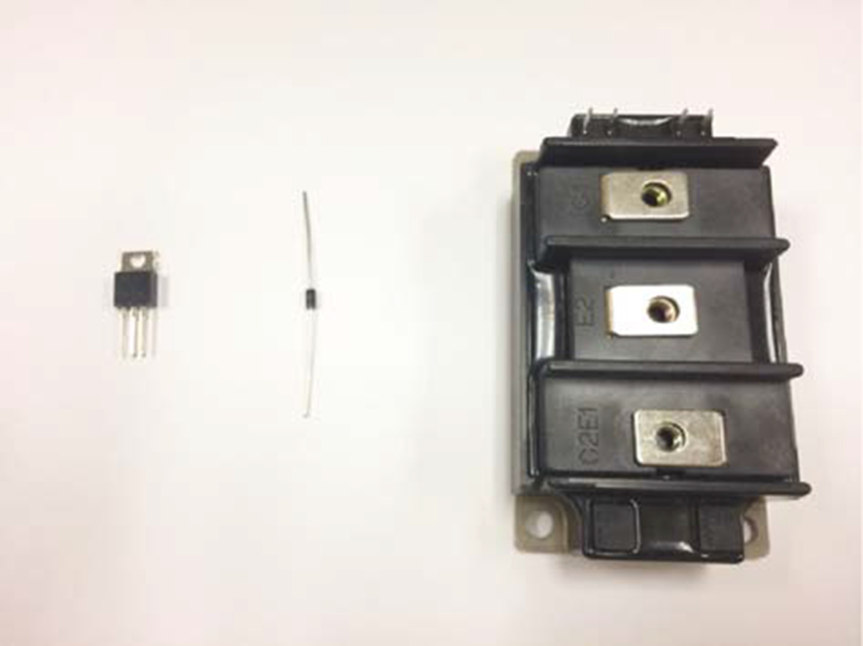

**FIG. 6.1** From left to right: photo of a discrete power MOSFET in TO220 package, a discrete leaded diode, and a power electronic module (Toshiba MG100Q2YS1).

## 6.3 An Example of Power Module

In this section, an example of an IGBT half-bridge power module is described. The physical structure of the power module with labeled terminal connections is shown in [Fig. 6.2](https://learning.oreilly.com/library/view/power-electronics-handbook/9780128114087/B9780128114070000064.xhtml#f0015).

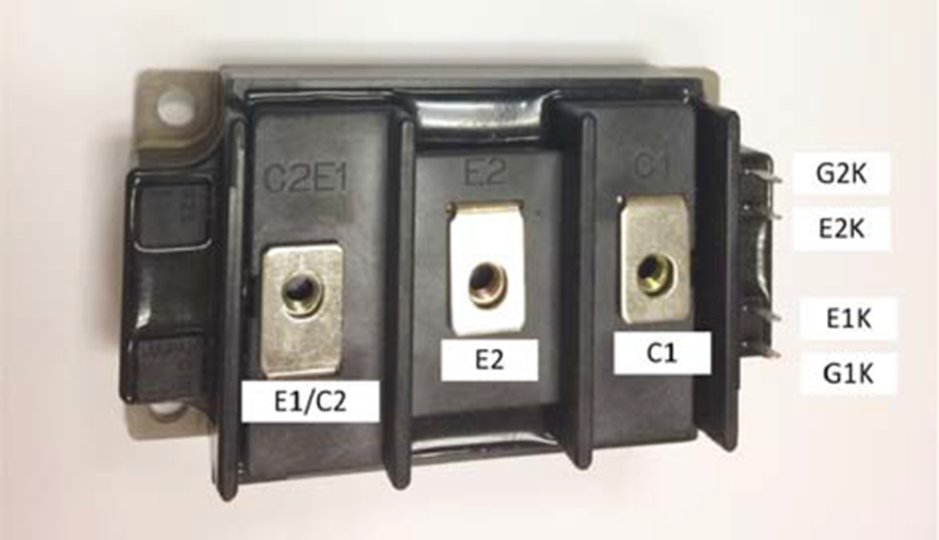

**FIG. 6.2** Photo of Toshiba MG100Q2YS1 IGBT half-bridge power module with labeled terminals.

The equivalent circuit of the module is shown in [Fig. 6.3](https://learning.oreilly.com/library/view/power-electronics-handbook/9780128114087/B9780128114070000064.xhtml#f0020) with labeled terminals. The top IGBT, called IGBT1, has collector terminal C1 and emitter terminal E1. The gate and emitter Kelvin terminals are called G1K and E1K, respectively (Kelvin contacts are discussed in [Section 6.8.3](https://learning.oreilly.com/library/view/power-electronics-handbook/9780128114087/B9780128114070000064.xhtml#s0155)). Labeling is similar for IGBT2, the bottom IGBT. Note that the module contains four distinct semiconductor devices, two IGBTs and two diodes. Each of these may consist of a single die or multiple dies connected in parallel to achieve higher current capability.

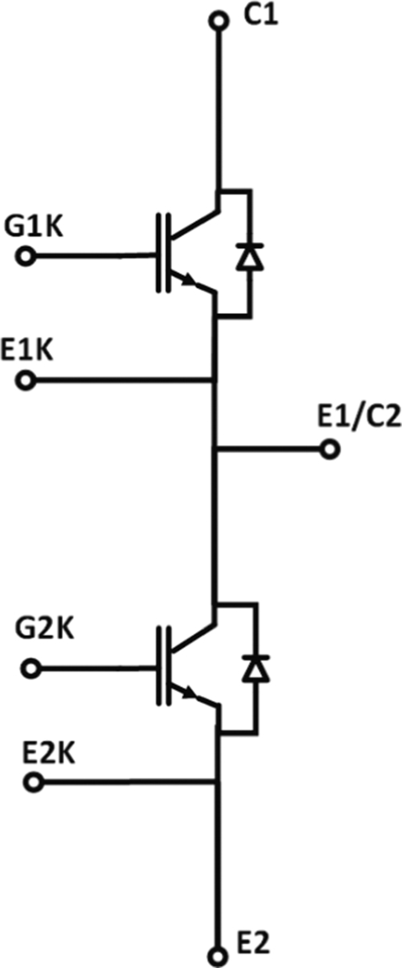

**FIG. 6.3** Equivalent circuit of Toshiba MG100Q2YS1 power module.

The IGBT half-bridge power module can be used to realize different switching power converters such as a bidirectional DC-DC converter (buck type in one direction and boost type in the other direction) or a single-phase two-level inverter. Three modules could be combined to create a three-phase inverter, but in that case, using a single three-phase module may be more convenient. Some of the external components required to realize a switching power converter are shown in [Fig. 6.4](https://learning.oreilly.com/library/view/power-electronics-handbook/9780128114087/B9780128114070000064.xhtml#f0025). First of all, gate drivers are required to control the IGBTs. In a switching converter, the two IGBTs are turned on in a complementary fashion, so that, when one IGBT is on, the other one is off. The gate driver controls should introduce a short dead time during which both switches are off to prevent shoot-through, that is, shorting capacitor *C*BYPASS. Second, a bypass capacitor *CBYPASS* is required to filter the square-wave current at the switching frequency drawn by the power module during operation. As will be described later, capacitor *C*BYPASS should be a high-frequency capacitor and should be placed physically close to the module to minimize interconnection parasitic inductance, which causes overshoot and ringing during switching operation. Finally, an inductor *L* is required to filter the square-wave voltage at the switching frequency created at node E1/C2 by the switching action. Sources and loads can then be connected to the 1-2 and 3-2 ports.

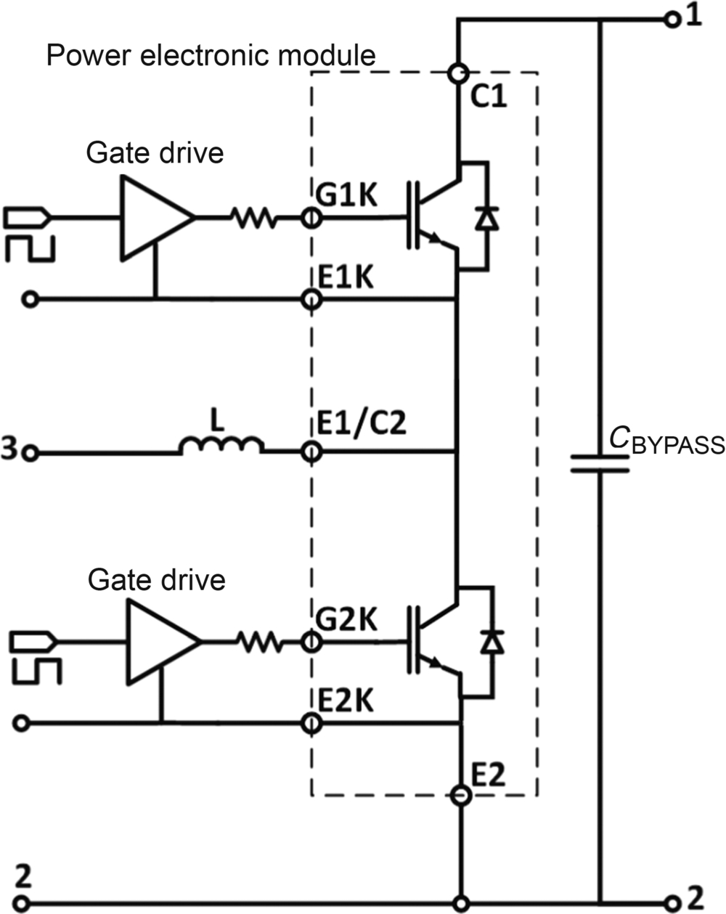

**FIG. 6.4** Equivalent circuit of power electronic module with some of the external components needed for switching converter realization.

## 6.4 Manufacturing Process

As mentioned above, power modules contain multiple power devices internally interconnected to realize a specific power processing function, such as the IGBT half-bridge module package shown in [Fig. 6.2](https://learning.oreilly.com/library/view/power-electronics-handbook/9780128114087/B9780128114070000064.xhtml#f0015). As shown in the equivalent circuit of [Fig. 6.3](https://learning.oreilly.com/library/view/power-electronics-handbook/9780128114087/B9780128114070000064.xhtml#f0020), this module contains multiple IGBT and diode chips interconnected to form a half-bridge topology. Physically, a power module is an integration of semiconductor chips, wire bonds, direct bonded copper (DBC) substrate, solder, baseplate, silicone gel, terminals, housing, and so on as shown in [Fig. 6.5](https://learning.oreilly.com/library/view/power-electronics-handbook/9780128114087/B9780128114070000064.xhtml#f0030). The manufacturing process includes attaching chips on the DBC substrate, bonding wires, attaching the DBC substrate to the baseplate, placing the top housing, and filling it with silicone gel. Each element of the generic power module of [Fig. 6.5](https://learning.oreilly.com/library/view/power-electronics-handbook/9780128114087/B9780128114070000064.xhtml#f0030) has a specific function, and its selection depends on many factors. The semiconductor chips are selected to provide the required voltage and current ratings. The DBC substrate provides electric isolation but good thermal coupling between the chips and the baseplate, so that heat generated on the chips can be efficiently conducted to the baseplate. The top copper layer provides the required electric connections among the bottom terminals of the chips. Wire bonds provide the required electric connections for the top terminals of the chips and connections to the module terminals. The baseplate provides mechanical support for the module and can be connected to a heat sink for heat removal. These elements and the techniques used for power module assembly will be described more in detail in the following subsections.

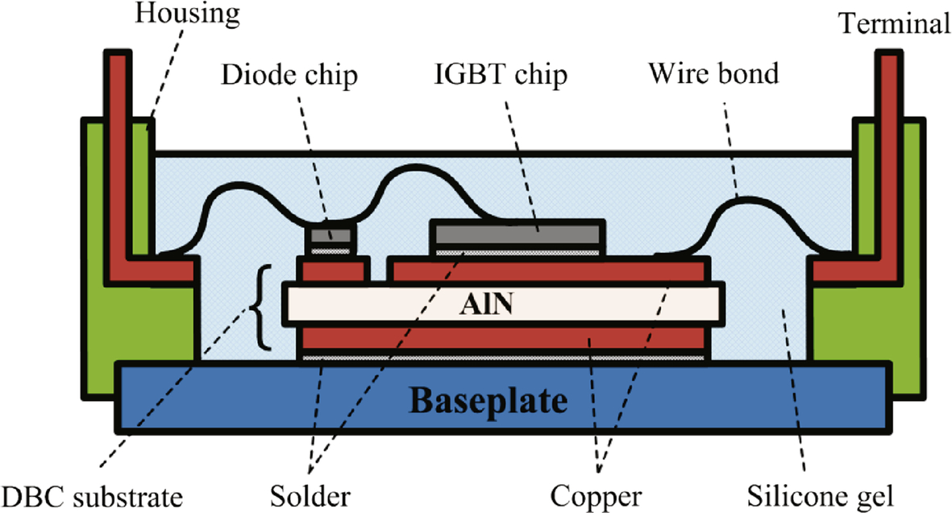

**FIG. 6.5** Cross section of IGBT power electronic module.

### 6.4.1 SEMICONDUCTOR CHIPS

The semiconductor chips form the core of a power electronic module. [Fig. 6.6](https://learning.oreilly.com/library/view/power-electronics-handbook/9780128114087/B9780128114070000064.xhtml#f0035) shows the interior of a power electronic module with semiconductor chips mounted on a DBC substrate and interconnected with wire bonds. Semiconductor chips determine the voltage, current, and power ratings of the power module. Power modules with different internal interconnections of semiconductor chips are available to realize different power converter topologies such as half bridge and full bridge. To achieve high-current capability, multiple semiconductor chips can be paralleled inside the module. The performance of power modules in terms of on-resistance, switching speed, and power loss is critically dependent on the semiconductor chip characteristics.

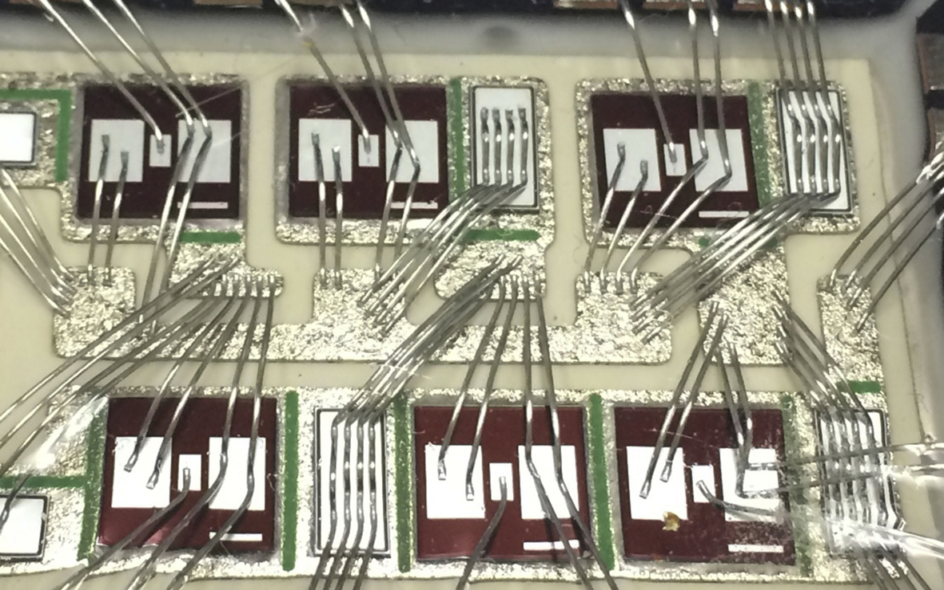

**FIG. 6.6** Top view of power module interior showing semiconductor chips mounted on DBC substrate with wire bond interconnections.

### 6.4.2 DIE ATTACH

Die attach is the process of attaching a die/chip to a substrate or package. For example, in the power module of [Fig. 6.5](https://learning.oreilly.com/library/view/power-electronics-handbook/9780128114087/B9780128114070000064.xhtml#f0030), the IGBT chip and the diode chip are attached to the top copper layer of the DBC substrate. Note that in case of vertical chip devices, the device power terminals are on opposite sides of the chip, and therefore, the chip current flows through the die attach joint. Die attach is usually accomplished by using one of the following processes: (1) eutectic, (2) solder, (3) adhesive, (4) glass or silver glass:

1) A *eutectic bond* is formed by melting a preform consisting of a mixture or alloy of two or more dissimilar metals in the joint between the die and substrate. The preform has a melting point that is lower than the melting point of its base materials. For example, considering a typical preform composed of gold and silicon, the melting point of gold is 1640°C, and the melting point of silicon is 1414°C. However, when the materials are combined in a preform, the melting point drops to 363°C [[1](https://learning.oreilly.com/library/view/power-electronics-handbook/9780128114087/B9780128114070000064.xhtml#bb0010)].

2) *Solder* is an attaching method commonly used in the semiconductor industry. Solder attach provides good mechanical strength, high thermal conductivity, and good electric conductivity. Lead-based solder has been popular for a long time with advantages of good performance, proved technology, and low cost. However, environmental concerns about the toxic properties of lead have recently arisen. As a result, lead-free solder is gradually replacing lead-based solder in many applications.

3) An *adhesive* bond is formed by attaching the die to the substrate using some type of adhesive material. It can be electrically insulating or conductive depending on the adhesive material used. An advantage of adhesive bonding is that it is performed at room temperature and does not require high temperatures.

4) A *glass bond* is formed by attaching the die to the substrate using glass in paste form. The glass paste may also contain silver particles that enhance thermal and electric conductivity (this is called silver-glass die bonding). The glass bonding process is similar to adhesive bonding. The differences are the material used and the need for heat. Glass bonds are heated to 350–450°C that melts the glass into a low viscosity liquid. The glass hardens as it cools, thereby making the bond [[1](https://learning.oreilly.com/library/view/power-electronics-handbook/9780128114087/B9780128114070000064.xhtml#bb0010)].

### 6.4.3 WIRE BONDS

The electric connections between the top connections of semiconductor chips and module terminals are realized by wire bonding (shown in [Figs. 6.5](https://learning.oreilly.com/library/view/power-electronics-handbook/9780128114087/B9780128114070000064.xhtml#f0030) and [6.6](https://learning.oreilly.com/library/view/power-electronics-handbook/9780128114087/B9780128114070000064.xhtml#f0035)). Conventional wire bonding materials include aluminum (Al), copper (Cu), and gold (Au). Aluminum is the most common material for power modules because of its low cost and convenient process, especially to form thick wires for high-current capability. Gold has the lowest resistivity and good high-frequency performance and is usually used for integrated circuit and high-frequency devices. Due to limited improvement of resistance in power module and high cost, gold is not commonly used in power modules. The electric properties of copper are intermediate between those of Al and Au, whereas the cost of aluminum is significantly lower than copper. Consequently, Al wire bonds are most common with copper used in special cases.

To satisfy high-current requirements, heavy wire bonding ([Fig. 6.7](https://learning.oreilly.com/library/view/power-electronics-handbook/9780128114087/B9780128114070000064.xhtml#f0040)) has been developed. Traditional wire size is smaller than 10 mils (1 mil=1/1000 in.) in diameter, whereas heavy wire bonding is significantly thicker and can save space on the bonding pad. An alternative solution is ribbon bonding ([Fig. 6.8](https://learning.oreilly.com/library/view/power-electronics-handbook/9780128114087/B9780128114070000064.xhtml#f0045)), which has the added advantage of better high-frequency performance [[2](https://learning.oreilly.com/library/view/power-electronics-handbook/9780128114087/B9780128114070000064.xhtml#bb0015)]. Ribbon bonding is a form of wedge bonding using flat ribbon to replace the round wire. Compared with round wire, ribbon wire can carry higher current at high frequency, where skin effect is the limiting factor, and has smaller effective inductance and less signal cross talk [[3](https://learning.oreilly.com/library/view/power-electronics-handbook/9780128114087/B9780128114070000064.xhtml#bb0020)].

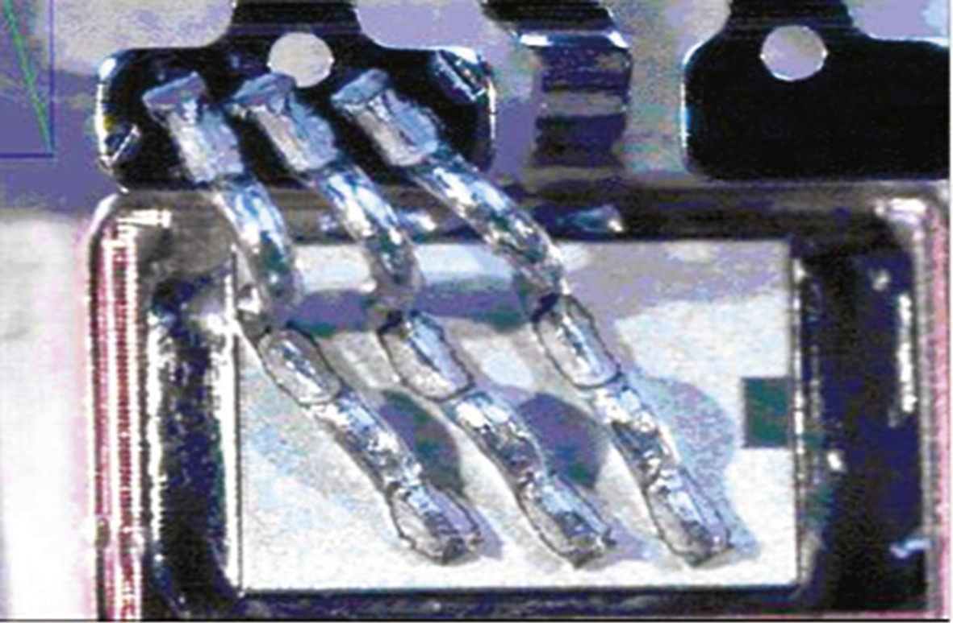

**FIG. 6.7** Heavy wire bonding.

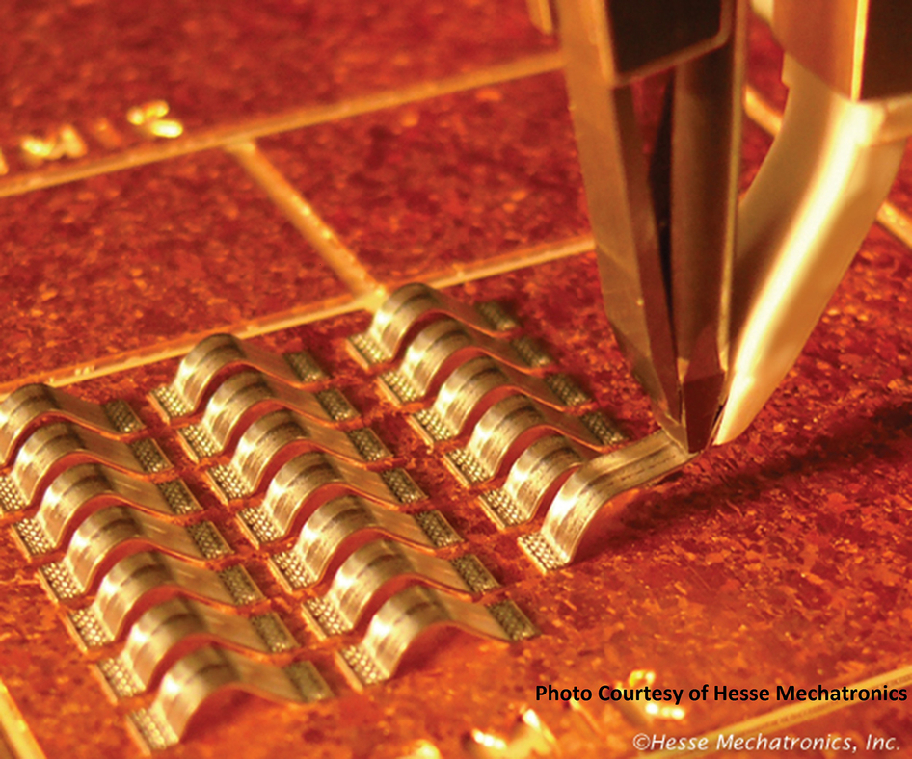

**FIG. 6.8** Ribbon bonding.

### 6.4.4 DBC SUBSTRATE

The DBC substrate is an important interface between the electric components in the power module and the external cooling system [[4](https://learning.oreilly.com/library/view/power-electronics-handbook/9780128114087/B9780128114070000064.xhtml#bb0025)]. It consists of a ceramic insulator layer with copper bonded to one or both sides by a high-temperature melting and diffusion process. DBC substrates provide electric conduction on the top copper layer, electric isolation from top to bottom thanks to the ceramic insulator layer, and outstanding thermal conduction from top to bottom. The top copper layer is etched to form the required electric interconnections and is electrically connected to the backside electrodes of semiconductor chips using one of the die attach techniques described above, most commonly by soldering. The excellent electric isolation is provided by the ceramic material. The two most common choices are alumina (Al2O3) and aluminum nitride (AlN). Al2O3 is inexpensive and widely used; however, it has the disadvantages of having relatively low thermal conductivity (24–28 W/m K) and of being brittle. Compared with Al2O3, AlN is more expensive, but it has better mechanical and thermal performance (thermal conductivity larger than 150 W/m K) and therefore has become popular in high-temperature applications [[5](https://learning.oreilly.com/library/view/power-electronics-handbook/9780128114087/B9780128114070000064.xhtml#bb0030)]. The bottom copper layer is usually not patterned and is soldered to the baseplate to achieve heat spreading from top to bottom. One important thermal characteristic of DBC substrates is a low coefficient of thermal expansion (CTE), which is close to that of silicon. This ensures good thermal cycling performance and higher reliability.

### 6.4.5 BASEPLATE

One of the main functions of the baseplate is to provide mechanical support for the electric components and the DBC substrate. At the same time, it must propagate the heat generated by the semiconductor chips to the external heat sink effectively. A high degree of surface smoothness is also required to guarantee no voids between the baseplate and the DBC substrate, because voids can cause hot spots that will eventually lead to cracking and poor reliability [[4](https://learning.oreilly.com/library/view/power-electronics-handbook/9780128114087/B9780128114070000064.xhtml#bb0025)]. In order to reduce the thermal resistance of the interface between the baseplate and the heatsink, a thin layer of thermal grease (also called thermal paste or heatsink compound) is applied between the baseplate and the heat sink. The purpose of the thermal grease is to fill up voids due to interface surface imperfections, because air in these voids acts as an excellent thermal insulator. However, thermal grease is not a good thermal conductor, so a thick layer of thermal grease may actually *increase* the thermal resistance between the baseplate and the heat sink.

CTE mismatch is a key consideration in power module design and needs to be addressed in each connection and attachment between two different materials inside the power module. To improve power module mechanical reliability, adjacent materials should have closely matched CTEs, so that, when the module heats up and cools down during operation, the adjacent materials expand and contract in a similar way, avoiding the development of mechanical stress, which can cause joint failure due to mechanical fatigue. This is particularly important for large-area connections, which may develop larger mechanical stress during thermal cycling. Therefore, the baseplate material should be thermally compatible with the DBC substrate material, and mechanical, chemical, and other factors also need to be considered.

The housing and silicone gel are used to insulate the electric components on the top of the module and prevent contamination. In modern IPMs, thermal sensors are attached to the DBC close to the chips, to measure the real-time junction temperature, which is very useful for device condition monitoring.

## 6.5 Types of Power Electronic Modules

There are several different types of power electronic modules available on the market today. They come in different shapes and sizes and can be categorized either by the power processing topology used or by the power semiconductor devices used.

### 6.5.1 A SURVEY OF POWER ELECTRONIC MODULE TOPOLOGIES

A brief survey of power electronic module topologies is now given:

Diode rectifier or thyristor rectifier: Four (or more) diodes or thyristors are connected in a bridge circuit configuration that converts an AC input (typically either single phase or three phase) into a DC output. A full-bridge and a three-phase bridge diode rectifier are shown in [Fig. 6.9](https://learning.oreilly.com/library/view/power-electronics-handbook/9780128114087/B9780128114070000064.xhtml#f0050). For an example of a three-phase module, see Ref. [[6](https://learning.oreilly.com/library/view/power-electronics-handbook/9780128114087/B9780128114070000064.xhtml#bb0035)].

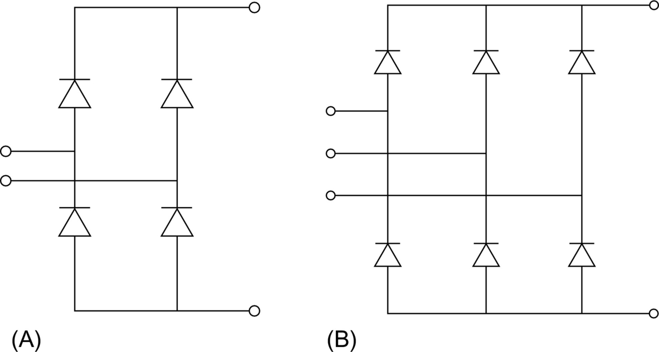

**FIG. 6.9** Diode rectifier: single-phase full-bridge (A) and three-phase (B) configuration.

• Half-bridge, full-bridge, or three-phase (six-pack) power module: Generally, these power modules, shown in [Fig. 6.10](https://learning.oreilly.com/library/view/power-electronics-handbook/9780128114087/B9780128114070000064.xhtml#f0055), are implemented with either power MOSFETs or IGBTs (insulated-gate bipolar transistors). Typically, IGBTs can achieve much higher current and voltage ratings, allowing them to operate at higher power levels with reduced conduction losses, whereas MOSFETs can operate at much higher switching frequencies, making them suitable for application where fast switching and high power density are required. A half-bridge configuration can be used to implement a DC-DC power-bidirectional converter or a single-phase inverter. A full-bridge configuration can be used to implement a full-bridge converter or a three-level single-phase inverter. A six-pack power module can be used to implement a three-phase inverter or a three-phase-controlled rectifier. Note that since all switches are controllable, all these converter topologies are power bidirectional, that is, power can flow in both directions. For an example of a six-pack power module, see Ref. [[7](https://learning.oreilly.com/library/view/power-electronics-handbook/9780128114087/B9780128114070000064.xhtml#bb0040)].

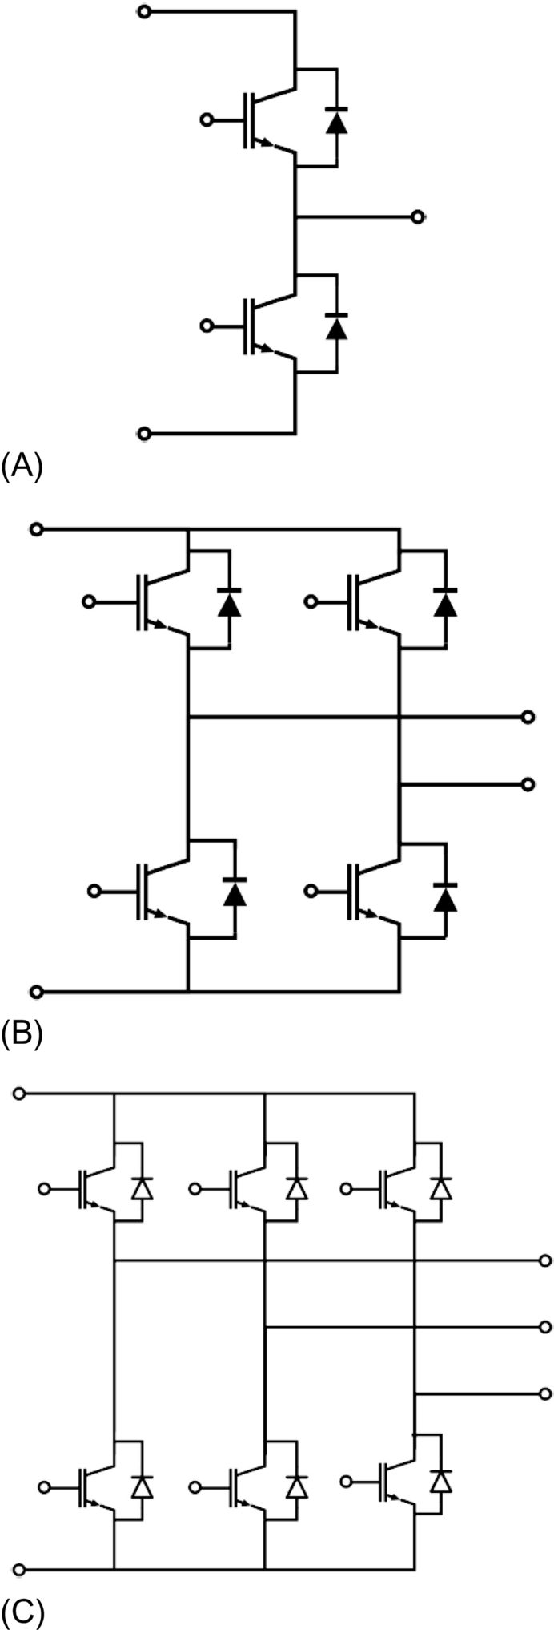

**FIG. 6.10** Circuit diagram of a half-bridge (A), full-bridge (B), and a three-phase six-pack power module (C).

• Converter-inverter-brake (CIB) module: The module, shown in [Fig. 6.11](https://learning.oreilly.com/library/view/power-electronics-handbook/9780128114087/B9780128114070000064.xhtml#f0060), contains a single-phase or three-phase uncontrolled or half-controlled bridge rectifier (C) plus an inverter (I) and a brake chopper (B). This module contains all power semiconductor devices required to implement a three-phase variable motor drive fed by three-phase power. The three-phase diode rectifier can be used to create a DC bus voltage that supplies the three-phase inverter connected to the three-phase motor. The chopper circuit allows to pulse-width modulate a braking resistor to dissipate energy during regenerative braking. See Ref. [[8](https://learning.oreilly.com/library/view/power-electronics-handbook/9780128114087/B9780128114070000064.xhtml#bb0045)] for more information about regeneration in motor drives.

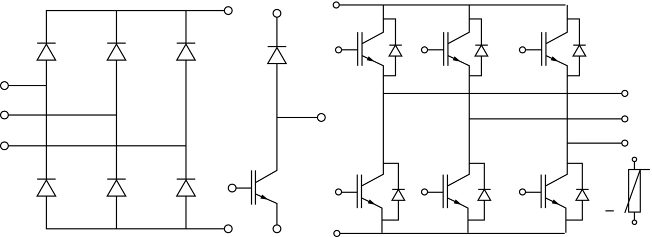

**FIG. 6.11** CIB module including a three-phase uncontrolled rectifier, a brake chopper, and a three-phase IGBT inverter. A temperature-sensing thermistor is also included.

• Neutral-point-clamped (NPC) module: Each leg has four power switches connected in series. The applied voltage on the power switch is one-half that of a two-level converter. The NPC topology can allow operation at voltages larger than the voltage rating of a single power device. In addition, NPC converter can achieve lower output current ripples and improve the total harmonic distortion (THD) of the output.

• Power factor correction (PFC) module: PFC module combines a rectifying function and a PFC function in order to reduce the harmonics of the input current and improve power factor.

### 6.5.2 POWER SEMICONDUCTOR DEVICES USED IN POWER ELECTRONIC MODULES

The most common power semiconductor devices used in power electronic modules are diodes, MOSFETs, IGBTs, and thyristors. Power bipolar junction transistors (BJTs) are less common and are briefly mentioned for completeness.

1. Power diode:

Power diodes provide uncontrolled rectification of power and are used in applications such as AC-DC converters and variable-frequency drives. Typically, the power diode can be either a P-i-N diode or a Schottky diode.

The P-i-N diode is a bipolar device having a so-called P-i-N structure, that is, it is a p-n junction with a wide, undoped intrinsic semiconductor layer (i-layer) in the middle to sustain a reverse blocking voltage. Frequently, the midlayer, rather than being intrinsic, has low N-doping and is therefore called N- (N minus) layer. [Fig. 6.12](https://learning.oreilly.com/library/view/power-electronics-handbook/9780128114087/B9780128114070000064.xhtml#f0065) shows the basic structure of a P-i-N diode. In the forward-biased conduction, the diode has a forward conduction drop, which causes conduction loss, and the diode can be modeled as a junction voltage source, equal to the threshold voltage, and a series equivalent resistance that represents the increasing slope in the diode I-V characteristics. In the reverse-biased condition, a small reverse leakage current flows, which increases gradually with the applied reverse voltage. If the applied reverse voltage exceeds a certain voltage, called breakdown voltage, the reverse current becomes very large due to avalanche breakdown, and the diode may be destroyed due to large power dissipation in the device. The advantage of a P-i-N diode is low on-state voltage drop in high-current conduction, due to the minority carrier injection in epitaxial drift region resulting in conductivity modulation. However, the minority carrier injection during conduction causes a large reverse recovery current during diode turnoff, which is not desirable, because it causes additional turn-on loss in the active switch.

The Schottky diode is a very attractive unipolar device, formed by an electrically nonlinear contact between a metal and a semiconductor bulk region shown in [Fig. 6.13](https://learning.oreilly.com/library/view/power-electronics-handbook/9780128114087/B9780128114070000064.xhtml#f0070). It has low on-state voltage drop, almost zero reverse recovery charge, and extremely high switching speed, but its reverse leakage current is large especially at high temperature due to its lower built-in potential barrier. Additionally, the breakdown voltage of Schottky diode is limited by the increase of drift region resistance without any conductivity modulation effect.

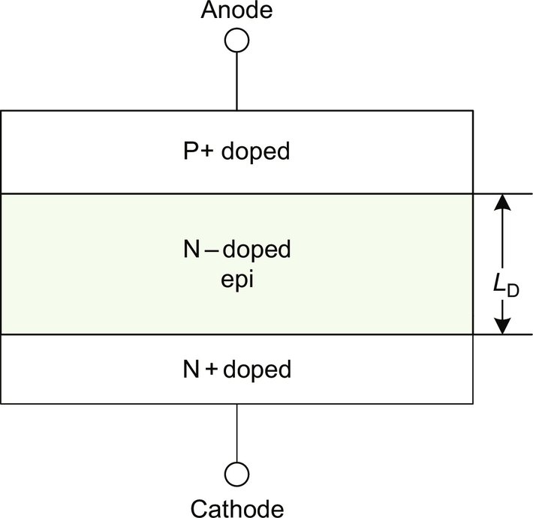

**FIG. 6.12** Basic structure of a P-i-N diode.

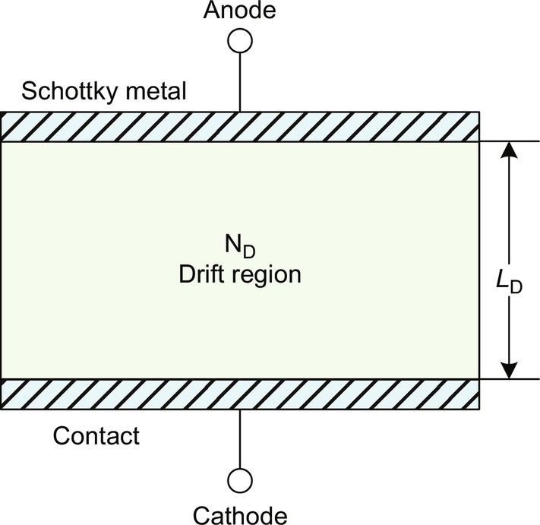

**FIG. 6.13** Basic structure of a Schottky diode.

2. Power MOSFET

The power metal-oxide-semiconductor field-effect transistor (MOSFET) is a unipolar, majority carrier, and voltage-controlled device. It is one of the most commonly used power devices due to its easy gate driving, fast switching speed, and low loss dissipation. Most power MOSFETs feature a vertical structure (a structure of alternating p-type and n-type doping) shown in [Fig. 6.14](https://learning.oreilly.com/library/view/power-electronics-handbook/9780128114087/B9780128114070000064.xhtml#f0075). In most power MOSFETs, the N+ source and P-well junction are shorted to prevent the parasitic bipolar transistor from turning on accidentally. When no gate voltage is applied, the power MOSFET is capable of supporting a drain-source blocking voltage through the reverse-biased P-well and N-epi junction. In high-voltage devices, most of the blocking voltage is supported by the lightly doped N-epi layer.

Generally speaking, the power MOSFET can operate in two different quadrants of its *I*-*V* characteristics: the first quadrant operation and the third quadrant operation. As the gate voltage (*V*G) increases above a threshold voltage (*V*th), the MOSFET starts to conduct current. When the gate voltage *V*G is much larger than the threshold voltage *V*th, the output *I*-*V* curve appears linear, and the MOSFET channel is fully turned on. Under low gate overdrive, the drain current reaches a saturation value when the MOSFET channel is pinched off.

The MOSFET's switching behavior is highly dependent on the parasitic capacitances gate-to-source *C*gs, gate-to-drain *C*gd, and drain-to-source *C*ds. Gate-to-drain capacitance *C*gd and drain-to-source *C*ds are nonlinear and a function of bias voltages.

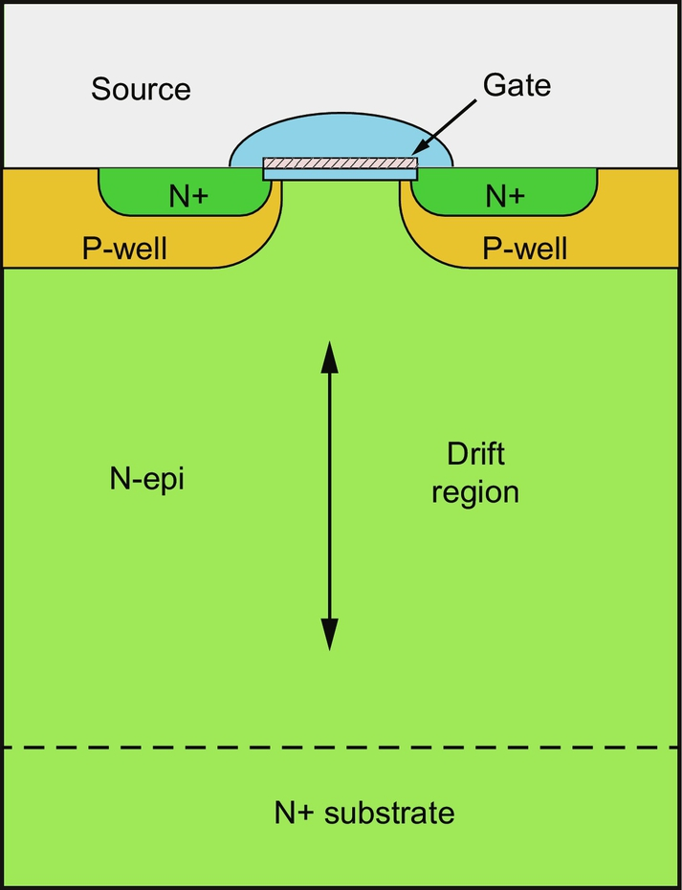

**FIG. 6.14** Basic structure of a power MOSFET.

3. Power IGBT

The insulated-gate bipolar transistor (IGBT) is a minority carrier device with high input impedance and large current-carrying capability. The IGBT combines the advantages of both power MOSFET and BJT, and it has MOS input characteristics and bipolar output characteristics. The basic structure of a power IGBT is shown in [Fig. 6.15](https://learning.oreilly.com/library/view/power-electronics-handbook/9780128114087/B9780128114070000064.xhtml#f0080).

The IGBT is widely used in many applications of power electronics, such as motor drives, uninterruptible power supplies (UPS), and power modules, because of the following advantages:

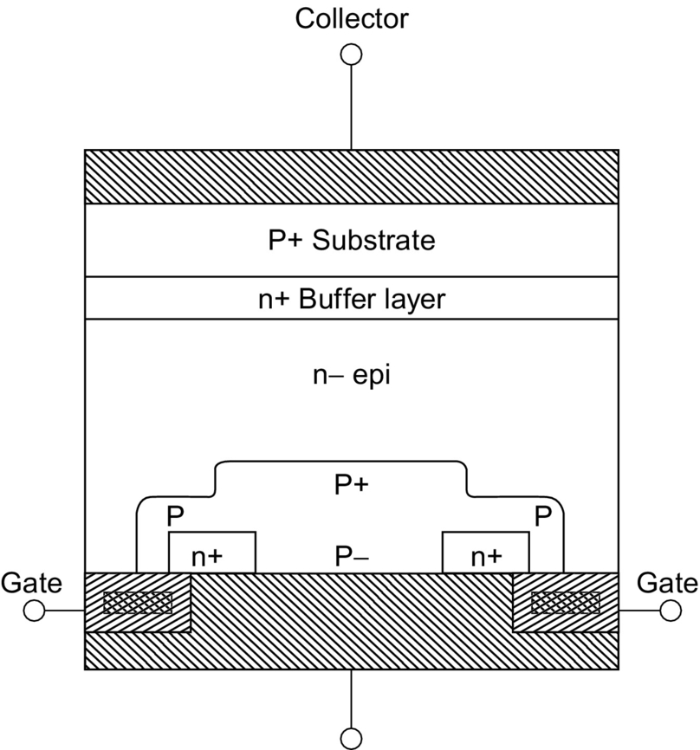

**FIG. 6.15** Basic structure of a power IGBT.

• A very low on-state voltage drop due to conductivity modulation and very small conduction loss

• A simple gate driver circuit design due to the MOS gate structure

• A very large current-carrying capability and smaller chip size for a given conduction current

• Good forward and reverse voltage blocking capability

However, the IGBT has some drawbacks, compared with power MOSFET:

• Slow switching speed, current tailing due to carrier combination

• Latch-up issue due to the parasitic thyristor structure

The IGBT is viewed as a serial connection of a MOSFET and a P-i-N diode, and sometimes it is modeled as a wide base PNP transistor driven by a MOSFET in Darlington configuration. In the output I-V characteristics of a power IGBT, the conduction current starts flowing when the gate voltage exceeds the threshold voltage, and collector-source voltage is approximately above 0.7 V.

4. Power Thyristor

A thyristor is a power device with four alternating layers of p-type and n-type doping and can be turned on by the gate terminal but cannot be turned off by the gate [[9](https://learning.oreilly.com/library/view/power-electronics-handbook/9780128114087/B9780128114070000064.xhtml#bb0050)]. It has the largest power-handling capability.

5. Power BJT

The power bipolar transistors (BJT) are conceptually the same as the small-signal BJTs. The main difference is that the active area of power BJT device is much larger resulting in a much higher current handling capability. Power BJTs also have a thick and lightly doped collector region. Such collector regions result in a large blocking voltage.

### 6.5.3 SIC POWER SEMICONDUCTOR DEVICES IN POWER MODULES

In recent times, power semiconductor devices using silicon carbide (SiC), a wide bandgap material, rather than silicon have become commercially available. The SiC material has superior material properties for power electronic applications. SiC devices are starting to be used in power modules. In particular, SiC-merged barrier Schottky diodes are used to replace high-voltage P-i-N diodes. The advantage is that, unlike P-i-N diodes, SiC Schottky diodes are majority carrier devices and do not exhibit reverse recovery at turnoff. SiC MOSFETs are also being introduced in modules. Presently, the higher cost of SiC devices limits their adoption.

## 6.6 Thermal Management of Power Modules

### **6.6.1 THE PURPOSE OF THERMAL MANAGEMENT**

For a variety of system-level reasons, modern power electronic applications require compact and high-power density power converters. In order to achieve this required miniaturization, higher integration of components and higher switching frequencies, which reduce passive filtering element size, are required. The increase in switching frequency leads to increased power losses and the physical integration makes it harder to remove the loss heat generated. This creates a significant design challenge that requires careful thermal management. Additionally, in power modules, the power dissipation is concentrated inside the small power semiconductor chips, making heat removal particularly difficult. Power module datasheets specify a maximum allowable junction temperature, that is, temperature at the semiconductor chips inside the module. Exceeding this temperature will lead to module failure. Moreover, lower operating junction temperatures lead to markedly improved module reliability. The maximum junction temperature for current commercially available silicon-based power modules is around 150°C.

Another thermal concern affecting module reliability is thermal cycling, that is, the alternate heating and cooling of the module as a result of varying operating conditions. Excessive thermal cycling leads to aging and early failure of the module. In order to avoid overheating and to improve reliability, a common recommendation is that junction temperature should not exceed 125°C. Therefore, thermal management of power module is necessary to satisfy the thermal requirements described above.

### 6.6.2 EQUIVALENT THERMAL NETWORK OF POWER MODULE

[Fig. 6.16](https://learning.oreilly.com/library/view/power-electronics-handbook/9780128114087/B9780128114070000064.xhtml#f0085) shows a cross section of a power electronic module. Power dissipation occurs at the silicon chip due to conduction and switching losses. The heat is conducted through several material layers inside the module until it reaches the baseplate. [Fig. 6.16](https://learning.oreilly.com/library/view/power-electronics-handbook/9780128114087/B9780128114070000064.xhtml#f0085) shows that the heat flows from top to bottom through the top solder layer, the top copper layer, the ceramic substrate, the bottom copper layer, the bottom solder layer, and the baseplate. From the baseplate, the heat exits the module, crosses the thermal grease layer, and reaches the heat sink. In case of air cooling, the heat then transfers by convection to the air surrounding the heat sink. Usually, the heat flow is modeled as being unidimensional with the lateral heat spreading modeled as a spreading angle that increases the heat flow cross section. It should be kept in mind that this approximation introduces a certain error [[10](https://learning.oreilly.com/library/view/power-electronics-handbook/9780128114087/B9780128114070000064.xhtml#bb0055)]. Each material layer has a certain thermal resistance and thermal capacitance. The temperature gradient across each layer drives the conductive heat transfer. Consequently, the temperature gradually decreases from junction temperature at the silicon chip to ambient temperature *T*AMB.

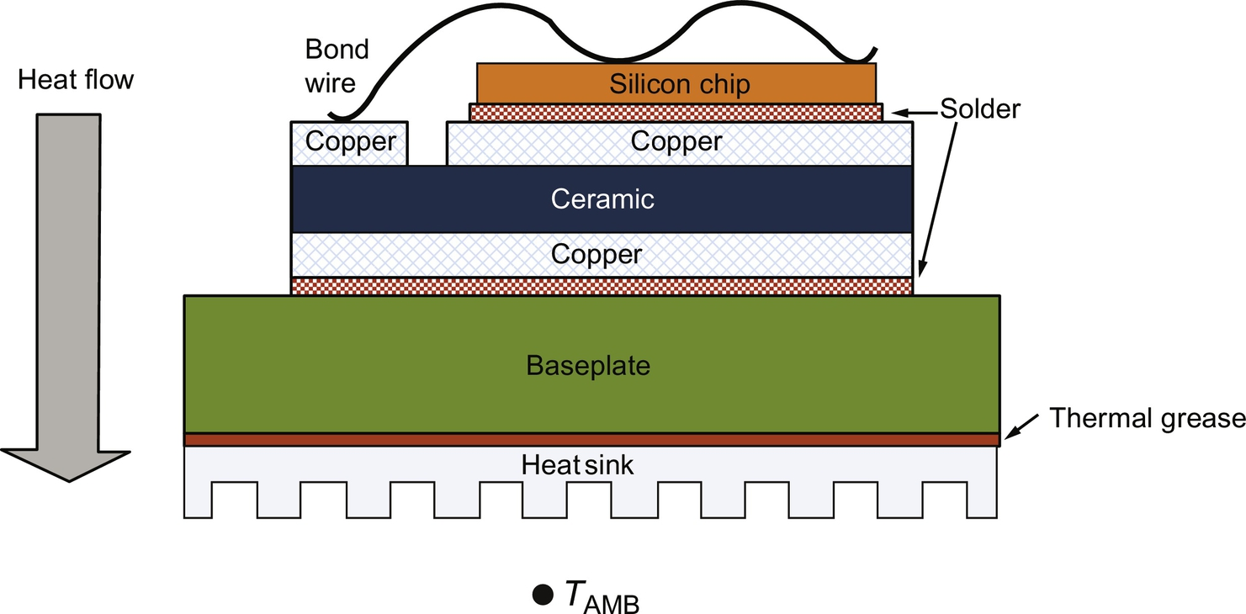

**FIG. 6.16** Cross section of power electronic module showing heat flow.

The junction temperature in the power module can be estimated by the equivalent Cauer *RC* thermal network shown in [Fig. 6.17](https://learning.oreilly.com/library/view/power-electronics-handbook/9780128114087/B9780128114070000064.xhtml#f0090). In this equivalent model, voltage represents temperature, and current represents heat flow. An *RC* cell represents a specific material layer [[11](https://learning.oreilly.com/library/view/power-electronics-handbook/9780128114087/B9780128114070000064.xhtml#bb0060)]. The thermal resistance *Ri* of the *i*th layer is given by

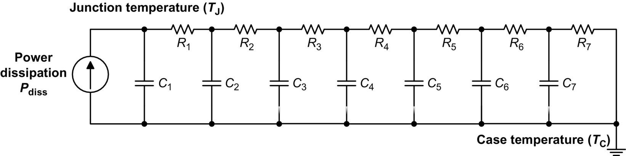

**FIG. 6.17** Equivalent Cauer RC thermal network of the power module from junction to case.

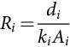 **(6.1)**

where *di* is the *i*th layer thickness; *Ai* is the effective cross-sectional area, including a spreading angle for conductors; and *ki* is the thermal conductivity of the *i*th layer.

Thermal capacitance *Ci* of the *i*th layer is given by the equation

 **(6.2)**

where *c* is the constant pressure-specific heat capacity, *ρ* is the mass density, and *V* is the effective volume of the *i*th layer.

According to the equivalent thermal network, the junction temperature *T*J is numerically equal to the top left node voltage (the top node of the input current source), while the case temperature *T*C represents the reference node voltage of the network. The power module datasheets provide a numerical value for the junction-to-case thermal resistance *R*th(JC). The term “case” indicates the bottom of the baseplate, where the heat sink is attached. In the equivalent model of [Fig. 6.17](https://learning.oreilly.com/library/view/power-electronics-handbook/9780128114087/B9780128114070000064.xhtml#f0090), *R*th(JC) is equal to the sum of all thermal resistances *R*1 through *R*7. The relationship between *T*J and *T*C is given by the following equation [[12](https://learning.oreilly.com/library/view/power-electronics-handbook/9780128114087/B9780128114070000064.xhtml#bb0065)]:

 **(6.3)**

This thermal resistance directly provides the temperature difference between junction and case. To calculate the absolute temperature, it is necessary to calculate the case temperature *T*C. This temperature can be calculated based on the selected heat sink, air flow, and ambient temperature *T*AMB.

As previously mentioned, power modules frequently have a thermal sensor mounted in close proximity of the chips. This gives experimental access to junction temperature in real time [[13](https://learning.oreilly.com/library/view/power-electronics-handbook/9780128114087/B9780128114070000064.xhtml#bb0070)]. Note that this method can only measure the junction temperature in steady state or for slowly varying thermal transients, because the measured value is accurate only at thermal equilibrium.

According to the thermal network, the junction temperature can be controlled in an acceptable range by applying external cooling to the case of the module.

### 6.6.3 COOLING SOLUTIONS FOR POWER MODULE

#### **6.6.3.1 Air Cooling**

The fin heat sink is a common air cooling solution used in industry, as shown in [Fig. 6.18](https://learning.oreilly.com/library/view/power-electronics-handbook/9780128114087/B9780128114070000064.xhtml#f0095).

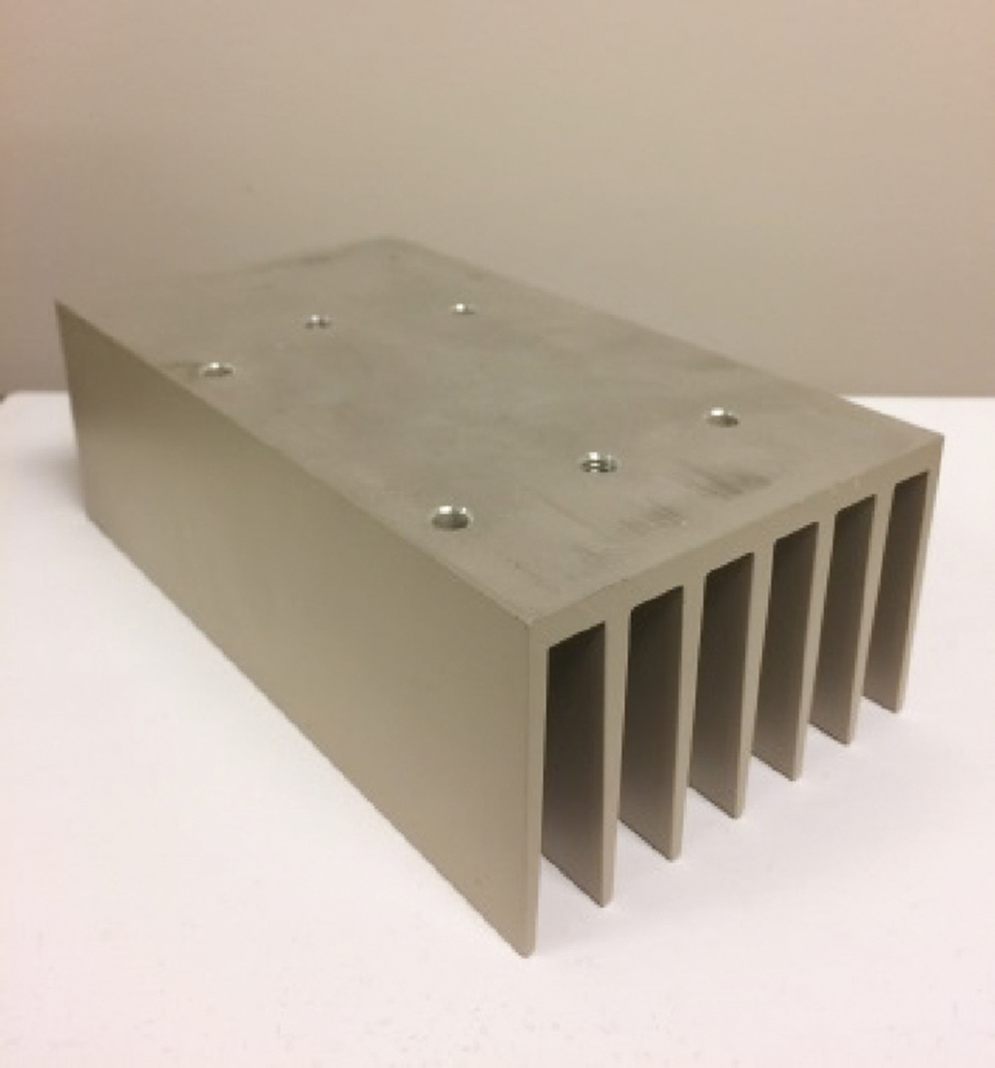

**FIG. 6.18** Structure of fin heat sink for power electronics.

For low-power application, a fin heat sink with natural convection is a good choice because no additional device is needed. When the dissipated power is larger, forced convection cooling using an electric fan can be used. However, when the dissipated power density exceeds 100 W/cm2, the heat sink will not satisfy the cooling requirement, and a more effective cooling method is needed, such as liquid cooling.

#### **6.6.3.2 Liquid Cooling**

Liquid cooling has higher thermal transfer efficiency than air cooling and is used in high-power modules. The power module baseplate is thermally connected to a so-called cold plate, which is liquid-cooled. A liquid cooling system is required, as shown in [Fig. 6.19](https://learning.oreilly.com/library/view/power-electronics-handbook/9780128114087/B9780128114070000064.xhtml#f0100). The cooling liquid in the system, such as water, is pumped into the inlet of the cold plate, is heated by the heat flow from the module, flows out from the outlet, and transfers the heat to the cooling radiator. The cold water is gathered in the coolant tank and recirculated. Liquid cooling provides superior thermal performance compared with air cooling, but it incurs additional cost and may affect reliability due to possible coolant leaks.

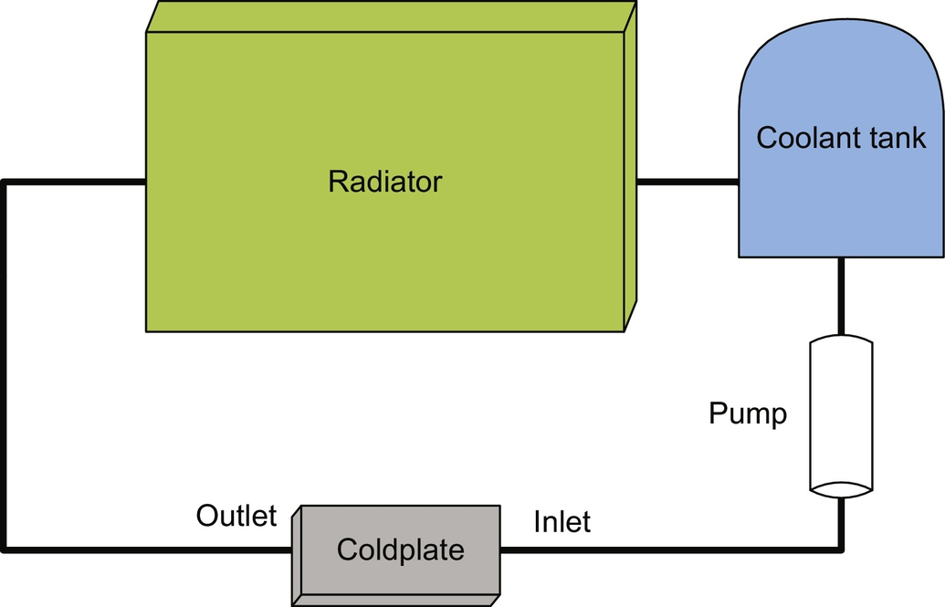

**FIG. 6.19** Schematic cold plate and liquid cooling system.

#### **6.6.3.3 Double-Sided Cooling**

An approach to increase cooling performance is to remove heat from both sides of the semiconductor dies, instead of removing it from one side only. This approach cannot be used effectively in case of the wire bond package of [Fig. 6.16](https://learning.oreilly.com/library/view/power-electronics-handbook/9780128114087/B9780128114070000064.xhtml#f0085), because the wire bonds prevent heat removal from the top. Consequently, double-sided cooling can be applied only to wire-bond-free power modules. Wire-bond-free packaging techniques include low-temperature attach using double-sided DBC, flip chip solder balls interconnection technology, and press-pack technology. Design complexity, cooling efficiency, electric isolation, and power density must be considered for each case when interfacing the device package with advanced double-sided cooling schemes. The cooling methods are different and depend on the packaging technology used. The double-sided cooling methods are now briefly discussed for the double-sided DBC structure and for the press-pack structure.

#### **6.6.3.4 Double-Sided Cooling Using the DBC Structure**

Low-temperature attach techniques have been used to connect IGBT devices to DBC on both sides in order to achieve double-sided liquid cooling. This technique increases cooling performance, but electric isolation via DBC adds thermal resistance. [Fig. 6.20](https://learning.oreilly.com/library/view/power-electronics-handbook/9780128114087/B9780128114070000064.xhtml#f0105) shows a cross section of the double-sided cooling structure with power semiconductors. This package design gave a thermal resistance of 0.087°C/W for a flow rate of 1.6 gal/min [[14](https://learning.oreilly.com/library/view/power-electronics-handbook/9780128114087/B9780128114070000064.xhtml#bb0075)].

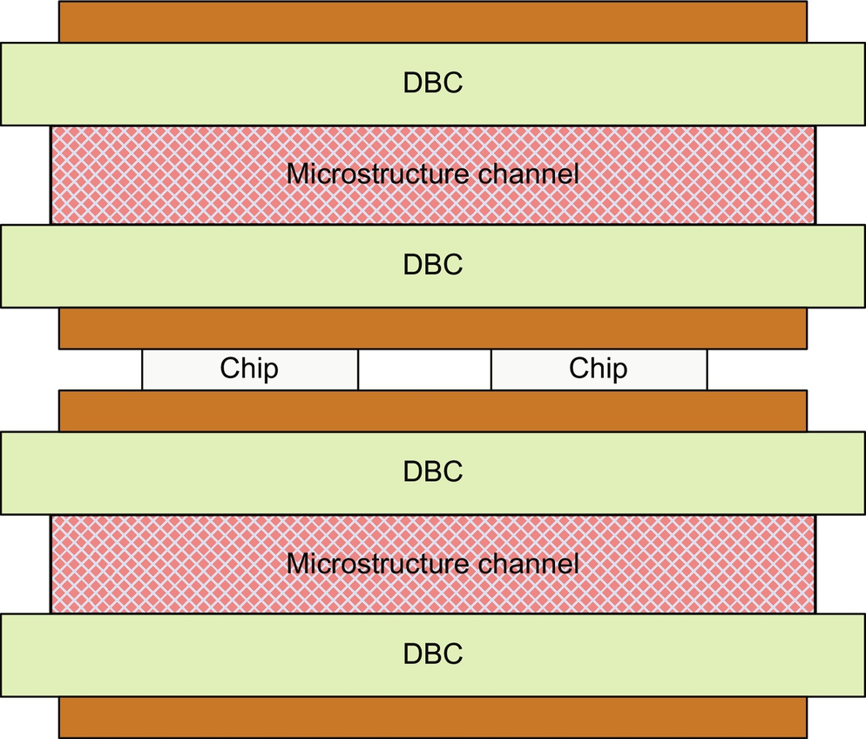

**FIG. 6.20** Cross section of the double-sided cooling structure with low temperature joining techniques.

Flip chip solder ball interconnection technology can be used to eliminate cooling interface issues related to wire bonds, but electric isolation requirements limit the efficiency of the cooling system also in this case. Microchannels are integrated directly in the package to provide double-sided cooling. The interface between the device and DBC via solder balls as well as the use of DBC as isolation between the device and heat sinks somewhat reduces the heat transfer from the chip. This cooling and package configuration provides a thermal resistance of 0.09–0.12°C/W for a flow rate range of 0.2–2 gal/min [[14](https://learning.oreilly.com/library/view/power-electronics-handbook/9780128114087/B9780128114070000064.xhtml#bb0075)]. [Fig. 6.21](https://learning.oreilly.com/library/view/power-electronics-handbook/9780128114087/B9780128114070000064.xhtml#f0110) shows a cross section of the structure.

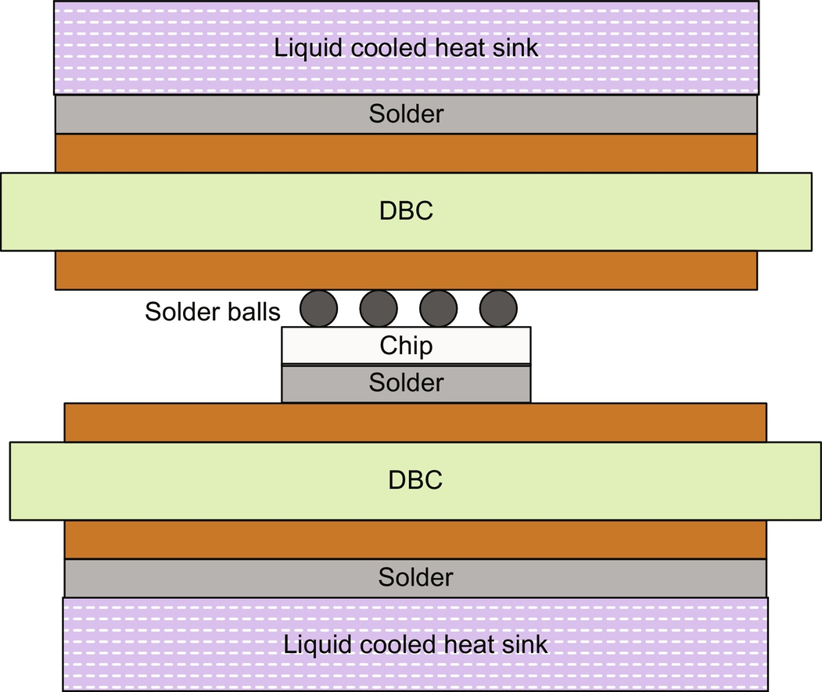

**FIG. 6.21** Cross section of the double-sided cooling structure with flip chip solder.

#### **6.6.3.5 Double-Sided Cooling Using the Press-Pack Structure**

Press-pack semiconductor packaging technology can also allow advanced double-side cooling schemes. This example uses evaporators on both sides of the semiconductors. This method is promising for applications that use press-pack technology. [Fig. 6.22](https://learning.oreilly.com/library/view/power-electronics-handbook/9780128114087/B9780128114070000064.xhtml#f0115) shows the cross section of the press-pack and double-sided multiphase cooling structure.

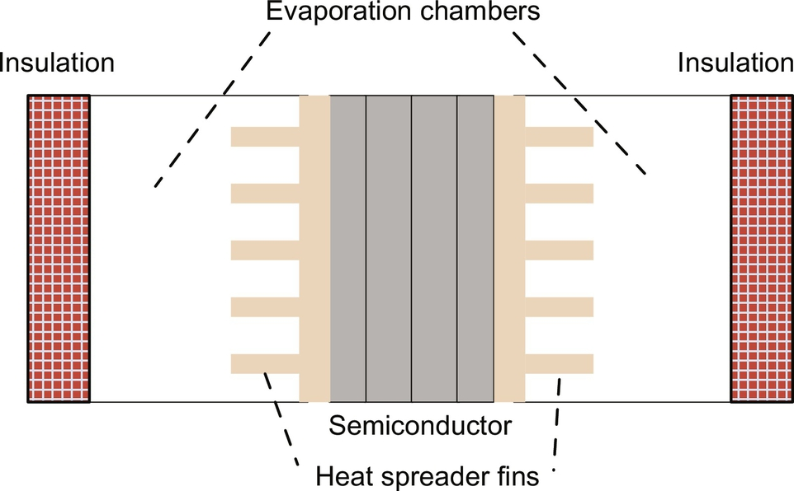

**FIG. 6.22** Cross section of the double-sided cooling structure for press pack.

## 6.7 Reliability of Power Modules

For power electronic applications, reliability of power modules is an important issue. The reliability of power electronics has been improving over the years. As an example, power module failure rate in traction has decreased from 1000 FITs in 1995 to 20 FITs in 2000 (1 FIT=one failure per 109 device hours). In recent years, many failure-detecting tests have been proposed or improved, such as solder cracking and bond wire lift-off tests [[15](https://learning.oreilly.com/library/view/power-electronics-handbook/9780128114087/B9780128114070000064.xhtml#bb0080)].

Thermomechanical stress on power module packaging materials is the most common reason for module failure due to mismatch in the coefficients of thermal expansion (CTE) between different adjacent materials inside the power module package. The structure of a power module, shown in [Fig. 6.5](https://learning.oreilly.com/library/view/power-electronics-handbook/9780128114087/B9780128114070000064.xhtml#f0030), has been described earlier. The most common module failures are due to wire bond lifting, that is, the wire bond detaching from the surface it was bonded to, and solder cracking.

Bond wire lifting is one of the main reasons for power electronic module failures: a crack is formed and grows at the junction between the chip and the bond wire due to mismatch between the CTEs as a result of temperature variations. The difference in the CTEs causes strain at the interface. The strain initiates the crack that grows as a result of successive stress cycles during operation. This is shown in [Fig. 6.23](https://learning.oreilly.com/library/view/power-electronics-handbook/9780128114087/B9780128114070000064.xhtml#f0120). The bond wire lifting failures can be examined by microstructural testing. A discussion of reliability in power modules can be found in [[16](https://learning.oreilly.com/library/view/power-electronics-handbook/9780128114087/B9780128114070000064.xhtml#bb0085)].

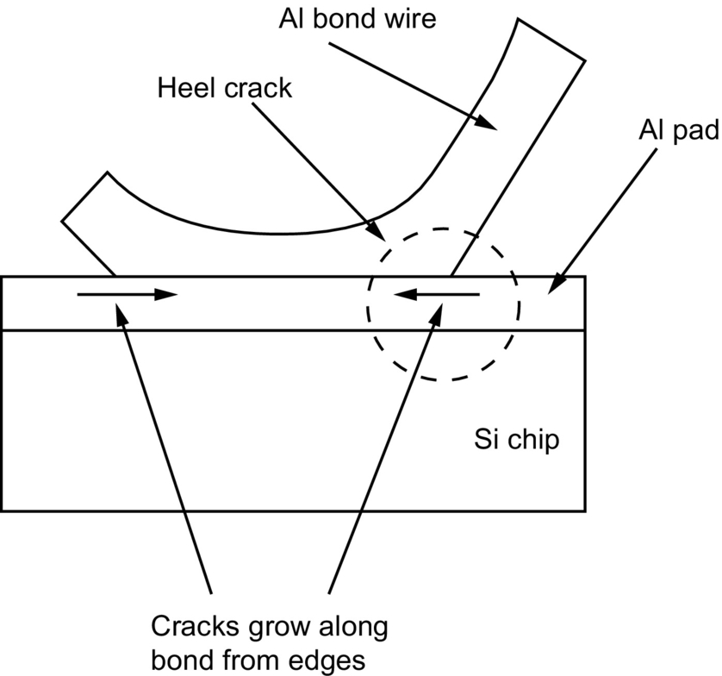

**FIG. 6.23** Bond wire lifting resulting from crack propagation.

Cracks usually grow from the two end sides during thermal cycles, and the bond wire lifts up when the crack reaches the center. A contributing factor to bond wire failures is magnetic forces induced on the wire bonds by inductive coupling among bond wires.

The second most common failure is related to solder fatigue at a solder joint inside the power module. For example, a failure may occur in the solder joint between a silicon die and the copper substrate, as shown in [Fig. 6.24](https://learning.oreilly.com/library/view/power-electronics-handbook/9780128114087/B9780128114070000064.xhtml#f0125). The failure occurs because of CTE mismatch between the die chip and the substrate, which results in mechanical stress that shifts the solder layers laterally in relation to each other and eventually creates voids.

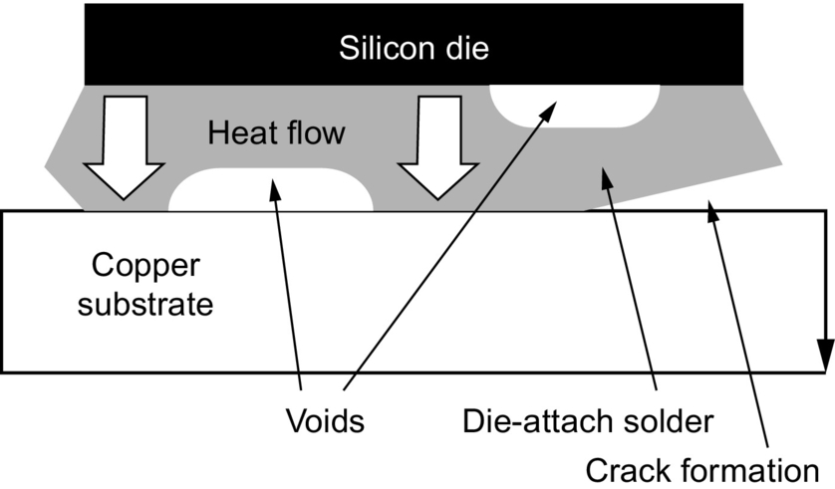

**FIG. 6.24** Void and crack formation between die and substrate.

As shown in [Fig. 6.24](https://learning.oreilly.com/library/view/power-electronics-handbook/9780128114087/B9780128114070000064.xhtml#f0125), the voids are a barrier to heat conduction from die to substrate and cause a nonuniform heat distribution. This in turn increases the thermal resistance between die and substrate and damages the die. The stress on the interfaces depends on temperature and increases as temperature increases.

Two different types of thermal stress can be identified, power cycling and thermal cycling. Power cycling refers to temperature variations caused by varying power loss in the devices due to a variation of operating conditions. Thermal cycling is the effect of temperature variations in the environment around the power module.

Power converters usually undergo both types of temperature cycling but with different levels of temperature variation and frequency [[16](https://learning.oreilly.com/library/view/power-electronics-handbook/9780128114087/B9780128114070000064.xhtml#bb0085)].

### 6.7.1 RELIABILITY TESTS [[17](https://learning.oreilly.com/library/view/power-electronics-handbook/9780128114087/B9780128114070000064.xhtml#bb0090)]

A power module is exposed to active temperature cycles due to its operation and to passive temperature cycles due to variation of the surrounding environment. Thermal cycling and power cycling tests can be performed to represent these conditions and evaluate reliability:

#### **6.7.1.1 Thermal Cycling Test**

In this test, the temperature of the power module is changed as a result of a change in case temperature or of variation of ambient temperature (TST, thermal shock test). No electric stress is applied. This test evaluates lifetime of the solder joints and ability of the device to survive sudden temperature variation.

#### **6.7.1.2 Power Cycling Test**

In this test, the ruggedness of semiconductor devices such as IGBTs and MOSFETs is evaluated under thermomechanical stress due to power loss cycling in the internal semiconductor dies. The variation of temperature is due to periodic variations of load current. This test evaluates reliability under high-temperature operation.

The equivalent test cycles can be evaluated by converting the thermal stress on solder and bond joints due to active and passive thermal stress into reliability test data.

## 6.8 Design Guidelines and Considerations

In order to utilize a commercially available power module to realize a switching converter for a specific application, the following steps should be followed:

1. *Power module selection based on switching converter specifications*. A power module of the desired topology with the appropriate voltage and current rating should be selected. The type (IGBT, MOSFET, and so on) and characteristics of the power semiconductor devices in the module determine achievable switching frequency. From the manufacturer's datasheets, conduction and switching losses can be estimated.

2. *Electric design*. Referring to [Fig. 6.4](https://learning.oreilly.com/library/view/power-electronics-handbook/9780128114087/B9780128114070000064.xhtml#f0025), the external components required to realize the converter need to be designed. These include bypass capacitor *CBYPASS*, gate drivers (unless they are already integrated inside the module), power inductor *L*, and converter control. Some special considerations regarding the first two items, which are specific to power modules, will be discussed below.

3. *Thermal design.* Based on the estimated losses, the thermal design must be completed. The cooling method—natural convection, forced convection, or liquid cooling—is selected and the thermal circuit designed to achieve a desired maximum junction temperature under worst-case conditions.

For a successful design, it is critical to follow the specifications and recommendations in the manufacturer's datasheets. Manufacturers also provide additional design support, such as application notes, technical papers, and online loss calculation software tools for their products.

### 6.8.1 BYPASS CAPACITOR CONSIDERATIONS

Besides component selection, as is frequently the case in power electronics, proper physical layout is critical. As shown in [Fig. 6.25](https://learning.oreilly.com/library/view/power-electronics-handbook/9780128114087/B9780128114070000064.xhtml#f0130), for the case of a half-bridge converter, the switching loop should be minimized in physical size in order to reduce overshoot and ringing during switching. The objective is to reduce the distributed parasitic inductance of the switching loop, shown as lumped inductance *L*SWITCH in the figure.

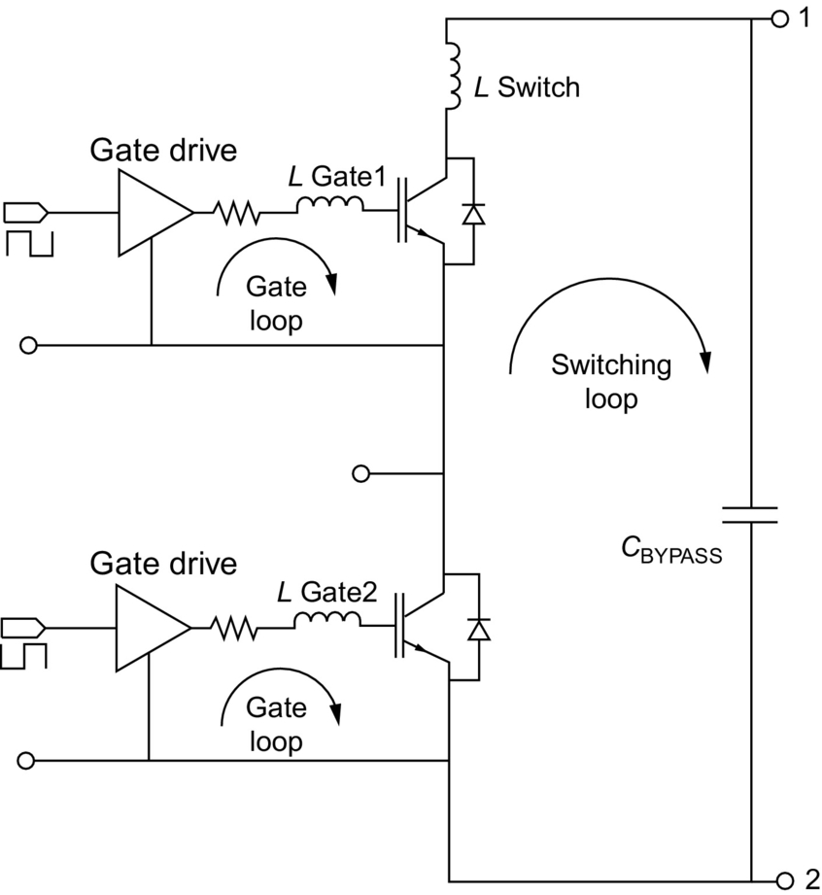

**FIG. 6.25** Half-bridge module schematic showing the switching loop and the gate loops that should be minimized for proper converter operation.

As shown in [Fig. 6.4](https://learning.oreilly.com/library/view/power-electronics-handbook/9780128114087/B9780128114070000064.xhtml#f0025), the switching loop is partially inside the power module, but it is completed by the external capacitor *C*BYPASS. This capacitor should absorb the square-wave current at the switching frequency resulting from switching converter operation. It is critical to use a high-frequency high-current-ripple capacitor. Ceramic or metal film capacitors are appropriate. Polypropylene capacitors are a popular choice. It is critical to mount the bypass capacitor physically close to the module. A laminated bus bar is recommended to reduce parasitic inductance by having closely spaced flat conductors conducting opposite polarity currents.

### 6.8.2 GATE DRIVER DESIGN CONSIDERATIONS

The gate driver design is similar to what is commonly done for discrete power semiconductor devices. Based on the total gate charge *Q*G from the datasheets and on the desired gate voltage rise and fall time, a gate driver with adequate current capability is selected. The choice of gate resistor is a trade-off: a smaller gate resistor gives faster switching speed with lower switching losses and with increased gate noise immunity, whereas a larger gate resistor gives slower switching speed with reduced switching noise and reduced diode reverse recovery. It should be kept in mind that power modules frequently have internal gate resistances in case of multiple paralleled dies as shown in [Fig. 6.26](https://learning.oreilly.com/library/view/power-electronics-handbook/9780128114087/B9780128114070000064.xhtml#f0135). Resistances *R*g are internal to the module and are needed to ensure dynamic current balance. If a single gate resistor was used, there could be an LC oscillation caused by the input capacitances of the two IGBTs resonating with the parasitic inductance of the gate connection. In the case of [Fig. 6.26](https://learning.oreilly.com/library/view/power-electronics-handbook/9780128114087/B9780128114070000064.xhtml#f0135), this resonant path has a 2*R*g series damping resistance. The module datasheets usually provide a recommended external gate resistor range of values.

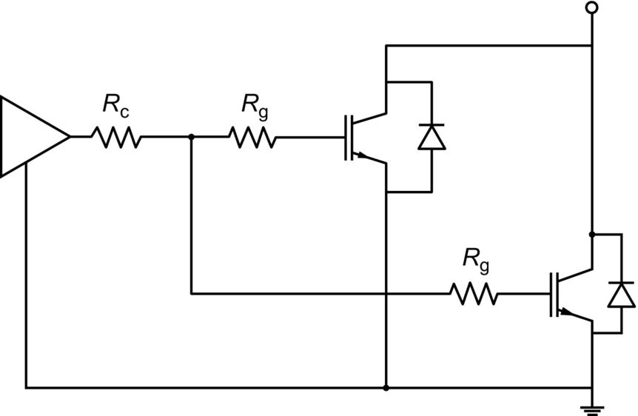

**FIG. 6.26** Schematic of bottom switch of power module consisting of two paralleled IGBTs with internal resistances *R*g.

Regarding layout, it is important to minimize the gate loops shown in [Fig. 6.25](https://learning.oreilly.com/library/view/power-electronics-handbook/9780128114087/B9780128114070000064.xhtml#f0130). A large gate loop causes a large parasitic inductance *L*GATE that resonates with the IGBT input capacitance causing gate voltage ringing, which may cause spurious IGBT switching. The power module gate contacts should be directly connected to the gate driver printed circuit board if possible.

### 6.8.3 GATE KELVIN CONTACTS

Power modules typically have gate Kelvin contacts. It is essential that they be used for the gate drive as shown in [Fig. 6.4](https://learning.oreilly.com/library/view/power-electronics-handbook/9780128114087/B9780128114070000064.xhtml#f0025) in order to have an effective dynamic gate voltage control. [Fig. 6.27](https://learning.oreilly.com/library/view/power-electronics-handbook/9780128114087/B9780128114070000064.xhtml#f0140) shows the case of no emitter Kelvin contact. As a result, there is a parasitic emitter inductance *L*E that is part of both the switching loop and the gate loop (refer to [Fig. 6.25](https://learning.oreilly.com/library/view/power-electronics-handbook/9780128114087/B9780128114070000064.xhtml#f0130)). This inductance conducts the full collector current. During turn-on, the gate drive voltage increases, and the IGBT gradually turns on. The increasing collector current induces a positive voltage *v*LE on the parasitic emitter inductance that subtracts from the gate driver voltage and slows down the gate-emitter voltage rise. This negative feedback effect is undesirable because it slows down the switching transition and causes the gate driver to have less dynamic control of the actual gate-emitter voltage. A similar negative feedback effect occurs at turnoff, slowing down this transition as well. This problem can be solved by providing a separate emitter Kelvin contact as shown in [Fig. 6.28](https://learning.oreilly.com/library/view/power-electronics-handbook/9780128114087/B9780128114070000064.xhtml#f0145). The power contact emitter inductance (in red) is not part of the gate loop, and the negative feedback effect is eliminated.

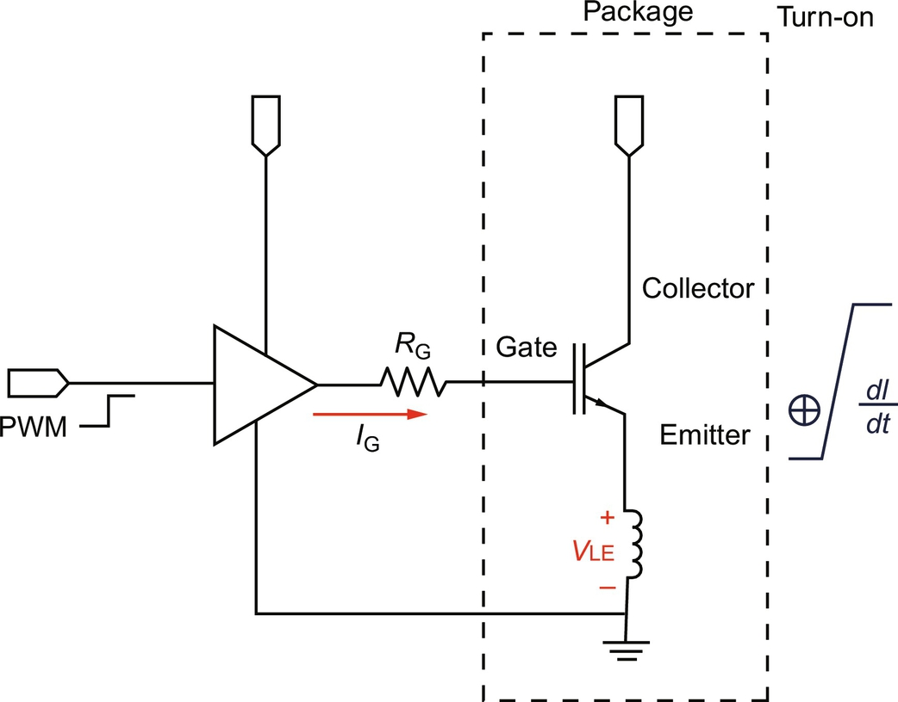

**FIG. 6.27** Packaged IGBT without emitter Kelvin contact.

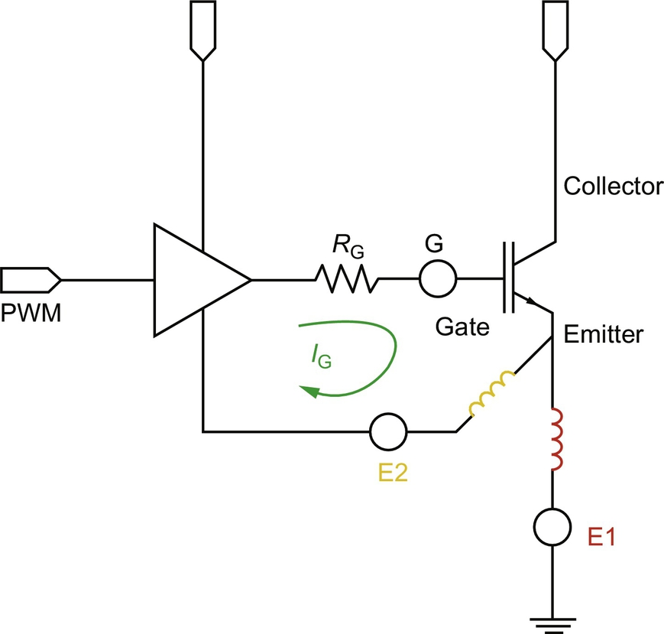

**FIG. 6.28** Emitter Kelvin contact E2 is separate from emitter power contact E1.

[Fig. 6.29](https://learning.oreilly.com/library/view/power-electronics-handbook/9780128114087/B9780128114070000064.xhtml#f0150) shows the inside of a six-pack IGBT power module. On the bottom left side, one can see the power emitter pin and the Kelvin emitter pin. Notice that dedicated wire bonds go from the IGBT chip to the Kelvin emitter pin. These wire bonds conduct only the gate driver current and not the collector current and represent the E2 connection of [Fig. 6.28](https://learning.oreilly.com/library/view/power-electronics-handbook/9780128114087/B9780128114070000064.xhtml#f0145). The figure also shows the IGBT and diode dies, the IGBT gate and emitter pads, the wire bonds, the top copper layer, the ceramic substrate, and the thermistor.

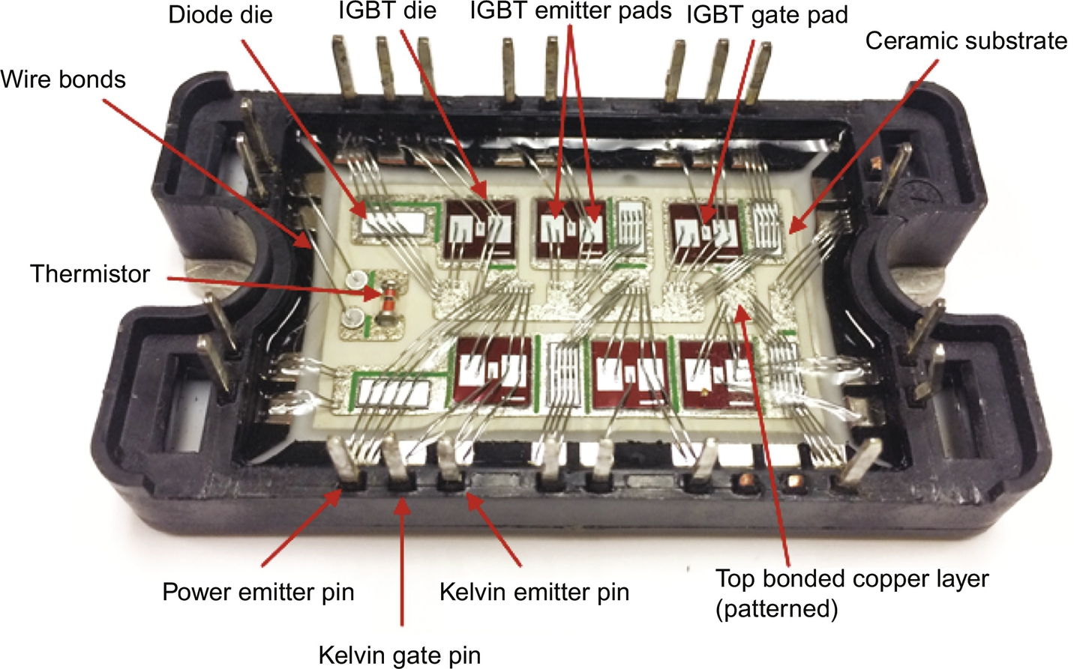

**FIG. 6.29** Photo of opened Microsemi APTGF50X60T3G six-pack IGBT power module (from 600 V to 50 A) with several internal features labeled.

### 6.8.4 OTHER DESIGN CONSIDERATIONS

In order to realize a switching converter, other design aspects must be considered, such as protection, sensing, and control implementation. The gate driver may include protections, such as short circuit protection. Current sensing may be implemented for protection and for current mode programming control. Voltage sensing is typically required for control. Either an analog or a digital controller can be used. Snubbers and clamps may be required to reduce switching waveform overshoot and ringing. EMI filters may be required.

## References

[1] Online resource, [www.HYBOND.com](http://www.hybond.com/) (Accessed 23 February 2017).

[2] Online resource, [www.hesse-mechatronics.com](http://www.hesse-mechatronics.com/) (Accessed 23 February 2017).

[3] Wei Qin I., Reid P., Werner R.E., Doerr D. *Automatic wedge bonding with ribbon wire for high frequency applications.* In: IEMT; 2002:97–101.

[4] Sheng W.W., Colino R.P. *Power Electronic Modules Design and Manufacture.* Boca Raton, Florida: CRC Press; 2005.

[5] Xingsheng L. *Processing and Reliability Assessment of Solder Joint Interconnection for Power Chips.* (Virginia Tech Dissertation) 2001.

[6] Powerex three-phase diode bridge module RM75TPM-2H, <http://www.pwrx.com/pwrx/docs/rm75tpm-2> h.pdf (Accessed 23 February 2017).

[7] Infineon power IGBT module FS100R07PE4, <http://www.infineon.com/dgdl/Infineon-FS100R07PE4-DS-v02_00-en_de.pdf?fileId=db3a304333227b5e013359531e9908c6> (Accessed 23 February 2017).

[8] Allen Bradley, What is regeneration? <http://www.ab.com/support/abdrives/documentation/techpapers/RegenOverview01.pdf> (Accessed 23 February 2017).

[9] Jayant Baliga B. *Fundamentals of Power Semiconductor Devices.* New York: Springer; 2008.

[10] Van Godbold C., Sankaran V.A., Hudgins J.L. Thermal analysis of high-power modules. *IEEE Trans. Power Electron.* 1997;12(1):3–11.

[11] Gachovska T.K., Tian B., Hudgins J., Qiao W. A real-time thermal model for monitoring of power semiconductor devices. *IEEE Trans. Ind. Appl.* 2015;51(4):3361–3367.

[12] Tian B., Qiao W., Wang Z., Gachovska T.K., Hudgins J. *Monitoring IGBT's health condition via junction temperature variations.* In: APEC; 2014:2550–2555.

[13] Infineon application note, <http://www.infineon.com/dgdl/Infineon-AN2009_10_Using_the_NTC-AN-v1.0-en.pdf> (Accessed 23 February 2017).

[14] Charboneau B.C. *Double-sided liquid cooling for power semiconductor devices using embedded power technology.* Blacksburg, VA: Virginia Polytechnic Institute; 2005.

[15] Yang S., Bryant A., Mawby P., Xiang D., Ran L., Tavner P. An industry-based survey of reliability in power electronic converters. *IEEE Trans. Ind. Appl.* 2011;47(3):1441–1451.

[16] Yang S., Xiang D., Bryant A., Mawby P., Ran L., Tavner P. Condition monitoring for device reliability in power electronic converters: A review. *IEEE Trans. Power Electron.* 2010;25(11):2734–2752.

[17] Christmann A., Thoben M., Mainka K. Reliability of power modules in hybrid vehicles. In: *PCIM Europe International Exhibition and Conference for Power Electronics, Intelligent Motion, Renewable Energy and Energy Management Proceedings.* 2009:1–7.

## Further Reading

[18] Sun Y.S., Driscoll J.C. A new hybrid power technique utilizing a direct copper to ceramic bond. *IEEE Trans. Electron Devices.* 1976;23(8):961–967.

**SECTION II**

Power Conversion

**7**

# Diode Rectifiers

Yim-Shu Lee The Hong Kong Polytechnic University, Hung Hom, Hong Kong

Martin H.L. Chow The Hong Kong Polytechnic University, Hung Hom, Hong Kong

## Abstract

Rectifier circuits are commonly found in all types of electronic systems. The function of a rectifier circuit is to convert an ac voltage into a dc voltage as part of a power supply. Traditionally, the ac voltage is usually a single-phase or polyphase voltage at mains’ frequency. However in some modern applications, e.g., switching regulators, the ac voltage can also be a nonsinusoidal waveform at a frequency of more than 100 kHz.

### KEYWORDS

Single-phase rectifier circuits; Three-phase rectifier circuits; Polyphase rectifier circuits; High-frequency rectifier circuits

7.1 [Introduction](https://learning.oreilly.com/library/view/power-electronics-handbook/9780128114087/B9780128114070000076.xhtml#s0010)

7.2 [Single-Phase Diode Rectifiers](https://learning.oreilly.com/library/view/power-electronics-handbook/9780128114087/B9780128114070000076.xhtml#s0015)

7.2.1 Single-Phase Half-Wave Rectifiers

7.2.2 Single-Phase Full-Wave Rectifiers

7.2.3 Performance Parameters

7.2.4 Design Considerations

7.3 [Three-Phase Diode Rectifiers](https://learning.oreilly.com/library/view/power-electronics-handbook/9780128114087/B9780128114070000076.xhtml#s0075)

7.3.1 Three-Phase Star Rectifiers

7.3.2 Three-Phase Bridge Rectifiers

7.3.3 Operation of Rectifiers With Finite Source Inductance

7.4 [Poly-Phase Diode Rectifiers](https://learning.oreilly.com/library/view/power-electronics-handbook/9780128114087/B9780128114070000076.xhtml#s0110)

7.4.1 Six-Phase Star Rectifier

7.4.2 Six-Phase Series Bridge Rectifier

7.4.3 Six-Phase Parallel Bridge Rectifier

7.5 [Filtering Systems in Rectifier Circuits](https://learning.oreilly.com/library/view/power-electronics-handbook/9780128114087/B9780128114070000076.xhtml#s0130)

7.5.1 Inductive-Input DC Filters

7.5.2 Capacitive-Input DC Filters

7.6 [High-Frequency Diode Rectifier Circuits](https://learning.oreilly.com/library/view/power-electronics-handbook/9780128114087/B9780128114070000076.xhtml#s0170)

7.6.1 Forward Rectifier Diode, Flywheel Diode, and Magnetic-Reset Clamping Diode in a Forward Converter

7.6.2 Flyback Rectifier Diode and Clamping Diode in a Flyback Converter

7.6.3 Design Considerations

7.6.4 Precautions in Interpreting Simulation Results

[Further Reading](https://learning.oreilly.com/library/view/power-electronics-handbook/9780128114087/B9780128114070000076.xhtml#fr0010)

## 7.1 Introduction

This chapter describes the application and design of diode rectifier circuits. It covers single-phase rectifier circuits, three-phase rectifier circuits, polyphase rectifier circuits, and high-frequency rectifier circuits. The objectives of this chapter are the following:

• To enable the readers to understand the operation of typical rectifier circuits

• To enable the readers to appreciate the different qualities of rectifiers required for different applications

• To enable the reader to design practical rectifier circuits

The high-frequency rectifier waveforms given are obtained from PSpice simulations, which take into account the secondary effects of stray and parasitic components. In this way, the waveforms can closely resemble the real ones. These waveforms are particularly useful to help designers determine the practical voltage, current, and other ratings of high-frequency rectifiers.

## 7.2 Single-Phase Diode Rectifiers

There are two types of single-phase diode rectifier that convert a single-phase ac supply into a dc voltage, namely, single-phase half-wave rectifiers and single-phase full-wave rectifiers. In the following subsections, the operations of these rectifier circuits are examined, and their performances are analyzed and compared in a tabulated form. For the sake of simplicity, the diodes are considered to be ideal, that is, they have zero forward voltage drop and reverse recovery time. This assumption is generally valid for the case of diode rectifiers that use the mains, a low-frequency source, as the input and when the forward voltage drop is small compared with the peak voltage of the mains. Furthermore, it is assumed that the load is purely resistive such that the load voltage and the load current have similar waveforms. In [Section 7.5](https://learning.oreilly.com/library/view/power-electronics-handbook/9780128114087/B9780128114070000076.xhtml#s0130), Filtering Systems in Rectifiers Circuits, the effects of inductive load and capacitive load on a diode rectifier are considered in detail.

### 7.2.1 SINGLE-PHASE HALF-WAVE RECTIFIERS

The simplest single-phase diode rectifier is the single-phase half-wave rectifier. A single-phase half-wave rectifier with resistive load is shown in [Fig. 7.1](https://learning.oreilly.com/library/view/power-electronics-handbook/9780128114087/B9780128114070000076.xhtml#f0010). The circuit consists of only one diode that is usually fed with a secondary transformer as shown. During the positive half cycle of the transformer secondary voltage, diode *D* conducts. During the negative half cycle, diode *D* stops conducting. Assuming that the transformer has zero internal impedance and provides perfect sinusoidal voltage on its secondary winding, the voltage and current waveforms of resistive load R and the voltage waveform of diode *D* are shown in [Fig. 7.2](https://learning.oreilly.com/library/view/power-electronics-handbook/9780128114087/B9780128114070000076.xhtml#f0015).

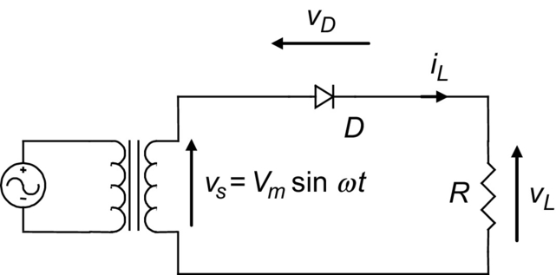

**FIG. 7.1** A single-phase half-wave rectifier with resistive load.

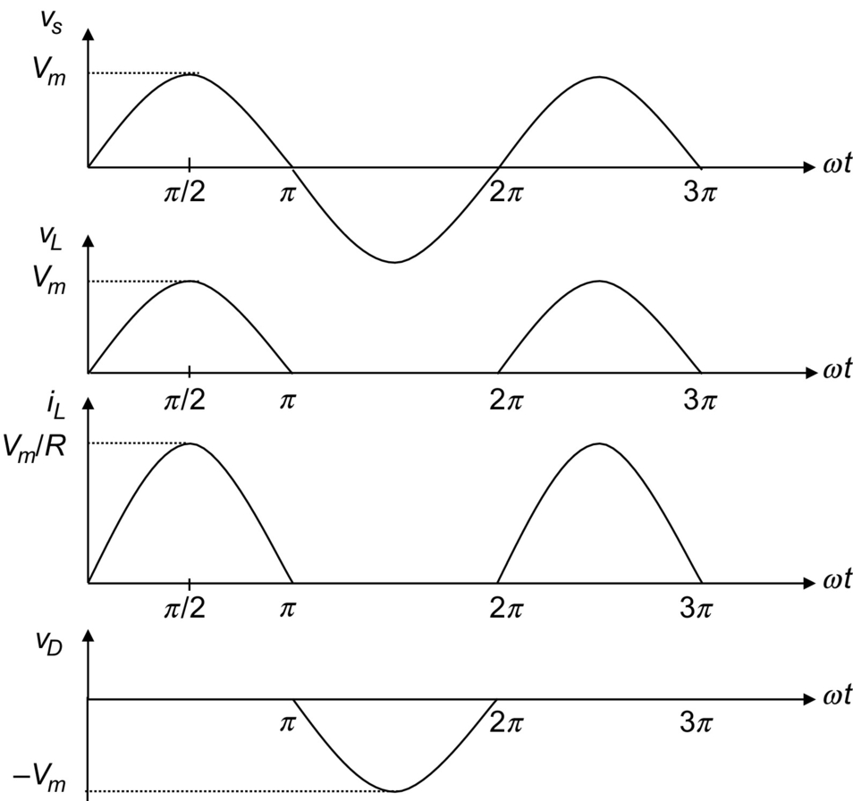

**FIG. 7.2** Voltage and current waveforms of the half-wave rectifier with resistive load.

By observing the voltage waveform of diode *D* in [Fig. 7.2](https://learning.oreilly.com/library/view/power-electronics-handbook/9780128114087/B9780128114070000076.xhtml#f0015), it is clear that the peak inverse voltage (PIV) of diode *D* is equal to *Vm* during the negative half cycle of the transformer secondary voltage. Hence, the peak repetitive reverse voltage (*VRRM*) rating of diode *D* must be chosen to be higher than *Vm* to avoid reverse breakdown. In the positive half cycle of the transformer secondary voltage, diode *D* has a forward current that is equal to the load current; therefore, the peak repetitive forward current (*IFRM*) rating of diode *D* must be chosen to be higher than the peak load current, *Vm*/*R*, in practice. In addition, the transformer has to carry a dc current that may result in a dc saturation problem of the transformer core.

### 7.2.2 SINGLE-PHASE FULL-WAVE RECTIFIERS

There are two types of single-phase full-wave rectifier, namely, full-wave rectifiers with center-tapped transformer and bridge rectifiers. A full-wave rectifier with a center-tapped transformer is shown in [Fig. 7.3](https://learning.oreilly.com/library/view/power-electronics-handbook/9780128114087/B9780128114070000076.xhtml#f0020). It is clear that each diode, together with the associated half of the transformer, acts as a half-wave rectifier. The outputs of the two half-wave rectifiers are combined to produce full-wave rectification in the load. As far as the transformer is concerned, the dc currents of the two half-wave rectifiers are equal and opposite, such that there is no dc current for creating a transformer core saturation problem. The voltage and current waveforms of the full-wave rectifier are shown in [Fig. 7.4](https://learning.oreilly.com/library/view/power-electronics-handbook/9780128114087/B9780128114070000076.xhtml#f0025). By observing diode voltage waveforms  and  in [Fig. 7.4](https://learning.oreilly.com/library/view/power-electronics-handbook/9780128114087/B9780128114070000076.xhtml#f0025), it is clear that the PIV of the diodes is equal to 2*Vm* during their blocking state. Hence, the *VRRM* rating of the diodes must be chosen to be higher than 2*Vm* to avoid reverse breakdown. (Note that, compared with the half-wave rectifier shown in [Fig. 7.1](https://learning.oreilly.com/library/view/power-electronics-handbook/9780128114087/B9780128114070000076.xhtml#f0010), the full-wave rectifier has twice the dc output voltage, as shown in [Section 7.2.4](https://learning.oreilly.com/library/view/power-electronics-handbook/9780128114087/B9780128114070000076.xhtml#s0070).) During its conducting state, each diode has a forward current which is equal to the load current; therefore, the *IFRM* rating of these diodes must be chosen to be higher than the peak load current, *Vm*/*R*, in practice.

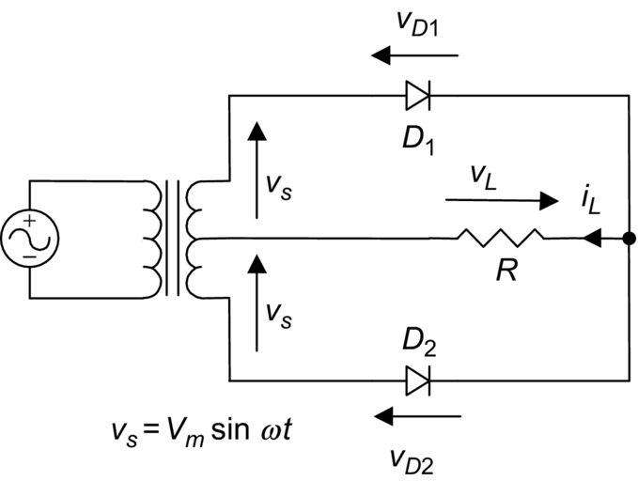

**FIG. 7.3** Full-wave rectifier with center-tapped transformer.

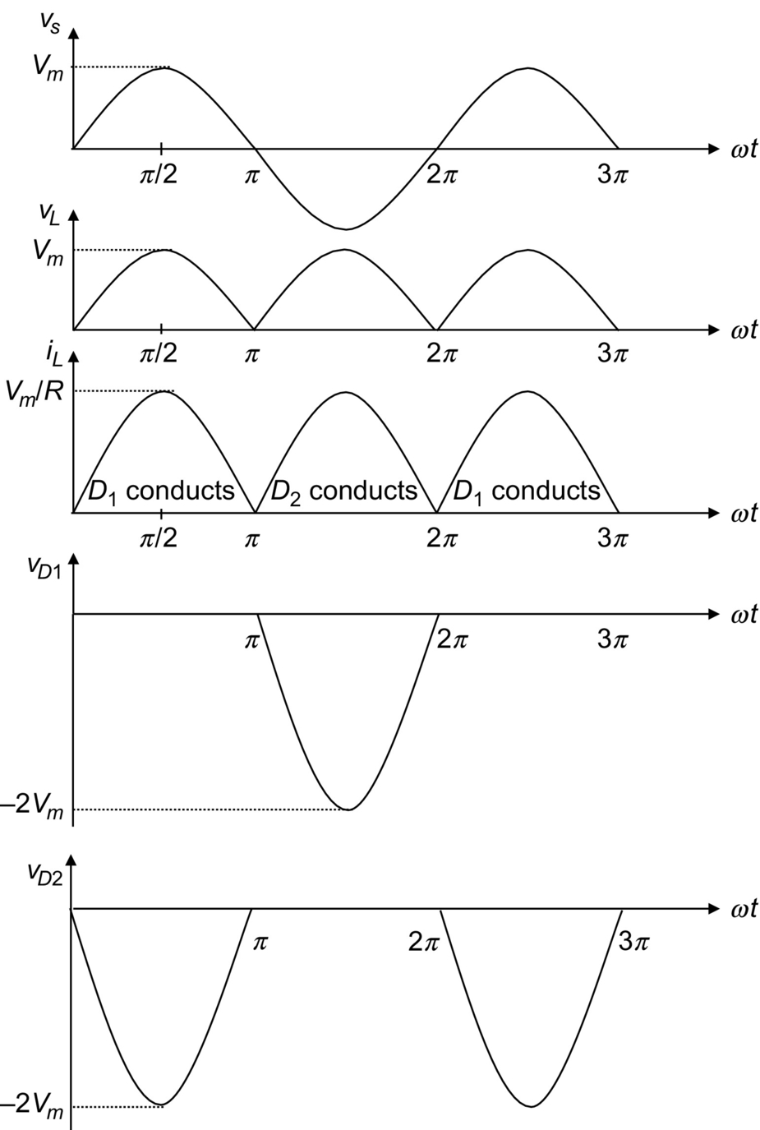

**FIG. 7.4** Voltage and current waveforms of the full-wave rectifier with center-tapped transformer.

Employing four diodes instead of two, a bridge rectifier as shown in [Fig. 7.5](https://learning.oreilly.com/library/view/power-electronics-handbook/9780128114087/B9780128114070000076.xhtml#f0030) can provide full-wave rectification without using a center-tapped transformer. During the positive half cycle of the transformer secondary voltage, the current flows to the load through diodes *D*1 and *D*2. During the negative half cycle, *D*3 and *D*4 conduct. The voltage and current waveforms of the bridge rectifier are shown in [Fig. 7.6](https://learning.oreilly.com/library/view/power-electronics-handbook/9780128114087/B9780128114070000076.xhtml#f0035). As with the full-wave rectifier with center-tapped transformer, the *IFRM* rating of the employed diodes must be chosen to be higher than the peak load current, *Vm*/*R*. However, the PIV of the diodes is reduced from 2*Vm* to *Vm* during their blocking state.

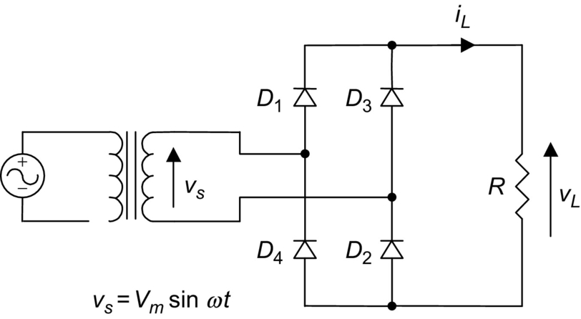

**FIG. 7.5** Bridge rectifier.

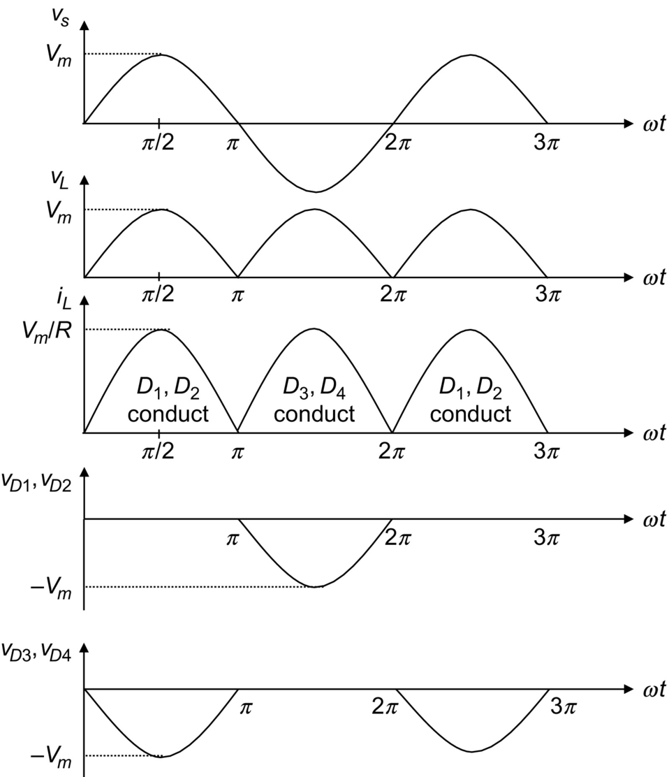

**FIG. 7.6** Voltage and current waveforms of the bridge rectifier.

### 7.2.3 PERFORMANCE PARAMETERS

In this subsection, the performance of the rectifiers mentioned above will be evaluated in terms of the following parameters.

#### **7.2.3.1 Voltage Relationships**

The average value of the load voltage *vL* is *Vdc* and it is defined as

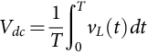 **(7.1)**

In the case of a half-wave rectifier, [Fig. 7.2](https://learning.oreilly.com/library/view/power-electronics-handbook/9780128114087/B9780128114070000076.xhtml#f0015) indicates that load voltage  for the negative half cycle. Note that the angular frequency of the source , and Eq. [(7.1)](https://learning.oreilly.com/library/view/power-electronics-handbook/9780128114087/B9780128114070000076.xhtml#fo0010) can be rewritten as

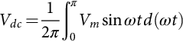 **(7.2)**

Therefore,

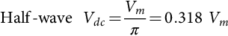 **(7.3)**

In the case of a full-wave rectifier, [Figs. 7.4](https://learning.oreilly.com/library/view/power-electronics-handbook/9780128114087/B9780128114070000076.xhtml#f0025) and [7.6](https://learning.oreilly.com/library/view/power-electronics-handbook/9780128114087/B9780128114070000076.xhtml#f0035) indicate that  for both the positive and negative half cycles. Hence, Eq. [(7.1)](https://learning.oreilly.com/library/view/power-electronics-handbook/9780128114087/B9780128114070000076.xhtml#fo0010) can be rewritten as

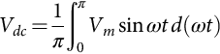 **(7.4)**

Therefore,

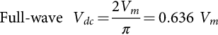 **(7.5)**

The root-mean-square (rms) value of load voltage *vL* is *VL*, which is defined as

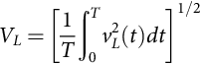 **(7.6)**

In the case of a half-wave rectifier,  for the negative half cycle; therefore, Eq. [(7.6)](https://learning.oreilly.com/library/view/power-electronics-handbook/9780128114087/B9780128114070000076.xhtml#fo0035) can be rewritten as

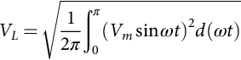 **(7.7)**

or

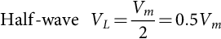 **(7.8)**

In the case of a full-wave rectifier,  for both the positive and negative half cycles. Hence, Eq. [(7.6)](https://learning.oreilly.com/library/view/power-electronics-handbook/9780128114087/B9780128114070000076.xhtml#fo0035) can be rewritten as

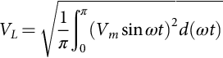 **(7.9)**

or

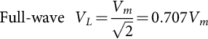 **(7.10)**

The result of Eq. [(7.10)](https://learning.oreilly.com/library/view/power-electronics-handbook/9780128114087/B9780128114070000076.xhtml#fo0055) is as expected because the rms value of a full-wave rectified voltage should be equal to that of the original ac voltage.

#### **7.2.3.2 Current Relationships**

The average value of load current *iL* is *Idc*, and because load *R* is purely resistive, it can be found as

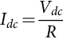 **(7.11)**

The rms value of load current *iL* is *IL*, and it can be found as

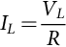 **(7.12)**

In the case of a half-wave rectifier, from Eq. [(7.3)](https://learning.oreilly.com/library/view/power-electronics-handbook/9780128114087/B9780128114070000076.xhtml#fo0020),

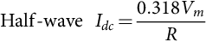 **(7.13)**

and from Eq. [(7.8)](https://learning.oreilly.com/library/view/power-electronics-handbook/9780128114087/B9780128114070000076.xhtml#fo0045),

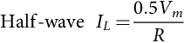 **(7.14)**

In the case of a full-wave rectifier, from Eq. [(7.5)](https://learning.oreilly.com/library/view/power-electronics-handbook/9780128114087/B9780128114070000076.xhtml#fo0030),

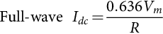 **(7.15)**

and from Eq. [(7.10)](https://learning.oreilly.com/library/view/power-electronics-handbook/9780128114087/B9780128114070000076.xhtml#fo0055),

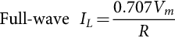 **(7.16)**

#### **7.2.3.3 Rectification Ratio**

The rectification ratio, which is a figure of merit for comparing the effectiveness of rectification, is defined as

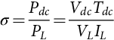 **(7.17)**

In the case of a half-wave diode rectifier, the rectification ratio can be determined by substituting Eqs. [(7.3)](https://learning.oreilly.com/library/view/power-electronics-handbook/9780128114087/B9780128114070000076.xhtml#fo0020), [(7.13)](https://learning.oreilly.com/library/view/power-electronics-handbook/9780128114087/B9780128114070000076.xhtml#fo0070), [(7.8)](https://learning.oreilly.com/library/view/power-electronics-handbook/9780128114087/B9780128114070000076.xhtml#fo0045), and [(7.14)](https://learning.oreilly.com/library/view/power-electronics-handbook/9780128114087/B9780128114070000076.xhtml#fo0075) into Eq. [(7.17)](https://learning.oreilly.com/library/view/power-electronics-handbook/9780128114087/B9780128114070000076.xhtml#fo0090):

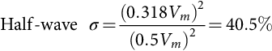 **(7.18)**

In the case of a full-wave rectifier, the rectification ratio is obtained by substituting Eqs. [(7.5)](https://learning.oreilly.com/library/view/power-electronics-handbook/9780128114087/B9780128114070000076.xhtml#fo0030), [(7.15)](https://learning.oreilly.com/library/view/power-electronics-handbook/9780128114087/B9780128114070000076.xhtml#fo0080), [(7.10)](https://learning.oreilly.com/library/view/power-electronics-handbook/9780128114087/B9780128114070000076.xhtml#fo0055), and [(7.16)](https://learning.oreilly.com/library/view/power-electronics-handbook/9780128114087/B9780128114070000076.xhtml#fo0085) into Eq. [(7.17)](https://learning.oreilly.com/library/view/power-electronics-handbook/9780128114087/B9780128114070000076.xhtml#fo0090):

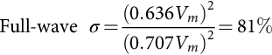 **(7.19)**

#### **7.2.3.4 Form Factor**

The form factor (FF) is defined as the ratio of the root-mean-square value (heating component) of a voltage or current to its average value:

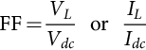 **(7.20)**

**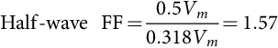** **(7.21)**

In the case of a full-wave rectifier, the FF can be found by substituting Eqs. [(7.16)](https://learning.oreilly.com/library/view/power-electronics-handbook/9780128114087/B9780128114070000076.xhtml#fo0085) and [(7.15)](https://learning.oreilly.com/library/view/power-electronics-handbook/9780128114087/B9780128114070000076.xhtml#fo0080) into Eq. [(7.20)](https://learning.oreilly.com/library/view/power-electronics-handbook/9780128114087/B9780128114070000076.xhtml#fo0105):

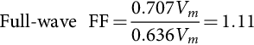 **(7.22)**

#### **7.2.3.5 Ripple Factor**

The ripple factor (RF), which is a measure of the ripple content, is defined as

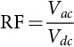 **(7.23)**

where *Vac* is the effective (rms) value of the ac component of load voltage *vL*:

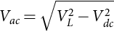 **(7.24)**

Substituting Eq. [(7.24)](https://learning.oreilly.com/library/view/power-electronics-handbook/9780128114087/B9780128114070000076.xhtml#fo0125) into Eq. [(7.23)](https://learning.oreilly.com/library/view/power-electronics-handbook/9780128114087/B9780128114070000076.xhtml#fo0120), the RF can be expressed as

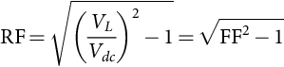 **(7.25)**

In the case of a half-wave rectifier,

 **(7.26)**

In the case of a full-wave rectifier,

 **(7.27)**

#### **7.2.3.6 Transformer Utilization Factor**

The transformer utilization factor (TUF), which is a measure of the merit of a rectifier circuit, is defined as the ratio of the dc output power to the transformer volt-ampere (VA) rating required by the secondary winding:

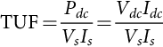 **(7.28)**

where *Vs* and *Is* are the rms voltage and rms current ratings of the secondary transformer:

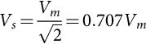 **(7.29)**

The rms value of the transformer secondary current *Is* is the same as that of the load current *IL*. For a half-wave rectifier, *Is* can be found from Eq. [(7.14)](https://learning.oreilly.com/library/view/power-electronics-handbook/9780128114087/B9780128114070000076.xhtml#fo0075):

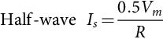 **(7.30)**

For a full-wave rectifier, *Is* is found from Eq. [(7.16)](https://learning.oreilly.com/library/view/power-electronics-handbook/9780128114087/B9780128114070000076.xhtml#fo0085):

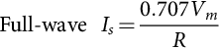 **(7.31)**

Therefore, the TUF of a half-wave rectifier can be obtained by substituting Eqs. [(7.3)](https://learning.oreilly.com/library/view/power-electronics-handbook/9780128114087/B9780128114070000076.xhtml#fo0020), [(7.13)](https://learning.oreilly.com/library/view/power-electronics-handbook/9780128114087/B9780128114070000076.xhtml#fo0070), [(7.29)](https://learning.oreilly.com/library/view/power-electronics-handbook/9780128114087/B9780128114070000076.xhtml#fo0150), and [(7.30)](https://learning.oreilly.com/library/view/power-electronics-handbook/9780128114087/B9780128114070000076.xhtml#fo0155) into Eq. [(7.28)](https://learning.oreilly.com/library/view/power-electronics-handbook/9780128114087/B9780128114070000076.xhtml#fo0145):

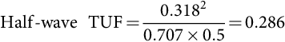 **(7.32)**

The poor TUF of a half-wave rectifier signifies that the transformer employed must have a 3.496 (1/0.286) VA rating in order to deliver 1 W dc output power to the load. In addition, the transformer secondary winding has to carry a dc current that may cause magnetic core saturation. As a result, half-wave rectifiers are used only when the current requirement is small.

In the case of a full-wave rectifier with center-tapped transformer, the circuit can be treated as two half-wave rectifiers operating together. Therefore, the transformer secondary VA rating, *VsIs*, is double that of a half-wave rectifier, but the output dc power is increased by a factor of four due to higher rectification ratio as indicated by Eqs. [(7.5)](https://learning.oreilly.com/library/view/power-electronics-handbook/9780128114087/B9780128114070000076.xhtml#fo0030) and [(7.15)](https://learning.oreilly.com/library/view/power-electronics-handbook/9780128114087/B9780128114070000076.xhtml#fo0080). Therefore, the TUF of a full-wave rectifier with center-tapped transformer can be found from Eq. [(7.32)](https://learning.oreilly.com/library/view/power-electronics-handbook/9780128114087/B9780128114070000076.xhtml#fo0165):

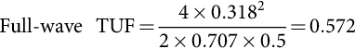 **(7.33)**

In the case of a bridge rectifier, it has the highest TUF in single-phase rectifier circuits because the currents flowing in both the primary and secondary windings are continuous sinewaves. By substituting Eqs. [(7.5)](https://learning.oreilly.com/library/view/power-electronics-handbook/9780128114087/B9780128114070000076.xhtml#fo0030), [(7.15)](https://learning.oreilly.com/library/view/power-electronics-handbook/9780128114087/B9780128114070000076.xhtml#fo0080), [(7.29)](https://learning.oreilly.com/library/view/power-electronics-handbook/9780128114087/B9780128114070000076.xhtml#fo0150), and [(7.31)](https://learning.oreilly.com/library/view/power-electronics-handbook/9780128114087/B9780128114070000076.xhtml#fo0160) into Eq. [(7.28)](https://learning.oreilly.com/library/view/power-electronics-handbook/9780128114087/B9780128114070000076.xhtml#fo0145), the TUF of a bridge rectifier can be found:

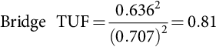 **(7.34)**

The transformer primary VA rating of a full-wave rectifier is equal to that of a bridge rectifier since the current flowing in the primary winding is also a continuous sinewave.

#### **7.2.3.7 Harmonics**

Full-wave rectifier circuits with resistive load do not produce harmonic currents in their transformers. In half-wave rectifiers, harmonic currents are generated. The amplitudes of the harmonic currents of a half-wave rectifier with resistive load, relative to the fundamental, are given in [Table 7.1](https://learning.oreilly.com/library/view/power-electronics-handbook/9780128114087/B9780128114070000076.xhtml#t0010). The extra loss caused by the harmonics in the resistive loaded rectifier circuits is often neglected because it is not high compared with other losses. However, with nonlinear loads, harmonics can cause appreciable loss and other problems such as poor power factor and interference.

**Table 7.1**

**Harmonic percentages of a half-wave rectifier with resistive load**

|  |  |  |  |  |  |  |  |
| --- | --- | --- | --- | --- | --- | --- | --- |
| **Harmonic** | **Second** | **Third** | **Fourth** | **Fifth** | **Sixth** | **Seventh** | **Eighth** |
| % | 21.2 | 0 | 4.2 | 0 | 1.8 | 0 | 1.01 |

### 7.2.4 DESIGN CONSIDERATIONS

In a practical design, the goal is to achieve a given dc output voltage. Therefore, it is more convenient to put all the design parameters in terms of *Vdc*. For example, the rating and turn ratio of the transformer in a rectifier circuit can be easily determined if the rms input voltage to the rectifier is in terms of the required output voltage *Vdc*.

Denote the rms value of the input voltage to the rectifier as *Vs*, which is equal to 0.707*Vm*. Based on this relation and Eq. [(7.3)](https://learning.oreilly.com/library/view/power-electronics-handbook/9780128114087/B9780128114070000076.xhtml#fo0020), the rms input voltage to a half-wave rectifier is found as

 **(7.35)**

Similarly, from Eqs. [(7.5)](https://learning.oreilly.com/library/view/power-electronics-handbook/9780128114087/B9780128114070000076.xhtml#fo0030) and [(7.29)](https://learning.oreilly.com/library/view/power-electronics-handbook/9780128114087/B9780128114070000076.xhtml#fo0150), the rms input voltage per secondary winding of a full-wave rectifier is found as

 **(7.36)**

Another important design parameter is the *VRRM* rating of the diodes employed.

In the case of a half-wave rectifier, from Eq. [(7.3)](https://learning.oreilly.com/library/view/power-electronics-handbook/9780128114087/B9780128114070000076.xhtml#fo0020),

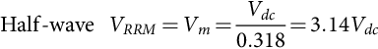 **(7.37)**

In the case of a full-wave rectifier with center-tapped transformer, from Eq. [(7.5)](https://learning.oreilly.com/library/view/power-electronics-handbook/9780128114087/B9780128114070000076.xhtml#fo0030),

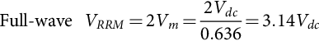 **(7.38)**

In the case of a bridge rectifier, also from Eq. [(7.5)](https://learning.oreilly.com/library/view/power-electronics-handbook/9780128114087/B9780128114070000076.xhtml#fo0030),

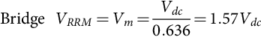 **(7.39)**

It is important to evaluate the *IFRM* rating of the employed diodes in rectifier circuits.

In the case of a half-wave rectifier, from Eq. [(7.13)](https://learning.oreilly.com/library/view/power-electronics-handbook/9780128114087/B9780128114070000076.xhtml#fo0070),

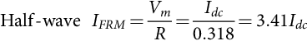 **(7.40)**

In the case of full-wave rectifiers, from Eq. [(7.15)](https://learning.oreilly.com/library/view/power-electronics-handbook/9780128114087/B9780128114070000076.xhtml#fo0080),

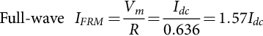 **(7.41)**

The important design parameters of basic single-phase rectifier circuits with resistive loads are summarized in [Table 7.2](https://learning.oreilly.com/library/view/power-electronics-handbook/9780128114087/B9780128114070000076.xhtml#t0015).

**Table 7.2**

**Important design parameters of basic single-phase rectifier circuits with resistive load**

|  |  |  |  |
| --- | --- | --- | --- |
|  | **Half-wave rectifier** | **Full-wave rectifier with center-tapped transformer** | **Full-wave bridge rectifier** |
| Peak repetitive reverse voltage *VRRM* | 3.14*Vdc* | 3.14*Vdc* | 1.57*Vdc* |
| RMS input voltage per transformer leg *Vs* | 2.22*Vdc* | 1.11*Vdc* | 1.11*Vdc* |
| Diode average current *IF*(*AV*) | 1.00*Idc* | 0.50*Idc* | 0.50*Idc* |
| Peak repetitive forward current *IFRM* | 3.14*IF*(*AV*) | 1.57*IF*(*AV*) | 1.57*IF*(*AV*) |
| Diode rms current *IF*(*RMS*) | 1.57*Idc* | 0.785*Idc* | 0.785*Idc* |
| Form factor of diode current *IF*(*RMS*)/*IF*(*AV*) | 1.57 | 1.57 | 1.57 |
| Rectification ratio | 0.405 | 0.81 | 0.81 |
| Form factor | 1.57 | 1.11 | 1.11 |
| Ripple factor | 1.21 | 0.482 | 0.482 |
| Transformer rating primary VA | 2.69*Pdc* | 1.23*Pdc* | 1.23*Pdc* |
| Transformer rating secondary VA | 3.49*Pdc* | 1.75*Pdc* | 1.23*Pdc* |
| Output ripple frequency *fr* | 1*fi* | 2*fi* | 2*fi* |

## 7.3 Three-Phase Diode Rectifiers

It has been shown in [Section 7.2](https://learning.oreilly.com/library/view/power-electronics-handbook/9780128114087/B9780128114070000076.xhtml#s0015) that single-phase diode rectifiers require a rather high transformer VA rating for a given dc output power. Therefore, these rectifiers are suitable only for low-to-medium power applications. For power output higher than 15 kW, three-phase or polyphase diode rectifiers should be employed. There are two types of three-phase diode rectifier that convert a three-phase ac supply into a dc voltage, namely, star rectifiers and bridge rectifiers. In the following subsections, the operations of these rectifiers are examined, and their performances are analyzed and compared in tabulated form. For the sake of simplicity, the diodes and the transformers are considered to be ideal, that is, the diodes have zero forward voltage drop and reverse current and the transformers possess no resistance and no leakage inductance. Furthermore, it is assumed that the load is purely resistive, such that the load voltage and the load current have similar waveforms. In [Section 7.5](https://learning.oreilly.com/library/view/power-electronics-handbook/9780128114087/B9780128114070000076.xhtml#s0130), Filtering Systems in Rectifier Circuits, the effects of inductive load and capacitive load on a diode rectifier are considered in detail.

### 7.3.1 THREE-PHASE STAR RECTIFIERS

#### **7.3.1.1 Basic Three-Phase Star Rectifier Circuit**

A basic three-phase star rectifier circuit is shown in [Fig. 7.7](https://learning.oreilly.com/library/view/power-electronics-handbook/9780128114087/B9780128114070000076.xhtml#f0040). This circuit can be considered as three single-phase half-wave rectifiers combined together. Therefore, it is sometimes referred to as a three-phase half-wave rectifier. The diode in a particular phase conducts during the period when the voltage on that phase is higher than that on the other two phases. The voltage waveforms of each phase and the load are shown in [Fig. 7.8](https://learning.oreilly.com/library/view/power-electronics-handbook/9780128114087/B9780128114070000076.xhtml#f0045). It is clear that, unlike the single-phase rectifier circuit, the conduction angle of each diode is 2*π*/3, instead of *π*. This circuit finds uses where the required dc output voltage is relatively low, and the required output current is too large for a practical single-phase system.

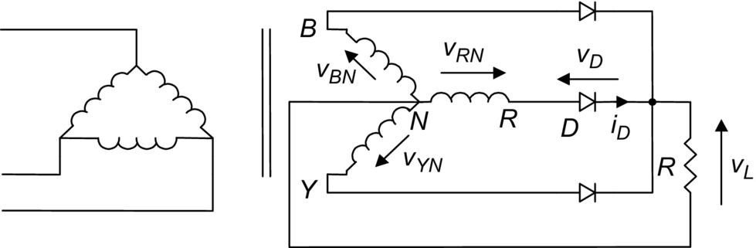

**FIG. 7.7** Three-phase star rectifier.

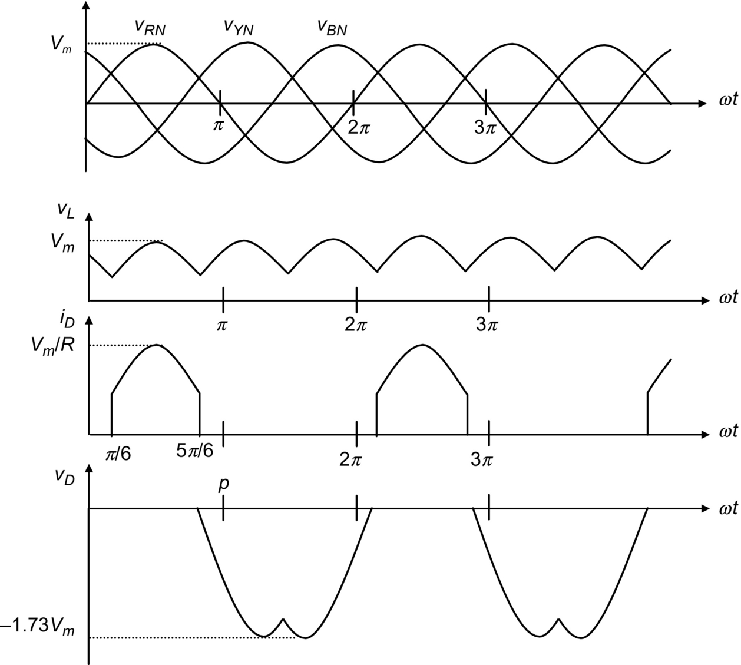

**FIG. 7.8** Waveforms of voltage and current of the three-phase star rectifier shown in [Fig. 7.7](https://learning.oreilly.com/library/view/power-electronics-handbook/9780128114087/B9780128114070000076.xhtml#f0040).

Taking phase *R* as an example, diode *D* conducts from *π*/6 to 5*π*/6. Therefore, using Eq. [(7.1)](https://learning.oreilly.com/library/view/power-electronics-handbook/9780128114087/B9780128114070000076.xhtml#fo0010), the average value of the output can be found as

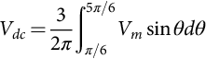 **(7.42)**

or

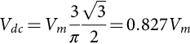 **(7.43)**

Similarly, using Eq. [(7.6)](https://learning.oreilly.com/library/view/power-electronics-handbook/9780128114087/B9780128114070000076.xhtml#fo0035), the rms value of the output voltage can be found as

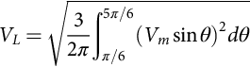 **(7.44)**

or

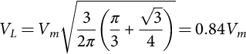 **(7.45)**

In addition, the rms current in each transformer secondary winding can also be found as

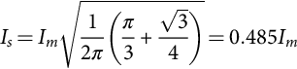 **(7.46)**

where .

Based on the relationships stated in Eqs. [(7.43)](https://learning.oreilly.com/library/view/power-electronics-handbook/9780128114087/B9780128114070000076.xhtml#fo0220), [(7.45)](https://learning.oreilly.com/library/view/power-electronics-handbook/9780128114087/B9780128114070000076.xhtml#fo0230), [(7.46)](https://learning.oreilly.com/library/view/power-electronics-handbook/9780128114087/B9780128114070000076.xhtml#fo0235), all the important design parameters of the three-phase star rectifier can be evaluated, as listed in [Table 7.3](https://learning.oreilly.com/library/view/power-electronics-handbook/9780128114087/B9780128114070000076.xhtml#t0020), which is given at the end of [Section 7.3.2](https://learning.oreilly.com/library/view/power-electronics-handbook/9780128114087/B9780128114070000076.xhtml#s0100). Note that, as with a single-phase half-wave rectifier, the three-phase star rectifier shown in [Fig. 7.7](https://learning.oreilly.com/library/view/power-electronics-handbook/9780128114087/B9780128114070000076.xhtml#f0040) has direct currents in the secondary windings that can cause a transformer core saturation problem. In addition, the currents in the primary do not sum to zero. Therefore, it is preferable not to have star-connected primary windings.

**Table 7.3**

**Important design parameters of the three-phase rectifier circuits with the resistive load**

|  |  |  |  |
| --- | --- | --- | --- |
|  | **Three-phase star rectifier** | **Three-phase double-star rectifier with interphase transformer** | **Three-phase bridge rectifier** |
| Peak repetitive reverse voltage *VRRM* | 2.092*Vdc* | 1.06*Vdc* | 1.05*Vdc* |
| RMS input voltage per transformer leg *Vs* | 0.855*Vdc* | 0.855*Vdc* | 0.428*Vdc* |
| Diode average current *IF*(*AV*) | 0.333*Idc* | 0.167*Idc* | 0.333*Idc* |
| Peak repetitive forward current *IFRM* | 3.63*IF*(*AV*) | 3.15*IF*(*AV*) | 3.14*IF*(*AV*) |
| Diode rms current *IF*(*RMS*) | 0.587*Idc* | 0.293*Idc* | 0.579*Idc* |
| Form factor of diode current *IF*(*RMS*)/*IF*(*AV*) | 1.76 | 1.76 | 1.74 |
| Rectification ratio | 0.968 | 0.998 | 0.998 |
| Form factor | 1.0165 | 1.0009 | 1.0009 |
| Ripple factor | 0.182 | 0.042 | 0.042 |
| Transformer rating primary VA | 1.23*Pdc* | 1.06*Pdc* | 1.05*Pdc* |
| Transformer rating secondary VA | 1.51*Pdc* | 1.49*Pdc* | 1.05*Pdc* |
| Output ripple frequency *fr* | 3*fi* | 6*fi* | 6*fi* |

#### **7.3.1.2 Three-Phase Interstar Rectifier Circuit**

The transformer core saturation problem in the three-phase star rectifier can be avoided by a special arrangement in its secondary windings, known as zigzag connection. The modified circuit is called the three-phase interstar or zigzag rectifier circuit, as shown in [Fig. 7.9](https://learning.oreilly.com/library/view/power-electronics-handbook/9780128114087/B9780128114070000076.xhtml#f0050). Each secondary-phase voltage is obtained from two equal-voltage secondary windings (with a phase displacement of *π*/3) connected in series so that the dc magnetizing forces due to the two secondary windings on any limb are equal and opposite. At the expense of extra secondary windings (increasing the transformer secondary rating factor from 1.51 to 1.74 VA/W), this circuit connection eliminates the effects of core saturation and reduces the transformer primary rating factor to the minimum of 1.05 VA/W. Apart from transformer ratings, all the design parameters of this circuit are the same as those of a three-phase star rectifier (therefore not separately listed in [Table 7.3](https://learning.oreilly.com/library/view/power-electronics-handbook/9780128114087/B9780128114070000076.xhtml#t0020)). Furthermore, a star-connected primary winding with no neutral connection is equally permissible because the sum of all primary phase currents is zero at all times.

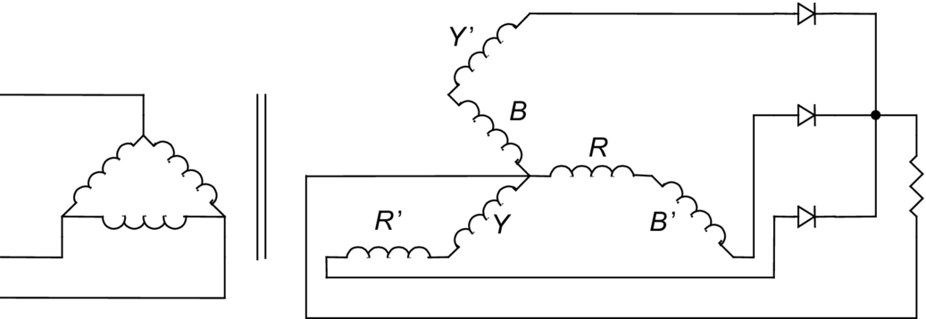

**FIG. 7.9** Three-phase interstar rectifier.

#### **7.3.1.3 Three-Phase Double-Star Rectifier With Interphase Transformer**

This circuit consists essentially of two three-phase star rectifiers with their neutral points interconnected through an interphase transformer or reactor ([Fig. 7.10](https://learning.oreilly.com/library/view/power-electronics-handbook/9780128114087/B9780128114070000076.xhtml#f0055)). The polarities of the corresponding secondary windings in the two interconnected systems are reversed with respect to each other, so that the rectifier output voltage of one three-phase unit is at a minimum when the rectifier output voltage of the other unit is at a maximum as shown in [Fig. 7.11](https://learning.oreilly.com/library/view/power-electronics-handbook/9780128114087/B9780128114070000076.xhtml#f0060). The function of the interphase transformer is to cause the output voltage *vL* to be the average of the rectified voltages *v*1 and *v*2 as shown in [Fig. 7.11](https://learning.oreilly.com/library/view/power-electronics-handbook/9780128114087/B9780128114070000076.xhtml#f0060). In addition, the ripple frequency of the output voltage is now six times that of the mains, and therefore, the component size of the filter (if there is any) becomes smaller. In a balanced circuit, the output currents of two three-phase units flowing in opposite directions in the interphase transformer winding will produce no dc magnetization current. Similarly, the dc magnetization currents in the secondary windings of two three-phase units cancel each other out.

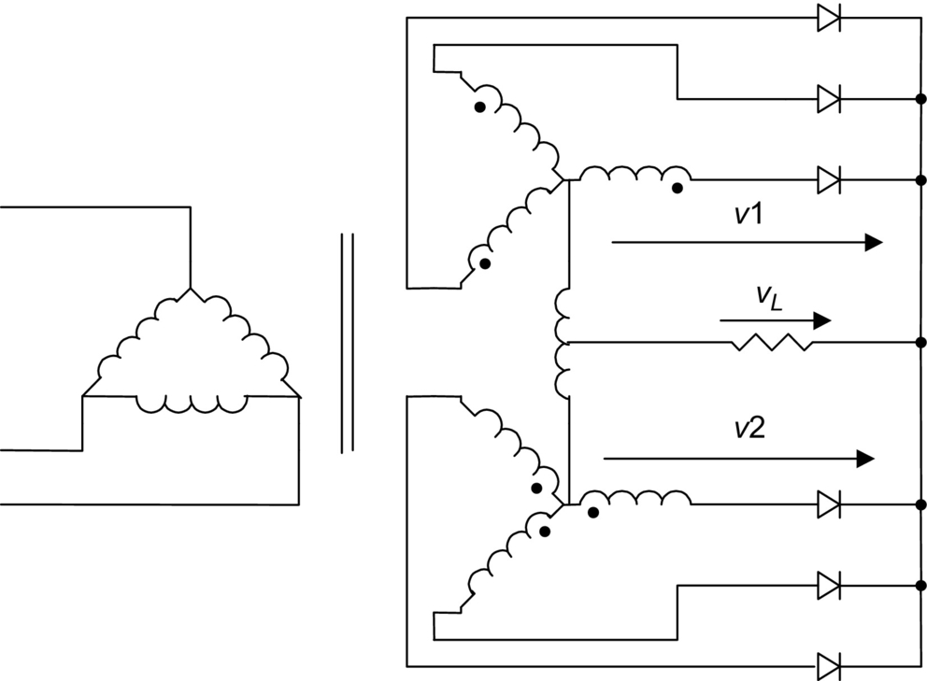

**FIG. 7.10** Three-phase double-star rectifier with interphase transformer.

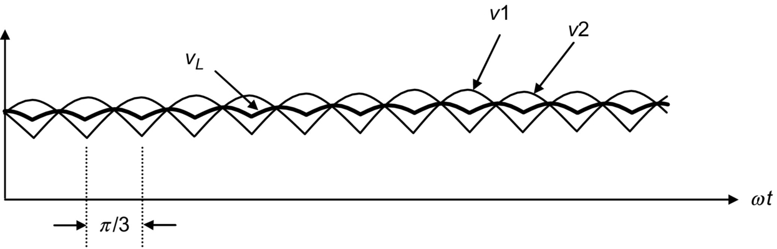

**FIG. 7.11** Voltage waveforms of the three-phase double-star rectifier.

By virtue of the symmetry of the secondary circuits, the three primary currents add up to zero at all times. Therefore, a star primary winding with no neutral connection would be equally permissible.

### 7.3.2 THREE-PHASE BRIDGE RECTIFIERS

Three-phase bridge rectifiers are commonly used for high-power applications because they have the highest possible transformer utilization factor for a three-phase system. The circuit of a three-phase bridge rectifier is shown in [Fig. 7.12](https://learning.oreilly.com/library/view/power-electronics-handbook/9780128114087/B9780128114070000076.xhtml#f0065). The diodes are numbered in the order of conduction sequences, and the conduction angle of each diode is 2*π*/3.

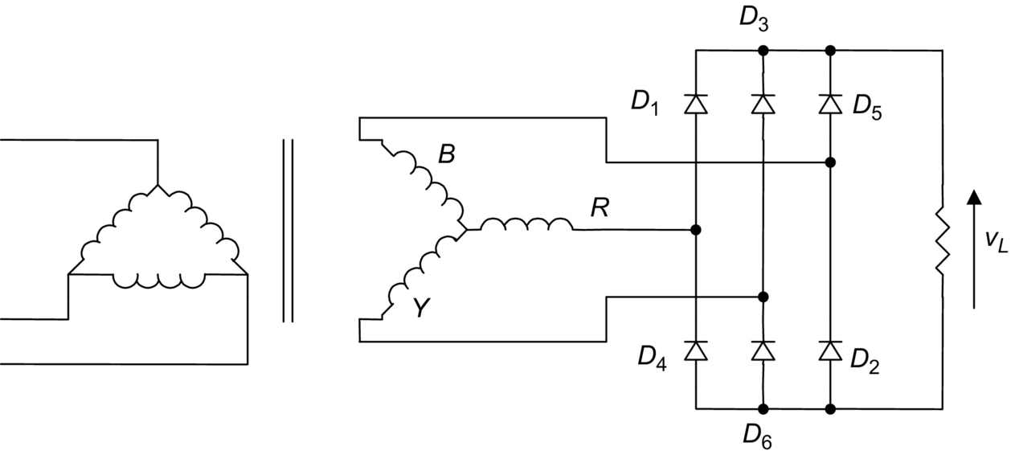

**FIG. 7.12** Three-phase bridge rectifier.

The conduction sequence for diodes is 12, 23, 34, 45, 56, and 61. The voltage and the current waveforms of the three-phase bridge rectifier are shown in [Fig. 7.13](https://learning.oreilly.com/library/view/power-electronics-handbook/9780128114087/B9780128114070000076.xhtml#f0070). The line voltage is 1.73 times the phase voltage of a three-phase star-connected source. It is permissible to use any combination of star- or delta-connected primary and secondary windings because the currents associated with the secondary windings are symmetrical.

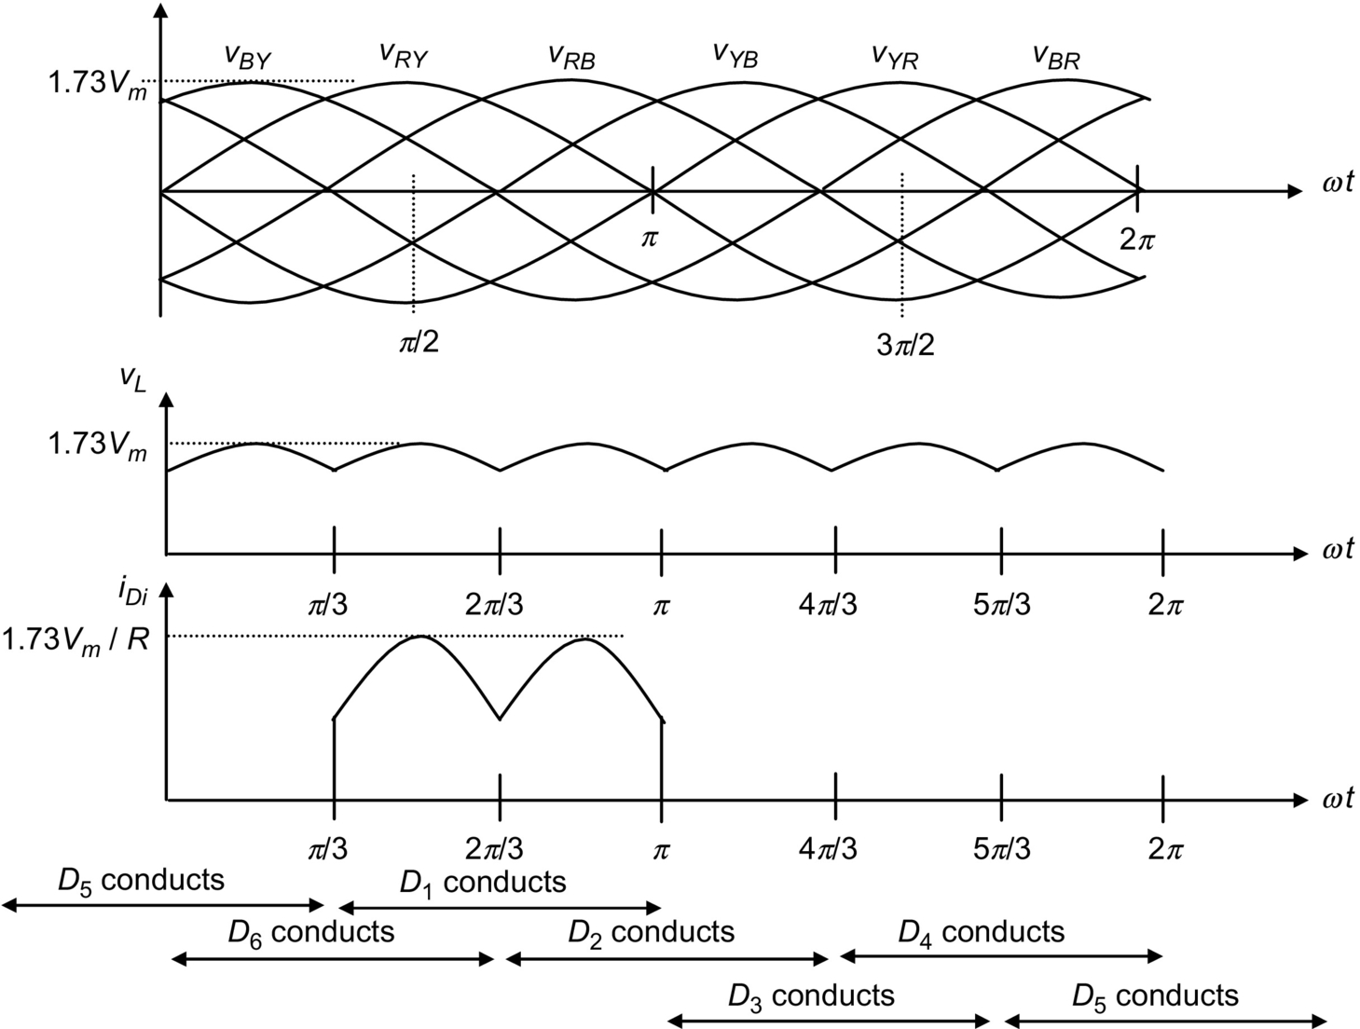

**FIG. 7.13** Voltage and current waveforms of the three-phase bridge rectifier.

Using Eq. [(7.1)](https://learning.oreilly.com/library/view/power-electronics-handbook/9780128114087/B9780128114070000076.xhtml#fo0010), the average value of the output can be found as

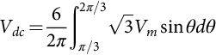 **(7.47)**

or

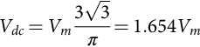 **(7.48)**

Similarly, using Eq. [(7.6)](https://learning.oreilly.com/library/view/power-electronics-handbook/9780128114087/B9780128114070000076.xhtml#fo0035), the rms value of the output voltage can be found as

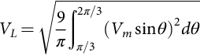 **(7.49)**

or

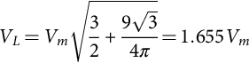 **(7.50)**

In addition, the rms current in each transformer secondary winding can also be found as

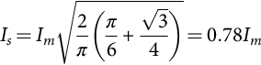 **(7.51)**

and the rms current through a diode is

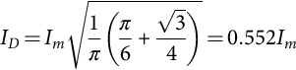 **(7.52)**

where .

Based on Eqs. [(7.48)](https://learning.oreilly.com/library/view/power-electronics-handbook/9780128114087/B9780128114070000076.xhtml#fo0245), [(7.50)](https://learning.oreilly.com/library/view/power-electronics-handbook/9780128114087/B9780128114070000076.xhtml#fo0255), [(7.51)](https://learning.oreilly.com/library/view/power-electronics-handbook/9780128114087/B9780128114070000076.xhtml#fo0260), [(7.52)](https://learning.oreilly.com/library/view/power-electronics-handbook/9780128114087/B9780128114070000076.xhtml#fo0265), all the important design parameters of the three-phase star rectifier can be evaluated, as listed in [Table 7.3](https://learning.oreilly.com/library/view/power-electronics-handbook/9780128114087/B9780128114070000076.xhtml#t0020). The dc output voltage is slightly lower than the peak line voltage or 2.34 times the rms phase voltage. The *VRRM* rating of the employed diodes is 1.05 times the dc output voltage, and the *IFRM* rating of the employed diodes is 0.579 times the dc output current. Therefore, this three-phase bridge rectifier is very efficient and popular wherever both dc voltage and current requirements are high. In many applications, no additional filter is required because the output ripple voltage is only 4.2%. Even if a filter is required, the size of the filter is relatively small because the ripple frequency is increased to six times the input frequency.

### 7.3.3 OPERATION OF RECTIFIERS WITH FINITE SOURCE INDUCTANCE

It has been assumed in the preceding sections that the commutation of current from one diode to the next takes place instantaneously when the interphase voltage assumes the necessary polarity. In practice, this is hardly possible because there are finite inductances associated with the source. For the purpose of discussing the effects of the finite source inductance, a three-phase star rectifier with transformer leakage inductances is shown in [Fig. 7.14](https://learning.oreilly.com/library/view/power-electronics-handbook/9780128114087/B9780128114070000076.xhtml#f0075), where *l*1, *l*2, and *l*3 denote the leakage inductances associated with the transformer secondary windings.

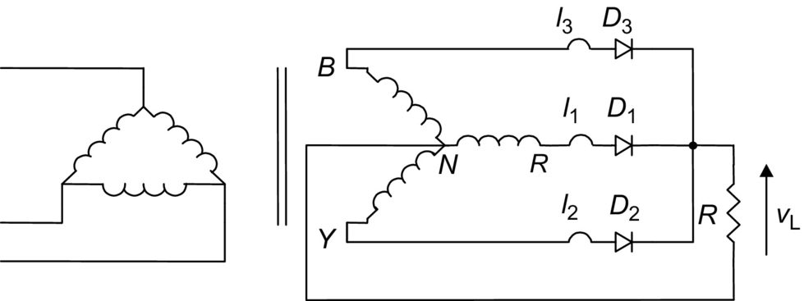

**FIG. 7.14** Three-phase star rectifier with the transformer leakage inductances.

Refer to [Fig. 7.15](https://learning.oreilly.com/library/view/power-electronics-handbook/9780128114087/B9780128114070000076.xhtml#f0080). At the time when *vYN* is about to become larger than *vRN*, due to leakage inductance *l*1, the current in *D*1 cannot fall to zero immediately. Similarly, due to the leakage inductance *l*2, the current in *D*2 cannot increase immediately to the full value. The result is that both the diodes conduct for a certain period, which is called the overlap (or commutation) angle. The overlap reduces the rectified voltage *vL* as shown in the upper voltage waveform of [Fig. 7.15](https://learning.oreilly.com/library/view/power-electronics-handbook/9780128114087/B9780128114070000076.xhtml#f0080). If all the leakage inductances are equal, that is, , then the amount of reduction of dc output voltage can be estimated as *mfilcIdc*, where *m* is the ratio of the lowest ripple frequency to the input frequency.

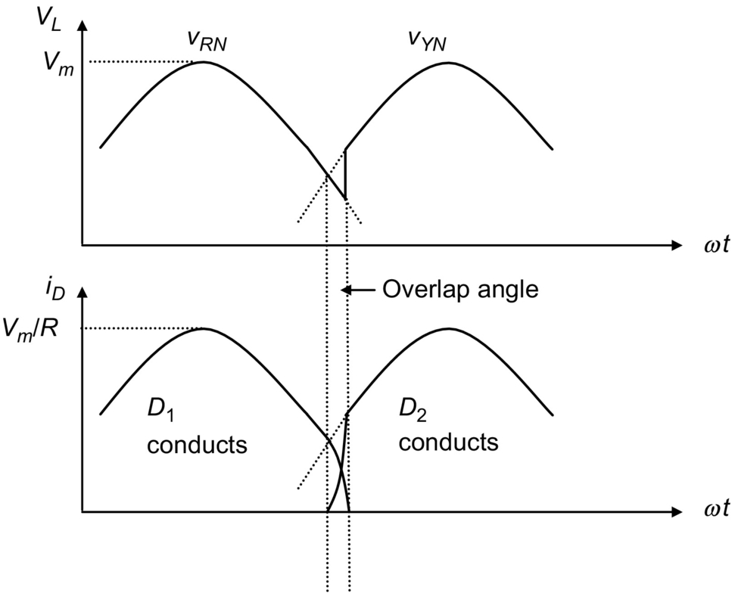

**FIG. 7.15** Waveforms during commutation in [Fig. 7.14](https://learning.oreilly.com/library/view/power-electronics-handbook/9780128114087/B9780128114070000076.xhtml#f0075).

For example, for a three-phase star rectifier operating from a 60 Hz supply with an average load current of 50 A, the amount of reduction of the dc output voltage is 2.7 V if the leakage inductance in each secondary winding is 300 μH.

## 7.4 Poly-Phase Diode Rectifiers

### **7.4.1 SIX-PHASE STAR RECTIFIER**

A basic six-phase star rectifier circuit is shown in [Fig. 7.16](https://learning.oreilly.com/library/view/power-electronics-handbook/9780128114087/B9780128114070000076.xhtml#f0085). The six-phase voltages on the secondary are obtained by means of a center-tapped arrangement on a star-connected three-phase winding. Therefore, it is sometimes referred to as a three-phase full-wave rectifier. The diode in a particular phase conducts during the period when the voltage on that phase is higher than that on the other phases. The voltage waveforms of each phase and the load are shown in [Fig. 7.17](https://learning.oreilly.com/library/view/power-electronics-handbook/9780128114087/B9780128114070000076.xhtml#f0090). It is clear that, unlike the three-phase star rectifier circuit, the conduction angle of each diode is *π*/3, instead of 2*π*/3. Currents flow in only one rectifying element at a time, resulting in a low average current, but a high peak to an average current ratio in the diodes and poor transformer secondary utilization. Nevertheless, the dc currents in the secondary of the six-phase star rectifier cancel in the secondary windings like a full-wave rectifier and, therefore, core saturation is not encountered. This six-phase star circuit is attractive in applications that require a low ripple factor and a common cathode or anode for the rectifiers.

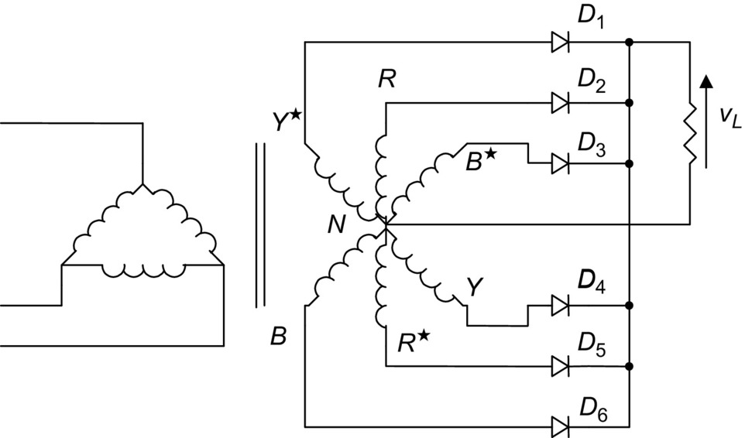

**FIG. 7.16** Six-phase star rectifier.

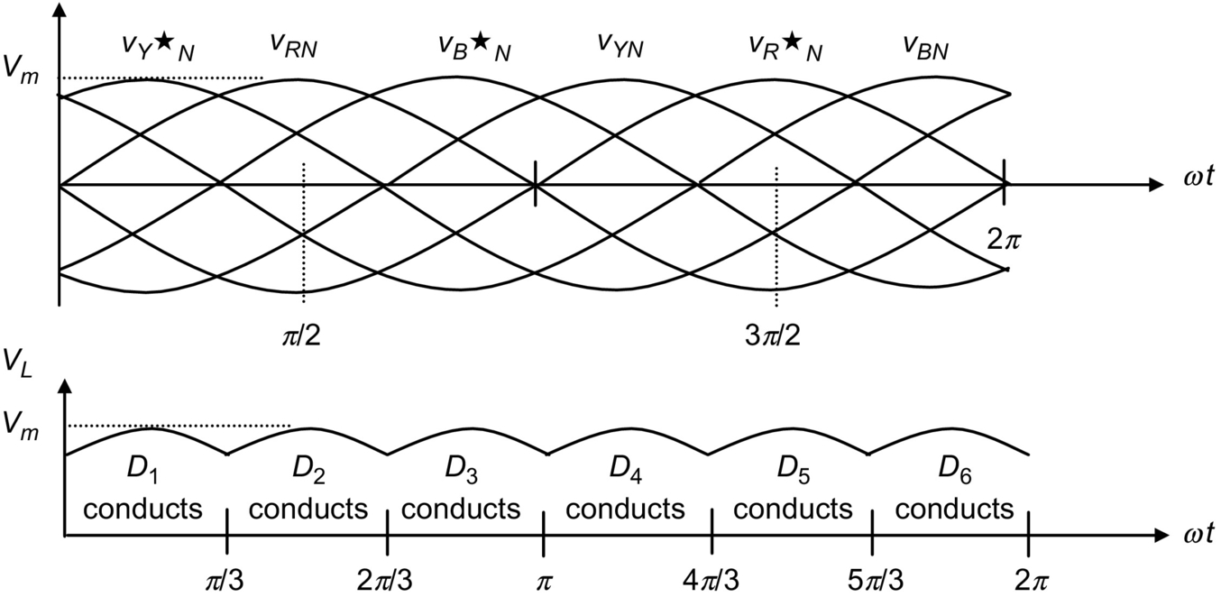

**FIG. 7.17** Voltage waveforms of the six-phase star rectifier.

By considering the output voltage provided by *vRN* between *π*/3 and 2*π*/3, the average value of the output voltage can be found as

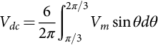 **(7.53)**

or

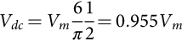 **(7.54)**

Similarly, the rms value of the output voltage can be found as

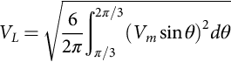 **(7.55)**

or

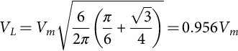 **(7.56)**

In addition, the rms current in each transformer secondary winding can also be found as

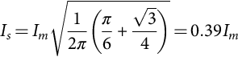 **(7.57)**

where .

Based on the relationships stated in Eqs. [(7.55)](https://learning.oreilly.com/library/view/power-electronics-handbook/9780128114087/B9780128114070000076.xhtml#fo0280)–[(7.57)](https://learning.oreilly.com/library/view/power-electronics-handbook/9780128114087/B9780128114070000076.xhtml#fo0290), all the important design parameters of the six-phase star rectifier can be evaluated, as listed in [Table 7.4](https://learning.oreilly.com/library/view/power-electronics-handbook/9780128114087/B9780128114070000076.xhtml#t0025) (given at the end of [Section 7.4.3](https://learning.oreilly.com/library/view/power-electronics-handbook/9780128114087/B9780128114070000076.xhtml#s0125)).

**Table 7.4**

**Important design parameters of the six-phase rectifier circuits with resistive load**

|  |  |  |  |
| --- | --- | --- | --- |
|  | **Six-phase star rectifier** | **Six-phase series bridge rectifier** | **Six-phase parallel bridge rectifier (with interphase transformer)** |
| Peak repetitive reverse voltage *VRRM* | 2.09*Vdc* | 0.524*Vdc* | 1.05*Vdc* |
| RMS input voltage per transformer leg *Vs* | 0.74*Vdc* | 0.37*Vdc* | 0.715*Vdc* |
| Diode average current *IF*(*AV*) | 0.167*Idc* | 0.333*Idc* | 0.167*Idc* |
| Peak repetitive forward current *IFRM* | 6.28*IF*(*AV*) | 3.033*IF*(*AV*) | 3.14*IF*(AV) |
| Diode rms current *IF*(*RMS*) | 0.409*Idc* | 0.576*Idc* | 0.409*Idc* |
| Form factor of diode current *IF*(*RMS*)/*IF*(*AV*) | 2.45 | 1.73 | 2.45 |
| Rectification ratio | 0.998 | 1.00 | 1.00 |
| Form factor | 1.0009 | 1.00005 | 1.00005 |
| Ripple factor | 0.042 | 0.01 | 0.01 |
| Transformer rating primary VA | 1.28*Pdc* | 1.01*Pdc* | 1.01*Pdc* |
| Transformer rating secondary VA | 1.81*Pdc* | 1.05*Pdc* | 1.05*Pdc* |
| Output ripple frequency *fr* | 6*fi* | 12*fi* | 12*fi* |

### 7.4.2 SIX-PHASE SERIES BRIDGE RECTIFIER

The star- and delta-connected secondaries have an inherent *π*/6-phase displacement between their output voltages. When a star- and a delta-connected bridge rectifier are connected in series as shown in [Fig. 7.18](https://learning.oreilly.com/library/view/power-electronics-handbook/9780128114087/B9780128114070000076.xhtml#f0095), the combined output voltage will have a doubled ripple frequency (12 times that of the mains). The ripple of the combined output voltage will also be reduced from 4.2% (for each individual bridge rectifier) to 1%. The combined bridge rectifier is referred to as a six-phase series bridge rectifier.

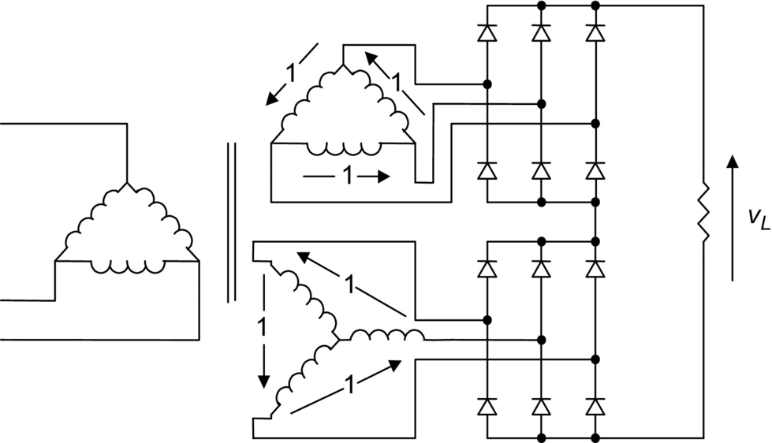

**FIG. 7.18** Six-phase series bridge rectifier.

In the six-phase series bridge rectifier shown in [Fig. 7.18](https://learning.oreilly.com/library/view/power-electronics-handbook/9780128114087/B9780128114070000076.xhtml#f0095), let  be the peak voltage of the delta-connected secondary. The peak voltage between the lines of the star-connected secondary is also . The peak voltage across the load, denoted as *Vm*, is equal to  or 1.932 because there is *π*/6-phase displacement between the secondaries. The ripple frequency is twelve times the mains frequency. The average value of the output voltage can be found as

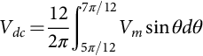 **(7.58)**

or

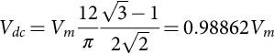 **(7.59)**

The rms value of the output voltage can be found as

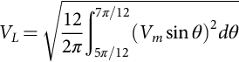 **(7.60)**

or

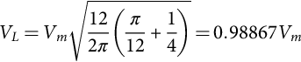 **(7.61)**

The rms current in each transformer secondary winding is

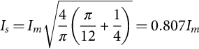 **(7.62)**

The rms current through a diode is

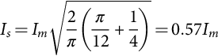 **(7.63)**

where .

Based on Eqs. [(7.59)](https://learning.oreilly.com/library/view/power-electronics-handbook/9780128114087/B9780128114070000076.xhtml#fo0300), [(7.61)](https://learning.oreilly.com/library/view/power-electronics-handbook/9780128114087/B9780128114070000076.xhtml#fo0310), [(7.62)](https://learning.oreilly.com/library/view/power-electronics-handbook/9780128114087/B9780128114070000076.xhtml#fo0315), [(7.63)](https://learning.oreilly.com/library/view/power-electronics-handbook/9780128114087/B9780128114070000076.xhtml#fo0320), all the important design parameters of the six-phase series bridge rectifier can be evaluated, as listed in [Table 7.4](https://learning.oreilly.com/library/view/power-electronics-handbook/9780128114087/B9780128114070000076.xhtml#t0025) (given at the end of [Section 7.4.3](https://learning.oreilly.com/library/view/power-electronics-handbook/9780128114087/B9780128114070000076.xhtml#s0125)).

### 7.4.3 SIX-PHASE PARALLEL BRIDGE RECTIFIER

The six-phase series bridge rectifier described above is useful for high-output voltage applications. However, for high-output current applications, the six-phase parallel bridge rectifier (with an interphase transformer) shown in [Fig. 7.19](https://learning.oreilly.com/library/view/power-electronics-handbook/9780128114087/B9780128114070000076.xhtml#f0100) should be used.

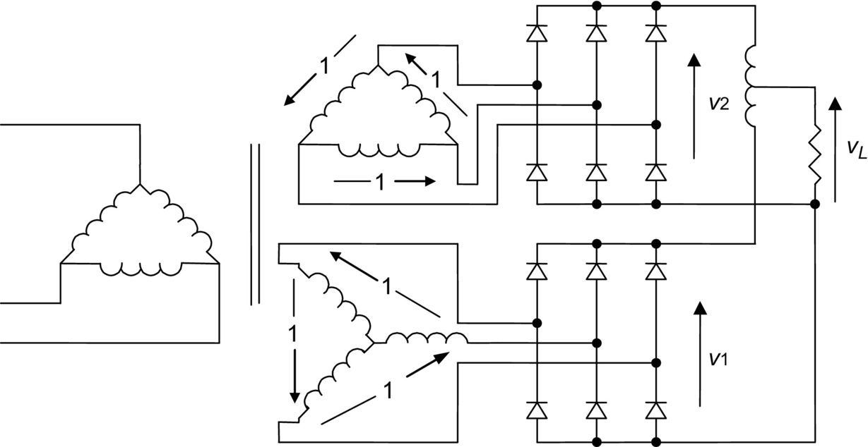

**FIG. 7.19** Six-phase parallel bridge rectifier.

The function of the interphase transformer is to cause the output voltage *vL* to be the average of the rectified voltages *v*1 and *v*2 as shown in [Fig. 7.20](https://learning.oreilly.com/library/view/power-electronics-handbook/9780128114087/B9780128114070000076.xhtml#f0105). As with the six-phase series bridge rectifier, the output ripple frequency of the six-phase parallel bridge rectifier is also 12 times that of the mains. Further filtering on the output voltage is usually not required. Assuming a balanced circuit, the output currents of two three-phase units (flowing in opposite directions in the interphase transformer winding) produce no dc magnetization current.

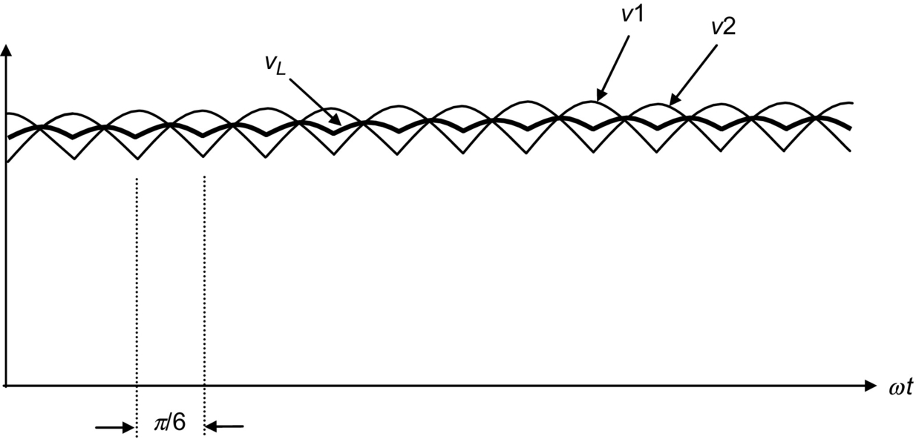

**FIG. 7.20** Voltage waveforms of the six-phase bridge rectifier with interphase transformer.

All the important design parameters of the six-phase parallel rectifiers with interphase transformer are also listed in [Table 7.4](https://learning.oreilly.com/library/view/power-electronics-handbook/9780128114087/B9780128114070000076.xhtml#t0025).

## 7.5 Filtering Systems in Rectifier Circuits

Filters are commonly employed in rectifier circuits for smoothing out the dc output voltage of the load. They are classified as inductor-input dc filters and capacitor-input dc filters. Inductor-input dc filters are preferred in high-power applications because more efficient transformer operation is obtained due to the reduction in the form factor of the rectifier current. Capacitor-input dc filters can provide volumetrically efficient operation, but they demand excessive turn-on and repetitive surge currents. Therefore, capacitor-input dc filters are suitable only for lower-power systems where close regulation is usually achieved by an electronic regulator cascaded with the rectifier.

### 7.5.1 INDUCTIVE-INPUT DC FILTERS

The simplest inductive-input dc filter is shown in [Fig. 7.21A](https://learning.oreilly.com/library/view/power-electronics-handbook/9780128114087/B9780128114070000076.xhtml#f0110). The output current of the rectifier can be maintained at a steady value if the inductance of *Lf* is sufficiently large . The filtering action is more effective in heavy load conditions than in light load conditions. If the ripple attenuation is not sufficient even with large values of inductance, an L-section filter as shown in [Fig. 7.21B](https://learning.oreilly.com/library/view/power-electronics-handbook/9780128114087/B9780128114070000076.xhtml#f0110) can be used for further filtering. In practice, multiple L-section filters can also be employed if the requirement on the output ripple is very stringent.

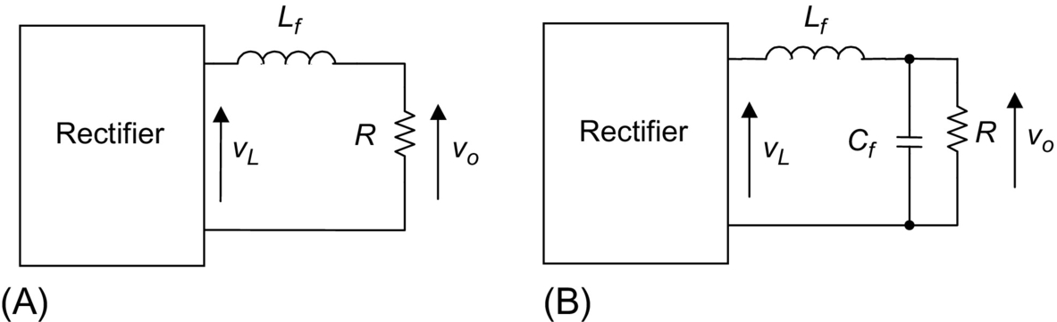

**FIG. 7.21** Inductive-input dc filters. (A) Simple inductive-input dc filter. (B) L-section filter.

For a simple inductive-input dc filter shown in [Fig. 7.21A](https://learning.oreilly.com/library/view/power-electronics-handbook/9780128114087/B9780128114070000076.xhtml#f0110) the ripple is reduced by the factor

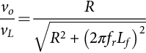 **(7.64)**

where *vL* is the ripple voltage before filtering, *vo* is the ripple voltage after filtering, and *fr* is the ripple frequency.

For the inductive-input dc filter shown in [Fig. 7.21B](https://learning.oreilly.com/library/view/power-electronics-handbook/9780128114087/B9780128114070000076.xhtml#f0110), the amount of reduction in the ripple voltage can be estimated as

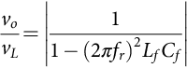 **(7.65)**

where *fr* is the ripple frequency, if .

#### **7.5.1.1 Voltage and Current Waveforms of Full-Wave Rectifier With Inductor-Input DC Filter**

[Fig. 7.22](https://learning.oreilly.com/library/view/power-electronics-handbook/9780128114087/B9780128114070000076.xhtml#f0115) shows a single-phase full-wave rectifier with an inductor-input dc filter. The voltage and current waveforms are illustrated in [Fig. 7.23](https://learning.oreilly.com/library/view/power-electronics-handbook/9780128114087/B9780128114070000076.xhtml#f0120).

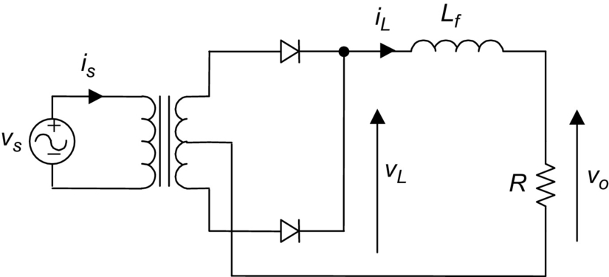

**FIG. 7.22** A full-wave rectifier with inductor-input dc filter.

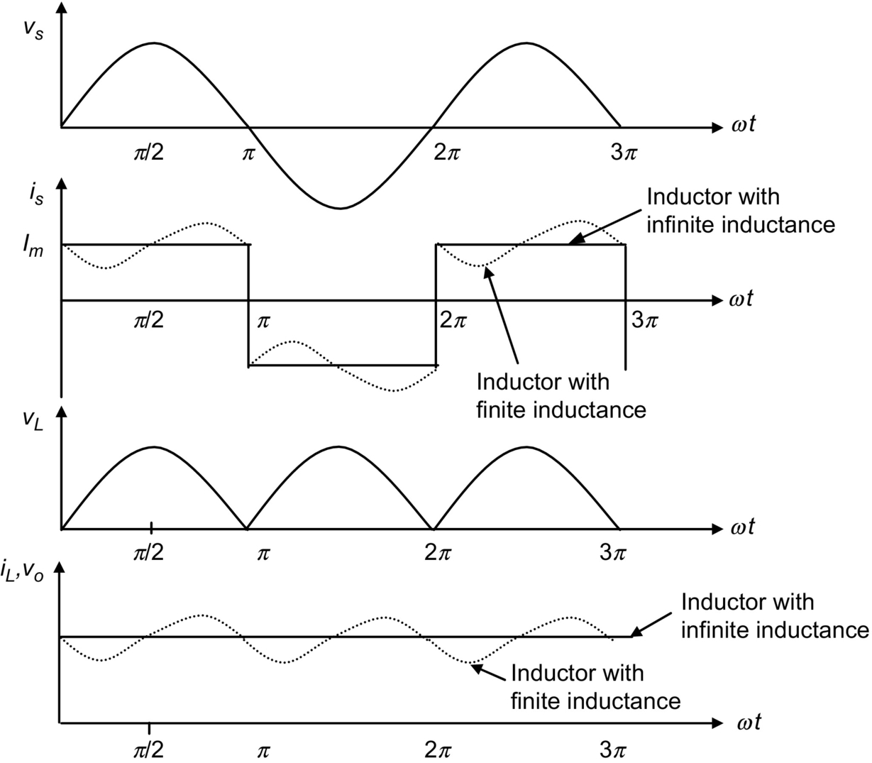

**FIG. 7.23** Voltage and current waveforms of full-wave rectifier with inductor-input dc filter.

When the inductance of *Lf* is infinite, the current through the inductor and the output voltage are constant. When inductor *Lf* is finite, the current through the inductor has a ripple component, as shown by the dotted lines in [Fig. 7.23](https://learning.oreilly.com/library/view/power-electronics-handbook/9780128114087/B9780128114070000076.xhtml#f0120). If the input inductance is too small, the current decreases to zero (becoming discontinuous) during a portion of the time between the peaks of the rectifier output voltage. The minimum value of inductance required to maintain a continuous current is known as the critical inductance *LC*.

#### **7.5.1.2 Critical Inductance *LC***

In the case of single-phase full-wave rectifiers, the critical inductance can be found as

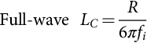 **(7.66)**

where *fi* is the input mains frequency.

In the case of polyphase rectifiers, the critical inductance can be found as

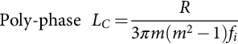 **(7.67)**

where *m* is ratio of the lowest ripple frequency to the input frequency, for example,  for a three-phase bridge rectifier.

#### **7.5.1.3 Determining the Input Inductance for a Given Ripple Factor**

In practice, the choice of the input inductance depends on the required ripple factor of the output voltage. The ripple voltage of a rectifier without filtering can be found by means of Fourier analysis. For example, the coefficient of the *n*th harmonic component of the rectified voltage *vL* shown in [Fig. 7.22](https://learning.oreilly.com/library/view/power-electronics-handbook/9780128114087/B9780128114070000076.xhtml#f0115) can be expressed as

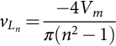 **(7.68)**

where , etc.

The dc component of the rectifier voltage is given by Eq. [(7.5)](https://learning.oreilly.com/library/view/power-electronics-handbook/9780128114087/B9780128114070000076.xhtml#fo0030). Therefore, in addition to Eq. [(7.27)](https://learning.oreilly.com/library/view/power-electronics-handbook/9780128114087/B9780128114070000076.xhtml#fo0140), the ripple factor can also be expressed as

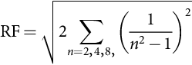 **(7.69)**

Considering only the lowest-order harmonic , the output ripple factor of a simple inductor-input dc filter (without *Cf*) can be found, from Eqs. [(7.64)](https://learning.oreilly.com/library/view/power-electronics-handbook/9780128114087/B9780128114070000076.xhtml#fo0325) and [(7.69)](https://learning.oreilly.com/library/view/power-electronics-handbook/9780128114087/B9780128114070000076.xhtml#fo0350), as

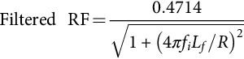 **(7.70)**

#### **7.5.1.4 Harmonics of the Input Current**

In general, the total harmonic distortion (THD) of an input current is defined as

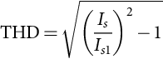 **(7.71)**

where *Is* is the rms value of the input current and *Is*1 and the rms value of the fundamental component of the input current. The THD can also be expressed as

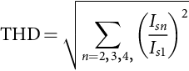 **(7.72)**

where *Isn* is the rms value of the *n*th harmonic component of the input current.

Moreover, the input power factor is defined as

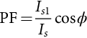 **(7.73)**

where *ϕ* is the displacement angle between the fundamental components of the input current and voltage.

Assume that inductor *Lf* of the circuit shown in [Fig. 7.22](https://learning.oreilly.com/library/view/power-electronics-handbook/9780128114087/B9780128114070000076.xhtml#f0115) has an infinitely large inductance. The input current is then a square wave. This input current contains undesirable higher harmonics that reduce the input power factor of the system. The input current can be easily expressed as

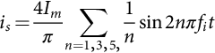 **(7.74)**

The rms values of the input current and its fundamental component are *Im* and 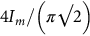, respectively. Therefore, the THD of the input current of this circuit is 0.484. Since the displacement angle is , the power factor is 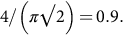

The power factor of the circuit shown in [Fig. 7.22](https://learning.oreilly.com/library/view/power-electronics-handbook/9780128114087/B9780128114070000076.xhtml#f0115) can be improved by installing an ac filter between the source and the rectifier, as shown in [Fig. 7.24](https://learning.oreilly.com/library/view/power-electronics-handbook/9780128114087/B9780128114070000076.xhtml#f0125).

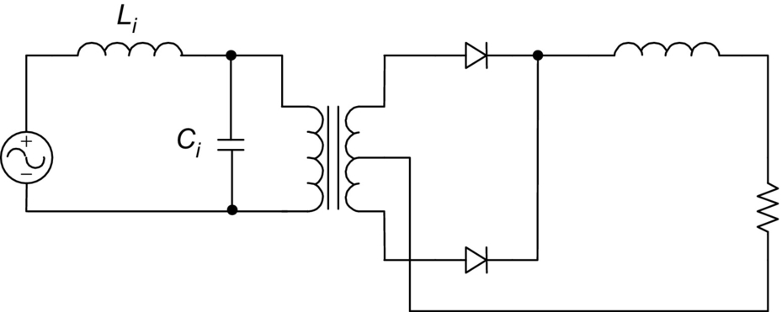

**FIG. 7.24** Rectifier with input ac filter.

Considering only the harmonic components, the equivalent circuit of the rectifier given in [Fig. 7.24](https://learning.oreilly.com/library/view/power-electronics-handbook/9780128114087/B9780128114070000076.xhtml#f0125) can be found as shown in [Fig. 7.25](https://learning.oreilly.com/library/view/power-electronics-handbook/9780128114087/B9780128114070000076.xhtml#f0130). The rms value of the *n*th harmonic current appearing in the supply can then be obtained using the current divider rule:

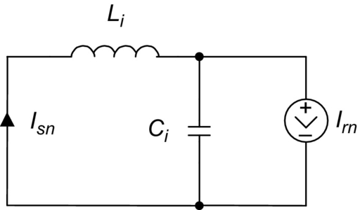

**FIG. 7.25** Equivalent circuit for input ac filter.

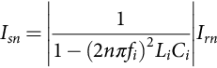 **(7.75)**

where *Irn* is the rms value of the *n*th harmonic current of the rectifier.

Applying Eq. [(7.73)](https://learning.oreilly.com/library/view/power-electronics-handbook/9780128114087/B9780128114070000076.xhtml#fo0370) and knowing  from Eq. [(7.74)](https://learning.oreilly.com/library/view/power-electronics-handbook/9780128114087/B9780128114070000076.xhtml#fo0375), the THD of the rectifier with input filter shown in [Fig. 7.24](https://learning.oreilly.com/library/view/power-electronics-handbook/9780128114087/B9780128114070000076.xhtml#f0125) can be found as

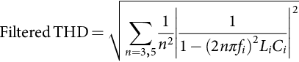 **(7.76)**

The important design parameters of typical single-phase and three-phase rectifiers with inductor-input dc filter are listed in [Table 7.5](https://learning.oreilly.com/library/view/power-electronics-handbook/9780128114087/B9780128114070000076.xhtml#t0030). Note that, in a single-phase half-wave rectifier, a freewheeling diode is required to be connected across the input of the dc filters such that the flow of load current can be maintained during the negative half cycle of the supply voltage.

**Table 7.5**

**Important design parameters of typical rectifier circuits with inductor-input dc filter**

|  |  |  |  |  |  |
| --- | --- | --- | --- | --- | --- |
|  | **Full-wave rectifier with center-tapped transformer** | **Full-wave bridge rectifier** | **Three-phase star rectifier** | **Three-phase bridge rectifier** | **Three-phase double-star rectifier with interphase transformer** |
| Peak repetitive reverse voltage *VRRM* | 3.14*Vdc* | 1.57*Vdc* | 2.09*Vdc* | 1.05*Vdc* | 2.42*Vdc* |
| RMS input voltage per transformer leg *Vs* | 1.11*Vdc* | 1.11*Vdc* | 0.885*Vdc* | 0.428*Vdc* | 0.885*Vdc* |
| Diode average current *IF*(*AV*) | 0.5*Idc* | 0.5*Idc* | 0.333*Idc* | 0.333*Idc* | 0.167*Idc* |
| Peak repetitive forward current *IFRM* | 2.00*IF*(*AV*) | 2.00*IF*(*AV*) | 3.00*IF*(*AV*) | 3.00*IF*(*AV*) | 3.00*IF*(*AV*) |
| Diode rms current *IF*(*RMS*) | 0.707*Idc* | 0.707*Idc* | 0.577*Idc* | 0.577*Idc* | 0.289*Idc* |
| Form factor of diode current *IF*(*RMS*)/*IF*(*AV*) | 1.414 | 1.414 | 1.73 | 1.73 | 1.73 |
| Transformer rating primary VA | 1.11*Pdc* | 1.11*Pdc* | 1.21*Pdc* | 1.05*Pdc* | 1.05*Pdc* |
| Transformer rating secondary VA | 1.57*Pdc* | 1.11*Pdc* | 1.48*Pdc* | 1.05*Pdc* | 1.48*Pdc* |
| Output ripple frequency *fr* | 2*fi* | 2*fi* | 3*fi* | 6*fi* | 6*fi* |
| Ripple component *Vr* at | | | | | |
| (a) Fundamental | 0.667*Vdc* | 0.667*Vdc* | 0.250*Vdc* | 0.057*Vdc* | 0.057*Vdc* |
| (b) Second harmonic | 0.133*Vdc* | 0.133*Vdc* | 0.057*Vdc* | 0.014*Vdc* | 0.014*Vdc* |
| (c) Third harmonic of the ripple frequency | 0.057*Vdc* | 0.057*Vdc* | 0.025*Vdc* | 0.006*Vdc* | 0.006*Vdc* |

### 7.5.2 CAPACITIVE-INPUT DC FILTERS

[Fig. 7.26](https://learning.oreilly.com/library/view/power-electronics-handbook/9780128114087/B9780128114070000076.xhtml#f0135) shows a full-wave rectifier with capacitor-input dc filter. The voltage and current waveforms of this rectifier are shown in [Fig. 7.27](https://learning.oreilly.com/library/view/power-electronics-handbook/9780128114087/B9780128114070000076.xhtml#f0140). When the instantaneous voltage of the secondary winding *vs* is higher than the instantaneous value of capacitor voltage *vL*, either *D*1 or *D*2 conducts, and the capacitor *C* is charged up from the transformer. When the instantaneous voltage of the secondary winding *vs* falls below the instantaneous value of capacitor voltage *vL*, both the diodes are reverse biased and the capacitor *C* is discharged through load resistance *R*. The resulting capacitor voltage *vL* varies between a maximum value of *Vm* and a minimum value of  as shown in [Fig. 7.27](https://learning.oreilly.com/library/view/power-electronics-handbook/9780128114087/B9780128114070000076.xhtml#f0140). (*Vr*(*pp*) is the peak-to-peak ripple voltage.) As shown in [Fig. 7.27](https://learning.oreilly.com/library/view/power-electronics-handbook/9780128114087/B9780128114070000076.xhtml#f0140), the conduction angle *θc* of the diodes becomes smaller when the output ripple voltage decreases. Consequently, the power supply and the diodes suffer from high repetitive surge currents. An LC ac filter, as shown in [Fig. 7.24](https://learning.oreilly.com/library/view/power-electronics-handbook/9780128114087/B9780128114070000076.xhtml#f0125), may be required to improve the input power factor of the rectifier.

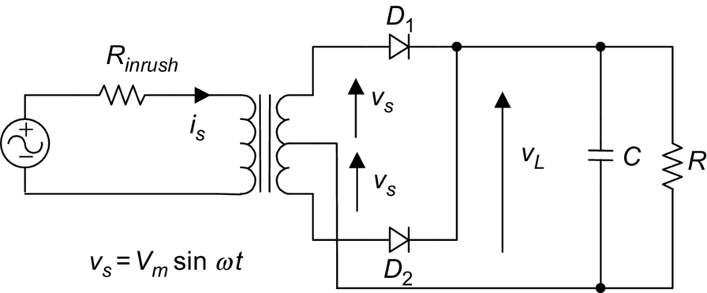

**FIG. 7.26** Full-wave rectifier with capacitor-input dc filter.

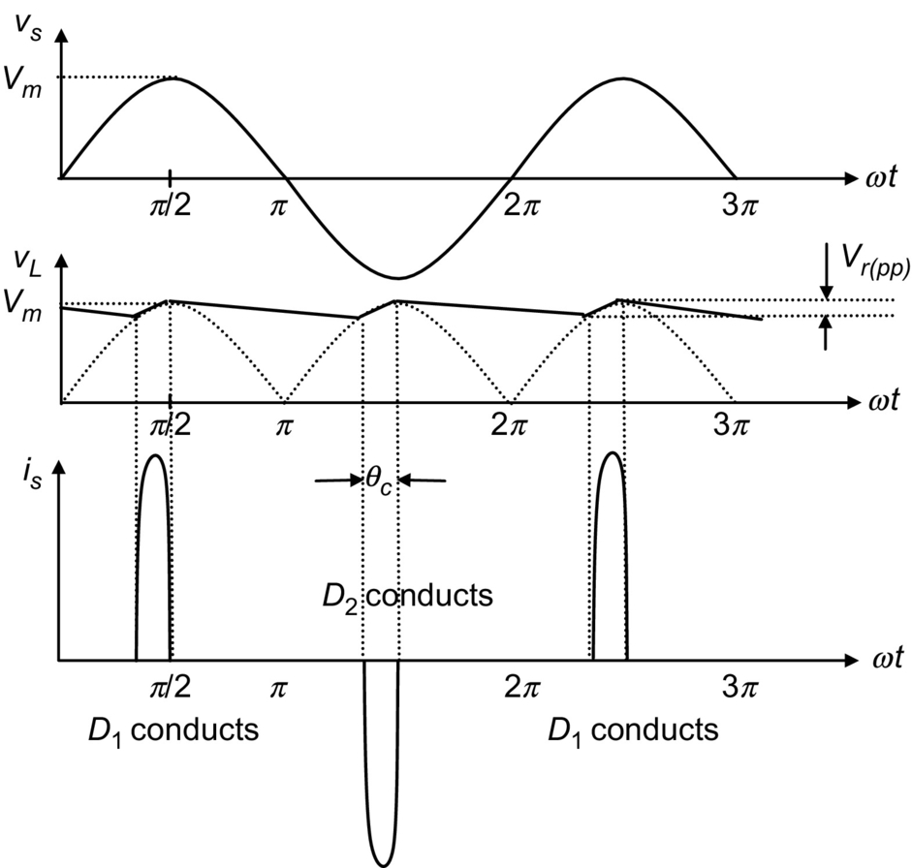

**FIG. 7.27** Voltage and current waveforms of the full-wave rectifier with capacitor-input dc filter.

In practice, if the peak-to-peak ripple voltage is small, it can be approximated as

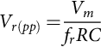 **(7.77)**

where *fr* is the output ripple frequency of the rectifier.

Therefore, the average output voltage *Vdc* is given by

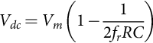 **(7.78)**

The rms output ripple voltage *Vac* is approximately given by

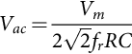 **(7.79)**

The ripple factor RF can be found from

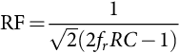 **(7.80)**

#### **7.5.2.1 Inrush Current**

The resistor *Rinrush* in [Fig. 7.26](https://learning.oreilly.com/library/view/power-electronics-handbook/9780128114087/B9780128114070000076.xhtml#f0135) is used to limit the inrush current imposed on the diodes during the instant when the rectifier is being connected to the supply. The inrush current can be very large because capacitor C has zero charge initially. The worst case occurs when the rectifier is connected to the supply at its maximum voltage. The worst-case inrush current can be estimated from

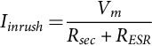 **(7.81)**

where *Rsec* is the equivalent resistance looking from the secondary transformer and *RESR* is the equivalent series resistance (ESR) of the filtering capacitor. Hence, the employed diode should be able to withstand the inrush current for a half cycle of the input voltage. In other words, the *maximum allowable surge current* (*IFSM*) rating of the employed diodes must be higher than the inrush current. The equivalent resistance associated with the transformer windings and the filtering capacitor is usually sufficient to limit the inrush current to an acceptable level. However, in cases where the transformer is omitted, for example, the rectifier of an off-line switch-mode supply, resistor *Rinrush* must be added for controlling the inrush current.

Consider as an example, a single-phase bridge rectifier, which is to be connected to a 120 V to 60 Hz source (without transformer). Assume that the *IFSM* rating of the diodes is 150 A for an interval of 8.3 ms. If the ESR of the filtering capacitor is zero, the value of the resistor for limiting inrush current resistance can be estimated to be 1.13 Ω using Eq. [(7.81)](https://learning.oreilly.com/library/view/power-electronics-handbook/9780128114087/B9780128114070000076.xhtml#fo0410).

## 7.6 High-Frequency Diode Rectifier Circuits

In high-frequency converters, diodes perform various functions, such as rectifying, flywheeling, and clamping. One special quality a high-frequency diode must possess is a fast switching speed. In technical terms, it must have a short reverse recovery time and a short forward recovery time.

The reverse recovery time of a diode may be understood as the time a forwardly conducting diode takes to recover to a blocking state when the voltage across it is suddenly reversed (which is known as forced turnoff). The temporary short circuit during the reverse recovery period may result in large reverse current, excessive ringing, and large power dissipation, all of which are highly undesirable.

The forward recovery time of a diode may be understood as the time a nonconducting diode takes to change to the fully on state when a forward current is suddenly forced into it (which is known as forced turn-on). Before the diode reaches the fully on state, the forward voltage drop during the forward recovery time can be significantly higher than the normal on-state voltage drop. This may cause voltage spikes in the circuit.

It should be interesting to note that, as far as circuit operation is concerned, a diode with a long reverse recovery time is similar to a diode with a large parasitic capacitance. A diode with a long forward recovery time is similar to a diode with a large parasitic inductance. (Spikes caused by the slow forward recovery of diodes are often wrongly thought to be caused by leakage inductance.) Comparatively, the adverse effect of a long reverse recovery time is much worse than that of a long forward recovery time.

Among commonly used diodes, the Schottky diode has the shortest forward and reverse recovery times. Schottky diodes are therefore most suitable for high-frequency applications. However, Schottky diodes have relatively low reverse breakdown voltage (normally lower than 200 V) and large leakage current. If, due to these limitations, Schottky diodes cannot be used, ultrafast diodes should be used in high-frequency converter circuits.

Using the example of a forward converter, the operations of a forward rectifier diode, a flywheel diode, and a clamping diode will be studied in [Section 7.6.1](https://learning.oreilly.com/library/view/power-electronics-handbook/9780128114087/B9780128114070000076.xhtml#s0175). Because of the difficulties encountered in the full analyses taking into account parasitic/stray/leakage components, PSpice simulations are extensively used here to study the following:

• The idealized operation of the converter

• The adverse effects of relatively slow rectifiers (e.g., the so-called ultrafast diodes, which are actually much slower than Schottky diodes)

• The improvement achievable by using high-speed rectifiers (Schottky diodes)

• The effects of leakage inductance of the transformer

• The use of snubber circuits to reduce ringing

• The operation of a practical converter with snubber circuits

Using the example of a flyback converter, the operations of a flyback rectifier diode and a clamping diode will also be studied in [Section 7.6.2](https://learning.oreilly.com/library/view/power-electronics-handbook/9780128114087/B9780128114070000076.xhtml#s0210).

The design considerations for high-frequency diode rectifier circuits will be discussed in [Section 7.6.3](https://learning.oreilly.com/library/view/power-electronics-handbook/9780128114087/B9780128114070000076.xhtml#s0225). Some precautions that must be taken in the interpretation of computer simulation results are briefed in [Section 7.6.4](https://learning.oreilly.com/library/view/power-electronics-handbook/9780128114087/B9780128114070000076.xhtml#s0230).

### 7.6.1 FORWARD RECTIFIER DIODE, FLYWHEEL DIODE, AND MAGNETIC-RESET CLAMPING DIODE IN A FORWARD CONVERTER

#### **7.6.1.1 Ideal Circuit**

[Fig. 7.28](https://learning.oreilly.com/library/view/power-electronics-handbook/9780128114087/B9780128114070000076.xhtml#f0145) shows the basic circuit of a forward converter. [Fig. 7.29](https://learning.oreilly.com/library/view/power-electronics-handbook/9780128114087/B9780128114070000076.xhtml#f0150) shows the idealized steady-state waveforms for continuous-mode operation (the current in *L*1 being continuous). These waveforms are obtained from PSpice simulations, based on the following assumptions:

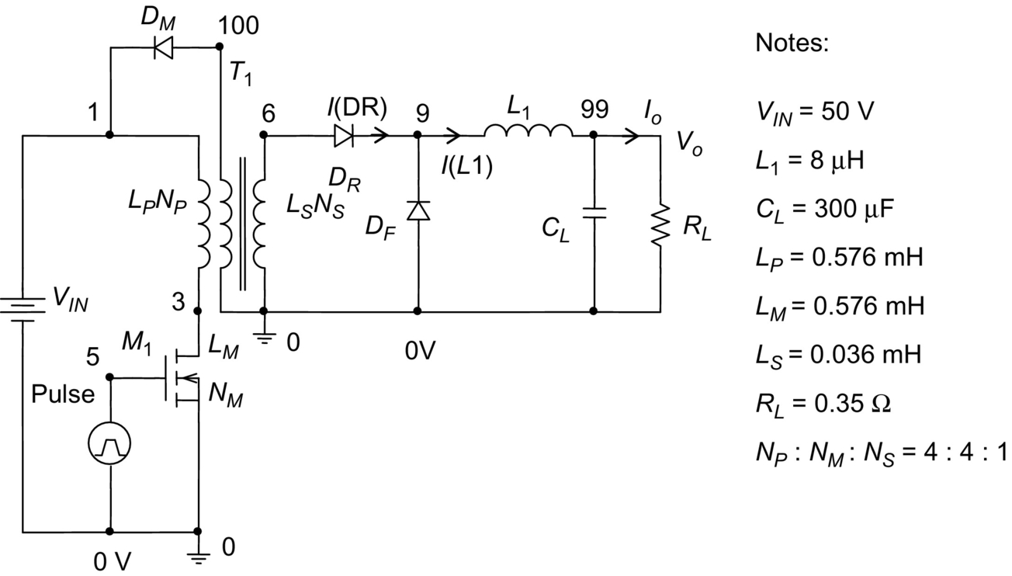

**FIG. 7.28** Basic circuit of forward converter.

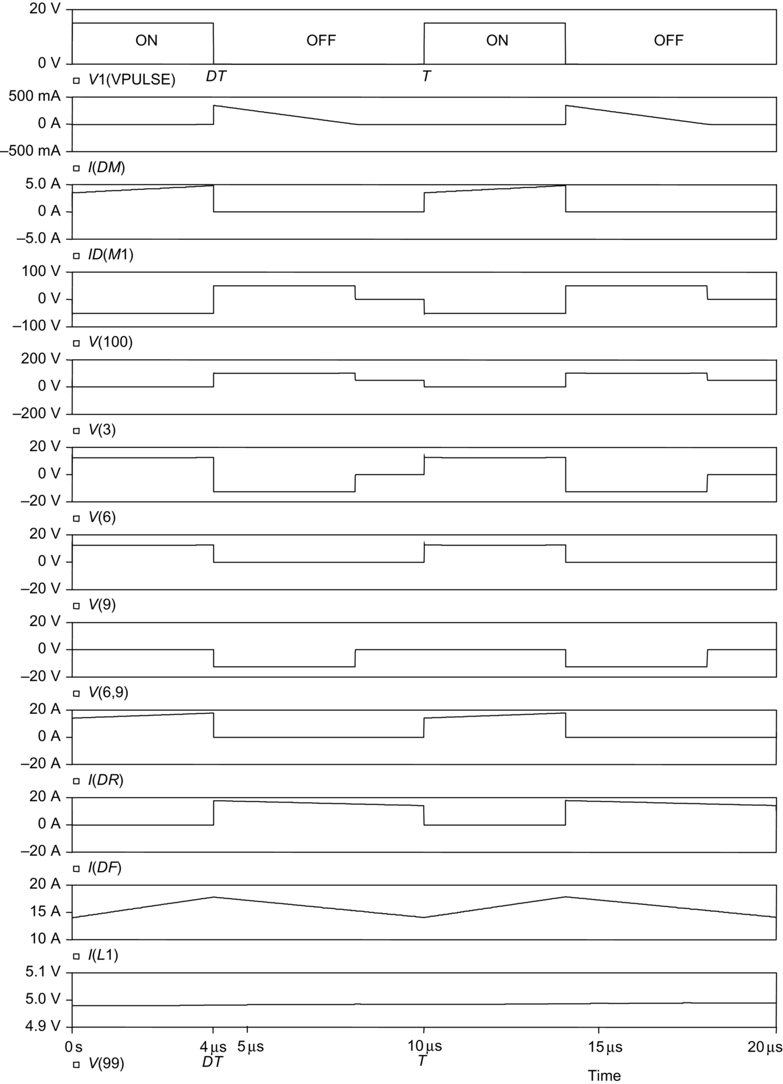

**FIG. 7.29** Idealized steady-state waveforms of forward converter for continuous-mode operation.

• Rectifier diode *DR*, flywheel diode *DF*, and magnetic-reset clamping diode *DM* are ideal diodes with infinitely fast switching speed.

• Electronic switch *M*1 is an idealized MOS switch with infinitely fast switching speed and

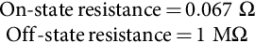

It should be noted that PSpice does not allow a switch to have zero on-state resistance and infinite off-state resistance.

• Transformer T1 has a coupling coefficient of 0.99999999. PSpice does not accept a coupling coefficient of 1.

• The switching operation of the converter has reached a steady state.

Referring to the circuit shown in [Fig. 7.28](https://learning.oreilly.com/library/view/power-electronics-handbook/9780128114087/B9780128114070000076.xhtml#f0145) and the waveforms shown in [Fig. 7.29](https://learning.oreilly.com/library/view/power-electronics-handbook/9780128114087/B9780128114070000076.xhtml#f0150), the operation of the converter can be explained as follows:

1. For  (*D* is the duty cycle of the MOS switch *M*1 and *T* is the switching period of the converter. *M*1 is turned on when *V*1 (VPULSE) is 15 V and turned off when *V*1(VPULSE) is 0 V).

The switch *M*1 is turned on at .

The voltage at node 3, denoted as *V*(3), is

 **(7.82)**

The voltage induced at node 6 of the secondary winding *LS* is

 **(7.83)**

This voltage drives a current *I*(*DR*) (current through rectifier diode *DR*) into the output circuit to produce the output voltage *Vo*. The rate of increase of *I*(*DR*) is given by

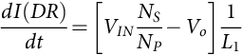 **(7.84)**

where *Vo* is the dc output voltage of the converter.

The flywheel diode *DF* is reversely biased by *V*(9), the voltage at node 9:

 **(7.85)**

The magnetic-reset clamping diode *DM* is reversely biased by the negative voltage at node 100. Assuming that *LM* and *LP* have the same number of turns, we have

 **(7.86)**

A magnetizing current builds up linearly in *LP*. This magnetizing current reaches the maximum value of (*VINDT*)/*LP* at .

2. For 

The switch *M*1 is turned off at .

The collapse of magnetic flux induces a back emf in *LM*, which is equal to *LP*, to turn-on the clamping diode *DM*. The magnetizing current in *LM* drops (from the maximum value of (*VIN* *DT*)/*LP*, as mentioned above) at the rate of *VIN*/*LP*. It reaches zero at .

The back emf induced across *LP* is equal to *VIN*. The voltage at node 3 is

 **(7.87)**

The back emf across *LS* forces *DR* to stop conducting.

The inductive current in *L*1 forces the flywheel diode *DF* to conduct. *I*(*L*1) (current through *L*1) falls at the rate of

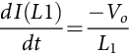 **(7.88)**

The voltage across *DR*, denoted as *V*(6,9) (the voltage at node 6 with respect to node 9), is

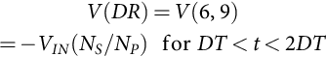 **(7.89)**

3. For 

*DM* stops conducting at . The voltage across *LM* then falls to zero.

The voltage across *LP* is zero:

 **(7.90)**

The voltage across *LS* is also zero:

 **(7.91)**

Inductive current *I*(*L*1) continues to fall at the rate of

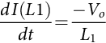 **(7.92)**

The switching cycle restarts when the switch *M*1 is turned on again at .

From the waveforms shown in [Fig. 7.29](https://learning.oreilly.com/library/view/power-electronics-handbook/9780128114087/B9780128114070000076.xhtml#f0150), the following useful information (for continuous-mode operation) can be found:

• The output voltage *Vo* is equal to the average value of *V*(9):

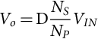 **(7.93)**

• The maximum current in the forward rectifying diode *DR* and flywheel diode *DF* is

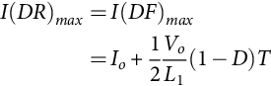 **(7.94)**

where  and *Io* is the output loading current.

• The maximum reverse voltage of *DR* and *DF* is

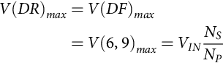 **(7.95)**

• The maximum reverse voltage of *DM* is

 **(7.96)**

• The maximum current in *DM* is

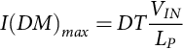 **(7.97)**

• The maximum current in the switch *M*1, denoted as *ID(M1)*, is

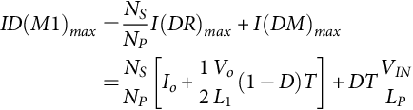 **(7.98)**

It should, however, be understood that, due to the nonideal characteristics of practical components, the idealized waveforms shown in [Fig. 7.29](https://learning.oreilly.com/library/view/power-electronics-handbook/9780128114087/B9780128114070000076.xhtml#f0150) cannot actually be achieved in the real world. In the following, the effects of nonideal diodes and transformers will be examined.

#### **7.6.1.2 Circuit Using Ultra-Fast Diodes**

[Fig. 7.30](https://learning.oreilly.com/library/view/power-electronics-handbook/9780128114087/B9780128114070000076.xhtml#f0155) shows the waveforms of the forward converter (circuit given in [Fig. 7.28](https://learning.oreilly.com/library/view/power-electronics-handbook/9780128114087/B9780128114070000076.xhtml#f0145)) when ultrafast diodes are used as *DM*, *DR*, and *DF*. (Note that ultrafast diodes are actually much slower than Schottky diodes.) The waveforms are obtained by PSpice simulations, based on the following assumptions:

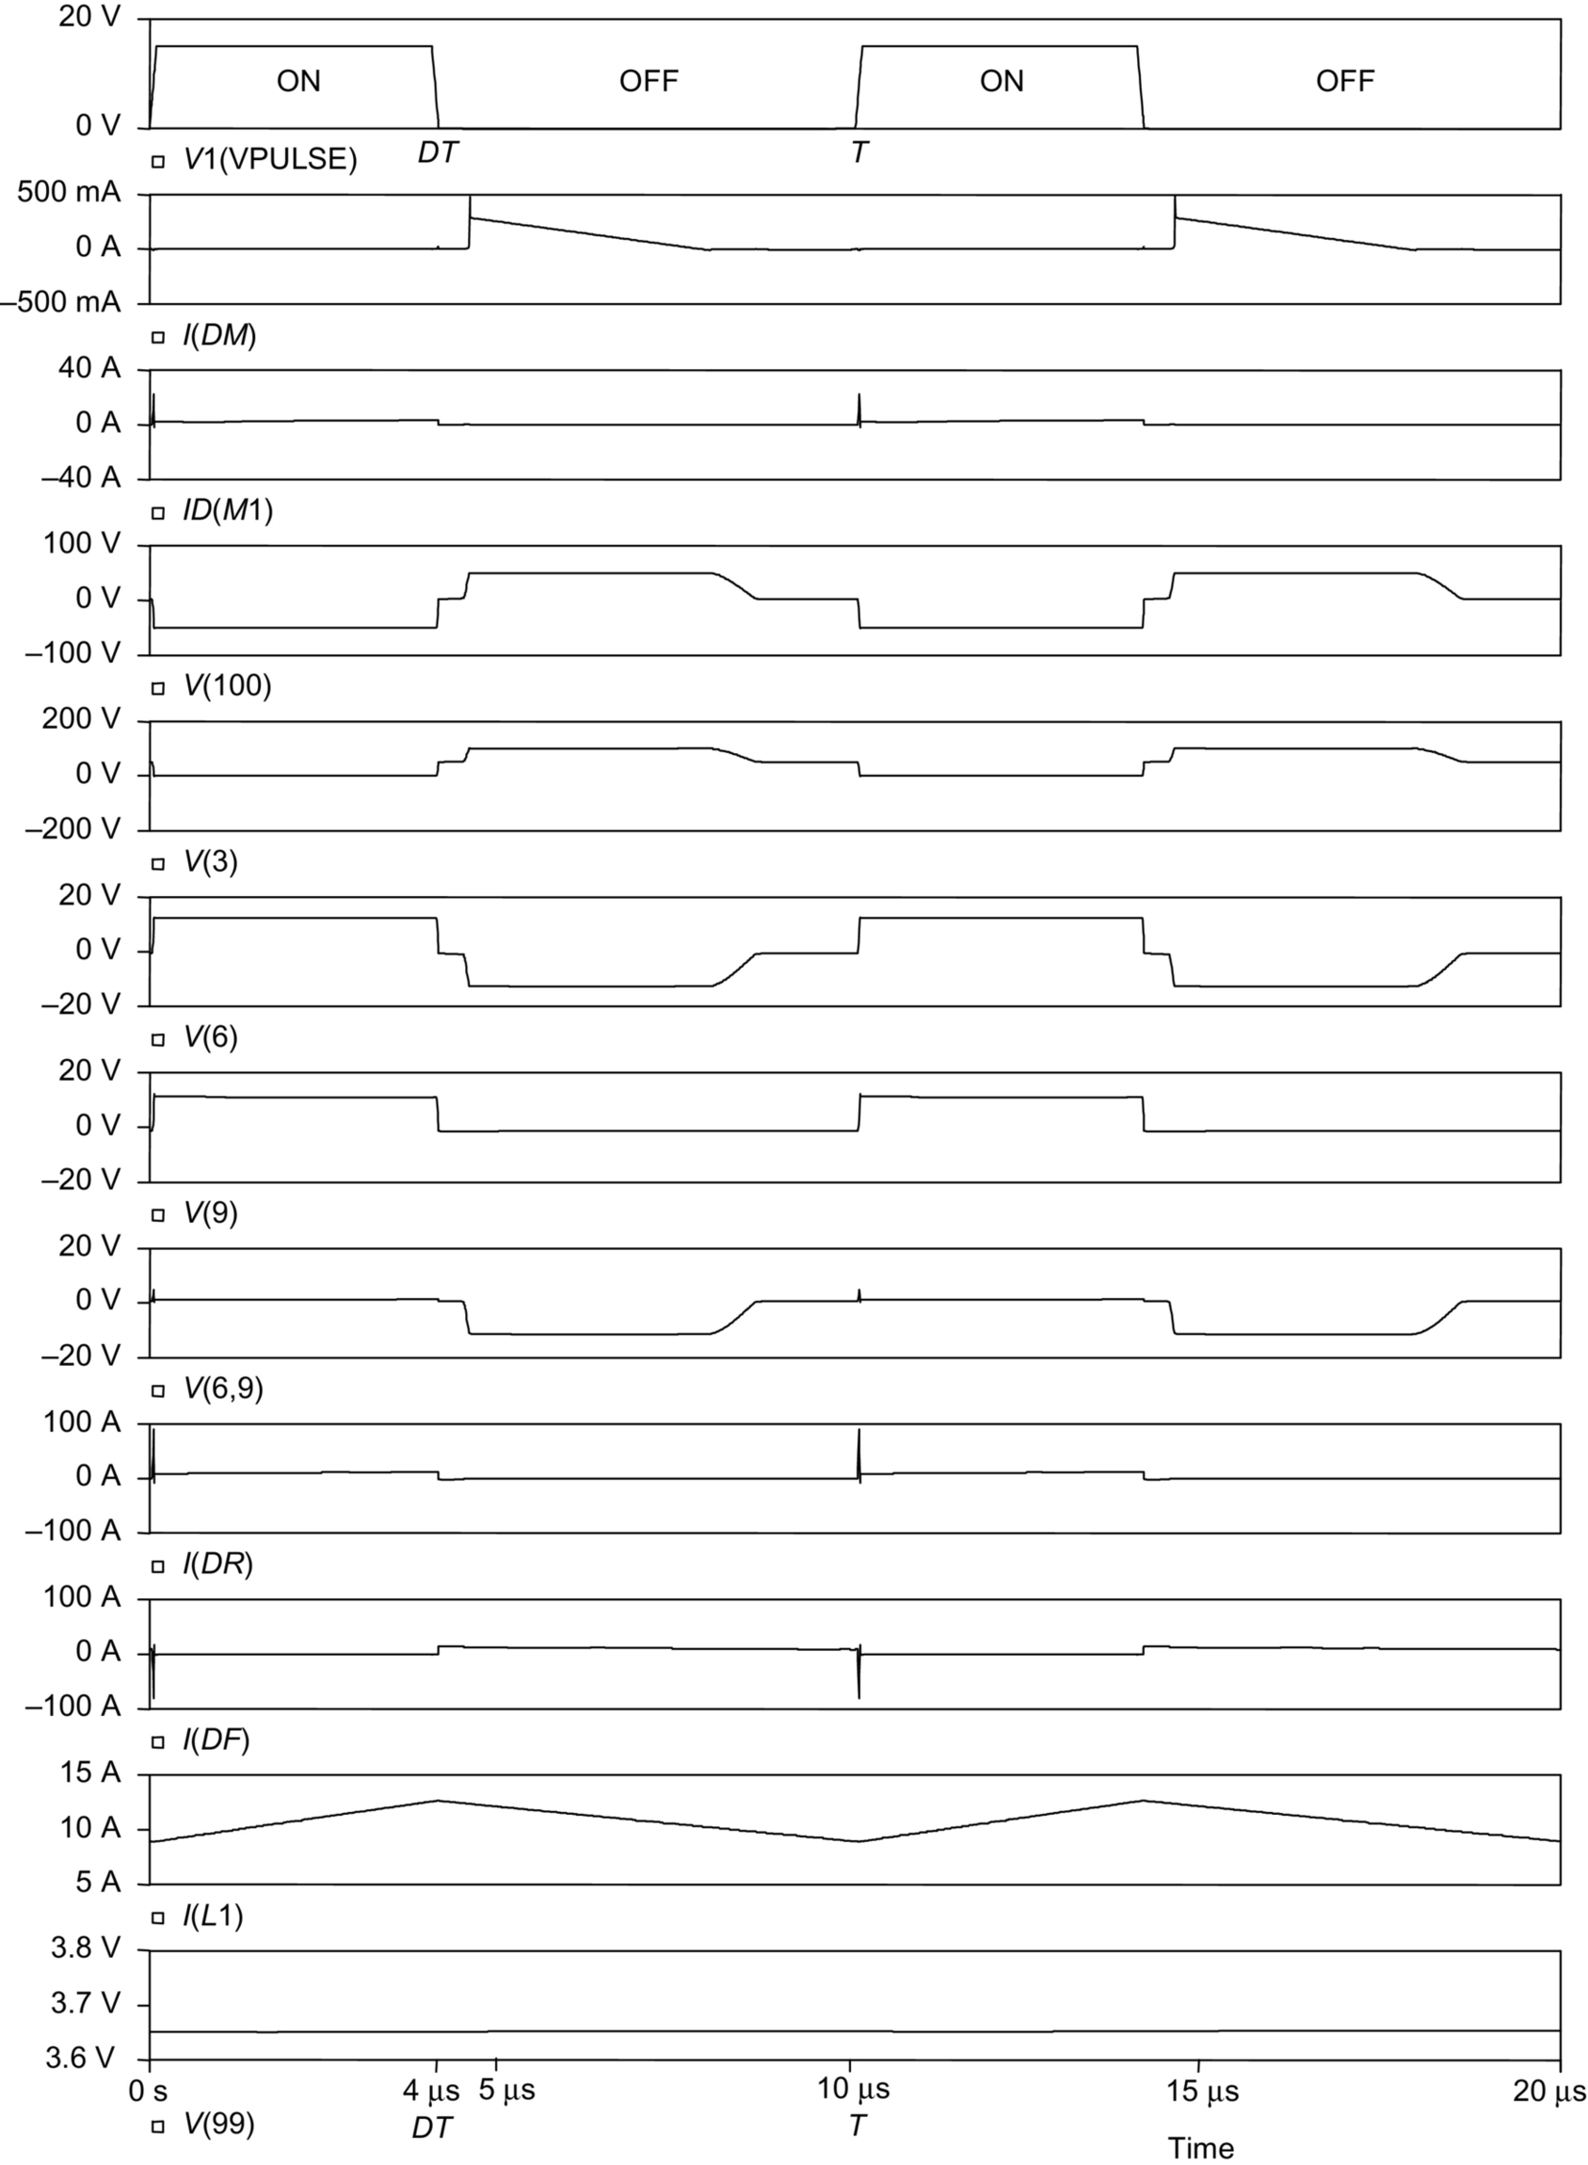

**FIG. 7.30** Waveforms of forward converter using “ultrafast” diodes (which are actually much slower than Schottky diodes).

• *DM* is an MUR460 ultrafast diode. *DR* and *DF* are MUR1560 ultrafast diodes.

• *M*1 is an IRF640 MOS transistor.

• Transformer *T*1 has a coupling coefficient of 0.99999999 (which may be assumed to be 1).

• The switching operation of the converter has reached a steady state.

It is observed that a large spike appears in the current waveforms of diodes *DR* and *DF* (denoted as *I(DR)* and *I(DF)* in [Fig. 7.30](https://learning.oreilly.com/library/view/power-electronics-handbook/9780128114087/B9780128114070000076.xhtml#f0155)) whenever the MOS transistor *M*1 is turned on. This is due to the relatively slow reverse recovery of the flywheel diode *DF*. During the reverse recovery time, the positive voltage suddenly appearing across *L* *S* (which is equal to *VIN* (*NS*/*NP*)) drives a large transient current through *DR* and *DF*. This current spike results in large current stress and power dissipation in *DR*, *DF*, and *M*1.

A method of reducing the current spikes is to use Schottky diodes as *DR* and *DF*, as described below.

#### **7.6.1.3 Circuit Using Schottky Diodes**

In order to reduce the current spikes caused by the slow reverse recovery of rectifiers, Schottky diodes are now used as *DR* and *DF*. The assumptions made here are (referring to the circuit shown in [Fig. 7.28](https://learning.oreilly.com/library/view/power-electronics-handbook/9780128114087/B9780128114070000076.xhtml#f0145)) the following:

• *DR* and *DF* are MBR2540 Schottky diodes.

• *DM* is an MUR460 ultrafast diode.

• *M*1 is an IRF640 MOS transistor.

• Transformer *T*1 has a coupling coefficient of 0.99999999.

• The switching operation of the converter has reached a steady state.

The new simulated waveforms are given in [Fig. 7.31](https://learning.oreilly.com/library/view/power-electronics-handbook/9780128114087/B9780128114070000076.xhtml#f0160). It is found that, by employing Schottky diodes as *DR* and *DF*, the amplitudes of the current spikes in *ID(M1)*, *I(DR)*, and *I(DF)* can be reduced to practically zero. This solves the slow-speed problem of ultrafast diodes.

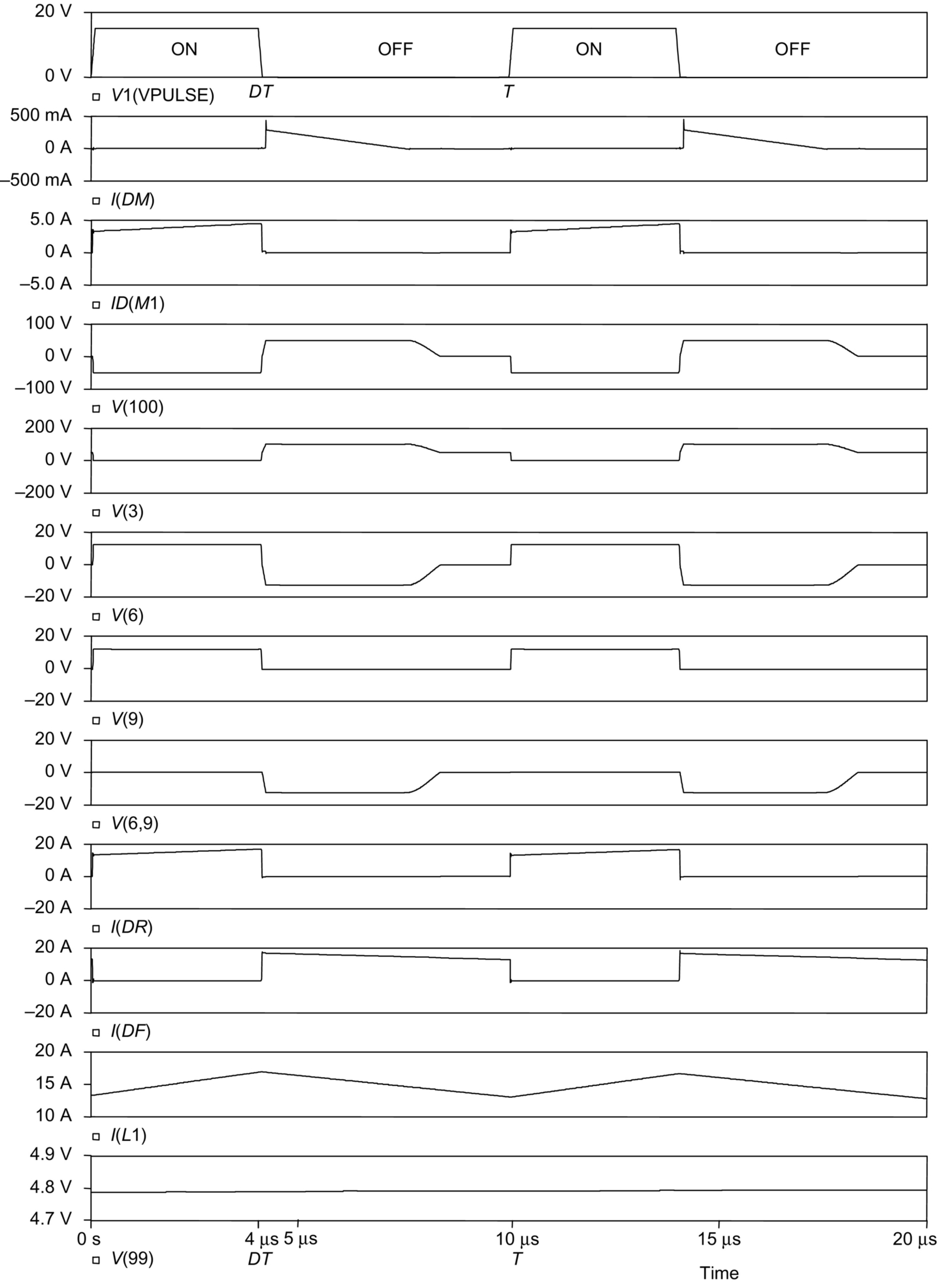

**FIG. 7.31** Waveforms of forward converter using Schottky (fast-speed) diodes as output rectifiers.

#### **7.6.1.4 Circuit With Practical Transformer**

The simulation results given above in [Figs. 7.29](https://learning.oreilly.com/library/view/power-electronics-handbook/9780128114087/B9780128114070000076.xhtml#f0150)–[7.31](https://learning.oreilly.com/library/view/power-electronics-handbook/9780128114087/B9780128114070000076.xhtml#f0160) (for the forward converter circuit shown in [Fig. 7.28](https://learning.oreilly.com/library/view/power-electronics-handbook/9780128114087/B9780128114070000076.xhtml#f0145)) are based on the assumption that transformer *T*1 has effectively no leakage inductance (with coupling coefficient ). It is, however, found that when a practical transformer (having a slightly lower *K*) is used, severe ringings occur. [Fig. 7.32](https://learning.oreilly.com/library/view/power-electronics-handbook/9780128114087/B9780128114070000076.xhtml#f0165) shows some simulation results to demonstrate this phenomenon, where the following assumptions are made:

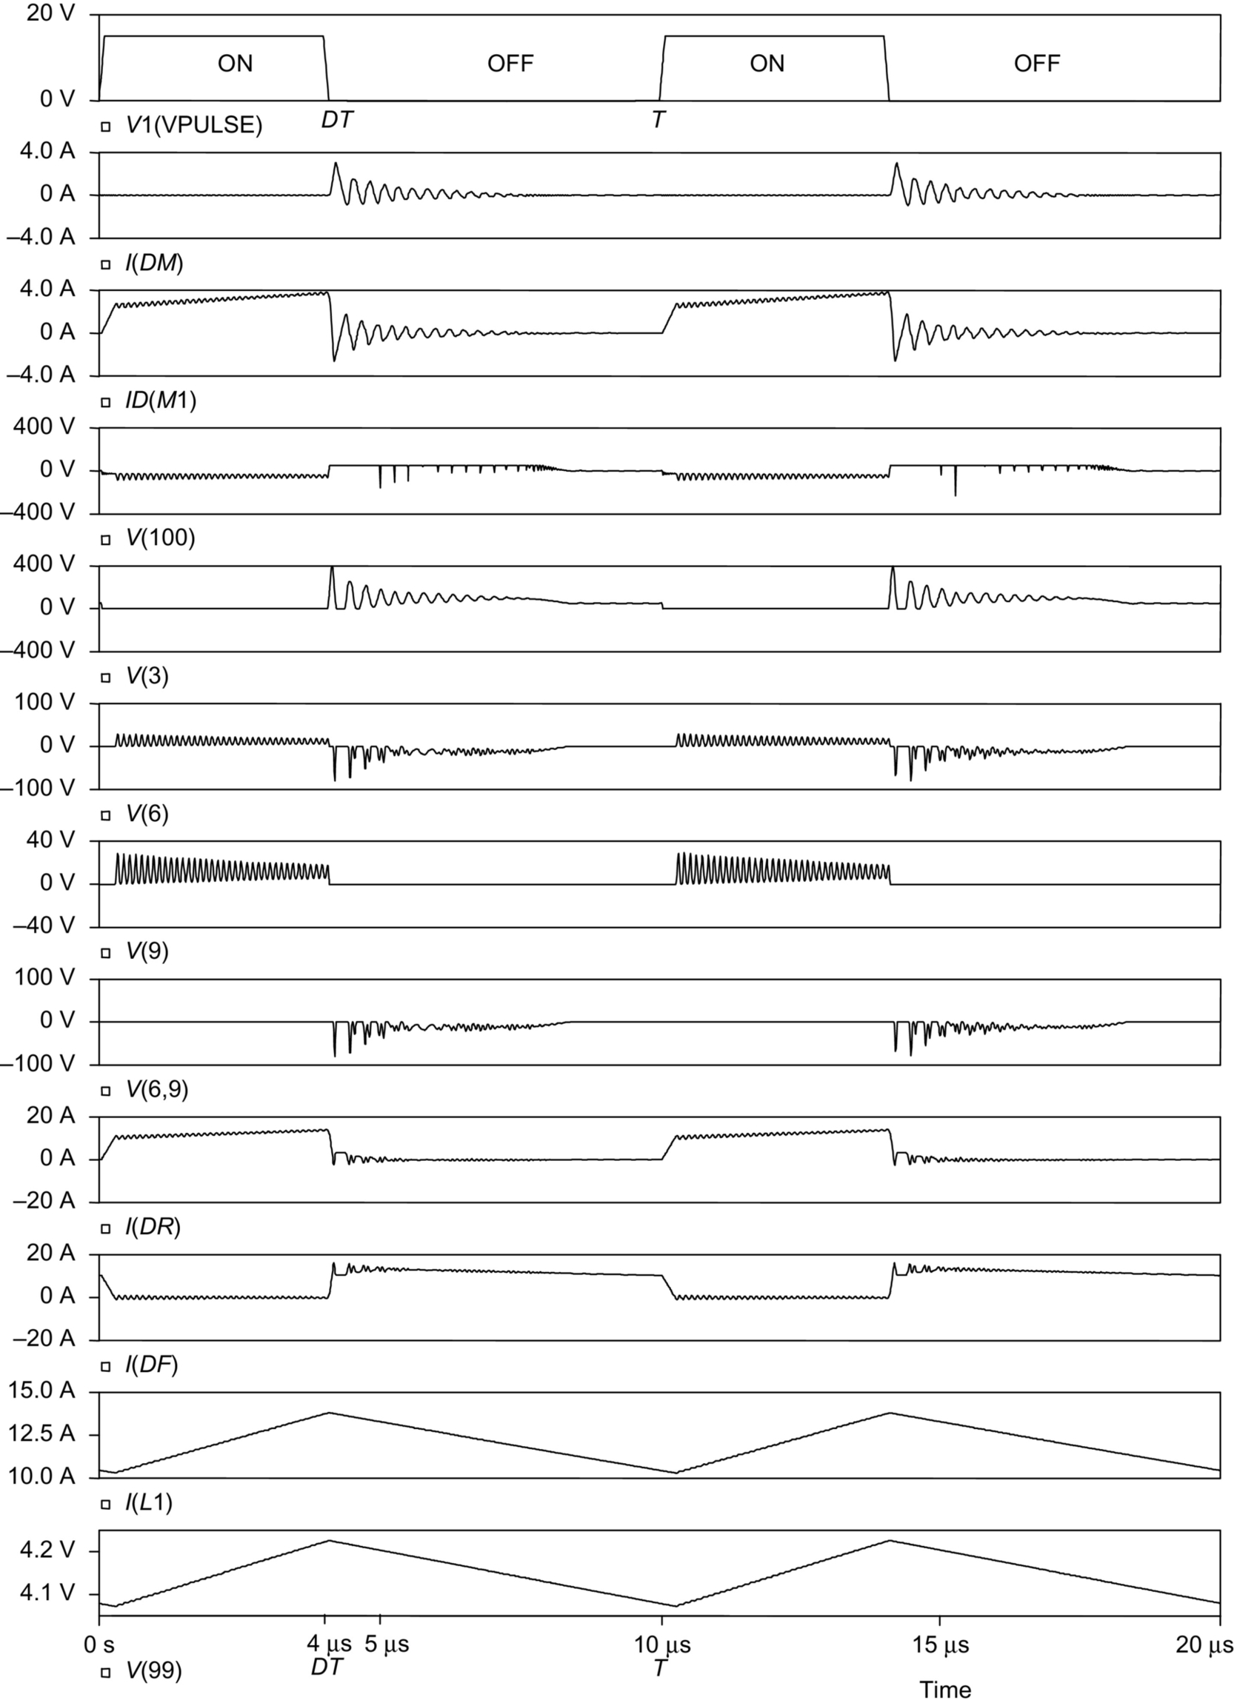

**FIG. 7.32** Waveforms of forward converter with practical transformer and output filtering capacitor having nonzero series effective resistance.

• *DR* and *DF* are MBR2540 Schottky diodes. *DM* is an MUR460 ultrafast diode.

• *M*1 is an IRF640 MOS transistor.

• Transformer *T*1 has a practical coupling coefficient of 0.996.

• The effective winding resistance of *LP* is 0.1 Ω. The effective winding resistance of *LM* is 0.4 Ω. The effective winding resistance of *LS* is 0.01 Ω.

• The effective series resistance of the output filtering capacitor is 0.05 Ω.

• The switching operation of the converter has reached a steady state.

The resultant waveforms shown in [Fig. 7.32](https://learning.oreilly.com/library/view/power-electronics-handbook/9780128114087/B9780128114070000076.xhtml#f0165) indicate that there are large voltage and current ringings in the circuit. These ringings are caused by the resonant circuits formed by the leakage inductance of the transformer and the parasitic capacitances of diodes and transistor.

A practical converter may therefore need snubber circuits to damp these ringings, as described below.

#### **7.6.1.5 Circuit With Snubber Across The Transformer**

In order to suppress the ringing voltage caused by the resonant circuit formed by transformer leakage inductance and the parasitic capacitance of the MOS switch, a snubber circuit, shown as *R*1 and *C*1 in [Fig. 7.33](https://learning.oreilly.com/library/view/power-electronics-handbook/9780128114087/B9780128114070000076.xhtml#f0170), is now connected across the primary winding of transformer *T*1. The new waveforms are shown in [Fig. 7.34](https://learning.oreilly.com/library/view/power-electronics-handbook/9780128114087/B9780128114070000076.xhtml#f0175). Here, the drain-to-source voltage waveform of the MOS transistor, *V*(3), is found to be acceptable. However, there are still large ringing voltages across the output rectifiers (*V*(6,9) and *V*(9)).

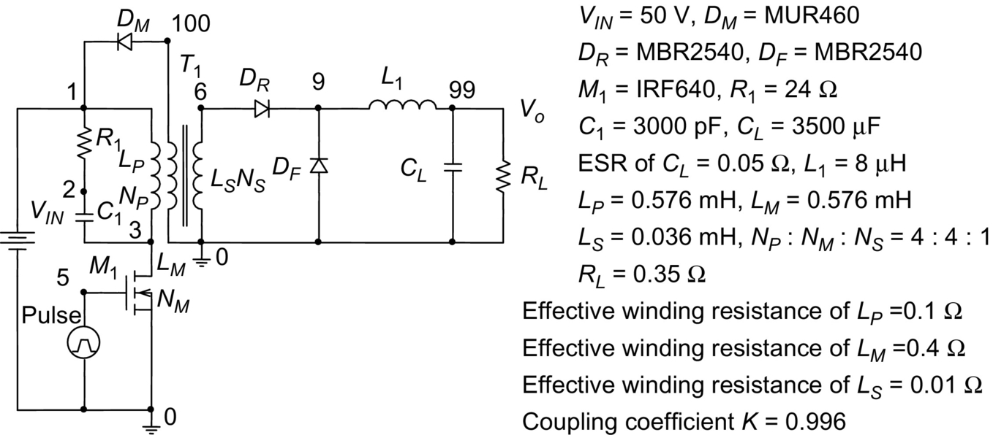

**FIG. 7.33** Forward converter with snubber circuit (*R*1*C*1) across transformer.

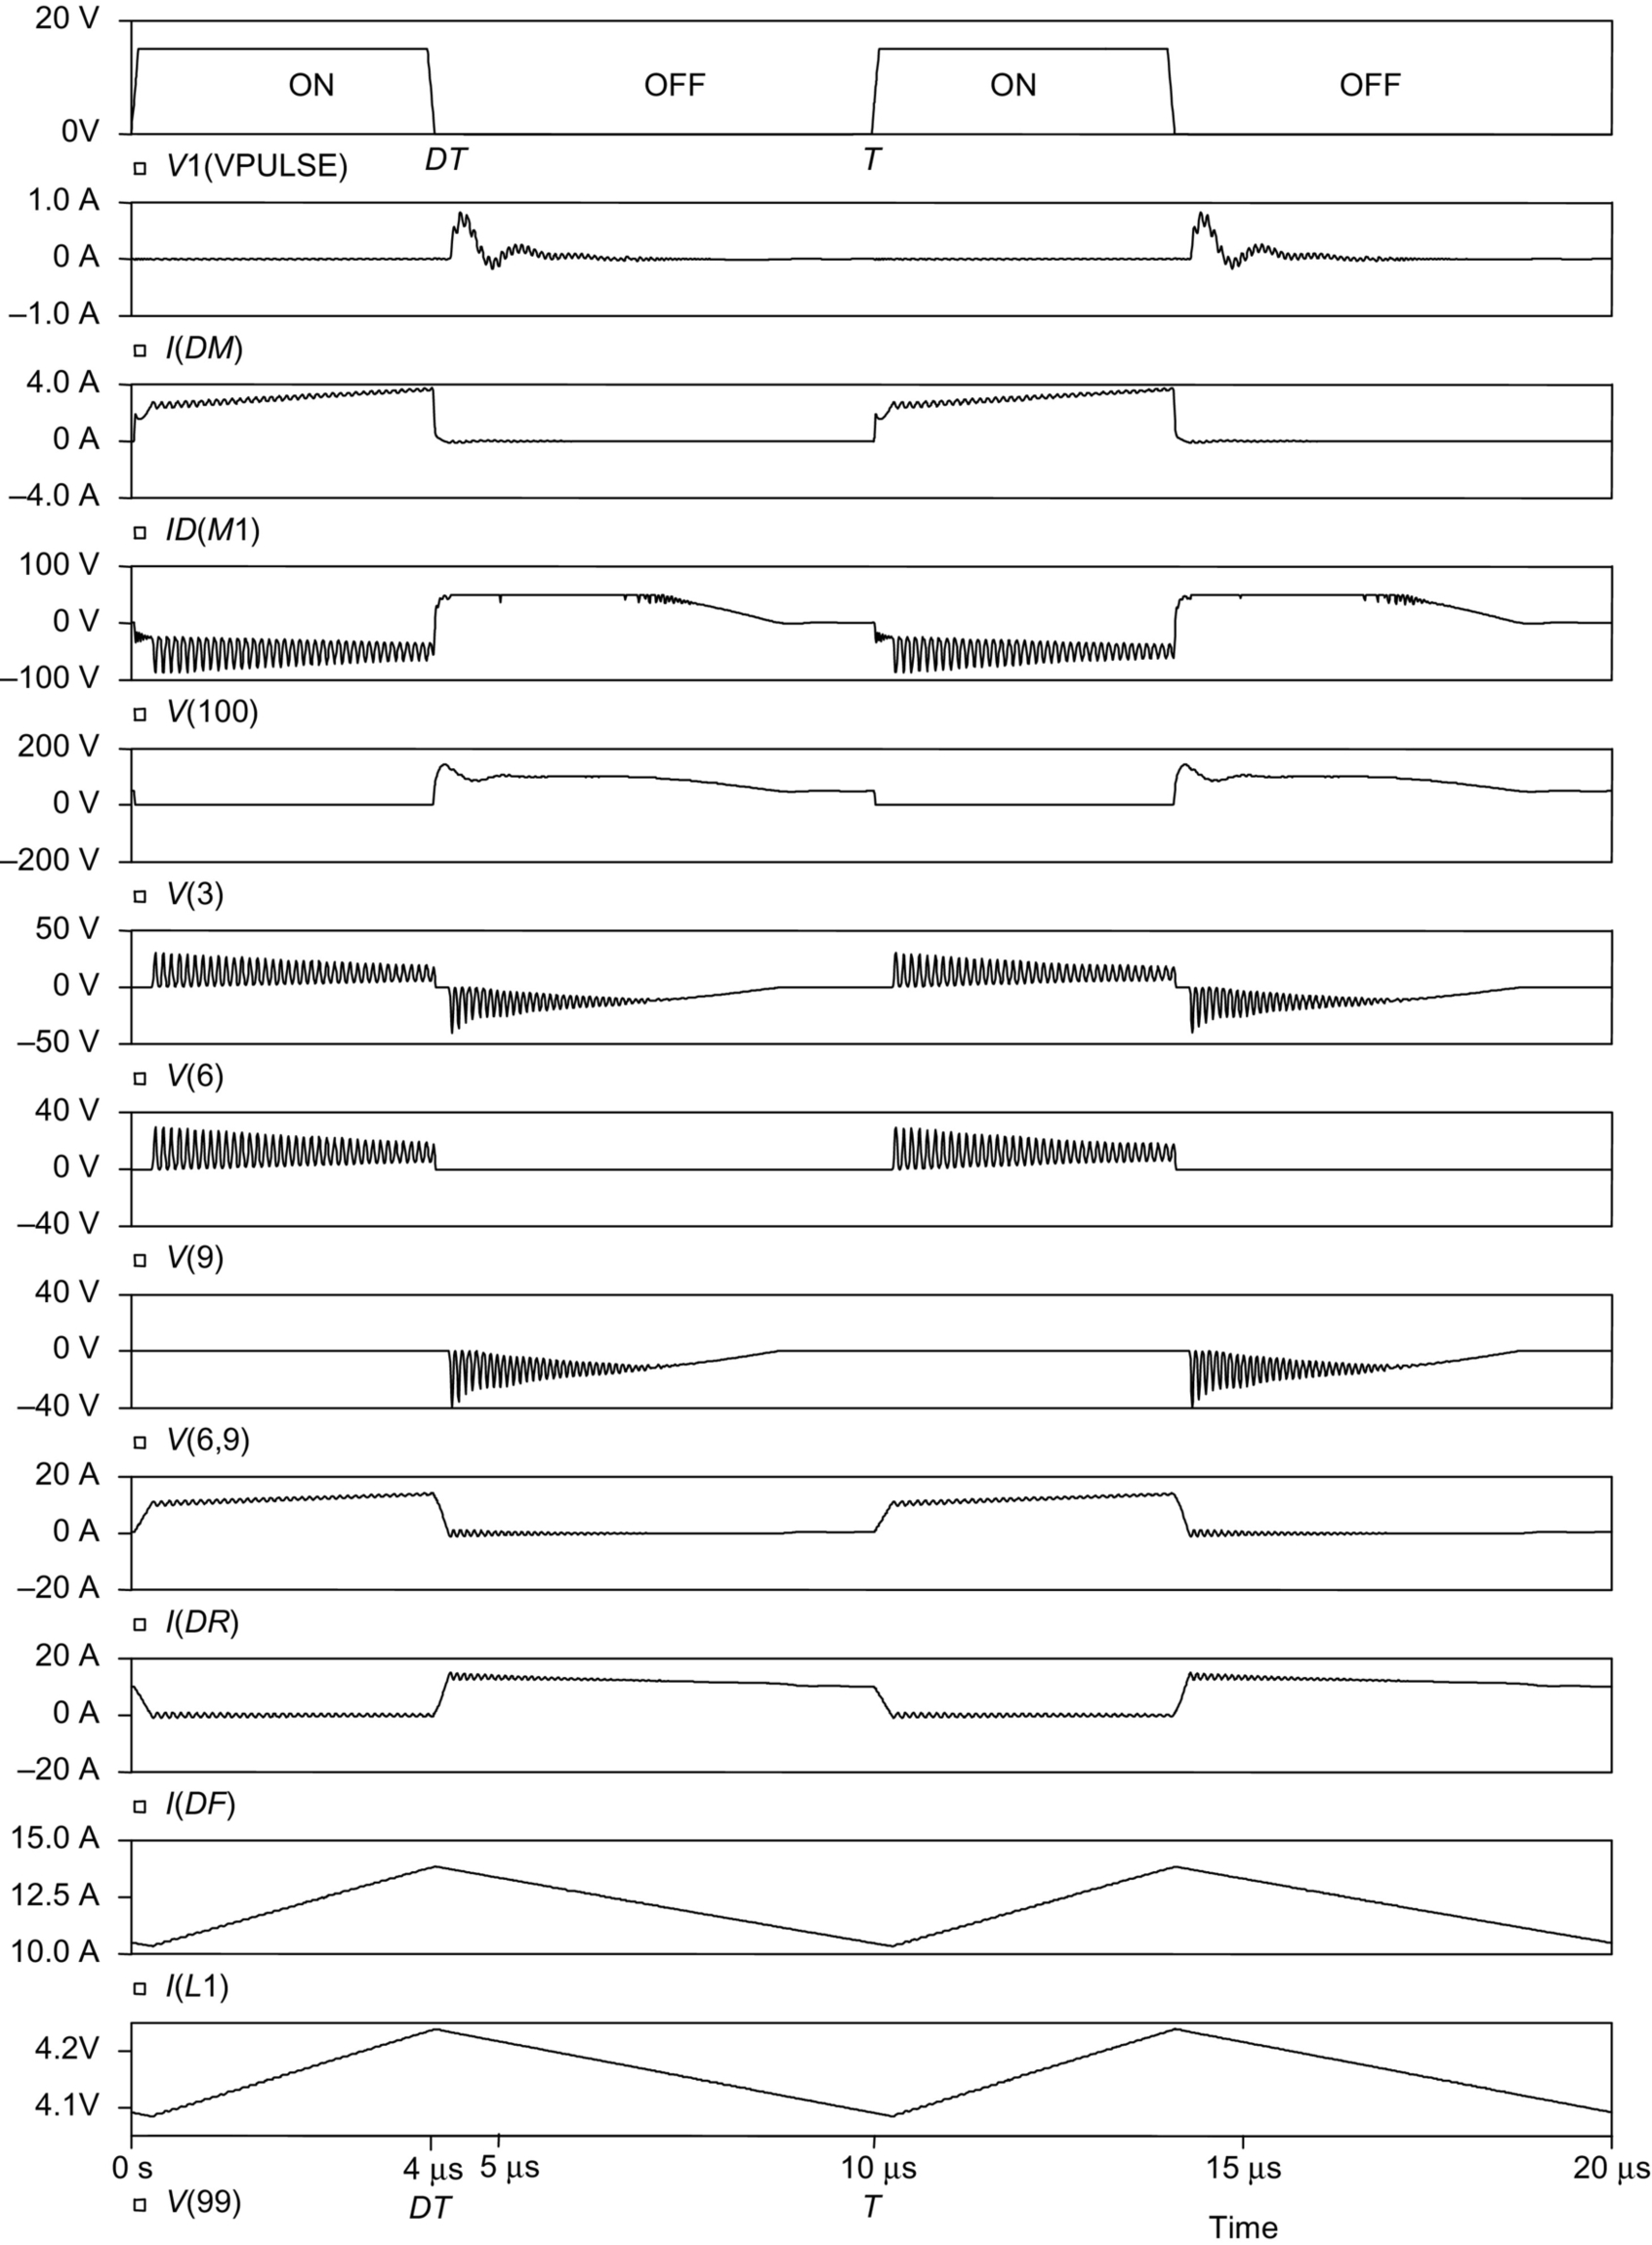

**FIG. 7.34** Waveforms of forward converter with snubber circuit across the transformer.

In order to damp the ringing voltages across the output rectifiers, additional snubber circuits across the rectifiers may therefore also be required in a practical circuit, as described below.

#### **7.6.1.6 Practical Circuit**

[Fig. 7.35](https://learning.oreilly.com/library/view/power-electronics-handbook/9780128114087/B9780128114070000076.xhtml#f0180) shows a practical forward converter with snubber circuits added also to rectifiers (*R*2*C*2 for *DR* and *R*3*C*3 for *DF*) to reduce the voltage ringing. [Figs. 7.36](https://learning.oreilly.com/library/view/power-electronics-handbook/9780128114087/B9780128114070000076.xhtml#f0185) and [7.37](https://learning.oreilly.com/library/view/power-electronics-handbook/9780128114087/B9780128114070000076.xhtml#f0190) show the resultant voltage and current waveforms. [Fig. 7.36](https://learning.oreilly.com/library/view/power-electronics-handbook/9780128114087/B9780128114070000076.xhtml#f0185) is for continuous-mode operation , where *I(L1)* (current in *L*1) is continuous. [Fig. 7.37](https://learning.oreilly.com/library/view/power-electronics-handbook/9780128114087/B9780128114070000076.xhtml#f0190) is for discontinuous-mode operation , where *I(L1)* becomes discontinuous due to an increased value of *RL*. These waveforms are considered to be acceptable.

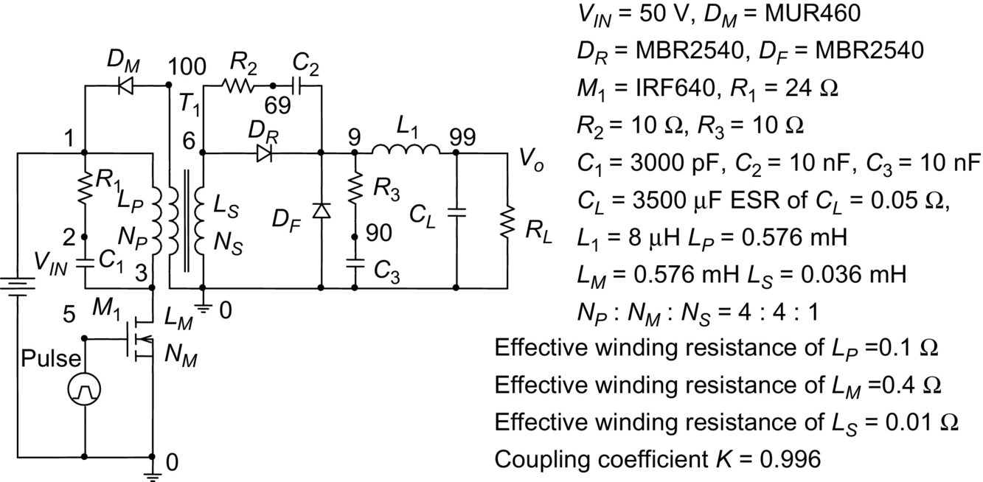

**FIG. 7.35** Practical forward converter with snubber circuits across the transformer and rectifiers.

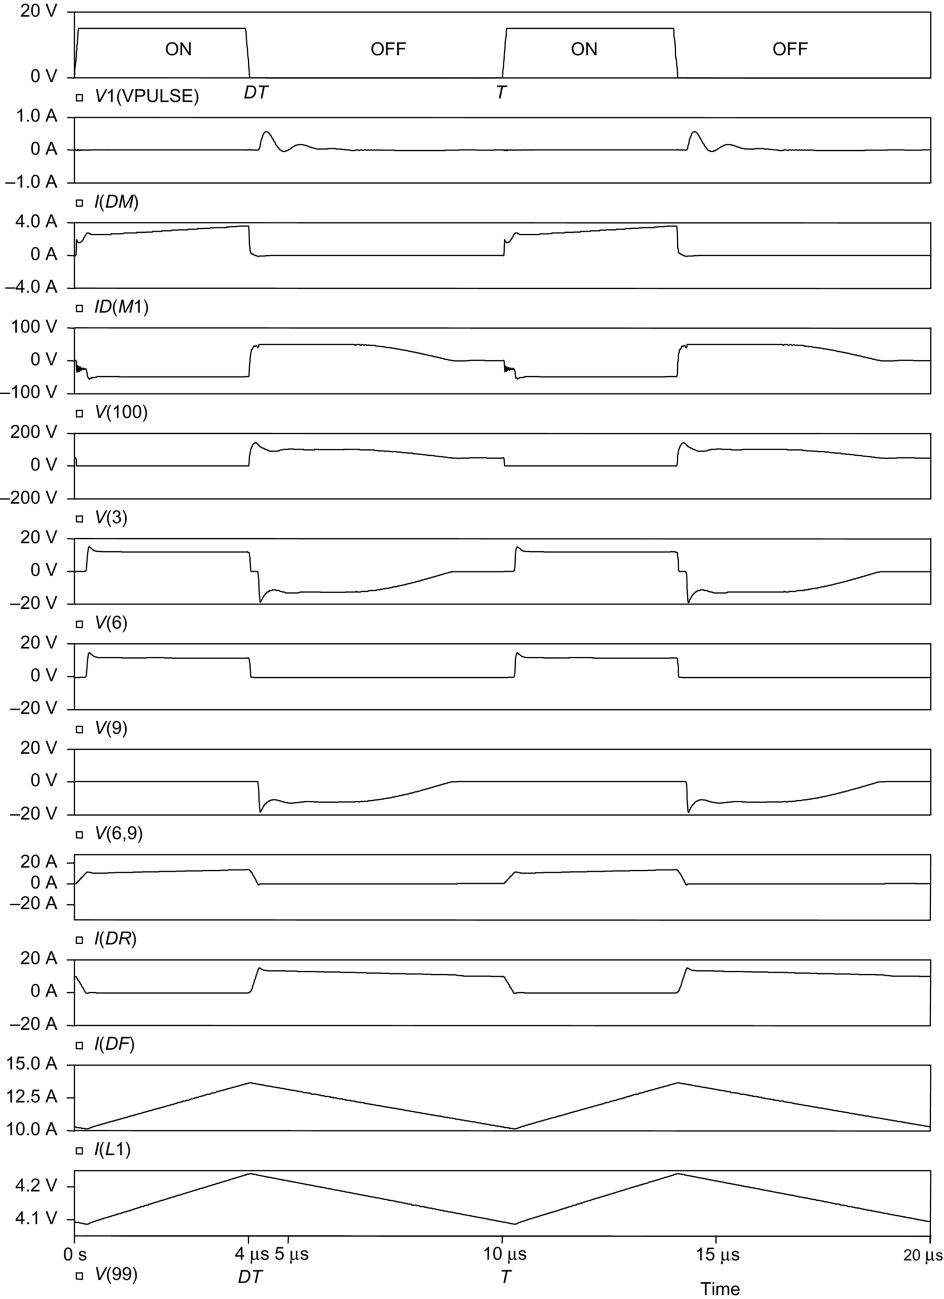

**FIG. 7.36** Waveforms of practical forward converter for continuous-mode operation.

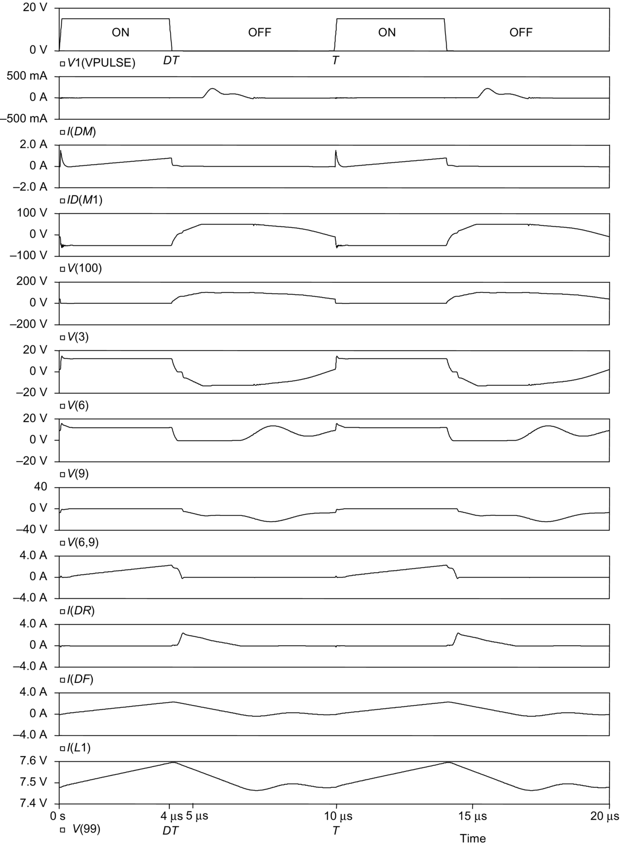

**FIG. 7.37** Waveforms of practical forward converter for discontinuous-mode operation.

The design considerations of diode rectifier circuits in high-frequency converters will be discussed later in [Section 7.6.3](https://learning.oreilly.com/library/view/power-electronics-handbook/9780128114087/B9780128114070000076.xhtml#s0225).

### 7.6.2 FLYBACK RECTIFIER DIODE AND CLAMPING DIODE IN A FLYBACK CONVERTER

#### **7.6.2.1 Ideal Circuit**

[Fig. 7.38](https://learning.oreilly.com/library/view/power-electronics-handbook/9780128114087/B9780128114070000076.xhtml#f0195) shows the basic circuit of a flyback converter. Due to its simple circuit, this type of converter is widely used in low-cost low-power applications. Discontinuous-mode operation (meaning that the magnetizing current in the transformer falls to zero before the end of each switching cycle) is often used because it offers the advantages of easy control and low diode reverse recovery loss. [Fig. 7.39](https://learning.oreilly.com/library/view/power-electronics-handbook/9780128114087/B9780128114070000076.xhtml#f0200) shows the idealized steady-state waveforms for discontinuous-mode operation. These waveforms are obtained from PSpice simulations, based on the following assumptions:

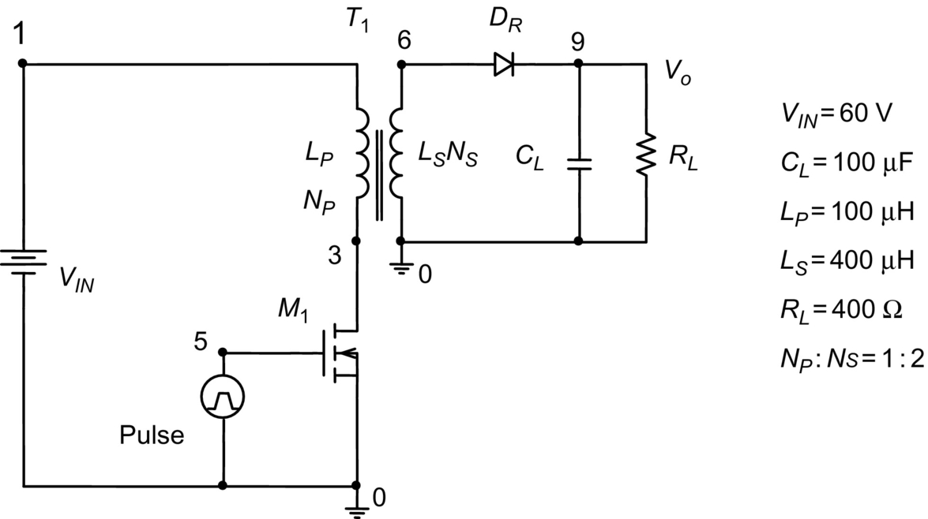

**FIG. 7.38** Basic circuit of flyback converter.

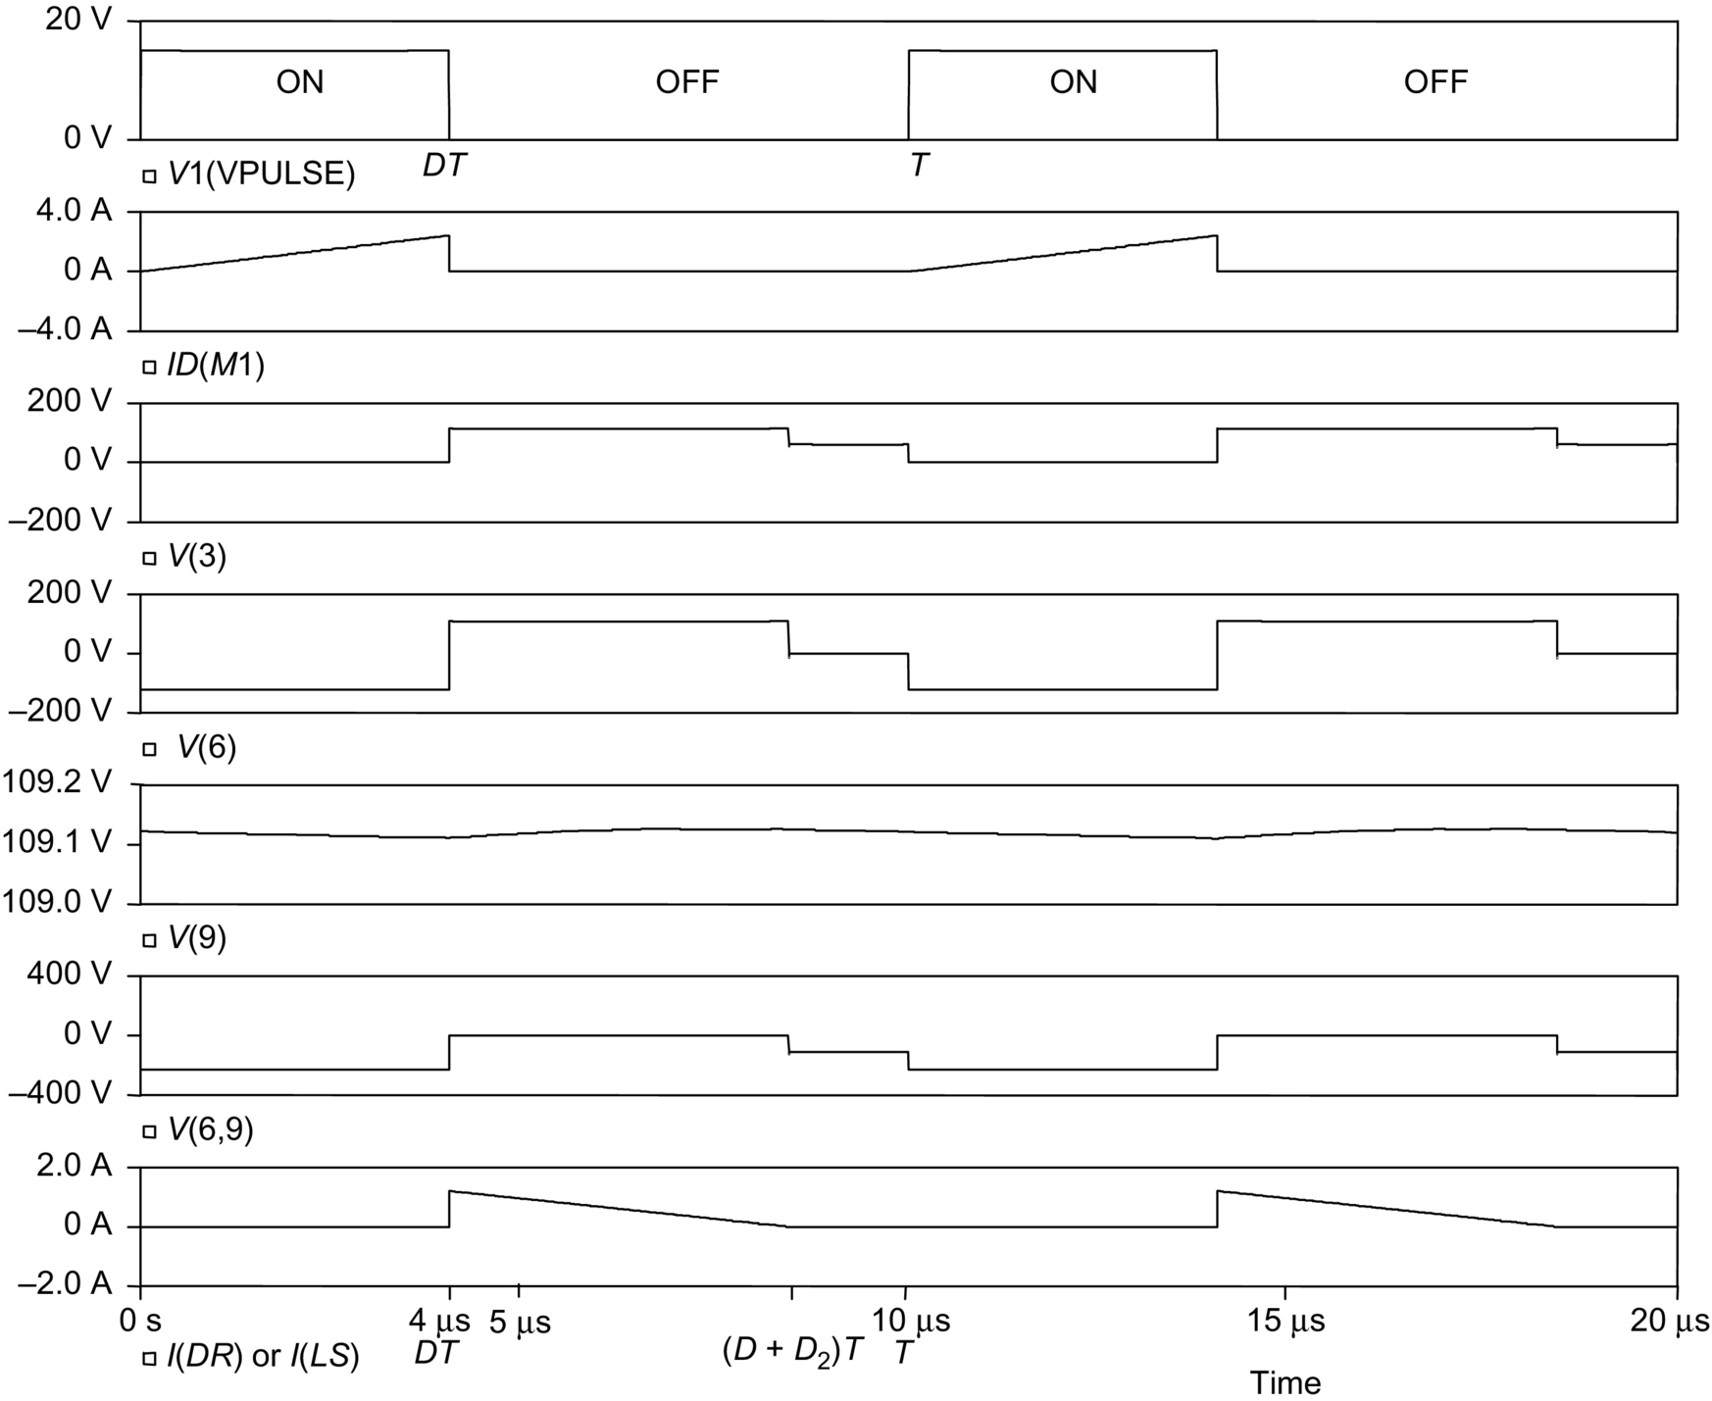

**FIG. 7.39** Idealized steady-state waveforms of flyback converter for discontinuous-mode operation.

• *DR* is an idealized rectifier diode with infinitely fast switching speed.

• *M*1 is an idealized MOS switch with infinitely fast switching speed and

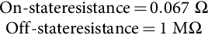

• Transformer *T*1 has a coupling coefficient of 0.99999999.

• The switching operation of the converter has reached a steady state.

Referring to the circuit shown in [Fig. 7.38](https://learning.oreilly.com/library/view/power-electronics-handbook/9780128114087/B9780128114070000076.xhtml#f0195) and the waveforms shown in [Fig. 7.39](https://learning.oreilly.com/library/view/power-electronics-handbook/9780128114087/B9780128114070000076.xhtml#f0200), the operation of the converter can be explained as follows:

1. For 

The switch *M*1 is turned on at :



The current in *M*1, denoted as *ID*(*M*1), increases at the rate of

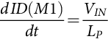 **(7.99)**

The output rectifier *DR* is reversely biased.

2. For 

The switching *M*1 is turned off at .

The collapse of magnetic flux induces a back emf in *LS* to turn-on the output rectifier *DR*. The initial amplitude of the rectifier current *I*(*DR*), which is also denoted as *I*(*LS*), can be found by equating the energy stored in the primary winding current *I*(*LP*) just before  to the energy stored in the secondary winding current *I*(*LS*) just after :

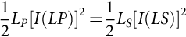 **(7.100)**

**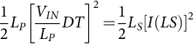** **(7.101)**

**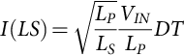** **(7.102)**

**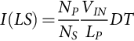** **(7.103)**

The amplitude of *I*(*LS*) falls at the rate of

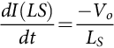 **(7.104)**

and *I(LS)* falls to zero at *t*=(*D*+*D*2)*T*. Since ,

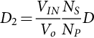 **(7.105)**

*D*2 is effectively the duty cycle of the output rectifier *DR*.

3. For 

The output rectifier *DR* is off.

The output capacitor *CL* provides the output current to the load *RL*.

The switching cycle restarts when the switch *M*1 is turned on again at .

From the waveforms shown in [Fig. 7.39](https://learning.oreilly.com/library/view/power-electronics-handbook/9780128114087/B9780128114070000076.xhtml#f0200), the following information (for discontinuous-mode operation) can be obtained:

• The maximum value of the current in the switch *M*1 is

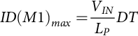 **(7.106)**

• The maximum value of the current in the output rectifier *DR* is

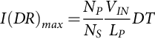 **(7.107)**

• The output voltage *Vo* can be found by equating the input energy to the output energy within a switching cycle.

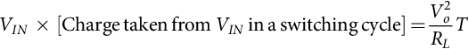

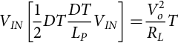 **(7.108)**

**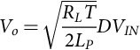** **(7.109)**

• The maximum reverse voltage of *DR*, *V*(6,9) (which is the voltage at node 6 with respect to node 9), is

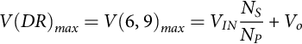 **(7.110)**

#### **7.6.2.2 Practical Circuit**

When a practical transformer (with leakage inductance) is used in the flyback converter circuit shown in [Fig. 7.38](https://learning.oreilly.com/library/view/power-electronics-handbook/9780128114087/B9780128114070000076.xhtml#f0195), there will be large ringings. In order to reduce these ringings to practically acceptable levels, snubber and clamping circuits have to be added. [Fig. 7.40](https://learning.oreilly.com/library/view/power-electronics-handbook/9780128114087/B9780128114070000076.xhtml#f0205) shows a practical flyback converter circuit where a resistor-capacitor snubber (*R*2*C*2) is used to damp the ringing voltage across the output rectifier *DR* and a resistor-capacitor-diode clamping (*R*1*C*1*DS*) is used to clamp the ringing voltage across the switch *M*1. What the diode *DS* does here is to allow the energy stored by the current in the leakage inductance to be converted to the form of a dc voltage across the clamping capacitor *C*1. The energy transferred to *C*1 is then dissipated slowly in the parallel resistor *R*1, without ringing problems.

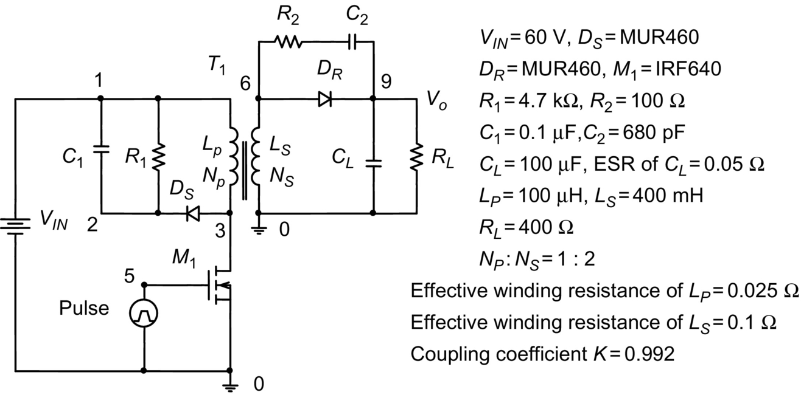

**FIG. 7.40** Practical flyback converter circuit.

The simulated waveforms of the flyback converter (circuit given in [Fig. 7.40](https://learning.oreilly.com/library/view/power-electronics-handbook/9780128114087/B9780128114070000076.xhtml#f0205)) for discontinuous-mode operation are shown in [Fig. 7.41](https://learning.oreilly.com/library/view/power-electronics-handbook/9780128114087/B9780128114070000076.xhtml#f0210), where the following assumptions are made:

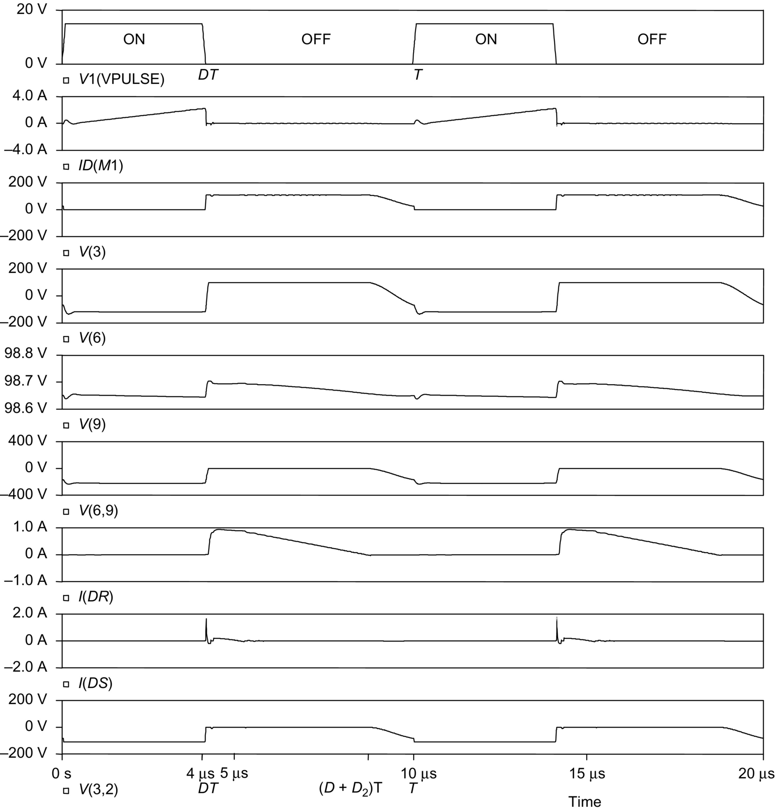

**FIG. 7.41** Waveforms of practical flyback converter for discontinuous-mode operation.

• *DR* and *DS* are MUR460 ultrafast diodes.

• *M*1 is an IRF640 MOS transistor.

• Transformer *T*1 has a practical coupling coefficient of 0.992.

• The effective winding resistance of *LP* is 0.025 Ω. The effective winding resistance of *LS* is 0.1 Ω.

• The effective series resistance of the output filtering capacitor *CL* is 0.05 Ω.

• The switching operation of the converter has reached a steady state.

The waveforms shown in [Fig. 7.40](https://learning.oreilly.com/library/view/power-electronics-handbook/9780128114087/B9780128114070000076.xhtml#f0205) are considered to be acceptable.

### 7.6.3 DESIGN CONSIDERATIONS

In the design of rectifier circuits, it is necessary for the designer to determine the voltage and current ratings of the diodes. The idealized waveforms and expressions for the maximum diode voltages and currents given under the heading of “Ideal Circuit” above (for both forward and flyback converters) are a good starting point. However, when parasitic/stray components are also considered, the simulation results given under “Practical Circuit” are much more useful for the determination of the voltage and current ratings of the high-frequency rectifier diodes.

Assuming that the voltage and current ratings have been determined, proper diodes can be selected to meet the requirements. The following are some general guidelines on the selection of diodes:

• For low-voltage applications, Schottky diodes should be used because they have very fast switching speed and low forward voltage drop. If Schottky diodes cannot be used, either because of their low reverse breakdown voltage or because of their large leakage current (when reversely biased), ultrafast diodes should be used.

• The reverse breakdown voltage rating of the diode should be reasonably higher (e.g., 10% or 20% higher) than the maximum reverse voltage, the diode is expected to encounter under the worst-case condition. However, an overly conservative design (using a diode with much higher breakdown voltage than necessary) would result in a lower rectifier efficiency, because a diode having a higher reverse voltage rating would normally have a larger voltage drop when it is conducting.

• The current rating of the diode should be substantially higher than the maximum current the diode is expected to carry during normal operation. Using a diode with a relatively large current rating has the following advantages:

• It reduces the possibility of damage due to transients caused by start-up, accidental short circuit, or random turning on and off of the converter.

• It reduces the forward voltage drop because the diode is operated in the lower current region of the *V-I* characteristic.

In some of the “high-efficiency” converter circuits, the current rating of the output rectifier can be many times larger than the actual current expected in the rectifier. In this way, a higher efficiency is achieved at the expense of a larger silicon area.

In the design of *R-C* snubber circuits for rectifiers, it should be understood that a larger *C* (and a smaller *R*) will give better damping. However, a large *C* (and a small *R*) will result in a large switching loss (which is equal to 0.5 *CV*2*f*). As a guideline, a capacitor with five to ten times the junction capacitance of the rectifier may be used as a starting point for iterations. The value of the resistor should be chosen to provide a slightly underdamped operating condition.

### 7.6.4 PRECAUTIONS IN INTERPRETING SIMULATION RESULTS

In using the simulated waveforms as references for design purposes, attention should be paid to the following:

• The voltage/current spikes that appear in the practically measured waveforms may not appear in the simulated waveforms. This is due to the lack of a model in the computer simulation to simulate unwanted coupling among the practical components.

• Most of the computer models of diodes, including those used in the simulations given above, do not take into account the effects of the forward recovery time. (The forward recovery time is not even mentioned in most manufacturers' data sheets.) However, it is also interesting to note that in most cases, the effect of the forward recovery time of a diode is masked by that of the effective inductance in series with the diode (e.g., the leakage inductance of a transformer).

## Further Reading

[1] *Rectifier Applications Handbook.* third ed. Phoenix, AZ: Motorola, Inc; 1993.

[2] Rashid M.H. *Power Electronics: Circuits, Devices, and Applications.* second ed. Englewood Cliffs, NJ: Prentice Hall, Inc., 1993.

[3] Lee Y.-S. *Computer-Aided Analysis and Design of Switch-Mode Power Supplies.* New York: Marcel Dekker, Inc., 1993.

[4] Nilsson J.W. *Introduction to PSpice Manual, Electric Circuits Using OrCAD Release 9.1.* fourth ed. Upper Saddle River, NJ: Prentice Hall, Inc., 2000.

[5] Keown J. *OrCAD PSpice and Circuit Analysis.* fourth ed. Upper Saddle River, NJ: Prentice Hall, Inc., 2001.

**8**

# Single-Phase Controlled Rectifiers

Kishore N. Mude University of Porto, Porto, Portugal

Amrita Vishwa Vidyapeetham University, Bengaluru, India

## Abstract

In this chapter, the various topologies of single-phase controlled rectifier are presented. In the first part of the chapter, topologies pertaining to low switching frequency such as half-wave, biphase, and full-wave rectifier with source inductance are presented. In the later parts, the various concepts and topologies pertaining to active rectification are presented. The performance issues pertaining to input currents, power factor, and commutation problems in control rectifier are addressed. The various topologies of unity-power-factor rectifiers, synchronous rectifiers, and rectifier using matrix converter are presented.

### KEYWORDS:

Line-commutated control rectifiers; Unity-power-factor rectifiers; Active rectification; Synchronous rectifier

8.1 [Introduction](https://learning.oreilly.com/library/view/power-electronics-handbook/9780128114087/B9780128114070000088.xhtml#s0010)

8.2 [Line-Commutated Single-Phase Controlled Rectifiers](https://learning.oreilly.com/library/view/power-electronics-handbook/9780128114087/B9780128114070000088.xhtml#s0015)

8.2.1 Single-Phase Half-Wave Rectifier

8.2.2 Bi-Phase Half-Wave Rectifier

8.2.3 Single-Phase Bridge Rectifier

8.2.4 Analysis of the Input Current

8.2.5 Power Factor of the Rectifier

8.2.6 The Commutation of the Thyristors

8.2.7 Operation in the Inverting Mode

8.2.8 Applications

8.3 [Unity Power Factor Single-Phase Rectifiers](https://learning.oreilly.com/library/view/power-electronics-handbook/9780128114087/B9780128114070000088.xhtml#s0060)

8.3.1 The Problem of Power Factor in Single-Phase Line-Commutated Rectifiers

8.3.2 Standards for Harmonics in Single-Phase Rectifiers

8.3.3 The Single-Phase Boost Rectifier

8.3.4 Voltage Doubler PWM Rectifier

8.3.5 The PWM Rectifier in Bridge Connection

8.3.6 Applications of Unity Power Factor Rectifiers

8.3.7 Synchronous Rectifier

8.3.8. Controlled Rectifier Using Single Phase Matrix Converter (SPMC)—Boost Rectifier Operation

[References](https://learning.oreilly.com/library/view/power-electronics-handbook/9780128114087/B9780128114070000088.xhtml#bi0010)

## 8.1 Introduction

This chapter is dedicated to single-phase controlled rectifiers, which are used in a wide range of applications. As shown in [Fig. 8.1](https://learning.oreilly.com/library/view/power-electronics-handbook/9780128114087/B9780128114070000088.xhtml#f0010), single-phase rectifiers can be classified into two big categories:

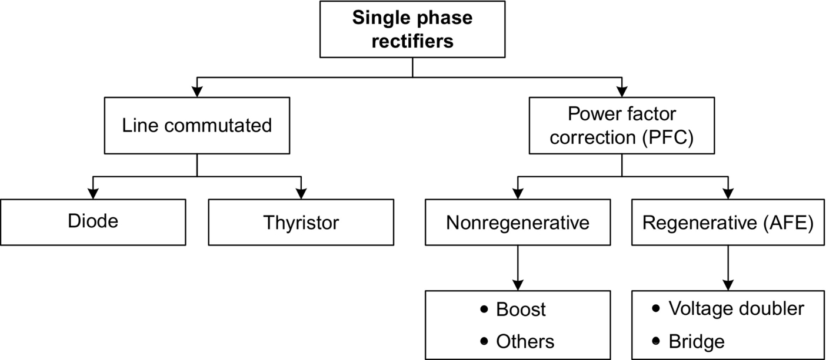

**FIG. 8.1** Single-phase rectifier classification.

(i) Topologies working with low switching frequency, also known as line-commutated or phase controlled rectifiers

(ii) Circuits working with high switching frequency, also known as power factor correctors (PFCs), synchronous rectifiers

Line-commutated rectifiers with diodes, covered in a previous chapter of this handbook, do not allow the control of power being converted from ac to dc. This control can be achieved with the use of thyristors. These controlled rectifiers are addressed in the first part of this chapter.

In the last years, increasing attention has been paid to the control of current harmonics present at the input side of the rectifiers, originating from a very important development in the so-called PFCs and synchronous rectifiers. These circuits use power transistors working with high switching frequency to improve the waveform quality of the input current, increasing the power factor. High-power-factor rectifiers can be classified in regenerative and nonregenerative topologies. The synchronous rectification (SR) uses MOSFETs to achieve the rectification function typically performed by diodes. SR improves efficiency, thermal performance, power density, manufacturability, and reliability and decreases the overall system cost of power supply systems. New topology of control rectifier using the single-phase matrix converter is also covered in the second part of this chapter.

## 8.2 Line-Commutated Single-Phase Controlled Rectifiers

### **8.2.1 SINGLE-PHASE HALF-WAVE RECTIFIER**

The single-phase half-wave rectifier uses a single thyristor to control the load voltage as shown in [Fig. 8.2](https://learning.oreilly.com/library/view/power-electronics-handbook/9780128114087/B9780128114070000088.xhtml#f0015). The thyristor will conduct, on-state, when the voltage *vT* is positive and a firing current pulse *iG* is applied to the gate terminal. The control of the load voltage is performed by delaying the firing pulse by an angle *α*. The firing angle *α* is measured from the position where a diode would naturally conduct. In case of [Fig. 8.2](https://learning.oreilly.com/library/view/power-electronics-handbook/9780128114087/B9780128114070000088.xhtml#f0015), the angle *α* is measured from the zero-crossing point of the supply voltage *vs*. The load in [Fig. 8.2](https://learning.oreilly.com/library/view/power-electronics-handbook/9780128114087/B9780128114070000088.xhtml#f0015) is resistive, and therefore, the current *id* has the same waveform of the load voltage. The thyristor goes to the nonconducting condition, off-state, when the load voltage and consequently the current reach a negative value.

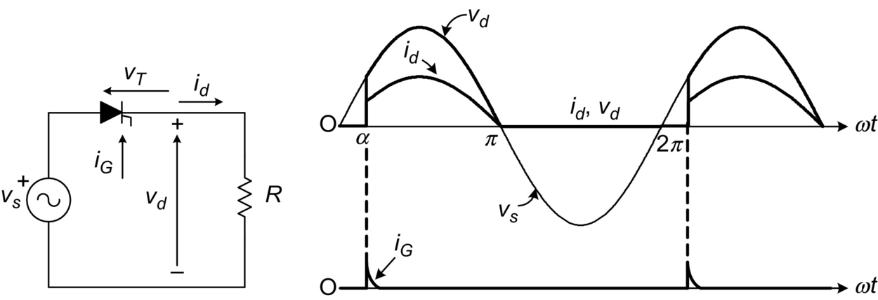

**FIG. 8.2** Single-thyristor rectifier with resistive load.

The load average voltage is given by [[1](https://learning.oreilly.com/library/view/power-electronics-handbook/9780128114087/B9780128114070000088.xhtml#bb0010)]

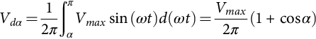 **(8.1)**

where *Vmax* is the supply peak voltage. Hence, it can be seen from Eq. [(8.1)](https://learning.oreilly.com/library/view/power-electronics-handbook/9780128114087/B9780128114070000088.xhtml#fo0010) that changing the firing angle *α* controls both the load average voltage and the amount of transferred power.

[Fig. 8.3A](https://learning.oreilly.com/library/view/power-electronics-handbook/9780128114087/B9780128114070000088.xhtml#f0020) shows the rectifier waveforms for an *R-L* load. When the thyristor is turned on, the voltage across the inductance is

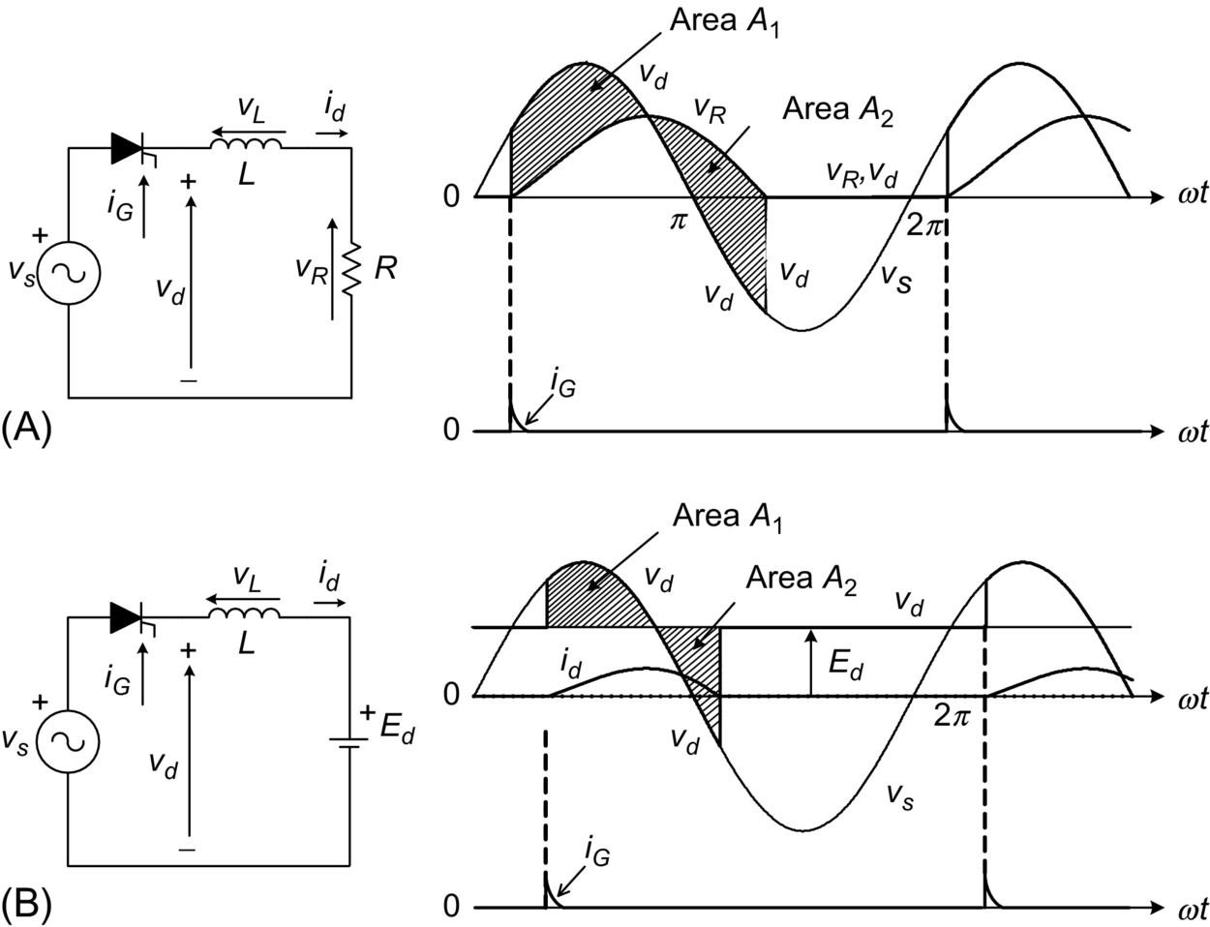

**FIG. 8.3** Single-thyristor rectifier with (A) resistive-inductive load and (B) active load.

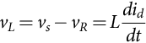 **(8.2)**

where *vR* is the voltage in the resistance *R*, given by *vR*=*R*⋅*id*. If *vs*−*vR*>0, from Eq. [(8.2)](https://learning.oreilly.com/library/view/power-electronics-handbook/9780128114087/B9780128114070000088.xhtml#fo0015) holds that the load current increases its value. On the other hand, *id* decreases its value when *vs*−*vR*<0. The load current is given by

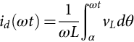 **(8.3)**

Graphically, Eq. [(8.3)](https://learning.oreilly.com/library/view/power-electronics-handbook/9780128114087/B9780128114070000088.xhtml#fo0020) means that the load current *id* is equal to zero when *A*1=*A*2, maintaining the thyristor in conduction state even when *vs*<0.

When an inductive-active load is connected to the rectifier, as illustrated in [Fig. 8.3B](https://learning.oreilly.com/library/view/power-electronics-handbook/9780128114087/B9780128114070000088.xhtml#f0020), the thyristor will be turned on if the firing pulse is applied to the gate when *vs*>*Ed*. Again, the thyristor will remain in the on-state until . When the thyristor is turned off, the load voltage will be .

### 8.2.2 BI-PHASE HALF-WAVE RECTIFIER

The biphase half-wave rectifier, shown in [Fig. 8.4](https://learning.oreilly.com/library/view/power-electronics-handbook/9780128114087/B9780128114070000088.xhtml#f0025), uses a center-tapped transformer to provide two voltages *v*1 and *v*2. These two voltages are 180 degrees out of phase with respect to the midpoint neutral *N*. In this scheme, the load is fed via thyristors T1 and T2 during each positive cycle of voltages *v*1 and *v*2, respectively, while the load current returns via the neutral *N*.

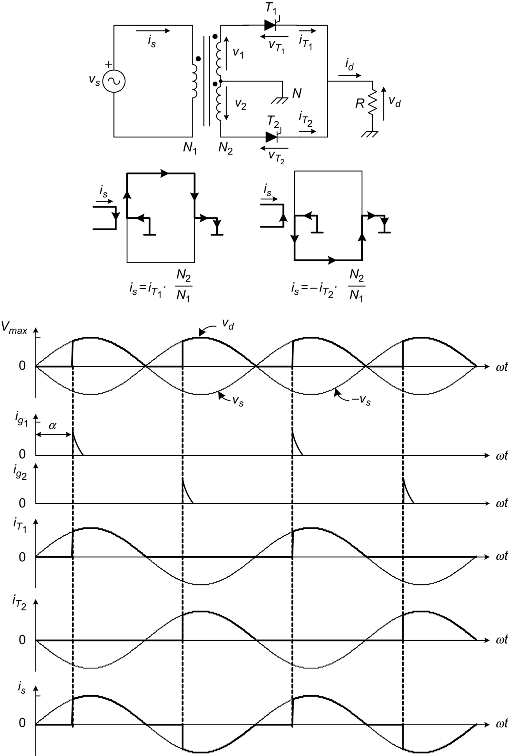

**FIG. 8.4** Biphase half-wave rectifier.

As illustrated in [Fig. 8.4](https://learning.oreilly.com/library/view/power-electronics-handbook/9780128114087/B9780128114070000088.xhtml#f0025), thyristor T1 can be fired into the on-state at any time, while voltage . The firing pulses are delayed by an angle *α* with respect to the instant where diodes would conduct. Also the current paths for each conduction state are presented in [Fig. 8.4](https://learning.oreilly.com/library/view/power-electronics-handbook/9780128114087/B9780128114070000088.xhtml#f0025). Thyristor T1 remains in the on-state until the load current tends to a negative value. Thyristor T2 is fired into the on-state when , which corresponds in [Fig. 8.4](https://learning.oreilly.com/library/view/power-electronics-handbook/9780128114087/B9780128114070000088.xhtml#f0025) to the condition when .

The mean value of the load voltage with resistive load is determined by

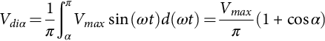 **(8.4)**

The ac supply current is equal to  when *T*1 is in the on-state and  when T2 is in the on-state, where *N*2/*N*1 is the transformer turns ratio.

The effect of the load time constant  on the normalized load current *id*(*t*)/*îR*(*t*) for a firing angle  is shown in [Fig. 8.5](https://learning.oreilly.com/library/view/power-electronics-handbook/9780128114087/B9780128114070000088.xhtml#f0030). The ripple in the load current reduces as the load inductance increases. If the load inductance , then the current is perfectly filtered.

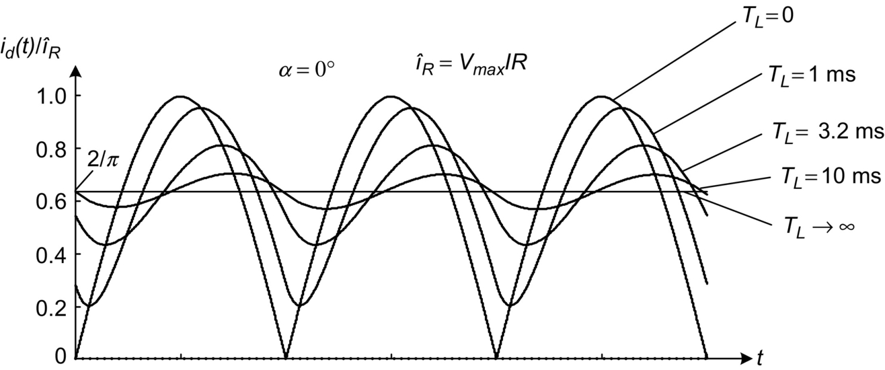

**FIG. 8.5** Effect of the load time constant over the current ripple.

### 8.2.3 SINGLE-PHASE BRIDGE RECTIFIER

[Fig. 8.6A](https://learning.oreilly.com/library/view/power-electronics-handbook/9780128114087/B9780128114070000088.xhtml#f0035) shows a fully controlled bridge rectifier, which uses four thyristors to control the average load voltage. In addition, [Fig. 8.6B](https://learning.oreilly.com/library/view/power-electronics-handbook/9780128114087/B9780128114070000088.xhtml#f0035) shows the half-controlled bridge rectifier that uses two thyristors and two diodes.

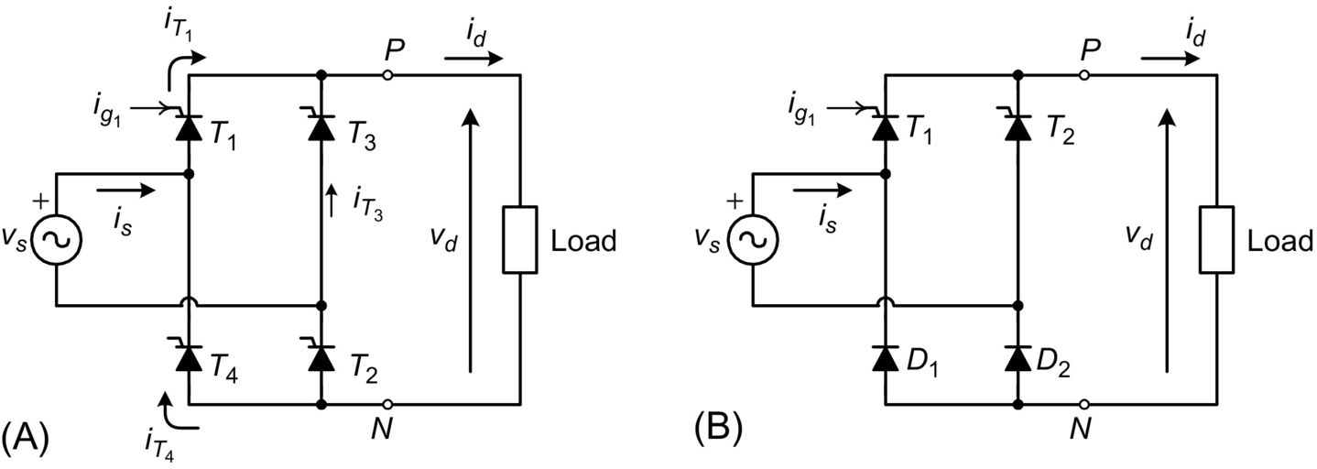

**FIG. 8.6** Single-phase bridge rectifier, (A) fully controlled and (B) half-controlled.

The voltage and current waveforms of the fully controlled bridge rectifier for a resistive load are illustrated in [Fig. 8.7](https://learning.oreilly.com/library/view/power-electronics-handbook/9780128114087/B9780128114070000088.xhtml#f0040). Thyristors T1 and T2 must be fired on simultaneously during the positive half wave of the source voltage *vs*, to allow the conduction of current. Alternatively, thyristors T3 and T4 must be fired simultaneously during the negative half wave of the source voltage. To ensure simultaneous firing, thyristors T1 and T2 use the same firing signal. The load voltage is similar to the voltage obtained with the biphase half-wave rectifier. The input current is given by

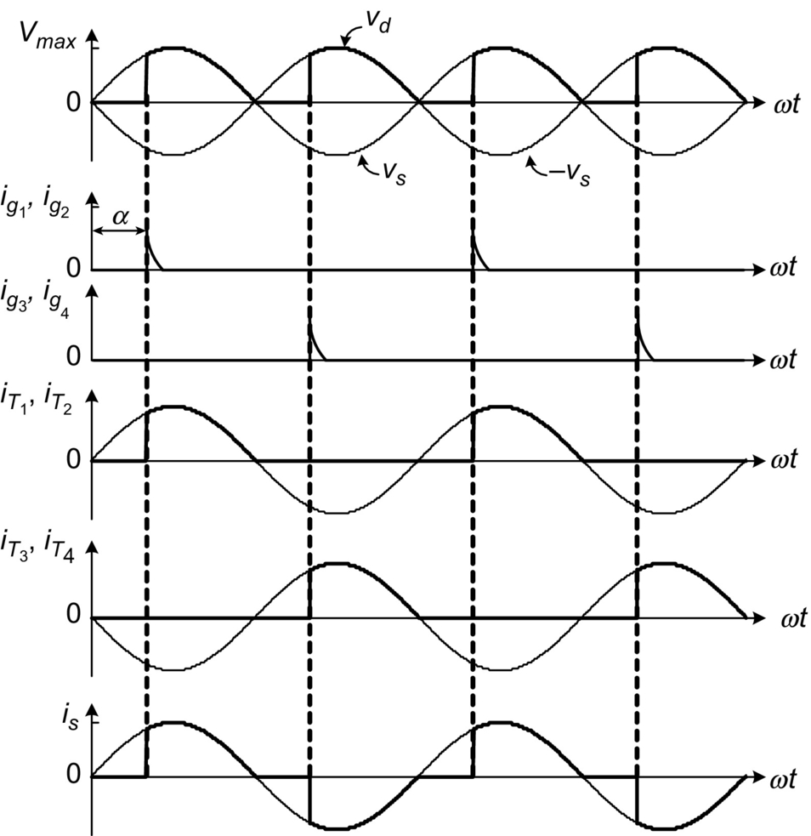

**FIG. 8.7** Waveforms of a fully controlled bridge rectifier with resistive load.

 **(8.5)**

and its waveform is shown in [Fig. 8.7](https://learning.oreilly.com/library/view/power-electronics-handbook/9780128114087/B9780128114070000088.xhtml#f0040).

[Fig. 8.8](https://learning.oreilly.com/library/view/power-electronics-handbook/9780128114087/B9780128114070000088.xhtml#f0045) presents the behavior of the fully controlled rectifier with resistive-inductive load (with ) [[2](https://learning.oreilly.com/library/view/power-electronics-handbook/9780128114087/B9780128114070000088.xhtml#bb0015)] . The high load inductance generates a perfectly filtered current, and the rectifier behaves like a current source. With continuous load current, thyristors T1 and T2 remain in the on-state beyond the positive half wave of the source voltage *vs*. For this reason, the load voltage *vd* can have a negative instantaneous value. The firing of thyristors T3 and T4 has two effects:

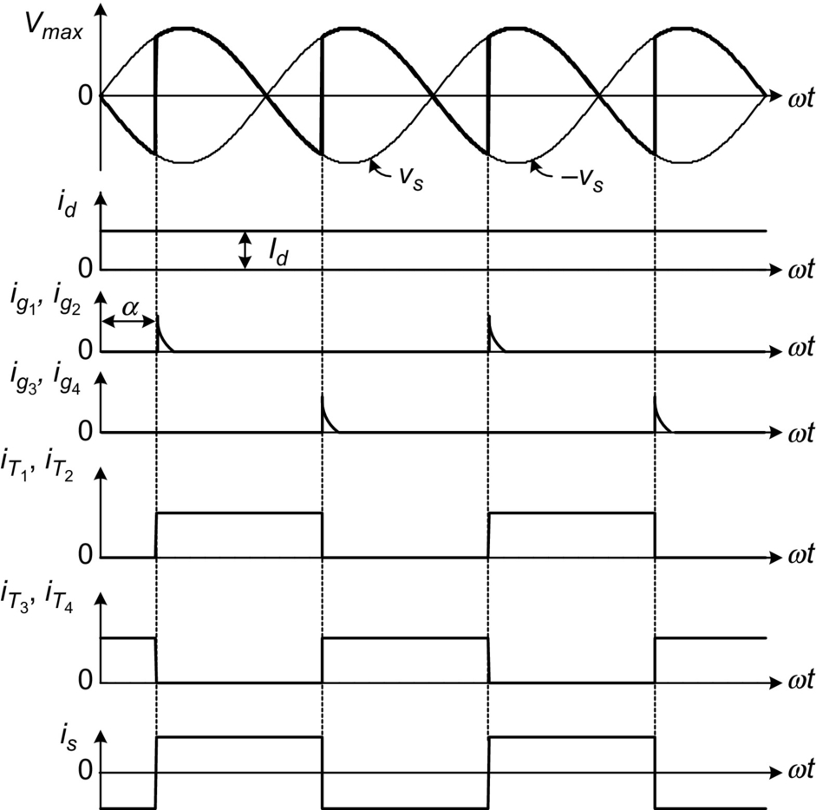

**FIG. 8.8** Waveforms of a fully controlled bridge rectifier with resistive-inductive load ().

(i) They turn off thyristors T1 and T2.

(ii) After the commutation, they conduct the load current.

This is the main reason why this type of converters is called “naturally commutated” or “line-commutated” rectifiers. The supply current *iS* has the square waveform, as shown in [Fig. 8.9](https://learning.oreilly.com/library/view/power-electronics-handbook/9780128114087/B9780128114070000088.xhtml#f0050), for continuous conduction. In this case, the average load voltage is given by

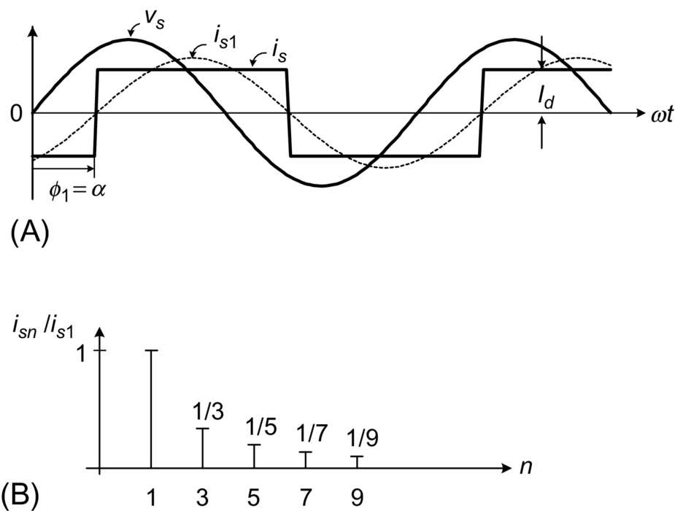

**FIG. 8.9** Input current of the single-phase controlled rectifier in bridge connection, (A) waveforms and (B) harmonics spectrum.

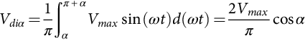 **(8.6)**

### 8.2.4 ANALYSIS OF THE INPUT CURRENT

Considering a very high inductive load, the input current in a bridge-controlled rectifier is filtered and presents a square waveform. In addition, the input current *is* is shifted by the firing angle *α* with respect to the input voltage *vs*, as shown in [Fig. 8.9A](https://learning.oreilly.com/library/view/power-electronics-handbook/9780128114087/B9780128114070000088.xhtml#f0050). The input current can be expressed as a Fourier series, where the amplitude of the different harmonics is

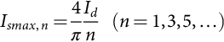 **(8.7)**

where *n* is the harmonic order. The root mean square (rms) value of each harmonic can be expressed as

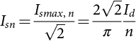 **(8.8)**

Thus, the rms value of the fundamental current *is*1 is

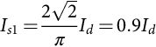 **(8.9)**

It can be observed from [Fig. 8.9A](https://learning.oreilly.com/library/view/power-electronics-handbook/9780128114087/B9780128114070000088.xhtml#f0050) that the displacement angle *ϕ*1 of the fundamental current *is*1 corresponds to the firing angle *α*. [Fig. 8.9B](https://learning.oreilly.com/library/view/power-electronics-handbook/9780128114087/B9780128114070000088.xhtml#f0050) shows that in the harmonic spectrum of the input current, only odd harmonics are present with decreasing amplitude while the frequency increases. Finally, the rms value of the input current *is* is

 **(8.10)**

The total harmonic distortion (THD) of the input current can be determined by [[3](https://learning.oreilly.com/library/view/power-electronics-handbook/9780128114087/B9780128114070000088.xhtml#bb0020)]

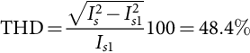 **(8.11)**

### 8.2.5 POWER FACTOR OF THE RECTIFIER

The displacement factor of the fundamental current, obtained from [Fig. 8.9A](https://learning.oreilly.com/library/view/power-electronics-handbook/9780128114087/B9780128114070000088.xhtml#f0050), is

 **(8.12)**

In the case of nonsinusoidal currents, the active power delivered by the sinusoidal single-phase supply is

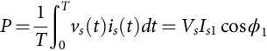 **(8.13)**

where *Vs* is the rms value of the single-phase voltage *vs*.

The apparent power is given by

 **(8.14)**

The power factor (PF) is defined by

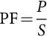 **(8.15)**

Substitution from Eqs. [(8.12)](https://learning.oreilly.com/library/view/power-electronics-handbook/9780128114087/B9780128114070000088.xhtml#fo0065), [(8.13)](https://learning.oreilly.com/library/view/power-electronics-handbook/9780128114087/B9780128114070000088.xhtml#fo0070), and [(8.14)](https://learning.oreilly.com/library/view/power-electronics-handbook/9780128114087/B9780128114070000088.xhtml#fo0075) in Eq. [(8.15)](https://learning.oreilly.com/library/view/power-electronics-handbook/9780128114087/B9780128114070000088.xhtml#fo0080) yields

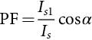 **(8.16)**

This equation shows clearly that due to the nonsinusoidal waveform of the input current, the power factor of the rectifier is negatively affected both by the firing angle *α* and by the distortion of the input current. In effect, an increase in the distortion of the current produces an increase in the value of *Is* in Eq. [(8.16)](https://learning.oreilly.com/library/view/power-electronics-handbook/9780128114087/B9780128114070000088.xhtml#fo0085), which deteriorates the power factor.

### 8.2.6 THE COMMUTATION OF THE THYRISTORS

Until now, the current commutation between thyristors has been considered to be instantaneous. This condition is not valid in real cases due to the presence of the line inductance *L*, as shown in [Fig. 8.10A](https://learning.oreilly.com/library/view/power-electronics-handbook/9780128114087/B9780128114070000088.xhtml#f0055). During the commutation, the current through the thyristors cannot change instantaneously, and for this reason, during the commutation angle *μ*, all four thyristors are conducting simultaneously. Therefore, during the commutation, the following relationship for the load voltage holds

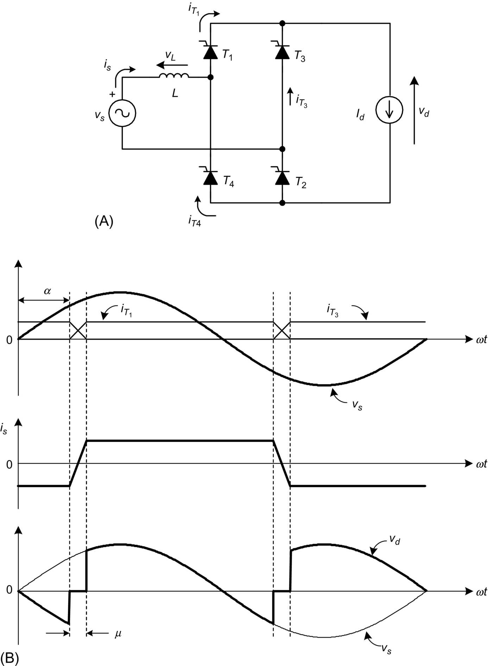

**FIG. 8.10** The commutation process, (A) circuit and (B) waveforms.

 **(8.17)**

The effect of the commutation on the supply current, the voltage waveforms, and the thyristor current waveforms can be observed in [Fig. 8.10B](https://learning.oreilly.com/library/view/power-electronics-handbook/9780128114087/B9780128114070000088.xhtml#f0055).

During the commutation, the following expression holds

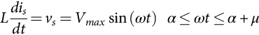 **(8.18)**

Integrating Eq. [(8.18)](https://learning.oreilly.com/library/view/power-electronics-handbook/9780128114087/B9780128114070000088.xhtml#fo0095) over the commutation interval yields

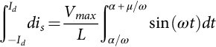 **(8.19)**

From Eq. [(8.19)](https://learning.oreilly.com/library/view/power-electronics-handbook/9780128114087/B9780128114070000088.xhtml#fo0100), the following relationship for the commutation angle *μ* is obtained:

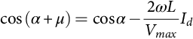 **(8.20)**

Eq. [(8.20)](https://learning.oreilly.com/library/view/power-electronics-handbook/9780128114087/B9780128114070000088.xhtml#fo0105) shows that an increase of the line inductance *L* or an increase of the load current *Id* increases the commutation angle *μ*. In addition, the commutation angle is affected by the firing angle *α*. In effect, Eq. [(8.18)](https://learning.oreilly.com/library/view/power-electronics-handbook/9780128114087/B9780128114070000088.xhtml#fo0095) shows that with different values of *α*, the supply voltage *vs* has a different instantaneous value, which produces different *dis/dt*, thereby affecting the duration of the commutation.

Eq. [(8.17)](https://learning.oreilly.com/library/view/power-electronics-handbook/9780128114087/B9780128114070000088.xhtml#fo0090) and the waveform of [Fig. 8.10B](https://learning.oreilly.com/library/view/power-electronics-handbook/9780128114087/B9780128114070000088.xhtml#f0055) show that the commutation process reduces the average load voltage *Vdα*. When the commutation is considered, the expression for the average load voltage is given by

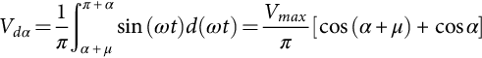 **(8.21)**

Substituting Eq. [(8.20)](https://learning.oreilly.com/library/view/power-electronics-handbook/9780128114087/B9780128114070000088.xhtml#fo0105) into Eq. [(8.21)](https://learning.oreilly.com/library/view/power-electronics-handbook/9780128114087/B9780128114070000088.xhtml#fo0110) yields

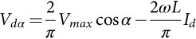 **(8.22)**

### 8.2.7 OPERATION IN THE INVERTING MODE

When the angle , it is possible to obtain a negative average load voltage. In this condition, the power is fed back to the single-phase supply from the load. This operating mode is called inverter or inverting mode, because the energy is transferred from the dc to the ac side. In practical cases, this operating mode is obtained when the load configuration is as shown in [Fig. 8.11A](https://learning.oreilly.com/library/view/power-electronics-handbook/9780128114087/B9780128114070000088.xhtml#f0060). It must be noticed that this rectifier allows unidirectional load current flow. [Fig. 8.11B](https://learning.oreilly.com/library/view/power-electronics-handbook/9780128114087/B9780128114070000088.xhtml#f0060) shows the waveform of the load voltage with the rectifier in the inverting mode, neglecting the source inductance *L*.

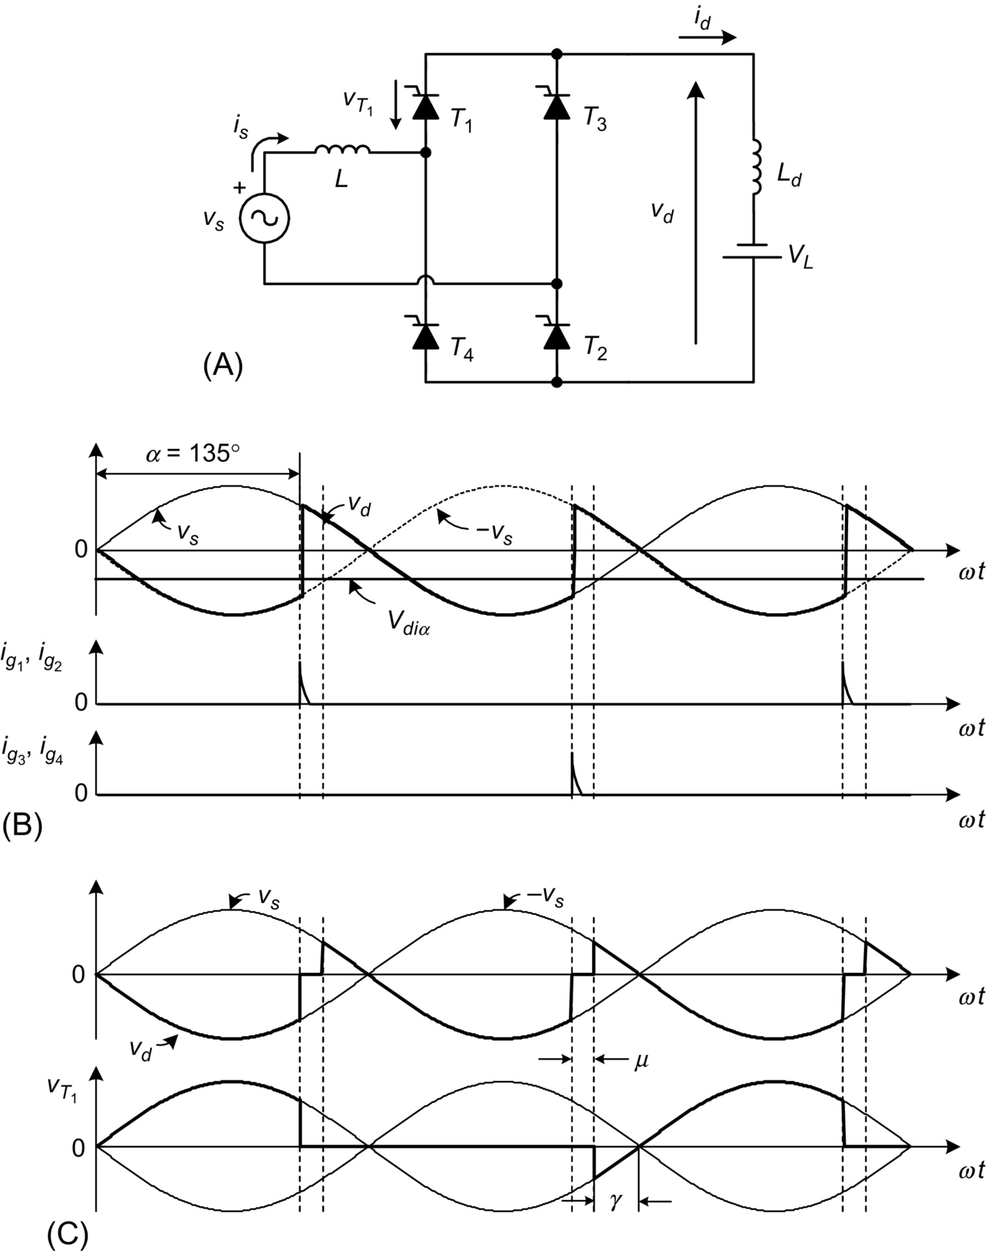

**FIG. 8.11** Rectifier in the inverting mode: (A) circuit, (B) waveforms neglecting source inductance *L*, and (C) waveforms considering *L*.

[Section 8.2.6](https://learning.oreilly.com/library/view/power-electronics-handbook/9780128114087/B9780128114070000088.xhtml#s0045) described how supply inductance increases the conduction interval of the thyristors by the angle *μ*. As shown in [Fig. 8.11C](https://learning.oreilly.com/library/view/power-electronics-handbook/9780128114087/B9780128114070000088.xhtml#f0060), the thyristor voltage  has a negative value during the extinction angle *γ*, defined by

 **(8.23)**

To ensure that the outgoing thyristor will recover its blocking capability after the commutation, the extinction angle should satisfy the following restriction:

 **(8.24)**

where *ω* is the supply frequency and *tq* is the thyristor turn-off time. Considering Eqs. [(8.23)](https://learning.oreilly.com/library/view/power-electronics-handbook/9780128114087/B9780128114070000088.xhtml#fo0120) and [(8.24)](https://learning.oreilly.com/library/view/power-electronics-handbook/9780128114087/B9780128114070000088.xhtml#fo0125), the maximum firing angle is, in practice,

 **(8.25)**

If the condition of Eq. [(8.25)](https://learning.oreilly.com/library/view/power-electronics-handbook/9780128114087/B9780128114070000088.xhtml#fo0130) is not satisfied, the commutation process will fail, originating destructive currents.

### 8.2.8 APPLICATIONS

Important application areas of controlled rectifiers include uninterruptible power supplies (UPS), for feeding critical loads. [Fig. 8.12](https://learning.oreilly.com/library/view/power-electronics-handbook/9780128114087/B9780128114070000088.xhtml#f0065) shows a simplified diagram of a single-phase UPS configuration, typically rated for <10 kVA. A fully controlled or half-controlled rectifier is used to generate the dc voltage for the inverter. In addition, the input rectifier acts as a battery charger. The output of the inverter is filtered before it is fed to the load. The operating modes of UPS are best explained in Ref. [[4](https://learning.oreilly.com/library/view/power-electronics-handbook/9780128114087/B9780128114070000088.xhtml#bb0025)]. The control of low-power dc motors is another interesting application of controlled single-phase rectifiers. In the circuit of [Fig. 8.13](https://learning.oreilly.com/library/view/power-electronics-handbook/9780128114087/B9780128114070000088.xhtml#f0070), the controlled rectifier regulates the armature voltage and consequently controls the motor current *id* in order to produce a required torque.

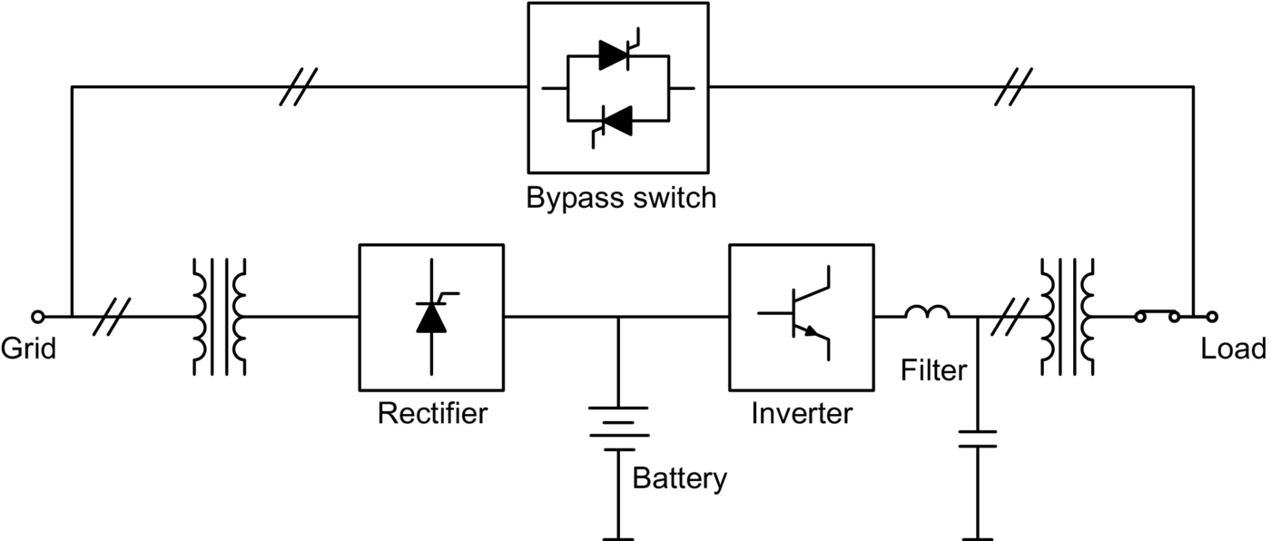

**FIG. 8.12** Application of a rectifier in single-phase UPS.

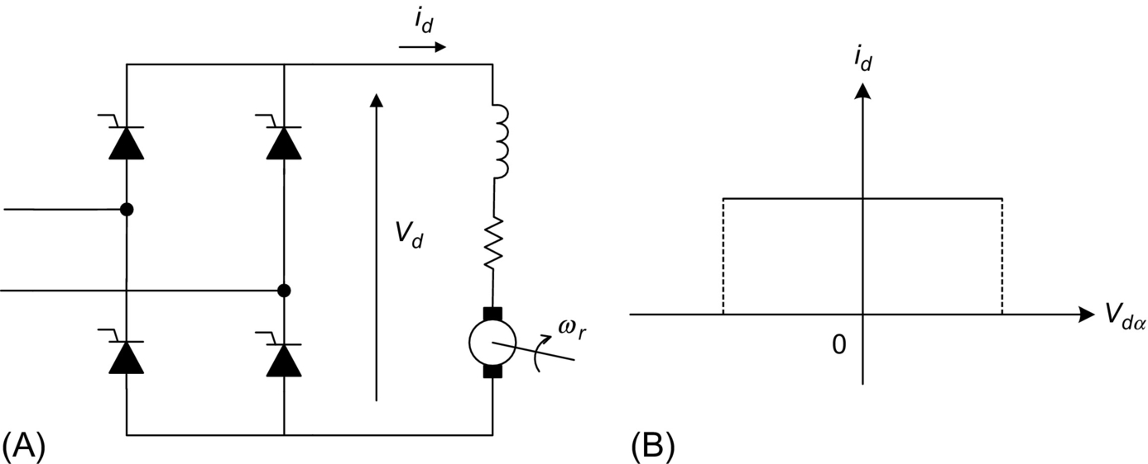

**FIG. 8.13** Two-quadrant dc drive, (A) circuit and (B) quadrants of operation.

This configuration allows only positive current flow in the load. However, the load voltage can be both positive and negative. For this reason, this converter works in the two-quadrant mode of operation in the plane *id* vs *Vdα*.

A better performance can be obtained with two rectifiers in back-to-back connection at the dc terminals, as shown in [Fig. 8.14A](https://learning.oreilly.com/library/view/power-electronics-handbook/9780128114087/B9780128114070000088.xhtml#f0075). This arrangement, known as a dual-converter configuration, allows four-quadrant operation of the drive. Rectifier I provides positive load current *id*, while rectifier II provides negative load current. The motor can work in forward powering, forward braking (regenerating), reverse powering, and reverse braking (regenerating). These operating modes are shown in [Fig. 8.14B](https://learning.oreilly.com/library/view/power-electronics-handbook/9780128114087/B9780128114070000088.xhtml#f0075), where the torque *T* vs the rotor speed *ωr* is illustrated.

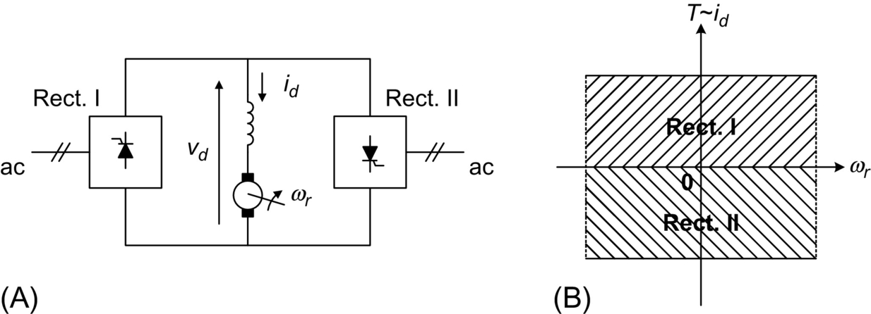

**FIG. 8.14** Single-phase dual-converter drive, (A) connection and (B) four-quadrant operation.

## 8.3 Unity Power Factor Single-Phase Rectifiers

### **8.3.1 THE PROBLEM OF POWER FACTOR IN SINGLE-PHASE LINE-COMMUTATED RECTIFIERS**

The main disadvantages of the classical line-commutated rectifiers are that (i) they produce a lagging displacement factor with respect to the voltage of the utility and (ii) they generate an important amount of input current harmonics. These aspects have a negative influence on both power factor and power quality. In the last several years, the massive use of single-phase power converters has increased the problems of power quality in electric systems. In effect, modern commercial buildings have 50% and even up to 90% of the demand, originated by nonlinear loads, which are composed mainly of rectifiers [[5](https://learning.oreilly.com/library/view/power-electronics-handbook/9780128114087/B9780128114070000088.xhtml#bb0030),[6](https://learning.oreilly.com/library/view/power-electronics-handbook/9780128114087/B9780128114070000088.xhtml#bb0035)]. Today, it is not unusual to find rectifiers with total harmonic distortion of the current , originating severe overloads in conductors and transformers.

[Fig. 8.15A](https://learning.oreilly.com/library/view/power-electronics-handbook/9780128114087/B9780128114070000088.xhtml#f0080) shows a single-phase rectifier with a capacitive filter, used in much of today's low-power equipment. The input current produced by this rectifier is illustrated in [Fig. 8.15B](https://learning.oreilly.com/library/view/power-electronics-handbook/9780128114087/B9780128114070000088.xhtml#f0080); it appears highly distorted due to the presence of the filter capacitor. This current has a harmonic content shown in [Fig. 8.16](https://learning.oreilly.com/library/view/power-electronics-handbook/9780128114087/B9780128114070000088.xhtml#f0085) and [Table 8.1](https://learning.oreilly.com/library/view/power-electronics-handbook/9780128114087/B9780128114070000088.xhtml#t0010), with a .

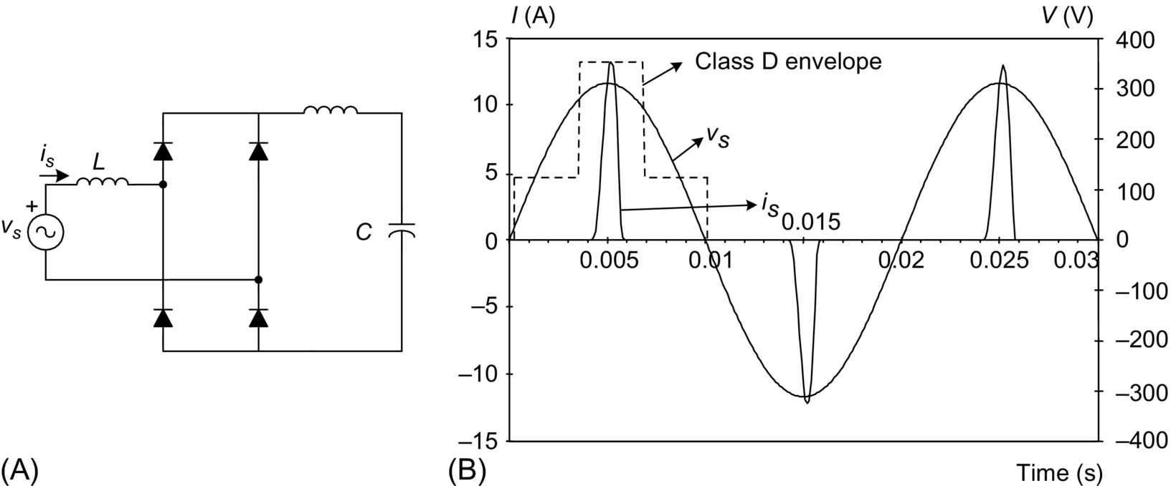

**FIG. 8.15** Single-phase rectifier, (A) circuit and (B) waveforms of the input voltage and current.

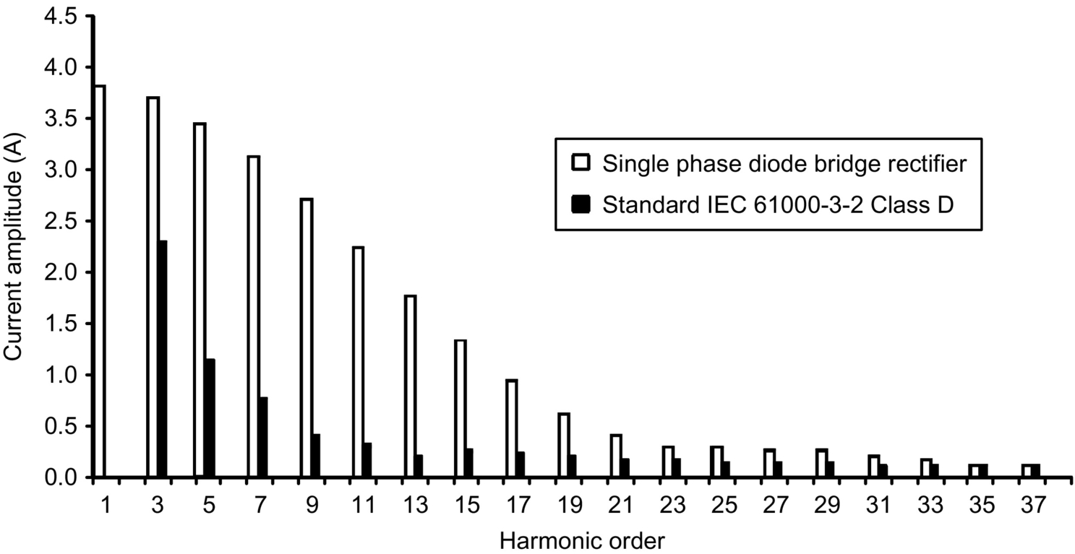

**FIG. 8.16** Input current harmonics produced by a single-phase diode bridge rectifier.

**Table 8.1**

**Harmonic Content of the Current of** [**Fig. 8.15**](https://learning.oreilly.com/library/view/power-electronics-handbook/9780128114087/B9780128114070000088.xhtml#f0080)

|  |  |  |  |  |  |  |  |  |  |  |
| --- | --- | --- | --- | --- | --- | --- | --- | --- | --- | --- |
| *n* | 3 | 5 | 7 | 9 | 11 | 13 | 15 | 17 | 19 | 21 |
| *In*/*I*1 (%) | 96.8 | 90.5 | 81.7 | 71.0 | 59.3 | 47.3 | 35.7 | 25.4 | 16.8 | 10.6 |

The rectifier in [Fig. 8.15](https://learning.oreilly.com/library/view/power-electronics-handbook/9780128114087/B9780128114070000088.xhtml#f0080) has a very low power factor of , due mainly to its large harmonic content.

### 8.3.2 STANDARDS FOR HARMONICS IN SINGLE-PHASE RECTIFIERS

The relevance of the problems originated by harmonics in single-phase line-commutated rectifiers has motivated some agencies to introduce restrictions to these converters. The IEC 61000-3-2 [[7](https://learning.oreilly.com/library/view/power-electronics-handbook/9780128114087/B9780128114070000088.xhtml#bb0040)], Class D International Standard, establishes limits to all low-power single-phase equipment having an input current with a “special wave shape” and an active input power . Class D equipment has an input current with a special wave shape contained within the envelope given in [Fig. 8.15B](https://learning.oreilly.com/library/view/power-electronics-handbook/9780128114087/B9780128114070000088.xhtml#f0080). This class of equipment must satisfy certain harmonic limits, shown in [Fig. 8.16](https://learning.oreilly.com/library/view/power-electronics-handbook/9780128114087/B9780128114070000088.xhtml#f0085). It is clear that a single-phase line-commutated rectifier with the parameters shown in [Fig. 8.15A](https://learning.oreilly.com/library/view/power-electronics-handbook/9780128114087/B9780128114070000088.xhtml#f0080) is not able to comply with the standard IEC 61000-3-2 Class D. The standard can be satisfied only by adding huge passive filters, which increases the size, weight, and cost of the rectifier. This standard has been the motivation for the development of active methods to improve the quality of the input current and, consequently, the power factor.

### 8.3.3 THE SINGLE-PHASE BOOST RECTIFIER

One of the most important high-power-factor rectifiers, from a theoretical and conceptual point of view, is the so-called single-phase boost rectifier, shown in [Fig. 8.17A](https://learning.oreilly.com/library/view/power-electronics-handbook/9780128114087/B9780128114070000088.xhtml#f0090), which is obtained from a classical noncontrolled bridge rectifier, with the addition of transistor T, diode D, and inductor *L*.

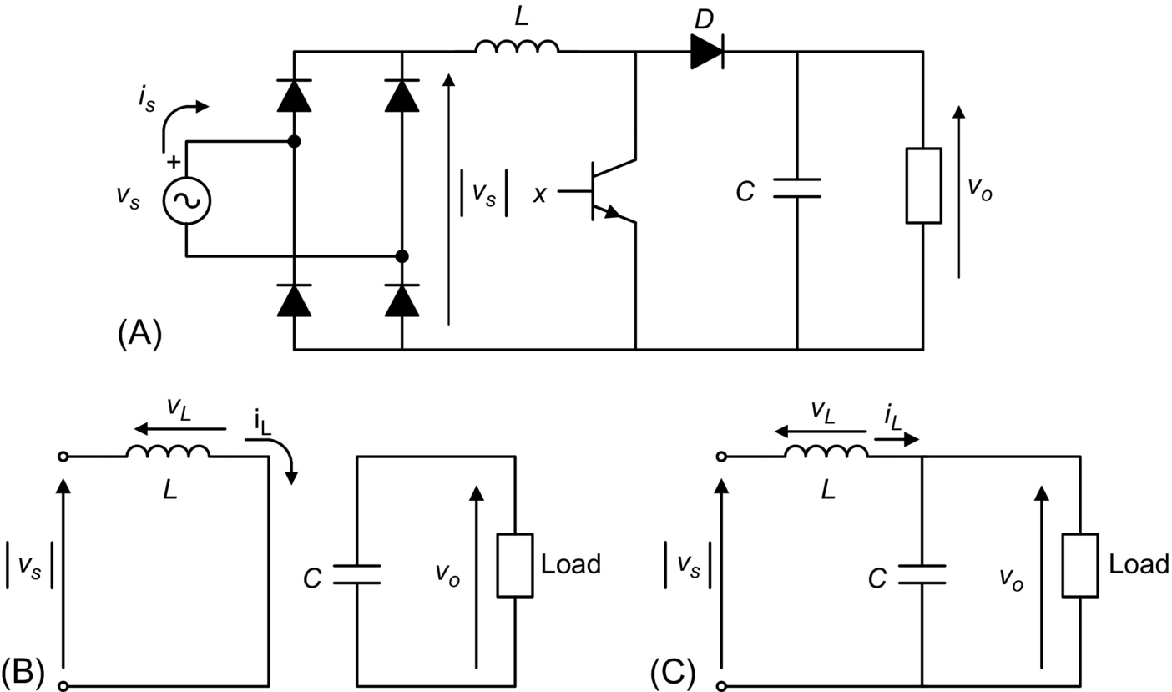

**FIG. 8.17** Single-phase boost rectifier, (A) power circuit and equivalent circuit for transistor T in the (B) on-state and (C) off-state.

#### **8.3.3.1 Working Principle, Basic Concepts**

In boost rectifiers, the input current *is*(*t*) is controlled by changing the conduction state of transistor T. When transistor T is in the on-state, the single-phase power supply is short-circuited through the inductance *L*, as shown in [Fig. 8.17B](https://learning.oreilly.com/library/view/power-electronics-handbook/9780128114087/B9780128114070000088.xhtml#f0090); the diode D avoids the discharge of the filter capacitor *C* through the transistor. The current of the inductance *iL* is given by the following equation:

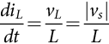 **(8.26)**

Due to the fact that , the on-state of transistor T always produces an increase in the inductance current *iL* and consequently an increase in the absolute value of the source current *is*.

When transistor T is turned off, the inductor current *iL* cannot be interrupted abruptly and flows through diode D, charging capacitor *C*. This is observed in the equivalent circuit of [Fig. 8.17C](https://learning.oreilly.com/library/view/power-electronics-handbook/9780128114087/B9780128114070000088.xhtml#f0090). In this condition, the behavior of the inductor current is described by

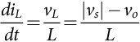 **(8.27)**

If , which is an important condition for the correct behavior of the rectifier, then , and this means that in the off-state the inductor current decreases its instantaneous value.

#### **8.3.3.2 Continuous Conduction Mode (CCM)**

When an appropriate firing pulse sequence is applied to transistor T, the waveform of the input current *is* can be controlled to follow a sinusoidal reference, as can be observed in the positive half wave of *is* in [Fig. 8.18](https://learning.oreilly.com/library/view/power-electronics-handbook/9780128114087/B9780128114070000088.xhtml#f0095). This figure shows the reference inductor current , the inductor current *iL*, and the gate drive signal *x* for transistor T. Transistor T is on when , and it is off when .

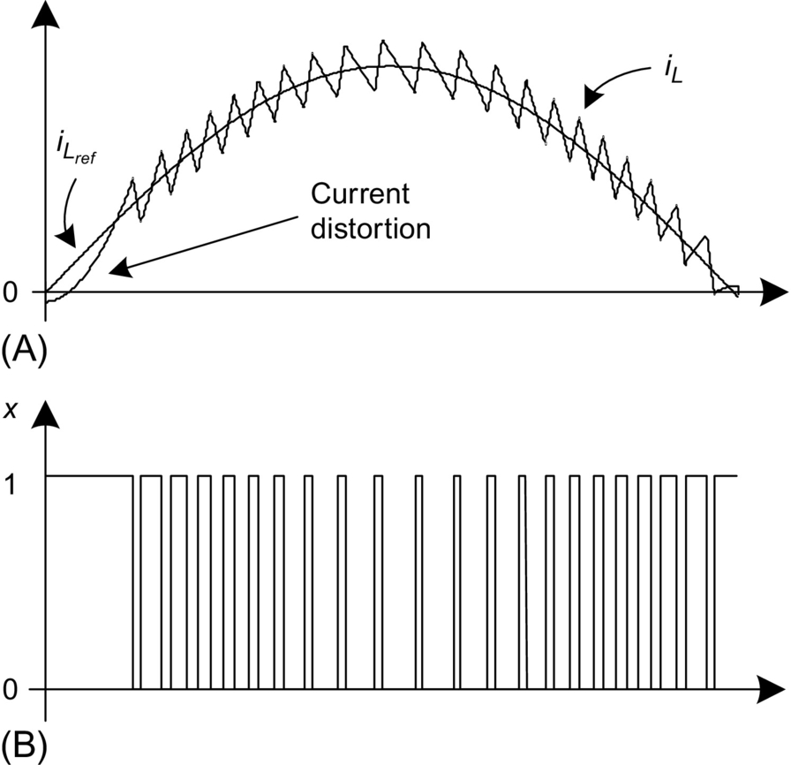

**FIG. 8.18** Behavior of the inductor current *iL*, (A) waveforms and (B) transistor T gate drive signal *x*.

[Fig. 8.18](https://learning.oreilly.com/library/view/power-electronics-handbook/9780128114087/B9780128114070000088.xhtml#f0095) clearly shows that the on(off)-state of transistor T produces an increase (decrease) in the inductor current *iL*. Note that for low values of *vs*, the inductor does not have enough energy to increase the current value and, for this reason, it presents a distortion in their current waveform as shown in [Fig. 8.18A](https://learning.oreilly.com/library/view/power-electronics-handbook/9780128114087/B9780128114070000088.xhtml#f0095).

[Fig. 8.19](https://learning.oreilly.com/library/view/power-electronics-handbook/9780128114087/B9780128114070000088.xhtml#f0100) presents a block diagram of the control system for the boost rectifier, which includes a proportional-integral (PI) controller, to regulate the output voltage *vo*. The reference value  for the inner current control loop is obtained from the multiplication between the output of the voltage controller and the absolute value . A hysteresis controller provides a fast control for the inductor current *iL*, resulting in a practically sinusoidal input current *is*.

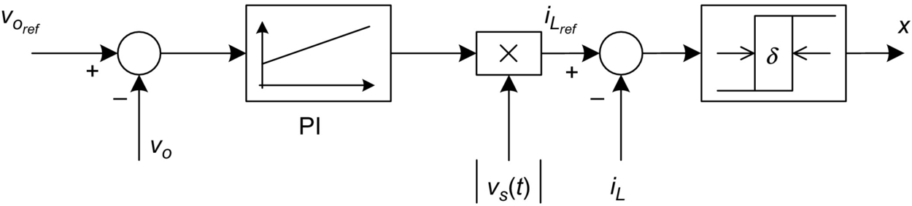

**FIG. 8.19** Control system of the boost rectifier.

Typically, the output voltage *vo* should be at least 10% higher than the peak value of the source voltage *vs*(*t*), in order to assure good dynamic control of the current. The control works with the following strategy: a step increase in the reference voltage  will produce an increase in the voltage error  and an increase of the output of the PI controller, which originates an increase in the amplitude of the reference current . The current controller will follow this new reference and will increase the amplitude of the sinusoidal input current *is*, which will increase the active power delivered by the single-phase power supply, producing finally an increase in the output voltage *vo*.

[Fig. 8.20A](https://learning.oreilly.com/library/view/power-electronics-handbook/9780128114087/B9780128114070000088.xhtml#f0105) shows the waveform of the input current *is* and the source voltage *vs*. The ripple of the input current can be reduced by shortening the hysteresis width *δ*. The trade-off for this improvement is an increase in the switching frequency, which is proportional to the commutation losses of the transistors. For a given hysteresis width *δ*, a reduction of inductance *L* also produces an increase in the switching frequency. As can be seen, the input current presents a third-harmonic component. This harmonic is generated by the second-harmonic component present in *vo*, which is fed back through the voltage (PI) controller and multiplied by the sinusoidal waveform, generating a third-harmonic component on . This harmonic contamination can be avoided by filtering the *vo* measurement with a low-pass filter or a band-stop filter around 2*ωs*. The input current obtained using the measurement filter is shown in [Fig. 8.20B](https://learning.oreilly.com/library/view/power-electronics-handbook/9780128114087/B9780128114070000088.xhtml#f0105). [Fig. 8.20D](https://learning.oreilly.com/library/view/power-electronics-handbook/9780128114087/B9780128114070000088.xhtml#f0105) confirms the reduction of the third-harmonic component.

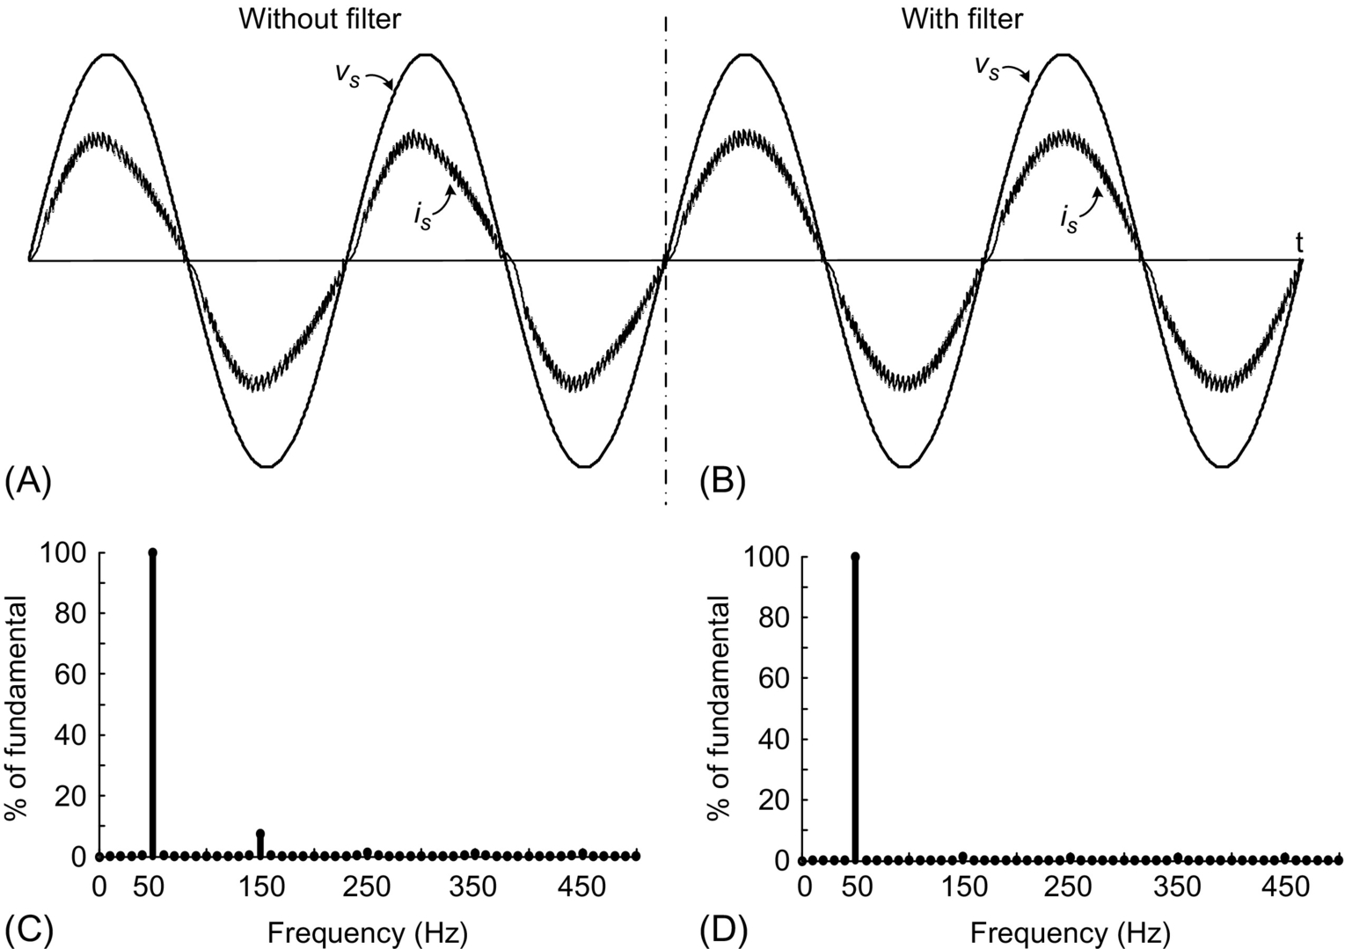

**FIG. 8.20** Input current and voltage of the single-phase boost rectifier: (A) without a filter on *vo* measurement; (B) with a filter on *vo* measurement, frequency spectrum; (C) without filter; and (D) with filter.

However, in both cases, a drastic reduction in the harmonic content of the input current *is* can be observed in the frequency spectrum of [Fig. 8.20C and D](https://learning.oreilly.com/library/view/power-electronics-handbook/9780128114087/B9780128114070000088.xhtml#f0105). This current fulfills the restrictions established by standard IEC 61000-3-2. The total harmonic distortion of the current in [Fig. 8.20A](https://learning.oreilly.com/library/view/power-electronics-handbook/9780128114087/B9780128114070000088.xhtml#f0105) is THD=7.46%, while the THD of the current of [Fig. 8.20B](https://learning.oreilly.com/library/view/power-electronics-handbook/9780128114087/B9780128114070000088.xhtml#f0105) is 4.83%; in both cases, a very high power factor, over 0.99, is reached.

[Fig. 8.21](https://learning.oreilly.com/library/view/power-electronics-handbook/9780128114087/B9780128114070000088.xhtml#f0110) shows the dc voltage control loop dynamic behavior for step changes in the load. An increase in the load, at *t*=0.3 (s), produces an initial reduction of the output voltage *vo*, which is compensated by an increase in the input current *is*. At *t*=0.6 (s), a step decrease in the load is applied. The dc voltage controller again adjusts the supply current in order to balance the active power.

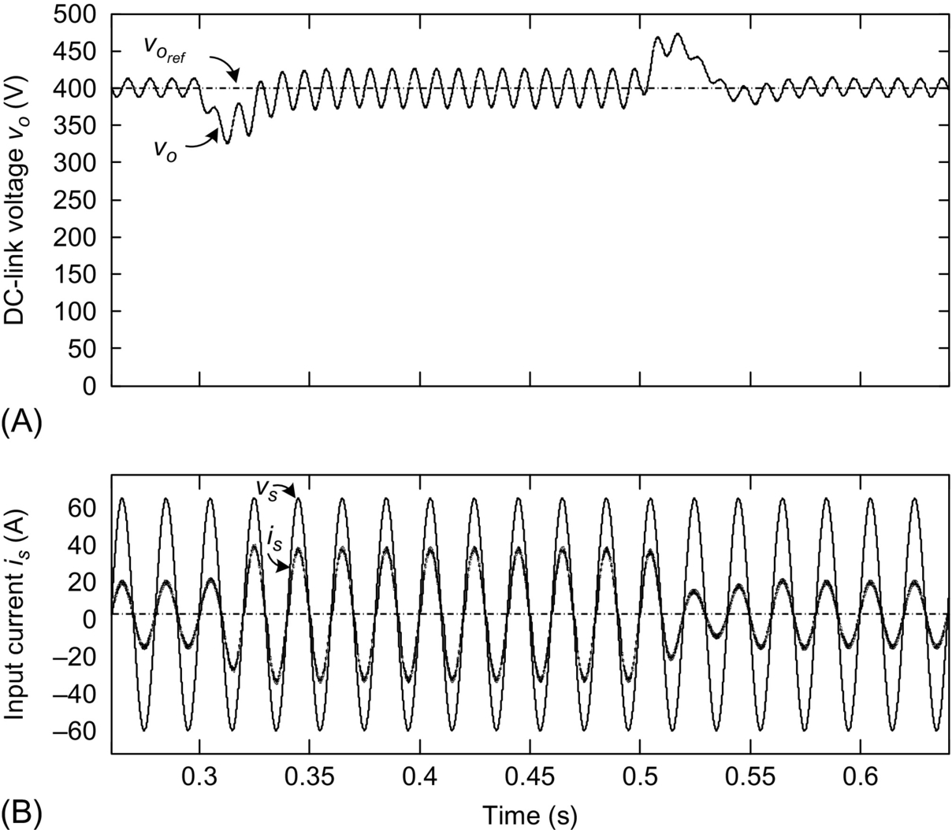

**FIG. 8.21** Response to a change in the load, (A) output voltage *vo* and (B) input current *is*.

#### **8.3.3.3 Discontinuous Conduction Mode (DCM)**

This PFC method is based on an active current waveform-shaping principle. There are two different approaches considering fixed and variable switching frequency, both operating principles are illustrated in [Fig. 8.22](https://learning.oreilly.com/library/view/power-electronics-handbook/9780128114087/B9780128114070000088.xhtml#f0115).

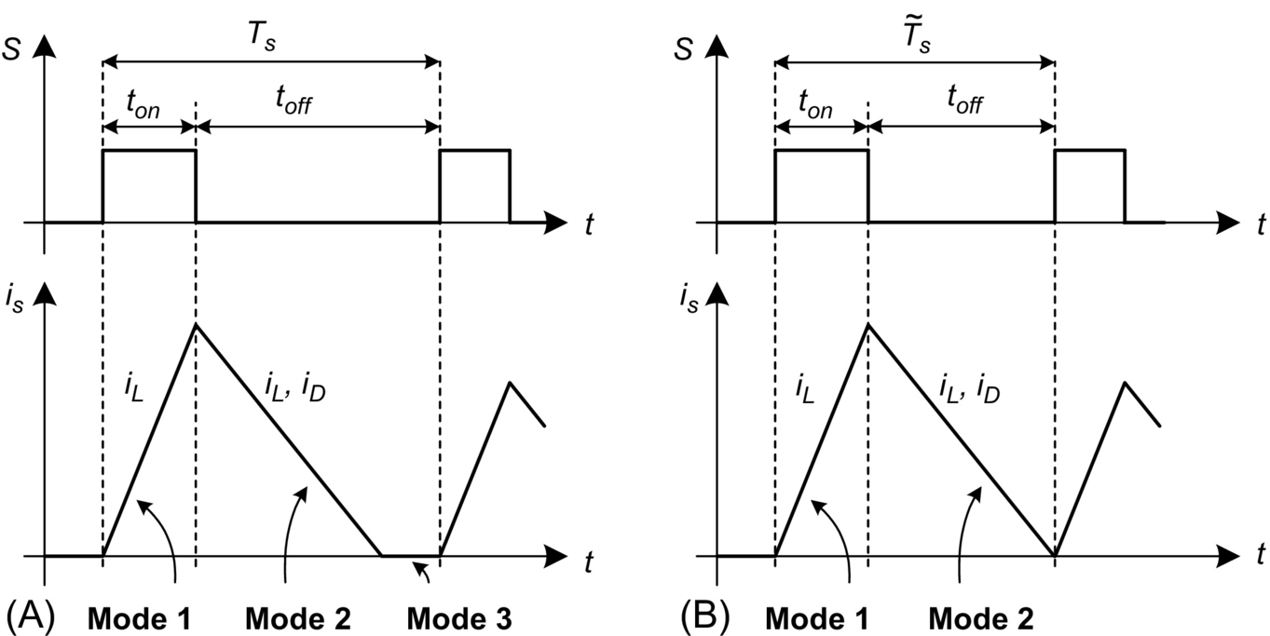

**FIG. 8.22** Boost DCM operating principle, (A) with fixed switching frequency and (B) with variable switching frequency.

(a) DCM with fixed switching frequency

The current shaping strategy is achieved by combining three different conduction modes, performed over a fixed switching period *Ts*. At the beginning of each period, the power semiconductor is turned on. During the on-state, shown in [Fig. 8.23A](https://learning.oreilly.com/library/view/power-electronics-handbook/9780128114087/B9780128114070000088.xhtml#f0120), the power supply is short-circuited through the rectifier diodes, the inductor *L*, and the boost switch *T*. Hence, the inductor current *iL* increases at a rate proportional to the instantaneous value of the supply voltage. As a result, during the on-state, the average supply current *is* is proportional to the supply voltage *vs*, which yields to power factor correction.

When the switch is turned off, the current flows to the load trough diode D, as shown in [Fig. 8.23B](https://learning.oreilly.com/library/view/power-electronics-handbook/9780128114087/B9780128114070000088.xhtml#f0120). The instantaneous current value decreases (since the load voltage *vo* is higher than the supply peak voltage) at a rate proportional to the difference between the supply and load voltage. Finally, the last mode, illustrated in [Fig. 8.23C](https://learning.oreilly.com/library/view/power-electronics-handbook/9780128114087/B9780128114070000088.xhtml#f0120), corresponds to the time in which the current reaches zero value, completing the switching period *Ts*. Therefore, the supply current is not proportional to the voltage source during the whole control period, introducing distortion and undesirable EMI in comparison with CCM.

The duty cycle  is determined by the control loop, in order to obtain the desired output power and to ensure operation in DCM, that is, to reach zero current before the new switching cycle starts. The control strategy can be implemented with analog circuitry as shown in [Fig. 8.24](https://learning.oreilly.com/library/view/power-electronics-handbook/9780128114087/B9780128114070000088.xhtml#f0125), or digitally with modern computing devices. Generally, the duty cycle is controlled with a slow control loop, maintaining the output voltage and duty cycle constant over a half-source cycle.

A qualitative example of the supply voltage and current obtained using DCM is illustrated in [Fig. 8.25](https://learning.oreilly.com/library/view/power-electronics-handbook/9780128114087/B9780128114070000088.xhtml#f0130).

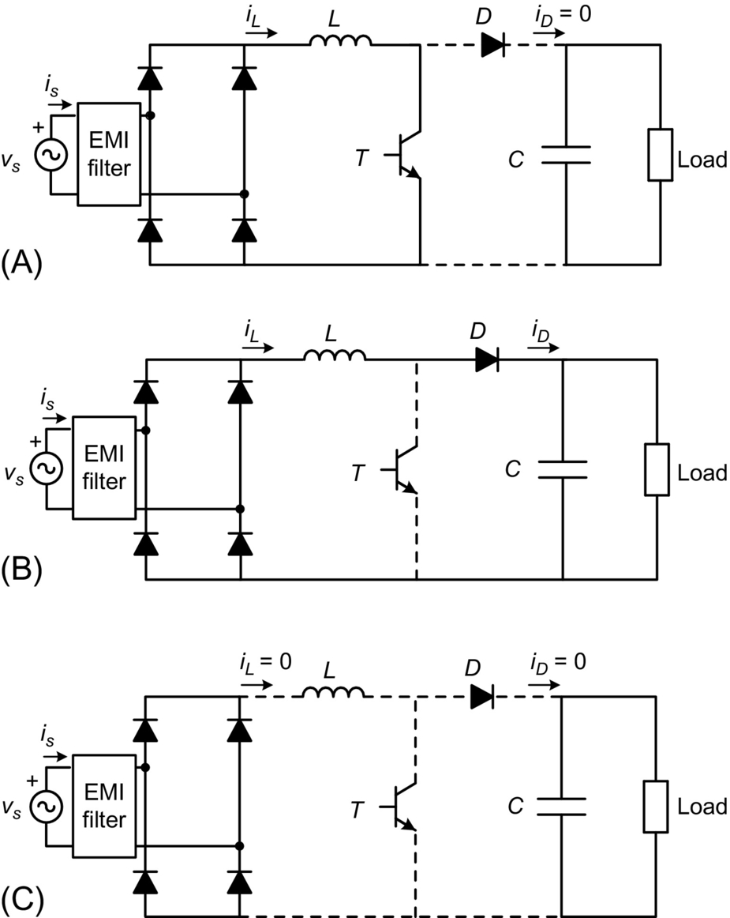

**FIG. 8.23** Boost DCM equivalent circuits: (A) mode 1, transistor on, inductor current increasing; (B) mode 2, transistor off, inductor current decreasing; and (C) mode 3, transistor off, inductor current reaches zero. (Insert figure from the third edition).

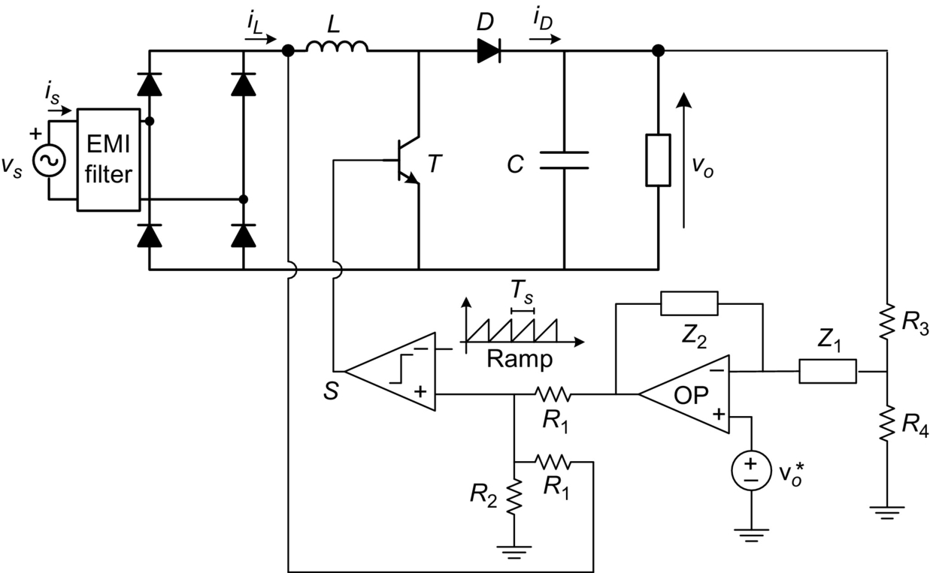

**FIG. 8.24** Boost DCM control circuit with fixed switching frequency.

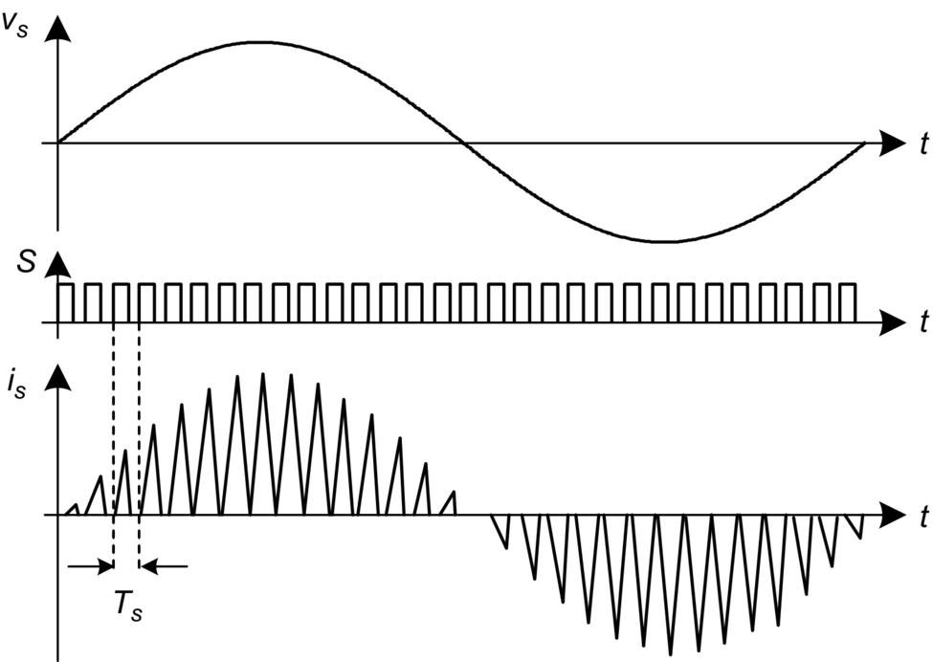

**FIG. 8.25** Boost DCM waveforms: supply voltage, transistor control signal, and supply current.

(b) DCM with variable switching frequency

The operating principle is similar to the one used in the previous case, the main difference is that mode 3 is avoided by switching the transistor again to the on-state, immediately after the inductor current reaches zero value. This reduces the current distortion, with the trade-off of introducing variable switching frequency (*Ts* is variable) and consequently lower-order harmonic content.

Both CCM and DCM achieve an improvement in the power factor. The DCM is more efficient since reverse-recovery losses of the boost diode are eliminated; however, this mode introduces high-current ripple and considerable distortion, and usually, an important fifth-order harmonic is obtained. Therefore, boost DCM applications are limited to 300 W power levels, to meet standards and regulations. The DCM with variable switching frequency reduces this harmonic content, at expends of a wide distributed current spectrum and all related design problems.

#### **8.3.3.4 Resonant Structures for the Boost Rectifiers**

An important issue in power electronics is the power losses in power semiconductors. These losses can be classified in two groups: conduction losses and switching losses, as shown in [Fig. 8.26](https://learning.oreilly.com/library/view/power-electronics-handbook/9780128114087/B9780128114070000088.xhtml#f0135).

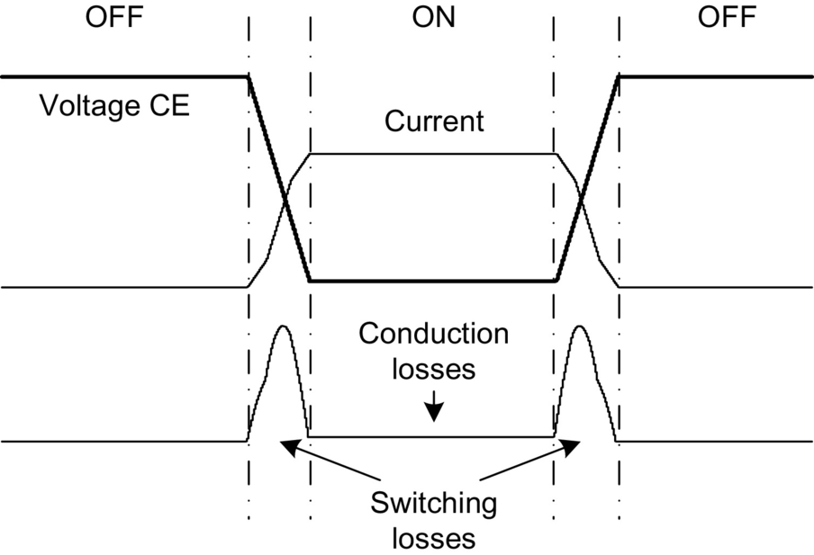

**FIG. 8.26** Conduction and switching losses on a power switch.

The conduction losses are produced by the current through the semiconductor juncture, so these losses are unavoidable. However, the switching losses, which are produced while the power semiconductors work in linear state during the transition from on- to off-state or from off- to on-state, can be reduced or even eliminated, if the switch (transition) occurs when (a) the current across the power semiconductor is zero or (b) the voltage between the power terminals of the power semiconductor is zero.

This operation mode is used in the so-called *resonant* or *soft-switched* converters, which are discussed in detail in a different chapter of this handbook. Resonant operation can also be used with the boost converter topology. In order to produce this condition, topology of [Fig. 8.17](https://learning.oreilly.com/library/view/power-electronics-handbook/9780128114087/B9780128114070000088.xhtml#f0090) needs to be modified, by including reactive components and additional semiconductors.

In [Fig. 8.27](https://learning.oreilly.com/library/view/power-electronics-handbook/9780128114087/B9780128114070000088.xhtml#f0140), a resonant structure for zero-current switching (ZCS) [[8](https://learning.oreilly.com/library/view/power-electronics-handbook/9780128114087/B9780128114070000088.xhtml#bb0045)] is shown. As can be seen, additional resonant inductors ( and ), capacitors (*Cr*), diodes ( and ), and power switch (*Sr*) have been included.

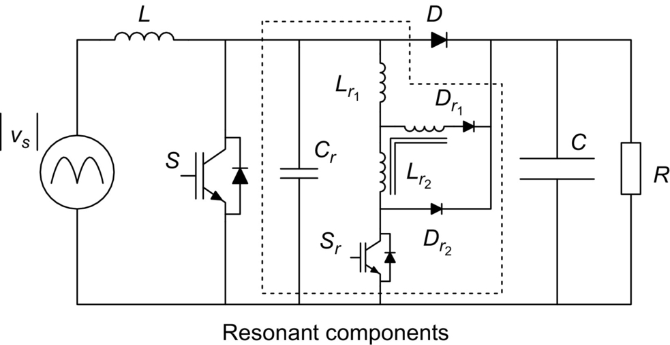

**FIG. 8.27** Boost rectifier with ZCS.

In a similar way, in [Fig. 8.28](https://learning.oreilly.com/library/view/power-electronics-handbook/9780128114087/B9780128114070000088.xhtml#f0145), a resonant structure for zero-voltage switching (ZVS) [[9](https://learning.oreilly.com/library/view/power-electronics-handbook/9780128114087/B9780128114070000088.xhtml#bb0050)] is shown. Once again, additional inductance (*Lr*), capacitor (*Cr*), and power switch (*Sr*) are added; note, however, that diode D has been replaced by two “resonant diodes,”  and . In both cases, the ZVS or ZCS condition is reached through a proper control of *Sr*. Other resonant topologies are described in the literature [[10](https://learning.oreilly.com/library/view/power-electronics-handbook/9780128114087/B9780128114070000088.xhtml#bb0055)–[12](https://learning.oreilly.com/library/view/power-electronics-handbook/9780128114087/B9780128114070000088.xhtml#bb0065)] with similar behavior.

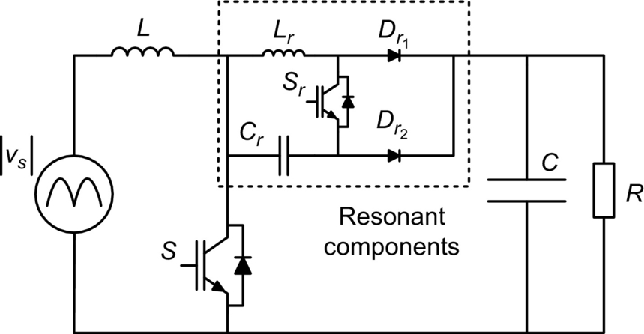

**FIG. 8.28** Boost rectifier with ZVS.

#### **8.3.3.5 Bridgeless Boost Rectifier**

The bridgeless boost rectifier [[13](https://learning.oreilly.com/library/view/power-electronics-handbook/9780128114087/B9780128114070000088.xhtml#bb0070)] is shown in [Fig. 8.29A](https://learning.oreilly.com/library/view/power-electronics-handbook/9780128114087/B9780128114070000088.xhtml#f0150). This rectifier replaces the input diode rectifier by a combination of two boost rectifiers that work alternately: (a) When *vs* is positive, T1 and D1 operate as boost rectifier 1 ([Fig. 8.29B](https://learning.oreilly.com/library/view/power-electronics-handbook/9780128114087/B9780128114070000088.xhtml#f0150)), and (b) when *vs* is negative, T2 and D2 operate as boost rectifier 2 ([Fig. 8.29C](https://learning.oreilly.com/library/view/power-electronics-handbook/9780128114087/B9780128114070000088.xhtml#f0150)).

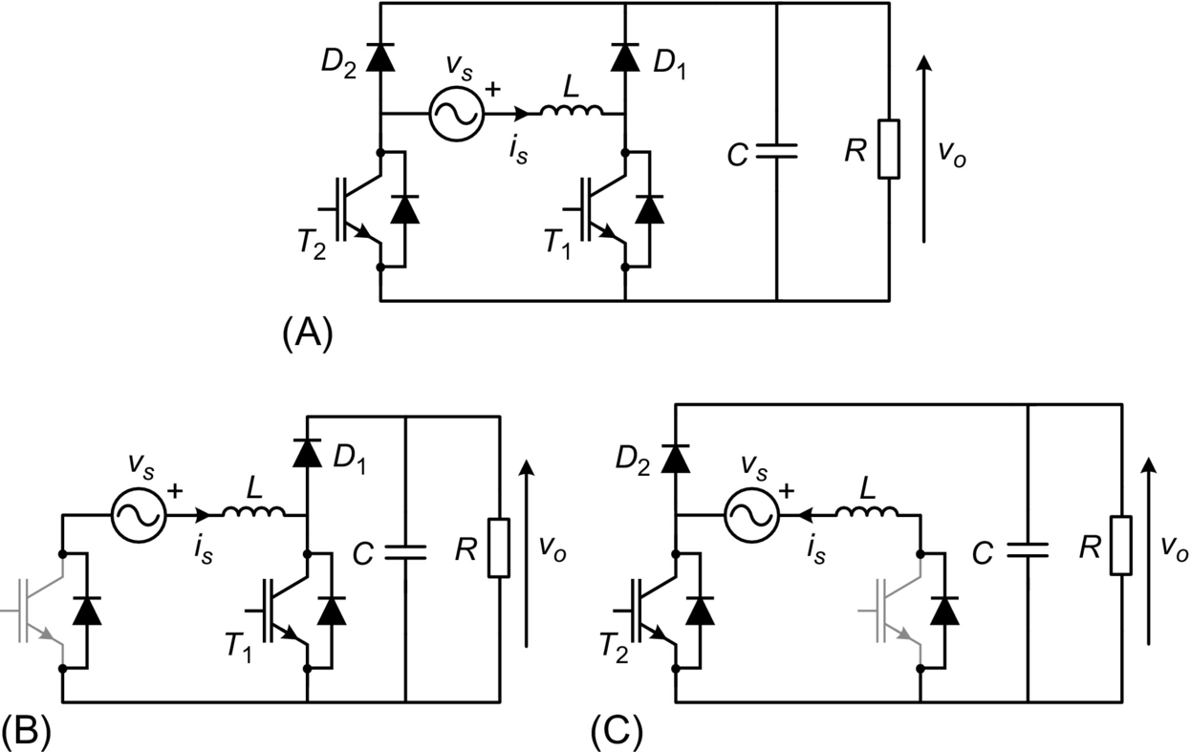

**FIG. 8.29** (A) Power circuit of bridgeless boost rectifier; equivalent circuit when (B) *vs*>0 and (C) *vs*<0.

This topology reduces the conduction losses of the rectifier [[14](https://learning.oreilly.com/library/view/power-electronics-handbook/9780128114087/B9780128114070000088.xhtml#bb0075),[15](https://learning.oreilly.com/library/view/power-electronics-handbook/9780128114087/B9780128114070000088.xhtml#bb0080)] but requires a slightly more complex control scheme; also EMI and EMC aspects must be considered.

### 8.3.4 VOLTAGE DOUBLER PWM RECTIFIER

[Fig. 8.30A](https://learning.oreilly.com/library/view/power-electronics-handbook/9780128114087/B9780128114070000088.xhtml#f0155) shows the power circuit of the voltage-doubler pulse-width-modulated (PWM) rectifier, which uses two transistors T1 and T2 and two filter capacitors *C*1 and *C*2. The transistors are switched complementary to control the waveform of the input current *is* and the output dc voltage *vo*. Capacitor voltages *VC*1 and *VC*2 must be higher than the peak value of the input voltage *vs* to ensure the control of the input current.

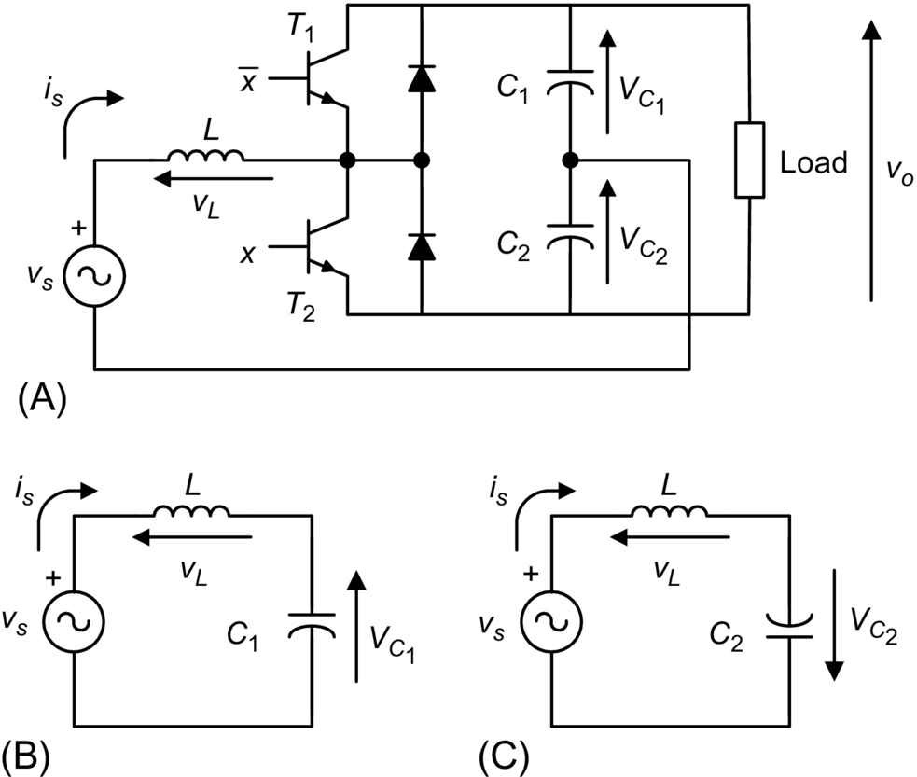

**FIG. 8.30** Voltage-doubler rectifier: (A) power circuit, (B) equivalent circuit with T1 on, and (C) equivalent circuit with T2 on.

The equivalent circuit of this rectifier with transistor T1 in the on-state is shown in [Fig. 8.30B](https://learning.oreilly.com/library/view/power-electronics-handbook/9780128114087/B9780128114070000088.xhtml#f0155). For this case, the inductor voltage dynamic equation is 10.5:

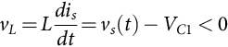 **(8.28)**

Eq. [(8.28)](https://learning.oreilly.com/library/view/power-electronics-handbook/9780128114087/B9780128114070000088.xhtml#fo0145) means that under this conduction state, current *is*(*t*) decreases its value.

On the other hand, the equivalent circuit of [Fig. 8.30C](https://learning.oreilly.com/library/view/power-electronics-handbook/9780128114087/B9780128114070000088.xhtml#f0155) is valid when transistor T2 is in the conduction state, resulting in the following expression for the inductor voltage

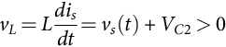 **(8.29)**

Hence, for this condition, the input current *is*(*t*) increases.

Therefore, the waveform of the input current can be controlled by switching appropriately transistors T1 and T2 in a similar way as shown in [Fig. 8.18A](https://learning.oreilly.com/library/view/power-electronics-handbook/9780128114087/B9780128114070000088.xhtml#f0095) for the single-phase boost converter. [Fig. 8.31](https://learning.oreilly.com/library/view/power-electronics-handbook/9780128114087/B9780128114070000088.xhtml#f0160) shows a block diagram of the control system for the voltage-doubler rectifier, which is very similar to the control scheme of the boost rectifier. This topology can present an unbalance in the capacitor voltages *VC*1 and *VC*2, which will affect the quality of the control. This problem is solved by adding to the actual current value *is* an offset signal proportional to the capacitor's voltage difference.

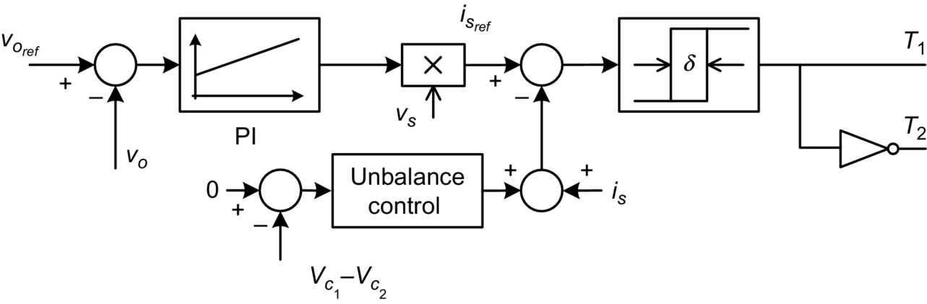

**FIG. 8.31** Control system of the voltage-doubler rectifier.

[Fig. 8.32](https://learning.oreilly.com/library/view/power-electronics-handbook/9780128114087/B9780128114070000088.xhtml#f0165) shows the waveform of the input current. The ripple amplitude of this current can be reduced by decreasing the hysteresis width of the controller.

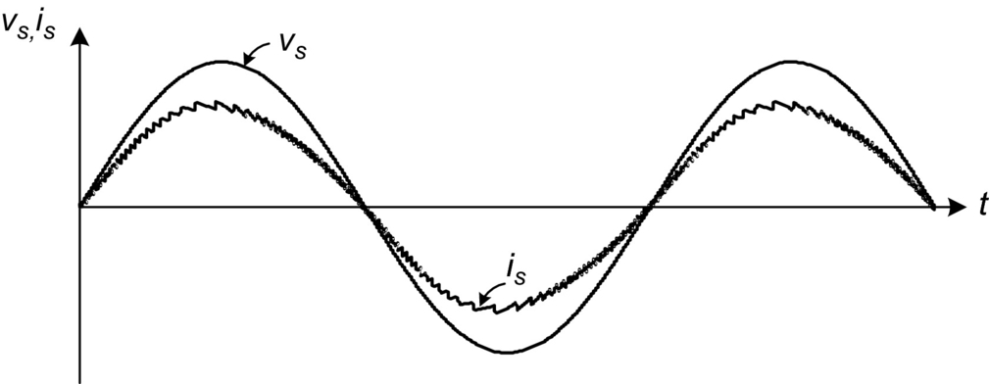

**FIG. 8.32** Waveform of the input current in the voltage-doubler rectifier.

### 8.3.5 THE PWM RECTIFIER IN BRIDGE CONNECTION

[Fig. 8.33A](https://learning.oreilly.com/library/view/power-electronics-handbook/9780128114087/B9780128114070000088.xhtml#f0170) shows the power circuit of the fully controlled single-phase PWM rectifier in bridge connection, which uses four transistors with antiparallel diodes to produce a controlled dc voltage *vo*. Using a bipolar PWM switching strategy, this converter may have two conduction states: (i) transistors T1 and T4 in the on-state and T2 and T3 in the off-state and (ii) transistors T2 and T3 in the on-state and T1 and T4 in the off-state.

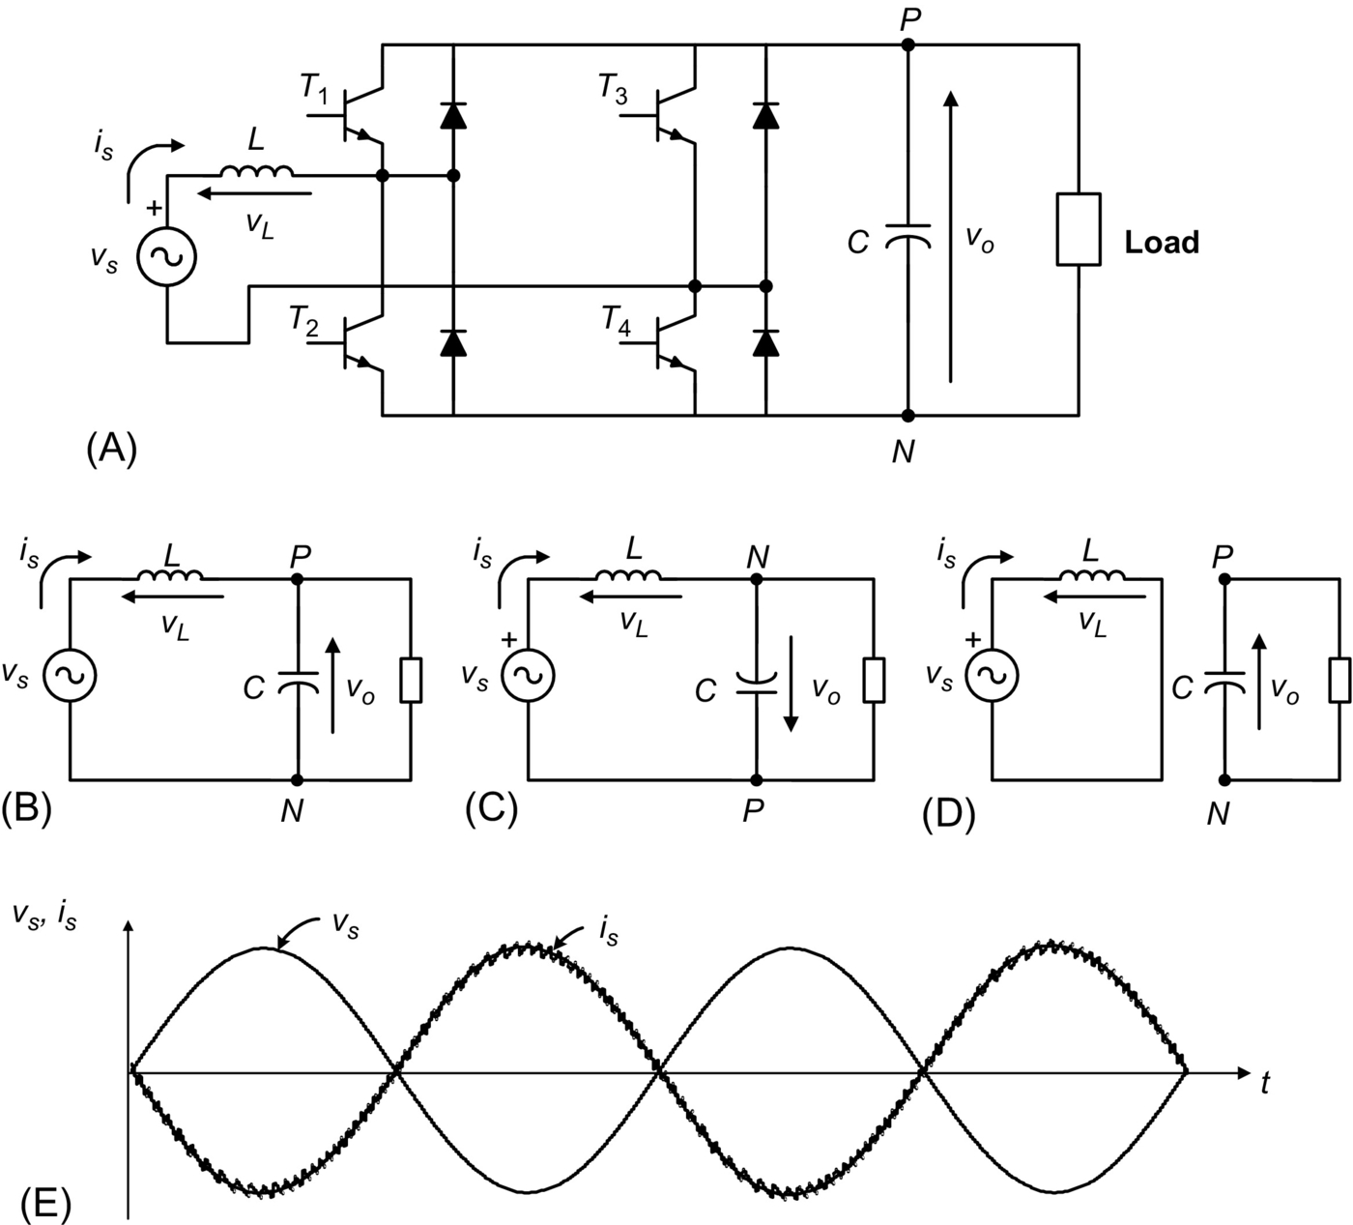

**FIG. 8.33** Single-phase PWM rectifier in bridge connection: (A) power circuit, (B) equivalent circuit with T1 and T4 on, (C) equivalent circuit with T2 and T3 on, (D) equivalent circuit with T1 and T3 or T2 and T4 on, and (E) waveform of the input current during regeneration.

In this topology, the output voltage *vo* must be higher than the peak value of the ac source voltage *vs*, to ensure a proper control of the input current.

[Fig. 8.33B](https://learning.oreilly.com/library/view/power-electronics-handbook/9780128114087/B9780128114070000088.xhtml#f0170) shows the equivalent circuit with transistors T1 and T4 on. In this case, the inductor voltage is given by

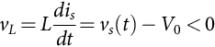 **(8.30)**

Therefore, in this condition, a reduction of the inductor current *is* is produced.

[Fig. 8.33C](https://learning.oreilly.com/library/view/power-electronics-handbook/9780128114087/B9780128114070000088.xhtml#f0170) shows the equivalent circuit with transistors T2 and T3 on. Here, the inductor voltage has the following expression:

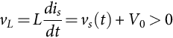 **(8.31)**

which means an increase in the instantaneous value of the input current *is*.

Finally, [Fig. 8.33D](https://learning.oreilly.com/library/view/power-electronics-handbook/9780128114087/B9780128114070000088.xhtml#f0170) shows the equivalent circuit with transistors T1 and T3 or T2 and T4 are in the on-state. In this case, the input voltage source is short-circuited through inductor *L*, which yields

 **(8.32)**

Eq. [(8.32)](https://learning.oreilly.com/library/view/power-electronics-handbook/9780128114087/B9780128114070000088.xhtml#fo0165) implies that the current value will depend on the sign of *vs*.

The waveform of the input current *is* can be controlled by appropriately switching transistors T1–T4 or T2–T3, originating a similar shape to the one shown in [Fig. 8.18A](https://learning.oreilly.com/library/view/power-electronics-handbook/9780128114087/B9780128114070000088.xhtml#f0095) for the single-phase boost rectifier.

The control strategy for the rectifier is similar to the one illustrated in [Fig. 8.31](https://learning.oreilly.com/library/view/power-electronics-handbook/9780128114087/B9780128114070000088.xhtml#f0160), for the voltage-doubler topology. The quality of the input current obtained with this rectifier is the same as presented in [Fig. 8.32](https://learning.oreilly.com/library/view/power-electronics-handbook/9780128114087/B9780128114070000088.xhtml#f0165) for the voltage-doubler configuration.

The input current waveform can be slightly improved if the state of [Fig. 8.33D](https://learning.oreilly.com/library/view/power-electronics-handbook/9780128114087/B9780128114070000088.xhtml#f0170) is used. This can be done by replacing the hysteresis current control with a more complex linear control plus a three-level PWM modulator. This method reduces the semiconductor switching frequency and provides a more defined current spectrum.

Finally, it must be said that one of the most attractive characteristics of the fully controlled PWM converter in bridge connection and the voltage doubler is their regeneration capability. In effect, these rectifiers can deliver power from the load to the single-phase supply, operating with sinusoidal current and a high power factor of . [Fig. 8.33E](https://learning.oreilly.com/library/view/power-electronics-handbook/9780128114087/B9780128114070000088.xhtml#f0170) shows that during regeneration, the input current *is* is 180 degrees out of phase with respect to the supply voltage *vs*, which means operation with power factor  (PF is approximately 1 because of the small harmonic content in the input current).

### 8.3.6 APPLICATIONS OF UNITY POWER FACTOR RECTIFIERS

#### **8.3.6.1 Boost Rectifier Applications**

The single-phase boost rectifier has become the most popular topology for power factor correction (PFC) in general-purpose power supplies. To reduce the costs, the complete control system shown in [Fig. 8.19](https://learning.oreilly.com/library/view/power-electronics-handbook/9780128114087/B9780128114070000088.xhtml#f0100) and the gate drive circuit of the power transistor have been included in a single integrated circuit (IC), like the UC3854 [[16](https://learning.oreilly.com/library/view/power-electronics-handbook/9780128114087/B9780128114070000088.xhtml#bb0085)] or MC33262, shown in [Fig. 8.34](https://learning.oreilly.com/library/view/power-electronics-handbook/9780128114087/B9780128114070000088.xhtml#f0175).

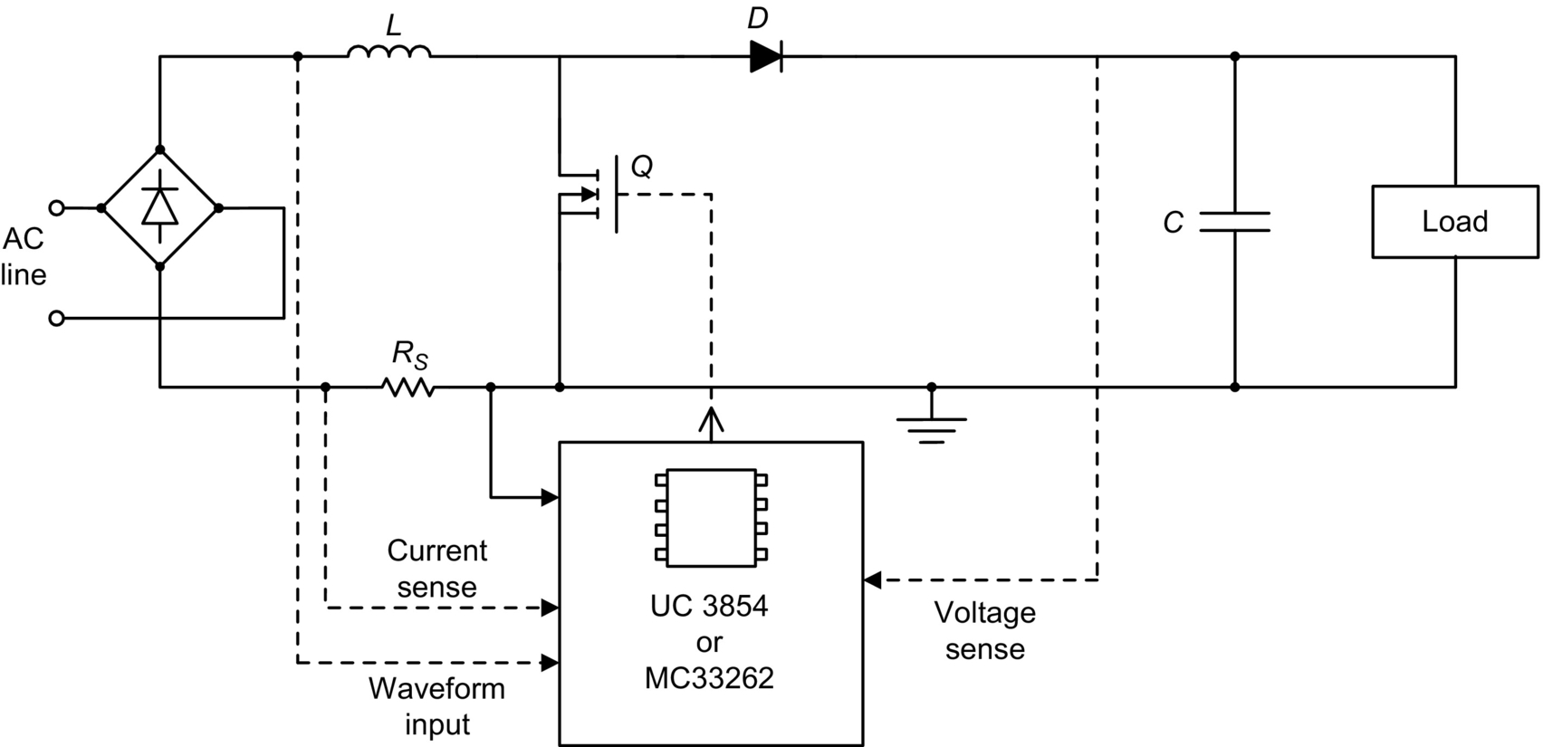

**FIG. 8.34** Simplified circuit of a power factor corrector with control integrated circuit.

Today, there is increased interest in developing high-frequency electronic ballasts to replace the classical electromagnetic ballast present in fluorescent lamps. These electronic ballasts require an ac-dc converter. To satisfy the harmonic current injection from electronic equipment and to maintain a high power quality, a high-power-factor rectifier can be used, as shown in [Fig. 8.35](https://learning.oreilly.com/library/view/power-electronics-handbook/9780128114087/B9780128114070000088.xhtml#f0180) [[17](https://learning.oreilly.com/library/view/power-electronics-handbook/9780128114087/B9780128114070000088.xhtml#bb0090)].

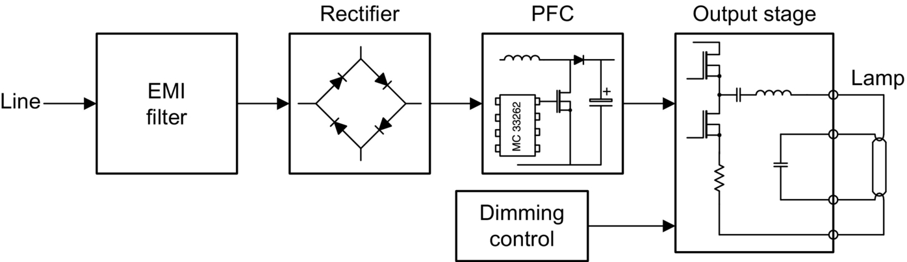

**FIG. 8.35** Functional block diagram of electronic ballast with power factor correction.

#### **8.3.6.2 Voltage Doubler PWM Rectifier**

The development of low-cost compact motor drive systems is a very relevant topic, particularly in the low-power range. [Fig. 8.36](https://learning.oreilly.com/library/view/power-electronics-handbook/9780128114087/B9780128114070000088.xhtml#f0185) shows a low-cost converter for low-power induction motor drives. In this configuration, a three-phase induction motor is fed through the converter from a single-phase power supply. Transistors T1 and T2 and capacitors *C*1 and *C*2 constitute the voltage-doubler single-phase rectifier, which controls the dc link voltage and generates sinusoidal input current, working with close-to-unity power factor [[18](https://learning.oreilly.com/library/view/power-electronics-handbook/9780128114087/B9780128114070000088.xhtml#bb0095)]. On the other hand, transistors T3, T4, T5, and T6 and capacitors *C*1 and *C*2 constitute the power circuit of an asymmetrical inverter that supplies the motor. An important characteristic of the power circuit shown in [Fig. 8.36](https://learning.oreilly.com/library/view/power-electronics-handbook/9780128114087/B9780128114070000088.xhtml#f0185) is the capability of regenerating power to the single-phase mains.

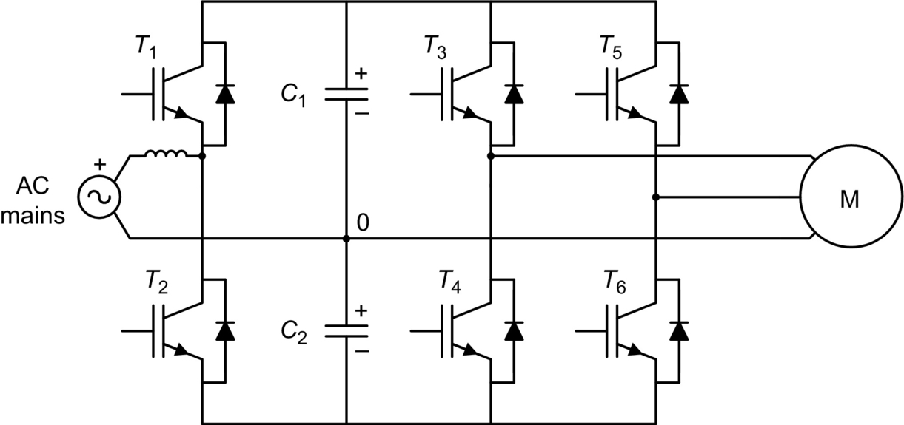

**FIG. 8.36** Low-cost induction motor drive.

#### **8.3.6.3 PWM Rectifier in Bridge Connection**

Distortion of the input current in the line-commutated rectifiers with capacitive filtering is particularly critical in the UPS fed from motor-generator sets. In effect, due to the higher value of the generator impedance, the current distortion can originate an unacceptable distortion on the ac voltage, which affects the behavior of the whole system. For this reason, it is very attractive to use rectifiers with low distortion in the input current.

[Fig. 8.37](https://learning.oreilly.com/library/view/power-electronics-handbook/9780128114087/B9780128114070000088.xhtml#f0190) shows the power circuit of a single-phase UPS, which has a PWM rectifier in bridge connection at the input side. This rectifier generates a sinusoidal input current and controls the charge of the battery [[19](https://learning.oreilly.com/library/view/power-electronics-handbook/9780128114087/B9780128114070000088.xhtml#bb0100)].

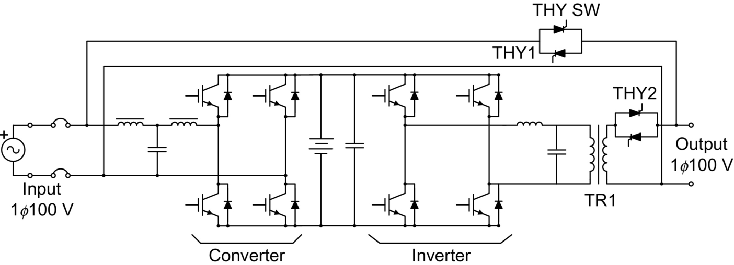

**FIG. 8.37** Single-phase UPS with PWM rectifier.

Perhaps the most typical and widely accepted area of application of high-power-factor single-phase rectifiers is in locomotive drives [[20](https://learning.oreilly.com/library/view/power-electronics-handbook/9780128114087/B9780128114070000088.xhtml#bb0105)]. An essential prerequisite for proper operation of voltage-source three-phase inverter drives in modern locomotives is the use of four-quadrant line-side converters, which ensure motoring and braking of the drive, with reduced harmonics in the input current. [Fig. 8.38](https://learning.oreilly.com/library/view/power-electronics-handbook/9780128114087/B9780128114070000088.xhtml#f0195) shows a simplified power circuit of a typical drive for a locomotive connected to a single-phase power supply [[20](https://learning.oreilly.com/library/view/power-electronics-handbook/9780128114087/B9780128114070000088.xhtml#bb0105)], which includes a high-power-factor rectifier at the input.

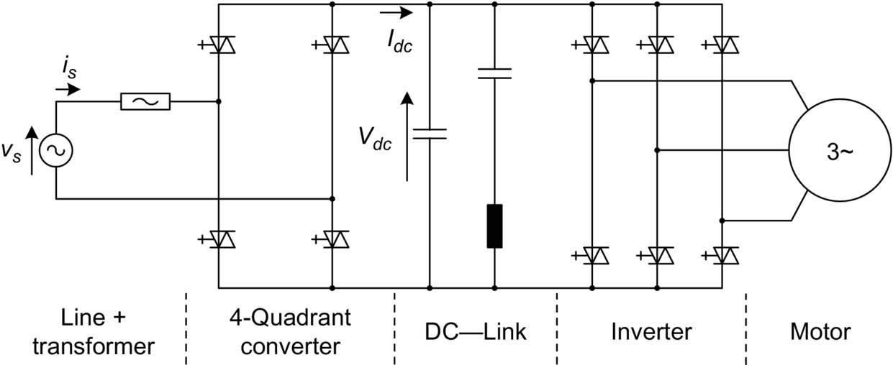

**FIG. 8.38** Typical power circuit of an ac drive for locomotive.

Finally, [Fig. 8.39](https://learning.oreilly.com/library/view/power-electronics-handbook/9780128114087/B9780128114070000088.xhtml#f0200) shows the main circuit diagram of the 300 series Shinkansen train [[21](https://learning.oreilly.com/library/view/power-electronics-handbook/9780128114087/B9780128114070000088.xhtml#bb0110)]. In this application, ac power from the overhead catenary is transmitted through a transformer to single-phase PWM rectifiers, which provide the dc voltage for the inverters. The rectifiers are capable of controlling the input ac current in an approximate sine waveform and in phase with the voltage, achieving power factor close to unity on powering and on regenerative braking. Regenerative braking produces energy savings and an important operational flexibility.

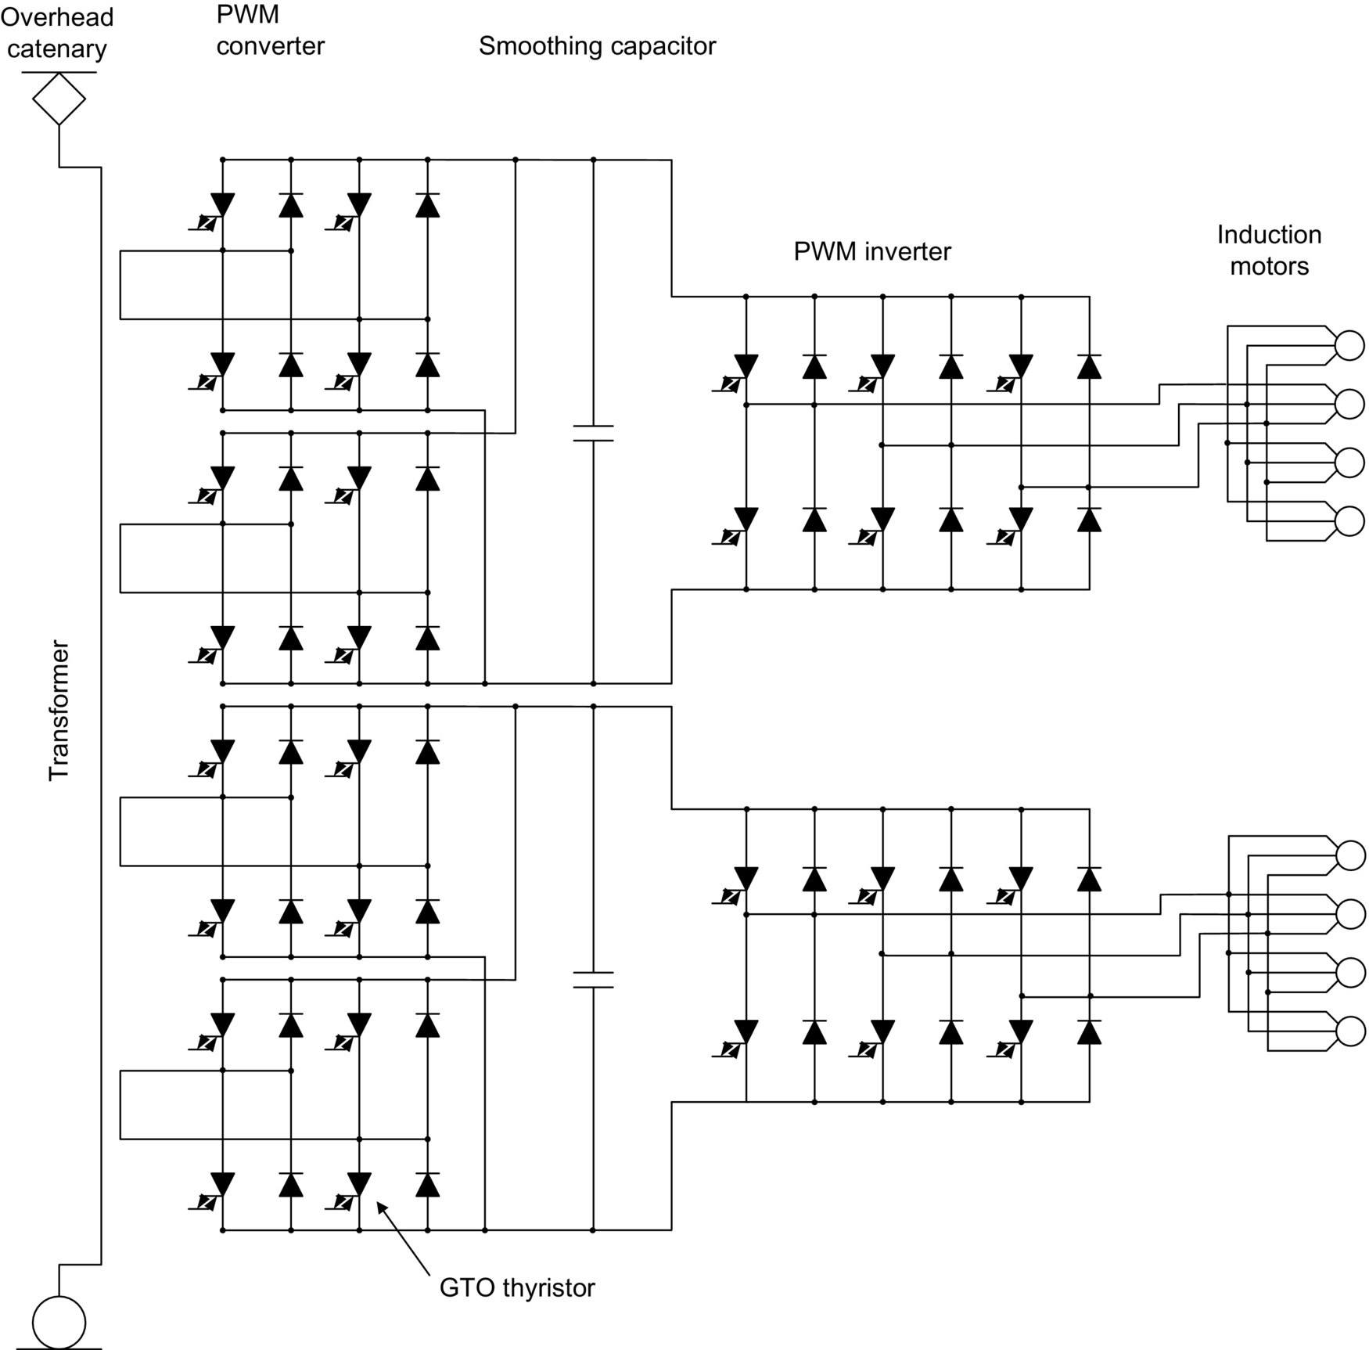

**FIG. 8.39** Main circuit diagram of 300 series Shinkansen locomotives.

### 8.3.7 SYNCHRONOUS RECTIFIER

The synchronous rectifier (SR) also known as active rectifier is able to reduce the losses, which lead to improvement in efficiency. The conduction loss contributes a significant role in the overall power loss of diode rectifier, especially in low-output-voltage applications. In the diode rectifier, conduction loss of diode depends on the forward voltage drop, diode resistance, and the magnitude of current that passes through the devices, while in the SR, MOSFET conduction loss depends on the on resistance (*RDS,on*) of the MOSFET and the current that passes through the devices. Moreover, driving loss is also a part of conduction losses in MOSFET, but it has a very less significant role as compared with total power loss. Therefore, the SR has been widely adopted in low-output-voltage applications with reducing the conduction loss of the output rectifier to improve the efficiency.

The advantages of using SR in high-performance, high-power converters include better efficiency, lower power dissipation, better thermal performance, and inherently optimal current sharing when synchronous MOSFETs are paralleled. The number of MOSFETs can be paralleled to handle higher output currents and results in less equivalent effective *RDS,on*. Moreover, *RDS,on* has a positive temperature coefficient so the MOSFETs will automatically tend to share current equally, facilitating optimal thermal distribution among the SR devices. This improves the ability to remove heat from the components and the PCB, directly improving the thermal performance of the design. Other potential benefits from SR include smaller form factors, higher ambient operating temperatures, and higher power densities. As discussed above, the downside to SRs is that they require control circuitry to ensure the devices turn on or off synchronously, that is, at the right time. Circuitry required for the control of the SR normally includes voltage and current detectors and drive circuitry for the active devices.

#### **8.3.7.1 Operating Principle**

[Fig. 8.40](https://learning.oreilly.com/library/view/power-electronics-handbook/9780128114087/B9780128114070000088.xhtml#f0205) shows the circuit diagram of SR that consists an inductor and four transistors with their body diodes. The transistor used in the circuit must be the MOSFET that can conduct in both the direction. The operating principle of SR is based on the modes of technique to generate the gate signal. The current-driven SR has been used to generate the gate signal for the devices as this method is suitable for all types of topologies and offered number of advantages over voltage-driven method. The current-driven method senses the current flowing through the SR to turn on and turn off the SR properly. The current sensor is used to sense the input current that must flow through the devices. However, for positive half cycle of supply voltage, the current will flow (source to rectifier direction) through the MOSFETs *S*1 and *S*2, and for negative cycle of supply voltage, current will flow (rectifier to source direction) through MOSFETs *S*3 and *S*4.

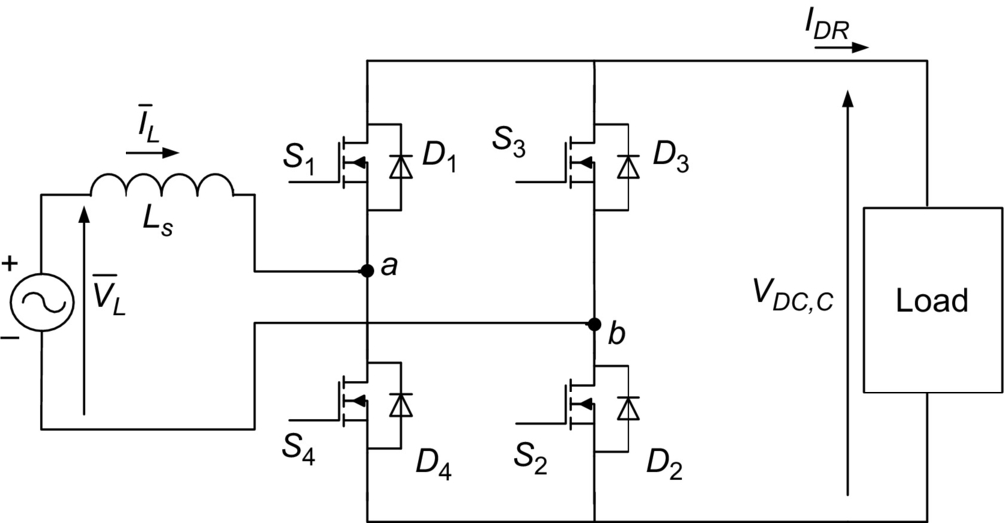

**FIG. 8.40** Schematic of synchronous rectifier.

The waveforms of gate signal and dead time are shown in [Fig. 8.41](https://learning.oreilly.com/library/view/power-electronics-handbook/9780128114087/B9780128114070000088.xhtml#f0210). At the beginning of the sinusoidal cycle, the current starts flowing in the body diode, generating a negative *VDS* across the MOSFET; at that point, turn-on signal is provided to the MOSFET. The dropout voltage across the device falls to much lower voltage, and MOSFET turned on as soft switching that helps to reduce the power losses and results in increasing the system efficiency. Once the MOSFET is on, it must remain in this position until the rectified current will decrease to almost zero; closer is better for the losses point of view. Therefore, a zero-crossing comparator can be used to understand when the drain-source voltage reaches the zero-voltage condition. For this purposes, the value of threshold voltage to turn off the devices must be negative and close to zero, to avoid cross conduction and reduce the body-diode conduction interval at the tail of the semisinusoid.

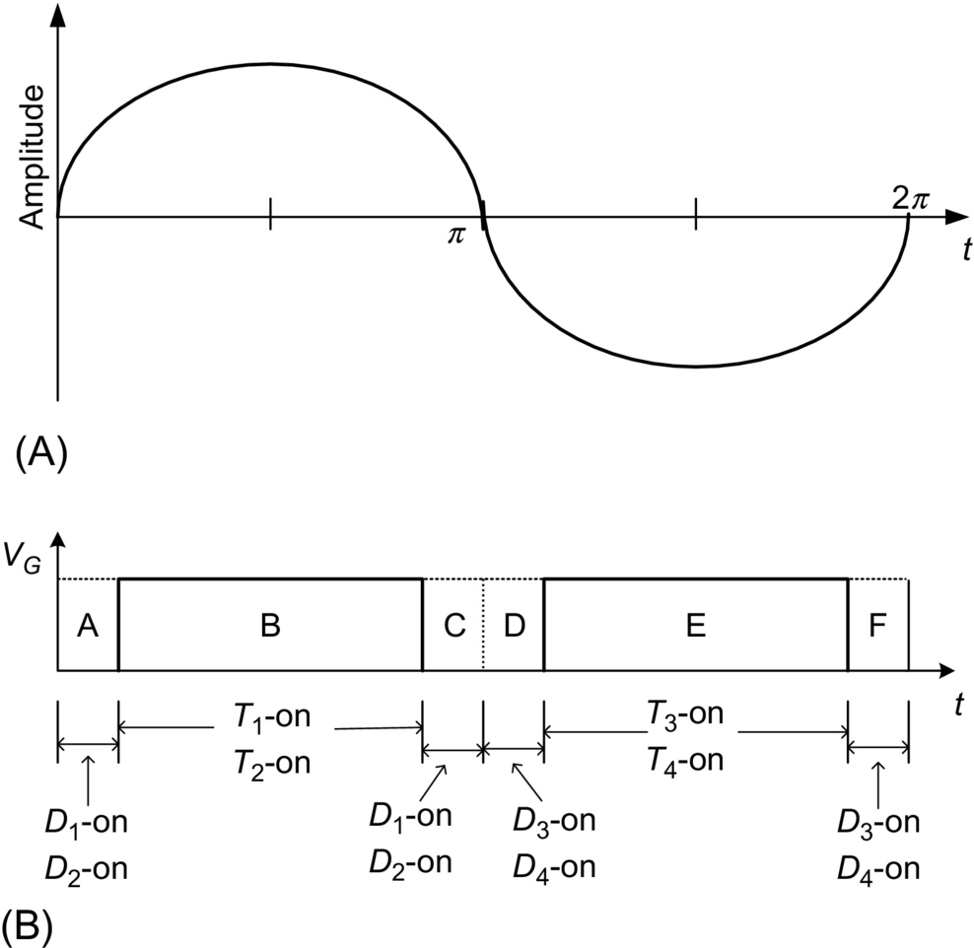

**FIG. 8.41** Schematic diagram of (A) current signal and (B) turn-on and turn-off period [[22](https://learning.oreilly.com/library/view/power-electronics-handbook/9780128114087/B9780128114070000088.xhtml#bb0115)].

Let us assume that there are two situations that occur: (a) Current has a spike, and (b) current has multiple zero crossing as shown in [Figs. 8.42](https://learning.oreilly.com/library/view/power-electronics-handbook/9780128114087/B9780128114070000088.xhtml#f0215) and [8.43](https://learning.oreilly.com/library/view/power-electronics-handbook/9780128114087/B9780128114070000088.xhtml#f0220), respectively. When current has a spike, sensor detects zero current, and MOSFETs *S*1 and *S*2 are turned off, and negative current flows through the body diodes. Again, current crosses the zero crossing and becomes positive, and body diodes *D*1 and *D*2 start conducting for the dead-time C as shown in [Fig. 8.43](https://learning.oreilly.com/library/view/power-electronics-handbook/9780128114087/B9780128114070000088.xhtml#f0220). After the dead-time C, again MOSFETs. Moreover, in the case of multiple zero crossing, when the current passes from positive to negative (i.e., at point *z*1), sensor detects zero current, and MOSFETs *S*1 and *S*2 are turned off. The negative current flows through the body diodes *D*3 and *D*4, and again, current changes the direction, crosses the zero crossing (i.e., at point *z*2), and becomes positive. Then, body diodes *D*1 and *D*2 start conducting, and again, current changes the direction, crosses the zero crossing (i. e. at point *z*3), becomes negative, and flows through the body diodes *D*3 and *D*4, and process will have continued. In multiple zero crossing, the conduction period of body diodes either *D*1 and *D*2 or *D*3 and *D*4 is larger than dead time; then, respective MOSFETs (for instance, for diodes *D*1 and *D*2, MOSFETs *S*1 and *S*2 will conduct) will turn on, and they will conduct till the next zero crossing.

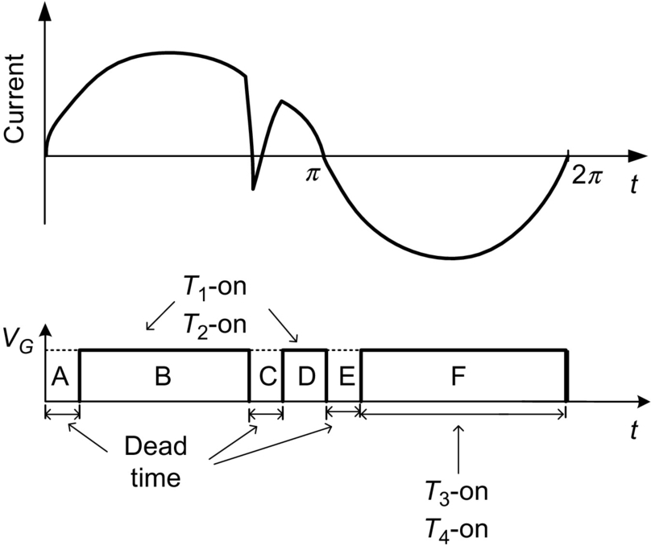

**FIG. 8.42** Waveform of current spike.

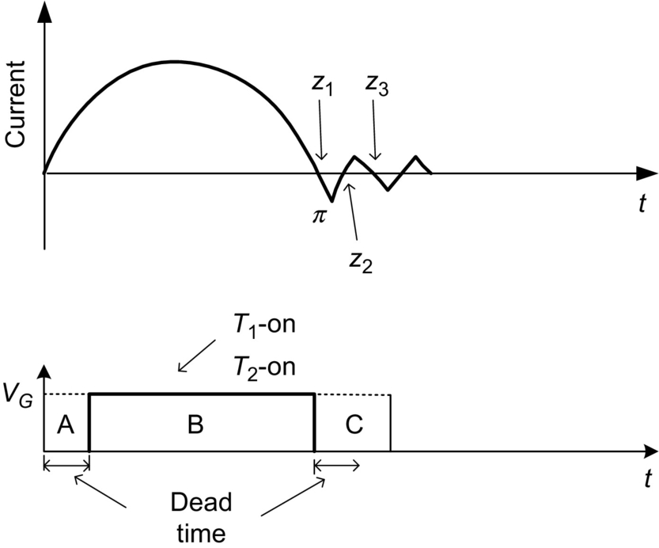

**FIG. 8.43** Waveform of current with multiple zero crossing.

### 8.3.8 CONTROLLED RECTIFIER USING SINGLE PHASE MATRIX CONVERTER (SPMC)—BOOST RECTIFIER OPERATION

The commutation problem is the use of inductive loads where the commutation occurs during the pair of switches turn “off” making the energy in the inductor, being converted into switching spikes. Theoretically, the switching in the SPMC must be instantaneous and simultaneous; unfortunately, it is impossible for realization in practical systems due to turn-on/turn-off IGBT characteristics; to solve these difficulties, safe commutation strategy was developed in Ref. [[18](https://learning.oreilly.com/library/view/power-electronics-handbook/9780128114087/B9780128114070000088.xhtml#bb0095)] to suppress the spikes induced by manipulation of the switch according to the switching pattern as in Fig. 2.

The controlled rectifier using SPMC for boost operation is shown in [Fig. 8.44](https://learning.oreilly.com/library/view/power-electronics-handbook/9780128114087/B9780128114070000088.xhtml#f0225). A boost inductor *L* is connected at the ac side to reduce electromagnetic interference. The circuit in [Fig. 8.44](https://learning.oreilly.com/library/view/power-electronics-handbook/9780128114087/B9780128114070000088.xhtml#f0225) operates in two modes; in the mode 1, S1a and S3a are switched “on” at *t*=0. And the input current flows through inductor *L*. At *t*=1, switches S1a and S4a are switched “on” at *t*=1, while S3a is switched “off.” Current would reverse and now flow through the load. The inductor current falls until switch S3a is turned “on” again in the next cycle. The energy stored in inductor *L* is then transferred to the load. The switching waveform is shown in the [Fig. 8.45](https://learning.oreilly.com/library/view/power-electronics-handbook/9780128114087/B9780128114070000088.xhtml#f0230).

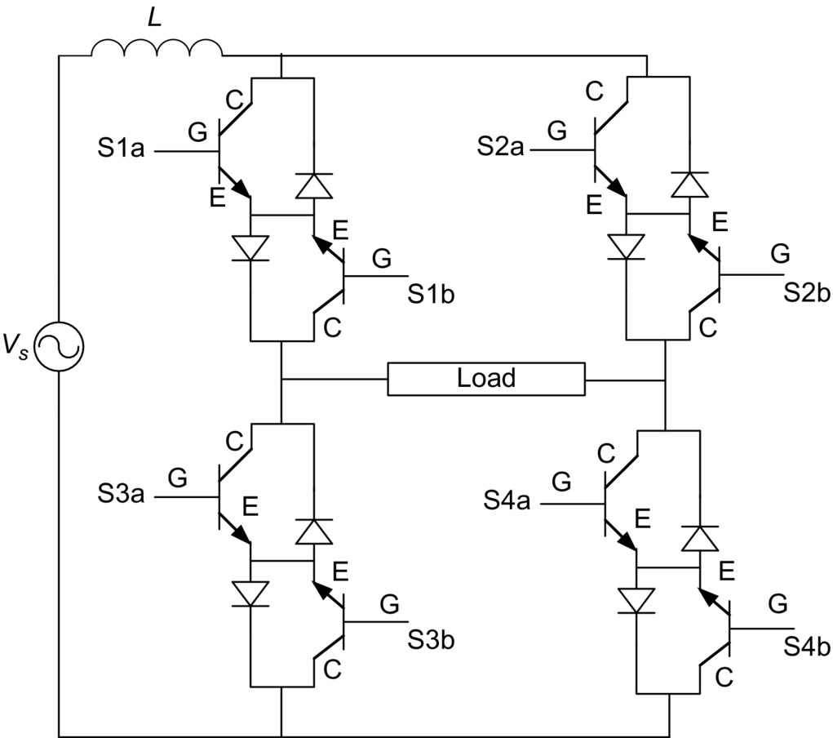

**FIG. 8.44** Controlled rectifier using SPMC topology for boost rectifier operation [[23](https://learning.oreilly.com/library/view/power-electronics-handbook/9780128114087/B9780128114070000088.xhtml#bb0120)].

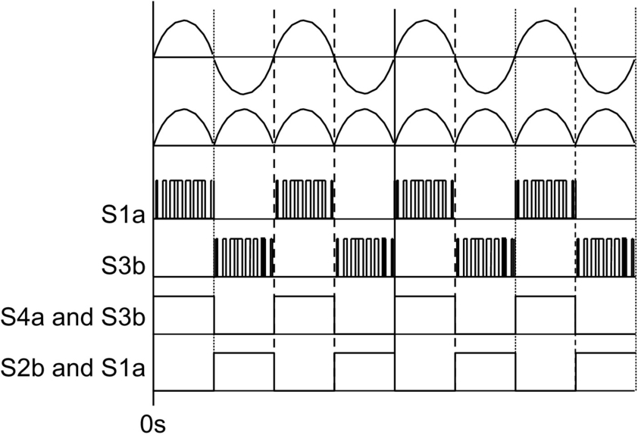

**FIG. 8.45** Switching pattern for commutation strategy [[23](https://learning.oreilly.com/library/view/power-electronics-handbook/9780128114087/B9780128114070000088.xhtml#bb0120)].

## References

[1] Rashid M.H. *Power Electronics, Circuits, Devices and Applications.* third ed. New York: Academic; 2001.

[2] Mohan N., Undeland T., Robbins W. *Power Electronics: Converters Applications and Design.* third ed. New York: Wiley; 2002.

[3] Rodríguez J., Lezana P., Kouro S., Weinstein A. Single-Phase Controlled Rectifiers. In: Rashid M.H., ed. *Power Electronics Handbook.* third ed. Boston: Butterworth-Heinemann; 2011:183–204 (Chapter 11).

[4] Perkinson J. *UPS systems: a review.* In: Proc. of IEEE Applied Power Electronics Conference and Exposition; 1988:151–154.

[5] Rodriguez J.R., Dixon J.W., Espinoza J.R., Pontt J., Lezana P. PWM regenerative rectifiers: state of the art. *IEEE Trans. Ind. Electron.* 2005;52(1):5–22.

[6] Dwyer R., Mueller D. *Selection of transformers for commercial buildings.* In: Proc. of IEEE/IAS 1992 Annual Meeting, U.S.A., Oct 1992; 1992:1335–1342.

[7] IEC 61000-3-2:2014, Electromagnetic compatibility (EMC)—Part 3-2: Limits—Limits for harmonic current emissions (equipment input current≤16 A per phase), IEC 61000-3-2:2004, International Standard, 2004.

[8] Martins D.C., de Seixas F.J.M., Brilhante J.A., Barbi I. *A family of dc-to-dc PWM converters using a new ZVS commutation cell.* In: Proc. IEEE PESC'93; 1993:524–530.

[9] Bassett J. *New, zero voltage switching, high frequency boost converter topology for power factor correction.* In: Proc. INTELEC'95; 1995:813–820.

[10] Streit R., Tollik D. *High efficiency telecom rectifier using a novel soft-switched boost-based input current shaper.* In: Proc. INTELEC'91; 1991:720–726.

[11] Jang Y., Jovanović M.M. *A new, soft-switched, high-power-factor boost converter with IGBTs.* In: Presented at the INTELEC'99; 1999 Paper 8–3.

[12] Jovanović M.M. *A technique for reducing rectifier reverse-recovery-related losses in high-voltage, high-power boost converters.* In: Proc. IEEE APEC'97; 1997:1000–1007.

[13] D.M. Mitchell, 1983. AC-DC converter having an improved power factor. U.S. Patent 4 412 277.

[14] de Souza A.F., Barbi I. A new ZVS-PWM unity power factor rectifier with reduced conduction losses. *IEEE Trans. Power Electron.* 1995;10(6):746–752.

[15] de Souza A.F., Barbi I. A new ZVS semiresonant power factor rectifier with reduced conduction losses. *IEEE Trans. Ind. Electron.* 1999;46(1):82–90.

[16] P. Todd, UC3854 controlled power factor correction circuit design. Application Note U-134, Unitrode Corp.

[17] Adams J., Ribarich T., Ribarich J. *A new control IC for dimmable high-frequency electronic ballast.* In: IEEE Applied Power Electronics Conference APEC'99, USA; 1999:713–719.

[18] Jacobina C., Beltrao M., Cabral E., Nogueira A. Induction motor drive system for low-power applications. *IEEE Trans. Ind. Appl.* 1999;35(1):52–60.

[19] Hirachi K., Yamamoto H., Matsui T., Watanabe S., Nakaoka M. *Cost-effective practical developments of high-performance 1kVA UPS with new system configurations and their specific control implementations.* In: European Conference on Power Electronics EPE 95, Spain; 1995:2035–2040.

[20] Hückelheim K., Mangold C. *Novel 4-quadrant converter control method.* In: European Conference on Power Electronics EPE 89, Germany; 1989:573–576.

[21] Ohmae T., Nakamura K. *Hitachi's role in the area of power electronics for transportation.* In: Proc. of the IECON'93. Hawai; 1993:714–718.

[22] <http://www.ti.com/lit/wp/snva595a/snva595a.pdf> (Accessed 23 February 2017).

[23] Baharom R., Hamzah N.R., Hamzah M.K. *Advanced single-phase AC-DC converter using single-phase matrix converter topology.* In: Proc. IEEE International Conference on Electrical, Control and Computer Engineering; 2011:33–38.

**9**

# Three-Phase Controlled Rectifiers

Muhammad H. Rashid Florida Polytechnic University, Lakeland, FL, United States

## Abstract

Three-phase controlled rectifiers have a wide range of applications, from small rectifiers to large high-voltage direct-current transmission systems. They are used for electrochemical processes, many kinds of motor drives, traction equipment, controlled power supplies, and many other applications. From the point of view of the commutation process, they can be classified into two important categories: *line-commutated controlled rectifiers (thyristor rectifiers) and force-commutated pulse-width modulated rectifiers.*

### KEYWORDS

Line and forced commutations; DC link voltage control; Power factor; Controlled rectifiers

9.1 [Introduction](https://learning.oreilly.com/library/view/power-electronics-handbook/9780128114087/B978012811407000009X.xhtml#s0010)

9.2 [Line-Commutated Controlled Rectifiers](https://learning.oreilly.com/library/view/power-electronics-handbook/9780128114087/B978012811407000009X.xhtml#s0015)

9.2.1 Three-Phase Half-Wave Rectifier

9.2.2 Six-Pulse or Double Star Rectifier

9.2.3 Double Star Rectifier With Interphase Connection

9.2.4 Three-Phase Full-Wave Rectifier or Graetz Bridge

9.2.5 Half Controlled Bridge Converter

9.2.6 Commutation

9.2.7 Power Factor

9.2.8 Harmonic Distortion

9.2.9 Special Configurations for Harmonic Reduction

9.2.10 Applications of Line-Commutated Rectifiers in Machine Drives

9.2.11 Applications in HVDC Power Transmission

9.2.12 Dual Converters

9.2.13 Cycloconverters

9.2.14 Harmonic Standards and Recommended Practices

9.3 [Force-Commutated Three-Phase Controlled Rectifiers](https://learning.oreilly.com/library/view/power-electronics-handbook/9780128114087/B978012811407000009X.xhtml#s0090)

9.3.1 Basic Topologies and Characteristics

9.3.2 Operation of the Voltage Source Rectifier

9.3.3 PWM Phase-to-Phase and Phase-to-Neutral Voltages

9.3.4 Control of the *DC* Link Voltage

9.3.5 New Technologies and Applications of Force-Commutated Rectifiers

[Further Reading](https://learning.oreilly.com/library/view/power-electronics-handbook/9780128114087/B978012811407000009X.xhtml#fr0010)

## 9.1 Introduction

Three-phase controlled rectifiers have a wide range of applications, from small rectifiers to large high-voltage direct-current (HVDC) transmission systems. They are used for electrochemical processes, many kinds of motor drives, traction equipment, controlled power supplies, and many other applications. From the point of view of the commutation process, they can be classified into two important categories: *line-commutated controlled rectifiers (thyristor rectifiers) and force-commutated pulse-width modulated (PWM) rectifiers.*

## 9.2 Line-Commutated Controlled Rectifiers

### **9.2.1 THREE-PHASE HALF-WAVE RECTIFIER**

[Fig. 9.1](https://learning.oreilly.com/library/view/power-electronics-handbook/9780128114087/B978012811407000009X.xhtml#f0010) shows the three-phase half-wave rectifier topology. To control the load voltage, the half-wave rectifier uses three common cathode thyristor arrangements. In this figure, the power supply and the transformer are assumed ideal. The thyristor will conduct (*ON* state), when the anode-to-cathode voltage *vAK* is positive and a firing current pulse *iG* is applied to the gate terminal. Delaying the firing pulse by an angle *α* controls the load voltage. As shown in [Fig. 9.2](https://learning.oreilly.com/library/view/power-electronics-handbook/9780128114087/B978012811407000009X.xhtml#f0015), the firing angle *α* is measured from the crossing point between the phase supply voltages. At that point, the anode-to-cathode thyristor voltage *vAK* begins to be positive. [Fig. 9.3](https://learning.oreilly.com/library/view/power-electronics-handbook/9780128114087/B978012811407000009X.xhtml#f0020) shows that the possible range for gating delay is between *α*=0 and 180 degrees, but because of commutation problems in actual situations, the maximum firing angle is limited to around 160 degrees. As shown in [Fig. 9.4](https://learning.oreilly.com/library/view/power-electronics-handbook/9780128114087/B978012811407000009X.xhtml#f0025), when the load is resistive, current *id* has the same waveform of the load voltage. As the load becomes more and more inductive, the current flattens and finally becomes constant. The thyristor goes to the nonconducting condition (*OFF* state) when the following thyristor is switched *ON* or the current tries to reach a negative value.

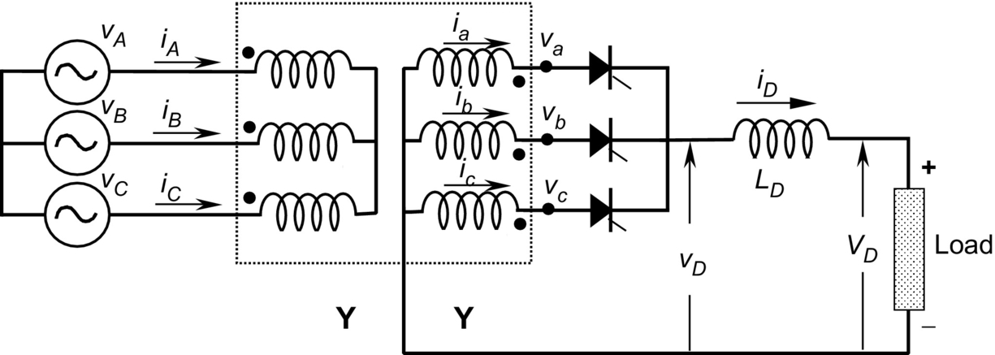

**FIG. 9.1** Three-phase half-wave rectifier.

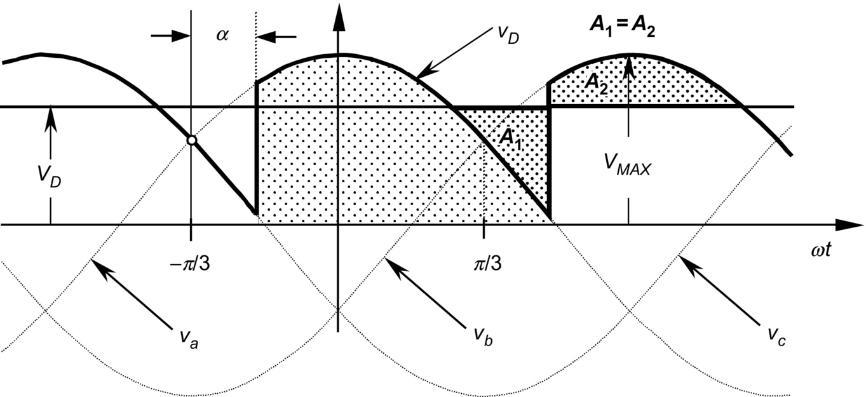

**FIG. 9.2** Instantaneous *dc* voltage *vD*, average *dc* voltage *VD*, and firing angle *α*.

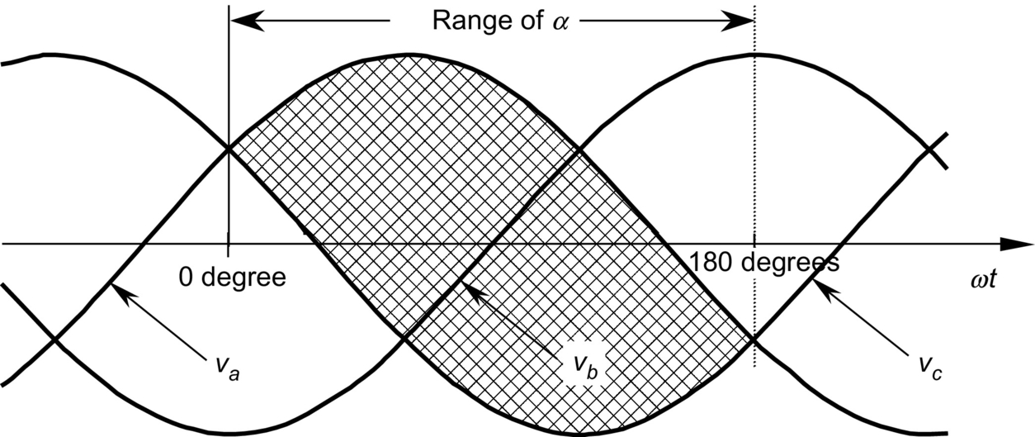

**FIG. 9.3** Possible range for gating delay in angle *α*.

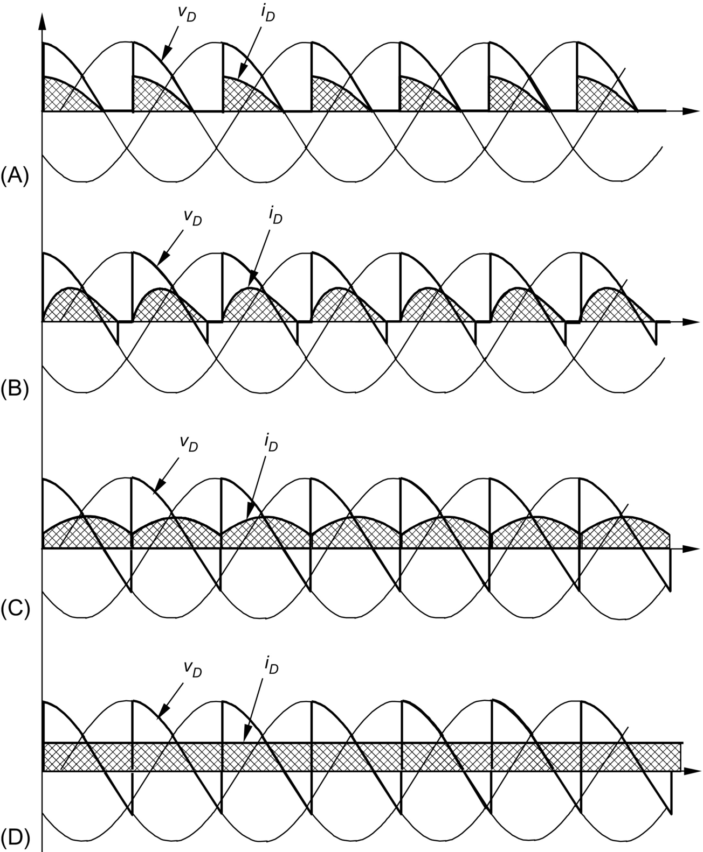

**FIG. 9.4** *DC* current waveforms. (A) *R*>0, *LD*=0, (B) *R*>0, *LD*>0, (C) *R*>0, *LD* large, and (D) *R* small, *LD* very large.

With the help of [Fig. 9.2](https://learning.oreilly.com/library/view/power-electronics-handbook/9780128114087/B978012811407000009X.xhtml#f0015), the load average voltage can be evaluated and is given by

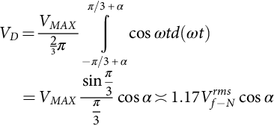 **(9.1)**

where *VMAX* is the secondary phase-to-neutral peak voltage,  is its root-mean-square (*rms)* value, and *ω* is the angular frequency of the main power supply. It can be seen from Eq. [(9.1)](https://learning.oreilly.com/library/view/power-electronics-handbook/9780128114087/B978012811407000009X.xhtml#fo0010) that the load average voltage *VD* is modified by changing firing angle *α*. When *α<*90 degrees, *VD* is positive, and when *α>*90 degrees, the average *dc* voltage becomes negative. In such a case, the rectifier begins to work as an inverter, and the load needs to be able to generate power reversal by reversing its *dc* voltage.

The *ac* currents of the half-wave rectifier are shown in [Fig. 9.5](https://learning.oreilly.com/library/view/power-electronics-handbook/9780128114087/B978012811407000009X.xhtml#f0030). This drawing assumes that the *dc* current is constant (very large *LD*). Disregarding commutation overlap, each valve conducts during 120 degrees per period. The secondary currents (and thyristor currents) present a *dc* component that is undesirable and makes this rectifier not useful for high-power applications. The primary currents show the same waveform but with the *dc* component removed. This very distorted waveform requires an input filter to reduce harmonic contamination.

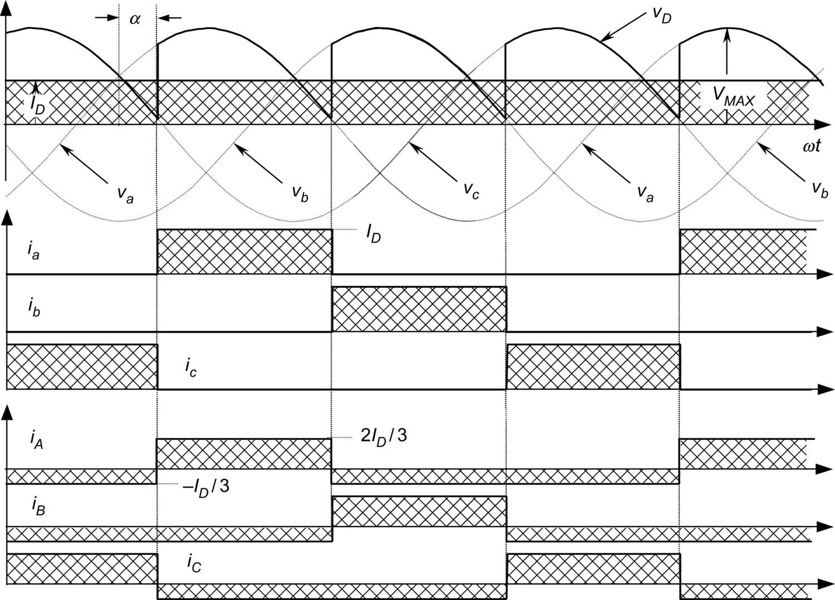

**FIG. 9.5** *AC* current waveforms for the half-wave rectifier.

The current waveforms shown in [Fig. 9.5](https://learning.oreilly.com/library/view/power-electronics-handbook/9780128114087/B978012811407000009X.xhtml#f0030) are useful for designing the power transformer. Starting from

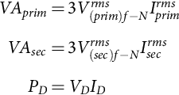 **(9.2)**

where *VAprim* and *VAsec* are the ratings of the transformer for the primary and secondary side, respectively. Here, *PD* is the power transferred to the *dc* side. The maximum power transfer is with *α*=0 degree (or *α*=180 degrees). Then, to establish a relation between *ac* and *dc* voltages, Eq. [(9.1)](https://learning.oreilly.com/library/view/power-electronics-handbook/9780128114087/B978012811407000009X.xhtml#fo0010) for *α*=0 degree is required:

 **(9.3)**

and

 **(9.4)**

where *a* is the secondary to primary turn relation of the transformer. On the other hand, a relation between the currents is also possible to obtain. With the help of [Fig. 9.5](https://learning.oreilly.com/library/view/power-electronics-handbook/9780128114087/B978012811407000009X.xhtml#f0030),

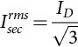 **(9.5)**

**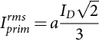** **(9.6)**

Combining Eqs. [(9.2)](https://learning.oreilly.com/library/view/power-electronics-handbook/9780128114087/B978012811407000009X.xhtml#fo0015)–[(9.6)](https://learning.oreilly.com/library/view/power-electronics-handbook/9780128114087/B978012811407000009X.xhtml#fo0035), it yields

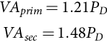 **(9.7)**

Eq. [(9.7)](https://learning.oreilly.com/library/view/power-electronics-handbook/9780128114087/B978012811407000009X.xhtml#fo0040) shows that the power transformer has to be oversized 21% at the primary side and 48% at the secondary side. Then, a special transformer has to be built for this rectifier. In terms of average *VA*, the transformer needs to be 35% larger than the rating of the *dc* load. The larger rating of the secondary with respect to primary is because the secondary carries a *dc* component inside the windings. Furthermore, the transformer is oversized because the circulation of current harmonics does not generate active power. Core saturation, due to the *dc* components inside the secondary windings, also needs to be taken in account for iron oversizing.

### 9.2.2 SIX-PULSE OR DOUBLE STAR RECTIFIER

The thyristor side windings of the transformer shown in [Fig. 9.6](https://learning.oreilly.com/library/view/power-electronics-handbook/9780128114087/B978012811407000009X.xhtml#f0035) form a six-phase system, resulting in a six-pulse starpoint (midpoint connection). Disregarding commutation overlap, each valve conducts only during 60 degrees per period. The direct voltage is higher than that from the half-wave rectifier, and its average value is given by

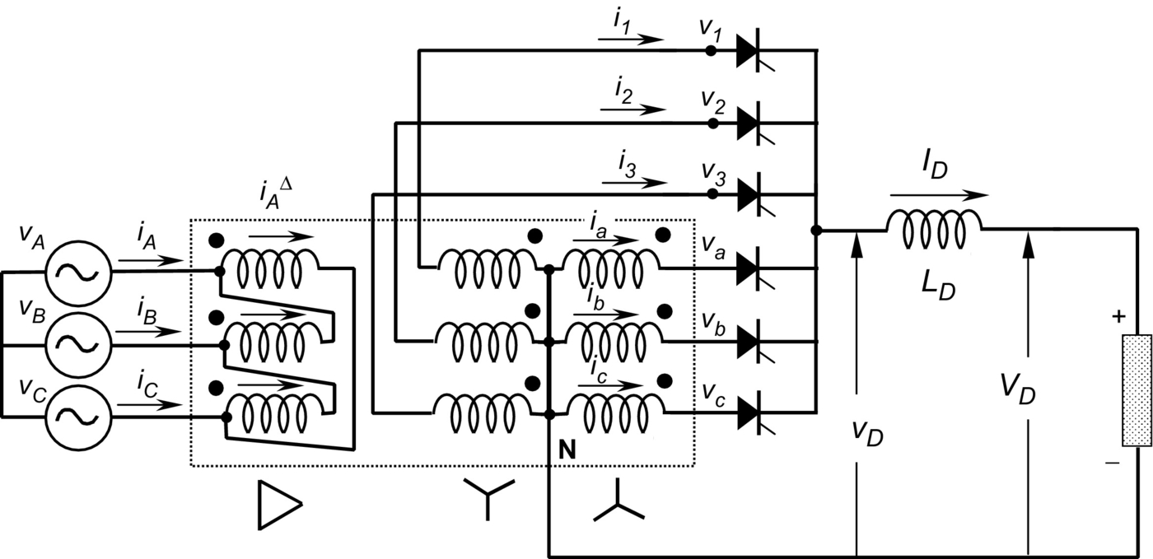

**FIG. 9.6** Six-pulse rectifier.

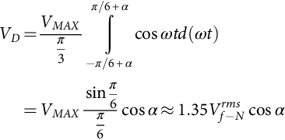 **(9.8)**

The *dc* voltage ripple is also smaller than the one generated by the half-wave rectifier, due to the absence of the third harmonic with its inherently high amplitude. The smoothing reactor *LD* is also considerably smaller than the one needed for a three-pulse (half-wave) rectifier.

The *ac* currents of the six-pulse rectifier are shown in [Fig. 9.7](https://learning.oreilly.com/library/view/power-electronics-handbook/9780128114087/B978012811407000009X.xhtml#f0040). The currents in the secondary windings present a *dc* component, but the magnetic flux is compensated by the double star. As can be observed, only one valve is fired at a time, and then this connection in no way corresponds to a parallel connection. The currents inside the delta show a symmetrical waveform with 60 degrees conduction. Finally, due to the particular transformer connection shown in [Fig. 9.6](https://learning.oreilly.com/library/view/power-electronics-handbook/9780128114087/B978012811407000009X.xhtml#f0035), the source currents also show a symmetrical waveform but with 120 degrees conduction.

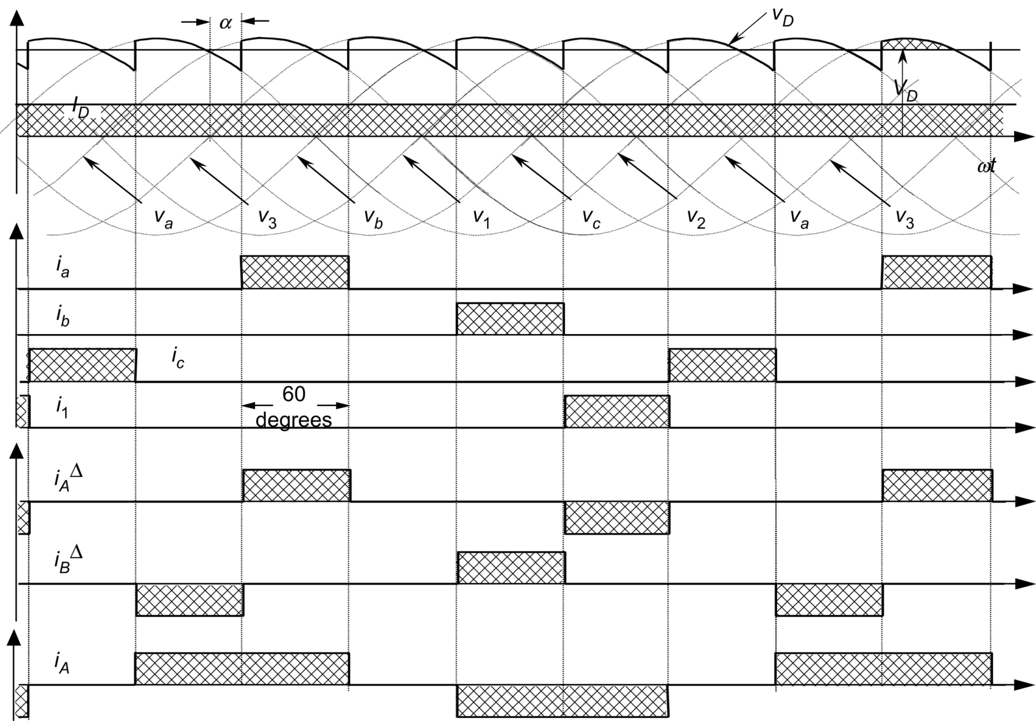

**FIG. 9.7** *AC* current waveforms for the six-pulse rectifier.

Evaluation of the rating of the transformer is done in similar fashion to the way the half-wave rectifier is evaluated:

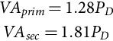 **(9.9)**

Thus, the transformer must be oversized 28% at the primary side and 81% at the secondary side. In terms of size, it has an average apparent power of 1.55 times the power *PD* (55% oversized). Because of the short conducting period of the valves, the transformer is not particularly well utilized.

### 9.2.3 DOUBLE STAR RECTIFIER WITH INTERPHASE CONNECTION

This topology works as two half-wave rectifiers in parallel and is very useful when high *dc* current is required. An optimal way to reach both good balance and elimination of harmonics is through the connection shown in [Fig. 9.8](https://learning.oreilly.com/library/view/power-electronics-handbook/9780128114087/B978012811407000009X.xhtml#f0045). The two rectifiers are shifted by 180 degrees, and their secondary neutrals are connected through a middle-point autotransformer called “interphase transformer.” The interphase transformer is connected between the two secondary neutrals and the middle point at the load return. In this way, both groups operate in parallel. Half the direct current flows in each half of the interphase transformer, and then its iron core does not become saturated. The potential of each neutral can oscillate independently, generating an almost triangular voltage waveform (*vT*) in the interphase transformer, as shown in [Fig. 9.9](https://learning.oreilly.com/library/view/power-electronics-handbook/9780128114087/B978012811407000009X.xhtml#f0050). As this converter works like two half-wave rectifiers connected in parallel, the load average voltage is the same as in Eq. [(9.1)](https://learning.oreilly.com/library/view/power-electronics-handbook/9780128114087/B978012811407000009X.xhtml#fo0010):

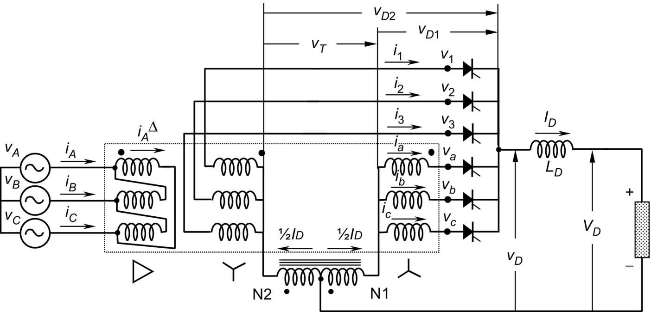

**FIG. 9.8** Double-star rectifier with interphase transformer.

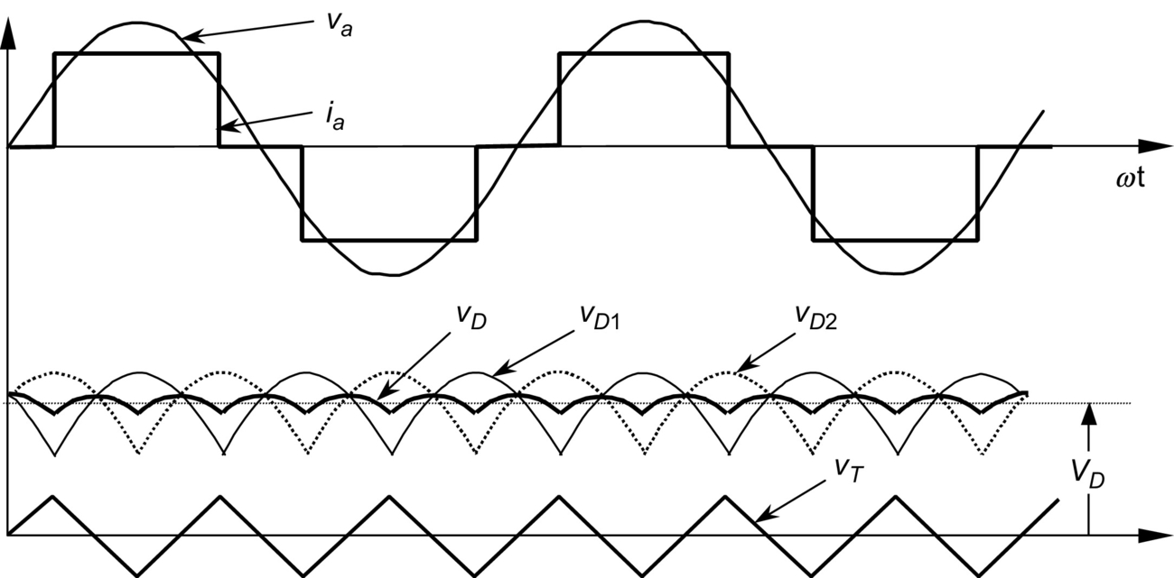

**FIG. 9.9** Operation of the interphase connection for *α*=0 degree.

 **(9.10)**

where  is the phase-to-neutral *rms* voltage at the valve side of the transformer (secondary).

[Fig. 9.9](https://learning.oreilly.com/library/view/power-electronics-handbook/9780128114087/B978012811407000009X.xhtml#f0050) also shows the two half-wave rectifier voltages, related to their respective neutrals. Voltage *vD*1 represents the potential between the common cathode connection and the neutral N1. The voltage *vD*2 is between the common cathode connection and N2. It can be seen that the two instantaneous voltages are shifted, which gives as a result, a voltage *vD* that is smoother than *vD*1 and *vD*2.

[Fig. 9.10](https://learning.oreilly.com/library/view/power-electronics-handbook/9780128114087/B978012811407000009X.xhtml#f0055) shows how *vD*, *vD*1, *vD*2, and *vT* change when the firing angle changes from *α*=0 to 180 degrees. The transformer rating in this case is

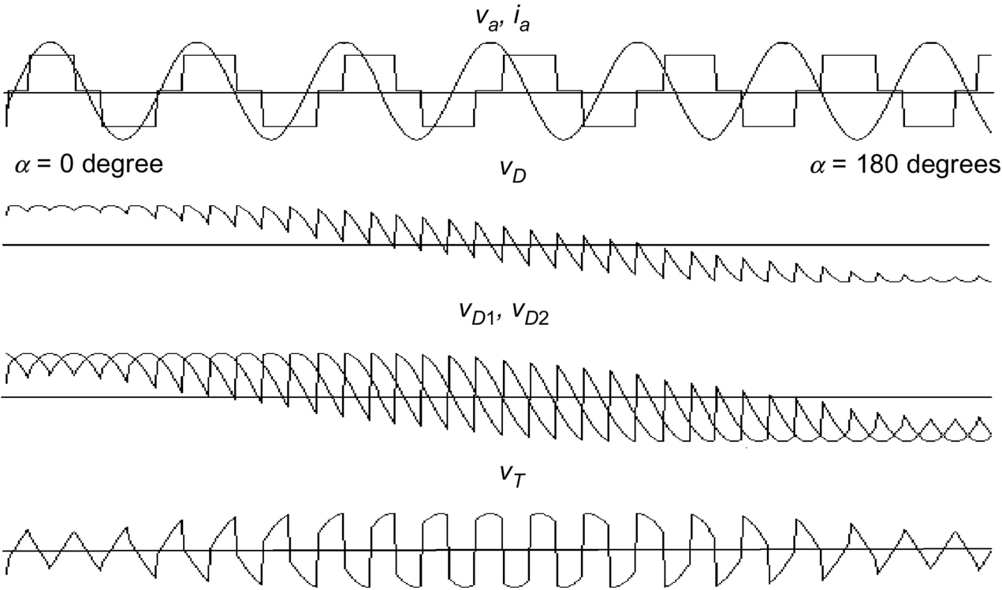

**FIG. 9.10** Firing angle variation from *α*=0 to 180 degrees.

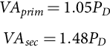 **(9.11)**

And the average rating power will be 1.26*PD*, which is better than the previous rectifiers (1.35 for the half-wave rectifier and 1.55 for the six-pulse rectifier). Thus, the transformer is well utilized. [Fig. 9.11](https://learning.oreilly.com/library/view/power-electronics-handbook/9780128114087/B978012811407000009X.xhtml#f0060) shows *ac* current waveforms for a rectifier with interphase transformer.

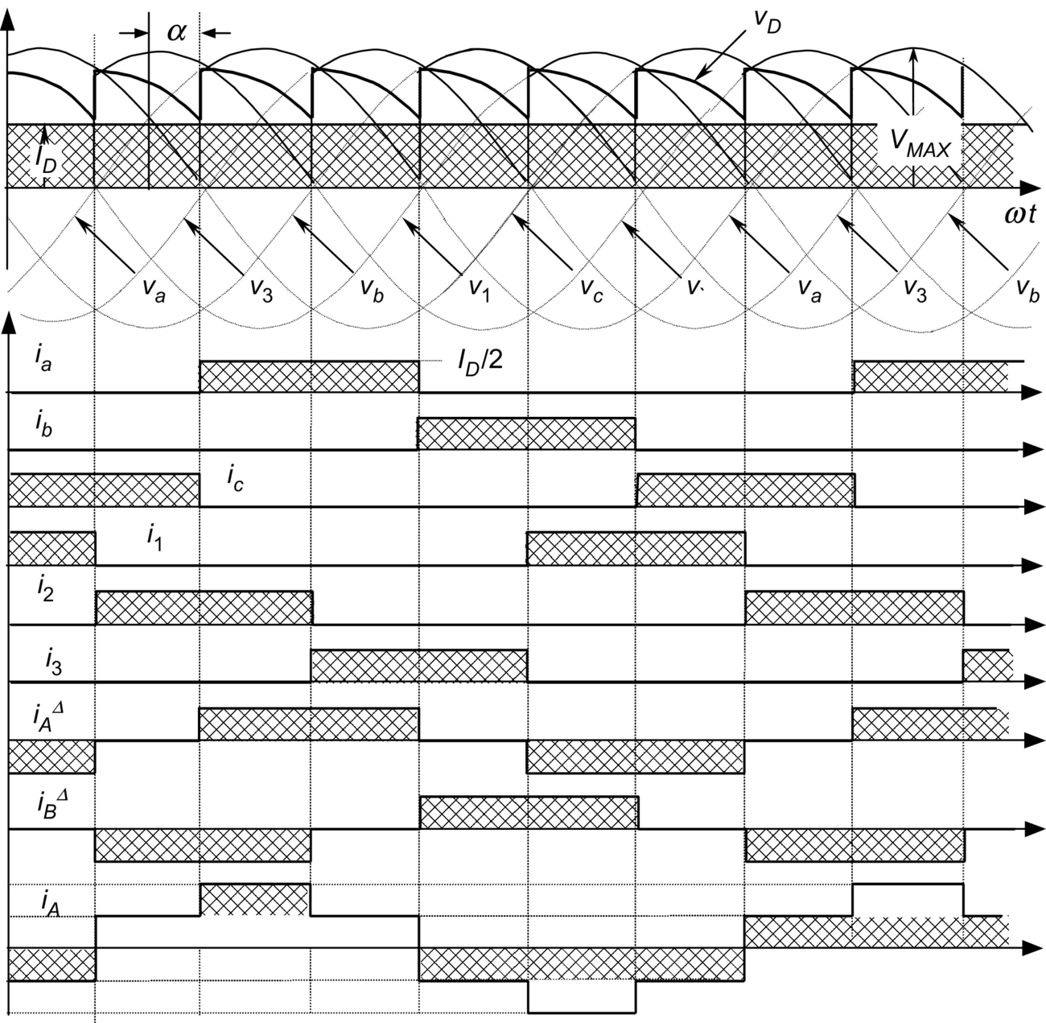

**FIG. 9.11** *AC* current waveforms for the rectifier with interphase transformer.

### 9.2.4 THREE-PHASE FULL-WAVE RECTIFIER OR GRAETZ BRIDGE

Parallel connection via interphase transformers permits the implementation of rectifiers for high current applications. Series connection for high voltage is also possible, as shown in the full-wave rectifier of [Fig. 9.12](https://learning.oreilly.com/library/view/power-electronics-handbook/9780128114087/B978012811407000009X.xhtml#f0065). With this arrangement, it can be seen that the three common cathode valves generate a positive voltage with respect to the neutral and the three common anode valves produce a negative voltage. The result is a *dc* voltage, twice the value of the half-wave rectifier. Each half of the bridge is a three-pulse converter group. This bridge connection is a two-way connection, and alternating currents flow in the valve-side transformer windings during both half periods, avoiding *dc* components into the windings and saturation in the transformer magnetic core. These characteristics make the so-called Graetz bridge the most widely used line-commutated thyristor rectifier. The configuration does not need any special transformer and works as a six-pulse rectifier. The series characteristic of this rectifier produces a *dc* voltage twice the value of the half-wave rectifier. The load average voltage is given by

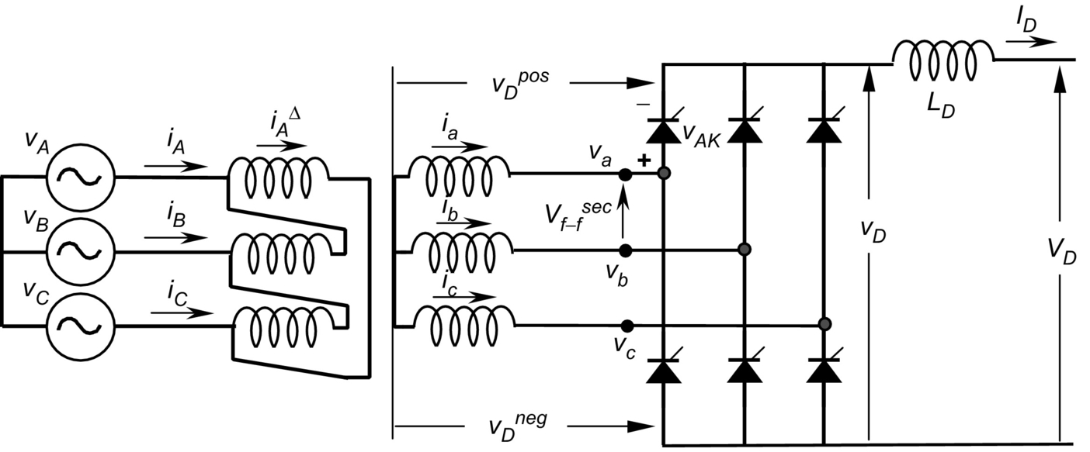

**FIG. 9.12** Three-phase full-wave rectifier or Graetz bridge.

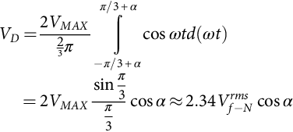 **(9.12)**

or

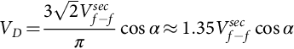 **(9.13)**

where *VMAX* is the peak phase-to-neutral voltage at the secondary transformer terminals,  its *rms* value, and  the *rms* phase-to-phase secondary voltage at the valve terminals of the rectifier.

[Fig. 9.13](https://learning.oreilly.com/library/view/power-electronics-handbook/9780128114087/B978012811407000009X.xhtml#f0070) shows the voltages of each half-wave bridge of this topology, *vDpos* and *vDneg*, the total instantaneous *dc* voltage *vD*, and the anode-to-cathode voltage *vAK* in one of the bridge thyristors. The maximum value of *vAK* is √3*VMAX*, which is the same as that of the half-wave converter and the interphase transformer rectifier. The double-star rectifier presents a maximum anode-to-cathode voltage of two times *VMAX*. [Fig. 9.14](https://learning.oreilly.com/library/view/power-electronics-handbook/9780128114087/B978012811407000009X.xhtml#f0075) shows the currents of the rectifier, which assumes that *LD* is large enough to keep the *dc* current smooth. The example is for the same Δ*Y* transformer connection shown in the topology of [Fig. 9.9](https://learning.oreilly.com/library/view/power-electronics-handbook/9780128114087/B978012811407000009X.xhtml#f0050). It can be noted that the secondary currents do not carry any *dc* component, thereby avoiding overdesign of the windings and transformer saturation. These two figures have been drawn for a firing angle, *α*, of approximately 30 degrees. The perfect symmetry of the currents in all windings and lines is one of the reasons why this rectifier is the most popular of its type. The transformer rating in this case is

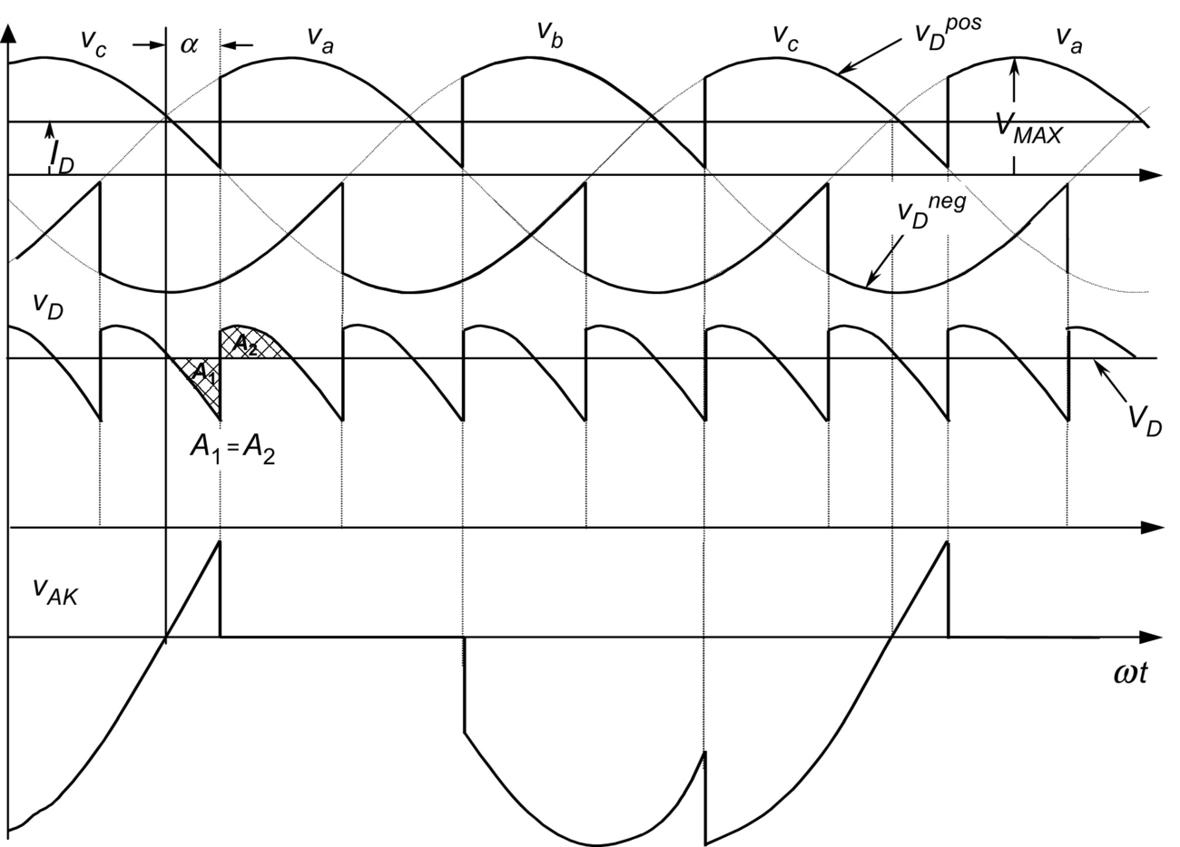

**FIG. 9.13** Voltage waveforms for the Graetz bridge.

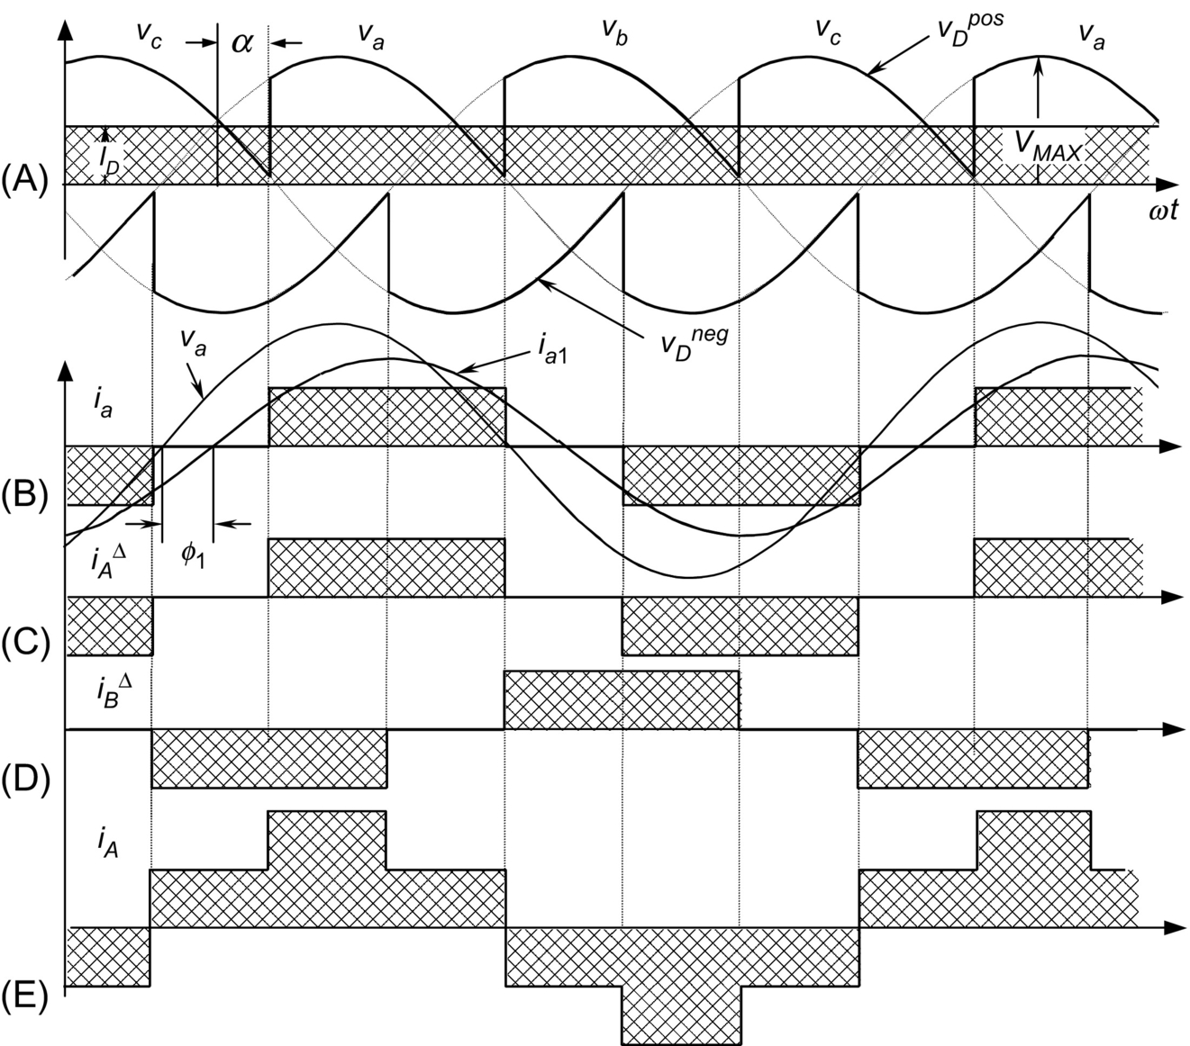

**FIG. 9.14** Current waveforms for the Graetz bridge. (A) Output voltages for phases “*a*,” “*b*,” and “*c*”; (B) Phase “*a*” current, fundamental phase voltage, and current; (C) Phase “*b*” current; (D) Phase “*c*” current; (E) Line “*a*” current.

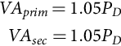 **(9.14)**

As can be noted, the transformer needs to be oversized only 5%, and both primary and secondary windings have the same rating. Again, this value can be compared with the previous rectifier transformers: 1.35*PD* for the half-wave rectifier, 1.55*PD* for the six-pulse rectifier, and 1.26*PD* for the interphase transformer rectifier. The Graetz bridge makes excellent use of the power transformer.

### 9.2.5 HALF CONTROLLED BRIDGE CONVERTER

The fully controlled three-phase bridge converter shown in [Fig. 9.12](https://learning.oreilly.com/library/view/power-electronics-handbook/9780128114087/B978012811407000009X.xhtml#f0065) has six thyristors. As already explained here, this circuit operates as a rectifier when each thyristor has a firing angle *α*<90 degrees and functions as an inverter for *α*>90 degrees. If inverter operation is not required, the circuit may be simplified by replacing three controlled rectifiers with power diodes, as in [Fig. 9.15A](https://learning.oreilly.com/library/view/power-electronics-handbook/9780128114087/B978012811407000009X.xhtml#f0080). This simplification is economically attractive because diodes are considerably less expensive than thyristors and they do not require firing angle control electronics.

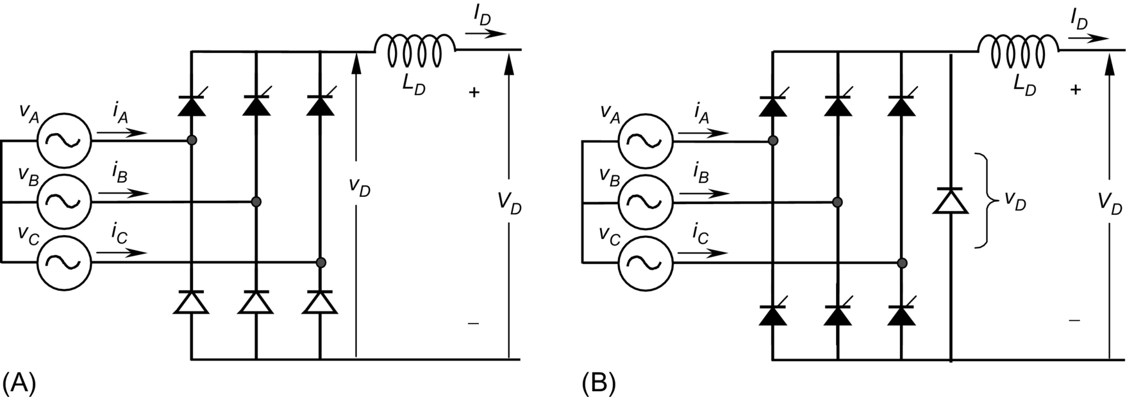

**FIG. 9.15** One-quadrant bridge converter circuits: (A) half-controlled bridge and (B) freewheeling diode bridge.

The half-controlled bridge, or “semiconverter,” is analyzed by considering it as a phase-controlled half-wave circuit in series with an uncontrolled half-wave rectifier. The average *dc* voltage is given by the following equation:

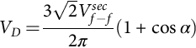 **(9.15)**

Then, the average voltage *VD* never reaches negative values. The output voltage waveforms of half-controlled bridge are similar to those of a fully controlled bridge with a freewheeling diode. The advantage of the freewheeling diode connection, shown in [Fig. 9.15B](https://learning.oreilly.com/library/view/power-electronics-handbook/9780128114087/B978012811407000009X.xhtml#f0080), is that there is always a path for the *dc* current, independent of the status of the *ac* line and of the converter. This can be important if the load is inductive-resistive with a large time constant and there is an interruption in one or more of the line phases. In such a case, the load current could commutate to the freewheeling diode.

### 9.2.6 COMMUTATION

The description of the converters in the previous sections was based upon the assumption that the commutation was instantaneous. In practice, this is not possible, because the transfer of current between two consecutive valves in a commutation group takes a finite time. This time, called *overlap time*, depends on the phase-to-phase voltage between the valves participating in the commutation process and the line inductance *LS* between the converter and power supply. During the overlap time, two valves conduct, and the phase-to-phase voltage drops entirely on the inductances *LS*. Assuming the *dc* current *ID* to be smooth and with the help of [Fig. 9.16](https://learning.oreilly.com/library/view/power-electronics-handbook/9780128114087/B978012811407000009X.xhtml#f0085), the following relation is deduced:

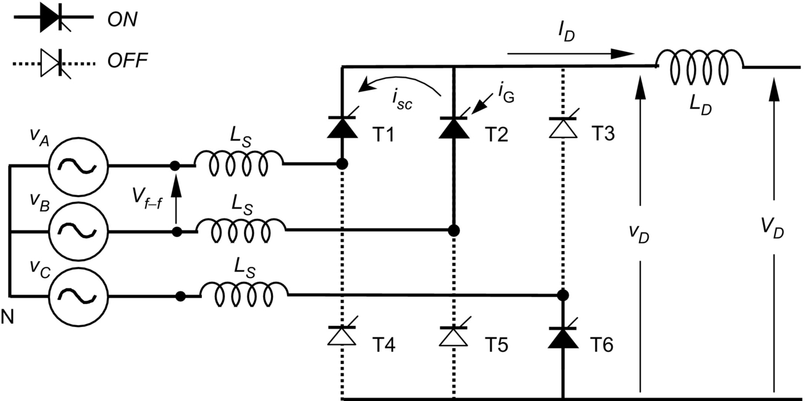

**FIG. 9.16** Commutation process.

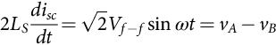 **(9.16)**

where *isc* is the current in the valve being fired during the commutation process (thyristor T2 in [Fig. 9.16](https://learning.oreilly.com/library/view/power-electronics-handbook/9780128114087/B978012811407000009X.xhtml#f0085)). This current can be evaluated, and it yields

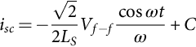 **(9.17)**

The constant “*C*” is evaluated through initial conditions at the instant when T2 is ignited. In terms of angle, when *ωt*=*α*,

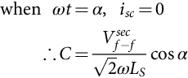 **(9.18)**

Replacing Eq. [(9.18)](https://learning.oreilly.com/library/view/power-electronics-handbook/9780128114087/B978012811407000009X.xhtml#fo0095) in [(9.17)](https://learning.oreilly.com/library/view/power-electronics-handbook/9780128114087/B978012811407000009X.xhtml#fo0090),

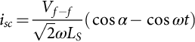 **(9.19)**

Before commutation, the current *ID* was carried by thyristor T1 (see [Fig. 9.16](https://learning.oreilly.com/library/view/power-electronics-handbook/9780128114087/B978012811407000009X.xhtml#f0085)). During the commutation time, the load current *ID* remains constant, *isc* returns through T1, and T1 is automatically switched off when the current *isc* reaches the value of *ID*. This happens because thyristors cannot conduct in reverse direction. At this moment, the overlap time lasts, and the current *ID* is then conducted by T2. In terms of angle, when *ωt*=*α*+*μ*, *isc*=*ID*, where *μ* is defined as the *overlap angle*. Replacing this final condition in Eq. [(9.19)](https://learning.oreilly.com/library/view/power-electronics-handbook/9780128114087/B978012811407000009X.xhtml#fo0100) yields

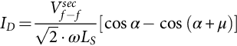 **(9.20)**

To avoid confusion in a real analysis, it has to be remembered that *Vf−f* corresponds to the secondary voltage in the case of transformer utilization. For this reason, the abbreviation “*sec*” has been added to the phase-to-phase voltage in Eq. [(9.20)](https://learning.oreilly.com/library/view/power-electronics-handbook/9780128114087/B978012811407000009X.xhtml#fo0105).

During commutation, two valves conduct at a time, which means that there is an instantaneous short circuit between the two voltages participating in the process. As the inductances of each phase are the same, the current *isc* produces the same voltage drop in each *LS* but with opposite sign because this current flows in reverse direction and with opposite slope in each inductance. The phase with the higher instantaneous voltage suffers a voltage drop −Δ*v*, and the phase with the lower voltage suffers a voltage increase +Δ*v*. This situation affects the *dc* voltage *VC*, reducing its value an amount Δ*Vmed*. [Fig. 9.17](https://learning.oreilly.com/library/view/power-electronics-handbook/9780128114087/B978012811407000009X.xhtml#f0090) shows the meanings of Δ*v*, Δ*Vmed*, *μ*, and *isc*.

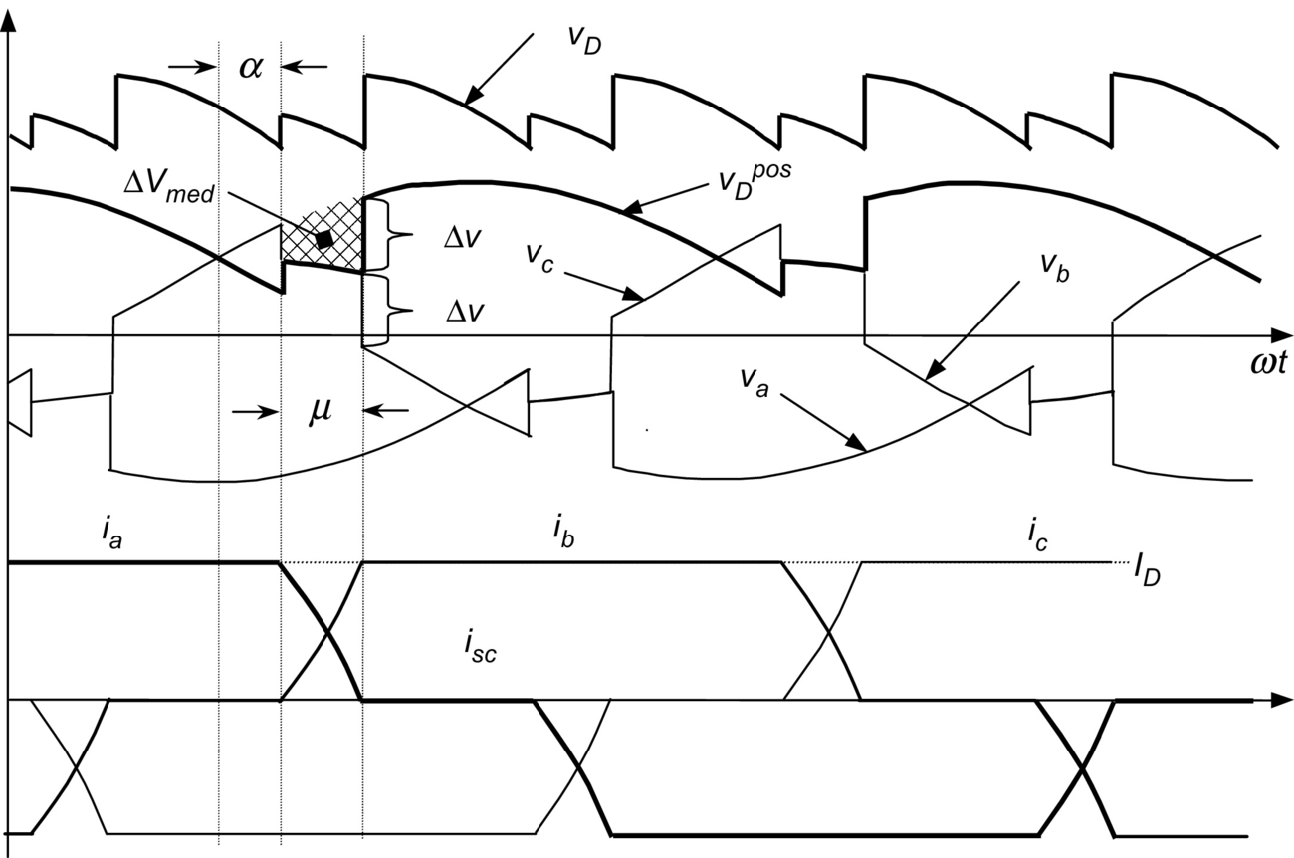

**FIG. 9.17** Effect of the overlap angle on the voltages and currents.

The area Δ*Vmed* shown in [Fig. 9.17](https://learning.oreilly.com/library/view/power-electronics-handbook/9780128114087/B978012811407000009X.xhtml#f0090) represents the loss of voltage that affects the average voltage *VC* and can be evaluated through the integration of Δ*v* during the overlap angle *μ*. The voltage drop Δ*v* can be expressed as

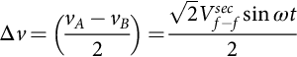 **(9.21)**

Integrating Eq. [(9.21)](https://learning.oreilly.com/library/view/power-electronics-handbook/9780128114087/B978012811407000009X.xhtml#fo0110) into the corresponding period (60 degrees) and interval (*μ*) and starting at the instant when the commutation begins (*α*),

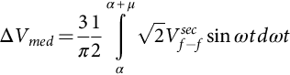 **(9.22)**

**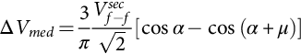** **(9.23)**

Subtracting Δ*Vmed* in Eq. [(9.13)](https://learning.oreilly.com/library/view/power-electronics-handbook/9780128114087/B978012811407000009X.xhtml#fo0070),

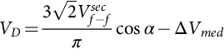 **(9.24)**

**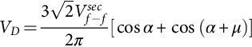** **(9.25)**

or

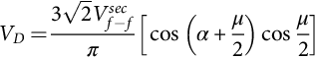 **(9.26)**

Eqs. [(9.20)](https://learning.oreilly.com/library/view/power-electronics-handbook/9780128114087/B978012811407000009X.xhtml#fo0105), [(9.25)](https://learning.oreilly.com/library/view/power-electronics-handbook/9780128114087/B978012811407000009X.xhtml#fo0130) can be written as a function of the primary winding of the transformer, if there is any transformer:

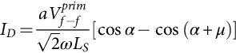 **(9.27)**

**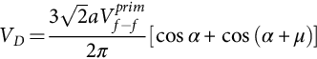** **(9.28)**

where . With Eqs. [(9.27)](https://learning.oreilly.com/library/view/power-electronics-handbook/9780128114087/B978012811407000009X.xhtml#fo0140), [(9.28)](https://learning.oreilly.com/library/view/power-electronics-handbook/9780128114087/B978012811407000009X.xhtml#fo0145), one gets

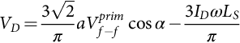 **(9.29)**

Eq. [(9.29)](https://learning.oreilly.com/library/view/power-electronics-handbook/9780128114087/B978012811407000009X.xhtml#fo0150) allows a very simple equivalent circuit of the converter to be made, as shown in [Fig. 9.18](https://learning.oreilly.com/library/view/power-electronics-handbook/9780128114087/B978012811407000009X.xhtml#f0095). It is important to note that the equivalent resistance of this circuit is not real, because it does not dissipate power.

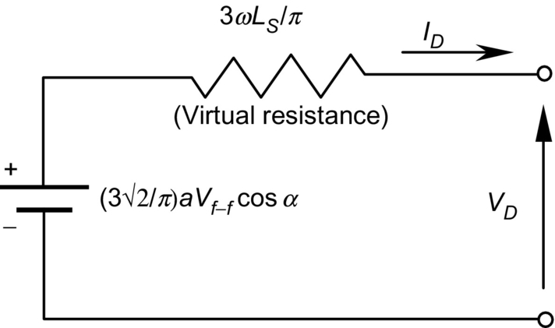

**FIG. 9.18** Equivalent circuit for the converter.

From the equivalent circuit, regulation curves for the rectifier under different firing angles are shown in [Fig. 9.19](https://learning.oreilly.com/library/view/power-electronics-handbook/9780128114087/B978012811407000009X.xhtml#f0100). It should be noted that these curves correspond only to an ideal situation but help in understanding the effect of voltage drop Δ*v* on *dc* voltage. The commutation process and the overlap angle also affect the voltage *va* and anode-to-cathode thyristor voltage, as shown in [Fig. 9.20](https://learning.oreilly.com/library/view/power-electronics-handbook/9780128114087/B978012811407000009X.xhtml#f0105).

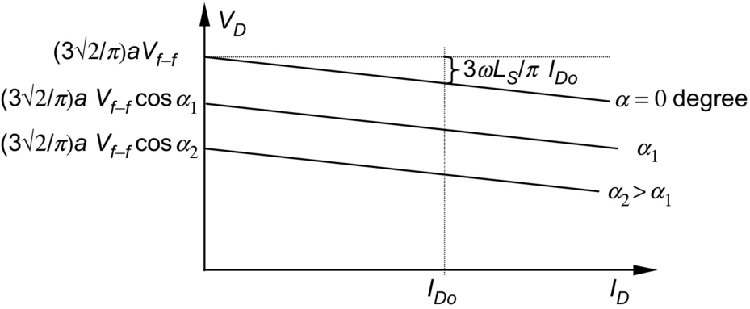

**FIG. 9.19** *DC* voltage regulation curves for rectifier operation.

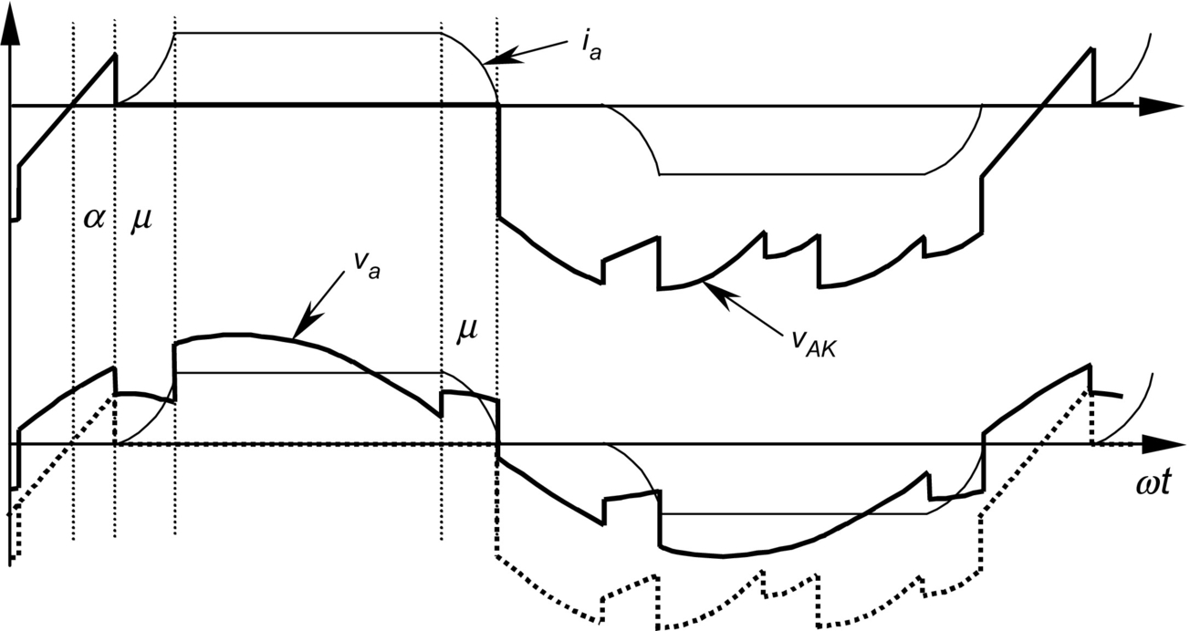

**FIG. 9.20** Effect of the overlap angle on *va* and on thyristor voltage *vAK*.

### 9.2.7 POWER FACTOR

The displacement factor of the fundamental current, obtained from [Fig. 9.14](https://learning.oreilly.com/library/view/power-electronics-handbook/9780128114087/B978012811407000009X.xhtml#f0075), is

 **(9.30)**

In the case of nonsinusoidal current, the active power delivered per phase by the sinusoidal supply is

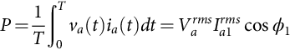 **(9.31)**

where *Varms* is the *rms* value of the voltage *va* and *Ia*1*rms* the *rms* value of *ia*1 (fundamental component of *ia*). Analog relations can be obtained for *vb* and *vc*.

The apparent power per phase is given by

 **(9.32)**

The power factor is defined by

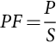 **(9.33)**

By substituting Eqs. [(9.30)](https://learning.oreilly.com/library/view/power-electronics-handbook/9780128114087/B978012811407000009X.xhtml#fo0155)–[(9.32)](https://learning.oreilly.com/library/view/power-electronics-handbook/9780128114087/B978012811407000009X.xhtml#fo0165) into Eq. [(9.33)](https://learning.oreilly.com/library/view/power-electronics-handbook/9780128114087/B978012811407000009X.xhtml#fo0170), the power factor can be expressed as follows:

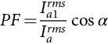 **(9.34)**

This equation shows clearly that due to the nonsinusoidal waveform of the currents, the power factor of the rectifier is negatively affected by both the firing angle *α* and the distortion of the input current. In effect, an increase in the distortion of the current produces an increase in the value of *Iarms* in Eq. [(9.34)](https://learning.oreilly.com/library/view/power-electronics-handbook/9780128114087/B978012811407000009X.xhtml#fo0175), which deteriorates the power factor.

### 9.2.8 HARMONIC DISTORTION

The currents of the line-commutated rectifiers are far from being sinusoidal. For example, the currents generated from the Graetz rectifier (see [Fig. 9.14B](https://learning.oreilly.com/library/view/power-electronics-handbook/9780128114087/B978012811407000009X.xhtml#f0075)) have the following harmonic content:

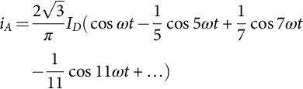 **(9.35)**

Some of the characteristics of the currents, obtained from Eq. [(9.35)](https://learning.oreilly.com/library/view/power-electronics-handbook/9780128114087/B978012811407000009X.xhtml#fo0180), include (i) the absence of triple harmonics, (ii) the presence of harmonics of order 6*k*±1 for integer values of *k*, (iii) those harmonics of orders 6*k*+1 that are of positive sequence, (iv) those of orders 6*k*−1 that are of negative sequence, (v) the *rms* magnitude of the fundamental frequency that is

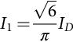 **(9.36)**

and (vi) the *rms* magnitude of the *n*th harmonic that is

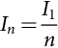 **(9.37)**

If either the primary or the secondary three-phase windings of the rectifier transformer are connected in delta, the *ac* side current waveforms consist of the instantaneous differences between two rectangular secondary currents 120e apart as shown in [Fig. 9.14E](https://learning.oreilly.com/library/view/power-electronics-handbook/9780128114087/B978012811407000009X.xhtml#f0075). The resulting Fourier series for the current in phase “a” on the primary side is

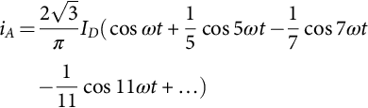 **(9.38)**

This series differs from that of a star-connected transformer only by the sequence of rotation of harmonic orders 6*k*±1 for odd values of *k*, that is, the 5th, 7th, 17th, and 19th.

### 9.2.9 SPECIAL CONFIGURATIONS FOR HARMONIC REDUCTION

A common solution for harmonic reduction is through the connection of passive filters, which are tuned to trap a particular harmonic frequency. A typical configuration is shown in [Fig. 9.21](https://learning.oreilly.com/library/view/power-electronics-handbook/9780128114087/B978012811407000009X.xhtml#f0110).

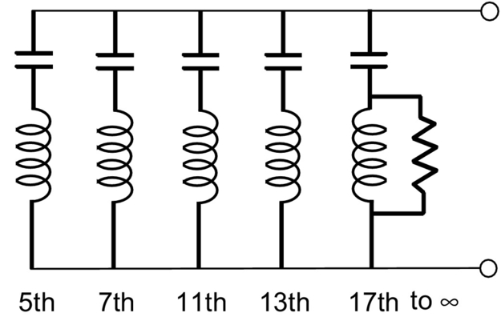

**FIG. 9.21** Typical passive filter for one phase.

However, harmonics also can be eliminated using special configurations of converters. For example, 12-pulse configuration consists of 2 sets of converters connected as shown in [Fig. 9.22](https://learning.oreilly.com/library/view/power-electronics-handbook/9780128114087/B978012811407000009X.xhtml#f0115). The resultant *ac* current is given by the sum of the two Fourier series of the star connection (Eq. [9.35](https://learning.oreilly.com/library/view/power-electronics-handbook/9780128114087/B978012811407000009X.xhtml#fo0180)) and delta connection transformers (Eq. [9.38](https://learning.oreilly.com/library/view/power-electronics-handbook/9780128114087/B978012811407000009X.xhtml#fo0195)):

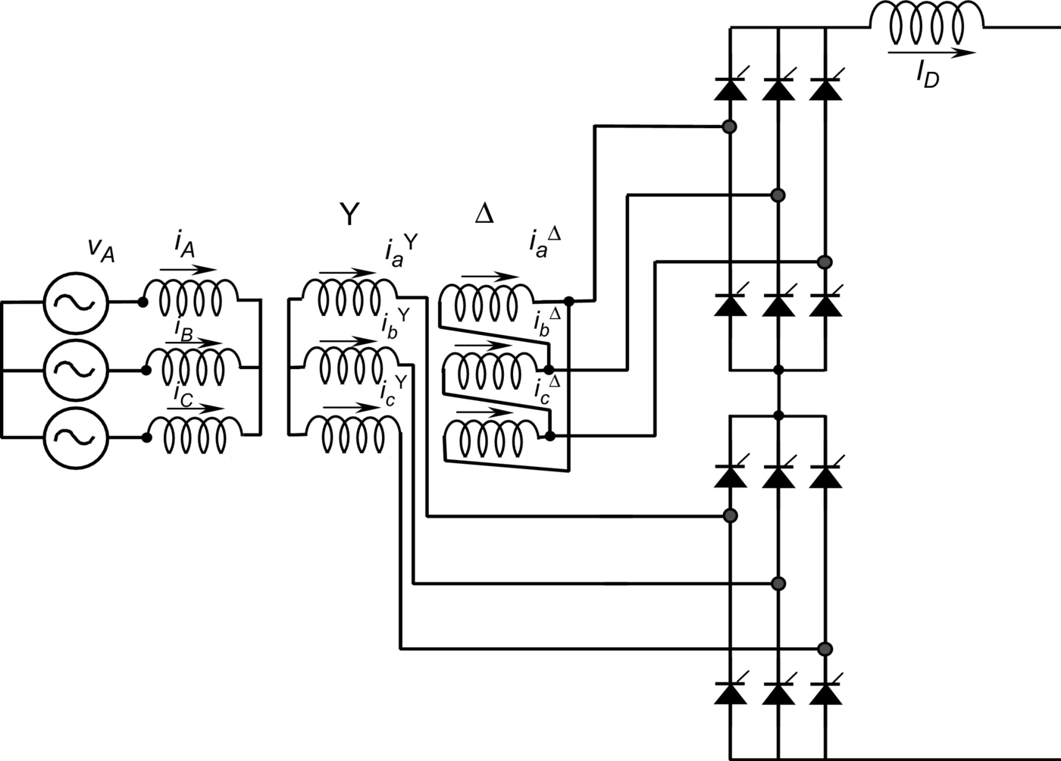

**FIG. 9.22** Twelve-pulse rectifier configuration.

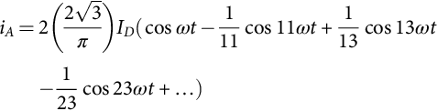 **(9.39)**

The series only contains harmonics of order 12*k*±1. The harmonic currents of orders 6*k*±1 (with *k* odd), that is, 5th, 7th, 17th, and 19th, circulate between the two converter transformers but do not penetrate the *ac* network.

The resulting line current for the 12-pulse rectifier, shown in [Fig. 9.23](https://learning.oreilly.com/library/view/power-electronics-handbook/9780128114087/B978012811407000009X.xhtml#f0120), is closer to a sinusoidal waveform than previous line currents. The instantaneous *dc* voltage is also smoother with this connection.

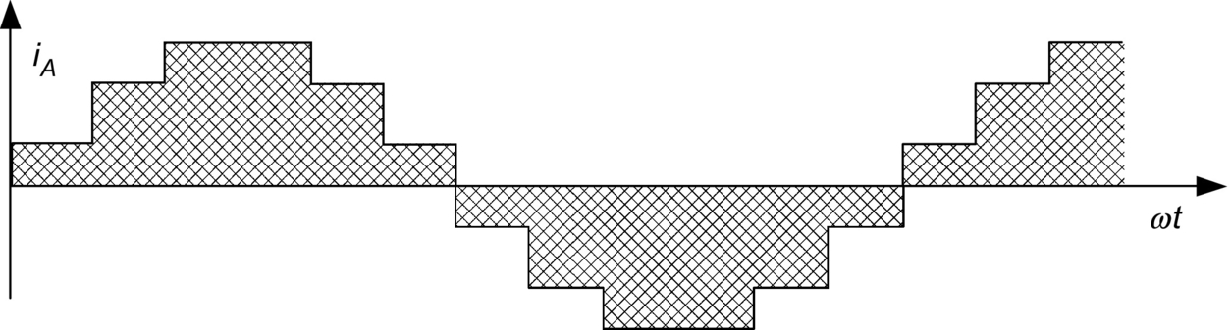

**FIG. 9.23** Line current for the 12-pulse rectifier.

Higher-pulse configuration using the same principle is also possible. The 12-pulse rectifier was obtained with a 30 degrees phase shift between the two secondary transformers. The addition of further, appropriately shifted, transformers in parallel provides the basis for increasing pulse configurations. For instance, 24-pulse operation is achieved by means of 4 transformers with 15 degrees phase shift, and 48-pulse operation requires 8 transformers with 7.5 degrees phase shift (transformer connections in zigzag configuration).

Although theoretically possible, pulse numbers above 48 are rarely justified due to the practical levels of distortion found in the supply voltage waveforms. Further, the converter topology becomes more and more complicated.

An ingenious and very simple way to reach high-pulse operation is shown in [Fig. 9.24](https://learning.oreilly.com/library/view/power-electronics-handbook/9780128114087/B978012811407000009X.xhtml#f0125). This configuration is called *dc* ripple reinjection. It consists of two parallel converters connected to the load through a multistep reactor. The reactor uses a chain of thyristor-controlled taps, which are connected to symmetrical points of the reactor. By firing the thyristors located at the reactor at the right time, high-pulse operation is reached. The level of pulse operation depends on the number of thyristors connected to the reactor. They multiply the basic level of operation of the two converters. The example in [Fig. 9.24](https://learning.oreilly.com/library/view/power-electronics-handbook/9780128114087/B978012811407000009X.xhtml#f0125) shows a 48-pulse configuration, obtained by the multiplication of basic 12-pulse operation by 4 reactor thyristors. This technique also can be applied to series-connected bridges.

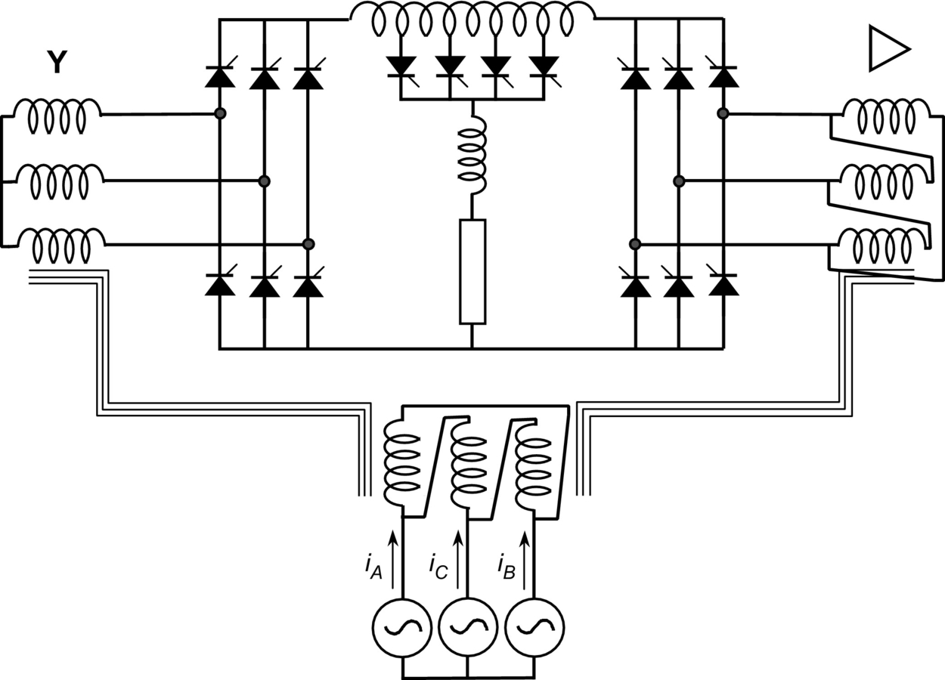

**FIG. 9.24** *DC* ripple reinjection technique for 48-pulse operation.

Another solution for harmonic reduction is the utilization of active power filters. Active power filters are special pulse-width modulated (PWM) converters, able to generate the harmonics the converter requires. [Fig. 9.25](https://learning.oreilly.com/library/view/power-electronics-handbook/9780128114087/B978012811407000009X.xhtml#f0130) shows a current-controlled shunt active power filter.

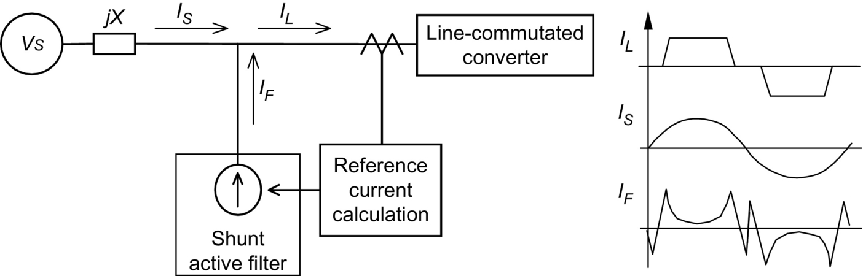

**FIG. 9.25** Current-controlled shunt active power filter.

### 9.2.10 APPLICATIONS OF LINE-COMMUTATED RECTIFIERS IN MACHINE DRIVES

Important applications for line-commutated three-phase controlled rectifiers are found in machine drives. [Fig. 9.26](https://learning.oreilly.com/library/view/power-electronics-handbook/9780128114087/B978012811407000009X.xhtml#f0135) shows a *dc* machine control implemented with a six-pulse rectifier. Torque and speed are controlled through the armature current *ID* and excitation current *Iexc*. Current *ID* is adjusted with *VD*, which is controlled by the firing angle *α* through Eq. [(9.12)](https://learning.oreilly.com/library/view/power-electronics-handbook/9780128114087/B978012811407000009X.xhtml#fo0065). This *dc* drive can operate in two quadrants: positive and negative *dc* voltage. This two-quadrant operation allows regenerative braking when *α*>90 degrees and *Iexc*<0.

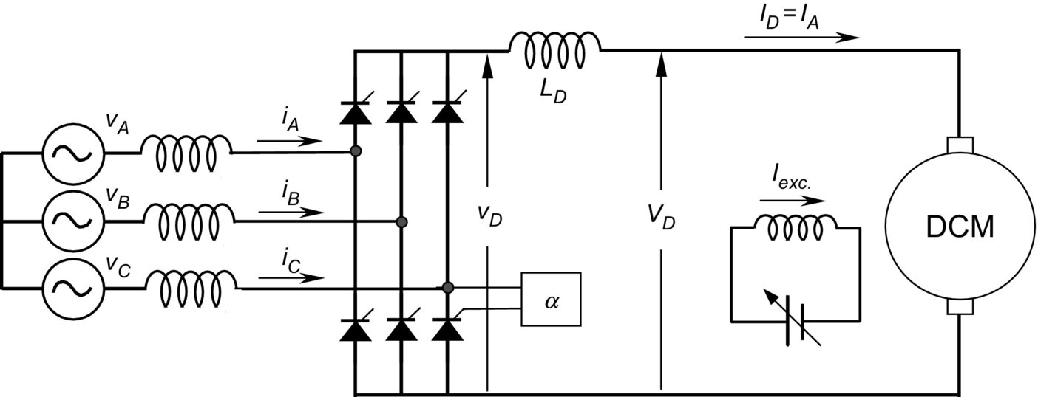

**FIG. 9.26** *DC* machine drive with a six-pulse rectifier.

The converter of [Fig. 9.26](https://learning.oreilly.com/library/view/power-electronics-handbook/9780128114087/B978012811407000009X.xhtml#f0135) can also be used to control synchronous machines, as shown in [Fig. 9.27](https://learning.oreilly.com/library/view/power-electronics-handbook/9780128114087/B978012811407000009X.xhtml#f0140). In this case, a second converter working in the inverting mode operates the machine as self-controlled synchronous motor. With this second converter, the synchronous motor behaves like a *dc* motor but has none of the disadvantages of mechanical commutation. This converter is not line commutated, but machine commutated.

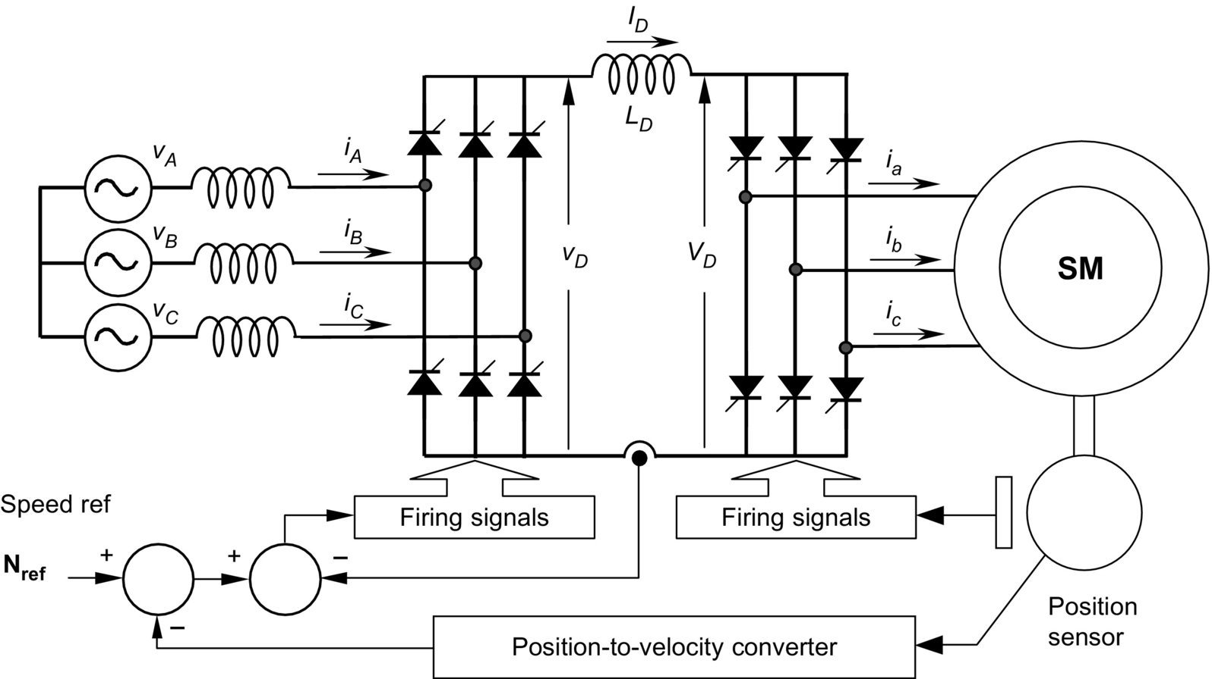

**FIG. 9.27** Self-controlled synchronous motor drive.

The nominal synchronous speed of the motor on a 50 or 60 Hz *ac* supply is now meaningless, and the upper speed limit is determined by the mechanical limitations of the rotor construction. There is disadvantage that the rotational *emfs* required for load commutation of the machine side converter are not available at standstill and low speeds. In such a case, auxiliary force-commutated circuits must be used.

The line-commutated rectifier controls the torque of the machine through firing angle a. This approach gives direct torque control of the commutatorless motor and is analogous to the use of armature current control shown in [Fig. 9.26](https://learning.oreilly.com/library/view/power-electronics-handbook/9780128114087/B978012811407000009X.xhtml#f0135) for the converter-fed *dc* motor drive.

Line-commutated rectifiers are also used for speed control of wound rotor induction motors. Subsynchronous and supersynchronous static converter cascades using a naturally commutated *dc* link converter can be implemented. [Fig. 9.28](https://learning.oreilly.com/library/view/power-electronics-handbook/9780128114087/B978012811407000009X.xhtml#f0145) shows a supersynchronous cascade for a wound rotor induction motor, using a naturally commutated *dc* link converter.

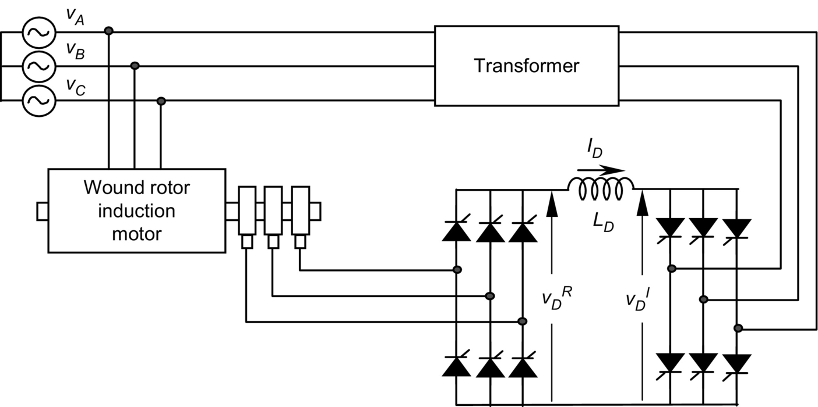

**FIG. 9.28** Supersynchronous cascade for a wound rotor induction motor.

In the supersynchronous cascade shown in [Fig. 9.28](https://learning.oreilly.com/library/view/power-electronics-handbook/9780128114087/B978012811407000009X.xhtml#f0145), the right-hand bridge operates at slip frequency as a rectifier or inverter, while the other operates at network frequency as an inverter or rectifier. Control is difficult near synchronism when slip frequency *emfs* are insufficient for natural commutation and special circuit configuration employing forced commutation or devices with a self-turn-off capability are necessary for the passage through synchronism. This kind of supersynchronous cascade works better with cycloconverters.

### 9.2.11 APPLICATIONS IN HVDC POWER TRANSMISSION

High-voltage direct-current (HVDC) power transmission is the most powerful application for line-commutated converters that exist today. There are power converters with ratings in excess of 1000 MW. Series operation of hundreds of valves can be found in some HVDC systems. In high-power and long-distance applications, these systems become more economical than conventional *ac* systems. They also have some other advantages compared with *ac* systems:

1. They can link two *ac* systems operating unsynchronized or with different nominal frequencies, that is, 50↔60 Hz.

2. They can help in stability problems related with subsynchronous resonance in long *ac* lines.

3. They have very good dynamic behavior and can interrupt short-circuit problems very quickly.

4. If transmission is by submarine or underground cable, it is not practical to consider *ac* cable systems exceeding 50 km, but *dc* cable transmission systems are in service whose length is in hundreds of kilometers and even distances of 600 km or greater have been considered feasible.

5. Reversal of power can be controlled electronically by means of the delay firing angles a.

6. Some existing overhead *ac* transmission lines cannot be increased. If overbuilt with or upgraded to *dc* transmission, it can substantially increase the power transfer capability on the existing right-of-way.

The use of HVDC systems for interconnections of asynchronous systems is an interesting application. Some continental electric power systems consist of asynchronous networks such as those for the East, West, Texas, and Quebec networks in North America, and island loads such as that for the island of Gotland in the Baltic Sea make good use of the HVDC interconnections.

Nearly all HVDC power converters with thyristor valves are assembled in a converter bridge of 12-pulse configuration, as shown in [Fig. 9.29](https://learning.oreilly.com/library/view/power-electronics-handbook/9780128114087/B978012811407000009X.xhtml#f0150). Consequently, the *ac* voltages applied to each 6-pulse valve group that makes up the 12-pulse valve group have a phase difference of 30 degrees that is utilized to cancel the *ac* side, 5th and 7th harmonic currents, and *dc* side, 6th harmonic voltage, thus resulting in a significant saving in harmonic filters.

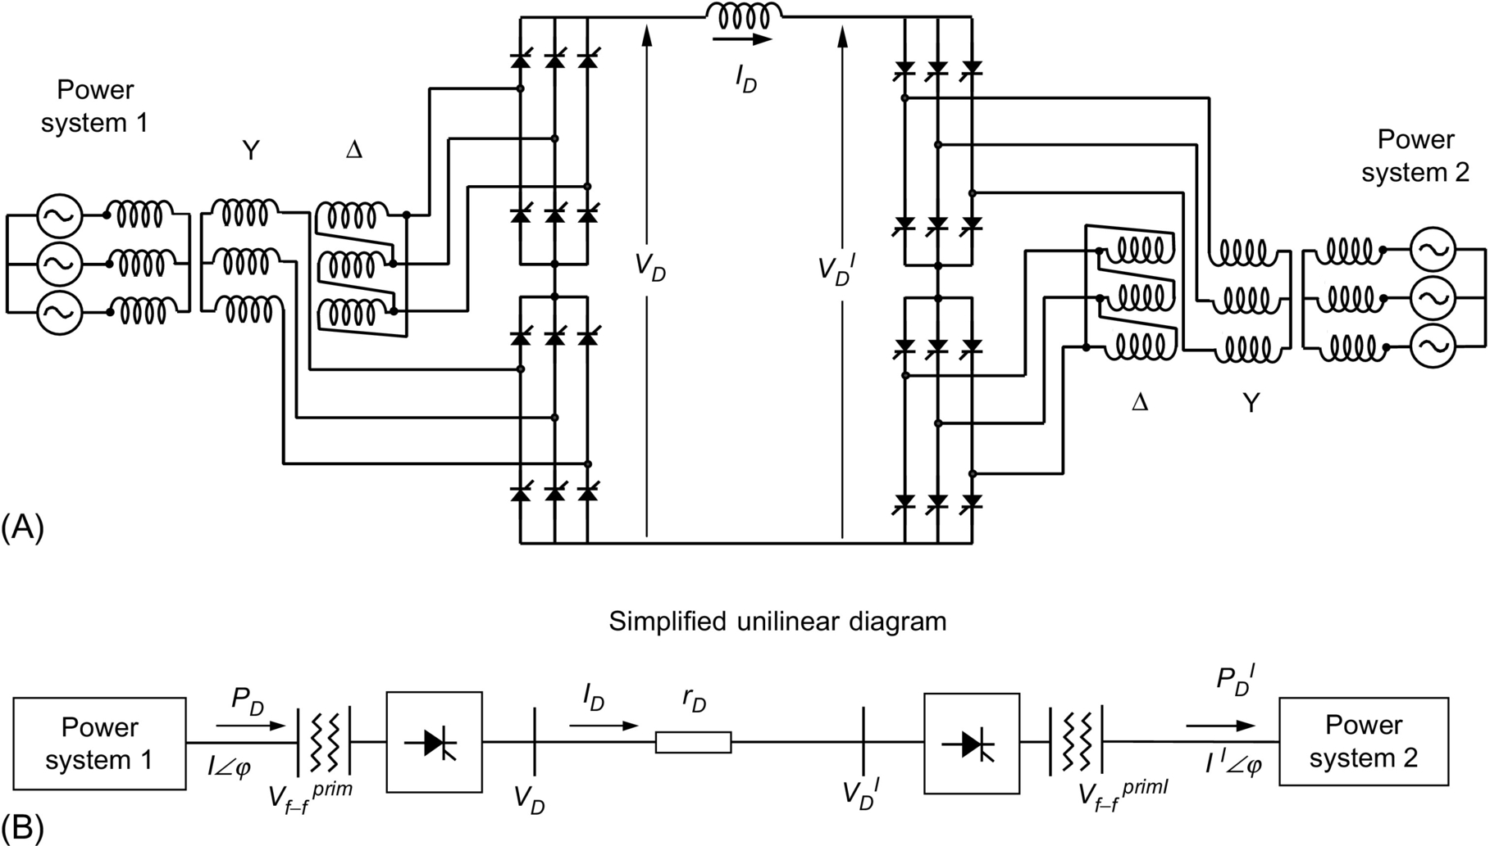

**FIG. 9.29** Typical HVDC power system: (A) detailed circuit and (B) unilinear diagram.

Some useful relations for HVDC systems include the following:

(a) Rectifier side

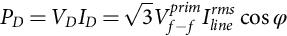 **(9.40)**

**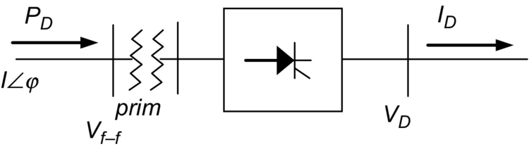**

**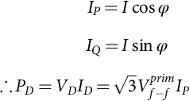** **(9.41)**

**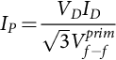** **(9.42)**

**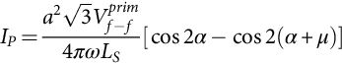** **(9.43)**

**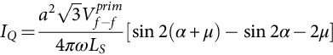** **(9.44)**

**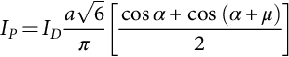** **(9.45)**

Fundamental secondary component of *I*

*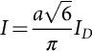* **(9.46)**

Replacing Eq. [(9.46)](https://learning.oreilly.com/library/view/power-electronics-handbook/9780128114087/B978012811407000009X.xhtml#fo0235) in [(9.45)](https://learning.oreilly.com/library/view/power-electronics-handbook/9780128114087/B978012811407000009X.xhtml#fo0230),

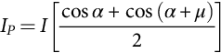 **(9.47)**

As *Ip*=*I* cos *φ*, it yields [Fig. 9.30A](https://learning.oreilly.com/library/view/power-electronics-handbook/9780128114087/B978012811407000009X.xhtml#f0155):

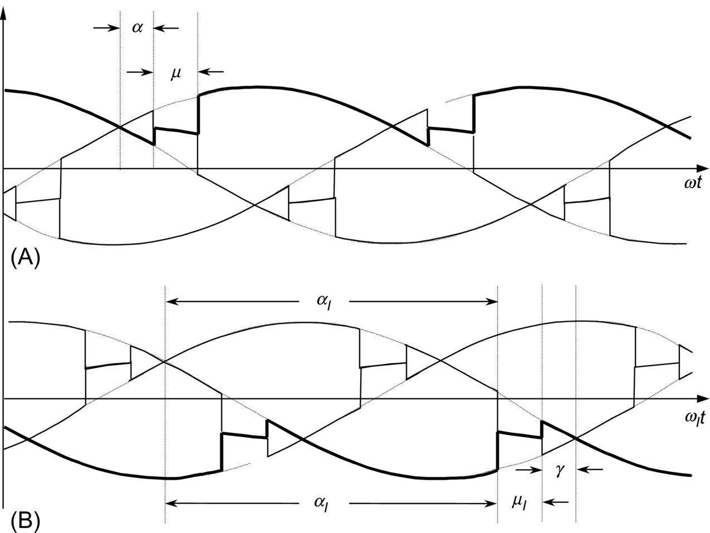

**FIG. 9.30** Definition of angle *γ* for inverter side: (A) rectifier side and (B) inverter side.

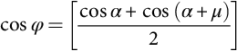 **(9.48)**

(b) Inverter side

The same equations are applied for the inverter side, but the firing angle *α* is replaced by *γ*, where *γ* is

 **(9.49)**

As reactive power always goes in the converter direction, Eq. [(9.44)](https://learning.oreilly.com/library/view/power-electronics-handbook/9780128114087/B978012811407000009X.xhtml#fo0225) for inverter side becomes ([Fig. 9.30B](https://learning.oreilly.com/library/view/power-electronics-handbook/9780128114087/B978012811407000009X.xhtml#f0155))

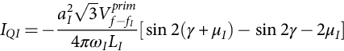 **(9.50)**

### 9.2.12 DUAL CONVERTERS

In many variable-speed drives, four-quadrant operation is required, and three-phase dual converters are extensively used in applications up to 2 MW level. [Fig. 9.31](https://learning.oreilly.com/library/view/power-electronics-handbook/9780128114087/B978012811407000009X.xhtml#f0160) shows a three-phase dual converter, where two converters are connected back-to-back.

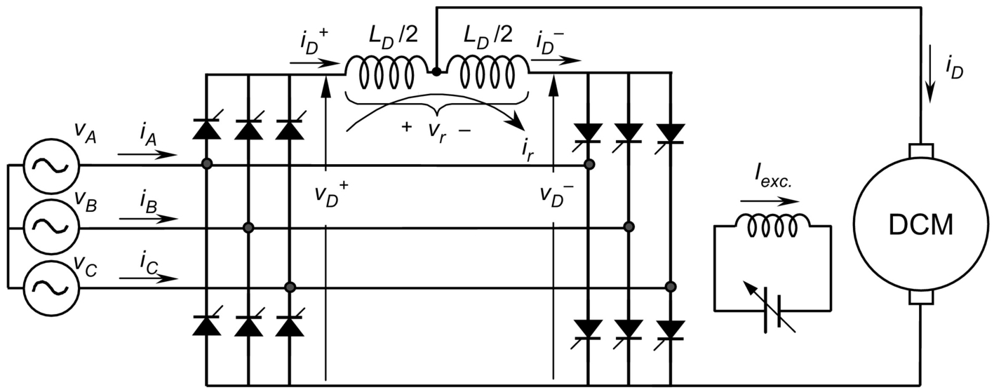

**FIG. 9.31** Dual converter in a four-quadrant *dc* drive.

In the dual converter, one rectifier provides the positive current to the load and the other the negative current. Due to the instantaneous voltage differences between the output voltages of the converters, a circulating current flows through the bridges. The circulating current is normally limited by circulating reactor, *LD*, as shown in [Fig. 9.31](https://learning.oreilly.com/library/view/power-electronics-handbook/9780128114087/B978012811407000009X.xhtml#f0160). The two converters are controlled in such a way that if *α*+ is the delay angle of the positive current converter, the delay angle of the negative current converter is *α*−=180 degrees−*α*+.

[Fig. 9.32](https://learning.oreilly.com/library/view/power-electronics-handbook/9780128114087/B978012811407000009X.xhtml#f0165) shows the instantaneous *dc* voltages of each converter,  and . Despite the average voltage *VD* is the same in both the converters, their instantaneous voltage differences shown as voltage *vr* are producing the circulating current *ir*, which is superimposed with the load currents  and .

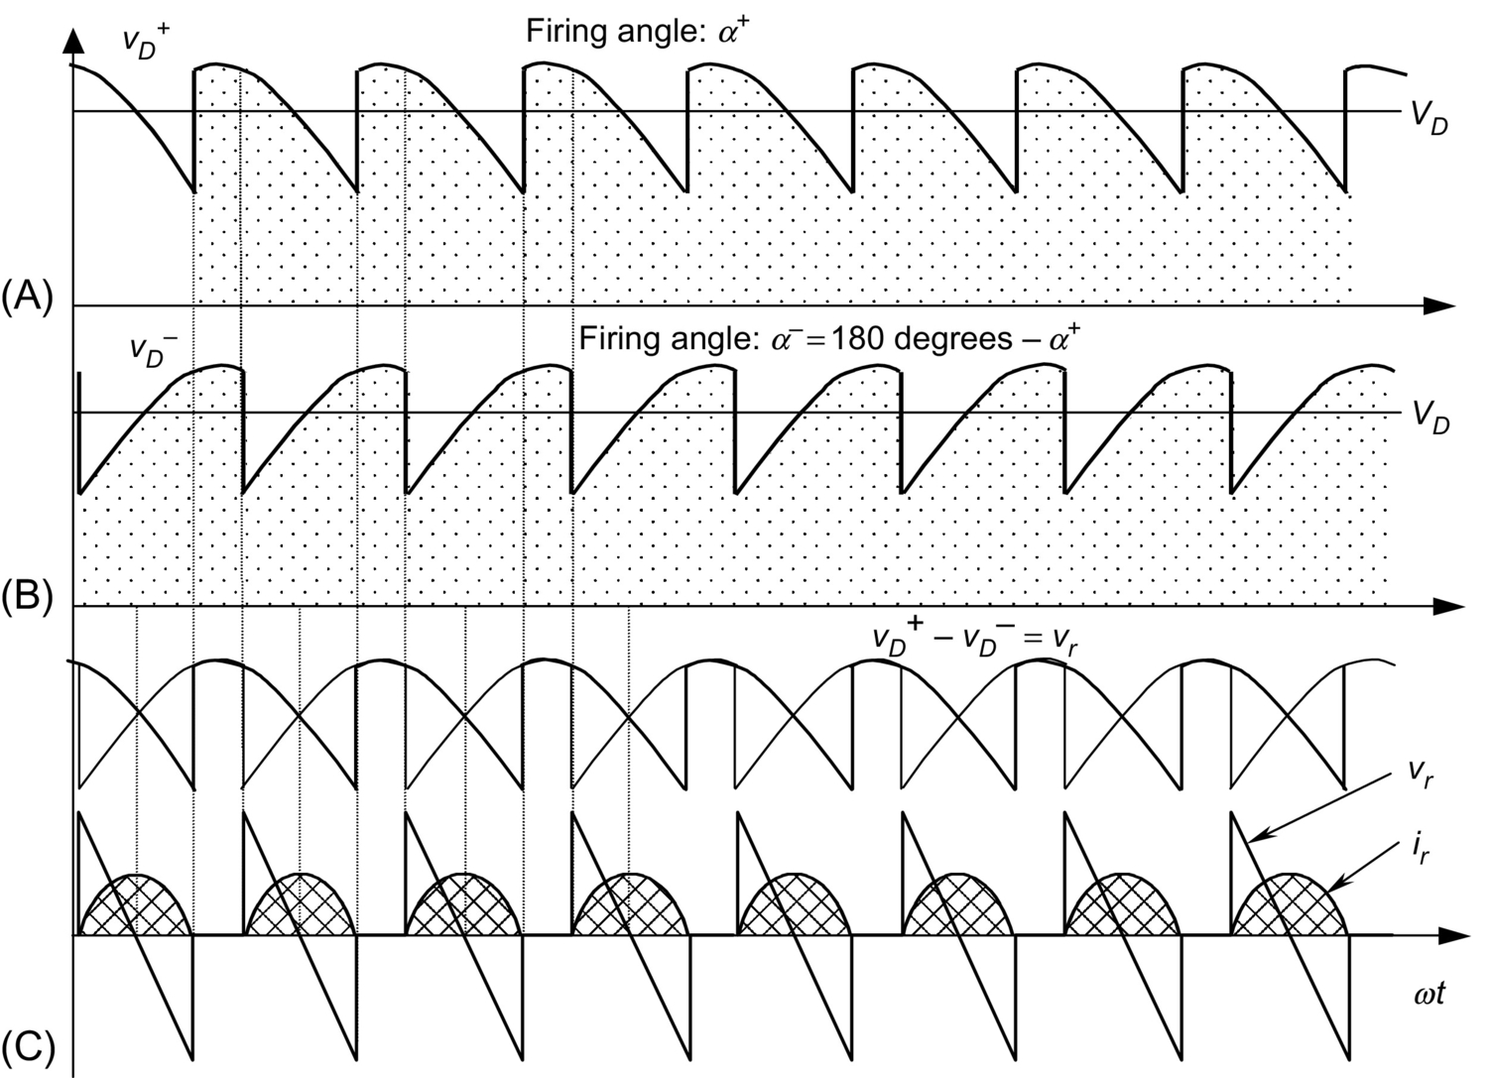

**FIG. 9.32** Waveform of circulating current: (A) instantaneous *dc* voltage from positive converter; (C) instantaneous *dc* voltage from negative converter; and (C) voltage difference between  and , *vr*, and circulating current *ir*.

To avoid the circulating current *ir*, it is possible to implement a “circulating current-free” converter if a dead time of a few milliseconds is acceptable. The converter section, not required to supply current, remains fully blocked. When a current reversal is required, a logic switchover system determines at first the instant at which the conducting converter's current becomes zero. This converter section is then blocked, and the further supply of gating pulses to it is prevented. After a short safety interval (dead time), the gating pulses for the other converter section are released.

### 9.2.13 CYCLOCONVERTERS

A different principle of frequency conversion is derived from the fact that a dual converter is able to supply an *ac* load with a lower frequency than the system frequency. If the control signal of the dual converter is a function of time, the output voltage will follow this signal. If this control signal value alters sinusoidally with the desired frequency, then the waveform depicted in [Fig. 9.33A](https://learning.oreilly.com/library/view/power-electronics-handbook/9780128114087/B978012811407000009X.xhtml#f0170) consists of a single-phase voltage with a large harmonic current. As shown in [Fig. 9.33B](https://learning.oreilly.com/library/view/power-electronics-handbook/9780128114087/B978012811407000009X.xhtml#f0170), if the load is inductive, the current will present less distortion than voltage.

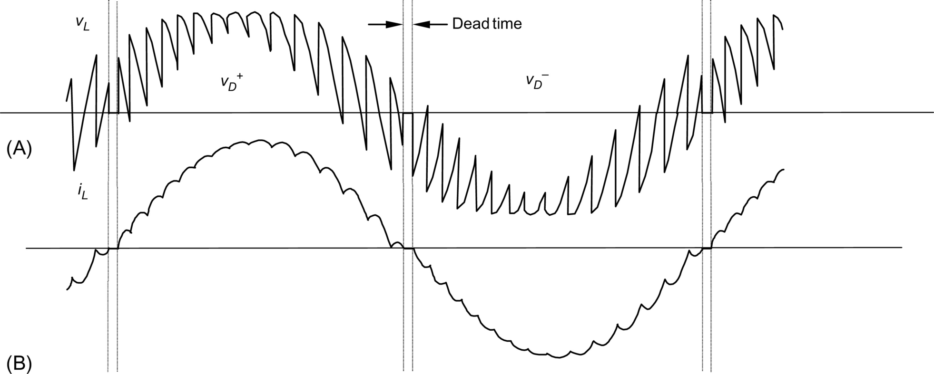

**FIG. 9.33** Cycloconverter operation: (A) voltage waveform and (B) current waveform for inductive load.

The cycloconverter operates in all four quadrants during a period. A pause (dead time) at least as small as the time required by the switchover logic occurs after the current reaches zero, that is, between the transfer to operation in the quadrant corresponding to the other direction of current flow.

Three single-phase cycloconverters may be combined to build a three-phase cycloconverter. The three-phase cycloconverters find an application in low-frequency, high-power requirements. Control speed of large synchronous motors in the low-speed range is one of the most common applications of three-phase cycloconverters. [Fig. 9.34](https://learning.oreilly.com/library/view/power-electronics-handbook/9780128114087/B978012811407000009X.xhtml#f0175) is a diagram for this application. They are also used to control slip frequency in wound rotor induction machines, for supersynchronous cascade (Scherbius system).

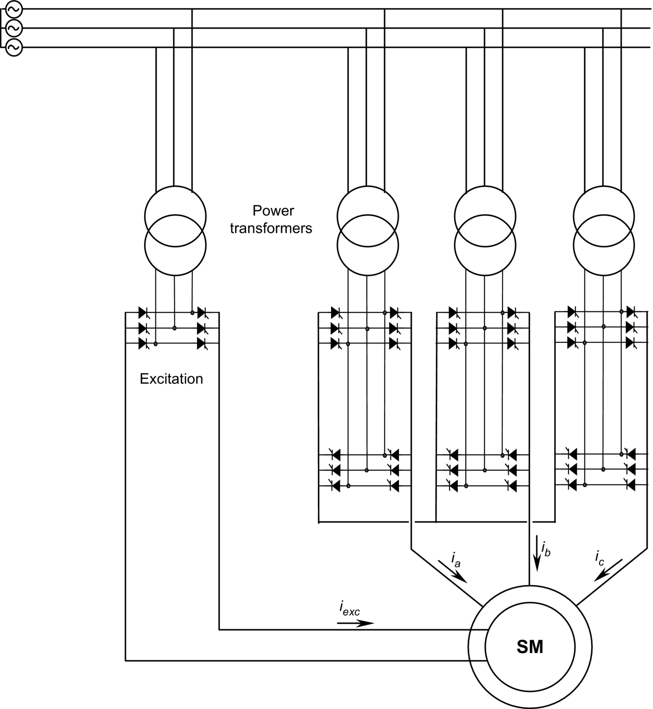

**FIG. 9.34** Synchronous machine drive with a cycloconverter.

### 9.2.14 HARMONIC STANDARDS AND RECOMMENDED PRACTICES

In view of the proliferation of the power converter equipment connected to the utility system, various national and international agencies have been considering limits on harmonic current injection to maintain good power quality. As a consequence, various standards and guidelines have been established that specify limits on the magnitudes of harmonic currents and harmonic voltages.

The Comité Européen de Normalisation Electrotechnique (CENELEC), International Electrotechnical Commission (IEC), and West German Standards (VDE) specify the limits on the voltages (as a percentage of the nominal voltage) at various harmonic frequencies of the utility frequency, when the equipment-generated harmonic currents are injected into a network whose impedances are specified.

According to the Institute of Electrical and Electronics Engineers-519 standards (IEEE), [Table 9.1](https://learning.oreilly.com/library/view/power-electronics-handbook/9780128114087/B978012811407000009X.xhtml#t0010) lists the limits on the harmonic currents that a user of power electronics equipment and other nonlinear loads is allowed to inject into the utility system. [Table 9.2](https://learning.oreilly.com/library/view/power-electronics-handbook/9780128114087/B978012811407000009X.xhtml#t0015) lists the quality of voltage that the utility can furnish the user.

**Table 9.1**

**Harmonic current limits in percent of fundamental**

|  |  |  |  |  |  |  |
| --- | --- | --- | --- | --- | --- | --- |
| **Short-circuit current (p.u.)** | ***h*<11** | **11<*h*<17** | **17<*h*<23** | **23<*h*<35** | **35<*h*** | **THD** |
| <20 | 4.0 | 2.0 | 1.5 | 0.6 | 0.3 | 5.0 |
| 20–50 | 7.0 | 3.5 | 2.5 | 1.0 | 0.5 | 8.0 |
| 50–100 | 10.0 | 4.5 | 4.0 | 1.5 | 0.7 | 12.0 |
| 100–1000 | 12.0 | 5.5 | 5.0 | 2.0 | 1.0 | 15.0 |
| >1000 | 15.0 | 7.0 | 6.0 | 2.5 | 1.4 | 20.0 |

**Table 9.2**

**Harmonic voltage limits in percent of fundamental**

|  |  |  |  |
| --- | --- | --- | --- |
| **Voltage level** | **2.3–69 kV** | **69–138 kV** | **>138 kV** |
| Maximum for individual harmonic | 3.0 | 1.5 | 1.0 |
| Total harmonic distortion (*THD)* | 5.0 | 2.5 | 1.5 |

In [Table 9.1](https://learning.oreilly.com/library/view/power-electronics-handbook/9780128114087/B978012811407000009X.xhtml#t0010), the values are given at the point of connection of nonlinear loads. The *THD* is the total harmonic distortion given by Eq. [(9.51)](https://learning.oreilly.com/library/view/power-electronics-handbook/9780128114087/B978012811407000009X.xhtml#fo0260), and *h* is the number of the harmonic:

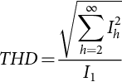 **(9.51)**

The total current harmonic distortion allowed in [Table 9.1](https://learning.oreilly.com/library/view/power-electronics-handbook/9780128114087/B978012811407000009X.xhtml#t0010) increases with the value of short-circuit current.

The total harmonic distortion in the voltage can be calculated in a manner similar to that given by Eq. [(9.51)](https://learning.oreilly.com/library/view/power-electronics-handbook/9780128114087/B978012811407000009X.xhtml#fo0260). [Table 9.2](https://learning.oreilly.com/library/view/power-electronics-handbook/9780128114087/B978012811407000009X.xhtml#t0015) specifies the individual harmonics and the *THD* limits on the voltage that the utility supplies to the user at the connection point.

## 9.3 Force-Commutated Three-Phase Controlled Rectifiers

### **9.3.1 BASIC TOPOLOGIES AND CHARACTERISTICS**

Force-commutated rectifiers are built with semiconductors with gate-turn-off capability. The gate-turn-off capability allows full control of the converter, because valves can be switched *ON* and *OFF* whenever is required. This allows the commutation of the valves, hundreds of times in one period that is not possible with line-commutated rectifiers, where thyristors are switched *ON* and *OFF* only once a cycle. This feature has the following advantages: (a) The current or voltage can be modulated (PWM), generating less harmonic contamination; (b) power factor can be controlled and even it can be made leading; (c) they can be built as voltage-source or current-source rectifiers; and (d) the reversal of power in thyristor rectifiers is by reversal of voltage at the *dc* link. Instead, force-commutated rectifiers can be implemented for both, reversal of voltage or reversal of current.

There are two ways to implement force-commutated three-phase rectifiers: (A) as a current-source rectifier, where power reversal is by *dc* voltage reversal, and (B) as a voltage-source rectifier, where power reversal is by current reversal at the *dc* link. [Fig. 9.35](https://learning.oreilly.com/library/view/power-electronics-handbook/9780128114087/B978012811407000009X.xhtml#f0180) shows the basic circuits for these two topologies.

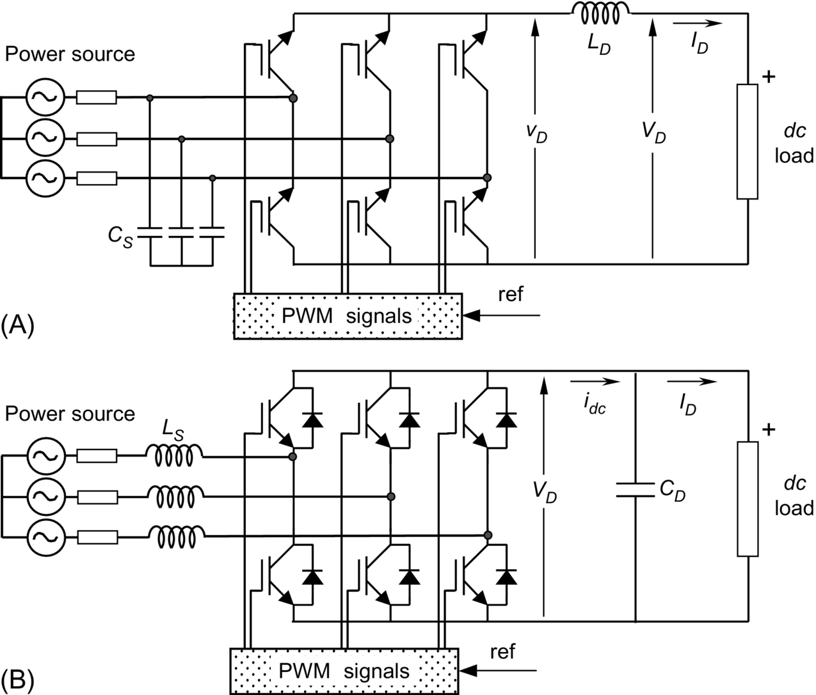

**FIG. 9.35** Basic topologies for force-commutated PWM rectifiers: (A) current-source rectifier and (B) voltage-source rectifier.

### 9.3.2 OPERATION OF THE VOLTAGE SOURCE RECTIFIER

The voltage-source rectifier is by far the most widely used, and because of the duality of the two topologies shown in [Fig. 9.35](https://learning.oreilly.com/library/view/power-electronics-handbook/9780128114087/B978012811407000009X.xhtml#f0180), only this type of force-commutated rectifier will be explained in detail.

The voltage-source rectifier operates by keeping the *dc* link voltage at a desired reference value, using a feedback control loop as shown in [Fig. 9.36](https://learning.oreilly.com/library/view/power-electronics-handbook/9780128114087/B978012811407000009X.xhtml#f0185). To accomplish this task, the *dc* link voltage is measured and compared with a reference *VREF*. The error signal generated from this comparison is used to switch the six valves of the rectifier *ON* and *OFF.* In this way, power can come or return to the *ac* source according to the *dc* link voltage requirements. The voltage *VD* is measured at the capacitor *CD*.



**FIG. 9.36** Operation principle of the voltage-source rectifier.

When the current *ID* is positive (rectifier operation), the capacitor *CD* is discharged, and the error signal asks the control block for more power from the *ac* supply. The control block takes the power from the supply by generating the appropriate PWM signals for the six valves. In this way, more current flows from the *ac* to the *dc* side, and the capacitor voltage is recovered. Inversely, when *ID* becomes negative (inverter operation), the capacitor *CD* is overcharged, and the error signal asks the control to discharge the capacitor and return power to the *ac* mains.

The PWM control can manage not only the active power but also the reactive power, allowing this type of rectifier to correct power factor. In addition, the *ac* current waveforms can be maintained as almost sinusoidal, which reduces harmonic contamination to the mains supply.

The PWM consists of switching the valves *ON* and *OFF*, following a preestablished template. This template could be a sinusoidal waveform of voltage or current. For example, the modulation of one phase could be as the one shown in [Fig. 9.37](https://learning.oreilly.com/library/view/power-electronics-handbook/9780128114087/B978012811407000009X.xhtml#f0190). This PWM pattern is a periodical waveform whose fundamental is a voltage with the same frequency of the template. The amplitude of this fundamental, called *VMOD* in [Fig. 9.37](https://learning.oreilly.com/library/view/power-electronics-handbook/9780128114087/B978012811407000009X.xhtml#f0190), is also proportional to the amplitude of the template.

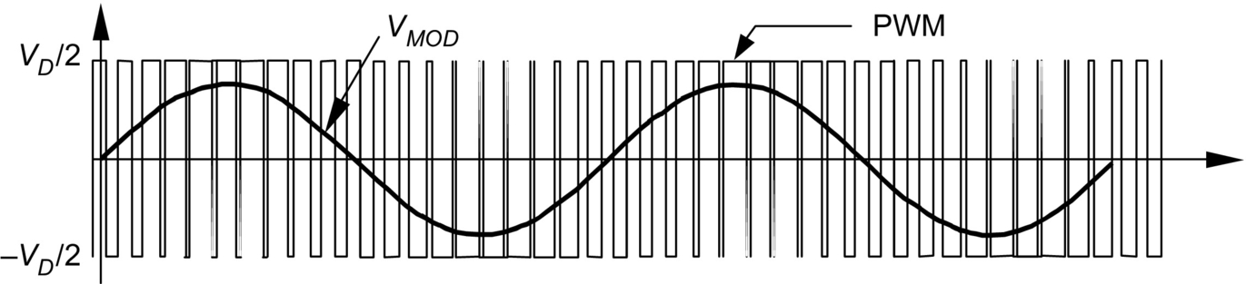

**FIG. 9.37** A PWM pattern and its fundamental *VMOD*.

To make the rectifier work properly, the PWM pattern must generate a fundamental *VMOD* with the same frequency as the power source. Changing the amplitude of this fundamental and its phase shift with respect to the mains, the rectifier can be controlled to operate in the four quadrants: leading power factor rectifier, lagging power factor rectifier, leading power factor inverter, and lagging power factor inverter. Changing the pattern of modulation, as shown in [Fig. 9.38](https://learning.oreilly.com/library/view/power-electronics-handbook/9780128114087/B978012811407000009X.xhtml#f0195), modifies the magnitude of *VMOD*. Displacing the PWM pattern changes the phase shift.

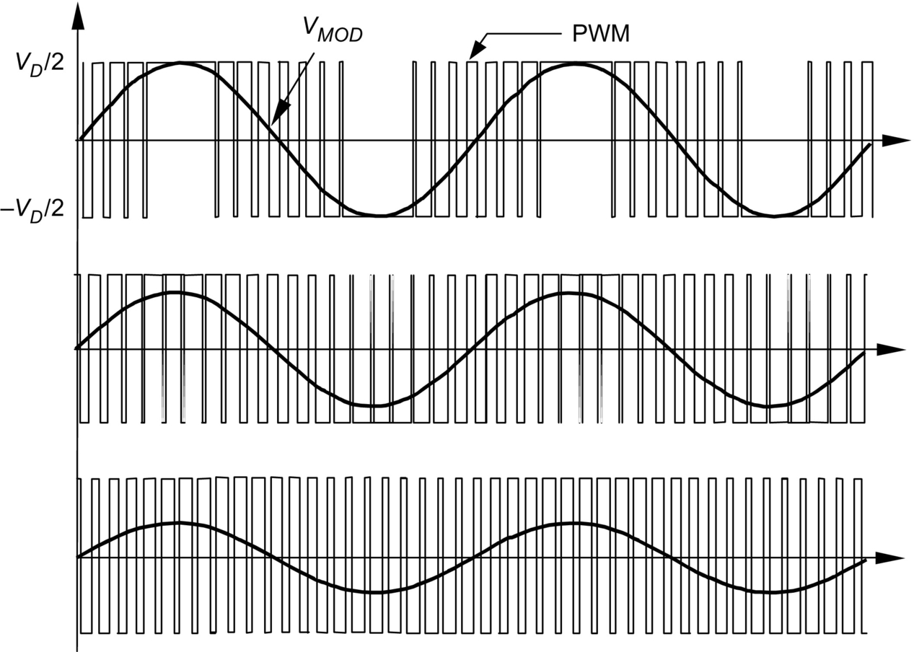

**FIG. 9.38** Changing *VMOD* through the PWM pattern.

The interaction between *VMOD* and *V* (source voltage) can be seen through a phasor diagram. This interaction permits understanding of the four-quadrant capability of this rectifier. In [Fig. 9.39](https://learning.oreilly.com/library/view/power-electronics-handbook/9780128114087/B978012811407000009X.xhtml#f0200), the following operations are displayed: (A) rectifier at unity power factor, (B) inverter at unity power factor, (C) capacitor (zero power factor), and (D) inductor (zero power factor).

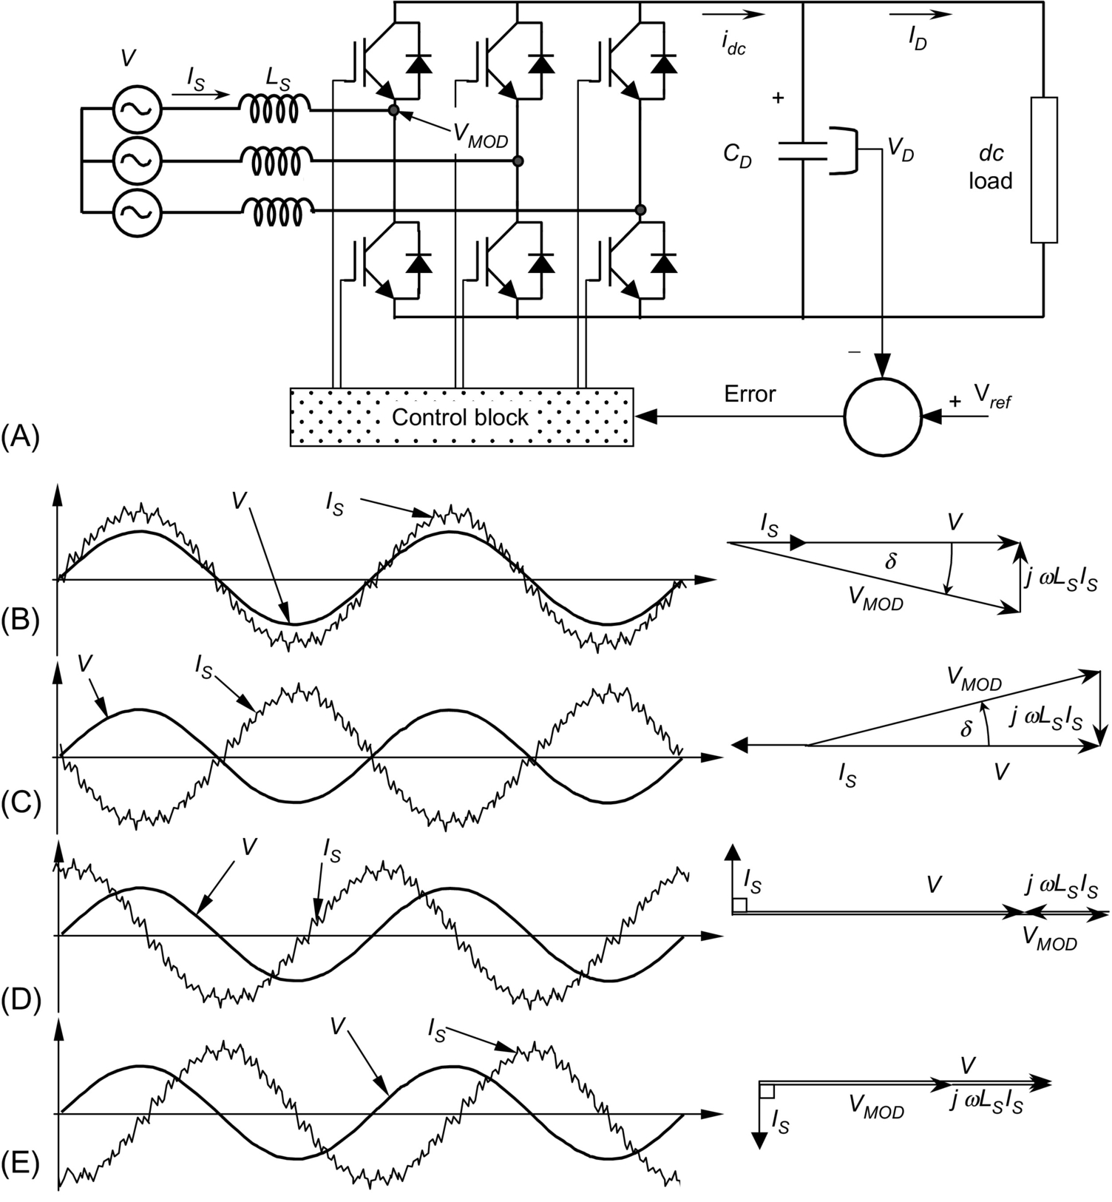

**FIG. 9.39** Four-quadrant operation of the force-commutated rectifier: (A) the PWM force-commutated rectifier, (B) rectifier operation at unity power factor, (C) inverter operation at unity power factor, (D) capacitor operation at zero power factor, and (E) inductor operation at zero power factor.

In [Fig. 9.39](https://learning.oreilly.com/library/view/power-electronics-handbook/9780128114087/B978012811407000009X.xhtml#f0200), *IS* is the *rms* value of the source current *is*. This current flows through the semiconductors in the way shown in [Fig. 9.40](https://learning.oreilly.com/library/view/power-electronics-handbook/9780128114087/B978012811407000009X.xhtml#f0205). During the positive half cycle, the transistor *TN*, connected at the negative side of the *dc* link, is switched *ON*, and the current *is* begins to flow through *TN* (*iTn*). The current returns to the mains and comes back to the valves, closing a loop with another phase and passing through a diode connected at the same negative terminal of the *dc* link. The current can also go to the *dc* load (inversion) and return through another transistor located at the positive terminal of the *dc* link. When the transistor *TN* is switched *OFF,* the current path is interrupted, and the current begins to flow through the diode *Dp*, connected at the positive terminal of the *dc* link. This current, called *iDp* in [Fig. 9.39](https://learning.oreilly.com/library/view/power-electronics-handbook/9780128114087/B978012811407000009X.xhtml#f0200), goes directly to the *dc* link, helping in the generation of the current *idc*. The current *idc* charges the capacitor *CD* and permits the rectifier to produce *dc* power. The inductances *LS* are very important in this process, because they generate an induced voltage that allows the conduction of the diode *Dp*. Similar operation occurs during the negative half cycle but with *Tp* and *DN* (see [Fig. 9.40](https://learning.oreilly.com/library/view/power-electronics-handbook/9780128114087/B978012811407000009X.xhtml#f0205)).



**FIG. 9.40** Current waveforms through the mains, the valves, and the *dc* link.

Under inverter operation, the current paths are different because the currents flowing through the transistors come mainly from the *dc* capacitor, *CD*. Under rectifier operation, the circuit works like a boost converter, and under inverter, it works as a buck converter.

To have full control of the operation of the rectifier, their six diodes must be polarized negatively at all values of instantaneous *ac* voltage supply. Otherwise, diodes will conduct, and the PWM rectifier will behave like a common diode rectifier bridge. The way to keep the diodes blocked is to ensure a *dc* link voltage higher than the peak *dc* voltage generated by the diodes alone, as shown in [Fig. 9.41](https://learning.oreilly.com/library/view/power-electronics-handbook/9780128114087/B978012811407000009X.xhtml#f0210). In this way, the diodes remain polarized negatively, and they will conduct only when at least one transistor is switched *ON,* and favorable instantaneous *ac* voltage conditions are given. In [Fig. 9.41](https://learning.oreilly.com/library/view/power-electronics-handbook/9780128114087/B978012811407000009X.xhtml#f0210), *VD* represents the capacitor *dc* voltage, which is kept higher than the normal diode-bridge rectification value *vBRIDGE*. To maintain this condition, the rectifier must have a control loop like the one displayed in [Fig. 9.36](https://learning.oreilly.com/library/view/power-electronics-handbook/9780128114087/B978012811407000009X.xhtml#f0185).



**FIG. 9.41** The *DC* link voltage condition for the operation of the PWM rectifier.

### 9.3.3 PWM PHASE-TO-PHASE AND PHASE-TO-NEUTRAL VOLTAGES

The PWM waveforms shown in the preceding figures are voltages measured between the middle point of the *dc* voltage and the corresponding phase. The phase-to-phase PWM voltages can be obtained with the help of Eq. [(9.52)](https://learning.oreilly.com/library/view/power-electronics-handbook/9780128114087/B978012811407000009X.xhtml#fo0265), where the voltage *VPWMAB* is evaluated:

 **(9.52)**

where *VPWMA* and *VPWMB* are the voltages measured between the middle point of the *dc* voltage and the phases *a* and *b*, respectively. In a less straightforward fashion, the phase-to-neutral voltage can be evaluated with the help of Eq. [(9.53)](https://learning.oreilly.com/library/view/power-electronics-handbook/9780128114087/B978012811407000009X.xhtml#fo0270):

 **(9.53)**

where *VPWMAN* is the phase-to-neutral voltage for phase *a* and *VPWMjk* is the phase-to-phase voltage between phase *j* and phase *k*. [Fig. 9.42](https://learning.oreilly.com/library/view/power-electronics-handbook/9780128114087/B978012811407000009X.xhtml#f0215) shows the PWM patterns for the phase-to-phase and phase-to-neutral voltages.

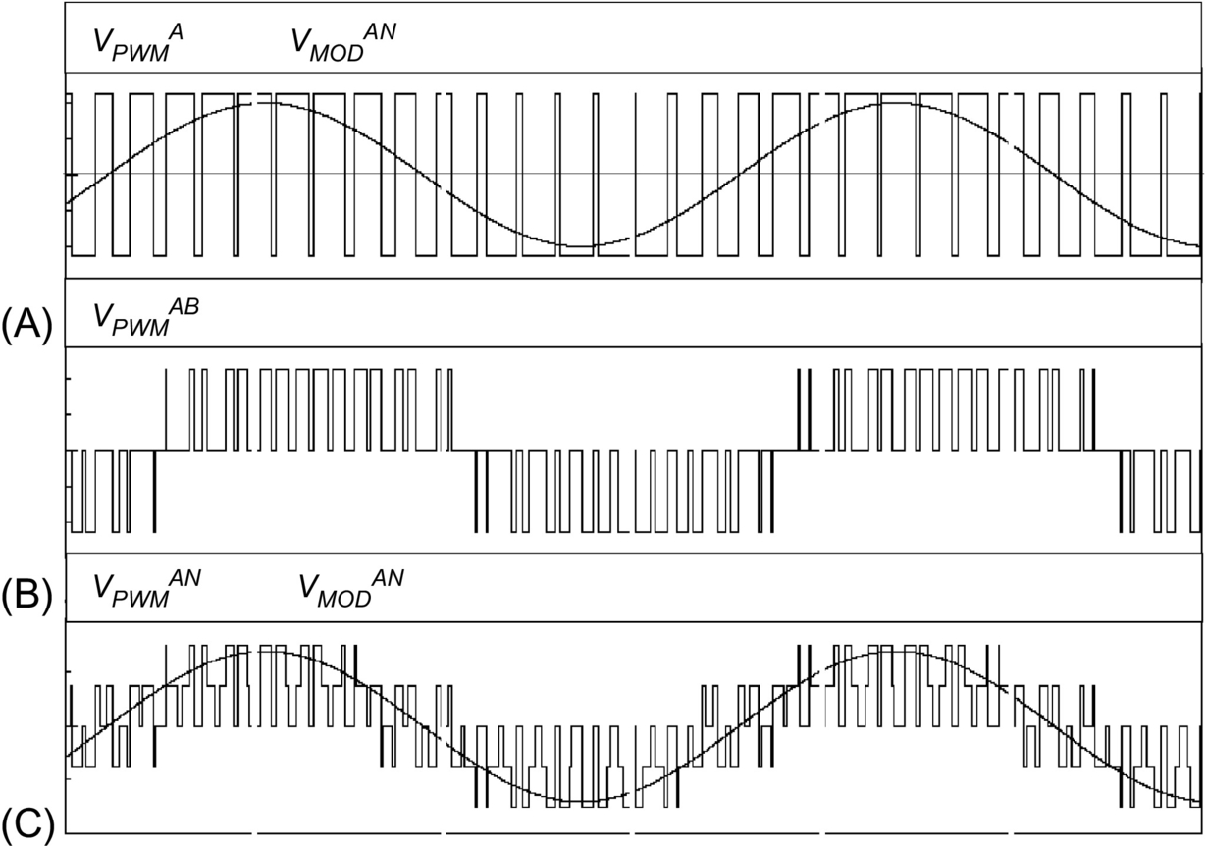

**FIG. 9.42** PWM phase voltages: (A) PWM phase modulation, (B) PWM phase-to-phase voltage, and (C) PWM phase-to-neutral voltage.

### 9.3.4 CONTROL OF THE *DC* LINK VOLTAGE

Control of the *dc* link voltage requires a feedback control loop. As already explained in [Section 9.3.2](https://learning.oreilly.com/library/view/power-electronics-handbook/9780128114087/B978012811407000009X.xhtml#s0100), the *dc* voltage *VD* is compared with a reference *VREF*, and the error signal “e” obtained from this comparison is used to generate a template waveform. The template should be a sinusoidal waveform with the same frequency of the mains supply. This template is used to produce the PWM pattern and allows controlling the rectifier in two different ways: (1) as a voltage-source current-controlled PWM rectifier and (2) as a voltage-source voltage-controlled PWM rectifier. The first method controls the input current, and the second controls the magnitude and phase of the voltage *VMOD*. The current-controlled method is simpler and more stable than the voltage-controlled method, and for these reasons, it will be explained first.

#### **9.3.4.1 Voltage-Source Current-Controlled PWM Rectifier**

This method of control is shown in the rectifier in [Fig. 9.43](https://learning.oreilly.com/library/view/power-electronics-handbook/9780128114087/B978012811407000009X.xhtml#f0220). Control is achieved by measuring the instantaneous phase currents and forcing them to follow a sinusoidal current reference template, *I*\_ref. The amplitude of the current reference template, *IMAX*, is evaluated using the following equation:

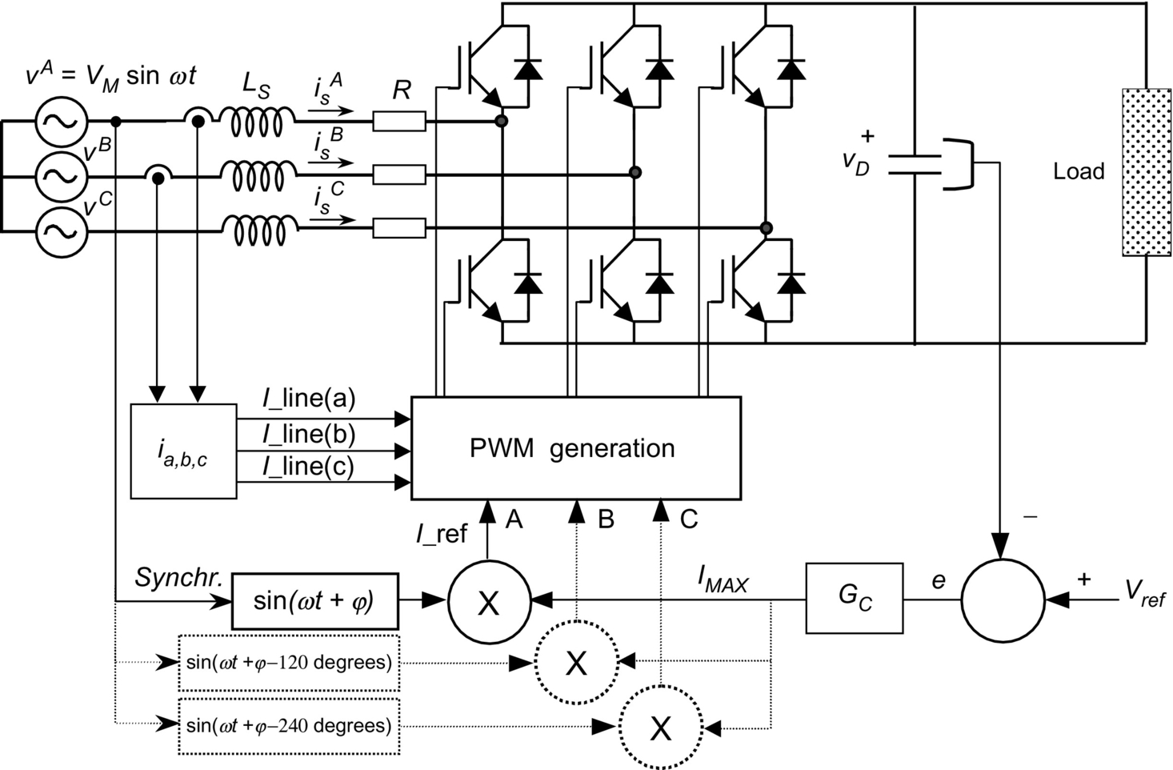

**FIG. 9.43** Voltage-source current-controlled PWM rectifier.

 **(9.54)**

where *GC* is shown in [Fig. 9.43](https://learning.oreilly.com/library/view/power-electronics-handbook/9780128114087/B978012811407000009X.xhtml#f0220) and represents a controller such as PI, P, Fuzzy, or other. The sinusoidal waveform of the template is obtained by multiplying *IMAX* with a sine function, with the same frequency of the mains and with the desired phase-shift angle *φ*, as shown in [Fig. 9.43](https://learning.oreilly.com/library/view/power-electronics-handbook/9780128114087/B978012811407000009X.xhtml#f0220). Further, the template must be synchronized with the power supply. After that, the template has been created and is ready to produce the PWM pattern.

However, one problem arises with the rectifier because the feedback control loop on the voltage *VC* can produce instability. Then, it becomes necessary to analyze this problem during rectifier design. Upon introducing the voltage feedback and the *GC* controller, the control of the rectifier can be represented in a block diagram in Laplace dominion, as shown in [Fig. 9.44](https://learning.oreilly.com/library/view/power-electronics-handbook/9780128114087/B978012811407000009X.xhtml#f0225). This block diagram represents a linearization of the system around an operating point, given by the *rms* value of the input current, *IS*.

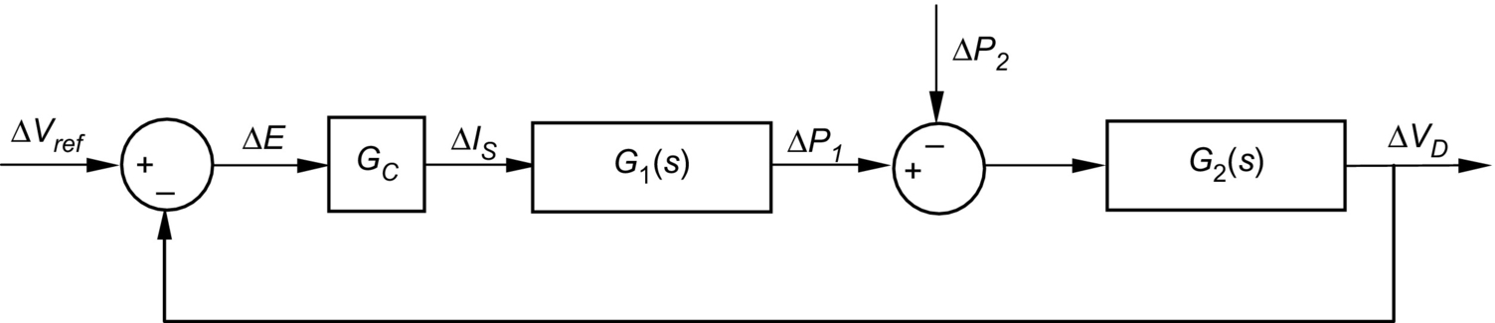

**FIG. 9.44** Closed-loop rectifier transfer function.

The blocks *G*1(*s*) and *G*2(*s*) in [Fig. 9.44](https://learning.oreilly.com/library/view/power-electronics-handbook/9780128114087/B978012811407000009X.xhtml#f0225) represent the transfer function of the rectifier (around the operating point) and the transfer function of the *dc* link capacitor *CD*, respectively:

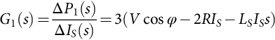 **(9.55)**

**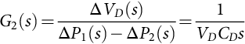** **(9.56)**

where Δ*P*1(*s*) and Δ*P*2(*s*) represent the input and output power of the rectifier in Laplace dominion, *V* the *rms* value of the mains voltage supply (phase-to-neutral), *IS* the input current being controlled by the template, *LS* the input inductance, and *R* the resistance between the converter and power supply. According to stability criteria and assuming a *PI* controller, the following relations are obtained:

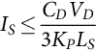 **(9.57)**

**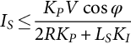** **(9.58)**

These two relations are useful for the design of the current-controlled rectifier. They relate the values of *dc* link capacitor, *dc* link voltage, *rms* voltage supply, input resistance and inductance, and input power factor with the *rms* value of the input current, *IS*. With these relations, the proportional and integral gains *KP* and *KI* can be calculated to ensure the stability of the rectifier. These relations only establish limitations for rectifier operation, because negative currents always satisfy the inequalities.

With these two stability limits satisfied, the rectifier will keep the *dc* capacitor voltage at the value of *VREF* (*PI* controller), for all load conditions, by moving power from the *ac* to the *dc* side. Under inverter operation, the power will move in the opposite direction.

Once the stability problems have been solved and the sinusoidal current template has been generated, a modulation method will be required to produce the PWM pattern for the power valves. The PWM pattern will switch the power valves to force the input currents *I*\_line to follow the desired current template *I*\_ref. There are many modulation methods in the literature, but three methods for voltage-source current-controlled rectifiers are the most widely used ones: *periodical sampling* (PS), *hysteresis band* (HB), and *triangular carrier* (TC).

The PS method switches the power transistors of the rectifier during the transitions of a square-wave clock of fixed frequency: the *periodical sampling* frequency. In each transition, a comparison between *I*\_ref and *I*\_line is made, and corrections take place. As shown in [Fig. 9.45A](https://learning.oreilly.com/library/view/power-electronics-handbook/9780128114087/B978012811407000009X.xhtml#f0230), this type of control is very simple to implement: only a comparator and a D-type flip-flop are needed per phase. The main advantage of this method is that the minimum time between switching transitions is limited to the period of the sampling clock. This characteristic determines the maximum switching frequency of the converter. However, the average switching frequency is not clearly defined.

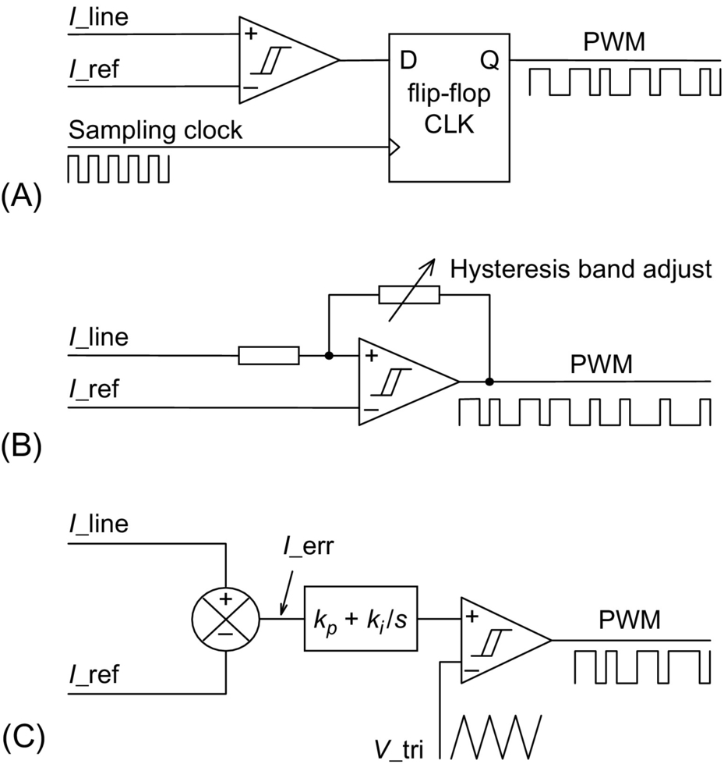

**FIG. 9.45** Modulation control methods: (A) periodical sampling, (B) hysteresis band, and (C) triangular carrier.

The HB method switches the transistors when the error between *I*\_ref and *I*\_line exceeds a fixed magnitude: the *hysteresis band.* As it can be seen in [Fig. 9.45B](https://learning.oreilly.com/library/view/power-electronics-handbook/9780128114087/B978012811407000009X.xhtml#f0230), this type of control needs a single comparator with hysteresis per phase. In this case, the switching frequency is not determined, but its maximum value can be evaluated through the following equation:

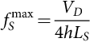 **(9.59)**

where *h* is the magnitude of the hysteresis band.

The TC method, shown in [Fig. 9.45C](https://learning.oreilly.com/library/view/power-electronics-handbook/9780128114087/B978012811407000009X.xhtml#f0230), compares the error between *I*\_ref and *I*\_line with a triangular wave. This triangular wave has fixed amplitude and frequency and is called the *triangular carrier.* The error is processed through a proportional-integral (PI) gain stage before comparison with the TC takes place. As can be seen, this control scheme is more complex than PS and HB. The values for *kp* and *ki* determine the transient response and steady-state error of the TC method. It has been found empirically that the values for *kp* and *ki* shown in Eqs. [(9.60)](https://learning.oreilly.com/library/view/power-electronics-handbook/9780128114087/B978012811407000009X.xhtml#fo0305), [(9.61)](https://learning.oreilly.com/library/view/power-electronics-handbook/9780128114087/B978012811407000009X.xhtml#fo0310) give a good dynamic performance under several operating conditions:

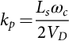 **(9.60)**

**** **(9.61)**

where *LS* is the total series inductance seen by the rectifier, *ωc* is the TC frequency, and *VD* is the *dc* link voltage of the rectifier.

In order to measure the level of distortion (or undesired harmonic generation) introduced by these three control methods, Eq. [(9.62)](https://learning.oreilly.com/library/view/power-electronics-handbook/9780128114087/B978012811407000009X.xhtml#fo0315) is defined:

 **(9.62)**

In Eq. [(9.62)](https://learning.oreilly.com/library/view/power-electronics-handbook/9780128114087/B978012811407000009X.xhtml#fo0315), the term *Irms* is the effective value of the desired current. The term inside the square root gives the *rms* value of the error current, which is undesired. This formula measures the percentage of error (or distortion) of the generated waveform. This definition considers the ripple, amplitude, and phase errors of the measured waveform, as opposed to the *THD*, which does not take into account offsets, scalings, and phase shifts.

[Fig. 9.46](https://learning.oreilly.com/library/view/power-electronics-handbook/9780128114087/B978012811407000009X.xhtml#f0235) shows the current waveforms generated by the three aforementioned methods. The example uses an average switching frequency of 1.5 kHz. The PS is the worst, but its digital implementation is simpler. The HB method and TC with PI control are quite similar, and the TC with only proportional control gives a current with a small phase shift. However, [Fig. 9.47](https://learning.oreilly.com/library/view/power-electronics-handbook/9780128114087/B978012811407000009X.xhtml#f0240) shows that the higher the switching frequency, the closer the results obtained with the different modulation methods. Over 6 kHz of switching frequency, the distortion is very small for all methods.



**FIG. 9.46** Waveforms obtained using 1.5 kHz switching frequency and *LS*=13 mH: (a) PS method, (b) HB method, (c) TC method (*KP*+*KI*), and (d) TC method (*KP* only).



**FIG. 9.47** Distortion comparison for a sinusoidal current reference.

#### **9.3.4.2 Voltage-Source Voltage-Controlled PWM Rectifier**

[Fig. 9.48](https://learning.oreilly.com/library/view/power-electronics-handbook/9780128114087/B978012811407000009X.xhtml#f0245) shows a one-phase diagram from which the control system for a voltage-source voltage-controlled rectifier is derived. This diagram represents an equivalent circuit of the fundamentals, that is, pure sinusoidal at the mains side and pure *dc* at the *dc* link side. The control is achieved by creating a sinusoidal voltage template *VMOD*, which is modified in amplitude and angle to interact with the mains voltage *V*. In this way, the input currents are controlled without measuring them. The template *VMOD* is generated using the differential equations that govern the rectifier.



**FIG. 9.48** One-phase fundamental diagram of the voltage-source rectifier.

The following differential equation can be derived from [Fig. 9.48](https://learning.oreilly.com/library/view/power-electronics-handbook/9780128114087/B978012811407000009X.xhtml#f0245):

 **(9.63)**

Assuming that , then the solution for *is*(*t*), to acquire a template *VMOD* able to make the rectifier work at constant power factor, should be of the form

 **(9.64)**

Eqs. [(9.63)](https://learning.oreilly.com/library/view/power-electronics-handbook/9780128114087/B978012811407000009X.xhtml#fo0320), [(9.64)](https://learning.oreilly.com/library/view/power-electronics-handbook/9780128114087/B978012811407000009X.xhtml#fo0325), and *v(t)* allow a function of time able to modify *VMOD* in amplitude and phase that will make the rectifier work at a fixed power factor. Combining these equations with *v(t)* yields

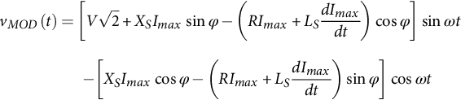 **(9.65)**

Eq. [(9.65)](https://learning.oreilly.com/library/view/power-electronics-handbook/9780128114087/B978012811407000009X.xhtml#fo0330) provides a template for *VMOD*, which is controlled through variations of the input current amplitude *Imax*. Substituting the derivatives of *Imax* into Eq. [(9.65)](https://learning.oreilly.com/library/view/power-electronics-handbook/9780128114087/B978012811407000009X.xhtml#fo0330) makes sense, because *Imax* changes every time the *dc* load is modified. The term *XS* in Eq. [(9.65)](https://learning.oreilly.com/library/view/power-electronics-handbook/9780128114087/B978012811407000009X.xhtml#fo0330) is *ωLS*. This equation can also be written for unity power factor operation. In such a case, cos *φ*=1 and sin *φ*=0:

 **(9.66)**

With this last equation, a unity power factor, voltage-source, voltage-controlled PWM rectifier can be implemented as shown in [Fig. 9.49](https://learning.oreilly.com/library/view/power-electronics-handbook/9780128114087/B978012811407000009X.xhtml#f0250). It can be observed that Eqs. [(9.65)](https://learning.oreilly.com/library/view/power-electronics-handbook/9780128114087/B978012811407000009X.xhtml#fo0330), [(9.66)](https://learning.oreilly.com/library/view/power-electronics-handbook/9780128114087/B978012811407000009X.xhtml#fo0335) have an *in-phase* term with the mains supply (sin *ωt*) and an *in-quadrature* term (cos *ωt*). These two terms allow the template *VMOD* to change in magnitude and phase so as to have full unity power factor control of the rectifier.

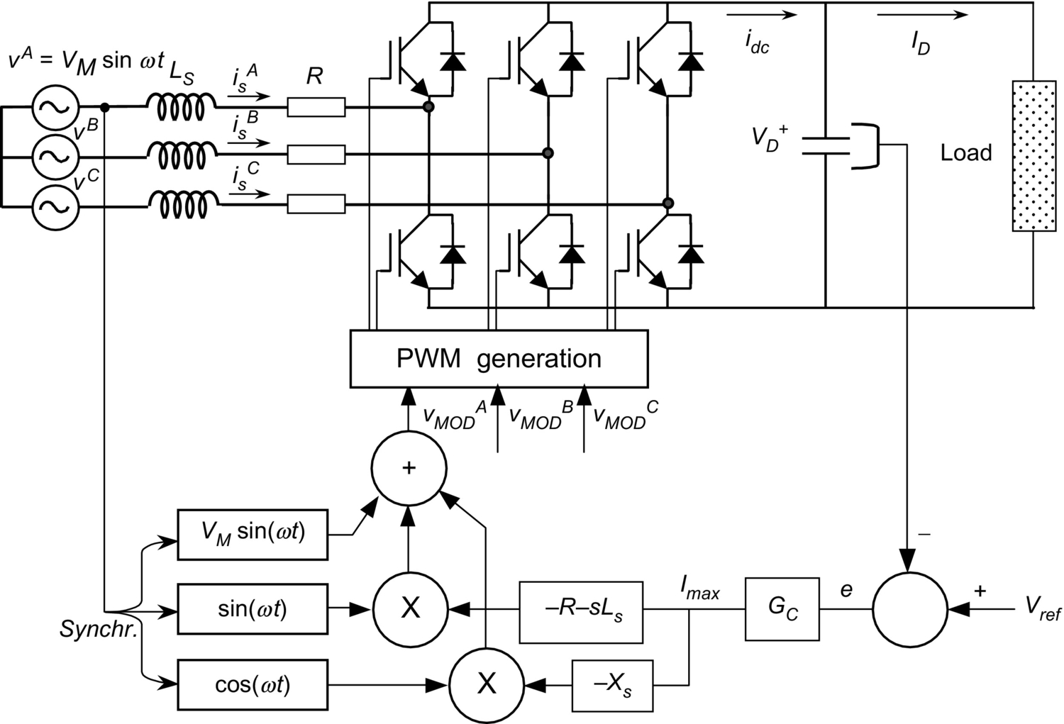

**FIG. 9.49** Implementation of the voltage-controlled rectifier for unity power factor operation.

Compared with the control block of [Fig. 9.43](https://learning.oreilly.com/library/view/power-electronics-handbook/9780128114087/B978012811407000009X.xhtml#f0220), in the voltage-source voltage-controlled rectifier of [Fig. 9.49](https://learning.oreilly.com/library/view/power-electronics-handbook/9780128114087/B978012811407000009X.xhtml#f0250), there is no need to sense the input currents. However, to ensure stability limits as good as the limits of the current-controlled rectifier, the blocks “−*R*−*sLS*” and “−*XS*” in [Fig. 9.49](https://learning.oreilly.com/library/view/power-electronics-handbook/9780128114087/B978012811407000009X.xhtml#f0250) have to emulate and reproduce exactly the real values of *R*, *XS*, and *LS* of the power circuit. However, these parameters do not remain constant, and this fact affects the stability of this system, making it less stable than the system shown in [Fig. 9.43](https://learning.oreilly.com/library/view/power-electronics-handbook/9780128114087/B978012811407000009X.xhtml#f0220). In theory, if the impedance parameters are reproduced exactly, the stability limits of this rectifier are given by the same equations as used for the current-controlled rectifier seen in [Fig. 9.43](https://learning.oreilly.com/library/view/power-electronics-handbook/9780128114087/B978012811407000009X.xhtml#f0220) (Eqs. [9.57](https://learning.oreilly.com/library/view/power-electronics-handbook/9780128114087/B978012811407000009X.xhtml#fo0290), [9.58](https://learning.oreilly.com/library/view/power-electronics-handbook/9780128114087/B978012811407000009X.xhtml#fo0295)).

Under steady state, *Imax* is constant, and Eq. [(9.66)](https://learning.oreilly.com/library/view/power-electronics-handbook/9780128114087/B978012811407000009X.xhtml#fo0335) can be written in terms of phasor diagram, resulting in Eq. [(9.67)](https://learning.oreilly.com/library/view/power-electronics-handbook/9780128114087/B978012811407000009X.xhtml#fo0340). As shown in [Fig. 9.50](https://learning.oreilly.com/library/view/power-electronics-handbook/9780128114087/B978012811407000009X.xhtml#f0255), different operating conditions for the unity power factor rectifier can be displayed with this equation:



**FIG. 9.50** Steady-state operation of the unity power factor rectifier under different load conditions.

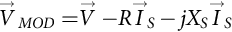 **(9.67)**

With the sinusoidal template *VMOD* already created, a modulation method to commutate the transistors will be required. As in the case of current-controlled rectifier, there are many methods to modulate the template, with the most well-known the so-called sinusoidal pulse-width modulation (SPWM), which uses a TC to generate the PWM as shown in [Fig. 9.51](https://learning.oreilly.com/library/view/power-electronics-handbook/9780128114087/B978012811407000009X.xhtml#f0260). Only this method will be described in this chapter.



**FIG. 9.51** Sinusoidal modulation method based on TC.

In this method, there are two important parameters to define: the amplitude modulation ratio or modulation index *m* and the frequency modulation ratio *p*. Definitions are given by

 **(9.68)**

**** **(9.69)**

where *VMODmax* and *VTRIANGmax* are the amplitudes of *VMOD* and *VTRIANG*, respectively. On the other hand, *fS* is the frequency of the mains supply and *fT* the frequency of the TC. In [Fig. 9.51](https://learning.oreilly.com/library/view/power-electronics-handbook/9780128114087/B978012811407000009X.xhtml#f0260), *m*=0.8 and *p*=21. When *m*>1, overmodulation is defined.

The modulation method described in [Fig. 9.51](https://learning.oreilly.com/library/view/power-electronics-handbook/9780128114087/B978012811407000009X.xhtml#f0260) has a harmonic content that changes with *p* and *m*. When *p*<21, it is recommended that synchronous PWM be used, which means that the TC and the template should be synchronized. Furthermore, to avoid subharmonics, it is also desired that *p* be an integer. If *p* is an odd number, even harmonics will be eliminated. If *p* is a multiple of 3, then the PWM modulation of the three phases will be identical. When *m* increases, the amplitude of the fundamental voltage increases proportionally, but some harmonics decrease. Under overmodulation (*m*>1), the fundamental voltage does not increase linearly, and more harmonics appear. [Fig. 9.52](https://learning.oreilly.com/library/view/power-electronics-handbook/9780128114087/B978012811407000009X.xhtml#f0265) shows the harmonic spectrum of the three-phase PWM voltage waveforms for different values of *m*, and *p*=3*k* where *k* is an odd number.



**FIG. 9.52** Harmonic spectrum for SPWM modulation.

Due to the presence of the input inductance *LS*, the harmonic currents that result are proportionally attenuated with the harmonic number. This characteristic is shown in the current waveforms of [Fig. 9.53](https://learning.oreilly.com/library/view/power-electronics-handbook/9780128114087/B978012811407000009X.xhtml#f0270), where larger *p* numbers generate cleaner currents. The rectifier that originated the currents of [Fig. 9.53](https://learning.oreilly.com/library/view/power-electronics-handbook/9780128114087/B978012811407000009X.xhtml#f0270) has the following characteristics: *VD*=450*Vdc*, , *LS*=2 mH, and input current *IS*=80 A*rms*. It can be observed that with *p*>21, the current distortion is quite small. The value of *p*=81 in [Fig. 9.53](https://learning.oreilly.com/library/view/power-electronics-handbook/9780128114087/B978012811407000009X.xhtml#f0270) produces an almost pure sinusoidal waveform, and it means 4860 Hz of switching frequency at 60 Hz or only 4.050 Hz in a rectifier operating in a 50 Hz supply. This switching frequency can be managed by MOSFETs, IGBTs, and even Power Darlingtons. Then, a number *p*=81 is feasible for today's low- and medium-power rectifiers.



**FIG. 9.53** Current waveforms for different values of *p.*

#### **9.3.4.3 Voltage-Source Load-Controlled PWM Rectifier**

A simple method of control for small PWM rectifiers (up to 10–20 kW) is based on direct control of the *dc* current. [Fig. 9.54](https://learning.oreilly.com/library/view/power-electronics-handbook/9780128114087/B978012811407000009X.xhtml#f0275) shows the schematic of this control system. The fundamental voltage *VMOD* modulated by the rectifier is produced by a fixed and unique PWM pattern, which can be carefully selected to eliminate most undesirable harmonics. As the PWM does not change, it can be stored in a permanent digital memory (ROM).



**FIG. 9.54** Voltage-source load-controlled PWM rectifier.

The control is based on changing the power angle *δ* between the mains voltage *V* and fundamental PWM voltage *VMOD*. When *δ* changes, the amount of power flow transferred from the *ac* to the *dc* side also changes. When the power angle is negative (*VMOD* lags *V*), the power flow goes from the *ac* to the *dc* side. When the power angle is positive, the power flows in the opposite direction. Then, the power angle can be controlled through the current *ID*. The voltage *VD* does not need to be sensed, because this control establishes a stable *dc* voltage operation for each *dc* current and power angle. With these characteristics, it is possible to find a relation between *ID* and *δ* so as to obtain constant *dc* voltage for all load conditions. This relation is given by

 **(9.70)**

From Eq. [(9.70)](https://learning.oreilly.com/library/view/power-electronics-handbook/9780128114087/B978012811407000009X.xhtml#fo0355), a plot and a reciprocal function *δ*=*f(ID)* is obtained to control the rectifier. The relation between *ID* and *δ* allows for leading power factor operation and null regulation. The leading power factor operation is shown in the phasor diagram of [Fig. 9.54](https://learning.oreilly.com/library/view/power-electronics-handbook/9780128114087/B978012811407000009X.xhtml#f0275).

The control scheme of the voltage-source load-controlled rectifier is characterized by the following: (i) There is neither input current sensors nor *dc* voltage sensor, (ii) it works with a fixed and predefined PWM pattern, (iii) it presents very good stability, (iv) its stability does not depend on the size of the *dc* capacitor, (v) it can work at leading power factor for all load conditions, and (vi) it can be adjusted with Eq. [(9.70)](https://learning.oreilly.com/library/view/power-electronics-handbook/9780128114087/B978012811407000009X.xhtml#fo0355) to work at zero regulation. The drawback appears when *R* in Eq. [(9.70)](https://learning.oreilly.com/library/view/power-electronics-handbook/9780128114087/B978012811407000009X.xhtml#fo0355) becomes negligible, because in such a case, the control system is unable to find an equilibrium point for the *dc* link voltage. That is why this control method is not applicable to large systems.

### 9.3.5 NEW TECHNOLOGIES AND APPLICATIONS OF FORCE-COMMUTATED RECTIFIERS

The additional advantages of force-commutated rectifiers with respect to line-commutated rectifiers make them better candidates for industrial requirements. They permit new applications such as rectifiers with harmonic elimination capability (active filters), power factor compensators, machine drives with four-quadrant operation, frequency links to connect 50 Hz with 60 Hz systems, and regenerative converters for traction power supplies. Modulation with very fast valves such as IGBTs permits almost sinusoidal currents to be obtained. The dynamics of these rectifiers is so fast that they can reverse power almost instantaneously. In machine drives, current-source PWM rectifiers, like the one shown in [Fig. 9.35A](https://learning.oreilly.com/library/view/power-electronics-handbook/9780128114087/B978012811407000009X.xhtml#f0180), can be used to drive *dc* machines from the three-phase supply. Four-quadrant applications using voltage-source PWM rectifiers are extended for induction machines, synchronous machines with starting control, and special machines such as brushless dc motors. Back-to-back systems are being used in Japan to link power systems with different frequencies.

#### **9.3.5.1 Active Power Filter**

Force-commutated PWM rectifiers can work as active power filters. The voltage-source current-controlled rectifier has the capability to eliminate harmonics produced by other polluting loads. It only needs to be connected as shown in [Fig. 9.55](https://learning.oreilly.com/library/view/power-electronics-handbook/9780128114087/B978012811407000009X.xhtml#f0280).



**FIG. 9.55** Voltage-source rectifier with harmonic elimination capability.

The current sensors are located at the input terminals of the power source, and these currents (instead of the rectifier currents) are forced to be sinusoidal. As there are polluting loads in the system, the rectifier is forced to deliver the harmonics that loads need, because the current sensors do not allow the harmonics going to the mains. As a result, the rectifier currents become distorted, but an adequate *dc* capacitor *CD* can keep the *dc* link voltage in good shape. In this way, the rectifier can do its duty and also eliminate harmonics to the source. In addition, it also can compensate power factor and unbalanced load problems.

#### **9.3.5.2 Frequency Link Systems**

Frequency link systems permit power to be transferred form one frequency to another one. They are also useful for linking unsynchronized networks. Line-commutated converters are widely used for this application, but they have some drawbacks that force-commutated converters can eliminate. For example, the harmonic filter requirement, the poor power factor, and the necessity to count with a synchronous compensator when generating machines at the load side are absent. [Fig. 9.56](https://learning.oreilly.com/library/view/power-electronics-handbook/9780128114087/B978012811407000009X.xhtml#f0285) shows a typical line-commutated system in which a 60 Hz load is fed by a 50 Hz supply. As the 60 Hz side needs excitation to commutate the valves, a synchronous compensator has been required.



**FIG. 9.56** Frequency link systems with line-commutated converters.

In contrast, an equivalent system with force-commutated converters is simpler, cleaner, and more reliable. It is implemented with a *dc* voltage-controlled rectifier and another identical converter working in the inversion mode. The power factor can be adjusted independently at the two *ac* terminals, and filters or synchronous compensators are not required. [Fig. 9.57](https://learning.oreilly.com/library/view/power-electronics-handbook/9780128114087/B978012811407000009X.xhtml#f0290) shows a frequency-link system with force-commutated converters.



**FIG. 9.57** Frequency link systems with force-commutated converters.

#### **9.3.5.3 Special Topologies for High Power Applications**

High-power applications require series- and/or parallel-connected rectifiers. Series and parallel operations with force-commutated rectifiers allow improving the power quality because harmonic cancelation can be applied to these topologies. [Fig. 9.58](https://learning.oreilly.com/library/view/power-electronics-handbook/9780128114087/B978012811407000009X.xhtml#f0295) shows a series connection of force-commutated rectifiers, where the modulating carriers of the valves in each bridge are shifted to cancel harmonics. The example uses sinusoidal PWM that are with TC shifted.



**FIG. 9.58** Series connection system with force-commutated rectifiers.

The waveforms of the input currents for the series connection system are shown in [Fig. 9.59](https://learning.oreilly.com/library/view/power-electronics-handbook/9780128114087/B978012811407000009X.xhtml#f0300). The frequency modulation ratio shown in this figure is for *p*=9. The carriers are shifted by 90 degrees each, to obtain harmonic cancelation. Shifting of the carriers *δT* depends on the number of converters in series (or in parallel) and is given by



**FIG. 9.59** Input currents and carriers of the series connection system of [Fig. 9.58](https://learning.oreilly.com/library/view/power-electronics-handbook/9780128114087/B978012811407000009X.xhtml#f0295).

 **(9.71)**

where *n* is the number of converters in series or in parallel. It can be observed that despite the low value of *p*, the total current becomes quite clean and clear, better than the current of one of the converters in the chain.

The harmonic cancelation with series- or parallel-connected rectifiers, using the same modulation but the carriers shifted, is quite effective. The resultant current is better with *n* converters and frequency modulation *p*=*p*1 than with one converter and *p*=*np*1. This attribute is verified in [Fig. 9.60](https://learning.oreilly.com/library/view/power-electronics-handbook/9780128114087/B978012811407000009X.xhtml#f0305), where the total current of four converters in series with *p*=9 and carriers shifted is compared with the current of only one converter and *p*=36. This technique also allows for the use of valves with slow commutation times, such as high-power GTOs. Generally, high-power valves have low commutation times, and hence, the parallel and/or series options remain very attractive.



**FIG. 9.60** Four converters in series and *p*=9 compared with one converter and *p*=36.

Another special topology for high power was implemented for Asea Brown Boveri (ABB) in Bremen. A 100 MW power converter supplies energy to the railways at 162/3 Hz. It uses basic “H” bridges like the one shown in [Fig. 9.61](https://learning.oreilly.com/library/view/power-electronics-handbook/9780128114087/B978012811407000009X.xhtml#f0310), connected to the load through power transformers. These transformers are connected in parallel at the converter side and in series at the load side.



**FIG. 9.61** The “H” modulator: (A) one bridge and (B) bridges connected in series at load side through isolation transformers.

The system uses SPWM with TCs shifted, and depending on the number of converters connected in the chain of bridges, the voltage waveform becomes more and more sinusoidal. [Fig. 9.62](https://learning.oreilly.com/library/view/power-electronics-handbook/9780128114087/B978012811407000009X.xhtml#f0315) shows a back-to-back system using a chain of 12 “H” converters connected as shown in [Fig. 9.61B](https://learning.oreilly.com/library/view/power-electronics-handbook/9780128114087/B978012811407000009X.xhtml#f0310).



**FIG. 9.62** Frequency link with force-commutated converters and sinusoidal voltage modulation.

The *ac* voltage waveform obtained with the topology of [Fig. 9.62](https://learning.oreilly.com/library/view/power-electronics-handbook/9780128114087/B978012811407000009X.xhtml#f0315) is displayed in [Fig. 9.63](https://learning.oreilly.com/library/view/power-electronics-handbook/9780128114087/B978012811407000009X.xhtml#f0320). It can be observed that the voltage is formed by small steps that depend on the number of converters in the chain (12 in this case). The current is almost perfectly sinusoidal.



**FIG. 9.63** Voltage and current waveforms with 12 converters.

[Fig. 9.64](https://learning.oreilly.com/library/view/power-electronics-handbook/9780128114087/B978012811407000009X.xhtml#f0325) shows the voltage waveforms for different number of converters connected in the bridge. It is clear that the larger the number of converters, the better the voltage.



**FIG. 9.64** Voltage waveforms with different numbers of “H” bridges in series.

Another interesting result with this converter is that the *ac* voltages become modulated by both PWM and amplitude modulation (AM). This is because when the pulse modulation changes, the steps of the amplitude change. The maximum number of steps of the resultant voltage is equal to the number of converters. When the voltage decreases, some steps disappear, and then, the AM becomes a discrete function. [Fig. 9.65](https://learning.oreilly.com/library/view/power-electronics-handbook/9780128114087/B978012811407000009X.xhtml#f0330) shows the AM of the voltage.



**FIG. 9.65** Amplitude modulation of the “H” bridges of [Fig. 9.62](https://learning.oreilly.com/library/view/power-electronics-handbook/9780128114087/B978012811407000009X.xhtml#f0315).

#### **9.3.5.4 Machine Drives Applications**

One of the most important applications of force-commutated rectifiers is in machine drives. Line-commutated thyristor converters have limited applications because they need excitation to extinguish the valves. This limitation does not allow the use of line-commutated converters in induction machine drives. On the other hand, with force-commutated converters, four-quadrant operation is achievable. [Fig. 9.66](https://learning.oreilly.com/library/view/power-electronics-handbook/9780128114087/B978012811407000009X.xhtml#f0335) shows a typical frequency converter with a force-commutated rectifier-inverter link. The rectifier side controls the *dc* link, and the inverter side controls the machine. The machine can be a synchronous, brushless *dc,* or induction machine. The reversal of both speed and power is possible with this topology. At the rectifier side, the power factor can be controlled, and even with an inductive load such as an induction machine, the source can “see” the load as capacitive or resistive. Changing the frequency of the inverter controls the machine speed, and the torque is controlled through the stator currents and torque angle. The inverter will become a rectifier during regenerative braking, which is possible by making slip negative in an induction machine or by making the torque angle negative in synchronous and brushless *dc* machines.



**FIG. 9.66** Frequency converter with force-commutated converters.

A variation of the drive of [Fig. 9.66](https://learning.oreilly.com/library/view/power-electronics-handbook/9780128114087/B978012811407000009X.xhtml#f0335) is found in electric traction applications. Battery-powered vehicles use the inverter as a rectifier during regenerative braking, and sometimes, the inverter is also used as a battery charger. In this case, the rectifier can be fed by a single-phase or three-phase system. [Fig. 9.67](https://learning.oreilly.com/library/view/power-electronics-handbook/9780128114087/B978012811407000009X.xhtml#f0340) shows a battery-powered electric bus system. This system uses the power inverter of the traction motor as rectifier for two purposes: regenerative braking and as a battery charger fed by a three-phase power source.



**FIG. 9.67** Electric bus system with regenerative braking and battery charger.

#### **9.3.5.5 Variable Speed Power Generation**

Power generation at 50 or 60 Hz requires constant speed machines. In addition, induction machines are not currently used in power plants because of magnetization problems. With the use of frequency-link force-commutated converters, variable-speed constant-frequency generation becomes possible even with induction generators. The power plant in [Fig. 9.68](https://learning.oreilly.com/library/view/power-electronics-handbook/9780128114087/B978012811407000009X.xhtml#f0345) shows a wind generator implemented with an induction machine and a rectifier-inverter frequency link connected to the utility. The *dc* link voltage is kept constant with the converter located at the mains side. The converter connected at the machine side controls the slip of the generator and adjusts it according to the speed of wind or power requirements. The utility is not affected by the power factor of the generator, because the two converters keep the cos *φ* of the machine independent of the mains supply. The converter at the mains side can even be adjusted to operate at leading power factor.



**FIG. 9.68** Variable-speed constant-frequency wind generator.

Variable-speed constant-frequency generation also can be used in either hydraulic or thermal plants. This allows for optimal adjustment of the efficiency-speed characteristics of the machines. In many places, wound rotor induction generators working as variable-speed synchronous machines are being used as constant-frequency generators. They operate in hydraulic plants that are able to store water during low-demand periods. A power converter is connected at the slip rings of the generator. The rotor is then fed with variable-frequency excitation. This allows the generator to generate at different speeds around the synchronous rotating flux.

#### **9.3.5.6 Power Rectifiers Using Multilevel Topologies**

Almost all voltage-source rectifiers already described are two-level configurations. Today, multilevel topologies are becoming very popular, mainly three-level converters. The most popular three-level configuration is called diode-clamped converter, which is shown in [Fig. 9.69](https://learning.oreilly.com/library/view/power-electronics-handbook/9780128114087/B978012811407000009X.xhtml#f0350). This topology is today the standard solution for high-power steel rolling mills, which uses back-to-back three-phase rectifier-inverter link configuration. In addition, this solution has been recently introduced in high-power downhill conveyor belts that operate almost permanently in the regeneration mode or rectifier operation. The more important advantage of three-level rectifiers is that voltage and current harmonics are reduced due to the increased number of levels.



**FIG. 9.69** Voltage-source rectifier using three-level converter.

Higher number of levels can be obtained using the same diode-clamped strategy, as shown in [Fig. 9.70](https://learning.oreilly.com/library/view/power-electronics-handbook/9780128114087/B978012811407000009X.xhtml#f0355), where only one phase of a general approach is displayed. However, this topology becomes more and more complex with the increase of the number of levels. For this reason, new topologies are being studied to get a large number of levels with less power transistors. One example of such of these topologies is the multistage, 27-level converter shown in [Fig. 9.71](https://learning.oreilly.com/library/view/power-electronics-handbook/9780128114087/B978012811407000009X.xhtml#f0360). This special 27-level, 4-quadrant rectifier uses only 3 H-bridges per phase with independent input transformers for each H-bridge. The transformers allow galvanic isolation and power escalation to get high-quality voltage waveforms, with *THD* of less than 1%. The power scalation consists on increasing the voltage rates of each transformer making use of the “three-level” characteristics of H-bridges. Then, the number of levels is optimized when transformers are scaled in power of three. Some advantages of this 27-level topology are the following: (a) Only one of the three H-bridges, called “main converter,” manages more than 80% of the total active power in each phase, and (b) this main converter switches at fundamental frequency reducing the switching losses at a minimum value. The rectifier of [Fig. 9.71](https://learning.oreilly.com/library/view/power-electronics-handbook/9780128114087/B978012811407000009X.xhtml#f0360) is a current-controlled voltage-source type, with a conventional feedback control loop, which is being used as a rectifier in a subway substation. It includes fast reversal of power and the ability to produce clean *ac* and *dc* waveforms with negligible ripple. This rectifier can also compensate power factor and eliminate harmonics produced by other loads in the *ac* line. [Fig. 9.72](https://learning.oreilly.com/library/view/power-electronics-handbook/9780128114087/B978012811407000009X.xhtml#f0365) shows the *ac* voltage waveform obtained with this rectifier from an experimental prototype. If one more H-bridge is added, 81 levels are obtained, because the number of levels increases according with *N*=3*k*, where *N* is the number of levels or voltage steps and *k* the number of H-bridges used per phase.



**FIG. 9.70** Multilevel rectifier using diode-clamped topology.



**FIG. 9.71** Twenty-seven-level rectifier for railways, using H-bridges scaled in power of three.



**FIG. 9.72** *AC* voltage waveform generated by the 27-level rectifier.

Many other high-level topologies are under study, but this matter is beyond the main topic of this chapter.

## Further Reading

[1] Möltgen G. *Line Commutated Thyristor Converters.* London: Siemens Aktiengesellschaft, Berlin-Munich, Pitman Publishing; 1972.

[2] Möltgen G. *Converter Engineering, and Introduction to Operation and Theory.* New York, NY: John Wiley and Sons; 1984.

[3] Thorborg K. *Power Electronics.* London: Prentice-Hall International (UK) Ltd., 1988.

[4] Rashid M.H. *Power Electronics, Circuits Devices and Applications.* London: Prentice-Hall International Editions; 1992.

[5] Mohan N., Undeland T.M., Robbins W.P. *Power Electronics: Converters, Applications, and Design.* New York, NY: John Wiley and Sons; 1989.

[6] Arrillaga J., Bradley D.A., Bodger P.S. *Power System Harmonics.* New York, NY: John Wiley and Sons; 1989.

[7] Murphy J.M.D., Turnbull F.G. *Power Electronic Control of AC Motors.* Oxford, England: Pergamon Press; 1988.

[8] Villablanca M.E., Arrillaga J. Pulse multiplication in parallel convertors by multitap control of interphase reactor. *IEE Proc. B.* 1992;139(1):13–20.

[9] D.A. Woodford, HVDC transmission, Professional report from Manitoba HVDC Research Center, Winnipeg, Manitoba, March 1998.

[10] Veas D.R., Dixon J.W., Ooi B.T. A novel load current control method for a leading power factor voltage source PEM rectifier. *IEEE Trans. Power Electron.* 1994;9(2):153–159.

[11] Morán L., Mora E., Wallace R., Dixon J. *Performance analysis of a power factor compensator which simultaneously eliminates line current harmonics.* In: IEEE Power Electronics Specialists Conference, PESC'92, Toledo, España, June 29 to July 3; 1992.

[12] Ziogas P.D., Morán L., Joos G., Vincenti D. *A refined PWM scheme for voltage and current source converters.* In: IEEE-IAS Annual Meeting; 1990:977–983.

[13] McMurray W. Modulation of the chopping frequency in DC choppers and PWM inverters having current hysteresis controllers. *IEEE Trans. Ind. Appl.* 1984;IA-20:763–768.

[14] Dixon J.W., Ooi B.T. Indirect current control of a unity power factor sinusoidal current boost type three-phase rectifier. *IEEE Trans. Ind. Electron.* 1988;35(4):508–515.

[15] Morán L., Dixon J., Wallace R. A three-phase active power filter operating with fixed switching frequency for reactive power and current harmonic compensation. *IEEE Trans. Ind. Electron.* 1995;42(4):402–408.

[16] Boost M.A., Ziogas P. State-of-the-art PWM techniques, a critical evaluation. *IEEE Trans. Ind. Appl.* 1988;24(2):271–280.

[17] Dixon J.W., Ooi B.T. Series and parallel operation of hysteresis current-controlled PWM rectifiers. *IEEE Trans. Ind. Appl.* 1989;25(4):644–651.

[18] Ooi B.T., Dixon J.W., Kulkarni A.B., Nishimoto M. An integrated AC drive system using a controlled-current PWM rectifier/inverter link. *IEEE Trans. Power Electron.* 1988;3(1):64–71.

[19] Koyama M., Shimomura Y., Yamaguchi H., Mukunoki M., Okayama H., Mizoguchi S. *Large capacity high efficiency three-level GCT inverter system for steel rolling mill drivers.* In: Proceedings of the 9th European Conference on Power Electronics, EPE, Austria, CDROM; 2001.

[20] Rodríguez J., Dixon J., Espinoza J., Lezana P. PWM regenerative rectifiers: state of the art. *IEEE Trans. Ind. Electron.* 2005;52(4):5–22.

[21] Dixon J., Morán L. A clean four-quadrant sinusoidal power rectifier, using multistage converters for subway applications. *IEEE Trans. Ind. Electron.* 2005;52(5):653–661.

**10**

# DC-DC Converters

Dariusz Czarkowski New York University, New York, NY, United States

## Abstract

Modern electronic systems require high-quality, small, lightweight, reliable, and efficient power supplies. Linear power regulators, whose principle of operation is based on a voltage or current divider, are inefficient. They are limited to output voltages smaller than the input voltage. Also, their power density is low because they require low-frequency (50 or 60 Hz) line transformers and filters. Linear regulators can, however, provide a very high-quality output voltage. Their main area of application is at low power levels as low-dropout voltage (LDO) regulators. Electronic devices in linear regulators operate in their active (linear) modes. At higher power levels, switching regulators are used. Switching regulators use power electronic semiconductor switches in *on* and *off* states. Since there is a small power loss in those states (low voltage across a switch in the *on* state, zero current through a switch in the *off* state), switching regulators can achieve high energy conversion efficiencies. Modern power electronic switches can operate at high frequencies. The higher the operating frequency, the smaller and lighter the transformers, filter inductors, and capacitors. In addition, dynamic characteristics of converters improve with increasing operating frequencies. The bandwidth of a control loop is usually determined by the corner frequency of the output filter. Therefore, high operating frequencies allow for achieving a faster dynamic response to rapid changes in the load current and/or the input voltage.

### KEYWORDS

DC Choppers; Continuous conduction mode; Discontinuous conduction mode; Converters; Forward converter; Push-pull converter

10.1 [Introduction](https://learning.oreilly.com/library/view/power-electronics-handbook/9780128114087/B9780128114070000106.xhtml#s0010)

10.2 [DC Choppers](https://learning.oreilly.com/library/view/power-electronics-handbook/9780128114087/B9780128114070000106.xhtml#s0015)

10.3 [Step-Down (Buck) Converter](https://learning.oreilly.com/library/view/power-electronics-handbook/9780128114087/B9780128114070000106.xhtml#s0020)

10.3.1 Basic Converter

10.3.2 Transformer Versions of Buck Converter

10.4 [Step-Up (Boost) Converter](https://learning.oreilly.com/library/view/power-electronics-handbook/9780128114087/B9780128114070000106.xhtml#s0055)

10.5 [Buck-Boost Converter](https://learning.oreilly.com/library/view/power-electronics-handbook/9780128114087/B9780128114070000106.xhtml#s0060)

10.5.1 Basic Converter

10.5.2 Flyback Converter

10.6 [Ćuk Converter](https://learning.oreilly.com/library/view/power-electronics-handbook/9780128114087/B9780128114070000106.xhtml#s0075)

10.7 [Effects of Parasitic Components](https://learning.oreilly.com/library/view/power-electronics-handbook/9780128114087/B9780128114070000106.xhtml#s0080)

10.8 [Synchronous and Bidirectional Converters](https://learning.oreilly.com/library/view/power-electronics-handbook/9780128114087/B9780128114070000106.xhtml#s0085)

10.9 [Control Principles](https://learning.oreilly.com/library/view/power-electronics-handbook/9780128114087/B9780128114070000106.xhtml#s0090)

10.10 [Applications of DC-DC Converters](https://learning.oreilly.com/library/view/power-electronics-handbook/9780128114087/B9780128114070000106.xhtml#s0095)

[Further Reading](https://learning.oreilly.com/library/view/power-electronics-handbook/9780128114087/B9780128114070000106.xhtml#fr0010)

## 10.1 Introduction

Modern electronic systems require high-quality, small, lightweight, reliable, and efficient power supplies. Linear power regulators, whose principle of operation is based on a voltage or current divider, are inefficient. They are limited to output voltages smaller than the input voltage. Also, their power density is low because they require low-frequency (50 or 60 Hz) line transformers and filters. Linear regulators can, however, provide a very high-quality output voltage. Their main area of application is at low power levels as low-dropout voltage (LDO) regulators. Electronic devices in linear regulators operate in their active (linear) modes. At higher power levels, switching regulators are used. Switching regulators use power electronic semiconductor switches in *on* and *off* states. Since there is a small power loss in those states (low voltage across a switch in the *on* state, zero current through a switch in the *off* state), switching regulators can achieve high energy conversion efficiencies. Modern power electronic switches can operate at high frequencies. The higher the operating frequency, the smaller and lighter the transformers, filter inductors, and capacitors. In addition, dynamic characteristics of converters improve with increasing operating frequencies. The bandwidth of a control loop is usually determined by the corner frequency of the output filter. Therefore, high operating frequencies allow for achieving a faster dynamic response to rapid changes in the load current and/or the input voltage.

High-frequency electronic power processors are used in dc-dc power conversion. The functions of dc-dc converters are

• to convert a dc input voltage *V*S into a dc output voltage *V*O,

• to regulate the dc output voltage against load and line variations,

• to reduce the ac voltage ripple on the dc output voltage below the required level,

• to provide isolation between the input source and the load (isolation is not always required),

• to protect the supplied system and the input source from electromagnetic interference (EMI),

• to satisfy various international and national safety standards.

The dc-dc converters can be divided into two main types: hard-switching pulse-width-modulated (PWM) converters and resonant and soft-switching converters. This chapter deals with the former type of dc-dc converters. The PWM converters have been very popular for the last three decades. They are widely used at all power levels. Topologies and properties of PWM converters are well understood and described in literature. Advantages of PWM converters include low component count, high efficiency, constant frequency operation, relatively simple control and commercial availability of integrated circuit controllers, and ability to achieve high conversion ratios for both step-down and step-up application. A disadvantage of PWM dc-dc converters is that PWM rectangular voltage and current waveforms cause turn-on and turn-off losses in semiconductor devices that limit practical operating frequencies to a megahertz range. Rectangular waveforms also inherently generate EMI.

This chapter starts from a section on dc choppers that are used primarily in dc drives. The output voltage of dc choppers is controlled by adjusting the *on* time of a switch, which in turn adjusts the width of a voltage pulse at the output. This is the so-called pulse-width-modulation (PWM) control. The dc choppers with additional filtering components form PWM dc-dc converters. Four basic dc-dc converter topologies are presented in [Sections 10.3](https://learning.oreilly.com/library/view/power-electronics-handbook/9780128114087/B9780128114070000106.xhtml#s0020)–[10.6](https://learning.oreilly.com/library/view/power-electronics-handbook/9780128114087/B9780128114070000106.xhtml#s0075): buck, boost, buck-boost, and Ćuk converters. Popular isolated versions of these converters are also discussed. Operation of converters is explained under ideal component and semiconductor device assumptions. [Section 10.7](https://learning.oreilly.com/library/view/power-electronics-handbook/9780128114087/B9780128114070000106.xhtml#s0080) discusses effects of nonidealities in PWM converters. [Section 10.8](https://learning.oreilly.com/library/view/power-electronics-handbook/9780128114087/B9780128114070000106.xhtml#s0085) presents topologies for increased efficiency at low output voltage and for bidirectional power flow. [Section 10.9](https://learning.oreilly.com/library/view/power-electronics-handbook/9780128114087/B9780128114070000106.xhtml#s0090) reviews control principles of PWM dc-dc converters. Two main control schemes, voltage-mode control and current-mode control, are described. Summary of application areas of PWM dc-dc converters is given in [Section 10.10](https://learning.oreilly.com/library/view/power-electronics-handbook/9780128114087/B9780128114070000106.xhtml#s0095). Finally, a list of modern textbooks on power electronics is provided. These books are excellent resources for deeper exploration of the area of dc-dc power conversion.

## 10.2 DC Choppers

A step-down dc chopper with a resistive load is shown in [Fig. 10.1A](https://learning.oreilly.com/library/view/power-electronics-handbook/9780128114087/B9780128114070000106.xhtml#f0010). It is a series connection of a dc input voltage source *V*S, controllable switch *S*, and load resistance *R*. In most cases, switch *S* has a unidirectional voltage blocking capabilities and unidirectional current conduction capabilities. Power electronic switches are usually implemented with power MOSFETs, IGBTs, MCTs, power BJTs, or GTOs. If an antiparallel diode is used or embedded in a switch, a switch exhibits a bidirectional current conduction property. [Fig. 10.1B](https://learning.oreilly.com/library/view/power-electronics-handbook/9780128114087/B9780128114070000106.xhtml#f0010) depicts waveforms in a step-down chopper. The switch is being operated with a duty ratio *D* defined as a ratio of the switch *on* time to the sum of the *on* and the *off* times. For a constant frequency operation,

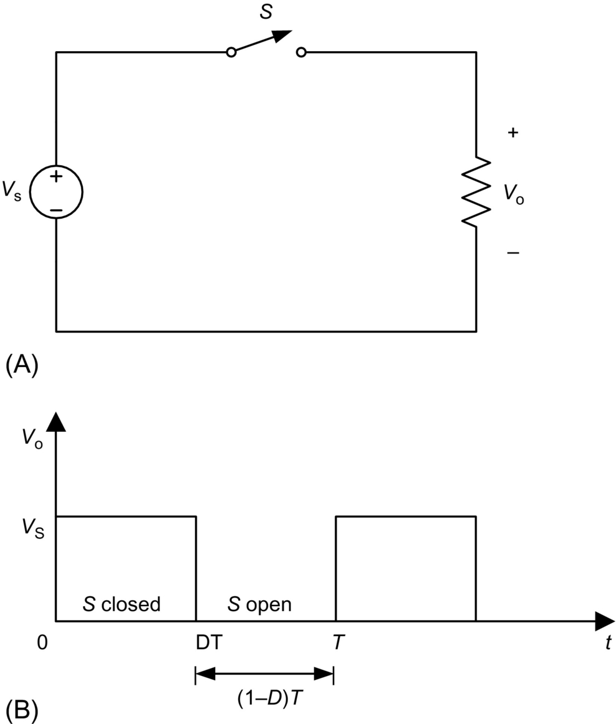

**FIG. 10.1** DC chopper with resistive load, (A) circuit diagram and (B) output voltage waveform.

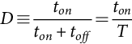 **(10.1)**

where *T*=1/*f* is the period of the switching frequency *f*. The average value of the output voltage is

 **(10.2)**

and can be regulated by adjusting duty ratio *D*. The average output voltage is always smaller than the input voltage, hence, the name of the converter.

The dc step-down choppers are commonly used in dc drives. In such a case, the load is presented as a series combination of inductance *L*, resistance *R*, and back emf *E* as shown in [Fig. 10.2A](https://learning.oreilly.com/library/view/power-electronics-handbook/9780128114087/B9780128114070000106.xhtml#f0015). To provide a path for a continuous inductor current flow when the switch is in the *off* state, an antiparallel diode *D* must be connected across the load. Since the chopper of [Fig. 10.2A](https://learning.oreilly.com/library/view/power-electronics-handbook/9780128114087/B9780128114070000106.xhtml#f0015) provides a positive voltage and a positive current to the load, it is called a first-quadrant chopper. The load voltage and current are graphed in [Fig. 10.2B](https://learning.oreilly.com/library/view/power-electronics-handbook/9780128114087/B9780128114070000106.xhtml#f0015) under assumptions that the load current never reaches zero and the load time constant  is much greater than the period *T*. Average values of the output voltage and current can be adjusted by changing the duty ratio *D*.

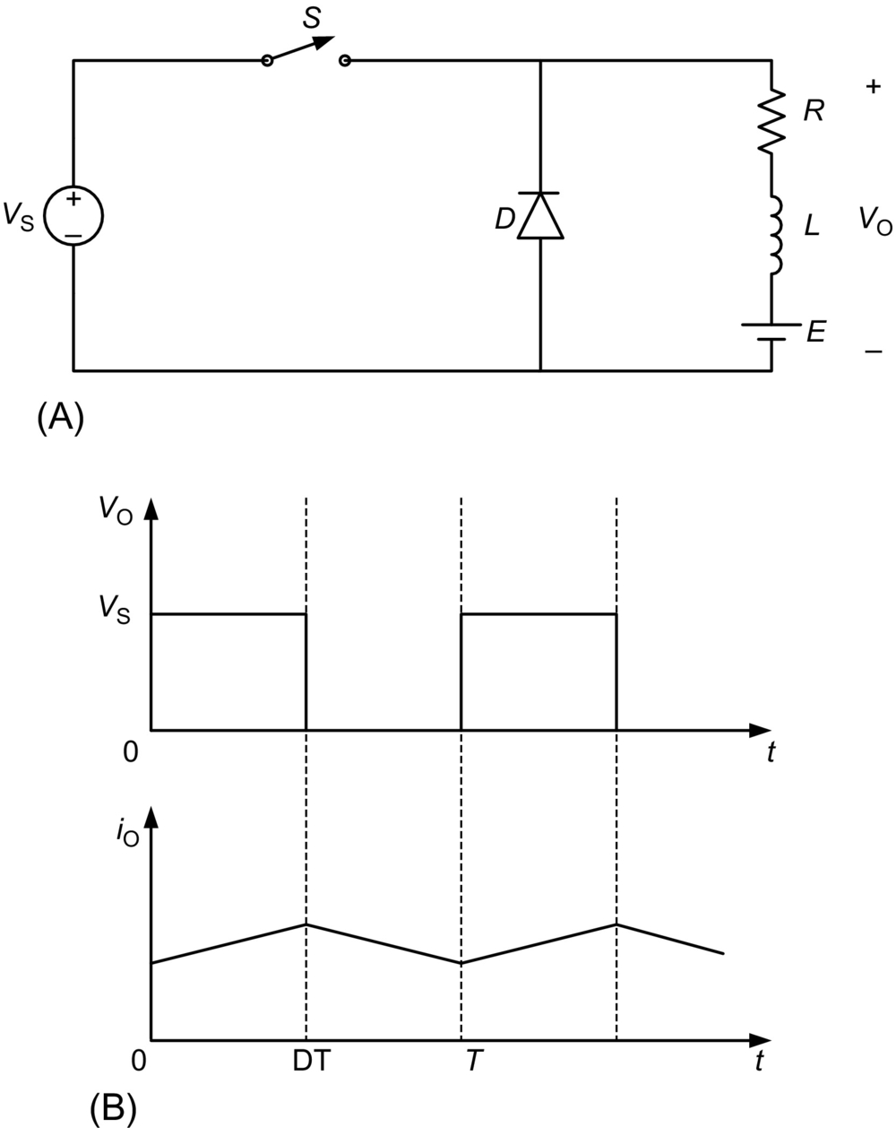

**FIG. 10.2** DC chopper with RLE load, (A) circuit diagram and (B) waveforms.

The dc choppers can also provide peak output voltages higher than the input voltage. Such a step-up configuration is presented in [Fig. 10.3](https://learning.oreilly.com/library/view/power-electronics-handbook/9780128114087/B9780128114070000106.xhtml#f0020). It consists of dc input source *V*S, inductor *L* connected in series with the source, switch S connecting the inductor to ground, and a series combination of diode *D* and load. If the switch operates with a duty ratio *D*, the output voltage is a series of pulses of duration  and amplitude . Neglecting losses, the average value of the output voltage is *V*S. To obtain an average value of the output voltage greater than *V*S, a capacitor must be connected in parallel with the load. This results in a topology of a boost dc-dc converter that is described in [Section 10.4](https://learning.oreilly.com/library/view/power-electronics-handbook/9780128114087/B9780128114070000106.xhtml#s0055).

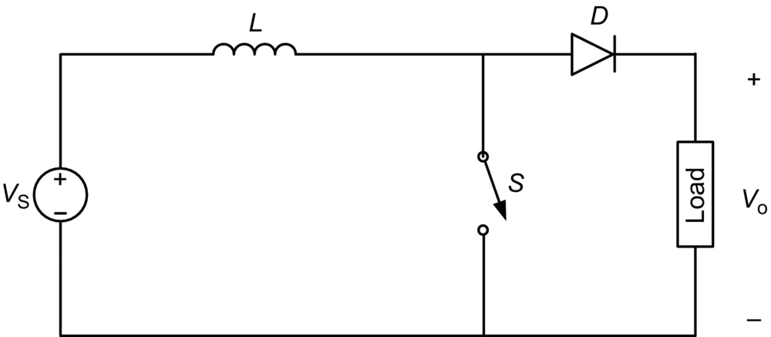

**FIG. 10.3** The dc step-up chopper.

## 10.3 Step-Down (Buck) Converter

### **10.3.1 BASIC CONVERTER**

The step-down dc-dc converter, commonly known as a buck converter, is shown in [Fig. 10.4A](https://learning.oreilly.com/library/view/power-electronics-handbook/9780128114087/B9780128114070000106.xhtml#f0025). It consists of dc input voltage source *V*S, controlled switch *S*, diode *D*, filter inductor *L*, filter capacitor *C*, and load resistance *R*. Typical waveforms in the converter are shown in [Fig. 10.4B](https://learning.oreilly.com/library/view/power-electronics-handbook/9780128114087/B9780128114070000106.xhtml#f0025) under assumption that the inductor current is always positive. The state of the converter in which the inductor current is never zero for any period of time is called the continuous conduction mode (CCM). It can be seen from the circuit that when the switch *S* is commanded to the *on* state, the diode *D* is reverse biased. When the switch *S* is off, the diode conducts to support an uninterrupted current in the inductor.

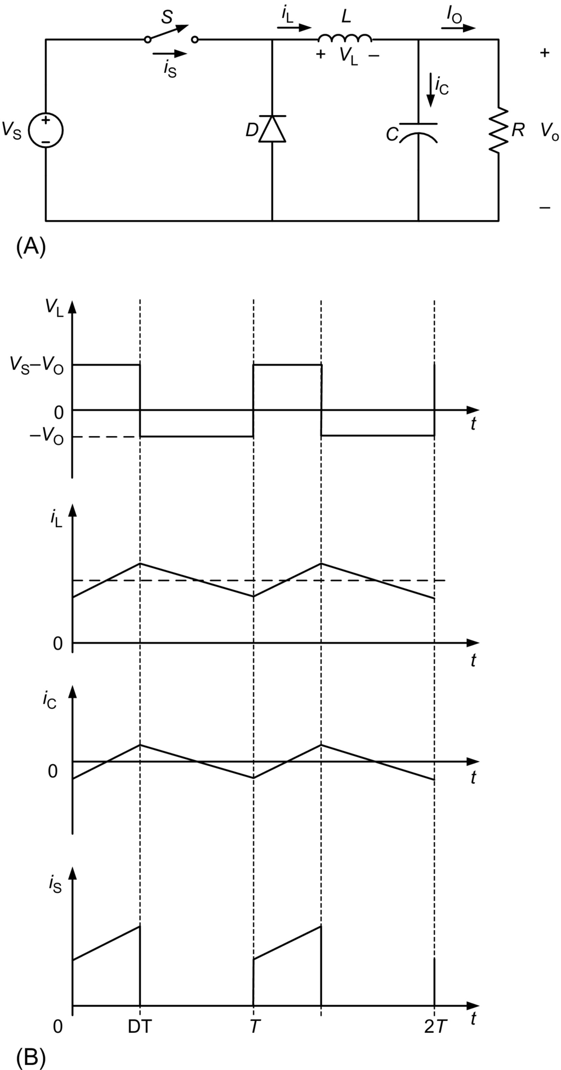

**FIG. 10.4** Buck converter: (A) circuit diagram and (B) waveforms.

The relationship among the input voltage, output voltage, and the switch duty ratio *D* can be derived, for instance, from the inductor voltage *v*L waveform (see [Fig. 10.4B](https://learning.oreilly.com/library/view/power-electronics-handbook/9780128114087/B9780128114070000106.xhtml#f0025)). According to Faraday's law, the inductor volt-second product over a period of steady-state operation is zero. For the buck converter,

 **(10.3)**

Hence, the dc voltage transfer function, defined as the ratio of the output voltage to the input voltage, is

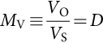 **(10.4)**

It can be seen from Eq. [(10.4)](https://learning.oreilly.com/library/view/power-electronics-handbook/9780128114087/B9780128114070000106.xhtml#fo0025) that the output voltage is always smaller than the input voltage.

The dc-dc converters can operate in two distinct modes with respect to the inductor current *i*L. [Fig. 10.4B](https://learning.oreilly.com/library/view/power-electronics-handbook/9780128114087/B9780128114070000106.xhtml#f0025) depicts the CCM in which the inductor current is always greater than zero. When the average value of the input current is low (high *R*) and/or the switching frequency *f* is low, the converter may enter the discontinuous conduction mode (DCM). In the DCM, the inductor current is zero during a portion of the switching period. The CCM is preferred for high efficiency and good utilization of semiconductor switches and passive components. The DCM may be used in applications with special control requirements, since the dynamic order of the converter is reduced (the energy stored in the inductor is zero at the beginning and at the end of each switching period). It is uncommon to mix these two operating modes because of different control algorithms. For the buck converter, the value of the filter inductance that determines the boundary between CCM and DCM is given by

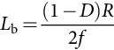 **(10.5)**

For typical values of , , and , the boundary is . For , the converter operates in the CCM.

The filter inductor current *i*L in the CCM consists of a dc component *I*O with a superimposed triangular ac component. Almost all of this ac component flows through the filter capacitor as a current *i*c. Current *i*c causes a small voltage ripple across the dc output voltage *V*O. To limit the peak-to-peak value of the ripple voltage below certain value *V*r, the filter capacitance *C* must be greater than

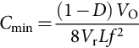 **(10.6)**

At , , , and , the minimum capacitance is .

Eqs. [(10.5)](https://learning.oreilly.com/library/view/power-electronics-handbook/9780128114087/B9780128114070000106.xhtml#fo0030) and [(10.6)](https://learning.oreilly.com/library/view/power-electronics-handbook/9780128114087/B9780128114070000106.xhtml#fo0035) are the key design equations for the buck converter. The input and output dc voltages (hence the duty ratio *D*) and the range of load resistance *R* are usually determined by preliminary specifications. The designer needs to determine values of passive components *L* and *C* and of the switching frequency *f*. The value of the filter inductor *L* is calculated from the CCM/DCM condition using Eq. [(10.5)](https://learning.oreilly.com/library/view/power-electronics-handbook/9780128114087/B9780128114070000106.xhtml#fo0030). The value of the filter capacitor *C* is obtained from the voltage ripple condition Eq. [(10.6)](https://learning.oreilly.com/library/view/power-electronics-handbook/9780128114087/B9780128114070000106.xhtml#fo0035). For the compactness and low conduction losses of a converter, it is desirable to use small passive components. Eqs. [(10.5)](https://learning.oreilly.com/library/view/power-electronics-handbook/9780128114087/B9780128114070000106.xhtml#fo0030) and [(10.6)](https://learning.oreilly.com/library/view/power-electronics-handbook/9780128114087/B9780128114070000106.xhtml#fo0035) show that it can be accomplished by using a high switching frequency *f*. The switching frequency is limited, however, by the type of semiconductor switches used and by switching losses. It should be also noted that values of *L* and *C* may be altered by effects of parasitic components in the converter, especially by the equivalent series resistance of the capacitor. The issue of parasitic components in dc-dc converters is discussed in [Section 10.7](https://learning.oreilly.com/library/view/power-electronics-handbook/9780128114087/B9780128114070000106.xhtml#s0080).

### 10.3.2 TRANSFORMER VERSIONS OF BUCK CONVERTER

In many dc power supplies, a galvanic isolation between the dc or ac input and the dc output is required for safety and reliability. An economical mean of achieving such an isolation is to employ a transformer version of a dc-dc converter. High-frequency transformers are of a small size and weight and provide high efficiency. Their turns ratio can be used to additionally adjust the output voltage level. Among buck-derived dc-dc converters, the most popular are forward converter, push-pull converter, half-bridge converter, and full-bridge converter.

#### **10.3.2.1 Forward Converter**

The circuit diagram of a forward converter is depicted in [Fig. 10.5](https://learning.oreilly.com/library/view/power-electronics-handbook/9780128114087/B9780128114070000106.xhtml#f0030). When the switch *S* is *on*, diode *D*1 conducts, and diode *D*2 is *off*. The energy is transferred from the input, through the transformer, to the output filter. When the switch is *off*, the state of diodes *D*1 and *D*2 is reversed. The dc voltage transfer function of the forward converter is

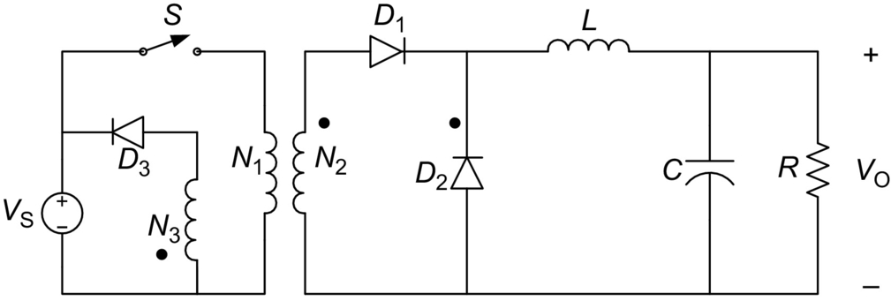

**FIG. 10.5** Forward converter.

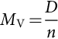 **(10.7)**

where .

In the forward converter, the energy-transfer current flows through the transformer in one direction. Hence, an additional winding with diode *D*3 is needed to bring the magnetizing current of the transformer to zero. This prevents transformer saturation. The turns ratio *N*1/*N*3 should be selected in such a way that the magnetizing current decreases to zero during a fraction of the time interval when the switch is *off*.

Eqs. [(10.5)](https://learning.oreilly.com/library/view/power-electronics-handbook/9780128114087/B9780128114070000106.xhtml#fo0030) and [(10.6)](https://learning.oreilly.com/library/view/power-electronics-handbook/9780128114087/B9780128114070000106.xhtml#fo0035) can be used to design the filter components. The forward converter is very popular for low-power applications. For medium power levels, converters with bidirectional transformer excitation (push-pull, half bridge, and full bridge) are preferred due to better utilization of magnetic components.

#### **10.3.2.2 Push-Pull Converter**

The PWM dc-dc push-pull converter is shown in [Fig. 10.6](https://learning.oreilly.com/library/view/power-electronics-handbook/9780128114087/B9780128114070000106.xhtml#f0035). The switches *S*1 and *S*2 operate shifted in phase by *T*/2 with the same duty ratio *D*. The duty ratio must be smaller than 0.5. When switch *S*1 is *on*, diode *D*1 conducts, and diode *D*2 is *off*. Diode states are reversed when switch *S*2 is *on*. When both controllable switches are *off*, the diodes are *on* and share equally the filter inductor current. The dc voltage transfer function of the push-pull converter is

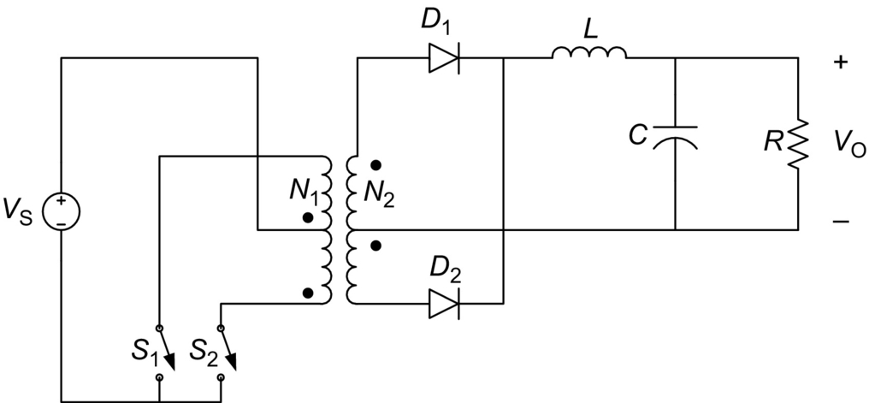

**FIG. 10.6** Push-pull converter.

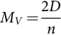 **(10.8)**

where . The boundary value of the filter inductor is

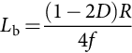 **(10.9)**

The filter capacitor can be obtained from

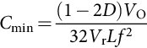 **(10.10)**

#### **10.3.2.3 Half-Bridge Converter**

[Fig. 10.7](https://learning.oreilly.com/library/view/power-electronics-handbook/9780128114087/B9780128114070000106.xhtml#f0040) shows the dc-dc half-bridge converter. The operation of the PWM half-bridge converter is similar to that of the push-pull converter. In comparison with the push-pull converter, the primary of the transformer is simplified at the expense of two voltage-sharing input capacitors. The half-bridge converter dc voltage transfer function is

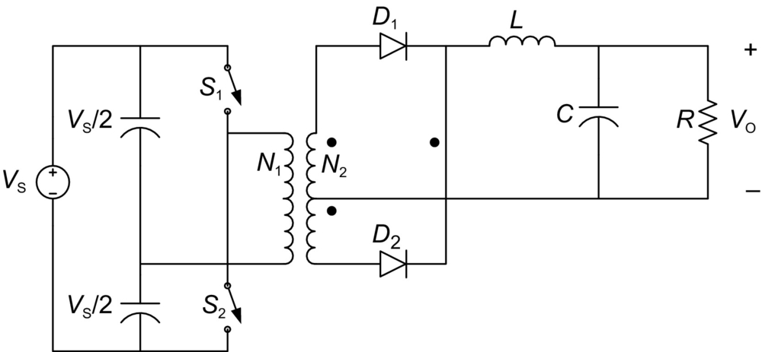

**FIG. 10.7** Half-bridge converter.

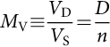 **(10.11)**

where  Eqs. [(10.9)](https://learning.oreilly.com/library/view/power-electronics-handbook/9780128114087/B9780128114070000106.xhtml#fo0050) and [(10.10)](https://learning.oreilly.com/library/view/power-electronics-handbook/9780128114087/B9780128114070000106.xhtml#fo0055) apply to the filter components of this converter.

#### **10.3.2.4 Full-Bridge Converter**

Comparing the PWM dc-dc full-bridge converter of [Fig. 10.8](https://learning.oreilly.com/library/view/power-electronics-handbook/9780128114087/B9780128114070000106.xhtml#f0045) with the half-bridge converter, it can be seen that the input capacitors have been replaced by two controllable switches. The controllable switches are operated in pairs. When *S*1 and *S*4 are *on*, voltage *V*S is applied to the primary of the transformer, and diode *D*1 conducts. With *S*2 and *S*3 *on*, there is voltage  across the primary transformer, and diode *D*2 is *on*. With all controllable switches *off*, both diodes conduct, similarly as in the push-pull and half-bridge converters. The dc voltage transfer function of the full-bridge converter is

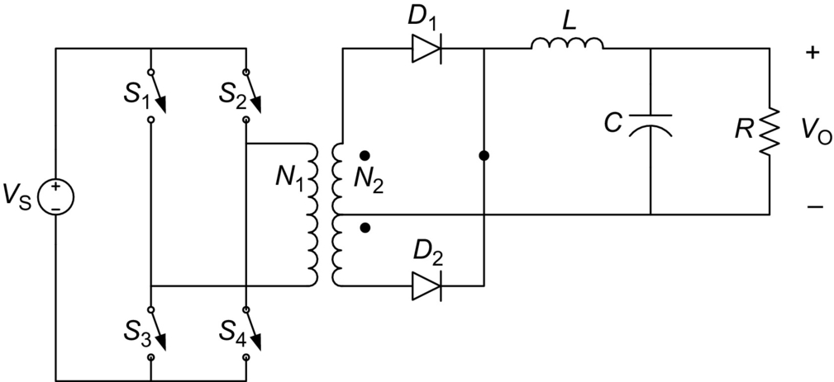

**FIG. 10.8** Full-bridge converter.

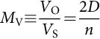 **(10.12)**

where . Values of filter components can be obtained from Eqs. [(10.9)](https://learning.oreilly.com/library/view/power-electronics-handbook/9780128114087/B9780128114070000106.xhtml#fo0050) and [(10.10)](https://learning.oreilly.com/library/view/power-electronics-handbook/9780128114087/B9780128114070000106.xhtml#fo0055).

It should be stressed that the full-bridge topology is a very versatile one. With different control algorithms, it is very popular in dc-ac conversion (square-wave and PWM single-phase inverters). It is also used in four-quadrant dc drives.

## 10.4 Step-Up (Boost) Converter

[Fig. 10.9A](https://learning.oreilly.com/library/view/power-electronics-handbook/9780128114087/B9780128114070000106.xhtml#f0050) depicts a step-up or a PWM boost converter. It is composed of dc input voltage source *V*S, boost inductor *L*, controlled switch *S*, diode *D*, filter capacitor *C*, and load resistance *R*. The converter waveforms in the CCM are presented in [Fig. 10.9B](https://learning.oreilly.com/library/view/power-electronics-handbook/9780128114087/B9780128114070000106.xhtml#f0050). When the switch S is in the *on* state, the current in the boost inductor increases linearly. The diode *D* is *off* at the time. When the switch *S* is turned *off*, the energy stored in the inductor is released through the diode to the input *RC* circuit.

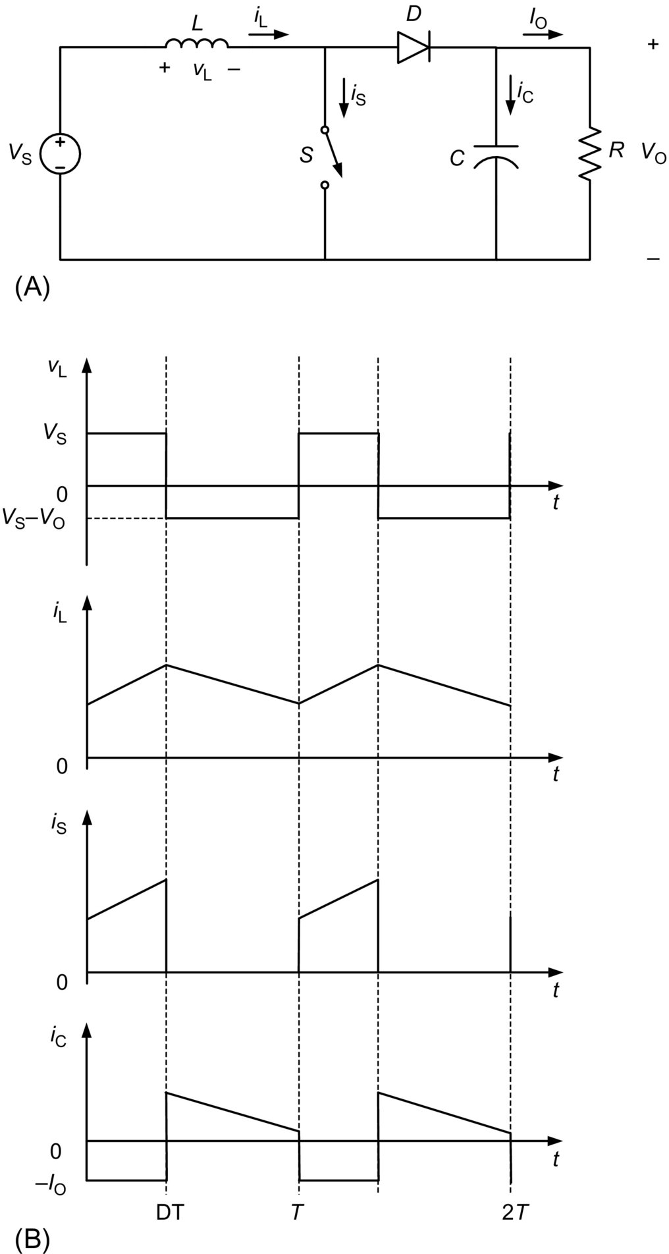

**FIG. 10.9** Boost converter: (A) circuit diagram and (B) waveforms.

Using the Faraday's law for the boost inductor,

 **(10.13)**

from which the dc voltage transfer function turns out to be

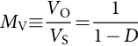 **(10.14)**

As the name of the converter suggests, the output voltage is always greater than the input voltage.

The boost converter operates in the CCM for  where

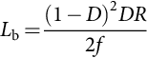 **(10.15)**

For , , and , the boundary value of the inductance is .

As shown in [Fig. 10.9B](https://learning.oreilly.com/library/view/power-electronics-handbook/9780128114087/B9780128114070000106.xhtml#f0050), the current supplied to the output *RC* circuit is discontinuous. Thus, a larger filter capacitor is required in comparison with that in the buck-derived converters to limit the output voltage ripple. The filter capacitor must provide the output dc current to the load when the diode *D* is *off*. The minimum value of the filter capacitance that results in the voltage ripple *V*r is given by

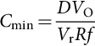 **(10.16)**

At , , , and , the minimum capacitance for the boost converter is .

The boost converter does not have a popular transformer (isolated) version.

## 10.5 Buck-Boost Converter

### **10.5.1 BASIC CONVERTER**

A nonisolated (transformerless) topology of the buck-boost converter is shown in [Fig. 10.10A](https://learning.oreilly.com/library/view/power-electronics-handbook/9780128114087/B9780128114070000106.xhtml#f0055). The converter consists of dc input voltage source *V*S, controlled switch *S*, inductor *L*, diode *D*, filter capacitor *C*, and load resistance *R*. With the switch *on*, the inductor current increases, while the diode is maintained *off*. When the switch is turned *off*, the diode provides a path for the inductor current. Note the polarity of the diode that results in its current being *drawn from* the output.

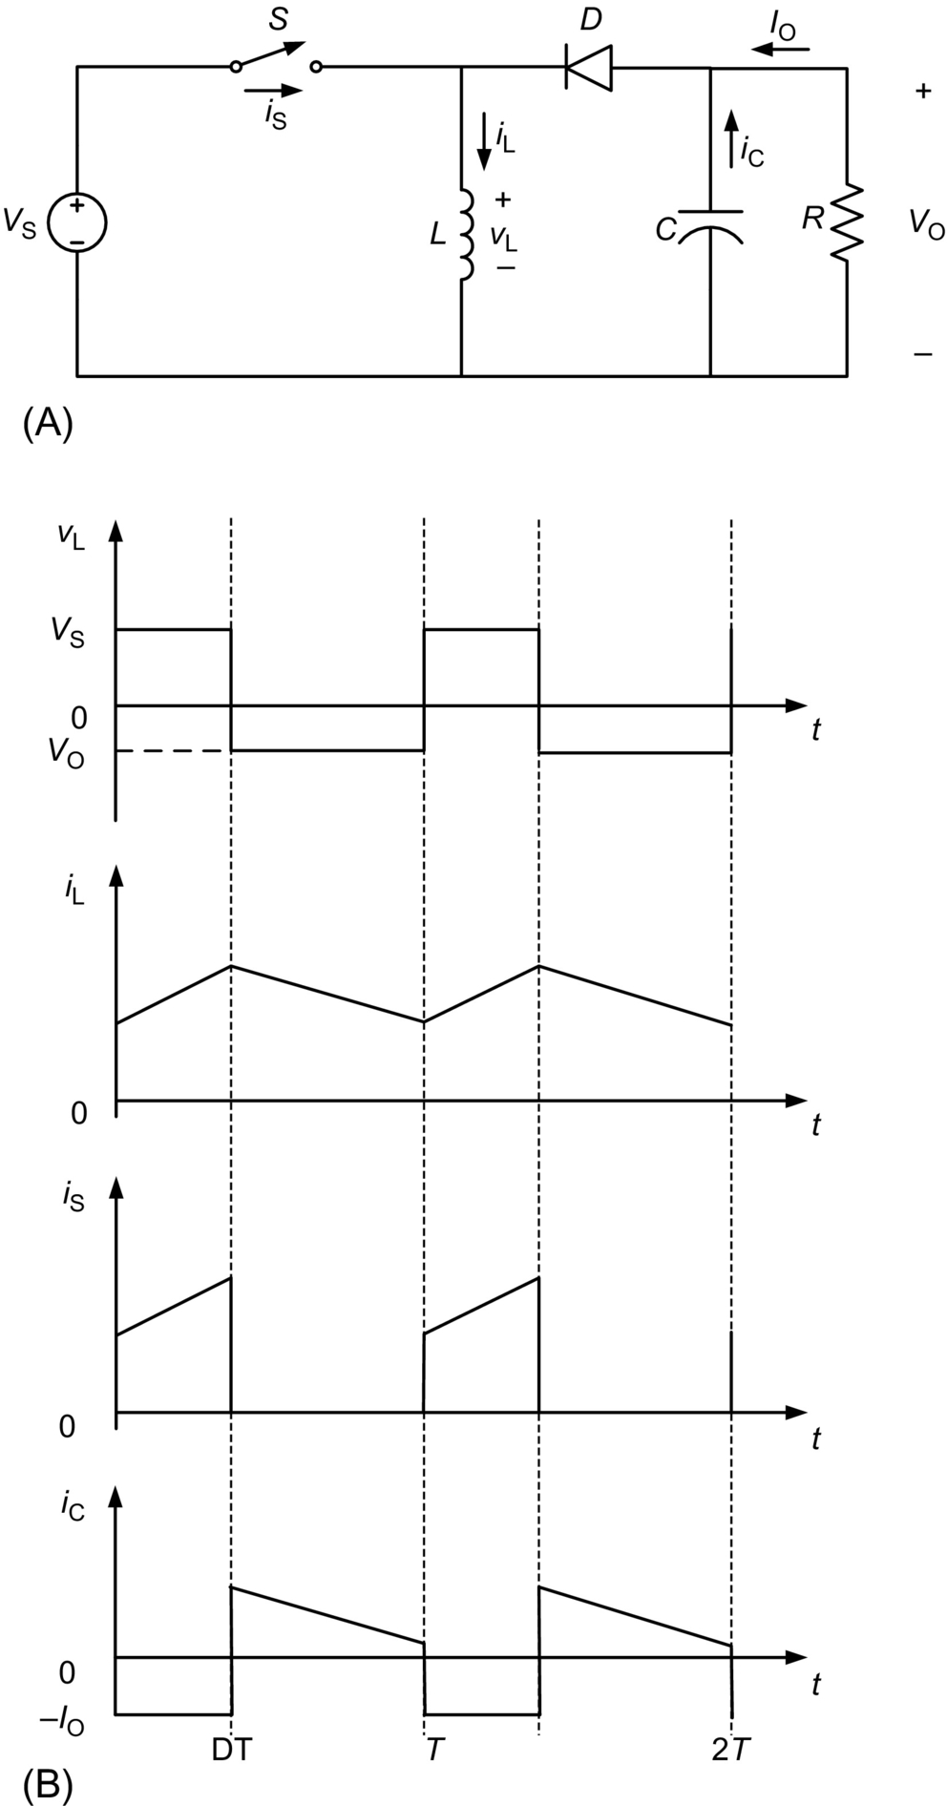

**FIG. 10.10** Buck-boost converter: (A) circuit diagram and (B) waveforms.

The buck-boost converter waveforms are depicted in [Fig. 10.10B](https://learning.oreilly.com/library/view/power-electronics-handbook/9780128114087/B9780128114070000106.xhtml#f0055). The condition of a zero volt-second product for the inductor in steady state yields

 **(10.17)**

Hence, the dc voltage transfer function of the buck-boost converter is

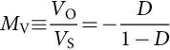 **(10.18)**

The output voltage *V*O is negative with respect to the ground. Its magnitude can be either greater or smaller (equal at ) than the input voltage as the converter's name implies.

The value of the inductor that determines the boundary between the CCM and DCM is

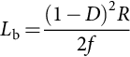 **(10.19)**

The structure of the output part of the converter is similar to that of the boost converter (reversed polarities being the only difference). Thus, the value of the filter capacitor can be obtained from Eq. [(10.16)](https://learning.oreilly.com/library/view/power-electronics-handbook/9780128114087/B9780128114070000106.xhtml#fo0085).

### 10.5.2 FLYBACK CONVERTER

A PWM flyback converter is a very practical isolated version of the buck-boost converter. The circuit of the flyback converter is presented in [Fig. 10.11A](https://learning.oreilly.com/library/view/power-electronics-handbook/9780128114087/B9780128114070000106.xhtml#f0060). The inductor of the buck-boost converter has been replaced by a flyback transformer. The input dc source *V*S and switch *S* are connected in series with the primary transformer. The diode *D* and the *RC* output circuit are connected in series with the secondary of the flyback transformer. [Fig. 10.11B](https://learning.oreilly.com/library/view/power-electronics-handbook/9780128114087/B9780128114070000106.xhtml#f0060) shows the converter with a simple flyback transformer model. The model includes a magnetizing inductance *L*m and an ideal transformer with a turns ratio . The flyback transformer leakage inductances and losses are neglected in the model. It should be noted that leakage inductances, although not important from the principle of operation point of view, affect adversely switch and diode transitions. Snubbers are usually required in flyback converters.

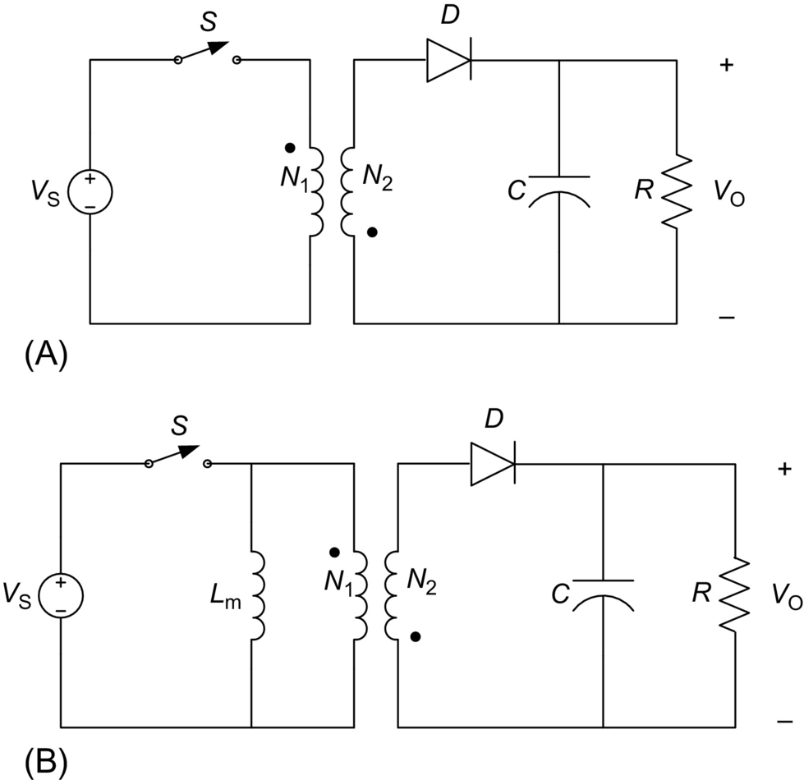

**FIG. 10.11** Flyback converter: (A) circuit diagram and (B) circuit with a transformer model showing the magnetizing inductance *L*m.

Refer to [Fig. 10.11B](https://learning.oreilly.com/library/view/power-electronics-handbook/9780128114087/B9780128114070000106.xhtml#f0060) for the converter operation. When the switch *S* is *on*, the current in the magnetizing inductance increases linearly. The diode *D* is *off*, and there is no current in the ideal transformer windings. When the switch is turned *off*, the magnetizing inductance current is diverted into the ideal transformer, the diode turns *on*, and the transformed magnetizing inductance current is supplied to the *RC* load. The dc voltage transfer function of the flyback converter is

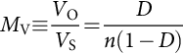 **(10.20)**

It differs from the buck-boost converter voltage transfer function by the turns ratio factor *n*. A positive sign has been obtained by an appropriate coupling of the transformer windings.

Unlike in transformer buck-derived converters, the magnetizing inductance *L*m of the flyback transformer is an important design parameter. The value of the magnetizing inductance that determines the boundary between the CCM and DCM is given by

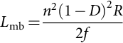 **(10.21)**

The value of the filter capacitance can be calculated using Eq. [(10.16)](https://learning.oreilly.com/library/view/power-electronics-handbook/9780128114087/B9780128114070000106.xhtml#fo0085).

## 10.6 Ćuk Converter

The circuit of the Ćuk converter is shown in [Fig. 10.12A](https://learning.oreilly.com/library/view/power-electronics-handbook/9780128114087/B9780128114070000106.xhtml#f0065). It consists of dc input voltage source *V*S, input inductor *L*1, controllable switch *S*, energy-transfer capacitor *C*1, diode *D*, filter inductor *L*2, filter capacitor *C*, and load resistance *R*. An important advantage of this topology is a continuous current at both the input and the output of the converter. Disadvantages of the Ćuk converter include a high number of reactive components and high current stresses on the switch, the diode, and the capacitor *C*1. Main waveforms in the converter are presented in [Fig. 10.12B](https://learning.oreilly.com/library/view/power-electronics-handbook/9780128114087/B9780128114070000106.xhtml#f0065). When the switch is *on*, the diode is *off*, and the capacitor *C*1 is discharged by the inductor *L*2 current. With the switch in the *off* state, the diode conducts currents of the inductors *L*1 and *L*2, whereas capacitor *C*1 is charged by the inductor *L*1 current.

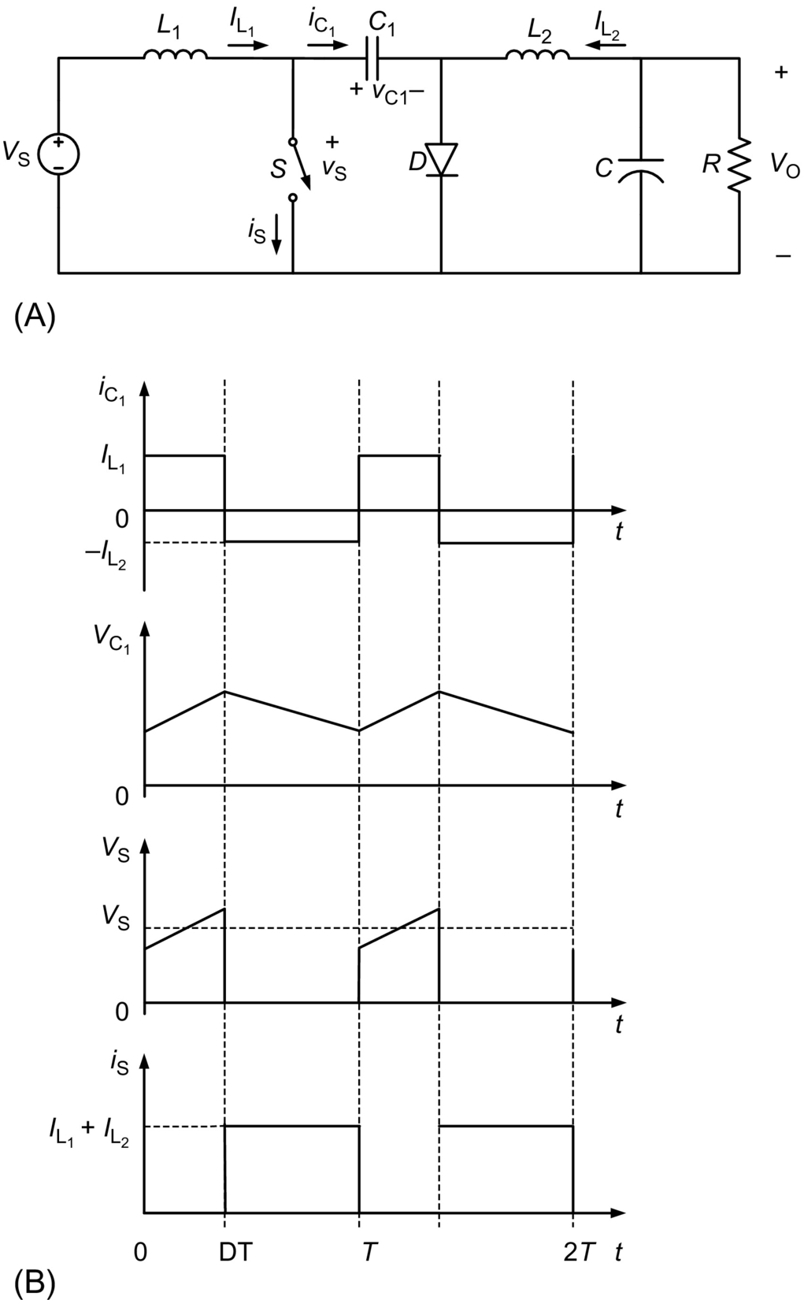

**FIG. 10.12** Ćuk converter: (A) circuit diagram and (B) waveforms.

To obtain the dc voltage transfer function of the converter, we shall use the principle that the average current through a capacitor is zero for steady-state operation. Let us assume that inductors *L*1 and *L*2 are large enough that their ripple current can be neglected. Capacitor *C*1 is in a steady state if

 **(10.22)**

For a lossless converter,

 **(10.23)**

Combining these two equations, the dc voltage transfer function of the Ćuk converter is

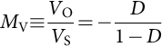 **(10.24)**

This voltage transfer function is the same as that for the buck-boost converter.

The boundaries between the CCM and DCM are determined by

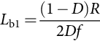 **(10.25)**

for *L*1 and

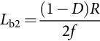 **(10.26)**

for *L*2.

The output part of the Ćuk converter is similar to that of the buck converter. Hence, the expression for the filter capacitor *C* is

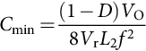 **(10.27)**

The peak-to-peak ripple voltage in the capacitor *C*1 can be estimated as

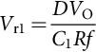 **(10.28)**

A transformer (isolated) version of the Ćuk converter can be obtained by splitting capacitor *C*1 and inserting a high-frequency transformer between the split capacitors.

## 10.7 Effects of Parasitic Components

The analysis of converters in [Sections 10.2](https://learning.oreilly.com/library/view/power-electronics-handbook/9780128114087/B9780128114070000106.xhtml#s0015)–[10.6](https://learning.oreilly.com/library/view/power-electronics-handbook/9780128114087/B9780128114070000106.xhtml#s0075) has been performed under ideal switch, diode, and passive component assumptions. Nonidealities or parasitics of practical devices and components may, however, greatly affect some performance parameters of dc-dc converters. In this section, effects of parasitics on output voltage ripple, efficiency, and voltage transfer function of converters will be illustrated.

A more realistic model of a capacitor than just a capacitance *C* consists of a series connection of capacitance *C* and resistance *r*C. The resistance *r*C is called an equivalent series resistance (ESR) of the capacitor and is due to losses in the dielectric and physical resistance of leads and connections. Recall Eq. [(10.6)](https://learning.oreilly.com/library/view/power-electronics-handbook/9780128114087/B9780128114070000106.xhtml#fo0035) that provided a value of the filter capacitance in a buck converter that limits the peak-to-peak output voltage ripple to *V*r. The equation was derived under an assumption that the entire triangular ac component of the inductor current flows through a capacitance *C*. It is, however, closer to reality to maintain that this triangular component flows through a series connection of capacitance *C* and resistance *r*C.

The peak-to-peak ripple voltage is independent of the voltage across the filter capacitor and is determined only by the ripple voltage of the ESR if the following condition is satisfied:

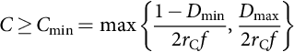 **(10.29)**

If condition [(10.29)](https://learning.oreilly.com/library/view/power-electronics-handbook/9780128114087/B9780128114070000106.xhtml#fo0150) is satisfied, the peak-to-peak ripple voltage of the buck and forward converters is

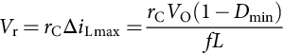 **(10.30)**

For push-pull, half-bridge, and full-bridge converters,

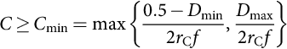 **(10.31)**

where . If condition [(10.31)](https://learning.oreilly.com/library/view/power-electronics-handbook/9780128114087/B9780128114070000106.xhtml#fo0160) is met, the peak-to-peak ripple voltage *V*r of these converters is given by

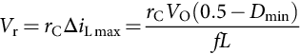 **(10.32)**

Waveforms of voltage across the ESR *V*rC, voltage across the capacitance *V*C, and total ripple voltage *V*r are depicted in [Fig. 10.13](https://learning.oreilly.com/library/view/power-electronics-handbook/9780128114087/B9780128114070000106.xhtml#f0070) for three values of the filter capacitances. For the case of the top graph in [Fig. 10.13](https://learning.oreilly.com/library/view/power-electronics-handbook/9780128114087/B9780128114070000106.xhtml#f0070), the peak-to-peak value of *V*r is higher than the peak-to-peak value of *V*rC because . Middle and bottom graphs in [Fig. 10.13](https://learning.oreilly.com/library/view/power-electronics-handbook/9780128114087/B9780128114070000106.xhtml#f0070) show the waveforms for  and , respectively. For both these cases, the peak-to-peak voltages of *V*r and *V*rC equal to each other.

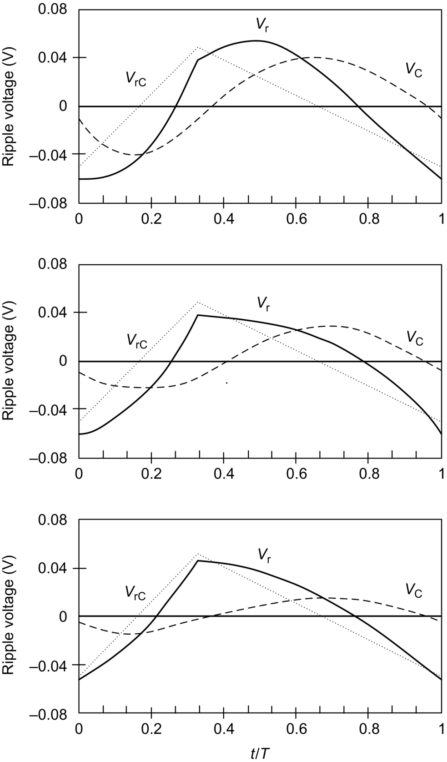

**FIG. 10.13** Voltage ripple waveforms *V*rC, *V*C, and *V*r for a buck converter at , .

Note that when the resistance *r*C sets the ripple voltage *V*r, the minimum value of inductance *L* is determined either by the boundary between the CCM and DCM according to Eq. [(10.5)](https://learning.oreilly.com/library/view/power-electronics-handbook/9780128114087/B9780128114070000106.xhtml#fo0030) (buck and forward converters) or Eq. [(10.9)](https://learning.oreilly.com/library/view/power-electronics-handbook/9780128114087/B9780128114070000106.xhtml#fo0050) (push-pull, half-bridge, and full-bridge converters) or by the voltage ripple condition [(10.30)](https://learning.oreilly.com/library/view/power-electronics-handbook/9780128114087/B9780128114070000106.xhtml#fo0155) or [(10.32)](https://learning.oreilly.com/library/view/power-electronics-handbook/9780128114087/B9780128114070000106.xhtml#fo0165).

In buck-boost and boost converters, the peak-to-peak capacitor current *I*Cpp is equal to the peak-to-peak diode current and is given by

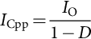 **(10.33)**

under condition that the inductor current ripple is much lower than the average value of the inductor current. The peak-to-peak voltage across the ESR is

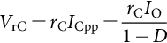 **(10.34)**

****, , and various values of *C*:  (top graph),  (middle graph), and  (bottom graph).

Assuming that the total ripple voltage *V*r is approximately equal to the sum of the ripple voltages across the ESR and the capacitance, the maximum value of the peak-to-peak ripple voltage across the capacitance is

 **(10.35)**

Finally, by analogy to Eq. [(10.16)](https://learning.oreilly.com/library/view/power-electronics-handbook/9780128114087/B9780128114070000106.xhtml#fo0085), when the ESR of the filter capacitor is taken into account in the boost-type output filter, the filter capacitance should be greater than

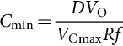 **(10.36)**

Parasitic resistances, capacitances, and voltage sources affect also an energy conversion efficiency of dc-dc converters. The efficiency *η* is defined as a ratio of output power to the input power:

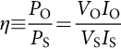 **(10.37)**

Efficiencies are usually specified in percent. Let us consider the boot converter as an example. Under low ripple assumption, the boost converter efficiency can be estimated as

 **(10.38)**

where *V*D is the forward conduction voltage drop of the diode, *C*o is the output capacitance of the switch, *r*L is the ESR of the inductor, and *r*D is the forward *on* resistance of the diode. The term *fC*o*R* in Eq. [(10.38)](https://learning.oreilly.com/library/view/power-electronics-handbook/9780128114087/B9780128114070000106.xhtml#fo0195) represents switching losses in the converter. Other terms account for conduction losses. Losses in a dc-dc converter also contribute to a decrease in the dc voltage transfer function. The nonideal dc voltage transfer function *M*Vn is a product of the ideal one and the efficiency:

 **(10.39)**

Sample graphs for the boost converter that correspond to Eqs. [(10.38)](https://learning.oreilly.com/library/view/power-electronics-handbook/9780128114087/B9780128114070000106.xhtml#fo0195) and [(10.39)](https://learning.oreilly.com/library/view/power-electronics-handbook/9780128114087/B9780128114070000106.xhtml#fo0200) are presented in [Fig. 10.14](https://learning.oreilly.com/library/view/power-electronics-handbook/9780128114087/B9780128114070000106.xhtml#f0075).

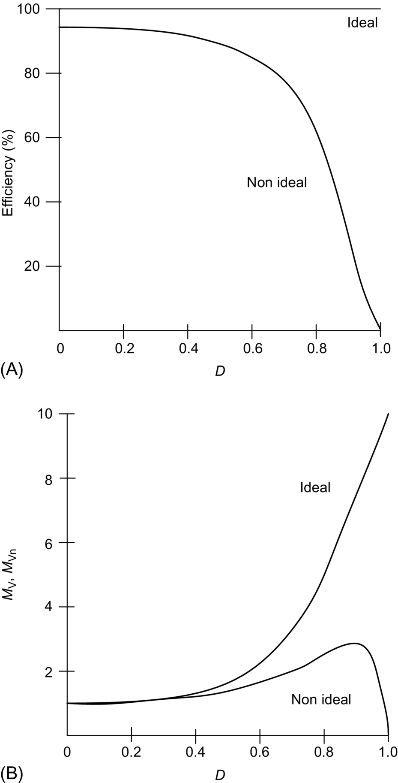

**FIG. 10.14** Effects of parasitics on characteristics of a boost converter, (A) efficiency and (B) dc voltage transfer function.

## 10.8 Synchronous and Bidirectional Converters

It can be observed in Eq. [(10.38)](https://learning.oreilly.com/library/view/power-electronics-handbook/9780128114087/B9780128114070000106.xhtml#fo0195) that the forward voltage of a diode *V*D contributes to a decrease in efficiency. This contribution is especially significant in low-output-voltage power supplies, for example, 3.3 V power supplies for microprocessors or power supplies for portable telecommunication equipment. Even with a Schottky diode, which has *V*D in the range of 0.4 V, the power loss in the diode can easily exceed 10% of the total power delivered to the load. To reduce conduction losses in the diode, a low on-resistance switch can be added in parallel as shown in [Fig. 10.15](https://learning.oreilly.com/library/view/power-electronics-handbook/9780128114087/B9780128114070000106.xhtml#f0080) for a buck converter. The input switch and the switch parallel to the diode must be turned on and off alternately. The arrangement of [Fig. 10.15](https://learning.oreilly.com/library/view/power-electronics-handbook/9780128114087/B9780128114070000106.xhtml#f0080) is called a synchronous converter or a synchronous rectifier. Modern low-voltage MOSFETs have *on* resistances of only several milliohms. Hence, a synchronous converter may exhibit higher efficiency than a conventional one at output currents as large as tens of amperes. The efficiency is increased at an expense of more complicated driving circuitry for the switches. In particular, a special can must be exercised to avoid having both switches *on* at the same time as this would short the input voltage source. Since power semiconductor devices usually have longer turn-off times than turn-on times, a dead time (sometimes called a blanking time) must be introduced in PWM driving signals.

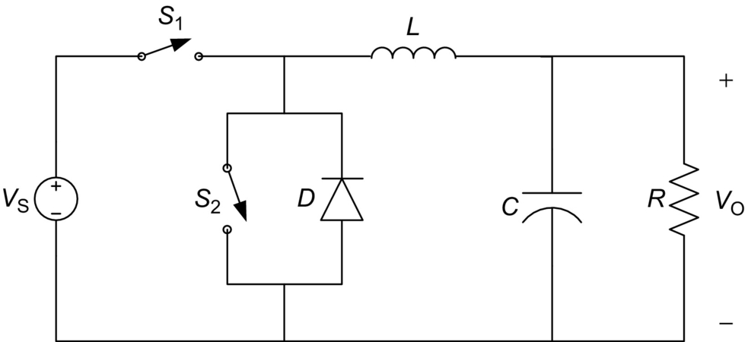

**FIG. 10.15** Synchronous buck converter.

The parallel combination of a controllable switch and a diode is also used in converters that allow for a current flow in both directions: from the input source to the load and from the load back to the input source. Such converters are called bidirectional power flow or simply bidirectional converters. As an example, a flyback bidirectional converter is shown in [Fig. 10.16](https://learning.oreilly.com/library/view/power-electronics-handbook/9780128114087/B9780128114070000106.xhtml#f0085). It contains unipolar voltage and bidirectional current switch-diode combinations at both primary and secondary of the flyback transformer. When the primary switch and secondary diode operate, the current flows from the input source to the load. The converter current can also flow from the output to the input through the secondary switch and primary diode. Bidirectional arrangements can be made for buck and boost converters. A bidirectional buck converter operates as a boost converter when the current flow is from the output to the input. A bidirectional boost converter operates as a buck converter with a reversed current flow. If for any reason (for instance, to avoid the DCM) the controllable switches are driven at the same time, they must be driven alternately with a sufficient dead time to avoid a shot-through current.

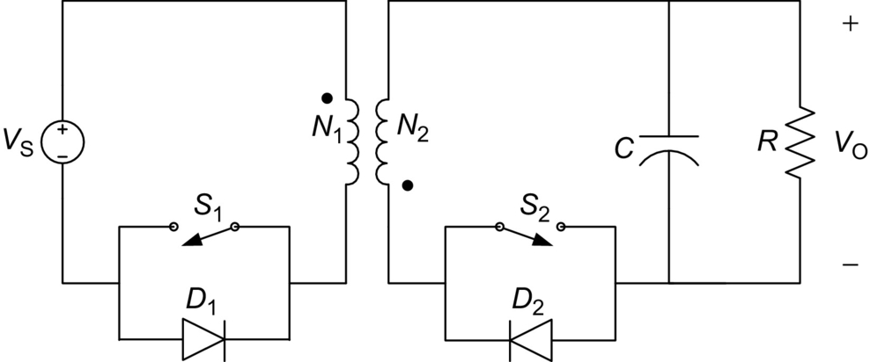

**FIG. 10.16** Bidirectional flyback converter.

## 10.9 Control Principles

A dc-dc converter must provide a regulated dc output voltage under varying load and input voltage conditions. The converter component values are also changing with time, temperature, pressure, etc. Hence, the control of the output voltage should be performed in a closed-loop manner using principles of negative feedback. Two most common closed-loop control methods for PWM dc-dc converters, namely, the voltage-mode control and the current-mode control, are presented schematically in [Fig. 10.17](https://learning.oreilly.com/library/view/power-electronics-handbook/9780128114087/B9780128114070000106.xhtml#f0090).

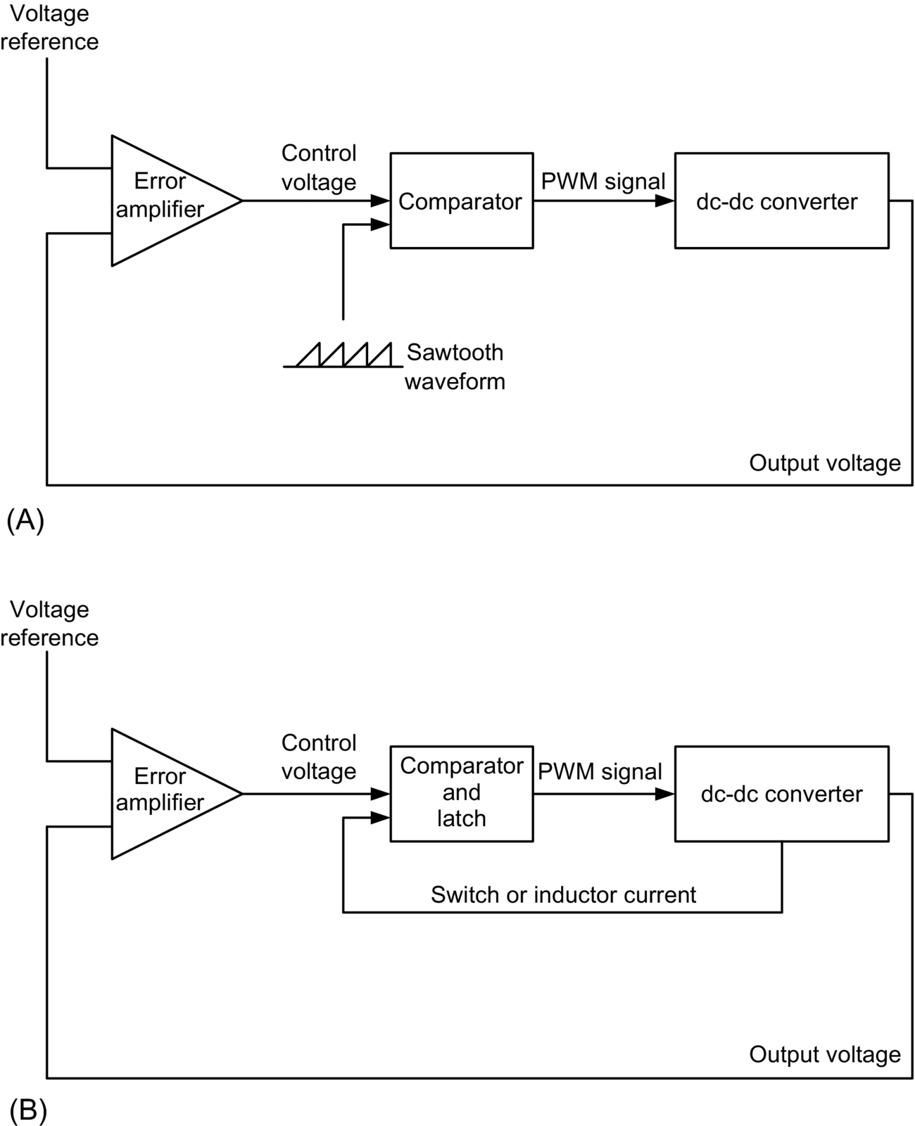

**FIG. 10.17** Main control schemes for dc-dc converters, (A) voltage-mode control and (B) current-mode control.

In the voltage-mode control scheme shown in [Fig. 10.17A](https://learning.oreilly.com/library/view/power-electronics-handbook/9780128114087/B9780128114070000106.xhtml#f0090), the converter output voltage is sensed and subtracted from an external reference voltage in an error amplifier. The error amplifier produces a control voltage that is compared to a constant-amplitude sawtooth waveform. The comparator produces a PWM signal that is fed to drivers of controllable switches in the dc-dc converter. The duty ratio of the PWM signal depends on the value of the control voltage. The frequency of the PWM signal is the same as the frequency of the sawtooth waveform. An important advantage of the voltage-mode control is its simple hardware implementation and flexibility.

The error amplifier in [Fig. 10.17A](https://learning.oreilly.com/library/view/power-electronics-handbook/9780128114087/B9780128114070000106.xhtml#f0090) reacts fast to changes in the converter output voltage. Thus, the voltage-mode control provides good load regulation, that is, regulation against variations in the load. Line regulation (regulation against variations in the input voltage) is, however, delayed because changes in the input voltage must first manifest themselves in the converter output before they can be corrected. To alleviate this problem, the voltage-mode control scheme is sometimes augmented by the so-called voltage feedforward path. The feedforward path affects directly the PWM duty ratio according to variations in the input voltage. As will be explained below, the input voltage feedforward is an inherent feature of current-mode control schemes.

The current-mode control scheme is presented in [Fig. 10.17B](https://learning.oreilly.com/library/view/power-electronics-handbook/9780128114087/B9780128114070000106.xhtml#f0090). An additional inner control loop feeds back an inductor current signal. This current signal, converted into its voltage analog, is compared with the control voltage. This modification of replacing the sawtooth waveform of the voltage-mode control scheme by a converter current signal significantly alters the dynamic behavior of the converter. The converter takes on some characteristics of a current source. The output current in PWM dc-dc converters is either equal to the *average* value of the output inductor current (buck-derived and Ćuk converters) or a product of an *average* inductor current and a function of the duty ratio. In practical implementations of the current-mode control, it is feasible to sense the peak inductor current instead of the average value. Since the peak inductor current is equal to the peak switch current, the latter can be used in the inner loop, which often simplifies the current sensor. Note that the peak inductor (switch) current is proportional to the input voltage. Hence, the inner loop of the current-mode control naturally accomplishes the input voltage feedforward technique. Among several current-mode control versions, the most popular is the constant frequency one that requires a clock signal. Advantages of the current-mode control include input voltage feedforward, limit on the peak switch current, equal current sharing in modular converters, and reduction in the converter dynamic order. The main disadvantage of the current-mode control is its complicated hardware that includes a need to compensate the control voltage by ramp signals (to avoid converter instability).

Among other control methods of dc-dc converters, a hysteretic (or bang-bang) control is very simple for hardware implementation. The hysteretic control results, however, in variable frequency operation of semiconductor switches. Generally, a constant switching frequency is preferred in power electronic circuits for easier elimination of electromagnetic interference and better utilization of magnetic components.

Application-specific integrated circuits (ASICs) are commercially available that contain main elements of voltage- or current-mode control schemes. On a single 14- or 16-pin chip, there is error amplifier, comparator, sawtooth generator, or sensed current input, latch, and PWM drivers. The switching frequency is usually set by an external *RC* network and can be varied from tens of kilohertz to a few megahertz. The controller has an oscillator output for synchronization with other converters in modular power supply systems. A constant voltage reference is generated on the chip as well. Additionally, the ASIC controller may be equipped in various diagnostic and protection features: current limiting, overvoltage and undervoltage protection, soft start, dead time in case of multiple PWM outputs, and duty ratio limiting. In several dc-dc converter topologies, for example, buck and buck-boost, neither control terminal of semiconductor switches is grounded (so-called high-side switches). The ASIC controllers are usually designed for a particular topology, and their PWM drivers may be able to drive high-side switches in low-voltage applications. In high-voltage applications, external PWM drivers must be used. External PWM drivers are also used for switches with high input capacitances. To take a full advantage of the input-output isolation in transformer versions of dc-dc converters, such an isolation must be also provided in the control loop. Signal transformers or optocouplers are used for isolating feedback signals.

Dynamic characteristic of closed-loop dc-dc converters must fulfill certain requirements. To simple analysis, these requirements are usually translated into desired properties of the open loop. The open loop should provide a sufficient (typically, at least 45 degrees) phase margin for stability, high bandwidth (about one-tenth of the switching frequency) for good transient response, and high gain (several tens of decibels) at low frequencies for small steady-state error.

The open-loop dynamic characteristics are shaped by compensating networks of passive components around the error amplifier. Second- or third-order *RC* networks are commonly used. Since the converter itself is a part of the control loop, the design of compensating networks requires a knowledge of small-signal characteristics of the converter. There are several methods of small-signal characterization of PWM dc-dc converters. The most popular methods provide average models of converters under high-switching-frequency assumption. The averaged models are then linearized at an operating point to obtain small-signal transfer functions. Among analytic averaging methods, state-space averaging has been popular since the late 1970s. Circuit-based averaging is usually performed using PWM switch or direct replacement of semiconductor switches by controlled current and voltage sources. All these methods can take into account converter parasitics.

The most important small-signal characteristic is the *control-to-output* transfer function *T*p. Other converter characteristics that are investigated include the *input-to-output* (or *line-to-output*) voltage transfer function, also called the *open-loop dynamic line regulation* or the *audio susceptibility*, which describes the input-output disturbance transmission; the *open-loop input impedance*; and the *open-loop dynamic load regulation*. Buck-derived, boost, and buck-boost converters are second-order dynamic systems; the Ćuk converter is a fourth-order system. Characteristics of buck and buck-derived converters are similar to each other. Another group of converters with similar small-signal characteristics is formed by boost, buck-boost, and flyback converters. Among parasitic components, the ESR of the filter capacitor *r*C introduces additional dynamic terms into transfer functions. Other parasitic resistances usually modify slightly the effective value of the load resistance. Sample characteristics below are given for nonzero *r*C, neglecting other parasitics.

The control-to-output transfer function of the forward converter is

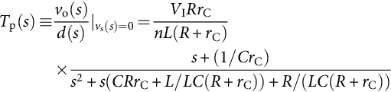 **(10.40)**

It can be seen that this transfer function has two poles and one zero. The zero is due to the filter capacitor ESR. Buck-derived converters can be easily compensated for stability with second-order controllers.

The control-to-output transfer function of the boost converter is given by

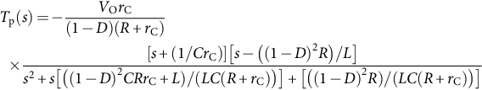 **(10.41)**

The zero −(1−*D*)2*R*/*L* is located in the right half of the *s*-plane. Therefore, the boost converter (and buck-boost and flyback converters) is a nonminimum phase system. Nonminimum phase dc-dc converters are typically compensated with third-order controllers. Step-by-step procedures for a design of compensating networks are usually given by manufacturers of ASIC controllers in application notes.

The final word of this section is on the behavior of dc-dc converters in distributed power supply systems. An important feature of closed-loop regulated dc-dc converters is that they exhibit a negative input resistance. As the load voltage is kept constant by the controller, the output power changes with the load. With slow load changes, an increase (decrease) in the input voltage results in a decrease (increase) in the input power. This negative resistance property must be carefully examined during the system design to avoid resonances.

## 10.10 Applications of DC-DC Converters

Step-down choppers find most of their applications in high-performance dc drive systems, for example, electric traction, electric vehicles, and machine tools. The dc motors with their winding inductances and mechanical inertia act as filters resulting in high-quality armature currents. The average output voltage of step-down choppers is a linear function of the switch duty ratio. Step-up choppers are used primarily in radar and ignition systems. The dc choppers can be modified for two-quadrant and four-quadrant operation. Two-quadrant choppers may be a part of autonomous power supply system that contain battery packs and such renewable dc sources as photovoltaic arrays, fuel cells, or wind turbines. Four-quadrant choppers are applied in drives in which regenerative breaking of dc motors is desired, for example, transportation systems with frequent stops. The dc choppers with inductive outputs serve as inputs to current-driven inverters.

An addition of filtering reactive components to dc choppers results in PWM dc-dc converters. The dc-dc converters can be viewed as dc transformers that deliver to the load as dc voltage or current at a different level than the input source. This dc transformation is performed by electronic switching means, not by electromagnetic means like in conventional transformers. Output voltages of dc-dc converters range from a volt for special VLSI circuits to tens of kilovolts in x-ray lamps. The most common output voltages are 3.3 V for modern microprocessors, 5 and 12 V for logic circuits, 48 V for telecommunication equipment, and 270 V for main dc bus on airplanes. Typical input voltages include 48, 170 (the peak value of a 120 V rms line), and 270 V.

Selection of a topology of dc-dc converters is determined not only by input/output voltages, which can be additionally adjusted with the turns ratio in isolated converters, but also by power levels, voltage and current stresses of semiconductor switches, and utilization of magnetic components. The low part-count flyback converter is popular in low-power applications (up to 200 W). Its main deficiencies are the large size of the flyback transformer core and high voltage stress on the semiconductor switch. The forward converter is also a single-switch converter. Since its core size requirements are smaller, it is popular in low-/medium (up to several hundreds of watts)-power applications. Disadvantages of the forward converter are in a need for demagnetizing winding and in a high voltage stress on the semiconductor switch. The push-pull converter is also used at medium power levels. Due to bidirectional excitation, the transformer size is small. An advantage of the push-pull converter is also a possibility to refer driving terminals of both switches to the ground, which greatly simplifies the control circuitry. A disadvantage of the push-pull converter is a potential core saturation in a case of asymmetry. The half-bridge converter has similar range of applications as the push-pull converter. There is no danger of transformer saturation in the half-bridge converter. It requires, however, two additional input capacitors to split in half the input dc source. The full-bridge converter is used at high (several kilowatts) power and voltage levels. The voltage stress on power switches is limited to the input voltage source value. A disadvantage of the full-bridge converter is a high number of semiconductor devices.

The dc-dc converters are building blocks of distributed power supply systems in which a common dc bus voltage is converted to various other voltages according to the requirements of particular loads. Such distributed dc systems are common in space stations, ships, and airplanes, as well as in computer and telecommunication equipment. It is expected that modern portable wireless communication and signal processing systems will use variable supply voltages to minimize power consumption and extend battery life. Low-output-voltage converters in these applications utilize the synchronous rectification arrangement.

Another big area of dc-dc converter applications is related to the utility ac grid. For critical loads, if the utility grid fails, there must be a backup source of energy, for example, a battery pack. This need for continuous power delivery gave rise to various types of uninterruptible power supplies (UPSs). The dc-dc converters are used in UPSs to adjust the level of a rectified grid voltage to that of the backup source. Since during normal operation the energy flows from the grid to the backup source and during emergency conditions the backup source must supply the load, bidirectional dc-dc converters are often used. The dc-dc converters are also used in dedicated battery chargers.

Power electronic loads, especially those with front-end rectifiers, pollute the ac grid with odd harmonics. The dc-dc converters are used as intermediate stages, just after a rectifier and before the load-supplying dc-dc converter, for shaping the input ac current to improve power factor and decrease the harmonic content. The boost converter is especially popular in such power-factor-correction (PFC) applications. Another utility grid-related application of dc-dc converters is in interfaces between ac networks and dc renewable energy sources such as fuel cells and photovoltaic arrays.

In isolated dc-dc converters, multiple outputs are possible with additional secondary windings of transformers. Only one output is regulated with a feedback loop. Other outputs depend on the duty ratio of the regulated one and on their loads. A multiple-output dc-dc converter is a convenient solution in application where there is a need for one closely regulated output voltage and for one or more noncritical other output voltage levels.

## Further Reading

[1] Severns R.P., Bloom G. *Modern DC-to-DC Switchmode Power Converter Circuits.* New York, NY: Van Nostrand Reinhold Company; 1985.

[2] Pressman A.I. *Switching Power Supply Design.* second ed. New York, NY: McGraw-Hill; 1998.

[3] Erickson R., Maksimovic D. *Fundamentals of Power Electronics.* second ed. Norwell, MA: Kluwer Academic; 2001.

[4] Mohan N., Undeland T.M., Robbins W.P. *Power Electronics: Converters, Applications and Design.* third ed. New York, NY: John Wiley & Sons; 2003.

[5] Hart D.W. *Power Electronics.* New York, NY: McGraw-Hill; 2010.

[6] Ioinovici A. *Power Electronics and Energy Conversion Systems, Fundamentals and Hard-Switching Converters.* New York, NY: Wiley; 2013.

[7] Rashid M.H. *Power Electronics Circuits, Devices, and Applications.* fourth ed. Upper Saddle River, NJ: Pearson Prentice Hall; 2013.

[8] Krein P.T. *Elements of Power Electronics.* second ed. New York, NY: Oxford University Press; 2014.

[9] Kazimierczuk M.K. *Pulse-Width Modulated DC-DC Power Converters.* second ed. New York, NY: Wiley; 2015.

[10] Trzynadlowski A.M. *Introduction to Modern Power Electronics.* third ed. New York, NY: Wiley; 2015.

**11**

# Inverters

Nimrod Vázquez Technological Institute of Celaya, Celaya, Mexico

Joaquín Vaquero López King Juan Carlos University, Madrid, Spain

## Abstract

In this chapter, not only single-phase inverters in their voltage-, current-, and impedance-source alternatives but also the three-phase inverters in their voltage- and current-source configurations will be reviewed. The multilevel configurations are also described. Specifically, the topologies, the modulating techniques, and the control aspects oriented to standard applications are analyzed. The inverters are required in many applications, like adjustable speed drives (ASDs), uninterruptible power supplies, static var compensators, active power filters, flexible ac transmission systems, and grid-connected photovoltaic systems, which are only a few applications.

### KEYWORDS:

Voltage-source inverter; Current-source inverter; Impedance-source inverter; Multilevel inverter; Modulation techniques; Single-phase inverters; Three-phase inverters

11.1 [Introduction](https://learning.oreilly.com/library/view/power-electronics-handbook/9780128114087/B9780128114070000118_1.xhtml#s0010)

11.2 [Single-Phase Inverters](https://learning.oreilly.com/library/view/power-electronics-handbook/9780128114087/B9780128114070000118_1.xhtml#s0015)

11.2.1 Voltage Source Inverter

11.2.2 Current Source Inverter

11.2.3 Impedance Source Inverter

11.2.4 Other Inverter Schemes

11.2.5 Pulse Width Modulation

11.3 [Three-Phase Voltage Source Inverters](https://learning.oreilly.com/library/view/power-electronics-handbook/9780128114087/B9780128114070000118_1.xhtml#s0080)

11.3.1 Sinusoidal PWM

11.3.2 Square-Wave Operation of Three-Phase VSIs

11.3.3 Sinusoidal PWM with Zero Sequence Signal Injection

11.3.4 Selective Harmonic Elimination in Three-Phase VSIs

11.3.5 Space-Vector (SV)-Based Modulating Techniques

11.3.6 DC Link Current in Three-Phase VSIs

11.3.7 Phase-Load Voltage in Three-Phase VSIs

11.4 [Three-Phase Current Source Inverters](https://learning.oreilly.com/library/view/power-electronics-handbook/9780128114087/B9780128114070000118_1.xhtml#s0135)

11.4.1 Carrier-Based PWM Techniques in CSIs

11.4.2 Square-Wave Operation of Three-Phase CSIs

11.4.3 Selective Harmonic Elimination in Three-Phase CSIs

11.4.4 Space-Vector-Based Modulating Techniques in CSIs

11.4.5 DC Link Voltage in Three-Phase CSIs

11.5 [Multilevel Inverters](https://learning.oreilly.com/library/view/power-electronics-handbook/9780128114087/B9780128114070000118_2.xhtml#s0180)

11.5.1 Voltage Source-Based Multilevel Topologies

11.5.2 Current Source-Based Multilevel Topologies

11.5.3 Modulation Techniques in Multilevel Inverters

11.6 [Closed-Loop Operation of Inverters](https://learning.oreilly.com/library/view/power-electronics-handbook/9780128114087/B9780128114070000118_2.xhtml#s0235)

11.6.1 Feedforward Techniques in Voltage Source Inverters

11.6.2 Feedback Techniques in Voltage Source Inverters

11.6.3 Feedback Techniques in Current Source Inverters

11.7 [Regeneration in Inverters](https://learning.oreilly.com/library/view/power-electronics-handbook/9780128114087/B9780128114070000118_2.xhtml#s0270)

11.7.1 Motoring Operating Mode in Three-Phase VSIs

11.7.2 Regenerative Operating Mode in Three-Phase VSIs

11.7.3 Regenerative Operating Mode in Three-Phase CSIs

[Further Reading](https://learning.oreilly.com/library/view/power-electronics-handbook/9780128114087/B9780128114070000118_2.xhtml#fr0010)

## 11.1 Introduction

To produce an ac output waveform from a dc power supply is the main objective of inverters. These types of converters are required in many applications, like adjustable speed drives (ASDs), uninterruptible power supplies, static var compensators, active power filters, flexible ac transmission systems, and grid-connected photovoltaic systems, which are only a few applications. For sinusoidal ac outputs, the magnitude, frequency, and phase of the waveform should be controllable. In the literature, different topologies have been reported; one of the most known converters is the voltage-source inverters (VSIs), but current-source inverters (CSIs) and impedance-source inverters (ISIs) can also be found; in [Fig. 11.1](https://learning.oreilly.com/library/view/power-electronics-handbook/9780128114087/B9780128114070000118_1.xhtml#f0010), a classification of inverters is illustrated that considers the input source. The VSIs are the most widely used because they naturally behave as voltage sources as required by many industrial applications, such as ASDs, which are the most popular application of inverters. Similarly, the other topologies are widely used in medium-voltage industrial or low-power commercial applications.

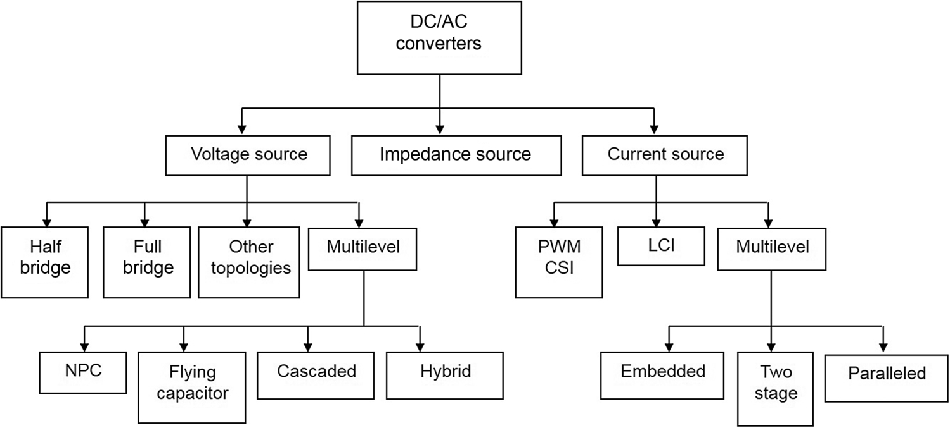

**FIG. 11.1** Classification of the inverters.

The inverters are constructed from power switches and diodes. This leads to the generation of waveforms that feature fast transitions rather than smooth ones. These waveforms are made up of a fundamental component that behaves as a pure sinusoidal and an infinite number of harmonics. This behavior should be ensured by a modulating technique that controls the amount of time and the sequence used to switch the power semiconductors on and off. The modulating techniques mostly used are the carrier-based technique (e.g., sinusoidal pulse width modulation, SPWM), the space-vector (SV) technique, and the selective harmonic elimination (SHE) technique.

As an alternative not only to produce an inverter output with low harmonic content but also to avoid the negative side effects of high *dv*/*dt* (such as bearing and isolation problems), the multilevel topologies should be used. The basic principle is to construct the required ac output waveform from various levels, which achieves waveforms at reduced *dv*/*dt*. Although these topologies are well developed in ASDs, they are also suitable for static var compensators, active power filters, and so on. Specialized modulating techniques have been developed to switch the higher number of power semiconductors involved in these topologies. Among others, the carrier-based (SPWM) and SV-based techniques have been naturally extended to these applications.

In many applications, it is required to take energy from the ac side of the inverter and send it back into the dc side. For instance, whenever ASDs need to either brake or slow down the motor speed, the kinetic energy is sent into the voltage dc link. This is known as the regenerative operating mode, and in contrast to the motoring mode, the dc link current direction is reversed due to the fact that the dc link voltage is fixed. If a capacitor is used to maintain the dc link voltage (as in standard ASDs), the energy must be either dissipated or fed back into the distribution system; otherwise, the dc link voltage gradually increases. The first approach requires the dc link capacitor be connected in parallel with a resistor, which must be properly switched only when the energy flows from the motor to the dc link. A better alternative is to feed back such energy into the distribution system. However, this alternative requires a reversible-current topology connected between the distribution system and the dc link capacitor. A modern approach to such a requirement is to use the active front-end rectifier technologies, where the regeneration mode is a natural operating mode of the system.

In this chapter, not only single-phase inverters in their voltage-, current-, and impedance-source alternatives but also the three-phase inverters in their voltage- and current-source configurations will be reviewed. Specifically, the topologies, the modulating techniques, and the control aspects oriented to standard applications are analyzed. In order to simplify the analysis, the inverters are considered lossless topologies, and the dc link will be assumed to be a perfect dc. Nevertheless, some practical nonideal conditions are also considered.

## 11.2 Single-Phase Inverters

Single-phase inverters can be classified by its input source; they are VSIs, CSIs, and ISIs. The operating principles are different in each converter. The main features of the different approaches are reviewed and presented in the following subsections. Although these converters cover the low-power range, they are widely used in power supplies or single-phase UPSs.

### 11.2.1 VOLTAGE SOURCE INVERTER

The traditional topologies for single-phase VSIs are half bridge and full bridge ([Fig. 11.2](https://learning.oreilly.com/library/view/power-electronics-handbook/9780128114087/B9780128114070000118_1.xhtml#f0015)). The converter is composed of capacitors, switches, and diodes, where an array of two switches is called “inverter leg.” For instance, the inverter leg of the half bridge is composed of  and . The capacitors required to provide a neutral point *N* are large, such that each capacitor maintains a constant voltage.

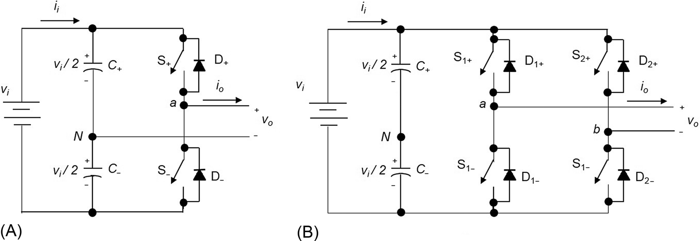

**FIG. 11.2** Single-phase VSI: (A) half bridge and (B) full bridge.

In order to operate properly the voltage-source inverter, the following rules are compulsory:

1. Switches of the same leg cannot be on simultaneously, because a short circuit across the dc link voltage source *vi* would be produced.

2. Diode in antiparallel to each switch must be placed, in order to provide a current path for inductive loads. If the commercial switch includes this diode, then the circuit is already complete.

3. In practical implementation, a dead time, also known as blanking time, must be considered in the control signals of the leg switches, to avoid breaking rule 1.

For the half-bridge VSI ([Fig. 11.2A](https://learning.oreilly.com/library/view/power-electronics-handbook/9780128114087/B9780128114070000118_1.xhtml#f0015)), there are two defined (states 1 and 2) and one undefined (state 3) switching state as shown in [Table 11.1](https://learning.oreilly.com/library/view/power-electronics-handbook/9780128114087/B9780128114070000118_1.xhtml#t0010). In order to avoid an undefined ac output voltage condition, state 3 should be used just for the dead time. Then, the modulating technique should always ensure that at any instant either the top or the bottom switch of the inverter leg is on.

**Table 11.1**

**Switch states for a half-bridge single-phase VSI**

|  |  |  |  |  |
| --- | --- | --- | --- | --- |
| **State** | **State no.** | ***vo*** | **Components conducting** | |
| si1_e is on, and si2_e is off | 1 | *vi*/2 | si1_e | If si48_e |
| si49_e | If si50_e |
| si2_e is on, and si1_e is off | 2 | si53_e | si54_e | If si48_e |
| si2_e | If si50_e |
| si1_e and si2_e are all off | 3 | si53_e | si54_e | If si48_e |
| *vi*/2 | si49_e | If si50_e |

[Fig. 11.3](https://learning.oreilly.com/library/view/power-electronics-handbook/9780128114087/B9780128114070000118_1.xhtml#f0020) shows the ideal waveforms associated with the half-bridge inverter shown in [Fig. 11.2A](https://learning.oreilly.com/library/view/power-electronics-handbook/9780128114087/B9780128114070000118_1.xhtml#f0015). The states for the switches  and  are defined by the modulating technique, which in this case is a carrier-based PWM.

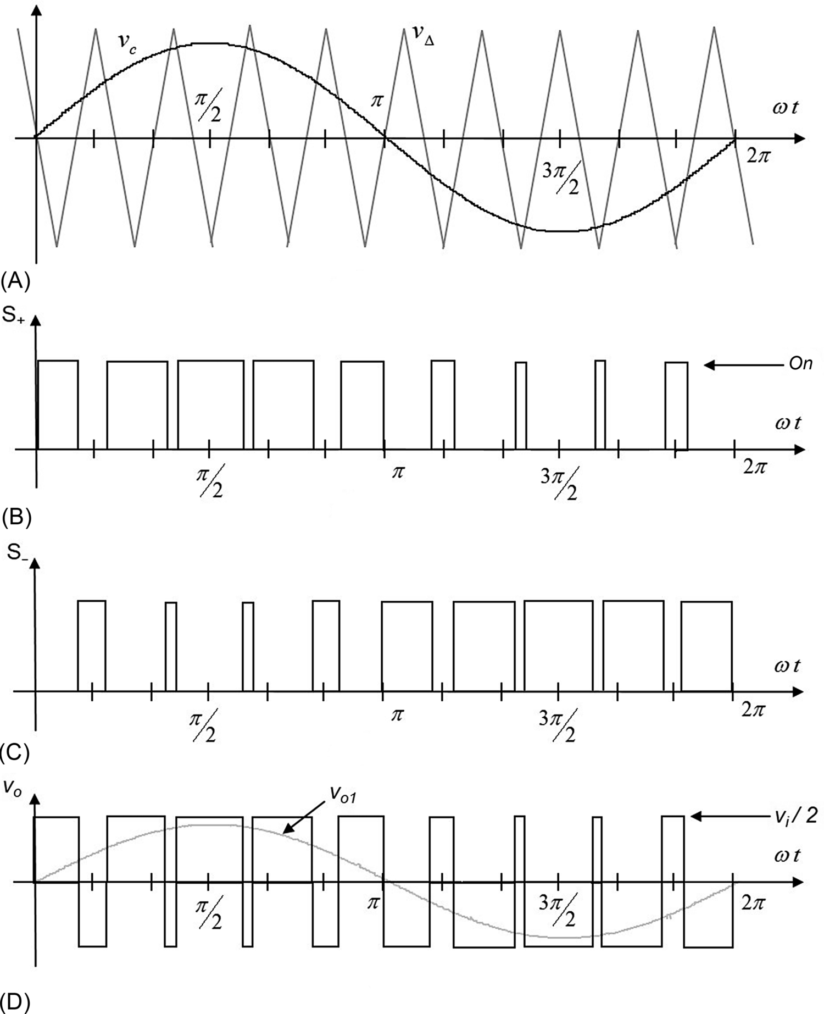

**FIG. 11.3** The half-bridge VSI. Ideal waveforms for the SPWM: (A) carrier and modulating signals, (B) switch  state, (C) switch  state, and (D) ac output voltage.

For the full-bridge VSI ([Fig. 11.2B](https://learning.oreilly.com/library/view/power-electronics-handbook/9780128114087/B9780128114070000118_1.xhtml#f0015)), there are four defined (states 1–4) and one undefined (state 5) switching state as shown in [Table 11.2](https://learning.oreilly.com/library/view/power-electronics-handbook/9780128114087/B9780128114070000118_1.xhtml#t0015). Again, in order to avoid an undefined ac output voltage condition, state 5 should be used just for the dead time. Then, the modulating technique should always ensure that at any instant either the top or the bottom switch of an inverter leg is on.

**Table 11.2**

**Switch states for a full-bridge single-phase VSI**

|  |  |  |  |  |  |  |
| --- | --- | --- | --- | --- | --- | --- |
| **State** | **State no.** | ***vaN*** | ***vbN*** | ***vo*** | **Components conducting** | |
| si3_e and si10_e are on, and si6_e and si4_e are off | 1 | *vi*/2 | si53_e | *vi* | si3_e and si10_e | If si48_e |
| si73_e and si74_e | If si50_e |
| si6_e and si4_e are on, and si3_e and si10_e are off | 2 | si53_e | *vi*/2 | si81_e | si82_e and si83_e | If si48_e |
| si6_e and si4_e | If si50_e |
| si3_e and si4_e are on, and si6_e and si10_e are off | 3 | *vi*/2 | *vi*/2 | 0 | si3_e and si83_e | If si48_e |
| si73_e and si4_e | If si50_e |
| si6_e and si10_e are on, and si3_e and si4_e are off | 4 | si53_e | si53_e | 0 | si82_e and si10_e | If si48_e |
| si6_e and si74_e | If si50_e |
| si6_e and si3_e are off | 5 | si53_e |  | Depends on si10_e and si4_e | si82_e | If si48_e |
| *vi*/2 |  | si73_e | If si50_e |
| si10_e and si4_e are off |  | *vi*/2 | Depends on si6_e and si3_e | si83_e | If si48_e |
|  | si53_e | si74_e | If si50_e |

[Fig. 11.4](https://learning.oreilly.com/library/view/power-electronics-handbook/9780128114087/B9780128114070000118_1.xhtml#f0025) shows the ideal waveforms associated with the full-bridge inverter shown in [Fig. 11.2B](https://learning.oreilly.com/library/view/power-electronics-handbook/9780128114087/B9780128114070000118_1.xhtml#f0015). The states for the switches are defined by the modulating technique, which in this case is a carrier-based PWM, but unipolar output is considered.



**FIG. 11.4** The full-bridge VSI. Ideal waveforms for the unipolar SPWM: (A) carrier and modulating signals, (B) switch  state, (C) switch  state, and (D) ac output voltage.

For the VSIs, different output filters may be employed, in order to provide the fundamental component of the output. Depending on the application, it would be desirable to provide a voltage or a current output. In [Fig. 11.5](https://learning.oreilly.com/library/view/power-electronics-handbook/9780128114087/B9780128114070000118_1.xhtml#f0030), some output filters for this converter are shown; in all cases, an inductor is required immediately for the output of the converter. The first and the last one are used to provide a current output, such as in VSIs connected to the grid, where a current-like performance is required. The second-order filter is used for voltage output, such as stand-alone applications or ASDs.



**FIG. 11.5** Output filter for a VSI: (A) inductor, (B) second-order filter, and (C) LCL filter.

### 11.2.2 CURRENT SOURCE INVERTER

The topology for the single-phase CSIs is the shown in [Fig. 11.6](https://learning.oreilly.com/library/view/power-electronics-handbook/9780128114087/B9780128114070000118_1.xhtml#f0035). The converter is composed of inductors, switches, and diodes. The inductors required are large, such that the inductors maintain a constant current *ii*. Current-source topologies feature a low switching dv/dt and reliable overcurrent/short-circuit protection.



**FIG. 11.6** Single-phase CSI.

In order to operate properly the current-source inverter, the following rules are compulsory:

1. Top or bottom switches of the different legs cannot be off simultaneously, because no current path is provided to the input inductors.

2. Diode in series to each switch must be placed, because a short circuit across the output voltage *vo* would be produced. If the commercial switch does not include antiparallel diodes, then the circuit is already complete.

3. In practical implementation, an overlapping time must be considered in the control signals of the top or bottom switches of the different legs.

According to the previous rules, it should be noticed that both switches of the inverter leg can be turned on at the same time, and this is not possible in VSI.

For the CSI ([Fig. 11.6](https://learning.oreilly.com/library/view/power-electronics-handbook/9780128114087/B9780128114070000118_1.xhtml#f0035)), there are four defined (states 1–4) and one not permitted switching state (state 5) as shown in [Table 11.3](https://learning.oreilly.com/library/view/power-electronics-handbook/9780128114087/B9780128114070000118_1.xhtml#t0020). The modulating technique should always ensure that at any instant, at least one of the top and bottom switch of the inverter legs is on; otherwise, the inverter will be damaged.

**Table 11.3**

**Switch states for a single-phase CSI**

|  |  |  |  |
| --- | --- | --- | --- |
| **State** | **State no.** | ***io*** | **Components conducting** |
| si3_e and si10_e are on, and  si6_e and si4_e are off | 1 | *ii* | si3_e, si10_e,  si73_e, and si74_e |
| si6_e and si4_e are on, and  si3_e and si10_e are off | 2 | −*ii* | si6_e, si4_e,  si82_e, and si83_e |
| si3_e and si6_e are on, and  si4_e and si10_e are off | 3 | 0 | si3_e, si6_e,  si73_e, and si82_e |
| si4_e and si10_e are on, and  si3_e and si6_e are off | 4 | 0 | si4_e, si10_e,  si82_e, and si74_e |
| si3_e and si6_e are off, and  si4_e and si10_e are off | 5 |  | This state must be avoided |

[Fig. 11.7](https://learning.oreilly.com/library/view/power-electronics-handbook/9780128114087/B9780128114070000118_1.xhtml#f0040) shows the ideal waveforms associated with the CSI shown in [Fig. 11.6](https://learning.oreilly.com/library/view/power-electronics-handbook/9780128114087/B9780128114070000118_1.xhtml#f0035). Notice that only the control signals of one inverter leg are graphed, since the other control signals are the opposite due to the rules ( = not  and  = not ), but the overlapping time should be considered for implementation. The states for the switches are defined by the modulating technique, which in this case is a carrier-based PWM, but unipolar output is considered.



**FIG. 11.7** The CSI, ideal waveforms for the unipolar SPWM: (A) carrier and modulating signals, (B) switch  state, (C) switch  state, and (D) ac output current.

For the CSIs, different output filters may be employed, in order to provide the fundamental component of the output waveform. Depending on the application, it would be desirable to provide a voltage or current output. In [Fig. 11.8](https://learning.oreilly.com/library/view/power-electronics-handbook/9780128114087/B9780128114070000118_1.xhtml#f0045), some output filters for this converter are shown; in all cases, a capacitor is required immediately for the output of the converter.



**FIG. 11.8** Output filter for a CSI: (a) just capacitor, (b) second-order filter, and (c) CLC filter.

### 11.2.3 IMPEDANCE SOURCE INVERTER

There are different topologies for single-phase ISIs, namely, “Z,”- “qZ,”- and “TZ”-source inverters; in [Fig. 11.9](https://learning.oreilly.com/library/view/power-electronics-handbook/9780128114087/B9780128114070000118_1.xhtml#f0050), the Z-source inverter (ZSI) is shown. The converter is composed of capacitors and inductors, switches, and diodes. The capacitors and the inductors are arranged to form an input impedance for the inverter.



**FIG. 11.9** Single-phase ZSI.

In order to operate properly the impedance-source inverter of [Fig. 11.9](https://learning.oreilly.com/library/view/power-electronics-handbook/9780128114087/B9780128114070000118_1.xhtml#f0050), the following rules are compulsory:

1. No restrictions to the switches of the inverter leg apply.

2. Diodes in antiparallel to each switch must be placed, in order to provide a current path for inductive loads. If the commercial switch includes these diodes, then the circuit is already complete.

3. In practical implementation, no dead or overlapping time must be considered in the control signals of the leg switches.

According to the previous rules, it should be noticed that the switches of the inverter leg can be turned on and off at any time, and then, this converter has more switching states than the others, and this is used to boost the input voltage.

For the ISI shown in [Fig. 11.9](https://learning.oreilly.com/library/view/power-electronics-handbook/9780128114087/B9780128114070000118_1.xhtml#f0050), there are five defined (states 1–5) and one undefined switching state as shown in [Table 11.4](https://learning.oreilly.com/library/view/power-electronics-handbook/9780128114087/B9780128114070000118_1.xhtml#t0025). The modulating technique may permit to use the additional switching state (no. 5, known as shoot-through state), and then, another modulating signal should be employed for this purpose, but usually, it has a constant waveform.

**Table 11.4**

**Switch states for a single-phase ZSI**

|  |  |  |
| --- | --- | --- |
| **State** | **State no.** | ***vo*** |
| si3_e and si10_e are on, and si6_e and si4_e are off | 1 | 2*vcz*−*vi* |
| si6_e and si4_e are on, and si3_e and si10_e are off | 2 | −(2*vcz*−*vi*) |
| si3_e and si4_e are on, and si6_e and si10_e are off | 3 | 0 |
| si6_e and si10_e are on, and si3_e and si4_e are off | 4 | 0 |
| si3_e and si4_e are on, and si6_e or si10_e is on | 5 | 0 |
| si6_e and si10_e are on, and si3_e or si4_e is on |
| si6_e and si3_e are off | 6 | Depends on si10_e and si4_e |
| si10_e and si4_e are off | Depends on si6_e and si3_e |

[Fig. 11.10](https://learning.oreilly.com/library/view/power-electronics-handbook/9780128114087/B9780128114070000118_1.xhtml#f0055) shows the ideal waveforms associated with the ZSI shown in [Fig. 11.9](https://learning.oreilly.com/library/view/power-electronics-handbook/9780128114087/B9780128114070000118_1.xhtml#f0050). The states for the switches are defined by the modulating technique, which in this case is a carrier-based PWM, but unipolar output is considered; the shoot-through state is modulated by *vr*.



**FIG. 11.10** The ZSI, ideal waveforms for the unipolar SPWM: (A) carrier and modulating signals, (B) switch  state, (C) switch  state, (D) switch  state, (E) switch  state, and (F) ac output voltage.

For the converter ZSI, the output filter may be the same as for the VSI, and then, the filters are like the ones shown in [Fig. 11.5](https://learning.oreilly.com/library/view/power-electronics-handbook/9780128114087/B9780128114070000118_1.xhtml#f0030).

### 11.2.4 OTHER INVERTER SCHEMES

In the literature, other inverter topologies, with different operation from the previous discussed converters, have been proposed. However, the compulsory rules are valid, according to the input source. The entitled boost inverter is based on two bidirectional dc/dc boost converters and is able to produce an output voltage higher than the input voltage. This idea can be easily extrapolated to other dc/dc converter topologies. For more details, the appropriate references can be consulted.

### 11.2.5 PULSE WIDTH MODULATION

In order to produce a sinusoidal output, the pulse width modulation is employed. The modulating techniques mostly used are the carrier-based technique (e.g., sinusoidal pulse width modulation, SPWM), the space-vector (SV) technique, and the selective harmonic elimination (SHE) technique.

#### **11.2.5.1 The Carrier-Based Pulse Width Modulation (PWM) Technique**

As mentioned earlier, it is desired that the ac output voltage, *vo*, follows a given waveform (e.g., sinusoidal) on a continuous basis by properly switching the semiconductors. The carrier-based PWM technique fulfills such a requirement as it defines the on and off states of the switches of the inverter legs by comparing a modulating signal *vc* (desired ac output voltage) and a triangular waveform *v*Δ (carrier signal).

A special case is when the modulating signal *vc* is a sinusoidal at frequency *fc* and amplitude , and the triangular signal *v*Δ is at frequency *f*Δ and amplitude . This is the sinusoidal PWM (SPWM) scheme. In this case, the modulation index *ma* (also known as the amplitude modulation ratio) is defined as

 **(11.1)**

and the normalized carrier frequency *mf* (also known as the frequency modulation ratio) is

 **(11.2)**

There are two known output waveforms entitled bipolar and unipolar output. [Figs. 11.3D](https://learning.oreilly.com/library/view/power-electronics-handbook/9780128114087/B9780128114070000118_1.xhtml#f0020) (bipolar) and [11.4d](https://learning.oreilly.com/library/view/power-electronics-handbook/9780128114087/B9780128114070000118_1.xhtml#f0025) (unipolar) clearly show that the ac output voltage *vo* is basically a sinusoidal waveform plus harmonics.

##### **Bipolar PWM technique**

To generate a bipolar output, a carrier-based technique can be used as shown in [Fig. 11.3](https://learning.oreilly.com/library/view/power-electronics-handbook/9780128114087/B9780128114070000118_1.xhtml#f0020). In this technique, only one modulating signal *vc* is used and also only one triangular signal *v*Δ. The important features for the bipolar output are the following:

(a) The amplitude of the fundamental component of the ac output voltage  satisfies the following expression:

 **(11.3)**

for half-bridge VSI, [Fig. 11.2A](https://learning.oreilly.com/library/view/power-electronics-handbook/9780128114087/B9780128114070000118_1.xhtml#f0015),

 **(11.4)**

for the full-bridge VSI, [Fig. 11.2B](https://learning.oreilly.com/library/view/power-electronics-handbook/9780128114087/B9780128114070000118_1.xhtml#f0015); these equations are valid for , which is called the linear region of the modulating technique (higher values of *ma* lead to overmodulation that will be discussed later).

(b) For odd values of the normalized carrier frequency *mf*, the harmonics in the ac output voltage appear at normalized frequencies *fh* centered around *mf* and its multiples, specifically,

 **(11.5)**

where  for  and  for .

(c) The amplitude of the ac output voltage harmonics is a function of the modulation index *ma* and is independent of the normalized carrier frequency *mf* for .

(d) The harmonics in the dc link current (due to the modulation) appear at normalized frequencies *fp* centered around the normalized carrier frequency *mf* and its multiples, specifically,

 **(11.6)**

where  for  and  for .

Additional important issues are the following: (a) For small values of *mf* (), the carrier signal *v*Δ and the signal *vc* should be synchronized to each other (*mf* integer), which is required to hold the previous features; if this is not the case, subharmonics will be present in the ac output voltage; (b) for large values of *mf* (), the subharmonics are negligible if an asynchronous PWM technique is used; however, due to potential very low-order subharmonics, its use should be avoided; finally, (c) in the overmodulation region (), some intersections between the carrier and the modulating signal are missed, which leads to the generation of low-order harmonics, but a higher fundamental ac output voltage is obtained; unfortunately, the linearity between *ma* and  achieved in the linear region does not hold in the overmodulation region; moreover, a saturation effect can be observed ([Fig. 11.11](https://learning.oreilly.com/library/view/power-electronics-handbook/9780128114087/B9780128114070000118_1.xhtml#f0060)).



**FIG. 11.11** Normalized fundamental ac component of the output voltage in a half-bridge VSI SPWM modulated.

As mentioned before, the PWM technique allows an ac output voltage to be generated that tracks a given modulating signal. In the SPWM technique, the modulating signal is a sinusoidal that provides, in the linear region, an ac output voltage that varies linearly as a function of the modulation index, and the harmonics are at well-defined frequencies and amplitudes. These features simplify the design of filtering components. Unfortunately, the maximum amplitude of the fundamental ac voltage is bounded in this operating mode. Higher voltages are obtained by using the overmodulation region (); however, low-order harmonics appear in the ac output voltage. Very large values of the modulation index () lead to a totally square ac output voltage.

##### **Unipolar PWM technique**

To generate a unipolar output, also a carrier-based technique can be used as shown in [Fig. 11.4](https://learning.oreilly.com/library/view/power-electronics-handbook/9780128114087/B9780128114070000118_1.xhtml#f0025), where two sinusoidal modulating signals (*vc* and  are used. The signal *vc* is used to generate *S1+*, and  is used to generate *S2+*. Notice that this output cannot be produced by a half-bridge inverter. Important features for the unipolar output are the following:

(a) The amplitude of the fundamental component of the ac output voltage  satisfies the following expression:

 **(11.7)**

(b) Since the phase voltages (*vaN* and *vbN*) are identical but 180*°* out of phase, the output voltage () will not contain even harmonics. Thus, if *mf* is taken even, the harmonics in the ac output voltage appear at normalized odd frequencies *fh* centered around twice the normalized carrier frequency *mf* and its multiples. Specifically,

 **(11.8)**

where ; this feature is considered to be an advantage because it allows the use of smaller filtering components to obtain high-quality voltage and current waveforms while using the same switching frequency as in VSIs modulated by the bipolar approach.

(c) The amplitude of the ac output voltage harmonics is also a function of the modulation index *ma*.

(d) The harmonics in the dc link current appear at normalized frequencies *fp* centered around twice the normalized carrier frequency *mf* and its multiples. Specifically,

 **(11.9)**

where 

#### **11.2.5.2 Selective Harmonic Elimination**

The main objective is to obtain a sinusoidal ac output voltage waveform where the fundamental component can be adjusted arbitrarily within a range and the intrinsic harmonics selectively eliminated. This is achieved by mathematically generating the exact instant of the turn-on and turnoff of the power semiconductors. The ac output voltage features odd half- and quarter-wave symmetry; therefore, even harmonics are not present (, ). Moreover, the phase voltage waveform (*vo*) should be chopped *N* times per half cycle in order to adjust the fundamental and eliminate  harmonics in the ac output voltage waveform.

For this modulation, also the output may be bipolar or unipolar.

##### **Bipolar SHE technique**

The general expressions to eliminate an even  () number of harmonics are

 **(11.10)**

where *α*1, *α*2,…, *αN* should satisfy .

For instance, to eliminate the third and fifth harmonics and to perform fundamental magnitude control (), the equations to be solved are the following:

 **(11.11)**

where the angles *α*1, *α*2, and *α*3 are defined as shown in [Fig. 11.12A](https://learning.oreilly.com/library/view/power-electronics-handbook/9780128114087/B9780128114070000118_1.xhtml#f0065) and the spectrum in [Fig. 11.12B](https://learning.oreilly.com/library/view/power-electronics-handbook/9780128114087/B9780128114070000118_1.xhtml#f0065). The angles are found by means of iterative algorithms as no analytic solutions can be derived. The angles *α*1, *α*2, and *α*3 are plotted for different values of  in [Fig. 11.13A](https://learning.oreilly.com/library/view/power-electronics-handbook/9780128114087/B9780128114070000118_1.xhtml#f0070).



**FIG. 11.12** The half-bridge VSI. Ideal waveforms for the SHE technique: (A) ac output voltage for third- and fifth-harmonic elimination, (B) spectrum of (A), (C) ac output voltage for third-, fifth-, and seventh-harmonic elimination, and (D) spectrum of (C).



**FIG. 11.13** Chopping angles for SHE and fundamental voltage control in half-bridge VSIs: (A) third- and fifth-harmonic elimination and (B) third-, fifth-, and seventh-harmonic elimination.

Similarly, the general expressions to eliminate an odd  () number of harmonics are given by

 **(11.12)**

where *α*1,*α*2,…,*αN* should satisfy .

For instance, to eliminate the third, fifth, and seventh harmonics and to perform the fundamental magnitude control (), the equations to be solved are

 **(11.13)**

where the angles *α*1, *α*2, *α*3, and *α*4 are defined as shown in [Fig. 11.12C](https://learning.oreilly.com/library/view/power-electronics-handbook/9780128114087/B9780128114070000118_1.xhtml#f0065), and the spectrum in [Fig. 11.12D](https://learning.oreilly.com/library/view/power-electronics-handbook/9780128114087/B9780128114070000118_1.xhtml#f0065). The angles *α*1, *α*2, and *α*3 are plotted for different values of  in [Fig. 11.13B](https://learning.oreilly.com/library/view/power-electronics-handbook/9780128114087/B9780128114070000118_1.xhtml#f0070).

##### **Unipolar SHE technique**

The general expressions to eliminate an arbitrary  () number of harmonics are given by

 **(11.14)**

where *α*1,*α*2,…,*αN* should satisfy .

For instance, to eliminate the third, the fifth, and the seventh harmonics and to perform fundamental component magnitude control (), the equations to be solved are

 **(11.15)**

where the angles *α*1, *α*2, *α*3, and *α*4 are defined as shown in [Fig. 11.14A](https://learning.oreilly.com/library/view/power-electronics-handbook/9780128114087/B9780128114070000118_1.xhtml#f0075) and the spectrum in [Fig. 11.14B](https://learning.oreilly.com/library/view/power-electronics-handbook/9780128114087/B9780128114070000118_1.xhtml#f0075). The angles *α*1, *α*2, *α*3, and *α*4 are plotted for different values of  in [Fig. 11.15A](https://learning.oreilly.com/library/view/power-electronics-handbook/9780128114087/B9780128114070000118_1.xhtml#f0080).



**FIG. 11.14** The half-bridge VSI. Ideal waveforms for the SHE technique: (A) ac output voltage for third-, fifth-, and seventh-harmonic elimination; (B) spectrum of (A); (C) ac output voltage for fundamental control; and (D) spectrum of (C).



**FIG. 11.15** Chopping angles for SHE and fundamental voltage control in half-bridge VSIs: (A) fundamental control and third-, fifth-, and seventh-harmonic elimination and (B) fundamental control.

[Fig. 11.14C](https://learning.oreilly.com/library/view/power-electronics-handbook/9780128114087/B9780128114070000118_1.xhtml#f0075) shows a special case where only the fundamental ac output voltage is controlled. This is known as output control by voltage cancellation, which derives from the fact that its implementation is easily attainable by using two phase-shifted square-wave switching signals as shown in [Fig. 11.16](https://learning.oreilly.com/library/view/power-electronics-handbook/9780128114087/B9780128114070000118_1.xhtml#f0085). The phase-shift angle becomes two  ([Fig. 11.16B](https://learning.oreilly.com/library/view/power-electronics-handbook/9780128114087/B9780128114070000118_1.xhtml#f0085)). Thus, the amplitude of the fundamental component and harmonics in the ac output voltage are given by



**FIG. 11.16** The full-bridge VSI. Ideal waveforms for the output control by voltage cancellation: (A) switch  state, (B) switch  state, (C) ac output voltage, and (D) ac output voltage spectrum.

 **(11.16)**

It can also be observed in [Fig. 11.16C](https://learning.oreilly.com/library/view/power-electronics-handbook/9780128114087/B9780128114070000118_1.xhtml#f0085) that for  square-wave operation is achieved. In this case, the fundamental ac output voltage is given by

 **(11.17)**

where the fundamental load voltage can be controlled by the manipulation of the dc link voltage *vi*. Additional means to modify this voltage should be provided. Depending on the dc link source of power, this could be a controlled rectifier, for ac sources, or a dc/dc converter, for dc sources.

To implement the SHE modulating technique, the modulator should generate the gating pattern according to the angles as shown in [Figs. 11.13](https://learning.oreilly.com/library/view/power-electronics-handbook/9780128114087/B9780128114070000118_1.xhtml#f0070) and [11.15](https://learning.oreilly.com/library/view/power-electronics-handbook/9780128114087/B9780128114070000118_1.xhtml#f0080). This task is usually performed by digital systems that normally store the angles in look-up tables.

#### **11.2.5.3 DC Link Current**

Due to the fact that the inverter is assumed lossless and constructed without storage energy components, the instantaneous power balance indicates that

 **(11.18)**

For inductive load and relatively high switching frequencies, the load current *I*o is nearly sinusoidal. As a first approximation, the ac output voltage can also be considered sinusoidal. On the other hand, if the dc link voltage remains constant *vi*(*t*)=*Vi*, Eq. [(11.18)](https://learning.oreilly.com/library/view/power-electronics-handbook/9780128114087/B9780128114070000118_1.xhtml#fo0095) can be simplified to

 **(11.19)**

where *Vo1* is the fundamental rms ac output voltage, *I*o is the rms load current, and *φ* is an arbitrary inductive load power factor. Thus, the dc link current can be further simplified to

 **(11.20)**

The preceding expression reveals an important issue, that is, the presence of a large second-order harmonic in the dc link current (its amplitude is similar to the dc link current). This second harmonic is injected back into the dc voltage source; thus, its design should be considered in order to guarantee a nearly constant dc link voltage. In practical terms, the dc voltage source is required to feature large amounts of capacitance, which is costly and demands space, both undesired features, especially in medium- to high-power supplies.

## 11.3 Three-Phase Voltage Source Inverters

Single-phase VSIs cover low-range power applications, and three-phase VSIs cover medium- to high-power applications. The main purpose of these topologies is to provide a three-phase voltage source, where the amplitude, phase, and frequency of the voltages should always be controllable. Although most of the applications require sinusoidal voltage waveforms (e.g., ASDs, UPSs, FACTS, and var compensators), arbitrary voltages are also required in some other applications (e.g., active power filters and voltage compensators).

The standard three-phase VSI topology is shown in [Fig. 11.17](https://learning.oreilly.com/library/view/power-electronics-handbook/9780128114087/B9780128114070000118_1.xhtml#f0090), and the eight valid switch states are given in [Table 11.5](https://learning.oreilly.com/library/view/power-electronics-handbook/9780128114087/B9780128114070000118_1.xhtml#t0030). As in single-phase VSIs, the compulsory rules previously described in [Section 11.2.1](https://learning.oreilly.com/library/view/power-electronics-handbook/9780128114087/B9780128114070000118_1.xhtml#s0020) also apply.



**FIG. 11.17** Three-phase VSI topology.

**Table 11.5**

**Valid switch states for a three-phase VSI**

|  |  |  |  |  |  |
| --- | --- | --- | --- | --- | --- |
| **State** | **State no.** | ***vab*** | ***vbc*** | ***vca*** | **Space vector** |
| *S*1, *S*2, and *S*6 are on, and  *S*4, *S*5, and *S*3 are off | 1 | *vi* | 0 | si81_e | si197_e |
| *S*2, *S*3, and *S*1 are on, and  *S*5, *S*6, and *S*4 are off | 2 | 0 | *vi* | si81_e | si199_e |
| *S*3, *S*4, and *S*2 are on, and  *S*6, *S*1, and *S*5 are off | 3 | si81_e | *vi* | 0 | si201_e |
| *S*4, *S*5, and *S*3 are on, and  *S*1, *S*2, and *S*6 are off | 4 | si81_e | 0 | *vi* | si203_e |
| *S*5, *S*6, and *S*4 are on, and  *S*2, *S*3, and *S*1 are off | 5 | 0 | si81_e | *vi* | si205_e |
| *S*6, *S*1, and *S*5 are on, and  *S*3, *S*4, and *S*2 are off | 6 | *vi* | si81_e | 0 | si207_e |
| *S*1, *S*3, and *S*5 are on, and  *S*4, *S*6, and *S*2 are off | 7 | 0 | 0 | 0 | si208_e |
| *S*4, *S*6, and *S*2 are on, and  *S*1, *S*3, and *S*5 are off | 8 | 0 | 0 | 0 | si209_e |

Of the eight valid states, two of them (7 and 8 in [Table 11.5](https://learning.oreilly.com/library/view/power-electronics-handbook/9780128114087/B9780128114070000118_1.xhtml#t0030)) produce zero ac line voltages. The remaining states (1–6 in [Table 11.5](https://learning.oreilly.com/library/view/power-electronics-handbook/9780128114087/B9780128114070000118_1.xhtml#t0030)) produce nonzero ac output voltages. In order to generate a given voltage waveform, the inverter moves from one state to another. Thus, the resulting ac output line voltages consist of discrete values of voltages that are *vi*, 0, and  for the topology shown in [Fig. 11.17](https://learning.oreilly.com/library/view/power-electronics-handbook/9780128114087/B9780128114070000118_1.xhtml#f0090). The selection of the states in order to generate the given waveform is done by the modulating technique that should ensure the use of only the valid states.

### 11.3.1 SINUSOIDAL PWM

This is an extension of the one introduced for single-phase VSIs. In this case and in order to produce 120*°* out-of-phase load voltages, three modulating signals that are 120*°* out of phase are used. [Fig. 11.18](https://learning.oreilly.com/library/view/power-electronics-handbook/9780128114087/B9780128114070000118_1.xhtml#f0095) shows the ideal waveforms of three-phase VSI SPWM. In order to use a single-carrier signal and preserve the features of the PWM technique, the normalized carrier frequency *mf* should be an odd multiple of 3. Thus, all phase voltages (*vaN*, *vbN*, and  are identical, but 120*°* out of phase without even harmonics; moreover, harmonics at frequencies, a multiple of 3, are identical in amplitude and phase in all phases. For instance, if the ninth harmonic in phase *aN* is



**FIG. 11.18** The three-phase VSI. Ideal waveforms for the SPWM (, ): (A) carrier and modulating signals, (B) switch *S*1 state, (C) switch *S*3 state, (D) ac output voltage, (E) ac output voltage spectrum, (F) ac output current, (G) dc current, (H) dc current spectrum, (I) switch *S*1 current, and (J) diode *D*1 current.

 **(11.21)**

the ninth harmonic in phase *bN* will be

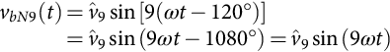 **(11.22)**

Thus, the ac output line voltage  will not contain the ninth harmonic. Therefore, for odd multiple of 3 values of the normalized carrier frequency *mf*, the harmonics in the ac output voltage appear at normalized frequencies *fh* centered around *mf* and its multiples, specifically, at

 **(11.23)**

where  for  and  for  such that *h* is not a multiple of 3. Therefore, the harmonics will be at , , , , , . For nearly sinusoidal ac load current, the harmonics in the dc link current are at frequencies given by

 **(11.24)**

where  for  and  for  such that  is positive and not a multiple of 3.

The identical conclusions can be drawn for the operation at small and large values of *mf* as for the single-phase configurations. However, because the maximum amplitude of the fundamental phase voltage in the linear region () is *vi*/2, the maximum amplitude of the fundamental ac output line voltage is . Therefore, one can write

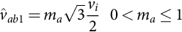 **(11.25)**

To further increase the amplitude of the load voltage, the amplitude of the modulating signal  can be made higher than the amplitude of the carrier signal , which leads to overmodulation. The relationship between the amplitude of the fundamental ac output line voltage and the dc link voltage becomes nonlinear as in single-phase VSIs. Thus, in the overmodulation region, the line voltages range is

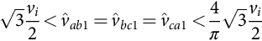 **(11.26)**

### 11.3.2 SQUARE-WAVE OPERATION OF THREE-PHASE VSIS

Large values of *ma* in the SPWM technique lead to full overmodulation. This is known as square-wave operation as illustrated in [Fig. 11.19](https://learning.oreilly.com/library/view/power-electronics-handbook/9780128114087/B9780128114070000118_1.xhtml#f0100), where the power semiconductors are on for 180*°*. In this operation mode, the VSI cannot control the load voltage except by means of the dc link voltage *vi*. This is based on the fundamental ac line-voltage expression

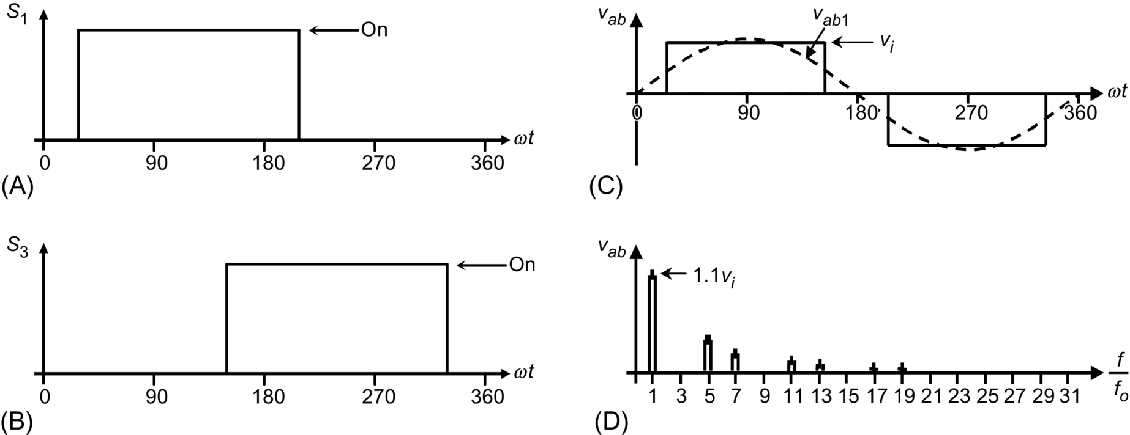

**FIG. 11.19** The three-phase VSI. Square-wave operation: (A) switch *S*1 state, (B) switch *S*3 state, (C) ac output voltage, and (D) ac output voltage spectrum.

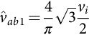 **(11.27)**

The ac line output voltage contains the harmonics *fh*, where  (), and they feature amplitudes that are inversely proportional to their harmonic order ([Fig. 11.18D](https://learning.oreilly.com/library/view/power-electronics-handbook/9780128114087/B9780128114070000118_1.xhtml#f0095)). Their amplitudes are

 **(11.28)**

### 11.3.3 SINUSOIDAL PWM WITH ZERO SEQUENCE SIGNAL INJECTION

The restriction for *ma* () can be relaxed if a zero-sequence signal is added to the modulating signals before they are compared with the carrier signal. [Fig. 11.20](https://learning.oreilly.com/library/view/power-electronics-handbook/9780128114087/B9780128114070000118_1.xhtml#f0105) shows the block diagram of the technique. Clearly, the addition of the zero sequence reduces the peak amplitude of the resulting modulating signals (*uca*, *ucb*, , while the fundamental components remain unchanged. This approach expands the range of the linear region as it allows the use of modulation indexes *ma* up to  without getting into the overmodulating region.

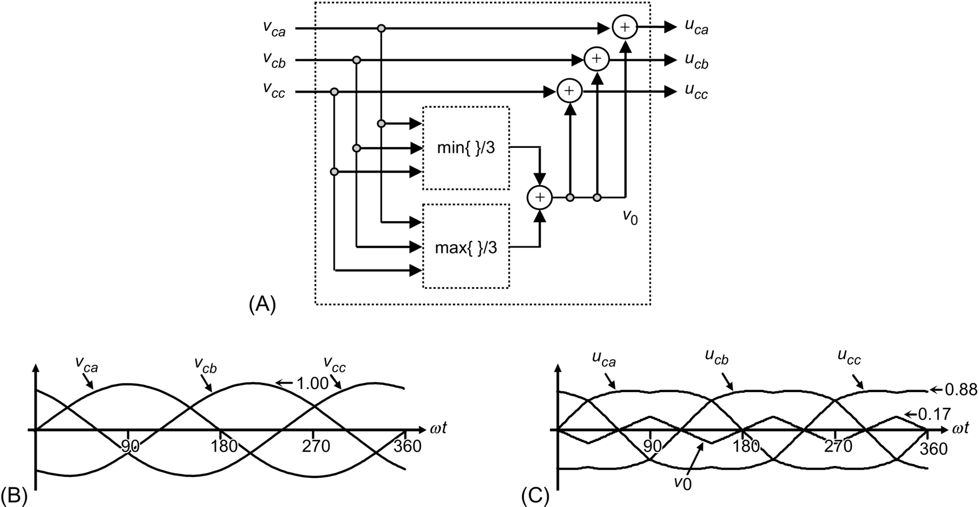

**FIG. 11.20** Zero-sequence signal generator (, ): (A) block diagram, (B) modulating signals, and (C) zero sequence and modulating signals with zero-sequence injection.

The maximum amplitude of the fundamental phase voltage in the linear region  is *vi*/2; thus, the maximum amplitude of the fundamental ac output line voltage is *vi*. Therefore, one can write

 **(11.29)**

[Fig. 11.21](https://learning.oreilly.com/library/view/power-electronics-handbook/9780128114087/B9780128114070000118_1.xhtml#f0110) shows the ideal waveforms of a three-phase VSI SPWM with zero injection for .



**FIG. 11.21** The three-phase VSI. Ideal waveforms for the SPWM (, ) with zero-sequence signal injection: (A) modulating signals, (B) carrier and modulating signals with zero-sequence signal injection, (C) switch *S*1 state, (D) ac output voltage, (E) ac output voltage spectrum, (F) ac output current, (G) dc current, (H) dc current spectrum, (I) switch *S*1 current, and (J) diode *D*1 current.

### 11.3.4 SELECTIVE HARMONIC ELIMINATION IN THREE-PHASE VSIS

As in single-phase VSIs, the SHE technique can be applied to three-phase VSIs. In this case, the power semiconductors of each leg of the inverter are switched so as to eliminate a given number of harmonics and to control the fundamental phase voltage amplitude. Considering that in many applications the required line output voltages should be balanced and 120*°* out of phase, the harmonic multiples of 3 (), which could be present in the phase voltages (*vaN*, *vbN*, and *vcN*), will not be present in the load voltages (*vab*, *vbc*, and *vca*). Therefore, these harmonics are not required to be eliminated; thus, the chopping angles are used to eliminate only the harmonics at frequencies  as required.

The expressions to eliminate a given number of harmonics are the same as those used in single-phase inverters. For instance, to eliminate the fifth and seventh harmonics and perform fundamental magnitude control (), the equations to be solved are

 **(11.30)**

where the angles *α*1, *α*2, and *α*3 are defined as shown in [Fig. 11.22A](https://learning.oreilly.com/library/view/power-electronics-handbook/9780128114087/B9780128114070000118_1.xhtml#f0115) and plotted in [Fig. 11.23](https://learning.oreilly.com/library/view/power-electronics-handbook/9780128114087/B9780128114070000118_1.xhtml#f0120). [Fig. 11.22B](https://learning.oreilly.com/library/view/power-electronics-handbook/9780128114087/B9780128114070000118_1.xhtml#f0115) shows that the third, ninth, fifteenth, … harmonics are all present in the phase voltages; however, they are not in the line voltages ([Fig. 11.22D](https://learning.oreilly.com/library/view/power-electronics-handbook/9780128114087/B9780128114070000118_1.xhtml#f0115)). If necessary, higher-order harmonics not eliminated with this technique can be filtered using small filters.



**FIG. 11.22** The three-phase VSI. Ideal waveforms for the SHE technique: (A) phase voltage *vaN* for fifth- and seventh-harmonic elimination, (B) spectrum of (A), (C) line voltage *vab* for fifth- and seventh-harmonic elimination, and (D) spectrum of (C).



**FIG. 11.23** Chopping angles for SHE and fundamental voltage control in three-phase VSIs: fifth- and seventh-harmonic elimination.

### 11.3.5 SPACE-VECTOR (SV)-BASED MODULATING TECHNIQUES

At present, the control strategies are implemented in digital systems, and therefore, digital modulating techniques are also available. The SV-based modulating technique is a digital technique in which the objective is to generate PWM load line voltages that are on average equal to given load line voltages. This is done in each sampling period by properly selecting the switch states from the valid ones of the VSI ([Table 11.5](https://learning.oreilly.com/library/view/power-electronics-handbook/9780128114087/B9780128114070000118_1.xhtml#t0030)) and by proper calculation of the period of times they are used. The selection and calculation times are based upon the SV transformation.

#### **11.3.5.1 Space-Vector Transformation**

Any three-phase set of variables that add up to zero in the stationary *abc* frame can be represented in a complex plane by a complex vector that contains a real (*α*) and an imaginary (*β*) component. For instance, the vector of three-phase line-modulating signals  can be represented by the complex vector  by means of the following transformation:

 **(11.31)**

**** **(11.32)**

If the line-modulating signals **v***c*abc are three balanced sinusoidal waveforms that feature an amplitude  and an angular frequency *ω*, the resulting modulating signals in the *αβ* stationary frame become a vector  of fixed module , which rotates at frequency *ω* ([Fig. 11.24](https://learning.oreilly.com/library/view/power-electronics-handbook/9780128114087/B9780128114070000118_1.xhtml#f0125)). Similarly, the SV transformation is applied to the line voltages of the eight states of the VSI normalized with respect to *vi* ([Table 11.5](https://learning.oreilly.com/library/view/power-electronics-handbook/9780128114087/B9780128114070000118_1.xhtml#t0030)), which generates the eight space vectors (, ) in [Fig. 11.24](https://learning.oreilly.com/library/view/power-electronics-handbook/9780128114087/B9780128114070000118_1.xhtml#f0125). As expected,  to  are nonnull line-voltage vectors, and  and  are null line-voltage vectors.



**FIG. 11.24** The space-vector representation.

The objective of the SV technique is to approximate the line-modulating signal space vector  with the eight space vectors (, ) available in VSIs. However, if the modulating signal  is laying between the arbitrary vectors  and , only the nearest two nonzero vectors ( and ) and the zero SV ( or ) should be used. Thus, the maximum load line voltage is maximized, and the switching frequency is minimized. To ensure that the generated voltage in one sampling period *Ts* (made up of the voltages provided by the vectors , , and  used during times *Ti*, , and *Tz*) is on average equal to the vector , the following expression should hold:

 **(11.33)**

The solution of the real and imaginary parts of Eq. [(11.32)](https://learning.oreilly.com/library/view/power-electronics-handbook/9780128114087/B9780128114070000118_1.xhtml#fo0165) for a line-load voltage that features an amplitude restricted to  gives

 **(11.34)**

**** **(11.35)**

**** **(11.36)**

The preceding expressions indicate that the maximum fundamental line-voltage amplitude is unity as . This is an advantage over the SPWM technique that achieves a  maximum fundamental line-voltage amplitude in the linear operating region. Although the space-vector-modulation (SVM) technique selects the vectors to be used and their respective on-times, the sequence in which they are used, the selection of the zero space vector, and the normalized sampled frequency remain undetermined.

For instance, if the modulating line-voltage vector is in sector 1 ([Fig. 11.24](https://learning.oreilly.com/library/view/power-electronics-handbook/9780128114087/B9780128114070000118_1.xhtml#f0125)), the vectors , , and  should be used within a sampling period by intervals given by *T*1, *T*2, and *Tz*, respectively. However, the sequence should be different, for example, (i) , (ii) , and (iii) . Finally, the technique does not indicate whether  should be , , or a combination of both.

#### **11.3.5.2 Space-Vector Sequences and Zero Space-Vector Selection**

The sequence to be used should ensure load line voltages that feature quarter-wave symmetry in order to reduce unwanted harmonics in their spectra (even harmonics). Additionally, the zero SV selection should be done in order to reduce the switching frequency. Although there is not a systematic approach to generate a SV sequence, a graphic representation shows that the sequence , ,  (where v*z* is alternately chosen among  and ) provides high performance in terms of minimizing unwanted harmonics and reducing the switching frequency.

#### **11.3.5.3 The Normalized Sampling Frequency**

The normalized carrier frequency *mf* in three-phase carrier-based PWM techniques is chosen to be an odd integer number multiple of 3 (, ). Thus, it is possible to minimize parasitic or nonintrinsic harmonics in the PWM waveforms. A similar approach can be used in the SVM technique to minimize uncharacteristic harmonics. Hence, it is found that the normalized sampling frequency *fsn* should be an integer multiple of 6. This is due to the fact that in order to produce symmetrical line voltages, all the sectors (a total of six) should be used equally in one period. As an example, [Fig. 11.25](https://learning.oreilly.com/library/view/power-electronics-handbook/9780128114087/B9780128114070000118_1.xhtml#f0130) shows the relevant waveforms of a VSI SVM for  and . [Fig. 11.25](https://learning.oreilly.com/library/view/power-electronics-handbook/9780128114087/B9780128114070000118_1.xhtml#f0130) confirms that the first set of relevant harmonics in the load line voltage are at *fsn*, which is also the switching frequency.



**FIG. 11.25** The three-phase VSI. Ideal waveforms for space-vector modulation (, ): (A) modulating signals, (B) switch *S*1 state, (C) switch *S*3 state, (D) ac output voltage, (E) ac output voltage spectrum, (F) ac output current, (G) dc current, (H) dc current spectrum, (I) switch *S*1 current, and (J) diode *D*1 current.

### 11.3.6 DC LINK CURRENT IN THREE-PHASE VSIS

Due to the fact that the inverter is assumed to be lossless and constructed without storage energy components, the instantaneous power balance indicates that

 **(11.37)**

where *ia*(*t*), *ib*(*t*), and *ic*(*t*) are the phase-load currents as shown in [Fig. 11.26](https://learning.oreilly.com/library/view/power-electronics-handbook/9780128114087/B9780128114070000118_1.xhtml#f0135). If the load is balanced and inductive and a relatively high switching frequency is used, the load currents become nearly sinusoidal balanced waveforms. On the other hand, if the ac output voltages are considered sinusoidal and the dc link voltage is assumed constant , Eq. [(11.37)](https://learning.oreilly.com/library/view/power-electronics-handbook/9780128114087/B9780128114070000118_1.xhtml#fo0190) can be simplified to



**FIG. 11.26** Phase-load currents definition in a delta-connected load.

 **(11.38)**

where *Vo*1 is the fundamental rms ac output line voltage, *Io* is the rms phase-load current, and *ϕ* is an arbitrary inductive load power factor. Hence, the dc link current expression can be further simplified to

 **(11.39)**

where  is the rms load line current. The resulting dc link current expression indicates that under harmonic-free load voltages, only a clean dc current should be expected in the dc bus and, compared with single-phase VSIs, there is no presence of second harmonic. However, as the ac load line voltages contain harmonics around the normalized sampling frequency *fsn*, the dc link current will contain harmonics but around *fsn* as shown in [Fig. 11.25H](https://learning.oreilly.com/library/view/power-electronics-handbook/9780128114087/B9780128114070000118_1.xhtml#f0130).

### 11.3.7 PHASE-LOAD VOLTAGE IN THREE-PHASE VSIS

The load is sometimes wye-connected, and the phase-load voltages *van*, *vbn*, and *vcn* may be required ([Fig. 11.27](https://learning.oreilly.com/library/view/power-electronics-handbook/9780128114087/B9780128114070000118_1.xhtml#f0140)). To obtain them, it should be considered that the line-voltage vector is



**FIG. 11.27** Phase-load voltages definition in a wye-connected load.

 **(11.40)**

which can be written as a function of the phase voltage vector [*vanvbnvcn*]*T* as

 **(11.41)**

Expression [(11.41)](https://learning.oreilly.com/library/view/power-electronics-handbook/9780128114087/B9780128114070000118_1.xhtml#fo0210) represents a linear system where the unknown quantity is the vector [*vanvbnvcn*]*T*. Unfortunately, the system is singular as the rows add up to zero (line voltages add up to zero); therefore, the phase-load voltages cannot be obtained by matrix inversion. However, if the phase-load voltages add up to zero, Eq. [(11.41)](https://learning.oreilly.com/library/view/power-electronics-handbook/9780128114087/B9780128114070000118_1.xhtml#fo0210) can be rewritten as

 **(11.42)**

which is not singular, and hence,

 **(11.43)**

that can be further simplified to

 **(11.44)**

The final expression for the phase-load voltages is only a function of *vab* and *vbc*, which is due to the fact that the last row in Eq. [(11.42)](https://learning.oreilly.com/library/view/power-electronics-handbook/9780128114087/B9780128114070000118_1.xhtml#fo0215) is chosen to be only ones. [Fig. 11.28](https://learning.oreilly.com/library/view/power-electronics-handbook/9780128114087/B9780128114070000118_1.xhtml#f0145) shows the line and phase voltages obtained using Eq. [(11.44)](https://learning.oreilly.com/library/view/power-electronics-handbook/9780128114087/B9780128114070000118_1.xhtml#fo0225).



**FIG. 11.28** The three-phase VSI and line- and phase-load voltages: (A) line-load voltage *vab* and (B) phase-load voltage *van*.

In the particular case of a square-wave three-phase VSI, this is known as a six-step inverter because of the six voltage changes per output voltage cycle.

## 11.4 Three-Phase Current Source Inverters

The main objective of these static power converters is to produce an ac output current waveforms from a dc current power supply. For sinusoidal ac outputs, its magnitude, frequency, and phase should be controllable. Due to the fact that the ac line currents *ioa*, *iob*, and *ioc* ([Fig. 11.29](https://learning.oreilly.com/library/view/power-electronics-handbook/9780128114087/B9780128114070000118_1.xhtml#f0150)) feature high *di*/*dt*, a capacitive filter should be connected at the ac output. These topologies are mainly used in medium-voltage industrial applications, where high-quality voltage waveforms are required.



**FIG. 11.29** Three-phase CSI topology.

In order to properly gate the power switches of a three-phase CSI, the compulsory rules of [Section 11.2.2](https://learning.oreilly.com/library/view/power-electronics-handbook/9780128114087/B9780128114070000118_1.xhtml#s0025) are valid. The main constraints are that one top switch (1, 3, or 5 ([Fig. 11.29](https://learning.oreilly.com/library/view/power-electronics-handbook/9780128114087/B9780128114070000118_1.xhtml#f0150))) and one bottom switch (4, 6, or 2 ([Fig. 11.29](https://learning.oreilly.com/library/view/power-electronics-handbook/9780128114087/B9780128114070000118_1.xhtml#f0150))) should be closed at any time.

There are nine valid states in three-phase CSIs. The states 7, 8, and 9 ([Table 11.6](https://learning.oreilly.com/library/view/power-electronics-handbook/9780128114087/B9780128114070000118_1.xhtml#t0035)) produce zero ac line currents. The remaining states (1–6 in [Table 11.6](https://learning.oreilly.com/library/view/power-electronics-handbook/9780128114087/B9780128114070000118_1.xhtml#t0035)) produce nonzero ac output line currents. In order to generate a given set of ac line current waveforms, the inverter must move from one state to another. Thus, the resulting line currents consist of discrete values of current, which are *ii*, 0, and . The selection of the states in order to generate the given waveforms is done by the modulating technique that should ensure the use of only the valid states.

**Table 11.6**

**Valid switch states for a three-phase CSI**

|  |  |  |  |  |  |
| --- | --- | --- | --- | --- | --- |
| **State** | **State no.** | ***ioa*** | ***iob*** | si210_e | **Space vector** |
| *S*1 and *S*2 are on, and *S*3, *S*4, *S*5, and *S*6 are off | 1 | *ii* | 0 | si211_e | si212_e |
| *S*2 and *S*3 are on, and *S*4, *S*5, *S*6, and *S*1 are off | 2 | 0 | *ii* | si211_e | si214_e |
| *S*3 and *S*4 are on, and *S*5, *S*6, *S*1, and *S*2 are off | 3 | si211_e | *ii* | 0 | si216_e |
| *S*4 and *S*5 are on, and *S*6, *S*1, *S*2, and *S*3 are off | 4 | si211_e | 0 | *ii* | si218_e |
| *S*5 and *S*6 are on, and *S*1, *S*2, *S*3, and *S*4 are off | 5 | 0 | si211_e | *ii* | si220_e |
| *S*6 and *S*1 are on, and *S*2, *S*3, *S*4, and *S*5 are off | 6 | *ii* | si211_e | 0 | si222_e |
| *S*1 and *S*4 are on, and *S*2, *S*3, *S*5, and *S*6 are off | 7 | 0 | 0 | 0 | si223_e |
| *S*3 and *S*6 are on, and *S*1, *S*2, *S*4, and *S*5 are off | 8 | 0 | 0 | 0 | si224_e |
| *S*5 and *S*2 are on, and *S*6, *S*1, *S*3, and *S*4 are off | 9 | 0 | 0 | 0 | si225_e |

There are several modulating techniques that deal with the special requirements of CSIs and can be implemented. These techniques are classified into three categories: (a) the carrier-based, (b) the SHE-based, and (c) the SV-based techniques. Although they are different, they generate gating signals that satisfy the special requirements of CSIs. To simplify the analysis, a constant dc link current source is considered ().

### 11.4.1 CARRIER-BASED PWM TECHNIQUES IN CSIS

It has been mentioned that the carrier-based PWM techniques that were initially developed for three-phase VSIs can be extended to three-phase CSIs. The circuit shown in [Fig. 11.30](https://learning.oreilly.com/library/view/power-electronics-handbook/9780128114087/B9780128114070000118_1.xhtml#f0155) obtains the gating pattern for a CSI from the gating pattern developed for a VSI. As a result, the line current appears to be identical to the line voltage in a VSI for similar carrier and modulating signals.

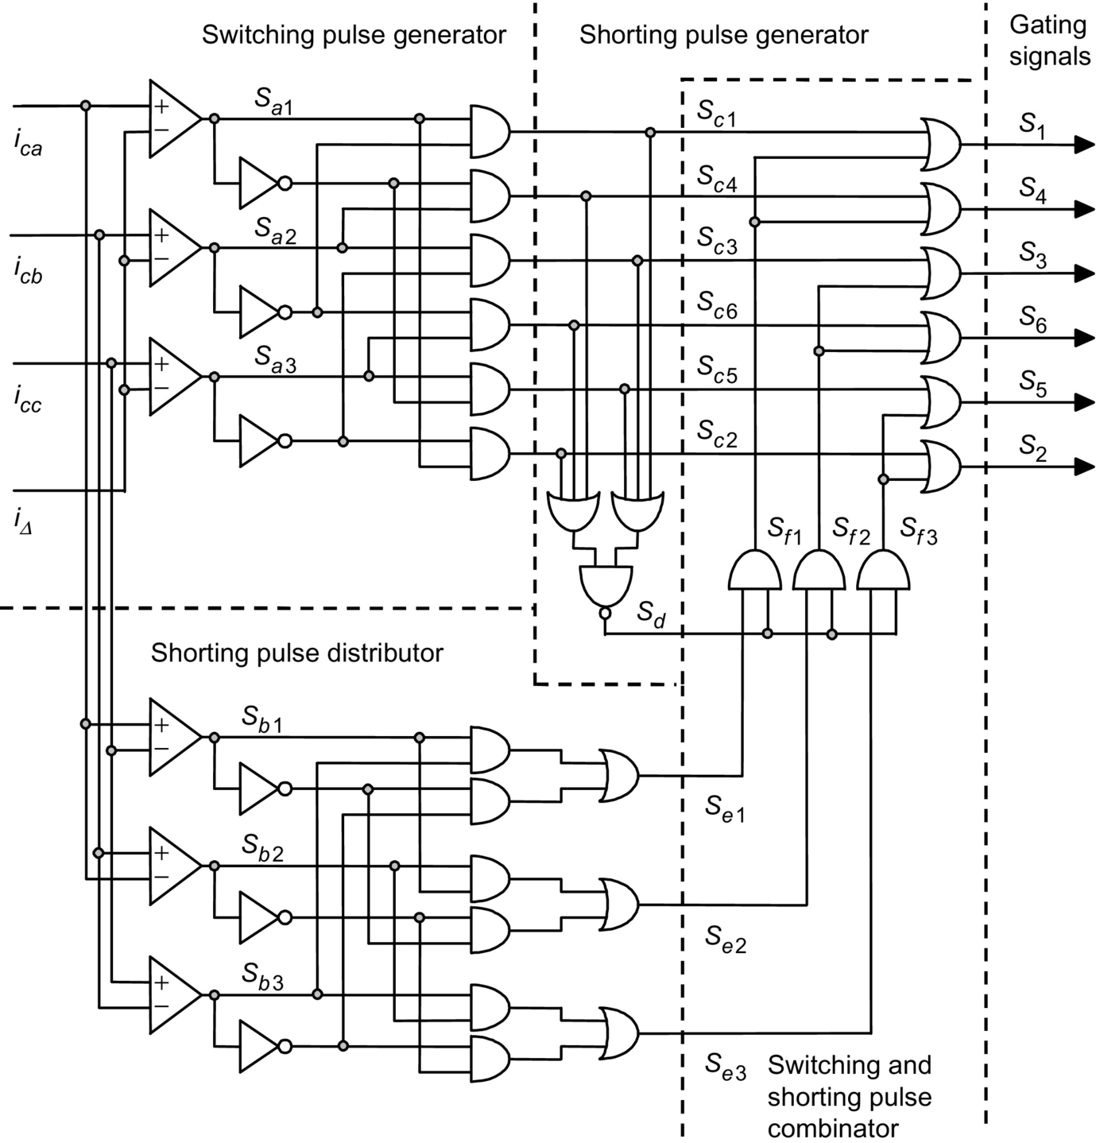

**FIG. 11.30** The three-phase CSI. Gating pattern generator for analog online carrier-based PWM.

It is composed of a switching pulse generator, a shorting pulse generator, a shorting pulse distributor, and a switching and shorting pulse combinator. The circuit basically produces the gating signals () according to a carrier *i*Δ and three modulating signals .

The first component of this stage ([Fig. 11.30](https://learning.oreilly.com/library/view/power-electronics-handbook/9780128114087/B9780128114070000118_1.xhtml#f0155)) is the switching pulse generator, where the signals **sa**123 are generated according to

 **(11.45)**

The outputs of the *switching pulse generator* are the signals **sc**, which are basically the gating signals of the CSI without the shorting pulses. These are necessary to inject the dc link current *ii* when no zero ac output currents are required.

In order to satisfy the first compulsory rule for CSI, the shorting pulse () is generated by the *shorting pulse generator* ([Fig. 11.30](https://learning.oreilly.com/library/view/power-electronics-handbook/9780128114087/B9780128114070000118_1.xhtml#f0155)); this are used to produce zero ac output currents. Then, this pulse is added (using OR gates) to only one leg of the CSI (either to the switches 1 and 4, 3 and 6, or 5 and 2) by means of the *switching and shorting pulse combinator* ([Fig. 11.30](https://learning.oreilly.com/library/view/power-electronics-handbook/9780128114087/B9780128114070000118_1.xhtml#f0155)). The signals generated by the *shorting pulse generator* **se**123 not only ensure that only one leg of the CSI is shorted at any time but also give an even distribution of the shorting pulse, as **se**123 is high for 120*°* in each period. This ensures that the rms currents are equal in all legs.

[Fig. 11.31](https://learning.oreilly.com/library/view/power-electronics-handbook/9780128114087/B9780128114070000118_1.xhtml#f0160) shows the relevant waveforms if a triangular carrier *i*Δ and sinusoidal modulating signals **ic***abc* are used in combination with the gating pattern generator circuit ([Fig. 11.30](https://learning.oreilly.com/library/view/power-electronics-handbook/9780128114087/B9780128114070000118_1.xhtml#f0155)); this is SPWM in CSIs. It can be observed that some of the waveforms ([Fig. 11.31](https://learning.oreilly.com/library/view/power-electronics-handbook/9780128114087/B9780128114070000118_1.xhtml#f0160)) are identical to those obtained in three-phase VSIs, where an SPWM technique is used ([Fig. 11.18](https://learning.oreilly.com/library/view/power-electronics-handbook/9780128114087/B9780128114070000118_1.xhtml#f0095)). Specifically, (i) the load line voltage ([Fig. 11.18D](https://learning.oreilly.com/library/view/power-electronics-handbook/9780128114087/B9780128114070000118_1.xhtml#f0095)) in the VSI is identical to the load line current ([Fig. 11.31D](https://learning.oreilly.com/library/view/power-electronics-handbook/9780128114087/B9780128114070000118_1.xhtml#f0160)) in the CSI and (ii) the dc link current ([Fig. 11.18G](https://learning.oreilly.com/library/view/power-electronics-handbook/9780128114087/B9780128114070000118_1.xhtml#f0095)) in the VSI is identical to the dc link voltage ([Fig. 11.31G](https://learning.oreilly.com/library/view/power-electronics-handbook/9780128114087/B9780128114070000118_1.xhtml#f0160)) in the CSI.



**FIG. 11.31** The three-phase CSI. Ideal waveforms for the SPWM (, ): (A) carrier and modulating signals, (B) switch *S*1 state, (C) switch *S*3 state, (D) ac output current, (E) ac output current spectrum, (F) ac output voltage, (G) dc voltage, (H) dc voltage spectrum, (I) switch *S*1 current, and (J) switch *S*1 voltage.

This brings up the duality issue between both the topologies when similar modulation approaches are used. Therefore, for odd multiples of 3 values of the normalized carrier frequency *mf*, the harmonics in the ac output current appear at normalized frequencies *fh* centered around *mf* and its multiples, specifically, at

 **(11.46)**

where  for  and  for  such that *h* is not a multiple of 3. Therefore, the harmonics will be at , , , , , , , . For nearly sinusoidal ac load voltages, the harmonics in the dc link voltage are at frequencies given by

 **(11.47)**

where  for  and  for  such that  is positive and not a multiple of 3. For instance, [Fig. 11.31H](https://learning.oreilly.com/library/view/power-electronics-handbook/9780128114087/B9780128114070000118_1.xhtml#f0160) shows the sixth harmonic (), which is due to . Identical conclusions can be drawn for the small and large values of *mf* in the same way as for three-phase VSI configurations. Thus, the maximum amplitude of the fundamental ac output line current is , and therefore, one can write

 **(11.48)**

To further increase the amplitude of the load current, the overmodulation approach can be used. In this region, the fundamental line currents range in

 **(11.49)**

To further test the gating signal generator circuit ([Fig. 11.30](https://learning.oreilly.com/library/view/power-electronics-handbook/9780128114087/B9780128114070000118_1.xhtml#f0155)), a sinusoidal set with third- and ninth-harmonic injection modulating signals are used. [Fig. 11.32](https://learning.oreilly.com/library/view/power-electronics-handbook/9780128114087/B9780128114070000118_1.xhtml#f0165) shows the relevant waveforms.



**FIG. 11.32** Gating pattern generator. Waveforms for third- and ninth-harmonic injection PWM (, ): signals as described in [Fig. 11.30](https://learning.oreilly.com/library/view/power-electronics-handbook/9780128114087/B9780128114070000118_1.xhtml#f0155).

### 11.4.2 SQUARE-WAVE OPERATION OF THREE-PHASE CSIS

As in VSIs, large values of *ma* in the SPWM technique lead to full overmodulation. This is known as square-wave operation. [Fig. 11.33](https://learning.oreilly.com/library/view/power-electronics-handbook/9780128114087/B9780128114070000118_1.xhtml#f0170) depicts this operating mode in a three-phase CSI, where the power semiconductors are on for 120*°*. As presumed, the CSI cannot control the load current except by means of the dc link current *ii*. This is due to the fact that the fundamental ac line current expression is



**FIG. 11.33** The three-phase CSI. Square-wave operation: (A) switch *S*1 state, (B) switch *S*3 state, (C) ac output current, and (D) ac output current spectrum.

 **(11.50)**

The ac line current contains the harmonics *fh*, where  (), and they feature amplitudes that are inversely proportional to their harmonic order ([Fig. 11.33D](https://learning.oreilly.com/library/view/power-electronics-handbook/9780128114087/B9780128114070000118_1.xhtml#f0170)). Thus,

 **(11.51)**

The duality issue among both the three-phase VSI and CSI should be noted especially in terms of the line-load waveforms. The line-load voltage produced by a VSI is identical to the load line current produced by the CSI when both are modulated using identical techniques. The next section will show that this also holds for SHE-based techniques.

### 11.4.3 SELECTIVE HARMONIC ELIMINATION IN THREE-PHASE CSIS

The SHE-based modulating techniques in VSIs define the gating signals such that a given number of harmonics are eliminated and the fundamental phase voltage amplitude is controlled. If the required line output voltages are balanced and 120*°* out of phase, the chopping angles are used to eliminate only the harmonics at frequencies  as required.

The circuit shown in [Fig. 11.34](https://learning.oreilly.com/library/view/power-electronics-handbook/9780128114087/B9780128114070000118_1.xhtml#f0175) uses the gating signals **sa**123 developed for a VSI and a set of synchronizing signals **ic**abc to obtain the gating signals **s** for a CSI. The synchronizing signals **ic**abc are sinusoidal balanced waveforms that are synchronized with the signals **sa**123 in order to symmetrically distribute the shorting pulse and thus generate symmetrical gating patterns. The circuit ensures line current waveforms as the line-voltage ones in a VSI. Therefore, any arbitrary number of harmonics can be eliminated, and the fundamental line current can be controlled in CSIs. Moreover, the same chopping angles obtained for VSIs can be used in CSIs.



**FIG. 11.34** The three-phase CSI. Gating pattern generator for SHE PWM techniques.

For instance, to eliminate the fifth and seventh harmonics, the chopping angles are shown in [Fig. 11.35](https://learning.oreilly.com/library/view/power-electronics-handbook/9780128114087/B9780128114070000118_1.xhtml#f0180), which are identical to that obtained for a VSI using Eq. [(11.10)](https://learning.oreilly.com/library/view/power-electronics-handbook/9780128114087/B9780128114070000118_1.xhtml#fo0055). [Fig. 11.36](https://learning.oreilly.com/library/view/power-electronics-handbook/9780128114087/B9780128114070000118_1.xhtml#f0185) shows that the line current does not contain the fifth and the seventh harmonics as expected. Hence, any number of harmonics can be eliminated in three-phase CSIs by means of the circuit ([Fig. 11.34](https://learning.oreilly.com/library/view/power-electronics-handbook/9780128114087/B9780128114070000118_1.xhtml#f0175)) without the hassle of how to satisfy the gating signal constrains.



**FIG. 11.35** Chopping angles for SHE and fundamental current control in three-phase CSIs, fifth- and seventh-harmonic elimination.



**FIG. 11.36** The three-phase CSI. Ideal waveforms for the SHE technique: (A) VSI gating pattern for fifth- and seventh-harmonic elimination, (B) CSI gating pattern for fifth- and seventh-harmonic elimination, (C) line current *ioa* for fifth- and seventh-harmonic elimination, and (D) spectrum of (C).